Spontaneous Reactions — Student Notes
Unit: Kinetics & Equilibrium — Lesson 04 Name: _______________________ Date: __________ Period: ____

Learning Targets
By the end of today’s 42 minutes I can:
- Define a spontaneous process as one that proceeds on its own, without continuous outside help, and give two everyday examples.
- Identify the two factors that favor a spontaneous change: releasing energy (exothermic, low enthalpy) and increasing disorder (entropy increase).
- Predict, qualitatively, whether a described process is spontaneous, and justify the prediction with energy and disorder evidence.
- Explain, using Energy and Matter, why a messy room forms on its own but a tidy room must be made.

Key Vocabulary
- spontaneous — _______________________________________________ _______________________________________________
- enthalpy — _______________________________________________ _______________________________________________
- entropy — _______________________________________________ _______________________________________________

Guided Notes
The big idea — Energy and Matter: Some changes happen all by themselves; their opposites never do. A change that proceeds on its own, with no outside force, is called __________. Nature tends toward states of __________ energy and __________ disorder.
“Spontaneous” does NOT mean fast. Spontaneous tells you the __________ a change goes, not its __________. Rust is spontaneous but takes years.
The two factors that decide spontaneity:
Factor | Favors spontaneity when… | The word for it
Energy | the process __________ energy (exothermic, ΔH < 0) | __________
Disorder | the disorder __________ (ΔS > 0) | __________
When the two factors agree, the answer is easy. When they disagree, __________ decides which factor wins (heat favors disorder; cold favors order).
The four-corner grid — fill in each corner from the figure:
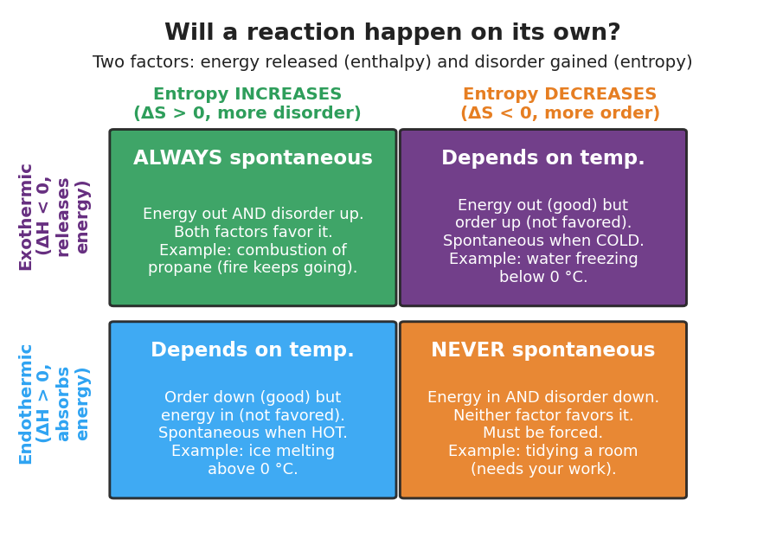
Two-by-two decision grid titled ‘Will a reaction happen on its own?’ Columns are entropy increases versus entropy decreases; rows are exothermic versus endothermic. Top-left (exothermic, entropy up) reads ALWAYS spontaneous. Top-right (exothermic, entropy down) and bottom-left (endothermic, entropy up) read Depends on temperature. Bottom-right (endothermic, entropy down) reads NEVER spontaneous, with the example of tidying a room.
 | Entropy INCREASES (more disorder) | Entropy DECREASES (more order)
Exothermic (releases energy) | __________ spontaneous | depends on __________
Endothermic (absorbs energy) | depends on __________ | __________ spontaneous
Where does the messy room go on this grid? Tidying a room absorbs effort (energy in) AND decreases disorder — so it lands in the __________ corner. That is why a room never tidies itself.

Worked Example
Scenario: Decide whether wood burning is spontaneous, and explain using both factors.
Step 1 — Describe the energy change.
When wood burns, you feel heat coming off the fire. So the process __________ energy. This makes it ____________________ (exothermic / endothermic). The enthalpy factor: ____________________ (favors / does not favor) spontaneity.
Step 2 — Describe the disorder (entropy) change.
A solid log turns into spreading hot gases, smoke, and ash. The disorder ____________________ (increases / decreases). So entropy ____________________. The entropy factor: ____________________ (favors / does not favor) spontaneity.
Step 3 — Combine the two factors.
Both factors __________ spontaneity (they agree). So wood burning lands in the __________ corner of the grid: __________ spontaneous.
Step 4 — Speed check.
Is “spontaneous” the same as “fast”? __________. Wood needs a spark to start (that is activation energy from the rates lesson), but once lit it keeps going on its own — that is what spontaneous means.
Step 5 — Because / But / So
Wood burning is spontaneous because _______________________________________________, but _______________________________________________, so _______________________________________________.
Check your reasoning: “because” should name both factors (releases energy AND increases disorder); “but” should address speed or the spark needed to start; “so” should state that it keeps going on its own.

Summary
Complete the sentence:
A process is spontaneous when it _________________________ , and it is favored by ____________ energy and ____________ entropy (disorder).
Complete the Because / But / So sentence:
A messy room forms on its own, but a tidy room never does, because __________________________________________, but __________________________________________, so __________________________________________.
Reminders:
- Spontaneous = happens on its own (a question of direction), not fast (that is rate/kinetics).
- Two factors favor spontaneity: releasing energy (exothermic) and increasing entropy (disorder).
- When the factors disagree, temperature decides — heat favors disorder, cold favors order.

