Chemical Equilibrium — Student Notes
Unit: Kinetics & Equilibrium — Lesson 05 Name: _______________________ Date: __________ Period: ____

Learning Targets
By the end of today’s 42 minutes I can:
- Describe a reversible reaction and read the double arrow (⇌) as “proceeds in both directions.”
- State the two characteristics of a system at equilibrium: the forward and reverse rates are equal, and the concentrations stay constant.
- Explain that equilibrium is dynamic (the reactions never stop) and that “equal rates” does not mean “equal concentrations.”
- Explain, using Stability and Change, why a sealed soda keeps its fizz while an open one goes flat.

Key Vocabulary
- reversible reaction — _______________________________________________ _______________________________________________
- equilibrium — _______________________________________________ _______________________________________________
- dynamic equilibrium — _______________________________________________ _______________________________________________

Guided Notes
The big idea — Stability and Change: A system at equilibrium looks ______________ on the outside (constant color, concentration, pressure), but at the particle scale it is still ______________ — molecules keep reacting in both directions. The outside stays steady because two opposite changes happen at ______________ rates.
The double arrow:
- A single arrow (→) means the reaction goes ______________ (one way / both ways) to completion.
- A double arrow (⇌) means the reaction is ______________ — it runs in both directions at once.
The TWO characteristics of a system at equilibrium:
- The ______________ reaction rate equals the ______________ reaction rate.
- The ______________ of all reactants and products stay ______________ (do not change).
Two warnings (the most common mistakes):
- Equilibrium does not mean the reaction has ______________. (It is still running both ways — that’s why we call it dynamic.)
- “Equal rates” does not mean “equal ______________.” The amounts can be very different; only the rates are equal.
The figure — forward and reverse rates approaching equilibrium:
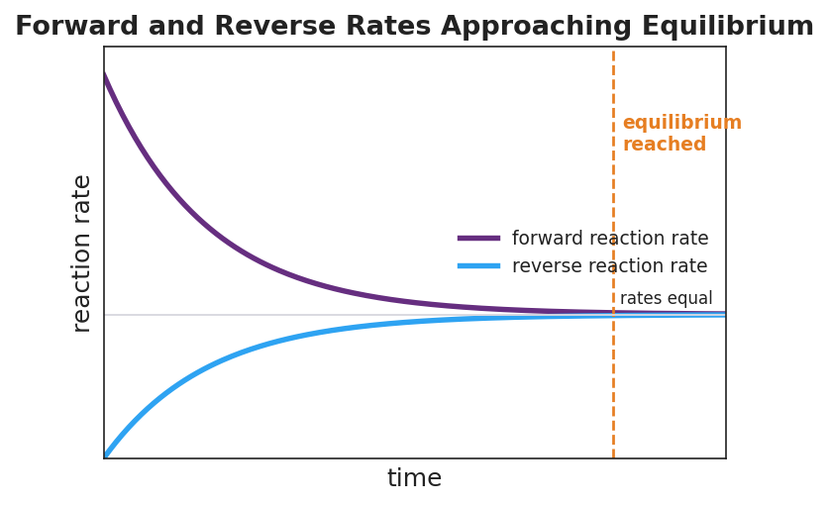
Line graph titled ‘Forward and Reverse Rates Approaching Equilibrium’: the purple forward-reaction-rate curve starts high and falls over time; the blue reverse-reaction-rate curve starts at zero and rises; the two curves converge to the same constant value, marked by a dashed orange vertical line labeled ‘equilibrium reached’ and a gray horizontal line labeled ‘rates equal’; the x-axis is labeled ‘time’ and the y-axis is labeled ‘reaction rate’.
From the figure above, fill in the blanks:
- At the start, the ______________ rate (purple) is high and the ______________ rate (blue) is near zero.
- As time goes on, the forward rate ______________ and the reverse rate ______________.
- At the dashed line, the two rates become ______________ and stay there. After that, the concentrations are ______________.
- The rates level off at the same height that is not zero — this proves the reaction is still ______________, not stopped.
The Hochman appositive definition:
Dynamic equilibrium — _________________________________ — is not a stopped reaction.

Worked Example
Scenario: A pair runs the cup-transfer simulation. They start with 40 counters in the Reactants cup and 0 in Products. Each round they move ½ of Reactants forward and 1/10 of Products back, then count.
Step 1 — Run the first two rounds (model):
Round | Reactants (R) | Forward (½ of R) | Products (P) | Back (1/10 of P)
Start | 40 | — | 0 | —
1 | _____ | 20 | _____ | 0
2 | _____ | _____ | _____ | _____
(Round 1: forward = ½·40 = 20, back = 1/10·0 = 0, so R = 40 − 20 + 0 = 20 and P = 0 + 20 − 0 = 20.)
Step 2 — Where does it settle? After several rounds the counts stop changing near:
Reactants ≈ _______ Products ≈ _______ (NOT equal to each other)
Step 3 — What is equal at the steady state?
The number of counters moving ______________ each round equals the number moving ______________ each round. The ______________ are equal; the ______________ in the two cups are not.
Step 4 — Name it: This steady state is called ______________ ______________. The counters never stop moving — so it is ______________, not stopped.
Step 5 — Appositive sentence:
Dynamic equilibrium — the condition where the forward and reverse reactions occur at ______________ rates so the ______________ stay constant — is not a stopped reaction.
Step 6 — Because / But / So
The cup counts stopped changing because _______________________________________________, but _______________________________________________, so _______________________________________________.
Check your reasoning: “because” should name the equal forward/back transfers; “but” should note that counters still move every round; “so” should state that the counts hold constant while the reaction stays dynamic.

Summary
Complete the appositive sentence:
Dynamic equilibrium — _________________________________ — is not a stopped reaction.
Complete the Because / But / So sentence:
A sealed bottle of soda keeps its fizz, but an open bottle goes flat, because __________________________________________, but __________________________________________, so __________________________________________.
Reminder: At equilibrium, what is equal is the rates, not the amounts. The concentrations are constant (unchanging) — but they are usually NOT equal to each other. And the reaction never stops; it is dynamic.
Key reference (from the 2025 NYS Reference Tables): The double arrow ⇌ denotes a reversible reaction at equilibrium.

