Le Châtelier’s Principle — Student Notes
Unit: Kinetics & Equilibrium — Lesson 06 Name: _______________________ Date: __________ Period: ____

Learning Targets
By the end of today’s 42 minutes I can:
- State Le Châtelier’s principle in my own words.
- Predict the direction an equilibrium shifts when I change a concentration, a pressure, or a temperature — and justify the prediction.
- Explain why a catalyst speeds up the approach to equilibrium but does not change the equilibrium position or the yield.
- Refine the conditions of the Haber process to specify changes that increase the equilibrium yield of ammonia.

Key Vocabulary
- Le Châtelier’s principle — _______________________________________________ _______________________________________________
- equilibrium shift — _______________________________________________ _______________________________________________
- stress — _______________________________________________ _______________________________________________

Guided Notes
The big idea — Stability and Change: A system at equilibrium is __________ — the forward and reverse rates are equal and the amounts stop changing. When a __________ disturbs it, the system __________ in the direction that partially relieves the stress, until it reaches a __________ equilibrium.
Le Châtelier’s principle (write the rule):
When a system at equilibrium is disturbed by a stress, the equilibrium shifts in the direction that _______________________________________________.
The four kinds of stress — and which way the equilibrium shifts:
Stress | Direction of shift | Memory hook
Add a reactant | toward __________ | “use up what you added”
Remove a reactant | toward __________ | “replace what you took”
Add a product | toward __________ | “use up what you added”
Remove a product | toward __________ | “replace what you took”
Increase pressure (gas) | toward the side with __________ gas molecules | “relieve the squeeze”
Increase temperature | treat __________ as a substance (see below) | “use up the added heat”
Add a catalyst | __________ shift | “speed only, not position”
Heat is a substance — but which side?
- If the forward reaction is endothermic (ΔH is +): heat is a __________ → adding heat shifts toward __________.
- If the forward reaction is exothermic (ΔH is −): heat is a __________ → adding heat shifts toward __________.
The catalyst rule (write it carefully): A catalyst lowers the activation energy of the forward and reverse reactions by the same amount. So it changes how __________ equilibrium is reached, but not __________ the equilibrium sits. The yield is unchanged.
The figure — Haber process yield vs. pressure:
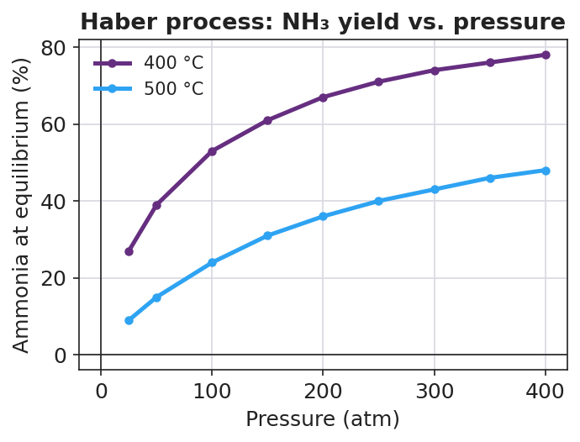
Line graph titled ‘Haber process: NH₃ yield vs. pressure’ showing ammonia yield (%) rising as pressure (atm) increases, with an upper curve at 400 °C and a lower curve at 500 °C; the cooler 400 °C curve sits above the hotter 500 °C curve at every pressure.
From the figure, fill in the blanks for N₂(g) + 3 H₂(g) ⇌ 2 NH₃(g), ΔH = −92 kJ:
- As pressure increases, the yield goes __________. The product side has __________ gas molecules, so higher pressure shifts the equilibrium toward __________.
- The cooler 400 °C curve is __________ the hotter 500 °C curve, so a lower temperature gives a __________ yield. This is because the forward reaction is __________ (heat is a product), so removing heat shifts toward __________.

Worked Example
Scenario: Predict and justify every shift for the FeSCN²⁺ equilibrium.
Fe³⁺(aq, pale yellow) + SCN⁻(aq, colorless) ⇌ FeSCN²⁺(aq, deep red)
Step 1 — Identify what is on each side.
Reactants: ___________ and ___________ Product: ___________ (the deep-red color)
Step 2 — Apply each stress and predict the shift.
Stress | Shift direction (← / →) | Predicted color change
Add more Fe³⁺
Add more SCN⁻
Remove Fe³⁺ (add Na₂HPO₄)
Step 3 — State the underlying rule. In each case the system shifted to __________ the stress: it used up what was added (deeper red), or replaced what was removed (faded red).
Step 4 — Because / But / So.
Adding more Fe³⁺ deepens the red because _______________________________________________, but _______________________________________________, so _______________________________________________.
Check your reasoning: “because” should name the stress (added reactant); “but” should note the system can’t stay at the old balance once a rate speeds up; “so” should state the shift direction and the color result.

Summary
Complete the rule:
Le Châtelier’s principle — when a system at equilibrium is stressed by a change in __________, __________, or __________ — the equilibrium shifts in the direction that _______________________________________________.
Complete the Because / But / So sentence (the Haber temperature trade-off):
Lowering the temperature should raise the ammonia yield because __________________________________________, but __________________________________________, so __________________________________________.
Reminder — the two most common traps: 1. A catalyst changes the rate, not the position — it never changes the yield. 2. For temperature, always check the sign of ΔH first: heat is a reactant for an endothermic forward reaction, but a product for an exothermic one.
Key reference (from the 2025 NYS Reference Tables): Table I lists ΔH values; a negative ΔH means the forward reaction is exothermic (heat is released, so heat behaves like a product).

