Le Châtelier’s Principle — Student Worksheet
Unit: Kinetics & Equilibrium — Lesson 06 Name: _______________________ Date: __________ Period: ____

Phenomenon
Industrial chemists want to make ammonia (NH₃) — the basis of the fertilizer that feeds about half the world. The reaction uses two cheap ingredients: nitrogen from the air and hydrogen.
N₂(g) + 3 H₂(g) ⇌ 2 NH₃(g)
But the reaction is reversible — as fast as ammonia forms, it breaks back apart, and the reaction stalls at a low yield. For decades nobody could make ammonia profitably. Fritz Haber’s breakthrough was not a new reaction — it was a recipe of conditions: high pressure, a chosen temperature, a catalyst, and pulling the ammonia out as it forms. Each choice nudges this same reaction toward more product.
Driving question: How do you tilt a reversible reaction’s balance toward the product you want?

Notice & Wonder
I notice… | I wonder…
Turn & Talk #1: Look at the yield chart your teacher is projecting — raising the pressure raised the ammonia yield. Count the gas molecules on each side of N₂(g) + 3 H₂(g) ⇌ 2 NH₃(g). In one sentence, why might squeezing the gases (raising pressure) help the product side?

Initial Model
Before your teacher names any rule: a reversible reaction sits at equilibrium, so the forward and reverse rates are equal and the amounts of reactant and product stop changing.
A + B ⇌ C
Now you suddenly add more A.
- Which reaction now has more to work with — the forward or the reverse? _______________
- So which rate speeds up first? _______________
- While the system re-balances, does the amount of C go up or down? _______________
- Sketch a quick “before → after” picture of the amount of C:
 | Before adding A | Right after adding A | At the new balance
Amount of C

Investigation

Part 1 — FeSCN²⁺ color-change equilibrium
The iron–thiocyanate reaction is reversible, and its color shows the position of the equilibrium:
Fe³⁺(aq, pale yellow) + SCN⁻(aq, colorless) ⇌ FeSCN²⁺(aq, deep red)
Deeper red = more product (FeSCN²⁺). Fading red = the system shifted back toward reactants. Split your equilibrium mixture across four tubes and apply one stress to each. Record the color change and the shift direction.
Tube | Stress applied | Color change you observe | Shift direction (← reactants / → products / none)
1 | Add 0.1 M Fe(NO₃)₃ (more Fe³⁺)
2 | Add 0.1 M KSCN (more SCN⁻)
3 | Add a pinch of Na₂HPO₄ / NaF (removes Fe³⁺)
4 | Control — add a few drops of water only
Pattern question: Adding a reactant and removing a reactant pushed the equilibrium in opposite directions. State the pattern in one sentence:

Part 2 — Temperature as a stress (teacher demo: CoCl₂)
[Co(H₂O)₆]²⁺(pink) + 4 Cl⁻ ⇌ [CoCl₄]²⁻(blue) + 6 H₂O (forward reaction is endothermic)
Treat heat like a substance. Because the forward reaction absorbs heat, heat acts like a reactant on the left.
Stress applied | Color you observe | Shift direction
Warm the tube (add heat)
Cool the tube (remove heat)

Part 3 — Reading the Haber yield chart
Look at figures/ammonia_yield_pressure.png:
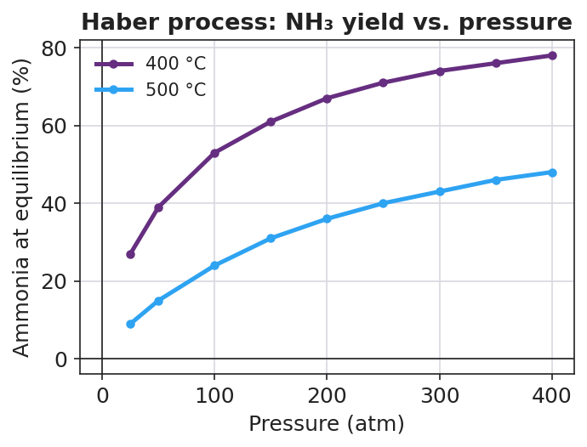
Line graph titled ‘Haber process: NH₃ yield vs. pressure’ with pressure in atmospheres on the x-axis (0 to 400 atm) and ammonia at equilibrium as a percentage on the y-axis (0 to 80%). Two curves rise as pressure increases: an upper purple curve labeled 400 °C and a lower blue curve labeled 500 °C; the cooler 400 °C curve sits above the hotter 500 °C curve at every pressure.
- As pressure increases, does the ammonia yield go up or down? _______________
- The product side (2 NH₃) has fewer gas molecules than the reactant side (1 N₂ + 3 H₂). Use that to explain why higher pressure raises the yield.

- At every pressure, the cooler 400 °C curve is above the hotter 500 °C curve. The forward reaction is exothermic (it releases heat). Why does a lower temperature give a higher yield?

Make It Make Sense
For each stress, state the shift direction (toward reactants ← or toward products →, or no shift) and justify it with Le Châtelier reasoning.
1. FeSCN²⁺ equilibrium: Fe³⁺(aq) + SCN⁻(aq) ⇌ FeSCN²⁺(aq, red). You add more SCN⁻.
- Shift direction: _______________
- Justification: _______________________________________________
- Predicted color change: _______________
2. Haber equilibrium: N₂(g) + 3 H₂(g) ⇌ 2 NH₃(g), ΔH = −92 kJ. You increase the pressure.
- Shift direction: _______________
- Justification (count gas molecules): _______________________________________________
3. Haber equilibrium: N₂(g) + 3 H₂(g) ⇌ 2 NH₃(g), ΔH = −92 kJ. You raise the temperature.
- Shift direction: _______________
- Justification (use the sign of ΔH — is heat a reactant or a product?): _______________________________________________
4. Haber equilibrium: N₂(g) + 3 H₂(g) ⇌ 2 NH₃(g). You add an iron catalyst.
- Effect on the equilibrium position: _______________
- Justification: _______________________________________________

Vocabulary in Action
Use each term in a sentence about today’s investigation. Do not copy the definition — describe something you actually did, saw, or predicted.
- Le Châtelier’s principle: _______________________________________________ _______________________________________________
- equilibrium shift: _______________________________________________ _______________________________________________
- stress: _______________________________________________ _______________________________________________

Revise Your Model
Return to your Initial Model (the A + B ⇌ C “add A” sketch). Now you can name what happened.
- The change you imposed (adding A) is called a __________.
- The system’s response — C going up until the rates re-balance — is called an equilibrium __________.
- The system shifted in the direction that __________ the stress.
Now act as the Haber plant engineer. For N₂(g) + 3 H₂(g) ⇌ 2 NH₃(g), ΔH = −92 kJ, specify a change in each lever that would increase the ammonia yield:
Lever | Change that increases NH₃ yield | Why (Le Châtelier)
Pressure
Temperature
Concentration (of NH₃)
Catalyst
Then finish this Because / But / So sentence about the temperature trade-off:
Lowering the temperature should raise the ammonia yield because __________________________________________, but __________________________________________, so __________________________________________.

Exit Ticket
Consider a different reversible reaction — the contact process used to make sulfuric acid:
2 SO₂(g) + O₂(g) ⇌ 2 SO₃(g), ΔH = −198 kJ (the forward reaction is exothermic)
- Predict the shift if you increase the pressure. Justify by counting the gas molecules on each side.
Shift: _______________ — because: _______________________________________________
- Predict the shift if you raise the temperature. Justify using the sign of ΔH (is heat a reactant or a product here?).
Shift: _______________ — because: _______________________________________________
- A factory adds a vanadium(V) oxide catalyst. What happens to the equilibrium position, and why?

