Arrhenius Theory of Acids & Bases — Student Notes
Unit: Acids and Bases — Lesson 01 Name: _______________________ Date: __________ Period: ____

Learning Targets
By the end of today’s 42 minutes I can:
- Describe the shared properties of acids (sour, react with active metals, turn blue litmus red) and bases (bitter, slippery, turn red litmus blue).
- State the Arrhenius definitions: an acid produces hydrogen ions (H⁺) in water; a base produces hydroxide ions (OH⁻) in water.
- Identify a substance as an Arrhenius acid or base from its chemical formula.
- Explain, using Patterns, why all acids share a common set of properties even though they are made of different elements.

Key Vocabulary
- Arrhenius acid — _______________________________________________ _______________________________________________
- Arrhenius base — _______________________________________________ _______________________________________________
- hydrogen ion (H⁺) — _______________________________________________ _______________________________________________

Guided Notes
The big idea — Patterns: Many substances that come from __________ sources share the same set of properties. A shared pattern of properties is evidence of a shared __________ . For acids and bases, that shared cause is a common __________ released into the water.
Properties — fill in the two families:
 | Acids | Bases
Taste (from experience, never tasted in lab)
Feel | (not slippery)
Red litmus paper
Blue litmus paper
Reaction with active metals (Mg, Zn)
The Arrhenius definitions:
- An Arrhenius acid produces __________ ions ( __________ ) when dissolved in water.
- An Arrhenius base produces __________ ions ( __________ ) when dissolved in water.
Reading a formula (the identification rule):
- If the formula starts with H (HCl, HNO₃, H₂SO₄) — or has a –COOH group — it is an __________ , because it releases __________ in water.
- If the formula contains an OH group bonded to a metal (NaOH, KOH, Ca(OH)₂) — it is a __________ , because it releases __________ in water.
- If the formula has neither a leading H nor an OH group (NaCl, CaCl₂) — it is __________ .
Why all acids act alike (the CCC connection):
Complete the sentence:
Different acids are made of __________ other atoms, but every acid releases the same __________ ( __________ ) in water, so the shared properties come from the __________ they have in common, not from the parts that differ.
The figure — what happens when an acid and a base dissolve in water:
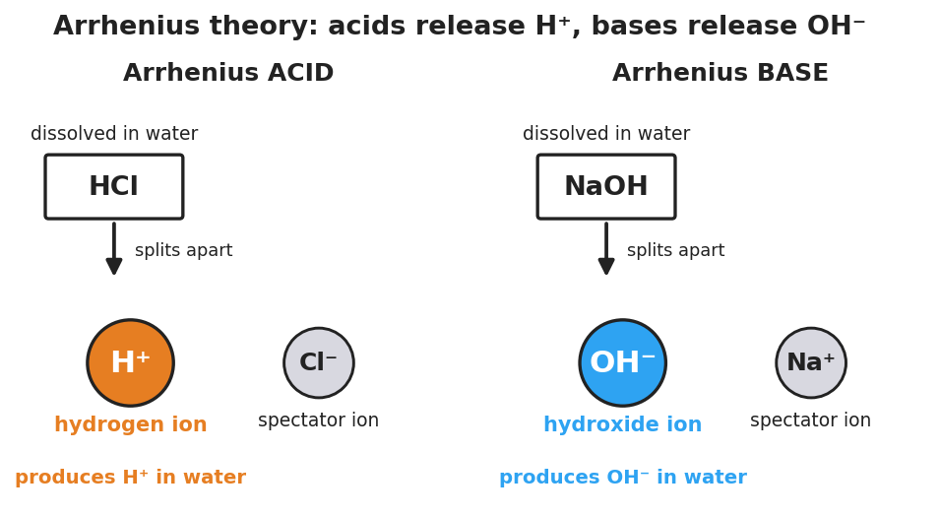
Two-panel particle diagram of the Arrhenius model. Left panel labeled ‘Arrhenius ACID’: the formula HCl dissolved in water splits into a large orange hydrogen ion H plus and a grey spectator chloride ion Cl minus, captioned ‘produces H plus in water.’ Right panel labeled ‘Arrhenius BASE’: the formula NaOH dissolved in water splits into a large blue hydroxide ion OH minus and a grey spectator sodium ion Na plus, captioned ‘produces OH minus in water.’
From the figure above, fill in the blanks:
- HCl in water splits into __________ and Cl⁻. The ion that makes it an acid is __________ .
- NaOH in water splits into Na⁺ and __________ . The ion that makes it a base is __________ .
- The grey ions (Cl⁻ and Na⁺) are called __________ ions — they are “along for the ride” and do not cause the acid or base behavior.

Worked Example
Scenario: You are given three labeled bottles and must classify each one from its formula alone, without testing: HBr, Ca(OH)₂, and CaCl₂.
Step 1 — Look at the first part of each formula:
- HBr → starts with __________
- Ca(OH)₂ → contains the group __________
- CaCl₂ → starts with __________ ; contains an OH group? __________ (yes / no)
Step 2 — Apply the rule:
- HBr starts with H, so it is an __________ . It produces __________ in water.
- Ca(OH)₂ contains OH bonded to a metal (Ca), so it is a __________ . It produces __________ in water.
- CaCl₂ has no leading H and no OH group, so it is __________ .
Step 3 — Name the ion responsible for the behavior:
- The acid’s properties come from the __________ ion.
- The base’s properties come from the __________ ion.
Step 4 — Because / But / So
HBr and citric acid (in lemon juice) are completely different substances because _______________________________________________, but _______________________________________________, so _______________________________________________.
Check your reasoning: “because” should name how the substances differ; “but” should name the ion they share (H⁺); “so” should state that the shared properties come from the shared ion.

Summary
Complete the Because / But / So sentence:
All acids share the same properties (sour, fizz on metal, turn blue litmus red) because __________________________________________, but __________________________________________, so __________________________________________.
Reminder — the formula rule: - Leading H (or –COOH) → acid → produces H⁺ - OH bonded to a metal → base → produces OH⁻ - Neither → neutral
Key idea: The properties of an acid or base come from the ion it releases in water (H⁺ or OH⁻), not from the parts of the formula that change from one substance to the next. That shared ion is the pattern behind the shared behavior.

