Neutralization — Student Notes
Unit: Acids and Bases — Lesson 02 Name: _______________________ Date: __________ Period: ____

Learning Targets
By the end of today’s 42 minutes I can:
- State the general pattern of a neutralization reaction: acid + base → salt + water.
- Identify the salt and the water produced when a named acid reacts with a named base.
- Write and balance a neutralization equation, including pairs that need coefficients.
- Explain, using conservation of atoms (Energy and Matter), why a neutralization equation must be balanced and why an antacid stops the burning of stomach acid.

Key Vocabulary
- neutralization — _______________________________________________ _______________________________________________
- salt — _______________________________________________ _______________________________________________
- conservation of atoms — _______________________________________________ _______________________________________________

Guided Notes
The big idea — conservation of atoms (Energy and Matter): In a neutralization reaction, atoms are not created or __________. They are __________. The H⁺ from the acid and the OH⁻ from the base combine to form __________, while the leftover ions pair up to form a __________. The equation must be __________ so that each kind of atom has the same count on both sides.
The general pattern of neutralization:
__________ + __________ → __________ + __________ (acid) (base) (salt) (water)
Where each product comes from:
- The H⁺ from the acid + the OH⁻ from the base → __________
- The cation from the base + the anion from the acid → the __________
The Hochman appositive definition:
Neutralization — _________________________ — consumes the H⁺ and OH⁻ ions that make solutions acidic or basic.
The figure — atoms are conserved in HCl + NaOH → NaCl + H₂O:
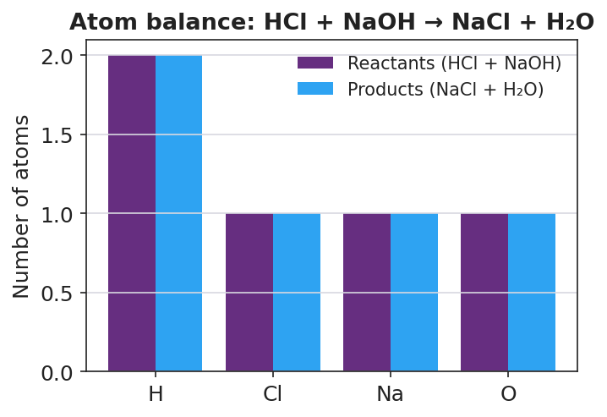
Grouped bar chart titled ‘Atom balance: HCl + NaOH → NaCl + H₂O’ with the x-axis listing four elements (H, Cl, Na, O) and the y-axis labeled ‘Number of atoms’; for each element a purple reactant bar and a blue product bar are shown side by side, and for every element the two bars are exactly equal height (H = 2, Cl = 1, Na = 1, O = 1), showing that atoms are conserved.
From the figure above, fill in the blanks:
- For hydrogen, the reactant side has ___ atoms and the product side has ___ atoms.
- The reactant and product bars are the same height for ___________ (all / some) elements.
- Equal bars on both sides show that atoms are ___________ during the reaction.
Balancing reminders (when you need a coefficient):
If the acid or base has… | Then you usually need… | Example
A diprotic acid (2 H⁺), e.g. H₂SO₄ | a 2 in front of the base | H₂SO₄ + 2 NaOH → Na₂SO₄ + 2 H₂O
A base with two OH⁻, e.g. Mg(OH)₂ | a 2 in front of the acid | 2 HCl + Mg(OH)₂ → MgCl₂ + 2 H₂O

Worked Example
Scenario: A student needs to write and balance the neutralization of sulfuric acid (H₂SO₄) with sodium hydroxide (NaOH).
Step 1 — Write the reactants:
H₂SO₄ + NaOH → ?
Step 2 — Identify the products (salt + water):
- The H⁺ and OH⁻ form __________ (water).
- The leftover ions are Na⁺ (from the base) and SO₄²⁻ (from the acid). Because SO₄²⁻ has a 2− charge, it needs __________ Na⁺ ions. The salt is __________.
So the unbalanced equation is: H₂SO₄ + NaOH → Na₂SO₄ + H₂O
Step 3 — Count atoms on each side (unbalanced):
Element | Left | Right | Balanced?
H | 3 | 2 | no
S | 1 | 1 | yes
O | 5 | 5 | check again
Na | 1 | 2 | no
Step 4 — Add coefficients so atoms match: The acid donates ___ H⁺, so you need ___ NaOH to supply ___ OH⁻, which makes ___ H₂O.
_____ H₂SO₄ + _____ NaOH → _____ Na₂SO₄ + _____ H₂O
Step 5 — Re-count to confirm it is balanced:
Element | Left | Right | Balanced?
H | ___ | ___ | ___
S | ___ | ___ | ___
O | ___ | ___ | ___
Na | ___ | ___ | ___
Step 6 — Appositive sentence:
The neutralization of sulfuric acid — _________________________ — produces the salt __________ and water.
Step 7 — Because / But / So
The neutralization of H₂SO₄ with NaOH needs a coefficient of 2 on the base because _______________________________________________, but _______________________________________________, so _______________________________________________.
Check your reasoning: “because” should explain why two OH⁻ are needed; “but” should acknowledge what you would get if you forgot the coefficient; “so” should state the correctly balanced equation.

Summary
Complete the appositive sentence:
Neutralization — _________________________ — consumes the H⁺ and OH⁻ ions that make solutions acidic or basic.
Complete the Because / But / So sentence:
An antacid makes the burning of heartburn go away because __________________________________________, but __________________________________________, so __________________________________________.
Reminder: A salt is any ionic compound from the base’s cation and the acid’s anion — not only table salt (NaCl). And the equation must be balanced, because atoms are conserved.
Key reference (from the 2025 NYS Reference Tables): General pattern: acid + base → salt + water Common ion charges (Table for ions): Na⁺, K⁺, Cl⁻, NO₃⁻, OH⁻, Mg²⁺, Ca²⁺, SO₄²⁻

