Titration — Student Notes
Unit: Acids and Bases — Lesson 03 Name: _______________________ Date: __________ Period: ____

Learning Targets
By the end of today’s 42 minutes I can:
- Describe the titration procedure: deliver a base of known concentration from a burette into a measured volume of acid until an indicator signals neutralization.
- Define the equivalence point and locate it on a titration curve as the steep vertical jump through pH 7.
- Calculate an unknown concentration using M_a V_a = M_b V_b, solving for any one of the four variables.
- Explain, using Scale, Proportion, and Quantity, why a more concentrated acid requires a larger volume of the same base to reach the equivalence point.

Key Vocabulary
- titration — _______________________________________________ _______________________________________________
- equivalence point — _______________________________________________ _______________________________________________
- neutralization equation (M_a V_a = M_b V_b) — _______________________________________________ _______________________________________________

Guided Notes
The big idea — Scale, Proportion, and Quantity: At the equivalence point, the moles of __________ exactly equal the moles of __________. Neutralization is a __________ relationship: a more concentrated acid needs a __________ volume of the same base to be neutralized.
The titration procedure — how it works:
- Measure a known __________ of the unknown acid into a flask.
- Add a few drops of __________ (an indicator that is colorless in acid, pink in base).
- Slowly add a base of __________ concentration from a __________, swirling as you go.
- Stop at the first single drop that makes the color __________ — this is the endpoint, right at the equivalence point.
- Read the volume of base delivered, then calculate the unknown concentration.
The equivalence point: the moment when moles of base __________ moles of acid, so neither is in excess. On a strong-acid/strong-base curve it sits at pH __________.
The neutralization equation:
M_a V_a = M_b V_b
Symbol | Meaning
M_a | molarity (concentration) of the __________
V_a | volume of the __________
M_b | molarity (concentration) of the __________
V_b | volume of the __________
Unit note: the volumes only have to __________ on both sides — mL works as long as both are mL, because the units cancel.
The figure — titration curve for NaOH added to 25.0 mL of HCl:
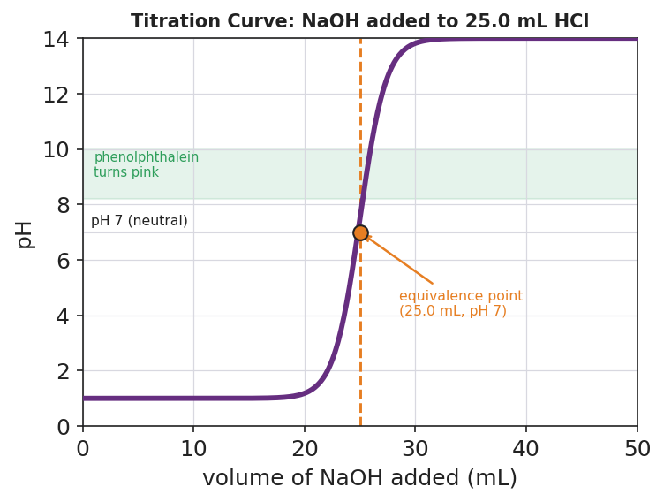
Brand-styled titration curve titled ‘Titration Curve: NaOH added to 25.0 mL HCl’. The x-axis is volume of NaOH added in milliliters from 0 to 50; the y-axis is pH from 0 to 14. A thick purple S-shaped curve starts near pH 1 in the acidic region, stays low until about 20 mL, then rises almost vertically through pH 7 at 25 mL of base, and levels off near pH 13 in the basic region. A horizontal grey line marks pH 7 (neutral). A dashed orange vertical line at 25.0 mL and an orange dot mark the equivalence point, labeled ‘(25.0 mL, pH 7)’. A light green horizontal band between pH 8.2 and 10 is labeled ‘phenolphthalein turns pink’, showing where the indicator changes color just past the equivalence point.
From the figure above, fill in the blanks:
- The curve starts in the __________ region (low pH) and ends in the __________ region (high pH).
- The steep vertical jump — the equivalence point — happens at ______ mL of NaOH, at pH ______.
- Phenolphthalein turns pink just (before / after) the jump: ______________
Solving template (use this for every titration calculation):
Step | What to do
1 | Label the four numbers: which are M_a, V_a (acid) and which are M_b, V_b (base)
2 | Identify the one variable that is missing — that’s what you solve for
3 | Substitute the three known values into M_a V_a = M_b V_b
4 | Solve algebraically for the missing variable; keep the unit

Worked Example
Scenario: 25.0 mL of an unknown HCl is exactly neutralized by 50.0 mL of 0.10 M NaOH. Find the molarity of the acid.
Step 1 — Label the four numbers:
Acid: V_a = ______ mL, M_a = ______ (this is the unknown) Base: M_b = ______ M, V_b = ______ mL
Step 2 — Identify the missing variable: we are solving for ______.
Step 3 — Substitute into M_a V_a = M_b V_b:
M_a × ______ = ______ × ______
Step 4 — Solve for M_a (divide both sides by V_a):
M_a = ( ______ × ______ ) ÷ ______ = ______ M
Step 5 — Because / But / So
This acid came out more concentrated than a 0.10 M acid because _______________________________________________, but _______________________________________________, so _______________________________________________.
Check your reasoning: “because” should explain why more base was needed; “but” should note that the base concentration was the same in both; “so” should state the acid’s calculated molarity.

Summary
Complete the sentence using your own words:
A titration finds an unknown concentration by adding a solution of known concentration until the __________ point, where the moles of acid and base are __________.
Complete the Because / But / So sentence:
A more concentrated acid requires a larger volume of the same base to reach the equivalence point because __________________________________________, but __________________________________________, so __________________________________________.
Reminder: At the equivalence point, moles of acid = moles of base. That equality is exactly what M_a V_a = M_b V_b says. Always label which numbers are the acid and which are the base before you substitute.
Key reference (from the 2025 NYS Reference Tables): Molarity (M) = moles of solute ÷ liters of solution Neutralization (titration): M_a V_a = M_b V_b

