Titration — Student Worksheet
Unit: Acids and Bases — Lesson 03 Name: _______________________ Date: __________ Period: ____

Phenomenon
A chemist is handed a bottle of hydrochloric acid recovered from the stockroom. There is no concentration printed on the label — it could be a harmless rinse or a dangerously strong reagent, and you cannot tell by looking, because both are clear and colorless. Instead of guessing, the chemist measures out 25.0 mL of the mystery acid, adds two drops of phenolphthalein (which stays colorless in acid), and slowly drips in sodium hydroxide of known concentration from a burette. Drop after drop: nothing. Then one single drop flashes the whole flask pink — and it stays. The chemist reads the burette and, using only two volumes and one known concentration, calculates the exact molarity of the unknown acid.
Driving question: How can a chemist determine the exact concentration of an unknown acid or base using only a known solution, a burette, and a color change?

Notice & Wonder
I notice… | I wonder…
Turn & Talk #1: The base that was added had a known concentration, and the volumes of acid and base were both measured. Why might knowing the concentration of one solution and the volumes of both let you find the concentration of the other? Take a guess — you don’t need to be right yet.

Initial Model
Your teacher will project results from three titrations of different acid samples, each neutralized by the same 0.10 M NaOH:
Trial | Acid sample volume (mL) | NaOH (0.10 M) used to neutralize (mL)
1 | 25.0 | 25.0
2 | 25.0 | 50.0
3 | 25.0 | 12.5
- Rank the three acid samples from least concentrated to most concentrated:
least ______ → ______ → ______ most
- Explain your ranking in one sentence (hint: what does needing more base tell you about how much acid was there?):

- At your whiteboard: Trial 1’s acid turns out to be 0.10 M. Write a single equation that connects acid concentration, acid volume, base concentration, and base volume — one that works for all three trials. Then use it to find the concentrations of the Trial 2 and Trial 3 acids.
My equation: _______________________________________________
Trial 2 acid concentration: ______ M Trial 3 acid concentration: ______ M

Investigation

Part 1 — Run the titration
Goggles and apron on. You will titrate 25.0 mL of an “unknown” HCl with 0.10 M NaOH and two drops of phenolphthalein. Add base a full milliliter at a time at first; near 20 mL, slow to drop by drop, swirling after each drop. Stop at the first single drop that turns the whole flask a permanent faint pink. Read the burette.
Measurement | Value
Volume of unknown HCl (mL) | 25.0
Volume of 0.10 M NaOH delivered at the endpoint (mL)

Part 2 — Read the titration curve
Look at figures/titration_curve_naoh_into_hcl.png:
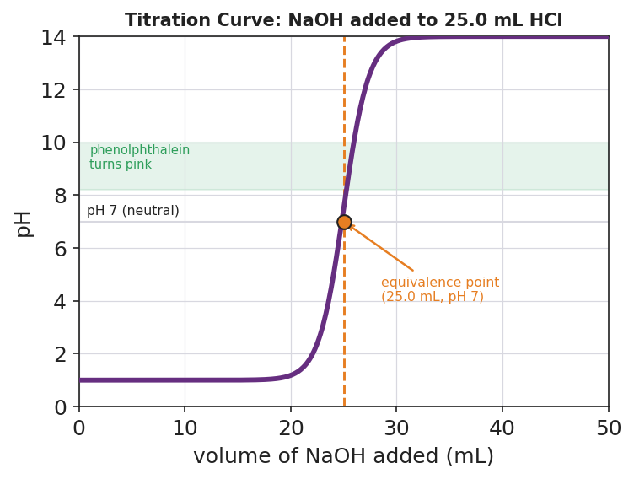
Brand-styled titration curve titled ‘Titration Curve: NaOH added to 25.0 mL HCl’. The x-axis is volume of NaOH added in milliliters from 0 to 50; the y-axis is pH from 0 to 14. A thick purple S-shaped curve starts near pH 1 in the acidic region, stays low until about 20 mL, then rises almost vertically through pH 7 at 25 mL of base, and levels off near pH 13 in the basic region. A horizontal grey line marks pH 7 (neutral). A dashed orange vertical line at 25.0 mL and an orange dot mark the equivalence point, labeled ‘(25.0 mL, pH 7)’. A light green horizontal band between pH 8.2 and 10 is labeled ‘phenolphthalein turns pink’, showing where the indicator changes color just past the equivalence point.
- At what volume of NaOH does the curve make its steep vertical jump? ______ mL
- What is the pH at that jump? ______
- The green band shows where phenolphthalein turns pink. Is that band just before or just after the steep jump? ______________
- In one sentence, explain how the color change told you when to stop adding base:

Part 3 — Set up the calculation
For each problem, first label which numbers are the acid (M_a, V_a) and which are the base (M_b, V_b). Then substitute into M_a V_a = M_b V_b and solve for the missing one. Show the substitution.
Problem 1 (solve for M_a): 25.0 mL of HCl is neutralized by 25.0 mL of 0.10 M NaOH. Find the acid’s molarity.
Setup: ______ × ______ = ______ × ______ M_a = ______ M
Problem 2 (solve for M_a): 25.0 mL of HCl is neutralized by 50.0 mL of 0.10 M NaOH. Find the acid’s molarity.
Setup: ______ × ______ = ______ × ______ M_a = ______ M
Problem 3 (solve for V_b): How many mL of 0.10 M NaOH are needed to neutralize 25.0 mL of 0.05 M HCl?
Setup: ______ × ______ = ______ × ______ V_b = ______ mL

Make It Make Sense
Solve each titration problem. Label the acid and base, substitute into M_a V_a = M_b V_b, and solve for the missing variable. These are the same situations you worked in the Investigation — confirm your setups here.
1. Solve for M_a: 25.0 mL of HCl is neutralized by 25.0 mL of 0.10 M NaOH.
M_a × ______ = ______ × ______ → M_a = ______ M
2. Solve for M_a: 25.0 mL of HCl is neutralized by 50.0 mL of 0.10 M NaOH.
M_a × ______ = ______ × ______ → M_a = ______ M
3. Solve for V_b: How many mL of 0.10 M NaOH neutralize 25.0 mL of 0.05 M HCl?
______ × ______ = ______ × V_b → V_b = ______ mL

Vocabulary in Action
Use each term in a sentence about today’s investigation. Do not copy the definition — describe something you actually did or observed.
- titration: _______________________________________________ _______________________________________________
- equivalence point: _______________________________________________ _______________________________________________
- neutralization equation (M_a V_a = M_b V_b): _______________________________________________ _______________________________________________

Revise Your Model
Return to your Initial Model (the equation you wrote at the whiteboard). Add labels:
- Rewrite your equation using the proper symbols: ______ × ______ = ______ × ______
- On the projected curve, mark the equivalence point. At what volume and pH does it sit? ______ mL, pH ______
- Write one cause→effect statement connecting acid concentration to the volume of base required:

Then finish this Because / But / So sentence:
Trial 2’s acid needed twice as much NaOH as Trial 1’s acid to reach the equivalence point, even though both acid samples were 25.0 mL, because __________________________________________, but __________________________________________, so __________________________________________.

Exit Ticket
(a) A 20.0 mL sample of HCl is exactly neutralized by 40.0 mL of 0.25 M NaOH. Set up M_a V_a = M_b V_b and calculate the molarity of the HCl. Show the substitution.
Setup: ______ × ______ = ______ × ______ M_a = ______ M
(b) Define the equivalence point in one sentence.

(c) In one sentence, explain why a more concentrated acid requires a larger volume of the same base to reach the equivalence point.

