Brønsted-Lowry Theory of Acids & Bases — Student Notes
Unit: Acids and Bases — Lesson 04 Name: _______________________ Date: __________ Period: ____

Learning Targets
By the end of today’s 42 minutes I can:
- State the Brønsted-Lowry definitions: an acid is a proton (H⁺) donor; a base is a proton acceptor.
- Identify the proton donor and proton acceptor in an acid-base equation by tracking the H⁺.
- Identify conjugate acid-base pairs — two species that differ by exactly one H⁺.
- Explain, using Systems and System Models, why the Brønsted-Lowry model can account for NH₃ acting as a base even though it has no OH⁻.

Key Vocabulary
- Brønsted-Lowry acid (proton donor) — _______________________________________________ _______________________________________________
- Brønsted-Lowry base (proton acceptor) — _______________________________________________ _______________________________________________
- conjugate acid-base pair — _______________________________________________ _______________________________________________

Guided Notes
The big idea — Systems and System Models: The Arrhenius model and the Brønsted-Lowry model are two __________ of the same acid-base system. The Brønsted-Lowry model is more __________ because it explains every Arrhenius case and new cases (like NH₃) the Arrhenius model __________.
Two ways to define an acid and a base:
 | Arrhenius (Lesson 01) | Brønsted-Lowry (today)
Acid | produces __________ in water | __________ donor
Base | produces __________ in water | __________ acceptor
Tracking the proton (H⁺): In any acid-base reaction, one species __________ an H⁺ (the acid) and one species __________ an H⁺ (the base). Follow the proton and you can label everything.
The ammonia mystery — solved:
Reaction: NH₃ + H₂O → NH₄⁺ + OH⁻
- NH₃ is the __________ (proton acceptor) → it gains an H⁺ and becomes __________.
- H₂O is the __________ (proton donor) → it loses an H⁺ and becomes __________.
- The OH⁻ that makes the solution basic comes from the __________, not from the ammonia. Ammonia never contained OH⁻; it caused OH⁻ by taking a proton away from water.
Conjugate acid-base pairs: Two species that differ by exactly one __________ (and one unit of charge). The conjugate acid has one __________ H⁺ than its conjugate base.
Conjugate acid | Conjugate base | They differ by
NH₄⁺ | NH₃ | one __________
H₂O | OH⁻ | one __________
H₃O⁺ | H₂O | one __________
Charge check: Adding an H⁺ adds +1 charge. So the conjugate acid is always one charge unit __________ (more positive / more negative) than its conjugate base.
The figure — proton transfer in the ammonia reaction:
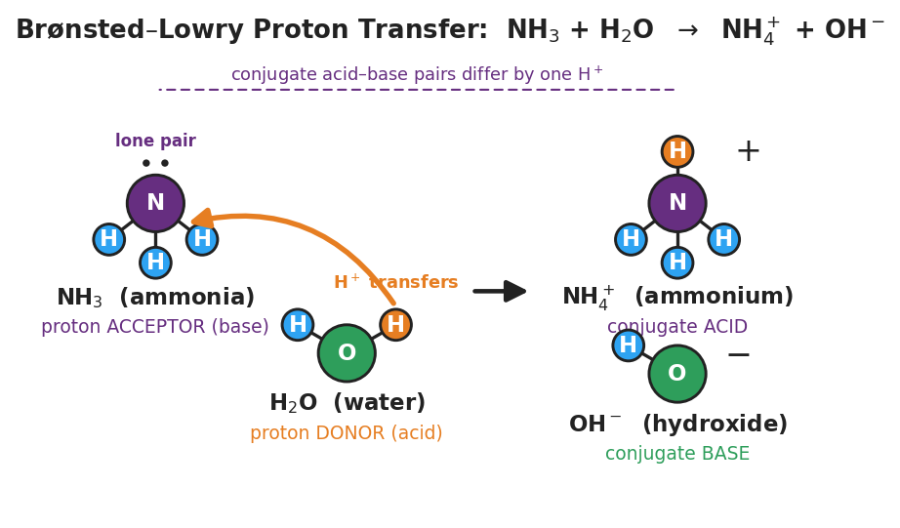
Particle diagram of NH₃ + H₂O → NH₄⁺ + OH⁻. Ammonia (purple nitrogen with a lone pair and three blue hydrogens) is labeled proton acceptor (base); water (green oxygen with two hydrogens, one orange transferring proton) is labeled proton donor (acid). A curved orange arrow shows an H⁺ moving from water to nitrogen. The products NH₄⁺ and OH⁻ are labeled conjugate acid and conjugate base. A dashed bracket notes that conjugate acid–base pairs differ by one H⁺.
From the figure, fill in the blanks:
- The orange particle that moves is the __________ (H⁺).
- It moves from __________ to __________.
- NH₄⁺ and NH₃ are a conjugate pair because __________________________________________

Worked Example
Scenario: Label the proton donor, the proton acceptor, and both conjugate acid-base pairs in this reaction:
HCl + H₂O → Cl⁻ + H₃O⁺
Step 1 — Track the proton. Count H atoms on each species, left to right.
- HCl (1 H) → Cl⁻ (0 H): HCl __________ an H⁺.
- H₂O (2 H) → H₃O⁺ (3 H): H₂O __________ an H⁺.
Step 2 — Assign roles.
- Proton donor (acid) = __________
- Proton acceptor (base) = __________
Step 3 — Find the conjugate pairs. Pair each species with the partner it became (same backbone, differs by one H⁺).
Conjugate acid | Conjugate base | Charge change
HCl | ______ | 0 → −1
H₃O⁺ | ______ | +1 → 0
Step 4 — Check the charge. Removing one H⁺ removes one __________ charge, so each conjugate base is one unit __________ than its conjugate acid.
Step 5 — Because / But / So
In this reaction water is the base because _______________________________________________, but in the ammonia reaction water was the acid _______________________________________________, so _______________________________________________.
Check your reasoning: “because” should name what water did with the proton here; “but” should note water’s opposite role with ammonia; “so” should state that acid/base is a role, not a fixed property.

Summary
Complete the sentences:
A Brønsted-Lowry acid is a proton __________; a Brønsted-Lowry base is a proton __________.
A conjugate acid-base pair is two species that differ by exactly __________.
Complete the Because / But / So sentence:
Ammonia (NH₃) is a base even though it has no OH⁻ because __________________________________________, but __________________________________________, so __________________________________________.
Reminder: To label any acid-base reaction, follow the H⁺. The species that loses it is the acid (donor); the species that gains it is the base (acceptor). Each one and its before/after partner form a conjugate pair that differs by one H⁺.
Key reference (from the 2025 NYS Reference Tables): Brønsted-Lowry: acid = H⁺ donor, base = H⁺ acceptor. A conjugate acid has one more H⁺ (and +1 more charge) than its conjugate base.

