pH & Indicators — Student Notes
Unit: Acids & Bases — Lesson 05 Name: _______________________ Date: __________ Period: ____

Learning Targets
By the end of today’s 42 minutes I can:
- Place a solution on the 0–14 pH scale and classify it as acidic (pH < 7), neutral (pH = 7), or basic (pH > 7).
- State that pH is a measure of hydrogen-ion concentration and convert a whole-number pH to [H⁺] using [H⁺] = 10⁻ᵖᴴ.
- Explain, using Scale, Proportion, and Quantity, why each step on the pH scale is a tenfold change in [H⁺] (so pH 2 has 100× the [H⁺] of pH 4).
- Predict the color an indicator will show in an acidic vs. basic solution and use it to estimate pH.

Key Vocabulary
- pH — _______________________________________________ _______________________________________________
- hydrogen-ion concentration ([H⁺]) — _______________________________________________ _______________________________________________
- indicator — _______________________________________________ _______________________________________________

Guided Notes
The big idea — Scale, Proportion, and Quantity: pH packs a huge range of hydrogen-ion concentrations onto a small scale from __________ to __________. Each step on the scale is not an addition — it is a __________-fold change in [H⁺]. A __________ pH means a high [H⁺] (acidic); a __________ pH means a low [H⁺] (basic).
The pH scale — three zones:
pH range | Name | [H⁺] compared to OH⁻
0 – 6 | __________ | more H⁺ than OH⁻
7 | __________ | [H⁺] equals [OH⁻]
8 – 14 | __________ | less H⁺ than OH⁻
Connecting pH and [H⁺]:
To find the hydrogen-ion concentration from a whole-number pH, use:
[H⁺] = 10⁻ᵖᴴ → for pH = 4, [H⁺] = 10⁻⁴ = __________ mol/L
- As pH goes up, [H⁺] goes __________ (the solution becomes less acidic).
- As pH goes down, [H⁺] goes __________ (the solution becomes more acidic).
- Each whole pH unit changes [H⁺] by a factor of __________.
The Hochman appositive definition:
pH — _________________________ — runs from 0 (most acidic) to 14 (most basic), with 7 as neutral.
Indicators: An indicator changes __________ over a specific pH range, so it lets you see roughly where a solution sits on the scale without a meter. From the figure below, the natural indicator in red cabbage juice (and in a hydrangea flower) turns one color in acid and another in base.
The figure — the pH scale, [H⁺], and three indicators:
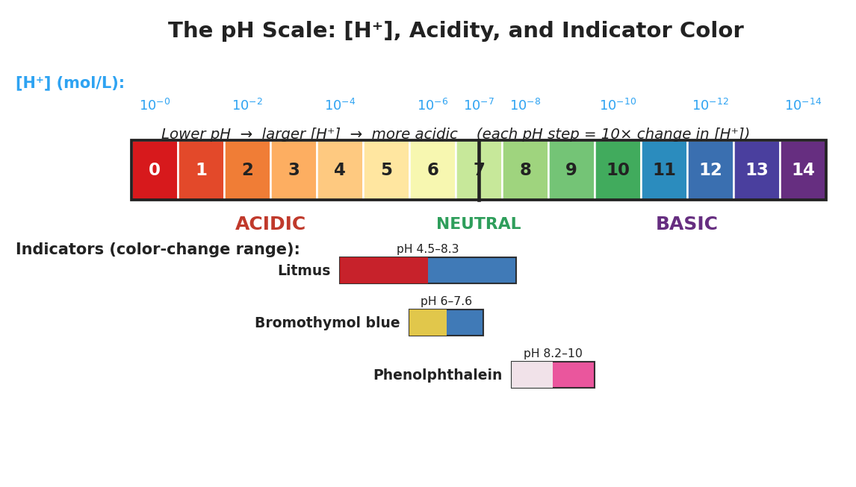
Brand-styled pH scale figure titled ‘The pH Scale: [H plus], Acidity, and Indicator Color.’ A horizontal color bar runs from pH 0 (red) through pH 7 (neutral, pale green, marked with a vertical line) to pH 14 (purple), with each whole-number labeled. Above the bar a blue row shows hydrogen-ion concentration as powers of ten from 10 to the minus 0 down to 10 to the minus 14. Below the bar the regions are labeled ACIDIC, NEUTRAL, and BASIC. At the bottom, three indicator color-change bands are shown: litmus (red to blue, pH 4.5 to 8.3), bromothymol blue (yellow to blue, pH 6.0 to 7.6), and phenolphthalein (colorless to pink, pH 8.2 to 10).
From the figure above, fill in the blanks:
- The most acidic end of the scale is pH ___ and shows the color ___________.
- Litmus is ___________ in acid and ___________ in base.
- An indicator that is colorless below pH 8.2 and pink above it is ___________.

Worked Example
Scenario: A student measures a cup of black coffee and finds a pH of 5. They need to (1) find its [H⁺], (2) classify it, and (3) compare it to pure water at pH 7.
Step 1 — Convert pH to [H⁺]:
pH = 5, so [H⁺] = 10⁻⁵ = ___________ mol/L
Step 2 — Classify:
pH 5 is __________ than 7, so the coffee is ___________ (acidic / neutral / basic).
Step 3 — Compare coffee (pH 5) to water (pH 7):
Steps from pH 5 to pH 7: 5 → 6 → 7 = ___ steps. Each step is ×10, so the coffee has 10^___ = ___________ times more H⁺ than the water.
Step 4 — Appositive sentence:
The coffee’s pH — ___________ — tells me it is acidic because its hydrogen-ion concentration is ___________ mol/L.
Step 5 — Because / But / So
The coffee is more acidic than pure water because _______________________________________________, but _______________________________________________, so _______________________________________________.
Check your reasoning: “because” should compare [H⁺]; “but” should note the count of ×10 steps; “so” should state how many times more acidic.

Summary
Complete the appositive sentence:
pH — _________________________ — measures how acidic or basic a solution is on a scale from 0 to 14.
Complete the Because / But / So sentence:
A solution at pH 2 is far more acidic than a solution at pH 5 because __________________________________________, but __________________________________________, so __________________________________________.
Reminder: The pH scale is logarithmic. Each whole-number step is a tenfold (×10) change in hydrogen-ion concentration — so always count the steps and multiply by 10 each time. Subtracting the pH values does not give the concentration ratio.
Key reference (from the 2025 NYS Reference Tables): pH = −log[H⁺] and [H⁺] = 10⁻ᵖᴴ Neutral water at 25 °C: [H⁺] = [OH⁻] = 10⁻⁷ mol/L → pH 7

