pH & Indicators — Student Worksheet
Unit: Acids & Bases — Lesson 05 Name: _______________________ Date: __________ Period: ____

Phenomenon
A gardener plants two hydrangea bushes that are cuttings from the same parent plant — genetically identical. One goes in the front yard, one in the backyard. The next summer, the front bush blooms deep blue and the backyard bush blooms bright pink. Same plant, same sunlight, same water from the same hose. The gardener swears she did nothing differently. The hidden difference is the soil: a hydrangea flower acts like a living color-changer that responds to how acidic the dirt is.
Driving question: Why does a hydrangea plant produce blue flowers in some yards and pink in others?

Notice & Wonder
I notice… | I wonder…
Turn & Talk #1: On the figure your teacher is projecting, the hydrogen-ion concentration at pH 2 is 10⁻² and at pH 4 is 10⁻⁴ — just two steps apart. In one sentence, predict: is pH 2 only a little more acidic than pH 4, or a lot more? Why?

Initial Model
Before your teacher names the math: the figure shows pH 1 has [H⁺] = 10⁻¹ mol/L, pH 2 has 10⁻², and pH 3 has 10⁻³. Continue the pattern.
- Write the [H⁺] for pH 4: _______________ mol/L
- Write the [H⁺] for pH 6: _______________ mol/L
- As pH goes up, does the amount of H⁺ go up or down? _______________
- In one sentence, explain how you can tell from the exponent.

Investigation

Part 1 — ABCs: Test and observe (before any definitions)
Add a few drops of the purple indicator to each substance and record the color. Then dip pH paper in each one and record the number. Do not look anything up yet — just observe.
Substance | Indicator color | pH-paper reading
Lemon juice
Vinegar
Pure water
Baking-soda solution
Ammonia cleaner
Find the pattern: Line your cups up from most red/pink to most blue/green. Which color goes with the low pH numbers? Which goes with the high numbers?

Part 2 — Convert pH to [H⁺]
Use the relationship [H⁺] = 10⁻ᵖᴴ. Fill in the table.
pH | [H⁺] (mol/L) | Acidic, neutral, or basic?
1
3
7
11

Part 3 — Compare concentrations
A solution at pH 3 and a solution at pH 6 — how many times more concentrated is the H⁺ in the pH 3 solution? Show your reasoning by counting the ×10 steps.
Steps from pH 3 to pH 6: ___ → ___ → ___ → ___ (that is ___ steps) Each step is ×10, so the factor is 10 × 10 × 10 = _______________

Part 4 — Reading the pH-scale figure
Look at figures/ph_scale_indicators.png:
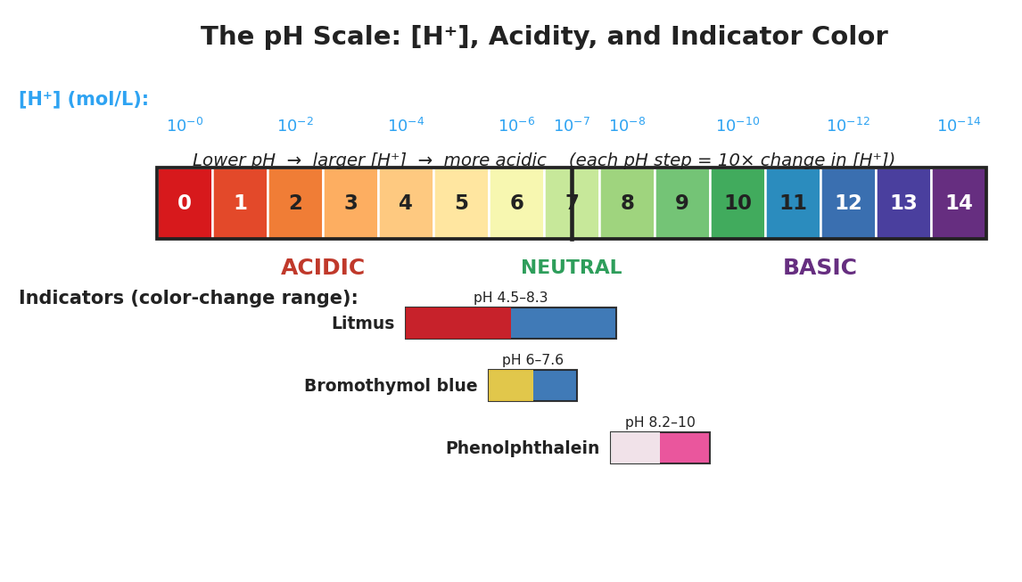
Brand-styled pH scale figure titled ‘The pH Scale: [H plus], Acidity, and Indicator Color.’ A horizontal color bar runs from pH 0 (red) on the left through pH 7 (neutral, pale green, marked with a vertical line) to pH 14 (purple) on the right, with each whole-number labeled. Above the bar a blue row shows hydrogen-ion concentration as powers of ten, from 10 to the minus 0 at pH 0 down to 10 to the minus 14 at pH 14. Below the bar the regions are labeled ACIDIC (left), NEUTRAL (center), and BASIC (right). At the bottom, three indicator color-change bands are shown: litmus (red to blue, pH 4.5 to 8.3), bromothymol blue (yellow to blue, pH 6.0 to 7.6), and phenolphthalein (colorless to pink, pH 8.2 to 10).
- A solution turns litmus blue. Is it acidic or basic? About what pH? _______________
- Which indicator would best tell apart a solution of pH 9 from a solution of pH 7? _______________
- A solution has [H⁺] = 10⁻⁵ mol/L. What is its pH, and is it acidic or basic? _______________

Make It Make Sense
For each item, show your work. These use the same relationship and substances you practiced in the Investigation — confirm your reasoning here.
1. Convert each pH to [H⁺] using [H⁺] = 10⁻ᵖᴴ, and classify it.
pH | [H⁺] (mol/L) | Acidic / neutral / basic
1
3
7
11
2. How many times greater is the [H⁺] of a solution at pH 3 than a solution at pH 6? Show the steps.

3. A cup of pure water tests at pH 7, and a cup of vinegar tests at pH 3. Using the words hydrogen-ion concentration and acidic, explain in one sentence why the vinegar is acidic and the water is not.

Vocabulary in Action
Use each term in a sentence about today’s investigation. Do not copy the definition — describe something you actually did or observed.
- pH: _______________________________________________ _______________________________________________
- hydrogen-ion concentration ([H⁺]): _______________________________________________ _______________________________________________
- indicator: _______________________________________________ _______________________________________________

Revise Your Model
Return to your Initial Model (the [H⁺] pattern you wrote).
- Label the column where you wrote 10⁻¹, 10⁻², … as “hydrogen-ion concentration ([H⁺]).”
- Circle the row that is neutral and write its pH: _______________
- Write a revised appositive sentence:
pH — ___________________________________ — runs from 0 (most acidic) to 14 (most basic), with 7 as neutral.
Then finish this Because / But / So sentence:
A hydrangea blooms blue in acidic soil but pink in basic soil because __________________________________________, but __________________________________________, so __________________________________________.

Exit Ticket
(a) A solution has a pH of 3. Classify it as acidic, neutral, or basic, and write its hydrogen-ion concentration [H⁺] in mol/L.
Classification: _______________ [H⁺] = _______________ mol/L
(b) How many times greater is the [H⁺] of a solution at pH 2 than a solution at pH 5? Show your reasoning.

(c) Predict the color of litmus in a solution of pH 11, and explain how you know.

