Assigning Oxidation Numbers — Student Notes
Unit: Redox & Electrochemistry — Lesson 01 Name: _______________________ Date: __________ Period: ____

Learning Targets
By the end of today’s 42 minutes I can:
- Assign an oxidation number to each atom in a free element, a monatomic ion, and a compound, using the rule set.
- Apply the core rules: free element = 0; monatomic ion = its charge; oxygen = −2; hydrogen = +1; the oxidation numbers add up to the overall charge.
- Identify which atom is oxidized (number increases) and which is reduced (number decreases) in a reaction.
- Explain, using Patterns, why the copper in a tarnished penny has a different oxidation number than the copper in a bright penny.

Key Vocabulary
- oxidation number — _______________________________________________ _______________________________________________
- oxidized — _______________________________________________ _______________________________________________
- reduced — _______________________________________________ _______________________________________________

Guided Notes
The big idea — Patterns: Oxidation numbers are not memorized one substance at a time. They follow a short, fixed set of __________. Once you know the rules, you can assign an oxidation number to an atom you have __________ seen before. A __________ in oxidation number across a reaction is the pattern that tells you a redox event happened.
The five rules for assigning oxidation numbers:
- A free element (alone or bonded only to itself) = __________. (Cu, O₂, H₂, Na)
- A monatomic ion = __________. (Na⁺ = +1; Cl⁻ = −1; Cu²⁺ = +2)
- Oxygen = __________ in almost every compound. (Exception: peroxides like H₂O₂ = −1)
- Hydrogen = __________ in almost every compound. (Exception: metal hydrides like NaH = −1)
- The oxidation numbers in a neutral compound add up to __________; in a polyatomic ion they add up to __________.
The method (works every time):
- Step 1: Assign the atoms with __________ rules first (oxygen, hydrogen, the ions).
- Step 2: __________ for the unknown atom using “the sum equals the overall charge.”
Oxidized vs. reduced — the direction of the change:
The atom’s oxidation number… | The atom… | We say it is…
goes UP (more positive) | __________ electrons | __________
goes DOWN (more negative) | __________ electrons | __________
Oxidation and reduction always happen __________ — electrons lost by one atom are gained by another.
The figure — the oxidation number line:
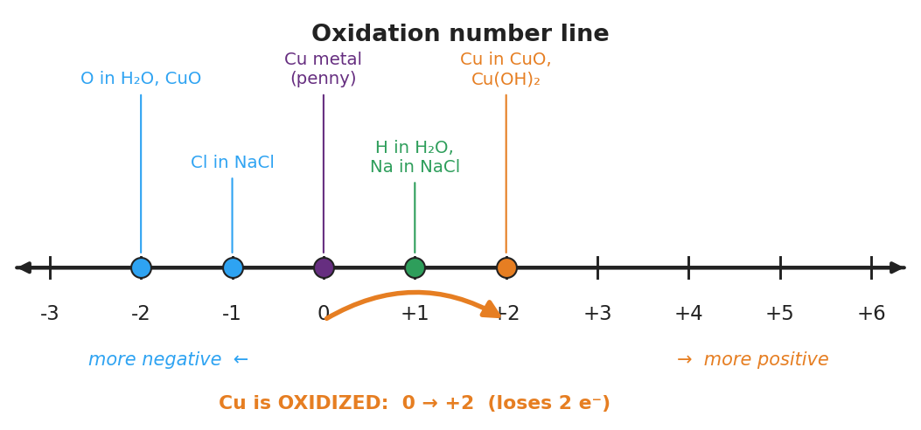
Horizontal oxidation-number number line from −3 to +6 with labeled dots: oxygen in H₂O and CuO at −2, chlorine in NaCl at −1, copper metal in the bright penny at 0, hydrogen in H₂O and sodium in NaCl at +1, and copper in CuO and Cu(OH)₂ at +2; a curved orange arrow runs from 0 to +2 with the caption “Cu is OXIDIZED: 0 → +2 (loses 2 electrons)”.
From the figure above, fill in the blanks:
- Copper in the bright penny sits at __________ on the line.
- Copper in the green (tarnished) penny sits at __________ on the line.
- Moving to the right (more positive) means the atom is being __________.
- Moving to the left (more negative) means the atom is being __________.

Worked Example
Scenario: A student needs to assign the oxidation number of copper in CuO (the compound that forms as a penny tarnishes).
Step 1 — Assign the atom you know from a fixed rule:
Oxygen in a compound = __________ (rule ). So O = _.
Step 2 — Note the overall charge of the formula:
CuO is a neutral compound, so all oxidation numbers must add up to __________.
Step 3 — Solve for the unknown atom:
Cu + (O) = 0 → Cu + ( ____ ) = 0 → Cu = ____
Step 4 — Check against the bright vs. green penny:
In the bright penny, copper is a free element, so its oxidation number is ____. In CuO (the green patina), copper is ____. The change from the bright penny to the green penny is from ____ to ____.
Step 5 — Name the change:
Because copper’s oxidation number went UP, the copper is __________.
Step 6 — Because / But / So
When a penny tarnishes, the copper is oxidized because _______________________________________________, but _______________________________________________, so _______________________________________________.
Check your reasoning: “because” should name the electron loss / number increase; “but” should note that it is still the same copper element; “so” should explain why the penny can turn green without anything being added.

Summary
Complete the sentence:
The oxidation number of an atom is a __________ label that tracks __________ bookkeeping; you assign it using the __________ (free element = 0, oxygen = −2, hydrogen = +1, and the sum equals the overall charge).
Complete the Because / But / So sentence:
The copper in a tarnished penny has a higher oxidation number than the copper in a bright penny because __________________________________________, but __________________________________________, so __________________________________________.
Reminder — the order that works every time: assign oxygen (−2), hydrogen (+1), and any ions first; then solve for the leftover atom using “the sum equals the overall charge.” An atom whose number goes up is oxidized; an atom whose number goes down is reduced.
Key reference (from the 2025 NYS Reference Tables): Common ionic charges and the periodic table give you the ion values you need for Rule 2.

