Identifying Reduction & Oxidation — Student Notes
Unit: Redox & Electrochemistry — Lesson 02 Name: _______________________ Date: __________ Period: ____

Learning Targets
By the end of today’s 42 minutes I can:
- Define oxidation and reduction in terms of electron loss and gain (OIL RIG / LEO the lion says GER).
- Given a reaction with oxidation numbers, identify which species is oxidized and which is reduced.
- Track the change in an element’s oxidation number across a reaction and use the direction (up or down) as evidence.
- Explain, using Energy and Matter (electron conservation), why the electrons lost by one species equal the electrons gained by the other — and why salt water speeds up the rusting of iron.

Key Vocabulary
- oxidation — _______________________________________________ _______________________________________________
- reduction — _______________________________________________ _______________________________________________
- redox reaction — _______________________________________________ _______________________________________________

Guided Notes
The big idea — Energy and Matter (electrons are conserved): In a redox reaction, electrons are not created or destroyed — they __________ from one species to another. The electrons one species __________ are exactly the electrons another species __________. That is why oxidation and reduction always happen __________.
The two events — fill in the directions:
Event | What happens to electrons | What happens to the oxidation number | Mnemonic
Oxidation | electrons are __________ | goes __________ (more positive) | Oxidation Is Loss / LEO
Reduction | electrons are __________ | goes __________ (more negative) | Reduction Is Gain / GER
How to identify oxidation and reduction in a reaction:
- Assign the __________ number to each element in the reactants and products (Lesson 01 rules).
- Find the element whose number went __________ — that species was oxidized (it lost electrons).
- Find the element whose number went __________ — that species was reduced (it gained electrons).
- Check: the electrons __________ must equal the electrons __________ (conservation).
The Hochman appositive definition:
Oxidation — _________________________ — is shown by an oxidation number that goes up.
The figure — the oxidation-number line:
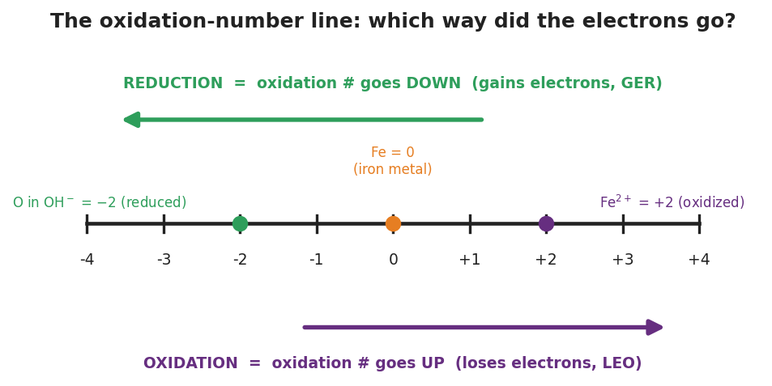
A horizontal oxidation-number line from −4 to +4. A green arrow above the line points left (toward more negative) labeled ‘REDUCTION = oxidation # goes DOWN (gains electrons, GER).’ A purple arrow below the line points right (toward more positive) labeled ‘OXIDATION = oxidation # goes UP (loses electrons, LEO).’ Three dots mark example values: O in OH⁻ at −2 (reduced), Fe at 0 (iron metal), and Fe²⁺ at +2 (oxidized).
From the figure above, fill in the blanks:
- Moving right on the line (more positive) means the oxidation number went __________, so the species was __________ (lost electrons).
- Moving left on the line (more negative) means the oxidation number went __________, so the species was __________ (gained electrons).
- In rusting, iron sits at 0 and moves to __________; oxygen sits at 0 and moves to __________.
The rusting phenomenon (Energy and Matter):
When an iron nail rusts, the iron is __________ (loses electrons) and dissolved oxygen is __________ (gains electrons). Dissolved __________ ions in salt water carry charge through the water, so the electron transfer happens faster — which is why the salt-water nail rusts faster.

Worked Example
Scenario: Identify the species oxidized and the species reduced in the reaction:
2 Al + 3 Cl₂ → 2 AlCl₃ (in AlCl₃, aluminum is +3 and chlorine is −1)
Step 1 — Assign oxidation numbers (before and after):
- Al as a free element = ___ → Al in AlCl₃ = ___
- Cl as a free element (Cl₂) = ___ → Cl in AlCl₃ = ___
Step 2 — Track the direction of each change:
Element | Before | After | Up or down? | Lost or gained e⁻?
Al | ___ | ___ | ___ | ___
Cl | ___ | ___ | ___ | ___
Step 3 — Name the events:
- Aluminum went __________ (0 → +3), so aluminum was __________ . It __________ electrons.
- Chlorine went __________ (0 → −1), so chlorine was __________ . It __________ electrons.
Step 4 — Appositive sentence:
In this reaction, aluminum — __________ — is oxidized because its oxidation number goes from ___ to ___.
Step 5 — Because / But / So
Aluminum is the species that was oxidized because _______________________________________________, but _______________________________________________, so _______________________________________________.
Check your reasoning: “because” should name the up/down change; “but” should acknowledge the trap (a positive charge does NOT mean electrons were gained); “so” should state that aluminum lost electrons and was oxidized.

Summary
Complete the appositive sentences:
Oxidation — _________________________ — makes the oxidation number go up. Reduction — _________________________ — makes the oxidation number go down.
Complete the Because / But / So sentence:
An iron nail rusts faster in salt water than in fresh water because __________________________________________, but __________________________________________, so __________________________________________.
Reminder — don’t fall for the charge trap: A species becoming positive (like Fe²⁺) lost electrons and was oxidized. A positive oxidation number does NOT mean electrons were gained. Track the direction of the change: up = lost = oxidized; down = gained = reduced.
Key reference (mnemonics): OIL RIG — Oxidation Is Loss, Reduction Is Gain (of electrons) LEO the lion says GER — Lose Electrons = Oxidation, Gain Electrons = Reduction

