Identifying Reduction & Oxidation — Student Worksheet
Unit: Redox & Electrochemistry — Lesson 02 Name: _______________________ Date: __________ Period: ____

Phenomenon
Two identical iron nails sat in water for two days. One was in fresh tap water; the other was in salt water. The salt-water nail is now much rustier — more orange flaking, a cloudier solution — even though both nails were under water the whole time. A third nail, coated in oil, barely rusted at all. Same metal, same air, same two days.
When iron rusts, the iron atoms lose electrons and dissolved oxygen gains them. The electrons move from the iron to the oxygen. The dissolved salt helps those electrons travel through the water, so the salt-water nail rusts faster.
Driving question: Why does an iron nail rust faster in salt water than in fresh water — and what is actually moving when iron turns to rust?

Notice & Wonder
I notice… | I wonder…
Turn & Talk #1: Look at the electron-transfer diagram your teacher is projecting. The iron loses electrons and the oxygen gains them. If exactly 4 electrons left the iron, how many electrons must the oxygen have gained? In one sentence, why must those two numbers be connected?

Initial Model
Before your teacher names the process, study the two halves of the rusting reaction:
Iron half: Fe → Fe²⁺ + 2e⁻ (iron’s oxidation number: 0 → +2) Oxygen half: O₂ + 2H₂O + 4e⁻ → 4OH⁻ (oxygen’s oxidation number: 0 → −2)
- Iron’s oxidation number went from 0 to +2 (it went up). Did each iron atom lose or gain electrons? How many? _______________________________________________
- Oxygen’s oxidation number went from 0 to −2 (it went down). Did each oxygen atom lose or gain electrons? _______________________________________________
- The iron half shows “+ 2e⁻” on the product side; the oxygen half shows “+ 4e⁻” on the reactant side. What does the side of the equation that the electrons are written on tell you about whether they were lost or gained?

Investigation

Part 1 — ABCs: Mark the movers (before you name anything)
For each reaction below, the oxidation numbers are given. Find the one element whose oxidation number goes UP (highlight it one color) and the one whose oxidation number goes DOWN (highlight it another color). Do not worry yet about what to call them.
Reaction | Element that goes UP (more positive) | Element that goes DOWN (more negative)
2 Fe + O₂ → 2 FeO (Fe: 0→+2, O: 0→−2)
Zn + Cu²⁺ → Zn²⁺ + Cu (Zn: 0→+2, Cu: +2→0)
2 Ag + S → Ag₂S (Ag: 0→+1, S: 0→−2)
2 Na + Cl₂ → 2 NaCl (Na: 0→+1, Cl: 0→−1)
Find the rule: Across all four reactions, is there always exactly one element going up and one going down? When an oxidation number goes up, did that atom gain or lose electrons?

Part 2 — Track the electrons (use the oxidation-number line)
Use the figure below: moving right on the line (more positive) = oxidation number goes UP = electrons lost. Moving left (more negative) = oxidation number goes DOWN = electrons gained.
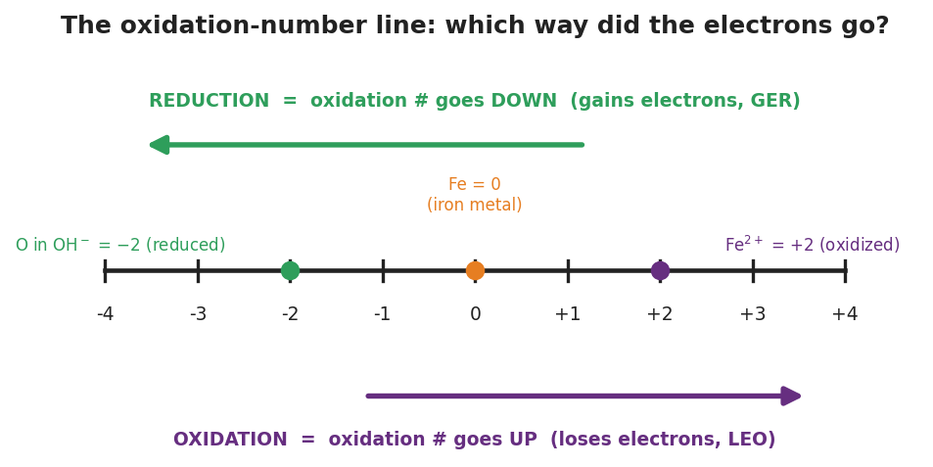
A horizontal oxidation-number line from −4 to +4. A green arrow above the line points left (toward more negative) labeled ‘REDUCTION = oxidation # goes DOWN (gains electrons, GER).’ A purple arrow below the line points right (toward more positive) labeled ‘OXIDATION = oxidation # goes UP (loses electrons, LEO).’ Three dots mark example values: O in OH⁻ at −2 (reduced), Fe at 0 (iron metal), and Fe²⁺ at +2 (oxidized).
For each reaction, complete the tracking table and state which species lost electrons and which gained electrons.
Reaction A: Zn + Cu²⁺ → Zn²⁺ + Cu
Element | Oxidation # before | Oxidation # after | Up or down? | Lost or gained e⁻?
Zn
Cu
Species that lost electrons: ___________ · Species that gained electrons: ___________
Reaction B: 2 Na + Cl₂ → 2 NaCl
Element | Oxidation # before | Oxidation # after | Up or down? | Lost or gained e⁻?
Na
Cl
Species that lost electrons: ___________ · Species that gained electrons: ___________
Reaction C: 2 Ag + S → Ag₂S
Element | Oxidation # before | Oxidation # after | Up or down? | Lost or gained e⁻?
Ag
S
Species that lost electrons: ___________ · Species that gained electrons: ___________

Part 3 — Reading the electron-transfer diagram
Look at figures/redox_electron_transfer.png:
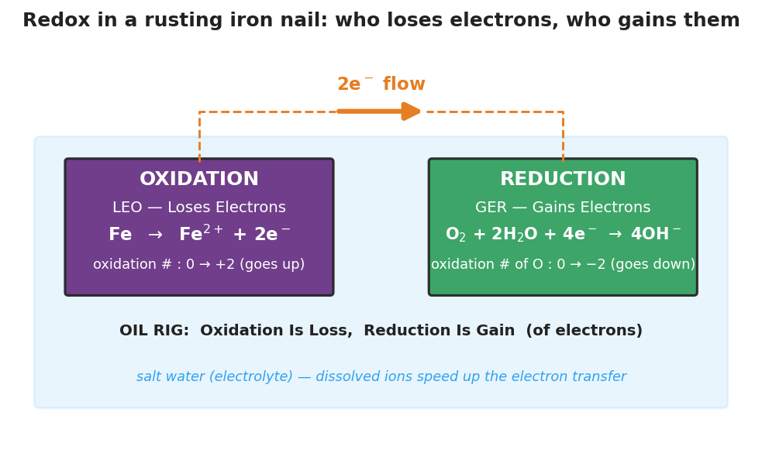
Two labeled boxes inside a pale blue salt-water region. The left purple box reads OXIDATION, LEO — Loses Electrons, with the half-reaction Fe → Fe²⁺ + 2e⁻ and the note that iron’s oxidation number goes 0 to +2. The right green box reads REDUCTION, GER — Gains Electrons, with the half-reaction O₂ + 2H₂O + 4e⁻ → 4OH⁻ and the note that oxygen’s oxidation number goes 0 to −2. An orange arrow labeled ‘2e⁻ flow’ runs from the oxidation box to the reduction box.
- Which way does the orange arrow point — from the iron to the oxygen, or from the oxygen to the iron? What is moving along that arrow? _______________________________________________
- The diagram is set inside a pale-blue “salt water” region. Based on the phenomenon, what is the salt’s job in the rusting process? _______________________________________________

Make It Make Sense
For each reaction below, complete the tracking table, then identify the species that lost electrons and the species that gained electrons. These are the same reactions you worked in the Investigation — confirm your work here.
1. Zn + Cu²⁺ → Zn²⁺ + Cu
Element | Oxidation # before | Oxidation # after | Up or down? | Lost or gained e⁻?
Zn
Cu
Lost electrons: ___________ · Gained electrons: ___________
2. 2 Na + Cl₂ → 2 NaCl
Element | Oxidation # before | Oxidation # after | Up or down? | Lost or gained e⁻?
Na
Cl
Lost electrons: ___________ · Gained electrons: ___________
3. 2 Ag + S → Ag₂S
Element | Oxidation # before | Oxidation # after | Up or down? | Lost or gained e⁻?
Ag
S
Lost electrons: ___________ · Gained electrons: ___________

Vocabulary in Action
Use each term in a sentence about today’s investigation. Do not copy the definition — describe something you actually tracked or observed.
- oxidation: _______________________________________________ _______________________________________________
- reduction: _______________________________________________ _______________________________________________
- redox reaction: _______________________________________________ _______________________________________________

Revise Your Model
Return to your Initial Model (the two halves of the rusting reaction). Add vocabulary labels:
- Next to the iron half (Fe → Fe²⁺ + 2e⁻), write whether iron is oxidized or reduced, and circle “up” or “down” for its oxidation number.
- Next to the oxygen half, write whether oxygen is oxidized or reduced, and circle “up” or “down.”
- Write a revised appositive sentence for reduction:
Reduction — _________________________ — happens to the dissolved oxygen when a nail rusts.
Then finish this Because / But / So sentence:
An iron nail rusts faster in salt water than in fresh water because __________________________________________, but __________________________________________, so __________________________________________.

Exit Ticket
Consider the reaction: 2 Mg + O₂ → 2 MgO (in MgO, magnesium is +2 and oxygen is −2).
(a) Fill in the oxidation numbers before and after.
Element | Oxidation # before | Oxidation # after | Up or down? | Lost or gained e⁻?
Mg
O
(b) Which species is oxidized and which is reduced? Justify using LEO/GER or the direction the oxidation number moved.
Oxidized: ___________ because _______________________________________________ Reduced: ___________ because _______________________________________________
(c) In one sentence, explain how you know the electrons magnesium lost are the same electrons oxygen gained.

