Writing Half-Reactions — Student Notes
Unit: Redox & Electrochemistry — Lesson 03 Name: _______________________ Date: __________ Period: ____

Learning Targets
By the end of today’s 42 minutes I can:
- Split a single redox reaction into an oxidation half-reaction and a reduction half-reaction, each showing the electrons (e⁻) explicitly.
- Place the electrons on the correct side of each half-reaction: products for the species that loses them, reactants for the species that gains them.
- Balance the electrons between the two half-reactions by multiplying each by a whole number so the electrons lost equal the electrons gained.
- Explain, using Energy and Matter (conservation), why the electrons lost in oxidation must equal the electrons gained in reduction — and connect that count to the current a voltmeter reads in a cell.

Key Vocabulary
- half-reaction — _______________________________________________ _______________________________________________
- balancing electrons — _______________________________________________ _______________________________________________
- net ionic equation — _______________________________________________ _______________________________________________

Guided Notes
The big idea — Energy and Matter (conservation): Electrons are __________. In a redox reaction they are not created or destroyed — they are __________ from one species to another. So the number of electrons __________ by the species that is oxidized must equal the number __________ by the species that is reduced.
Where the electrons go in each half-reaction:
If the species is… | its oxidation number… | it ___ electrons | so e⁻ is a…
oxidized | goes up | __________ | ____________ (right side)
reduced | goes down | __________ | ____________ (left side)
The figure — making the electron flow visible:
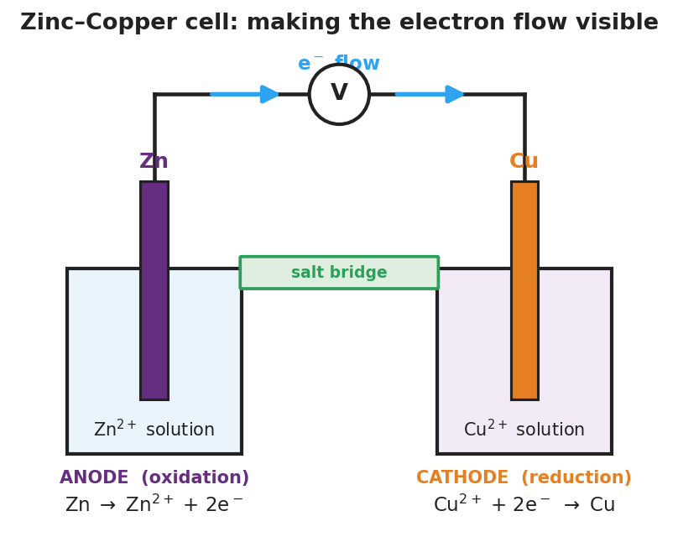
Diagram of a zinc–copper electrochemical cell with a zinc anode in zinc(II)-ion solution, a copper cathode in copper(II)-ion solution, a salt bridge joining the solutions, and a wire carrying a voltmeter; blue arrows show electrons flowing from the zinc anode to the copper cathode; the anode performs Zn to Zn 2 plus plus 2 electrons (oxidation) and the cathode performs Cu 2 plus plus 2 electrons to Cu (reduction).
From the figure, fill in the blanks:
- The electrode that loses electrons (dissolves away) is the __________ ; it performs __________ .
- The electrons travel through the wire from the __________ electrode to the __________ electrode.
- The number of electrons crossing the wire per zinc atom is ___ — that is what the voltmeter detects.
How to write and balance half-reactions (use this every time):
- Use the oxidation-number change to decide which species is __________ (loses e⁻) and which is __________ (gains e⁻).
- Write the oxidation half-reaction with e⁻ on the __________ side.
- Write the reduction half-reaction with e⁻ on the __________ side.
- Count the electrons in each half. If they are equal, you are done. If not, multiply each half-reaction by the smallest whole number — the __________ — so the counts match.
- Add the two balanced halves and cancel the electrons to get the __________ equation.

Worked Example
Scenario: Write and balance the half-reactions for Al + Cu²⁺ → Al³⁺ + Cu.
Step 1 — Decide who loses and who gains (oxidation numbers from Lesson 02):
Al goes from 0 to +3, so Al __________ electrons → __________ (oxidation). Cu goes from +2 to 0, so Cu²⁺ __________ electrons → __________ (reduction).
Step 2 — Write each half-reaction with electrons on the correct side:
Oxidation: Al → Al³⁺ + ___ e⁻ Reduction: Cu²⁺ + ___ e⁻ → Cu
Step 3 — Count the electrons:
Electrons lost = ___ Electrons gained = ___ Equal? ___
**Step 4 — Balance the electrons (least common multiple of 3 and 2 = ___):**
Multiply the oxidation half by : Al → ___ Al³⁺ + ___ e⁻ Multiply the reduction half by : Cu²⁺ + ___ e⁻ → ___ Cu
Now electrons lost = ___ and electrons gained = ___. ✓
Step 5 — Net ionic equation (add the halves, cancel the e⁻):
___ Al + ___ Cu²⁺ → ___ Al³⁺ + ___ Cu
Step 6 — Because / But / So
We had to scale the half-reactions because _______________________________________________, but _______________________________________________, so _______________________________________________.
Check your reasoning: “because” should explain why the counts didn’t match; “but” should name what conservation requires; “so” should state the least-common-multiple fix and the final electron count.

Summary
Complete the sentence:
In a redox reaction the electrons lost by the oxidized species must equal the electrons __________ by the reduced species, because electrons are __________.
Complete the Because / But / So sentence:
A student wrote a reduction half-reaction with the electrons on the product side because __________________________________________, but __________________________________________, so __________________________________________.
Reminder: Oxidation = loss of electrons (e⁻ on the right). Reduction = gain of electrons (e⁻ on the left). When you multiply a half-reaction to balance electrons, multiply everything — atoms, ions, and electrons.
Key reference (from the 2025 NYS Reference Tables): Table J — Activity Series (which metal will lose electrons to which ion) Table E — Selected Polyatomic Ions (for spectator-ion identification)

