Writing Half-Reactions — Student Worksheet
Unit: Redox & Electrochemistry — Lesson 03 Name: _______________________ Date: __________ Period: ____

Phenomenon
A clean strip of zinc metal is dropped into a clear blue copper(II) sulfate solution. After a few minutes, the zinc is coated with reddish copper metal and the blue color of the solution fades. Something moved from one substance to the other — but you can’t see it. Now the same reaction is built as a cell: zinc in one beaker, copper in another, connected by a wire and a salt bridge, with a voltmeter clipped into the wire. The needle jumps. The meter is reading the electrons flowing through the wire — the invisible made visible.
Driving question: How can we “see” the invisible flow of electrons — and write it down — in a chemical reaction?

Notice & Wonder
I notice… | I wonder…
Turn & Talk #1: In the cell, the zinc strip slowly disappears and the copper strip slowly grows. Where are the electrons coming from, and where are they going? Try to name the direction of the flow.

Initial Model
Before your teacher names any process, look at this single-replacement reaction:
Zn + Cu²⁺ → Zn²⁺ + Cu
Using your oxidation-number skills from Lesson 02, split it into two equations: one for the species that loses electrons and one for the species that gains electrons. Show the electrons (e⁻) in each. You may look at the diagram your teacher is projecting.
Equation for the species that LOSES electrons:

Equation for the species that GAINS electrons:

- How many electrons does the losing species give up? _______
- How many electrons does the gaining species take in? _______
- Are those two numbers equal? _______ What would it mean for the electrons if they were not equal? _______________________________________________

Investigation

Part 1 — Reading the cell diagram
Look at figures/electrochemical_cell.png:
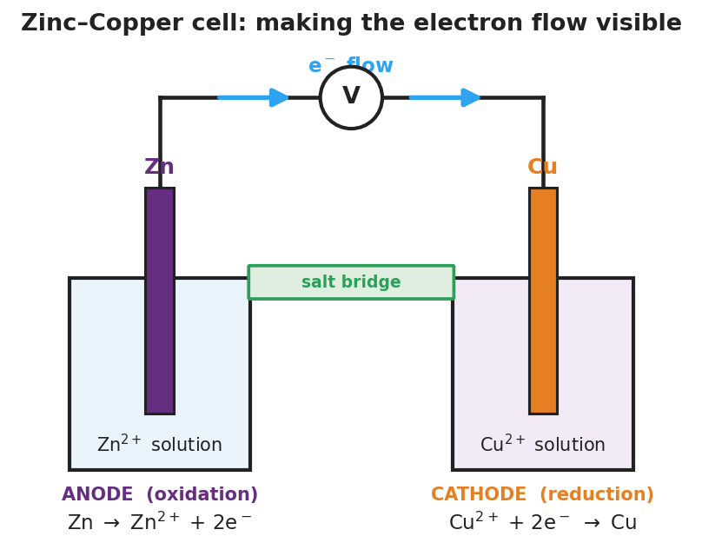
Diagram of a zinc–copper electrochemical cell: a zinc electrode in zinc(II)-ion solution on the left and a copper electrode in copper(II)-ion solution on the right, connected by a salt bridge between the solutions and an external wire carrying a voltmeter; blue arrows show electrons flowing from the zinc anode to the copper cathode; the zinc side is labeled ANODE (oxidation) with Zn to Zn 2 plus plus 2 electrons, and the copper side is labeled CATHODE (reduction) with Cu 2 plus plus 2 electrons to Cu.
- Which electrode loses electrons (the metal that dissolves away)? _______________
- Which direction do the electrons travel in the wire — toward zinc or toward copper? _______________
- The diagram shows “2e⁻” in each half-reaction. What is the voltmeter detecting when its needle moves?

Part 2 — Split and balance (board work)
For each reaction, write the equation for the species that loses electrons (e⁻ on the right) and the species that gains electrons (e⁻ on the left). Then check whether the electrons lost equal the electrons gained. If they do not, multiply each equation by the smallest whole number that makes them equal.
Reaction A: Zn + Cu²⁺ → Zn²⁺ + Cu (warm-up — confirm your Initial Model)
Loses electrons: _______________________________________________ Gains electrons: _______________________________________________ Electrons lost = ___ Electrons gained = ___ Equal? ___
Reaction B: Mg + 2H⁺ → Mg²⁺ + H₂
Loses electrons: _______________________________________________ Gains electrons: _______________________________________________ Electrons lost = ___ Electrons gained = ___ Equal? ___
Reaction C: Al + Cu²⁺ → Al³⁺ + Cu (careful — the electrons will not match at first!)
Loses electrons (before scaling): _______________________________________________ Gains electrons (before scaling): _______________________________________________ Electrons lost = ___ Electrons gained = ___ Equal? ___
Smallest number both counts divide into (LCM): Loses electrons (after scaling): ____________________________________________ Gains electrons (after scaling): _______________________________________________ Electrons lost = ___ Electrons gained = ___ Equal now? ___
Key question: For Reaction C, why are you allowed to multiply an entire equation by a whole number? What stays true about the electrons after you scale?

Make It Make Sense
For each reaction below, write the two balanced half-reactions (one for the species that loses electrons, one for the species that gains them) and confirm the electrons lost equal the electrons gained. These are the same reactions you worked at the board — confirm your work here.
1. Zn + Cu²⁺ → Zn²⁺ + Cu
Oxidation (loses e⁻): _______________________________________________ Reduction (gains e⁻): _______________________________________________ Electrons transferred: ___ Net ionic equation: _______________________
2. Mg + 2H⁺ → Mg²⁺ + H₂
Oxidation (loses e⁻): _______________________________________________ Reduction (gains e⁻): _______________________________________________ Electrons transferred: ___ Net ionic equation: _______________________
3. Al + Cu²⁺ → Al³⁺ + Cu (scale to the least common multiple)
Oxidation (loses e⁻), scaled: _______________________________________________ Reduction (gains e⁻), scaled: _______________________________________________ Electrons transferred: ___ Net ionic equation: _______________________

Vocabulary in Action
Use each term in a sentence about today’s investigation. Do not copy the definition — describe something you actually did or observed.
- half-reaction: _______________________________________________ _______________________________________________
- balancing electrons: _______________________________________________ _______________________________________________
- net ionic equation: _______________________________________________ _______________________________________________

Revise Your Model
Return to your Initial Model (the Zn + Cu²⁺ split). Add vocabulary labels:
- Label the equation with e⁻ on the right: _______________________ half-reaction.
- Label the equation with e⁻ on the left: _______________________ half-reaction.
- Write the net ionic equation (add the two halves and cancel the electrons):

Then finish this Because / But / So sentence:
In the reaction Al + Cu²⁺, the electrons did not balance at first because __________________________________________, but __________________________________________, so __________________________________________.

Exit Ticket
(a) For the reaction Ca + 2Ag⁺ → Ca²⁺ + 2Ag, write the balanced oxidation half-reaction and the balanced reduction half-reaction. Show the electrons in each.
Oxidation half-reaction (loses e⁻): _______________________________________________
Reduction half-reaction (gains e⁻): _______________________________________________
Electrons transferred: ___
(b) The reaction of aluminum with nickel(II) ions has these half-reactions:
Al → Al³⁺ + 3e⁻ Ni²⁺ + 2e⁻ → Ni
Balance the electrons by multiplying each half-reaction by the correct whole number. Then state how many electrons are transferred.
Least common multiple of 3 and 2: Oxidation half-reaction, scaled: ____________________________________________ Reduction half-reaction, scaled: _______________________________________________ Electrons transferred: ___

