Electrochemical Cells — Student Notes
Unit: Redox & Electrochemistry — Lesson 04 Name: _______________________ Date: __________ Period: ____

Learning Targets
By the end of today’s 42 minutes I can:
- Build a working voltaic cell from two metals and measure the voltage it produces.
- Identify the anode (oxidation, electrons leave) and the cathode (reduction, electrons arrive) and state the direction of electron flow.
- Explain the job of the salt bridge in completing the circuit and keeping each solution neutral.
- Distinguish a voltaic cell (makes electricity) from an electrolytic cell (uses electricity), and explain, using Energy and Matter, why a battery eventually dies.

Key Vocabulary
- anode / cathode — _______________________________________________ _______________________________________________
- voltaic cell — _______________________________________________ _______________________________________________
- electrolytic cell — _______________________________________________ _______________________________________________

Guided Notes
The big idea — Energy and Matter: A spontaneous redox reaction transfers electrons from the substance __________ to the substance __________. In an electrochemical cell, we split that reaction into two containers so the electrons must travel through a __________ to get from one electrode to the other. That moving stream of electrons is the electricity. The stored __________ energy of the reactants is converted into __________ energy. The cell “dies” when the __________ are used up.
The parts of a voltaic cell:
Part | What happens there | Memory hook
Anode | oxidation; electrons __________ ; electrode __________ mass | AN OX
Cathode | reduction; electrons __________ ; ions __________ onto it | RED CAT
External wire | carries __________ from anode to cathode
Salt bridge | carries __________ to keep each solution __________
Direction of electron flow: Electrons always move from the __________ to the __________ through the external wire.
The figure — a Zn/Cu voltaic cell:
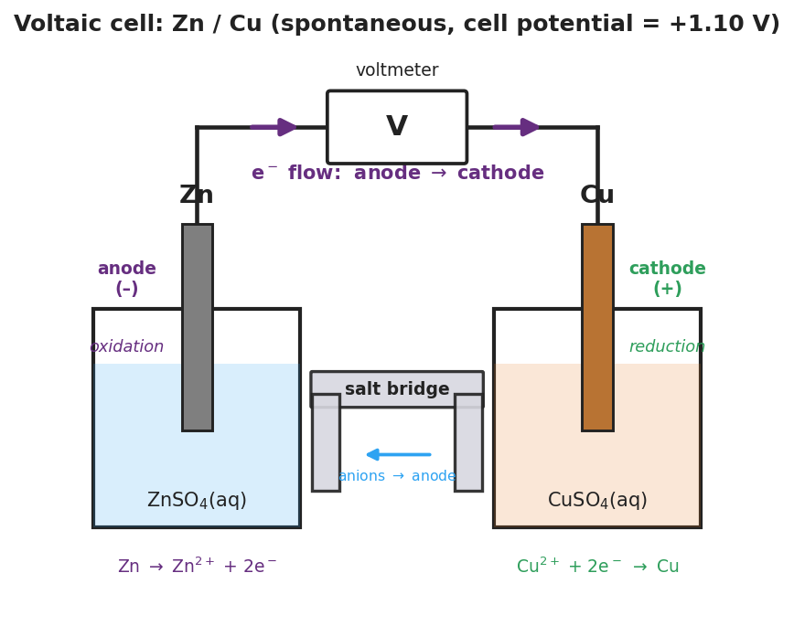
Brand-styled diagram of a Zn/Cu voltaic cell: a zinc anode in zinc-sulfate solution on the left where oxidation occurs; a copper cathode in copper-sulfate solution on the right where reduction occurs; an external wire through a voltmeter at the top shows electron flow from anode to cathode; a salt bridge connects the two beakers; the cell potential is +1.10 V.
From the figure, fill in the blanks:
- The anode is the _______________ electrode; its half-reaction is _______________________________________________
- The cathode is the _______________ electrode; its half-reaction is _______________________________________________
- The cell potential shown is _______________ V, and a positive value means the reaction is _______________ (spontaneous / non-spontaneous).
Two kinds of electrochemical cell:
 | Voltaic cell | Electrolytic cell
Reaction is… | __________ (runs on its own) | __________ (must be forced)
Energy… | comes __________ (chemical → electrical) | goes __________ (electrical drives reaction)
Example | a __________ | __________ or recharging a battery
Cause and effect — why a battery dies: A battery stores __________ energy, not electricity. It produces electricity by running a redox reaction; it dies when the __________ are consumed. Nothing leaks out — matter is __________.

Worked Example
Scenario: A voltaic cell is built from a zinc strip in ZnSO₄(aq) and a copper strip in CuSO₄(aq), joined by a salt bridge. The voltmeter reads about 1.1 V, and the red (positive) lead is on the copper.
Step 1 — Identify which metal is oxidized:
Zinc gives up electrons more easily than copper, so __________ is oxidized.
Step 2 — Assign the electrodes:
The electrode where oxidation happens is the __________ → that is the __________ strip. The electrode where reduction happens is the __________ → that is the __________ strip.
Step 3 — Write the half-reactions:
Anode (oxidation): Zn → __________ + __________ Cathode (reduction): Cu²⁺ + __________ → __________
Step 4 — State the direction of electron flow:
Electrons flow from the __________ (Zn) to the __________ (Cu) through the external wire.
Step 5 — Identify the salt bridge’s job:
Without the salt bridge the voltage was about __________ V. The salt bridge lets __________ move between the beakers to keep each one electrically __________, so the electrons can keep flowing.
Step 6 — Because / But / So
The zinc electrode loses mass as the cell runs because _______________________________________________, but _______________________________________________, so _______________________________________________.
Check your reasoning: “because” should name the oxidation half-reaction; “but” should note that matter is conserved (the zinc becomes ions, not nothing); “so” should explain what stops when the zinc is gone.

Summary
Complete the sentences (Because / But / So):
A lemon battery produces electricity because __________________________________________, but __________________________________________, so __________________________________________.
Reminders:
- AN OX = ANode is OXidation. RED CAT = REDuction is CAThode.
- Electrons travel through the wire (anode → cathode); ions travel through the salt bridge.
- Voltaic cell = spontaneous, makes electricity (a battery). Electrolytic cell = non-spontaneous, uses electricity (electroplating, recharging).
Key reference (from the 2025 NYS Reference Tables): Reduction potentials are listed on Reference Table J (Activity Series) and in the standard reduction potential table — the metal higher on the activity series is oxidized more easily and becomes the anode.

