Electrochemical Cells — Student Worksheet
Unit: Redox & Electrochemistry — Lesson 04 Name: _______________________ Date: __________ Period: ____

Phenomenon
Your teacher pushes a strip of copper and a strip of zinc into a lemon, connects them to a voltmeter, and the needle climbs to almost a full volt. No outlet, no charger — a piece of fruit is producing electricity. Wire a few cells together and a small LED lights up. But if you leave it connected long enough, the voltage fades and the light dies. A fresh AA battery and a dead one look identical on the outside, yet only one runs a motor.
Driving question: How does a battery actually produce electricity, and why do batteries eventually die?

Notice & Wonder
I notice… | I wonder…
Turn & Talk #1: The electrons have to travel from one metal to the other through the wire. In which direction are they moving — from the zinc to the copper, or the other way? Write your prediction and your reasoning.

Initial Model
You will build a real cell: a zinc strip in ZnSO₄(aq) and a copper strip in CuSO₄(aq), wired through a voltmeter and joined by a salt bridge.
Record your measurements:
Measurement | Reading
Voltage before the salt bridge is connected | V
Voltage after the salt bridge is connected | V
Which metal is the voltmeter’s positive (red) lead clipped to?
Before your teacher names any parts, draw an arrow on the diagram below showing which way electrons move through the wire, and write the half-reaction happening at each metal.
Metal | Half-reaction (oxidation or reduction?)
Zinc (Zn)
Copper (Cu)
- Through the external wire, electrons flow from the _______________ to the _______________.
- What was your evidence for that direction? _______________________________________________

Investigation

Part 1 — Build and observe
Set up the cell with your group. Connect everything except the salt bridge first; read the voltmeter. Then lay the salt bridge across and read it again.
- What did the voltmeter read before the salt bridge was connected? _______________ V
- What did it read after? _______________ V
- What does this tell you about whether the circuit was complete before the salt bridge was added? _______________________________________________

Part 2 — What does each part do?
Use your observations to reason about the role of each part of the cell.
Part | What you observed | What you think it does
Zinc electrode | (gains/loses mass?)
Copper electrode | (gains/loses mass? color change?)
Salt bridge | (voltage with vs. without)
External wire | (carries what?)

Part 3 — Reading the labeled cell
Study the diagram below.
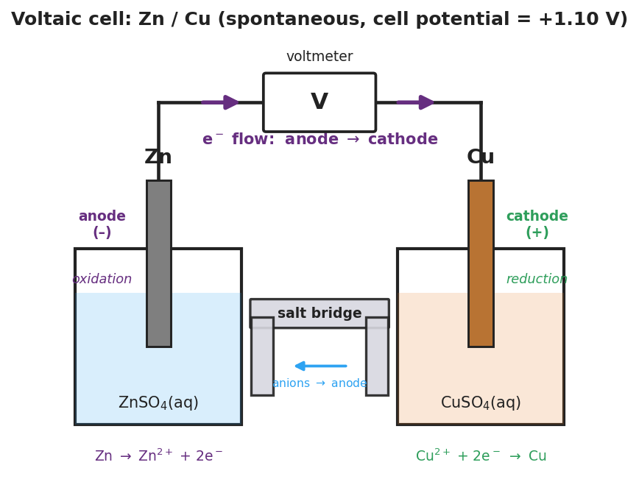
Brand-styled diagram of a Zn/Cu voltaic cell: a zinc electrode in zinc-sulfate solution on the left labeled anode, negative, oxidation; a copper electrode in copper-sulfate solution on the right labeled cathode, positive, reduction; an external wire runs through a voltmeter at the top with arrows showing electron flow from anode to cathode; a salt bridge connects the two beakers at the bottom; the title notes a spontaneous cell with a cell potential of +1.10 V.
- Which metal is the anode (where oxidation happens)? _______________
- Which metal is the cathode (where reduction happens)? _______________
- Does the electron-flow arrow in the figure point the same direction as the arrow you drew in your Initial Model? _______________

Make It Make Sense
Answer each question using evidence from your build and the diagram.
- A classmate says, “Electrons travel through the salt bridge to get from the zinc to the copper.” Is this correct? If not, what actually travels through the salt bridge, and what travels through the wire?
  - Correct or incorrect? _______________
  - What travels through the wire: _______________________________________________
  - What travels through the salt bridge: _______________________________________________
- In your cell, the zinc electrode slowly dissolves and the copper electrode gains a reddish coating.
  - Which electrode is the anode? _______________ Why? _______________________________________________
  - Write the half-reaction at the zinc: _______________________________________________
  - Write the half-reaction at the copper: _______________________________________________
- Two students build a cell using two copper strips in two beakers of CuSO₄(aq), joined by a salt bridge. The voltmeter reads 0 V.
  - Why does this cell produce no voltage? _______________________________________________
  - What would they need to change to make it work? _______________________________________________
- Your teacher connects a power supply and forces current backward through a fresh cell to plate copper onto a steel key.
  - Is this a voltaic cell or an electrolytic cell? _______________
  - Is the reaction being driven spontaneous or non-spontaneous? _______________
  - Where is the energy coming from in this case? _______________________________________________

Vocabulary in Action
Use each term in a sentence about today’s investigation. Do not copy the definition — describe something you actually did or observed.
- anode / cathode: _______________________________________________ _______________________________________________
- voltaic cell: _______________________________________________ _______________________________________________
- electrolytic cell: _______________________________________________ _______________________________________________

Revise Your Model
Return to your Initial Model (the electron-flow arrow and half-reactions). Add vocabulary labels:
- Label the zinc electrode anode and the copper electrode cathode. Next to each, write whether oxidation or reduction happens there.
- Label the direction of electron flow through the wire: from _______________ to _______________.
- Predict a new cell. Magnesium is oxidized even more easily than zinc. In a magnesium–copper cell:
The anode is _______________, the cathode is _______________, and electrons flow from _______________ to _______________. Compared to your zinc–copper cell, the voltage would be (higher / lower): _______________
Then finish this Because / But / So sentence:
A battery eventually dies even though no electricity “leaked out” of it because __________________________________________, but __________________________________________, so __________________________________________.

Exit Ticket
A voltaic cell is built from a magnesium strip in Mg(NO₃)₂(aq) and a silver strip in AgNO₃(aq), joined by a salt bridge. Magnesium is oxidized much more easily than silver.
(a) Which metal is the anode and which is the cathode? Explain how you decided.
Anode: _______________ Cathode: _______________
How I decided: _______________________________________________
(b) State the direction electrons flow through the external wire.
Electrons flow from the _______________ to the _______________.
(c) In one sentence, explain why this battery will eventually stop producing electricity.

