Cumulative Review — One Story of Matter and Energy — Student Notes
Unit: Regents Review — Lesson 01 Name: _______________________ Date: __________ Period: ____

Learning Targets
By the end of today’s 42 minutes I can:
- Locate any required value on the 2025 NYS Chemistry Reference Tables in under 30 seconds (density → Table S, solubility → Table F, formulas → Table T).
- Identify the type of a mixed Regents question and reach for the matching tool (calculation, lookup, classification, balancing).
- Run a mole / gram-formula-mass calculation and a balancing / conservation check accurately under time pressure.
- Explain, using the CCC of Patterns, how at least two units of this course connect into one understanding of matter and energy.

Key Vocabulary
- reference table — _______________________________________________ _______________________________________________
- distractor — _______________________________________________ _______________________________________________
- constructed response — _______________________________________________ _______________________________________________

Guided Notes
The big idea — Patterns: The eleven units are not eleven separate lists. They are one connected story of __________ and __________. Every Regents question belongs to a recognizable __________ — once you name the type, you know which __________ to reach for.
The course in one map — the spine that connects every unit:
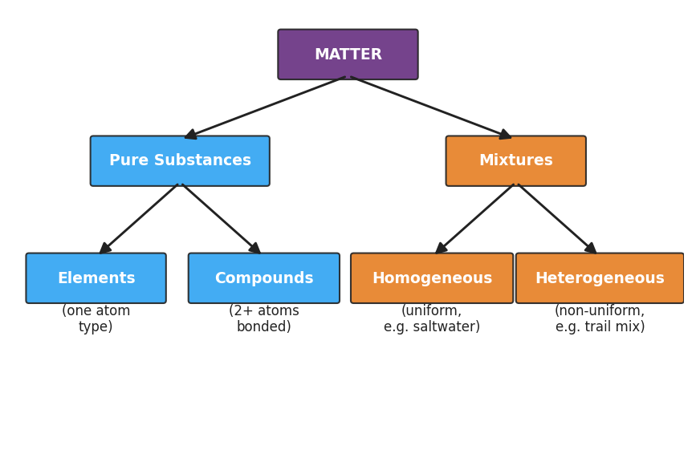
Course concept map: a classification tree of matter — MATTER branches into Pure Substances (Elements = one atom type; Compounds = two or more atoms bonded) and Mixtures (Homogeneous = uniform, e.g. saltwater; Heterogeneous = non-uniform, e.g. trail mix). This single tree is the spine of the whole course.
From the map above, fill in the blanks:
- A pure substance made of one kind of atom is an __________.
- A pure substance made of two or more kinds of atoms bonded together is a __________.
- A uniform mixture (e.g., saltwater) is __________.
- A non-uniform mixture (e.g., trail mix) is __________.
The three reference tables you will use most:
If the question asks for… | Reach for Table…
density or a physical property | ___
whether a compound is soluble in water | ___
a formula (moles, density, percent error) | ___
Recognize the type, reach for the tool:
Question pattern | First tool to reach for
“How many moles in ___ grams?” | gram formula mass + Table ___ (moles = mass ÷ GFM)
“Is ___ soluble?” | Table ___ (solubility)
“Balance: ___ → ___” | conservation of mass — same atoms each side
“Classify ___” | the concept-map tree above

Worked Example
Scenario: A Regents item gives you 88 g of carbon dioxide (CO₂) and asks for the number of moles. This is a mole-conversion pattern.
Step 1 — Name the type: It gives grams and asks for moles → use moles = mass ÷ gram formula mass (Table T).
Step 2 — Find the gram formula mass of CO₂ (Periodic Table):
Element | Atomic mass (g/mol) | Subscript | Mass contribution
C | ___ | 1 | ___
O | ___ | 2 | ___
GFM |  |  | ___ g/mol
Step 3 — Set up using the Table T formula:
moles = mass ÷ GFM = 88 g ÷ ________ g/mol = ________ mol
Step 4 — Check the answer is reasonable: 88 g is twice the GFM (44 g/mol), so the answer should be about __________ moles.
Step 5 — Because / But / So:
A student who writes only the final number “2.0 mol” on a constructed response may lose points because _______________________________________________, but _______________________________________________, so _______________________________________________.
Check your reasoning: “because” should name what constructed-response items reward; “but” should name what the student left out; “so” should state what to always show.

Summary
Complete the Because / But / So sentence:
The eleven units of chemistry are easier to study as one story than as eleven separate lists because __________________________________________, but __________________________________________, so __________________________________________.
Reminder — the two threads of the whole course: Matter is classified, built from atoms, and bonded. Energy drives every change matter undergoes — melting, dissolving, reacting. Every unit is one of those two threads.
Key reference (from the 2025 NYS Reference Tables): - Table S — densities and physical properties (e.g., aluminum = 2.70 g/cm³) - Table F — solubility guidelines (e.g., AgCl is insoluble; most nitrates are soluble) - Table T — important formulas (e.g., number of moles = given mass ÷ gram-formula-mass)

