Cumulative Review — One Story of Matter and Energy — Student Worksheet
Unit: Regents Review — Lesson 01 Name: _______________________ Date: __________ Period: ____

Phenomenon
Eleven unit titles are on the board. They look like eleven separate topics to cram. But watch one sugar cube travel the whole course: it can be classified (a compound, C₆H₁₂O₆), drawn as bonded atoms, given a gram formula mass (180 g/mol), dissolved into a solution, and combusted in a reaction where every atom is conserved and energy is released. One sugar cube touches half the course. The eleven units are not a list — they are one connected story of matter and energy.
Driving question: How do all the units of chemistry connect into one understanding of matter and energy?

Notice & Wonder
I notice… | I wonder…
Turn & Talk #1: On the Regents, the same types of questions come back every year — a mole problem, a “use this reference table” problem, a balancing problem. In one sentence: if you could recognize the type of a question in the first five seconds, what would that do for your speed?

Initial Model
Before we name any test-taking strategy, sketch a quick concept map. Put MATTER in the middle. Draw at least four units of this course branching off it. On each branch, write one thing you learned in that unit. Speed over neatness — you have three minutes.
(Draw your concept map in the space below.)

Investigation
Rotate through the five stations with your group. You have 4 minutes per station. At each station, first say out loud what TYPE of question it is, then solve it. Open the answer envelope and self-score before you rotate.
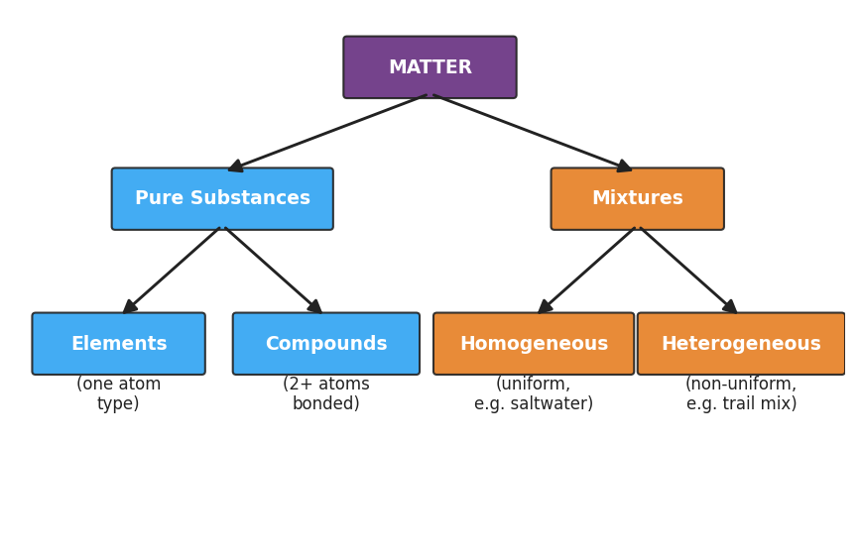
Course concept map: a classification tree of matter — MATTER branching into Pure Substances (Elements, Compounds) and Mixtures (Homogeneous, Heterogeneous). Use this tree at Station 4.

Station 1 — Moles & Gram Formula Mass
- Gram formula mass of CO₂:
Element | Atomic mass (g/mol) | Subscript | Mass contribution
C |  | 1
O |  | 2
GFM |  |  | ___ g/mol
- How many moles are in 88 g of CO₂? (Use Table T: moles = mass ÷ GFM.)
moles = ________ ÷ ________ = ________ mol

Station 2 — Reference-Table Retrieval
- Density of aluminum (Table S): ________ g/cm³
- Is silver chloride (AgCl) soluble or insoluble in water (Table F)? ________
- Which table gives you the formula for number of moles? ________

Station 3 — Balancing & Conservation of Mass
Balance the equation, then confirm mass is conserved.
___ H₂ + ___ O₂ → ___ H₂O
Atoms of H on each side: ____ Atoms of O on each side: ____ Is mass conserved? ________ Why? _______________________________________________

Station 4 — Bonding & Classification
- Classify each using the concept map (element / compound / homogeneous mixture / heterogeneous mixture):
Substance | Classification
O₂
NaCl
air
sand stirred into water
- Is NaCl ionic or covalent? ________ Why? _______________________________________________

Station 5 — Mixed Regents Multiple Choice
Circle the best answer. (Answers are in the station envelope.)
- The gram formula mass of CaCO₃ is closest to:

    - 56 g/mol

    - 68 g/mol

    - 100 g/mol

    - 116 g/mol
- Which of the following is a chemical change?

    - melting ice

    - dissolving salt in water

    - burning propane

    - boiling water

Make It Make Sense
For each item, name the question type, solve it, and (where asked) name the reference table you would use. These are the same problems you practiced at the stations — confirm your work here.
1. Gram formula mass of CO₂, and moles in 88 g.
- Question type: _______________________________________________
- GFM of CO₂ = ________ g/mol
- Moles in 88 g = ________ ÷ ________ = ________ mol
2. Reference-table retrieval: density of aluminum; solubility of AgCl.
- Question type: _______________________________________________
- Density of Al = ________ g/cm³ (Table ___)
- AgCl is ________ in water (Table ___)
3. Balancing: H₂ + O₂ → H₂O.
- Question type: _______________________________________________
- Balanced: ___ H₂ + ___ O₂ → ___ H₂O
- Mass is conserved because _______________________________________________

Vocabulary in Action
Use each term in a sentence about today’s stations or the Regents. Do not copy the definition — describe something you actually did or noticed.
- reference table: _______________________________________________ _______________________________________________
- distractor: _______________________________________________ _______________________________________________
- constructed response: _______________________________________________ _______________________________________________

Revise Your Model
Return to your Initial Model concept map.
- Add any unit you left off.
- Draw at least one connection line between two units and label what the two share (a tool, an idea, or a thread like “matter” or “energy”).
- Finish this Because / But / So sentence:
A student who studies all eleven units as eleven separate lists to memorize finds the Regents harder because __________________________________________, but __________________________________________, so __________________________________________.

Exit Ticket
(a) Calculate the number of moles in 36 g of water (H₂O). Show the gram formula mass and the Table T setup (moles = mass ÷ GFM).
Element | Atomic mass (g/mol) | Subscript | Mass contribution
H
O
GFM |  |  | ___ g/mol
moles = ________ ÷ ________ = ________ mol
(b) Using the reference tables: is sodium nitrate (NaNO₃) soluble in water (Table F)? Which table did you use?
NaNO₃ is ________ in water. Table used: ________
(c) In one sentence, use the word “pattern” to connect any two units of this course into one idea about matter or energy.

