Density — Student Notes
Unit: Safety and Measurement — Lesson 05 Name: _______________________ Date: __________ Period: ____

Learning Targets
By the end of today’s 42 minutes I can:
- Calculate density using D = m/V and express the result in g/mL or g/cm³.
- Explain why the slope of a mass-versus-volume graph equals density.
- Compare an object’s density to water (1.0 g/mL) to predict whether it floats or sinks.
- Use the CCC of Structure and Function to explain why ice is less dense than liquid water.

Key Vocabulary
- density — _______________________________________________ _______________________________________________
- mass — _______________________________________________ _______________________________________________
- volume — _______________________________________________ _______________________________________________

Guided Notes
The big idea — Structure and Function: The way particles are __________ at the molecular level determines the __________ of density at the macroscopic level. Density determines whether an object __________ or __________ in water.
The formula:
D = ___ / ___
Units: D is measured in __________ or __________. Mass is measured in __________. Volume is measured in __________.
Rearranging for mass and volume (formula triangle):
Cover the unknown | Formula to use
Cover D | D = m ÷ V
Cover m | m = D × V
Cover V | V = m ÷ D
Float vs. sink rule:
- If D_object ___ 1.0 g/mL → object floats in water.
- If D_object ___ 1.0 g/mL → object sinks in water.
The slope connection:
On a mass-versus-volume graph: - x-axis = __________ (mL) - y-axis = __________ (g) - Slope = rise / run = Δmass / Δvolume = ___________ (g/mL)
This means: the slope of a mass-vs-volume graph equals the __________ of the material.
The figure — aluminum mass-vs-volume graph:
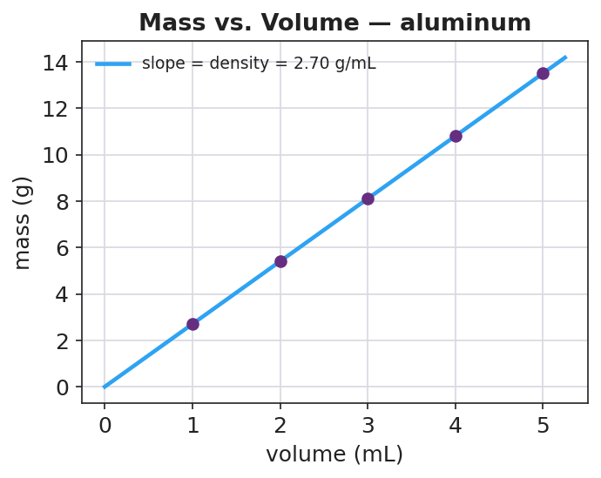
A scatter plot of mass (y-axis, in grams) versus volume (x-axis, in mL) for a set of aluminum samples. Several data points cluster tightly along a straight line through the origin. A best-fit line is drawn through the data points. The slope of the line is labeled as 2.70 g/mL — the density of aluminum. The x-axis is labeled “Volume (mL)” and the y-axis is labeled “Mass (g)”. The title reads “Mass vs. Volume — Aluminum Samples.”
From the figure, fill in the blanks:
- Material plotted: ___________
- Slope of the best-fit line: ___________ g/mL
- This slope equals the ___________ of aluminum.
- If a different-sized aluminum sample were added to this graph, its data point would fall __________ the same line.
The ice vs. water particle diagram:
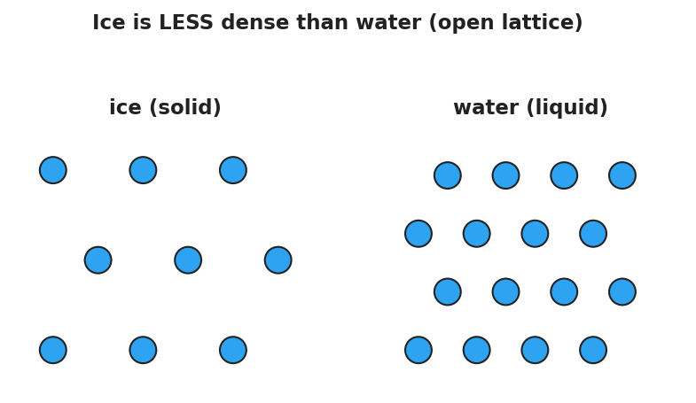
Two side-by-side particle diagrams. The left panel is labeled “Ice” and shows water molecules arranged in an open, spread-out hexagonal lattice with large gaps between molecules — the lattice is rigid and the particles are spaced far apart relative to their size. The right panel is labeled “Liquid Water” and shows water molecules packed much more closely together in a disordered arrangement. A banner above the figure reads “Ice is LESS dense than water (open lattice).”
From the diagram, answer:
 | Ice | Liquid Water
Particle arrangement | open hexagonal __________ | closely __________
Relative particle spacing | __________ apart | __________ together
Density (g/mL) | ≈ 0.92 | 1.0
Floats or sinks? | __________ | (reference)
Why does ice float? (Structure and Function):
Structure: Ice forms an open hexagonal ___________, spacing molecules __________ apart than in liquid water.
Property: Because the same molecules take up __________ space, ice has a __________ density than liquid water.
Function: Ice __________ on liquid water, creating an insulating layer that allows aquatic life to survive winter.

Worked Example
Scenario: A 27.0 g block of aluminum has a volume of 10.0 mL. Find its density and predict whether it sinks or floats in water.
Step 1 — Identify what you know and what you need:
- Known: mass = _____ g, volume = _____ mL
- Unknown: density = ?
Step 2 — Write the formula:
D = ___ / ___
Step 3 — Substitute and calculate:
D = _____ g / _____ mL = _______________ g/mL
Step 4 — Compare to water:
D_aluminum = _______________ g/mL D_water = 1.0 g/mL
Since _______________ g/mL > 1.0 g/mL, this block will __________ in water.
Step 5 — Because / But / So
The aluminum block sinks in water because _______________________________________________, but _______________________________________________, so _______________________________________________.
Check your reasoning: “because” should give the density comparison; “but” should name the material that does float (something with density < 1.0 g/mL); “so” should state the consequence for the aluminum block.

Summary
Complete the sentence (Because / But / So):
Ice floats on liquid water because __________________________________________, but __________________________________________, so __________________________________________.
Key reference values (from the 2025 Reference Table):
Substance | Density (g/mL)
Water (liquid) | 1.0
Ice | ≈ 0.92
Aluminum | 2.70
Copper | 8.96
Reminder: To identify an unknown material, calculate D = m/V and compare to a reference table. Density is an intensive property — doubling the sample size doubles both mass and volume, leaving D unchanged.

