Lab Safety & Working Like a Scientist — Student Worksheet
Unit: Safety and Measurement — Lesson 01 Name: _______________________ Date: __________ Period: ____

Phenomenon
Your teacher tells a story in two acts. In Act 1, a student rushes through a pre-lab checklist: goggles pushed up, wrong gloves, fume hood sash left open. A small splash of liquid reaches the eye area — and the situation turns into a first-aid emergency. In Act 2, the same student, same lab task, same splash — but this time goggles are sealed around the eyes, apron tied, fume hood running. The splash hits the goggle lens and wipes off harmlessly.
Driving question: What routines let chemists work with dangerous substances and stay safe?

Notice & Wonder
I notice… | I wonder…
Turn & Talk #1: The splash happened in both Act 1 and Act 2 — the chemistry didn’t change. What specifically was different in Act 2 that stopped the harm from reaching the student? Try to name the specific item or action.

Initial Model
Before your teacher explains anything, write down your best guess: what are the most important safety items in a chemistry lab, and what does each one protect? List at least three. You may look around the room.
Safety item | What it protects (your best guess)

Investigation

Part 1 — Safety Equipment Scavenger Hunt
Find each item from the labeled panel below somewhere in your classroom or lab space. Write one sentence describing its purpose in your own words.
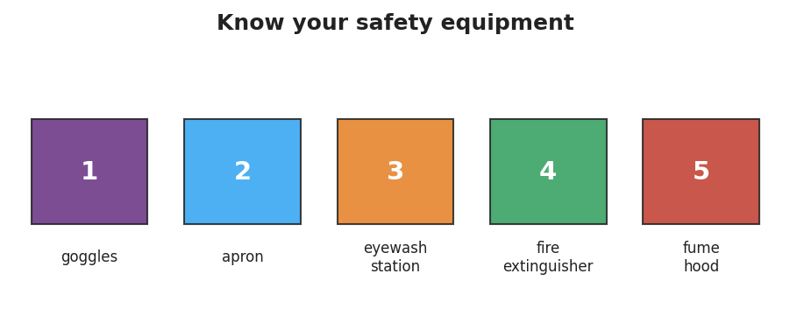
Labeled panel of core lab-safety equipment: goggles, apron, eyewash station, fire extinguisher, fume hood.
Item | Found it? (✓) | Purpose — write it in your own words
1 Goggles
2 Apron
3 Eyewash station
4 Fire extinguisher
5 Fume hood

Part 2 — SDS Interpretation
Use the Safety Data Sheet your teacher provides. Find and record the following three pieces of information.
Hazard statement (Section 2):

Required PPE (Section 8):

First-aid measure for eye contact (Section 4):

Key question: Why does the SDS tell you the first-aid steps and the required PPE — both in the same document?

Make It Make Sense
For each scenario below, identify the hazard, name the missing PPE or safety step, and explain what could happen without it.
- A student heats a test tube of liquid pointed directly at a partner who is working nearby.
  - The hazard is: _______________________________________________
  - The missing safety step is: _______________________________________________
  - Without it, what could happen? _______________________________________________
- A student adds a chemical to water in a fume hood but is not wearing an apron. The liquid splashes onto their shirt.
  - The hazard is: _______________________________________________
  - The missing PPE is: _______________________________________________
  - The apron would have prevented: _______________________________________________
- A student starts an experiment without reading the SDS first. The chemical turns out to require acid-resistant gloves, but they are wearing standard latex gloves.
  - The hazard is: _______________________________________________
  - What should the student have done before starting? _______________________________________________
  - Where would they have found that information? _______________________________________________

Vocabulary in Action
Use each term in a sentence about today’s phenomenon or investigation. Do not just copy the definition — use the word to describe something you observed or did.
- SDS (Safety Data Sheet): _______________________________________________ _______________________________________________
- PPE (personal protective equipment): _______________________________________________ _______________________________________________
- hazard: _______________________________________________ _______________________________________________

Revise Your Model
Return to your Initial Model. Add any items you missed. Then, for each item, add a cause→effect note: what cause (unsafe action) does this item prevent from becoming an effect (injury)?
Then finish this Because / But / So sentence:
A student who skips the pre-lab safety checklist is at risk because __________________________________________, but __________________________________________, so __________________________________________.

Exit Ticket
A lab procedure calls for heating a liquid that can splash.
- Name two pieces of PPE required for this procedure and explain why each one is needed.
PPE 1: _________________ — needed because: _______________________________
PPE 2: _________________ — needed because: _______________________________
- Where would you look up the specific hazards of the liquid and the correct first-aid response?

- In one sentence, explain why following the safety routine matters. Try to use the words cause and effect or the words hazard and prevent.

