Algebra and Trigonometry for Physics — Teacher Guide

Cover
Unit: Math in Science — Lesson 01: Algebra and Trigonometry for Physics East Meadow Schools × Valley Stream Central High School District Strategy chips: HOCHMAN

Curated Resources (from East Meadow Scope & Sequence)

NYSSLS Standards
This is a foundational math-skills lesson with no single NYSSLS performance expectation of its own. It builds the science and engineering practice “Using Mathematics and Computational Thinking,” which is woven through every HS-PS standard in the course — students cannot reach HS-PS2-1 (Newton’s Second Law), HS-PS3 (energy), or any quantitative target without first being able to rearrange a formula and resolve a vector. The crosscutting concept in focus is Scale, Proportion, and Quantity: a relationship like v = d / t expresses how one quantity changes in proportion to another, and trig lets us scale a slanted distance into its horizontal and vertical parts.

Phenomenon
- Zipline / ramp at an angle — students see a cable strung from a high anchor to a low one and ask: how high is the top, and how far does the rider travel across the ground? https://www.youtube.com/results?search_query=zipline+physics
- PhET “Trig Tour” (sine/cosine on a triangle and circle): https://phet.colorado.edu/en/simulations/trig-tour

Javalab / Labs
- Javalab “Vector composition and decomposition” (resolve a vector into components): https://javalab.org/en/vector_composition_en/
- Optional: tape an angled “zipline” string across the room and measure the rise and run directly to confirm the trig.

Assessments
- PhET Trig Tour has a built-in self-check. The Exit Ticket below (find the height and run of an angled cable) is the formative check for this lesson.

Lesson Overview
Duration | 42 minutes (1 period)
NYSSLS link | Practice: Using Mathematics and Computational Thinking (supports all HS-PS)
CCC focus | Scale, Proportion, and Quantity — formulas express proportional relationships; trig scales a slant into components
Strategy chips | HOCHMAN (Because/But/So + kernel sentences on the rearrangement rule)
Materials | Whiteboards/markers; calculators (degree mode); a length of string + protractor (optional live zipline); printed right-triangle handout
Safety | If stringing a physical zipline, keep it low and clear walkways. No other hazards.
Prior knowledge | Middle-school algebra (solving one-step equations); the idea of a right triangle. No prior trig assumed.
Lesson objectives — students can:
- Isolate a chosen variable in a one- or two-step physics formula (e.g., rearrange v = d / t into d = v t and t = d / v).
- Identify the opposite, adjacent, and hypotenuse sides of a right triangle relative to a given angle.
- Use sine (and cosine/tangent via SOH-CAH-TOA) to find the height and horizontal run of an angled cable or ramp.

Phase 1 · Engage (0 – 8 min)

0–3 min · Opening Connection (SEL)
Quick whole-class check-in. Prompt: “Think of a time you had to rearrange a plan to make it work — same pieces, different order. Share one in a sentence.” This primes the idea that rearranging an equation keeps the same relationship, just solved for a different piece.

3–8 min · Phenomenon hook — the angled zipline
Teacher actions. Show the zipline image (or the string strung across the room). The cable runs from a high anchor down to a low platform at an angle.
Sample teacher language:
“Here’s the only thing the installer measured: the cable is 26 meters long and it leaves the top tower at 18 degrees below horizontal. The town inspector needs two numbers the installer never measured — how high is the top tower, and how far across the ground does the rider travel. We’re going to get both numbers without climbing anything.”
Anticipated student responses:
- “Just measure it.” — reframe: “The cable is up in the air; we only have the length and the angle. That’s all we ever get in physics.”
- “Use the Pythagorean theorem.” — affirm, then push: “That needs two sides; we have one side and an angle. Trig is the tool for one-side-plus-angle.”
- “Is it a triangle?” — yes; name it as a right triangle and bridge to Phase 2.

Bridge to Phase 2
Every student leaves Phase 1 able to sketch the cable as a right triangle and label which number they were given (the slanted side, the hypotenuse) and which two they need.

Phase 2 · Explore (8 – 26 min)

8–14 min · Skill A — Isolating a variable (algebra)
Put v = d / t on the board. Do not give the rearranged forms yet. Pose three race questions:
“If a sprinter runs at v for time t, how far did she go? Solve for d.” “If we know the distance and the speed, how long did it take? Solve for t.”
Let students try on whiteboards. Circulate. The move to name is isolate the variable: do the same operation to both sides until the wanted variable is alone.
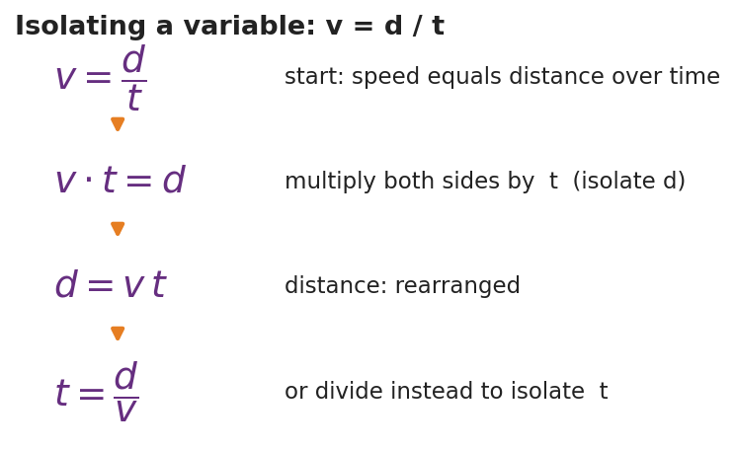
Isolating a variable in v = d / t
Teacher facilitation language:
“Whatever I do to the left side I do to the right side — that keeps the equation balanced. To free d, what’s currently happening to it? It’s being divided by t, so I undo that by multiplying both sides by t.”
Anticipated student responses:
- “d = v / t?” — common error; check units (m/s ÷ s gives m/s², not meters). Redirect to multiply, not divide.
- “d = v t.” — confirm and have them state the kernel sentence aloud (see Phase 4).

14–26 min · Skill B — Right-triangle trig (SOH-CAH-TOA)
Hand out / project the labeled right triangle. Define opposite, adjacent, hypotenuse relative to the angle.
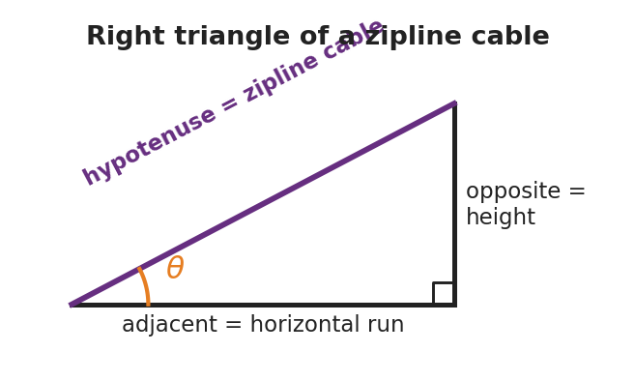
Right triangle of a zipline cable
Run the Javalab vector tool or PhET Trig Tour so students see sine change as the angle changes. Then give them the zipline numbers (hypotenuse = 26 m, angle = 18°) and ask them to find the height (opposite) and run (adjacent).
Teacher facilitation during Explore:
- What to look for — students correctly tagging which side is opposite the 18° angle (the height) before reaching for a button on the calculator.
- What to resist — supplying “use sine” too early; let them test which ratio uses the hypotenuse.
- What to redirect — calculators in radian mode (answers will be wildly off); have them confirm sin 30° = 0.5 as a mode check.

Phase 3 · Explain (26 – 34 min)

26–30 min · Turn-and-Talk + class consensus
“Which trig ratio connects the side you want to the side you were given? Talk it through with your partner using the words opposite and hypotenuse.”
Target consensus:
“The height is the side opposite the angle and we were given the hypotenuse, so we use sine: sin θ = opposite / hypotenuse. The run is adjacent, so it uses cosine.”

30–34 min · Vocabulary introduction (≤ 3 terms)
Sample teacher language:
“Three words make today portable to every future lesson. To isolate a variable means to get it alone on one side of the equation. A right triangle is any triangle with one 90° corner — every ramp, cable, and resolved vector becomes one. And sine is the ratio of the side opposite an angle to the hypotenuse — sin θ = opp / hyp.”

Discussion prompts to deploy here
- “We solved v = d / t for d. If a problem instead gives you d and v, which form do you grab, and why?”
  - Sample student response: “t = d / v, because t is the unknown and I isolate it by dividing.”
- “On the zipline, why is the height the opposite side and the ground-run the adjacent side?”
  - Sample student response: “Opposite is across from the angle; adjacent is the one touching the angle along the ground.”

Phase 4 · Elaborate (34 – 39 min)

34–37 min · HOCHMAN Because/But/So + kernel sentence
Have students compress today’s rule into a kernel sentence and then expand it.
*“Write a kernel sentence: ‘Sine relates two sides.’ Now expand it with Because / But / So: Sine relates the opposite side to the hypotenuse because , but , so ___.”*
Target: “…because that ratio stays fixed for a given angle, but it does not involve the adjacent side, so I use cosine when I need the run instead.”

37–39 min · Return to the phenomenon
“Give the inspector both numbers in one sentence each, with units.”
Target: height ≈ 26 × sin 18° ≈ 8.0 m; run ≈ 26 × cos 18° ≈ 24.7 m.

Phase 5 · Evaluate (39 – 42 min)

39–42 min · Exit Ticket + Closing Reflection
“A wheelchair ramp is 5.0 m long (the slanted hypotenuse) and rises at 10° above the ground. (a) Rearrange v = d / t to solve for t. (b) Which side of the ramp triangle is the rise — opposite or adjacent to the 10° angle? (c) Find the rise (height) of the ramp.”
Expected: (a) t = d / v; (b) opposite; (c) height = 5.0 × sin 10° ≈ 0.87 m. See Answer_Key.docx.
Closing Reflection (SEL, 30 seconds):
“Which felt harder today — rearranging the equation or choosing the trig ratio? Name one thing that made the harder one click.”

Common Misconceptions
- Misconception: “To solve v = d / t for d, divide by t.” → Correction: d is already divided by t; undo division by multiplying both sides by t, giving d = v t. Unit-check it: (m/s)(s) = m.
- Misconception: “Opposite and adjacent are fixed sides of the triangle.” → Correction: They are defined relative to the chosen angle; the same leg can be opposite for one angle and adjacent for another.
- Misconception: “sin, cos, and tan are interchangeable.” → Correction: Pick the ratio that uses the two sides you have/want — SOH-CAH-TOA tells you exactly which.
- Misconception (silent killer): calculator left in radians. → Correction: confirm sin 30° = 0.5 before trusting any answer.

Access & Differentiation
- ELL/ENL supports: Sentence frame: *“To isolate , I both sides by ___.”* Pair each trig word with a gesture (sine = hand sweeping up the opposite rise). Provide a SOH-CAH-TOA reference card with a picture, not just letters.
- IEP/SPED supports: Provide the right triangle pre-drawn and pre-labeled so students focus only on choosing the ratio. Offer a two-column “operation / result” organizer for the rearrangement so each algebra step has its own line. Allow a formula card with d = v t and t = d / v already shown for the trig portion.
- Extensions: Ask students to derive the third unknown — the angle itself — from two measured sides using the inverse sine (sin⁻¹), and to verify their zipline answers with the Pythagorean theorem (8.0² + 24.7² ≈ 26²).

Strategy Spotlight
HOCHMAN (sentence-level literacy). Today’s chip is the Because/But/So expansion plus the kernel sentence in Phase 4. The goal is precision, not volume: students compress the trig rule into a single kernel sentence (“Sine relates two sides”), then stretch it with the three conjunctions so they have to articulate the limits of the rule (when sine does not apply). Keep it to one tight paragraph; collect a few aloud and reward the most precise, not the longest.

NYSSLS Observation Checklist Crosswalk
# | Checklist item | Where it appears in this lesson
1 | Local/relatable phenomenon | Phase 1 — angled zipline; Phase 5 — wheelchair ramp
2 | Turn and Talk (2–3×) | Phase 3 (which ratio?), Phase 4 (Because/But/So share)
3 | Students develop questions/models/procedures | Phase 2 — sketch the triangle, choose the ratio, derive the rearrangement
4 | CCC defined and used | Lesson Overview · Scale, Proportion, and Quantity, applied in Phase 2
5 | ENL — ≤ 3 vocab, second half | Phase 3 — vocabulary at 30–34 min (isolate / right triangle / sine)
6 | Revisit phenomenon with evidence | Phase 4 — give the inspector the height and run
7 | ENL/SPED supports | Access & Differentiation block
8 | Assessment check | Phase 5 — Exit Ticket (ramp rise + rearrangement)

Companion Materials
- Student_Worksheet.docx — the 5E student investigation (hand out at start of Phase 2)
- Student_Notes.docx — guided note-guide for the rearrangement steps and the trig worked example
- Answer_Key.docx — answers to “Make It Make Sense” prompts and the Exit Ticket

Key Vocabulary (max 3)
- isolate (a variable) — to use inverse operations on both sides of an equation until the wanted variable stands alone (e.g., v = d / t → d = v t)
- sine — the trig ratio of the side opposite an angle to the hypotenuse: sin θ = opposite / hypotenuse
- right triangle — a triangle with one 90° angle; its longest side (opposite the right angle) is the hypotenuse

