Newton’s Second Law and Net Force — Teacher Guide

Cover
Unit: Forces — Lesson 02: Newton’s Second Law and Net Force East Meadow Schools × Valley Stream Central High School District Strategy chips: HOCHMAN

Curated Resources (from East Meadow Scope & Sequence)

NYSSLS Standards
This lesson is the heart of HS-PS2-1: “Analyze data to support the claim that Newton’s second law of motion describes the mathematical relationship among the net force on a macroscopic object, its mass, and its acceleration.” It builds directly on Lesson 01 (Newton’s First Law), where students established the zero-net-force baseline — motion does not change when forces are balanced. Here we ask the next question: when the net force is not zero, how much does the motion change? The answer is the proportional, mathematical relationship F_net = m·a. On the 2025 Physics Reference Table this appears as a = F_net / m. The lesson also seeds HS-PS2-2 (momentum) by treating force as the agent of change in motion.

Phenomenon
- Slingshot launch: the same rubber band, pulled back the same distance, launches three different-size balls (ping-pong, golf, steel) — the light ball rockets away while the heavy one barely leaves. Same pull, different acceleration.
- Alternate (no slingshot needed): an empty cart vs. a loaded cart given the same push — the loaded cart accelerates far less.

Javalab / Labs
- Force and movement simulation: https://javalab.org/en/force_movement_en/
- oPhysics force-and-motion / inclined plane: https://ophysics.com/f1.html

Assessments
- HS-PS2-1 cluster task “The Gyro Drop” — students analyze acceleration data from a drop ride to argue the F_net = m·a relationship.
- HS-PS2-1 cluster task “Newton’s 2nd Law” — data-analysis cluster on net force, mass, and acceleration. The Exit Ticket below is the formative check for this lesson.

Lesson Overview
Duration | 42 minutes (1 period)
NYSSLS link | HS-PS2-1 (core) → HS-PS2-2 (thread)
CCC focus | Cause and Effect — net force is the cause; acceleration is the effect. Bigger cause → bigger effect; bigger mass → smaller effect.
Strategy chips | HOCHMAN (Because/But/So sentence expansion on F_net = m·a)
Materials | Rubber band/slingshot frame; ping-pong, golf, and steel balls (or 3 graduated masses); a rolling cart; objects to load the cart; whiteboards/markers; the 2025 Reference Table.
Safety | Launch balls into a soft target or open floor only — never toward people. Keep walkways clear for the cart.
Prior knowledge | Lesson 01 — net force, balanced/unbalanced forces, inertia; Kinematics — acceleration as the rate of change of velocity.
Lesson objectives — students can:
- State Newton’s Second Law in words and as the equation F_net = m·a (equivalently a = F_net / m).
- Predict how acceleration changes when net force or mass changes, and justify it with the equation.
- Solve a quantitative problem: given any two of F_net, m, and a, find the third, with units in newtons.

Phase 1 · Engage (0 – 10 min)

0–3 min · Do Now + Opening Connection
Post the Do Now: “In one sentence, what does it take to change how fast something is moving? (Hint from yesterday: balanced or unbalanced?)” Take one or two responses to surface the bridge from Lesson 01: it takes an unbalanced (net) force.

3–8 min · Phenomenon hook — the slingshot launch
Teacher actions. Hold the slingshot frame steady. Pull the same rubber band back the same distance each time and launch the ping-pong ball, then the golf ball, then the steel ball into a soft target. The light ball flies fast and far; the heavy one barely moves.
Sample teacher language:
“Same band, same pull every time — so the same push. Watch how differently each ball takes off. What is the pull doing differently to each one?”
Anticipated student responses:
- “The heavy one is harder to move.” — capture; we will sharpen “harder to move” into less acceleration.
- “You pulled the light one harder.” — correct gently: “Same pull every time — that’s the whole point.”
- “The big ball weighs more so it goes slower.” — capture “more mass → less change in motion.”

8–10 min · Notice & Wonder + Turn-and-Talk #1
Two columns on the board. Then:
“Turn to your partner: the push was the same on all three, so what made the light ball speed up so much more? Use the word mass in your answer.”
Target insight to listen for (leave open if no one lands it): same force, but less mass means more speeding-up.

Bridge to Phase 2
Every student leaves Phase 1 with a one-sentence initial model: “The light ball sped up more because ______.”

Phase 2 · Explore (10 – 30 min)

10–15 min · Initial Model (silent / individual)
Prompt on the board:
“Draw the three balls leaving the slingshot. Draw one arrow for the push (same size on each) and a second arrow for how fast each speeds up. Then write one sentence predicting which ball speeds up the most and why.”
This surfaces the proportional intuition before any equation.

15–30 min · Investigation — Javalab force-and-movement sim
Open https://javalab.org/en/force_movement_en/ (or the loaded/empty cart if running hands-on). Students work the worksheet table in two rounds:
- Hold mass constant, change force. Double the applied force. Record what happens to acceleration.
- Hold force constant, change mass. Double the mass. Record what happens to acceleration.
Teacher facilitation language:
“When you doubled the force and kept the mass the same — what did the acceleration do?” “Now keep the force the same and double the mass — which way did the acceleration go?” “Can you write that as a fraction? Acceleration equals what, over what?”
As the data accumulates, sketch (or project) the acceleration-vs-net-force relationship. A straight line through the origin is the visual proof that a is proportional to net force:
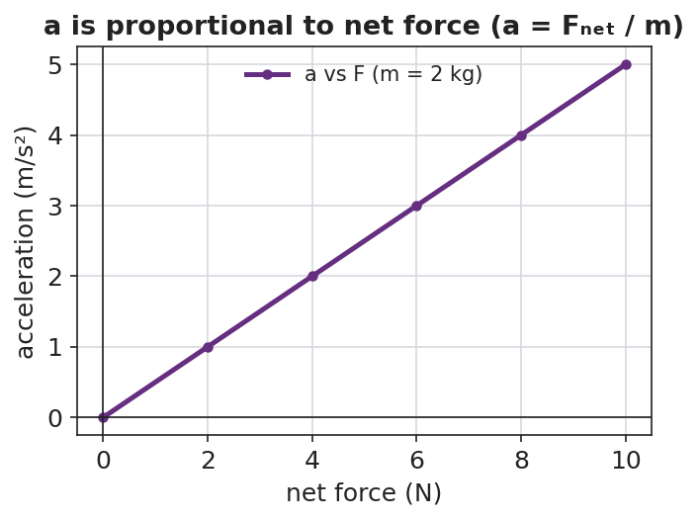
Line graph of acceleration versus net force: a straight line through the origin, showing acceleration is directly proportional to net force.
The reason a cart accelerates at all is that its forces are unbalanced — the applied push beats friction, leaving a net force in the direction of motion:
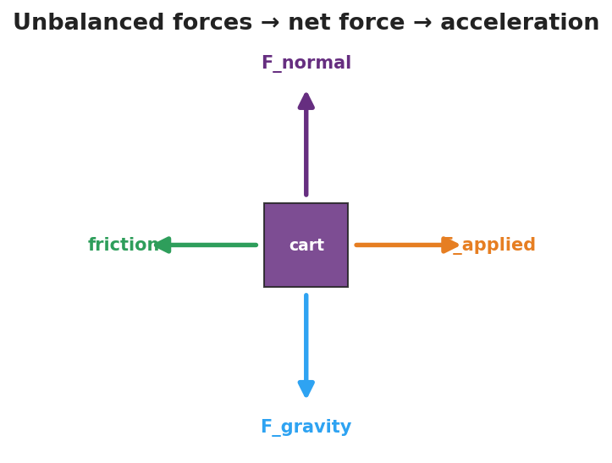
Free-body diagram of a cart with the applied force larger than friction, plus balanced vertical forces, leaving an unbalanced net force that causes acceleration.

Teacher facilitation during Explore
- What to look for — students seeing acceleration double when force doubles (direct), and acceleration halve when mass doubles (inverse).
- What to resist — don’t hand them F_net = m·a yet; let the data build the pattern so the equation names what they already found.
- What to redirect — students who change force and mass at once should isolate one variable per trial (controlled investigation).

Phase 3 · Explain (30 – 36 min)

30–33 min · Turn-and-Talk #2 + class consensus
“Put your two patterns into one rule. Acceleration goes ___ when force goes up, and ___ when mass goes up.”
Target consensus:
“Acceleration is bigger when the net force is bigger, and smaller when the mass is bigger. Acceleration = net force ÷ mass.”

33–36 min · Vocabulary introduction (≤ 3 terms)
Sample teacher language:
“The single push left over after we combine all forces is the net force. The speeding-up or slowing-down it produces is the acceleration. And we measure force in newtons — one newton is exactly the force that gives a 1 kg mass an acceleration of 1 m/s². Put it together and you get Newton’s Second Law: F_net = m·a, or a = F_net / m on your Reference Table.”

Discussion prompts to deploy here
- “If you push two carts with the same net force but one has twice the mass, how do their accelerations compare?”
  - Sample student response: “The heavy one has half the acceleration — mass is on the bottom of the fraction.”
- “A 2 kg ball accelerates at 3 m/s². What net force acted on it?”
  - Sample student response: “F = m·a = 2 × 3 = 6 newtons.”

Phase 4 · Elaborate (36 – 40 min)

36–39 min · Revise the model + HOCHMAN sentence expansion
Students return to the three-ball drawing and re-label arrows using net force and acceleration. Then run the Hochman move (see Strategy Spotlight) — complete the Because/But/So expansion of F_net = m·a:
“The steel ball accelerated the least because ____, but ____, so ____.”

39–40 min · Return to the phenomenon
“Why does a loaded delivery truck take longer to speed up than an empty one, even with the same engine force? Answer in one sentence using net force, mass, and acceleration.”
Target: “Same net force, but more mass, so the acceleration is smaller (a = F_net / m).”

Phase 5 · Evaluate (40 – 42 min)

40–42 min · Exit Ticket + Closing Reflection
“A net force of 12 N acts on a 4 kg cart. (a) Find the cart’s acceleration. Show F_net = m·a (or a = F_net / m). (b) If the mass were doubled to 8 kg with the same 12 N, what is the new acceleration? (c) In one sentence, explain what happened to the acceleration and why.”
Expected: (a) a = 12/4 = 3 m/s²; (b) a = 12/8 = 1.5 m/s²; (c) doubling the mass halved the acceleration because acceleration is inversely proportional to mass. See Answer_Key.docx.
Closing Reflection (SEL, 30 seconds):
“What is one thing today that changed how you think about force and motion? Who helped you make sense of it?”

Common Misconceptions
- Misconception: “More force always means more speed.” → Correction: More net force means more acceleration (rate of change of velocity), not automatically more speed at a given instant.
- Misconception: “Heavy and light objects accelerate the same under the same push.” → Correction: For the same net force, more mass gives less acceleration — mass is in the denominator (a = F_net / m).
- Misconception: “Each separate force has its own acceleration.” → Correction: Only the single net force (all forces combined) determines the acceleration.

Access & Differentiation
- ELL/ENL supports: Sentence frame: *“When the net force ___ and the mass stays the same, the acceleration ___.”* Word-choice box: {net force, mass, acceleration, newton, doubles, halves}. Pair acceleration with a “speeding-up” hand gesture; pair newton with the 1 kg → 1 m/s² mental image.
- IEP/SPED supports: Provide the equation triangle (F_net on top; m and a on the bottom) so students can cover the unknown to see the operation. Offer a pre-built data table for the Javalab sim so students focus on the pattern, not table setup.
- Extensions: Have students use the Javalab sim to find the net force that gives a 5 kg object an acceleration of 4 m/s² (answer 20 N), then predict and verify the acceleration for the same force on a 10 kg object.

Strategy Spotlight
HOCHMAN (Because/But/So sentence expansion). Sentence-level writing makes abstract equations precise. In Phase 4, students expand a single kernel sentence — “The steel ball accelerated the least” — using the three Hochman conjunctions, each forcing a different kind of reasoning:
- because → a cause (“…because it has the most mass and a = F_net / m”)
- but → a contrast (“…but the net force on it was the same as on the other balls”)
- so → a consequence (“…so dividing the same net force by a larger mass gives a smaller acceleration”)
Model one example aloud, then have students write their own for a different ball. Collect a few to check that “because” names the cause (mass), not just restates the claim — this is the comprehension signal you are looking for, and it maps directly onto the Cause-and-Effect CCC.

NYSSLS Observation Checklist Crosswalk
# | Checklist item | Where it appears in this lesson
1 | Local/relatable phenomenon | Phase 1 — slingshot launch; loaded truck in Phase 4
2 | Turn and Talk (2–3×) | Phase 1 (TT#1 — why the light ball sped up more), Phase 3 (TT#2 — one combined rule)
3 | Students develop questions/models/procedures | Phase 1 (initial model), Phase 2 (controlled sim investigation), Phase 4 (revise model)
4 | CCC defined and used | Lesson Overview · Cause and Effect, restated in Phase 2 and Phase 4
5 | ENL — ≤ 3 vocab, second half | Phase 3 — vocabulary at 33–36 min (net force / acceleration / newton)
6 | Revisit phenomenon with evidence | Phase 4 — three-ball re-labeling + loaded-truck prompt
7 | ENL/SPED supports | Access & Differentiation block
8 | Assessment check | Phase 5 — Exit Ticket (12 N on a 4 kg cart)

Companion Materials
- Student_Worksheet.docx — the 5E student investigation (hand out at start of Phase 2)
- Student_Notes.docx — guided note-guide for vocabulary and the worked example
- Answer_Key.docx — answers to “Make It Make Sense” prompts and the Exit Ticket

Key Vocabulary (max 3)
- net force — the single force equivalent to all forces on an object combined (as vectors); the cause of acceleration
- acceleration — the rate at which an object’s velocity changes; equal to net force divided by mass (a = F_net / m)
- newton — the SI unit of force; 1 N = 1 kg·m/s², the force that accelerates a 1 kg mass at 1 m/s²

