Friction — Teacher Guide

Cover
Unit: Forces — Lesson 04: Friction East Meadow Schools × Valley Stream Central High School District Strategy chips: BTC

Curated Resources (from East Meadow Scope & Sequence)

NYSSLS Standards
This lesson sits in HS-PS2 (forces and motion). Friction is the anchoring force for HS-PS2-3 — “Apply scientific and engineering ideas to design, evaluate, and refine a device that minimizes the force on a macroscopic object during a collision.” Friction is the everyday way students feel a contact force, so it also reinforces HS-PS2-1 (friction is one of the forces summed into the net force). The CCC focus is Cause and Effect: changing a surface or the normal force causes a measurable change in the friction force.

Phenomenon
- Sneaker Lab — drag a sneaker across tile, carpet, and sandpaper with a spring scale; the pull needed is different every time even though the sneaker never changed.
- The “stuck book” — a heavy book will not slide no matter how gently you push, then suddenly breaks loose and slides easily once you push hard enough.

Javalab / Labs
- oPhysics — Friction (block on a surface, vary μ and FN): https://ophysics.com/f1.html
- PhET — Forces and Motion: Basics (Friction tab): https://phet.colorado.edu/sims/html/forces-and-motion-basics/latest/forces-and-motion-basics_all.html
- Sneaker Lab — spring scale + one sneaker dragged at constant speed over three surfaces; record the scale reading (= friction force) for each.

Assessments
- Exit ticket below serves as the formative check (one conceptual item, one numeric Ff = μ·FN item). PhET “Friction” tab gives an informal check during Explore.

Lesson Overview
Duration | 42 minutes (1 period)
NYSSLS link | HS-PS2-3 (anchor) · HS-PS2-1 (friction in Fnet)
CCC focus | Cause and Effect — changing the surfaces or the normal force causes a change in the friction force.
Strategy chips | BTC (Building Thinking Classrooms — random groups + VNPS thin-sliced task)
Materials | One sneaker per group; spring scales (0–10 N); tile/carpet/sandpaper samples; known masses; chart paper at standing height + markers; deck of playing cards; whiteboards.
Safety | Keep spring scales below their max rating. Tape sandpaper down so it does not slide.
Prior knowledge | Newton’s First Law (balanced forces, net force); the normal force as the surface’s upward push (Lesson 01/03).
Lesson objectives — students can:
- Describe friction as a contact force that opposes relative motion (or attempted motion).
- Distinguish static friction (varies up to a maximum, before sliding) from kinetic friction (roughly constant, while sliding).
- Use Ff = μ·FN to explain and calculate how friction depends on the surfaces (μ) and the normal force (FN).

Phase 1 · Engage (0 – 10 min)

0–3 min · Opening Connection (SEL)
Quick whip-around, one sentence each: “Name a time something would not budge — and then suddenly gave way.” (A stuck jar lid, a desk dragged across the floor.) This plants the static-vs-kinetic “breakaway” feeling you will name in Phase 3.

3–7 min · Phenomenon hook — the Sneaker Lab preview + the stuck book
Teacher actions. Hook a spring scale to one sneaker. Drag it slowly across the tile and read the scale aloud. Move to carpet, then sandpaper, same sneaker, same constant speed — the readings climb. Then set a heavy book flat and push it sideways gently: nothing. Push harder: still nothing. Push harder still — it breaks loose and slides.
Sample teacher language:
“Same sneaker, same speed — but the scale reads a different number on each surface. The sneaker didn’t change. What did?”
Anticipated student responses:
- “Carpet is rougher, so it grabs more.” — surface; the word we will sharpen is friction.
- “The book is too heavy to move.” — capture, then complicate: “But I did move it — what changed right before it slid?”
- “You finally pushed hard enough.” — gold; this is the static-friction maximum.

7–10 min · Notice & Wonder + Turn-and-Talk #1
Two columns on the board. Then:
“Turn to your partner: why does the same sneaker need a different pull on each surface? Use the word force.”
Take 2–3 responses. Desirable insight: something between the surfaces pushes back against the motion, and rougher pairings push back more. Leave it open if no one lands it.

Bridge to Phase 2
Every student leaves Phase 1 with a one-sentence initial model: “The pull was different because ______.”

Phase 2 · Explore (10 – 32 min)

10–13 min · Initial Model (silent / individual)
Prompt on the board:
“Draw the sneaker being dragged. Draw an arrow for the pull (spring scale) and an arrow for whatever pushes back. Predict: which surface needs the biggest pull, and why?”
This surfaces force intuitions before any vocabulary.

13–30 min · Investigation — BTC: random groups + vertical non-permanent surfaces
Form visibly random groups of 3 (deal playing cards; same suit = same group). Each group works a chart-paper station at standing height. Hand each station the same thin-sliced task card (four levels, hardest last):
- Level 1. Drag the sneaker at constant speed on each of the three surfaces. Record each scale reading. Rank the surfaces.
- Level 2. Pile known masses on the sneaker. On one surface, how does the scale reading change as you add weight? Plot pull vs. weight.
- Level 3. Push the sneaker without it moving, then just hard enough to start it sliding. Compare the “just before it moves” reading to the “while sliding” reading. Which is bigger?
- Level 4. Your data shows pull ÷ weight is about the same for a given surface. Give that ratio a name and predict the pull for a weight you have not tested.
Teacher facilitation language (walk, do not solve):
“What stays the same and what changes between your two surfaces?” “Right before it slips, is the scale still climbing or holding steady?” “What does pull ÷ weight tell you that the raw pull doesn’t?”
As students drag the sneaker, the free-body diagram below names the forces in play: the applied pull, the friction force opposing it, and the balanced normal/gravity pair.
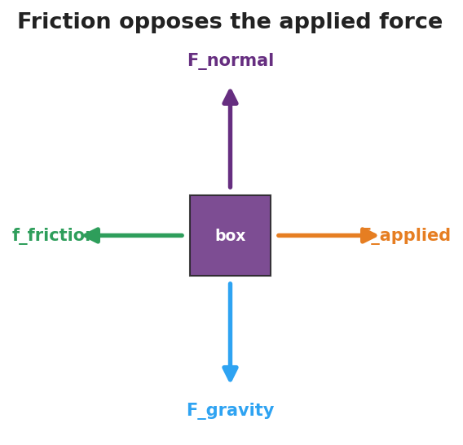
Free-body diagram of a box being dragged: applied force to the right, friction opposing to the left, normal force up, and gravity down.
The Level-3 “breakaway” pattern shows up clearly when friction force is plotted against applied force — it climbs through the static region to a peak, then drops to a steadier kinetic plateau:
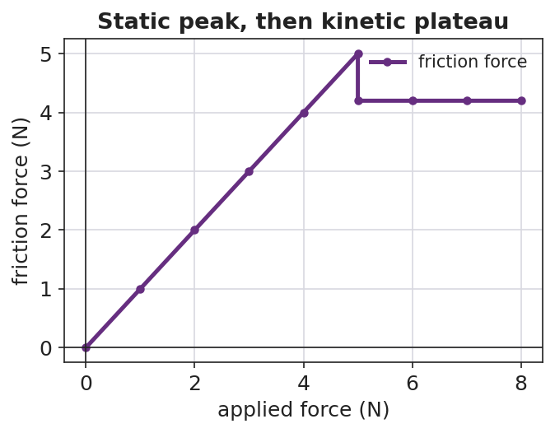
Line graph of friction force versus applied force: a rising static region up to a peak, then a lower, flat kinetic plateau once the object is sliding.

Teacher facilitation during Explore
- What to look for — groups noticing the reading climbs before the book/sneaker breaks loose, then drops and steadies once sliding.
- What to resist — don’t supply “μ” or “kinetic” yet; let the spring scales do the teaching.
- What to redirect — groups who say “heavier = more friction, always” should test it and articulate it as more normal force, more friction (Ff depends on FN, not mass directly).

30–32 min · Gallery check
Groups rotate one station clockwise. “What’s the same in their data? What’s different?” Surface the two big patterns: the breakaway (static peak > sliding) and the constant ratio (pull ÷ normal force).

Phase 3 · Explain (32 – 37 min)

32–35 min · Class consensus
“Across every station, what always pushed back on the sneaker, and what made that push bigger or smaller?”
Target consensus:
“A contact force pushes back against the motion. It’s bigger on rougher surface pairings and bigger when you press the surfaces together harder. Right before something slides, that push reaches a maximum; once it’s sliding, the push is steady and a bit smaller.”

35–37 min · Vocabulary introduction (≤ 3 terms)
Sample teacher language:
“That push-back is friction. Before an object slides, it’s static friction — it grows to match your push, up to a maximum. Once it slides, it’s kinetic friction — roughly constant. Your ‘pull ÷ weight’ ratio is the coefficient of friction, μ, and the Reference Table gives us Ff = μ·FN: friction equals μ times the normal force.”

Discussion prompts to deploy here
- “Why is it harder to start sliding a desk than to keep it sliding?”
  - Sample student response: “Static friction has a bigger maximum than kinetic friction, so the first push has to beat the bigger one.”
- “Two boxes on the same floor; one is heavier. Which needs more force to slide, and why?”
  - Sample student response: “The heavier one — more normal force, so Ff = μ·FN is larger.”

Phase 4 · Elaborate (37 – 40 min)

37–39 min · Revise the model
“Return to your sneaker drawing. Label the push-back arrow ‘friction.’ Add a sentence: when is it static, when is it kinetic, and what two things set its size? Use Ff = μ·FN.”

39–40 min · Return to the phenomenon (HS-PS2-3 thread)
“A phone in a padded case hits the floor. In one sentence using friction and normal force, why does a grippy case help it stop without sliding off the table edge first?”
Target: a grippy case raises μ, so even a small normal force gives enough friction to keep the phone from sliding — the design minimizes the force the phone takes by controlling how it stops.

Phase 5 · Evaluate (40 – 42 min)

40–42 min · Exit Ticket + Closing Reflection
“(a) A crate sits still while you push it gently and it does not move. Name the force opposing your push and say whether it is static or kinetic. Explain. (b) A 200 N crate sits on a floor with μ = 0.30 between the crate and the floor. Calculate the kinetic friction force on the crate as it slides. Show Ff = μ·FN. (c) Cause and Effect: name one change that would make the friction force larger.”
Expected: (a) static friction, because the crate is not sliding — it grows to match the push up to a maximum; (b) Ff = μ·FN = 0.30 × 200 N = 60 N; (c) a rougher surface (larger μ) or pressing it down harder / adding weight (larger FN). See Answer_Key.docx.
Closing Reflection (SEL, 30 seconds):
“Whose idea at your station changed how you think about friction today?”

Common Misconceptions
- Misconception: “Friction depends on how big the contact area is.” → Correction: For these surfaces, friction depends on μ and the normal force (Ff = μ·FN), not on contact area.
- Misconception: “Friction depends on speed.” → Correction: Kinetic friction is roughly constant regardless of sliding speed at this level.
- Misconception: “Heavier always means more friction.” → Correction: It’s the normal force that matters; more weight usually means more normal force, but tilt or extra downward push can change FN independent of mass.
- Misconception: “Static and kinetic friction are the same.” → Correction: Static friction varies up to a maximum (usually larger); kinetic friction is steady once sliding.

Access & Differentiation
- ELL/ENL supports: Sentence frame: *“Friction is ___ when the object is not moving and ___ when it slides; it gets bigger when ___ or ___.”* Word-choice box: {static, kinetic, rougher, normal force, opposes, μ}. Pair friction with a rubbing-hands gesture.
- IEP/SPED supports: Provide a pre-labeled force diagram (pull arrow + friction arrow) so students label “static/kinetic” rather than draw from scratch. Provide the Ff = μ·FN equation pre-printed with FN and μ boxes to fill.
- Extensions: Have students design a “minimize the force” pad (HS-PS2-3) and argue, using μ and FN, why their surface choice slows an object most gently.

Strategy Spotlight
Building Thinking Classrooms — random groups + vertical non-permanent surfaces (17 min) — see Phase 2, Investigation. The full process: visibly random groups of 3 by playing-card suit; chart-paper stations at standing height; one thin-sliced task card per station with four progressively harder tasks (Level 1 → 4). Teacher circulates and asks questions but does not solve. After ~17 minutes, rotate one station clockwise: “What’s the same in their data? What’s different?” — surface the breakaway (static peak > kinetic) and the constant pull ÷ normal-force ratio (μ).
The strategy works because visibly random groups signal that anyone can think with anyone, and the vertical non-permanent surface keeps thinking public and erasable, so groups take risks and the next group can verify the data on the wall.

NYSSLS Observation Checklist Crosswalk
# | Checklist item | Where it appears in this lesson
1 | Local/relatable phenomenon | Phase 1 — Sneaker Lab + stuck book; phone case in Phase 4
2 | Turn and Talk (2–3×) | Phase 1 (TT#1 — why different pull), Phase 2 (gallery check), Phase 3 (consensus)
3 | Students develop questions/models/procedures | Phase 1 (initial model), Phase 2 (BTC thin-sliced task), Phase 4 (revise model)
4 | CCC defined and used | Lesson Overview · Cause and Effect, restated in Phase 2 and Exit Ticket (c)
5 | ENL — ≤ 3 vocab, second half | Phase 3 — vocabulary at 35–37 min (friction / static / kinetic)
6 | Revisit phenomenon with evidence | Phase 4 — phone case + sneaker re-labeling with Ff = μ·FN
7 | ENL/SPED supports | Access & Differentiation block
8 | Assessment check | Phase 5 — Exit Ticket (crate, numeric Ff = μ·FN)

Companion Materials
- Student_Worksheet.docx — the 5E student investigation (hand out at start of Phase 2)
- Student_Notes.docx — guided note-guide for vocabulary and the worked example
- Answer_Key.docx — answers to “Make It Make Sense” prompts and the Exit Ticket

Key Vocabulary (max 3)
- friction — a contact force that opposes relative motion (or attempted motion) between two surfaces; on the Reference Table, Ff = μ·FN
- static friction — friction on an object that is not yet sliding; it varies to match the applied force up to a maximum
- kinetic friction — friction on an object that is already sliding; it is roughly constant

