Centripetal Force and Circular Motion — Teacher Guide

Cover
Unit: Forces — Lesson 05: Centripetal Force and Circular Motion East Meadow Schools × Valley Stream Central High School District Strategy chips: ACTIVE LEARNING

Curated Resources (from East Meadow Scope & Sequence)

NYSSLS Standards
This row of the Forces unit names no specific Performance Expectation, but it directly supports HS-PS2-1 (a net force causes acceleration). The twist students must confront: an object moving in a circle at constant speed is still accelerating, because its velocity direction keeps changing. The net force that produces that acceleration points toward the center of the circle. The CCC focus is Cause and Effect — a center-directed (centripetal) force is the cause, and center-directed acceleration (a curved path) is the effect.

Phenomenon
- Motorcycle “lowside” crash in a curve — the moment grip is lost, the bike stops turning and slides straight: https://www.youtube.com/watch?v=wRXOf-9YJU0
- Water stays in a bucket swung in a vertical circle: https://youtu.be/Zulw5bQ18Kk
- A ball or rubber stopper swung overhead on a string (live demo).

Javalab / Labs
- Circular Motion Labs — swing a rubber stopper on a string, vary radius and speed, and feel the tension change: https://javalab.org/en/circular_motion_en/
- oPhysics circular motion simulation (force vectors on a revolving object): https://ophysics.com/r1.html

Assessments
- Exit ticket below serves as the formative check (quantitative, uses Fc = m·v²/r).

Lesson Overview
Duration | 42 minutes (1 period)
NYSSLS link | Supports HS-PS2-1 (net force → acceleration, here center-directed)
CCC focus | Cause and Effect — a center-seeking net force causes a curved path; remove it and the path goes straight.
Strategy chips | ACTIVE LEARNING (swing-and-predict stopper stations)
Materials | Rubber stoppers on ~1 m strings (or beaded keychains); a few washers/weights; stopwatch; safety goggles; open floor space; whiteboards/markers.
Safety | Goggles on for all swinging. Clear a wide radius; swing in a vertical or horizontal plane away from faces. Inspect strings for fraying.
Prior knowledge | Velocity is a vector (size + direction); acceleration is any change in velocity (Lessons 01–04); net force causes acceleration.
Lesson objectives — students can:
- Explain why an object in uniform circular motion is accelerating even though its speed is constant.
- Identify the real force (tension, friction, gravity, normal) that acts as the centripetal force in a given situation.
- Use Fc = m·v²/r to relate force, mass, speed, and radius, and predict how each change affects the others.

Phase 1 · Engage (0 – 10 min)

0–3 min · Opening Connection (SEL)
Quick whip-around, one sentence each (pass allowed): “Name a time you felt like you were being thrown outward — a car turn, a spinning ride, a sharp bike turn.” You are deliberately collecting the feeling of being thrown outward; you will name and overturn it as the centrifugal misconception in Phase 3.

3–8 min · Phenomenon hook — the lowside crash
Teacher actions. Play the motorcycle lowside clip (pause the instant the tire loses grip). Replay in slow motion. Ask students to track the direction the bike travels the moment grip is lost.
Sample teacher language:
“Watch the curve. The rider is turning — turning — and the instant the tire loses grip, which way does the bike go? Not more curved. Watch.”
Anticipated student responses:
- “It shoots straight off the road.” — exactly; capture straight.
- “It slides outward / centrifugal force throws it out.” — capture this; we will test it. “Outward, or just straight ahead? Hold that thought.”
- “The road was slippery, so it lost the force keeping it turning.” — gold; “What force was that?”

8–10 min · Notice & Wonder + Turn-and-Talk #1
Two-column board capture. Then:
“Turn to your partner: while the bike was successfully turning, something had to keep pulling it into the curve. What was it, and which way did it point?”
Target seed: something pointed inward (toward the center of the curve) — friction from the tires. Leave open if no one lands it.

Bridge to Phase 2
Every student leaves with a one-sentence initial model: “The bike kept turning because ______, and it went straight when ______.”

Phase 2 · Explore (10 – 30 min)

10–14 min · Initial Model (silent / individual)
Prompt on the board:
“Draw the bike on the curved road from above. Draw an arrow showing the force that keeps it turning. Then predict: if that force vanishes, draw the dotted path the bike takes.”
This surfaces the inward-vs-outward intuition before any vocabulary.

14–30 min · Investigation — swing it, feel it, let it go (ACTIVE LEARNING)
Goggles on. Stopper-on-a-string stations (rotate or run as a carousel):
- Which way is the pull? Swing the stopper in a horizontal circle overhead at steady speed. Which way does your hand pull on the string — toward you (center) or away? What is the string doing to the stopper?
- Let it go. On a count, release the string mid-swing (point it at an open wall, not a person). Which way does the stopper fly — outward along the radius, or straight along a tangent? Repeat and watch carefully.
- Speed and radius. Swing faster: does the string pull harder or softer? Choke up to a shorter radius at the same speed: harder or softer? Add a washer (more mass): harder or softer?
Teacher facilitation language:
“Feel your hand. Are you pulling the stopper in or pushing it out?” “When you let go, did it curve outward — or go straight in the direction it was already heading?” “Faster swing — what happens to the tension you feel? Shorter string — what happens?”
The diagram below captures both station discoveries at once: the velocity points along the tangent (the direction the stopper flies when released), while the centripetal force points toward the center (the inward pull your hand feels).
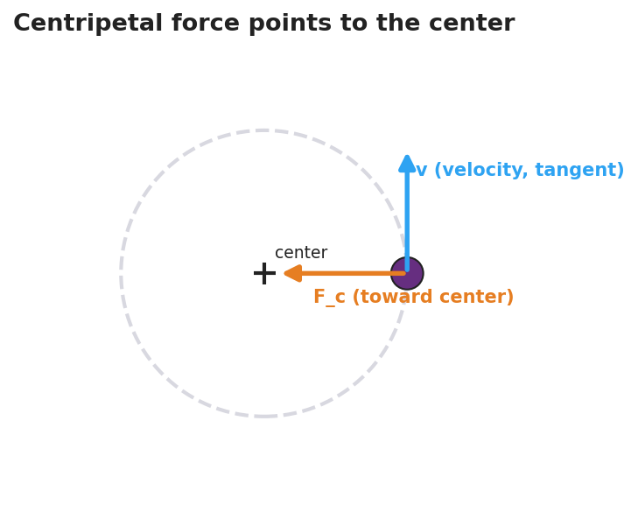
Diagram of an object on a circular path: a velocity arrow drawn tangent to the circle and a centripetal force arrow pointing inward toward the center.

Teacher facilitation during Explore
- What to look for — students reporting the released stopper flies off on a tangent (straight), not radially outward; and that faster/shorter/heavier all increase the felt tension.
- What to resist — don’t supply “centripetal” yet; let their hands feel the inward pull.
- What to redirect — students who insist the stopper flew “outward” should re-run station 2 and sight along the path; it leaves on the tangent line.

Phase 3 · Explain (30 – 36 min)

30–33 min · Turn-and-Talk #2 + class consensus
“Across every station, which way did the force point — and what happened the instant we removed it?”
Target consensus:
“The string always pulled the stopper toward the center. The speed was steady, but the direction kept changing — so the velocity changed — so it was accelerating. Remove the force and it flies off straight (tangent), because nothing is changing its direction anymore.”

33–36 min · Vocabulary introduction (≤ 3 terms) + the misconception
Sample teacher language:
“That inward, center-seeking pull is the centripetal force — centripetal literally means ‘center-seeking.’ It produces a centripetal acceleration pointed at the center, because the velocity direction is changing. How sharp the turn is depends on the radius. And here’s the key: there is no ‘centrifugal force’ throwing you out. That outward feeling is just your inertia — your body wanting to go straight while the car/string curves you in. The only real force is the inward one.”
Name the real provider each time: tension (string), friction (tires, the lowside), gravity (orbit, top of a vertical loop), normal force (a banked turn or the bucket bottom).

Discussion prompts to deploy here
- “When you swing the bucket of water overhead, why doesn’t the water fall out at the top?”
  - Sample student response: “It’s moving fast and wants to go straight; the bucket bottom pushes it inward (toward the center) faster than gravity could pull it out, so it stays in.”
- “A car turns left. Which way does the passenger feel thrown, and which way is the real force?”
  - Sample student response: “You feel thrown right (outward), but that’s inertia — the real force, friction, pushes the car left, toward the center.”

Phase 4 · Elaborate (36 – 40 min)

36–38 min · Revise the model
“Return to your bike drawing. Label the inward arrow ‘centripetal force (friction)’ and label the straight dotted release path ‘tangent — inertia, no net force.’ Write one revised sentence using centripetal force and radius.”

38–40 min · Quick quantitative reasoning (Fc = m·v²/r)
“From the Reference Table, Fc = m·v²/r. In station 3 you doubled the speed. What happened to the tension?”
Target: “It got about four times as hard, because v is squared.” Follow up: “Shorter radius at the same speed?” → “Harder, because r is in the denominator.” Tie directly back to what their hands felt.

Phase 5 · Evaluate (40 – 42 min)

40–42 min · Exit Ticket + Closing Reflection
“A 0.20 kg ball is swung in a horizontal circle of radius 0.50 m at a constant speed of 3.0 m/s. (a) Is the ball accelerating? Explain in one sentence. (b) Calculate the centripetal force on the ball. Show the equation and units. (c) A student says a ‘centrifugal force’ pushes the ball outward. Is the student correct? Explain.”
Expected: (a) Yes — direction (and so velocity) is changing. (b) Fc = m·v²/r = 0.20 · (3.0)² / 0.50 = 3.6 N, directed toward the center. (c) No — the only real force is the inward (centripetal) tension; the outward feeling is inertia, not a force. See Answer_Key.docx.
Closing Reflection (SEL, 30 seconds):
“What is one thing today that changed how you think about turning or spinning? Who helped you see it?”

Common Misconceptions
- Misconception: “A ‘centrifugal force’ throws objects outward in a turn.” → Correction: There is no outward force. Objects tend to go straight (inertia); the only real force is the inward centripetal force that curves the path. The outward “throw” is a feeling, not a force.
- Misconception: “Constant speed means no acceleration.” → Correction: Acceleration is any change in velocity; in a circle the direction changes constantly, so there is centripetal acceleration even at constant speed.
- Misconception: “Centripetal force is a new, separate kind of force.” → Correction: It is always provided by a real, familiar force — tension, friction, gravity, or normal force — acting toward the center.
- Misconception: “Released objects fly outward along the radius.” → Correction: They leave on the tangent, continuing in the straight-line direction they had at the instant of release.

Access & Differentiation
- ELL/ENL supports: Sentence frame: *“The ___ pulls the object toward the , so the object’s changes and it accelerates ___.”* Word-choice box: {center, tension, friction, gravity, direction, inward, tangent}. Pair centripetal with a hand-pulling-inward gesture.
- IEP/SPED supports: Provide a pre-drawn circle with the center marked; students draw and label only the inward arrow and the tangent release line. Offer the swing demo as a hands-on alternative to written explanation. Pre-fill the Fc equation with values to plug in.
- Extensions: Have students explain a banked highway curve or a satellite in orbit, naming which real force is centripetal, and reason about how doubling the radius changes Fc at fixed speed.

Strategy Spotlight
ACTIVE LEARNING (predict-and-test stations). Today’s core is a hands-on, predict-then-feel investigation. Students physically swing a stopper and (1) feel whether their hand pulls inward or outward, and (2) predict the release path, then test it by letting go. The “let it go” moment is the lesson’s hinge: students who expect a curved/outward exit watch the stopper leave on a tangent, which directly dismantles the centrifugal-force misconception through their own observation rather than teacher assertion. Keep predictions written before each test (commitment increases the conceptual payoff), insist on goggles, and have each group sight along the release path to confirm “straight, not outward.” Time-box each station to ~5 minutes.

NYSSLS Observation Checklist Crosswalk
# | Checklist item | Where it appears in this lesson
1 | Local/relatable phenomenon | Phase 1 — motorcycle lowside crash; bucket/string in Phase 3
2 | Turn and Talk (2–3×) | Phase 1 (TT#1 — what keeps it turning), Phase 3 (TT#2 — direction of force)
3 | Students develop questions/models/procedures | Phase 1 (initial model), Phase 2 (swing-and-release stations), Phase 4 (revise model)
4 | CCC defined and used | Lesson Overview · Cause and Effect, restated in Phases 2–3
5 | ENL — ≤ 3 vocab, second half | Phase 3 — vocabulary at 33–36 min (centripetal force / centripetal acceleration / radius)
6 | Revisit phenomenon with evidence | Phase 4 — re-label bike drawing with tangent + centripetal arrow
7 | ENL/SPED supports | Access & Differentiation block
8 | Assessment check | Phase 5 — quantitative Exit Ticket (Fc = m·v²/r)

Companion Materials
- Student_Worksheet.docx — the 5E student investigation (hand out at start of Phase 2)
- Student_Notes.docx — guided note-guide for vocabulary and the worked example
- Answer_Key.docx — answers to “Make It Make Sense” prompts and the Exit Ticket

Key Vocabulary (max 3)
- centripetal force — the net inward, “center-seeking” force that keeps an object moving in a circle; always provided by a real force (tension, friction, gravity, or normal force): Fc = m·v²/r
- centripetal acceleration — the center-directed acceleration of an object in circular motion, caused by its constantly changing velocity direction: ac = v²/r
- radius — the distance from the center of the circle to the object; smaller radius means a sharper turn and (at fixed speed) a larger required force

