Universal Gravitation — Teacher Guide

Cover
Unit: Forces — Lesson 06: Universal Gravitation East Meadow Schools × Valley Stream Central High School District Strategy chips: HOCHMAN

Curated Resources (from East Meadow Scope & Sequence)

NYSSLS Standards
This lesson targets HS-PS2-4 — “Use mathematical representations of Newton’s Law of Gravitation and Coulomb’s Law to describe and predict the gravitational and electrostatic forces between objects.” The CCC focus is Patterns: the same inverse-square mathematical pattern governs both gravity and electric force, so the structure students master here transfers directly to Coulomb’s Law in the later Electrostatics unit. Today the focus is gravitation; name the parallel pattern but do not teach Coulomb’s Law yet.

Phenomenon
- PhET Gravity Force Lab (basics) — drag two masses and watch the attraction change with mass and distance: https://phet.colorado.edu/en/simulations/gravity-force-lab-basics
- Anchoring question: Why doesn’t the Moon fall down onto Earth? / Why do astronauts feel weightless in orbit even though Earth’s gravity still acts on them? (Khan Academy): https://www.khanacademy.org/science/physics/centripetal-force-and-gravitation/gravity-newtonian/a/what-is-gravity

Javalab / Labs
- PhET Gravity Force Lab Basics — students drag two masses, increase a mass and watch the force arrows grow; double the separation and watch the force shrink to one-quarter: https://phet.colorado.edu/en/simulations/gravity-force-lab-basics

Assessments
- Exit ticket below serves as the formative check (numeric inverse-square reasoning). See Answer_Key.docx.

Lesson Overview
Duration | 42 minutes (1 period)
NYSSLS link | HS-PS2-4 (gravitation; parallels Coulomb’s Law)
CCC focus | Patterns — the inverse-square relationship is a repeating mathematical pattern across gravity and, later, electric force.
Strategy chips | HOCHMAN (sentence-level literacy: Because/But/So + appositive on the inverse-square law)
Materials | Projector + PhET Gravity Force Lab Basics (one device per pair if possible); 2025 Reference Tables; whiteboards/markers; calculators.
Safety | None — simulation and pencil-and-paper.
Prior knowledge | Weight as a force (Fg = mg), the difference between a force and a property, vectors as size + direction.
Lesson objectives — students can:
- State the law of universal gravitation in their own words: every mass attracts every other mass, and the pull depends on the masses and the distance between them.
- Use Fg = G·m₁·m₂/r² (2025 Reference Table) to calculate or compare gravitational forces.
- Apply the inverse-square law as a pattern: when distance doubles, the force drops to one-quarter.
- Distinguish mass (an unchanging amount of matter) from weight (the gravitational force on that mass).

Phase 1 · Engage (0 – 10 min)

0–3 min · Do Now / Opening Connection
Post the Do Now: “You weigh about 1/6 as much on the Moon as on Earth — but a scale that counts atoms would read exactly the same. How can both be true?” Take one or two responses; do not resolve it. This seeds the mass-vs-weight distinction you’ll name in Phase 3.

3–8 min · Phenomenon hook — Why doesn’t the Moon fall?
Teacher actions. Show the Moon-orbit image or the Khan clip. Pose the anchoring question.
Sample teacher language:
“Earth’s gravity reaches all the way to the Moon — it’s what holds the Moon in orbit. So why doesn’t the Moon just fall down onto us like a dropped ball?”
Anticipated student responses:
- “The Moon is too far away for gravity to reach.” — surface; we’ll show gravity does reach, just weaker with distance.
- “There’s no gravity in space.” — common misconception; flag it, address in Phase 3.
- “It’s moving sideways fast enough to keep missing Earth.” — excellent; capture it.

8–10 min · Notice & Wonder + Turn-and-Talk #1
Capture two columns. Then:
“Turn to your partner: name two things that might change how strongly two objects pull on each other.”
Target: how much stuff (mass) each has, and how far apart they are. Leave open if no one lands it.

Bridge to Phase 2
Every student leaves with a one-sentence initial model: “Two objects pull harder when ______.”

Phase 2 · Explore (10 – 28 min)

10–14 min · Initial Model (silent / individual)
Prompt on the board:
“Draw two spheres. Draw an arrow showing the pull each feels from the other. Then predict: if I make one sphere heavier, what happens to the arrows? If I move them farther apart, what happens?”
This surfaces intuition before any formula.

14–28 min · Investigation — PhET Gravity Force Lab Basics
Pairs (or whole-class projection) work the simulation:
- Mass test — keep distance fixed; double mass 1. What happens to the force? (It doubles.)
- Distance test — keep masses fixed; double the separation. What happens to the force? (It drops to one-quarter, not one-half — the surprise.)
- Pattern hunt — triple the distance. Predict first, then check. (Force → one-ninth.)
Teacher facilitation language:
“Predict before you drag. Doubling the distance — half the force, or something else?” “Force fell to one-quarter, not one-half. What did we square — the masses or the distance?” “Are the two arrows on the two masses equal or unequal? Even when the masses are very different?”
The “÷4, then ÷9” surprise is the inverse-square law. Project the graph below so students see the force falling off steeply — not linearly — as distance grows:
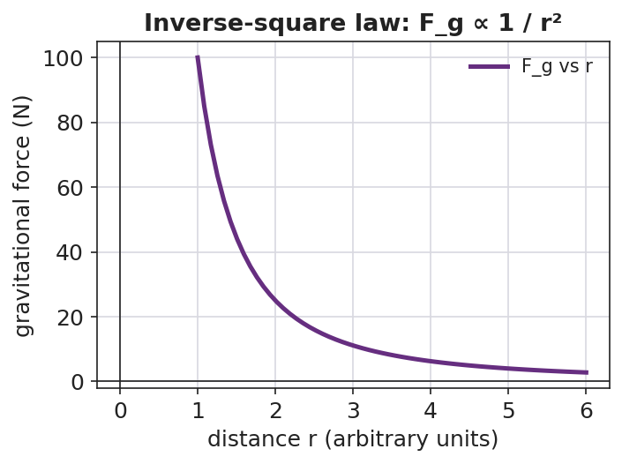
Line graph of gravitational force versus distance r: a steep inverse-square curve that falls off rapidly as r increases.
And no matter how different the two masses are, the pulls are equal in size and opposite in direction (a Newton’s-third-law cameo):
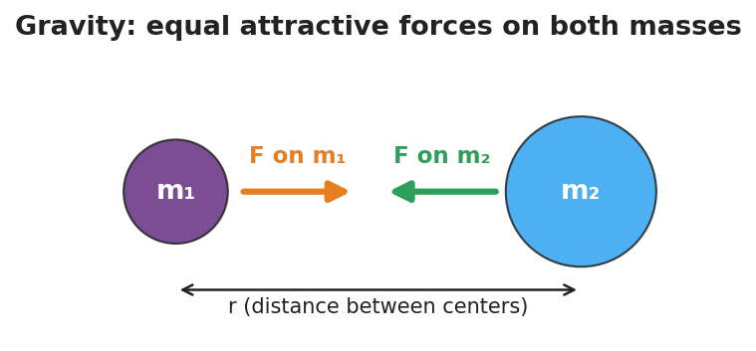
Two masses m1 and m2 separated by distance r, each feeling an equal-length attractive force arrow pointing toward the other.

Teacher facilitation during Explore
- What to look for — students noticing the force changes with the square of distance, and that the two pulls are always equal-and-opposite (Newton’s Third Law cameo).
- What to resist — don’t write Fg = Gm₁m₂/r² yet; let the simulation reveal the ÷4 pattern first.
- What to redirect — students who say “double distance, half force” should re-run the ×3 distance trial and confront the ÷9 result.

Phase 3 · Explain (28 – 35 min)

28–31 min · Turn-and-Talk #2 + class consensus
“What pattern did distance follow? Say it as a rule.”
Target consensus:
“More mass means more pull. But the distance matters in a stronger way — squaring it. Double the distance and the force isn’t halved, it’s quartered.”

31–35 min · Vocabulary + the equation (≤ 3 terms)
Sample teacher language:
“The pull every mass feels from every other mass is the gravitational force. The rule that the force falls with the square of the distance is the inverse-square law. And the amount of matter that sets how strong the pull is — and never changes — is mass.”
Write the Reference-Table equation and unpack it:
Fg = G·m₁·m₂ / r², where G = 6.67×10⁻¹¹ N·m²/kg². Near Earth’s surface this same gravitational force is what we call weight: Fg = mg, with g ≈ 9.81 m/s².

Discussion prompts to deploy here
- “Why is weight on the Moon smaller but mass the same?”
  - Sample student response: “Mass is how much matter you have — unchanged. Weight is the gravitational force, and the Moon’s smaller mass pulls less, so weight drops to about 1/6.”
- “Earth pulls the Moon; does the Moon pull Earth equally?”
  - Sample student response: “Yes — the two forces are equal and opposite, even though Earth is far more massive.”

Phase 4 · Elaborate (35 – 39 min)

35–37 min · Hochman Because/But/So
Project the stem and build it together (see Strategy Spotlight):
*“The gravitational force between two objects depends on their masses because , but it depends even more sharply on distance because , so ___.”*

37–39 min · Return to the phenomenon
“Now answer the Do Now and the Moon question in one sentence each, using gravitational force and inverse-square law.”
Target: Astronauts in orbit do feel Earth’s gravity — they are in continuous free fall, circling Earth, so they float; and the Moon stays in orbit because gravity pulls it inward while its sideways speed keeps it from falling straight down.

Phase 5 · Evaluate (39 – 42 min)

39–42 min · Exit Ticket + Closing Reflection
“Two satellites pull on each other with a gravitational force of 8 N. (a) Their masses stay the same, but the distance between them doubles. What is the new force? Show your reasoning. (b) Is the amount of matter (mass) in each satellite changed by moving them apart? Explain.”
Expected: (a) 8 N ÷ 4 = 2 N (inverse-square: double r → divide force by 2² = 4); (b) no — mass is unchanged; only the gravitational force changed. See Answer_Key.docx.
Closing Reflection (SEL, 30 seconds):
“What is one thing today that changed how you think about gravity or weight? Who helped you make sense of it?”

Common Misconceptions
- Misconception: “There is no gravity in space, so astronauts float.” → Correction: Earth’s gravity reaches far into space (it holds the Moon!). Orbiting astronauts float because they are in continuous free fall around Earth, not because gravity is absent.
- Misconception: “Mass and weight are the same thing.” → Correction: Mass is the unchanging amount of matter (kg); weight is the gravitational force on that mass (N) and depends on local g. Same mass on the Moon, smaller weight.
- Misconception: “Double the distance halves the force.” → Correction: It is an inverse-square law — double the distance divides the force by 2² = 4.
- Misconception: “Only the smaller object is pulled.” → Correction: Both objects pull on each other with equal and opposite gravitational forces, regardless of size.

Access & Differentiation
- ELL/ENL supports: Sentence frame: “When the distance doubles, the gravitational force becomes ___ because the distance is ___ in the formula.” Word-choice box: {squared, one-quarter, mass, weight, attract, distance}. Pair inverse-square with a gesture (hands spreading apart while the other hand shrinks).
- IEP/SPED supports: Provide the PhET data table pre-labeled with columns (mass, distance, force); students fill values only. Offer the worked example with the substitution already set up so students complete the arithmetic.
- Extensions: Have students compute the actual gravitational force between two 50 kg students standing 1 m apart using Fg = Gm₁m₂/r², and explain why we never feel it (≈ 1.7×10⁻⁷ N — far too small).

Strategy Spotlight
HOCHMAN (sentence-level literacy). Today’s signature move is a Because/But/So expansion built around an appositive on the inverse-square law. First model the appositive in Phase 3 by renaming the key term: “The inverse-square law — the rule that squaring the distance shrinks the force — explains the Moon’s steady orbit.” The appositive (set off by dashes) forces students to define the term in-line, a Hochman comprehension check. Then in Phase 4, students complete the Because/But/So stem so that a single complex sentence captures the whole conceptual contrast: mass matters, but distance matters more sharply, so the inverse-square pattern dominates at large separations. Collect 2–3 finished sentences and read them aloud so the class hears the precise causal language.

NYSSLS Observation Checklist Crosswalk
# | Checklist item | Where it appears in this lesson
1 | Local/relatable phenomenon | Phase 1 — Moon orbit / Moon-weight Do Now
2 | Turn and Talk (2–3×) | Phase 1 (TT#1 — what affects pull), Phase 3 (TT#2 — name the distance pattern)
3 | Students develop questions/models/procedures | Phase 1 (initial model), Phase 2 (PhET investigation), Phase 4 (revise model)
4 | CCC defined and used | Lesson Overview · Patterns, restated in Phase 2 (inverse-square pattern)
5 | ENL — ≤ 3 vocab, second half | Phase 3 — vocabulary at 31–35 min (gravitational force / inverse-square law / mass)
6 | Revisit phenomenon with evidence | Phase 4 — Moon orbit + astronaut free fall, using PhET evidence
7 | ENL/SPED supports | Access & Differentiation block
8 | Assessment check | Phase 5 — Exit Ticket (8 N → 2 N inverse-square)

Companion Materials
- Student_Worksheet.docx — the 5E student investigation (hand out at start of Phase 2)
- Student_Notes.docx — guided note-guide for vocabulary and the worked example
- Answer_Key.docx — answers to “Make It Make Sense” prompts and the Exit Ticket

Key Vocabulary (max 3)
- gravitational force — the attractive force every mass exerts on every other mass; near Earth’s surface it is what we call weight (Fg = mg)
- inverse-square law — the pattern in which a force shrinks with the square of the distance, so doubling the distance divides the force by four
- mass — the unchanging amount of matter in an object (in kilograms), which sets how strongly it gravitates and is not the same as weight

