Work — Teacher Guide

Cover
Unit: Work, Energy & Power — Lesson 01: Work East Meadow Schools × Valley Stream Central High School District Strategy chips: HOCHMAN

Curated Resources (from East Meadow Scope & Sequence)

NYSSLS Standards
The Work, Energy & Power unit develops HS-PS3 (energy). This opening lesson defines the transfer mechanism — work — that the rest of the unit quantifies. It builds the vocabulary and the W = F·d relationship that make HS-PS3-1 possible: “Create a computational model to calculate the change in energy of one component in a system when the change in energy of the other component(s) and energy flows in and out of the system are known.” (Crosscutting Concept: Systems and System Models.) Work is the first “energy flow in/out” students will compute.

Phenomenon
- Lifting a loaded backpack straight up onto a high shelf vs. carrying the same backpack across a level hallway. https://www.youtube.com/watch?v=2WS1sErgcUI (Khan Academy: Work as the transfer of energy)
- The Physics Classroom — “Definition and Mathematics of Work”: https://www.physicsclassroom.com/class/energy/Lesson-1/Definition-and-Mathematics-of-Work

Javalab / Labs
- Javalab — Work and energy simulations index: https://javalab.org/en/category/energy_en/

Assessments
- The Physics Classroom check-set on the work equation (link above). The Exit Ticket below is the formative check; the constructed-response “Make It Make Sense” items map to HS-PS3-1.

Lesson Overview
Duration | 42 minutes (1 period)
NYSSLS link | HS-PS3-1 (foundation — work as an energy flow into/out of a system)
CCC focus | Systems and System Models — work is energy transferred into or out of a chosen system.
Strategy chips | HOCHMAN (Because/But/So + appositive on W = F·d)
Materials | A loaded backpack or textbook stack; a bathroom/spring scale (N) or known masses; meter stick; whiteboards/markers.
Safety | Lift with knees; keep walkways clear; do not drop masses on feet.
Prior knowledge | Forces — net force and the newton; displacement as a vector (size + direction).
Lesson objectives — students can:
- Define work as energy transferred when a force moves an object through a displacement, and state its unit, the joule.
- Calculate work with W = F·d, using only the component of force along the displacement.
- Explain why carrying a load horizontally at steady speed does zero work on the load, while lifting it does positive work.

Phase 1 · Engage (0 – 10 min)

0–3 min · Opening Connection (SEL)
Quick pair-share, one sentence each: “Name a time today your arms or legs felt tired even though you didn’t really go anywhere.” Hold a few responses (holding a sibling, carrying groceries, standing on the train). Plant the puzzle: being tired is not the same as doing physics “work.”

3–7 min · Phenomenon hook — lift it vs. carry it
Teacher actions. Hold a loaded backpack. (1) Lift it straight up from the floor to a high shelf. (2) Now carry it across the room at a steady walk, holding it at constant height.
Sample teacher language:
“Both made my arms tired. But a physicist would say I did work in only one of these. Watch where the bag moves compared to the direction I’m pushing or pulling on it.”
Anticipated student responses:
- “You did work both times — you were holding it!” — surface; honor the effort, then redirect to direction of motion.
- “The lift was harder so that’s the work one.” — closer; we will tie work to force and distance, not just effort.
- “When you carried it, it went sideways but you held it up.” — capture this; it is the seed of “force ⟂ motion.”

7–10 min · Notice & Wonder + Turn-and-Talk #1
Two columns on the board. Then:
“Turn to your partner: in which case did the force you applied point the same direction the bag actually moved? Use the words force and direction.”
Take 2–3 responses. Desirable insight: when lifting, your force (up) and the bag’s motion (up) line up; when carrying, your force is up but the motion is sideways.

Bridge to Phase 2
Every student leaves Phase 1 with an initial model sentence: “Work was done when ______ because ______.”

Phase 2 · Explore (10 – 28 min)

10–15 min · Initial Model (silent / individual)
Prompt on the board:
“Draw the backpack in each case. Draw one arrow for your force and one arrow for the bag’s displacement. Then predict: in which case did you do more work on the bag — and is one of them zero?”
This surfaces the alignment intuition before any equation.

15–28 min · Investigation — measure the work
Whole-class or small groups with one scale and a meter stick:
- Lift it. Read the weight (force, in N) needed to hold the load. Lift it a measured height h. Record F and d (= h). Compute W = F·d.
- Carry it. Walk the same load a measured horizontal distance at constant height. Ask: what is the vertical force you apply? What direction did the load move? How much of your force points along that motion?
- Vary the distance. Lift the same load 0.5 m, then 1.0 m, then 1.5 m. Tabulate W vs. d.
Project the figure as the data come in:
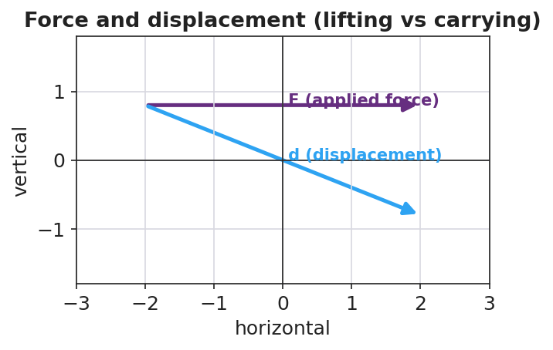
Force and displacement: lifting (force along motion) vs carrying (force perpendicular to motion)
Teacher facilitation language:
“When you carried it, which way did the bag move? Which way did your force point? Is any part of your push pointing along the walk?” “Double the lift height. What happened to the work? Predict before you compute.”
Anticipated student responses:
- “When I doubled the height, the work doubled.” — exactly; W is proportional to d at fixed F.
- “Carrying it, my force is up but it moved sideways, so… none of my force is along the motion?” — land this; that is zero work on the bag.

Teacher facilitation during Explore
- What to look for — students noting that only the part of the force along the displacement counts.
- What to resist — don’t hand them “joule” or the formula yet; let the scale and meter stick build it.
- What to redirect — “I was tired so I did work” → ask what direction did the object move relative to your force?

Phase 3 · Explain (28 – 35 min)

28–31 min · Turn-and-Talk #2 + class consensus
“Across both cases, what two things did it take to do work on the bag — and why was carrying it zero?”
Target consensus:
“Work happens when a force moves an object in the direction of the force. Lifting: force up, motion up — they line up, so work is done. Carrying at steady height: force up, motion sideways — the force is perpendicular to the motion, so it does zero work on the bag.”

31–35 min · Vocabulary introduction (≤ 3 terms) + HOCHMAN
Build the equation from the reference table: W = F·d (force × distance moved along the force). Units: a newton-meter is a joule (J).
Sample teacher language (Hochman appositive + Because/But/So):
“Write it as an appositive: Work, the energy transferred when a force moves an object through a displacement, is measured in joules. Now Because/But/So: Carrying the box does zero work on it because the upward force is perpendicular to the sideways motion, but my muscles still get tired, so ‘tired’ and ‘work’ are not the same thing in physics.”

Discussion prompts to deploy here
- “A waiter holds a tray steady while standing still. How much work does he do on the tray? Why?”
  - Sample response: “Zero — the tray doesn’t move, so d = 0, so W = 0.”
- “You push a 200 N crate 3 m across the floor. How much work?”
  - Sample response: “W = F·d = 200 × 3 = 600 J.”

Phase 4 · Elaborate (35 – 40 min)

35–38 min · Revise the model + apply the graph
“Return to your two drawings. Re-label each: is the force along the motion, or perpendicular to it? Compute the work for the lift. Then sketch how work changes as the lift distance grows.”
Project:
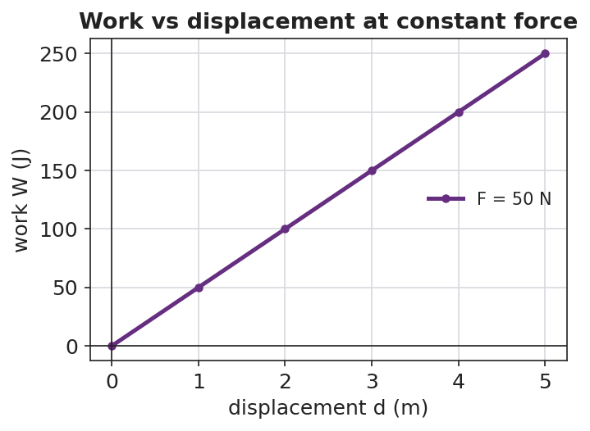
Work vs displacement at constant force is a straight line through the origin
Target: at constant force, work grows in direct proportion to distance — a straight line through the origin whose slope is the force.

38–40 min · Return to the phenomenon
“Explain to your partner, in one Because/But/So sentence, why carrying the backpack down the hall does zero work on it but lifting it onto the shelf does positive work.”

Phase 5 · Evaluate (40 – 42 min)

40–42 min · Exit Ticket + Closing Reflection
“A custodian pushes a 250 N mop bucket 8.0 m across a level floor at steady speed. (a) How much work does she do on the bucket? Show W = F·d. (b) She then holds the bucket still for 10 seconds. How much work does she do during those 10 seconds? Explain. (c) A student carries a 40 N lunch tray across the cafeteria at constant height. How much work is done on the tray, and why?”
Expected: (a) 250 × 8.0 = 2000 J; (b) zero — no displacement; (c) zero — the supporting force is perpendicular to the horizontal motion. See Answer_Key.docx.
Closing Reflection (SEL, 30 seconds):
“What is one everyday moment you’ll now describe differently because of today — and who helped you see it?”

Common Misconceptions
- Misconception: “If I get tired, I did work.” → Correction: Physics work requires the object to move in the direction of the force; holding something still does zero work (d = 0).
- Misconception: “Any force on a moving object does work.” → Correction: Only the component of force along the displacement does work; a perpendicular force does zero work.
- Misconception: “Carrying a box across a room does work on the box.” → Correction: At constant height the support force is vertical while motion is horizontal — they are perpendicular, so W = 0 on the box.

Access & Differentiation
- ELL/ENL supports: Sentence frame: “Work was done on the ___ because the force pointed ___ the motion, so energy was transferred.” Word box: {force, displacement, joule, along, perpendicular}. Pair perpendicular with an L-shaped hand gesture.
- IEP/SPED supports: Provide a pre-drawn two-panel diagram (lift / carry) with force and motion arrows already drawn; students only label “along” or “perpendicular” and circle which does work. Provide the W = F·d formula and a worked unit example on a reference card.
- Extensions: Introduce work done by a force at an angle (W = F·d·cosθ): predict and check the work when a sled rope is pulled at 30° vs. 0°.

Strategy Spotlight
HOCHMAN (literacy). Today’s writing moves are the appositive (defining work mid-sentence) and Because/But/So (explaining the zero-work case). Model the appositive aloud, then have students expand one kernel sentence — “Work is energy transferred” — into a full appositive definition. The Because/But/So in Phase 4 forces students to hold the “tired ≠ work” distinction in a single, precise sentence. Collect two or three on the board and revise for precision as a class.

NYSSLS Observation Checklist Crosswalk
# | Checklist item | Where it appears in this lesson
1 | Local/relatable phenomenon | Phase 1 — backpack lift vs. carry; custodian bucket in Phase 5
2 | Turn and Talk (2–3×) | Phase 1 (TT#1 — force vs. direction), Phase 3 (TT#2 — what makes work)
3 | Students develop questions/models/procedures | Phase 1 (initial model), Phase 2 (measure W = F·d), Phase 4 (revise model)
4 | CCC defined and used | Lesson Overview · Systems and System Models, applied in Phase 2
5 | ENL — ≤ 3 vocab, second half | Phase 3 — vocabulary at 31–35 min (work / joule / displacement)
6 | Revisit phenomenon with evidence | Phase 4 — re-label lift vs. carry with measured W
7 | ENL/SPED supports | Access & Differentiation block
8 | Assessment check | Phase 5 — Exit Ticket (mop bucket + lunch tray)

Companion Materials
- Student_Worksheet.docx — the 5E student investigation (hand out at start of Phase 2)
- Student_Notes.docx — guided note-guide for vocabulary and the worked example
- Answer_Key.docx — answers to “Make It Make Sense” prompts and the Exit Ticket

Key Vocabulary (max 3)
- work — energy transferred when a force moves an object through a displacement along the force; W = F·d
- joule — the SI unit of work and energy; one joule equals one newton-meter (1 J = 1 N·m)
- displacement — the change in an object’s position (size and direction); only motion along the force counts toward work

