Heat Transfer and the Second Law of Thermodynamics — Teacher Guide

Cover
Unit: Thermal Energy & Conservation (Thermodynamics) — Lesson 02: Heat Transfer and the Second Law of Thermodynamics East Meadow Schools × Valley Stream Central High School District Strategy chips: HOCHMAN

Curated Resources (from East Meadow Scope & Sequence)

NYSSLS Standards
This lesson is the conceptual core of the unit’s anchor standard, HS-PS3-4: “Plan and conduct an investigation to provide evidence that the transfer of thermal energy when two components of different temperature are combined within a closed system results in a more uniform energy distribution among the components (second law of thermodynamics). (Systems and System Models).” Students establish the direction of spontaneous heat flow (hot → cold), the idea of thermal equilibrium, and the second law of thermodynamics as the statement that energy spreads toward a more uniform distribution. Lesson 03 then measures the transfer quantitatively with Q = m·c·ΔT.

Phenomenon
- Penguin huddle (BBC) — emperor penguins rotate through a tight huddle so warmth spreads and no one stays frozen on the outside: https://www.youtube.com/watch?v=4Py9eXIO_z0
- An ice cube melting in a warm drink — track the drink cooling and the ice warming until both reach one temperature.
- Heat pipe / metal spoon in hot soup — the handle warms even though only the bowl end touched the soup.

Javalab / Labs
- Javalab — Heat transfer / thermal equilibrium (two bodies at different temperatures reach equilibrium): https://javalab.org/en/heat_transfer_en/
- Javalab — Conduction, convection, radiation: https://javalab.org/en/heat_transfer_methods_en/

Assessments
- Exit Ticket below (spoon in soup + direction of heat flow) is the formative check.
- Javalab equilibrium sim has an observable “temperatures meet” endpoint usable as a quick check.

Lesson Overview
Duration | 42 minutes (1 period)
NYSSLS link | HS-PS3-4 (core — second law, uniform energy distribution)
CCC focus | Systems and System Models — within a closed system, energy redistributes from concentrated (hot) to spread-out (uniform).
Strategy chips | HOCHMAN (sentence-level literacy: Because/But/So)
Materials | Warm water + ice cubes + clear cups + thermometers (one set per group); metal spoon; penguin-huddle clip; heat-transfer-modes diagram; whiteboards.
Safety | Use warm (not scalding) tap water. Wipe spills to prevent slips.
Prior knowledge | Lesson 01 — temperature is average particle KE; thermal energy is total particle KE.
Lesson objectives — students can:
- Describe how heat flows spontaneously from a hotter object to a cooler one until they reach thermal equilibrium.
- Identify conduction, convection, and radiation as the three ways thermal energy transfers.
- State the second law of thermodynamics in their own words: in a closed system, thermal energy spreads to a more uniform distribution.

Phase 1 · Engage (0 – 12 min)

0–3 min · Opening Connection (SEL)
Quick whip-around (one sentence): “Name one thing you do to warm up or cool down — and say whether you are adding or letting go of energy.” This primes the direction-of-flow idea.

3–8 min · Phenomenon hook — the penguin huddle / ice in a drink
Teacher actions. Play ~60 seconds of the penguin-huddle clip; the birds on the cold edge rotate inward and warmth spreads through the group. Then drop an ice cube into a cup of warm water at each table and start a stopwatch.
Sample teacher language:
“Watch the penguins on the outside — they’re freezing. Watch what the huddle does about it. Now, in your cup: the water is warm and the ice is cold. In two minutes, what will the thermometer say? Will the ice ‘win,’ will the water ‘win,’ or something else?”
Anticipated student responses:
- “The water warms the ice up until they’re the same.” — capture “the same”; that is thermal equilibrium.
- “Cold flows into the water.” — gently flag: we will argue it is energy that flows (hot → cold), not “cold.”
- “The penguins share heat so nobody freezes.” — name it: energy spreads out to become more uniform.

8–12 min · Notice & Wonder + Turn-and-Talk #1
Two columns on the board. Then:
“Turn to your partner: which way does the energy move — from the warm water to the ice, or from the ice to the water? How do you know?”
Target seed: energy always moves from the hotter thing to the colder thing, never the other way on its own. Leave open if unresolved.

Bridge to Phase 2
Each student leaves with a one-sentence initial model: “The energy moves from ______ to ______ because ______.”

Phase 2 · Explore (12 – 32 min)

12–17 min · Initial Model (silent / individual)
Prompt on the board:
“Draw the warm water and the ice cube the instant they meet. Use arrows to show which way thermal energy flows. Predict the final temperature: closer to the ice, closer to the warm water, or in between?”

17–32 min · Investigation — tracking two temperatures to equilibrium
Each group measures two temperatures over time: the warm water and a cold-water (or melting-ice) sample, recording every 30 seconds.
- Direction. Which sample’s temperature goes down? Which goes up?
- Equilibrium. Do the two temperatures meet? What happens after they meet?
- Modes. Touch the metal spoon left in hot water (conduction); watch warm water rise in the cup (convection); feel warmth from a lamp without touching it (radiation). Use the diagram:
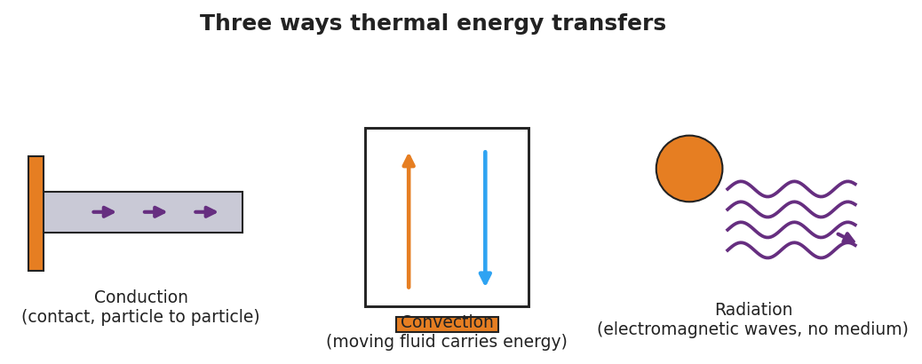
Conduction, convection, and radiation — three ways thermal energy transfers
Plot the class data as two converging curves:
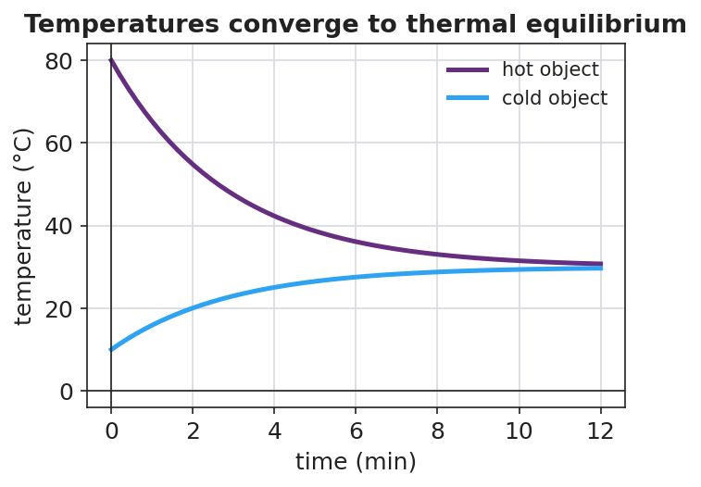
Two objects’ temperatures converging to thermal equilibrium
Teacher facilitation language:
“Tell me which thermometer is dropping and which is climbing. Now — do they ever cross, or do they meet and stop?” “Is ‘cold’ flowing into the water, or is energy flowing out of the water into the ice?” “Once they’re equal, does energy keep moving back and forth, or has it spread out evenly?”

Teacher facilitation during Explore
- What to look for — students noticing the two curves converge and then flatten at one shared temperature.
- What to resist — don’t name the second law yet; let the converging curves do the arguing.
- What to redirect — “cold flows in” → ask “What is actually moving — energy, or cold? Which direction?” Steer to “energy flows hot → cold.”

Phase 3 · Explain (32 – 37 min)

32–35 min · Turn-and-Talk #2 + class consensus
“Across every group, which way did the energy always flow, and where did the temperatures end up?”
Target consensus:
“Thermal energy always flows on its own from the hotter object to the cooler one, until both reach the same temperature — thermal equilibrium. The energy spreads out to become more uniform.”

35–37 min · Vocabulary introduction (≤ 3 terms)
Sample teacher language:
“The thermal energy that moves because of a temperature difference is called heat. It always flows from hot to cold until the objects reach thermal equilibrium — the same temperature. The rule that energy spontaneously spreads to a more uniform distribution is the second law of thermodynamics.”

Discussion prompts to deploy here
- “Why does the metal spoon handle get warm even though only the bowl end is in the soup?”
  - Sample student response: “Conduction — fast-moving particles at the hot end bump the next particles, passing energy along until the handle warms toward equilibrium.”
- “Why do the penguins rotate through the huddle?”
  - Sample student response: “So thermal energy spreads more uniformly through the group — no one stays at the cold edge; that’s the second law working for them.”

Phase 4 · Elaborate (37 – 40 min)

37–39 min · Revise the model — Hochman Because/But/So
This is the Hochman strategy lesson. Have every student expand one kernel sentence using all three conjunctions:
“Complete: ‘Thermal energy flows from the hot water into the ice because ____, but ____, so ____.’”
Model one on the board first, e.g.: “…because the hot water’s particles have more energy, but the flow stops once both are the same temperature, so the system reaches thermal equilibrium with energy spread evenly.”

39–40 min · Return to the phenomenon
“Use the second law to explain in one sentence why the penguin huddle keeps the whole group alive.”
Target: “Energy spreads from the warm inner birds outward to a more uniform distribution as they rotate, so no penguin stays cold enough to die — the second law made even.”

Phase 5 · Evaluate (40 – 42 min)

40–42 min · Exit Ticket + Closing Reflection
“You drop a warm metal spoon into a cup of cold water in an insulated (closed) container. (a) Which way does thermal energy flow, and why? (b) What is the final situation called, and how do the two temperatures compare then? (c) Name the heat-transfer mode that warms the spoon’s handle, and state the second law of thermodynamics in your own words.”
Expected: (a) from the warmer spoon to the cooler water — heat flows hot → cold; (b) thermal equilibrium — the spoon and water reach the same temperature; (c) conduction; second law: in a closed system energy spontaneously spreads to a more uniform distribution. See Answer_Key.docx.
Closing Reflection (SEL, 30 seconds):
“What is one thing today that changed how you think? Who helped you make sense of it?”

Common Misconceptions
- Misconception: “Cold flows into warm objects.” → Correction: Cold is not a substance. Thermal energy flows from hot to cold; “getting colder” means losing energy.
- Misconception: “Heat and temperature are the same.” → Correction: Heat is energy in transit due to a temperature difference; temperature is the average particle KE of one object.
- Misconception: “At equilibrium, energy stops moving entirely.” → Correction: Particles still move and exchange energy, but there is no net flow — the distribution is uniform.

Access & Differentiation
- ELL/ENL supports: Sentence frame: *“Thermal energy flows from the ___ object to the ___ object until they reach ___.”* Word-choice box: {hotter, cooler, thermal equilibrium, heat, uniform}. Pair equilibrium with two hands meeting at the same height.
- IEP/SPED supports: Provide a pre-labeled two-line graph axis; students draw the two converging curves rather than building the table from scratch. Offer the spoon-in-water station as a hands-on alternative to writing.
- Extensions: Ask students to explain why a closed thermos slows — but cannot stop — the approach to equilibrium, and which transfer modes a thermos is designed to block.

Strategy Spotlight
HOCHMAN (sentence-level literacy). Phase 4 uses the Hochman Because / But / So expansion on a single kernel sentence about heat flow. Model one complete expansion first, then require each student to produce one that is physics-correct (energy flows hot → cold; flow stops at equilibrium). The three conjunctions force cause (because), limitation (but), and consequence (so) — exactly the reasoning the second law demands. Keep it to one sentence; quality over quantity.

NYSSLS Observation Checklist Crosswalk
# | Checklist item | Where it appears in this lesson
1 | Local/relatable phenomenon | Phase 1 — penguin huddle / ice in a warm drink; spoon in soup in Phase 3
2 | Turn and Talk (2–3×) | Phase 1 (TT#1 — which way energy moves), Phase 3 (TT#2 — direction + endpoint)
3 | Students develop questions/models/procedures | Phase 1 (initial model), Phase 2 (two-temperature investigation), Phase 4 (revise model)
4 | CCC defined and used | Lesson Overview · Systems and System Models, restated in Phase 2
5 | ENL — ≤ 3 vocab, second half | Phase 3 — vocabulary at 35–37 min (heat / thermal equilibrium / second law)
6 | Revisit phenomenon with evidence | Phase 4 — penguin huddle re-explained + Because/But/So
7 | ENL/SPED supports | Access & Differentiation block
8 | Assessment check | Phase 5 — Exit Ticket (spoon in cold water)

Companion Materials
- Student_Worksheet.docx — the 5E student investigation (hand out at start of Phase 2)
- Student_Notes.docx — guided note-guide for vocabulary and the worked example
- Answer_Key.docx — answers to “Make It Make Sense” prompts and the Exit Ticket
- figures/approach_equilibrium.png, figures/heat_transfer_modes.png — projection visuals

Key Vocabulary (max 3)
- heat — thermal energy that flows from a hotter object to a cooler one because of a temperature difference
- thermal equilibrium — the state in which two objects in contact reach the same temperature and there is no net flow of thermal energy between them
- second law of thermodynamics — in a closed system, thermal energy spontaneously spreads to a more uniform (less concentrated) distribution

