Calorimetry — Thermal Tales — Teacher Guide

Cover
Unit: Thermal Energy & Conservation (Thermodynamics) — Lesson 03: Calorimetry — Thermal Tales East Meadow Schools × Valley Stream Central High School District Strategy chips: ACTIVE LEARNING

Curated Resources (from East Meadow Scope & Sequence)

NYSSLS Standards
This lesson is the investigation that fully satisfies the unit anchor, HS-PS3-4: “Plan and conduct an investigation to provide evidence that the transfer of thermal energy when two components of different temperature are combined within a closed system results in a more uniform energy distribution among the components (second law of thermodynamics). (Systems and System Models).” Students plan and conduct a calorimetry investigation: combine hot and cold water in a closed (insulated) cup, predict and measure the final temperature, and show with Q = m·c·ΔT that the heat lost by the hot water equals the heat gained by the cold water. This is the quantitative payoff of Lesson 02’s hot-to-cold flow.

Phenomenon
- Thermal Tales / mixing water — pour a measured mass of hot water into a measured mass of cold water in an insulated cup; predict the final temperature before you read the thermometer. Reference investigation framing (NYSED Investigating Energy / Thermal Energy tasks): https://www.nysed.gov/curriculum-instruction/science-learning-standards
- PhET Energy Forms and Changes — heat and mix substances, watch energy chunks move: https://phet.colorado.edu/en/simulations/energy-forms-and-changes

Javalab / Labs
- Calorimetry / “Thermal Tales” lab (this lesson) — hot + cold water mixing in a foam-cup calorimeter; heat lost = heat gained.
- Javalab — Specific heat / calorimetry: https://javalab.org/en/specific_heat_en/

Assessments
- Exit Ticket below (predict-the-final-temperature calculation) is the formative check.
- The completed calorimetry data table + Q-balance is a NYSSLS investigation artifact for HS-PS3-4.

Lesson Overview
Duration | 42 minutes (1 period; pairs well with a double-period day for a longer run)
NYSSLS link | HS-PS3-4 (investigation — plan, conduct, evidence; closed system; uniform distribution)
CCC focus | Energy and Matter / Systems and System Models — energy is conserved within a closed system; heat lost = heat gained.
Strategy chips | ACTIVE LEARNING (NYS Investigation)
Materials | Foam-cup calorimeters with lids; hot water (~80 °C) and cold water (~20 °C); graduated cylinders/balances; thermometers; stopwatch; whiteboards. NYS Reference Table (Q = m·c·ΔT; c_water = 4,186 J/kg·°C).
Safety | Hot water ~80 °C — pour carefully, no scalding water above that. Wipe spills immediately.
Prior knowledge | Lessons 01–02 — thermal energy is total particle KE; heat flows hot → cold to equilibrium.
Lesson objectives — students can:
- Use Q = m·c·ΔT to calculate the heat gained or lost by a water sample.
- Show that, in a closed system, the heat lost by the hot object equals the heat gained by the cold object.
- Plan and conduct a calorimetry investigation and predict the final equilibrium temperature.

Phase 1 · Engage (0 – 12 min)

0–3 min · Opening Connection (SEL)
Quick whip-around (one sentence): “Name one time you mixed something hot and something cold — and what you got.” (Coffee + ice, hot cocoa + cold milk, a bath you adjusted.) This anchors the predict-the-mix task.

3–8 min · Phenomenon hook — predict the mix
Teacher actions. Hold up a cup of hot water (~80 °C) and a cup of cold water (~20 °C), each the same amount. Before mixing, ask every student to commit to a prediction on a whiteboard.
Sample teacher language:
“Equal amounts: this one’s 80 degrees, this one’s 20. I pour them together in this insulated cup. Write down right now — what does the thermometer read after they mix? Don’t hedge. Commit to a number.”
Anticipated student responses:
- “100 — you add them.” — common error; surface it, we will refute with conservation.
- “50 — it’s the average.” — for equal masses this is right; ask them why the average works.
- “Somewhere in the middle, closer to whichever there’s more of.” — excellent; this previews unequal masses.

8–12 min · Notice & Wonder + Turn-and-Talk #1
Two columns on the board. Then:
“Turn to your partner: the hot water cools down and the cold water warms up. Is the energy that leaves the hot water the same amount the cold water gains? Why?”
Target seed: in a closed cup, no energy escapes — what the hot loses, the cold gains. Leave open if unresolved.

Bridge to Phase 2
Each student commits a predicted final temperature with one sentence of reasoning.

Phase 2 · Explore (12 – 32 min)

12–16 min · Initial Model + plan the investigation (Active Learning)
Prompt on the board:
“With your group, write the procedure: what will you measure (masses, starting temperatures), how will you keep the system closed, and how will you know when you’ve reached the final temperature?”
Groups draft a short plan; circulate and approve before they pour. This is the plan and conduct an investigation move of HS-PS3-4.

16–32 min · Investigation — the Thermal Tales calorimetry run
Each group:
- Measures and records the mass and starting temperature of the hot water and the cold water.
- Pours both into the foam-cup calorimeter, lids it, and records the temperature every 15 seconds until it levels off.
- Plots both samples meeting at the final temperature, and computes Q for each side.
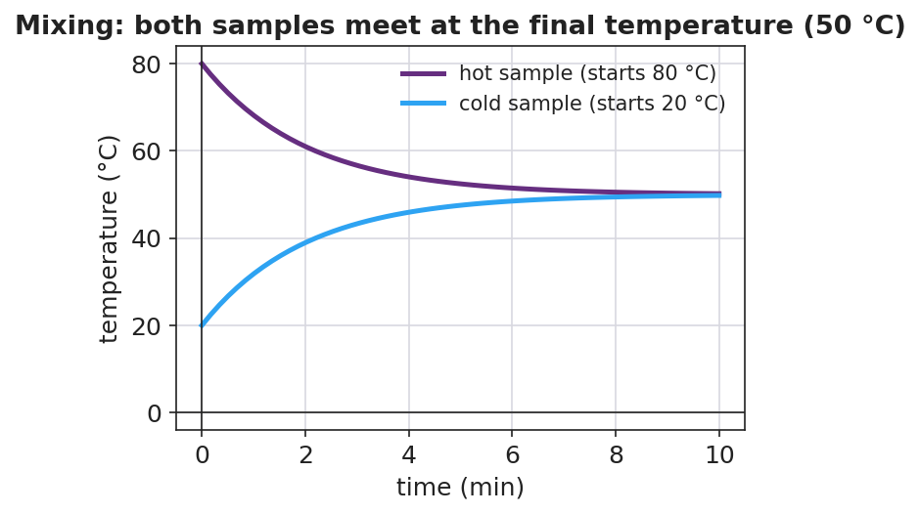
Hot and cold samples meeting at the final temperature
Then they test the conservation claim with Q = m·c·ΔT (c_water = 4,186 J/kg·°C from the Reference Table):
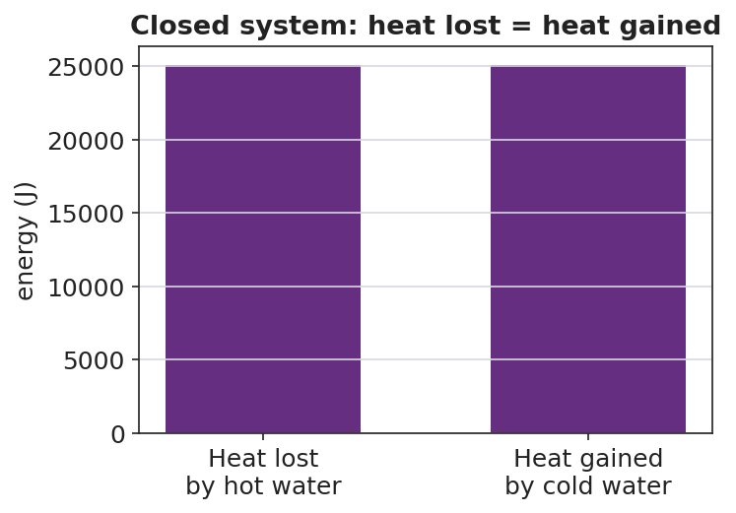
Heat lost by the hot water equals heat gained by the cold water
Teacher facilitation language:
“What’s your ΔT for the hot water? For the cold water? Now run Q = m·c·ΔT for each.” “Compare the two Q’s — are they close? If not, where did the missing energy go?” “Why did we use a foam cup with a lid instead of a metal beaker?”

Teacher facilitation during Explore
- What to look for — Q_lost ≈ Q_gained (within a few percent); students attributing the small gap to energy escaping the “closed” cup.
- What to resist — don’t hand them the final-temperature formula; let the measured equilibrium and the Q-balance teach it.
- What to redirect — groups whose Q’s are far apart: check ΔT signs and that masses (not volumes mislabeled) were used.

Phase 3 · Explain (32 – 37 min)

32–35 min · Turn-and-Talk #2 + class consensus
“Compare your hot-water Q to your cold-water Q. What’s the relationship, and what does it prove about the closed system?”
Target consensus:
“In a closed system the heat lost by the hot water equals the heat gained by the cold water — energy is conserved. Q = m·c·ΔT lets us calculate each side, and they balance.”

35–37 min · Vocabulary introduction (≤ 3 terms)
Sample teacher language:
“Measuring heat transfer this way — in an insulated cup — is called calorimetry. The ‘c’ in Q = m·c·ΔT is the specific heat: how much energy it takes to raise 1 kg of a substance by 1 °C. And heat, Q, is the thermal energy that moved from the hot sample into the cold one.”

Discussion prompts to deploy here
- “If you mix equal masses of hot and cold water, why is the final temperature the average?”
  - Sample student response: “Same mass and same c, so equal-size ΔT’s balance — the hot drops as much as the cold rises, landing in the middle.”
- “If you mixed a little hot water into a lot of cold water, where would the final temperature land?”
  - Sample student response: “Closer to the cold water — the large mass needs a big Q to change temperature, so it barely moves while the small hot sample drops a lot.”

Phase 4 · Elaborate (37 – 40 min)

37–39 min · Revise the model — predict an unequal mix
“Predict: 0.10 kg of 80 °C water poured into 0.30 kg of 20 °C water. Will the final temperature be above or below 50 °C? Justify with Q = m·c·ΔT (heat lost = heat gained).”
Target reasoning: below 50 °C — the larger cold mass dominates; setting m_hot·c·(80 − T_f) = m_cold·c·(T_f − 20) gives T_f = 35 °C.

39–40 min · Return to the phenomenon
“Use heat lost = heat gained to explain in one sentence why your mixed cup settled where it did.”
Target: “The hot water lost exactly as much thermal energy as the cold water gained, so the final temperature sat where those two Q’s balanced — at thermal equilibrium.”

Phase 5 · Evaluate (40 – 42 min)

40–42 min · Exit Ticket + Closing Reflection
“In an insulated cup you mix 0.20 kg of water at 80 °C with 0.20 kg of water at 20 °C. (c_water = 4,186 J/kg·°C.) (a) Using heat lost = heat gained, what is the final temperature? (b) Calculate the heat gained by the cold water with Q = m·c·ΔT. (c) How does that compare to the heat lost by the hot water, and what principle does that show?”
Expected: (a) 50 °C (equal masses → average); (b) Q = (0.20)(4,186)(50 − 20) = 25,116 J ≈ 2.5 × 10⁴ J; (c) equal in size to the heat lost by the hot water — conservation of energy in a closed system (heat lost = heat gained). See Answer_Key.docx.
Closing Reflection (SEL, 30 seconds):
“What is one thing today that changed how you think? Who helped you make sense of it?”

Common Misconceptions
- Misconception: “Mixing 80 °C and 20 °C water gives 100 °C.” → Correction: Temperatures do not add; energy is conserved. Equal masses average to 50 °C.
- Misconception: “The final temperature is always the average.” → Correction: Only when the masses (and specific heats) are equal. Unequal masses pull the result toward the larger sample.
- Misconception: “Heat and temperature are interchangeable in Q = m·c·ΔT.” → Correction: Q (joules) is energy transferred; ΔT (°C) is the temperature change. They are linked by mass and specific heat, not equal.

Access & Differentiation
- ELL/ENL supports: Sentence frame: *“The heat lost by the ___ water equals the heat gained by the ___ water, so the final temperature is ___.”* Word-choice box: {hot, cold, equal, conserved, specific heat}. Provide the Q = m·c·ΔT formula with each symbol labeled in the student’s home language where possible.
- IEP/SPED supports: Provide a partially worked Q calculation (masses and c filled in; student computes ΔT and multiplies). Offer a calculator and a two-row “lost / gained” table to organize the numbers. Group roles (timer, recorder, pourer) so every student has an entry point.
- Extensions: Have students mix a metal (e.g. a warmed steel nut) into cold water and solve for the metal’s specific heat from the calorimetry data — a true unknown-c determination.

Strategy Spotlight
ACTIVE LEARNING (NYS Investigation). Phase 2 hands students the plan and conduct responsibility required by HS-PS3-4: they write the procedure, choose what to measure, keep the system closed, and decide how they will know they reached the final temperature. The teacher approves plans but does not script them. Students then generate their own evidence (the Q-balance) rather than receiving it. Keep groups to 3–4 with clear roles so the hands-on time stays productive.

NYSSLS Observation Checklist Crosswalk
# | Checklist item | Where it appears in this lesson
1 | Local/relatable phenomenon | Phase 1 — predict the hot+cold water mix; everyday mixing in the SEL opener
2 | Turn and Talk (2–3×) | Phase 1 (TT#1 — lost = gained?), Phase 3 (TT#2 — compare the two Q’s)
3 | Students develop questions/models/procedures | Phase 2 — groups plan and conduct the calorimetry investigation (HS-PS3-4)
4 | CCC defined and used | Lesson Overview · Energy and Matter / Systems, restated in Phase 2
5 | ENL — ≤ 3 vocab, second half | Phase 3 — vocabulary at 35–37 min (calorimetry / specific heat / heat)
6 | Revisit phenomenon with evidence | Phase 4 — predict an unequal mix using heat lost = heat gained
7 | ENL/SPED supports | Access & Differentiation block
8 | Assessment check | Phase 5 — Exit Ticket (final temperature + Q calculation)

Companion Materials
- Student_Worksheet.docx — the 5E student investigation / calorimetry lab (hand out at start of Phase 2)
- Student_Notes.docx — guided note-guide for the formula and the worked example
- Answer_Key.docx — answers to “Make It Make Sense” prompts and the Exit Ticket
- figures/mixing_temps.png, figures/heat_lost_gained.png — projection visuals

Key Vocabulary (max 3)
- calorimetry — the measurement of heat transfer, usually by mixing substances in an insulated container and tracking temperature change
- specific heat — the energy needed to raise the temperature of 1 kg of a substance by 1 °C (the “c” in Q = m·c·ΔT)
- heat — the thermal energy (Q) transferred from a hotter object to a cooler one, measured in joules

