Coulomb’s Law — Teacher Guide

Cover
Unit: Electrostatics — Lesson 04: Coulomb’s Law East Meadow Schools × Valley Stream Central High School District Strategy chips: HOCHMAN

Curated Resources (from East Meadow Scope & Sequence)

NYSSLS Standards
This is the quantitative core of the unit and the unit’s anchor to HS-PS2-4: “Use mathematical representations of Newton’s Law of Gravitation and Coulomb’s Law to describe and predict the gravitational and electrostatic forces between objects. (Patterns).” Students see the same inverse-square pattern they met in Universal Gravitation (Forces, Lesson 06) reappear for charge — a deliberate Patterns crosscutting-concept callback.

Phenomenon
- PhET “Coulomb’s Law” — drag two charged spheres, read the force in real time: https://phet.colorado.edu/en/simulations/coulombs-law
- Two charged pith balls / foil-covered balls swing apart on threads (classroom demo): https://www.youtube.com/watch?v=G+coulombs+law+pith+ball

Javalab / Labs
- PhET “Coulomb’s Law” macro scale (primary lab): https://phet.colorado.edu/en/simulations/coulombs-law
- Coulomb force between two charges (Javalab): https://javalab.org/en/coulombs_law_en/

Assessments
- Reference Table relationship: Fₑ = k·q₁·q₂ / r², with k = 8.99 × 10⁹ N·m²/C² and e = 1.6 × 10⁻¹⁹ C. The numeric Exit Ticket below is the formative check.

Lesson Overview
Duration | 42 minutes (1 period)
NYSSLS link | HS-PS2-4 (mathematical representation of Coulomb’s Law; the inverse-square Pattern)
CCC focus | Patterns — the electrostatic force follows the same inverse-square pattern as gravity.
Strategy chips | HOCHMAN (literacy)
Materials | Devices for the PhET sim; calculators; Reference Table; sentence-expansion strips (Because/But/So); whiteboards/markers.
Safety | Standard classroom safety; simulation-based, no hazards.
Prior knowledge | Lessons 01–03 (like repel/unlike attract); the inverse-square law from Universal Gravitation (Fg = G·m₁·m₂ / r²).
Lesson objectives — students can:
- State Coulomb’s law in words and symbols: Fₑ = k·q₁·q₂ / r², and identify each quantity and its unit.
- Predict how the force changes when charge or distance changes (especially the inverse-square fall-off with r).
- Calculate the electrostatic force between two charges using the Reference Table value of k.

Phase 1 · Engage (0 – 10 min)

0–2 min · Opening Connection (SEL)
One-phrase whip-around: “Name something that gets dramatically weaker the farther away you get from it.” (A campfire’s warmth, a speaker’s volume.) This primes the inverse-square fall-off.

2–7 min · Phenomenon hook — PhET two charges
Teacher actions. Open PhET “Coulomb’s Law.” Project two charges with the force readout visible. Double one charge — force doubles. Halve the distance — force quadruples. Let students call out predictions before each move.
Sample teacher language:
“I’m going to move these two charges to half their distance apart. The force won’t just double — watch the number. Predict first: by how much?”
Anticipated student responses:
- “It doubles when you halve the distance.” — capture; the surprise that it quadruples is the hook.
- “More charge means more force.” — yes, build on it: how exactly?
- “It looks like gravity from last unit.” — gold; this is the Patterns callback to HS-PS2-4.

7–10 min · Notice & Wonder + Turn-and-Talk #1
“Turn to your partner: halving the distance made the force four times bigger, not two. What relationship between force and distance would do that?”
Target idea: force depends on distance squared. Leave open if unspoken.

Bridge to Phase 2
Each student writes a one-sentence initial model: “The force gets bigger when ______ and smaller when ______.”

Phase 2 · Explore (10 – 28 min)

10–14 min · Initial Model (silent / individual)
“Sketch two charges a distance r apart. Predict, in words, what happens to the force if you (a) triple one charge, (b) double the distance. Then test each on PhET.”

14–28 min · Investigation — find the pattern on PhET
Structured data collection (devices in pairs):
- Charge sweep — fix r; set q₁ = 1, 2, 3, 4 µC; record force. Pattern: force is proportional to charge.
- Distance sweep — fix charges; set r = 1, 2, 3, 4 units; record force. Pattern: force ÷ 4, ÷ 9, ÷ 16 → inverse-square.
Plot the distance data; it matches the curve below.
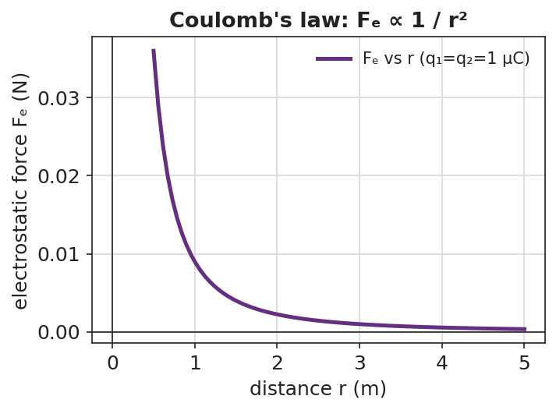
A line graph of electrostatic force versus separation distance: the curve starts high at small r and falls off steeply, flattening as r grows — the inverse-square shape of Coulomb’s law.
Teacher facilitation language:
“When you doubled r, the force didn’t halve — what fraction did it become? And at triple r?” “Where have you seen a force that dies off as 1/r² before this unit?”

Teacher facilitation during Explore
- What to look for — pairs noticing force ÷ 4 at double distance, ÷ 9 at triple → “it’s r squared.”
- What to resist — don’t write the formula yet; let the ÷4, ÷9 data force the squared relationship.
- What to redirect — pairs who confuse “double charge” (×2) with “double distance” (÷4) should re-run one variable at a time.

Phase 3 · Explain (28 – 36 min)

28–31 min · Turn-and-Talk #2 + class consensus
“In one sentence: how does the electrostatic force depend on the two charges and on the distance between them?”
Target consensus:
“The force grows in proportion to each charge and falls off as the square of the distance — exactly like gravity, but for charge.”

31–33 min · Vocabulary introduction (≤ 3 terms)
Sample teacher language:
“This relationship is Coulomb’s law. The push or pull between charges is the electrostatic force, Fₑ. Because it dies off as 1/r², we call it an inverse-square law — the same Pattern as gravity. In symbols: Fₑ = k·q₁·q₂ / r², with k = 8.99 × 10⁹ N·m²/C².”
The two-charge force pair below shows the forces are equal and opposite (Newton’s third law for charge):
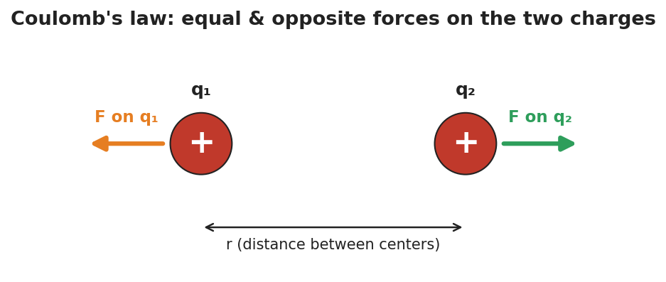
Two like charges with equal-length repulsive force arrows pointing away from each other, separated by a distance r — the electrostatic force on each charge is equal in size and opposite in direction.

33–36 min · HOCHMAN sentence work
Run a Because/But/So expansion of the key relationship on sentence strips:
Stem: “The electrostatic force gets stronger…” - because … (more charge → more force) - but … (it weakens fast as the charges move apart) - so … (doubling the distance cuts the force to one-quarter)
Then an appositive drill: “Coulomb’s law, the rule that the force falls off as 1/r², predicts the force between any two charges.”

Discussion prompts to deploy here
- “If you triple both charges, what happens to the force?”
  - Sample student response: “It goes up nine times — three times for each charge, 3 × 3.”
- “Why is the unit of k written N·m²/C²?”
  - Sample student response: “So that q·q/r² (C²/m²) times k gives newtons — the units cancel to a force.”

Phase 4 · Elaborate (36 – 40 min)

36–39 min · Revise the model (with numbers)
“Two charges of +2.0 × 10⁻⁶ C each sit 0.30 m apart. Use Fₑ = k·q₁·q₂ / r² to find the force. Then state what happens to that force if the distance is doubled.”
Work it with the class (full solution in Student_Notes.docx): Fₑ = (8.99 × 10⁹)(2.0 × 10⁻⁶)(2.0 × 10⁻⁶) / (0.30)² ≈ 0.40 N, repulsive. Doubling r → one-quarter the force ≈ 0.10 N.

39–40 min · Return to the phenomenon
“On PhET, why did halving the distance quadruple the force? Answer in one Because/But/So sentence.”
Target: “Halving r made r² one-quarter as big, but r² is in the denominator, so the force became four times larger.”

Phase 5 · Evaluate (40 – 42 min)

40–42 min · Exit Ticket (numeric) + Closing Reflection
“Use Fₑ = k·q₁·q₂ / r², k = 8.99 × 10⁹ N·m²/C². (a) Two charges, q₁ = +3.0 × 10⁻⁶ C and q₂ = +3.0 × 10⁻⁶ C, are 0.20 m apart. Calculate the electrostatic force. Is it attractive or repulsive? (b) Without recalculating from scratch, state what happens to the force if the distance is tripled. (c) Coulomb’s law shares its 1/r² shape with which force from the Forces unit?”
Expected: (a) Fₑ = (8.99 × 10⁹)(3.0 × 10⁻⁶)(3.0 × 10⁻⁶)/(0.20)² ≈ 2.0 N, repulsive (both positive); (b) tripling r divides the force by 9 → ≈ 0.22 N; (c) gravitation (Fg = G·m₁·m₂/r²). See Answer_Key.docx.
Closing Reflection (SEL, 30 seconds):
“Which sentence stem (because / but / so) made the math click for you today, and why?”

Common Misconceptions
- Misconception: “Doubling the distance halves the force.” → Correction: Distance is squared, so doubling r divides the force by four.
- Misconception: “The bigger charge feels a bigger force than the smaller one.” → Correction: The two charges feel equal and opposite forces (Newton’s third law), regardless of their relative sizes.
- Misconception: “k and the masses/charges have the same role as in gravity.” → Correction: The form is identical (inverse-square), but k (8.99 × 10⁹) is enormous compared with G — the electric force is vastly stronger than gravity for the same separation.

Access & Differentiation
- ELL/ENL supports: Provide the Because/But/So strips pre-printed with the stem. Word-choice box: {Coulomb’s law, electrostatic force, inverse-square, charge, distance, quadruple, quarter}. Pair “inverse-square” with a hand gesture (force shrinking fast as hands separate).
- IEP/SPED supports: Provide a plug-in template for the calculation with the formula and k pre-filled; students substitute only the numbers. Offer a scaffolded “÷4, ÷9, ÷16” table for the distance pattern.
- Extensions: Have students compute the ratio of the electric force to the gravitational force between two protons and explain (with k vs. G) why electricity dominates at the atomic scale.

Strategy Spotlight
HOCHMAN (literacy). Today’s vocabulary and the key relationship are consolidated through sentence-level Hochman moves: a Because/But/So expansion of “the electrostatic force gets stronger…,” and an appositive drill naming Coulomb’s law inside the sentence. These force students to encode the inverse-square idea in precise prose, not just a formula. Keep the strips short (one clause each) and read several aloud — fluency with the sentence is the goal, not length.

NYSSLS Observation Checklist Crosswalk
# | Checklist item | Where it appears in this lesson
1 | Local/relatable phenomenon | Phase 1 — PhET two charges; campfire warmth analogy
2 | Turn and Talk (2–3×) | Phase 1 (TT#1 — why force quadruples), Phase 3 (TT#2 — force vs. charge and distance)
3 | Students develop questions/models/procedures | Phase 1 (initial model), Phase 2 (PhET data sweeps), Phase 4 (numeric revision)
4 | CCC defined and used | Lesson Overview · Patterns (inverse-square callback), restated in Phase 3
5 | ENL — ≤ 3 vocab, second half | Phase 3 — vocabulary at 31–33 min (Coulomb’s law / electrostatic force / inverse-square law)
6 | Revisit phenomenon with evidence | Phase 4 — PhET “why quadruple” Because/But/So
7 | ENL/SPED supports | Access & Differentiation block
8 | Assessment check | Phase 5 — numeric Exit Ticket (calculate Fₑ; predict ×⅑ at triple r)

Companion Materials
- Student_Worksheet.docx — the 5E student investigation (hand out at start of Phase 2)
- Student_Notes.docx — guided note-guide with the full worked calculation
- Answer_Key.docx — worked answers to “Make It Make Sense” prompts and the numeric Exit Ticket

Key Vocabulary (max 3)
- Coulomb’s law — the rule that the electrostatic force between two charges is Fₑ = k·q₁·q₂ / r², with k = 8.99 × 10⁹ N·m²/C²
- electrostatic force — the attractive or repulsive force (Fₑ) between charged objects
- inverse-square law — a relationship in which a quantity falls off as 1 / r²; shared by Coulomb’s law and Newton’s law of gravitation

