Electric Fields — Teacher Guide

Cover
Unit: Electrostatics — Lesson 05: Electric Fields East Meadow Schools × Valley Stream Central High School District Strategy chips: ACTIVE LEARNING

Curated Resources (from East Meadow Scope & Sequence)

NYSSLS Standards
This lesson is the heart of the unit’s modeling standard, HS-PS3-5: “Develop and use a model of two objects interacting through electric or magnetic fields to illustrate the forces between objects and the changes in energy of the objects due to the interaction. (Cause and Effect).” Students develop the field model — the idea that a charge fills the space around it with a force-per-charge that causes a force on any other charge placed there.

Phenomenon
- A plasma ball; bringing a hand or a fluorescent tube near it lights up at a distance (standard demo): https://www.youtube.com/watch?v=plasma+ball+fluorescent
- A fluorescent bulb glows when held near a Van de Graaff or charged source (Veritasium/PhysicsGirl): https://www.youtube.com/watch?v=electric+field+bulb

Javalab / Labs
- Electric field line (place a charge, see the field): https://javalab.org/en/electric_field_line_en/
- Electric field of point charges (Javalab): https://javalab.org/en/electric_field_en/

Assessments
- Reference Table relationship: E = Fₑ / q (units N/C). The Exit Ticket below is the formative check.

Lesson Overview
Duration | 42 minutes (1 period)
NYSSLS link | HS-PS3-5 (the field model of charge interaction)
CCC focus | Cause and Effect — a charge creates a field everywhere, and that field causes a force on any charge placed in it.
Strategy chips | ACTIVE LEARNING
Materials | Plasma ball (or Javalab); small “test charge” tokens for the floor-map activity; tape; calculators; Reference Table; whiteboards/markers.
Safety | If a plasma ball is used, follow its operating limits; no prolonged contact.
Prior knowledge | Lesson 04 — Coulomb’s law (Fₑ = k·q₁·q₂ / r²); the inverse-square fall-off.
Lesson objectives — students can:
- Define the electric field as force per unit charge, E = Fₑ / q, with units N/C.
- Explain the test-charge idea: a tiny positive charge maps the field’s direction (away from +, toward −).
- Calculate field strength from a force and a charge, and the force on a charge from a field.

Phase 1 · Engage (0 – 10 min)

0–2 min · Opening Connection (SEL)
One-phrase whip-around: “Name something you can’t see but you know is there because of what it does to other things.” (Wind moving leaves, gravity, a smell.) This primes “a field you detect by its effect.”

2–7 min · Phenomenon hook — the plasma ball lights a bulb
Teacher actions. Run a plasma ball. Bring a fluorescent tube near it (not touching) — it glows. Move it farther — it dims. The ball is doing something to the space around it.
Sample teacher language:
“The bulb isn’t plugged in and it isn’t touching the ball — yet it lights up, and it dims as I pull it away. What is filling the space between them?”
Anticipated student responses:
- “Electricity is jumping to it.” — close; ask what the electricity travels through.
- “There’s an invisible energy field around the ball.” — excellent; we’ll name it the electric field.
- “It’s like the balloon attracting paper, but stronger.” — yes, connect to the at-a-distance interactions from Lessons 03–04.

7–10 min · Notice & Wonder + Turn-and-Talk #1
“Turn to your partner: the effect on the bulb got weaker as it moved away. What does that tell you about whatever surrounds the ball?”
Target idea: the influence fills space and weakens with distance. Leave open if unspoken.

Bridge to Phase 2
Each student writes a one-sentence initial model: “The bulb lights because the space around the ball ______.”

Phase 2 · Explore (10 – 28 min)

10–14 min · Initial Model (silent / individual)
“Draw the plasma ball. Around it, draw arrows showing how you think it pushes or pulls on a small positive test charge placed at several spots. Where would the push be strongest?”

14–28 min · Active-Learning investigation — map the field with your bodies
Tape a large “+” source charge on the floor. Hand out “test charge” cards (each a small +). Active-learning protocol:
- Place and feel — students stand at assigned spots holding a + test card; each predicts the direction of the force on it and points an arrow (away from the source).
- Map the strength — students close to the source crouch (strong field); those far stand tall (weak field) → a human inverse-square map.
- Flip the source — swap to a “−” source; every arrow reverses (now pointing toward the source). Quick re-vote.
Compare the human map to the field diagram below.
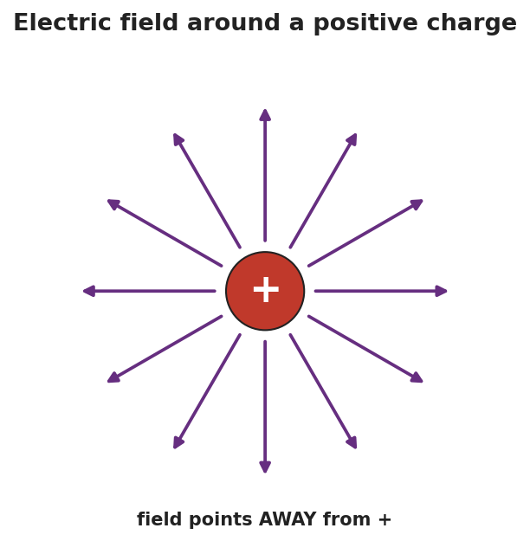
Radial arrows pointing outward from a single positive charge in all directions, representing the electric field around a positive charge — the field points away from a positive source.
Teacher facilitation language:
“Point your test-charge arrow. Which way does the force push a positive test charge near a positive source?” “Who’s feeling the strongest field — and what does that tell us about field strength vs. distance?”

Teacher facilitation during Explore
- What to look for — students pointing arrows away from a + source and toward a − source, and crowding-strength near the source.
- What to resist — don’t give E = Fₑ/q yet; let the human map establish direction and strength first.
- What to redirect — students who point the arrow toward a + source should recall: a + test charge is repelled by +, so it points away.

Phase 3 · Explain (28 – 36 min)

28–31 min · Turn-and-Talk #2 + class consensus
“In one sentence: what is in the space around a charge, and how do we know which way it points?”
Target consensus:
“Every charge surrounds itself with an electric field — a force-per-charge at every point. We probe it with a tiny positive test charge: the field points the way that test charge is pushed (away from +, toward −), and it’s strongest near the source.”

31–33 min · Vocabulary introduction (≤ 3 terms)
Sample teacher language:
“That force-per-charge is the electric field, E = Fₑ / q, measured in newtons per coulomb (N/C). The tiny imaginary charge we use to find its direction is the test charge. The size of E at a point is the field strength — bigger near the source, falling off as 1/r².”
The E-vs-r graph shows the strength falling off:
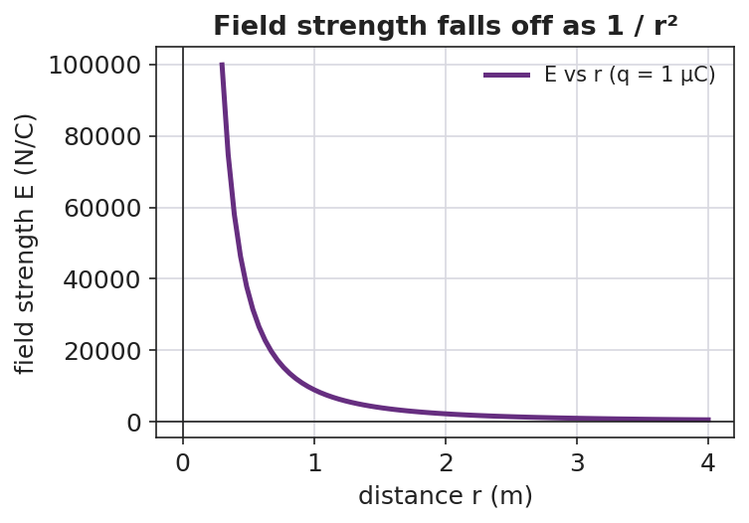
A graph of electric field strength E versus distance r from a point charge, falling off steeply as 1/r².

Discussion prompts to deploy here
- “If a 2 N force acts on a +0.5 C charge placed at a point, what is E there?”
  - Sample student response: “E = Fₑ/q = 2 / 0.5 = 4 N/C.”
- “Why do we use a positive test charge to define the field’s direction?”
  - Sample student response: “It’s the agreed convention — the field points the way a positive charge would be pushed.”

Phase 4 · Elaborate (36 – 40 min)

36–39 min · Revise the model (with numbers)
“A field of 500 N/C exists at a point. (a) What force would it exert on a charge of +2.0 × 10⁻⁶ C placed there? (b) Which way, if the field points east?”
Work it with the class: Fₑ = E·q = (500)(2.0 × 10⁻⁶) = 1.0 × 10⁻³ N, directed east (a positive charge follows the field).

39–40 min · Return to the phenomenon
“Why does the fluorescent tube glow brighter the closer it is to the plasma ball? Answer in one sentence using field strength.”
Target: “The electric field is stronger closer to the ball, so it pushes the gas’s charges harder and the tube glows brighter.”

Phase 5 · Evaluate (40 – 42 min)

40–42 min · Exit Ticket + Closing Reflection
“Use E = Fₑ / q. (a) A charge of +4.0 × 10⁻⁶ C feels a force of 0.012 N at a point. Calculate the electric field strength there, with units. (b) Draw the field around a single negative charge — which way do the arrows point? (c) In one sentence, explain what a ‘test charge’ is and why it must be small.”
Expected: (a) E = Fₑ/q = 0.012 / (4.0 × 10⁻⁶) = 3.0 × 10³ N/C; (b) arrows point inward, toward the negative charge; (c) a tiny positive charge used to probe a field’s direction and strength — small so it doesn’t disturb the field it’s measuring. See Answer_Key.docx.
Closing Reflection (SEL, 30 seconds):
“What part of the human field-map helped you ‘see’ the invisible field? Whose arrow helped you fix yours?”

Common Misconceptions
- Misconception: “The field only exists where there’s another charge to feel it.” → Correction: The field fills the space around a charge whether or not a second charge is present; the second charge just reveals it.
- Misconception: “The field points whichever way the source charge would move.” → Correction: By convention E points the way a positive test charge is pushed (away from +, toward −).
- Misconception: “Field strength and force are the same thing.” → Correction: E is force per coulomb (N/C); the force on a particular charge is Fₑ = E·q.

Access & Differentiation
- ELL/ENL supports: Sentence frame: “The electric field points ___ a positive charge and ___ a negative charge, and it is ___ (stronger/weaker) close to the source.” Word-choice box: {electric field, test charge, field strength, away from, toward, N/C}. Provide pre-drawn radial arrows to label.
- IEP/SPED supports: Give an E = Fₑ/q plug-in template with units printed; students substitute numbers only. Offer the human field-map as the hands-on alternative to drawing.
- Extensions: Have students combine Coulomb’s law and E = Fₑ/q to show E = k·q / r² for a point charge, and use it to find the field 0.10 m from a +1 µC charge.

Strategy Spotlight
ACTIVE LEARNING. Today’s Explore turns the class into a living field map: each student is a positive test charge that points the force direction and crouches/stands to show strength. Flipping the source from + to − forces an immediate, embodied re-vote. Keep the activity kinetic and quick (3–4 source positions), then connect the human map directly to the radial-arrow diagram. Your role is to ask “which way are you pushed?” rather than to draw the field for them.

NYSSLS Observation Checklist Crosswalk
# | Checklist item | Where it appears in this lesson
1 | Local/relatable phenomenon | Phase 1 — plasma ball lighting a bulb; brightness vs. distance in Phase 4
2 | Turn and Talk (2–3×) | Phase 1 (TT#1 — what fills the space), Phase 3 (TT#2 — field direction and strength)
3 | Students develop questions/models/procedures | Phase 1 (initial model), Phase 2 (human field-map), Phase 4 (numeric revision)
4 | CCC defined and used | Lesson Overview · Cause and Effect, restated in Phase 2
5 | ENL — ≤ 3 vocab, second half | Phase 3 — vocabulary at 31–33 min (electric field / test charge / field strength)
6 | Revisit phenomenon with evidence | Phase 4 — bulb brightness + field-strength explanation
7 | ENL/SPED supports | Access & Differentiation block
8 | Assessment check | Phase 5 — Exit Ticket (calculate E; field direction around −)

Companion Materials
- Student_Worksheet.docx — the 5E student investigation (hand out at start of Phase 2)
- Student_Notes.docx — guided note-guide with the worked field calculation
- Answer_Key.docx — worked answers to “Make It Make Sense” prompts and the Exit Ticket

Key Vocabulary (max 3)
- electric field — the force per unit charge at a point in space around a charge: E = Fₑ / q, measured in newtons per coulomb (N/C)
- test charge — a tiny positive charge used to probe a field’s direction and strength without disturbing it
- field strength — the magnitude of the electric field at a point; larger near the source and falling off as 1/r²

