Series Circuits — Teacher Guide

Cover
Unit: Current Electricity — Lesson 03: Series Circuits East Meadow Schools × Valley Stream Central High School District Strategy chips: ACTIVE LEARNING

Curated Resources (from East Meadow Scope & Sequence)

NYSSLS Standards
This lesson supports HS-PS3-6: “Analyze data to support the claim that Ohm’s Law describes the mathematical relationship among the potential difference, current, and resistance of an electric circuit.” Students apply V = I·R to a single-path circuit, discover that resistances add (R_total = R₁ + R₂ + …) and that the same current flows everywhere while voltage drops add up to the source. It extends Lessons 01–02 to multi-resistor circuits.

Phenomenon
- Old-style holiday light string where removing or burning out one bulb kills the whole string: https://www.youtube.com/results?search_query=why+do+old+christmas+lights+all+go+out
- Series-circuit walkthrough (Khan Academy, “Series resistors”): https://www.khanacademy.org/science/physics/circuits-topic/circuits-resistance/a/ee-series-resistors

Javalab / Labs
- PhET Circuit Construction Kit: DC — build a one-loop series circuit with three resistors; measure current at several points and voltage across each resistor: https://phet.colorado.edu/en/simulations/circuit-construction-kit-dc

Assessments
- PhET CCK-DC series data table (I at three points; V across each resistor) — formative during Explore.
- Exit ticket below; full key in Answer_Key.docx.

Lesson Overview
Duration | 42 minutes (1 period)
NYSSLS link | HS-PS3-6 (core — Ohm’s Law in a series path)
CCC focus | Systems and System Models — a series circuit is one path; what happens at one element constrains the whole system.
Strategy chips | ACTIVE LEARNING (build-measure-predict at PhET stations)
Materials | Devices for PhET CCK-DC; whiteboards; calculators; (optional) an old holiday light string and a fresh one for the hook.
Safety | Low-voltage / simulated circuits only. If using a real light string, keep it unplugged during inspection.
Prior knowledge | Lessons 01–02 — Ohm’s Law V = I·R; resistance and its origins.
Lesson objectives — students can:
- Identify a series circuit as a single path and explain why the same current flows everywhere in it.
- Compute the equivalent resistance of resistors in series (R_total = R₁ + R₂ + …) and use it to find the current.
- Explain why the voltage drops across series resistors add up to the source voltage.

Phase 1 · Engage (0 – 10 min)

0–2 min · Opening Connection (SEL)
One-sentence whip-around: “Describe a time when one small thing breaking shut down something much bigger (a group project, a relay race, a recipe).” Hold the metaphor; a series circuit fails exactly this way.

2–7 min · Phenomenon hook — the holiday lights
Teacher actions. Show the old light string. Remove (or “burn out”) one bulb — the whole string goes dark. Contrast with a modern string where the rest stay lit.
Sample teacher language:
“I pulled out one bulb and the entire string died. There are fifty bulbs — why would one missing bulb take down all of them?”
Anticipated student responses:
- “It broke the circle.” — yes; one path, one break stops everything.
- “They’re all connected in a line.” — capture “line”; that’s series.
- “The electricity can’t get around the gap.” — exactly; no alternate path.

7–10 min · Notice & Wonder + Turn-and-Talk #1
“Turn to your partner: in a single-loop circuit, if you removed one resistor, what happens to the current everywhere else? Use the word path.”
Target: with only one path, breaking it stops the current everywhere.

Bridge to Phase 2
Each student writes a one-sentence initial model: “One missing bulb kills the whole string because ______.”

Phase 2 · Explore (10 – 30 min)

10–14 min · Initial Model (silent / individual)
Prompt on the board:
“Sketch three bulbs wired in a single loop with a battery. Draw one arrow showing the current. Predict: is the current the same at every bulb, or does it shrink as it passes each one?”
This surfaces the “current gets used up” misconception before measurement.

14–30 min · Investigation — PhET CCK-DC series circuit
Students build a battery (20 V) with three resistors (2 Ω, 3 Ω, 5 Ω) in one loop.
- Measure current at three points (before R₁, between R₂ and R₃, after R₃). Is it the same?
- Measure voltage across each resistor; add the three drops.
- Remove one resistor (open the loop) — what happens to the current?
Teacher facilitation language:
“Is the ammeter reading the same at all three spots? What does that tell you about current in a series loop?” “Add up the three voltage drops — how does the total compare to the battery’s 20 V?” “You found R_total. How does it compare to R₁ + R₂ + R₃?”
Use the schematic and the voltage-drop bar chart to consolidate:
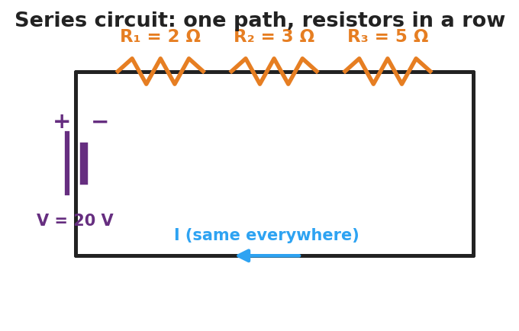
Schematic of a series circuit: a 20-volt battery on the left side drives a single current through three resistors in a row along the top wire labeled R-one 2 ohms, R-two 3 ohms, and R-three 5 ohms; the current is the same everywhere.
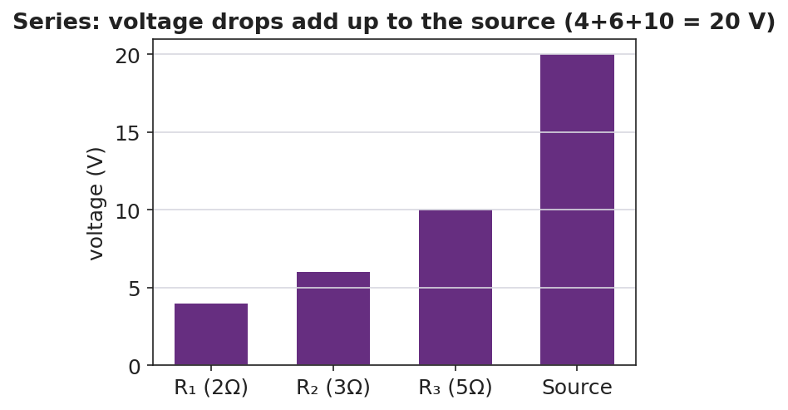
Bar chart of voltage drops in a series circuit: 4 volts across R-one, 6 volts across R-two, 10 volts across R-three, summing to the 20-volt source.

Teacher facilitation during Explore
- What to look for — groups stating “the ammeter reads the same everywhere” and “the three drops add to the battery voltage.”
- What to resist — handing them R_total = ΣR; let them sum the resistors and check against I = V/R_total.
- What to redirect — students who think current is consumed: have them re-read all three ammeters aloud (identical).

Phase 3 · Explain (30 – 36 min)

30–33 min · Turn-and-Talk #2 + class consensus
“Across your measurements, what three rules describe a series circuit?”
Target consensus:
“(1) The current is the same everywhere. (2) The total resistance is the sum of the resistors. (3) The voltage drops add up to the source voltage.”

33–36 min · Vocabulary introduction (≤ 3 terms)
Sample teacher language:
“A circuit with a single path is a series circuit. Because there’s one path, the current is the same at every point. The single resistor that could replace all of them is the equivalent resistance: R_total = R₁ + R₂ + R₃. Then the loop current is just I = V ÷ R_total.”
Reference relationships to post: V = I·R; series R_total = R₁ + R₂ + …; power P = V·I = I²·R.

Discussion prompts to deploy here
- “Three 2 Ω resistors are in series with a 12 V battery. What’s R_total and the current?”
  - Sample response: “R_total = 6 Ω; I = 12/6 = 2 A everywhere.”
- “Why do the voltage drops have to add up to the source?”
  - Sample response: “All the energy the battery gives each charge is spent crossing the resistors, so the drops total the battery voltage.”

Phase 4 · Elaborate (36 – 40 min)

36–38 min · Apply — add a resistor
“You add a fourth resistor in series. Predict what happens to R_total and to the current. Explain in one sentence.”
Target: R_total increases, so the current decreases (same battery, more total resistance).

38–40 min · Return to the phenomenon
“Explain, in one sentence using series and path, why one missing bulb kills the whole old light string.”
Target: “The bulbs are in series — one path — so a missing bulb breaks the only path and stops the current everywhere.”

Phase 5 · Evaluate (40 – 42 min)

40–42 min · Exit Ticket + Closing Reflection
“A 24 V battery is connected in series to a 4 Ω and an 8 Ω resistor. (a) Find the equivalent (total) resistance. (b) Find the current in the circuit. (c) Find the voltage drop across the 8 Ω resistor and check that the two drops add to 24 V.”
Expected: (a) R_total = 12 Ω; (b) I = 24/12 = 2 A; (c) V₈ = I·R = 2 × 8 = 16 V; V₄ = 8 V; 16 + 8 = 24 V. See Answer_Key.docx.
Closing Reflection (SEL, 30 seconds):
“What’s one prediction you made today that the measurements proved wrong — and what changed your mind?”

Common Misconceptions
- Misconception: “Current is used up as it passes each resistor.” → Correction: Current is the same at every point in a series loop; it is the voltage (energy per charge) that drops across each resistor.
- Misconception: “Adding resistors in series increases the current.” → Correction: Adding series resistors raises R_total, so the current decreases for the same battery.
- Misconception: “Each resistor gets the full battery voltage.” → Correction: The battery voltage is shared — the drops across the resistors add up to the source.

Access & Differentiation
- ELL/ENL supports: Sentence frames: “In a series circuit, the current is ___ everywhere.” / “The total resistance is the ___ of the resistors.” Word box: {same, sum, single path, voltage drops, add}. Color-code the single current path on the schematic.
- IEP/SPED supports: Provide a pre-built PhET file and a fill-in table (I at each point, V across each resistor). Give a partly worked R_total = R₁ + R₂ + R₃ template.
- Extensions: Have students show algebraically that the voltage drops must add to the source (V = I·R₁ + I·R₂ + I·R₃ = I·R_total) and compute the power dissipated in each resistor (P = I²·R), noting which runs hottest.

Strategy Spotlight
ACTIVE LEARNING. Students build, measure, and predict at PhET stations rather than receive the three series rules. Structure each station with a predict → measure → reconcile loop: predict the ammeter reading, take it, then explain any mismatch. The removal-of-a-resistor test is the active hinge — it forces the “one path” idea into the open. Close by having groups post their three-rule consensus and compare.

NYSSLS Observation Checklist Crosswalk
# | Checklist item | Where it appears in this lesson
1 | Local/relatable phenomenon | Phase 1 — old holiday light string
2 | Turn and Talk (2–3×) | Phase 1 (TT#1 — removing a resistor), Phase 3 (TT#2 — three series rules)
3 | Students develop questions/models/procedures | Phase 1 (initial model), Phase 2 (build/measure/predict), Phase 4 (revise)
4 | CCC defined and used | Lesson Overview · Systems and System Models, used in Phase 2
5 | ENL — ≤ 3 vocab, second half | Phase 3 — series circuit / equivalent resistance / current at 33–36 min
6 | Revisit phenomenon with evidence | Phase 4 — why one missing bulb kills the string
7 | ENL/SPED supports | Access & Differentiation block
8 | Assessment check | Phase 5 — series Ohm’s-law exit ticket

Companion Materials
- Student_Worksheet.docx — the 5E student investigation (hand out at start of Phase 2)
- Student_Notes.docx — guided note-guide for vocabulary and the worked example
- Answer_Key.docx — answers to “Make It Make Sense” prompts and the Exit Ticket

Key Vocabulary (max 3)
- series circuit — a circuit with a single path for charge, so the current is the same at every point
- equivalent resistance — the single resistance that could replace a group of resistors; in series, R_total = R₁ + R₂ + …
- current — the rate of flow of charge (amperes); in a series circuit it is identical everywhere in the loop

