Parallel Circuits — Teacher Guide

Cover
Unit: Current Electricity — Lesson 04: Parallel Circuits East Meadow Schools × Valley Stream Central High School District Strategy chips: ACTIVE LEARNING

Curated Resources (from East Meadow Scope & Sequence)

NYSSLS Standards
This lesson supports HS-PS3-6: “Analyze data to support the claim that Ohm’s Law describes the mathematical relationship among the potential difference, current, and resistance of an electric circuit.” Students apply V = I·R to a multi-path circuit, discover that each branch sees the full source voltage, that branch currents add to the total, and that the equivalent resistance follows 1/R_total = Σ(1/R). It completes the series/parallel pair begun in Lesson 03.

Phenomenon
- Home outlets — unplug one lamp and the others stay lit (house wiring is parallel): https://www.youtube.com/results?search_query=why+are+house+circuits+wired+in+parallel
- Parallel-resistor walkthrough (Khan Academy, “Parallel resistors”): https://www.khanacademy.org/science/physics/circuits-topic/circuits-resistance/a/ee-parallel-resistors

Javalab / Labs
- PhET Circuit Construction Kit: DC — build a battery with two or three resistor branches; measure the voltage across each branch and the current in each branch and in the main wire: https://phet.colorado.edu/en/simulations/circuit-construction-kit-dc

Assessments
- PhET CCK-DC parallel data table (branch voltages; branch and total currents) — formative during Explore.
- Exit ticket below; full key in Answer_Key.docx.

Lesson Overview
Duration | 42 minutes (1 period)
NYSSLS link | HS-PS3-6 (core — Ohm’s Law across parallel branches)
CCC focus | Systems and System Models — multiple independent paths; a system can keep functioning when one branch fails.
Strategy chips | ACTIVE LEARNING (build-measure-predict at PhET stations)
Materials | Devices for PhET CCK-DC; whiteboards; calculators; (optional) a power strip with several plugged-in lamps for the hook.
Safety | Low-voltage / simulated circuits only. Never demonstrate house wiring with real mains.
Prior knowledge | Lessons 01–03 — Ohm’s Law V = I·R; series rules (single path, current same, R adds).
Lesson objectives — students can:
- Identify a parallel circuit and explain why each branch has the same voltage across it.
- Explain why branch currents add to the total current, and why one branch can fail while others keep working.
- Compute the equivalent resistance of parallel resistors using 1/R_total = 1/R₁ + 1/R₂ + … and find branch currents.

Phase 1 · Engage (0 – 10 min)

0–2 min · Opening Connection (SEL)
One-sentence whip-around: “Name a system in your life with a ‘backup path’ — where if one option fails, you still have another way through.” Hold the idea of independent paths.

2–7 min · Phenomenon hook — home outlets
Teacher actions. Plug three lamps into a power strip; all are lit. Unplug one — the other two stay bright. Contrast with yesterday’s series string, where one removal killed everything.
Sample teacher language:
“Yesterday one missing bulb killed the whole string. Today I unplug one lamp and the others don’t even flicker. What’s different about how these are wired?”
Anticipated student responses:
- “They each have their own wire.” — yes; separate branches / paths.
- “The electricity has another way to go.” — capture; multiple paths.
- “Each one is connected straight to the outlet.” — each branch sees the full voltage.

7–10 min · Notice & Wonder + Turn-and-Talk #1
“Turn to your partner: if each lamp has its own path to the source, what must be true about the voltage each lamp gets? Use the word branch.”
Target: each branch gets the full source voltage.

Bridge to Phase 2
Each student writes a one-sentence initial model: “Unplugging one lamp leaves the others lit because ______.”

Phase 2 · Explore (10 – 30 min)

10–14 min · Initial Model (silent / individual)
Prompt on the board:
“Sketch three lamps each wired directly across the same battery (three branches). Predict: does each lamp get the full battery voltage or a share of it? Does the same current flow through all three?”

14–30 min · Investigation — PhET CCK-DC parallel circuit
Students build a 12 V battery with three parallel resistor branches (6 Ω, 3 Ω, 2 Ω).
- Measure the voltage across each branch. Are they equal?
- Measure the current in each branch and in the main wire. How do the branch currents relate to the total?
- Open one branch — what happens to the other branches?
Teacher facilitation language:
“Is the voltmeter reading the same across all three branches? What does that tell you?” “Add the three branch currents — how do they compare to the current in the main wire?” “When you open one branch, do the others change? Why does that match the lamp demo?”
Use the schematic and the branch-current bar chart to consolidate:
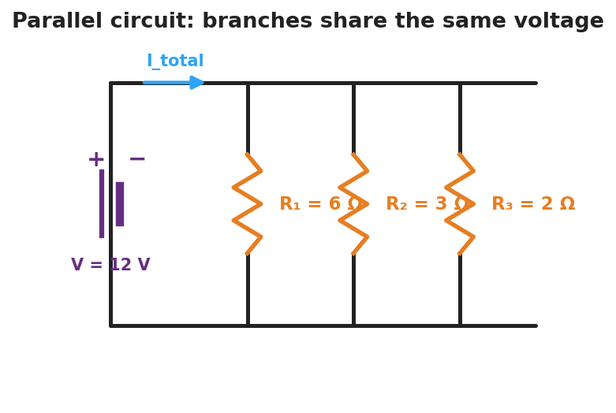
Schematic of a parallel circuit: a 12-volt battery on the left connects to a top rail and a bottom rail, with three vertical resistor branches between them labeled R-one 6 ohms, R-two 3 ohms, and R-three 2 ohms; the total current splits among the branches.
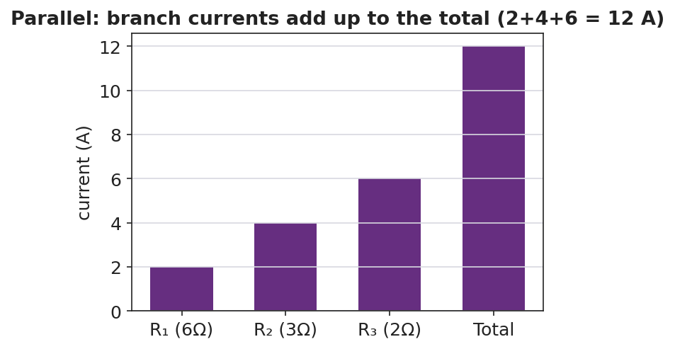
Bar chart of branch currents in a parallel circuit: 2 amps, 4 amps, and 6 amps in the three branches, summing to a 12-amp total.

Teacher facilitation during Explore
- What to look for — groups stating “the voltage is the same across every branch” and “the branch currents add to the main current.”
- What to resist — handing them 1/R_total = Σ1/R; let them compute each branch current with I = V/R first, then add.
- What to redirect — students surprised that R_total is less than the smallest resistor: more paths means less total opposition.

Phase 3 · Explain (30 – 36 min)

30–33 min · Turn-and-Talk #2 + class consensus
“Across your measurements, what three rules describe a parallel circuit?”
Target consensus:
“(1) The voltage is the same across every branch. (2) The branch currents add up to the total. (3) The equivalent resistance is less than any single branch.”

33–36 min · Vocabulary introduction (≤ 3 terms)
Sample teacher language:
“A circuit with more than one path is a parallel circuit. Each separate path is a branch, and every branch has the full source voltage across it. The single resistor that could replace them all is the equivalent resistance — but in parallel you combine reciprocals: 1/R_total = 1/R₁ + 1/R₂ + 1/R₃. Because you’re adding paths, R_total comes out smaller than any one branch.”
Reference relationships to post: V = I·R; parallel 1/R_total = 1/R₁ + 1/R₂ + …; power P = V·I = I²·R.

Discussion prompts to deploy here
- “Two 4 Ω resistors are in parallel across 8 V. Find each branch current and the total.”
  - Sample response: “Each branch: I = 8/4 = 2 A; total = 4 A; R_total = 2 Ω.”
- “Why is R_total smaller than the smallest branch resistor?”
  - Sample response: “Every added branch gives charge another path, so overall it’s easier for current to flow.”

Phase 4 · Elaborate (36 – 40 min)

36–38 min · Apply — add a branch
“You add a fourth lamp in parallel. Predict what happens to the total current drawn from the battery and to the equivalent resistance. Explain in one sentence.”
Target: equivalent resistance drops further, so the total current the battery delivers increases.

38–40 min · Return to the phenomenon
“Explain, in one sentence using parallel and branch, why unplugging one lamp leaves the others lit.”
Target: “The lamps are in parallel — each on its own branch — so opening one branch leaves the other branches (and their full voltage) untouched.”

Phase 5 · Evaluate (40 – 42 min)

40–42 min · Exit Ticket + Closing Reflection
“A 12 V battery is connected to two parallel resistors: 4 Ω and 6 Ω. (a) What is the voltage across each resistor? (b) Find the current in each branch. (c) Find the total current and the equivalent resistance (1/R_total = 1/4 + 1/6).”
Expected: (a) 12 V across each; (b) I₄ = 3 A, I₆ = 2 A; (c) total = 5 A, R_total = 12/5 = 2.4 Ω. See Answer_Key.docx.
Closing Reflection (SEL, 30 seconds):
“What surprised you most about parallel circuits compared with yesterday’s series circuits?”

Common Misconceptions
- Misconception: “The voltage splits among the parallel branches.” → Correction: Each branch gets the full source voltage; it’s the current that splits among the branches.
- Misconception: “Adding a parallel branch raises the total resistance.” → Correction: Adding branches lowers the equivalent resistance (more paths for current), so the battery delivers more total current.
- Misconception: “Opening one branch changes the others.” → Correction: Branches are independent; opening one leaves the others’ voltage and current unchanged.

Access & Differentiation
- ELL/ENL supports: Sentence frames: *“In a parallel circuit, the voltage across each branch is ___.”* / “The branch currents ___ to the total.” Word box: {same, add, branch, multiple paths, full voltage}. Color-code each branch a different color on the schematic.
- IEP/SPED supports: Provide a pre-built PhET file and a fill-in table (branch voltages, branch currents). Give a step-by-step reciprocal template for 1/R_total with the fractions pre-set.
- Extensions: Have students show that for two parallel resistors R_total = (R₁·R₂)/(R₁+R₂), and explain why home circuits use parallel wiring (each device gets full voltage and operates independently) while computing the power each branch draws (P = V²/R).

Strategy Spotlight
ACTIVE LEARNING. As in Lesson 03, students build-measure-predict at PhET stations. The active hinge here is opening one branch and watching the others stay lit — the experiential counterpart to yesterday’s series break. Run a predict → measure → reconcile loop on branch voltage (predict equal, confirm) and on total current (predict the sum, confirm). Have groups post their three-rule consensus side-by-side with the series rules from Lesson 03 to make the contrast explicit.

NYSSLS Observation Checklist Crosswalk
# | Checklist item | Where it appears in this lesson
1 | Local/relatable phenomenon | Phase 1 — home outlets / power strip
2 | Turn and Talk (2–3×) | Phase 1 (TT#1 — branch voltage), Phase 3 (TT#2 — three parallel rules)
3 | Students develop questions/models/procedures | Phase 1 (initial model), Phase 2 (build/measure/predict), Phase 4 (revise)
4 | CCC defined and used | Lesson Overview · Systems and System Models, used in Phase 2
5 | ENL — ≤ 3 vocab, second half | Phase 3 — parallel circuit / branch / equivalent resistance at 33–36 min
6 | Revisit phenomenon with evidence | Phase 4 — why other lamps stay lit
7 | ENL/SPED supports | Access & Differentiation block
8 | Assessment check | Phase 5 — parallel Ohm’s-law exit ticket

Companion Materials
- Student_Worksheet.docx — the 5E student investigation (hand out at start of Phase 2)
- Student_Notes.docx — guided note-guide for vocabulary and the worked example
- Answer_Key.docx — answers to “Make It Make Sense” prompts and the Exit Ticket

Key Vocabulary (max 3)
- parallel circuit — a circuit with more than one path for charge, so every branch has the same full source voltage across it
- branch — one of the separate parallel paths between the same two points; its current is set by its own resistance (I = V/R)
- equivalent resistance — the single resistance that could replace the branches; in parallel, 1/R_total = 1/R₁ + 1/R₂ + … (smaller than any branch)

