Wave Speed, Frequency, and Wavelength — Teacher Guide

Cover
Unit: Waves — Lesson 03: Wave Speed, Frequency, and Wavelength East Meadow Schools × Valley Stream Central High School District Strategy chips: HOCHMAN

Curated Resources (from East Meadow Scope & Sequence)

NYSSLS Standards
HS-PS4-1. “Use mathematical representations to support a claim regarding relationships among the frequency, wavelength, and speed of waves traveling in various media. (Cause and Effect)”
This is the lesson where students do the mathematical representation: v = f·λ. They use it to support the claim that in a given medium the speed is fixed, so frequency and wavelength must trade off (an inverse relationship). This is the quantitative heart of HS-PS4-1.

Phenomenon
- Guitar strings of different thickness and length sound different notes even when plucked the same way: https://www.youtube.com/watch?v=DLOmHViGqYY

Javalab / Labs
- PhET Wave on a String (oscillate mode) — fix the speed, change the driver frequency, measure the wavelength with the ruler tool: https://phet.colorado.edu/en/simulations/wave-on-a-string

Assessments
- PhET measurement task: students complete an f-vs-λ data table at fixed tension (fixed speed) and confirm f·λ is constant. Numeric exit ticket below serves as the formative check.

Lesson Overview
Duration | 42 minutes (1 period)
NYSSLS link | HS-PS4-1 (core — the v = f·λ relationship)
CCC focus | Cause and Effect — at a fixed wave speed, increasing frequency causes wavelength to decrease (inverse trade-off).
Strategy chips | HOCHMAN
Materials | Guitar/ukulele or rubber bands stretched over a box; rulers; calculators; whiteboards; device for PhET.
Safety | None beyond normal classroom care.
Prior knowledge | Lessons 01–02 — wavelength, frequency, period (T = 1/f); wave types.
Lesson objectives — students can:
- Use the equation v = f·λ to solve for speed, frequency, or wavelength.
- Explain that in a given medium the wave speed is constant, so f and λ are inversely related.
- Convert between period and frequency using T = 1/f.

Phase 1 · Engage (0 – 12 min)

0–3 min · Opening Connection (SEL)
Quick check-in: “Name a song stuck in your head — and whether it’s a high-pitched or low-pitched part.” One sentence each. This previews high vs. low frequency.

3–8 min · Phenomenon hook — different strings, different notes
Teacher actions. Pluck a thick, low string and a thin, high string on a guitar. Then play the same string open vs. fretted (shorter). Same instrument, different pitches.
Sample teacher language:
“I plucked these the same way, but they sound completely different. The wave speed on each string is set by the string itself. So if the speed is fixed, what must be different about the waves making these two notes?”
Anticipated student responses:
- “The thick one is lower.” — affirm; lower pitch = lower frequency.
- “The short string is higher.” — yes; shorter → higher frequency.
- “Different wavelengths?” — capture; this is the target.

8–12 min · Notice & Wonder + Turn-and-Talk #1
Capture columns. Then:
“Turn to your partner: if two notes travel at the same speed on a string but have different frequencies, what has to be different about their wavelengths?”
Target: higher frequency must mean shorter wavelength, so the speed comes out the same.

Bridge to Phase 2
Initial model sentence: “At a fixed wave speed, a higher-frequency wave must have a ______ wavelength.”

Phase 2 · Explore (12 – 32 min)

12–17 min · Initial Model (silent / individual)
Prompt:
“Predict: if you keep the wave speed the same but double the frequency, what happens to the wavelength? Write your prediction and a reason.”

17–32 min · Investigation — PhET measurement (fixed speed)
Pairs at PhET in oscillate mode, tension fixed (so speed is fixed):
- Set frequency to a low value. Use the ruler to measure one wavelength. Record f and λ.
- Increase frequency in steps. Measure λ each time. Build a data table of (f, λ).
- Compute f·λ for each row. What do you notice about the product?
- Plot λ vs. f on a quick whiteboard graph.
Use these figures to anchor the pattern and the equation:
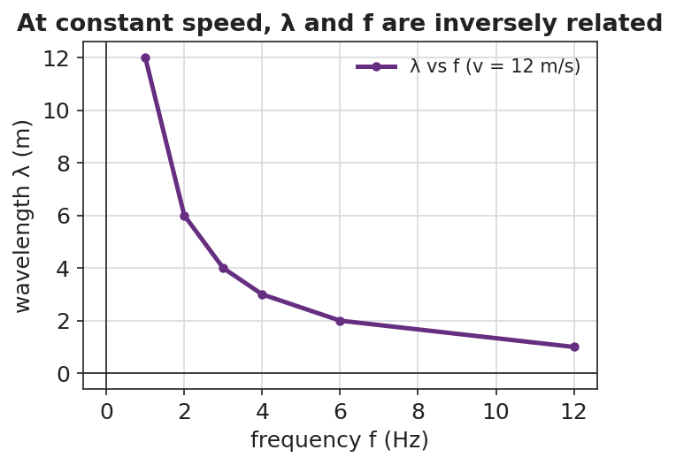
A line graph of wavelength versus frequency at a constant wave speed of 12 m/s, showing an inverse (curved-down) relationship.
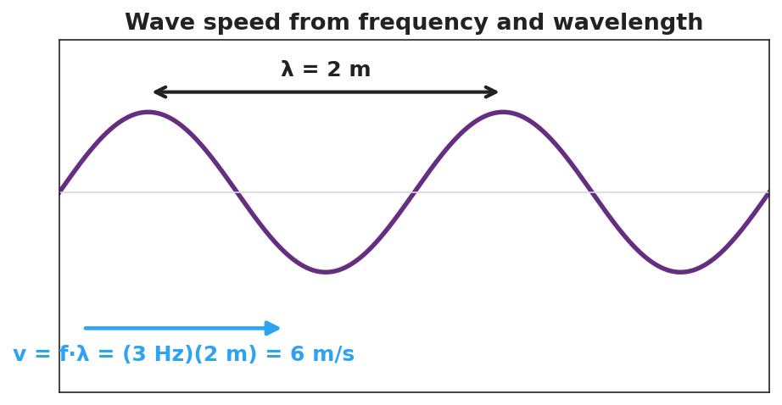
A wave with wavelength λ = 2 m labeled, showing the worked relationship v = f·λ = (3 Hz)(2 m) = 6 m/s.

Teacher facilitation during Explore
- What to look for — pairs noticing f·λ stays (nearly) constant; the λ-vs-f graph curving downward (inverse, not straight-line).
- What to resist — don’t write v = f·λ on the board yet; let the constant product surface from the data.
- What to redirect — students who expect a straight line should be asked, “if f goes up and the product stays the same, what must λ do?”

Phase 3 · Explain (32 – 37 min)

32–35 min · Turn-and-Talk #2 + class consensus
“Why did f·λ come out the same in every row?”
Target consensus:
“Because f·λ equals the wave’s speed, and the speed didn’t change — it’s set by the medium. So when f goes up, λ must go down to keep the product (the speed) the same.”

35–37 min · Vocabulary introduction (≤ 3 terms) + the HOCHMAN sentence
Sample teacher language:
“That constant product is the wave speed: v = f·λ. Frequency is measured in hertz (cycles per second), and the time for one cycle is the period, T = 1/f.”
HOCHMAN Because/But/So expansion (do this aloud, then students write):
“In a given medium the wave speed is constant because the medium sets how fast a disturbance travels, but the source can change the frequency, so the wavelength must change in the opposite direction to keep v = f·λ true.”

Discussion prompts to deploy here
- “A wave travels at 340 m/s with a frequency of 170 Hz. What is its wavelength?”
  - Sample student response: “λ = v/f = 340/170 = 2 m.”
- “If you double the frequency at the same speed, what happens to the wavelength?”
  - Sample student response: “It halves — they’re inversely related.”

Phase 4 · Elaborate (37 – 40 min)

37–39 min · Revise the model
“Return to your prediction. Was it right? Re-write it as a Because/But/So sentence using v = f·λ and the words wave speed, frequency, and wavelength.”

39–40 min · Return to the phenomenon
“Back to the guitar: the thin string and thick string can carry the same note’s speed — so why do they sound different? Answer in one sentence using frequency and wavelength.”
Target: “Each string’s wave speed is fixed, so a different frequency (pitch) means a different wavelength — that’s why thinner/shorter strings sound higher.”

Phase 5 · Evaluate (40 – 42 min)

40–42 min · Exit Ticket + Closing Reflection
“A sound wave in air travels at 340 m/s. (a) A note has a frequency of 256 Hz. Find its wavelength. Show v = f·λ rearranged. (b) A higher note has a frequency of 512 Hz at the same speed. Without a calculator, is its wavelength longer or shorter, and by what factor? (c) What is the period of the 256 Hz note?”
Expected: (a) λ = v/f = 340/256 ≈ 1.33 m; (b) shorter — half the wavelength, since frequency doubled at the same speed; (c) T = 1/f = 1/256 ≈ 0.0039 s. See Answer_Key.docx.
Closing Reflection (SEL, 30 seconds):
“What is one thing about the v = f·λ relationship that finally clicked today?”

Common Misconceptions
- Misconception: “Increasing the frequency makes the wave travel faster.” → Correction: Speed is set by the medium; raising f shortens λ instead — the product v = f·λ stays the same.
- Misconception: “Wavelength and frequency are directly proportional.” → Correction: At constant speed they are inversely proportional (f up → λ down).
- Misconception: “Period and frequency are the same number.” → Correction: They are reciprocals; a 256 Hz note has a tiny period of about 0.0039 s.

Access & Differentiation
- ELL/ENL supports: Provide the formula triangle (v on top; f and λ on the bottom) and a sentence frame: “When frequency goes ______, wavelength goes ______, because the speed stays ______.” Word-choice box: {up, down, constant, inversely}.
- IEP/SPED supports: Give a partially completed v = f·λ table; students fill only the missing cell using the formula triangle. Provide calculators and a worked first row.
- Extensions: Different media — a sound wave moving from air (340 m/s) into water (~1500 m/s) keeps the same frequency (set by the source). What happens to its wavelength? (It gets longer.) Preview of refraction (Lesson 08).

Strategy Spotlight
HOCHMAN. The key relationship is built as a single complex sentence using Because / But / So. Model it aloud first, then have students write their own. The conjunctions force the causal logic: the speed is fixed because the medium sets it, but the source changes the frequency, so the wavelength must change in the opposite direction. This sentence-level expansion is the literacy core of the lesson; collect a few and read them back to refine precision (e.g., replacing “changes” with “decreases”).

NYSSLS Observation Checklist Crosswalk
# | Checklist item | Where it appears in this lesson
1 | Local/relatable phenomenon | Phase 1 — guitar strings; sound wave in Phase 5
2 | Turn and Talk (2–3×) | Phase 1 (TT#1 — same speed, different f), Phase 3 (TT#2 — why f·λ is constant)
3 | Students develop questions/models/procedures | Phase 1 (prediction), Phase 2 (PhET data table + graph), Phase 4 (revise)
4 | CCC defined and used | Lesson Overview · Cause and Effect, restated in Phase 2
5 | ENL — ≤ 3 vocab, second half | Phase 3 — vocabulary at 35–37 min (wave speed / period / hertz)
6 | Revisit phenomenon with evidence | Phase 4 — guitar explanation using v = f·λ
7 | ENL/SPED supports | Access & Differentiation block
8 | Assessment check | Phase 5 — numeric Exit Ticket (sound in air)

Companion Materials
- Student_Worksheet.docx — the 5E student investigation (hand out at start of Phase 2)
- Student_Notes.docx — guided note-guide for vocabulary and the worked example
- Answer_Key.docx — answers to “Make It Make Sense” prompts and the Exit Ticket

Key Vocabulary (max 3)
- wave speed — how fast a wave’s energy travels through a medium; v = f·λ, set by the medium (not by amplitude or frequency)
- period — the time for one complete wave cycle, in seconds; the reciprocal of frequency, T = 1/f
- hertz — the unit of frequency, equal to one cycle per second (Hz)

