Interference: Constructive and Destructive — Teacher Guide

Cover
Unit: Waves — Lesson 05: Interference (Constructive and Destructive) East Meadow Schools × Valley Stream Central High School District Strategy chips: BTC

Curated Resources (from East Meadow Scope & Sequence)

NYSSLS Standards
HS-PS4-1. “Use mathematical representations to support a claim regarding relationships among the frequency, wavelength, and speed of waves traveling in various media. (Cause and Effect)”
Interference is the principle of superposition in action and is the mechanism behind the standing waves of Lesson 04. Two waves of the same frequency and wavelength add point-by-point; whether they reinforce or cancel depends on their phase — a Cause-and-Effect relationship between path difference and loudness/brightness.

Phenomenon
- Two speakers playing the same steady tone create “loud spots” and “quiet spots” as you walk across a room: https://www.youtube.com/watch?v=ImoQqDyHd1Y
- Noise-canceling headphones: a microphone hears the noise and the speaker plays the opposite wave to cancel it.

Javalab / Labs
- Javalab Wave Superposition / Interference — drag two waves together and watch them add: https://javalab.org/en/wave_synthesis_en/

Assessments
- Javalab superposition task: students align two waves in phase (predict the sum) and then shift one by half a wavelength (predict cancellation). Exit ticket below serves as the formative check.

Lesson Overview
Duration | 42 minutes (1 period)
NYSSLS link | HS-PS4-1 (superposition; mechanism of standing waves)
CCC focus | Cause and Effect — the phase relationship between two waves causes either reinforcement (constructive) or cancellation (destructive).
Strategy chips | BTC (Building Thinking Classrooms)
Materials | Vertical non-permanent surfaces (whiteboards/windows); markers; two small speakers + tone generator app; ripple-tank video or Javalab on devices.
Safety | Keep tone-generator volume moderate.
Prior knowledge | Lessons 01–04 — amplitude, wavelength, frequency; standing waves come from interfering reflections.
Lesson objectives — students can:
- State the principle of superposition: overlapping waves add point-by-point.
- Distinguish constructive interference (in phase → amplitudes add) from destructive interference (out of phase → amplitudes cancel).
- Explain a real “loud/quiet spot” or noise-canceling situation using interference.

Phase 1 · Engage (0 – 12 min)

0–3 min · Opening Connection (SEL)
Quick check-in: “Name a time two things combined to make something bigger — or two things canceled each other out.” One sentence each. This previews constructive vs. destructive.

3–8 min · Phenomenon hook — walk the room of two speakers
Teacher actions. Play the same steady tone from two speakers a few meters apart. Walk slowly across the front; students hear the volume rise and fall. Show the noise-canceling clip as the second case.
Sample teacher language:
“Same tone, two speakers, and yet some spots are loud and some are nearly silent — and I didn’t touch the volume. How can adding a second speaker make a spot quieter?”
Anticipated student responses:
- “The sounds cancel somewhere.” — exactly; capture cancel.
- “They add up in the loud spots.” — yes; reinforcement.
- “The waves are out of step.” — excellent; this is phase.

8–12 min · Notice & Wonder + Turn-and-Talk #1
Capture columns. Then:
“Turn to your partner: what would have to be true about the two waves arriving at a quiet spot for them to cancel?”
Target: they arrive out of step — a crest of one lands on a trough of the other.

Bridge to Phase 2
Initial model sentence: “A quiet spot happens because the two waves arrive ______, so they ______ each other.”

Phase 2 · Explore (12 – 32 min)

12–17 min · Initial Model (silent / individual)
Prompt:
“Draw two waves arriving at the same point. Draw one version that would make a LOUD spot and one that would make a QUIET spot. What’s different about how the crests line up?”

17–32 min · Investigation — BTC: random groups, vertical surfaces
Form visibly random groups of 3; send each to a vertical non-permanent surface with one marker per group. Pose the thin-slice tasks one at a time, escalating:
- Two identical waves, crest-on-crest. Draw the sum. (Bigger.)
- Two identical waves, crest-on-trough. Draw the sum. (Flat — zero.)
- Shift one wave by half a wavelength. What’s the sum now? Relate it to task 2.
- Stretch: In the two-speaker room, why does the quiet spot become loud if you cover one speaker? (Removing one wave removes the cancellation.)
Have students confirm at Javalab, then check predictions against this figure pair:
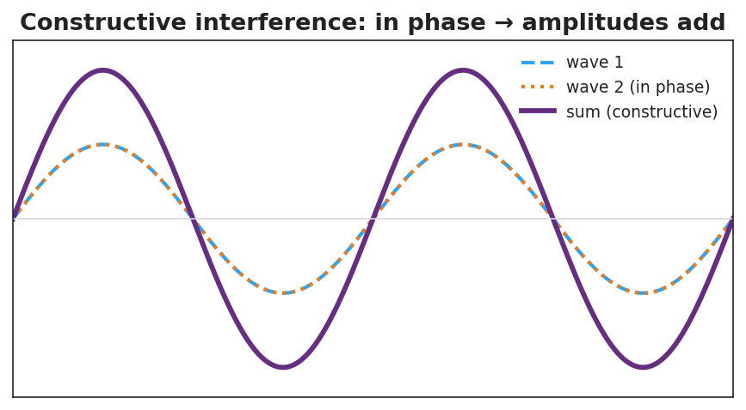
Two in-phase waves adding to a larger wave — constructive interference.
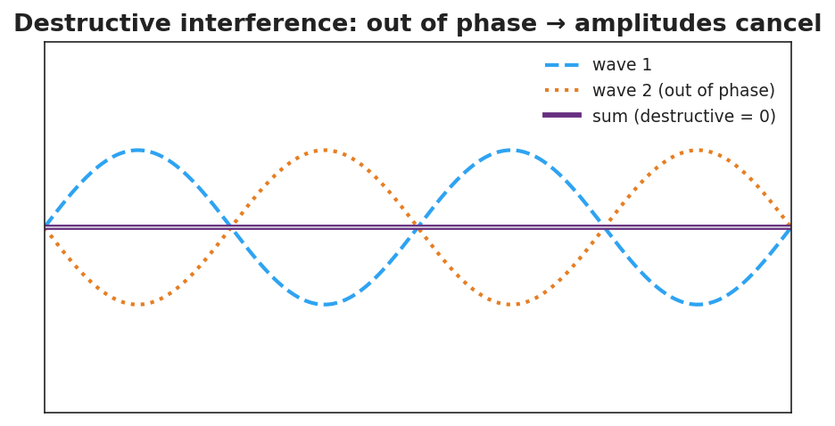
Two out-of-phase waves canceling to a flat line — destructive interference.

Teacher facilitation during Explore
- What to look for — groups adding waves point-by-point (sampling several x-values), not just eyeballing.
- What to resist — don’t supply “superposition,” “constructive,” or “destructive” yet; circulate and ask, “what did you do to combine them?”
- What to redirect — groups who say “they just disappear” should be asked, “where did the energy go — is it gone everywhere, or moved to the loud spots?”

Phase 3 · Explain (32 – 37 min)

32–35 min · Turn-and-Talk #2 + class consensus
“What is the rule for combining two overlapping waves, and what decides whether you get a loud or quiet result?”
Target consensus:
“You add the two waves point-by-point. If they’re in step (in phase), the crests add and you get a bigger wave. If they’re out of step (a crest on a trough), they cancel.”

35–37 min · Vocabulary introduction (≤ 3 terms)
Sample teacher language:
“Adding overlapping waves point-by-point is superposition. When they’re in phase and reinforce, that’s constructive interference. When they’re out of phase and cancel, that’s destructive interference — exactly how noise-canceling headphones silence a hum.”

Discussion prompts to deploy here
- “Two waves of amplitude 3 cm meet exactly in phase. What is the amplitude of the result?”
  - Sample student response: “6 cm — they add.”
- “The same two waves meet exactly out of phase. What is the result?”
  - Sample student response: “Zero — they cancel.”

Phase 4 · Elaborate (37 – 40 min)

37–39 min · Revise the model
“Return to your loud-spot and quiet-spot drawings. Label one constructive and one destructive. Add a sentence using the word superposition.”

39–40 min · Return to the phenomenon
“Explain in one sentence how noise-canceling headphones make a hum disappear, using destructive interference.”
Target: “The headphones play a wave that is exactly out of phase with the hum, so by superposition the two cancel — destructive interference — and you hear silence.”

Phase 5 · Evaluate (40 – 42 min)

40–42 min · Exit Ticket + Closing Reflection
“Two speakers play the same tone. At one point in the room a listener hears almost nothing. (a) Is this constructive or destructive interference? (b) Describe how the two waves are arriving at that point (in phase or out of phase?). (c) Two waves of amplitude 4 cm meet exactly in phase. What is the resulting amplitude?”
Expected: (a) destructive; (b) out of phase — crest meets trough; (c) 8 cm. See Answer_Key.docx.
Closing Reflection (SEL, 30 seconds):
“In your random group today, when did your thinking ‘add up’ (constructive) — and was there a moment it ‘canceled’ and you had to rethink?”

Common Misconceptions
- Misconception: “When two waves cancel, the energy is destroyed.” → Correction: Energy is conserved — it is redistributed to the constructive (loud/bright) regions; cancellation is local.
- Misconception: “Two waves always make a bigger wave.” → Correction: Only if in phase; out of phase they cancel.
- Misconception: “Interference only happens with sound.” → Correction: All waves interfere — light, water, and radio waves too.

Access & Differentiation
- ELL/ENL supports: Sentence frame: “When two waves are ______ they add (constructive); when they are ______ they cancel (destructive).” Word-choice box: {in phase, out of phase, superposition, amplitude}. Pair constructive with hands coming together and destructive with hands canceling.
- IEP/SPED supports: Provide graph paper with two pre-drawn waves aligned; students add the y-values at marked x-points to build the sum. Offer a “crest + trough = flat” manipulative (two transparency sine curves to overlay).
- Extensions: Path difference — explain why a fixed point is loud or quiet in terms of the difference in distance to the two speakers (a whole number of wavelengths → constructive; a half-wavelength offset → destructive).

Strategy Spotlight
BTC (Building Thinking Classrooms). Use visibly random groups of 3 and vertical non-permanent surfaces (whiteboards/windows), one marker per group. Pose the interference tasks as escalating thin slices — start with crest-on-crest, then crest-on-trough, then a half-wavelength shift — giving each task only after the previous is solved. The vertical surface keeps thinking public and erasable; the single marker forces collaboration. Defer all vocabulary to Phase 3.

NYSSLS Observation Checklist Crosswalk
# | Checklist item | Where it appears in this lesson
1 | Local/relatable phenomenon | Phase 1 — two-speaker loud/quiet spots; noise-canceling headphones
2 | Turn and Talk (2–3×) | Phase 1 (TT#1 — cancellation condition), Phase 3 (TT#2 — the combining rule)
3 | Students develop questions/models/procedures | Phase 1 (initial model), Phase 2 (BTC vertical-surface tasks + Javalab), Phase 4 (revise)
4 | CCC defined and used | Lesson Overview · Cause and Effect, restated in Phase 2
5 | ENL — ≤ 3 vocab, second half | Phase 3 — vocabulary at 35–37 min (superposition / constructive / destructive)
6 | Revisit phenomenon with evidence | Phase 4 — noise-canceling explanation
7 | ENL/SPED supports | Access & Differentiation block
8 | Assessment check | Phase 5 — Exit Ticket (quiet spot; amplitude sum)

Companion Materials
- Student_Worksheet.docx — the 5E student investigation (hand out at start of Phase 2)
- Student_Notes.docx — guided note-guide for vocabulary and the worked example
- Answer_Key.docx — answers to “Make It Make Sense” prompts and the Exit Ticket

Key Vocabulary (max 3)
- superposition — the principle that when waves overlap, the total displacement is the point-by-point sum of the individual waves
- constructive interference — when waves meet in phase so their amplitudes add, producing a larger wave (louder/brighter)
- destructive interference — when waves meet out of phase so their amplitudes cancel, producing a smaller wave or silence

