The Electromagnetic Spectrum — Teacher Guide

Cover
Unit: Waves — Lesson 07: The Electromagnetic Spectrum East Meadow Schools × Valley Stream Central High School District Strategy chips: ACTIVE LEARNING

Curated Resources (from East Meadow Scope & Sequence)

NYSSLS Standards
HS-PS4-1. “Use mathematical representations to support a claim regarding relationships among the frequency, wavelength, and speed of waves traveling in various media. (Cause and Effect)”
The EM spectrum is the ultimate test of v = f·λ: every band — radio to gamma — travels at the same speed c in vacuum, so the bands differ only by frequency and wavelength (which trade off inversely). Naming the order radio → micro → IR → visible → UV → X → gamma is a Cause-and-Effect application of v = f·λ at fixed v = c.

Phenomenon
- A single classroom “uses” the whole spectrum: the radio plays music (radio waves), the microwave heats lunch (microwaves), the remote works (infrared), you see the board (visible), sunscreen blocks sunburn (ultraviolet), the nurse takes an X-ray, and radiation therapy uses gamma rays: https://www.youtube.com/watch?v=cfXzwh3KadE

Javalab / Labs
- Javalab Electromagnetic Wave — a 3D transverse EM wave (electric and magnetic fields perpendicular): https://javalab.org/en/electromagnetic_wave_en/

Assessments
- Card-sort + Javalab check: students order the seven bands by increasing frequency and confirm all share c. Exit ticket below serves as the formative check.

Lesson Overview
Duration | 42 minutes (1 period)
NYSSLS link | HS-PS4-1 (all EM waves obey v = f·λ at v = c)
CCC focus | Cause and Effect — because v = c is fixed for all EM waves, a higher frequency causes a proportionally shorter wavelength.
Strategy chips | ACTIVE LEARNING
Materials | Seven band cards per group (radio, micro, IR, visible, UV, X-ray, gamma) with one example each; devices for Javalab; whiteboards.
Safety | None.
Prior knowledge | Lessons 01–03 — frequency, wavelength, v = f·λ; Lesson 02 — transverse waves.
Lesson objectives — students can:
- State that EM waves are transverse and travel at c = 3.0 × 10⁸ m/s in a vacuum.
- Order the spectrum from radio to gamma by increasing frequency / decreasing wavelength.
- Explain that all EM waves share the same speed, so frequency and wavelength trade off.

Phase 1 · Engage (0 – 12 min)

0–3 min · Opening Connection (SEL)
Quick check-in: “Name a device you used this morning that sent or received an invisible signal.” One sentence each. This primes the “invisible waves everywhere” idea.

3–8 min · Phenomenon hook — one room, the whole spectrum
Teacher actions. Point around the room: the speaker (radio), the microwave (microwaves), the TV remote (IR), your eyes (visible), the sunscreen poster (UV), the X-ray on the screen, the cancer-treatment clip (gamma). Same family of waves, wildly different uses.
Sample teacher language:
“Every one of these — the radio, the remote, your own eyes, an X-ray — is the same kind of wave. They all travel at the same speed. So what makes a radio wave different from an X-ray?”
Anticipated student responses:
- “They have different energies.” — affirm; energy tracks frequency.
- “Different wavelengths.” — yes; this is the key sorting variable.
- “Some you can see, some you can’t.” — true; visible is a tiny slice.

8–12 min · Notice & Wonder + Turn-and-Talk #1
Capture columns. Then:
“Turn to your partner: if all these waves travel at the same speed, what must be different between a radio wave and a gamma ray?”
Target: frequency and wavelength differ (inversely), since speed is the same.

Bridge to Phase 2
Initial model sentence: “Radio waves and X-rays are the same kind of wave but differ in ______ and ______.”

Phase 2 · Explore (12 – 32 min)

12–17 min · Initial Model (silent / individual)
Prompt:
“Make your best guess at the order of the spectrum from longest wavelength to shortest. Where does visible light fall? Where would the highest-energy waves go?”

17–32 min · Investigation — ACTIVE LEARNING: build the spectrum
Groups of 3–4 get seven shuffled band cards (each with an example and, on the back, a wavelength).
- Order by use/intuition first. Lay the cards left-to-right however your group thinks they go.
- Check with wavelengths. Flip the cards. Re-order by decreasing wavelength. Does visible light land between IR and UV?
- Apply v = f·λ. Since v = c for all, rank by frequency. Which band has the highest frequency? The shortest wavelength?
- Javalab. View the 3D EM wave; confirm it’s transverse and note that all bands share c.
Use this figure as the answer key the groups check against:
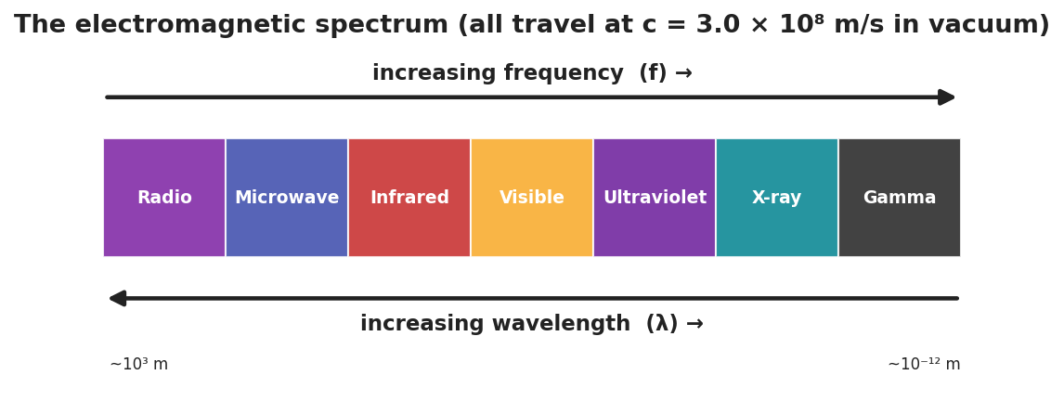
A horizontal band chart of the electromagnetic spectrum, radio to gamma, with arrows showing increasing frequency one way and increasing wavelength the other; all bands travel at c = 3.0 × 10⁸ m/s.
This paired bar chart makes the key claim explicit — every band shares the same speed c, even though their wavelengths span 15 orders of magnitude:
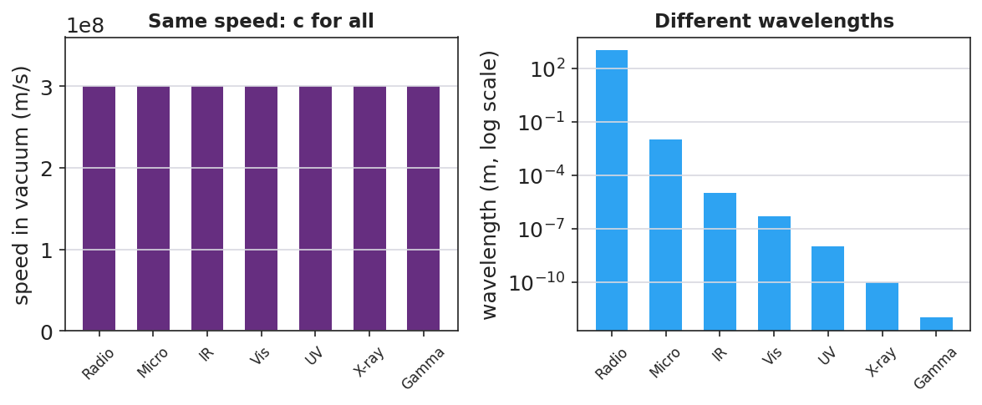
Two bar charts: on the left, all seven EM bands have the identical speed c = 3.0 × 10⁸ m/s; on the right, their wavelengths differ enormously on a logarithmic scale, from kilometers (radio) to picometers (gamma).

Teacher facilitation during Explore
- What to look for — groups using v = c (fixed) to argue that higher frequency must mean shorter wavelength.
- What to resist — don’t give the order; let the card-flip and v = f·λ reasoning produce it.
- What to redirect — groups who think “different waves go different speeds” should revisit the v = c claim at Javalab.

Phase 3 · Explain (32 – 37 min)

32–35 min · Turn-and-Talk #2 + class consensus
“What stays the same across the whole spectrum, and what changes from band to band?”
Target consensus:
“All EM waves are transverse and travel at the same speed, c, in a vacuum. What changes is the frequency and wavelength — and they trade off inversely (radio = low f / long λ; gamma = high f / short λ).”

35–37 min · Vocabulary introduction (≤ 3 terms)
Sample teacher language:
“These are all electromagnetic waves — waves of electric and magnetic fields that need no medium. The full ordered family is the spectrum. And the speed they all share in a vacuum is the speed of light, c = 3.0 × 10⁸ m/s.”

Discussion prompts to deploy here
- “Which has the longer wavelength: a radio wave or an X-ray?”
  - Sample student response: “Radio — it has the lowest frequency, so by v = f·λ the longest wavelength.”
- “Do microwaves travel faster than visible light in a vacuum?”
  - Sample student response: “No — all EM waves travel at c in a vacuum.”

Phase 4 · Elaborate (37 – 40 min)

37–39 min · Revise the model
“Return to your guessed order. Correct it using the spectrum chart. Add an arrow for ‘increasing frequency’ and one for ‘increasing wavelength,’ pointing opposite ways.”

39–40 min · Return to the phenomenon
“In one sentence, explain to a peer why a radio wave and an X-ray are the ‘same kind’ of wave, using electromagnetic wave and speed of light.”
Target: “Both are electromagnetic waves that travel at the speed of light; they only differ in frequency and wavelength, with X-rays having far higher frequency and shorter wavelength than radio waves.”

Phase 5 · Evaluate (40 – 42 min)

40–42 min · Exit Ticket + Closing Reflection
“Use the EM spectrum. (a) List these in order of increasing frequency: visible light, radio, X-ray, infrared. (b) A microwave and a gamma ray both travel through a vacuum. Which is faster? Explain. (c) Ultraviolet light has a higher frequency than visible light. Compare their wavelengths.”
Expected: (a) radio < infrared < visible < X-ray; (b) neither — both travel at c in vacuum; (c) UV has a shorter wavelength than visible (higher f → shorter λ). See Answer_Key.docx.
Closing Reflection (SEL, 30 seconds):
“Which part of the spectrum will you ‘see’ differently now — and who in your group sorted it best?”

Common Misconceptions
- Misconception: “Higher-frequency EM waves travel faster.” → Correction: All EM waves travel at c in a vacuum; higher frequency means shorter wavelength, not higher speed.
- Misconception: “EM waves need a medium like sound does.” → Correction: EM waves are not mechanical; they travel through a vacuum (that’s why sunlight reaches Earth).
- Misconception: “Visible light is a big part of the spectrum.” → Correction: Visible light is a tiny band between infrared and ultraviolet.

Access & Differentiation
- ELL/ENL supports: Sentence frame: “All EM waves travel at ______, so a higher frequency means a ______ wavelength.” Word-choice box: {c / speed of light, shorter, longer, transverse}. Provide a bilingual band-name glossary (radio, micro, IR, visible, UV, X-ray, gamma).
- IEP/SPED supports: Provide the seven band cards pre-printed with both the name and a familiar example image; students sequence rather than recall. Color-code the cards to match the spectrum figure.
- Extensions: Use c = f·λ to compute the wavelength of a 100 MHz FM radio station (λ = c/f = 3.0×10⁸ / 1.0×10⁸ = 3 m) and compare to an X-ray (~10⁻¹⁰ m).

Strategy Spotlight
ACTIVE LEARNING. Groups physically build the spectrum from shuffled cards, first by intuition and then by flipping to reveal wavelengths and reasoning with v = c. The manipulation — argue, flip, re-order, justify — makes the inverse f/λ relationship concrete before it is named. Facilitate with one prompt: “All the same speed — so what has to be true about frequency and wavelength as you move down the line?”

NYSSLS Observation Checklist Crosswalk
# | Checklist item | Where it appears in this lesson
1 | Local/relatable phenomenon | Phase 1 — one room uses the whole spectrum
2 | Turn and Talk (2–3×) | Phase 1 (TT#1 — what differs at same speed), Phase 3 (TT#2 — same vs. changing)
3 | Students develop questions/models/procedures | Phase 1 (guessed order), Phase 2 (card sort + Javalab), Phase 4 (revise)
4 | CCC defined and used | Lesson Overview · Cause and Effect, restated in Phase 2
5 | ENL — ≤ 3 vocab, second half | Phase 3 — vocabulary at 35–37 min (electromagnetic wave / spectrum / speed of light)
6 | Revisit phenomenon with evidence | Phase 4 — radio-vs-X-ray explanation
7 | ENL/SPED supports | Access & Differentiation block
8 | Assessment check | Phase 5 — Exit Ticket (order by frequency; same speed)

Companion Materials
- Student_Worksheet.docx — the 5E student investigation (hand out at start of Phase 2)
- Student_Notes.docx — guided note-guide for vocabulary and the worked example
- Answer_Key.docx — answers to “Make It Make Sense” prompts and the Exit Ticket

Key Vocabulary (max 3)
- electromagnetic wave — a transverse wave of oscillating electric and magnetic fields that requires no medium and travels at the speed of light in a vacuum
- spectrum — the full ordered range of electromagnetic waves, from radio (low frequency) through gamma rays (high frequency)
- speed of light — the speed of all electromagnetic waves in a vacuum, c = 3.0 × 10⁸ m/s

