Optics: Lenses and Mirrors — Teacher Guide

Cover
Unit: Waves — Lesson 09: Optics (Lenses and Mirrors) East Meadow Schools × Valley Stream Central High School District Strategy chips: ACTIVE LEARNING

Curated Resources (from East Meadow Scope & Sequence)

NYSSLS Standards
HS-PS4-6 (NYS). “Use mathematical models to determine relationships among the size and location of images, size and location of objects, and focal lengths of lenses and mirrors.”
This is the core HS-PS4-6 lesson. Building on refraction (Lesson 08), students use ray diagrams and the thin-lens / mirror equation 1/f = 1/dₒ + 1/dᵢ to relate object distance, image distance, and focal length, and to predict whether an image is real or virtual.

Phenomenon
- Corrective glasses and contact lenses fix blurry vision; a magnifying glass enlarges print and can focus sunlight; a curved makeup/shaving mirror magnifies your face: https://www.youtube.com/watch?v=Q3FrL_T0r2c

Javalab / Labs
- oPhysics Converging Lens and Concave/Convex Mirror — drag the object and read the image position, size, and type: https://www.ophysics.com/l1.html

Assessments
- oPhysics ray-tracing task: students place an object at several distances and record image distance, magnification, and real/virtual, confirming 1/f = 1/dₒ + 1/dᵢ. Quantitative exit ticket below serves as the formative check.

Lesson Overview
Duration | 42 minutes (1 period)
NYSSLS link | HS-PS4-6 (NYS) — the thin-lens / mirror equation
CCC focus | Cause and Effect — the object’s distance relative to the focal length causes a real or virtual image of a predictable size and location.
Strategy chips | ACTIVE LEARNING
Materials | Converging lenses (magnifiers); concave mirrors (or spoons); a candle/LED + screen; rulers; calculators; devices for oPhysics.
Safety | Do not focus sunlight onto skin or flammable material with a lens.
Prior knowledge | Lesson 08 — refraction, index of refraction, Snell’s law (lenses bend light by refraction; mirrors by reflection).
Lesson objectives — students can:
- Distinguish converging from diverging lenses and concave from convex mirrors, and identify the focal point.
- Draw principal rays to locate an image and classify it as real or virtual.
- Use 1/f = 1/dₒ + 1/dᵢ to solve for focal length, object distance, or image distance.

Phase 1 · Engage (0 – 12 min)

0–3 min · Opening Connection (SEL)
Quick check-in: “Name something you use to see better — glasses, a phone zoom, a screen.” One sentence each. This primes “lenses shape what we see.”

3–8 min · Phenomenon hook — the magnifying glass surprise
Teacher actions. Hand out (or demo) a magnifying glass. Have students hold it close to text (enlarged, upright) and then far from text/a window (small, upside-down image). Same lens, two completely different images.
Sample teacher language:
“Close up, the magnifier makes the print bigger and right-side-up. Move it far away, and look — the image flips upside down and shrinks. Same lens. What changed?”
Anticipated student responses:
- “How far away it is.” — exactly; object distance is the variable.
- “It flipped.” — capture; foreshadows real vs. virtual.
- “It focuses the window on the wall.” — great; that’s a real image.

8–12 min · Notice & Wonder + Turn-and-Talk #1
Capture columns. Then:
“Turn to your partner: what decides whether the image is big-and-upright or small-and-upside-down?”
Target: the object’s distance compared with the lens’s focal length.

Bridge to Phase 2
Initial model sentence: “The magnifier gives a different image depending on the ______ between the object and the lens.”

Phase 2 · Explore (12 – 32 min)

12–17 min · Initial Model (silent / individual)
Prompt:
“Draw a lens with a candle on the left. Sketch where you think the image forms when the candle is FAR from the lens, then when it’s VERY CLOSE. Label which one is upside-down.”

17–32 min · Investigation — ACTIVE LEARNING: ray-trace and measure
Groups of 3–4 with a converging lens, a screen, a light source, and oPhysics open:
- Real image. Place the object well beyond the focal point. Move the screen until the image is sharp. Measure dₒ and dᵢ; note size and orientation (inverted).
- Virtual image. Bring the object inside the focal length. The screen shows nothing — look through the lens (magnified, upright, virtual).
- Concave mirror. Repeat with a concave mirror (or the bowl of a spoon): far object → small inverted real image; close object → magnified upright image.
- oPhysics. Drag the object, record (dₒ, dᵢ) pairs, and check 1/f = 1/dₒ + 1/dᵢ.
Use these ray diagrams to standardize the three principal rays:
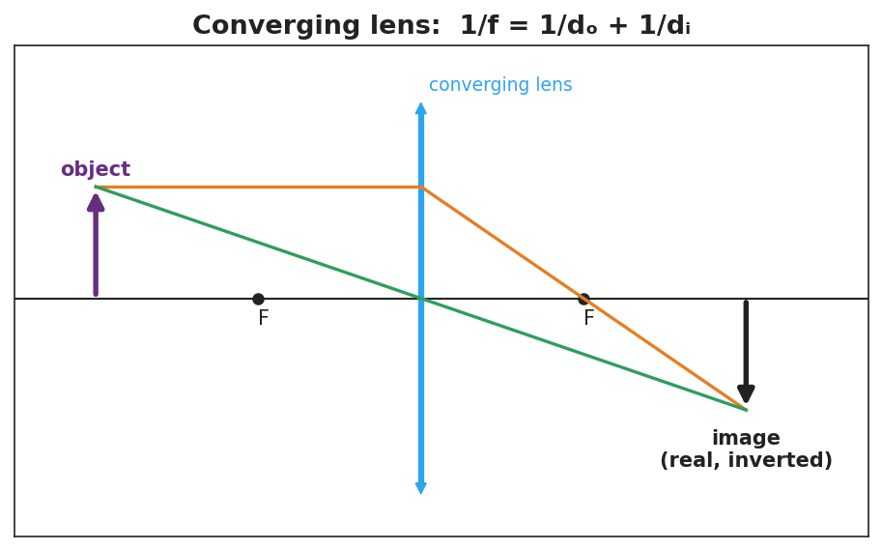
A converging-lens ray diagram: an object beyond F, the parallel ray refracting through the far focus, the central ray going straight, meeting at a real, inverted image; labeled 1/f = 1/dₒ + 1/dᵢ.
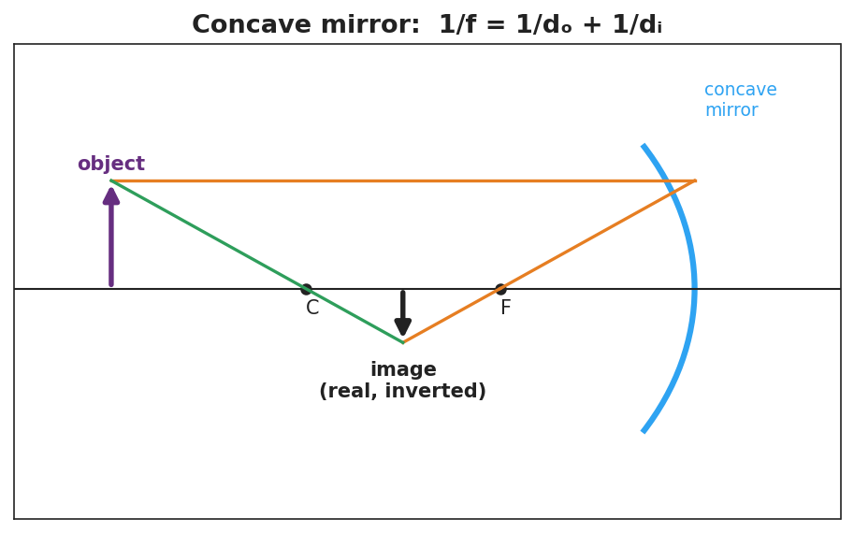
A concave-mirror ray diagram: an object beyond C, the parallel ray reflecting through F, the ray through C reflecting back on itself, meeting at a real, inverted image; labeled 1/f = 1/dₒ + 1/dᵢ.

Teacher facilitation during Explore
- What to look for — groups connecting “object inside f → no image on the screen” to “virtual image” (cannot be projected).
- What to resist — don’t give the equation first; let the (dₒ, dᵢ) data reveal the 1/f relationship.
- What to redirect — students who expect a screen image from a close object should be asked, “can you catch this image on paper, or only see it through the lens?”

Phase 3 · Explain (32 – 37 min)

32–35 min · Turn-and-Talk #2 + class consensus
“What decides whether you get a real (projectable) or virtual (look-through) image?”
Target consensus:
“If the object is beyond the focal point, a converging lens or concave mirror forms a real, inverted image you can project. If the object is inside the focal length, the image is virtual, upright, and magnified — you can only see it by looking through.”

35–37 min · Vocabulary introduction (≤ 3 terms)
Sample teacher language:
“The distance from the lens or mirror to its focus is the focal length, f. A lens that brings parallel rays together is a converging lens (and a concave mirror converges too). What forms where the rays meet — or appear to meet — is the image, related by 1/f = 1/dₒ + 1/dᵢ.”

Discussion prompts to deploy here
- “An object is 30 cm from a converging lens with f = 10 cm. Where is the image?”
  - Sample student response: “1/dᵢ = 1/f − 1/dₒ = 1/10 − 1/30 = 1/15 → dᵢ = 15 cm (real, inverted).”
- “Why can’t you project the magnified image from a magnifying glass onto a wall?”
  - Sample student response: “It’s a virtual image — the rays don’t actually meet, so there’s nothing to catch on a screen.”

Phase 4 · Elaborate (37 – 40 min)

37–39 min · Revise the model
“Return to your candle sketch. Re-draw both cases with the three principal rays. Label one image real, inverted and one virtual, upright. Note where the focal point F is.”

39–40 min · Return to the phenomenon
“Explain in one sentence why the magnifier’s image flips when you move it far from the page, using focal length and image.”
Target: “When the page is closer than the focal length the image is virtual and upright (magnified), but when the page is beyond the focal length the rays cross and form a real, inverted image — so it flips.”

Phase 5 · Evaluate (40 – 42 min)

40–42 min · Exit Ticket + Closing Reflection
“A converging lens has a focal length of 12 cm. An object is placed 36 cm from the lens. (a) Use 1/f = 1/dₒ + 1/dᵢ to find the image distance. Show your work. (b) Is the image real or virtual? Upright or inverted? (c) If the object is moved to 6 cm (inside the focal length), can the image be projected on a screen? Why or why not?”
Expected: (a) 1/dᵢ = 1/12 − 1/36 = 1/18 → dᵢ = 18 cm; (b) real and inverted (object beyond f); (c) no — inside f the image is virtual and cannot be projected. See Answer_Key.docx.
Closing Reflection (SEL, 30 seconds):
“What’s one device with a lens or mirror you now understand better, and who helped you trace the rays?”

Common Misconceptions
- Misconception: “A bigger lens always magnifies more.” → Correction: Magnification depends on the focal length and object distance, not the lens diameter.
- Misconception: “All images can be projected on a screen.” → Correction: Only real images (rays actually meet) project; virtual images (rays only appear to meet) cannot.
- Misconception: “Converging and concave mean opposite things.” → Correction: A converging lens and a concave mirror both bring parallel rays to a focus; they converge light.

Access & Differentiation
- ELL/ENL supports: Sentence frame: “When the object is ______ the focal length, the image is ______ (real/virtual) and ______ (upright/inverted).” Word-choice box: {beyond, inside, real, virtual, upright, inverted}. Provide a labeled ray-diagram template.
- IEP/SPED supports: Provide pre-drawn principal axes with F marked; students draw only the two easiest rays (parallel and central). Give a 1/f = 1/dₒ + 1/dᵢ template with the unknown isolated and a worked example beside it.
- Extensions: Diverging lenses and convex mirrors always form reduced, upright, virtual images. Explain why a convex (passenger-side) car mirror is labeled “objects are closer than they appear.”

Strategy Spotlight
ACTIVE LEARNING. Students physically place objects, hunt for the sharp image on a screen, and discover that a close object yields no screen image (a virtual image) before any term is introduced. Tracing the three principal rays by hand on the diagram cements the geometry. Facilitate with one prompt during the hunt: “Can you catch this image on paper, or only see it through the lens?” — separating real from virtual by experience.

NYSSLS Observation Checklist Crosswalk
# | Checklist item | Where it appears in this lesson
1 | Local/relatable phenomenon | Phase 1 — magnifying glass; glasses, spoons; car mirror in extensions
2 | Turn and Talk (2–3×) | Phase 1 (TT#1 — what decides image type), Phase 3 (TT#2 — real vs. virtual)
3 | Students develop questions/models/procedures | Phase 1 (initial sketch), Phase 2 (ray-trace + oPhysics data), Phase 4 (revise)
4 | CCC defined and used | Lesson Overview · Cause and Effect, restated in Phase 2
5 | ENL — ≤ 3 vocab, second half | Phase 3 — vocabulary at 35–37 min (focal length / converging lens / image)
6 | Revisit phenomenon with evidence | Phase 4 — magnifier flip explanation
7 | ENL/SPED supports | Access & Differentiation block
8 | Assessment check | Phase 5 — quantitative Exit Ticket (lens, f = 12 cm)

Companion Materials
- Student_Worksheet.docx — the 5E student investigation (hand out at start of Phase 2)
- Student_Notes.docx — guided note-guide for vocabulary and the worked example
- Answer_Key.docx — answers to “Make It Make Sense” prompts and the Exit Ticket

Key Vocabulary (max 3)
- focal length — the distance (f) from a lens or mirror to its focal point, where parallel rays converge
- converging lens — a lens (thicker in the middle) that brings parallel rays together at the focal point; a concave mirror does the same by reflection
- image — the reproduction of an object formed by a lens or mirror; real if rays actually meet (projectable), virtual if they only appear to meet

