Digital Technologies and Information — Teacher Guide

Cover
Unit: Waves — Lesson 10: Digital Technologies and Information East Meadow Schools × Valley Stream Central High School District Strategy chips: BTC

Curated Resources (from East Meadow Scope & Sequence)

NYSSLS Standards
HS-PS4-2. “Evaluate questions about the advantages of using a digital transmission and storage of information. (Stability and Change)”
This closing lesson asks students to evaluate why modern technology encodes information digitally. Waves (the whole unit) are how signals travel; here students compare an analog wave to its digital (sampled, bit-encoded) version and weigh the advantages — robustness to noise, exact copying, and easy storage. The Crosscutting Concept is Stability and Change: digital encoding keeps information stable as it is transmitted and copied.

Phenomenon
- A scratchy vinyl record (analog) vs. a crisp streamed song (digital); a blurry, pixelated photo “cleaning up” as more data loads; a tenth-generation photocopy vs. a re-printed PDF: https://www.youtube.com/watch?v=Hh-qWaMG6Sw

Javalab / Labs
- Javalab Analog vs Digital Signal — toggle between a smooth wave and its sampled, quantized version and add “noise”: https://javalab.org/en/analog_digital_signal_en/

Assessments
- Telephone-game data activity + Javalab noise test: students pass an analog vs. a digital “message” down a line and measure which survives copying. Exit ticket below serves as the formative check.

Lesson Overview
Duration | 42 minutes (1 period)
NYSSLS link | HS-PS4-2 (advantages of digital transmission/storage)
CCC focus | Stability and Change — digital encoding keeps information stable against noise and repeated copying.
Strategy chips | BTC (Building Thinking Classrooms)
Materials | Vertical non-permanent surfaces + markers; graph paper; an old photocopy + a fresh PDF print (demo); devices for Javalab.
Safety | None.
Prior knowledge | Lessons 01–07 — waves carry information as signals; amplitude/frequency encode a message.
Lesson objectives — students can:
- Distinguish an analog signal (continuous) from a digital signal (discrete samples encoded as bits).
- Explain how sampling and bits represent a wave, and that more bits / faster sampling means higher fidelity.
- Evaluate, with reasoning, why digital transmission and storage are more robust to noise and easier to copy than analog.

Phase 1 · Engage (0 – 12 min)

0–3 min · Opening Connection (SEL)
Quick check-in: “Name a message that got ‘garbled’ on the way to you — a bad photocopy, a frozen video call, a misheard rumor.” One sentence each. This primes the noise/fidelity idea.

3–8 min · Phenomenon hook — vinyl crackle vs. clean stream
Teacher actions. Play a few seconds of a scratchy vinyl/old tape recording, then the same song streamed. Show a tenth-generation photocopy next to a freshly printed PDF. Old analog copies degrade; digital copies don’t.
Sample teacher language:
“Copy a copy of a copy on this photocopier and it turns to mush. But I can copy this PDF a million times and the millionth is identical to the first. Why does one survive copying and the other doesn’t?”
Anticipated student responses:
- “The digital one is just numbers.” — excellent; capture this.
- “The analog one picks up noise.” — yes; noise accumulates.
- “Computers can fix errors.” — good; digital is correctable.

8–12 min · Notice & Wonder + Turn-and-Talk #1
Capture columns. Then:
“Turn to your partner: what is it about storing something as numbers (digital) that lets it survive copying perfectly?”
Target: a digital signal only has to decide between a few exact values, so small noise can be cleaned back to the nearest value.

Bridge to Phase 2
Initial model sentence: “A digital copy survives because the signal is stored as ______ instead of a continuous ______.”

Phase 2 · Explore (12 – 32 min)

12–17 min · Initial Model (silent / individual)
Prompt:
“Draw a smooth wave (analog). Now show how you would store it using only a few measured points (samples). What information do you lose? What do you gain?”

17–32 min · Investigation — BTC: random groups, vertical surfaces
Form visibly random groups of 3 at vertical non-permanent surfaces, one marker each. Escalating thin-slice tasks:
- Sample it. Given a printed analog wave, mark sample points at regular intervals and round each to the nearest grid line (quantize). Draw the resulting stair-step.
- More vs. fewer samples. Redraw with twice as many samples. Which stair-step matches the original better?
- Add noise. Add a small random wobble to both an analog wave and a digital stair-step. After “cleaning” (rounding to nearest level), which one recovers the original exactly?
- Evaluate (the HS-PS4-2 question). List two advantages of digital over analog for transmitting and storing a song. Is there any disadvantage?
Confirm at Javalab, then compare to these figures:
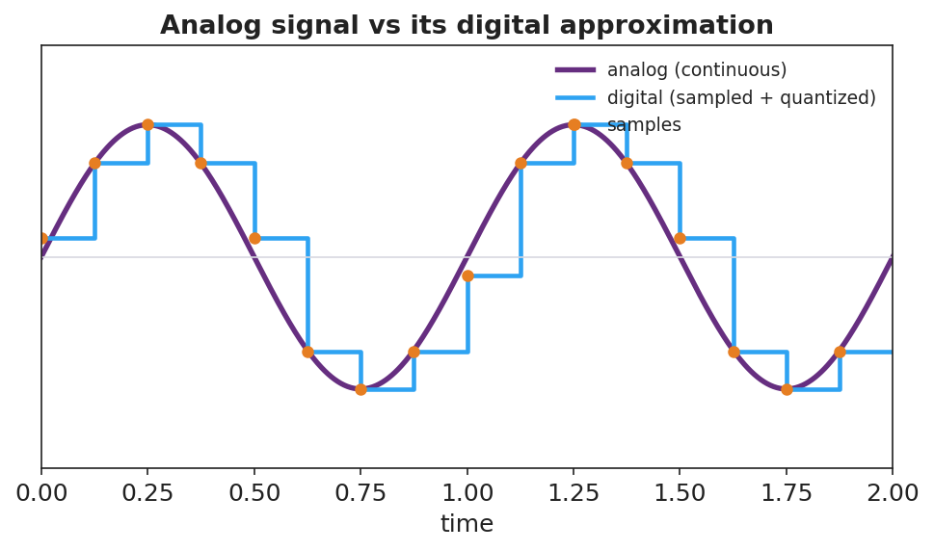
A smooth analog sine wave overlaid with its digital version: sample points and a stair-step (sampled and quantized) approximation.
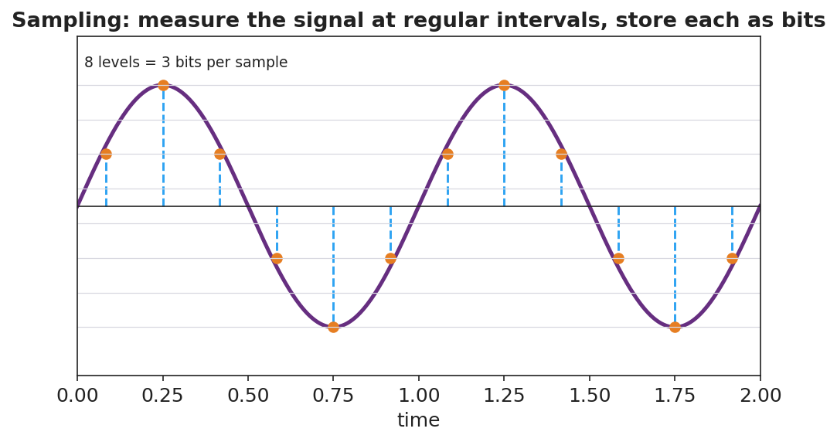
A sampling diagram: a continuous wave measured at regular time intervals, each sample stored at a discrete level (8 levels = 3 bits).

Teacher facilitation during Explore
- What to look for — groups reasoning that small noise on a digital signal rounds back to the correct level, while noise on analog is indistinguishable from the real signal.
- What to resist — don’t define analog/digital/bit first; let “smooth vs. stair-step” and “numbers vs. continuous” emerge.
- What to redirect — groups who claim digital is “always better/perfect” should be pushed to find the cost (lost detail between samples; needs enough bits/sampling rate).

Phase 3 · Explain (32 – 37 min)

32–35 min · Turn-and-Talk #2 + class consensus
“Why does digital information survive transmission and copying better than analog?”
Target consensus:
“An analog signal is continuous, so any noise becomes part of the signal and builds up with each copy. A digital signal is a set of exact numbers (bits); small noise can be cleaned back to the nearest value, so copies stay identical.”

35–37 min · Vocabulary introduction (≤ 3 terms)
Sample teacher language:
“A continuous, smoothly varying signal is analog. A signal stored as discrete sampled values is digital. The smallest unit of digital information — a single 0 or 1 — is a bit; more bits per sample means more levels and higher fidelity.”

Discussion prompts to deploy here
- “Why does a digital photo copied 100 times look identical, but a photocopied photo degrades?”
  - Sample student response: “The digital photo is exact numbers that get reproduced perfectly; the photocopy adds a little noise each time.”
- “What’s a disadvantage of digital?”
  - Sample student response: “You lose the detail between samples unless you sample fast enough and use enough bits.”

Phase 4 · Elaborate (37 – 40 min)

37–39 min · Revise the model
“Return to your sampled wave. Label the smooth curve analog and the stair-step digital. Add a one-sentence evaluation: why is digital better for sending a song across the world?”

39–40 min · Return to the phenomenon
“Explain in one sentence why the streamed song stays crisp but the vinyl gets scratchier, using analog, digital, and noise.”
Target: “Vinyl is analog, so every scratch adds noise to the continuous groove; a streamed song is digital — stored as bits — so noise can be removed by rounding to the nearest value and every copy stays identical.”

Phase 5 · Evaluate (40 – 42 min)

40–42 min · Exit Ticket + Closing Reflection
“A friend says, ‘Records sound warmer, so analog must be better in every way.’ (a) Define analog and digital signals. (b) Give two advantages of digital for transmitting and storing music. (c) Evaluate the friend’s claim: name one thing analog might do well and one clear advantage of digital they’re overlooking.”
Expected: (a) analog = continuous signal, digital = discrete sampled values stored as bits; (b) robust to noise / identical copies / easy to store and compress; (c) analog can capture continuous nuance, but digital resists noise and copies perfectly — the friend overlooks robustness/fidelity in transmission. See Answer_Key.docx.
Closing Reflection (SEL, 30 seconds):
“After this whole Waves unit, what’s one wave idea you’ll carry with you — and how did this class help you ‘tune in’?”

Common Misconceptions
- Misconception: “Digital signals are perfect with no information loss.” → Correction: Sampling and quantization discard detail between samples; fidelity depends on sampling rate and bit depth.
- Misconception: “Analog is old and useless.” → Correction: Analog captures continuous variation; the lesson is about trade-offs, especially digital’s robustness to noise.
- Misconception: “A bit is the same as a byte / a sample.” → Correction: A bit is a single 0/1; multiple bits encode one sample’s level (e.g., 3 bits = 8 levels).

Access & Differentiation
- ELL/ENL supports: Sentence frame: “An analog signal is ______; a digital signal is ______. Digital survives noise because ______.” Word-choice box: {continuous, discrete/sampled, rounded to the nearest value, bits}. Provide the analog-vs-digital figure with both labeled.
- IEP/SPED supports: Provide graph paper with an analog wave already drawn and grid levels marked; students place sample dots and round to the nearest line. Offer the photocopy-degradation demo as a concrete anchor for “noise builds up.”
- Extensions: Estimate the bits needed for CD audio (16 bits/sample × 44,100 samples/s × 2 channels) and discuss why higher sampling rates and bit depths improve fidelity but increase file size.

Strategy Spotlight
BTC (Building Thinking Classrooms). Use visibly random groups of 3 at vertical non-permanent surfaces, one marker per group. The escalating thin slices — sample, refine, add noise, then evaluate — culminate in the HS-PS4-2 evaluation question, which is genuinely open and benefits from public, erasable thinking. Defer vocabulary to Phase 3 and circulate with one prompt: “After adding noise, which signal can you clean back to the original — and why?”

NYSSLS Observation Checklist Crosswalk
# | Checklist item | Where it appears in this lesson
1 | Local/relatable phenomenon | Phase 1 — vinyl vs. stream; photocopy vs. PDF
2 | Turn and Talk (2–3×) | Phase 1 (TT#1 — why numbers survive copying), Phase 3 (TT#2 — why digital is robust)
3 | Students develop questions/models/procedures | Phase 1 (initial model), Phase 2 (BTC sampling + noise tasks + Javalab), Phase 4 (revise)
4 | CCC defined and used | Lesson Overview · Stability and Change, restated in Phase 2
5 | ENL — ≤ 3 vocab, second half | Phase 3 — vocabulary at 35–37 min (analog signal / digital signal / bit)
6 | Revisit phenomenon with evidence | Phase 4 — vinyl-vs-stream explanation
7 | ENL/SPED supports | Access & Differentiation block
8 | Assessment check | Phase 5 — Exit Ticket (evaluate the “analog is better” claim)

Companion Materials
- Student_Worksheet.docx — the 5E student investigation (hand out at start of Phase 2)
- Student_Notes.docx — guided note-guide for vocabulary and the worked example
- Answer_Key.docx — answers to “Make It Make Sense” prompts and the Exit Ticket

Key Vocabulary (max 3)
- analog signal — a continuous, smoothly varying signal that can take any value (e.g., a vinyl groove, a sound wave in air)
- digital signal — a signal represented by discrete sampled values encoded as bits, taking only specific levels
- bit — the smallest unit of digital information, a single 0 or 1; more bits per sample give more levels and higher fidelity

