The Photoelectric Effect — Teacher Guide

Cover
Unit: Modern Physics — Lesson 01: The Photoelectric Effect East Meadow Schools × Valley Stream Central High School District Strategy chips: HOCHMAN

Curated Resources (from East Meadow Scope & Sequence)

NYSSLS Standards
This lesson is the core treatment of HS-PS4-4: “Evaluate the validity and reliability of claims in published materials of the effects that different frequencies of electromagnetic radiation have when absorbed by matter. (Cause and Effect).” The photoelectric effect is the cleanest case in the curriculum where the frequency of light — not its brightness — is the cause that determines an effect (whether electrons are ejected). It also closes the Waves unit’s wave model of light by introducing the complementary particle (photon) model.

Phenomenon
- Different-color lasers (red, green, violet) shining on a glow/photo surface — only some colors eject electrons, no matter how bright: https://www.youtube.com/watch?v=kcSYV8bMQzg
- Why a UV lamp fogs photographic paper but a much brighter red lamp does not (cause-and-effect framing).

Javalab / Labs
- PhET Photoelectric Effect simulation: https://phet.colorado.edu/en/simulations/photoelectric

Assessments
- Exit ticket below (threshold-frequency reasoning) is the formative check. The PhET simulation includes built-in data tables students can screenshot as evidence.

Lesson Overview
Duration | 42 minutes (1 period)
NYSSLS link | HS-PS4-4 (core)
CCC focus | Cause and Effect — the frequency of light, not its intensity, causes (or fails to cause) electron ejection.
Strategy chips | HOCHMAN (Because/But/So + appositive on threshold frequency)
Materials | Projector for the laser/PhET demo; student devices or a shared screen for PhET; whiteboards/markers; reference table (E = h·f, h = 6.63×10⁻³⁴ J·s).
Safety | If using real lasers, never aim at eyes; the simulation is the safe default.
Prior knowledge | Waves — frequency and wavelength (violet light is higher frequency than red); energy as a measurable quantity.
Lesson objectives — students can:
- Describe light as a stream of energy packets (photons) whose energy is set by frequency, E = h·f.
- Explain why electrons are ejected only above a threshold frequency, regardless of intensity.
- Use E = h·f to calculate a photon’s energy and compare it to a threshold.

Phase 1 · Engage (0 – 10 min)

0–2 min · Opening Connection (SEL)
Quick whip-around (one sentence each, pass allowed): “Name something where doing it harder doesn’t help — only doing it a different way does.” (e.g., a key that’s the wrong shape — pushing harder won’t open the lock.) Park these; you’ll call back to “wrong shape vs. harder push” when intensity fails but frequency succeeds.

2–7 min · Phenomenon hook — colored lasers on a photo surface
Teacher actions. Project the laser clip (or PhET). Shine a bright red beam on the surface: no electrons leave. Switch to a dim violet beam: electrons fly off immediately.
Sample teacher language:
“I just made the red light much brighter and nothing happened. Then I used a dim purple light and electrons jumped off right away. Brightness lost to color. Why would the color of the light decide this, when more brightness couldn’t?”
Anticipated student responses:
- “Purple light is stronger.” — reframe: “Stronger how? It’s actually dimmer. What’s different about purple?”
- “Maybe purple has more energy per beam.” — capture energy; we’ll sharpen “per beam” to “per packet.”
- “It’s the frequency — purple is higher frequency.” — gold; hold it for Phase 3.

7–10 min · Notice & Wonder + Turn-and-Talk #1
Two columns on the board. Then:
“Turn to your partner: what does brightness change, and what does color change? Predict which one controls whether electrons leave.”
Target seed: brightness = how many; color (frequency) = how much energy each carries.

Bridge to Phase 2
Every student leaves with a one-sentence initial model: “Electrons are ejected when ______.”

Phase 2 · Explore (10 – 30 min)

10–14 min · Initial Model (silent / individual)
Prompt on the board:
“Draw the light hitting the metal. Show what you think ‘brighter’ does and what ‘higher frequency’ does. Predict: which change will start ejecting electrons?”

14–30 min · Investigation — PhET Photoelectric Effect
Students (pairs) run the PhET sim and fill the data table on the worksheet:
- Hold frequency low (red), raise intensity to max. Do electrons eject? (No.)
- Hold intensity low, raise frequency until electrons just begin to leave. Record that frequency — the threshold.
- Above threshold: raise frequency higher. What happens to the speed/energy of ejected electrons? (Increases.)
- Above threshold: raise intensity. What happens to the number of electrons? (Increases, but their energy does not.)
Teacher facilitation language:
“At max brightness with red light — anything? Now creep the frequency up. Watch for the exact moment electrons appear.” “Once they’re flying, what does turning up brightness change — their number or their speed?” “What does turning up frequency change instead?”
Use the diagram below to make “one photon, one electron” visible while students model the ejection event:
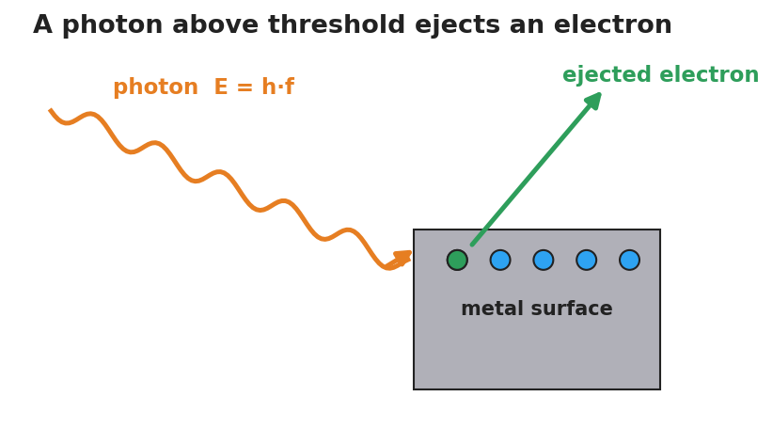
A single photon of energy E equals h times f strikes a metal surface and ejects one electron, which flies away.

Teacher facilitation during Explore
- What to look for — students noticing the sharp on/off at a particular frequency, not a gradual fade.
- What to resist — don’t name “photon” or “quantized” yet; let the threshold surprise them.
- What to redirect — “more brightness = more energy” should be tested: more brightness below threshold still ejects nothing.

Phase 3 · Explain (30 – 36 min)

30–33 min · Turn-and-Talk #2 + class consensus
“Brightness changed the number of electrons but never started them. Frequency had an on/off line. What does that tell you about how light delivers its energy?”
Target consensus:
“Light arrives in separate packets. Each packet’s energy depends on frequency. One packet hits one electron — if that single packet doesn’t carry enough energy, no amount of extra packets (brightness) helps.”

33–36 min · Vocabulary introduction (≤ 3 terms)
Sample teacher language:
“Each energy packet of light is a photon — a particle of light. Its energy is E = h·f, so higher frequency means a more energetic photon. The ejecting of electrons by light is the photoelectric effect. The lowest frequency that can eject any electron is the threshold frequency — below it, brightness is useless; above it, brightness only adds more electrons.”

Discussion prompts to deploy here
- “Why can’t a brighter red beam ever eject an electron that violet ejects easily?”
  - Sample student response: “Brighter red just sends more low-energy photons; each one is still too weak. Violet photons each clear the threshold.”
- “If h is tiny, why does frequency matter so much?”
  - Sample student response: “E = h·f — h is fixed, so the only way to raise each photon’s energy is to raise f.”

Phase 4 · Elaborate (36 – 39 min)

36–38 min · Hochman Because/But/So + revise the model
Students complete the sentence stem (modeled, then independent):
“A bright red light cannot eject electrons because ______, but a dim violet light can because ______, so the deciding factor is ______ , not ______.”
Coach the appositive: “A photon, a single packet of light energy, carries E = h·f.”

38–39 min · Return to the phenomenon
“Restate the laser demo in one sentence using photon and threshold frequency.”
Target: “Violet photons cleared the threshold frequency and ejected electrons; red photons — even many of them — each fell below it.”

Phase 5 · Evaluate (39 – 42 min)

39–42 min · Exit Ticket + Closing Reflection
“A metal has a threshold frequency of 5.0×10¹⁴ Hz. (a) Find the energy of one photon of light at 6.0×10¹⁴ Hz. (Use E = h·f, h = 6.63×10⁻³⁴ J·s.) (b) Will that light eject electrons? Explain. (c) Doubling the brightness of light at 4.0×10¹⁴ Hz does what? Why?”
Expected: (a) E = (6.63×10⁻³⁴)(6.0×10¹⁴) ≈ 4.0×10⁻¹⁹ J; (b) yes — 6.0×10¹⁴ Hz is above threshold; (c) nothing is ejected — below threshold, more photons still each lack the energy. See Answer_Key.docx.
Closing Reflection (SEL, 30 seconds):
“What is one idea about light that changed for you today?”

Common Misconceptions
- Misconception: “Brighter light always carries more energy to each electron.” → Correction: Brighter light = more photons, not more energetic ones. Each photon’s energy is set by frequency (E = h·f).
- Misconception: “Light is only a wave.” → Correction: Light also behaves as particles (photons); the photoelectric effect is the evidence the wave model alone cannot explain.
- Misconception: “Any light, given enough time/intensity, eventually ejects electrons.” → Correction: Below the threshold frequency, no intensity and no waiting will eject an electron — it’s an on/off threshold.

Access & Differentiation
- ELL/ENL supports: Sentence frame: “Light below the ___ frequency ejects ___ electrons, but light above it ejects electrons whose energy ___ as frequency rises.” Word box: {threshold, no, increases, photon, intensity}. Pair photon with a gesture (one fist = one packet).
- IEP/SPED supports: Provide the PhET data table pre-labeled; students circle “ejects / does not eject” rather than writing. Offer a partially worked E = h·f calculation with the substitution already set up.
- Extensions: Have students compute the threshold energy in joules from the threshold frequency and explain why two metals with different thresholds respond to different colors.

Strategy Spotlight
HOCHMAN (literacy). Today’s literacy move is the Because/But/So expansion in Phase 4, which forces students to coordinate cause (frequency) against a distractor (intensity) in a single complex sentence. Model one aloud, then release. The appositive drill — “A photon, a single packet of light energy, carries E = h·f” — gives students a compact way to define the new term mid-sentence, a transferable academic-writing structure.

NYSSLS Observation Checklist Crosswalk
# | Checklist item | Where it appears in this lesson
1 | Local/relatable phenomenon | Phase 1 — colored lasers; UV vs. red lamp
2 | Turn and Talk (2–3×) | Phase 1 (TT#1 — brightness vs. color), Phase 3 (TT#2 — how light delivers energy)
3 | Students develop questions/models/procedures | Phase 1 (initial model), Phase 2 (PhET investigation), Phase 4 (revise model)
4 | CCC defined and used | Lesson Overview · Cause and Effect (frequency → ejection), restated in Phase 3
5 | ENL — ≤ 3 vocab, second half | Phase 3 — vocabulary at 33–36 min (photon / photoelectric effect / threshold frequency)
6 | Revisit phenomenon with evidence | Phase 4 — restate the laser demo using new terms
7 | ENL/SPED supports | Access & Differentiation block
8 | Assessment check | Phase 5 — Exit Ticket (E = h·f + threshold)

Companion Materials
- Student_Worksheet.docx — the 5E student investigation with the PhET data table (hand out at start of Phase 2)
- Student_Notes.docx — guided note-guide for vocabulary and the E = h·f worked example
- Answer_Key.docx — answers to “Make It Make Sense” prompts and the Exit Ticket

Key Vocabulary (max 3)
- photon — a single packet (particle) of light energy; its energy is E = h·f, where h = 6.63×10⁻³⁴ J·s
- photoelectric effect — the ejection of electrons from a surface when light of high enough frequency strikes it
- threshold frequency — the lowest frequency of light that can eject electrons from a given surface; below it, no electrons leave regardless of intensity

