Models of the Atom — Teacher Guide

Cover
Unit: Modern Physics — Lesson 02: Models of the Atom East Meadow Schools × Valley Stream Central High School District Strategy chips: ACTIVE LEARNING

Curated Resources (from East Meadow Scope & Sequence)

NYSSLS Standards
This is a model-building lesson anchored to the Science and Engineering Practice Developing and Using Models. Students see that a scientific model is revised when new evidence appears — the central habit of mind behind every Modern Physics standard. It builds the atomic structure that the spectra lesson (HS-ESS1-2 connection) and the nuclear-change lesson (HS-PS1-8) depend on.

Phenomenon
- Rutherford’s gold-foil scattering: most alpha particles pass straight through a thin gold foil, but a tiny fraction bounce sharply backward: https://www.youtube.com/watch?v=XBqHkraf8iE
- Rutherford’s own line: “as if you fired a 15-inch shell at a piece of tissue paper and it came back and hit you.”

Javalab / Labs
- Rutherford scattering (interactive): https://javalab.org/en/rutherford_scattering_en/

Assessments
- Exit ticket below (match a model to the evidence that overturned it). The gold-foil claim-evidence card sort in Phase 2 is the formative check.

Lesson Overview
Duration | 42 minutes (1 period)
NYSSLS link | SEP: Developing and Using Models (supports HS-PS1-8 and HS-ESS1-2 later in the unit)
CCC focus | Patterns / Stability and Change — a model holds until new evidence forces a change.
Strategy chips | ACTIVE LEARNING (claim–evidence card sort + model-revision gallery)
Materials | Pre-cut model/evidence card sets (one per group); chart paper or whiteboards; markers; the model-progression handout.
Safety | None — simulation and paper-based.
Prior knowledge | Atoms contain protons, neutrons, electrons (from earlier science); charge basics (+/−).
Lesson objectives — students can:
- Sequence the atomic models (Dalton → Thomson → Rutherford → Bohr → quantum) and state what each got right.
- Explain how the gold-foil experiment provided evidence for a small, dense nucleus.
- Argue, using evidence, why a scientific model changes over time.

Phase 1 · Engage (0 – 10 min)

0–2 min · Opening Connection (SEL)
Whip-around (one sentence, pass allowed): “Tell me about a time you changed your mind because you got new information.” Park responses — you’ll connect them to “scientists change models with new evidence.”

2–7 min · Phenomenon hook — the gold-foil surprise
Teacher actions. Play the gold-foil clip (or run the Javalab sim). Set up the expectation first: scientists thought the atom was a soft “pudding” of positive charge. Show alphas firing at the foil; most pass through, a rare few rebound.
Sample teacher language:
“They expected every bullet to sail straight through soft pudding. Instead, one in thousands bounced straight back. Rutherford said it was like firing a cannon shell at tissue paper and having it come back at you. What inside the atom could do that?”
Anticipated student responses:
- “There’s something hard in the middle.” — gold; capture small + hard + central.
- “The whole atom is solid.” — counter with: “Then why do most pass straight through?”
- “It’s charged and pushed them back.” — capture; the dense center is positive.

7–10 min · Notice & Wonder + Turn-and-Talk #1
“Turn and talk: if MOST pass through but a FEW bounce hard, what must the inside of the atom look like — solid, empty, or something in between?”
Target seed: mostly empty space with a tiny, dense, charged center.

Bridge to Phase 2
Each student writes a one-sentence initial model: “The atom’s inside must be ______ because ______.”

Phase 2 · Explore (10 – 30 min)

10–14 min · Initial Model (silent / individual)
Prompt:
“Draw what you think the inside of a gold atom looks like, based on the scattering result. Mark where the ‘hard’ part is and how much is empty.”

14–30 min · Investigation — model/evidence card sort (ACTIVE LEARNING)
Groups of 3–4 receive shuffled cards: five model cards (Dalton solid sphere, Thomson plum pudding, Rutherford nucleus, Bohr orbits, quantum cloud) and matching evidence cards (e.g., “elements combine in fixed ratios,” “rays bend toward + plate → negative particles exist,” “alpha particles bounce back,” “atoms emit only specific colors of light,” “electrons behave as probability clouds”). Groups:
- Order the models oldest → newest.
- Match each model to the evidence that supported it and the evidence that broke it.
- Build a chart-paper timeline; star the gold-foil card as the turning point for the nucleus.
Teacher facilitation language:
“Which evidence card could Dalton’s solid sphere NOT explain?” “What did Thomson get right that Dalton missed — and what did the gold foil reveal that Thomson missed?” “Bohr’s orbits explain which observation that Rutherford’s couldn’t? (Hold that — it’s Lesson 03.)”
Use the progression figure to anchor the gallery:
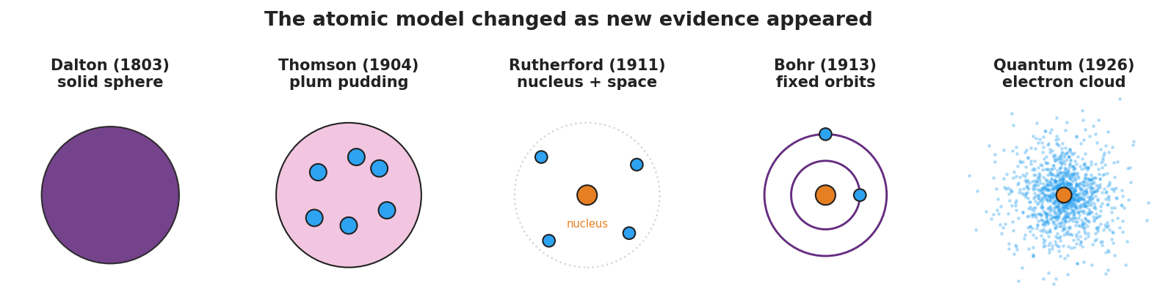
Five-panel progression of atomic models: Dalton solid sphere, Thomson plum pudding, Rutherford nucleus with empty space, Bohr fixed orbits, and the quantum electron cloud.
And the scattering diagram for the turning-point card:
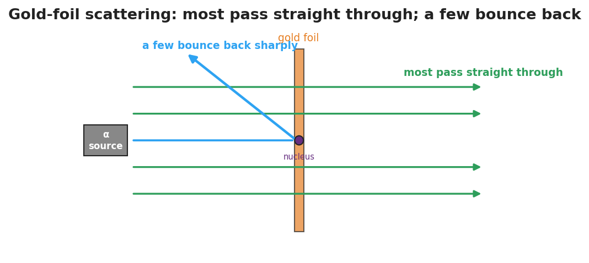
Gold-foil scattering: most alpha particles pass straight through the foil while a few deflect sharply off the tiny dense nucleus.

Teacher facilitation during Explore
- What to look for — groups tying each change to a specific new observation, not just memorizing an order.
- What to resist — don’t pre-label which evidence breaks which model; let the sort do the reasoning.
- What to redirect — “the newest model is the only right one” → every model was the best fit for its evidence.

Phase 3 · Explain (30 – 36 min)

30–33 min · Gallery walk + class consensus
Groups post timelines; one quick gallery walk. Then build consensus:
“Across all five, what always triggered a new model? New, surprising evidence that the old model couldn’t explain.”

33–36 min · Vocabulary introduction (≤ 3 terms)
Sample teacher language:
“The tiny, dense, positively charged center the gold foil revealed is the nucleus. The light, negatively charged particles around it are electrons. A picture scientists use to represent the atom’s structure is an atomic model — and that model has changed every time new evidence arrived.”

Discussion prompts to deploy here
- “Why didn’t Thomson’s plum-pudding model survive the gold-foil result?”
  - Sample student response: “Soft, spread-out positive charge couldn’t bounce an alpha straight back; only a tiny dense nucleus could.”
- “Is the quantum model ‘the truth’ or just the current best model?”
  - Sample student response: “The current best model — it fits today’s evidence, and it could be revised again.”

Phase 4 · Elaborate (36 – 39 min)

36–38 min · Revise the model
“Return to your Initial Model. Redraw the gold atom using the words nucleus and electron, showing the right proportions (tiny dense center, lots of empty space).”

38–39 min · Return to the phenomenon
“In one sentence, explain the gold-foil result using nucleus.”
Target: “Most alphas pass through the empty space, but the few that hit the tiny dense nucleus are pushed sharply back.”

Phase 5 · Evaluate (39 – 42 min)

39–42 min · Exit Ticket + Closing Reflection
“(a) Which atomic model first included a tiny, dense nucleus, and what experiment supported it? (b) Name one thing the Thomson (plum-pudding) model got right. (c) Why do scientists change a model like the atom over time?”
Expected: (a) Rutherford’s model; the gold-foil scattering experiment; (b) atoms contain negative electrons (and a positive part); (c) new evidence appears that the old model cannot explain. See Answer_Key.docx.
Closing Reflection (SEL, 30 seconds):
“Whose idea in your group helped you make sense of the timeline today?”

Common Misconceptions
- Misconception: “The newest model proves the old ones were wrong/stupid.” → Correction: Each model was the best explanation for the evidence available; models improve, they don’t shame their predecessors.
- Misconception: “The atom is mostly solid matter.” → Correction: An atom is overwhelmingly empty space; the nucleus is tiny but holds nearly all the mass.
- Misconception: “Electrons orbit the nucleus on neat circular tracks.” → Correction: That’s the Bohr picture; the current quantum model describes electrons as probability clouds, not fixed paths.

Access & Differentiation
- ELL/ENL supports: Sentence frame: *“The ___ model changed to the ___ model because of evidence from ___.”* Word box: {Thomson, Rutherford, gold foil, nucleus, electron}. Provide the model cards with both a picture and a one-word label.
- IEP/SPED supports: Pre-sort the card set into the correct order for some groups; their task becomes matching evidence to a given sequence. Provide a fill-in timeline rather than blank chart paper.
- Extensions: Have students research and add a sixth card — a modern refinement (e.g., isotopes, the discovery of the neutron) — and justify where it fits and what evidence supports it.

Strategy Spotlight
ACTIVE LEARNING. The card sort makes students do the historical reasoning rather than receive a timeline. Cognitive load stays on the model–evidence relationship. Keep groups to 3–4, rotate a “challenger” role whose job is to ask “what evidence breaks this model?”, and end with a brief gallery walk so every group sees an alternative arrangement before consensus. This positions the gold-foil result as the turning point students argue toward, not one you announce.

NYSSLS Observation Checklist Crosswalk
# | Checklist item | Where it appears in this lesson
1 | Local/relatable phenomenon | Phase 1 — gold-foil “cannon shell off tissue paper”
2 | Turn and Talk (2–3×) | Phase 1 (TT#1 — what’s inside the atom), Phase 3 (gallery-walk consensus discussion)
3 | Students develop questions/models/procedures | Phase 1 (initial model), Phase 2 (card sort + timeline), Phase 4 (revise model)
4 | CCC defined and used | Lesson Overview · Patterns / Stability and Change, restated in Phase 3
5 | ENL — ≤ 3 vocab, second half | Phase 3 — vocabulary at 33–36 min (nucleus / electron / atomic model)
6 | Revisit phenomenon with evidence | Phase 4 — re-explain gold foil using nucleus
7 | ENL/SPED supports | Access & Differentiation block
8 | Assessment check | Phase 5 — Exit Ticket (model ↔ evidence)

Companion Materials
- Student_Worksheet.docx — the 5E student investigation with the card-sort timeline (hand out at start of Phase 2)
- Student_Notes.docx — guided note-guide for the model progression and vocabulary
- Answer_Key.docx — answers to “Make It Make Sense” prompts and the Exit Ticket

Key Vocabulary (max 3)
- nucleus — the tiny, dense, positively charged center of an atom; it holds nearly all the atom’s mass
- electron — a light, negatively charged particle found in the space around the nucleus
- atomic model — a scientific picture or representation of the atom’s structure, revised as new evidence appears

