Fusion, Fission, and Radioactive Decay — Teacher Guide

Cover
Unit: Modern Physics — Lesson 05: Fusion, Fission, and Radioactive Decay East Meadow Schools × Valley Stream Central High School District Strategy chips: ACTIVE LEARNING

Curated Resources (from East Meadow Scope & Sequence)

NYSSLS Standards
This lesson is the core treatment of the chemistry-shared HS-PS1-8: “Develop models to illustrate the changes in the composition of the nucleus of the atom and the energy released during the processes of fission, fusion, and radioactive decay. (Energy and Matter) (only teach scale of energy release).” Per the standard, we teach the scale of nuclear energy (E = mc² as a why-it’s-enormous idea, not a calculation). It connects to HS-ESS1-2 through star formation: fusion in stars is what lights them and forges new elements.

Phenomenon
- The Sun (fusion), a nuclear power plant (fission), and carbon-14 dating of ancient artifacts (radioactive decay) — three places nuclear change shows up: https://www.youtube.com/watch?v=KWAsz59F8gA
- The puzzle: the Sun has burned for billions of years. No chemical fire could last that long — so what powers it?

Javalab / Labs
- Nuclear fission / chain reaction (interactive): https://javalab.org/en/nuclear_fission_en/

Assessments
- Exit ticket below (classify a nuclear change; explain the scale of energy). The fission/fusion/decay station sort in Phase 2 is the formative check.

Lesson Overview
Duration | 42 minutes (1 period)
NYSSLS link | HS-PS1-8 (core; scale of energy only) · HS-ESS1-2 (star formation connection)
CCC focus | Energy and Matter — nuclear changes rearrange the nucleus and release enormous energy.
Strategy chips | ACTIVE LEARNING (three-station rotation: fission, fusion, decay)
Materials | Three station setups (model pieces or printed scenarios); the fission/fusion and decay diagrams; whiteboards; reference note: E = mc² (scale only).
Safety | None — models and simulation; no radioactive sources.
Prior knowledge | The nucleus holds protons and neutrons (Lessons 02, 04); quarks make up nucleons (Lesson 04); energy is conserved/transferred.
Lesson objectives — students can:
- Distinguish fission (a heavy nucleus splits), fusion (light nuclei combine), and radioactive decay (a nucleus emits α, β, or γ).
- Explain that nuclear changes release enormous energy compared with chemical reactions, on the scale described by E = mc² (no calculation).
- Connect fusion to star formation and decay to applications like carbon dating.

Phase 1 · Engage (0 – 10 min)

0–2 min · Opening Connection (SEL)
Whip-around (one sentence, pass allowed): “Name something that has lasted way longer than you’d expect.” Park these; you’ll call back to “the Sun has burned for billions of years” in Phase 1’s hook.

2–7 min · Phenomenon hook — what powers the Sun?
Teacher actions. Show the Sun / power-plant / carbon-dating clip. Pose the puzzle: a campfire burns out in hours; the Sun has shone for ~5 billion years. Chemical burning cannot explain that.
Sample teacher language:
“A bonfire dies overnight. The Sun has been blazing for five billion years and is barely halfway done. No chemical fire could last like that. Where is all that energy coming from — and why is it so much more than burning?”
Anticipated student responses:
- “It’s huge, so it lasts.” — capture huge, but push: size alone isn’t the source.
- “It’s nuclear.” — gold; we’ll split nuclear change into three types.
- “Stuff turns into energy.” — capture; this is the E = mc² scale idea (later).

7–10 min · Notice & Wonder + Turn-and-Talk #1
“Turn and talk: the same word — nuclear — covers the Sun, power plants, and carbon dating. Predict how the nucleus might change differently in each.”
Target seed: some nuclei split, some combine, some emit a particle.

Bridge to Phase 2
Each student writes a one-sentence initial model: “Nuclear energy is so large because ______.”

Phase 2 · Explore (10 – 30 min)

10–13 min · Initial Model (silent / individual)
Prompt:
“Draw a nucleus (protons + neutrons). Show one way you think it could change to release energy.”

13–30 min · Investigation — three-station rotation (ACTIVE LEARNING)
Groups rotate through three stations (~5 min each); each has a scenario card + model pieces:
- Fission station. A neutron strikes a heavy uranium nucleus; it splits into two lighter nuclei + more neutrons + energy. Model it; note the chain-reaction possibility.
- Fusion station. Two light hydrogen nuclei are forced together into a heavier nucleus + energy. Model it; label this as what powers the Sun and stars.
- Decay station. An unstable nucleus emits alpha (a helium nucleus), beta (an electron, as a neutron becomes a proton), or gamma (a high-energy photon). Sort three scenario cards by decay type; note carbon-14 dating as a use of decay.
Teacher facilitation language:
“At fission — what hits the nucleus to start it, and what comes out that could start the next one?” “At fusion — are nuclei joining or splitting? Which one happens in the Sun?” “At decay — which type changes the element (alpha/beta), and which just sheds energy (gamma)?”
Anchor with the diagrams:
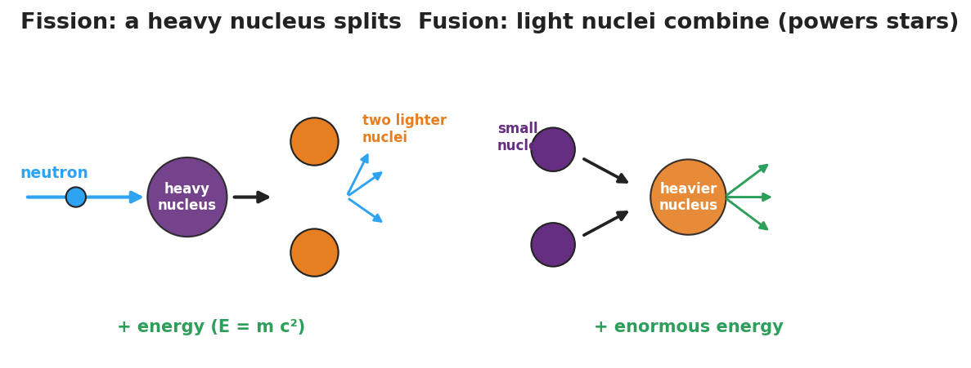
Side-by-side diagram: fission, where a neutron splits a heavy nucleus into two lighter nuclei plus more neutrons and energy; and fusion, where light nuclei combine into a heavier nucleus plus enormous energy.
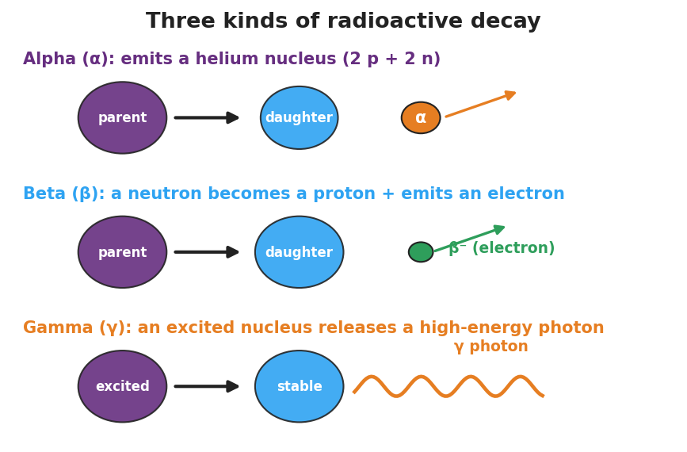
Diagram of alpha, beta, and gamma decay: alpha emits a helium nucleus, beta emits an electron as a neutron becomes a proton, and gamma releases a high-energy photon.

Teacher facilitation during Explore
- What to look for — groups correctly sorting “split vs. combine vs. emit” and tying fusion to stars.
- What to resist — do not do E = mc² calculations; keep energy at the scale/comparison level per the standard.
- What to redirect — “fission and fusion are the same” → fission splits heavy nuclei; fusion combines light ones.

Phase 3 · Explain (30 – 36 min)

30–33 min · Consensus
“Three nuclear changes, one common result — what is it, and why is it so much bigger than burning?”
Target consensus:
“Fission splits a heavy nucleus, fusion combines light nuclei, and radioactive decay emits a particle (α/β/γ). All rearrange the nucleus and release energy — and because a small amount of mass is converted to energy (E = mc², where c is huge), the energy released is enormous compared with chemical reactions.”

33–36 min · Vocabulary introduction (≤ 3 terms)
Sample teacher language:
“Fission is the splitting of a heavy nucleus into lighter ones — that’s how nuclear power plants work. Fusion is the combining of light nuclei into a heavier one — that’s what powers the Sun and forms elements in stars. Radioactive decay is when an unstable nucleus emits radiation (alpha, beta, or gamma) on its own. All three release energy on the scale of E = mc².”

Discussion prompts to deploy here
- “Why does fusion connect to how stars and elements form?”
  - Sample student response: “Stars fuse light nuclei into heavier ones, which lights the star and builds the elements that later make planets and us.”
- “Why is nuclear energy so much larger than chemical energy?”
  - Sample student response: “A tiny bit of mass becomes energy, and E = mc² with a huge c means even tiny mass gives huge energy.”

Phase 4 · Elaborate (36 – 39 min)

36–38 min · Revise the model
“Return to your Initial Model. Redraw it as one of the three changes — fission, fusion, or decay — and label where the enormous energy comes from (mass → energy, E = mc², scale only).”

38–39 min · Return to the phenomenon
“In one sentence, explain what powers the Sun, using fusion.”
Target: “The Sun is powered by fusion — light hydrogen nuclei combine into heavier nuclei, releasing enormous energy (E = mc² scale) and forming new elements.”

Phase 5 · Evaluate (39 – 42 min)

39–42 min · Exit Ticket + Closing Reflection
“(a) A heavy uranium nucleus is struck by a neutron and splits into two lighter nuclei. Is this fission, fusion, or decay? (b) The Sun combines hydrogen nuclei into helium. Which process is this, and what does it have to do with star formation? (c) Why is the energy from a nuclear change so much larger than the energy from burning fuel? (Use E = mc² as a scale idea — no calculation.)”
Expected: (a) fission; (b) fusion — fusion powers and lights stars and forms heavier elements; (c) a small amount of mass is converted to energy, and because c is enormous, E = mc² gives a huge energy from tiny mass — far more than chemical bonds release. See Answer_Key.docx.
Closing Reflection (SEL, 30 seconds):
“What’s one place in your life that nuclear physics quietly shows up?”

Common Misconceptions
- Misconception: “Fission and fusion are basically the same.” → Correction: Fission splits a heavy nucleus; fusion combines light nuclei. Opposite directions.
- Misconception: “The Sun is a giant chemical fire.” → Correction: The Sun runs on nuclear fusion; no chemical fire could last billions of years.
- Misconception: “Nuclear energy comes from nowhere.” → Correction: A tiny amount of mass is converted to energy (E = mc²); because c is enormous, even a little mass yields enormous energy.

Access & Differentiation
- ELL/ENL supports: Sentence frame: *“In , a heavy nucleus splits; in , light nuclei combine; in ___, a nucleus emits radiation.”* Word box: {fission, fusion, radioactive decay, neutron, energy}. Pair fusion with hands coming together, fission with hands splitting apart.
- IEP/SPED supports: Provide pre-sorted station cards (already labeled fission/fusion/decay) so the task is matching the energy/result rather than identifying the type. Offer the alpha/beta/gamma diagram as a fill-in match.
- Extensions: Have students explain, using beta decay, how a neutron (udd) becomes a proton (uud) — connecting to the quark changes from Lesson 04 — and why this changes the element.

Strategy Spotlight
ACTIVE LEARNING. The three-station rotation lets students model each nuclear change with their hands before any definitions, so “split vs. combine vs. emit” is physical, not memorized. Keep stations to ~5 minutes with a clear rotation signal, assign a recorder at each, and reserve E = mc² strictly for the scale-of-energy discussion in Phase 3 (per HS-PS1-8, no calculation). End with a whole-class consensus so the three stations resolve into one big idea.

NYSSLS Observation Checklist Crosswalk
# | Checklist item | Where it appears in this lesson
1 | Local/relatable phenomenon | Phase 1 — the Sun, nuclear power, carbon dating
2 | Turn and Talk (2–3×) | Phase 1 (TT#1 — how the nucleus changes differently), Phase 3 (consensus discussion)
3 | Students develop questions/models/procedures | Phase 1 (initial model), Phase 2 (station modeling), Phase 4 (revise model)
4 | CCC defined and used | Lesson Overview · Energy and Matter, restated in Phase 3
5 | ENL — ≤ 3 vocab, second half | Phase 3 — vocabulary at 33–36 min (fission / fusion / radioactive decay)
6 | Revisit phenomenon with evidence | Phase 4 — explain the Sun using fusion
7 | ENL/SPED supports | Access & Differentiation block
8 | Assessment check | Phase 5 — Exit Ticket (classify change; scale of energy)

Companion Materials
- Student_Worksheet.docx — the 5E student investigation with the three-station sort (hand out at start of Phase 2)
- Student_Notes.docx — guided note-guide for the three nuclear changes and the worked example
- Answer_Key.docx — answers to “Make It Make Sense” prompts and the Exit Ticket

Key Vocabulary (max 3)
- fission — the splitting of a heavy nucleus into lighter nuclei, releasing energy (used in nuclear power plants)
- fusion — the combining of light nuclei into a heavier nucleus, releasing enormous energy (powers the Sun and forms elements in stars)
- radioactive decay — the spontaneous emission of radiation (alpha, beta, or gamma) from an unstable nucleus

