Significant Figures & Scientific Notation — Student Notes
Unit: Safety and Measurement — Lesson 03 Name: _______________________ Date: __________ Period: ____

Learning Targets
By the end of today’s 42 minutes I can:
- Count the significant figures in a measured value, including tricky zero cases.
- Read a measuring instrument to one digit past the smallest scale division, recognizing that the last digit is estimated.
- Express a measured value in scientific notation and convert back to standard form.
- Explain, using Scale, Proportion, and Quantity, why the precision I record must honestly reflect the instrument I used.

Key Vocabulary
- significant figures — _______________________________________________ _______________________________________________
- scientific notation — _______________________________________________ _______________________________________________
- precision — _______________________________________________ _______________________________________________

Guided Notes
The big idea — Scale, Proportion, and Quantity: Every digit you write is a __________ about what you measured. Writing more digits than your instrument supports is a false __________ claim. Writing fewer digits than your instrument supports throws away useful information.
Estimate the last digit — the rule:
When you read any measuring instrument, the last digit you record is the __________ digit. All the digits the instrument’s scale told you directly, plus that one estimated digit, are your __________.
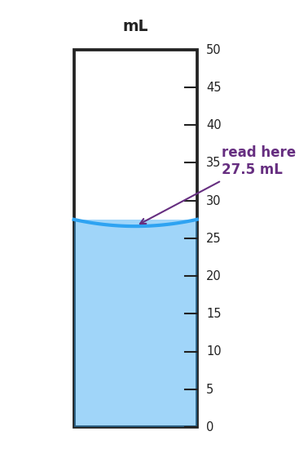
A 50 mL graduated cylinder filled to 27.5 mL, showing a concave meniscus between the 25 and 30 mL marks; tick marks represent every 1 mL; the liquid surface sits halfway between the 27 and 28 mL marks, with the meniscus bottom landing at 27.5 mL — illustrating that the last digit (5) is the estimated digit.
- Reading from the figure: _____________ mL
- Certain digits: _____________ Estimated digit: _____________
- Number of significant figures: _____
The five sig-fig rules:
Rule | Example | Sig figs
All non-zero digits count | 34.7
Captive zeros (between non-zero digits) count | 102.0
Leading zeros do not count — they are place-holders | 0.0040
Trailing zeros after a decimal point count | 1500.
Trailing zeros in a whole number without a decimal are ambiguous | 1500
Scientific notation — why use it:
Standard notation: 6,420,000 → coefficient __________ × 10 raised to the power __________ → _______________
The coefficient must be a number ≥ 1 and < 10. The exponent tells you how many places you moved the decimal.
- Moving the decimal to the left → the exponent is __________ (positive / negative)
- Moving the decimal to the right → the exponent is __________ (positive / negative)
Scientific notation makes the sig-fig count explicit: 6.42 × 10⁶ has _____ sig figs; 6.420 × 10⁶ has _____ sig figs. Standard notation can be ambiguous; scientific notation is not.
Connecting precision to sig figs:
A reading of 27.5 mL claims precision to the __________ (ones / tenths / hundredths) of a milliliter. A reading of 28 mL claims precision to the __________ of a milliliter. The reading with more significant figures is (circle one): more precise / less precise.

Worked Example
Scenario: A student uses a centimeter ruler (smallest markings: 0.1 cm) to measure the length of a metal rod. She estimates one digit past the markings and records 8.47 cm. A second student uses a less precise ruler (smallest markings: 1 cm) and records 8 cm. A calculation multiplying these two values on a calculator returns 67.76.
Step 1 — Count sig figs in each measured value:
- 8.47 cm has _____ sig figs (rule: all non-zero digits count)
- 8 cm has _____ sig fig
Step 2 — Identify the limiting value:
When multiplying or dividing, the result may carry no more sig figs than the __________ (most / least) precise measurement. Here, the limiting value is __________ cm with _____ sig fig.
Step 3 — Round the calculator result:
Calculator result: 67.76 → rounded to _____ sig fig → ___________
Step 4 — Because / But / So
The calculator answer of 67.76 is a false precision claim because _______________________________________________, but _______________________________________________, so _______________________________________________.
Check your reasoning: “because” should name what the instrument can actually support; “but” should explain why the calculator ignores that limit; “so” should state the correctly rounded answer.

Summary
Complete the sentence (Because / But / So):
Recording the correct number of significant figures matters because __________________________________________, but __________________________________________, so __________________________________________.
Reminder: When in doubt about trailing zeros, express the number in scientific notation — it removes the ambiguity and shows exactly how many sig figs you mean. Example: 1500 is ambiguous; 1.5 × 10³ is clearly two sig figs; 1.500 × 10³ is clearly four.

