Significant Figures & Scientific Notation — Student Worksheet
Unit: Safety and Measurement — Lesson 03 Name: _______________________ Date: __________ Period: ____

Phenomenon
Three students measure the same pencil with different rulers and write down their results: one writes 15 cm, the next writes 15.0 cm, and the third writes 15.00 cm. Then a calculator divides two measured numbers and displays 15.2837 cm on the screen.
Driving question: How precise are we actually allowed to claim our answer is?

Notice & Wonder
I notice… | I wonder…
Turn & Talk #1: Student A wrote 15 cm and Student C wrote 15.00 cm — they measured the same pencil. In one sentence, describe what is different about those two measurements. Do not use the word “zeros” in your answer — describe what the measurements claim about the ruler.

Initial Model
Before your teacher names any rules: look at the figure your teacher is projecting on the screen.
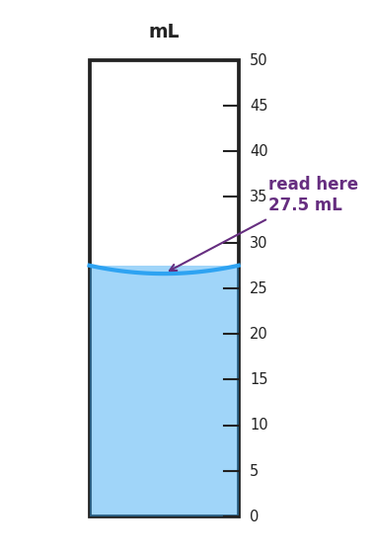
A 50 mL graduated cylinder filled to 27.5 mL, showing a concave meniscus between the 25 and 30 mL marks; tick marks represent every 1 mL; the liquid surface sits halfway between the 27 and 28 mL marks, with the meniscus bottom landing at 27.5 mL — illustrating that the last digit (5) is the estimated digit.
- What is the reading on the cylinder? _____________ mL
- Which digits did the instrument tell you for certain? _______________
- Which digit did you estimate? _______________
- How many significant figures does this reading have? _____

Investigation

Part 1 — Sig-Fig Sorting Cards
Your group will receive a set of cards. For each value, count the significant figures and write your reasoning in the table. Your group works on the vertical surface — write large enough for others to see.
Value | How many sig figs? | Reasoning (which digits count, and why?)
34.7
0.0040
1500
1500.
0.03080
102.0
Gallery walk question: After you look at another group’s board, write one idea you want to borrow and one you want to challenge.
Borrow: _______________________________________________
Challenge: _______________________________________________

Part 2 — Scientific Notation Conversions
Convert each value. Show your reasoning.
Standard notation | Scientific notation
6,420,000
0.000452
0.000 000 000 911 (mass of an electron in kg, approx.)

Scientific notation | Standard notation
6.02 × 10²³
3.5 × 10⁻⁴
Connection to precision: How many significant figures does 6.42 × 10⁶ have? _____ How do you know? _______________________________________________

Make It Make Sense
- Count the significant figures in each value. Write your count and one-line reasoning.
Value | Sig figs | Reasoning
0.0040
1500
1500.
0.03080
102.0
- A calculator gives the result 48.7263 cm for a measurement that was made with two tools: one that can report to the nearest 0.1 cm, and one that can report to the nearest 1 cm. Round the result to the appropriate number of significant figures and explain your reasoning.
- Rounded result: _____________ Reasoning: _______________________________________________ _______________________________________________
- Convert the following to scientific notation.
  - 0.000452 → _______________________________________________
  - 92,500,000 → _______________________________________________

Vocabulary in Action
Use each term in a sentence about today’s measurement or investigation. Do not copy the definition — describe something you observed or did.
- significant figures: _______________________________________________ _______________________________________________
- scientific notation: _______________________________________________ _______________________________________________
- precision: _______________________________________________ _______________________________________________

Revise Your Model
Return to your Initial Model reading of the cylinder (27.5 mL). Now add:
- Write 27.5 mL in scientific notation: _______________________________________________
- Write a revised sentence explaining what the reading claims about the instrument — how precise is the cylinder?

Then finish this Because / But / So sentence:
A calculator answer of 15.2837 cm is a false precision claim because __________________________________________, but __________________________________________, so __________________________________________.

Exit Ticket
- How many significant figures are in 0.03080?

- Write 6,420,000 in scientific notation.

- Round 7.86342 to 3 significant figures.

