Math in Science — Unit Plan

Cover
Unit: Math in Science (Unit 00 — course opener) East Meadow Schools × Valley Stream Central High School District 4 lessons · ~4 instructional periods (42 min each) Format: DOCX (Teacher Guide · Student Worksheet · Student Notes · Answer Key per lesson)

Unit Scope (from East Meadow Scope & Sequence)
This is the quantitative-readiness unit that opens the physics course. Before students meet a single force or wave, they build the math toolkit every later unit reuses: rearranging formulas, resolving vectors with trig, reading graphs and slopes, writing numbers in scientific notation, estimating by order of magnitude, and converting units. It carries no NYSSLS performance expectation of its own; instead it develops the science and engineering practice “Using Mathematics and Computational Thinking” that threads through every HS-PS standard. It feeds directly into Kinematics (slopes of motion graphs, vector components) and Forces (Fnet = m·a rearrangements, units of the newton).
# | Lesson | Core idea
01 | Algebra and Trigonometry for Physics | Isolate a variable; resolve a slant into components with SOH-CAH-TOA
02 | Graphing and Interpreting Data | Independent vs. dependent variable; line of best fit; slope as a proportionality constant
03 | Scientific Notation and Fermi Estimates | Powers of ten; scientific notation; order-of-magnitude estimation
04 | Units, Prefixes, and Dimensional Analysis | SI units; metric prefixes; factor-label conversion and unit checking

Pacing Calendar
Day | Lesson | Phenomenon anchor | Strategy
1 | 01 Algebra & Trig | Angled zipline/ramp — find height and run | Hochman
2 | 02 Graphing & Data | Pi / Lid Lab — slope of C vs. d is π | Active Learning
3 | 03 Scientific Notation & Fermi | Scale of the Universe; basketballs in the gym | BTC
4 | 04 Units & Dimensional Analysis | Mixed-unit recipe / road sign | Hochman
Double-period days (every other day) let the Pi/Lid Lab (Lesson 02) and the Fermi board work (Lesson 03) run long.

Strategy Rotation
- HOCHMAN (literacy): Lessons 01, 04 — kernel sentences and Because/But/So on the rearrangement rule (01); appositive definitions and Because/But/So on why units must match (04).
- ACTIVE LEARNING: Lesson 02 — hands-on lid measurement plus the Slow Reveal Graphs discourse routine; students generate the data that yields π.
- BTC (Building Thinking Classrooms): Lesson 03 — visibly random groups, vertical non-permanent surfaces, and a thin-sliced scientific-notation sequence building to an open Fermi estimate.
SEL (Opening Connection + Closing Reflection), ELL/SPED supports, and a Curated Resources block appear in every lesson.

NYSSLS Coverage Matrix
This unit develops a science and engineering practice rather than a content performance expectation, so the matrix maps the practice and crosscutting concept onto each lesson.
Practice / CCC | Description | Lessons
SEP: Using Mathematics and Computational Thinking | Rearrange relationships, compute, and represent quantities — prerequisite to every HS-PS performance expectation | 01, 02, 03, 04
SEP: Analyzing and Interpreting Data | Read graphs, draw best-fit lines, extract slopes | 02
CCC: Scale, Proportion, and Quantity | Proportional relationships; powers of ten; rescaling units | 01, 02, 03, 04
CCC: Patterns | A straight-line graph reveals and names a proportional pattern | 02
Feeds → HS-PS2-1, HS-PS3, HS-PS4 | Quantitative tools reused throughout Kinematics, Forces, Energy, and Waves | all

Vocabulary Scope
Three terms maximum per lesson, introduced in the second half (NYSSLS observation item 5).
Lesson | Terms
01 | isolate (a variable) · sine · right triangle
02 | independent variable · dependent variable · slope
03 | scientific notation · order of magnitude · exponent
04 | SI unit · metric prefix · dimensional analysis

Algebra and Trigonometry for Physics — Teacher Guide

Cover
Unit: Math in Science — Lesson 01: Algebra and Trigonometry for Physics East Meadow Schools × Valley Stream Central High School District Strategy chips: HOCHMAN

Curated Resources (from East Meadow Scope & Sequence)

NYSSLS Standards
This is a foundational math-skills lesson with no single NYSSLS performance expectation of its own. It builds the science and engineering practice “Using Mathematics and Computational Thinking,” which is woven through every HS-PS standard in the course — students cannot reach HS-PS2-1 (Newton’s Second Law), HS-PS3 (energy), or any quantitative target without first being able to rearrange a formula and resolve a vector. The crosscutting concept in focus is Scale, Proportion, and Quantity: a relationship like v = d / t expresses how one quantity changes in proportion to another, and trig lets us scale a slanted distance into its horizontal and vertical parts.

Phenomenon
- Zipline / ramp at an angle — students see a cable strung from a high anchor to a low one and ask: how high is the top, and how far does the rider travel across the ground? https://www.youtube.com/results?search_query=zipline+physics
- PhET “Trig Tour” (sine/cosine on a triangle and circle): https://phet.colorado.edu/en/simulations/trig-tour

Javalab / Labs
- Javalab “Vector composition and decomposition” (resolve a vector into components): https://javalab.org/en/vector_composition_en/
- Optional: tape an angled “zipline” string across the room and measure the rise and run directly to confirm the trig.

Assessments
- PhET Trig Tour has a built-in self-check. The Exit Ticket below (find the height and run of an angled cable) is the formative check for this lesson.

Lesson Overview
Duration | 42 minutes (1 period)
NYSSLS link | Practice: Using Mathematics and Computational Thinking (supports all HS-PS)
CCC focus | Scale, Proportion, and Quantity — formulas express proportional relationships; trig scales a slant into components
Strategy chips | HOCHMAN (Because/But/So + kernel sentences on the rearrangement rule)
Materials | Whiteboards/markers; calculators (degree mode); a length of string + protractor (optional live zipline); printed right-triangle handout
Safety | If stringing a physical zipline, keep it low and clear walkways. No other hazards.
Prior knowledge | Middle-school algebra (solving one-step equations); the idea of a right triangle. No prior trig assumed.
Lesson objectives — students can:
- Isolate a chosen variable in a one- or two-step physics formula (e.g., rearrange v = d / t into d = v t and t = d / v).
- Identify the opposite, adjacent, and hypotenuse sides of a right triangle relative to a given angle.
- Use sine (and cosine/tangent via SOH-CAH-TOA) to find the height and horizontal run of an angled cable or ramp.

Phase 1 · Engage (0 – 8 min)

0–3 min · Opening Connection (SEL)
Quick whole-class check-in. Prompt: “Think of a time you had to rearrange a plan to make it work — same pieces, different order. Share one in a sentence.” This primes the idea that rearranging an equation keeps the same relationship, just solved for a different piece.

3–8 min · Phenomenon hook — the angled zipline
Teacher actions. Show the zipline image (or the string strung across the room). The cable runs from a high anchor down to a low platform at an angle.
Sample teacher language:
“Here’s the only thing the installer measured: the cable is 26 meters long and it leaves the top tower at 18 degrees below horizontal. The town inspector needs two numbers the installer never measured — how high is the top tower, and how far across the ground does the rider travel. We’re going to get both numbers without climbing anything.”
Anticipated student responses:
- “Just measure it.” — reframe: “The cable is up in the air; we only have the length and the angle. That’s all we ever get in physics.”
- “Use the Pythagorean theorem.” — affirm, then push: “That needs two sides; we have one side and an angle. Trig is the tool for one-side-plus-angle.”
- “Is it a triangle?” — yes; name it as a right triangle and bridge to Phase 2.

Bridge to Phase 2
Every student leaves Phase 1 able to sketch the cable as a right triangle and label which number they were given (the slanted side, the hypotenuse) and which two they need.

Phase 2 · Explore (8 – 26 min)

8–14 min · Skill A — Isolating a variable (algebra)
Put v = d / t on the board. Do not give the rearranged forms yet. Pose three race questions:
“If a sprinter runs at v for time t, how far did she go? Solve for d.” “If we know the distance and the speed, how long did it take? Solve for t.”
Let students try on whiteboards. Circulate. The move to name is isolate the variable: do the same operation to both sides until the wanted variable is alone.
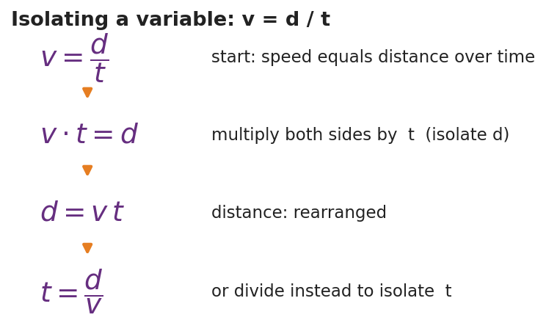
Isolating a variable in v = d / t
Teacher facilitation language:
“Whatever I do to the left side I do to the right side — that keeps the equation balanced. To free d, what’s currently happening to it? It’s being divided by t, so I undo that by multiplying both sides by t.”
Anticipated student responses:
- “d = v / t?” — common error; check units (m/s ÷ s gives m/s², not meters). Redirect to multiply, not divide.
- “d = v t.” — confirm and have them state the kernel sentence aloud (see Phase 4).

14–26 min · Skill B — Right-triangle trig (SOH-CAH-TOA)
Hand out / project the labeled right triangle. Define opposite, adjacent, hypotenuse relative to the angle.
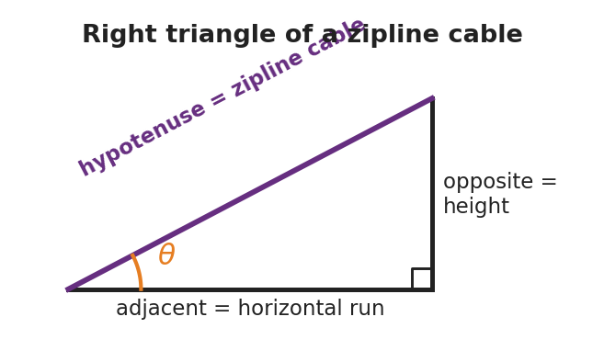
Right triangle of a zipline cable
Run the Javalab vector tool or PhET Trig Tour so students see sine change as the angle changes. Then give them the zipline numbers (hypotenuse = 26 m, angle = 18°) and ask them to find the height (opposite) and run (adjacent).
Teacher facilitation during Explore:
- What to look for — students correctly tagging which side is opposite the 18° angle (the height) before reaching for a button on the calculator.
- What to resist — supplying “use sine” too early; let them test which ratio uses the hypotenuse.
- What to redirect — calculators in radian mode (answers will be wildly off); have them confirm sin 30° = 0.5 as a mode check.

Phase 3 · Explain (26 – 34 min)

26–30 min · Turn-and-Talk + class consensus
“Which trig ratio connects the side you want to the side you were given? Talk it through with your partner using the words opposite and hypotenuse.”
Target consensus:
“The height is the side opposite the angle and we were given the hypotenuse, so we use sine: sin θ = opposite / hypotenuse. The run is adjacent, so it uses cosine.”

30–34 min · Vocabulary introduction (≤ 3 terms)
Sample teacher language:
“Three words make today portable to every future lesson. To isolate a variable means to get it alone on one side of the equation. A right triangle is any triangle with one 90° corner — every ramp, cable, and resolved vector becomes one. And sine is the ratio of the side opposite an angle to the hypotenuse — sin θ = opp / hyp.”

Discussion prompts to deploy here
- “We solved v = d / t for d. If a problem instead gives you d and v, which form do you grab, and why?”
  - Sample student response: “t = d / v, because t is the unknown and I isolate it by dividing.”
- “On the zipline, why is the height the opposite side and the ground-run the adjacent side?”
  - Sample student response: “Opposite is across from the angle; adjacent is the one touching the angle along the ground.”

Phase 4 · Elaborate (34 – 39 min)

34–37 min · HOCHMAN Because/But/So + kernel sentence
Have students compress today’s rule into a kernel sentence and then expand it.
*“Write a kernel sentence: ‘Sine relates two sides.’ Now expand it with Because / But / So: Sine relates the opposite side to the hypotenuse because , but , so ___.”*
Target: “…because that ratio stays fixed for a given angle, but it does not involve the adjacent side, so I use cosine when I need the run instead.”

37–39 min · Return to the phenomenon
“Give the inspector both numbers in one sentence each, with units.”
Target: height ≈ 26 × sin 18° ≈ 8.0 m; run ≈ 26 × cos 18° ≈ 24.7 m.

Phase 5 · Evaluate (39 – 42 min)

39–42 min · Exit Ticket + Closing Reflection
“A wheelchair ramp is 5.0 m long (the slanted hypotenuse) and rises at 10° above the ground. (a) Rearrange v = d / t to solve for t. (b) Which side of the ramp triangle is the rise — opposite or adjacent to the 10° angle? (c) Find the rise (height) of the ramp.”
Expected: (a) t = d / v; (b) opposite; (c) height = 5.0 × sin 10° ≈ 0.87 m. See Answer_Key.docx.
Closing Reflection (SEL, 30 seconds):
“Which felt harder today — rearranging the equation or choosing the trig ratio? Name one thing that made the harder one click.”

Common Misconceptions
- Misconception: “To solve v = d / t for d, divide by t.” → Correction: d is already divided by t; undo division by multiplying both sides by t, giving d = v t. Unit-check it: (m/s)(s) = m.
- Misconception: “Opposite and adjacent are fixed sides of the triangle.” → Correction: They are defined relative to the chosen angle; the same leg can be opposite for one angle and adjacent for another.
- Misconception: “sin, cos, and tan are interchangeable.” → Correction: Pick the ratio that uses the two sides you have/want — SOH-CAH-TOA tells you exactly which.
- Misconception (silent killer): calculator left in radians. → Correction: confirm sin 30° = 0.5 before trusting any answer.

Access & Differentiation
- ELL/ENL supports: Sentence frame: *“To isolate , I both sides by ___.”* Pair each trig word with a gesture (sine = hand sweeping up the opposite rise). Provide a SOH-CAH-TOA reference card with a picture, not just letters.
- IEP/SPED supports: Provide the right triangle pre-drawn and pre-labeled so students focus only on choosing the ratio. Offer a two-column “operation / result” organizer for the rearrangement so each algebra step has its own line. Allow a formula card with d = v t and t = d / v already shown for the trig portion.
- Extensions: Ask students to derive the third unknown — the angle itself — from two measured sides using the inverse sine (sin⁻¹), and to verify their zipline answers with the Pythagorean theorem (8.0² + 24.7² ≈ 26²).

Strategy Spotlight
HOCHMAN (sentence-level literacy). Today’s chip is the Because/But/So expansion plus the kernel sentence in Phase 4. The goal is precision, not volume: students compress the trig rule into a single kernel sentence (“Sine relates two sides”), then stretch it with the three conjunctions so they have to articulate the limits of the rule (when sine does not apply). Keep it to one tight paragraph; collect a few aloud and reward the most precise, not the longest.

NYSSLS Observation Checklist Crosswalk
# | Checklist item | Where it appears in this lesson
1 | Local/relatable phenomenon | Phase 1 — angled zipline; Phase 5 — wheelchair ramp
2 | Turn and Talk (2–3×) | Phase 3 (which ratio?), Phase 4 (Because/But/So share)
3 | Students develop questions/models/procedures | Phase 2 — sketch the triangle, choose the ratio, derive the rearrangement
4 | CCC defined and used | Lesson Overview · Scale, Proportion, and Quantity, applied in Phase 2
5 | ENL — ≤ 3 vocab, second half | Phase 3 — vocabulary at 30–34 min (isolate / right triangle / sine)
6 | Revisit phenomenon with evidence | Phase 4 — give the inspector the height and run
7 | ENL/SPED supports | Access & Differentiation block
8 | Assessment check | Phase 5 — Exit Ticket (ramp rise + rearrangement)

Companion Materials
- Student_Worksheet.docx — the 5E student investigation (hand out at start of Phase 2)
- Student_Notes.docx — guided note-guide for the rearrangement steps and the trig worked example
- Answer_Key.docx — answers to “Make It Make Sense” prompts and the Exit Ticket

Key Vocabulary (max 3)
- isolate (a variable) — to use inverse operations on both sides of an equation until the wanted variable stands alone (e.g., v = d / t → d = v t)
- sine — the trig ratio of the side opposite an angle to the hypotenuse: sin θ = opposite / hypotenuse
- right triangle — a triangle with one 90° angle; its longest side (opposite the right angle) is the hypotenuse

Algebra and Trigonometry for Physics — Student Worksheet
Unit: Math in Science — Lesson 01 Name: _______________________ Date: __________ Period: ____

Phenomenon
A zipline cable runs from a tall tower down to a low platform. The installer measured only two things: the cable is 26 m long and it leaves the top at 18° below horizontal. The town inspector needs two numbers nobody measured — how high is the top tower, and how far across the ground does the rider travel.

Right triangle of a zipline cable
Driving question: How can we find a height and a distance we can’t reach, using only a length and an angle?

Notice & Wonder
I notice… | I wonder…
Turn & Talk #1: What did the installer give us, and what is missing? Which shape could this cable make with the ground and the tower?

Initial Model
Sketch the zipline as a triangle. Label the 26 m cable and the 18° angle. Mark which side is the height of the tower and which side is the ground run. Write a one-sentence guess for how you might find the height.

My guess: ______________________________________

Investigation
Part A — Rearranging an equation. Start from the speed formula v = d / t.
I want to solve for… | What is happening to that variable now | What I do to both sides | Rearranged formula
d
t
Part B — Right-triangle trig. Using the triangle (hypotenuse = 26 m, angle = 18°):
I want | Which side is it (opp / adj / hyp)? | Which ratio (SOH-CAH-TOA)? | Value
height (rise)
ground run
Key question: Why does the height use the hypotenuse, and which trig function uses opposite ÷ hypotenuse?

Make It Make Sense
- Rearrange a = (v − u) / t to solve for v (the final speed).
- A ramp’s slanted top is 5.0 m long (the hypotenuse) and tilts 10° above the ground. Which side is the rise — opposite or adjacent to the 10° angle?
- Using question 2, find the rise (height) of the ramp.

Vocabulary in Action
Use each term in a sentence about today’s phenomenon.
- isolate (a variable): _______________________________________________
- sine: _______________________________________________
- right triangle: _______________________________________________

Revise Your Model
Return to your Initial Model sketch. Fill in the actual height and ground run of the zipline, with units. Then rewrite your one-sentence method using the word sine.
Height = __________ Ground run = __________ My method: _____________________________________

Exit Ticket
A wheelchair ramp is 5.0 m long (the slanted hypotenuse) and rises at 10° above the ground.
- Rearrange v = d / t to solve for t.
- Which side of the ramp triangle is the rise — opposite or adjacent to the 10° angle?
- Find the rise (height) of the ramp. Show the ratio you used.

Algebra and Trigonometry for Physics — Student Notes
Unit: Math in Science — Lesson 01 Name: _______________________ Date: __________ Period: ____

Learning Targets
By the end of today’s 42 minutes I can:
- Isolate a chosen variable in a physics formula (rearrange v = d / t into d = v t and t = d / v).
- Label the opposite, adjacent, and hypotenuse sides of a right triangle for a given angle.
- Use sine, cosine, or tangent (SOH-CAH-TOA) to find a missing side of a right triangle.

Key Vocabulary
- isolate (a variable) — _______________________________________________
- sine — _______________________________________________
- right triangle — _______________________________________________

Guided Notes
Golden rule of rearranging: whatever I do to one side of an equation, I do to the __________ side. I undo an operation with its __________ (multiply undoes divide; subtract undoes add).
Starting from v = d / t:
- To isolate d: d is being __________ by t, so __________ both sides by t → d = __________.
- To isolate t: get t out of the bottom, then __________ → t = __________.

Isolating a variable in v = d / t
Right-triangle trig — SOH-CAH-TOA. For an angle θ:
- Sin θ = __________ / hypotenuse
- Cos θ = adjacent / __________
- Tan θ = opposite / __________
The opposite side is across from θ; the adjacent side touches θ; the hypotenuse is the longest side, across from the __________ angle.

Right triangle of a zipline cable

Worked Example
Problem. A zipline cable is 26 m long (the hypotenuse) and leaves the top at 18° below horizontal. Find the tower height (the rise).
Solution. 1. The height is the side __________ the 18° angle, and I was given the __________. 2. Opposite over hypotenuse means I use __________: sin 18° = height / 26. 3. Solve: height = 26 × sin 18° = 26 × 0.309 ≈ __________ m. 4. (Run = 26 × cos 18° ≈ 24.7 m — the adjacent side.)

Summary
Finish the sentence (Because / But / So):
I can find a height I cannot reach because __________________________________________, but __________________________________________, so __________________________________________.

Algebra and Trigonometry for Physics — Answer Key

Cover
Unit: Math in Science — Lesson 01: Algebra and Trigonometry for Physics East Meadow Schools × Valley Stream Central HSD Strategy chip: HOCHMAN

Make-It-Make-Sense Answers
- Start from a = (v − u) / t. Multiply both sides by t: a t = v − u. Add u to both sides: v = u + a t. · Rubric: multiplies by t AND adds u → full credit; stopping at a t = v − u earns partial. · Practice: Using Mathematics and Computational Thinking.
- The rise is the side opposite the 10° angle (it is across from the angle, not touching it along the ground). · Rubric: “opposite” with a one-phrase justification. · CCC: Scale, Proportion, and Quantity.
- Opposite over hypotenuse → use sine: rise = 5.0 × sin 10° = 5.0 × 0.1736 ≈ 0.87 m. · Rubric: correct ratio (sine) AND answer 0.85–0.88 m with units. Accept 0.9 m if rounding is shown. · Common error: using cosine (gives 4.9 m) — that is the ground run, not the rise.

Exit Ticket Answer
- t = d / v. From v = d / t, multiply both sides by t to get v t = d, then divide both sides by v.
- The rise is the side opposite the 10° angle.
- sin 10° = rise / 5.0, so rise = 5.0 × sin 10° ≈ 0.87 m. (Calculator in degree mode: sin 10° ≈ 0.174.)
Tolerance/rubric: (a) must show t = d / v; (b) “opposite”; (c) names sine AND gives 0.85–0.88 m with units. 1 point each. The most common error is radian mode — an answer near 0.43 m signals it. Practice: Using Mathematics and Computational Thinking; CCC: Scale, Proportion, and Quantity.

Closing Reflection (rubric)
Closing reflection is formative, not graded. Award full credit for any honest response. Look for: - A clear choice of which task was harder (rearranging vs. choosing the ratio) - One specific reason the harder task started to click (a step, a gesture, a peer’s phrasing)

Graphing and Interpreting Data — Teacher Guide

Cover
Unit: Math in Science — Lesson 02: Graphing and Interpreting Data East Meadow Schools × Valley Stream Central High School District Strategy chips: ACTIVE LEARNING

Curated Resources (from East Meadow Scope & Sequence)

NYSSLS Standards
This is a foundational math-skills lesson with no single NYSSLS performance expectation of its own. It develops the science and engineering practice “Using Mathematics and Computational Thinking” (and “Analyzing and Interpreting Data”), which every quantitative HS-PS standard depends on — a slope is how students will later read acceleration off a velocity graph (HS-PS2) or a spring constant off a force graph (HS-PS3). The crosscutting concept in focus is Patterns: a straight line through data reveals a proportional relationship, and its slope is the constant that names that pattern.

Phenomenon
- “Pi / Lid Lab” — students measure the circumference and diameter of many round lids; plotted together, the points fall on a line whose slope is π.
- Slow Reveal Graphs — reveal a graph piece by piece to build interpretation skills: https://slowrevealgraphs.com/

Javalab / Labs
- Graphing Pi / Lid Lab (this lesson’s investigation): collect circumference vs. diameter for 5–6 round objects; plot and find the slope.
- Slow Reveal Graphs routine as the Engage warm-up: https://slowrevealgraphs.com/
- Desmos or graph paper for the line of best fit.

Assessments
- Slow Reveal Graphs includes discussion checks. The Exit Ticket below (read a slope and name the relationship) is the formative check for this lesson.

Lesson Overview
Duration | 42 minutes (1 period)
NYSSLS link | Practices: Using Mathematics & Computational Thinking; Analyzing & Interpreting Data (supports all HS-PS)
CCC focus | Patterns — a straight-line graph reveals a proportional relationship; the slope names it
Strategy chips | ACTIVE LEARNING (hands-on lid measurement + Slow Reveal discourse)
Materials | 5–6 round lids/cans per group; string or flexible tape measures; rulers; graph paper or Desmos; whiteboards
Safety | No hazards. Remind students not to roll cans off the desks.
Prior knowledge | Plotting an (x, y) point; the idea of “per” (miles per hour). No formal slope formula assumed.
Lesson objectives — students can:
- Identify the independent variable and dependent variable in an investigation and place each on the correct axis.
- Draw a line of best fit through scattered data and explain why it is not connect-the-dots.
- Calculate the slope (rise / run) of the best-fit line and interpret it as the constant of a proportional relationship.

Phase 1 · Engage (0 – 8 min)

0–3 min · Opening Connection (SEL)
Quick check-in. Prompt: “Name a time a picture (a chart, a map, a meme) explained something faster than words could.” This frames a graph as a fast-reading tool, not a chore.

3–8 min · Phenomenon hook — Slow Reveal + the lid question
Teacher actions. Run one Slow Reveal Graphs slide (reveal axes first, then points, then the line). Then hold up two round lids of very different sizes.
Sample teacher language:
“Here’s a wild claim: if I measure the distance around any of these lids and the distance across it, those two numbers are locked together by the same multiplier — every lid, big or small. Same multiplier. We’re going to catch that multiplier on a graph.”
Anticipated student responses:
- “Bigger lid, bigger everything.” — affirm; that’s a pattern, and we’ll make it exact.
- “The multiplier is pi!” — great early guess; have them prove it from data, not memory.
- “How do you measure around a circle?” — wrap string, then straighten it — a measurement procedure they design.

Bridge to Phase 2
Every student leaves Phase 1 with a prediction in one sentence: “As the diameter goes up, the circumference will , and the graph will look like .”

Phase 2 · Explore (8 – 26 min)

8–12 min · Set the variables (whole class)
Together, decide what we change and what we measure. We choose which lids to grab (diameter), and the circumference responds. Name the roles now so the graph is set up correctly.
Teacher facilitation language:
“Which number are we choosing, and which one just comes along for the ride? The one we choose goes on the bottom axis.”

12–26 min · Investigation — the Pi / Lid Lab (groups of 3–4)
Each group measures diameter (ruler) and circumference (string then ruler) for 5–6 lids, records a data table, and plots all points on one graph. Then they draw a single straight line of best fit — close to as many points as possible, NOT dot-to-dot — and compute its slope from a slope triangle.
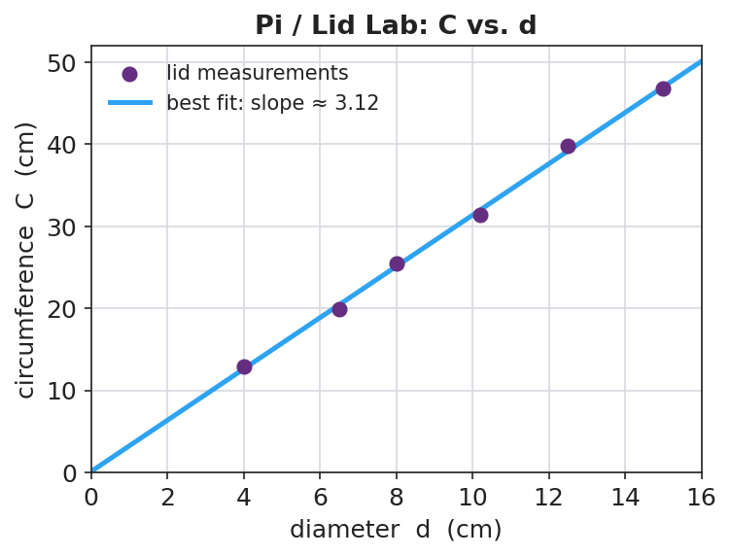
Pi / Lid Lab: circumference vs. diameter
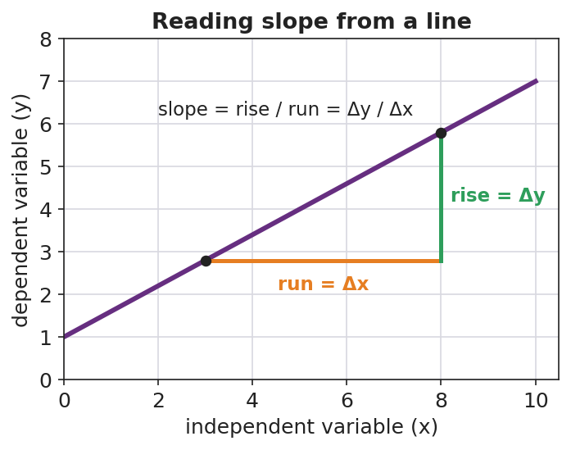
Reading slope from a line
Teacher facilitation during Explore:
- What to look for — best-fit lines that pass through the cloud, with roughly equal points above and below, and that pass near the origin.
- What to resist — handing out the slope formula before they’ve drawn the triangle; let the rise/run come from their own line.
- What to redirect — groups connecting dots zig-zag style (“that’s not a measured law, that’s tracing your errors”); groups forcing the line through the first point only.

Phase 3 · Explain (26 – 34 min)

26–30 min · Turn-and-Talk + class consensus
Post several groups’ slopes on the board (they will cluster near 3.1–3.2).
“Compare your slope to your neighbors’. Why did everyone — with different lids — land near the same number?”
Target consensus:
“The graph is a straight line through the origin, so circumference is proportional to diameter. The slope is the constant multiplier, and it’s about 3.14 — that’s π.”

30–34 min · Vocabulary introduction (≤ 3 terms)
Sample teacher language:
“Three words make every future graph readable. The independent variable is the one we choose — it goes on the x-axis (here, diameter). The dependent variable responds — it goes on the y-axis (circumference). And the slope is rise over run: how much y changes for each step in x. When the line is straight through the origin, that slope is the proportionality constant — for us, π.”

Discussion prompts to deploy here
- “If you’d plotted circumference on the x-axis instead, what would the slope have been?”
  - Sample student response: “About 1/π ≈ 0.32, because the axes are swapped — slope is y-over-x.”
- “Why is a best-fit line more trustworthy than connecting the dots?”
  - Sample student response: “It averages out our measurement errors instead of treating each wobble as real.”

Phase 4 · Elaborate (34 – 39 min)

34–37 min · Active Learning — predict from the line
“Without measuring, use your best-fit line to predict the circumference of a lid 20 cm across. Mark it on the graph and read it off. Then check: 20 × your slope. Do they match?”
This makes the line a tool, not a decoration — interpolation/extrapolation.

37–39 min · Return to the phenomenon
“State the locked-together rule in one sentence with the word slope.”
Target: “Circumference = slope × diameter, and the slope is π ≈ 3.14, so C = πd — the same multiplier for every lid.”

Phase 5 · Evaluate (39 – 42 min)

39–42 min · Exit Ticket + Closing Reflection
“A class plots a stretched spring’s length (cm) versus the mass hung on it (g). The line is straight and rises from 12 cm at 0 g. (a) Which is the independent variable and which is the dependent variable? (b) The line rises 8 cm over a run of 200 g. What is the slope, with units? (c) What does that slope tell you in plain words?”
Expected: (a) mass = independent (x), length = dependent (y); (b) slope = 8 cm / 200 g = 0.04 cm/g; (c) the spring stretches 0.04 cm for every extra gram. See Answer_Key.docx.
Closing Reflection (SEL, 30 seconds):
“Whose idea in your group changed how you drew or read the line today? Name them.”

Common Misconceptions
- Misconception: “Connect the dots to show the relationship.” → Correction: A best-fit line averages out measurement error; connect-the-dots treats every wobble as a real effect.
- Misconception: “The independent variable goes wherever there’s room.” → Correction: Independent (what you choose) goes on the x-axis; dependent (what responds) on the y-axis — always.
- Misconception: “Slope is just ‘how steep,’ no units.” → Correction: Slope is rise/run with units (e.g., cm per gram) and it carries the physical meaning of the relationship.
- Misconception: “A steeper line means a bigger y-value.” → Correction: Steepness is the rate of change, not the size of any single value.

Access & Differentiation
- ELL/ENL supports: Sentence frame: *“When the ___ goes up by , the goes up by ___.”* Color-code the axes (x = “I choose,” y = “it responds”). Provide a labeled slope-triangle card. Pre-teach “per” as “for each.”
- IEP/SPED supports: Provide a pre-labeled grid with axis titles and a scale already chosen, so students plot only. Offer a partially drawn best-fit line and have them compute the slope from a marked triangle. Reduce to 4 lids if measuring is slow.
- Extensions: Ask students to find the y-intercept of the spring graph and explain its physical meaning (the unstretched length), then write the full equation y = mx + b for their data.

Strategy Spotlight
ACTIVE LEARNING. Today’s chip pairs a hands-on measurement lab with a Slow Reveal discourse routine. Students generate the data that produces π rather than being told the value — the proportional pattern emerges from their own messy points, which is exactly why the best-fit line conversation lands. Keep groups small (3–4) so everyone measures, and require every group to post a slope so the class can see the pattern converge. The Slow Reveal warm-up trains the interpretation move (axes → points → line) you want them to use on their own graph.

NYSSLS Observation Checklist Crosswalk
# | Checklist item | Where it appears in this lesson
1 | Local/relatable phenomenon | Phase 1 — round lids; Phase 5 — stretched spring
2 | Turn and Talk (2–3×) | Phase 3 (why same slope?), Phase 4 (predict from the line)
3 | Students develop questions/models/procedures | Phase 2 — design the measuring method, plot, draw best fit
4 | CCC defined and used | Lesson Overview · Patterns, applied in Phase 3 consensus
5 | ENL — ≤ 3 vocab, second half | Phase 3 — vocabulary at 30–34 min (independent / dependent / slope)
6 | Revisit phenomenon with evidence | Phase 4 — state C = πd from the measured slope
7 | ENL/SPED supports | Access & Differentiation block
8 | Assessment check | Phase 5 — Exit Ticket (spring slope + interpretation)

Companion Materials
- Student_Worksheet.docx — the 5E student investigation with the lid data table (hand out at start of Phase 2)
- Student_Notes.docx — guided note-guide for variables, best fit, and the slope worked example
- Answer_Key.docx — answers to “Make It Make Sense” prompts and the Exit Ticket

Key Vocabulary (max 3)
- independent variable — the quantity you choose or change; it goes on the x-axis (here, the lid’s diameter)
- dependent variable — the quantity that responds and is measured; it goes on the y-axis (here, the circumference)
- slope — the rise divided by the run of a line (Δy / Δx); for a line through the origin it is the proportionality constant

Graphing and Interpreting Data — Student Worksheet
Unit: Math in Science — Lesson 02 Name: _______________________ Date: __________ Period: ____

Phenomenon
Your teacher claims that for any round lid, the distance around it and the distance across it are locked together by the same multiplier — big lid or small lid, same number. Today you will catch that multiplier on a graph.
Driving question: What single number connects the circumference of a circle to its diameter, and how does a graph reveal it?

Notice & Wonder
I notice… | I wonder…
Turn & Talk #1: As the lids get bigger across, what happens to the distance around them? What shape do you predict the graph will be?

Initial Model
Sketch the graph you expect before measuring. Label the axes. Predict in one sentence what the line will look like and whether it passes through the origin (0, 0).
My prediction: _________________________________

Investigation
Set the variables: Which quantity do you choose (independent, x-axis)? __________ Which responds (dependent, y-axis)? __________
Measure 5–6 lids. Use string to find the circumference, then straighten it against a ruler.
Lid | Diameter, d (cm) | Circumference, C (cm)
1
2
3
4
5
6
Plot all points. Draw one straight line of best fit (not dot-to-dot). Build a slope triangle on it.

Pi / Lid Lab: circumference vs. diameter
Slope: rise = __________ run = __________ slope = rise / run = __________
Key question: Why did your slope come out near 3.14 even though your lids were all different sizes?

Make It Make Sense
- A graph plots distance (y) versus time (x) for a walker. Which variable is independent and which is dependent?
- A best-fit line rises 6 units over a run of 3 units. What is its slope?
- Two lines are drawn on the same axes. Line A is steeper than Line B. What does the steeper slope mean about how fast y changes?

Vocabulary in Action
Use each term in a sentence about today’s lid investigation.
- independent variable: _______________________________________________
- dependent variable: _______________________________________________
- slope: _______________________________________________

Revise Your Model
Compare the graph you predicted to the graph you measured. Was it a straight line? Did it pass through the origin? Rewrite the locked-together rule as an equation using your slope.
Measured rule: C = __________ × d

Exit Ticket
A class plots a stretched spring’s length (cm) versus the mass hung on it (g). The line is straight and starts at 12 cm when 0 g is hung.
- Which is the independent variable and which is the dependent variable?
- The line rises 8 cm over a run of 200 g. What is the slope, including units?
- Explain in plain words what that slope tells you about the spring.

Graphing and Interpreting Data — Student Notes
Unit: Math in Science — Lesson 02 Name: _______________________ Date: __________ Period: ____

Learning Targets
By the end of today’s 42 minutes I can:
- Identify the independent and dependent variable and put each on the correct axis.
- Draw a line of best fit and explain why it beats connect-the-dots.
- Calculate a slope (rise / run) with units and say what it means.

Key Vocabulary
- independent variable — _______________________________________________
- dependent variable — _______________________________________________
- slope — _______________________________________________

Guided Notes
Which axis? The variable I choose (the __________ variable) goes on the __________-axis. The variable that responds and I measure (the __________ variable) goes on the __________-axis.
Line of best fit: a single straight line drawn close to as many points as possible, with about equal points __________ and below it. It is NOT __________-to-__________, because that would treat measurement error as real.
Slope: slope = rise / run = Δy / Δ__________ . Always include __________ (e.g., cm per gram). When a line is straight through the origin, the slope is the __________ constant.

Reading slope from a line

Worked Example
Problem. Lid data gives a straight line through the origin. Between two points, the circumference rises 31.4 cm while the diameter runs 10.0 cm. Find the slope and interpret it.
Solution. 1. slope = rise / run = 31.4 cm / __________ cm. 2. slope = __________ (no length unit left — cm / cm cancels). 3. The line passes through the __________, so this slope is the proportionality constant: C = __________ × d. 4. That constant ≈ 3.14, which is __________. So C = πd.

Pi / Lid Lab: circumference vs. diameter

Summary
Finish the sentence (Because / But / So):
A straight-line graph through the origin shows a proportional relationship because __________________________________________, but __________________________________________, so __________________________________________.

Graphing and Interpreting Data — Answer Key

Cover
Unit: Math in Science — Lesson 02: Graphing and Interpreting Data East Meadow Schools × Valley Stream Central HSD Strategy chip: ACTIVE LEARNING

Make-It-Make-Sense Answers
- Time is independent (x-axis) — it ticks on its own and we choose when to read it; distance is dependent (y-axis) — it responds to how far the walker has gone. · Rubric: both roles correct AND on the correct axes. · Practice: Analyzing & Interpreting Data.
- slope = rise / run = 6 / 3 = 2. · Rubric: 2, shown as rise over run. · CCC: Patterns.
- The steeper line (A) means y changes faster — a larger increase in y for each step in x (a greater rate of change). · Rubric: connects steepness to rate of change, not to the size of a single value. · Common error: “A has bigger numbers” — steepness is about the rate, not the height.

Exit Ticket Answer
- Mass is the independent variable (x-axis); length is the dependent variable (y-axis).
- slope = rise / run = 8 cm / 200 g = 0.04 cm/g.
- The spring stretches 0.04 cm for every extra gram hung on it — that is its stretch rate. (The 12 cm start is its unstretched length, the y-intercept.)
Tolerance/rubric: (a) both roles + correct axes; (b) 0.04 cm/g with units (accept 0.04 cm per gram); (c) “0.04 cm per gram of stretch” in plain words. 1 point each. Practice: Using Mathematics & Computational Thinking; CCC: Patterns.

Closing Reflection (rubric)
Closing reflection is formative, not graded. Award full credit for any honest response. Look for: - A specific peer named (or a self-acknowledgment) - A concrete idea that changed how they drew or read the line (e.g., “best fit, not dot-to-dot”)

Scientific Notation and Fermi Estimates — Teacher Guide

Cover
Unit: Math in Science — Lesson 03: Scientific Notation and Fermi Estimates East Meadow Schools × Valley Stream Central High School District Strategy chips: BTC

Curated Resources (from East Meadow Scope & Sequence)

NYSSLS Standards
This is a foundational math-skills lesson with no single NYSSLS performance expectation of its own. It develops the science and engineering practice “Using Mathematics and Computational Thinking,” which underpins every HS-PS standard — students will write charge in coulombs (HS-PS3), wavelengths in meters (HS-PS4), and astronomical distances (HS-ESS1) in scientific notation, and they will sanity-check answers by order of magnitude. The crosscutting concept in focus is Scale, Proportion, and Quantity: scientific notation is the language for comparing sizes that span dozens of powers of ten, from an atom to a galaxy.

Phenomenon
- “Scale of the Universe” interactive — zoom from quarks to the observable universe: https://htwins.net/scale2/
- Fermi question: “How many basketballs would fill the gym?” — a quantity nobody could ever count directly, estimated to the nearest power of ten.

Javalab / Labs
- Fermi estimation station (this lesson’s investigation): groups estimate “how many basketballs fill the gym” using only reasonable round numbers.
- “Scale of the Universe” as the Engage zoom: https://htwins.net/scale2/
- Powers of Ten classic film (Eames) as an optional extension: https://www.youtube.com/watch?v=0fKBhvDjuy0

Assessments
- The Exit Ticket below (convert to scientific notation + a one-step Fermi estimate) is the formative check for this lesson.

Lesson Overview
Duration | 42 minutes (1 period)
NYSSLS link | Practice: Using Mathematics and Computational Thinking (supports all HS-PS)
CCC focus | Scale, Proportion, and Quantity — comparing sizes across many powers of ten
Strategy chips | BTC (random groups + vertical non-permanent surfaces on a thin-sliced task)
Materials | Whiteboards / windows / vertical surfaces + markers; visibly random grouping cards; a basketball + the room dimensions; calculators
Safety | No hazards.
Prior knowledge | Place value; multiplying by 10; exponents as repeated multiplication.
Lesson objectives — students can:
- Write a large or small number in scientific notation (a number from 1–10 times a power of ten) and convert back to standard form.
- Use the exponent to count how many places the decimal moves and to compare two numbers’ sizes.
- Make an order-of-magnitude (Fermi) estimate of a quantity that cannot be counted directly, and express it as a power of ten.

Phase 1 · Engage (0 – 8 min)

0–3 min · Opening Connection (SEL)
Quick check-in. Prompt: “Name something so big or so small you can’t really picture it (a national debt, a virus, the number of stars).” This legitimizes the discomfort of huge/tiny numbers — the exact problem scientific notation solves.

3–8 min · Phenomenon hook — Scale of the Universe + the gym question
Teacher actions. Project “Scale of the Universe” and zoom from an atom out to a galaxy. Then point around the room: “How many basketballs would fill this gym?”
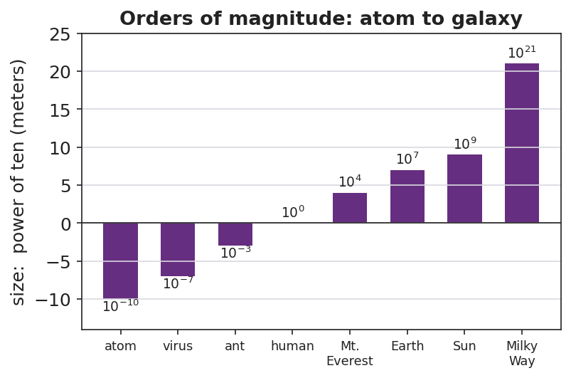
Orders of magnitude: atom to galaxy
Sample teacher language:
“Watch the exponent in the corner as I zoom — it jumps from negative ten to positive twenty. Nobody could write all those zeros and stay sane. Now: how many basketballs fill this gym? You will never count them — but by the end of class you’ll name the right power of ten, and you’ll defend it.”
Anticipated student responses:
- “A million? A billion?” — capture the guesses; we’ll see whose power of ten survives.
- “That’s impossible to know.” — reframe: “We don’t need exact; we need the right order of magnitude — the right power of ten.”
- “Just measure the gym and divide.” — yes — name that as the Fermi strategy.

Bridge to Phase 2
Every student leaves Phase 1 able to state the goal in one sentence: “Find the power of ten for the number of basketballs, not the exact count.”

Phase 2 · Explore (8 – 26 min)

8–14 min · Skill — scientific notation (BTC thin-slice at the boards)
Visibly random groups, markers, vertical surfaces. Feed a thin-sliced sequence (each step a small notch harder), one at a time:
- Write 3,000 as ___ × 10^? → 3 × 10³
- Write 47,000. Write 0.006. Write 250,000.
- Convert back: 5.2 × 10⁴ = ? ; 8 × 10⁻³ = ?
- Which is bigger: 9 × 10⁵ or 2 × 10⁶? (compare exponents first)
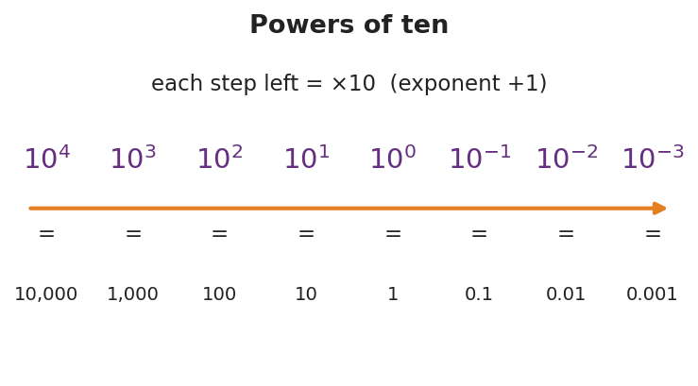
Powers of ten
Teacher facilitation language (BTC):
“I’m not answering ‘is this right?’ — convince your group at the board. When you’ve got it, signal and I’ll feed the next slice.”

14–26 min · Investigation — the Fermi gym estimate
Same boards. Groups estimate how many basketballs fill the gym using only round numbers: gym ≈ L × W × H; basketball ≈ a 0.24 m sphere (round its volume to ~10⁻² m³). Divide, then round the answer to a single power of ten and write it in scientific notation.
Teacher facilitation during Explore:
- What to look for — groups rounding aggressively (24 cm → 0.25 m → volume ~0.01 m³) instead of chasing decimals.
- What to resist — demanding the “real” answer; the win is a defensible power of ten.
- What to redirect — groups adding/subtracting exponents wrong; have them write each factor in scientific notation first, then combine.

Phase 3 · Explain (26 – 34 min)

26–30 min · Turn-and-Talk + class consensus
Post each group’s power of ten (they’ll cluster around 10⁴–10⁵).
“Compare your exponent to the next group’s. You don’t have to match exactly — but you should be within about one power of ten. Why is that ‘close enough’ in physics?”
Target consensus:
“Exact counts are impossible, but the order of magnitude — the power of ten — tells us if an answer is reasonable. Tens of thousands of basketballs, not hundreds and not billions.”

30–34 min · Vocabulary introduction (≤ 3 terms)
Sample teacher language:
“Three words run the rest of physics. Scientific notation writes any number as a value from 1 to 10 times a power of ten. The exponent is that power — it counts how many places the decimal moved, and it’s how we compare sizes fast. And the order of magnitude is just the power of ten itself — the level a quantity lives on, like 10⁴ for our basketballs.”

Discussion prompts to deploy here
- “9 × 10⁵ vs. 2 × 10⁶ — which is bigger and how do you know at a glance?”
  - Sample student response: “2 × 10⁶, because its exponent is bigger — one whole order of magnitude up.”
- “Why write 0.000006 as 6 × 10⁻⁶ instead of leaving it?”
  - Sample student response: “Fewer zeros to miscount, and the −6 instantly tells me how small it is.”

Phase 4 · Elaborate (34 – 39 min)

34–37 min · A second Fermi slice
“Estimate how many heartbeats you’ve had in your whole life. Round everything; give the answer as one power of ten in scientific notation.”
Target reasoning: ~70 beats/min × ~5×10⁵ min/yr × ~15 yr ≈ 5×10⁸ → order of magnitude 10⁸–10⁹.

37–39 min · Return to the phenomenon
“State the gym answer in scientific notation and name its order of magnitude in one sentence.”
Target: “About 3 × 10⁴ basketballs — order of magnitude 10⁴ — tens of thousands, because the gym’s volume is roughly ten thousand times a basketball’s.”

Phase 5 · Evaluate (39 – 42 min)

39–42 min · Exit Ticket + Closing Reflection
“(a) Write 84,000 and 0.00072 in scientific notation. (b) Which is larger: 4 × 10⁷ or 9 × 10⁶? How do you know? (c) Fermi: about how many grains of rice fill a coffee mug? Give your answer as a single power of ten and one sentence of reasoning.”
Expected: (a) 8.4 × 10⁴ and 7.2 × 10⁻⁴; (b) 4 × 10⁷ (bigger exponent); (c) ~10⁴ grains (mug ≈ 300 mL, a grain ≈ 0.02 mL → ~15,000 ≈ 10⁴), reasoning accepted if within one order. See Answer_Key.docx.
Closing Reflection (SEL, 30 seconds):
“Fermi estimates feel uncomfortable because there’s no single ‘right’ answer. Name one way being okay with ‘close enough’ could help you outside physics class.”

Common Misconceptions
- Misconception: “Scientific notation can start with any number, like 30 × 10².” → Correction: The leading number must be from 1 up to (not including) 10; 30 × 10² = 3 × 10³.
- Misconception: “A negative exponent means the number is negative.” → Correction: A negative exponent means small (between 0 and 1), not negative; 6 × 10⁻³ = 0.006, still positive.
- Misconception: “10⁶ is twice 10³ because 6 is twice 3.” → Correction: Each step up is ×10; 10⁶ is a thousand times 10³ (three orders of magnitude bigger).
- Misconception: “A Fermi estimate is wrong if it isn’t exact.” → Correction: The goal is the right order of magnitude; being within one power of ten is a success.

Access & Differentiation
- ELL/ENL supports: Sentence frame: “The number ___ equals ___ × 10 to the , so its order of magnitude is .” Provide the powers-of-ten chart as a reference. Pair “order of magnitude” with the zoom gesture from the Scale of the Universe demo.
- IEP/SPED supports: Provide a decimal-place counting strip (arrows showing the decimal hop) for conversions. Give the Fermi task with the round numbers pre-listed so students only divide and round the exponent. Allow calculator for the arithmetic.
- Extensions: Have students multiply two numbers in scientific notation (e.g., (3 × 10⁴)(2 × 10⁵)) by multiplying the leading numbers and adding the exponents, then estimate the mass of all the air in the room.

Strategy Spotlight
BTC (Building Thinking Classrooms). Today uses the three core BTC moves: visibly random groups, vertical non-permanent surfaces (whiteboards/windows), and a thin-sliced task fed one slice at a time. The thin-slicing matters most here — scientific notation fails quietly when students skip a difficulty notch, so each prompt rises just one step (whole thousands → arbitrary numbers → small numbers → comparisons). Refuse to be the answer key (“convince your group”); release the next slice only when a group signals understanding. The Fermi estimate is the rich task the slicing builds toward — open enough that no two boards look identical, bounded enough that all land within an order of magnitude.

NYSSLS Observation Checklist Crosswalk
# | Checklist item | Where it appears in this lesson
1 | Local/relatable phenomenon | Phase 1 — basketballs in the gym; Phase 4 — lifetime heartbeats
2 | Turn and Talk (2–3×) | Phase 3 (compare exponents), Phase 4 (heartbeat estimate share)
3 | Students develop questions/models/procedures | Phase 2 — design the Fermi division and round to a power of ten
4 | CCC defined and used | Lesson Overview · Scale, Proportion, and Quantity, applied in Phase 3
5 | ENL — ≤ 3 vocab, second half | Phase 3 — vocabulary at 30–34 min (scientific notation / order of magnitude / exponent)
6 | Revisit phenomenon with evidence | Phase 4 — state the gym answer in scientific notation
7 | ENL/SPED supports | Access & Differentiation block
8 | Assessment check | Phase 5 — Exit Ticket (conversion + comparison + Fermi)

Companion Materials
- Student_Worksheet.docx — the 5E student investigation with the Fermi gym task (hand out at start of Phase 2)
- Student_Notes.docx — guided note-guide for notation rules and the Fermi worked example
- Answer_Key.docx — answers to “Make It Make Sense” prompts and the Exit Ticket

Key Vocabulary (max 3)
- scientific notation — a way to write any number as a value from 1 to 10 multiplied by a power of ten (e.g., 8.4 × 10⁴)
- order of magnitude — the power of ten a quantity is closest to; the “level” of its size (e.g., 10⁴ basketballs)
- exponent — the power that ten is raised to; it counts how many places the decimal moves and lets you compare sizes

Scientific Notation and Fermi Estimates — Student Worksheet
Unit: Math in Science — Lesson 03 Name: _______________________ Date: __________ Period: ____

Phenomenon
In “Scale of the Universe” you zoom from an atom (about 10⁻¹⁰ m) all the way out to a galaxy (about 10²¹ m) — dozens of powers of ten. Then your teacher asks a number nobody could ever count: how many basketballs would fill this gym?

Orders of magnitude: atom to galaxy
Driving question: How do scientists write — and estimate — numbers far too big or too small to count?

Notice & Wonder
I notice… | I wonder…
Turn & Talk #1: What number do you guess for the basketballs in the gym? Is it closer to a thousand, a million, or a billion?

Initial Model
Write your gym guess as a normal number AND circle the power of ten you think it lives near (10³, 10⁴, 10⁵, 10⁶). You will test this guess by the end of class.
My guess: __________ Power of ten: __________

Investigation
Part A — Scientific notation warm-up. Fill in the blanks.
Standard form | Scientific notation
3,000
47,000
0.006
 | 5.2 × 10⁴
 | 8 × 10⁻³

Powers of ten
Part B — Fermi: basketballs in the gym. Use only round numbers.
- Gym volume ≈ length × width × height = __________ × __________ × __________ ≈ __________ m³
- One basketball ≈ a sphere about 0.24 m across ≈ __________ m³ (round to ~0.01 m³)
- Number of basketballs ≈ gym volume ÷ ball volume ≈ __________
- Rounded to one power of ten, in scientific notation: __________
Key question: Why is the power of ten a more honest answer here than an exact count?

Make It Make Sense
- Write 920,000 and 0.00045 in scientific notation.
- Which is larger: 7 × 10⁴ or 3 × 10⁵? Explain how you can tell quickly.
- A bacterium is about 10⁻⁶ m long and a person is about 10⁰ m (1 m) tall. How many orders of magnitude separate them?

Vocabulary in Action
Use each term in a sentence about today’s phenomenon.
- scientific notation: _______________________________________________
- order of magnitude: _______________________________________________
- exponent: _______________________________________________

Revise Your Model
Compare your gym answer to your Initial Model guess. Was your power of ten too high, too low, or right? Write the final answer in scientific notation and name its order of magnitude.
Final: __________ basketballs ≈ __________ (order of magnitude 10^___)

Exit Ticket
- Write 84,000 and 0.00072 in scientific notation.
- Which is larger: 4 × 10⁷ or 9 × 10⁶? How do you know?
- Fermi estimate: about how many grains of rice would fill a coffee mug? Give your answer as a single power of ten and one sentence of reasoning.

Scientific Notation and Fermi Estimates — Student Notes
Unit: Math in Science — Lesson 03 Name: _______________________ Date: __________ Period: ____

Learning Targets
By the end of today’s 42 minutes I can:
- Write large and small numbers in scientific notation and convert them back.
- Use the exponent to compare the sizes of two numbers.
- Make an order-of-magnitude (Fermi) estimate and express it as a power of ten.

Key Vocabulary
- scientific notation — _______________________________________________
- order of magnitude — _______________________________________________
- exponent — _______________________________________________

Guided Notes
The form: scientific notation is (a number from 1 to 10) × 10^(exponent). The leading number must be at least 1 and less than __________.
Moving the decimal:
- Big numbers → exponent is __________ (positive). 47,000 = 4.7 × 10^___ (decimal moved __________ places left).
- Small numbers → exponent is __________ (negative). 0.006 = 6 × 10^___ (decimal moved __________ places right).

Powers of ten
Comparing sizes: the number with the larger __________ is bigger. Each step in the exponent is a factor of __________. So 10⁶ is __________ times bigger than 10³.
Order of magnitude = the power of ten a quantity is nearest. It answers “what level of size?” not “exactly how many?”

Worked Example
Problem (Fermi). About how many basketballs fill a gym? Use only round numbers.
Solution. 1. Gym ≈ 30 m × 20 m × 10 m = __________ m³ = 6 × 10³ m³. 2. One basketball ≈ a 0.24 m sphere ≈ 0.01 m³ = 1 × 10⁻² m³. 3. Number ≈ gym ÷ ball = (6 × 10³) ÷ (1 × 10⁻²). Divide leading numbers, __________ the exponents: 6 × 10^(3 − (−2)) = 6 × 10^. 4. Answer ≈ 6 × 10⁵ → order of magnitude _______. (Hundreds of thousands — a defensible estimate.)

Orders of magnitude: atom to galaxy

Summary
Finish the sentence (Because / But / So):
I can estimate a number too big to count because __________________________________________, but __________________________________________, so __________________________________________.

Scientific Notation and Fermi Estimates — Answer Key

Cover
Unit: Math in Science — Lesson 03: Scientific Notation and Fermi Estimates East Meadow Schools × Valley Stream Central HSD Strategy chip: BTC

Make-It-Make-Sense Answers
- 920,000 = 9.2 × 10⁵; 0.00045 = 4.5 × 10⁻⁴. · Rubric: leading number 1–10 AND correct exponent (sign + size). Reject 92 × 10⁴ or 0.45 × 10⁻³. · Practice: Using Mathematics & Computational Thinking.
- 3 × 10⁵ is larger. Compare exponents first: 5 beats 4, a whole order of magnitude, so the leading numbers don’t matter. · Rubric: correct choice AND “bigger exponent” reasoning. · CCC: Scale, Proportion, and Quantity.
- From 10⁻⁶ to 10⁰ is 6 orders of magnitude (count the exponent steps: −6 up to 0). · Rubric: 6, by subtracting exponents. · Common error: answering “1,000,000” — that’s the factor, the question asks for the number of orders.

Exit Ticket Answer
- 84,000 = 8.4 × 10⁴; 0.00072 = 7.2 × 10⁻⁴.
- 4 × 10⁷ is larger — its exponent (7) is bigger than 6, one full order of magnitude up, so it outweighs the larger leading digit of 9 × 10⁶.
- ~10⁴ grains. Sample reasoning: a mug ≈ 300 mL and a grain of rice ≈ 0.02 mL, so 300 ÷ 0.02 ≈ 15,000 ≈ 10⁴. Any answer of 10³–10⁵ with reasoning is full credit.
Tolerance/rubric: (a) both correct, leading number 1–10; (b) 4 × 10⁷ with exponent reasoning; (c) a single power of ten in the 10³–10⁵ range with one sentence of round-number reasoning. 1 point each. Practice: Using Mathematics & Computational Thinking; CCC: Scale, Proportion, and Quantity.

Closing Reflection (rubric)
Closing reflection is formative, not graded. Award full credit for any honest response. Look for: - A genuine connection between “close enough / order of magnitude” and a real-world judgment (budgeting time, money, packing, etc.)

Units, Prefixes, and Dimensional Analysis — Teacher Guide

Cover
Unit: Math in Science — Lesson 04: Units, Prefixes, and Dimensional Analysis East Meadow Schools × Valley Stream Central High School District Strategy chips: HOCHMAN

Curated Resources (from East Meadow Scope & Sequence)

NYSSLS Standards
This is a foundational math-skills lesson with no single NYSSLS performance expectation of its own. It develops the science and engineering practice “Using Mathematics and Computational Thinking,” required everywhere in HS-PS — students must report acceleration in m/s², energy in joules, and current in amperes, and they must catch a wrong answer by noticing the units don’t work out. The crosscutting concept in focus is Scale, Proportion, and Quantity: metric prefixes rescale a base unit by powers of ten, and dimensional analysis keeps a quantity’s meaning intact while its units change.

Phenomenon
- A recipe / road sign with mixed units that must be reconciled — e.g., a European recipe in grams and milliliters, or a speed-limit sign in km/h that a US driver reads as mph.
- NIST “SI Units” primer for the base units and prefixes: https://www.nist.gov/pml/owm/metric-si/si-units

Javalab / Labs
- Unit-conversion station (this lesson’s investigation): convert a mixed-unit recipe or trip so every quantity shares one system.
- Optional: measure a hallway in meters, then convert to cm, mm, and km to feel the prefix ladder.

Assessments
- The Exit Ticket below (a prefix conversion + a factor-label conversion with a unit check) is the formative check for this lesson.

Lesson Overview
Duration | 42 minutes (1 period)
NYSSLS link | Practice: Using Mathematics and Computational Thinking (supports all HS-PS)
CCC focus | Scale, Proportion, and Quantity — prefixes rescale by powers of ten; units carry meaning
Strategy chips | HOCHMAN (appositive + Because/But/So on the role of units)
Materials | A mixed-unit recipe or road sign (projected/printed); metric prefix reference; calculators; whiteboards
Safety | No hazards.
Prior knowledge | Powers of ten (Lesson 03); multiplying fractions; the idea of canceling.
Lesson objectives — students can:
- Name the SI units for length, mass, and time (meter, kilogram, second) and the quantities they measure.
- Convert between units using a metric prefix (k, c, m, μ, M) by moving the decimal the right number of places.
- Use dimensional analysis (the factor-label method) to convert a compound unit (e.g., km/h → m/s) and check that the units cancel correctly.

Phase 1 · Engage (0 – 8 min)

0–3 min · Opening Connection (SEL)
Quick check-in. Prompt: “Tell us about a time a misunderstanding about ‘how much’ or ‘how big’ caused a problem (a recipe, a road trip, a measurement).” This sets up that units, not just numbers, carry meaning.

3–8 min · Phenomenon hook — the mixed-unit recipe / road sign
Teacher actions. Project a recipe that lists “250 g flour, 0.2 L milk, 15 mL oil, bake at 180 °C” next to US measuring cups and an oven in °F — or a “100 km/h” sign next to a US speedometer in mph.
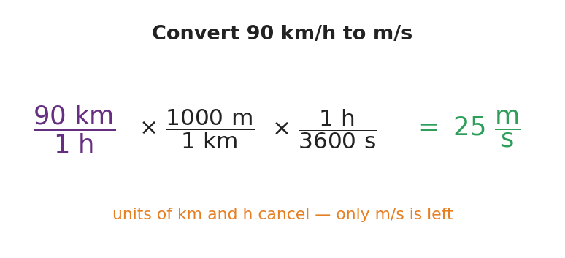
Convert 90 km/h to m/s with factor-label
Sample teacher language:
“This recipe and your kitchen don’t speak the same language. The recipe says 250 grams; your scoop says cups. The sign says 100 kilometers per hour; your speedometer says miles. Same physical amount — different units. Today we become the translators, and we’ll do it so carefully the units themselves tell us when we’re right.”
Anticipated student responses:
- “Just look it up / use Siri.” — affirm the instinct, then: “Siri doesn’t show its work, and on the Regents you do — let’s see the machinery.”
- “Grams and cups aren’t the same thing.” — exactly; one’s mass, one’s volume — units track what kind of quantity.
- “Kilo means a thousand, right?” — yes, capture it; that’s the prefix ladder.

Bridge to Phase 2
Every student leaves Phase 1 able to state the goal: “Rewrite every quantity in one consistent system without changing the actual amount.”

Phase 2 · Explore (8 – 26 min)

8–14 min · Skill A — SI base units and the prefix ladder
Establish the three core SI units: meter (length), kilogram (mass), second (time). Then build the prefix ladder — each rung is a power of ten.
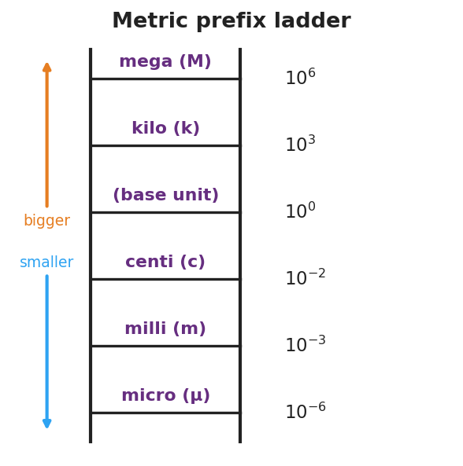
Metric prefix ladder
Teacher facilitation language:
“Going up a prefix means a bigger unit, so it takes fewer of them — 1500 m is only 1.5 km. Each rung is the decimal hopping by powers of ten. How many places, and which way?”
Anticipated student responses:
- “1 km = 100 m?” — common slip; kilo is 10³ = 1000, not 100.
- “Micro is the tiny one.” — yes, μ = 10⁻⁶; pair it with a gesture.

14–26 min · Skill B — dimensional analysis (factor-label)
Model converting 90 km/h → m/s by multiplying by “1” written as a ratio (1000 m / 1 km)(1 h / 3600 s) so the unwanted units cancel. Then groups convert the recipe / road-trip quantities.

Convert 90 km/h to m/s with factor-label
Teacher facilitation during Explore:
- What to look for — students writing the conversion factor so the old unit lands on the bottom and cancels.
- What to resist — letting them “just multiply by 1000” from memory; insist on writing the labeled ratio so the units do the checking.
- What to redirect — answers where km didn’t cancel (unit ends up km·m/h); have them flip the offending factor.

Phase 3 · Explain (26 – 34 min)

26–30 min · Turn-and-Talk + class consensus
“When you multiply by (1000 m / 1 km), why are you allowed to — and how do you know which way to write it? Use the word cancel.”
Target consensus:
“1000 m equals 1 km, so that ratio equals 1 — multiplying by 1 doesn’t change the amount, only the units. We write it with km on the bottom so the km we started with cancels, leaving meters.”

30–34 min · Vocabulary introduction (≤ 3 terms)
Sample teacher language:
“Three words make every conversion safe. An SI unit is the agreed scientific unit for a quantity — meter, kilogram, second. A metric prefix — like kilo or milli — rescales that unit by a power of ten. And dimensional analysis is the factor-label method: you multiply by ratios that equal 1 so the unwanted units cancel and the units of your answer prove it’s right.”

Discussion prompts to deploy here
- “How is multiplying by (1 h / 3600 s) different from just dividing by 3600?”
  - Sample student response: “It’s the same arithmetic, but the labeled ratio shows the hours cancel, so I can’t lose track of the units.”
- “If my answer for a speed comes out in km·m/h, what went wrong?”
  - Sample student response: “A factor was upside down — km didn’t cancel. Flip it so the unwanted unit is on the bottom.”

Phase 4 · Elaborate (34 – 39 min)

34–37 min · HOCHMAN appositive + Because/But/So
Have students define a unit with an appositive, then expand with the conjunctions.
“Write one sentence with an appositive: ’A newton, , is the SI unit of force.’ Then expand: Units must match before you add or compare because , but , so .”
Target appositive: “A newton, the push that gives 1 kg an acceleration of 1 m/s², is the SI unit of force.” Target B/B/S: “…because numbers without matching units are meaningless, but a prefix or factor-label step can rescale them, so I convert first, then compute.”

37–39 min · Return to the phenomenon
“Pick one recipe or road-sign quantity. State it in the US system in one sentence, and name how you knew your conversion was right.”
Target: e.g., “100 km/h ≈ 62 mph, and I knew it was right because the km and h units canceled, leaving mi/h.”

Phase 5 · Evaluate (39 – 42 min)

39–42 min · Exit Ticket + Closing Reflection
“(a) Convert 2.5 km to meters. (b) Convert 45 mm to meters (use the prefix). (c) Convert 72 km/h to m/s using the factor-label method, and circle the units that cancel.”
Expected: (a) 2,500 m; (b) 0.045 m; (c) 72 × (1000 m / 1 km) × (1 h / 3600 s) = 20 m/s, with km and h canceling. See Answer_Key.docx.
Closing Reflection (SEL, 30 seconds):
“Where else in your life would ‘check that the units make sense’ have saved you a mistake? Name one.”

Common Misconceptions
- Misconception: “kilo means 100.” → Correction: kilo = 10³ = 1000; centi = 10⁻², milli = 10⁻³.
- Misconception: “To convert km/h to m/s, just multiply by 1000.” → Correction: You must convert both the km (→ m) and the h (→ s); 90 km/h = 25 m/s, not 90,000 m/s.
- Misconception: “Units are just labels you tack on at the end.” → Correction: Units carry the meaning and the math; if they don’t cancel correctly, the number is wrong.
- Misconception: “Bigger prefix → bigger number of units.” → Correction: A bigger unit needs fewer of them — 1500 m is only 1.5 km.

Access & Differentiation
- ELL/ENL supports: Sentence frame: “To go from ___ to , I multiply by so the ___ cancels.” Provide the prefix ladder as a wall reference. Pre-teach “cancel” with a visual (crossing out matching units top and bottom).
- IEP/SPED supports: Provide a fill-in factor-label scaffold with the unit slots pre-drawn (just numbers to place). Offer a prefix-conversion arrow strip (places + direction). Limit Exit Ticket to parts (a) and (b) if needed.
- Extensions: Have students convert a compound unit they’ll meet later — e.g., g/cm³ to kg/m³ — and predict before computing whether the number gets bigger or smaller, justifying with the prefixes.

Strategy Spotlight
HOCHMAN (sentence-level literacy). Today’s chip is the appositive plus the Because/But/So expansion in Phase 4. Defining a unit with an appositive (“A newton, the push that…, is the SI unit of force”) forces students to pack a precise definition into a single clause — the exact skill the Regents constructed-response rewards. The Because/But/So then makes them articulate why units must match and what to do about it, turning a procedure into reasoning. Keep responses to one sentence each and collect the most precise appositives aloud.

NYSSLS Observation Checklist Crosswalk
# | Checklist item | Where it appears in this lesson
1 | Local/relatable phenomenon | Phase 1 — mixed-unit recipe / road sign; Phase 4 — km/h ↔ mph
2 | Turn and Talk (2–3×) | Phase 3 (why multiply by a ratio?), Phase 4 (appositive + B/B/S share)
3 | Students develop questions/models/procedures | Phase 2 — build the factor-label chain so units cancel
4 | CCC defined and used | Lesson Overview · Scale, Proportion, and Quantity, applied in Phase 2
5 | ENL — ≤ 3 vocab, second half | Phase 3 — vocabulary at 30–34 min (SI unit / metric prefix / dimensional analysis)
6 | Revisit phenomenon with evidence | Phase 4 — convert a recipe/road-sign quantity and justify
7 | ENL/SPED supports | Access & Differentiation block
8 | Assessment check | Phase 5 — Exit Ticket (prefix + factor-label conversions)

Companion Materials
- Student_Worksheet.docx — the 5E student investigation with the recipe/road-trip conversion (hand out at start of Phase 2)
- Student_Notes.docx — guided note-guide for prefixes and the factor-label worked example
- Answer_Key.docx — answers to “Make It Make Sense” prompts and the Exit Ticket

Key Vocabulary (max 3)
- SI unit — the agreed international scientific unit for a quantity: meter (length), kilogram (mass), second (time)
- metric prefix — a word/symbol (k, c, m, μ, M) that rescales a base unit by a power of ten (kilo = 10³, milli = 10⁻³)
- dimensional analysis — the factor-label method: multiplying by ratios equal to 1 so unwanted units cancel, leaving the desired units

Units, Prefixes, and Dimensional Analysis — Student Worksheet
Unit: Math in Science — Lesson 04 Name: _______________________ Date: __________ Period: ____

Phenomenon
A recipe reads “250 g flour, 0.2 L milk, bake at 180 °C” — but your kitchen has measuring cups and an oven in °F. A road sign says “100 km/h” — but your speedometer reads mph. Same physical amounts, different units. Today you become the translator.

Convert 90 km/h to m/s with factor-label
Driving question: How do we change a quantity’s units without changing the actual amount — and how do the units themselves prove we did it right?

Notice & Wonder
I notice… | I wonder…
Turn & Talk #1: Which numbers in the recipe/sign are in units your kitchen or car can’t read? What would you need to “translate” them?

Initial Model
Pick one quantity from the recipe or the road sign. Write what you’d have to do to express it in the US system. Do you think the number will get bigger or smaller? Why?

Investigation
Part A — The prefix ladder. Fill in the power of ten and convert.

Metric prefix ladder
Prefix | Power of ten | Example conversion
kilo (k) |  | 3 km = __________ m
centi (c) |  | 250 cm = __________ m
milli (m) |  | 45 mm = __________ m
micro (μ) |  | 1 m = __________ μm
Part B — Factor-label conversion. Convert 90 km/h to m/s. Write each factor as a ratio equal to 1 and cancel units.
90 km/h × ( ______ m / 1 km ) × ( 1 h / ______ s ) = __________ m/s
Key question: Which units cancel, and how does that tell you the answer is in the right units?

Make It Make Sense
- Convert 5,000 m to kilometers. Did the number get bigger or smaller, and why?
- Convert 3.2 m to centimeters.
- A student converts 72 km/h and gets an answer in km·m/h. What went wrong, and how should they fix it?

Vocabulary in Action
Use each term in a sentence about today’s phenomenon.
- SI unit: _______________________________________________
- metric prefix: _______________________________________________
- dimensional analysis: _______________________________________________

Revise Your Model
Return to the quantity you chose in your Initial Model. Convert it now, showing your factor-label or prefix step. Was your “bigger or smaller” prediction right?
Converted value: __________ Prediction correct? __________

Exit Ticket
- Convert 2.5 km to meters.
- Convert 45 mm to meters (use the prefix).
- Convert 72 km/h to m/s using the factor-label method. Circle the units that cancel.

Units, Prefixes, and Dimensional Analysis — Student Notes
Unit: Math in Science — Lesson 04 Name: _______________________ Date: __________ Period: ____

Learning Targets
By the end of today’s 42 minutes I can:
- Name the SI units for length, mass, and time and what each measures.
- Convert with a metric prefix (k, c, m, μ, M) by moving the decimal.
- Use dimensional analysis (factor-label) to convert a compound unit and check that units cancel.

Key Vocabulary
- SI unit — _______________________________________________
- metric prefix — _______________________________________________
- dimensional analysis — _______________________________________________

Guided Notes
SI base units: length → __________ (m); mass → __________ (kg); time → __________ (s).
Prefix ladder (each rung is a power of ten):
- kilo (k) = 10^___ ; centi (c) = 10^___ ; milli (m) = 10^___ ; micro (μ) = 10^___ ; mega (M) = 10^___ .
- A bigger unit needs __________ of them: 1500 m = __________ km.

Metric prefix ladder
Factor-label rule: multiply by a ratio that equals __________ (because the top and bottom are the same amount). Write the unwanted unit on the __________ so it __________ . The units of your answer prove it is right.

Convert 90 km/h to m/s with factor-label

Worked Example
Problem. Convert 90 km/h to m/s.
Solution. 1. Start with 90 km/h. I need to change km → m and h → s. 2. Multiply by (1000 m / 1 km) so __________ cancels, leaving meters on top. 3. Multiply by (1 h / 3600 s) so __________ cancels, leaving seconds on the bottom. 4. 90 × 1000 ÷ 3600 = __________ m/s. The leftover units are exactly __________, so it’s correct.

Summary
Finish the sentence (Because / But / So):
I can change a quantity’s units without changing the amount because __________________________________________, but __________________________________________, so __________________________________________.

Units, Prefixes, and Dimensional Analysis — Answer Key

Cover
Unit: Math in Science — Lesson 04: Units, Prefixes, and Dimensional Analysis East Meadow Schools × Valley Stream Central HSD Strategy chip: HOCHMAN

Make-It-Make-Sense Answers
- 5,000 m = 5 km. The number got smaller because a kilometer is a bigger unit, so it takes fewer of them for the same length. · Rubric: 5 km AND the “bigger unit → fewer of them” reasoning. · Practice: Using Mathematics & Computational Thinking.
- 3.2 m = 320 cm (centi = 10⁻² m, so 1 m = 100 cm; move the decimal two places right). · Rubric: 320 cm with units. · CCC: Scale, Proportion, and Quantity.
- The answer came out as km·m/h because a conversion factor was written upside down — the km did not cancel. Fix: write the factor as (1000 m / 1 km) so km sits on the bottom and cancels, and (1 h / 3600 s) so h cancels. · Rubric: identifies the inverted factor AND states the correct orientation. · Common error: blaming the arithmetic instead of the unit orientation.

Exit Ticket Answer
- 2.5 km = 2.5 × 1000 = 2,500 m.
- 45 mm = 45 × 10⁻³ = 0.045 m (milli = 10⁻³; move the decimal three places left).
- 72 km/h × (1000 m / 1 km) × (1 h / 3600 s) = (72 × 1000) ÷ 3600 = 20 m/s. The km cancels with the km on the bottom of the first ratio, and the h cancels with the h on the top of the second ratio, leaving m/s.
Tolerance/rubric: (a) 2,500 m; (b) 0.045 m (accept 4.5 × 10⁻² m); (c) 20 m/s AND km + h circled/identified as the canceling units. 1 point each. Practice: Using Mathematics & Computational Thinking; CCC: Scale, Proportion, and Quantity.

Closing Reflection (rubric)
Closing reflection is formative, not graded. Award full credit for any honest response. Look for: - A concrete real-world situation where a unit check would have caught a mistake (cooking, driving, shopping by weight, medication dosing, etc.)

Unit: Kinematics — Unit Plan

Cover
East Meadow Schools × Valley Stream Central High School District Unit: Kinematics 9 lessons · ~2 weeks at 42-minute periods (one double period per week) Aligned to the NEW East Meadow Physics Scope and Sequence (2026)

Unit Scope (from East Meadow Scope & Sequence)
The verbatim Kinematics row-by-row table from Scope_and_Sequence.md:
Topic | NYSSLS | Phenomenon | Javalab / Labs | Assessments
Vectors | HS-PS2-1 (Cause and Effect) | Physics Classroom Vector Animations | PhET Vector Addition; Physics Classroom Vector Addition Interactive; Vector Golf | An Introduction to Free Body Diagrams (Better Lesson)
Distance / Displacement | (carries HS-PS2-1 thread) | (none — see local hook) | Vector Walk (Physics Classroom) | (formative via exit ticket)
Average Speed / Velocity | (carries HS-PS2-1 thread) | (none — see local hook) | (none) | (formative via exit ticket)
Acceleration | HS-PS2-1 (Cause and Effect) | Physics Classroom — Acceleration | OPhysics Uniform Acceleration in 1D; Speeding Up / Slowing Down | Newton’s Second Law in 1-D Motion (Better Lesson)
Motion Graphs | HS-PS2-1 | (none — see local hook) | PhET Moving Man; Physics Classroom Graph That Motion (Concept Builder + Interactive) | (formative via exit ticket)
Freefall | (carries HS-PS2-1 thread) | Jumping from Space! (YouTube) | Java Lab Freefall | (formative via exit ticket)
Thrown Upwards / Vertical Projectiles | (carries HS-PS2-1 thread) | (image only — see local hook) | OPhysics Projectile Motion; PhET Projectile Motion | (formative via exit ticket)
Horizontal Projectile Motion | (carries HS-PS2-1 thread) | MythBusters Bullet Fired/Dropped; Shoot-n-Drop | PhET Projectile Motion; Java Lab Horizontal | (formative via exit ticket)
Projectiles at an Angle | (carries HS-PS2-1 thread) | Jamaal Murray hail mary | PhET Projectile Motion; Projectile Lab worksheet | (formative via exit ticket + design product)
The NYSSLS thread for the unit is HS-PS2-1: Newton’s Second Law of Motion — Analyze data to support the claim that Newton’s second law of motion describes the mathematical relationship among the net force on a macroscopic object, its mass, and its acceleration. (Cause and Effect)
Vectors (Lesson 01) and Acceleration (Lesson 04) are the explicitly NYSSLS-tagged rows in the source MD. The remaining lessons carry the thread by establishing the vector quantities (displacement, velocity, acceleration components) that HS-PS2-1 requires students to reason about. Conservation of momentum (HS-PS2-2) and gravitational/electrostatic forces (HS-PS2-4) belong to the Forces unit that follows.

Pacing Calendar
Week | Day | Lesson | Strategy chip(s) | Notes
1 | M | 01 Vectors | RESTORATIVE CIRCLE · ACTIVE LEARNING | Unit opener; Vector Golf stations
1 | T | 02 Distance and Displacement | (none) | Live walk-to-the-door demo
1 | W (double) | 03 Average Speed and Velocity | HOCHMAN | Sentence expansion organizer
1 | Th | 04 Acceleration | BTC | Random groups + VNPS thin-slicing
1 | F | 05 Motion Graphs | ACTIVE LEARNING | Gallery walk
2 | M | 06 Freefall | HOCHMAN | Because/but/so refutation
2 | T | 07 Vertical Projectiles | (none) | Toss-and-catch demo
2 | W (double) | 08 Horizontal Projectile Motion | BTC · HOCHMAN | Thin-slicing + paragraph topic sentence
2 | Th | 09 Projectiles at an Angle | ACTIVE LEARNING | Catapult design challenge
2 | F | Unit assessment | — | Regents-style cluster (Assessments/Kinematics_Regents_Style_Set.docx)
Total instructional time: 10 × 42 min = 420 min (~7 hours of class time across 2 weeks).

Strategy Rotation
The district pedagogical requirements dictate strategy frequencies:
- Hochman writing — 1–2× per week
- Active learning — 1–2× per week
- Building Thinking Classrooms (BTC) — occasional
- Restorative opening circle — where appropriate (canonical placements: unit opener; day after a high-stakes assessment)
- Differentiation/ELL supports — every lesson (built into every Teacher Guide’s Access & Differentiation block)
- SEL — every lesson (Opening Connection + Closing Reflection)
Tagged rotation across the unit:
Lesson | Strategy chips
01 Vectors | RESTORATIVE CIRCLE · ACTIVE LEARNING
02 Distance / Displacement | (none)
03 Average Speed and Velocity | HOCHMAN
04 Acceleration | BTC
05 Motion Graphs | ACTIVE LEARNING
06 Freefall | HOCHMAN
07 Vertical Projectiles | (none)
08 Horizontal Projectile Motion | BTC · HOCHMAN
09 Projectiles at an Angle | ACTIVE LEARNING
Totals: HOCHMAN 3 · ACTIVE LEARNING 3 · BTC 2 · RESTORATIVE CIRCLE 1 (unit opener). The second canonical restorative circle would land on the day after the Forces-unit midterm and is therefore in the next unit.

NYSSLS Coverage Matrix
Lesson | HS-PS2-1 | HS-PS2-2 | HS-PS2-3 | HS-PS2-4 | HS-PS2-5 | Notes
01 Vectors | ✓ |  |  |  |  | Establishes vector decomposition required for all PS2 reasoning
02 Distance / Displacement | ✓ |  |  |  |  | Vector vs. scalar foundation
03 Velocity | ✓ |  |  |  |  | Rate that net force changes
04 Acceleration | ✓ |  |  |  |  | The “a” in F=ma
05 Motion Graphs | ✓ |  |  |  |  | Visual language of x, v, a
06 Freefall | ✓ |  |  |  |  | Constant-a special case
07 Vertical Projectiles | ✓ |  |  |  |  | v₀ ≠ 0 freefall
08 Horizontal Projectiles | ✓ |  |  |  |  | x-y independence
09 Angled Projectiles | ✓ |  |  |  |  | 2-D culmination + design challenge
The unit is single-PE focused: every lesson reinforces HS-PS2-1. The remaining HS-PS2-* PEs (momentum, collision-design, gravity/Coulomb, magnetic-electric fields) live in the Forces, Momentum, and Electrostatics units.

Vocabulary Scope
3 terms per lesson, introduced in the second half of the lesson (per NYSSLS Observation Checklist item 5). Aggregated for the unit:
Lesson | Term 1 | Term 2 | Term 3
01 Vectors | vector | magnitude | direction
02 Distance / Displacement | distance | displacement | scalar
03 Velocity | speed | velocity | average rate
04 Acceleration | acceleration | deceleration | slope
05 Motion Graphs | position-time graph | velocity-time graph | area-under-curve
06 Freefall | freefall | gravity (g) | terminal velocity
07 Vertical Projectiles | peak | time-of-flight | symmetry
08 Horizontal Projectiles | horizontal velocity | vertical velocity | range
09 Angled Projectiles | launch angle | range equation | optimal angle
Total unit vocabulary load: 27 terms across 9 lessons. The capped-at-3 rule keeps the cognitive load low and aligns with district ELL/ENL guidance.
Cumulative vocabulary review (recommended for last 5 minutes of Lesson 09 or the assessment day): a 27-card matching deck where students match each term to its definition. Use as a Hochman kernel sentence prompt: “The ___ of a projectile is ___.” for any term.

Vectors — Teacher Guide

Cover
Unit: Kinematics — Lesson 01: Vectors East Meadow Schools × Valley Stream Central High School District Strategy chips: RESTORATIVE CIRCLE · ACTIVE LEARNING

Curated Resources (from East Meadow Scope & Sequence)

NYSSLS Standards
HS-PS2-1: Newton’s Second Law of Motion — Analyze data to support the claim that Newton’s second law of motion describes the mathematical relationship among the net force on a macroscopic object, its mass, and its acceleration. (Cause and Effect)
This lesson introduces the vector nature of the quantities (force, acceleration) that HS-PS2-1 requires students to reason about. Vectors are revisited in Lessons 02–05 (motion quantities) and Lessons 06–09 (gravity, projectiles).

Phenomenon
Physics Classroom — Vector Animations: http://www.physicsclassroom.com/mmedia/vectors/va.cfm
Two arrows added head-to-tail produce the same resultant regardless of which arrow comes first. The phenomenon invites students to notice that the order in which vectors are added does not change the result — a foothold for commutativity of vector addition.

Javalab / Labs
- PhET Vector Addition Simulation: https://phet.colorado.edu/en/simulations/vector-addition
- Physics Classroom Vector Addition Interactive: https://www.physicsclassroom.com/Physics-Interactives/Vectors-and-Projectiles/Vector-Addition/Vector-Addition-Interactive
- Vector Golf (Google Doc course): https://docs.google.com/document/d/1szBnR_mZA5WvECXAl-6wyQtQCxTnDcYVXrKPT8NvaFQ/edit?tab=t.0

Assessments
- An Introduction to Free Body Diagrams (Better Lesson) — students use the vector nature of forces to draw free body diagrams: http://betterlesson.com/lesson/630798/an-introduction-to-free-body-diagrams

Lesson Overview
Duration | 42 minutes (1 period)
NYSSLS link | HS-PS2-1
CCC focus | Cause and Effect — how the direction of a force changes motion, not just its magnitude.
Strategy chips | RESTORATIVE CIRCLE (unit opener) · ACTIVE LEARNING (Vector Golf stations)
Materials | Graph paper or vector grids (1 per student); rulers (1 per pair); printed Vector Golf course (4 stations × 1 copy each); chart paper for VNPS-style station work; colored markers (purple + blue per group, mirroring the brand palette); the slider-based interactive on each device or projected.
Safety | None.
Prior knowledge | Adding signed numbers; reading a coordinate grid; the difference between a measurement (number) and a measurement with direction (e.g., “30 mph” vs “30 mph north”).
Lesson objectives — students can:
- Describe a vector quantity using both magnitude and direction.
- Add two vectors graphically using the head-to-tail method.
- Decompose a vector into its x- and y-components.

Phase 1 · Engage (0 – 12 min)
Phenomenon-based lesson flow (PPTX slide 32): show the phenomenon → notice & wonder → prioritize a question through a CCC lens → develop an initial model.

0–3 min · Opening Connection (SEL)
Restorative Circle — unit opener. As students arrive, arrange chairs in a circle (or have students stand in a circle if the room is tight). Pass a small object hand-to-hand (a marker, a ball, a set of keys — anything that travels by hand). Each student answers a single prompt: “What is one experience you’ve had with motion this week?” Honor pass-rights — students may say “pass” without explanation. Do not respond to or evaluate any answer; nod, pass to the next student.
Sample teacher language to open the circle:
“Today we start a new unit, and we’re going to start with a circle. The point isn’t to be deep — it’s just to land in this room together before we start working. The question is: what is one experience you’ve had with motion this week? Pass-rights are honored — you can say ‘pass’ for any reason. I’ll go first, then [name to your left].”
Anticipated student responses:
- “I rode my bike to school” — affirm; this is a real-world example you’ll come back to.
- “I dropped my phone” — connect to Lesson 06 (freefall).
- “I scored a goal” / “I caught a ball” — projectile, Lesson 09 will revisit.
- “Pass” — fine, move on. Don’t push.
Close the circle: “What’s something you noticed about what people shared?” — invite one volunteer; this is the bridge to Phase 1’s content.

3–8 min · Phenomenon hook
Teacher actions. Project the Physics Classroom Vector Animation. Let it loop silently for ~30 seconds before saying anything. Resist the urge to narrate.
Sample teacher language:
“I’m not going to tell you what this is yet. Watch carefully. After a minute I’ll ask: what do you notice, and what do you wonder?”
After 30 seconds:
“OK. What do you notice?”
Anticipated student responses:
- “There are arrows” — affirm, then probe: “What do the arrows do?”
- “They get added together head-to-tail” — if a student says this, surface it for the class: “That’s a great word. We’ll come back to it.”
- “The dashed arrow is the resultant” — rare but possible. Do not validate as ‘right’ yet. Instead: “Interesting — what makes you think that’s a special arrow?”
- “It looks like the order doesn’t matter” — note this; we’ll come back to it in Phase 3.

8–12 min · Notice & Wonder + Turn-and-Talk #1
Capture two columns on the board: Notice and Wonder. Take 4–5 student observations (mix of voices). Then transition:
“Turn to your partner. One thing you noticed about the arrows. One thing you wondered. Pick a wondering you’d like the class to figure out today.”
After 90 seconds, take 2–3 wonderings. Write them on the board. The most useful ones to surface:
- “Why is the dashed arrow shorter than the two solid arrows added together?”
- “Does it matter which arrow comes first?”
- “How would you tell someone how to draw the dashed arrow?”
CCC framing. Briefly note: “We’re going to investigate cause and effect — when two forces or two motions combine, what determines the result? It’s not just about how big each one is.”

Bridge to Phase 2
By the end of Phase 1, every student should have a written initial model — a sketch in their notebook answering: “If arrow A points 4 squares right and arrow B points 3 squares up, where does the second arrow’s tip end up — and how would you describe that ending point in words?”

Phase 2 · Explore (12 – 32 min)
Investigation. Students engage with the phenomenon through hands-on Vector Golf stations and the slider-based interactive. Teacher walks but does not solve.

12–17 min · Initial Model (silent / individual)
Distribute graph paper. Students sketch their initial model individually. Specific prompt on the board:
“Arrow A points 4 squares right. Arrow B points 3 squares up. Draw both arrows head-to-tail starting from the origin. Where does B’s tip end up? In one sentence, describe that ending point.”
This is silent work. No collaboration yet. The point is to surface each student’s current mental model — including misconceptions — before the investigation surfaces the correct rule.
What to look for during the silent work:
- Students who add 4 + 3 = 7 (additivity misconception — they’re treating vectors like scalars). Mark these mentally; you’ll surface them in Phase 3.
- Students who draw the resultant correctly but can’t articulate it in words. Mark these too — they have intuition without vocabulary, which is exactly the gap vocabulary closes.

17–32 min · Investigation — Vector Golf stations (Active Learning)
Setup. Four stations around the room, each with a different “course” (a starting point and a target on a coordinate grid). Each station has chart paper at standing height (vertical non-permanent surface lite). Form random groups of 3 using a deck of cards: shuffle, deal one card per student face-down; same-suit groups (clubs together, diamonds together, etc.). The randomness signals that anyone can think with anyone.
Three-minute rotations. At each station, the group must use head-to-tail vector addition to plot a sequence of arrows that lands on the target. They leave their solution on the chart paper for the next group to verify. Walk the room and ask the discussion prompts; resist solving — let groups argue.
Sample teacher facilitation language during station work:
“What’s your evidence that arrow lands on the target?” “Could you have gotten there with fewer arrows? More?” “What does the group BEFORE you have — does their solution work?”

Teacher facilitation during Explore
- What to look for — groups discovering the head-to-tail rule by doing it. The “aha” moment is when a group realizes that A + B and B + A land in the same place.
- What to resist — do NOT explain the formal rule yet. The purpose of Phase 2 is for students to surface the pattern themselves. Resist the urge to validate “right answers” mid-investigation.
- What to redirect — if a group is stuck, redirect with: “What did the previous group try? What’s different about your course?” If a group thinks the order of vectors matters for the resultant, let them test it — they will discover the commutativity themselves.

Phase 3 · Explain (32 – 37 min)
Sense-making + class consensus. Students articulate the pattern they discovered. The teacher names the formal vocabulary (≤ 3 terms) — only after students have done the explaining work themselves. Per NYSSLS observation checklist item 5, vocabulary lands in the second half of the lesson.

32–35 min · Turn-and-Talk #2 + class consensus
Bring the class back together at one chart paper. Pick a group’s solution that shows two arrows (A and B) with their resultant. Ask:
“If A points right (magnitude 4) and B points up (magnitude 3), why does the resultant come out to 5 — not 7? Use the grid to convince your partner.”
After 90 seconds, take volunteers. The target consensus statement:
“When two vectors are perpendicular, the resultant’s magnitude follows the Pythagorean theorem: c² = a² + b². When they’re parallel, the magnitudes add. When they’re anti-parallel, they subtract.”
If no student arrives at the Pythagorean connection, prompt: “Look at the triangle the three arrows form. What do we know about right triangles?”

35–37 min · Vocabulary introduction (≤ 3 terms)
Now — and only now — name the three formal terms. Write them on the board with definitions and an example.
Sample teacher language:
“When a quantity has both a size and a direction, we call that a vector. The size is its magnitude. The way it points is its direction. Today we worked with vectors of length 4 and 3 that pointed perpendicular to each other; their resultant had magnitude 5 and a specific direction.”

Discussion prompts to deploy here
- “When two vectors point the same direction, what happens to their resultant? When they point opposite? When they’re perpendicular?”
  - Sample student response: “When perpendicular, the resultant is the diagonal of a rectangle, so we use Pythagoras to get its size.”
- “Could two different pairs of vectors give the same resultant? How would you draw an example?”
- “If you swap A and B in head-to-tail addition, does the resultant change? Why or why not?”

Phase 4 · Elaborate (37 – 40 min)
Apply the new ideas to the original phenomenon. Students return to their initial model from Phase 2 and revise it using today’s vocabulary and the pattern they surfaced.

37–39 min · Revise the model
Each student reopens their initial model sketch from Phase 2. Specific prompt on the board:
“Update your sketch. Use the words magnitude and direction in one sentence describing where B’s tip ends up. If your initial answer was 7, write a sentence underneath explaining why the correct answer is 5.”
This is the moment where the student’s own initial misconception (if they had one) gets corrected by their own hand. The Hochman because/but/so move can scaffold the correction:
“I first wrote 4 + 3 = 7 because I added the magnitudes, but the arrows are perpendicular, so the resultant uses Pythagoras: √(16+9) = 5.”

39–40 min · Return to the phenomenon
Re-show the original Physics Classroom vector animation. Ask the class:
“Now that we’ve worked this out, what would you say to a friend who watched this animation and said ‘I don’t get it’?”
Take one volunteer’s response. The target response uses vector, magnitude, direction in a single sentence — and that’s the lesson’s success criterion in action.

Phase 5 · Evaluate (40 – 42 min)
Transfer task assessment. A new phenomenon (different from the lesson’s hook) for students to apply their learning. Per the NYSSLS observation checklist (item 8), this is the in-lesson assessment.

40–42 min · Exit Ticket + Closing Reflection
Distribute exit slips. The transfer prompt:
“A boat sails 5 km east, then 12 km north. Sketch the resultant displacement on a grid and find its magnitude. Show one sentence of reasoning.”
Expected: 13 km, with reasoning that references the Pythagorean theorem or head-to-tail rule. See Answer_Key.docx for the rubric and tolerance.
Closing Reflection (SEL, 30 seconds, on the same exit slip):
“What is one thing that surprised you today? Who helped you make sense of something?”

Common Misconceptions
- Misconception: “Vectors with bigger numbers are always longer.” → Correction: Two vectors of equal magnitude but different directions add to different resultants — direction matters as much as magnitude.
- Misconception: “Adding vectors is the same as adding their magnitudes.” → Correction: That is only true when they point in exactly the same direction. In every other case the resultant magnitude is less than the sum (and equals zero when they cancel).
- Misconception: “The resultant is always longer than each input vector.” → Correction: Not when the vectors point opposite directions. The resultant can be shorter than either input, or even zero.

Access & Differentiation
- ELL/ENL supports: Sentence frames — *“The resultant of A + B has magnitude ___ because ___.”* and *“Adding A and B gives a resultant that points ___.”* Word-choice box: {magnitude, direction, resultant, components, scalar}. Visual-first framing — show two arrows on a grid before introducing the word vector. Bilingual glossary slot in student notebook for the three vocabulary words.
- IEP/SPED supports: Use the printed Vector Golf course as a chunked, scaffolded organizer; pre-draw the first arrow for each problem so students start from the head of an existing arrow. Provide a step list: (1) draw A from origin, (2) draw B from head of A, (3) draw R from origin to head of B. Allow oral responses for the exit ticket.
- Extensions: After Vector Golf, prompt advanced students to find the minimum number of vector additions to reach the target — introduces optimization thinking and previews path-planning intuition. Or: ask them to invent a 3-vector course where the resultant is exactly zero.

Strategy Spotlight
Restorative Circle (unit opener, 2 min) — see Phase 1, Opening Connection. The full process is described above with sample teacher language and anticipated responses. Keep the circle short — under 3 minutes — and resist responding to individual answers.
Active Learning — Vector Golf stations (15 min) — see Phase 2, Investigation. The full station setup, group-formation method, rotation cadence, and teacher facilitation language are described above. The key teacher move is resisting solving — the strategy depends on students arguing with each other at the chart paper.

NYSSLS Observation Checklist Crosswalk
# | Checklist item | Where it appears in this lesson
1 | Local/relatable phenomenon | Phase 1 — Phenomenon hook (Physics Classroom vector animation)
2 | Turn and Talk (2–3×) | Phase 1 (TT#1 after Notice & Wonder), Phase 3 (TT#2 on the 3,4,5 triangle)
3 | Students develop questions/models/procedures | Phase 1 (initial model), Phase 2 (Vector Golf station strategies), Phase 4 (revise model)
4 | CCC defined and used | Lesson Overview · Cause and Effect, restated mid-Phase 2
5 | ENL — ≤ 3 vocab, second half | Phase 3 — Vocabulary introduction at 35–37 min (vector / magnitude / direction)
6 | Revisit phenomenon with evidence | Phase 4 — Return to the phenomenon at 39–40 min
7 | ENL/SPED supports | Access & Differentiation block (sentence frames, pre-drawn arrows, oral exit-ticket option)
8 | Assessment check | Phase 5 — Exit Ticket (boat 5 km E + 12 km N) + Closing Reflection

Companion Materials
- Student_Exploration.html (rich interactive) — hand to students at start of Phase 2
- Student_Exploration.onenote.html (OneNote-paste static) — for distribution via Class Notebook
- Answer_Key.docx — answers to “Make It Make Sense” prompts and the Exit Ticket
- Web edition (live): https://angsta-ed.github.io/physics-kinematics/lessons/01-vectors.html

Key Vocabulary (max 3)
- vector — a quantity with both magnitude and direction
- magnitude — the size or length of a vector
- direction — the way a vector points, often given as an angle

Vectors — Answer Key

Cover
Unit: Kinematics — Lesson 01: Vectors East Meadow Schools × Valley Stream Central HSD

Make-It-Make-Sense Answers
- Slide the controls so A = 3 and B = 4. What is the magnitude and direction of the resultant? Expected: Magnitude = √(3² + 4²) = √25 = 5 units. Direction = arctan(4/3) ≈ 53.1° above the x-axis (counter-clockwise from the +x direction). Rubric: Full credit if both magnitude and direction are shown with units / degrees. Half credit if only magnitude is given. Tolerance: ±0.1 on magnitude, ±1° on angle. NYSSLS: HS-PS2-1 (vector quantities underpin Newton’s second law).
- Describe what happens to the resultant when A and B point in the same direction. What about opposite directions? Expected: When the two vectors point in the same direction, the resultant magnitude equals the sum of the magnitudes (and points the same way). When they point in opposite directions, the resultant equals the absolute difference of their magnitudes (and points along the larger vector). When the magnitudes are equal and opposite, the resultant is zero. Rubric: Full credit if both same-direction and opposite-direction cases are addressed and the student notes that direction matters (not just the numbers). Half credit if only one case is addressed. NYSSLS: HS-PS2-1 (sets up the net force idea — same-direction forces add, opposite cancel).
- If a vector has magnitude 10 and points 30° above the x-axis, what are its x- and y-components? Expected: x-component = 10·cos(30°) ≈ 8.66. y-component = 10·sin(30°) = 5.0. Rubric: Full credit if both components are correct to 1 decimal place; tolerance ±0.2. Look for cos↔sin swap as the most common error — half credit if components are swapped. NYSSLS: HS-PS2-1 (component decomposition is the foundation for 2-D motion in Lessons 05–09).

Exit Ticket Answer
A boat sails 5 km east, then 12 km north.
Expected: The two displacements form a right triangle. Resultant magnitude = √(5² + 12²) = √169 = 13 km. Direction ≈ arctan(12/5) ≈ 67.4° north of east. Sketch should show a right triangle with the 5 km leg horizontal, the 12 km leg vertical, and the resultant as the hypotenuse drawn from origin to end.
Rubric:
- Full credit: magnitude is 13 km (±0.5), reasoning sentence references the Pythagorean theorem or head-to-tail rule, and a labeled sketch is present.
- Partial credit: magnitude correct without sketch (-1) or sketch correct without explicit reasoning sentence (-1).
- No credit if student adds 5 + 12 = 17 km — that response shows the additivity misconception. Annotate with a Hochman because/but/so prompt for the next class: “Adding the numbers gives 17 km because I added the magnitudes, but the legs are perpendicular, so I must use Pythagoras and the answer is 13 km.”
NYSSLS: HS-PS2-1 (vector addition under perpendicular components).

Closing Reflection (rubric)
Closing reflection is formative, not graded. Award full credit for any honest response. Look for:
- Surprise / interest signal in answer 1 (e.g., “I was surprised that 3 and 4 give 5, not 7” or “I didn’t think direction mattered that much”)
- Naming a peer or self-acknowledgment in answer 2 (e.g., “Maya helped me see why we use Pythagoras” or “I figured out the components on my own”)

Distance and Displacement — Teacher Guide

Cover
Unit: Kinematics — Lesson 02: Distance and Displacement East Meadow Schools × Valley Stream Central High School District Strategy chips: (none)

Curated Resources (from East Meadow Scope & Sequence)

NYSSLS Standards
The Distance/Displacement row in the East Meadow Scope and Sequence does not name a specific NYSSLS performance expectation. This lesson supports HS-PS2-1 by establishing the vector vs. scalar distinction that motion quantities (velocity, acceleration) inherit in Lessons 03–05.

Phenomenon
(No phenomenon link curated for this row — teacher discretion.) Suggested local hook: a student walks from their seat to the door taking the long way around (around tables, behind chairs). Class measures both the path length (distance) and the straight-line gap (displacement) using a tape measure or floor tiles.

Javalab / Labs
- Vector Walk — Physics Classroom: https://www.physicsclassroom.com/Physics-Interactives/1-D-Kinematics/Vector-Walk/Vector-Walk-Interactive

Assessments
(No assessment curated for this row — teacher discretion. Exit ticket below serves as the formative check.)

Lesson Overview
Duration | 42 minutes (1 period)
NYSSLS link | HS-PS2-1 (thread continues)
CCC focus | Patterns — students notice the pattern that distance always grows along a path, while displacement only depends on the start and end points.
Strategy chips | (none)
Materials | Graph paper or printed grids; rulers; tape measure (optional, for the live phenomenon); access to the Physics Classroom Vector Walk interactive on devices.
Safety | None.
Prior knowledge | Lesson 01 (vectors, magnitude, direction); coordinate grids.
Lesson objectives — students can:
- Distinguish distance (a scalar — total path length) from displacement (a vector — straight-line change in position with direction).
- Calculate displacement from a path drawn on a coordinate grid.
- Identify a real situation where distance and displacement are different, and one where they are equal.

Phase 1 · Engage (0 – 12 min)

0–3 min · Opening Connection (SEL)
Pick one quick check-in: a 1-question warmup (“On a scale of 1–5, how’s your week going?”), a “name something you noticed since yesterday’s lesson,” or a quick gratitude / effort acknowledgment. 60–90 seconds total.

3–8 min · Phenomenon hook — the long-way walk
Teacher actions. Ask a willing student to walk from their seat to the door — but to take the long way (behind chairs, around tables). Time them. Have a second student measure two things, written on the board:
- The path length (count the floor tiles or use a tape measure).
- The straight-line gap from their seat to the door.
Sample teacher language:
“Maya is going to walk from her desk to the door — the long way. The rest of you have one job: tell me how far she traveled. We’re going to write down two numbers on the board, and then we’ll figure out which one is right.”
Anticipated student responses:
- Some students give the path length (distance). Some give the straight-line gap (displacement). Some give both.
- “Wait, those are different numbers” — perfect, that’s the point.
- “Which one is the right answer?” — do not answer yet. Reflect: “Great question. We’ll figure that out today.”

8–12 min · Notice & Wonder + Turn-and-Talk #1
Capture two columns. Then:
“Turn to your partner. Which number is ‘the answer’ — the path length or the straight-line gap? Why?”
After 90 seconds, take 2–3 responses. Most students will defend one side or the other. The desirable insight is: both are real, but they answer different questions. If no one says that, leave it as an open question for now.

Bridge to Phase 2
By end of Phase 1, every student should have a written initial model: their own walk path on grid paper, with both the path length and the straight-line gap labeled.

Phase 2 · Explore (12 – 32 min)

12–17 min · Initial Model (silent / individual)
Distribute graph paper. Specific prompt on the board:
“On the grid, sketch a walk: 4 squares east, then 3 squares north. Mark the start with a dot and the end with a dot. Label two numbers: the path length, and the straight-line gap from start to end.”
This surfaces the same number-pair as Maya’s walk, in students’ own hands.

17–32 min · Investigation — interactive path builder
Distribute devices. Students open the interactive path builder (or the Physics Classroom Vector Walk if devices aren’t available). The interactive lets them step a walker N/E/S/W on a grid and toggle “show distance” vs. “show displacement” independently.
Two specific challenges (write on the board):
- “Build a path with distance = 12 and displacement = 4.”
- “Build a path with distance = 8 and displacement = 0.”
Teacher facilitation language during the investigation:
“What did you do to make the displacement zero?” “Could you have done it differently? Show me a second way.” “If I told you the distance is 10 and the displacement is 6, can you imagine the shape of that path?”

Teacher facilitation during Explore
- What to look for — students who deliberately reverse direction to make displacement smaller than distance. The “aha” moment: realizing displacement only depends on start and end.
- What to resist — don’t define the words yet. Let the experience surface the distinction.
- What to redirect — students who think “displacement < distance” is impossible should be redirected to challenge #2 (a round trip — distance > 0, displacement = 0).

Phase 3 · Explain (32 – 37 min)

32–35 min · Turn-and-Talk #2 + class consensus
Bring the class back. Show a sketched round-trip path on the board (out 5, back 5). Ask:
“How far did this person travel? How far did they end up from where they started?”
Take volunteer answers. Surface that both answers are correct — they answer different questions. The target consensus statement:
“Distance tells you how much path you walked. Displacement tells you the straight-line gap from start to end, with direction. Both are real. They answer different questions.”

35–37 min · Vocabulary introduction (≤ 3 terms)
Sample teacher language:
“When a quantity has only a size — no direction — we call it a scalar. Distance is a scalar; it’s always positive. Displacement is a vector: it has size AND direction. Distance is the path; displacement is the gap. From now on, when you read a problem, ask yourself: is it asking me for the path or the gap?”

Discussion prompts to deploy here
- “If a runner finishes a 400 m lap exactly back at the starting line, what is her distance? What is her displacement?”
  - Sample student response: “Distance = 400 m, displacement = 0 because she ends where she started.”
- “Can displacement ever be larger than distance? Why or why not?”
  - Sample student response: “No. The straight line between two points is always the shortest route, so a curved path can only be longer. Displacement ≤ distance, with equality only in a straight-line trip.”

Phase 4 · Elaborate (37 – 40 min)

37–39 min · Revise the model
Students reopen their initial sketch from Phase 2. Specific prompt:
“Update your sketch. Label one number ‘distance’ and the other ‘displacement,’ and add an arrow showing the direction of the displacement.”

39–40 min · Return to the phenomenon
Re-pose Maya’s walk:
“If we re-do Maya’s walk, but she walks in a perfectly straight line from her seat to the door, do distance and displacement still differ? Predict in one sentence.”
Target: “No — for a straight-line walk in one direction, distance and displacement are equal.” Surface a student response, then move to evaluate.

Phase 5 · Evaluate (40 – 42 min)

40–42 min · Exit Ticket + Closing Reflection
Distribute exit slips. Transfer prompt:
“A student walks 4 m east, then 3 m north, then 4 m west. (a) What is the total distance traveled? (b) What is the displacement (magnitude and direction)? (c) In one sentence, explain why your answers to (a) and (b) are different.”
Expected: (a) 11 m. (b) 3 m, north. (c) “The student changed direction; distance accumulates path length while displacement only depends on start vs. end positions.” See Answer_Key.docx for the rubric.
Closing Reflection (SEL, 30 seconds, on the same exit slip):
“What is one thing that surprised you today? Who helped you make sense of something?”

Common Misconceptions
- Misconception: “Distance and displacement are the same thing.” → Correction: They agree only when motion is in a single straight line in one direction. Any turn or reversal makes them differ.
- Misconception: “Displacement is always positive.” → Correction: Displacement is a vector; in 1-D it has sign (left/right or +/−). It can be zero (round trip) or negative.
- Misconception: “If you go and come back, you traveled zero.” → Correction: Your displacement is zero, but your distance (total path) is not.

Access & Differentiation
- ELL/ENL supports: Sentence frame: *“The distance is ___ but the displacement is ___ because ___.”* Word-choice box: {path, straight-line, scalar, vector, zero, sign}. Visual-first — emphasize arrow vs. length labels.
- IEP/SPED supports: Provide a printed grid with dots already placed at start and end; students need only count squares. Pre-label one example as “distance” and “displacement” so the format is concrete.
- Extensions: Have students invent a path where distance equals exactly twice displacement; or where displacement is zero but distance is nonzero in 3 different ways.

Strategy Spotlight
(No tagged strategy this lesson — straight 5E phenomenon-based lesson. The path-builder interactive in Phase 2 carries the inquiry load.)

NYSSLS Observation Checklist Crosswalk
# | Checklist item | Where it appears in this lesson
1 | Local/relatable phenomenon | Phase 1 — Maya’s walk demonstration
2 | Turn and Talk (2–3×) | Phase 1 (TT#1 on which number is “right”), Phase 3 (TT#2 on the round-trip case)
3 | Students develop questions/models/procedures | Phase 1 (initial model), Phase 2 (path-builder challenges), Phase 4 (revise model)
4 | CCC defined and used | Lesson Overview · Patterns, restated in Phase 2
5 | ENL — ≤ 3 vocab, second half | Phase 3 — Vocabulary at 35–37 min (distance / displacement / scalar)
6 | Revisit phenomenon with evidence | Phase 4 — Return to Maya’s walk
7 | ENL/SPED supports | Access & Differentiation block
8 | Assessment check | Phase 5 — Exit Ticket (3-leg walk problem)

Companion Materials
- Student_Exploration.html (rich interactive) — hand to students at start of Phase 2
- Student_Exploration.onenote.html (OneNote-paste static) — for distribution via Class Notebook
- Answer_Key.docx — answers to “Make It Make Sense” prompts and the Exit Ticket
- Web edition (live): https://angsta-ed.github.io/physics-kinematics/lessons/02-distance-displacement.html

Key Vocabulary (max 3)
- distance — the total length of the path traveled (a scalar; always ≥ 0)
- displacement — the straight-line change in position from start to end, with direction (a vector; can be zero or negative in 1-D)
- scalar — a quantity with magnitude only (no direction); contrasts with vector

Distance and Displacement — Answer Key

Cover
Unit: Kinematics — Lesson 02: Distance and Displacement East Meadow Schools × Valley Stream Central HSD

Make-It-Make-Sense Answers
- A jogger runs around a 400 m oval track exactly once. What is the distance? What is the displacement? Expected: Distance = 400 m (one full lap of the path). Displacement = 0 m (the runner ends at the same position they started). Rubric: Full credit for both with units. Students who answer “400 m” for both reveal the additivity misconception — coach with the Hochman because/but/so: “The displacement is 400 m because I followed the runner around, but displacement only cares about start and end, so the displacement is actually 0 m.” NYSSLS: HS-PS2-1 (vector vs. scalar distinction).
- Sketch a path on the grid that has distance = 12 units and displacement = 4 units. Then sketch one with distance = 8 units and displacement = 0 units. Expected: Many valid solutions. For (a), e.g., 4 right → 4 up → 4 left (distance 12, displacement = 4 up). For (b), any closed loop of total length 8, e.g., 2 right → 2 up → 2 left → 2 down. Rubric: Full credit if both sketches use grid squares and both calculations are shown. Half credit for one valid sketch. NYSSLS: HS-PS2-1.
- Can displacement ever be larger than distance? Explain. Expected: No. The straight line between two points is always the shortest path between them; a curved or zig-zag path can only be longer. So displacement ≤ distance, with equality only when the motion is a straight line in a single direction. Rubric: Full credit for “no” plus a reason that invokes “straight line is shortest.” Half credit for “no” without justification. NYSSLS: HS-PS2-1.

Exit Ticket Answer
A student walks 4 m east, then 3 m north, then 4 m west.
- Total distance = 4 + 3 + 4 = 11 m.
- Displacement: Net east-west = 0 m (4 east cancels 4 west). Net north-south = 3 m north. So displacement = 3 m, north.
- Distance and displacement differ here because the student changed direction; distance accumulates path length while displacement only depends on start vs. end positions.
Rubric: Full credit for all three parts. (a) and (b) each worth 1 pt; (c) worth 2 pts (1 for noting “distance vs. start-end,” 1 for connecting to the change in direction). Tolerance: ±0.
NYSSLS: HS-PS2-1.

Closing Reflection (rubric)
Closing reflection is formative, not graded. Award full credit for any honest response. Look for:
- Surprise / interest signal in answer 1 (e.g., “I didn’t think ‘zero’ could be a real answer for motion”)
- Naming a peer or self-acknowledgment in answer 2

Average Speed and Velocity — Teacher Guide

Cover
Unit: Kinematics — Lesson 03: Average Speed and Velocity East Meadow Schools × Valley Stream Central High School District Strategy chips: HOCHMAN

Curated Resources (from East Meadow Scope & Sequence)

NYSSLS Standards
The Average Speed/Velocity row in the East Meadow Scope and Sequence does not name a specific NYSSLS performance expectation. This lesson supports HS-PS2-1 by making velocity — the rate quantity that net force changes — operational.

Phenomenon
(No phenomenon link curated for this row — teacher discretion.) Suggested local hook: two students walk side-by-side at the same pace; one stops halfway, the other continues. After 10 seconds, both have the same starting and ending positions but different paths. Which one had the higher speed? Higher velocity?

Javalab / Labs
(No labs curated for this row — teacher discretion. The interactive on the student page substitutes.)

Assessments
(No assessment curated for this row — teacher discretion. Exit ticket below serves as the formative check.)

Lesson Overview
Duration | 42 minutes (1 period)
NYSSLS link | HS-PS2-1 (thread continues)
CCC focus | Cause and Effect — equal time intervals can produce equal displacements but unequal paths (or vice versa). Higher velocity = more displacement per unit time, not just more ground covered.
Strategy chips | HOCHMAN (sentence expansion)
Materials | Stopwatches (or phone timers, 1 per pair); meter sticks or tape measures; printed Hochman expansion organizer (one per student); access to the interactive on devices.
Safety | None.
Prior knowledge | Lesson 01 (vectors), Lesson 02 (distance vs. displacement); division.
Lesson objectives — students can:
- Define average speed as distance ÷ time and average velocity as displacement ÷ time.
- Explain why two trips can have the same average speed but different average velocities (or vice versa).
- Use a kernel sentence and three Hochman expansions to describe motion precisely.

Phase 1 · Engage (0 – 12 min)

0–3 min · Opening Connection (SEL)
Quick check-in. 60–90 seconds.

3–8 min · Phenomenon hook — the two-student walk
Teacher actions. Pick two willing students. Student A walks straight to the door at a steady pace. Student B walks half the distance, doubles back to a friend’s seat (briefly stops to “say hi”), then walks the rest of the way. Both finish at the door at roughly the same time. Class times both with stopwatches.
Sample teacher language:
“I’m going to ask Student A and Student B to walk to the door. They’ll start at the same time. They’ll finish at roughly the same time. But they’re going to take different paths. After they’re done, I want you to tell me — did they ‘move the same’? Defend your answer with a number.”
Anticipated student responses:
- “Yes, they moved the same — they both took the same time and ended in the same place.” — surface this; it’s a productive starting point.
- “No, B moved faster because B’s path was longer.” — also surface; this is the speed-vs-velocity tension we’ll resolve.
- “Both, depending on what you mean.” — if a student says this, they’re already at the lesson’s destination. Reflect it back: “Interesting — what do you mean by ‘depending on what you mean’?”

8–12 min · Notice & Wonder + Turn-and-Talk #1
Capture two columns. Then:
“Turn to your partner. Did the two students ‘move the same’? Defend your answer with a number — even a guess.”
After 90 seconds, take 2–3 responses. Note the dispute on the board. Don’t resolve yet.

Bridge to Phase 2
By end of Phase 1, every student has written a kernel sentence in their notebook: “The car moves.” This becomes the seed for the Hochman sentence-expansion work in Phase 2.

Phase 2 · Explore (12 – 32 min)

12–17 min · Initial Model (silent / individual)
Distribute the Hochman expansion organizer. Students work silently. The organizer has four rows:
- Kernel: “The car moves.”
- Expansion 1 — add speed: “The car moves at ___.”
- Expansion 2 — add direction (velocity): “The car moves ___ at ___.”
- Expansion 3 — add time + trip detail: “The ___ car moves ___ at ___ for ___ seconds.”
Students fill in their best guesses for the blanks. They don’t know what numbers go where yet — that’s fine. The point is to surface what kinds of information they think describe motion precisely.

17–32 min · Investigation — two-cars race + Hochman expansions
Students open the interactive two-cars race. They run three pre-baked scenarios — Both go straight (different speeds), B reverses, B passes the end and comes back — and record the readouts in their organizer.
Then walk the class through the three Hochman expansions of “The car moves” using Car B’s reversal data:
- Expansion 1 — add speed. “The car moves at 8 m/s.” (Use Car B’s average speed reading.)
- Expansion 2 — add direction (turning speed into velocity). “The car moves east at 8 m/s.” Pause: “What changed when we added ‘east’? Why does that matter for physics?”
- Expansion 3 — add time and trip detail. “Car B moves east at an average velocity of about 4 m/s over 5 seconds, even though its average speed was 8 m/s — because the path included a reversal.”
Sample teacher facilitation language:
“Read your sentence aloud. Stop. What does ‘fast’ mean exactly? Can someone reproduce the motion just from ‘the car moves fast’? No. Try again with one more piece of information.”

Teacher facilitation during Explore
- What to look for — students realizing that “fast” is not measurable. The Hochman expansion forces measurable, reproducible language.
- What to resist — don’t write the formal definitions yet. Let the expansion process surface why direction matters.
- What to redirect — students who write only the magnitude (“30 m/s”) without direction should be redirected: “If I told a friend in another classroom ‘the car moves at 30 m/s,’ could they tell me where the car ends up?”

Phase 3 · Explain (32 – 37 min)

32–35 min · Turn-and-Talk #2 + class consensus
Bring the class back. Read three student final-expansion sentences aloud. Ask:
“Which of these sentences is precise enough that another physicist could re-create the motion in their classroom? Why?”
The target consensus statement:
“Speed is distance ÷ time. Velocity is displacement ÷ time. Speed is a scalar — just a number. Velocity is a vector — it has direction. Two trips can have the same average speed but different average velocities, or the same velocity but different speeds, depending on the path.”

35–37 min · Vocabulary introduction (≤ 3 terms)
Sample teacher language:
“Speed answers ‘how fast’ — it’s distance over time, always positive. Velocity answers ‘how fast in what direction’ — it’s displacement over time, can be zero or negative in 1-D. Average rate is the umbrella idea: total change ÷ total time. We use it for both.”

Discussion prompts to deploy here
- “If two cars travel between the same two cities in the same time, must their average speeds be equal? Their average velocities?”
  - Sample student response: “Their average velocities are equal because displacement ÷ time is the same. Average speed depends on path length.”
- “A round-trip cyclist returns to her starting point in 1 hour after biking 20 km of trail. What is her average speed? Her average velocity?”
  - Sample student response: “Average speed = 20 km/h, average velocity = 0 because displacement is 0.”

Phase 4 · Elaborate (37 – 40 min)

37–39 min · Revise the model
Students reopen their Hochman organizer from Phase 2. Specific prompt:
“Take ‘The car moves’ and complete a Hochman expansion that ends with a sentence precise enough to describe Car B’s motion from the simulator. Use both ‘speed’ and ‘velocity’ in your final sentence.”

39–40 min · Return to the phenomenon
Re-call the two-student walk. Ask:
“Re-classify Student A and Student B from the start of class. Did they have the same speed? The same velocity? Use today’s vocabulary.”
Target: “Same average velocity (same start, same end, same time → same displacement ÷ time). Different average speeds (B’s path was longer because of the reversal).”

Phase 5 · Evaluate (40 – 42 min)

40–42 min · Exit Ticket + Closing Reflection
Distribute exit slips. Transfer prompt:
“A cyclist rides 20 km along a trail and returns to her starting point. The whole trip takes 1 hour. (a) What is her average speed? (b) What is her average velocity? (c) Use a Hochman expansion: start with the kernel ‘The cyclist rode,’ and add three details so the sentence is precise enough that someone else could check her work.”
Expected: (a) 40 km/h. (b) 0 km/h. (c) ends with: “The cyclist rode 20 km out and 20 km back in 1 hour, averaging 40 km/h in speed but 0 km/h in velocity because her displacement was zero.”
Closing Reflection (SEL, 30 seconds, on the same exit slip):
“What is one thing that surprised you today? Who helped you make sense of something?”

Common Misconceptions
- Misconception: “Speed and velocity are the same word for the same thing.” → Correction: Speed is a scalar (magnitude only); velocity is a vector (magnitude and direction). Two cars going 30 mph in opposite directions have the same speed but different velocities.
- Misconception: “Average velocity equals (initial velocity + final velocity) ÷ 2.” → Correction: That formula only holds for constant acceleration. In general, average velocity = total displacement ÷ total time.
- Misconception: “If average velocity is zero, you didn’t move.” → Correction: You can move a lot — a round trip — and still have zero average velocity because displacement is zero.

Access & Differentiation
- ELL/ENL supports: Sentence frames embedded in the Hochman scaffold itself: “The ___ moves ___ at ___ m/s for ___ seconds.” Word-choice box: {speed, velocity, scalar, vector, displacement, rate, direction}.
- IEP/SPED supports: Pre-fill two of the four expansion blanks; the student adds the remaining two. Provide a labeled diagram with the kernel sentence and one full expansion as a worked example.
- Extensions: Students invent two scenarios — one where average speed > average velocity magnitude, and one where they are equal — and explain why.

Strategy Spotlight
Hochman sentence expansion (15 min) — see Phase 2, Investigation. The full process is: kernel sentence (“The car moves”) → expansion 1 (add speed) → expansion 2 (add direction, turning speed into velocity) → expansion 3 (add time + trip detail). After each expansion, students share with a partner what new information was added and why it matters for describing motion. The strategy works because Hochman expansion forces measurable, reproducible word choice — students who default to “the car moves fast” learn that “fast” is not a physics word.

NYSSLS Observation Checklist Crosswalk
# | Checklist item | Where it appears in this lesson
1 | Local/relatable phenomenon | Phase 1 — Two-student walk demonstration
2 | Turn and Talk (2–3×) | Phase 1 (TT#1 — “did they move the same?”), Phase 3 (TT#2 — “which sentence is precise enough?”)
3 | Students develop questions/models/procedures | Phase 1 (kernel sentence), Phase 2 (Hochman expansions), Phase 4 (revise)
4 | CCC defined and used | Lesson Overview · Cause and Effect, restated in Phase 2
5 | ENL — ≤ 3 vocab, second half | Phase 3 — Vocabulary at 35–37 min (speed / velocity / average rate)
6 | Revisit phenomenon with evidence | Phase 4 — Return to the two-student walk
7 | ENL/SPED supports | Access & Differentiation block (sentence frames built into the Hochman scaffold)
8 | Assessment check | Phase 5 — Exit Ticket (cyclist round-trip + Hochman expansion)

Companion Materials
- Student_Exploration.html (rich interactive) — hand to students at start of Phase 2
- Student_Exploration.onenote.html (OneNote-paste static) — for distribution via Class Notebook
- Answer_Key.docx — answers to “Make It Make Sense” prompts and the Exit Ticket
- Web edition (live): https://angsta-ed.github.io/physics-kinematics/lessons/03-velocity.html

Key Vocabulary (max 3)
- speed — distance ÷ time; a scalar; always ≥ 0
- velocity — displacement ÷ time; a vector; has direction and can be zero or negative in 1-D
- average rate — total change of a quantity ÷ total time elapsed (used for both average speed and average velocity)

Average Speed and Velocity — Answer Key

Cover
Unit: Kinematics — Lesson 03: Average Speed and Velocity East Meadow Schools × Valley Stream Central HSD

Make-It-Make-Sense Answers
- Car A travels 100 m east in 5 s. Car B travels 60 m east, then 40 m west, in 5 s. Find each car’s average speed and average velocity. Expected:
  - Car A: distance = 100 m, displacement = 100 m east. Average speed = 100/5 = 20 m/s. Average velocity = 100/5 = 20 m/s east.
  - Car B: distance = 60 + 40 = 100 m, displacement = 60 − 40 = 20 m east. Average speed = 100/5 = 20 m/s. Average velocity = 20/5 = 4 m/s east. Rubric: Full credit if all four numerical answers correct with units; half credit if speeds correct but velocities not. Tolerance: ±0. NYSSLS: HS-PS2-1.
- Use sentence expansion to describe Car B’s motion. Start with the kernel “The car moves.” Add three details. Expected (one valid expansion): Kernel: “The car moves.” → Expansion 1 (add speed): “The car moves at 20 m/s.” → Expansion 2 (add direction → velocity): “The car moves east at 4 m/s on average.” → Expansion 3 (add time and trip detail): “Car B moves east at an average velocity of 4 m/s over 5 seconds, even though its average speed was 20 m/s because the path included a reversal.” Rubric: Full credit if final sentence (a) names speed AND velocity, (b) includes the time, (c) acknowledges the reversal. Partial credit for any two of the three. NYSSLS: HS-PS2-1 (precise quantitative description of motion).
- Can two trips have equal average speeds but different average velocities? Sketch one example. Expected: Yes — any two trips with equal distance and time but different displacement. Common example: same 100 m walk in 20 s, but one is straight forward (velocity = 5 m/s forward) and one is a 50 m out-and-50 m-back round trip (velocity = 0). Rubric: Full credit for “yes” plus a labeled sketch with both numbers shown. NYSSLS: HS-PS2-1.

Exit Ticket Answer
A cyclist rides 20 km along a trail and returns to her starting point. The whole trip takes 1 hour.
- Average speed = total distance ÷ total time = 40 km ÷ 1 h = 40 km/h.
- Average velocity = displacement ÷ time = 0 km ÷ 1 h = 0 km/h (she ends at her starting point).
- Acceptable expansion: “The cyclist rode” → “The cyclist rode along a 20 km trail” → “The cyclist rode 20 km out and 20 km back along the trail” → “The cyclist rode 20 km out and 20 km back in 1 hour, averaging 40 km/h in speed but 0 km/h in velocity because her displacement was zero.”
Rubric: (a) and (b) each 1 pt. (c) 2 pts: 1 for ending at a sentence that distinguishes speed from velocity numerically, 1 for naming displacement = 0 (or equivalent reasoning). Tolerance: ±0 on numbers.
NYSSLS: HS-PS2-1.

Closing Reflection (rubric)
Closing reflection is formative, not graded. Award full credit for any honest response. Look for:
- Surprise / interest signal in answer 1 (e.g., “I never thought zero could be a velocity”)
- Naming a peer or self-acknowledgment in answer 2

Acceleration — Teacher Guide

Cover
Unit: Kinematics — Lesson 04: Acceleration East Meadow Schools × Valley Stream Central High School District Strategy chips: BTC

Curated Resources (from East Meadow Scope & Sequence)

NYSSLS Standards
HS-PS2-1: Newton’s Second Law of Motion — Analyze data to support the claim that Newton’s second law of motion describes the mathematical relationship among the net force on a macroscopic object, its mass, and its acceleration. (Cause and Effect)
This is the lesson where acceleration becomes a measurable, sign-aware quantity. The HS-PS2-1 thread that began in Lesson 01 (vectors) reaches its first full statement here: net force changes velocity, and the rate of that change is acceleration.

Phenomenon
Physics Classroom — Acceleration animations: http://www.physicsclassroom.com/mmedia/kinema/acceln.cfm

Javalab / Labs
- OPhysics: Uniform Acceleration in 1D: https://ophysics.com/k6.html
- Speeding up / Slowing Down (Google Doc): https://docs.google.com/document/d/1D36lv1SUPDFQEmgBKByWXksyVVC5y12s-4YqXao3zkY/edit?tab=t.0

Assessments
- Newton’s Second Law in 1-D Motion (Better Lesson) — students apply Newton’s Second Law to 1-dimensional motion: http://betterlesson.com/lesson/631023/newton-s-second-law-in-1-d

Lesson Overview
Duration | 42 minutes (1 period)
NYSSLS link | HS-PS2-1 (anchor lesson)
CCC focus | Cause and Effect — a change in velocity (cause: net force) produces acceleration (effect). Speeding up, slowing down, and changing direction all count as acceleration.
Strategy chips | BTC (random groups + VNPS thin-slicing)
Materials | Whiteboards or chart paper at standing height for VNPS-lite (4 stations); markers; deck of playing cards (for randomizing groups); printed thin-slicing task cards (4 levels per station); access to the interactive on devices.
Safety | None.
Prior knowledge | Lessons 01–03 (vectors, distance/displacement, velocity).
Lesson objectives — students can:
- Define acceleration as the change in velocity divided by the time interval.
- Identify positive, negative, and zero acceleration from a velocity-time graph or a written description.
- Explain why “deceleration” is just acceleration with a sign opposite the motion.

Phase 1 · Engage (0 – 12 min)

0–3 min · Opening Connection (SEL)
Quick check-in. 60–90 seconds.

3–8 min · Phenomenon hook — Physics Classroom acceleration animations
Teacher actions. Open the Physics Classroom acceleration animations. Show the first animation (constant velocity). Pause. Show the second (speeding up). Pause. Show the third (slowing down).
Sample teacher language:
“I’m showing you three short animations of dots moving on a line. The dots are evenly spaced in time — every dot represents one second. But the spacing between them on the page changes from one animation to the next. Watch carefully. What’s the difference?”
Anticipated student responses:
- “The dots get further apart in the second one” — affirm; that’s the visible signature of acceleration.
- “It’s speeding up / slowing down” — affirm, then probe: “How can you tell from the picture? What exactly are you seeing?”
- “The first one is just constant” — yes; surface that constant velocity = no acceleration.

8–12 min · Notice & Wonder + Turn-and-Talk #1
Capture two columns. Then:
“Some animations show dots that get further apart over time. Some show dots getting closer. Turn to your partner: what does that say about the object?”
After 90 seconds, take 2–3 responses. Surface the dispute that’s about to drive Phase 2: what number captures how the velocity is changing?

Bridge to Phase 2
By end of Phase 1, every student has sketched their initial model in their notebook: a v-t graph for “speeding up” and a v-t graph for “constant velocity.” They don’t have to be quantitative — just qualitative shapes.

Phase 2 · Explore (12 – 32 min)

12–17 min · Initial Model (silent / individual)
Specific prompt on the board:
“Sketch a velocity-time graph for an object that is speeding up at a constant rate. Then sketch one for an object at constant velocity. What’s the difference between the two graphs?”
This silent work surfaces the connection between v-t shape and acceleration. Many students will draw a curved line for “speeding up” — that’s a productive misconception we’ll surface in Phase 3.

17–32 min · Investigation — BTC random groups + VNPS thin-slicing
Time for the lesson’s main strategy. Form random groups of 3 using a deck of cards: shuffle, deal one card per student face-down; same-suit groups (clubs together, diamonds together, etc.). Direct groups to the four chart-paper stations around the room.
Each station has a thin-slicing task card with progressively harder puzzles:
- Level 1: “Sketch the v-t graph for a car at constant 10 m/s east.”
- Level 2: “Sketch the v-t graph for a car starting at 0 and reaching 20 m/s east in 5 seconds at constant acceleration.”
- Level 3: “A v-t graph goes from 10 to −10 m/s in 4 seconds. What is the average acceleration? Is the car speeding up or slowing down?”
- Level 4: “Sketch a v-t graph showing the car speed up, then slow down, then reverse direction. Label where acceleration changes sign.”
Three-minute rotations. Group works at chart paper; teacher walks but does not solve. Use the discussion prompts below to nudge.
Sample teacher facilitation language during the stations:
“Show me where on your graph the car is moving fastest.” “What does the slope of the line mean physically?” “If you flipped the slope upside down, what would the car be doing?”

Teacher facilitation during Explore
- What to look for — groups discovering that the slope of the v-t graph IS the acceleration. The “aha” moment is when a group realizes that “constant acceleration” means a straight (non-horizontal) line on v-t, not a curve.
- What to resist — do NOT write “slope = acceleration” on the board yet. Phase 3 is when that gets named.
- What to redirect — groups stuck on Level 3 (the sign-change problem) often need: “Is the slope positive or negative? What does that tell you about whether the car is speeding up or slowing down — given the direction of motion?”
After 12 minutes of stations, gather the class around one station’s chart paper and ask: “What’s the same in everyone’s answers? What’s different?” Surface the convergence on slope = acceleration.

Phase 3 · Explain (32 – 37 min)

32–35 min · Turn-and-Talk #2 + class consensus
Sample teacher language:
“Look at the v-t graph on chart paper. Talk to your partner: what does the slope of this line tell us about the motion?”
After 90 seconds, take volunteers. The target consensus statement:
“The slope of a velocity-time graph is the acceleration. Positive slope = speeding up in the positive direction. Negative slope = either slowing down (if moving in the positive direction) OR speeding up in the negative direction. Zero slope = constant velocity = zero acceleration.”

35–37 min · Vocabulary introduction (≤ 3 terms)
Sample teacher language:
“Acceleration is the change in velocity ÷ time. Units: meters per second per second, or m/s². Vector — has a direction. Deceleration is just informal English for acceleration whose vector opposes the velocity — a negative acceleration on a forward-moving car. The slope of a v-t graph equals the acceleration.”

Discussion prompts to deploy here
- “If a car’s velocity changes from 5 m/s east to 15 m/s east in 2 seconds, what’s its acceleration?”
  - Sample student response: “(15 − 5) / 2 = 5 m/s². Positive because it’s speeding up east.”
- “What does it mean if acceleration is negative? Is the object always slowing down?”
  - Probe: “What if the object is moving west and acceleration is negative? Is it speeding up or slowing down?” (Speeding up — both vectors point west.)

Phase 4 · Elaborate (37 – 40 min)

37–39 min · Revise the model
Students reopen their initial v-t sketches from Phase 2. Specific prompt:
“Update your sketches. Add slope labels (positive, negative, zero). Use the word acceleration in a sentence describing each graph. If your ‘speeding up’ graph was a curved line, redraw it as a straight line and explain why.”

39–40 min · Return to the phenomenon
Reopen one of the Physics Classroom acceleration animations. Ask:
“Predict the v-t graph for this animation. Then we’ll check it on the simulator.”
Take a volunteer’s sketch on the board; class compares to the simulator’s reading. The success criterion: the student sketches a straight line with the correct sign of slope.

Phase 5 · Evaluate (40 – 42 min)

40–42 min · Exit Ticket + Closing Reflection
Distribute exit slips. Transfer prompt:
“A sprinter starts from rest and reaches 9 m/s in 3 seconds. (a) What is her average acceleration? (b) Sketch her v-t graph. (c) After crossing the line, she slows from 9 m/s to 0 in 6 seconds. What is her acceleration during the slow-down phase? Is it positive or negative? Explain.”
Expected: (a) 3 m/s² forward. (b) Straight line from (0,0) to (3,9), slope +3. (c) −1.5 m/s², negative because velocity is decreasing — acceleration vector opposes the motion.
Closing Reflection (SEL, 30 seconds, on the same exit slip):
“What is one thing that surprised you today? Who helped you make sense of something?”

Common Misconceptions
- Misconception: “Negative acceleration always means slowing down.” → Correction: Negative acceleration means the acceleration vector points in the negative direction. Whether that speeds up or slows down an object depends on the object’s velocity sign. Negative acceleration on a westbound object speeds it up.
- Misconception: “Constant velocity means there is acceleration.” → Correction: Constant velocity = zero acceleration. Acceleration is about change in velocity.
- Misconception: “Acceleration is how fast something is going.” → Correction: Acceleration is how fast the velocity is changing — meters per second per second.

Access & Differentiation
- ELL/ENL supports: Sentence frame: “The acceleration is ___ m/s² because the velocity changed by ___ m/s in ___ seconds.” Word-choice box: {acceleration, deceleration, slope, change, rate}.
- IEP/SPED supports: Pre-printed v-t graph templates with axis labels and tick marks; students plot data points only. Pair them with a strong group at the BTC stations.
- Extensions: Invent a v-t graph where the average velocity is positive but the acceleration is negative. Or: a v-t graph that depicts an object speeding up, then slowing down, then reversing direction.

Strategy Spotlight
Building Thinking Classrooms — random groups + vertical non-permanent surfaces (15 min) — see Phase 2, Investigation. The full process: random groups of 3 by playing-card suit; four chart-paper stations at standing height; each station has a thin-slicing task card with four progressively harder puzzles (Level 1 → 4). Three-minute rotations. Teacher walks but does not solve. After 12 minutes: “What’s the same? What’s different?” — surface the slope = acceleration insight.
The strategy works because visibly random groups signal that anyone can think with anyone, and the vertical non-permanent surface (chart paper at standing height) keeps groups on task and makes thinking public for the next group to verify.

NYSSLS Observation Checklist Crosswalk
# | Checklist item | Where it appears in this lesson
1 | Local/relatable phenomenon | Phase 1 — Physics Classroom acceleration animations
2 | Turn and Talk (2–3×) | Phase 1 (TT#1 on dot-spacing observations), Phase 3 (TT#2 on slope = acceleration)
3 | Students develop questions/models/procedures | Phase 1 (initial v-t sketch), Phase 2 (BTC station strategies), Phase 4 (revise)
4 | CCC defined and used | Lesson Overview · Cause and Effect, restated in Phase 3 consensus
5 | ENL — ≤ 3 vocab, second half | Phase 3 — Vocabulary at 35–37 min (acceleration / deceleration / slope)
6 | Revisit phenomenon with evidence | Phase 4 — Predict v-t graph for original animation, then check
7 | ENL/SPED supports | Access & Differentiation block (pre-printed templates, strong pairing)
8 | Assessment check | Phase 5 — Exit Ticket (sprinter problem with sign reasoning)

Companion Materials
- Student_Exploration.html (rich interactive) — hand to students at start of Phase 2
- Student_Exploration.onenote.html (OneNote-paste static) — for distribution via Class Notebook
- Answer_Key.docx — answers to “Make It Make Sense” prompts and the Exit Ticket
- Web edition (live): https://angsta-ed.github.io/physics-kinematics/lessons/04-acceleration.html

Key Vocabulary (max 3)
- acceleration — change in velocity ÷ time; a vector; units m/s²
- deceleration — informal name for acceleration whose vector opposes the velocity vector (slowing down)
- slope — on a v-t graph, the steepness of the line; equals the acceleration

Acceleration — Answer Key

Cover
Unit: Kinematics — Lesson 04: Acceleration East Meadow Schools × Valley Stream Central HSD

Make-It-Make-Sense Answers
- Slide a = +3 m/s² and watch the dot for 4 s. What is the dot’s velocity at the end? How far did it travel from rest? Expected: v = a·t = 3 × 4 = 12 m/s. Distance from rest with constant a: d = ½ · a · t² = ½ · 3 · 16 = 24 m. Rubric: Full credit if both answers correct with units. Half credit if velocity correct but distance not. Tolerance: ±0. NYSSLS: HS-PS2-1 (kinematic relationships).
- What does the v-t graph slope tell you? Sketch a v-t graph for a car that speeds up at 2 m/s² for 5 s, then holds steady for 3 s. Expected: Slope of v-t = acceleration. Sketch: a straight line from v=0 at t=0 to v=10 m/s at t=5 s (slope +2 m/s²), then a horizontal line at v=10 m/s from t=5 to t=8 s (slope 0). Rubric: Full credit if (a) student names “slope = acceleration” AND (b) sketch shows the two segments with correct slopes and the right values at the joint. Half credit for sketch alone or naming alone. NYSSLS: HS-PS2-1.
- A car moving west has a negative acceleration (in the eastward-positive convention). Is the car speeding up or slowing down? Explain. Expected: The car is speeding up. The car’s velocity is negative (westward, in this convention). A negative acceleration means the acceleration vector also points west — same direction as the velocity. Same-direction acceleration speeds the object up. The sign of acceleration alone does not say “slowing down” — you must compare it to the direction of motion. Rubric: Full credit for “speeding up” plus the comparison reasoning. Half credit for “speeding up” without justification. No credit for “slowing down” — this catches the dominant misconception. NYSSLS: HS-PS2-1.

Exit Ticket Answer
A sprinter starts from rest and reaches 9 m/s in 3 seconds.
- Average acceleration = (9 − 0) / 3 = 3 m/s² (forward).
- v-t sketch: straight line from (t=0, v=0) to (t=3, v=9). Slope = +3.
- Slow-down phase: a = (0 − 9) / 6 = −1.5 m/s². Negative in the forward-positive convention because the velocity decreased, so the acceleration vector points opposite the motion. The runner is slowing down (deceleration).
Rubric: (a) 1 pt; (b) 1 pt for correct slope and direction; (c) 2 pts: 1 for correct number, 1 for naming “negative because the velocity is decreasing / acceleration opposes motion.” Tolerance: ±0.
NYSSLS: HS-PS2-1.

Closing Reflection (rubric)
Closing reflection is formative, not graded. Award full credit for any honest response. Look for:
- Surprise / interest signal in answer 1 (e.g., “I didn’t know acceleration could be negative without slowing down”)
- Naming a peer or self-acknowledgment in answer 2

Motion Graphs — Teacher Guide

Cover
Unit: Kinematics — Lesson 05: Motion Graphs East Meadow Schools × Valley Stream Central High School District Strategy chips: ACTIVE LEARNING

Curated Resources (from East Meadow Scope & Sequence)

NYSSLS Standards
HS-PS2-1: Newton’s Second Law of Motion — Analyze data to support the claim that Newton’s second law of motion describes the mathematical relationship among the net force on a macroscopic object, its mass, and its acceleration. (Cause and Effect)
This lesson is the visual culmination of Lessons 01–04. Position-time, velocity-time, and acceleration-time graphs become the language in which net-force-and-motion claims will be made for the rest of the year.

Phenomenon
(No phenomenon link curated for this row — teacher discretion.) Suggested live phenomenon: a student walks a defined choreography (forward 3 s, stop 2 s, backward 4 s) while another student narrates “she’s at +3 m, +3 m, +3 m, …, then 0 m/s, …” — surfacing how position and velocity tell different stories of the same motion.

Javalab / Labs
- PhET Moving Man: https://phet.colorado.edu/en/simulations/moving-man
- Physics Classroom — Graph That Motion (Concept Builder): https://www.physicsclassroom.com/Concept-Builders/Kinematics/Graph-That-Motion/Concept-Builder
- Physics Classroom — Graph That Motion (Interactive): https://www.physicsclassroom.com/Physics-Interactives/1-D-Kinematics/Graph-That-Motion/Graph-That-Motion-Interactive

Assessments
(No assessment curated for this row — teacher discretion. Exit ticket below serves as the formative check.)

Lesson Overview
Duration | 42 minutes (1 period)
NYSSLS link | HS-PS2-1
CCC focus | Patterns — slope of position-time graph = velocity; slope of velocity-time graph = acceleration. Same motion produces different but related graph patterns at each level.
Strategy chips | ACTIVE LEARNING (gallery walk)
Materials | Chart paper or large grid sheets (1 per student); markers (mixed colors); sticky notes (1 pad per pair); access to the interactive on devices.
Safety | None.
Prior knowledge | Lessons 01–04 (vectors, distance/displacement, velocity, acceleration).
Lesson objectives — students can:
- Read a position-time (x-t) graph and describe the motion in words.
- Read a velocity-time (v-t) graph and describe the motion in words.
- Connect the slope of an x-t graph to velocity, and the slope of a v-t graph to acceleration.

Phase 1 · Engage (0 – 12 min)

0–3 min · Opening Connection (SEL)
Quick check-in. 60–90 seconds.

3–8 min · Phenomenon hook — the student-walk choreography
Teacher actions. Pick a willing student to walk a choreography: 3 seconds forward, 2 seconds stopped, 4 seconds backward. A second student narrates her position out loud each second (“she’s at +1 m, +2 m, +3 m, +3 m, +3 m, +2 m, +1 m, 0 m, −1 m”). Time it with a stopwatch.
Sample teacher language:
“Maya is going to walk a specific routine. Tara is going to call out her position every second. Your job: capture this motion in a graph. We’re going to do it three different ways and see which one tells the truest story.”
Anticipated student responses:
- “I should plot position vs. time” — affirm.
- “I should plot velocity vs. time” — also affirm, this is the key second view.
- “When she stops, the position stays the same, so the line is flat” — yes, this insight unlocks the lesson.
- Confusion about whether velocity goes negative — that’s productive; we’ll resolve it.

8–12 min · Notice & Wonder + Turn-and-Talk #1
Capture two columns. Then:
“Turn to your partner: when Maya stopped, what did the position-time graph look like? What did the velocity-time graph look like? Were those the same number?”
After 90 seconds, take 2–3 responses. The dispute that drives the lesson: students often think a flat line means the same thing on x-t and v-t. They don’t.

Bridge to Phase 2
By end of Phase 1, every student has sketched their initial model: their best guess at the x-t graph for Maya’s choreography. Just shape — no exact numbers required.

Phase 2 · Explore (12 – 32 min)

12–17 min · Initial Model + interactive setup
Students sketch the x-t graph individually. Then they open the interactive scenario explorer. They run the four pre-baked scenarios — constant velocity, constant acceleration, forward → stop → backward, speed-up-then-slow-down — and record what each scenario looks like on x-t, v-t, and a-t.

17–32 min · Investigation — Active Learning gallery walk
Distribute one large grid sheet to each student. Each student draws their own x-t graph for a unique short motion — a story they invent. Examples to suggest:
- “I walked forward 5 s, stopped 3 s, walked forward faster for 4 s.”
- “I jogged for 4 s, then sprinted for 2 s, then stopped suddenly for 3 s.”
- “I biked uphill (slowing) for 5 s, then downhill (speeding up) for 5 s.”
Tape all graphs along one wall. The gallery walk has three rounds:
Round 1 (8 min): Silent walk. Students walk the gallery in pairs. At each graph they have 30 seconds to write on a sticky note: *“I think this person ___“* — one sentence describing the motion. They stick the note on the graph and move on. No talking during the walk.
Round 2 (4 min): Return. Students return to their own graph and read the sticky notes. Did the gallery readers describe their motion correctly? They flag the most-correct and most-wrong interpretations.
Round 3 (3 min): Whole-class debrief. Teacher picks three graphs that produced especially varied or wrong interpretations and discusses why. Surface the lesson’s central insight.
Sample teacher facilitation language during the walk:
“What’s the slope doing in the middle of this graph? What does that mean about the person?” “If two graphs both rise, do they show the same kind of motion?”

Teacher facilitation during Explore
- What to look for — students discovering that slope (not height) carries the velocity information. Common surface: students realize they can’t tell a story from the height alone.
- What to resist — don’t write “slope of x-t = velocity” on the board. Phase 3 names it.
- What to redirect — graphs that are unphysical (e.g., a vertical line on x-t = infinite velocity) become the most productive teaching moments. Highlight one in Round 3.

Phase 3 · Explain (32 – 37 min)

32–35 min · Turn-and-Talk #2 + class consensus
Bring the class back. Show one of the most-misinterpreted graphs from the gallery. Ask:
“Talk to your partner. Why did so many readers misread this graph? What information was hidden by the way it was drawn?”
After 90 seconds, take volunteers. The target consensus statement:
“The slope of an x-t graph is the velocity — not the height. The slope of a v-t graph is the acceleration. Same motion can be drawn three different ways (x-t, v-t, a-t), and they’re all true — they’re just different views of the same story.”

35–37 min · Vocabulary introduction (≤ 3 terms)
Sample teacher language:
“Position-time graph (x-t) — position vs. time. Slope tells you the velocity. Velocity-time graph (v-t) — velocity vs. time. Slope tells you the acceleration. And the area under a v-t curve equals the displacement during that interval — which is going to matter a lot in Lesson 09.”

Discussion prompts to deploy here
- “If two graphs both rise, do they show the same kind of motion? What if one is x-t and the other is v-t?”
  - Sample student response: “Rising x-t means the object is moving forward. Rising v-t means it’s speeding up — those aren’t the same.”
- “What does a horizontal line on a v-t graph mean? On an x-t graph?”
  - Sample student response: “Horizontal v-t = constant velocity (any value). Horizontal x-t = at rest (zero velocity).”

Phase 4 · Elaborate (37 – 40 min)

37–39 min · Revise the model
Students reopen their initial x-t sketch from Phase 2. Specific prompt:
“Update your sketch. Below it, draw the corresponding v-t graph. Label each region of both graphs (forward / stopped / backward) with one word.”

39–40 min · Return to the phenomenon
Re-narrate Maya’s choreography. Ask:
“Now narrate Maya’s motion using all three quantities — position, velocity, acceleration. Where does each one match up to the graphs you drew?”
Take a volunteer’s narration. Target: “Position increased linearly for 3 s; velocity was positive constant. Position stayed at 3 m for 2 s; velocity was zero; acceleration was zero (no change). Position decreased for 4 s; velocity was negative constant; acceleration was zero (still no change in velocity).”

Phase 5 · Evaluate (40 – 42 min)

40–42 min · Exit Ticket + Closing Reflection
Distribute exit slips. Transfer prompt:
*“Below is a velocity-time graph for a moving object: 0–4 s: v rises from 0 to 8 m/s (straight line) 4–7 s: v stays at 8 m/s (horizontal) 7–10 s: v falls from 8 m/s to 0 (straight line)
- What is the acceleration during 0–4 s? During 4–7 s? During 7–10 s?
- Sketch the corresponding x-t graph (qualitative shape — no numbers required).
- What is the total displacement over the 10 s? (Hint: area under the v-t graph.)“*
Expected: (a) +2 m/s², 0 m/s², −2.67 m/s². (b) Concave-up curve, then straight positive slope, then concave-down curve, monotonically increasing throughout. (c) 52 m total.
Closing Reflection (SEL, 30 seconds, on the same exit slip):
“What is one thing that surprised you today? Who helped you make sense of something?”

Common Misconceptions
- Misconception: “An x-t graph and a v-t graph that look the same describe the same motion.” → Correction: Same shape on different axes describes very different motion. Read the slope (not the height) and remember which axis you’re looking at.
- Misconception: “A horizontal x-t line means the object is at rest, but a horizontal v-t line means the object is moving slowly.” → Correction: Horizontal v-t at any non-zero height means constant velocity, not slow.
- Misconception: “Negative slope = bad / wrong.” → Correction: Negative slope on x-t means moving in the −x direction; negative slope on v-t means decelerating (or accelerating in the −x direction).

Access & Differentiation
- ELL/ENL supports: Sentence frames: “On the x-t graph, the slope is , which means the object is .” Word-choice box: {position, velocity, slope, rising, falling, horizontal, constant}. Pair with visuals — show graph and motion side by side before introducing words.
- IEP/SPED supports: Pre-printed templates with x-axis (time) and y-axis (position OR velocity) labeled; tick marks placed. Color-code: purple for x-t, blue for v-t, throughout. One-step prompts.
- Extensions: Given an a-t graph that is constant non-zero, sketch the v-t and x-t graphs. Or: invent an x-t graph that produces a v-t graph with a triangle wave (motion alternates between forward and backward).

Strategy Spotlight
Active Learning — gallery walk (15 min) — see Phase 2, Investigation. The full process: each student draws their own x-t graph for a unique invented motion. Tape them all to one wall. Three rounds: silent walk with sticky-note interpretations (8 min), return to read your own notes (4 min), whole-class debrief (3 min).
The strategy works because students get rapid, low-stakes feedback from peers and exercise reading skills (graph → narration), and confront the gap between their graph and others’ interpretations. Direction matters; slope matters. The misreadings are the most productive teaching moments.

NYSSLS Observation Checklist Crosswalk
# | Checklist item | Where it appears in this lesson
1 | Local/relatable phenomenon | Phase 1 — Maya’s walk choreography
2 | Turn and Talk (2–3×) | Phase 1 (TT#1 on stop-vs-flat-line), Phase 3 (TT#2 on misread graphs)
3 | Students develop questions/models/procedures | Phase 1 (initial x-t sketch), Phase 2 (gallery walk + interpretations), Phase 4 (revise)
4 | CCC defined and used | Lesson Overview · Patterns, restated in Phase 3 consensus
5 | ENL — ≤ 3 vocab, second half | Phase 3 — Vocabulary at 35–37 min (x-t / v-t / area-under-curve)
6 | Revisit phenomenon with evidence | Phase 4 — Re-narrate Maya’s motion using three views
7 | ENL/SPED supports | Access & Differentiation block (pre-printed templates, color-coded axes)
8 | Assessment check | Phase 5 — Exit Ticket (3-segment v-t with displacement-as-area)

Companion Materials
- Student_Exploration.html (rich interactive) — hand to students at start of Phase 2
- Student_Exploration.onenote.html (OneNote-paste static) — for distribution via Class Notebook
- Answer_Key.docx — answers to “Make It Make Sense” prompts and the Exit Ticket
- Web edition (live): https://angsta-ed.github.io/physics-kinematics/lessons/05-motion-graphs.html

Key Vocabulary (max 3)
- position-time graph (x-t) — graph of position vs time; slope equals velocity
- velocity-time graph (v-t) — graph of velocity vs time; slope equals acceleration
- area-under-curve — on a v-t graph, the area between the curve and the time axis equals the displacement over that interval

Motion Graphs — Answer Key

Cover
Unit: Kinematics — Lesson 05: Motion Graphs East Meadow Schools × Valley Stream Central HSD

Make-It-Make-Sense Answers
- Watch the dot move with constant velocity 4 m/s for 5 seconds. Sketch its x-t graph and its v-t graph. Expected: x-t: straight line from (0, 0) to (5, 20), slope = +4 (constant velocity). v-t: horizontal line at v = 4 m/s for 0–5 s. Rubric: Full credit if both graphs have correct shape and at least one labeled value (slope or height). Half credit for one graph. NYSSLS: HS-PS2-1.
- An object’s v-t graph rises from 0 at t = 0 to 10 m/s at t = 5 s. What is the acceleration? What is the displacement during this interval? Expected: Acceleration = (10 − 0) / 5 = 2 m/s². Displacement = area under the v-t graph = ½ · base · height = ½ · 5 · 10 = 25 m. Rubric: Full credit if both numbers correct with units and student names “area under v-t” reasoning. Half credit for either alone. NYSSLS: HS-PS2-1.
- The x-t graph of an object is a horizontal line. What is the velocity? Sketch the corresponding v-t graph. Expected: Horizontal x-t means position is unchanging, so velocity = 0. v-t graph is a horizontal line at v = 0 (i.e., the time axis itself). Rubric: Full credit if “velocity = 0” stated AND v-t sketched as horizontal at zero. Common error: students sketch v-t at the same height as x-t — coach: “It’s the slope of x-t that’s velocity, not the height.” NYSSLS: HS-PS2-1.

Exit Ticket Answer
v-t graph as described:
- Accelerations:
- 0–4 s: slope = (8 − 0)/4 = +2 m/s² (speeding up).
- 4–7 s: slope = 0 → 0 m/s² (constant velocity).
- 7–10 s: slope = (0 − 8)/3 ≈ −2.67 m/s² (slowing down).
- Qualitative x-t shape: a curve that gets steeper from 0 to 4 s (parabolic, opening up), then a straight line (constant slope) from 4 to 7 s, then a curve that flattens from 7 to 10 s (deceleration). Position is monotonically increasing throughout.
- Total displacement = area under v-t graph = (½ · 4 · 8) + (3 · 8) + (½ · 3 · 8) = 16 + 24 + 12 = 52 m.
Rubric: (a) 1 pt for each of three values (3 pts). (b) 1 pt for monotonic-increasing shape with correct concavity changes. (c) 2 pts: 1 for correct area calculation, 1 for “52 m” with units. Tolerance: ±0.5 on parts (a) and (c).
NYSSLS: HS-PS2-1.

Closing Reflection (rubric)
Closing reflection is formative, not graded. Award full credit for any honest response. Look for:
- Surprise / interest signal in answer 1 (e.g., “I didn’t realize the area under v-t was the displacement”)
- Naming a peer or self-acknowledgment in answer 2

Freefall — Teacher Guide

Cover
Unit: Kinematics — Lesson 06: Freefall East Meadow Schools × Valley Stream Central High School District Strategy chips: HOCHMAN

Curated Resources (from East Meadow Scope & Sequence)

NYSSLS Standards
(No explicit NYSSLS performance expectation in the MD row.) This lesson supports HS-PS2-1 by establishing freefall as a special case of constant acceleration (a = −g ≈ −9.8 m/s²) — and previews HS-PS2-4 (gravitational forces between objects) for later units.

Phenomenon
“Jumping from Space!” — YouTube: https://youtu.be/E9oKEJ1pXPw?si=oplOl_4-JpEXc2kW
A skydiver leaps from the edge of space. The video makes the point that with and without air resistance produces dramatically different motion, and that “freefall” in the physicists’ sense means only gravity acting.

Javalab / Labs
- Java Lab: Freefall: https://javalab.org/en/projectile_en/

Assessments
(No assessment curated for this row — teacher discretion. Exit ticket below serves as the formative check.)

Lesson Overview
Duration | 42 minutes (1 period)
NYSSLS link | HS-PS2-1 (constant-acceleration special case); previews HS-PS2-4
CCC focus | Cause and Effect — the cause of freefall acceleration is gravity. The effect is the same constant acceleration (a = −g) on every object, regardless of mass — as long as air resistance is negligible.
Strategy chips | HOCHMAN (because/but/so refutation of the heavier-falls-faster misconception)
Materials | A textbook and a sheet of paper (for the classic same-mass / different-shape demo); a vacuum tube demo if available; printed Hochman because/but/so organizers (one per student); access to the interactive on devices.
Safety | None for the demo if dropped from waist height. If you do a stairwell drop, ensure no one is below.
Prior knowledge | Lessons 01–05 (vectors, distance/displacement, velocity, acceleration, motion graphs).
Lesson objectives — students can:
- Explain why all objects in freefall experience the same acceleration (g ≈ 9.8 m/s² downward) regardless of mass — when air resistance is negligible.
- Calculate the velocity and the fallen distance of a freely falling object after a given time.
- Distinguish freefall (gravity only) from real-world falling (gravity plus air resistance).

Phase 1 · Engage (0 – 12 min)

0–3 min · Opening Connection (SEL)
Quick check-in. 60–90 seconds.

3–8 min · Phenomenon hook — Jumping from Space + textbook/paper drop
Teacher actions. Play 1 minute of Jumping from Space!. Then, in the room: hold up a textbook and a flat sheet of paper. Drop them from the same height, simultaneously.
Sample teacher language:
“I’m going to drop these two things at the same time. Predict — which lands first? Why?”
Drop them. The textbook lands clearly first.
“OK. Now I’m going to crumple the paper into a tight ball. Same height. Same instant. Predict again.”
Drop again. They land together (or very close).
“Same paper. Same gravity. Different result. What changed?”
Anticipated student responses:
- “The paper has air resistance” — yes, surface this immediately.
- “When you crumple it, the air doesn’t catch it as much” — exactly.
- “Heavier things fall faster” — do not correct yet. This is THE misconception we’re going to refute. Note it as the kernel claim for Phase 2’s Hochman work.
- “Gravity is the same on both” — affirm; this is the productive insight.

8–12 min · Notice & Wonder + Turn-and-Talk #1
Capture two columns. Then:
“Turn to your partner: which sentence do you believe right now — ‘heavier objects fall faster’ or ‘all objects fall at the same rate’? Defend your answer.”
After 90 seconds, take 3–4 responses on each side. Don’t resolve. Frame the lesson:
“We’re going to write the most precise sentence we can about how things fall. By the end of the lesson, every one of you will have a sentence that you’d defend in front of a physicist.”

Bridge to Phase 2
By end of Phase 1, every student writes the kernel claim in their notebook: “Heavier objects fall faster than lighter ones.” This is the seed for the Hochman because/but/so work.

Phase 2 · Explore (12 – 32 min)

12–17 min · Initial Model (silent / individual)
Specific prompt on the board:
“Sketch v-t graphs for a falling rock and a falling feather, both released from rest, in air. Are they the same shape?”
Most students draw two different curves. Some draw two identical lines. Both are productive starting points. Surface neither as right or wrong yet.

17–32 min · Investigation — interactive drop + Hochman because/but/so
Distribute the printed Hochman because/but/so organizer. Then students open the interactive freefall race. They drop the rock and the feather side-by-side, with air resistance toggled ON, then OFF.
Walk the class through the Hochman expansion of the misconception:
The kernel claim (already in students’ notebooks): “Heavier objects fall faster than lighter ones.”
Step 1 — the because clause. Students fill in:
“Heavier objects fall faster than lighter ones, because ___.”
Anticipated student responses: “they have more weight,” “gravity pulls them harder,” “more mass means more force.” All three are real student thinking; capture a few on the board.
Step 2 — the but clause. Students fill in:
“… but ___.”
Anticipated responses: “in a vacuum, all objects fall at the same rate,” “the textbook and crumpled paper land together,” “I just saw it happen.”
Step 3 — the so clause. Students fill in:
“… so ___.”
Anticipated responses: “the apparent difference is caused by air resistance, not gravity,” “true freefall depends on g alone, not mass,” “without air, mass doesn’t matter.”
The full corrected sentence, read aloud at the end:
“Heavier objects fall faster than lighter ones because they have more weight pulling them down, but in a vacuum (or with negligible air resistance) the textbook and the crumpled paper land at the same time, so the apparent difference is caused by air resistance, not by gravity itself — every object freely falls with the same acceleration g ≈ 9.8 m/s².”
Sample teacher facilitation language during the work:
“Read your because clause out loud. Does it sound like something a physicist would write — or something an everyday person would say? Both are OK; we’re going to refute it next.”
“Your but clause needs evidence. What evidence did you see in the simulator?”

Teacher facilitation during Explore
- What to look for — students who write a but clause that genuinely contradicts their because clause. The strategy depends on the contradiction being real, not papered-over.
- What to resist — don’t tell students the answer to the so clause. The whole point of because/but/so is that the student arrives at the corrected conclusion themselves.
- What to redirect — students who are stuck on but often need: “Toggle air resistance OFF in the simulator. What happens to the feather?”

Phase 3 · Explain (32 – 37 min)

32–35 min · Turn-and-Talk #2 + class consensus
Pick three student sentences (one from each because/but/so step). Read them aloud. Ask:
“Which of these versions would convince a peer who has never been to physics class? Why?”
Take volunteers. The target consensus statement:
“Freefall is motion under the influence of gravity alone — no air resistance. In freefall, all objects accelerate at g ≈ 9.8 m/s² downward, regardless of mass. The reason a feather falls slower in air than a rock is air resistance, not gravity. When air resistance balances gravity, the object reaches terminal velocity.”

35–37 min · Vocabulary introduction (≤ 3 terms)
Sample teacher language:
“Freefall — only gravity acts. Mass doesn’t matter; acceleration is g. g — Earth-surface acceleration ≈ 9.8 m/s² downward. Terminal velocity — when air resistance equals gravity, the object stops accelerating and reaches a maximum steady speed. In freefall, terminal velocity doesn’t apply; that’s the air-resistance regime.”

Discussion prompts to deploy here
- “If you drop a textbook and a flat sheet of paper at the same time, which hits first? What if you crumple the paper into a ball?”
  - Sample student response: “Textbook first when paper is flat. Together when paper is crumpled. Air resistance is the difference.”
- “If we did this experiment on the moon, what would happen?”
  - Sample student response: “Same time — no atmosphere, no air resistance, only gravity.”

Phase 4 · Elaborate (37 – 40 min)

37–39 min · Revise the model
Students reopen their initial v-t sketches from Phase 2. Specific prompt:
“Update your sketches. Use a different color for the rock and the feather. Mark where the curves diverge — and label what causes the divergence.”
Target: Both curves start at slope = g. The feather’s curve flattens to a horizontal asymptote at terminal velocity; the rock’s continues at slope g until impact. The divergence is caused by air resistance, not gravity.

39–40 min · Return to the phenomenon
Re-watch a 30-second clip of the Jumping from Space video — specifically the moment when the skydiver enters denser atmosphere and slows.
“Tell me what we just saw using the words freefall and terminal velocity.”
Target: “In near-vacuum at the start, he was in freefall — accelerating at g. As he entered denser atmosphere, air resistance grew, and he slowed toward terminal velocity.”

Phase 5 · Evaluate (40 – 42 min)

40–42 min · Exit Ticket + Closing Reflection
Distribute exit slips. Transfer prompt:
“A pebble is dropped from rest from a 45 m cliff. Ignore air resistance. Use g = 9.8 m/s². (a) What is its velocity 1 second after release? 2 seconds after? (b) How long until it hits the ground? (c) Use because/but/so to explain why a feather dropped from the same cliff in air takes longer than the pebble.”
Expected: (a) 9.8 m/s, 19.6 m/s. (b) ~3.03 s. (c) Because the pebble is heavier, students may think it should fall faster; but in a vacuum both fall at g, and even in air the acceleration due to gravity is the same; so the difference is air resistance, which has a much larger effect on the feather (low mass, high surface area) — the feather reaches a low terminal velocity quickly while the pebble is still accelerating when it hits.
Closing Reflection (SEL, 30 seconds, on the same exit slip):
“What is one thing that surprised you today? Who helped you make sense of something?”

Common Misconceptions
- Misconception: “Heavier objects fall faster than lighter ones.” → Correction: This is the dominant freefall misconception, present even after demonstration. Use the Hochman because/but/so to confront it explicitly.
- Misconception: “If air resistance is negligible, the velocity is constant during the fall.” → Correction: Velocity is constantly increasing by 9.8 m/s every second; acceleration is constant (g), not velocity.
- Misconception: “Terminal velocity means the object stops.” → Correction: At terminal velocity the object reaches a maximum steady speed because air resistance equals gravity — it keeps moving, just no longer accelerating.

Access & Differentiation
- ELL/ENL supports: The Hochman because/but/so scaffold itself acts as the sentence-frame for this lesson. Word-choice box: {gravity, mass, weight, freefall, air resistance, terminal velocity}. Pair the words mass and weight with concrete examples to head off the conflation.
- IEP/SPED supports: Pre-fill the because clause; students complete the but and so. Provide a printed v-t graph template with the y-axis pre-labeled g·t increments (9.8, 19.6, 29.4, …).
- Extensions: Compute how long it would take a feather to reach terminal velocity in air. Or: predict what fraction of the skydiver’s freefall is true freefall (no air resistance) vs. air-affected motion, and explain reasoning.

Strategy Spotlight
Hochman because/but/so (15 min) — see Phase 2, Investigation. The full process: kernel claim (“Heavier objects fall faster”) → because (surface reason) → but (counter-evidence from the simulator or demo) → so (corrected conclusion). Each clause is one to two sentences. The strategy works because it forces students to articulate their misconception explicitly — and then refute it with their own evidence — rather than have the teacher simply tell them the right answer. Self-correction is stickier than instruction.

NYSSLS Observation Checklist Crosswalk
# | Checklist item | Where it appears in this lesson
1 | Local/relatable phenomenon | Phase 1 — Jumping from Space + textbook/paper drop
2 | Turn and Talk (2–3×) | Phase 1 (TT#1 on heavier-vs-equal), Phase 3 (TT#2 on which sentence convinces)
3 | Students develop questions/models/procedures | Phase 1 (initial v-t sketch + kernel claim), Phase 2 (Hochman expansion), Phase 4 (revise)
4 | CCC defined and used | Lesson Overview · Cause and Effect, restated when air resistance is introduced
5 | ENL — ≤ 3 vocab, second half | Phase 3 — Vocabulary at 35–37 min (freefall / g / terminal velocity)
6 | Revisit phenomenon with evidence | Phase 4 — Re-watch Jumping from Space with vocabulary
7 | ENL/SPED supports | Access & Differentiation block (Hochman scaffold, pre-filled because clause)
8 | Assessment check | Phase 5 — Exit Ticket (pebble + because/but/so for feather)

Companion Materials
- Student_Exploration.html (rich interactive) — hand to students at start of Phase 2
- Student_Exploration.onenote.html (OneNote-paste static) — for distribution via Class Notebook
- Answer_Key.docx — answers to “Make It Make Sense” prompts and the Exit Ticket
- Web edition (live): https://angsta-ed.github.io/physics-kinematics/lessons/06-freefall.html

Key Vocabulary (max 3)
- freefall — motion under the influence of gravity alone (air resistance negligible)
- gravity (g) — the acceleration due to Earth’s gravity, ≈ 9.8 m/s² downward near the surface
- terminal velocity — the maximum steady speed an object reaches when air resistance equals gravity (reached only when air resistance is significant)

Freefall — Answer Key

Cover
Unit: Kinematics — Lesson 06: Freefall East Meadow Schools × Valley Stream Central HSD

Make-It-Make-Sense Answers
- Press Drop. The ball falls from rest. After 2.0 seconds, what is its velocity? How far has it fallen? Expected: v = g·t = 9.8 × 2 = 19.6 m/s downward. Distance = ½·g·t² = ½ × 9.8 × 4 = 19.6 m. Rubric: Full credit if both correct with units and direction. Half credit for one. Tolerance: ±0.5. NYSSLS: HS-PS2-1.
- Use because/but/so to refute “heavier objects always fall faster.” Expected (one valid completion):
  - Because: “they have more weight pulling them down.”
  - But: “in a vacuum (or when air resistance is negligible) all objects fall with the same acceleration; the textbook and crumpled paper land together.”
  - So: “the apparent difference is caused by air resistance, not by gravity itself — true freefall depends on g alone, not mass.” Rubric: Full credit if all three clauses are present and the but clause names a controlling factor (vacuum, air resistance, or a same-mass-different-shape comparison). Half credit if any clause is missing. NYSSLS: HS-PS2-1 (consistent constant-acceleration claim across all masses).
- A small rock and a large rock are dropped together from a low height (1 m). Which hits first? Expected: They hit at the same time (both freefall, air resistance negligible at this drop height). Time to fall 1 m: t = √(2h/g) = √(2/9.8) ≈ 0.45 s for both. Rubric: Full credit for “same time” plus calculated time. Half credit for “same time” without calculation. NYSSLS: HS-PS2-1.

Exit Ticket Answer
A pebble dropped from rest from a 45 m cliff. g = 9.8 m/s².
- After 1 s: v = g·t = 9.8 m/s downward. After 2 s: v = 19.6 m/s downward.
- Time to fall 45 m: 45 = ½·g·t² → t² = 90/9.8 ≈ 9.18 → t ≈ 3.03 s.
- Acceptable because/but/so:
- because the pebble is heavier than the feather, students may think it should fall faster;
- but in a vacuum both fall at the same g, and even in air, the acceleration due to gravity is the same on both;
- so the difference is caused by air resistance, which has a much larger effect on the feather (low mass, high surface area) than on the pebble — the feather quickly reaches a low terminal velocity, while the pebble is still accelerating when it hits.
Rubric: (a) 1 pt for both speeds. (b) 1 pt for ~3 s. (c) 2 pts: 1 for naming air resistance, 1 for distinguishing terminal velocity from acceleration. Tolerance: ±0.1 on speeds, ±0.1 s on time.
NYSSLS: HS-PS2-1.

Closing Reflection (rubric)
Closing reflection is formative, not graded. Award full credit for any honest response. Look for:
- Surprise / interest signal in answer 1 (e.g., “I always thought heavy things fell faster”)
- Naming a peer or self-acknowledgment in answer 2

Vertical Projectiles — Teacher Guide

Cover
Unit: Kinematics — Lesson 07: Thrown Upwards / Vertical Projectiles East Meadow Schools × Valley Stream Central High School District Strategy chips: (none)

Curated Resources (from East Meadow Scope & Sequence)

NYSSLS Standards
(No explicit NYSSLS performance expectation in the MD row.) This lesson supports HS-PS2-1 by extending freefall to objects launched upward: gravity is still −g; the new wrinkle is that the initial velocity is non-zero.

Phenomenon
(The MD row references an image rather than a link. Suggested replacement local hook: a basketball bounce-pass to a teammate at a higher hoop, or a student’s vertical jump captured on phone slow-motion. Both produce a clear “up, peak, down” trajectory.)

Javalab / Labs
- OPhysics — Projectile Motion: https://ophysics.com/k8.html
- PhET — Projectile Motion: https://phet.colorado.edu/en/simulations/projectile-motion

Assessments
(No assessment curated for this row — teacher discretion. Exit ticket below serves as the formative check.)

Lesson Overview
Duration | 42 minutes (1 period)
NYSSLS link | HS-PS2-1 (extension of freefall)
CCC focus | Patterns — the upward and downward halves of a vertical-throw trajectory are symmetric: time to rise = time to fall, and the speed at the same height on the way up equals the speed on the way down (only direction differs).
Strategy chips | (none)
Materials | A volleyball or tennis ball; a phone or stopwatch; access to the interactive on devices.
Safety | None for a soft ball thrown straight up at low height. Avoid throwing toward windows or fixtures.
Prior knowledge | Lesson 06 (freefall, g, terminal velocity).
Lesson objectives — students can:
- Describe the velocity of a vertically thrown object at three key moments: launch, peak, and landing.
- Explain why the time to rise equals the time to fall (when launch and landing heights are the same).
- Predict the peak height and total time-of-flight given an initial velocity.

Phase 1 · Engage (0 – 12 min)

0–3 min · Opening Connection (SEL)
Quick check-in. 60–90 seconds.

3–8 min · Phenomenon hook — toss a volleyball
Teacher actions. Toss a volleyball straight up so it rises ~2 m before falling back. A student times the air-time on a phone. Throw it three times and ask the class to record the air-times.
Sample teacher language:
“I’m going to throw this ball straight up. You time it from when it leaves my hand until it returns to my hand. Tell me — does it spend more time going up, or coming down? Or are they equal?”
Anticipated student responses:
- “More time coming down because it speeds up” — surface; this is a productive misconception (slow-down/speed-up framing).
- “Same time both ways because it’s symmetric” — surface; this is the lesson’s destination.
- “Hard to tell — too fast” — also fine, surface the difficulty of estimation.

8–12 min · Notice & Wonder + Turn-and-Talk #1
Capture two columns. Then:
“At the very peak — the highest point — what is the ball’s velocity? What is its acceleration? Are they the same number?”
After 90 seconds, take 2–3 responses. The dispute that drives Phase 2: most students think v = 0 means a = 0 too. They don’t realize gravity never pauses.

Bridge to Phase 2
By end of Phase 1, every student has sketched their initial model: a v-t graph for the entire trip from launch to landing. They mark the peak.

Phase 2 · Explore (12 – 32 min)

12–17 min · Initial Model (silent / individual)
Specific prompt on the board:
“Sketch a v-t graph for a ball thrown straight up at 10 m/s. Mark t = 0 (launch), the peak, and t_landing. What value of v is at the peak? What value of a?”
Common student answers: v-t is two segments — a positive line going down to zero (rising), then a negative line going down (falling). Many students think the slope changes (it doesn’t) or that there’s a flat spot at the peak (there isn’t). Both productive starting misconceptions.

17–32 min · Investigation — interactive ball-thrown-up explorer
Students open the interactive vertical-projectile explorer. They slide v₀ and press Throw. The ball rises, peaks (with v = 0 highlighted), and falls. The v-t graph draws alongside as a single straight line through zero.
Specific challenge for students (write on board):
“Run the simulator at v₀ = 10 m/s. Then run it again at v₀ = 20 m/s. Is the second ball in the air twice as long? Predict before you check.”
Most students predict yes (linear scaling). The simulator confirms — yes, time-of-flight scales linearly with v₀, because t_of = 2v₀/g.
Teacher facilitation language during the investigation:
“What’s the slope of the v-t line? Does it change between rising and falling?” “What’s special about the moment v crosses zero?” “If you doubled v₀, what doubled? What didn’t?”

Teacher facilitation during Explore
- What to look for — students realizing that the v-t graph is a single straight line, not two segments. The slope is −g throughout.
- What to resist — don’t say “v = 0 at the peak but a = −g” yet. Phase 3 names it.
- What to redirect — students who think there’s a “flat spot” at the peak need: “Look at the v-t graph in the simulator. Where’s the flat spot? Where does v cross zero? What’s the slope right at that moment?”

Phase 3 · Explain (32 – 37 min)

32–35 min · Turn-and-Talk #2 + class consensus
Sample teacher language:
“At the peak — when the ball is momentarily at rest — talk to your partner. What’s the velocity? What’s the acceleration? Are they the same number?”
Take volunteers. The target consensus statement:
“At the peak, v = 0 (momentarily). But a = −g still. Gravity never pauses. That’s why the ball immediately starts falling — there’s still acceleration even when there’s no velocity. The whole trip is a single straight line on v-t with constant slope −g.”

35–37 min · Vocabulary introduction (≤ 3 terms)
Sample teacher language:
“Peak — the highest point of the throw. v = 0 momentarily, a = −g. Time-of-flight — total time from launch to landing. For symmetric throws, t_of = 2v₀/g. Symmetry — time up = time down; speed at any height on the way up equals speed at the same height on the way down (only direction differs).”

Discussion prompts to deploy here
- “If a ball is launched at 10 m/s, how fast is it moving when it returns to the launch height?”
  - Sample student response: “10 m/s — same magnitude, opposite direction. That’s the symmetry.”
- “Why is the v-t graph a straight line, even though the ball is sometimes going up and sometimes going down?”
  - Sample student response: “Because acceleration is constant (a = −g) the whole time. The slope of v-t = a, so a constant slope means a constant acceleration.”

Phase 4 · Elaborate (37 – 40 min)

37–39 min · Revise the model
Students reopen their initial v-t sketch from Phase 2. Specific prompt:
“Update your sketch. Add: (1) the peak time t = v₀/g, (2) the launch and landing velocities (same magnitude, opposite signs), (3) the slope of the line (it’s −g throughout — but draw the temptation to flatten it at the peak, then refute it).”

39–40 min · Return to the phenomenon
Re-call the volleyball toss. Ask:
“If your air-time was 1.0 s, what was your launch speed? Use today’s tools.”
Target: t_of = 2v₀/g, so v₀ = g·t_of/2 = 9.8 × 0.5 = 4.9 m/s. Take a volunteer’s calculation; class verifies.

Phase 5 · Evaluate (40 – 42 min)

40–42 min · Exit Ticket + Closing Reflection
Distribute exit slips. Transfer prompt:
“A volleyball is thrown straight up with an initial velocity of 12 m/s. Use g = 9.8 m/s². (a) How long until it reaches its peak? (b) What is the maximum height above the launch point? (c) What is the velocity when it returns to the launch height? (d) Total time-of-flight?”
Expected: (a) 1.22 s. (b) 7.35 m. (c) 12 m/s downward (same magnitude as launch). (d) 2.45 s. See Answer_Key.docx.
Closing Reflection (SEL, 30 seconds, on the same exit slip):
“What is one thing that surprised you today? Who helped you make sense of something?”

Common Misconceptions
- Misconception: “At the peak, both velocity and acceleration are zero.” → Correction: Velocity is zero, but acceleration is still −g. Gravity does not pause; that’s why the ball begins to fall again immediately.
- Misconception: “It takes longer to fall than to rise (because the ball is slowing down on the way up).” → Correction: Both halves take exactly the same time when launch and landing heights match — that’s the symmetry.
- Misconception: “Throwing harder makes the ball stay up longer in proportion.” → Correction: Time to peak = v₀/g, so doubling v₀ doubles the air-time. Linear, not magic.

Access & Differentiation
- ELL/ENL supports: Sentence frames: *“At the peak, the ball’s velocity is ___ but its acceleration is ___.”* Word-choice box: {peak, launch, landing, symmetry, time-of-flight, gravity, zero}.
- IEP/SPED supports: Provide a pre-printed v-t template with the peak time and zero crossing marked; students fill in the remaining values. Use color (purple for upward, blue for downward) to highlight the sign change.
- Extensions: Predict the speed (magnitude) of the ball at half its peak height. Or: a ball thrown up from a balcony lands on the ground below — how does the asymmetry between rise and fall times change?

Strategy Spotlight
(No tagged strategy this lesson — straight 5E phenomenon-based lesson. The interactive itself carries the inquiry load.)

NYSSLS Observation Checklist Crosswalk
# | Checklist item | Where it appears in this lesson
1 | Local/relatable phenomenon | Phase 1 — Volleyball toss
2 | Turn and Talk (2–3×) | Phase 1 (TT#1 on velocity-vs-acceleration at peak), Phase 3 (TT#2 on the same after investigation)
3 | Students develop questions/models/procedures | Phase 1 (initial v-t sketch), Phase 2 (interactive predictions), Phase 4 (revise)
4 | CCC defined and used | Lesson Overview · Patterns, restated in Phase 2 (slope is constant, not segmented)
5 | ENL — ≤ 3 vocab, second half | Phase 3 — Vocabulary at 35–37 min (peak / time-of-flight / symmetry)
6 | Revisit phenomenon with evidence | Phase 4 — Compute v₀ from the volleyball air-time
7 | ENL/SPED supports | Access & Differentiation block (color-coded sign change, marked v-t template)
8 | Assessment check | Phase 5 — Exit Ticket (volleyball at 12 m/s, 4 parts)

Companion Materials
- Student_Exploration.html (rich interactive) — hand to students at start of Phase 2
- Student_Exploration.onenote.html (OneNote-paste static) — for distribution via Class Notebook
- Answer_Key.docx — answers to “Make It Make Sense” prompts and the Exit Ticket
- Web edition (live): https://angsta-ed.github.io/physics-kinematics/lessons/07-vertical-projectiles.html

Key Vocabulary (max 3)
- peak — the highest point of a vertical-throw trajectory; v = 0 momentarily
- time-of-flight — total time from launch to landing
- symmetry — for a vertical throw with equal launch and landing heights, time-up = time-down, and speed at any height on the way up equals the speed at the same height on the way down

Vertical Projectiles — Answer Key

Cover
Unit: Kinematics — Lesson 07: Thrown Upwards / Vertical Projectiles East Meadow Schools × Valley Stream Central HSD

Make-It-Make-Sense Answers
- Set v₀ = 10 m/s. What is the velocity at the peak? At what time does the ball reach the peak? Expected: Velocity at peak = 0 m/s (instantaneously). Time to peak = v₀/g = 10/9.8 ≈ 1.02 s. Rubric: Full credit if both answers correct with units. Half credit for one. Tolerance: ±0.05 s. NYSSLS: HS-PS2-1.
- Why is the v-t graph a straight line, even though the ball is sometimes going up and sometimes going down? Expected: Because acceleration is constant (a = −g) throughout the entire trip — gravity never pauses. The slope of the v-t graph equals the constant acceleration, so the v-t graph is a single straight line crossing zero at the peak. Rubric: Full credit for “constant acceleration → constant slope → straight line” reasoning. Half credit for “slope = acceleration” without the “constant” connection. NYSSLS: HS-PS2-1.
- A ball is thrown straight up at 8 m/s. How fast is it moving when it returns to the launch height? Expected: 8 m/s, but moving downward. The magnitudes are identical because of the symmetry; only the direction (sign) flips. Rubric: Full credit for “8 m/s downward” or equivalent. Half credit for “8 m/s” without specifying direction. No credit for any answer that says “less than 8 m/s” — that response shows the asymmetry misconception. NYSSLS: HS-PS2-1.

Exit Ticket Answer
Ball thrown straight up with v₀ = 12 m/s, g = 9.8 m/s².
- Time to peak: t_peak = v₀/g = 12/9.8 ≈ 1.22 s.
- Maximum height above launch: h = v₀² / (2g) = 144 / 19.6 ≈ 7.35 m.
- Velocity at the launch height on the way down: 12 m/s downward (same magnitude as launch, opposite sign — symmetry).
- Total time-of-flight = 2 × t_peak ≈ 2.45 s.
Rubric: (a) 1 pt; (b) 1 pt; (c) 1 pt (must include direction); (d) 1 pt. Tolerance: ±0.05 s, ±0.1 m.
NYSSLS: HS-PS2-1.

Closing Reflection (rubric)
Closing reflection is formative, not graded. Award full credit for any honest response. Look for:
- Surprise / interest signal in answer 1 (e.g., “I didn’t expect the speed coming down to equal the launch speed exactly”)
- Naming a peer or self-acknowledgment in answer 2

Horizontal Projectile Motion — Teacher Guide

Cover
Unit: Kinematics — Lesson 08: Horizontal Projectile Motion East Meadow Schools × Valley Stream Central High School District Strategy chips: BTC · HOCHMAN

Curated Resources (from East Meadow Scope & Sequence)

NYSSLS Standards
(No explicit NYSSLS performance expectation in the MD row.) This lesson supports HS-PS2-1 by separating motion into independent x- and y-components — the cornerstone for the 2-D analysis that all projectile and force-vector problems require.

Phenomenon
- MythBusters — Bullet Fired vs. Bullet Dropped: https://www.youtube.com/watch?v=D9wQVIEdKh8
- Shoot-n-Drop: https://youtu.be/zMF4CD7i3hg?si=bR5YxGmfllkFeEqf
The MythBusters experiment demonstrates that a horizontally-fired bullet and a simultaneously-dropped bullet hit the ground at the same time. Counterintuitive — and exactly the lesson’s punchline.

Javalab / Labs
- PhET — Projectile Motion: https://phet.colorado.edu/en/simulations/projectile-motion
- Java Lab — Horizontal Projectile: https://javalab.org/en/projectile_en/

Assessments
(No assessment curated for this row — teacher discretion. Exit ticket below + the design-challenge product serve as formative checks.)

Lesson Overview
Duration | 42 minutes (1 period; consider double-period day so the BTC plus Hochman can both land)
NYSSLS link | HS-PS2-1 (x-y independence)
CCC focus | Cause and Effect — the cause of simultaneous landing is that gravity acts only on the y-component of motion. The effect is that horizontal velocity does not affect fall time.
Strategy chips | BTC (thin-slicing) + HOCHMAN (paragraph topic-sentence)
Materials | Whiteboards / chart paper at standing height (4 stations); markers; deck of cards (random groups); printed thin-slicing task cards (4 levels per station); printed Hochman paragraph organizer (one per student); access to the interactive on devices.
Safety | None.
Prior knowledge | Lessons 01 (vectors → components), 06–07 (freefall, vertical projectiles).
Lesson objectives — students can:
- Explain why the horizontal velocity of a projectile does not change the fall time (in the absence of air resistance).
- Calculate the time-to-fall and the horizontal range for a projectile launched horizontally from a height.
- Write a 3-sentence paragraph (with a topic sentence) explaining why fall time depends only on the launch height.

Phase 1 · Engage (0 – 12 min)

0–3 min · Opening Connection (SEL)
Quick check-in. 60–90 seconds.

3–8 min · Phenomenon hook — MythBusters bullet experiment
Teacher actions. Play the MythBusters Bullet Fired vs. Bullet Dropped clip — about 2 minutes. The experiment: two bullets released at exactly the same instant from the same height, one fired horizontally, one simply dropped. They land simultaneously.
Sample teacher language:
“Watch this. Predict before they show the result: which bullet hits the ground first — the one fired horizontally, or the one simply dropped?”
Pause for predictions. Take a quick show-of-hands count: “fired” vs. “dropped” vs. “same time.” Most classes split heavily toward “fired” (because the bullet is moving fast — surely it stays aloft longer?). Reveal the result.
Anticipated student responses:
- “That’s not possible” — surface; the result IS counterintuitive.
- “The fired bullet must somehow gain altitude” — productive misconception.
- “Gravity is the only force in the y-direction” — perfect insight; surface for the class.

8–12 min · Notice & Wonder + Turn-and-Talk #1
Capture two columns. Then:
“Most students predict the dropped bullet lands first. Why is that intuition appealing — and why is it wrong?”
After 90 seconds, take 3–4 responses. The desirable insight to surface: gravity only acts vertically. There’s no horizontal force (ignoring air resistance), so horizontal velocity doesn’t slow the fall.

Bridge to Phase 2
By end of Phase 1, every student has sketched their initial model: on a y-vs-x grid, the trajectories of (1) a marble dropped from a table edge, and (2) a marble rolled off at 2 m/s. They mark the moment each one hits the floor.

Phase 2 · Explore (12 – 32 min)
This phase uses BOTH strategies — first BTC thin-slicing (10 min), then Hochman paragraph topic-sentence (10 min).

12–22 min · Investigation — BTC thin-slicing puzzles
Random groups of 3 (visibly random, by playing-card suit). Direct groups to the four chart-paper stations. Each station has the same four progressively harder puzzles printed on a card:
- Level 1: “A ball is dropped from a 5 m table. How long until it hits the floor? Use g = 9.8 m/s².” (Answer: t = √(2·5/9.8) ≈ 1.01 s.)
- Level 2: “Same ball, but rolled off the table at 2 m/s horizontally. Now how long until it hits the floor?” (Same answer: 1.01 s. The “aha.”)
- Level 3: “Now how far horizontally does the rolled ball travel before hitting the floor?” (Range = v_x · t = 2 × 1.01 ≈ 2.02 m.)
- Level 4: “If we double the table height to 10 m, what happens to the fall time and to the range?” (t becomes √2 ≈ 1.43 s; range becomes 2 × 1.43 ≈ 2.86 m. The fall time grew by √2, not 2.)
Three-minute rotations. Group works at chart paper; teacher walks but does not solve.
Sample teacher facilitation language:
“What’s the same in Levels 1 and 2? What changed?” “If horizontal velocity didn’t change, what does that say about the horizontal acceleration?” “Why does the fall time grow by √2 when you double the height, not by 2?”

22–32 min · Hochman paragraph topic-sentence
After the BTC stations, gather the class and distribute the printed Hochman paragraph organizer. Students write a 3-sentence paragraph explaining why horizontal velocity does not affect fall time.
Provide the topic-sentence frame as a starter:
“When a projectile is launched horizontally, its fall time depends only on the launch height — not on the horizontal speed.”
Students then write two supporting sentences that reference evidence from the BTC stations and the MythBusters phenomenon:
- Sentence 2 (evidence): “At Levels 1 and 2 of our station puzzles, the ball took the same time (~1 s) whether it was dropped or rolled off the table at 2 m/s.”
- Sentence 3 (causal mechanism): “This makes sense because gravity acts only vertically; the horizontal velocity has no force pulling it sideways, so the projectile keeps its launch speed in x while gravity pulls it down in y.”
Read three student paragraphs aloud (with permission). Discuss which topic sentence most clearly previews what the supporting sentences will show.
Teacher facilitation language for the Hochman work:
“Read your topic sentence aloud. Without reading the rest, can a listener predict what evidence will follow?” “Sentence 2 should give a number. Which number from the simulator best supports your topic?” “Sentence 3 says why. Which of these words is doing the heavy lifting: ‘because,’ ‘gravity,’ ‘only,’ ‘no force’?”

Teacher facilitation during Explore
- What to look for — students discovering that fall time is independent of horizontal speed. Then articulating it precisely in their topic sentence.
- What to resist — don’t write the formal x-y independence rule on the board until Phase 3. The strategy depends on students saying it themselves.
- What to redirect — students whose topic sentence is “Bullets fall the same as dropped objects” lack the cause (height-only). Redirect: “What does fall time depend on?” Lead them back to the height variable.

Phase 3 · Explain (32 – 37 min)

32–35 min · Turn-and-Talk #2 + class consensus
Bring the class back. Pick one student paragraph that landed cleanly. Read it. Ask:
“Talk to your partner: what does this paragraph tell us about which variable controls fall time? Which doesn’t?”
After 90 seconds, take volunteers. The target consensus statement:
“The horizontal velocity of a projectile does not affect its fall time. Fall time depends only on the launch height (and gravity). The horizontal velocity affects the range — how far the projectile travels — but not how long it stays in the air. The x and y components of motion are independent because gravity is purely vertical.”

35–37 min · Vocabulary introduction (≤ 3 terms)
Sample teacher language:
“Horizontal velocity (v_x) — the constant rightward (or leftward) speed of a projectile. No horizontal force, so v_x doesn’t change during flight. Vertical velocity (v_y) — the downward speed. Grows under gravity. Range — the horizontal distance from launch point to landing point. Range = v_x × t_of.”

Discussion prompts to deploy here
- “If you fire a bullet horizontally and drop another bullet at the same instant from the same height, which hits the ground first?”
  - Sample student response: “They hit at the same time, because gravity is the only thing pulling them down — and the bullets started with the same vertical velocity (zero).”
- “What is the horizontal velocity at the moment of landing?”
  - Probe: “Did it change during the fall? What does that say about the horizontal acceleration?”

Phase 4 · Elaborate (37 – 40 min)

37–39 min · Revise the model
Students reopen their y-vs-x sketches from Phase 2. Specific prompt:
“Update your sketch. Mark the fall time on each trajectory. Are they the same number? Add a one-line caption explaining why.”

39–40 min · Return to the phenomenon
Re-watch a 30-second clip of the MythBusters experiment. Ask:
“Use today’s vocabulary in a one-sentence explanation of why both bullets hit the ground at the same time.”
Target: “Both bullets had the same vertical velocity at launch (zero), and the only force acting was gravity, which is purely vertical — so the horizontal velocity of the fired bullet didn’t change its fall time.”

Phase 5 · Evaluate (40 – 42 min)

40–42 min · Exit Ticket + Closing Reflection
Distribute exit slips. Transfer prompt:
“A marble rolls off a 0.80 m high table at 1.5 m/s horizontally. Use g = 9.8 m/s². (a) How long does the marble take to hit the floor? (b) How far from the table’s edge does it land? (c) Write one topic sentence (Hochman style) that captures why a marble rolling faster horizontally would land further but at the same time.”
Expected: (a) 0.404 s. (b) 0.61 m. (c) “The horizontal speed of a projectile changes how far it travels but not how long it falls, because gravity acts only vertically.”
Closing Reflection (SEL, 30 seconds, on the same exit slip):
“What is one thing that surprised you today? Who helped you make sense of something?”

Common Misconceptions
- Misconception: “A faster horizontal launch keeps the projectile in the air longer.” → Correction: Time-of-fall is determined by the vertical component alone. Horizontal velocity affects range (how far it goes), not time.
- Misconception: “There is a horizontal force on the projectile.” → Correction: Once released, the only force on a projectile (ignoring air resistance) is gravity, which is purely vertical.
- Misconception: “Doubling the launch height doubles the fall time.” → Correction: Time goes as √h, so doubling h multiplies time by √2 ≈ 1.41, not 2.

Access & Differentiation
- ELL/ENL supports: Sentence frames embedded in the Hochman scaffold itself: *“Fall time depends only on , because gravity acts only , so horizontal velocity ___.”* Word-choice box: {horizontal, vertical, gravity, range, fall time, independent, components}.
- IEP/SPED supports: Pre-printed trajectory templates with the y-axis (height) marked at 1 m, 2 m, 5 m. Provide the formula t = √(2h/g) on a reference card.
- Extensions: Predict the speed (magnitude of v_x and v_y combined) at the moment of impact. Or: a marble rolls off a table 0.8 m high at 1 m/s — where does it land relative to the table edge?

Strategy Spotlight
Part 1 — BTC thin-slicing (10 min) — see Phase 2, 12–22 min. Random groups of 3 by playing-card suit; four chart-paper stations with the same four-level puzzle card; three-minute rotations. Teacher walks but does not solve. The lesson’s “aha” lands at Level 2 — the moment a group realizes that adding horizontal velocity changed nothing about the fall time. Don’t preview that — let them discover it.
Part 2 — Hochman paragraph topic sentence (10 min) — see Phase 2, 22–32 min. Topic-sentence frame provided (“When a projectile is launched horizontally, its fall time depends only on the launch height — not on the horizontal speed”). Students write two supporting sentences: an evidence sentence (a number from the simulator) and a causal-mechanism sentence (gravity is purely vertical). Read three paragraphs aloud and discuss which topic sentence most clearly previews what its supports will show.
The two strategies stack: BTC produces the discovery; Hochman makes the discovery defensible in writing.

NYSSLS Observation Checklist Crosswalk
# | Checklist item | Where it appears in this lesson
1 | Local/relatable phenomenon | Phase 1 — MythBusters bullet experiment
2 | Turn and Talk (2–3×) | Phase 1 (TT#1 on intuition vs. evidence), Phase 3 (TT#2 on which variable controls fall time)
3 | Students develop questions/models/procedures | Phase 1 (initial trajectory sketch), Phase 2 (BTC stations + Hochman paragraph), Phase 4 (revise)
4 | CCC defined and used | Lesson Overview · Cause and Effect, restated in Phase 3 consensus
5 | ENL — ≤ 3 vocab, second half | Phase 3 — Vocabulary at 35–37 min (horizontal velocity / vertical velocity / range)
6 | Revisit phenomenon with evidence | Phase 4 — Re-watch MythBusters with vocabulary
7 | ENL/SPED supports | Access & Differentiation block (Hochman frames, formula reference card)
8 | Assessment check | Phase 5 — Exit Ticket (table-edge marble + Hochman topic sentence)

Companion Materials
- Student_Exploration.html (rich interactive) — hand to students at start of Phase 2
- Student_Exploration.onenote.html (OneNote-paste static) — for distribution via Class Notebook
- Answer_Key.docx — answers to “Make It Make Sense” prompts and the Exit Ticket
- Web edition (live): https://angsta-ed.github.io/physics-kinematics/lessons/08-horizontal-projectile-motion.html

Key Vocabulary (max 3)
- horizontal velocity (v_x) — the constant rightward (or leftward) speed of a projectile (no horizontal force, so v_x is unchanged during flight)
- vertical velocity (v_y) — the downward speed of the projectile, growing under gravity
- range — the horizontal distance from launch point to landing point

Horizontal Projectile Motion — Answer Key

Cover
Unit: Kinematics — Lesson 08: Horizontal Projectile Motion East Meadow Schools × Valley Stream Central HSD

Make-It-Make-Sense Answers
- Set the table height to 1.25 m. Drop a marble (v₀_x = 0) and roll a second marble at 3 m/s simultaneously. Which lands first? Expected: They land at the same time. Time of fall: t = √(2h/g) = √(2·1.25/9.8) ≈ 0.51 s. Both have v_y(0) = 0; only the rolled marble has v_x. Gravity pulls both down equally. Rubric: Full credit for “same time” with the calculated value. Half credit for “same time” without calculation. No credit for “the rolled one lands later” — the dominant misconception. NYSSLS: HS-PS2-1.
- What is the horizontal velocity of the rolled marble at the moment of impact? Expected: 3 m/s — unchanged from the launch. There is no horizontal force during the fall (ignoring air resistance), so v_x stays constant. Rubric: Full credit for “3 m/s” with the no-horizontal-force reasoning. Half credit for “3 m/s” without reasoning. NYSSLS: HS-PS2-1.
- If you double the table height, what happens to the fall time? Does the range double too? Expected: Fall time goes as √h, so doubling h multiplies the time by √2 ≈ 1.41, not 2. Range = v_x · t, so range also grows by √2 (assuming the same horizontal launch speed). Range does not double. Rubric: Full credit for both factors of √2 (time AND range). Half credit for time but not range. No credit for “doubles” answers. NYSSLS: HS-PS2-1.

Exit Ticket Answer
Marble rolls off a 0.80 m table at v_x = 1.5 m/s. g = 9.8 m/s².
- Fall time: t = √(2h/g) = √(1.6/9.8) = √0.1633 ≈ 0.404 s.
- Range = v_x · t = 1.5 × 0.404 ≈ 0.61 m from the edge of the table.
- Acceptable topic sentence (one of many): “The horizontal speed of a projectile changes how far it travels but not how long it falls, because gravity acts only vertically.” (Or any sentence that names fall time depends only on launch height and previews the causal claim that gravity is purely vertical.)
Rubric: (a) 1 pt; (b) 1 pt; (c) 2 pts: 1 for a topic sentence that distinguishes fall time from range, 1 for previewing the mechanism (gravity is vertical / no horizontal force / x and y components are independent). Tolerance: ±0.05 s, ±0.05 m.
NYSSLS: HS-PS2-1.

Closing Reflection (rubric)
Closing reflection is formative, not graded. Award full credit for any honest response. Look for:
- Surprise / interest signal in answer 1 (e.g., “I didn’t believe both bullets land at the same time until I saw the simulation”)
- Naming a peer or self-acknowledgment in answer 2

Projectiles at an Angle — Teacher Guide

Cover
Unit: Kinematics — Lesson 09: Projectiles at an Angle East Meadow Schools × Valley Stream Central High School District Strategy chips: ACTIVE LEARNING

Curated Resources (from East Meadow Scope & Sequence)

NYSSLS Standards
(No explicit NYSSLS performance expectation in the MD row.) This lesson supports HS-PS2-1 by combining Lesson 01 (vector decomposition) with Lessons 06–08 (freefall, vertical and horizontal projectiles) into a full 2-D projectile analysis. It is also the unit’s culminating design challenge.

Phenomenon
Jamaal Murray catches his own hail mary: https://www.youtube.com/watch?v=YyekCd0g8B8
(A football/basketball star tosses the ball with one hand, runs around their defender, and catches the same ball again. The hail mary is a projectile launched at an angle; the player has internalized — without equations — the optimal launch angle and air-time for the ball to come back where they need it.)

Javalab / Labs
- PhET — Projectile Motion: https://phet.colorado.edu/en/simulations/projectile-motion
- Projectile Lab worksheet (Google Doc): https://docs.google.com/document/d/1urBrkxMU0f61gNARBEiuZELhE-vlfjjvFCr-GhaDq5I/edit?tab=t.0

Assessments
(No assessment curated for this row — teacher discretion. Exit ticket below + the design-challenge product serve as formative checks.)

Lesson Overview
Duration | 42 minutes (1 period; consider double-period day if running the design challenge in full)
NYSSLS link | HS-PS2-1 (2-D culmination)
CCC focus | Patterns — there is an optimal launch angle for maximum range on flat ground (45°). Angles symmetric around 45° (e.g., 30° and 60°) produce the same range with different times-of-flight.
Strategy chips | ACTIVE LEARNING (project-based design challenge)
Materials | Index cards, popsicle sticks, rubber bands, cup or paper bowl (for catapult building, 1 set per group of 3); marshmallows or pom-poms (1 per launch); meter sticks; masking tape; printed target with concentric circles (one per group); access to the interactive on devices.
Safety | Eyes! Establish a “no launching toward faces” rule. Use marshmallows or pom-poms — not anything denser.
Prior knowledge | Lessons 01 (vectors), 06–08 (freefall, vertical and horizontal projectiles).
Lesson objectives — students can:
- Decompose an angled launch velocity into its horizontal and vertical components.
- Predict the range and time-of-flight of a projectile launched at angle θ with speed v₀.
- Identify and explain why 45° is the optimal launch angle for maximum range on level ground (with no air resistance).

Phase 1 · Engage (0 – 12 min)

0–3 min · Opening Connection (SEL)
Quick check-in. 60–90 seconds.

3–8 min · Phenomenon hook — Jamaal Murray hail mary
Teacher actions. Play the Jamaal Murray hail mary catch clip. Replay it once with attention to the ball’s trajectory (rather than the player’s path).
Sample teacher language:
“Murray throws the ball, runs around his defender, and catches the same ball. He didn’t do calculus. But somehow he chose the right launch angle and the right speed to get the ball back to him. How? What does he know — without equations — that we’re going to figure out today?”
Anticipated student responses:
- “He throws it really high so he has time to run” — surface; high angle = long air-time.
- “There’s a sweet spot” — productive; that sweet spot IS the optimal angle.
- “He guessed” — fine, but probe: “Why does the guess work? What’s invariant?”

8–12 min · Notice & Wonder + Turn-and-Talk #1
Capture two columns. Then:
“If you had to throw a softball as far as possible — same speed every time — what angle would you choose? Why?”
After 90 seconds, take 3–4 responses. Most students intuit somewhere between 30° and 60°. Mark these on the board. The dispute that drives Phase 2: what’s THE optimal angle, and why?

Bridge to Phase 2
By end of Phase 1, every student has sketched their initial model: trajectories at the same v₀ for three angles — 20°, 45°, and 70°. They predict which lands farthest.

Phase 2 · Explore (12 – 32 min)

12–17 min · Initial Model + interactive setup
Students sketch the three trajectories. Then they open the interactive projectile target trainer. They run a few angle pairs (e.g., 20° vs. 70°, 30° vs. 60°) at the same v₀ and record what they see.

17–32 min · Investigation — Active Learning catapult design challenge
The challenge. Read aloud:
“Design a paper catapult that lands a marshmallow in the target circle at the front of the room (center is at distance D = 2.0 m from your launch table). Document your launch angle, your launch speed (estimate), and your prediction. You get exactly 3 launches.”
Phase 1 (4 min): Build. Random groups of 3. Each group gets the materials list above. The catapult must use exactly: 1 popsicle stick, 1 cup, 2 rubber bands. Limit the build to four minutes — the design is constrained, the calibration is the lesson.
Phase 2 (6 min): Calibrate. Groups make 2 calibration launches at any angle. They measure the actual range and back out the launch speed using v₀² = R·g / sin(2θ). They use the interactive on a phone or laptop to predict what angle to use for their final launch to hit the 2.0 m target.
Phase 3 (3 min): Final launch. One launch per group. Mark where the marshmallow lands. Marshmallows that land in the target circle = “hits.”
Phase 4 (2 min): Debrief. Which groups landed in the target? What was their angle? Did all the successful groups choose the same angle?
The reveal: they did not — multiple angles can hit the same range, by symmetry. 30° and 60° at the same v₀ have the same range.
Sample teacher facilitation language during the catapult work:
“What angle did your test launch use? What angle does the simulator say will land at 2 m?” “If you increased your launch speed by 50%, would you still want the same angle? Why?” “Look at the chart paper of another group. Did they pick a higher or lower angle than you? What range did they get?”

Teacher facilitation during Explore
- What to look for — the moment when two different groups (at, say, 30° and 60°) both hit the target. The class realizes there are two angles for any range below the maximum.
- What to resist — don’t tell them about 45° optimum yet. Teams that try 90° will discover that vertical launches go zero range; teams that try 5° will discover that very-low launches go short. The optimum reveals itself.
- What to redirect — groups who can’t measure their launch speed need: “Run a calibration at 45°. Measure the range. Use v₀² = R·g (because sin 90° = 1). That’s your launch speed.”

Phase 3 · Explain (32 – 37 min)

32–35 min · Turn-and-Talk #2 + class consensus
Sample teacher language:
“Try θ = 30° and θ = 60° at the same v₀ in the simulator. The ranges are equal! Why?”
After 90 seconds, take volunteers. The target consensus statement:
“Range is maximum at 45°. Angles symmetric around 45° (like 30° and 60°, or 15° and 75°) produce the same range. The reason: range R = v₀²·sin(2θ)/g. sin(2θ) is maximum when 2θ = 90°, i.e., θ = 45°. And sin(2θ) is the same for θ and (90° − θ) because sin(60°) = sin(120°), etc.”

35–37 min · Vocabulary introduction (≤ 3 terms)
Sample teacher language:
“Launch angle (θ) — the angle above horizontal at which the projectile is launched. Range equation: R = v₀² sin(2θ) / g. Valid only for level ground and no air resistance. Optimal angle — the launch angle that gives maximum range. On level ground in vacuum, that’s 45°. On real Earth (with air resistance), it’s slightly less — about 42°.”

Discussion prompts to deploy here
- “Two players kick a ball at the same speed but different angles — 30° and 60°. Which lands farther?”
  - Sample student response: “Same range — symmetric around 45°. The 30° kick stays low; the 60° kick goes high.”
- “Why does the time-of-flight depend on the vertical component but the range depend on both components?”
  - Sample student response: “Time aloft is set by how high the ball goes, which depends on v_y. Range is v_x times that time. So range needs both v_x and v_y.”

Phase 4 · Elaborate (37 – 40 min)

37–39 min · Revise the model
Students reopen their initial trajectory sketches from Phase 2. Specific prompt:
“Update your sketches. Add range and time-of-flight values for each angle. Highlight the symmetric pairs (15°/75°, 30°/60°). What other angle pair would also give the same range as your 20° launch?”
Target: 70° (since 20° + 70° = 90°).

39–40 min · Return to the phenomenon
Estimate Murray’s hail mary using today’s tools:
“If the ball was airborne for ~2.5 s and traveled ~25 m horizontally, what was the launch angle and approximate launch speed?”
Target: t_of = 2v₀ sin(θ)/g = 2.5 → v₀ sin(θ) ≈ 12.25. Range = v₀² sin(2θ)/g = 25 → v₀² sin(2θ) ≈ 245. Solving these two equations: θ ≈ 67° (a high arc), v₀ ≈ 13 m/s. Murray threw it high to give himself time to run.

Phase 5 · Evaluate (40 – 42 min)

40–42 min · Exit Ticket + Closing Reflection
Distribute exit slips. Transfer prompt:
“A soccer player kicks the ball at 14 m/s at 35° above horizontal. Use g = 9.8 m/s². (a) What are the horizontal and vertical components of the launch velocity? (b) How long is the ball in the air? (Assume launch and landing heights are equal.) (c) What is the range? (d) Predict whether kicking at 55° (same speed) lands closer or farther than the 35° kick. Explain.”
Expected: (a) v_x ≈ 11.47 m/s, v_y ≈ 8.03 m/s. (b) t_of ≈ 1.64 s. (c) Range ≈ 18.8 m. (d) Same range — 35° and 55° are symmetric around 45° (35° = 45° − 10°, 55° = 45° + 10°). The 55° kick has a longer time-of-flight but the same range.
Closing Reflection (SEL, 30 seconds, on the same exit slip):
“What is one thing that surprised you today? Who helped you make sense of something?”

Common Misconceptions
- Misconception: “The horizontal velocity changes during the flight.” → Correction: Horizontal velocity is constant (no horizontal force, ignoring air resistance). Only vertical velocity changes.
- Misconception: “The peak of the trajectory is where the ball is moving fastest.” → Correction: Speed is minimum at the peak — it’s where the vertical component is zero, leaving only the (constant) horizontal component.
- Misconception: “Higher angle = longer range.” → Correction: True only up to 45° (on flat ground, no air resistance). Beyond 45°, range decreases even though time-of-flight keeps growing.

Access & Differentiation
- ELL/ENL supports: Sentence frames: *“At a launch angle of °, the range is m because v_x = ___ and v_y = ___.”* Word-choice box: {launch angle, range, time-of-flight, optimal, components, horizontal, vertical}.
- IEP/SPED supports: Pre-decomposed component table on the worksheet (rows for 15°, 30°, 45°, 60°, 75°; columns for v_x, v_y, time, range — students fill in the trends rather than computing). Provide a printed protractor on the catapult.
- Extensions: “If the launch and landing heights differ (e.g., a cliff), what is the optimal angle?” (Slightly less than 45°; depends on the height difference.) Or: have students hand-derive the range equation R = v₀² sin(2θ) / g and verify it against the simulator.

Strategy Spotlight
Active Learning — project-based design challenge (15 min) — see Phase 2, 17–32 min. Four sub-phases: build (4 min) → calibrate (6 min) → final launch (3 min) → debrief (2 min). Random groups of 3 build a constrained catapult (1 popsicle stick, 1 cup, 2 rubber bands) and use 2 calibration launches plus the simulator to predict the angle for a 2.0 m target hit.
The strategy works because students engage with the optimization claim before they verbally state it. Teams that try 90° fail (zero range). Teams that try 45° succeed broadly. Teams that try 30° and 60° both succeed — exposing the symmetry. The experience makes the equation memorable.

NYSSLS Observation Checklist Crosswalk
# | Checklist item | Where it appears in this lesson
1 | Local/relatable phenomenon | Phase 1 — Jamaal Murray hail mary
2 | Turn and Talk (2–3×) | Phase 1 (TT#1 on softball-throwing-angle), Phase 3 (TT#2 on 30°/60° symmetry)
3 | Students develop questions/models/procedures | Phase 1 (initial trajectory sketches), Phase 2 (catapult design + calibration), Phase 4 (revise)
4 | CCC defined and used | Lesson Overview · Patterns, restated in Phase 3 (symmetry around 45°)
5 | ENL — ≤ 3 vocab, second half | Phase 3 — Vocabulary at 35–37 min (launch angle / range equation / optimal angle)
6 | Revisit phenomenon with evidence | Phase 4 — Estimate Murray’s launch from air-time and range
7 | ENL/SPED supports | Access & Differentiation block (pre-decomposed component table, printed protractor)
8 | Assessment check | Phase 5 — Exit Ticket (soccer kick at 35° + 55° prediction)

Companion Materials
- Student_Exploration.html (rich interactive) — hand to students at start of Phase 2
- Student_Exploration.onenote.html (OneNote-paste static) — for distribution via Class Notebook
- Answer_Key.docx — answers to “Make It Make Sense” prompts and the Exit Ticket
- Web edition (live): https://angsta-ed.github.io/physics-kinematics/lessons/09-projectiles-at-an-angle.html

Key Vocabulary (max 3)
- launch angle (θ) — the angle above horizontal at which the projectile is launched
- range equation — R = v₀² sin(2θ) / g, valid for level ground and no air resistance
- optimal angle — the launch angle that produces the maximum range; 45° on level ground in vacuum

Projectiles at an Angle — Answer Key

Cover
Unit: Kinematics — Lesson 09: Projectiles at an Angle East Meadow Schools × Valley Stream Central HSD

Make-It-Make-Sense Answers
- Set v₀ = 12 m/s and θ = 30°. What is the range? What is the time-of-flight? Expected: Range = v₀² sin(2θ)/g = 144 · sin(60°)/9.8 = 144 · 0.866/9.8 ≈ 12.7 m. Time-of-flight = 2·v₀·sin(θ)/g = 2 · 12 · 0.5/9.8 ≈ 1.22 s. Rubric: Full credit if both answers correct with units. Half credit for one. Tolerance: ±0.3 m, ±0.05 s. NYSSLS: HS-PS2-1.
- At the same v₀ = 12 m/s, set θ = 60°. Compare its range and time-of-flight to the 30° launch. Expected: Range at 60° = 144 · sin(120°)/9.8 = 144 · 0.866/9.8 ≈ 12.7 m — same as 30° (symmetry around 45°). Time-of-flight at 60° = 2 · 12 · sin(60°)/9.8 = 2 · 12 · 0.866/9.8 ≈ 2.12 s — much longer. The 60° kick stays in the air longer but lands at the same horizontal distance. Rubric: Full credit if (a) student notes “same range” AND (b) longer time-of-flight at 60° with the values. Half credit for one observation. Insight credit for naming “symmetric around 45°.” NYSSLS: HS-PS2-1 (patterns).
- At what launch angle is the range maximized? What is the maximum range at v₀ = 12 m/s? Expected: Range is maximized at θ = 45°. Max range = v₀²/g = 144/9.8 ≈ 14.7 m (since sin(90°) = 1). Rubric: Full credit for “45°” + max range value. Half credit for “45°” without value. Bonus credit for showing sin(2θ) = sin(90°) = 1 reasoning. NYSSLS: HS-PS2-1.

Exit Ticket Answer
Soccer kick: v₀ = 14 m/s at θ = 35°. g = 9.8 m/s².
- Components: v_x = v₀ cos(35°) = 14 × 0.819 ≈ 11.47 m/s. v_y = v₀ sin(35°) = 14 × 0.574 ≈ 8.03 m/s.
- Time-of-flight = 2·v_y/g = 2 × 8.03/9.8 ≈ 1.64 s.
- Range = v_x · t_of = 11.47 × 1.64 ≈ 18.8 m. (Or directly: R = v₀²·sin(2θ)/g = 196·sin(70°)/9.8 ≈ 18.8 m.)
- Comparison with 55°: by symmetry around 45°, 35° and 55° are symmetric (35° = 45° − 10°; 55° = 45° + 10°). The range is the same: ≈ 18.8 m. The 55° kick has a longer time-of-flight but the same range.
Rubric: (a) 1 pt; (b) 1 pt; (c) 1 pt; (d) 1 pt for “same range” with the symmetry reasoning. Tolerance: ±0.3 m on range, ±0.05 s on time, ±0.2 m/s on components.
NYSSLS: HS-PS2-1.

Closing Reflection (rubric)
Closing reflection is formative, not graded. Award full credit for any honest response. Look for:
- Surprise / interest signal in answer 1 (e.g., “I didn’t know two different angles could give the same range”)
- Naming a peer or self-acknowledgment in answer 2

Forces — Unit Plan

Cover
Unit: Forces East Meadow Schools × Valley Stream Central High School District 6 lessons · ~6 instructional periods (42 min each) Format: DOCX (Teacher Guide · Student Worksheet · Student Notes · Answer Key per lesson)

Unit Scope (from East Meadow Scope & Sequence)
This unit develops Newton’s three laws and the common forces that act in everyday and engineered systems. It builds directly on Kinematics (velocity and acceleration as changes in motion) and sets up Momentum & Impulse and Energy.
# | Lesson | Core idea
01 | Newton’s First Law and Inertia | Motion persists unless a net force acts; inertia scales with mass
02 | Newton’s Second Law and Net Force | Fnet = m·a — net force causes acceleration
03 | Newton’s Third Law (Action and Reaction) | Forces come in equal, opposite pairs acting on different objects
04 | Friction | Static vs. kinetic friction; Ff = μ·FN
05 | Centripetal Force and Circular Motion | Center-directed net force; Fc = m·v²/r
06 | Universal Gravitation | Fg = G·m₁·m₂/r²; inverse-square pattern

Pacing Calendar
Day | Lesson | Phenomenon anchor | Strategy
1 | 01 First Law / Inertia | Tablecloth pull; ISS floating objects | Restorative Circle (unit opener)
2 | 02 Second Law / Net Force | Slingshot launches different masses | Hochman
3 | 03 Third Law | Balloon/rocket recoil; rolling-chair push-off | Active Learning
4 | 04 Friction | Sneaker drag on different surfaces | BTC
5 | 05 Centripetal / Circular | Bucket of water swung in a circle; motorcycle lean | Active Learning
6 | 06 Universal Gravitation | Why the Moon stays in orbit | Hochman
Double-period days (every other day) allow the investigation phases of Lessons 04–05 to run long with a lab.

Strategy Rotation
- HOCHMAN (literacy): Lessons 02, 06 — Because/But/So expansion and appositives on the key relationships (Fnet = m·a, the inverse-square law).
- ACTIVE LEARNING: Lessons 03, 05 — force-pair hunt / station work and the predict-and-test stopper-on-a-string.
- BTC (Building Thinking Classrooms): Lesson 04 — random groups + vertical non-permanent surfaces on a friction thin-slice.
- RESTORATIVE CIRCLE: Lesson 01 — unit-opening circle (“hard to start, hard to stop”).
SEL (Opening Connection + Closing Reflection), ELL/SPED supports, and a Curated Resources block appear in every lesson.

NYSSLS Coverage Matrix
PE | Description | Lessons
HS-PS2-1 | Newton’s Second Law — net force, mass, acceleration (Cause and Effect) | 01 (baseline), 02 (core), 04, 05
HS-PS2-2 | Conservation of momentum (Systems and System Models) | 01, 03 (thread; developed fully in the Momentum unit)
HS-PS2-3 | Minimize force in a collision — engineering design (Cause and Effect) | 04
HS-PS2-4 | Newton’s Law of Gravitation & Coulomb’s Law (Patterns) | 06 (gravitation; Coulomb in Electrostatics)

Vocabulary Scope
Three terms maximum per lesson, introduced in the second half (NYSSLS observation item 5).
Lesson | Terms
01 | inertia · net force · balanced forces
02 | net force · acceleration · newton
03 | action–reaction pair · force pair · interaction
04 | friction · static friction · kinetic friction
05 | centripetal force · centripetal acceleration · radius
06 | gravitational force · inverse-square law · mass

Newton’s First Law and Inertia — Teacher Guide

Cover
Unit: Forces — Lesson 01: Newton’s First Law and Inertia East Meadow Schools × Valley Stream Central High School District Strategy chips: RESTORATIVE CIRCLE

Curated Resources (from East Meadow Scope & Sequence)

NYSSLS Standards
The Forces unit opens the study of HS-PS2 (forces and motion). The 1st-Law/Inertia row threads toward HS-PS2-1 (Newton’s Second Law: net force, mass, acceleration) by first establishing the zero-net-force baseline — what motion looks like when forces are balanced. It also seeds HS-PS2-2 (conservation of momentum) by introducing the idea that an object’s state of motion persists unless acted on.

Phenomenon
- Tablecloth pull — dishes stay put while the cloth is yanked out: https://youtu.be/eOKFWZ-5lQc
- NASA astronauts and floating objects on the ISS (Khan Academy): https://www.khanacademy.org/science/physics/forces-newtons-laws/newtons-laws-of-motion/a/what-is-newtons-first-law

Javalab / Labs
- Moment of inertia (3D): https://javalab.org/en/moment_of_inertia_3d_en/

Assessments
- Khan Academy: “What is Newton’s first law?” check-for-understanding set (link above). Exit ticket below serves as the formative check.

Lesson Overview
Duration | 42 minutes (1 period)
NYSSLS link | HS-PS2-1 (baseline) → HS-PS2-2 (thread)
CCC focus | Cause and Effect — a change in motion requires a cause (a net force). No net force → no change.
Strategy chips | RESTORATIVE CIRCLE (unit opener)
Materials | Index cards or coins; a smooth cloth/placemat per table; small cups (empty); a rolling cart or toy car; whiteboards/markers.
Safety | Use empty/unbreakable cups for the tablecloth demo. Clear walkways for the cart.
Prior knowledge | Kinematics — velocity and acceleration as changes in motion; the vector idea (size + direction).
Lesson objectives — students can:
- State Newton’s First Law in their own words: an object keeps its velocity (including zero) unless a net force acts on it.
- Explain a real situation using inertia and the idea of balanced (zero net) forces.
- Predict whether an object’s motion will change, given whether the forces on it are balanced or unbalanced.

Phase 1 · Engage (0 – 12 min)

0–3 min · Opening Connection (SEL) — Restorative Circle (unit opener)
This is the first lesson of a new unit, so open with a brief restorative circle. Pass a talking piece. Prompt: “Name one thing that is hard to get started — and one thing that is hard to stop — in your daily life.” Keep it to one sentence each; no cross-talk. This both builds community and plants the inertia metaphor you’ll name later.

3–8 min · Phenomenon hook — the tablecloth pull
Teacher actions. Set 2–3 empty cups (or stacked coins/index cards) on a smooth cloth at the table edge. Pull the cloth straight out, fast and level. The cups barely move. Run the ISS clip as a second case if time allows.
Sample teacher language:
“Watch the cups, not my hand. I’m going to take the cloth away and I want you to tell me what the cups do — and why they don’t come flying with it.”
Anticipated student responses:
- “The cups stayed because you pulled too fast for them to react.” — surface; closer to the truth than they realize.
- “Magic / a trick.” — reframe: “It’s a trick your physics plays, not me.”
- “The cups want to stay still.” — capture the word stay; we’ll sharpen “want” into “tend to.”

8–12 min · Notice & Wonder + Turn-and-Talk #1
Capture two columns on the board. Then:
“Turn to your partner: why did the cups stay put when the cloth left? Use the word motion in your answer.”
Take 2–3 responses. Desirable insight: the cups had no sideways push on them, so their motion (at rest) didn’t change. Leave it open if no one lands it.

Bridge to Phase 2
Every student should leave Phase 1 with a one-sentence initial model: “The cups stayed because ______.”

Phase 2 · Explore (12 – 32 min)

12–17 min · Initial Model (silent / individual)
Prompt on the board:
“Draw the cup on the cloth. Draw an arrow for every push or pull acting on the cup while the cloth is pulled out. Then write one sentence predicting whether the cup speeds up, slows down, or stays the same.”
This surfaces students’ intuitions about forces before any vocabulary.

17–32 min · Investigation — start it, stop it, keep it going
Stations (or whole-class with the cart/toy car):
- At rest stays at rest — flick the cloth out from under a coin stack; vary speed. When does the stack move?
- In motion stays in motion — give the cart a push on a smooth floor vs. carpet. Where does it travel farther? Why?
- Change of motion — what do you have to do to make the moving cart speed up, slow down, or turn?
Teacher facilitation language:
“What did you have to add to change how it was moving?” “On the smooth floor, what’s still slowing it down — is it truly nothing?” “If we removed every push and rub, what would the cart do forever?”
Use the free-body diagram below to make the “balanced forces” idea visible while students model the resting coin/cup: gravity down, the table’s normal force up, and a net force of zero.
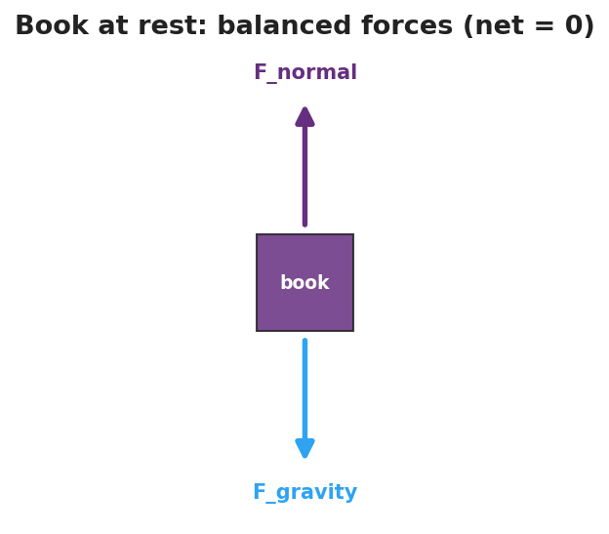
Free-body diagram of a book resting on a table: gravity pulls down, the normal force pushes up, and the two are balanced so the net force is zero.

Teacher facilitation during Explore
- What to look for — students connecting “it kept going farther on the smooth floor” to “less friction means less force to change its motion.”
- What to resist — don’t supply “inertia” or “net force” yet; let the carts and coins do the teaching.
- What to redirect — students who say “it stopped on its own” should be asked to name what stopped it (friction is a force, not “nothing”).

Phase 3 · Explain (32 – 37 min)

32–35 min · Turn-and-Talk #2 + class consensus
“Across all three stations, what did it always take to change how something was moving?”
Target consensus:
“An object keeps doing what it’s doing — staying still or moving at a steady speed in a straight line — unless a push or pull changes it. The bigger the mass, the harder it is to change.”

35–37 min · Vocabulary introduction (≤ 3 terms)
Sample teacher language:
“That tendency to keep its motion is called inertia — and more mass means more inertia. When all the forces on an object cancel out, we say the net force is zero — the forces are balanced — and the motion does not change. That’s exactly Newton’s First Law.”

Discussion prompts to deploy here
- “A book rests on the table. Name the two forces on it and explain why it doesn’t sink or fly up.”
  - Sample student response: “Gravity pulls down, the table pushes up. They’re balanced, so net force is zero and it stays still.”
- “Why is it harder to push a full cart than an empty one into motion?”
  - Sample student response: “More mass means more inertia, so it takes more force to change its motion.”

Phase 4 · Elaborate (37 – 40 min)

37–39 min · Revise the model
“Return to your cup drawing. Re-label the arrows: are the sideways forces on the cup balanced or unbalanced while the cloth slides under it? Use the words inertia and net force in your revised one-sentence explanation.”

39–40 min · Return to the phenomenon
“Why does a seatbelt matter the instant a car stops short? Answer in one sentence using inertia.”
Target: “Your body keeps moving forward (inertia) because the sudden stop acted on the car, not yet on you — the belt supplies the force that changes your motion.”

Phase 5 · Evaluate (40 – 42 min)

40–42 min · Exit Ticket + Closing Reflection
“A hockey puck slides across the ice at a steady speed in a straight line. (a) What is the net force on the puck? Explain. (b) Name the force that eventually slows it down. (c) On a frictionless rink with no air, what would the puck do? Why?”
Expected: (a) zero — constant velocity means balanced forces; (b) friction (ice + air resistance); (c) move forever at the same velocity, because no net force means no change in motion. See Answer_Key.docx.
Closing Reflection (SEL, 30 seconds):
“What is one thing today that changed how you think? Who helped you make sense of it?”

Common Misconceptions
- Misconception: “Motion needs a continuous force to keep going.” → Correction: Constant velocity needs zero net force; force is needed only to change motion.
- Misconception: “Heavier objects stop sooner because they ‘want’ to.” → Correction: Objects have no will; more mass means more inertia — more force needed to change its motion.
- Misconception: “A moving object stops ‘on its own.’” → Correction: Something (friction, air resistance) exerts a force to stop it; in their absence it would not stop.

Access & Differentiation
- ELL/ENL supports: Sentence frame: “The ___ stayed/kept moving because the net force was , so its motion did not .” Word-choice box: {balanced, unbalanced, inertia, net force, change, mass}. Pair the word inertia with a gesture (hand resisting a push).
- IEP/SPED supports: Provide pre-drawn force-arrow diagrams; students label “balanced” vs. “unbalanced” rather than drawing from scratch. Offer the cart demo as a hands-on alternative to writing.
- Extensions: Have students explain why it is harder to start a loaded shopping cart moving than an empty one, and harder to stop it, in terms of mass and inertia.

Strategy Spotlight
RESTORATIVE CIRCLE (unit opener). Today’s opening uses a circle to launch the Forces unit. Use a talking piece, one-sentence responses, and equity of voice (everyone speaks or passes). The prompt — what’s hard to start, hard to stop — is chosen so you can call back to it in Phase 3 (“that ‘hard to start, hard to stop’ feeling has a name: inertia”). Keep the circle to ~2–3 minutes; the goal is community plus a shared metaphor, not a long discussion.

NYSSLS Observation Checklist Crosswalk
# | Checklist item | Where it appears in this lesson
1 | Local/relatable phenomenon | Phase 1 — tablecloth pull; seatbelt in Phase 4
2 | Turn and Talk (2–3×) | Phase 1 (TT#1 — why cups stay), Phase 3 (TT#2 — what changes motion)
3 | Students develop questions/models/procedures | Phase 1 (initial model), Phase 2 (station investigation), Phase 4 (revise model)
4 | CCC defined and used | Lesson Overview · Cause and Effect, restated in Phase 2
5 | ENL — ≤ 3 vocab, second half | Phase 3 — vocabulary at 35–37 min (inertia / net force / balanced forces)
6 | Revisit phenomenon with evidence | Phase 4 — seatbelt + cup re-labeling
7 | ENL/SPED supports | Access & Differentiation block
8 | Assessment check | Phase 5 — Exit Ticket (hockey puck)

Companion Materials
- Student_Worksheet.docx — the 5E student investigation (hand out at start of Phase 2)
- Student_Notes.docx — guided note-guide for vocabulary and the worked example
- Answer_Key.docx — answers to “Make It Make Sense” prompts and the Exit Ticket

Key Vocabulary (max 3)
- inertia — an object’s tendency to resist a change in its motion; more mass means more inertia
- net force — the single force equivalent to all forces on an object added together (as vectors)
- balanced forces — forces whose net force is zero, so the object’s motion does not change

Newton’s First Law and Inertia — Student Worksheet
Unit: Forces — Lesson 01 Name: _______________________ Date: __________ Period: ____

Phenomenon
Your teacher pulls a cloth out from under a stack of cups — and the cups barely move. In a video from the International Space Station, a tool let go in mid-air just floats in place.
Driving question: What decides whether an object’s motion changes or stays the same?

Notice & Wonder
I notice… | I wonder…
Turn & Talk #1: Why did the cups stay put when the cloth was pulled away? Use the word motion in your answer.

Initial Model
Draw the cup sitting on the cloth. Draw an arrow for every push or pull acting on the cup while the cloth is yanked out. Then predict: does the cup speed up, slow down, or stay the same?

My prediction: _______________________________

Investigation
When an object stays at rest, the forces on it are balanced. The diagram below shows a book on a table — use it as a model for the resting coin/cup in Station 1.

Free-body diagram of a book on a table: the downward pull of gravity and the upward normal force are equal, so the net force is zero.
Complete each station. Record what you observe and what it tells you.
Station | What I did | What happened | What it tells me
1. Cloth + coin stack
2. Cart on smooth floor vs. carpet
3. Changing the cart’s motion
Key question: In every station, what did it take to change how something was moving?

Make It Make Sense
- A book lies still on a table. Gravity pulls it down. What second force acts on it, and why doesn’t the book move?
- Two students push a box from opposite sides with equal force. What is the net force, and what does the box do?
- Why is it harder to get a fully loaded backpack moving than an empty one?

Vocabulary in Action
Use each term in a sentence about today’s phenomenon.
- inertia: _______________________________________________
- net force: _______________________________________________
- balanced forces: _______________________________________________

Revise Your Model
Return to your Initial Model. Were the sideways forces on the cup balanced or unbalanced while the cloth slid underneath? Rewrite your explanation using inertia and net force.

Exit Ticket
A hockey puck slides across the ice at a steady speed in a straight line.
- What is the net force on the puck? Explain.
- Name the force that eventually slows it down.
- On a frictionless rink with no air, what would the puck do, and why?

Newton’s First Law and Inertia — Student Notes
Unit: Forces — Lesson 01 Name: _______________________ Date: __________ Period: ____

Learning Targets
By the end of today’s 42 minutes I can:
- State Newton’s First Law in my own words.
- Explain a real situation using inertia and balanced forces.
- Predict whether motion will change, given balanced or unbalanced forces.

Key Vocabulary
- inertia — _______________________________________________
- net force — _______________________________________________
- balanced forces — _______________________________________________

Guided Notes
Big idea (Newton’s First Law): An object keeps its velocity — staying at rest, or moving at a __________ speed in a __________ line — unless a __________ force acts on it.
- “Velocity” includes zero velocity → an object at rest stays at __________.
- Inertia depends on __________: more mass → __________ inertia → harder to change its motion.
- If forces are balanced, net force = __________, and motion does __________ change.
- If forces are unbalanced, net force ≠ 0, and motion __________ change (this is Lesson 02).
Force diagram — book on a table (fill the arrows):
- Down: __________ (gravity)
- Up: __________ (table pushing up, the normal force)
- Net force = __________ → the book stays __________.

Free-body diagram of a book on a table with a downward gravity arrow and an equal upward normal-force arrow, showing the net force is zero.
When the net force is zero, velocity does not change. A moving object simply keeps its velocity — a flat line on a velocity–time graph:
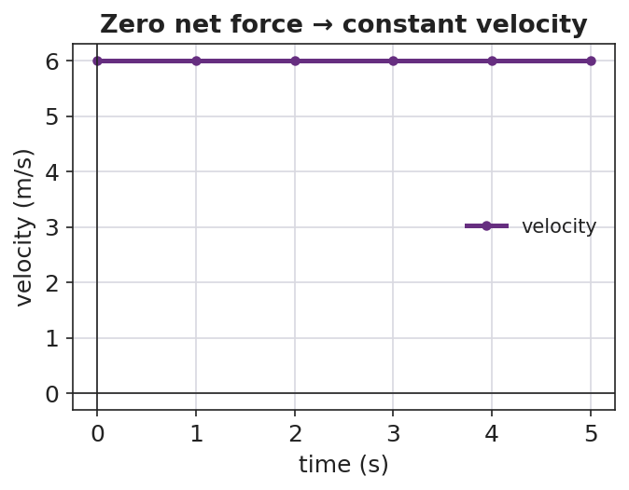
Velocity–time graph showing a horizontal line at constant velocity, illustrating that zero net force means no change in velocity.

Worked Example
Problem. A 1,200 kg car and a 60 kg shopping cart are both at rest. Which is harder to push into motion, and why?
Solution. 1. Both are at rest, so both currently have __________ net force. 2. To start moving, each needs an __________ force. 3. The __________ has more mass → more __________ → it needs a much larger force to get the same change in motion. The car is far harder to start.

Summary
Finish the sentence (Because / But / So):
An object at rest tends to stay at rest because __________________________________________, but __________________________________________, so __________________________________________.

Newton’s First Law and Inertia — Answer Key

Cover
Unit: Forces — Lesson 01: Newton’s First Law and Inertia East Meadow Schools × Valley Stream Central HSD

Make-It-Make-Sense Answers
- The table pushes up on the book (the normal force) with the same size as gravity pulling down. The two forces are balanced, so the net force is zero and the book stays at rest. · Rubric: names the normal force AND states net force = 0 → full credit. · NYSSLS: HS-PS2-1
- The net force is zero (equal and opposite pushes cancel), so the box stays at rest — or, if already moving, keeps moving at constant velocity. · Rubric: net force = 0 AND correct motion outcome. · NYSSLS: HS-PS2-1
- The loaded backpack has more mass, therefore more inertia, so it takes a larger force to produce the same change in motion. · Rubric: links mass → inertia → larger force. · NYSSLS: HS-PS2-1

Exit Ticket Answer
- Zero net force. Constant speed in a straight line = constant velocity = no change in motion, which means the forces are balanced.
- Friction (between puck and ice) plus a small amount of air resistance.
- It would keep moving forever at the same velocity — with no net force, there is nothing to change its motion (Newton’s First Law).
Tolerance/rubric: (a) must state zero AND justify via constant velocity; (b) friction (air resistance optional); (c) “constant velocity forever” + “no net force.” 1 point each. NYSSLS: HS-PS2-1.

Closing Reflection (rubric)
Closing reflection is formative, not graded. Award full credit for any honest response. Look for: - A genuine shift-in-thinking statement in answer 1 - Naming a peer or self-acknowledgment in answer 2

Newton’s Second Law and Net Force — Teacher Guide

Cover
Unit: Forces — Lesson 02: Newton’s Second Law and Net Force East Meadow Schools × Valley Stream Central High School District Strategy chips: HOCHMAN

Curated Resources (from East Meadow Scope & Sequence)

NYSSLS Standards
This lesson is the heart of HS-PS2-1: “Analyze data to support the claim that Newton’s second law of motion describes the mathematical relationship among the net force on a macroscopic object, its mass, and its acceleration.” It builds directly on Lesson 01 (Newton’s First Law), where students established the zero-net-force baseline — motion does not change when forces are balanced. Here we ask the next question: when the net force is not zero, how much does the motion change? The answer is the proportional, mathematical relationship F_net = m·a. On the 2025 Physics Reference Table this appears as a = F_net / m. The lesson also seeds HS-PS2-2 (momentum) by treating force as the agent of change in motion.

Phenomenon
- Slingshot launch: the same rubber band, pulled back the same distance, launches three different-size balls (ping-pong, golf, steel) — the light ball rockets away while the heavy one barely leaves. Same pull, different acceleration.
- Alternate (no slingshot needed): an empty cart vs. a loaded cart given the same push — the loaded cart accelerates far less.

Javalab / Labs
- Force and movement simulation: https://javalab.org/en/force_movement_en/
- oPhysics force-and-motion / inclined plane: https://ophysics.com/f1.html

Assessments
- HS-PS2-1 cluster task “The Gyro Drop” — students analyze acceleration data from a drop ride to argue the F_net = m·a relationship.
- HS-PS2-1 cluster task “Newton’s 2nd Law” — data-analysis cluster on net force, mass, and acceleration. The Exit Ticket below is the formative check for this lesson.

Lesson Overview
Duration | 42 minutes (1 period)
NYSSLS link | HS-PS2-1 (core) → HS-PS2-2 (thread)
CCC focus | Cause and Effect — net force is the cause; acceleration is the effect. Bigger cause → bigger effect; bigger mass → smaller effect.
Strategy chips | HOCHMAN (Because/But/So sentence expansion on F_net = m·a)
Materials | Rubber band/slingshot frame; ping-pong, golf, and steel balls (or 3 graduated masses); a rolling cart; objects to load the cart; whiteboards/markers; the 2025 Reference Table.
Safety | Launch balls into a soft target or open floor only — never toward people. Keep walkways clear for the cart.
Prior knowledge | Lesson 01 — net force, balanced/unbalanced forces, inertia; Kinematics — acceleration as the rate of change of velocity.
Lesson objectives — students can:
- State Newton’s Second Law in words and as the equation F_net = m·a (equivalently a = F_net / m).
- Predict how acceleration changes when net force or mass changes, and justify it with the equation.
- Solve a quantitative problem: given any two of F_net, m, and a, find the third, with units in newtons.

Phase 1 · Engage (0 – 10 min)

0–3 min · Do Now + Opening Connection
Post the Do Now: “In one sentence, what does it take to change how fast something is moving? (Hint from yesterday: balanced or unbalanced?)” Take one or two responses to surface the bridge from Lesson 01: it takes an unbalanced (net) force.

3–8 min · Phenomenon hook — the slingshot launch
Teacher actions. Hold the slingshot frame steady. Pull the same rubber band back the same distance each time and launch the ping-pong ball, then the golf ball, then the steel ball into a soft target. The light ball flies fast and far; the heavy one barely moves.
Sample teacher language:
“Same band, same pull every time — so the same push. Watch how differently each ball takes off. What is the pull doing differently to each one?”
Anticipated student responses:
- “The heavy one is harder to move.” — capture; we will sharpen “harder to move” into less acceleration.
- “You pulled the light one harder.” — correct gently: “Same pull every time — that’s the whole point.”
- “The big ball weighs more so it goes slower.” — capture “more mass → less change in motion.”

8–10 min · Notice & Wonder + Turn-and-Talk #1
Two columns on the board. Then:
“Turn to your partner: the push was the same on all three, so what made the light ball speed up so much more? Use the word mass in your answer.”
Target insight to listen for (leave open if no one lands it): same force, but less mass means more speeding-up.

Bridge to Phase 2
Every student leaves Phase 1 with a one-sentence initial model: “The light ball sped up more because ______.”

Phase 2 · Explore (10 – 30 min)

10–15 min · Initial Model (silent / individual)
Prompt on the board:
“Draw the three balls leaving the slingshot. Draw one arrow for the push (same size on each) and a second arrow for how fast each speeds up. Then write one sentence predicting which ball speeds up the most and why.”
This surfaces the proportional intuition before any equation.

15–30 min · Investigation — Javalab force-and-movement sim
Open https://javalab.org/en/force_movement_en/ (or the loaded/empty cart if running hands-on). Students work the worksheet table in two rounds:
- Hold mass constant, change force. Double the applied force. Record what happens to acceleration.
- Hold force constant, change mass. Double the mass. Record what happens to acceleration.
Teacher facilitation language:
“When you doubled the force and kept the mass the same — what did the acceleration do?” “Now keep the force the same and double the mass — which way did the acceleration go?” “Can you write that as a fraction? Acceleration equals what, over what?”
As the data accumulates, sketch (or project) the acceleration-vs-net-force relationship. A straight line through the origin is the visual proof that a is proportional to net force:
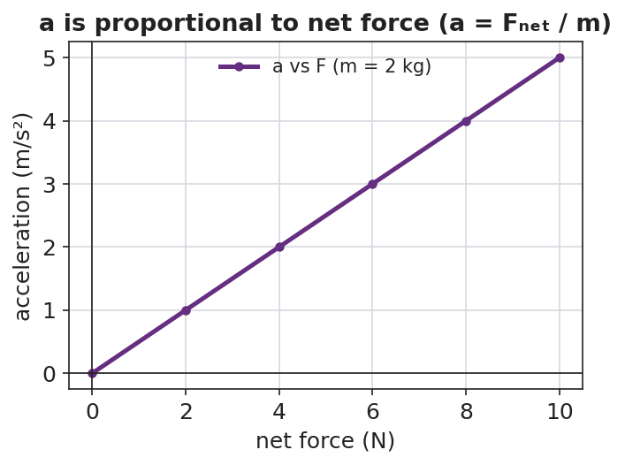
Line graph of acceleration versus net force: a straight line through the origin, showing acceleration is directly proportional to net force.
The reason a cart accelerates at all is that its forces are unbalanced — the applied push beats friction, leaving a net force in the direction of motion:
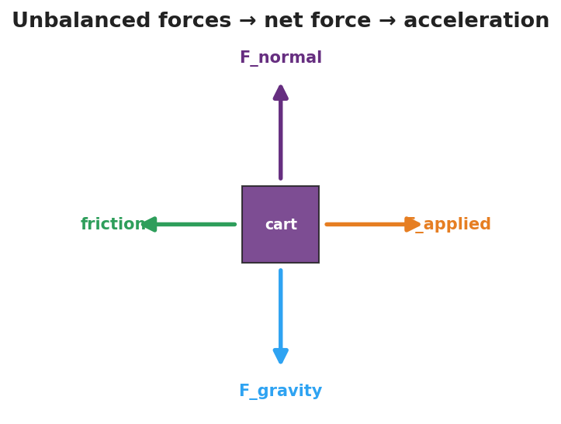
Free-body diagram of a cart with the applied force larger than friction, plus balanced vertical forces, leaving an unbalanced net force that causes acceleration.

Teacher facilitation during Explore
- What to look for — students seeing acceleration double when force doubles (direct), and acceleration halve when mass doubles (inverse).
- What to resist — don’t hand them F_net = m·a yet; let the data build the pattern so the equation names what they already found.
- What to redirect — students who change force and mass at once should isolate one variable per trial (controlled investigation).

Phase 3 · Explain (30 – 36 min)

30–33 min · Turn-and-Talk #2 + class consensus
“Put your two patterns into one rule. Acceleration goes ___ when force goes up, and ___ when mass goes up.”
Target consensus:
“Acceleration is bigger when the net force is bigger, and smaller when the mass is bigger. Acceleration = net force ÷ mass.”

33–36 min · Vocabulary introduction (≤ 3 terms)
Sample teacher language:
“The single push left over after we combine all forces is the net force. The speeding-up or slowing-down it produces is the acceleration. And we measure force in newtons — one newton is exactly the force that gives a 1 kg mass an acceleration of 1 m/s². Put it together and you get Newton’s Second Law: F_net = m·a, or a = F_net / m on your Reference Table.”

Discussion prompts to deploy here
- “If you push two carts with the same net force but one has twice the mass, how do their accelerations compare?”
  - Sample student response: “The heavy one has half the acceleration — mass is on the bottom of the fraction.”
- “A 2 kg ball accelerates at 3 m/s². What net force acted on it?”
  - Sample student response: “F = m·a = 2 × 3 = 6 newtons.”

Phase 4 · Elaborate (36 – 40 min)

36–39 min · Revise the model + HOCHMAN sentence expansion
Students return to the three-ball drawing and re-label arrows using net force and acceleration. Then run the Hochman move (see Strategy Spotlight) — complete the Because/But/So expansion of F_net = m·a:
“The steel ball accelerated the least because ____, but ____, so ____.”

39–40 min · Return to the phenomenon
“Why does a loaded delivery truck take longer to speed up than an empty one, even with the same engine force? Answer in one sentence using net force, mass, and acceleration.”
Target: “Same net force, but more mass, so the acceleration is smaller (a = F_net / m).”

Phase 5 · Evaluate (40 – 42 min)

40–42 min · Exit Ticket + Closing Reflection
“A net force of 12 N acts on a 4 kg cart. (a) Find the cart’s acceleration. Show F_net = m·a (or a = F_net / m). (b) If the mass were doubled to 8 kg with the same 12 N, what is the new acceleration? (c) In one sentence, explain what happened to the acceleration and why.”
Expected: (a) a = 12/4 = 3 m/s²; (b) a = 12/8 = 1.5 m/s²; (c) doubling the mass halved the acceleration because acceleration is inversely proportional to mass. See Answer_Key.docx.
Closing Reflection (SEL, 30 seconds):
“What is one thing today that changed how you think about force and motion? Who helped you make sense of it?”

Common Misconceptions
- Misconception: “More force always means more speed.” → Correction: More net force means more acceleration (rate of change of velocity), not automatically more speed at a given instant.
- Misconception: “Heavy and light objects accelerate the same under the same push.” → Correction: For the same net force, more mass gives less acceleration — mass is in the denominator (a = F_net / m).
- Misconception: “Each separate force has its own acceleration.” → Correction: Only the single net force (all forces combined) determines the acceleration.

Access & Differentiation
- ELL/ENL supports: Sentence frame: *“When the net force ___ and the mass stays the same, the acceleration ___.”* Word-choice box: {net force, mass, acceleration, newton, doubles, halves}. Pair acceleration with a “speeding-up” hand gesture; pair newton with the 1 kg → 1 m/s² mental image.
- IEP/SPED supports: Provide the equation triangle (F_net on top; m and a on the bottom) so students can cover the unknown to see the operation. Offer a pre-built data table for the Javalab sim so students focus on the pattern, not table setup.
- Extensions: Have students use the Javalab sim to find the net force that gives a 5 kg object an acceleration of 4 m/s² (answer 20 N), then predict and verify the acceleration for the same force on a 10 kg object.

Strategy Spotlight
HOCHMAN (Because/But/So sentence expansion). Sentence-level writing makes abstract equations precise. In Phase 4, students expand a single kernel sentence — “The steel ball accelerated the least” — using the three Hochman conjunctions, each forcing a different kind of reasoning:
- because → a cause (“…because it has the most mass and a = F_net / m”)
- but → a contrast (“…but the net force on it was the same as on the other balls”)
- so → a consequence (“…so dividing the same net force by a larger mass gives a smaller acceleration”)
Model one example aloud, then have students write their own for a different ball. Collect a few to check that “because” names the cause (mass), not just restates the claim — this is the comprehension signal you are looking for, and it maps directly onto the Cause-and-Effect CCC.

NYSSLS Observation Checklist Crosswalk
# | Checklist item | Where it appears in this lesson
1 | Local/relatable phenomenon | Phase 1 — slingshot launch; loaded truck in Phase 4
2 | Turn and Talk (2–3×) | Phase 1 (TT#1 — why the light ball sped up more), Phase 3 (TT#2 — one combined rule)
3 | Students develop questions/models/procedures | Phase 1 (initial model), Phase 2 (controlled sim investigation), Phase 4 (revise model)
4 | CCC defined and used | Lesson Overview · Cause and Effect, restated in Phase 2 and Phase 4
5 | ENL — ≤ 3 vocab, second half | Phase 3 — vocabulary at 33–36 min (net force / acceleration / newton)
6 | Revisit phenomenon with evidence | Phase 4 — three-ball re-labeling + loaded-truck prompt
7 | ENL/SPED supports | Access & Differentiation block
8 | Assessment check | Phase 5 — Exit Ticket (12 N on a 4 kg cart)

Companion Materials
- Student_Worksheet.docx — the 5E student investigation (hand out at start of Phase 2)
- Student_Notes.docx — guided note-guide for vocabulary and the worked example
- Answer_Key.docx — answers to “Make It Make Sense” prompts and the Exit Ticket

Key Vocabulary (max 3)
- net force — the single force equivalent to all forces on an object combined (as vectors); the cause of acceleration
- acceleration — the rate at which an object’s velocity changes; equal to net force divided by mass (a = F_net / m)
- newton — the SI unit of force; 1 N = 1 kg·m/s², the force that accelerates a 1 kg mass at 1 m/s²

Newton’s Second Law and Net Force — Student Worksheet
Unit: Forces — Lesson 02 Name: _______________________ Date: __________ Period: ____

Phenomenon
Your teacher pulls the same rubber band back the same distance every time — so the push is the same — and launches three different balls: a ping-pong ball, a golf ball, and a steel ball. The light ball rockets away. The heavy steel ball barely leaves.
Driving question: If the push is the same every time, what decides how much each object speeds up?

Notice & Wonder
I notice… | I wonder…
Turn & Talk #1: The push was the same on all three balls, so what made the light ball speed up so much more? Use the word mass in your answer.

Initial Model
Draw the three balls leaving the slingshot. Draw one arrow for the push (same size on each ball) and a second arrow for how fast each one speeds up. Then predict which ball speeds up the most and why.

My prediction: _______________________________

Investigation
Use the force-and-movement simulation (https://javalab.org/en/force_movement_en/) or the cart your teacher provides. Run two rounds and record what happens.
Round 1 — keep the mass the same, change the force.
Trial | Net force (N) | Mass (kg) | Acceleration (what happened?)
A
B (double the force)
Round 2 — keep the force the same, change the mass.
Trial | Net force (N) | Mass (kg) | Acceleration (what happened?)
C
D (double the mass)
Key questions:
- When you doubled the net force (same mass), the acceleration ______________.
- When you doubled the mass (same force), the acceleration ______________.
If you plot your Round 1 data, it should look like the graph below — a straight line through the origin, because acceleration is directly proportional to net force.

Line graph of acceleration versus net force showing a straight line through the origin.

Make It Make Sense
- A 2 kg ball is pushed with a net force of 6 N. What is its acceleration? Show your work using a = F_net / m.
- Two carts get the same net force, but Cart B has twice the mass of Cart A. How do their accelerations compare?
- A net force of 20 N gives a cart an acceleration of 4 m/s². What is the mass of the cart?

Vocabulary in Action
Use each term in a sentence about today’s phenomenon.
- net force: _______________________________________________
- acceleration: _______________________________________________
- newton: _______________________________________________

Revise Your Model
Return to your Initial Model. Re-label your arrows using the words net force and acceleration. Then finish this Because / But / So sentence:
The steel ball accelerated the least because __________________________________________, but __________________________________________, so __________________________________________.

Exit Ticket
A net force of 12 N acts on a 4 kg cart.
- Find the cart’s acceleration. Show F_net = m·a (or a = F_net / m).
- If the mass were doubled to 8 kg with the same 12 N net force, what is the new acceleration?
- In one sentence, explain what happened to the acceleration and why.

Newton’s Second Law and Net Force — Student Notes
Unit: Forces — Lesson 02 Name: _______________________ Date: __________ Period: ____

Learning Targets
By the end of today’s 42 minutes I can:
- State Newton’s Second Law in words and as the equation F_net = m·a.
- Predict how acceleration changes when the net force or the mass changes.
- Solve for F_net, m, or a given the other two, using units of newtons.

Key Vocabulary
- net force — _______________________________________________
- acceleration — _______________________________________________
- newton — _______________________________________________

Guided Notes
Big idea (Newton’s Second Law): The net force on an object equals its mass times its __________: F_net = m·a. On the 2025 Reference Table this is written a = F_net / __________.
- Acceleration is directly proportional to net force: more net force → __________ acceleration (same mass).
- Acceleration is inversely proportional to mass: more mass → __________ acceleration (same net force).
- The unit of force is the newton (N). One newton = 1 __________ · m/s² — the force that gives a 1 kg mass an acceleration of 1 m/s².
- Connection to Lesson 01: if the net force is zero, then a = __________, and the motion does not change.
Cause and Effect: the net force is the __________ (cause); the acceleration is the __________ (effect).
Because acceleration is directly proportional to net force, a graph of acceleration vs. net force is a straight line through the origin:

Line graph of acceleration versus net force: a straight line through the origin, illustrating that acceleration is directly proportional to net force.

Worked Example
Problem. A net force of 15 N acts on a 3 kg cart. Find the cart’s acceleration.
Solution. 1. Write the equation: a = F_net / m. 2. Substitute the values: a = 15 N / 3 kg. 3. Solve: a = 5 m/s². 4. Check the units: N / kg = (kg·m/s²) / kg = m/s². ✓
Try it: If the net force stays 15 N but the mass doubles to 6 kg, the new acceleration is __________ m/s². (It should be half of the answer above.)

Summary
Finish the sentence (Because / But / So):
A heavier object accelerates less than a lighter one under the same push because __________________________________________, but __________________________________________, so __________________________________________.

Newton’s Second Law and Net Force — Answer Key

Cover
Unit: Forces — Lesson 02: Newton’s Second Law and Net Force East Meadow Schools × Valley Stream Central HSD

Make-It-Make-Sense Answers
- a = F_net / m = 6 N / 2 kg = 3 m/s². · Rubric: correct equation set-up AND answer with units (m/s²) → full credit; equation only → partial. · NYSSLS: HS-PS2-1
- Cart B has twice the mass, so with the same net force its acceleration is half that of Cart A (acceleration is inversely proportional to mass). · Rubric: states “half” AND links to mass in the denominator. · NYSSLS: HS-PS2-1
- m = F_net / a = 20 N / 4 m/s² = 5 kg. · Rubric: rearranges F_net = m·a correctly AND reports 5 kg. · NYSSLS: HS-PS2-1

Exit Ticket Answer
- a = F_net / m = 12 N / 4 kg = 3 m/s². (Equivalently F_net = m·a → 12 = 4·a → a = 3 m/s².)
- a = 12 N / 8 kg = 1.5 m/s².
- The acceleration was cut in half (3 → 1.5 m/s²) because doubling the mass — with the same net force — halves the acceleration; acceleration is inversely proportional to mass (a = F_net / m).
Tolerance/rubric: (a) 3 m/s² with correct set-up and units; (b) 1.5 m/s²; (c) must state acceleration halved AND give the reason (more mass, same force → less acceleration). 1 point each. NYSSLS: HS-PS2-1.

Closing Reflection (rubric)
Closing reflection is formative, not graded. Award full credit for any honest response. Look for: - A genuine shift-in-thinking statement about force, mass, and acceleration in answer 1 - Naming a peer or self-acknowledgment in answer 2

Newton’s Third Law (Action and Reaction) — Teacher Guide

Cover
Unit: Forces — Lesson 03: Newton’s Third Law (Action and Reaction) East Meadow Schools × Valley Stream Central High School District Strategy chips: ACTIVE LEARNING

Curated Resources (from East Meadow Scope & Sequence)

NYSSLS Standards
The Scope & Sequence row “3rd Law — Action/Reaction” names no single performance expectation; instead it supports HS-PS2-1 and HS-PS2-2 by establishing the foundational idea that forces always come in pairs. Before students can quantify net force (HS-PS2-1) or reason about momentum transfer in collisions (HS-PS2-2), they must accept that a force is one side of an interaction between two objects — never something one object “has” alone. This lesson builds that base.

Phenomenon
- Newton’s Third Law demo short (rolling-chair / push-off): https://youtube.com/shorts/FMWxvYpGRBI
- Backup options if no screen: a balloon rocket strung on fishing line across the room, or two students on rolling chairs pushing apart.

Javalab / Labs
- Balloon rocket on fishing line (low-cost build); rolling-chair push-off; or a force-pair card sort (action card ↔ reaction card matching) used as the Phase 2 station task.

Assessments
- The Exit Ticket below serves as the formative check for this lesson. No separate quiz; look for the action–reaction language students produce in the force-pair hunt and on the exit ticket.

Lesson Overview
Duration | 42 minutes (1 period)
NYSSLS link | Supports HS-PS2-1 and HS-PS2-2 (forces come in pairs)
CCC focus | Systems and System Models — every force acts between two objects in a system; you cannot draw one without naming both.
Strategy chips | ACTIVE LEARNING
Materials | Balloons; fishing line + straws + tape (balloon rocket); 2 rolling chairs; force-pair card-sort sets (one per pair); whiteboards/markers; a screen for the short.
Safety | Spotters for rolling-chair push-off on a clear, flat floor; no racing. Keep balloon line clear of faces.
Prior knowledge | Lesson 01 (inertia, net force) and Lesson 02 (unbalanced forces cause acceleration); forces as vectors (size + direction).
Lesson objectives — students can:
- State Newton’s Third Law: for every action force there is an equal-in-magnitude, opposite-in-direction reaction force.
- Identify both members of an action–reaction pair and the two different objects each acts on.
- Explain why an action–reaction pair does not cancel (the two forces act on different objects, never on the same one).

Phase 1 · Engage (0 – 12 min)

0–3 min · Opening Connection (SEL)
Quick whip-around (one sentence, pass allowed): “Name a time you pushed on something and it pushed you back — a wall, a friend, a door.” Capture two or three; you’ll call back to “it pushed me back” in Phase 3.

3–8 min · Phenomenon hook — the push-off
Teacher actions. Play the Third-Law short, or stage it live: two students of clearly different sizes sit in rolling chairs, facing, soles touching. On your count, one student pushes the other away. Ask the class to watch both students.
Sample teacher language:
“Only one of them pushed. Watch carefully — who moves? Don’t answer who you expect; tell me who actually rolls.”
Anticipated student responses:
- “They both rolled apart!” — exactly the catch; only one pushed, yet both moved.
- “The lighter one rolled faster / farther.” — good, hold it; we’ll explain it with equal forces + different masses.
- “He pushed back too.” — capture this; sharpen “he pushed back” into “the floor/chair/other student pushed back.”

8–12 min · Notice & Wonder + Turn-and-Talk #1
Two columns on the board. Then:
“Turn to your partner: if only one person pushed, why did both people move? Use the word force in your answer.”
Take 2–3 responses. Desired surfacing: the second student pushed back without trying — there were two forces, on two people. Leave open if no one lands it.

Bridge to Phase 2
Each student writes a one-sentence initial model: “Both students moved because ______.”

Phase 2 · Explore (12 – 32 min)

12–16 min · Initial Model (silent / individual)
Prompt on the board:
“Draw the two students at the moment of the push. Draw an arrow for every push acting in the system, and label which object each arrow acts on. Predict how the two pushes compare in size.”
This surfaces the misconception early: many will draw only one arrow, or two arrows on the same person.

16–32 min · Active-Learning investigation — the Force-Pair Hunt (3 stations)
Students rotate in pairs through three active stations. At each, they must name both forces and both objects, then write the pair as “A pushes B → B pushes A back, equal and opposite.”
- Balloon rocket — tape an inflated balloon to a straw threaded on fishing line; release. The balloon pushes air backward; the air pushes the balloon forward.
- Rolling-chair push-off — push a partner away (spotted). You push partner forward; partner pushes you backward — both roll.
- Force-pair card sort — match each action card (“swimmer pushes water back”) to its reaction card (“water pushes swimmer forward”); flag the two different objects on each pair.
Teacher facilitation language:
“Name the two objects before you name the force. Who pushes whom?” “Where’s the second arrow? A push always has a partner pushing back.” “Both arrows here — are they on the same object or two different ones?”

Teacher facilitation during Explore
- What to look for — students naming two objects per pair and writing both forces as equal and opposite.
- What to resist — don’t hand them “they cancel” or “they don’t cancel” yet; let the card sort and the chairs force the question of which object each force acts on.
- What to redirect — any pair drawing both arrows on one object: “If both acted on the balloon, what’s pushing the air?”

Phase 3 · Explain (32 – 37 min)

32–35 min · Turn-and-Talk #2 + class consensus
“Across all three stations, what was always true about the two forces and the two objects?”
Target consensus:
“Every push (or pull) is one half of an interaction between two objects. The two forces are equal in size and opposite in direction, and they act on different objects — so they never cancel on either object.”
Project the diagram below to anchor the consensus: the two arrows are the same length (equal size), point opposite ways, and sit on two different bodies (A and B) — which is exactly why they don’t cancel.
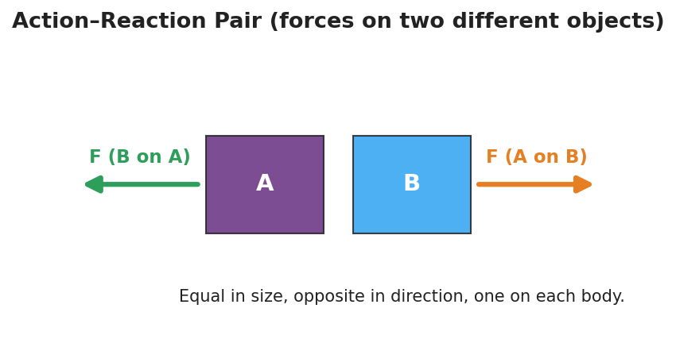
Action–reaction pair: object A and object B side by side, with an equal-length force arrow pushing right on B and an equal-length force arrow pushing left on A.

35–37 min · Vocabulary introduction (≤ 3 terms)
Sample teacher language:
“When two objects push on each other, that’s an interaction. The two forces it produces are a force pair — also called an action–reaction pair. Newton’s Third Law says they are always equal in size and opposite in direction. The key: they act on two different objects, so they do not cancel.”

Discussion prompts to deploy here
- “You walk forward. Name the action–reaction pair and the two objects.”
  - Sample student response: “My foot pushes the ground backward; the ground pushes me forward. Two objects — me and the ground.”
- “A gun recoils when fired. Why?”
  - Sample student response: “The gun pushes the bullet forward; the bullet pushes the gun back — equal and opposite, on two different objects.”

Phase 4 · Elaborate (37 – 40 min)

37–39 min · Revise the model
“Return to your push-off drawing. Make sure you have two arrows, equal in length, pointing opposite ways, each labeled with the object it acts on. In one sentence, explain why they do NOT cancel.”
Target: “They act on two different people, so neither person feels a zero net force — that’s why both roll.”

39–40 min · Return to the phenomenon
“Why did the lighter student roll faster if the two forces were equal? Answer in one sentence.”
Target: “The forces are equal, but equal force on less mass gives more acceleration (Lesson 02) — so the lighter student speeds up more.”

Phase 5 · Evaluate (40 – 42 min)

40–42 min · Exit Ticket + Closing Reflection
“A swimmer pushes off the pool wall and glides forward. (a) Name the action–reaction pair. State which object each force acts on. (b) The two forces are equal and opposite — so why doesn’t the swimmer stay still? (c) True or false: action and reaction forces cancel each other out. Explain.”
Expected: (a) swimmer pushes wall back / wall pushes swimmer forward — forces act on two different objects (swimmer, wall); (b) the two forces act on different objects, so the swimmer feels only the wall’s forward push — not zero; (c) False — they act on different objects, so they cannot cancel on a single object. See Answer_Key.docx.
Closing Reflection (SEL, 30 seconds):
“What is one idea today that pushed back on what you used to think? Who helped you make sense of it?”

Common Misconceptions
- Misconception: “Action and reaction forces cancel, so nothing moves.” → Correction: They act on different objects; forces only cancel when they act on the same object. Each object feels its own single force.
- Misconception: “The bigger / stronger object pushes harder.” → Correction: The forces in a pair are always equal in magnitude, no matter the masses. Different accelerations come from different masses, not different forces.
- Misconception: “The action happens first, then the reaction.” → Correction: The two forces are simultaneous — they are two descriptions of one interaction, not a cause followed by an effect in time.

Access & Differentiation
- ELL/ENL supports: Sentence frame: “___ pushes , so pushes ___ back, equal and opposite.” Word-choice box: {action–reaction pair, force pair, interaction, equal, opposite, different objects}. Pair interaction with a two-hands-pushing gesture.
- IEP/SPED supports: Pre-printed force-pair cards with the two objects already named; students draw and label the second arrow rather than building the whole diagram. Offer the balloon rocket as a hands-on alternative to writing.
- Extensions: Have students explain how a rocket accelerates in the vacuum of space with nothing to “push against” — the rocket pushes exhaust gas out; the gas pushes the rocket forward (the pair needs no air).

Strategy Spotlight
ACTIVE LEARNING — the Force-Pair Hunt (Phase 2). Rather than lecturing the law, students rotate in pairs through three hands-on stations (balloon rocket, rolling-chair push-off, force-pair card sort) and produce the physics themselves. The non-negotiable structure: at every station each pair must (1) name the two objects, (2) draw two arrows, and (3) write the pair as “A pushes B → B pushes A back, equal and opposite.” Movement, manipulation, and a required written product at each stop keep every student accountable and surface the “do they cancel?” question through experience before you ever name it. Budget ~5 min per station; ring a timer for clean rotations.

NYSSLS Observation Checklist Crosswalk
# | Checklist item | Where it appears in this lesson
1 | Local/relatable phenomenon | Phase 1 — rolling-chair push-off; walking/recoil/swimmer in Phases 3–5
2 | Turn and Talk (2–3×) | Phase 1 (TT#1 — why both moved), Phase 3 (TT#2 — two forces, two objects)
3 | Students develop questions/models/procedures | Phase 1 (initial model), Phase 2 (force-pair hunt stations), Phase 4 (revise model)
4 | CCC defined and used | Lesson Overview · Systems and System Models, restated in Phase 2 (“name both objects”)
5 | ENL — ≤ 3 vocab, second half | Phase 3 — vocabulary at 35–37 min (action–reaction pair / force pair / interaction)
6 | Revisit phenomenon with evidence | Phase 4 — push-off re-labeling + lighter-student-rolls-faster
7 | ENL/SPED supports | Access & Differentiation block
8 | Assessment check | Phase 5 — Exit Ticket (swimmer push-off)

Companion Materials
- Student_Worksheet.docx — the 5E student investigation (hand out at start of Phase 2)
- Student_Notes.docx — guided note-guide for vocabulary and the worked example
- Answer_Key.docx — answers to “Make It Make Sense” prompts and the Exit Ticket

Key Vocabulary (max 3)
- action–reaction pair — the two forces produced by one interaction; equal in magnitude and opposite in direction, acting on two different objects
- force pair — another name for an action–reaction pair; the two forces are always reported together
- interaction — the mutual push or pull between two objects; a force is one half of an interaction, never something a single object has alone

Newton’s Third Law (Action and Reaction) — Student Worksheet
Unit: Forces — Lesson 03 Name: _______________________ Date: __________ Period: ____

Phenomenon
Two students sit facing each other in rolling chairs, soles of their shoes touching. On a count, only one of them pushes. Both students roll apart.
Driving question: If only one person pushed, why did both people move?

Notice & Wonder
I notice… | I wonder…
Turn & Talk #1: If only one person pushed, why did both people move? Use the word force in your answer.

Initial Model
Draw the two students at the moment of the push. Draw an arrow for every push acting in the system, and label which object each arrow acts on. Then predict how the two pushes compare in size.

My prediction (sizes of the pushes): _______________________

Investigation
Rotate through the three stations (the Force-Pair Hunt). At each one, name the two objects, draw the two arrows, and write the pair. Use the diagram below as your model — equal-length arrows, pointing opposite ways, one on each object.

Action–reaction pair: two objects A and B, with equal-length force arrows pointing in opposite directions, one drawn on each object.
Station | The two objects | Force pair: “A pushes B → B pushes A back” | Equal & opposite?
1. Balloon rocket
2. Rolling-chair push-off
3. Force-pair card sort
Key question: In every station, what was true about the two forces and the two objects?

Make It Make Sense
- You walk forward across the floor. Name the action–reaction pair and state which object each force acts on.
- A rocket has no air to push against in space. How does it still speed up? Name the force pair.
- A small student and a large student push off in rolling chairs. The forces on each other are equal — so why does the smaller student roll away faster?

Vocabulary in Action
Use each term in a sentence about today’s phenomenon.
- action–reaction pair: _______________________________________________
- force pair: _______________________________________________
- interaction: _______________________________________________

Revise Your Model
Return to your Initial Model. Make sure you have two arrows, equal in length, pointing opposite ways, each labeled with the object it acts on. Then explain, in one sentence, why the two forces do NOT cancel.

Exit Ticket
A swimmer pushes off the pool wall and glides forward.
- Name the action–reaction pair. State which object each force acts on.
- The two forces are equal and opposite — so why doesn’t the swimmer stay still?
- True or false: action and reaction forces cancel each other out. Explain.

Newton’s Third Law (Action and Reaction) — Student Notes
Unit: Forces — Lesson 03 Name: _______________________ Date: __________ Period: ____

Learning Targets
By the end of today’s 42 minutes I can:
- State Newton’s Third Law in my own words.
- Identify both members of an action–reaction pair and the two objects each force acts on.
- Explain why an action–reaction pair does not cancel.

Key Vocabulary
- action–reaction pair — _______________________________________________
- force pair — _______________________________________________
- interaction — _______________________________________________

Guided Notes
Big idea (Newton’s Third Law): For every action force there is an equal-in-__________ , opposite-in-__________ reaction force.
- A force is always one half of an interaction between __________ objects.
- The two forces in a force pair are equal in __________ and opposite in __________.
- The two forces act on __________ (same / different) objects.
- Because they act on different objects, an action–reaction pair does NOT __________.
Force pair — student pushes off a wall (fill the arrows):
- Action: the student pushes the wall __________.
- Reaction: the wall pushes the student __________.
- These two forces act on __________ different objects: the __________ and the __________.
Same forces, different motion: If two people push off with equal forces, the one with __________ mass speeds up __________ (recall Lesson 02: a = F/m).
The two forces in a pair are vectors of the same length pointing in opposite directions:
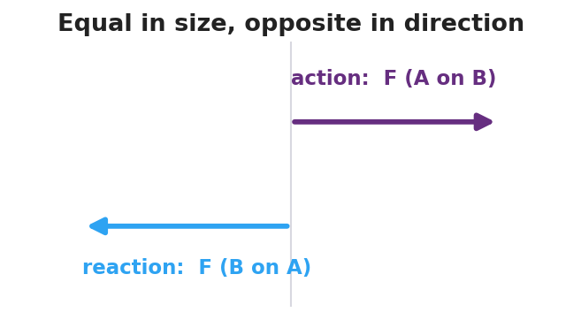
Two vectors of equal length pointing in opposite directions, labeled action force A on B and reaction force B on A.

Worked Example
Problem. A swimmer pushes backward on the water with a force of 200 N and glides forward. Identify the action–reaction pair and explain why the swimmer moves forward.
Solution. 1. Action: the swimmer pushes the water __________ with 200 N. 2. Reaction: the water pushes the swimmer __________ with __________ N (equal and opposite). 3. The two forces act on __________ different objects — the water and the swimmer. 4. The forward push acts on the __________, so the swimmer accelerates forward. The forces do not cancel because they are on __________ objects.

Summary
Finish the sentence (Because / But / So):
When the swimmer pushes the water backward, the water pushes the swimmer forward because __________________________________________, but __________________________________________, so __________________________________________.

Newton’s Third Law (Action and Reaction) — Answer Key

Cover
Unit: Forces — Lesson 03: Newton’s Third Law (Action and Reaction) East Meadow Schools × Valley Stream Central HSD

Make-It-Make-Sense Answers
- Action: your foot pushes the ground backward; Reaction: the ground pushes you forward. The two forces act on two different objects — you and the ground — and the forward push on you is what moves you. · Rubric: names both forces AND identifies the two different objects → full credit. · Supports HS-PS2-1
- The rocket pushes its exhaust gas backward; the gas pushes the rocket forward — an action–reaction pair that needs no air to push against. · Rubric: states the rocket–gas force pair, not “pushes against air.” · Supports HS-PS2-2
- The two forces are equal in magnitude, but the smaller student has less mass, so the same force produces a greater acceleration (a = F/m). Equal forces, unequal masses → unequal motion. · Rubric: equal forces AND links smaller mass → larger acceleration. · Supports HS-PS2-1

Exit Ticket Answer
- Action: the swimmer pushes the wall backward; Reaction: the wall pushes the swimmer forward. The two forces act on two different objects — the swimmer and the wall.
- The two forces act on different objects, so they do not cancel on the swimmer. The swimmer feels only the wall’s forward push, which is a real net force forward, so the swimmer accelerates.
- False. Action and reaction forces act on two different objects, so they can never cancel on a single object. Forces only cancel when they act on the same object.
Tolerance/rubric: (a) names both forces and both objects; (b) “different objects → swimmer feels only the forward force”; (c) False + “different objects.” 1 point each. Supports HS-PS2-1 / HS-PS2-2.

Closing Reflection (rubric)
Closing reflection is formative, not graded. Award full credit for any honest response. Look for: - A genuine shift-in-thinking statement in answer 1 (e.g., realizing forces never act alone) - Naming a peer or self-acknowledgment in answer 2

Friction — Teacher Guide

Cover
Unit: Forces — Lesson 04: Friction East Meadow Schools × Valley Stream Central High School District Strategy chips: BTC

Curated Resources (from East Meadow Scope & Sequence)

NYSSLS Standards
This lesson sits in HS-PS2 (forces and motion). Friction is the anchoring force for HS-PS2-3 — “Apply scientific and engineering ideas to design, evaluate, and refine a device that minimizes the force on a macroscopic object during a collision.” Friction is the everyday way students feel a contact force, so it also reinforces HS-PS2-1 (friction is one of the forces summed into the net force). The CCC focus is Cause and Effect: changing a surface or the normal force causes a measurable change in the friction force.

Phenomenon
- Sneaker Lab — drag a sneaker across tile, carpet, and sandpaper with a spring scale; the pull needed is different every time even though the sneaker never changed.
- The “stuck book” — a heavy book will not slide no matter how gently you push, then suddenly breaks loose and slides easily once you push hard enough.

Javalab / Labs
- oPhysics — Friction (block on a surface, vary μ and FN): https://ophysics.com/f1.html
- PhET — Forces and Motion: Basics (Friction tab): https://phet.colorado.edu/sims/html/forces-and-motion-basics/latest/forces-and-motion-basics_all.html
- Sneaker Lab — spring scale + one sneaker dragged at constant speed over three surfaces; record the scale reading (= friction force) for each.

Assessments
- Exit ticket below serves as the formative check (one conceptual item, one numeric Ff = μ·FN item). PhET “Friction” tab gives an informal check during Explore.

Lesson Overview
Duration | 42 minutes (1 period)
NYSSLS link | HS-PS2-3 (anchor) · HS-PS2-1 (friction in Fnet)
CCC focus | Cause and Effect — changing the surfaces or the normal force causes a change in the friction force.
Strategy chips | BTC (Building Thinking Classrooms — random groups + VNPS thin-sliced task)
Materials | One sneaker per group; spring scales (0–10 N); tile/carpet/sandpaper samples; known masses; chart paper at standing height + markers; deck of playing cards; whiteboards.
Safety | Keep spring scales below their max rating. Tape sandpaper down so it does not slide.
Prior knowledge | Newton’s First Law (balanced forces, net force); the normal force as the surface’s upward push (Lesson 01/03).
Lesson objectives — students can:
- Describe friction as a contact force that opposes relative motion (or attempted motion).
- Distinguish static friction (varies up to a maximum, before sliding) from kinetic friction (roughly constant, while sliding).
- Use Ff = μ·FN to explain and calculate how friction depends on the surfaces (μ) and the normal force (FN).

Phase 1 · Engage (0 – 10 min)

0–3 min · Opening Connection (SEL)
Quick whip-around, one sentence each: “Name a time something would not budge — and then suddenly gave way.” (A stuck jar lid, a desk dragged across the floor.) This plants the static-vs-kinetic “breakaway” feeling you will name in Phase 3.

3–7 min · Phenomenon hook — the Sneaker Lab preview + the stuck book
Teacher actions. Hook a spring scale to one sneaker. Drag it slowly across the tile and read the scale aloud. Move to carpet, then sandpaper, same sneaker, same constant speed — the readings climb. Then set a heavy book flat and push it sideways gently: nothing. Push harder: still nothing. Push harder still — it breaks loose and slides.
Sample teacher language:
“Same sneaker, same speed — but the scale reads a different number on each surface. The sneaker didn’t change. What did?”
Anticipated student responses:
- “Carpet is rougher, so it grabs more.” — surface; the word we will sharpen is friction.
- “The book is too heavy to move.” — capture, then complicate: “But I did move it — what changed right before it slid?”
- “You finally pushed hard enough.” — gold; this is the static-friction maximum.

7–10 min · Notice & Wonder + Turn-and-Talk #1
Two columns on the board. Then:
“Turn to your partner: why does the same sneaker need a different pull on each surface? Use the word force.”
Take 2–3 responses. Desirable insight: something between the surfaces pushes back against the motion, and rougher pairings push back more. Leave it open if no one lands it.

Bridge to Phase 2
Every student leaves Phase 1 with a one-sentence initial model: “The pull was different because ______.”

Phase 2 · Explore (10 – 32 min)

10–13 min · Initial Model (silent / individual)
Prompt on the board:
“Draw the sneaker being dragged. Draw an arrow for the pull (spring scale) and an arrow for whatever pushes back. Predict: which surface needs the biggest pull, and why?”
This surfaces force intuitions before any vocabulary.

13–30 min · Investigation — BTC: random groups + vertical non-permanent surfaces
Form visibly random groups of 3 (deal playing cards; same suit = same group). Each group works a chart-paper station at standing height. Hand each station the same thin-sliced task card (four levels, hardest last):
- Level 1. Drag the sneaker at constant speed on each of the three surfaces. Record each scale reading. Rank the surfaces.
- Level 2. Pile known masses on the sneaker. On one surface, how does the scale reading change as you add weight? Plot pull vs. weight.
- Level 3. Push the sneaker without it moving, then just hard enough to start it sliding. Compare the “just before it moves” reading to the “while sliding” reading. Which is bigger?
- Level 4. Your data shows pull ÷ weight is about the same for a given surface. Give that ratio a name and predict the pull for a weight you have not tested.
Teacher facilitation language (walk, do not solve):
“What stays the same and what changes between your two surfaces?” “Right before it slips, is the scale still climbing or holding steady?” “What does pull ÷ weight tell you that the raw pull doesn’t?”
As students drag the sneaker, the free-body diagram below names the forces in play: the applied pull, the friction force opposing it, and the balanced normal/gravity pair.
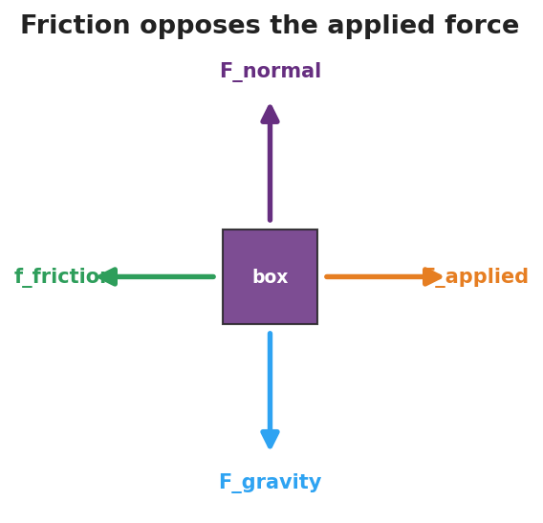
Free-body diagram of a box being dragged: applied force to the right, friction opposing to the left, normal force up, and gravity down.
The Level-3 “breakaway” pattern shows up clearly when friction force is plotted against applied force — it climbs through the static region to a peak, then drops to a steadier kinetic plateau:
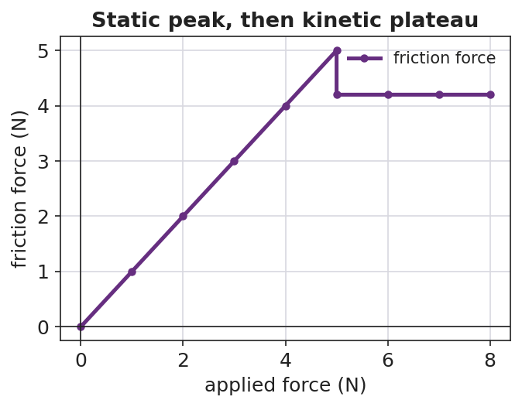
Line graph of friction force versus applied force: a rising static region up to a peak, then a lower, flat kinetic plateau once the object is sliding.

Teacher facilitation during Explore
- What to look for — groups noticing the reading climbs before the book/sneaker breaks loose, then drops and steadies once sliding.
- What to resist — don’t supply “μ” or “kinetic” yet; let the spring scales do the teaching.
- What to redirect — groups who say “heavier = more friction, always” should test it and articulate it as more normal force, more friction (Ff depends on FN, not mass directly).

30–32 min · Gallery check
Groups rotate one station clockwise. “What’s the same in their data? What’s different?” Surface the two big patterns: the breakaway (static peak > sliding) and the constant ratio (pull ÷ normal force).

Phase 3 · Explain (32 – 37 min)

32–35 min · Class consensus
“Across every station, what always pushed back on the sneaker, and what made that push bigger or smaller?”
Target consensus:
“A contact force pushes back against the motion. It’s bigger on rougher surface pairings and bigger when you press the surfaces together harder. Right before something slides, that push reaches a maximum; once it’s sliding, the push is steady and a bit smaller.”

35–37 min · Vocabulary introduction (≤ 3 terms)
Sample teacher language:
“That push-back is friction. Before an object slides, it’s static friction — it grows to match your push, up to a maximum. Once it slides, it’s kinetic friction — roughly constant. Your ‘pull ÷ weight’ ratio is the coefficient of friction, μ, and the Reference Table gives us Ff = μ·FN: friction equals μ times the normal force.”

Discussion prompts to deploy here
- “Why is it harder to start sliding a desk than to keep it sliding?”
  - Sample student response: “Static friction has a bigger maximum than kinetic friction, so the first push has to beat the bigger one.”
- “Two boxes on the same floor; one is heavier. Which needs more force to slide, and why?”
  - Sample student response: “The heavier one — more normal force, so Ff = μ·FN is larger.”

Phase 4 · Elaborate (37 – 40 min)

37–39 min · Revise the model
“Return to your sneaker drawing. Label the push-back arrow ‘friction.’ Add a sentence: when is it static, when is it kinetic, and what two things set its size? Use Ff = μ·FN.”

39–40 min · Return to the phenomenon (HS-PS2-3 thread)
“A phone in a padded case hits the floor. In one sentence using friction and normal force, why does a grippy case help it stop without sliding off the table edge first?”
Target: a grippy case raises μ, so even a small normal force gives enough friction to keep the phone from sliding — the design minimizes the force the phone takes by controlling how it stops.

Phase 5 · Evaluate (40 – 42 min)

40–42 min · Exit Ticket + Closing Reflection
“(a) A crate sits still while you push it gently and it does not move. Name the force opposing your push and say whether it is static or kinetic. Explain. (b) A 200 N crate sits on a floor with μ = 0.30 between the crate and the floor. Calculate the kinetic friction force on the crate as it slides. Show Ff = μ·FN. (c) Cause and Effect: name one change that would make the friction force larger.”
Expected: (a) static friction, because the crate is not sliding — it grows to match the push up to a maximum; (b) Ff = μ·FN = 0.30 × 200 N = 60 N; (c) a rougher surface (larger μ) or pressing it down harder / adding weight (larger FN). See Answer_Key.docx.
Closing Reflection (SEL, 30 seconds):
“Whose idea at your station changed how you think about friction today?”

Common Misconceptions
- Misconception: “Friction depends on how big the contact area is.” → Correction: For these surfaces, friction depends on μ and the normal force (Ff = μ·FN), not on contact area.
- Misconception: “Friction depends on speed.” → Correction: Kinetic friction is roughly constant regardless of sliding speed at this level.
- Misconception: “Heavier always means more friction.” → Correction: It’s the normal force that matters; more weight usually means more normal force, but tilt or extra downward push can change FN independent of mass.
- Misconception: “Static and kinetic friction are the same.” → Correction: Static friction varies up to a maximum (usually larger); kinetic friction is steady once sliding.

Access & Differentiation
- ELL/ENL supports: Sentence frame: *“Friction is ___ when the object is not moving and ___ when it slides; it gets bigger when ___ or ___.”* Word-choice box: {static, kinetic, rougher, normal force, opposes, μ}. Pair friction with a rubbing-hands gesture.
- IEP/SPED supports: Provide a pre-labeled force diagram (pull arrow + friction arrow) so students label “static/kinetic” rather than draw from scratch. Provide the Ff = μ·FN equation pre-printed with FN and μ boxes to fill.
- Extensions: Have students design a “minimize the force” pad (HS-PS2-3) and argue, using μ and FN, why their surface choice slows an object most gently.

Strategy Spotlight
Building Thinking Classrooms — random groups + vertical non-permanent surfaces (17 min) — see Phase 2, Investigation. The full process: visibly random groups of 3 by playing-card suit; chart-paper stations at standing height; one thin-sliced task card per station with four progressively harder tasks (Level 1 → 4). Teacher circulates and asks questions but does not solve. After ~17 minutes, rotate one station clockwise: “What’s the same in their data? What’s different?” — surface the breakaway (static peak > kinetic) and the constant pull ÷ normal-force ratio (μ).
The strategy works because visibly random groups signal that anyone can think with anyone, and the vertical non-permanent surface keeps thinking public and erasable, so groups take risks and the next group can verify the data on the wall.

NYSSLS Observation Checklist Crosswalk
# | Checklist item | Where it appears in this lesson
1 | Local/relatable phenomenon | Phase 1 — Sneaker Lab + stuck book; phone case in Phase 4
2 | Turn and Talk (2–3×) | Phase 1 (TT#1 — why different pull), Phase 2 (gallery check), Phase 3 (consensus)
3 | Students develop questions/models/procedures | Phase 1 (initial model), Phase 2 (BTC thin-sliced task), Phase 4 (revise model)
4 | CCC defined and used | Lesson Overview · Cause and Effect, restated in Phase 2 and Exit Ticket (c)
5 | ENL — ≤ 3 vocab, second half | Phase 3 — vocabulary at 35–37 min (friction / static / kinetic)
6 | Revisit phenomenon with evidence | Phase 4 — phone case + sneaker re-labeling with Ff = μ·FN
7 | ENL/SPED supports | Access & Differentiation block
8 | Assessment check | Phase 5 — Exit Ticket (crate, numeric Ff = μ·FN)

Companion Materials
- Student_Worksheet.docx — the 5E student investigation (hand out at start of Phase 2)
- Student_Notes.docx — guided note-guide for vocabulary and the worked example
- Answer_Key.docx — answers to “Make It Make Sense” prompts and the Exit Ticket

Key Vocabulary (max 3)
- friction — a contact force that opposes relative motion (or attempted motion) between two surfaces; on the Reference Table, Ff = μ·FN
- static friction — friction on an object that is not yet sliding; it varies to match the applied force up to a maximum
- kinetic friction — friction on an object that is already sliding; it is roughly constant

Friction — Student Worksheet
Unit: Forces — Lesson 04 Name: _______________________ Date: __________ Period: ____

Phenomenon
Your teacher drags the same sneaker at the same speed across tile, then carpet, then sandpaper — and the spring scale reads a different number every time. Then a heavy book will not slide at all… until one harder push, and it suddenly breaks loose and slides.
Driving question: What decides how hard friction pushes back — and why does an object suddenly “let go”?

Notice & Wonder
I notice… | I wonder…
Turn & Talk #1: Why does the same sneaker need a different pull on each surface? Use the word force.

Initial Model
Draw the sneaker being dragged. Draw an arrow for the pull (spring scale) and an arrow for whatever pushes back. Then predict which surface needs the biggest pull, and why.

My prediction: _______________________________

Investigation
Work at your group’s chart-paper station. Complete each level in order. The free-body diagram below shows the forces on the sneaker as you pull it — friction always points opposite your pull.

Free-body diagram of a box being dragged: an applied force pulling right, a friction force pushing left, the normal force up, and gravity down.
Level | What I did | What happened | What it tells me
1. Drag on 3 surfaces
2. Add weight, one surface
3. Just-before-sliding vs. while-sliding
4. Pull ÷ weight ratio
Key question: What two things make the friction force bigger or smaller?

Make It Make Sense
- Why is it harder to start a desk sliding than to keep it sliding once it moves?
- Two boxes sit on the same floor; one is heavier. Which needs more force to slide, and why?
- The same sneaker reads a bigger pull on sandpaper than on tile. What about the sandpaper makes friction larger?

Vocabulary in Action
Use each term in a sentence about today’s phenomenon.
- friction: _______________________________________________
- static friction: _______________________________________________
- kinetic friction: _______________________________________________

Revise Your Model
Return to your Initial Model. Label the push-back arrow friction. Add one sentence: when is it static, when is it kinetic, and what two things set its size? Use Ff = μ·FN.

Exit Ticket
- You push a crate gently and it does not move. Name the force opposing your push and say whether it is static or kinetic. Explain.
- A 200 N crate sits on a floor with μ = 0.30 between the crate and the floor. Calculate the kinetic friction force as it slides. Show Ff = μ·FN.
- Cause and Effect: name one change that would make the friction force larger.

Friction — Student Notes
Unit: Forces — Lesson 04 Name: _______________________ Date: __________ Period: ____

Learning Targets
By the end of today’s 42 minutes I can:
- Describe friction as a contact force that opposes motion.
- Tell static friction apart from kinetic friction.
- Use Ff = μ·FN to explain and calculate the friction force.

Key Vocabulary
- friction — _______________________________________________
- static friction — _______________________________________________
- kinetic friction — _______________________________________________

Guided Notes
Big idea: Friction is a __________ force that opposes the relative motion (or attempted motion) of two surfaces touching each other.
- Friction always points __________ the direction the object moves or tries to move.
- Static friction acts when the object is __________ sliding. It grows to match your push, up to a __________ value.
- Kinetic friction acts when the object __________ sliding. It is roughly __________ (it does not change much with speed).
- It is usually harder to start an object sliding than to keep it sliding, because the static maximum is __________ than the kinetic friction.

Line graph of friction force versus applied force: friction rises with the applied force through the static region up to a peak, then drops to a flat kinetic plateau once the object slides.
The equation (2025 Reference Table):
Ff = μ·FN
- Ff = the __________ force (newtons, N)
- μ = the __________ of friction (no units) — depends on the two __________
- FN = the __________ force (the surface’s push up on the object, in N)
So friction gets bigger when: μ is __________ (rougher pairing) OR FN is __________ (pressed together harder).

Worked Example
Problem. A 50 N wooden block slides across a tabletop. The coefficient of kinetic friction between the block and the table is μ = 0.20. What is the kinetic friction force on the block?
Solution. 1. On a flat surface, the normal force equals the weight, so FN = __________ N. 2. Write the equation: Ff = μ·FN = __________ × __________. 3. Ff = __________ N, pointing __________ to the block’s motion.
Check: If we doubled the block’s weight to 100 N, the friction force would __________ to __________ N — because Ff depends on FN.

Summary
Finish the sentence (Because / But / So):
A heavy desk will not slide when you push it gently because __________________________________________, but __________________________________________, so __________________________________________.

Friction — Answer Key

Cover
Unit: Forces — Lesson 04: Friction East Meadow Schools × Valley Stream Central HSD

Make-It-Make-Sense Answers
- Static friction has a larger maximum than kinetic friction. Starting the desk means overcoming the bigger static maximum; once it slides, only the smaller, roughly constant kinetic friction opposes you. · Rubric: names static > kinetic AND links to start vs. keep moving. · NYSSLS: HS-PS2-1
- The heavier box needs more force. More weight means a larger normal force (FN), and since Ff = μ·FN, larger FN means larger friction. · Rubric: links weight → normal force → larger Ff. · NYSSLS: HS-PS2-3
- Sandpaper is rougher, so the pairing has a larger coefficient of friction (μ). With the same normal force, a larger μ gives a larger Ff = μ·FN. · Rubric: names rougher surface → larger μ. · NYSSLS: HS-PS2-3

Exit Ticket Answer
- Static friction. The crate is not sliding, so the friction is static — it grows to match your push (up to its maximum), keeping the net force zero so the crate stays at rest.
- Ff = μ·FN = 0.30 × 200 N = 60 N. (On a flat floor FN equals the 200 N weight.)
- Cause and Effect: any one of — use a rougher surface (larger μ), add weight / press it down harder (larger FN). Either correctly increases Ff = μ·FN.
Tolerance/rubric: (a) must say static AND justify “not sliding”; (b) must show Ff = μ·FN with the answer 60 N (full credit for correct setup + answer; half for setup only); (c) any change that raises μ or FN. 1 point each. NYSSLS: HS-PS2-3 (and HS-PS2-1).

Closing Reflection (rubric)
Closing reflection is formative, not graded. Award full credit for any honest response. Look for: - A genuine attribution of an idea to a peer at the BTC station - Evidence the student can name one factor (μ or FN) that changes friction

Centripetal Force and Circular Motion — Teacher Guide

Cover
Unit: Forces — Lesson 05: Centripetal Force and Circular Motion East Meadow Schools × Valley Stream Central High School District Strategy chips: ACTIVE LEARNING

Curated Resources (from East Meadow Scope & Sequence)

NYSSLS Standards
This row of the Forces unit names no specific Performance Expectation, but it directly supports HS-PS2-1 (a net force causes acceleration). The twist students must confront: an object moving in a circle at constant speed is still accelerating, because its velocity direction keeps changing. The net force that produces that acceleration points toward the center of the circle. The CCC focus is Cause and Effect — a center-directed (centripetal) force is the cause, and center-directed acceleration (a curved path) is the effect.

Phenomenon
- Motorcycle “lowside” crash in a curve — the moment grip is lost, the bike stops turning and slides straight: https://www.youtube.com/watch?v=wRXOf-9YJU0
- Water stays in a bucket swung in a vertical circle: https://youtu.be/Zulw5bQ18Kk
- A ball or rubber stopper swung overhead on a string (live demo).

Javalab / Labs
- Circular Motion Labs — swing a rubber stopper on a string, vary radius and speed, and feel the tension change: https://javalab.org/en/circular_motion_en/
- oPhysics circular motion simulation (force vectors on a revolving object): https://ophysics.com/r1.html

Assessments
- Exit ticket below serves as the formative check (quantitative, uses Fc = m·v²/r).

Lesson Overview
Duration | 42 minutes (1 period)
NYSSLS link | Supports HS-PS2-1 (net force → acceleration, here center-directed)
CCC focus | Cause and Effect — a center-seeking net force causes a curved path; remove it and the path goes straight.
Strategy chips | ACTIVE LEARNING (swing-and-predict stopper stations)
Materials | Rubber stoppers on ~1 m strings (or beaded keychains); a few washers/weights; stopwatch; safety goggles; open floor space; whiteboards/markers.
Safety | Goggles on for all swinging. Clear a wide radius; swing in a vertical or horizontal plane away from faces. Inspect strings for fraying.
Prior knowledge | Velocity is a vector (size + direction); acceleration is any change in velocity (Lessons 01–04); net force causes acceleration.
Lesson objectives — students can:
- Explain why an object in uniform circular motion is accelerating even though its speed is constant.
- Identify the real force (tension, friction, gravity, normal) that acts as the centripetal force in a given situation.
- Use Fc = m·v²/r to relate force, mass, speed, and radius, and predict how each change affects the others.

Phase 1 · Engage (0 – 10 min)

0–3 min · Opening Connection (SEL)
Quick whip-around, one sentence each (pass allowed): “Name a time you felt like you were being thrown outward — a car turn, a spinning ride, a sharp bike turn.” You are deliberately collecting the feeling of being thrown outward; you will name and overturn it as the centrifugal misconception in Phase 3.

3–8 min · Phenomenon hook — the lowside crash
Teacher actions. Play the motorcycle lowside clip (pause the instant the tire loses grip). Replay in slow motion. Ask students to track the direction the bike travels the moment grip is lost.
Sample teacher language:
“Watch the curve. The rider is turning — turning — and the instant the tire loses grip, which way does the bike go? Not more curved. Watch.”
Anticipated student responses:
- “It shoots straight off the road.” — exactly; capture straight.
- “It slides outward / centrifugal force throws it out.” — capture this; we will test it. “Outward, or just straight ahead? Hold that thought.”
- “The road was slippery, so it lost the force keeping it turning.” — gold; “What force was that?”

8–10 min · Notice & Wonder + Turn-and-Talk #1
Two-column board capture. Then:
“Turn to your partner: while the bike was successfully turning, something had to keep pulling it into the curve. What was it, and which way did it point?”
Target seed: something pointed inward (toward the center of the curve) — friction from the tires. Leave open if no one lands it.

Bridge to Phase 2
Every student leaves with a one-sentence initial model: “The bike kept turning because ______, and it went straight when ______.”

Phase 2 · Explore (10 – 30 min)

10–14 min · Initial Model (silent / individual)
Prompt on the board:
“Draw the bike on the curved road from above. Draw an arrow showing the force that keeps it turning. Then predict: if that force vanishes, draw the dotted path the bike takes.”
This surfaces the inward-vs-outward intuition before any vocabulary.

14–30 min · Investigation — swing it, feel it, let it go (ACTIVE LEARNING)
Goggles on. Stopper-on-a-string stations (rotate or run as a carousel):
- Which way is the pull? Swing the stopper in a horizontal circle overhead at steady speed. Which way does your hand pull on the string — toward you (center) or away? What is the string doing to the stopper?
- Let it go. On a count, release the string mid-swing (point it at an open wall, not a person). Which way does the stopper fly — outward along the radius, or straight along a tangent? Repeat and watch carefully.
- Speed and radius. Swing faster: does the string pull harder or softer? Choke up to a shorter radius at the same speed: harder or softer? Add a washer (more mass): harder or softer?
Teacher facilitation language:
“Feel your hand. Are you pulling the stopper in or pushing it out?” “When you let go, did it curve outward — or go straight in the direction it was already heading?” “Faster swing — what happens to the tension you feel? Shorter string — what happens?”
The diagram below captures both station discoveries at once: the velocity points along the tangent (the direction the stopper flies when released), while the centripetal force points toward the center (the inward pull your hand feels).
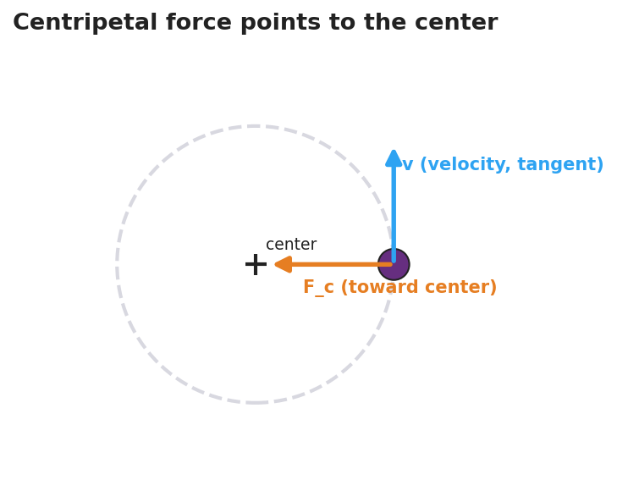
Diagram of an object on a circular path: a velocity arrow drawn tangent to the circle and a centripetal force arrow pointing inward toward the center.

Teacher facilitation during Explore
- What to look for — students reporting the released stopper flies off on a tangent (straight), not radially outward; and that faster/shorter/heavier all increase the felt tension.
- What to resist — don’t supply “centripetal” yet; let their hands feel the inward pull.
- What to redirect — students who insist the stopper flew “outward” should re-run station 2 and sight along the path; it leaves on the tangent line.

Phase 3 · Explain (30 – 36 min)

30–33 min · Turn-and-Talk #2 + class consensus
“Across every station, which way did the force point — and what happened the instant we removed it?”
Target consensus:
“The string always pulled the stopper toward the center. The speed was steady, but the direction kept changing — so the velocity changed — so it was accelerating. Remove the force and it flies off straight (tangent), because nothing is changing its direction anymore.”

33–36 min · Vocabulary introduction (≤ 3 terms) + the misconception
Sample teacher language:
“That inward, center-seeking pull is the centripetal force — centripetal literally means ‘center-seeking.’ It produces a centripetal acceleration pointed at the center, because the velocity direction is changing. How sharp the turn is depends on the radius. And here’s the key: there is no ‘centrifugal force’ throwing you out. That outward feeling is just your inertia — your body wanting to go straight while the car/string curves you in. The only real force is the inward one.”
Name the real provider each time: tension (string), friction (tires, the lowside), gravity (orbit, top of a vertical loop), normal force (a banked turn or the bucket bottom).

Discussion prompts to deploy here
- “When you swing the bucket of water overhead, why doesn’t the water fall out at the top?”
  - Sample student response: “It’s moving fast and wants to go straight; the bucket bottom pushes it inward (toward the center) faster than gravity could pull it out, so it stays in.”
- “A car turns left. Which way does the passenger feel thrown, and which way is the real force?”
  - Sample student response: “You feel thrown right (outward), but that’s inertia — the real force, friction, pushes the car left, toward the center.”

Phase 4 · Elaborate (36 – 40 min)

36–38 min · Revise the model
“Return to your bike drawing. Label the inward arrow ‘centripetal force (friction)’ and label the straight dotted release path ‘tangent — inertia, no net force.’ Write one revised sentence using centripetal force and radius.”

38–40 min · Quick quantitative reasoning (Fc = m·v²/r)
“From the Reference Table, Fc = m·v²/r. In station 3 you doubled the speed. What happened to the tension?”
Target: “It got about four times as hard, because v is squared.” Follow up: “Shorter radius at the same speed?” → “Harder, because r is in the denominator.” Tie directly back to what their hands felt.

Phase 5 · Evaluate (40 – 42 min)

40–42 min · Exit Ticket + Closing Reflection
“A 0.20 kg ball is swung in a horizontal circle of radius 0.50 m at a constant speed of 3.0 m/s. (a) Is the ball accelerating? Explain in one sentence. (b) Calculate the centripetal force on the ball. Show the equation and units. (c) A student says a ‘centrifugal force’ pushes the ball outward. Is the student correct? Explain.”
Expected: (a) Yes — direction (and so velocity) is changing. (b) Fc = m·v²/r = 0.20 · (3.0)² / 0.50 = 3.6 N, directed toward the center. (c) No — the only real force is the inward (centripetal) tension; the outward feeling is inertia, not a force. See Answer_Key.docx.
Closing Reflection (SEL, 30 seconds):
“What is one thing today that changed how you think about turning or spinning? Who helped you see it?”

Common Misconceptions
- Misconception: “A ‘centrifugal force’ throws objects outward in a turn.” → Correction: There is no outward force. Objects tend to go straight (inertia); the only real force is the inward centripetal force that curves the path. The outward “throw” is a feeling, not a force.
- Misconception: “Constant speed means no acceleration.” → Correction: Acceleration is any change in velocity; in a circle the direction changes constantly, so there is centripetal acceleration even at constant speed.
- Misconception: “Centripetal force is a new, separate kind of force.” → Correction: It is always provided by a real, familiar force — tension, friction, gravity, or normal force — acting toward the center.
- Misconception: “Released objects fly outward along the radius.” → Correction: They leave on the tangent, continuing in the straight-line direction they had at the instant of release.

Access & Differentiation
- ELL/ENL supports: Sentence frame: *“The ___ pulls the object toward the , so the object’s changes and it accelerates ___.”* Word-choice box: {center, tension, friction, gravity, direction, inward, tangent}. Pair centripetal with a hand-pulling-inward gesture.
- IEP/SPED supports: Provide a pre-drawn circle with the center marked; students draw and label only the inward arrow and the tangent release line. Offer the swing demo as a hands-on alternative to written explanation. Pre-fill the Fc equation with values to plug in.
- Extensions: Have students explain a banked highway curve or a satellite in orbit, naming which real force is centripetal, and reason about how doubling the radius changes Fc at fixed speed.

Strategy Spotlight
ACTIVE LEARNING (predict-and-test stations). Today’s core is a hands-on, predict-then-feel investigation. Students physically swing a stopper and (1) feel whether their hand pulls inward or outward, and (2) predict the release path, then test it by letting go. The “let it go” moment is the lesson’s hinge: students who expect a curved/outward exit watch the stopper leave on a tangent, which directly dismantles the centrifugal-force misconception through their own observation rather than teacher assertion. Keep predictions written before each test (commitment increases the conceptual payoff), insist on goggles, and have each group sight along the release path to confirm “straight, not outward.” Time-box each station to ~5 minutes.

NYSSLS Observation Checklist Crosswalk
# | Checklist item | Where it appears in this lesson
1 | Local/relatable phenomenon | Phase 1 — motorcycle lowside crash; bucket/string in Phase 3
2 | Turn and Talk (2–3×) | Phase 1 (TT#1 — what keeps it turning), Phase 3 (TT#2 — direction of force)
3 | Students develop questions/models/procedures | Phase 1 (initial model), Phase 2 (swing-and-release stations), Phase 4 (revise model)
4 | CCC defined and used | Lesson Overview · Cause and Effect, restated in Phases 2–3
5 | ENL — ≤ 3 vocab, second half | Phase 3 — vocabulary at 33–36 min (centripetal force / centripetal acceleration / radius)
6 | Revisit phenomenon with evidence | Phase 4 — re-label bike drawing with tangent + centripetal arrow
7 | ENL/SPED supports | Access & Differentiation block
8 | Assessment check | Phase 5 — quantitative Exit Ticket (Fc = m·v²/r)

Companion Materials
- Student_Worksheet.docx — the 5E student investigation (hand out at start of Phase 2)
- Student_Notes.docx — guided note-guide for vocabulary and the worked example
- Answer_Key.docx — answers to “Make It Make Sense” prompts and the Exit Ticket

Key Vocabulary (max 3)
- centripetal force — the net inward, “center-seeking” force that keeps an object moving in a circle; always provided by a real force (tension, friction, gravity, or normal force): Fc = m·v²/r
- centripetal acceleration — the center-directed acceleration of an object in circular motion, caused by its constantly changing velocity direction: ac = v²/r
- radius — the distance from the center of the circle to the object; smaller radius means a sharper turn and (at fixed speed) a larger required force

Centripetal Force and Circular Motion — Student Worksheet
Unit: Forces — Lesson 05 Name: _______________________ Date: __________ Period: ____

Phenomenon
A motorcycle leans into a curve, turning smoothly — until the tire loses grip. The instant it does, the bike does not curve harder. It shoots straight off the road. In another clip, a bucket of water is swung in a full vertical circle and the water never spills, not even at the top.
Driving question: What force keeps something moving in a circle — and what happens the instant that force is gone?

Notice & Wonder
I notice… | I wonder…
Turn & Talk #1: While the bike was successfully turning, something kept pulling it into the curve. What was it, and which way did it point?

Initial Model
Draw the bike on the curved road from above. Draw an arrow for the force that keeps it turning. Then, with a dotted line, show the path the bike takes if that force suddenly vanishes.

My prediction: _______________________________

Investigation
Goggles on. Complete each station with your stopper-on-a-string. Record what you observe. The diagram below shows what to look for: the velocity points along the tangent, and the force that keeps the stopper turning points toward the center.

Diagram of an object moving on a circular path with a tangent velocity arrow and an inward centripetal force arrow pointing to the center.
Station | What I did | What happened | What it tells me
1. Which way is the pull?
2. Let it go (release mid-swing)
3. Change speed, radius, mass
Key question: When you let go of the string, did the stopper fly outward along the radius or straight along a tangent? Which way did your hand pull the whole time?

Make It Make Sense
- A ball swings in a circle at a steady speed. A classmate says, “It’s not accelerating because the speed never changes.” Are they right? Explain.
- Name the real force that acts as the centripetal force in each case: (a) a car rounding a flat curve, (b) the Moon orbiting Earth, (c) water at the bottom of the swung bucket.
- You swing the stopper twice as fast at the same radius. Using Fc = m·v²/r, does the string tension stay the same, double, or quadruple? Explain.

Vocabulary in Action
Use each term in a sentence about today’s phenomenon.
- centripetal force: _______________________________________________
- centripetal acceleration: _______________________________________________
- radius: _______________________________________________

Revise Your Model
Return to your Initial Model. Label the inward arrow as the centripetal force (and name what really provides it). Label the dotted release path as the tangent path the bike takes due to inertia when there is no net force. Rewrite your explanation using centripetal force and radius.

Exit Ticket
A 0.20 kg ball is swung in a horizontal circle of radius 0.50 m at a constant speed of 3.0 m/s.
- Is the ball accelerating? Explain in one sentence.
- Calculate the centripetal force on the ball. Show the equation and units.
- A student says a “centrifugal force” pushes the ball outward. Is the student correct? Explain.

Centripetal Force and Circular Motion — Student Notes
Unit: Forces — Lesson 05 Name: _______________________ Date: __________ Period: ____

Learning Targets
By the end of today’s 42 minutes I can:
- Explain why an object moving in a circle at constant speed is still accelerating.
- Identify the real force that acts as the centripetal force in a situation.
- Use Fc = m·v²/r to relate force, mass, speed, and radius.

Key Vocabulary
- centripetal force — _______________________________________________
- centripetal acceleration — _______________________________________________
- radius — _______________________________________________

Guided Notes
Big idea: An object moving in a circle at constant speed is still __________, because its velocity __________ keeps changing (velocity is a vector — size and direction).
- The acceleration points toward the __________ of the circle. We call it centripetal acceleration: ac = v² / __________.
- The net force that causes it also points toward the __________. We call it the centripetal force: Fc = m · v² / __________.
- “Centripetal” means __________-seeking.
- The centripetal force is always provided by a real force. Match them:
  - Ball on a string → __________
  - Car on a flat curve → __________
  - Moon orbiting Earth → __________
  - Object at the bottom of a swung bucket → __________ force
The misconception (cross it out in your head):
- There is no “centrifugal force” throwing you outward. That outward feeling is just your __________ — your body trying to go __________ (in a straight line / tangent) while something curves you inward.
- If the centripetal force disappears, the object flies off on a __________ (straight line), not outward along the radius.
How the numbers behave (from Fc = m·v²/r):
- Double the speed v → force becomes about __________ times bigger (v is squared).
- Smaller radius r → __________ force needed (sharper turn is harder).
- More mass m → __________ force needed.
Because Fc depends on v², a graph of centripetal force vs. v² is a straight line — the force grows fast as speed increases:
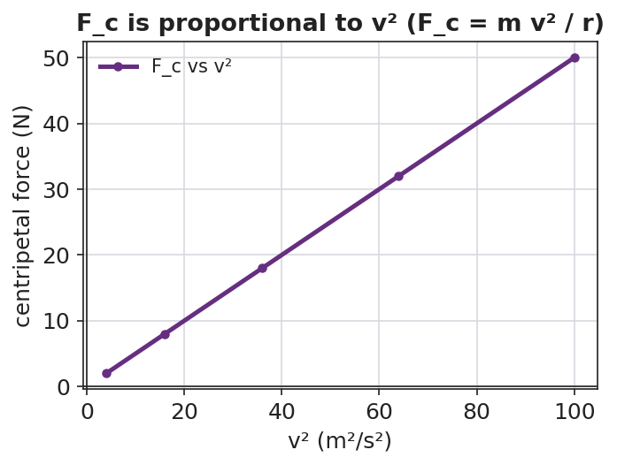
Line graph of centripetal force versus velocity squared: a straight line through the origin, showing centripetal force is proportional to v squared.

Worked Example
Problem. A 0.50 kg toy car rounds a circular track of radius 2.0 m at a constant speed of 4.0 m/s. Find the centripetal force on the car and state its direction.
Solution. 1. Write the equation (2025 Reference Table): Fc = m · v² / r. 2. Substitute: Fc = (0.50 kg) · (4.0 m/s)² / (2.0 m). 3. Compute the top: (4.0)² = 16, so 0.50 · 16 = 8.0; then 8.0 / 2.0 = __________ N. 4. Direction: toward the __________ of the circle. 5. What provides it here? The __________ between the tires and the track.

Summary
Finish the sentence (Because / But / So):
An object moving in a circle at constant speed is still accelerating because __________________________________________, but __________________________________________, so __________________________________________.

Centripetal Force and Circular Motion — Answer Key

Cover
Unit: Forces — Lesson 05: Centripetal Force and Circular Motion East Meadow Schools × Valley Stream Central HSD

Make-It-Make-Sense Answers
- The classmate is wrong. Acceleration is any change in velocity, and velocity is a vector (size and direction). In a circle the direction changes every instant, so the velocity changes and the ball is accelerating — toward the center — even though its speed is constant. · Rubric: states acceleration = change in velocity AND identifies the changing direction → full credit. · NYSSLS: HS-PS2-1

  - Friction between the tires and the road. (b) Gravity (Earth’s gravitational pull on the Moon). (c) The normal force from the bottom of the bucket pushing the water inward (toward the center). · Rubric: one real force named correctly per case. · NYSSLS: HS-PS2-1
- The tension quadruples (becomes about 4× as large). In Fc = m·v²/r the speed v is squared, so doubling v multiplies the force by 2² = 4. · Rubric: “quadruples” AND cites v² → full credit. · NYSSLS: HS-PS2-1

Exit Ticket Answer
Given: m = 0.20 kg, r = 0.50 m, v = 3.0 m/s.
- Yes, it is accelerating. Its speed is constant but its velocity direction is changing, so its velocity is changing — that is acceleration (directed toward the center).
- Fc = m·v²/r = (0.20 kg)(3.0 m/s)² / (0.50 m) = (0.20)(9.0) / (0.50) = 1.8 / 0.50 = 3.6 N, directed toward the center of the circle.
- No, the student is not correct. There is no real “centrifugal force.” The only real force is the inward (centripetal) tension in the string. The outward feeling is the ball’s inertia — its tendency to travel straight (tangent) while the string curves it inward — not a force.
Tolerance/rubric: (a) must say “yes” AND justify via changing direction; (b) correct setup with v² and a numeric answer of 3.6 N toward the center (accept minor rounding), units required; (c) “no” AND identifies inertia / absence of a real outward force. 1 point each. NYSSLS: HS-PS2-1.

Closing Reflection (rubric)
Closing reflection is formative, not graded. Award full credit for any honest response. Look for: - A genuine shift-in-thinking statement (e.g., “I used to think a force throws you outward, but really it pulls you in / you just go straight”). - Naming a peer or a self-acknowledgment for who helped them see it.

Universal Gravitation — Teacher Guide

Cover
Unit: Forces — Lesson 06: Universal Gravitation East Meadow Schools × Valley Stream Central High School District Strategy chips: HOCHMAN

Curated Resources (from East Meadow Scope & Sequence)

NYSSLS Standards
This lesson targets HS-PS2-4 — “Use mathematical representations of Newton’s Law of Gravitation and Coulomb’s Law to describe and predict the gravitational and electrostatic forces between objects.” The CCC focus is Patterns: the same inverse-square mathematical pattern governs both gravity and electric force, so the structure students master here transfers directly to Coulomb’s Law in the later Electrostatics unit. Today the focus is gravitation; name the parallel pattern but do not teach Coulomb’s Law yet.

Phenomenon
- PhET Gravity Force Lab (basics) — drag two masses and watch the attraction change with mass and distance: https://phet.colorado.edu/en/simulations/gravity-force-lab-basics
- Anchoring question: Why doesn’t the Moon fall down onto Earth? / Why do astronauts feel weightless in orbit even though Earth’s gravity still acts on them? (Khan Academy): https://www.khanacademy.org/science/physics/centripetal-force-and-gravitation/gravity-newtonian/a/what-is-gravity

Javalab / Labs
- PhET Gravity Force Lab Basics — students drag two masses, increase a mass and watch the force arrows grow; double the separation and watch the force shrink to one-quarter: https://phet.colorado.edu/en/simulations/gravity-force-lab-basics

Assessments
- Exit ticket below serves as the formative check (numeric inverse-square reasoning). See Answer_Key.docx.

Lesson Overview
Duration | 42 minutes (1 period)
NYSSLS link | HS-PS2-4 (gravitation; parallels Coulomb’s Law)
CCC focus | Patterns — the inverse-square relationship is a repeating mathematical pattern across gravity and, later, electric force.
Strategy chips | HOCHMAN (sentence-level literacy: Because/But/So + appositive on the inverse-square law)
Materials | Projector + PhET Gravity Force Lab Basics (one device per pair if possible); 2025 Reference Tables; whiteboards/markers; calculators.
Safety | None — simulation and pencil-and-paper.
Prior knowledge | Weight as a force (Fg = mg), the difference between a force and a property, vectors as size + direction.
Lesson objectives — students can:
- State the law of universal gravitation in their own words: every mass attracts every other mass, and the pull depends on the masses and the distance between them.
- Use Fg = G·m₁·m₂/r² (2025 Reference Table) to calculate or compare gravitational forces.
- Apply the inverse-square law as a pattern: when distance doubles, the force drops to one-quarter.
- Distinguish mass (an unchanging amount of matter) from weight (the gravitational force on that mass).

Phase 1 · Engage (0 – 10 min)

0–3 min · Do Now / Opening Connection
Post the Do Now: “You weigh about 1/6 as much on the Moon as on Earth — but a scale that counts atoms would read exactly the same. How can both be true?” Take one or two responses; do not resolve it. This seeds the mass-vs-weight distinction you’ll name in Phase 3.

3–8 min · Phenomenon hook — Why doesn’t the Moon fall?
Teacher actions. Show the Moon-orbit image or the Khan clip. Pose the anchoring question.
Sample teacher language:
“Earth’s gravity reaches all the way to the Moon — it’s what holds the Moon in orbit. So why doesn’t the Moon just fall down onto us like a dropped ball?”
Anticipated student responses:
- “The Moon is too far away for gravity to reach.” — surface; we’ll show gravity does reach, just weaker with distance.
- “There’s no gravity in space.” — common misconception; flag it, address in Phase 3.
- “It’s moving sideways fast enough to keep missing Earth.” — excellent; capture it.

8–10 min · Notice & Wonder + Turn-and-Talk #1
Capture two columns. Then:
“Turn to your partner: name two things that might change how strongly two objects pull on each other.”
Target: how much stuff (mass) each has, and how far apart they are. Leave open if no one lands it.

Bridge to Phase 2
Every student leaves with a one-sentence initial model: “Two objects pull harder when ______.”

Phase 2 · Explore (10 – 28 min)

10–14 min · Initial Model (silent / individual)
Prompt on the board:
“Draw two spheres. Draw an arrow showing the pull each feels from the other. Then predict: if I make one sphere heavier, what happens to the arrows? If I move them farther apart, what happens?”
This surfaces intuition before any formula.

14–28 min · Investigation — PhET Gravity Force Lab Basics
Pairs (or whole-class projection) work the simulation:
- Mass test — keep distance fixed; double mass 1. What happens to the force? (It doubles.)
- Distance test — keep masses fixed; double the separation. What happens to the force? (It drops to one-quarter, not one-half — the surprise.)
- Pattern hunt — triple the distance. Predict first, then check. (Force → one-ninth.)
Teacher facilitation language:
“Predict before you drag. Doubling the distance — half the force, or something else?” “Force fell to one-quarter, not one-half. What did we square — the masses or the distance?” “Are the two arrows on the two masses equal or unequal? Even when the masses are very different?”
The “÷4, then ÷9” surprise is the inverse-square law. Project the graph below so students see the force falling off steeply — not linearly — as distance grows:
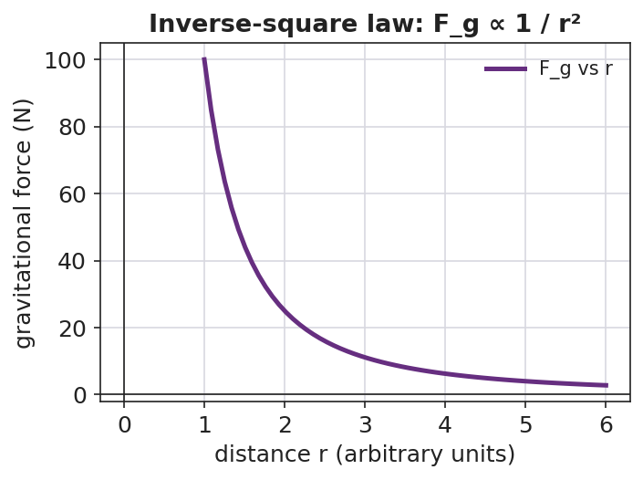
Line graph of gravitational force versus distance r: a steep inverse-square curve that falls off rapidly as r increases.
And no matter how different the two masses are, the pulls are equal in size and opposite in direction (a Newton’s-third-law cameo):
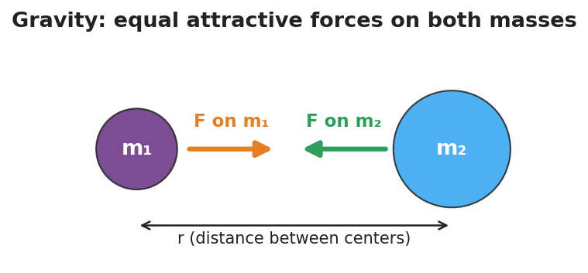
Two masses m1 and m2 separated by distance r, each feeling an equal-length attractive force arrow pointing toward the other.

Teacher facilitation during Explore
- What to look for — students noticing the force changes with the square of distance, and that the two pulls are always equal-and-opposite (Newton’s Third Law cameo).
- What to resist — don’t write Fg = Gm₁m₂/r² yet; let the simulation reveal the ÷4 pattern first.
- What to redirect — students who say “double distance, half force” should re-run the ×3 distance trial and confront the ÷9 result.

Phase 3 · Explain (28 – 35 min)

28–31 min · Turn-and-Talk #2 + class consensus
“What pattern did distance follow? Say it as a rule.”
Target consensus:
“More mass means more pull. But the distance matters in a stronger way — squaring it. Double the distance and the force isn’t halved, it’s quartered.”

31–35 min · Vocabulary + the equation (≤ 3 terms)
Sample teacher language:
“The pull every mass feels from every other mass is the gravitational force. The rule that the force falls with the square of the distance is the inverse-square law. And the amount of matter that sets how strong the pull is — and never changes — is mass.”
Write the Reference-Table equation and unpack it:
Fg = G·m₁·m₂ / r², where G = 6.67×10⁻¹¹ N·m²/kg². Near Earth’s surface this same gravitational force is what we call weight: Fg = mg, with g ≈ 9.81 m/s².

Discussion prompts to deploy here
- “Why is weight on the Moon smaller but mass the same?”
  - Sample student response: “Mass is how much matter you have — unchanged. Weight is the gravitational force, and the Moon’s smaller mass pulls less, so weight drops to about 1/6.”
- “Earth pulls the Moon; does the Moon pull Earth equally?”
  - Sample student response: “Yes — the two forces are equal and opposite, even though Earth is far more massive.”

Phase 4 · Elaborate (35 – 39 min)

35–37 min · Hochman Because/But/So
Project the stem and build it together (see Strategy Spotlight):
*“The gravitational force between two objects depends on their masses because , but it depends even more sharply on distance because , so ___.”*

37–39 min · Return to the phenomenon
“Now answer the Do Now and the Moon question in one sentence each, using gravitational force and inverse-square law.”
Target: Astronauts in orbit do feel Earth’s gravity — they are in continuous free fall, circling Earth, so they float; and the Moon stays in orbit because gravity pulls it inward while its sideways speed keeps it from falling straight down.

Phase 5 · Evaluate (39 – 42 min)

39–42 min · Exit Ticket + Closing Reflection
“Two satellites pull on each other with a gravitational force of 8 N. (a) Their masses stay the same, but the distance between them doubles. What is the new force? Show your reasoning. (b) Is the amount of matter (mass) in each satellite changed by moving them apart? Explain.”
Expected: (a) 8 N ÷ 4 = 2 N (inverse-square: double r → divide force by 2² = 4); (b) no — mass is unchanged; only the gravitational force changed. See Answer_Key.docx.
Closing Reflection (SEL, 30 seconds):
“What is one thing today that changed how you think about gravity or weight? Who helped you make sense of it?”

Common Misconceptions
- Misconception: “There is no gravity in space, so astronauts float.” → Correction: Earth’s gravity reaches far into space (it holds the Moon!). Orbiting astronauts float because they are in continuous free fall around Earth, not because gravity is absent.
- Misconception: “Mass and weight are the same thing.” → Correction: Mass is the unchanging amount of matter (kg); weight is the gravitational force on that mass (N) and depends on local g. Same mass on the Moon, smaller weight.
- Misconception: “Double the distance halves the force.” → Correction: It is an inverse-square law — double the distance divides the force by 2² = 4.
- Misconception: “Only the smaller object is pulled.” → Correction: Both objects pull on each other with equal and opposite gravitational forces, regardless of size.

Access & Differentiation
- ELL/ENL supports: Sentence frame: “When the distance doubles, the gravitational force becomes ___ because the distance is ___ in the formula.” Word-choice box: {squared, one-quarter, mass, weight, attract, distance}. Pair inverse-square with a gesture (hands spreading apart while the other hand shrinks).
- IEP/SPED supports: Provide the PhET data table pre-labeled with columns (mass, distance, force); students fill values only. Offer the worked example with the substitution already set up so students complete the arithmetic.
- Extensions: Have students compute the actual gravitational force between two 50 kg students standing 1 m apart using Fg = Gm₁m₂/r², and explain why we never feel it (≈ 1.7×10⁻⁷ N — far too small).

Strategy Spotlight
HOCHMAN (sentence-level literacy). Today’s signature move is a Because/But/So expansion built around an appositive on the inverse-square law. First model the appositive in Phase 3 by renaming the key term: “The inverse-square law — the rule that squaring the distance shrinks the force — explains the Moon’s steady orbit.” The appositive (set off by dashes) forces students to define the term in-line, a Hochman comprehension check. Then in Phase 4, students complete the Because/But/So stem so that a single complex sentence captures the whole conceptual contrast: mass matters, but distance matters more sharply, so the inverse-square pattern dominates at large separations. Collect 2–3 finished sentences and read them aloud so the class hears the precise causal language.

NYSSLS Observation Checklist Crosswalk
# | Checklist item | Where it appears in this lesson
1 | Local/relatable phenomenon | Phase 1 — Moon orbit / Moon-weight Do Now
2 | Turn and Talk (2–3×) | Phase 1 (TT#1 — what affects pull), Phase 3 (TT#2 — name the distance pattern)
3 | Students develop questions/models/procedures | Phase 1 (initial model), Phase 2 (PhET investigation), Phase 4 (revise model)
4 | CCC defined and used | Lesson Overview · Patterns, restated in Phase 2 (inverse-square pattern)
5 | ENL — ≤ 3 vocab, second half | Phase 3 — vocabulary at 31–35 min (gravitational force / inverse-square law / mass)
6 | Revisit phenomenon with evidence | Phase 4 — Moon orbit + astronaut free fall, using PhET evidence
7 | ENL/SPED supports | Access & Differentiation block
8 | Assessment check | Phase 5 — Exit Ticket (8 N → 2 N inverse-square)

Companion Materials
- Student_Worksheet.docx — the 5E student investigation (hand out at start of Phase 2)
- Student_Notes.docx — guided note-guide for vocabulary and the worked example
- Answer_Key.docx — answers to “Make It Make Sense” prompts and the Exit Ticket

Key Vocabulary (max 3)
- gravitational force — the attractive force every mass exerts on every other mass; near Earth’s surface it is what we call weight (Fg = mg)
- inverse-square law — the pattern in which a force shrinks with the square of the distance, so doubling the distance divides the force by four
- mass — the unchanging amount of matter in an object (in kilograms), which sets how strongly it gravitates and is not the same as weight

Universal Gravitation — Student Worksheet
Unit: Forces — Lesson 06 Name: _______________________ Date: __________ Period: ____

Phenomenon
Earth’s gravity reaches all the way out to the Moon — it is exactly what holds the Moon in orbit. Yet the Moon never falls down onto Earth, and astronauts circling Earth float as if there were no gravity at all.
Driving question: What decides how strongly two objects pull on each other through gravity?

Notice & Wonder
I notice… | I wonder…
Turn & Talk #1: Name two things that might change how strongly two objects pull on each other.

Initial Model
Draw two spheres. Draw an arrow showing the pull each sphere feels from the other. Then predict:
- If I make one sphere heavier, what happens to the arrows? _______________________
- If I move the spheres farther apart, what happens to the arrows? _______________________

Investigation
Use the PhET Gravity Force Lab Basics simulation. Record what you observe.
Test | What I changed | Force before | Force after | What it tells me
1. Double mass 1 (distance fixed)
2. Double the distance (mass fixed)
3. Triple the distance (mass fixed)
Key question: When the distance doubled, did the force become one-half — or something else? What about when it tripled?

Your distance data should trace the curve below. Notice how steeply the force drops as the masses move apart — that is the inverse-square law.

Line graph of gravitational force versus distance, showing a steep inverse-square curve that falls off rapidly as distance increases.

Make It Make Sense
- Two objects pull on each other with a force of 12 N. Their masses stay the same, but you double the distance between them. What is the new force?
- Your mass is the same on Earth and on the Moon, but you would weigh about 1/6 as much on the Moon. Explain how both statements can be true.
- Earth pulls on the Moon. Does the Moon pull back on Earth? Is that pull bigger, smaller, or equal? Explain.

Vocabulary in Action
Use each term in a sentence about today’s phenomenon.
- gravitational force: _______________________________________________
- inverse-square law: _______________________________________________
- mass: _______________________________________________

Revise Your Model
Return to your Initial Model. Rewrite your prediction about distance using the words inverse-square law — be specific about what happens to the force when distance doubles.

Exit Ticket
Two satellites pull on each other with a gravitational force of 8 N.
- Their masses stay the same, but the distance between them doubles. What is the new force? Show your reasoning.
- Is the amount of matter (mass) in each satellite changed by moving them apart? Explain.

Universal Gravitation — Student Notes
Unit: Forces — Lesson 06 Name: _______________________ Date: __________ Period: ____

Learning Targets
By the end of today’s 42 minutes I can:
- State the law of universal gravitation in my own words.
- Use Fg = G·m₁·m₂/r² to calculate or compare gravitational forces.
- Apply the inverse-square law: when distance doubles, the force becomes one-quarter.
- Explain why mass stays the same even when weight changes.

Key Vocabulary
- gravitational force — _______________________________________________
- inverse-square law — _______________________________________________
- mass — _______________________________________________

Guided Notes
Big idea (universal gravitation): Every mass attracts every __________ mass. The pull is stronger when the masses are __________ and weaker when the distance between them is __________.

Two masses m1 and m2 a distance r apart, each pulled toward the other by an equal-length attractive force arrow.
The equation (2025 Reference Table):
Fg = G · m₁ · m₂ / r² where G = 6.67×10⁻¹¹ N·m²/kg²
- The bigger either mass, the __________ the gravitational force.
- The distance r is __________ in the formula → distance changes the force more sharply than mass does.
- Inverse-square law: double the distance → force becomes __________ (1/2² = 1/4). Triple the distance → force becomes __________ (1/3² = 1/9).

Line graph of gravitational force versus distance r showing the inverse-square falloff: the force drops steeply as r increases.
Mass vs. weight:
- Mass = the amount of matter (unit: __________). It does not change when you move to the Moon.
- Weight = the gravitational __________ on that mass near a surface: Fg = mg, with g ≈ __________ m/s² on Earth.
- On the Moon you have the same __________ but smaller __________.

Worked Example
Problem. Two probes pull on each other with a gravitational force of 36 N. Without changing their masses, mission control moves them three times as far apart. What is the new force?
Solution. 1. Only the distance changes, so use the inverse-square pattern. 2. Distance is multiplied by 3 → divide the force by 3² = __________. 3. New force = 36 N ÷ __________ = __________ N.
Check the pattern: if the distance had only doubled, the force would be 36 ÷ 2² = 36 ÷ 4 = 9 N.

Summary
Finish the sentence (Because / But / So):
The gravitational force between two objects depends on their masses because __________________________________________, but it depends even more sharply on distance because __________________________________________, so __________________________________________.

Universal Gravitation — Answer Key

Cover
Unit: Forces — Lesson 06: Universal Gravitation East Meadow Schools × Valley Stream Central HSD

Make-It-Make-Sense Answers
- The distance doubled while the masses stayed the same, so by the inverse-square law the force is divided by 2² = 4. New force = 12 N ÷ 4 = 3 N. · Rubric: divides by 4 (not 2) AND correct value → full credit. · NYSSLS: HS-PS2-4
- Mass is the amount of matter you have — it does not change when you travel to the Moon. Weight is the gravitational force on that mass (Fg = mg), and the Moon’s smaller mass produces a smaller g, so you weigh about 1/6 as much while your mass stays the same. · Rubric: defines mass as matter (unchanged) AND weight as gravitational force (smaller). · NYSSLS: HS-PS2-4
- Yes — the Moon pulls back on Earth with an equal and opposite force. Gravitational forces always come in equal pairs, no matter how different the two masses are. · Rubric: states the pull is equal (not smaller). · NYSSLS: HS-PS2-4

Exit Ticket Answer
- Distance doubled, masses unchanged, so divide by 2² = 4. New force = 8 N ÷ 4 = 2 N. (Inverse-square law.)
- No. Mass is the unchanging amount of matter in each satellite. Moving the satellites apart changes only the gravitational force between them, not their mass.
Tolerance/rubric: (a) must divide by 4 (not 2) AND give 2 N — show the 2² reasoning; (b) must distinguish mass (unchanged) from force (changed). 1 point each. NYSSLS: HS-PS2-4.

Closing Reflection (rubric)
Closing reflection is formative, not graded. Award full credit for any honest response. Look for: - A genuine shift-in-thinking statement in answer 1 (often: “I thought double distance meant half force” or “I thought there was no gravity in space”) - Naming a peer or self-acknowledgment in answer 2

Momentum & Impulse — Unit Plan

Cover
Unit: Momentum & Impulse East Meadow Schools × Valley Stream Central High School District 4 lessons · ~4 instructional periods (42 min each) Format: DOCX (Teacher Guide · Student Worksheet · Student Notes · Answer Key per lesson)

Unit Scope (from East Meadow Scope & Sequence)
This unit develops momentum as a conserved quantity and impulse as the agent that changes it. It builds directly on Forces (Newton’s three laws, net force, inertia) and on Kinematics (velocity as a vector), and it sets up Energy (kinetic energy bookkeeping in collisions). The arc moves from a single object’s momentum, to the impulse that changes it, to the conservation of total momentum in a system, and finally to classifying collisions by whether kinetic energy is conserved.
# | Lesson | Core idea | Reference-table formula
01 | Momentum | Momentum p = m·v is a vector; more mass or more speed → more momentum | p = m·v
02 | Impulse and the Impulse–Momentum Theorem | Impulse J = F·Δt = Δp; extending contact time reduces force | J = F·Δt = Δp
03 | Conservation of Momentum | Total momentum is conserved when external net force = 0; before = after | Σp_before = Σp_after
04 | Collisions: Elastic and Inelastic | Momentum conserved in both; KE conserved only in elastic | KE = ½mv²

Pacing Calendar
Day | Lesson | Phenomenon anchor | Strategy
1 | 01 Momentum | Newton’s cradle; loaded truck vs. bicycle at the same speed | Restorative Circle (unit opener)
2 | 02 Impulse / Impulse–Momentum Theorem | Egg drop onto pillow vs. plate; airbag; catching a ball | Hochman
3 | 03 Conservation of Momentum | Two carts colliding; skaters pushing apart | Active Learning
4 | 04 Collisions: Elastic and Inelastic | Newton’s cradle (≈elastic) vs. clay balls sticking (inelastic) | BTC
Double-period days (every other day) allow the investigation phases of Lessons 03–04 to run long with a cart-collision lab and a PhET station rotation.

Strategy Rotation
- RESTORATIVE CIRCLE: Lesson 01 — unit-opening circle (“something hard to stop once it got going”).
- HOCHMAN (literacy): Lesson 02 — Because/But/So expansion and an appositive on J = F·Δt = Δp (why airbags reduce force).
- ACTIVE LEARNING: Lesson 03 — predict-measure-reconcile with carts and a shared class data table; PhET total-momentum readout.
- BTC (Building Thinking Classrooms): Lesson 04 — visibly random groups + vertical non-permanent surfaces on a momentum-then-energy thin-slice.
SEL (Opening Connection + Closing Reflection), ELL/SPED supports, and a Curated Resources block appear in every lesson.

NYSSLS Coverage Matrix
PE | Description | CCC | Lessons
HS-PS2-2 | “Use mathematical representations to support the claim that the total momentum of a system of objects is conserved when there is no net force on the system.” | Systems and System Models | 01 (builds the quantity), 02, 03 (core), 04
HS-PS2-3 | “Apply scientific and engineering ideas to design, evaluate, and refine a device that minimizes the force on a macroscopic object during a collision.” | Cause and Effect | 02 (core), 04

Vocabulary Scope
Three terms maximum per lesson, introduced in the second half (NYSSLS observation item 5).
Lesson | Terms
01 | momentum · mass · velocity
02 | impulse · force · time interval
03 | conservation of momentum · system · collision
04 | elastic collision · inelastic collision · kinetic energy

Momentum — Teacher Guide

Cover
Unit: Momentum & Impulse — Lesson 01: Momentum East Meadow Schools × Valley Stream Central High School District Strategy chips: RESTORATIVE CIRCLE

Curated Resources (from East Meadow Scope & Sequence)

NYSSLS Standards
This unit opener for Momentum & Impulse launches the strand assessed by HS-PS2-2:
HS-PS2-2. “Use mathematical representations to support the claim that the total momentum of a system of objects is conserved when there is no net force on the system.” (Crosscutting Concept: Systems and System Models)
Lesson 01 builds the quantity that the rest of the unit conserves: momentum, p = m·v. Before students can argue that a system’s momentum is conserved (L03–L04), they must first be fluent that a single object’s momentum scales with both its mass and its velocity, and that momentum is a vector (it has direction). The Regents Reference Table relationship introduced today is p = m·v, with momentum measured in kg·m/s.

Phenomenon
- Newton’s cradle in slow motion — one ball in, one ball out: https://youtu.be/2UHS883_P60
- A loaded dump truck vs. a bicycle, both rolling at the same speed — which is harder to stop? (district anchor video / teacher demo with carts of different mass)

Javalab / Labs
- PhET Collision Lab — set two masses and speeds, read off momentum: https://phet.colorado.edu/en/simulations/collision-lab
- Javalab momentum simulation: https://javalab.org/en/momentum_en/

Assessments
- Exit Ticket below (computing and comparing momentum, identifying it as a vector) is the formative check. PhET “momentum” readout serves as a live self-check during Explore.

Lesson Overview
Duration | 42 minutes (1 period)
NYSSLS link | HS-PS2-2 (introduces the conserved quantity, momentum)
CCC focus | Systems and System Models — momentum is the quantity we will track through a system; today we build it for one object.
Strategy chips | RESTORATIVE CIRCLE (unit opener)
Materials | Newton’s cradle (or video); two dynamics carts of clearly different mass; a basketball and a tennis ball; whiteboards/markers; devices for PhET Collision Lab.
Safety | Roll carts on a clear, level surface; keep the cradle away from desk edges.
Prior knowledge | Kinematics — velocity as a vector (size + direction); Forces — mass and inertia.
Lesson objectives — students can:
- Calculate the momentum of an object using p = m·v and state its unit, kg·m/s.
- Explain that momentum is a vector — it points in the direction of the velocity.
- Predict and justify which of two objects has more momentum when mass or velocity differs.

Phase 1 · Engage (0 – 12 min)

0–3 min · Opening Connection (SEL) — Restorative Circle (unit opener)
This is the first lesson of a new unit, so open with a brief restorative circle. Pass a talking piece; one sentence each, no cross-talk. Prompt:
“Tell us about one moment when something was really hard to stop once it got going — it could be a feeling, a habit, a game, anything.”
This builds community and seeds the intuition that “hard to stop” depends on how big and how fast — the two ingredients of momentum you’ll name in Phase 3.

3–8 min · Phenomenon hook — Newton’s cradle + truck vs. bike
Teacher actions. Lift one ball of the Newton’s cradle; release; one ball swings out the far side. Then pose the truck-vs-bike comparison: “A dump truck and a bike are both rolling at 20 miles per hour toward you. You can only step out of the way of one. Which do you let pass — and why?”
Sample teacher language:
“Same speed for both. So what makes the truck the scarier one to be hit by? Hold that thought — we’re going to put a number on it today.”
Anticipated student responses:
- “The truck, because it’s way heavier.” — capture mass.
- “It would hurt more / it’s harder to stop.” — capture hard to stop; this is the everyday name for momentum.
- “But a bike going super fast could still hurt.” — excellent; this previews that speed matters too.

8–12 min · Notice & Wonder + Turn-and-Talk #1
Capture two columns on the board. Then:
“Turn to your partner: what two things seem to decide how hard something is to stop? Use the words mass and speed.”
Take 2–3 responses. Desired insight: both how much stuff is moving (mass) and how fast it moves (speed) matter. Leave it open if nobody combines them yet.

Bridge to Phase 2
Every student leaves Phase 1 with a one-sentence initial model: “Something is hard to stop when ______ and ______.”

Phase 2 · Explore (12 – 32 min)

12–17 min · Initial Model (silent / individual)
Prompt on the board:
“Rank these from easiest to hardest to stop: a tennis ball thrown gently, a tennis ball thrown hard, a bowling ball rolled gently, a bowling ball rolled hard. Write one sentence explaining the rule you used to rank them.”
This surfaces students’ intuition that mass and speed combine before any formula.

17–32 min · Investigation — PhET Collision Lab
Students open PhET Collision Lab (or watch a guided projection). Task card:
- Set Ball 1 to mass 1 kg, velocity 2 m/s. Read the momentum. Record it.
- Double the mass (2 kg, still 2 m/s). What happens to momentum?
- Go back to 1 kg, then double the velocity (1 kg, 4 m/s). What happens to momentum?
- Send Ball 1 to the left instead of the right. What changes about the momentum value? (Sign!)
Teacher facilitation language:
“When you doubled the mass, by what factor did momentum change? When you doubled the speed?” “What does the negative sign on the momentum tell you — is the ball slower, or is it going a different way?” “Write the rule the simulation is following before I tell you the formula.”

Teacher facilitation during Explore
- What to look for — students noticing momentum doubles when either mass or velocity doubles (proportional to both).
- What to resist — don’t give “p = mv” until Phase 3; let the readout teach the proportionality.
- What to redirect — students who ignore the sign should be asked, “Could two balls have the same speed but different momentum? What’s different?” (direction).

Phase 3 · Explain (32 – 37 min)

32–35 min · Turn-and-Talk #2 + class consensus
“Across all your trials, write the relationship between momentum, mass, and velocity as a word equation.”
Target consensus:
“Momentum equals mass times velocity. It grows if you add mass or add speed, and it points whichever way the object is moving.”

35–37 min · Vocabulary introduction (≤ 3 terms)
Sample teacher language:
“That ‘hard-to-stop’ quantity is momentum, symbol p. It equals mass times velocity: p = m·v, measured in kilogram-meters per second, kg·m/s. Because velocity is a vector, momentum is a vector too — it points the same direction the object moves.”
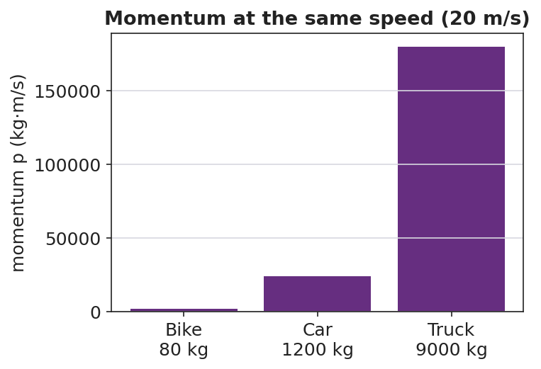
Momentum at the same speed for three vehicles
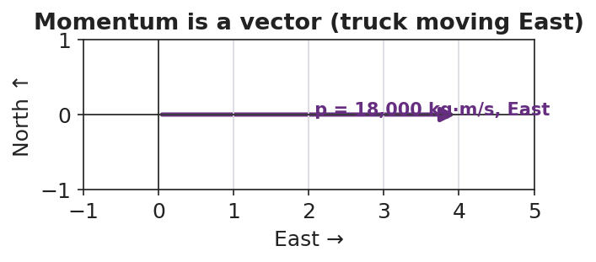
Momentum is a vector pointing the way the object moves

Discussion prompts to deploy here
- “A 1,200 kg car moves East at 20 m/s. Find its momentum and its direction.”
  - Sample student response: “p = 1,200 × 20 = 24,000 kg·m/s, East.”
- “Two objects have the same speed but different momentum. What must be different?”
  - Sample student response: “Their masses — more mass means more momentum at the same speed.”

Phase 4 · Elaborate (37 – 40 min)

37–39 min · Revise the model
“Return to your tennis-ball / bowling-ball ranking. Re-rank them by computing p = m·v for each (use tennis ball = 0.06 kg, bowling ball = 6 kg; gentle = 2 m/s, hard = 8 m/s). Does the math match your gut ranking?”

39–40 min · Return to the phenomenon
“Back to the truck and the bike at the same speed — in one sentence, use p = m·v to say why the truck is the dangerous one.”
Target: “At the same velocity, the truck’s far greater mass gives it far more momentum (p = m·v), so it is much harder to stop.”

Phase 5 · Evaluate (40 – 42 min)

40–42 min · Exit Ticket + Closing Reflection
“A 0.145 kg baseball is pitched West at 40 m/s. (a) Calculate its momentum, with units and direction. (b) A 0.045 kg golf ball is hit at 70 m/s. Show which ball has more momentum. (c) Is momentum a vector or a scalar? Give one reason.”
Expected: (a) p = 0.145 × 40 = 5.8 kg·m/s, West; (b) golf ball = 0.045 × 70 = 3.15 kg·m/s, so the baseball has more; (c) vector, because it has a direction (the same direction as the velocity). See Answer_Key.docx.
Closing Reflection (SEL, 30 seconds):
“What is one idea today that you understand better because of something a classmate said?”

Common Misconceptions
- Misconception: “Heavier always means more momentum.” → Correction: Only if speeds are equal; a light, fast object can out-momentum a heavy, slow one (p = m·v).
- Misconception: “Momentum is the same as speed.” → Correction: Speed ignores mass; momentum = mass × velocity and carries direction.
- Misconception: “Momentum has no direction.” → Correction: Momentum is a vector; it points the way the object moves, so opposite directions get opposite signs.

Access & Differentiation
- ELL/ENL supports: Sentence frame: *“The ___ has more momentum because its ___ (mass / velocity) is larger, so p = m·v is ___.”* Word-choice box: {mass, velocity, momentum, kg·m/s, direction, vector}. Pair momentum with a gesture (two hands pushing forward, “hard to stop”).
- IEP/SPED supports: Provide a pre-built p = m·v table with mass and velocity columns filled in; students compute only the product. Offer the cart demo as a hands-on alternative to the simulation.
- Extensions: Ask students to find a velocity at which a 0.045 kg golf ball would have the same momentum as a 0.145 kg baseball thrown at 40 m/s, and explain the trade-off between mass and speed.

Strategy Spotlight
RESTORATIVE CIRCLE (unit opener). Today’s opening uses a circle to launch the Momentum & Impulse unit. Use a talking piece, one-sentence responses, and equity of voice (everyone speaks or passes). The prompt — something hard to stop once it got going — is chosen so you can call it back in Phase 3 (“that ‘hard to stop’ feeling has a name and a formula: momentum, p = m·v”). Keep the circle to ~2–3 minutes; the goal is community plus a shared metaphor, not a long discussion.

NYSSLS Observation Checklist Crosswalk
# | Checklist item | Where it appears in this lesson
1 | Local/relatable phenomenon | Phase 1 — Newton’s cradle; truck vs. bike
2 | Turn and Talk (2–3×) | Phase 1 (TT#1 — what makes something hard to stop), Phase 3 (TT#2 — write the relationship)
3 | Students develop questions/models/procedures | Phase 1 (initial model), Phase 2 (PhET investigation), Phase 4 (revise model)
4 | CCC defined and used | Lesson Overview · Systems and System Models, restated in Phase 2
5 | ENL — ≤ 3 vocab, second half | Phase 3 — vocabulary at 35–37 min (momentum / mass / velocity)
6 | Revisit phenomenon with evidence | Phase 4 — re-rank with p = m·v; truck-vs-bike answer
7 | ENL/SPED supports | Access & Differentiation block
8 | Assessment check | Phase 5 — Exit Ticket (baseball / golf ball momentum)

Companion Materials
- Student_Worksheet.docx — the 5E student investigation (hand out at start of Phase 2)
- Student_Notes.docx — guided note-guide for vocabulary and the worked example
- Answer_Key.docx — answers to “Make It Make Sense” prompts and the Exit Ticket

Key Vocabulary (max 3)
- momentum — a measure of how hard an object is to stop; p = m·v, a vector measured in kg·m/s
- mass — the amount of matter in an object (kg); one of the two factors that set momentum
- velocity — how fast and in what direction an object moves (m/s); momentum points the same way

Momentum — Student Worksheet
Unit: Momentum & Impulse — Lesson 01 Name: _______________________ Date: __________ Period: ____

Phenomenon
In a Newton’s cradle, one ball swings in and one ball swings out — every time. Then your teacher asks: a dump truck and a bicycle are both rolling at the same speed toward you. You can only step out of the way of one.
Driving question: What makes one moving object harder to stop than another?

Notice & Wonder
I notice… | I wonder…
Turn & Talk #1: What two things seem to decide how hard a moving object is to stop? Use the words mass and speed.

Initial Model
Rank these from easiest to hardest to stop. Then write one sentence explaining the rule you used.
- a tennis ball thrown gently
- a tennis ball thrown hard
- a bowling ball rolled gently
- a bowling ball rolled hard
My ranking: ______________________________________ My rule: __________________________________________

Investigation
Open PhET Collision Lab. Complete each trial and record the momentum the simulation shows.
Trial | Mass (kg) | Velocity (m/s) | Momentum (kg·m/s)
1. Baseline | 1 | 2 (right)
2. Double the mass | 2 | 2 (right)
3. Double the velocity | 1 | 4 (right)
4. Send it left | 1 | 2 (left)
Key questions:
- When you doubled the mass, what happened to the momentum? ______________________
- When you doubled the velocity, what happened to the momentum? ______________________
- What did the negative sign in Trial 4 tell you? ______________________

Make It Make Sense
- A 1,200 kg car moves East at 20 m/s. Calculate its momentum, with units and direction.
- Two carts roll at the same speed, but Cart B has twice the mass of Cart A. How do their momenta compare?
- A golf ball and a baseball are thrown so they have the same momentum. The golf ball is lighter. What must be true about its speed? Explain.

Vocabulary in Action
Use each term in a sentence about today’s phenomenon.
- momentum: _______________________________________________
- mass: _______________________________________________
- velocity: _______________________________________________

Revise Your Model
Return to your tennis-ball / bowling-ball ranking. Compute p = m·v for each (tennis ball = 0.06 kg, bowling ball = 6 kg; gentle = 2 m/s, hard = 8 m/s). Does the math match your gut ranking? Rewrite your rule using p = m·v.

Exit Ticket
A 0.145 kg baseball is pitched West at 40 m/s.
- Calculate its momentum, with units and direction.
- A 0.045 kg golf ball is hit at 70 m/s. Show which ball has more momentum.
- Is momentum a vector or a scalar? Give one reason.

Momentum — Student Notes
Unit: Momentum & Impulse — Lesson 01 Name: _______________________ Date: __________ Period: ____

Learning Targets
By the end of today’s 42 minutes I can:
- Calculate momentum using p = m·v and state its unit, kg·m/s.
- Explain that momentum is a vector that points the way the object moves.
- Predict which of two objects has more momentum when mass or velocity differs.

Key Vocabulary
- momentum — _______________________________________________
- mass — _______________________________________________
- velocity — _______________________________________________

Guided Notes
Big idea: Momentum measures how hard a moving object is to __________.
- Reference-table formula: p = m · ____ .
- Symbol for momentum: __________ . Unit: __________ ( kg·m/s ).
- Momentum grows if you increase the __________ or the __________.
- Momentum is a vector: it points the same direction as the __________.
Sign and direction. If East is positive, an object moving West has a __________ momentum. Two objects with the same speed can have __________ momenta if they move in opposite directions.
Quick proportions. - Double the mass → momentum is __________ as big. - Double the velocity → momentum is __________ as big.


Momentum (p = m·v) compared for objects of different mass at the same speed — more mass means more momentum.

Worked Example
Problem. A 1,200 kg car moves East at 20 m/s. Find its momentum.
Solution. 1. Write the formula: p = m · ____ . 2. Substitute: p = (1,200 kg)(____ m/s). 3. Compute: p = __________ kg·m/s. 4. Direction: __________ (same as the velocity).

Summary
Finish the sentence (Because / But / So):
A truck and a bike can move at the same speed, because __________________________________________, but __________________________________________, so __________________________________________.

Momentum — Answer Key

Cover
Unit: Momentum & Impulse — Lesson 01: Momentum East Meadow Schools × Valley Stream Central HSD Strategy chip: RESTORATIVE CIRCLE

Make-It-Make-Sense Answers
- p = m·v = (1,200 kg)(20 m/s) = 24,000 kg·m/s, East. · Rubric: correct product AND direction (East). · NYSSLS: HS-PS2-2
- Cart B has twice the momentum of Cart A. Same velocity, so momentum is proportional to mass; double the mass → double the momentum. · Rubric: states 2× AND links to p = m·v with equal v. · NYSSLS: HS-PS2-2
- The golf ball must be moving faster. Since p = m·v is the same for both and the golf ball has less mass, its velocity must be larger to make up the difference. · Rubric: “faster” AND reasons from m·v held constant. · NYSSLS: HS-PS2-2

Exit Ticket Answer
- p = m·v = (0.145 kg)(40 m/s) = 5.8 kg·m/s, West.
- Golf ball: p = (0.045 kg)(70 m/s) = 3.15 kg·m/s. Since 5.8 > 3.15, the baseball has more momentum.
- Vector — momentum has a direction (the same direction as the velocity), not just a size.
Tolerance/rubric: (a) 5.8 kg·m/s with unit AND direction West; (b) golf ball 3.15 kg·m/s and correct comparison; (c) “vector” + a direction-based reason. 1 point each. NYSSLS: HS-PS2-2.

Closing Reflection (rubric)
Closing reflection is formative, not graded. Award full credit for any honest response. Look for: - A specific idea the student now understands better - Naming a peer whose comment helped (community-building goal of the opening circle)

Impulse and the Impulse–Momentum Theorem — Teacher Guide

Cover
Unit: Momentum & Impulse — Lesson 02: Impulse and the Impulse–Momentum Theorem East Meadow Schools × Valley Stream Central High School District Strategy chips: HOCHMAN

Curated Resources (from East Meadow Scope & Sequence)

NYSSLS Standards
This lesson is the engineering hinge of the unit, assessed by HS-PS2-3:
HS-PS2-3. “Apply scientific and engineering ideas to design, evaluate, and refine a device that minimizes the force on a macroscopic object during a collision.” (Crosscutting Concept: Cause and Effect)
The impulse–momentum theorem, J = F·Δt = Δp, is the physics that makes that design possible: for a fixed change in momentum, extending the contact time lowers the force. Airbags, crumple zones, and bending your knees on landing all trade time for force. The lesson also reinforces HS-PS2-2 by treating momentum change as the target quantity. Reference-Table relationships: p = m·v and J = F·Δt = Δp.

Phenomenon
- Egg drop onto a pillow vs. a plate — same drop, very different outcome: https://youtu.be/BLRfWtN3SQE
- Slow-motion airbag deployment / crash test: https://youtu.be/yQHDosNQGZk
- Catching a fast ball by pulling your hands back (teacher demo).

Javalab / Labs
- PhET Collision Lab (read force/time intuition by varying elasticity): https://phet.colorado.edu/en/simulations/collision-lab
- Javalab “impulse and momentum”: https://javalab.org/en/impulse_en/

Assessments
- Exit Ticket below (apply J = Δp; explain airbag in terms of Δt and force) is the formative check, scored with the Answer Key rubric.

Lesson Overview
Duration | 42 minutes (1 period)
NYSSLS link | HS-PS2-3 (design to minimize force) · HS-PS2-2 (momentum change)
CCC focus | Cause and Effect — extending contact time causes a smaller force for the same change in momentum.
Strategy chips | HOCHMAN (sentence-level literacy: Because/But/So + appositive on J = F·Δt = Δp)
Materials | Raw eggs, pillow + hard tray (over a tarp); a ball to catch; whiteboards; devices for PhET.
Safety | Egg drop over a covered/washable surface; wear closed-toe shoes; goggles optional.
Prior knowledge | Lesson 01 — momentum p = m·v; Forces — net force changes motion.
Lesson objectives — students can:
- Define impulse and use J = F·Δt = Δp to relate force, time, and change in momentum.
- Explain why extending the contact time reduces the force for a fixed change in momentum.
- Write a Hochman Because/But/So sentence connecting Δt and force in a safety device.

Phase 1 · Engage (0 – 12 min)

0–3 min · Opening Connection (SEL, 30 seconds)
Quick check-in (no circle today): “Thumbs up/middle/down — how ready do you feel after Lesson 01’s momentum formula?” Name that today we use that momentum to explain how airbags save lives.

3–8 min · Phenomenon hook — the egg drop
Teacher actions. Drop one egg onto a hard tray (it breaks) and an identical egg from the same height onto a pillow (it survives). Both eggs hit the surface with the same momentum and end at rest — the same change in momentum.
Sample teacher language:
“Same egg, same height, same speed at the bottom — so the change in momentum is identical. One survives. What was different about the stop?”
Anticipated student responses:
- “The pillow is soft.” — push for why soft helps: “what does soft do to the time of the stop?”
- “The pillow slows it down more gently / over more time.” — capture time; this is the key variable.
- “The hard tray stops it instantly.” — capture short time → big force.

8–12 min · Notice & Wonder + Turn-and-Talk #1
Two columns on the board. Then:
“Turn to your partner: both eggs had the same change in momentum, so what made the force on the egg so different? Use the word time.”
Target insight: the pillow stretches out the stopping time, so the force is smaller.

Bridge to Phase 2
Initial model sentence: “The pillow saves the egg because the stop took ______ time, so the force was ______.”

Phase 2 · Explore (12 – 32 min)

12–17 min · Initial Model (silent / individual)
Prompt on the board:
“Sketch two force-vs-time graphs for the same egg stopping: one on the tray, one on the pillow. Make them have the same total ‘push’ (area) but different shapes. Predict which has the taller spike.”
This surfaces the area-equals-impulse idea before it is named.

17–32 min · Investigation — catching a ball + PhET
Stations / whole-class:
- Catch a thrown ball two ways — once with stiff arms (hands stay still), once by pulling your hands back as you catch. Which sting less? Why?
- PhET Collision Lab — set one ball to hit a wall; compare a fast (elastic) bounce vs. a soft (inelastic) stop; relate the “harder hit” to a shorter interaction time.
- Read the graph — given the force-vs-time graphs below, students shade and compare the area (impulse) under each.
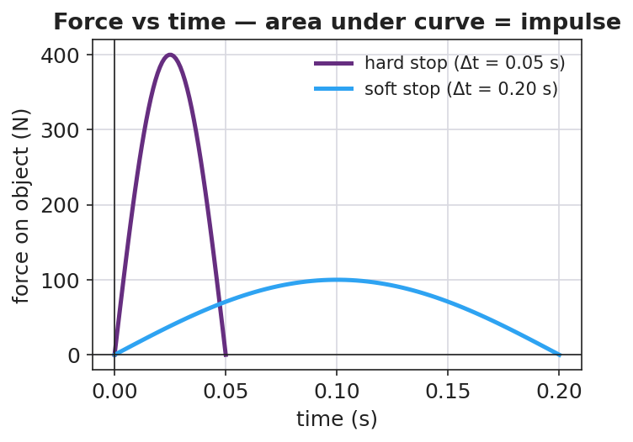
Force vs time for a hard stop and a soft stop (equal area = equal impulse)
Teacher facilitation language:
“When you pulled your hands back, did you change the ball’s momentum by a different amount — or just spread the stop over more time?” “Point to the area under each curve. If the areas are equal, what does that say about the impulse?” “Which graph has the dangerous spike — the tall narrow one or the low wide one?”

Teacher facilitation during Explore
- What to look for — students saying the area (impulse) is the same but the peak force differs.
- What to resist — don’t write J = F·Δt yet; let the graphs and the catch do the teaching.
- What to redirect — students who think the pillow “changes the momentum less” should compare end states: both eggs end at rest, so Δp is identical; only the time differs.

Phase 3 · Explain (32 – 37 min)

32–35 min · Turn-and-Talk #2 + class consensus
“Write a word equation linking force, the time it acts, and the change in momentum.”
Target consensus:
“Force times the time it acts equals the change in momentum. So for a fixed change in momentum, more time means less force.”

35–37 min · Vocabulary introduction (≤ 3 terms)
Sample teacher language:
“That product — force times the time interval it acts — is called impulse, symbol J. The impulse–momentum theorem says J = F·Δt = Δp: impulse equals the change in momentum. Rearranged, F = Δp / Δt — so stretching Δt shrinks the force for the same Δp. That is exactly what an airbag does.”
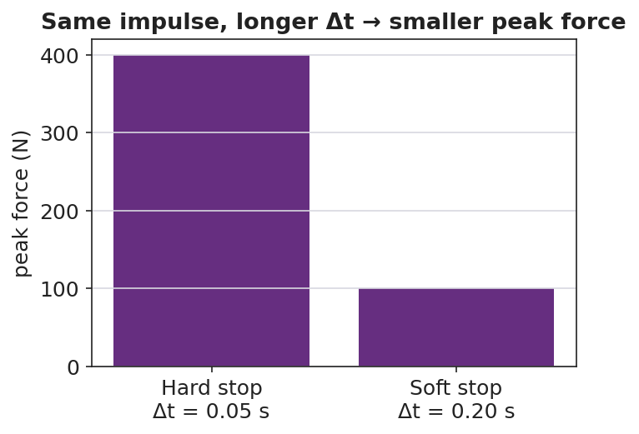
Same impulse, longer contact time gives a smaller peak force

Discussion prompts to deploy here
- “Why do crumple zones make a car safer even though the car is more damaged?”
  - Sample student response: “The crumple stretches out the collision time, so the force on the passengers is smaller (F = Δp/Δt).”
- “A boxer ‘rolls with the punch.’ How does that reduce the force?”
  - Sample student response: “Moving with the glove extends the contact time, so the same impulse delivers less force.”

Phase 4 · Elaborate (37 – 40 min)

37–39 min · Hochman Because/But/So + appositive
Today’s literacy move. On the board:
Sentence expansion. Finish all three for the airbag: “An airbag protects a driver because ______; but ______; so ______.” Appositive. Rewrite this into one sentence with an appositive naming impulse: “Impulse, ______, equals the change in momentum, so a longer contact time means a smaller force.”
Model one aloud, then have students draft. This is the Hochman thin-slice: precise sentences about J = F·Δt = Δp.

39–40 min · Return to the phenomenon
“In one Because/But/So sentence, explain why the egg on the pillow survives.”
Target: “Both eggs have the same change in momentum because they hit at the same speed and stop, but the pillow stretches the stopping time, so the force on the egg is small enough not to break it.”

Phase 5 · Evaluate (40 – 42 min)

40–42 min · Exit Ticket + Closing Reflection
“A 0.5 kg ball moving at 8 m/s is brought to rest. (a) Find the impulse needed to stop it (give units and direction). (b) If a glove stops it in 0.4 s, what average force does the glove apply? If a bare hand stops it in 0.05 s, what force? (c) Use J = F·Δt to explain, in one sentence, why the glove hurts less.”
Expected: (a) J = Δp = m·Δv = 0.5 × (0 − 8) = −4 kg·m/s, i.e. 4 N·s opposite the motion; (b) glove F = 4/0.4 = 10 N; bare hand F = 4/0.05 = 80 N; (c) same impulse over a longer time gives a smaller force. See Answer_Key.docx.
Closing Reflection (SEL, 30 seconds):
“Name one everyday object that secretly uses the impulse–momentum theorem to keep someone safe.”

Common Misconceptions
- Misconception: “A pillow reduces the change in momentum.” → Correction: Δp is the same (the egg still stops); the pillow reduces the force by extending the time.
- Misconception: “Impulse and force are the same thing.” → Correction: Impulse = force × time (J = F·Δt); a small force over a long time can equal a big force over a short time.
- Misconception: “More time means more force.” → Correction: For a fixed impulse, more time means less force (F = Δp/Δt).

Access & Differentiation
- ELL/ENL supports: Provide the Because/But/So frame pre-printed with the airbag context; word-choice box: {impulse, force, time interval, change in momentum, smaller, longer}. Pair impulse with the gesture of catching softly (hands drawing back).
- IEP/SPED supports: Give the force-vs-time graphs pre-shaded so students compare areas rather than draw them; provide the J = F·Δt formula triangle as a rearrangement scaffold.
- Extensions: Have students sketch and justify a force-vs-time graph for a phone dropped onto a rubber case vs. bare floor, predicting which has the larger peak force and why (HS-PS2-3 design link).

Strategy Spotlight
HOCHMAN (sentence-level literacy). Today’s literacy work lives in Phase 4: a Because/But/So sentence expansion and an appositive that names impulse precisely. The Hochman method keeps the writing at the sentence level — students are not writing paragraphs, they are building one accurate, complex sentence about J = F·Δt = Δp. Model one sentence aloud, require the appositive to define the term, and circulate to check that every Because/But/So clause is physically correct (Δp constant, Δt up, F down).

NYSSLS Observation Checklist Crosswalk
# | Checklist item | Where it appears in this lesson
1 | Local/relatable phenomenon | Phase 1 — egg drop; airbag; catching a ball
2 | Turn and Talk (2–3×) | Phase 1 (TT#1 — why the force differs), Phase 3 (TT#2 — word equation)
3 | Students develop questions/models/procedures | Phase 1 (initial model graphs), Phase 2 (catch + PhET), Phase 4 (revise)
4 | CCC defined and used | Lesson Overview · Cause and Effect, restated in Phase 3 (F = Δp/Δt)
5 | ENL — ≤ 3 vocab, second half | Phase 3 — vocabulary at 35–37 min (impulse / force / time interval)
6 | Revisit phenomenon with evidence | Phase 4 — Because/But/So egg-on-pillow sentence
7 | ENL/SPED supports | Access & Differentiation block
8 | Assessment check | Phase 5 — Exit Ticket (glove vs. bare hand force)

Companion Materials
- Student_Worksheet.docx — the 5E student investigation (hand out at start of Phase 2)
- Student_Notes.docx — guided note-guide for vocabulary and the worked example
- Answer_Key.docx — answers to “Make It Make Sense” prompts and the Exit Ticket

Key Vocabulary (max 3)
- impulse — the product of force and the time it acts, J = F·Δt; equals the change in momentum (Δp); unit N·s = kg·m/s
- force — a push or pull (N); for a fixed impulse, a smaller force results from a longer contact time
- time interval — Δt, how long a force acts (s); extending it reduces the force for the same impulse

Impulse and the Impulse–Momentum Theorem — Student Worksheet
Unit: Momentum & Impulse — Lesson 02 Name: _______________________ Date: __________ Period: ____

Phenomenon
Your teacher drops two identical eggs from the same height. One lands on a hard tray and shatters. The other lands on a pillow and survives. Both eggs hit moving at the same speed and end at rest.
Driving question: If both eggs had the same change in momentum, why did only one break?

Notice & Wonder
I notice… | I wonder…
Turn & Talk #1: Both eggs had the same change in momentum. What made the force on each egg so different? Use the word time.

Initial Model
Sketch two force-vs-time graphs for the same egg stopping: one landing on the tray, one on the pillow. Make the total “push” (area under the curve) the same, but the shapes different. Then predict which graph has the taller spike.
(sketch here)
My prediction: the taller spike is the ______ landing, because ______________________

Investigation
Complete each station. Record what you observe and what it tells you.
Station | What I did | What happened | What it tells me
1. Catch ball — stiff arms vs. pulling hands back
2. PhET Collision Lab — hard bounce vs. soft stop
3. Shade the area under each force-vs-time graph
Key questions:
- When you pulled your hands back, did you change the ball’s momentum by a different amount, or just spread the stop over more time? ______________________
- If the two graphs have the same area, what is the same about them? ______________________

Make It Make Sense
- An egg’s change in momentum stopping on a pillow is the same as on a tray. What single quantity does the pillow make bigger, and what does that do to the force?
- A crumple zone makes a car body more damaged in a crash but the people inside safer. Explain using J = F·Δt.
- A 0.5 kg ball moving at 8 m/s is caught and stopped. What impulse is needed to stop it? (Give units.)

Vocabulary in Action
Use each term in a sentence about today’s phenomenon.
- impulse: _______________________________________________
- force: _______________________________________________
- time interval: _______________________________________________

Revise Your Model
Return to your two graphs. Label the area under each as the impulse. Then finish the Because/But/So sentence:
Both eggs have the same change in momentum because ______________________, but ______________________, so ______________________.

Exit Ticket
A 0.5 kg ball moving at 8 m/s is brought to rest.
- Find the impulse needed to stop it (give units and direction).
- If a glove stops it in 0.4 s, what average force does the glove apply? If a bare hand stops it in 0.05 s, what force?
- Use J = F·Δt to explain, in one sentence, why the glove hurts less.

Impulse and the Impulse–Momentum Theorem — Student Notes
Unit: Momentum & Impulse — Lesson 02 Name: _______________________ Date: __________ Period: ____

Learning Targets
By the end of today’s 42 minutes I can:
- Use J = F·Δt = Δp to relate force, time, and change in momentum.
- Explain why a longer contact time means a smaller force for the same change in momentum.
- Write a Because/But/So sentence about a safety device using impulse.

Key Vocabulary
- impulse — _______________________________________________
- force — _______________________________________________
- time interval — _______________________________________________

Guided Notes
Big idea (impulse–momentum theorem): The impulse on an object equals its change in __________.
- Reference-table formula: **J = F · Δt = Δ____** .
- Symbol for impulse: __________ . Unit: N·s, which is the same as __________ .
- Rearranged for force: **F = Δp / Δ____** .
- For a fixed change in momentum: a longer Δt gives a __________ force.
Graph idea. On a force-vs-time graph, the area under the curve equals the __________. - A tall, narrow spike = __________ force, short time. - A low, wide bump = __________ force, long time. - If the two areas are equal, the __________ is equal.
Real devices that stretch Δt: airbag, crumple zone, bending your __________ on landing.


Force vs. time: the area under the curve is the impulse (J = F·Δt). The same impulse can come from a large force over a short time or a small force over a long time.

Worked Example
Problem. A 0.5 kg ball moving at 8 m/s is caught and stopped. Compare the force for a glove (Δt = 0.4 s) and a bare hand (Δt = 0.05 s).
Solution. 1. Impulse needed: J = Δp = m·Δv = (0.5)(0 − 8) = __________ kg·m/s (magnitude 4 N·s). 2. Glove: F = Δp / Δt = 4 / 0.4 = __________ N. 3. Bare hand: F = Δp / Δt = 4 / 0.05 = __________ N. 4. Same impulse, but the glove uses __________ time, so the force is __________.

Summary
Finish the sentence (Because / But / So):
An airbag protects a driver because __________________________________________, but __________________________________________, so __________________________________________.

Impulse and the Impulse–Momentum Theorem — Answer Key

Cover
Unit: Momentum & Impulse — Lesson 02: Impulse and the Impulse–Momentum Theorem East Meadow Schools × Valley Stream Central HSD Strategy chip: HOCHMAN

Make-It-Make-Sense Answers
- The pillow makes the contact time (Δt) bigger. Since J = F·Δt and the impulse (Δp) is fixed, a larger Δt means a smaller force on the egg, so it does not break. · Rubric: identifies Δt increase AND force decrease for fixed impulse. · NYSSLS: HS-PS2-3
- The crumple zone extends the collision time. The change in momentum is set by the crash, so by spreading it over more time the average force on the passengers drops (F = Δp/Δt) — that is what keeps the people safe even though the car is wrecked. · Rubric: links longer Δt → smaller force using J = F·Δt. · NYSSLS: HS-PS2-3
- J = Δp = m·Δv = (0.5 kg)(8 m/s) = 4 kg·m/s (4 N·s), directed opposite the ball’s motion. · Rubric: correct magnitude 4 N·s with unit. · NYSSLS: HS-PS2-2

Exit Ticket Answer
- J = Δp = m·Δv = (0.5 kg)(0 − 8 m/s) = −4 kg·m/s, i.e. 4 N·s opposite the motion.
- Glove: F = Δp/Δt = 4 / 0.4 = 10 N. Bare hand: F = 4 / 0.05 = 80 N.
- The impulse is the same, but the glove spreads it over a longer time, so by F = Δp/Δt the force is smaller — that is why it hurts less.
Tolerance/rubric: (a) 4 N·s with unit AND direction; (b) 10 N and 80 N (allow rounding); (c) “same impulse, longer time, smaller force.” 1 point each. NYSSLS: HS-PS2-3.

Closing Reflection (rubric)
Closing reflection is formative, not graded. Award full credit for any honest, physically reasonable example. Look for: - A real object/device that extends contact time (running shoe, helmet liner, trampoline, bubble wrap, etc.) - An implicit or explicit link to “longer time → smaller force”

Conservation of Momentum — Teacher Guide

Cover
Unit: Momentum & Impulse — Lesson 03: Conservation of Momentum East Meadow Schools × Valley Stream Central High School District Strategy chips: ACTIVE LEARNING

Curated Resources (from East Meadow Scope & Sequence)

NYSSLS Standards
This is the heart of the unit, the lesson the standard is written around:
HS-PS2-2. “Use mathematical representations to support the claim that the total momentum of a system of objects is conserved when there is no net force on the system.” (Crosscutting Concept: Systems and System Models)
Students used p = m·v (L01) and J = F·Δt = Δp (L02); here they combine them across a system. Because the forces two objects exert on each other are an equal-and-opposite pair (Newton’s Third Law), the impulses cancel, so the total momentum before a collision equals the total momentum after when no external net force acts: Σp_before = Σp_after.

Phenomenon
- Two dynamics carts colliding on a track (district anchor demo / video).
- Two ice skaters pushing off each other and gliding apart: https://youtu.be/5Y2bgFkWQqc

Javalab / Labs
- PhET Collision Lab — turn on the “momentum vectors” and “total” readout; verify total stays fixed: https://phet.colorado.edu/en/simulations/collision-lab
- Javalab “conservation of momentum”: https://javalab.org/en/conservation_of_momentum_en/

Assessments
- Exit Ticket below (compute an unknown final velocity using Σp_before = Σp_after) is the formative check, scored with the Answer Key rubric.

Lesson Overview
Duration | 42 minutes (1 period)
NYSSLS link | HS-PS2-2 (core)
CCC focus | Systems and System Models — define the system; when its external net force is zero, total momentum is constant.
Strategy chips | ACTIVE LEARNING (predict-measure-reconcile with carts; PhET station rotation)
Materials | Dynamics carts + track (or low-friction floor), masses, motion sensor or stopwatch + meterstick; rolling chairs / scooter boards (for the push-off); devices for PhET.
Safety | Clear the track path; spotters for any scooter-board push-off; no head-on cart launches toward people.
Prior knowledge | L01 momentum p = m·v (vector, signs); L02 impulse J = Δp; Newton’s Third Law (force pairs).
Lesson objectives — students can:
- State the law of conservation of momentum: a closed system’s total momentum is constant when the external net force is zero.
- Define the system and recognize a collision or push-off as an internal interaction.
- Use Σp_before = Σp_after to solve for an unknown velocity, tracking signs/direction.

Phase 1 · Engage (0 – 12 min)

0–3 min · Opening Connection (SEL, 30 seconds)
Quick partner greeting; name today’s goal: “We’ve measured momentum for one object — today we follow it through a whole system of objects and find something that never changes.”

3–8 min · Phenomenon hook — skaters push apart / carts collide
Teacher actions. Collide two carts of equal mass (one moving, one still) and let students watch the motion transfer. Then show two skaters at rest who push off and glide apart in opposite directions.
Sample teacher language:
“Before they push, the skaters’ total momentum is zero — nobody’s moving. After, both are gliding. Where did that momentum come from — and what’s the total now?”
Anticipated student responses:
- “They got momentum from pushing.” — capture that the push is internal to the system.
- “They go opposite ways.” — capture opposite signs.
- “The total is still zero because the two cancel.” — gold; if no one says it, leave it as the open question.

8–12 min · Notice & Wonder + Turn-and-Talk #1
Two columns on the board. Then:
“Turn to your partner: if the skaters started with zero total momentum, what is the total after they push apart? Use plus and minus signs.”
Target insight: equal and opposite momenta add to zero — the total didn’t change.

Bridge to Phase 2
Initial model sentence: “When the two carts interact, the total momentum of the system ______.”

Phase 2 · Explore (12 – 32 min)

12–17 min · Initial Model (silent / individual)
Prompt on the board:
“Draw two carts before and after a collision. Label each cart’s momentum arrow (size and direction) before and after. Predict: is the total (adding as vectors) the same before and after?”

17–32 min · Investigation — ACTIVE LEARNING: predict, measure, reconcile
Active-learning rotation. Each group predicts first, then measures:
- Equal-mass collision — one cart moving into a still cart of equal mass. Predict final velocities; measure with sensor/stopwatch.
- Unequal-mass collision — load one cart; repeat.
- Push-off — two carts (or students on scooter boards) at rest push apart; measure both speeds.
- PhET check — recreate each in Collision Lab; read the total momentum before and after.
Groups record total momentum before and after in a shared class table.
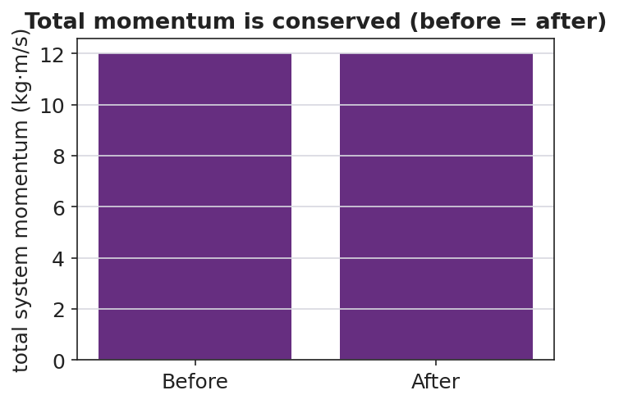
Total system momentum before vs after — equal
Teacher facilitation language:
“What did you predict for the total before you measured? Did the total change after the collision?” “Which momentum is positive and which is negative here? Add them as signed numbers.” “The carts pushed on each other — is that force inside or outside your system?”

Teacher facilitation during Explore
- What to look for — groups finding total before ≈ total after within measurement error.
- What to resist — don’t announce “conservation” until Phase 3; let the class data table reveal it.
- What to redirect — groups who say momentum “disappeared” in the push-off should add the signed values; opposite directions cancel to the original total.

Phase 3 · Explain (32 – 37 min)

32–35 min · Turn-and-Talk #2 + class consensus
“Look at the class data table. Write one sentence about the total momentum before vs. after every interaction.”
Target consensus:
“The total momentum of the system was the same before and after, as long as nothing from outside pushed on it.”

35–37 min · Vocabulary introduction (≤ 3 terms)
Sample teacher language:
“When we add up the momenta of every object we are tracking, that group is the system. A collision (or push-off) is an interaction inside the system. The law of conservation of momentum says: if the external net force on the system is zero, the total momentum is constant — Σp_before = Σp_after.”
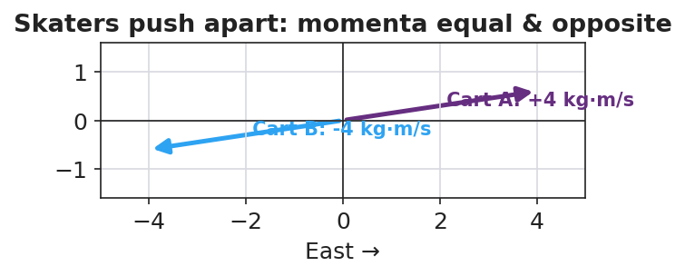
Skaters push apart: equal and opposite momenta sum to zero

Discussion prompts to deploy here
- “Why must we include both skaters in the system for the total to stay constant?”
  - Sample student response: “Because the push is internal; if we only watched one skater, an outside force (the other skater) acts on it.”
- “What outside force could break conservation on a real cart track?”
  - Sample student response: “Friction or a hand — those are external net forces.”

Phase 4 · Elaborate (37 – 40 min)

37–39 min · Revise the model
“Return to your before/after cart drawing. Write Σp_before = Σp_after with the actual signed momentum values. If one number was unknown, solve for it.”

39–40 min · Return to the phenomenon
“In one sentence, explain why the two skaters glide apart at different speeds if one is heavier — using conservation of momentum.”
Target: “Their momenta must stay equal and opposite to keep the total at zero, so the heavier skater moves slower (smaller v for larger m at equal p).”

Phase 5 · Evaluate (40 – 42 min)

40–42 min · Exit Ticket + Closing Reflection
“A 2 kg cart moving East at 3 m/s collides with a 1 kg cart at rest, and they stick together. (a) Find the total momentum of the system before the collision. (b) After they stick, what is the combined mass, and what is their velocity? (c) State the condition under which momentum is conserved.”
Expected: (a) Σp = (2)(3) + (1)(0) = 6 kg·m/s East; (b) combined mass 3 kg, v = 6/3 = 2 m/s East; (c) when the external net force on the system is zero (a closed/isolated system). See Answer_Key.docx.
Closing Reflection (SEL, 30 seconds):
“Whose prediction in your group was closest today, and what did you learn from comparing predictions to data?”

Common Misconceptions
- Misconception: “Momentum disappears in a push-off because it started at zero.” → Correction: Equal-and-opposite momenta add (as signed vectors) to the original total — still zero; nothing disappeared.
- Misconception: “The bigger object always ends up faster.” → Correction: For equal-and-opposite momenta, the larger mass moves slower (p = m·v).
- Misconception: “Momentum is always conserved, no matter what.” → Correction: Only when the external net force on the system is zero; friction or an outside push breaks it.

Access & Differentiation
- ELL/ENL supports: Sentence frame: *“The total momentum is the ___ before and after because the ___ force on the system is ___.”* Word-choice box: {system, collision, conservation of momentum, external, zero, equal}. Color-code East (+) and West (−) on the board.
- IEP/SPED supports: Provide the before/after table pre-labeled with mass and velocity columns; students fill momentum and the total only. Offer the PhET total-momentum readout as a check so the algebra is supported.
- Extensions: Have students predict and then verify the recoil speed of a “rocket” cart that ejects a mass, framing the ejected mass as part of the system.

Strategy Spotlight
ACTIVE LEARNING (predict–measure–reconcile). Today’s investigation is a structured active-learning rotation: every group commits to a prediction before each trial, then measures, then reconciles the gap. The cognitive work is in the reconciliation — students confront whether the total momentum really stayed constant. Keep groups accountable by collecting predictions in writing first, and build the shared class data table so the conservation pattern emerges from their numbers rather than from you. The closing reflection deliberately asks about prediction-vs-data to reinforce the move.

NYSSLS Observation Checklist Crosswalk
# | Checklist item | Where it appears in this lesson
1 | Local/relatable phenomenon | Phase 1 — colliding carts; skaters pushing apart
2 | Turn and Talk (2–3×) | Phase 1 (TT#1 — total after push-off), Phase 3 (TT#2 — total before vs. after)
3 | Students develop questions/models/procedures | Phase 1 (initial model), Phase 2 (predict-measure rotation), Phase 4 (revise)
4 | CCC defined and used | Lesson Overview · Systems and System Models, restated in Phase 2 (internal vs. external force)
5 | ENL — ≤ 3 vocab, second half | Phase 3 — vocabulary at 35–37 min (system / collision / conservation of momentum)
6 | Revisit phenomenon with evidence | Phase 4 — Σp_before = Σp_after with class data; heavier-skater answer
7 | ENL/SPED supports | Access & Differentiation block
8 | Assessment check | Phase 5 — Exit Ticket (stick-together collision)

Companion Materials
- Student_Worksheet.docx — the 5E student investigation (hand out at start of Phase 2)
- Student_Notes.docx — guided note-guide for vocabulary and the worked example
- Answer_Key.docx — answers to “Make It Make Sense” prompts and the Exit Ticket

Key Vocabulary (max 3)
- conservation of momentum — the total momentum of a system stays constant when the external net force on it is zero: Σp_before = Σp_after
- system — the set of objects whose momenta we add together; interactions inside it are internal forces
- collision — an interaction in which objects exert forces on each other for a short time (a push-off counts)

Conservation of Momentum — Student Worksheet
Unit: Momentum & Impulse — Lesson 03 Name: _______________________ Date: __________ Period: ____

Phenomenon
Two ice skaters stand still, facing each other, then push off. Both glide away in opposite directions. On a cart track, a moving cart hits a still cart and the motion transfers.
Driving question: When two objects interact, what happens to the total momentum of the system?

Notice & Wonder
I notice… | I wonder…
Turn & Talk #1: The skaters started with zero total momentum. What is the total after they push apart? Use plus and minus signs.

Initial Model
Draw two carts before and after a collision. Label each cart’s momentum arrow (size and direction) in both pictures. Predict: adding as vectors, is the total the same before and after?
(sketch here)
My prediction: ___________________________________

Investigation
You will predict first, then measure. Record the total momentum (add signed values) before and after each interaction.
Interaction | Predicted total before | Measured total before | Measured total after
1. Equal-mass collision
2. Unequal-mass collision
3. Push-off (start at rest)
4. PhET check
Key questions:
- Did the total momentum change after each interaction? ______________________
- The carts pushed on each other — was that force inside or outside your system? ______________________

Make It Make Sense
- Two skaters at rest push apart. The total before is zero. Explain why the total after is also zero, even though both are now moving.
- A 2 kg cart moving at 3 m/s East hits a still 1 kg cart and they stick. What outside force, if present, would stop momentum from being conserved?
- If two skaters of different mass push apart, which one moves faster? Justify with p = m·v and the idea that the total stays zero.

Vocabulary in Action
Use each term in a sentence about today’s phenomenon.
- conservation of momentum: _______________________________________________
- system: _______________________________________________
- collision: _______________________________________________

Revise Your Model
Return to your before/after cart drawing. Write Σp_before = Σp_after using your actual signed momentum values. If one value was unknown, solve for it here.
Σp_before = ____________________ = Σp_after = ____________________

Exit Ticket
A 2 kg cart moving East at 3 m/s collides with a 1 kg cart at rest, and they stick together.
- Find the total momentum of the system before the collision.
- After they stick, what is the combined mass, and what is their velocity?
- State the condition under which momentum is conserved.

Conservation of Momentum — Student Notes
Unit: Momentum & Impulse — Lesson 03 Name: _______________________ Date: __________ Period: ____

Learning Targets
By the end of today’s 42 minutes I can:
- State the law of conservation of momentum and the condition it requires.
- Define the system and identify a collision or push-off as an internal interaction.
- Use Σp_before = Σp_after to solve for an unknown velocity.

Key Vocabulary
- conservation of momentum — _______________________________________________
- system — _______________________________________________
- collision — _______________________________________________

Guided Notes
Big idea (conservation of momentum): The total momentum of a system stays __________ when the external net force on it is __________.
- Equation: Σp_before = Σp________ .
- The system is the set of objects whose momenta we __________ together.
- Forces the objects exert on each other are __________ forces; they come in equal-and-opposite pairs (Newton’s Third Law), so their impulses __________.
- Conservation breaks if an __________ net force (like friction or a hand) acts on the system.
Signs and direction. Momentum is a vector, so always add __________ values. If East is +, a momentum pointing West is __________.
Push-off from rest. Total before = 0, so total after must also = ____ . The two objects get __________ and opposite momenta.


Total momentum of the system before and after a collision is equal — momentum is conserved when no net external force acts.

Worked Example
Problem. A 2 kg cart moving East at 3 m/s collides with a 1 kg cart at rest and they stick together. Find their final velocity.
Solution. 1. Total before: Σp = (2)(3) + (1)(0) = __________ kg·m/s East. 2. After sticking, combined mass = __________ kg. 3. Conservation: Σp_before = Σp_after → 6 = (3)(v). 4. Solve: v = __________ m/s, directed __________.

Summary
Finish the sentence (Because / But / So):
Two skaters who push apart both start at rest because __________________________________________, but __________________________________________, so __________________________________________.

Conservation of Momentum — Answer Key

Cover
Unit: Momentum & Impulse — Lesson 03: Conservation of Momentum East Meadow Schools × Valley Stream Central HSD Strategy chip: ACTIVE LEARNING

Make-It-Make-Sense Answers
- The two skaters get equal and opposite momenta. Added as signed vectors, +p and −p sum to zero, the same total they started with — so the total is conserved even though both are now moving. · Rubric: states equal-and-opposite AND that they sum to the original zero. · NYSSLS: HS-PS2-2
- Friction (or anyone touching/pushing the carts) — any external net force on the system would prevent momentum from being conserved. · Rubric: names an external force; “friction” or “an outside push” accepted. · NYSSLS: HS-PS2-2
- The lighter skater moves faster. Their momenta have equal magnitude (to keep the total zero), and since p = m·v, the smaller mass needs a larger velocity for the same p. · Rubric: “lighter is faster” AND reasons from equal p with p = m·v. · NYSSLS: HS-PS2-2

Exit Ticket Answer
- Σp_before = (2 kg)(3 m/s) + (1 kg)(0) = 6 kg·m/s, East.
- Combined mass = 2 + 1 = 3 kg. Conservation: 6 = (3)(v) → v = 2 m/s, East.
- Momentum is conserved when the external net force on the system is zero (a closed/isolated system).
Tolerance/rubric: (a) 6 kg·m/s East; (b) 3 kg and 2 m/s East; (c) “external net force = zero” / “isolated system.” 1 point each. NYSSLS: HS-PS2-2.

Closing Reflection (rubric)
Closing reflection is formative, not graded. Award full credit for any honest response. Look for: - A specific comparison of a prediction to measured data - A statement of what the prediction-vs-data gap taught them (active-learning goal)

Collisions: Elastic and Inelastic — Teacher Guide

Cover
Unit: Momentum & Impulse — Lesson 04: Collisions: Elastic and Inelastic East Meadow Schools × Valley Stream Central High School District Strategy chips: BTC

Curated Resources (from East Meadow Scope & Sequence)

NYSSLS Standards
This closing lesson connects conservation to energy and to engineering design:
HS-PS2-2. “Use mathematical representations to support the claim that the total momentum of a system of objects is conserved when there is no net force on the system.” (Systems and System Models)
HS-PS2-3. “Apply scientific and engineering ideas to design, evaluate, and refine a device that minimizes the force on a macroscopic object during a collision.” (Cause and Effect)
Momentum is conserved in every collision (HS-PS2-2). What distinguishes collision types is kinetic energy: in an elastic collision KE is conserved; in an inelastic collision some KE is converted to heat, sound, and deformation (a perfectly inelastic collision is one where the objects stick together). Recognizing that inelastic collisions absorb energy is the physics behind crumple zones and helmets (HS-PS2-3). Reference-Table relationships in play: p = m·v, J = F·Δt = Δp, and KE = ½mv².

Phenomenon
- Newton’s cradle (≈ elastic — balls bounce, motion passes through): https://youtu.be/2UHS883_P60
- Two balls of clay thrown together and sticking (perfectly inelastic) — teacher demo.

Javalab / Labs
- PhET Collision Lab — the elasticity slider (0 % = perfectly inelastic/stick, 100 % = elastic); watch the KE bar vs. the momentum bar: https://phet.colorado.edu/en/simulations/collision-lab
- Javalab “elastic and inelastic collision”: https://javalab.org/en/collision_en/

Assessments
- Exit Ticket below (classify a collision; argue momentum conserved but KE not) is the formative check, scored with the Answer Key rubric.

Lesson Overview
Duration | 42 minutes (1 period)
NYSSLS link | HS-PS2-2 (momentum conserved in both) · HS-PS2-3 (energy absorption → safety design)
CCC focus | Cause and Effect — what causes kinetic energy to be lost, and how engineers use that.
Strategy chips | BTC (Building Thinking Classrooms: visibly random groups + vertical non-permanent surfaces)
Materials | Newton’s cradle; modeling clay; two superballs; whiteboards/VNPS around the room; deck of cards for random grouping; devices for PhET.
Safety | Throw clay only at the designated target; keep cradle clear of edges.
Prior knowledge | L01 p = m·v; L03 conservation of momentum; Energy unit — KE = ½mv².
Lesson objectives — students can:
- Distinguish elastic from inelastic collisions by whether kinetic energy is conserved.
- Argue that momentum is conserved in both collision types, while KE is conserved only in elastic ones.
- Identify a perfectly inelastic collision (objects stick) and connect energy absorption to safety design.

Phase 1 · Engage (0 – 12 min)

0–3 min · Opening Connection (SEL, 30 seconds) + BTC random groups
Form visibly random groups (deal cards) and send each to a vertical non-permanent surface (VNPS). Name today’s goal: “Two collisions both conserve momentum, but only one bounces back full of life — let’s find what’s different.”

3–8 min · Phenomenon hook — Newton’s cradle vs. clay
Teacher actions. Run the Newton’s cradle (balls click and pass motion cleanly). Then press two clay balls together so they stick and stop with a dull thud.
Sample teacher language:
“Both collisions kept momentum — we proved that last lesson. But listen: the cradle clicks and keeps bouncing; the clay goes thud and stops. Where did the clay’s motion energy go?”
Anticipated student responses:
- “The clay squished.” — capture deformation (energy went into changing shape).
- “It made a thud — sound.” — capture sound / heat.
- “The cradle didn’t lose energy.” — capture the elastic case.

8–12 min · Notice & Wonder + Turn-and-Talk #1
Two columns on the board. Then:
“Turn to your group: momentum is conserved in both. So what is different between the bouncy cradle and the sticky clay? Use the word energy.”
Target insight: the clay loses kinetic energy (to heat/sound/squish); the cradle keeps it.

Bridge to Phase 2
Initial model sentence: “Both collisions conserve momentum, but they differ in whether ______ is conserved.”

Phase 2 · Explore (12 – 32 min)

12–17 min · Initial Model (at the VNPS, as a group)
Prompt:
“At your board, draw before/after for the cradle and for the clay. Predict for each: is momentum conserved? Is kinetic energy conserved? Defend your prediction.”

17–32 min · Investigation — BTC thin-slice at the VNPS
The thin-slice problem, posed in escalating steps at the vertical surfaces (BTC):
- Compute momentum before and after for a given elastic collision (superballs) — confirm it’s conserved.
- Compute kinetic energy (KE = ½mv²) before and after the same elastic collision — is it conserved?
- Repeat both computations for a perfectly inelastic collision (clay sticks): a 2 kg ball at 4 m/s hits a 2 kg ball at rest and they move off together.
- PhET check — slide elasticity 100 % → 0 % and watch the KE bar drop while the total momentum bar stays fixed.
Groups graph their before/after results:
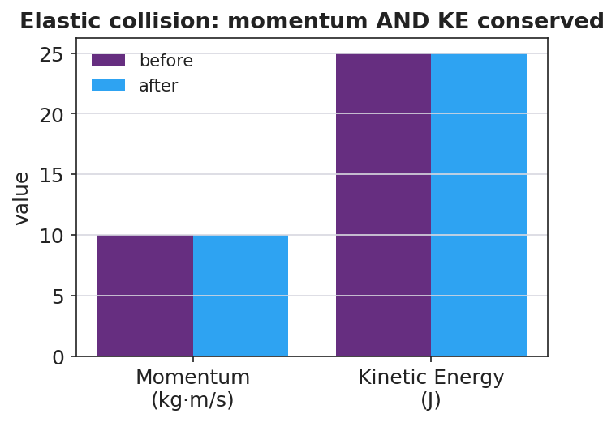
Elastic collision: momentum AND kinetic energy conserved
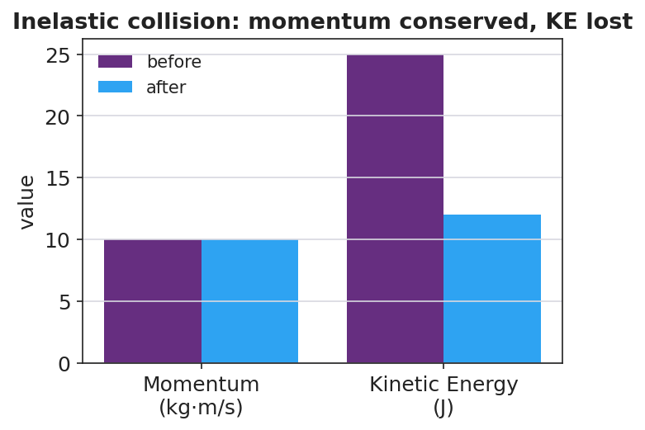
Inelastic collision: momentum conserved, kinetic energy lost
Teacher facilitation language (BTC — keep them thinking):
“Where did the missing kinetic energy go? It didn’t vanish — name three places.” “Is the momentum bar different before and after? Is the energy bar different?” “Build the next question for the group next to you.”

Teacher facilitation during Explore
- What to look for — groups finding momentum conserved in both, but KE lower after the inelastic collision.
- What to resist — don’t pre-label “elastic / inelastic”; let the KE numbers force the distinction.
- What to redirect — groups who think momentum is also lost in the clay collision should re-add signed momenta; only KE drops.

Phase 3 · Explain (32 – 37 min)

32–35 min · Turn-and-Talk #2 + class consensus
“Across both collisions, what was always conserved, and what was only sometimes conserved?”
Target consensus:
“Momentum was conserved in both collisions. Kinetic energy was conserved only in the bouncy one; in the sticky one some KE turned into heat, sound, and deformation.”

35–37 min · Vocabulary introduction (≤ 3 terms)
Sample teacher language:
“A collision where kinetic energy is conserved is elastic — like the cradle. A collision where kinetic energy is not conserved is inelastic; if the objects stick together it’s perfectly inelastic — like the clay. Momentum is conserved in both — only the energy bookkeeping changes.”
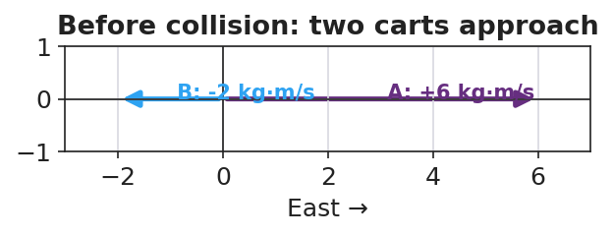
Before a collision: two carts approach with opposite momenta

Discussion prompts to deploy here
- “A car crash where the bumpers lock is which type? Where does the KE go?”
  - Sample student response: “Perfectly inelastic — KE goes into bending metal (deformation), heat, and sound.”
- “Why is an inelastic crumple zone safer than a perfectly elastic bumper?”
  - Sample student response: “It absorbs kinetic energy and extends the time, so less force reaches the passengers (HS-PS2-3).”

Phase 4 · Elaborate (37 – 40 min)

37–39 min · Revise the model
“Return to your VNPS before/after drawings. Label each collision elastic or inelastic, and annotate where any lost kinetic energy went. Confirm momentum is conserved in both with the numbers.”

39–40 min · Return to the phenomenon
“In one sentence, explain why the clay ‘thud’ and the cradle ‘click’ both conserve momentum but only one conserves kinetic energy.”
Target: “Both conserve momentum because no outside net force acts, but the clay is inelastic — its kinetic energy converts to heat, sound, and deformation — while the cradle is nearly elastic and keeps its kinetic energy.”

Phase 5 · Evaluate (40 – 42 min)

40–42 min · Exit Ticket + Closing Reflection
“A 2 kg ball moving at 4 m/s strikes a 2 kg ball at rest. They stick and move off together. (a) Find their combined velocity using conservation of momentum. (b) Compute the kinetic energy before and after. Is KE conserved? (c) Is this collision elastic or inelastic? Justify with your numbers, and name where the missing energy went.”
Expected: (a) Σp = (2)(4) = 8 = (4)(v) → v = 2 m/s; (b) KE_before = ½(2)(4²) = 16 J, KE_after = ½(4)(2²) = 8 J — not conserved; (c) inelastic (perfectly inelastic, they stick); missing 8 J went to heat, sound, and deformation. See Answer_Key.docx.
Closing Reflection (SEL, 30 seconds):
“What idea got clearer for you when you saw it written on the board by your group instead of in a notebook?”

Common Misconceptions
- Misconception: “Momentum is lost when objects stick together.” → Correction: Momentum is conserved in every collision with no external net force; only kinetic energy is lost in an inelastic one.
- Misconception: “Lost kinetic energy is destroyed.” → Correction: It is converted — to heat, sound, and deformation; total energy is still conserved.
- Misconception: “Elastic just means stretchy/bouncy in general.” → Correction: In physics, elastic specifically means kinetic energy is conserved in the collision.

Access & Differentiation
- ELL/ENL supports: Sentence frame: “This collision is ___ because the kinetic energy ___ conserved, but the momentum ___ conserved.” Word-choice box: {elastic, inelastic, kinetic energy, conserved, momentum, heat}. Pair elastic with a bounce gesture, inelastic with a “splat.”
- IEP/SPED supports: Provide the KE = ½mv² and p = m·v formulas with one worked substitution shown; students complete the parallel one. Offer a pre-built two-bar (momentum/energy) chart to fill rather than draw.
- Extensions: Have students design and justify a collision device (egg car / crumple bumper) that maximizes energy absorbed and extends Δt, citing HS-PS2-3 — then predict whether their device makes the collision more or less elastic.

Strategy Spotlight
BTC (Building Thinking Classrooms). Today uses two core BTC moves: visibly random groups (deal cards so students cannot self-sort) and vertical non-permanent surfaces (whiteboards on the walls). The investigation is a thin-slice sequence — momentum first, then energy, then a sticking case — posed in small escalating steps so every group can start and the cognitive load rises gradually. Keep yourself mobile, answer questions with questions (“where did the energy go?”), and have groups build the next question for a neighboring group. The closing reflection asks about the public-board experience to reinforce the practice.

NYSSLS Observation Checklist Crosswalk
# | Checklist item | Where it appears in this lesson
1 | Local/relatable phenomenon | Phase 1 — Newton’s cradle vs. sticking clay
2 | Turn and Talk (2–3×) | Phase 1 (TT#1 — what’s different), Phase 3 (TT#2 — always vs. sometimes conserved)
3 | Students develop questions/models/procedures | Phase 1 (initial model at VNPS), Phase 2 (BTC thin-slice), Phase 4 (revise)
4 | CCC defined and used | Lesson Overview · Cause and Effect, restated in Phase 3 (where KE goes)
5 | ENL — ≤ 3 vocab, second half | Phase 3 — vocabulary at 35–37 min (elastic / inelastic / kinetic energy)
6 | Revisit phenomenon with evidence | Phase 4 — label collisions + annotate energy on the VNPS
7 | ENL/SPED supports | Access & Differentiation block
8 | Assessment check | Phase 5 — Exit Ticket (stick-together: momentum vs. KE)

Companion Materials
- Student_Worksheet.docx — the 5E student investigation (hand out at start of Phase 2)
- Student_Notes.docx — guided note-guide for vocabulary and the worked example
- Answer_Key.docx — answers to “Make It Make Sense” prompts and the Exit Ticket

Key Vocabulary (max 3)
- elastic collision — a collision in which kinetic energy is conserved (e.g. a Newton’s cradle); momentum is conserved too
- inelastic collision — a collision in which kinetic energy is not conserved (some becomes heat/sound/deformation); momentum is still conserved. Perfectly inelastic = objects stick together
- kinetic energy — the energy of motion, KE = ½mv²; the quantity that distinguishes elastic from inelastic collisions

Collisions: Elastic and Inelastic — Student Worksheet
Unit: Momentum & Impulse — Lesson 04 Name: _______________________ Date: __________ Period: ____

Phenomenon
A Newton’s cradle clicks and the motion passes cleanly through — it keeps bouncing. Two balls of clay are pressed together and stop with a dull thud. Both collisions conserved momentum (you proved that last lesson).
Driving question: If both collisions conserve momentum, what is different between the bouncy one and the sticky one?

Notice & Wonder
I notice… | I wonder…
Turn & Talk #1: Momentum is conserved in both. What is different between the cradle and the clay? Use the word energy.

Initial Model
At your board, draw before/after for the cradle and for the clay. For each, predict: is momentum conserved? Is kinetic energy conserved? Defend your prediction.
Cradle — momentum: ______ kinetic energy: ______ Clay — momentum: ______ kinetic energy: ______ My reason: ___________________________________

Investigation
Work the thin-slice at your vertical board. Record before/after values.
Step | Momentum before | Momentum after | KE before | KE after
1–2. Elastic (superballs)
3. Inelastic — 2 kg @ 4 m/s hits 2 kg at rest, they stick
4. PhET: slide elasticity 100 % → 0 %
Key questions:
- Was momentum the same before and after in both collisions? ______________________
- Was kinetic energy the same before and after in both? ______________________
- Where did any missing kinetic energy go? Name three places. ______________________

Make It Make Sense
- Two balls of clay collide and stick. Momentum is conserved but kinetic energy is not. Where did the missing kinetic energy go?
- A car crash where the bumpers lock together is which type of collision? Justify.
- Why is an inelastic crumple zone safer for passengers than a perfectly elastic bumper that bounces back? (Hint: energy absorbed and contact time.)

Vocabulary in Action
Use each term in a sentence about today’s phenomenon.
- elastic collision: _______________________________________________
- inelastic collision: _______________________________________________
- kinetic energy: _______________________________________________

Revise Your Model
Return to your before/after drawings. Label each collision elastic or inelastic, annotate where any lost kinetic energy went, and confirm with numbers that momentum is conserved in both.

Exit Ticket
A 2 kg ball moving at 4 m/s strikes a 2 kg ball at rest. They stick and move off together.
- Find their combined velocity using conservation of momentum.
- Compute the kinetic energy before and after. Is kinetic energy conserved?
- Is this collision elastic or inelastic? Justify with your numbers, and name where the missing energy went.

Collisions: Elastic and Inelastic — Student Notes
Unit: Momentum & Impulse — Lesson 04 Name: _______________________ Date: __________ Period: ____

Learning Targets
By the end of today’s 42 minutes I can:
- Distinguish elastic from inelastic collisions by whether kinetic energy is conserved.
- Explain that momentum is conserved in both types of collision.
- Identify a perfectly inelastic collision and connect energy absorption to safety design.

Key Vocabulary
- elastic collision — _______________________________________________
- inelastic collision — _______________________________________________
- kinetic energy — _______________________________________________

Guided Notes
Big idea: Momentum is conserved in __________ collisions. Kinetic energy is conserved only in __________ collisions.
- Kinetic energy formula: KE = ½ m ____² .
- Elastic collision: KE is __________ (e.g. a Newton’s cradle).
- Inelastic collision: KE is __________ ; the lost energy becomes __________, sound, and deformation.
- Perfectly inelastic collision: the objects __________ together and move as one.
Bookkeeping check. In every collision with no external net force: - Σp_before ____ Σp_after (always true) - KE_before = KE_after only if the collision is __________.
Engineering link (HS-PS2-3). Crumple zones and helmets are designed to be __________ — they absorb kinetic energy and extend Δt, reducing the __________ on people.


In an elastic collision both momentum and kinetic energy are conserved; in an inelastic collision momentum is conserved but kinetic energy is not.

Worked Example
Problem. A 2 kg ball moving at 4 m/s strikes a 2 kg ball at rest. They stick together. Find the final velocity, then check kinetic energy.
Solution. 1. Momentum before: Σp = (2)(4) + (2)(0) = __________ kg·m/s. 2. After sticking, combined mass = __________ kg → 8 = (4)(v) → v = __________ m/s. 3. KE before = ½(2)(4²) = __________ J. 4. KE after = ½(4)(2²) = __________ J. 5. KE __________ conserved → the collision is __________.

Summary
Finish the sentence (Because / But / So):
Sticking clay and a Newton’s cradle both conserve momentum because __________________________________________, but __________________________________________, so __________________________________________.

Collisions: Elastic and Inelastic — Answer Key

Cover
Unit: Momentum & Impulse — Lesson 04: Collisions: Elastic and Inelastic East Meadow Schools × Valley Stream Central HSD Strategy chip: BTC

Make-It-Make-Sense Answers
- The missing kinetic energy is converted to heat, sound, and deformation (the clay squishing). It is not destroyed — total energy is conserved — but it is no longer kinetic. · Rubric: names at least two of heat/sound/deformation AND says energy is converted, not lost. · NYSSLS: HS-PS2-2
- Inelastic (perfectly inelastic, since the bumpers lock and the cars move together). Kinetic energy is lost to bending metal, heat, and sound; momentum is still conserved. · Rubric: “inelastic” AND a justification about KE loss / sticking. · NYSSLS: HS-PS2-2
- The inelastic crumple zone absorbs kinetic energy and extends the contact time, so the force on the passengers is smaller (F = Δp/Δt). A perfectly elastic bumper would bounce the car back, giving a larger change in momentum and a bigger force. · Rubric: links energy absorption AND longer Δt → smaller force. · NYSSLS: HS-PS2-3

Exit Ticket Answer
- Σp = (2 kg)(4 m/s) + (2 kg)(0) = 8 kg·m/s = (4 kg)(v) → v = 2 m/s (same direction as the first ball).
- KE_before = ½(2)(4²) = 16 J. KE_after = ½(4)(2²) = 8 J. KE is not conserved (16 J → 8 J).
- Inelastic (perfectly inelastic — they stick). The numbers show momentum conserved but KE halved; the missing 8 J went to heat, sound, and deformation.
Tolerance/rubric: (a) v = 2 m/s; (b) 16 J before, 8 J after, “not conserved”; (c) “inelastic/perfectly inelastic” + names where the 8 J went. 1 point each. NYSSLS: HS-PS2-2, HS-PS2-3.

Closing Reflection (rubric)
Closing reflection is formative, not graded. Award full credit for any honest response. Look for: - A specific idea that became clearer through working at the public vertical board - Acknowledgment of a groupmate’s contribution (BTC collaboration goal)

Work, Energy & Power — Unit Plan

Cover
Unit: Work, Energy & Power East Meadow Schools × Valley Stream Central High School District 6 lessons · ~6 instructional periods (42 min each) Format: DOCX (Teacher Guide · Student Worksheet · Student Notes · Answer Key per lesson)

Unit Scope (from East Meadow Scope & Sequence)
This unit develops energy as the unifying currency of physics. It builds on Forces (work is done by a force through a displacement) and Kinematics (speed and height), and it sets up later units on momentum, electricity, and thermodynamics. Students first quantify the transfer of energy (work, power), then the two macroscopic stores of mechanical energy (kinetic = motion, potential = position), then the law that ties them together (conservation), and finally apply it all to real energy-conversion devices (efficiency and engineering design).
# | Lesson | Core idea
01 | Work | W = F·d; only the force component along the displacement does work; the joule
02 | Power | P = W/t = Fv; the watt; same work faster = more power
03 | Kinetic Energy | KE = ½mv²; energy of motion depends on v²
04 | Gravitational Potential Energy | PE = mgh; stored energy relative to a reference height
05 | Conservation of Energy | Mechanical energy KE + PE is constant without friction; PE ↔ KE
06 | Energy in Systems: Wheels to Watts | Energy transfer, useful vs. wasted, efficiency = useful ÷ input; design/refine a converter
Reference-table formulas used this unit: W = F·d; P = W/t = Fv; KE = ½mv²; PE = mgh; g ≈ 9.81 m/s².

Pacing Calendar
Day | Lesson | Phenomenon anchor | Strategy
1 | 01 Work | Lifting vs. carrying a heavy backpack | Hochman
2 | 02 Power | Two students climbing stairs at different speeds (stair-climb lab) | Active Learning
3 | 03 Kinetic Energy | Car stopping distance vs. speed | BTC
4 | 04 Gravitational PE | Roller-coaster lift hill / water tower (Javalab) | Hochman
5 | 05 Conservation of Energy | Skate park / pendulum / coaster (PhET + Javalab) | Active Learning
6 | 06 Energy in Systems (Wheels to Watts) | Regenerative braking / bike generator | BTC (NYS Investigation)
Double-period days (every other day) let the stair-climb lab (Lesson 02), the PhET exploration (Lesson 05), and the build-and-refine investigation (Lesson 06) run long.

Strategy Rotation
- HOCHMAN (literacy): Lessons 01, 04 — appositive definitions and Because/But/So on W = F·d (the zero-work case) and PE = mgh (the reference-height idea).
- ACTIVE LEARNING: Lessons 02, 05 — the stair-climb personal-power lab and the PhET Energy Skate Park predict-and-test with student-read energy bar graphs.
- BTC (Building Thinking Classrooms): Lessons 03, 06 — random groups + vertical non-permanent surfaces on the thin-sliced KE = ½mv² (v² discovery) and the Wheels-to-Watts design-and-refine task.
SEL (Opening Connection + Closing Reflection), ELL/SPED supports, and a Curated Resources block appear in every lesson.

NYSSLS Coverage Matrix
PE | Description | Lessons
HS-PS3-1 | Create a computational model to calculate the change in energy of one component in a system when the change in energy of the other component(s) and energy flows in/out are known (Systems and System Models) | 01 (foundation), 02, 05 (core), 06
HS-PS3-2 | Energy at the macroscopic scale = energy of motion of particles + energy of relative positions (Energy and Matter) | 03 (motion), 04 (position), 05 (synthesis)
HS-PS3-3 | Design, build, and refine a device that converts one form of energy into another (Energy and Matter) | 06

Vocabulary Scope
Three terms maximum per lesson, introduced in the second half (NYSSLS observation item 5).
Lesson | Terms
01 | work · joule · displacement
02 | power · watt · energy
03 | kinetic energy · mass · speed
04 | potential energy · height · gravitational field
05 | mechanical energy · conservation of energy · energy transformation
06 | efficiency · energy transfer · system

Work — Teacher Guide

Cover
Unit: Work, Energy & Power — Lesson 01: Work East Meadow Schools × Valley Stream Central High School District Strategy chips: HOCHMAN

Curated Resources (from East Meadow Scope & Sequence)

NYSSLS Standards
The Work, Energy & Power unit develops HS-PS3 (energy). This opening lesson defines the transfer mechanism — work — that the rest of the unit quantifies. It builds the vocabulary and the W = F·d relationship that make HS-PS3-1 possible: “Create a computational model to calculate the change in energy of one component in a system when the change in energy of the other component(s) and energy flows in and out of the system are known.” (Crosscutting Concept: Systems and System Models.) Work is the first “energy flow in/out” students will compute.

Phenomenon
- Lifting a loaded backpack straight up onto a high shelf vs. carrying the same backpack across a level hallway. https://www.youtube.com/watch?v=2WS1sErgcUI (Khan Academy: Work as the transfer of energy)
- The Physics Classroom — “Definition and Mathematics of Work”: https://www.physicsclassroom.com/class/energy/Lesson-1/Definition-and-Mathematics-of-Work

Javalab / Labs
- Javalab — Work and energy simulations index: https://javalab.org/en/category/energy_en/

Assessments
- The Physics Classroom check-set on the work equation (link above). The Exit Ticket below is the formative check; the constructed-response “Make It Make Sense” items map to HS-PS3-1.

Lesson Overview
Duration | 42 minutes (1 period)
NYSSLS link | HS-PS3-1 (foundation — work as an energy flow into/out of a system)
CCC focus | Systems and System Models — work is energy transferred into or out of a chosen system.
Strategy chips | HOCHMAN (Because/But/So + appositive on W = F·d)
Materials | A loaded backpack or textbook stack; a bathroom/spring scale (N) or known masses; meter stick; whiteboards/markers.
Safety | Lift with knees; keep walkways clear; do not drop masses on feet.
Prior knowledge | Forces — net force and the newton; displacement as a vector (size + direction).
Lesson objectives — students can:
- Define work as energy transferred when a force moves an object through a displacement, and state its unit, the joule.
- Calculate work with W = F·d, using only the component of force along the displacement.
- Explain why carrying a load horizontally at steady speed does zero work on the load, while lifting it does positive work.

Phase 1 · Engage (0 – 10 min)

0–3 min · Opening Connection (SEL)
Quick pair-share, one sentence each: “Name a time today your arms or legs felt tired even though you didn’t really go anywhere.” Hold a few responses (holding a sibling, carrying groceries, standing on the train). Plant the puzzle: being tired is not the same as doing physics “work.”

3–7 min · Phenomenon hook — lift it vs. carry it
Teacher actions. Hold a loaded backpack. (1) Lift it straight up from the floor to a high shelf. (2) Now carry it across the room at a steady walk, holding it at constant height.
Sample teacher language:
“Both made my arms tired. But a physicist would say I did work in only one of these. Watch where the bag moves compared to the direction I’m pushing or pulling on it.”
Anticipated student responses:
- “You did work both times — you were holding it!” — surface; honor the effort, then redirect to direction of motion.
- “The lift was harder so that’s the work one.” — closer; we will tie work to force and distance, not just effort.
- “When you carried it, it went sideways but you held it up.” — capture this; it is the seed of “force ⟂ motion.”

7–10 min · Notice & Wonder + Turn-and-Talk #1
Two columns on the board. Then:
“Turn to your partner: in which case did the force you applied point the same direction the bag actually moved? Use the words force and direction.”
Take 2–3 responses. Desirable insight: when lifting, your force (up) and the bag’s motion (up) line up; when carrying, your force is up but the motion is sideways.

Bridge to Phase 2
Every student leaves Phase 1 with an initial model sentence: “Work was done when ______ because ______.”

Phase 2 · Explore (10 – 28 min)

10–15 min · Initial Model (silent / individual)
Prompt on the board:
“Draw the backpack in each case. Draw one arrow for your force and one arrow for the bag’s displacement. Then predict: in which case did you do more work on the bag — and is one of them zero?”
This surfaces the alignment intuition before any equation.

15–28 min · Investigation — measure the work
Whole-class or small groups with one scale and a meter stick:
- Lift it. Read the weight (force, in N) needed to hold the load. Lift it a measured height h. Record F and d (= h). Compute W = F·d.
- Carry it. Walk the same load a measured horizontal distance at constant height. Ask: what is the vertical force you apply? What direction did the load move? How much of your force points along that motion?
- Vary the distance. Lift the same load 0.5 m, then 1.0 m, then 1.5 m. Tabulate W vs. d.
Project the figure as the data come in:
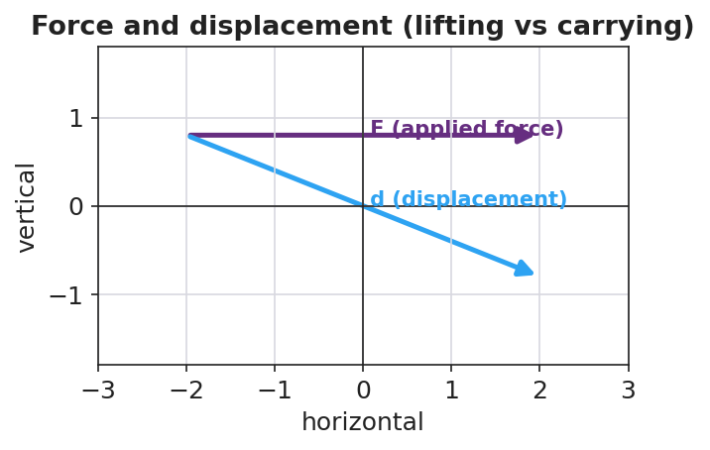
Force and displacement: lifting (force along motion) vs carrying (force perpendicular to motion)
Teacher facilitation language:
“When you carried it, which way did the bag move? Which way did your force point? Is any part of your push pointing along the walk?” “Double the lift height. What happened to the work? Predict before you compute.”
Anticipated student responses:
- “When I doubled the height, the work doubled.” — exactly; W is proportional to d at fixed F.
- “Carrying it, my force is up but it moved sideways, so… none of my force is along the motion?” — land this; that is zero work on the bag.

Teacher facilitation during Explore
- What to look for — students noting that only the part of the force along the displacement counts.
- What to resist — don’t hand them “joule” or the formula yet; let the scale and meter stick build it.
- What to redirect — “I was tired so I did work” → ask what direction did the object move relative to your force?

Phase 3 · Explain (28 – 35 min)

28–31 min · Turn-and-Talk #2 + class consensus
“Across both cases, what two things did it take to do work on the bag — and why was carrying it zero?”
Target consensus:
“Work happens when a force moves an object in the direction of the force. Lifting: force up, motion up — they line up, so work is done. Carrying at steady height: force up, motion sideways — the force is perpendicular to the motion, so it does zero work on the bag.”

31–35 min · Vocabulary introduction (≤ 3 terms) + HOCHMAN
Build the equation from the reference table: W = F·d (force × distance moved along the force). Units: a newton-meter is a joule (J).
Sample teacher language (Hochman appositive + Because/But/So):
“Write it as an appositive: Work, the energy transferred when a force moves an object through a displacement, is measured in joules. Now Because/But/So: Carrying the box does zero work on it because the upward force is perpendicular to the sideways motion, but my muscles still get tired, so ‘tired’ and ‘work’ are not the same thing in physics.”

Discussion prompts to deploy here
- “A waiter holds a tray steady while standing still. How much work does he do on the tray? Why?”
  - Sample response: “Zero — the tray doesn’t move, so d = 0, so W = 0.”
- “You push a 200 N crate 3 m across the floor. How much work?”
  - Sample response: “W = F·d = 200 × 3 = 600 J.”

Phase 4 · Elaborate (35 – 40 min)

35–38 min · Revise the model + apply the graph
“Return to your two drawings. Re-label each: is the force along the motion, or perpendicular to it? Compute the work for the lift. Then sketch how work changes as the lift distance grows.”
Project:
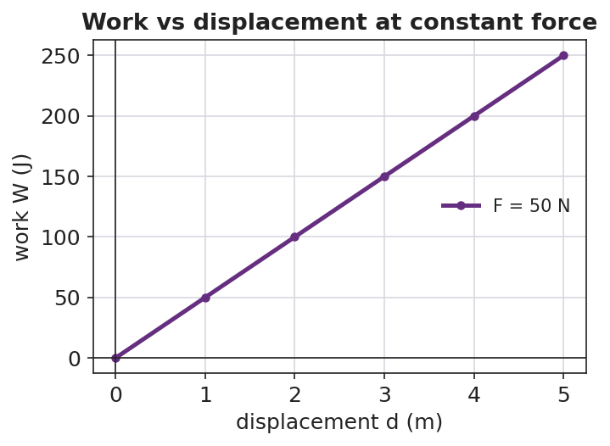
Work vs displacement at constant force is a straight line through the origin
Target: at constant force, work grows in direct proportion to distance — a straight line through the origin whose slope is the force.

38–40 min · Return to the phenomenon
“Explain to your partner, in one Because/But/So sentence, why carrying the backpack down the hall does zero work on it but lifting it onto the shelf does positive work.”

Phase 5 · Evaluate (40 – 42 min)

40–42 min · Exit Ticket + Closing Reflection
“A custodian pushes a 250 N mop bucket 8.0 m across a level floor at steady speed. (a) How much work does she do on the bucket? Show W = F·d. (b) She then holds the bucket still for 10 seconds. How much work does she do during those 10 seconds? Explain. (c) A student carries a 40 N lunch tray across the cafeteria at constant height. How much work is done on the tray, and why?”
Expected: (a) 250 × 8.0 = 2000 J; (b) zero — no displacement; (c) zero — the supporting force is perpendicular to the horizontal motion. See Answer_Key.docx.
Closing Reflection (SEL, 30 seconds):
“What is one everyday moment you’ll now describe differently because of today — and who helped you see it?”

Common Misconceptions
- Misconception: “If I get tired, I did work.” → Correction: Physics work requires the object to move in the direction of the force; holding something still does zero work (d = 0).
- Misconception: “Any force on a moving object does work.” → Correction: Only the component of force along the displacement does work; a perpendicular force does zero work.
- Misconception: “Carrying a box across a room does work on the box.” → Correction: At constant height the support force is vertical while motion is horizontal — they are perpendicular, so W = 0 on the box.

Access & Differentiation
- ELL/ENL supports: Sentence frame: “Work was done on the ___ because the force pointed ___ the motion, so energy was transferred.” Word box: {force, displacement, joule, along, perpendicular}. Pair perpendicular with an L-shaped hand gesture.
- IEP/SPED supports: Provide a pre-drawn two-panel diagram (lift / carry) with force and motion arrows already drawn; students only label “along” or “perpendicular” and circle which does work. Provide the W = F·d formula and a worked unit example on a reference card.
- Extensions: Introduce work done by a force at an angle (W = F·d·cosθ): predict and check the work when a sled rope is pulled at 30° vs. 0°.

Strategy Spotlight
HOCHMAN (literacy). Today’s writing moves are the appositive (defining work mid-sentence) and Because/But/So (explaining the zero-work case). Model the appositive aloud, then have students expand one kernel sentence — “Work is energy transferred” — into a full appositive definition. The Because/But/So in Phase 4 forces students to hold the “tired ≠ work” distinction in a single, precise sentence. Collect two or three on the board and revise for precision as a class.

NYSSLS Observation Checklist Crosswalk
# | Checklist item | Where it appears in this lesson
1 | Local/relatable phenomenon | Phase 1 — backpack lift vs. carry; custodian bucket in Phase 5
2 | Turn and Talk (2–3×) | Phase 1 (TT#1 — force vs. direction), Phase 3 (TT#2 — what makes work)
3 | Students develop questions/models/procedures | Phase 1 (initial model), Phase 2 (measure W = F·d), Phase 4 (revise model)
4 | CCC defined and used | Lesson Overview · Systems and System Models, applied in Phase 2
5 | ENL — ≤ 3 vocab, second half | Phase 3 — vocabulary at 31–35 min (work / joule / displacement)
6 | Revisit phenomenon with evidence | Phase 4 — re-label lift vs. carry with measured W
7 | ENL/SPED supports | Access & Differentiation block
8 | Assessment check | Phase 5 — Exit Ticket (mop bucket + lunch tray)

Companion Materials
- Student_Worksheet.docx — the 5E student investigation (hand out at start of Phase 2)
- Student_Notes.docx — guided note-guide for vocabulary and the worked example
- Answer_Key.docx — answers to “Make It Make Sense” prompts and the Exit Ticket

Key Vocabulary (max 3)
- work — energy transferred when a force moves an object through a displacement along the force; W = F·d
- joule — the SI unit of work and energy; one joule equals one newton-meter (1 J = 1 N·m)
- displacement — the change in an object’s position (size and direction); only motion along the force counts toward work

Work — Student Worksheet
Unit: Work, Energy & Power — Lesson 01 Name: _______________________ Date: __________ Period: ____

Phenomenon
Your teacher lifts a loaded backpack straight up onto a high shelf. Then your teacher carries the same backpack across the room at a steady height. Both make the arms tired — but a physicist says work was done in only one of them.
Driving question: What does it take to do work on an object, and why can a tiring task do zero work?

Notice & Wonder
I notice… | I wonder…
Turn & Talk #1: In which case did the applied force point the same direction the bag actually moved? Use the words force and direction.

Initial Model
Draw the backpack in each case. Draw one arrow for the force you apply and one arrow for the bag’s displacement (the way it actually moves).
Lifting (up onto shelf) | Carrying (across the room)
My prediction — which case does more work on the bag, and is one of them zero? _______________________________________________

Investigation
Use the scale (force, in newtons) and meter stick. Record your measurements.
Station | Force F (N) | Distance moved along the force d (m) | Work W = F·d (J)
1. Lift it straight up
2. Carry it sideways (force is up, motion is sideways)
3. Lift again — double the height

Force and displacement diagram
Key question: When you carried the bag, how much of your (upward) force pointed along the (sideways) motion? What does that make the work on the bag?

Make It Make Sense
- You push a 200 N crate 3.0 m across the floor in the direction of the push. How much work do you do on the crate? Show W = F·d.
- A waiter holds a tray perfectly still for 30 seconds. How much work does he do on the tray? Explain using the word displacement.
- Why does carrying a box across a level room at steady height do zero work on the box, even though your arms get tired?

Vocabulary in Action
Use each term in a sentence about today’s phenomenon.
- work: _______________________________________________
- joule: _______________________________________________
- displacement: _______________________________________________

Revise Your Model
Return to your two drawings. Re-label each arrow pair: is the force along the motion or perpendicular to it? Rewrite your explanation as one Because / But / So sentence using work and displacement.
Because _______________________________________________, but _______________________________________________, so _______________________________________________.

Exit Ticket
A custodian pushes a 250 N mop bucket 8.0 m across a level floor at steady speed.
- How much work does she do on the bucket? Show W = F·d.
- She then holds the bucket still for 10 seconds. How much work does she do during those 10 seconds? Explain.
- A student carries a 40 N lunch tray across the cafeteria at constant height. How much work is done on the tray, and why?

Work — Student Notes
Unit: Work, Energy & Power — Lesson 01 Name: _______________________ Date: __________ Period: ____

Learning Targets
By the end of today’s 42 minutes I can:
- Define work and state its unit, the joule.
- Calculate work with W = F·d, using only the force along the displacement.
- Explain why carrying a load horizontally does zero work on it.

Key Vocabulary
- work — _______________________________________________
- joule — _______________________________________________
- displacement — _______________________________________________

Guided Notes
Big idea: Work is energy __________ when a force moves an object through a __________.
- The formula (reference table): W = F·d, where F is the force in __________ and d is the distance moved __________ the force.
- The unit of work is the __________ (J). One joule = one __________·meter (1 J = 1 N·m).
- Only the part of the force that points __________ the displacement does work.
- If a force is __________ (at 90°) to the motion, it does __________ work.
- If the object does not move, d = __________, so W = __________.
Two cases (fill in):
 | Force direction | Motion direction | Work on object
Lifting a bag | up | up | __________ (positive / zero)
Carrying a bag at steady height | up | sideways | __________ (positive / zero)


Work vs. displacement at constant force: work (W = F·d) grows in proportion to how far the object moves along the force.

Worked Example
Problem. A mover pushes a crate with a steady 150 N force and the crate slides 4.0 m in the direction of the push. How much work is done on the crate?
Solution. 1. List what you know: F = __________ N, d = __________ m. 2. Use the reference-table formula: W = __________ × __________. 3. Compute: W = __________ J. 4. Units check: newtons × meters = __________ = joules. ✓

Summary
Finish the sentence (Because / But / So):
Carrying a box across a level room does zero work on the box because __________________________________________, but __________________________________________, so __________________________________________.

Work — Answer Key

Cover
Unit: Work, Energy & Power — Lesson 01: Work East Meadow Schools × Valley Stream Central HSD Strategy chip: HOCHMAN

Make-It-Make-Sense Answers
- W = F·d = 200 N × 3.0 m = 600 J. The force points the same direction the crate moves, so all of it does work. · Rubric: correct substitution AND 600 J with unit → full credit. · NYSSLS: HS-PS3-1
- Zero work. Work requires a displacement (W = F·d). The tray’s displacement is zero, so W = 0 regardless of how heavy it is or how long it is held. · Rubric: states W = 0 AND justifies via d = 0. · NYSSLS: HS-PS3-1
- While carrying, the supporting force points up but the box’s displacement is sideways (horizontal). The force is perpendicular to the motion, so the component of force along the displacement is zero — therefore zero work on the box. Tired muscles do not equal physics work. · Rubric: identifies perpendicular force/motion AND concludes W = 0. · NYSSLS: HS-PS3-1

Exit Ticket Answer
- W = F·d = 250 N × 8.0 m = 2000 J (2.0 × 10³ J).
- Zero work. During the 10 s of holding, the bucket does not move (d = 0), so W = F·d = 0.
- Zero work on the tray. The support force is vertical (up) while the tray moves horizontally; the force is perpendicular to the displacement, so it does no work.
Tolerance/rubric: (a) must show F·d and give 2000 J; (b) zero + “no displacement”; (c) zero + “force perpendicular to motion.” 1 point each. NYSSLS: HS-PS3-1.

Closing Reflection (rubric)
Closing reflection is formative, not graded. Award full credit for any honest response. Look for: - A genuine “I’ll describe this everyday moment differently” statement - Naming a peer or self-acknowledgment

Power — Teacher Guide

Cover
Unit: Work, Energy & Power — Lesson 02: Power East Meadow Schools × Valley Stream Central High School District Strategy chips: ACTIVE LEARNING

Curated Resources (from East Meadow Scope & Sequence)

NYSSLS Standards
Power is the rate of energy transfer — how fast work is done. It deepens HS-PS3-1: “Create a computational model to calculate the change in energy of one component in a system when the change in energy of the other component(s) and energy flows in and out of the system are known.” (CCC: Systems and System Models.) Once students can compute work (Lesson 01), power lets them quantify how quickly energy flows in or out of a system — the time dimension of every energy model.

Phenomenon
- Two students climbing the same staircase, one fast and one slow — same work, different power. https://www.youtube.com/watch?v=8jBJBwwTBc8 (Physics of stair-climbing power)
- The Physics Classroom — “Power”: https://www.physicsclassroom.com/class/energy/Lesson-1/Power

Javalab / Labs
- Stair-Climb Personal-Power Lab (this lesson) — students time a stair climb and compute their own power output. Javalab energy index for support sims: https://javalab.org/en/category/energy_en/

Assessments
- The Physics Classroom power problem set (link above). The Exit Ticket below is the formative check; the stair-climb data feed the “Make It Make Sense” items (HS-PS3-1).

Lesson Overview
Duration | 42 minutes (1 period)
NYSSLS link | HS-PS3-1 (rate of energy flow in/out of a system)
CCC focus | Systems and System Models — power is how fast energy enters or leaves a system.
Strategy chips | ACTIVE LEARNING (stair-climb lab, station data, predict-and-test)
Materials | A safe staircase or a step/box; stopwatches or phones; bathroom scale (to get weight in N); meter stick (step height); whiteboards.
Safety | One climber at a time; hand on rail; walk, do not run; spotter at base. No climbing for students who opt out — they time and record.
Prior knowledge | Work (W = F·d) and the joule from Lesson 01; weight = mass × g.
Lesson objectives — students can:
- Define power as the rate of doing work and state its unit, the watt.
- Calculate power with P = W/t (and recognize P = Fv for constant-speed motion).
- Explain why doing the same work in less time means more power, using stair-climb data.

Phase 1 · Engage (0 – 10 min)

0–3 min · Opening Connection (SEL)
Pair-share, one sentence: “Name something you do fast and something you do slow — and does doing it faster make it harder?” Surface a few (running vs. walking up stairs, sprinting to class). Plant the idea that speed of effort matters, not just total effort.

3–7 min · Phenomenon hook — two climbers, same stairs
Teacher actions. Two volunteers (or a video) climb the same staircase: one quickly, one slowly. Both reach the top.
Sample teacher language:
“Same stairs, same height, roughly the same body weight — so they did about the same work against gravity. But something is clearly different. What is it, and can we measure it?”
Anticipated student responses:
- “The fast one worked harder!” — reframe: did they do more work, or the same work faster?
- “The fast one is more powerful.” — capture the word powerful; we will define it precisely.
- “Time is the difference.” — exactly the variable we’ll add to work.

7–10 min · Notice & Wonder + Turn-and-Talk #1
Two columns. Then:
“Turn to your partner: if both climbers did the same work, what made the fast climber different? Use the word time.”
Desirable insight: same work ÷ less time = a bigger something. Leave the name for Phase 3.

Bridge to Phase 2
Each student leaves with an initial model sentence: “The faster climber was more ______ because ______.”

Phase 2 · Explore (10 – 28 min)

10–14 min · Initial Model (silent / individual)
Prompt:
“Write a formula in words for ‘how fast work is done.’ What would you divide by what? Predict whether a heavier climber or a faster climber has more of it.”

14–28 min · Investigation — Stair-Climb Personal-Power Lab
Active-learning rotation. Each student (who opts in) climbs a measured set of stairs; partners time and record. Compute personal power.
- Measure weight. Read weight on the scale; convert to newtons (N) — or use mass × g with g ≈ 9.81 m/s².
- Measure height. Height of the staircase (vertical rise only), in meters.
- Compute work. W = F·d = (weight in N) × (vertical height).
- Time the climb. t in seconds.
- Compute power. P = W/t, in watts.
- Compare fast vs. slow trials for the same climber.
Project as data arrive:
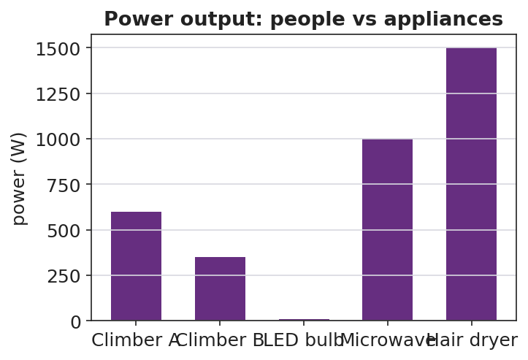
Power output of people vs household appliances
Teacher facilitation language:
“You climbed the same stairs twice. Same work? Then why is your power different?” “Whose power is bigger — and is it because of weight, height, or time? Isolate the variable.”
Anticipated student responses:
- “My second climb was faster, so my power went up even though the work was the same.” — exactly; P = W/t.
- “A heavier person doing the same climb in the same time has more power.” — yes; more work in the same time.

Teacher facilitation during Explore
- What to look for — students dividing work by time and getting watts; recognizing same-work/different-time.
- What to resist — don’t define “watt” until students need a name for W/t.
- What to redirect — “faster always means more work” → no, faster means same work in less time, so more power.

Phase 3 · Explain (28 – 35 min)

28–31 min · Turn-and-Talk #2 + class consensus
“From the lab: what single number tells us how fast work is done, and how did you compute it?”
Target consensus:
“Power is work divided by time, P = W/t. The same work done in less time is more power. For something moving at steady speed, power is also force times speed, P = Fv.”

31–35 min · Vocabulary introduction (≤ 3 terms)
From the reference table: P = W/t = Fv. The unit of power is the watt (W) — one watt is one joule per second (1 W = 1 J/s).
Sample teacher language:
“Power, the rate at which work is done, is measured in watts — joules per second. Energy is what gets transferred; power is how fast it’s transferred. Your stair climb was a few hundred watts; a hair dryer is over a thousand.”

Discussion prompts to deploy here
- “Two motors raise the same load the same height. Motor A takes 2 s, motor B takes 8 s. Which is more powerful, and by how much?”
  - Sample response: “A — same work, one-fourth the time, so four times the power.”
- “A 60 W bulb runs for 10 s. How much energy did it use?”
  - Sample response: “W = P·t = 60 × 10 = 600 J.”

Phase 4 · Elaborate (35 – 40 min)

35–38 min · Revise the model + read the graph
“Plot work vs. time for the fast climber and the slow climber. What does the slope of each line represent?”
Project:
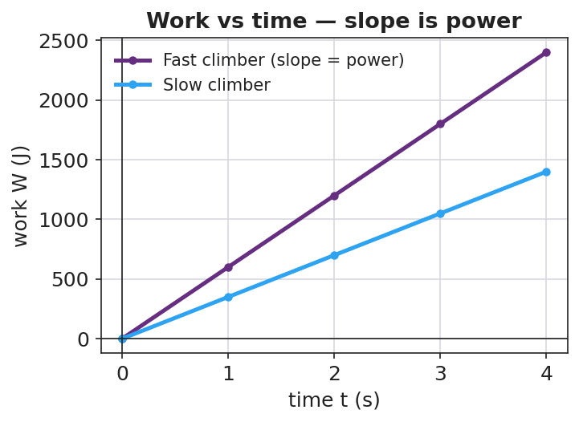
Work vs time: the slope of each line is the power
Target: the slope of a work-vs-time graph is the power; a steeper line = more power. Tie back to P = W/t.

38–40 min · Return to the phenomenon
“In one sentence, explain why the fast stair-climber is ‘more powerful’ than the slow one even though they did the same work. Use the words power and time.”

Phase 5 · Evaluate (40 – 42 min)

40–42 min · Exit Ticket + Closing Reflection
“An elevator does 48,000 J of work lifting a load. (a) If it takes 8.0 s, what is its power output? Show P = W/t. (b) A second elevator does the same 48,000 J in 16 s. How does its power compare? (c) A 700 N student runs up a 4.0 m staircase in 5.0 s. What is the student’s power output?”
Expected: (a) 6000 W; (b) half the power (3000 W) — same work, twice the time; (c) W = 700 × 4.0 = 2800 J, P = 2800/5.0 = 560 W. See Answer_Key.docx.
Closing Reflection (SEL, 30 seconds):
“What is one thing you can now measure about yourself that you couldn’t this morning — and who helped you figure it out?”

Common Misconceptions
- Misconception: “More power means more work.” → Correction: Power is the rate of work; the same work done faster is more power even though total work is unchanged.
- Misconception: “Power and energy are the same thing.” → Correction: Energy (joules) is the quantity transferred; power (watts) is how fast it transfers — joules per second.
- Misconception: “A watt is a unit of energy.” → Correction: A watt is a unit of power (1 W = 1 J/s); a watt-second is a joule of energy.

Access & Differentiation
- ELL/ENL supports: Sentence frame: *“The ___ climber has more power because they did the same work in ___ time, so P = W/t is ___.”* Word box: {power, watt, energy, rate, per second}. Build a “per second” gesture (tapping a beat).
- IEP/SPED supports: Provide a pre-built data table with labeled columns (weight, height, time) and the P = W/t formula with one row worked. Offer the timer/recorder role to students who opt out of climbing — full participation, no physical demand.
- Extensions: Convert personal power to horsepower (1 hp ≈ 746 W) and compare to a car engine; explore why sprinting up stairs cannot be sustained (peak vs. average power).

Strategy Spotlight
ACTIVE LEARNING. The whole lesson is built on student-generated data: each learner measures their own weight, height, and time, then computes their own power. The comparison that matters — same work, different time — emerges from their two trials, not from the teacher. Assign clear roles (climber, timer, recorder, calculator) so every student is doing physics, and rotate so opt-out students still own the math. The graph in Phase 4 turns their messy data into the clean “slope = power” idea.

NYSSLS Observation Checklist Crosswalk
# | Checklist item | Where it appears in this lesson
1 | Local/relatable phenomenon | Phase 1 — two students climbing the same stairs
2 | Turn and Talk (2–3×) | Phase 1 (TT#1 — what makes the fast climber different), Phase 3 (TT#2 — defining P = W/t)
3 | Students develop questions/models/procedures | Phase 1 (initial model), Phase 2 (stair-climb lab), Phase 4 (revise model)
4 | CCC defined and used | Lesson Overview · Systems and System Models, applied in Phase 2
5 | ENL — ≤ 3 vocab, second half | Phase 3 — vocabulary at 31–35 min (power / watt / energy)
6 | Revisit phenomenon with evidence | Phase 4 — work-vs-time slope; restate the two-climber result
7 | ENL/SPED supports | Access & Differentiation block
8 | Assessment check | Phase 5 — Exit Ticket (elevators + stair runner)

Companion Materials
- Student_Worksheet.docx — the 5E student investigation + stair-climb lab table (hand out at start of Phase 2)
- Student_Notes.docx — guided note-guide for vocabulary and the worked example
- Answer_Key.docx — answers to “Make It Make Sense” prompts and the Exit Ticket

Key Vocabulary (max 3)
- power — the rate at which work is done (energy transferred per unit time); P = W/t = Fv
- watt — the SI unit of power; one watt equals one joule per second (1 W = 1 J/s)
- energy — the capacity to do work, measured in joules; power tells how fast energy is transferred

Power — Student Worksheet
Unit: Work, Energy & Power — Lesson 02 Name: _______________________ Date: __________ Period: ____

Phenomenon
Two students climb the same staircase. One climbs fast, one climbs slowly. Both reach the top, so both did about the same work against gravity — but everyone agrees something is different.
Driving question: If two people do the same work, what makes one of them “more powerful,” and how do we measure it?

Notice & Wonder
I notice… | I wonder…
Turn & Talk #1: If both climbers did the same work, what made the fast climber different? Use the word time.

Initial Model
Write, in words, a formula for “how fast work is done.” What would you divide by what?
How-fast-work-is-done = ____________ ÷ ____________
My prediction — who has more of it, a heavier climber or a faster climber? Why? _______________________________________________

Investigation — Stair-Climb Personal-Power Lab
Roles: climber, timer, recorder, calculator. Walk, hold the rail, one at a time. Record two trials for the same climber.
Trial | Weight F (N) | Vertical height d (m) | Work W = F·d (J) | Time t (s) | Power P = W/t (W)
1 (normal pace)
2 (faster)

Power output: people vs appliances
Key question: Your two trials did the same work. Why was your power different? What changed?

Make It Make Sense
- Two motors raise the same load the same height. Motor A takes 2.0 s; motor B takes 8.0 s. Which motor is more powerful, and by what factor? Explain.
- A 60 W light bulb runs for 10 seconds. How much energy does it use? (Hint: rearrange P = W/t.)
- Your friend says, “The faster climber did more work.” Correct your friend using the words work, time, and power.

Vocabulary in Action
Use each term in a sentence about today’s phenomenon.
- power: _______________________________________________
- watt: _______________________________________________
- energy: _______________________________________________

Revise Your Model
Plot work vs. time for a fast climber and a slow climber. What does the slope of each line represent? Rewrite your explanation of “more powerful” in one sentence using power and time.

Work vs time — slope is power
The slope of a work-vs-time graph represents ____________. The fast climber is more powerful because _______________________________________________

Exit Ticket
An elevator does 48,000 J of work lifting a load.
- If it takes 8.0 s, what is its power output? Show P = W/t.
- A second elevator does the same 48,000 J in 16 s. How does its power compare to the first?
- A 700 N student runs up a 4.0 m staircase in 5.0 s. What is the student’s power output?

Power — Student Notes
Unit: Work, Energy & Power — Lesson 02 Name: _______________________ Date: __________ Period: ____

Learning Targets
By the end of today’s 42 minutes I can:
- Define power and state its unit, the watt.
- Calculate power with P = W/t (and recognize P = Fv).
- Explain why the same work done in less time means more power.

Key Vocabulary
- power — _______________________________________________
- watt — _______________________________________________
- energy — _______________________________________________

Guided Notes
Big idea: Power is the __________ at which work is done — how __________ energy is transferred.
- Reference-table formula: P = W/t = Fv, where W is __________ (J) and t is __________ (s).
- The unit of power is the __________ (W). One watt = one __________ per __________ (1 W = 1 J/s).
- Energy (joules) is the amount transferred; power (watts) is how __________ it is transferred.
- Same work in __________ time → __________ power.
- Rearranged: energy used = P × t, so a 100 W device for 5 s uses __________ J.
Slope of a work-vs-time graph = __________. A steeper line means __________ power.


Work vs. time: the slope of the line is power (P = W/t). A steeper line means the same work is done faster — more power.

Worked Example
Problem. A 600 N student climbs a 5.0 m staircase in 4.0 s. What is the student’s power output?
Solution. 1. Find the work: W = F·d = __________ N × __________ m = __________ J. 2. Use the power formula: P = W/t = __________ J ÷ __________ s. 3. Compute: P = __________ W. 4. Units check: joules ÷ seconds = __________ = watts. ✓

Summary
Finish the sentence (Because / But / So):
The fast climber and the slow climber did the same work because __________________________________________, but __________________________________________, so __________________________________________.

Power — Answer Key

Cover
Unit: Work, Energy & Power — Lesson 02: Power East Meadow Schools × Valley Stream Central HSD Strategy chip: ACTIVE LEARNING

Make-It-Make-Sense Answers
- Same work, but motor A takes 2.0 s and motor B takes 8.0 s — one-fourth the time. Since P = W/t, motor A has four times the power of motor B. · Rubric: identifies same work AND the 4× factor from the time ratio. · NYSSLS: HS-PS3-1
- Rearrange P = W/t → W = P·t = 60 W × 10 s = 600 J. · Rubric: correct rearrangement AND 600 J with unit. · NYSSLS: HS-PS3-1
- The faster climber did not do more work — both climb the same height, so both do the same work against gravity. The faster climber did that same work in less time, so they have more power (P = W/t). · Rubric: corrects “more work” to “same work, less time, more power.” · NYSSLS: HS-PS3-1

Exit Ticket Answer
- P = W/t = 48,000 J ÷ 8.0 s = 6000 W (6.0 kW).
- Same work in twice the time → half the power = 3000 W.
- Work first: W = F·d = 700 N × 4.0 m = 2800 J. Then P = W/t = 2800 J ÷ 5.0 s = 560 W.
Tolerance/rubric: (a) shows W/t and 6000 W; (b) 3000 W with “twice the time, half the power”; (c) computes W = 2800 J then P = 560 W. 1 point each. NYSSLS: HS-PS3-1.

Closing Reflection (rubric)
Closing reflection is formative, not graded. Award full credit for any honest response. Look for: - A genuine “something I can now measure about myself” statement - Naming a peer or self-acknowledgment

Kinetic Energy — Teacher Guide

Cover
Unit: Work, Energy & Power — Lesson 03: Kinetic Energy East Meadow Schools × Valley Stream Central High School District Strategy chips: BTC

Curated Resources (from East Meadow Scope & Sequence)

NYSSLS Standards
Kinetic energy names the energy of motion — the macroscopic “energy of motion of particles” half of HS-PS3-2: “Develop and use models to illustrate that energy at the macroscopic scale can be accounted for as a combination of energy associated with the motions of particles (objects) and energy associated with the relative positions of particles (objects).” (CCC: Energy and Matter.) It also supplies a quantity for HS-PS3-1 energy models: the moving component’s energy is ½mv².

Phenomenon
- Car stopping distance vs. speed — doubling speed roughly quadruples the stopping distance. https://www.youtube.com/watch?v=PIA1AfQfM4U (Stopping distance and speed)
- The Physics Classroom — “Kinetic Energy”: https://www.physicsclassroom.com/class/energy/Lesson-1/Kinetic-Energy

Javalab / Labs
- Javalab energy index (kinetic/potential sims for VNPS support): https://javalab.org/en/category/energy_en/

Assessments
- The Physics Classroom kinetic-energy problem set (link above). The Exit Ticket below is the formative check; the “Make It Make Sense” items map to HS-PS3-2.

Lesson Overview
Duration | 42 minutes (1 period)
NYSSLS link | HS-PS3-2 (energy of motion); supports HS-PS3-1
CCC focus | Energy and Matter — kinetic energy is the energy a moving object carries because of its motion.
Strategy chips | BTC (random groups, vertical non-permanent surfaces, a thin-sliced KE = ½mv² task)
Materials | Vertical whiteboards / wall surfaces + markers; calculators; visibly random grouping cards; the stopping-distance video.
Safety | Standard classroom movement protocols for VNPS rotation.
Prior knowledge | Work (W = F·d), the joule; speed/velocity from Kinematics.
Lesson objectives — students can:
- Define kinetic energy as the energy of motion and compute it with KE = ½mv².
- Explain why kinetic energy depends on the square of speed: doubling the speed multiplies KE by four.
- Use the v² relationship to reason about why fast cars need far more stopping distance.

Phase 1 · Engage (0 – 10 min)

0–3 min · Opening Connection (SEL)
Pair-share, one sentence: “Describe a time you (or a car) needed way more room to stop than you expected.” Surface a couple. Plant the puzzle that speed changes stopping distance more than people think.

3–7 min · Phenomenon hook — stopping distance vs. speed
Teacher actions. Play the stopping-distance clip (or show a stopping-distance table). At 20 mph vs. 40 mph, the stopping distance roughly quadruples, not doubles.
Sample teacher language:
“Speed only doubled — 20 to 40. So why does it take four times the distance to stop? The energy of motion isn’t growing the way you’d guess.”
Anticipated student responses:
- “Double the speed, double the distance.” — capture this prediction; the data will contradict it.
- “It’s heavier when it’s faster?” — no, mass is unchanged; the change is in speed.
- “Faster means way more energy somehow.” — yes; we’ll find the v² rule.

7–10 min · Notice & Wonder + Turn-and-Talk #1
Two columns. Then:
“Turn to your partner: if speed only doubled, why might the energy grow by more than double? Make a guess about the math.”

Bridge to Phase 2
Each student leaves with an initial model: “When the car’s speed doubles, its energy of motion ______ because ______.”

Phase 2 · Explore (10 – 28 min)

10–13 min · BTC setup — visibly random groups + VNPS
Form visibly random groups of 3 with cards. Each group claims a vertical non-permanent surface (whiteboard/wall). No sitting; thinking happens standing at the board.

13–28 min · Thin-sliced task — building KE = ½mv²
Reveal the task one slice at a time; let early groups race ahead. Give m = 1000 kg throughout so the v² pattern is unmasked.
- Compute KE at v = 10 m/s using KE = ½mv².
- Now v = 20 m/s (double). Compare to slice 1 — by what factor did KE grow?
- Now v = 30 m/s (triple). Factor?
- Generalize: “If speed becomes n times bigger, KE becomes ____ times bigger. Why?”
- Extension slice: two cars, same speed, one twice the mass — compare KE.
Project the building pattern when most groups reach slice 3:
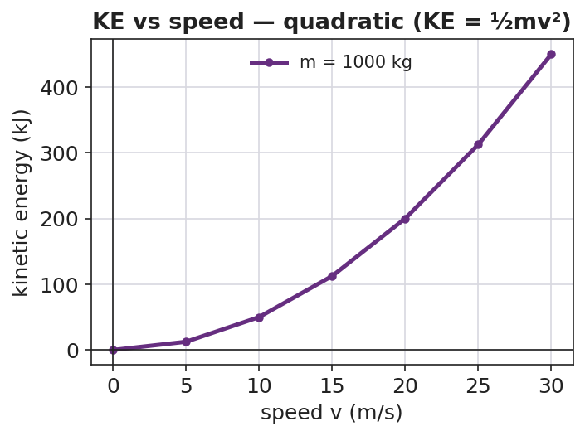
Kinetic energy vs speed is a quadratic curve
Teacher facilitation language (BTC — answer questions with questions):
“You doubled v and KE went up by four — where did the 4 come from in ½mv²?” “Will tripling the speed triple the energy? Test it on the board before you tell me.”
Anticipated student responses:
- “Doubling v gave 4× because we square the velocity!” — the target insight.
- “Tripling gives 9× — it’s n².” — generalization reached.

Teacher facilitation during Explore
- What to look for — groups connecting the v² in the formula to the 4×, 9× growth.
- What to resist — don’t confirm answers; bounce questions back; let groups check each other’s boards.
- What to redirect — groups computing 2× growth → “show me 20² vs 10² — is that doubling?”

Phase 3 · Explain (28 – 35 min)

28–31 min · Turn-and-Talk #2 + class consensus
“Tour two other boards. What is the rule connecting speed to kinetic energy?”
Target consensus:
“Kinetic energy is ½mv². Because the speed is squared, doubling the speed gives four times the KE, and tripling gives nine times. Mass matters too, but only to the first power.”

31–35 min · Vocabulary introduction (≤ 3 terms)
From the reference table: KE = ½mv², in joules. Name the terms.
Sample teacher language:
“Kinetic energy is the energy of motion. It grows with mass to the first power, but with speed squared — that v² is why a small jump in speed is a big jump in energy, and a big jump in stopping distance.”

Discussion prompts to deploy here
- “A 2.0 kg ball moves at 3.0 m/s. What is its KE?”
  - Sample response: “KE = ½(2.0)(3.0²) = ½(2.0)(9.0) = 9.0 J.”
- “Why is a highway speed limit so important for safety, in energy terms?”
  - Sample response: “A small speed increase squares into a large KE increase, so far more energy must be removed to stop — much longer stopping distance.”

Phase 4 · Elaborate (35 – 40 min)

35–38 min · Revise the model + the bar chart
“Return to your initial model. Using KE = ½mv², make a bar chart of KE at 1×, 2×, and 3× speed for the same car. Label each bar with the factor (1, 4, 9).”
Project:
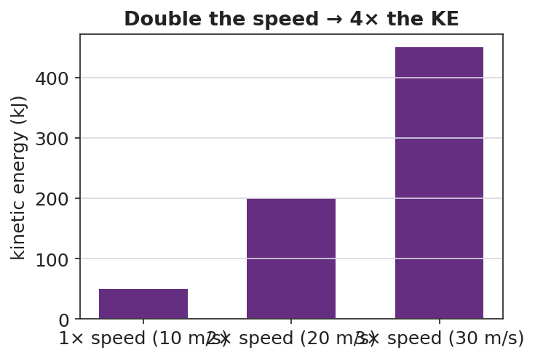
Kinetic energy at 1×, 2×, 3× speed — bars in ratio 1:4:9
Target: the bars are in the ratio 1 : 4 : 9, matching n².

38–40 min · Return to the phenomenon
“In one sentence, explain why a car at 40 mph needs about four times the stopping distance of a car at 20 mph. Use KE = ½mv².”

Phase 5 · Evaluate (40 – 42 min)

40–42 min · Exit Ticket + Closing Reflection
“A 1500 kg car travels at 10 m/s. (a) Calculate its kinetic energy. Show KE = ½mv². (b) The car speeds up to 20 m/s. What is its new KE, and by what factor did it change? (c) In one sentence, explain why doubling speed makes the car so much harder to stop.”
Expected: (a) 75,000 J; (b) 300,000 J — 4×; (c) KE depends on v², so doubling v quadruples KE, requiring 4× the work/distance to stop. See Answer_Key.docx.
Closing Reflection (SEL, 30 seconds):
“What is one idea your group cracked today that you couldn’t alone — and who pushed the thinking forward?”

Common Misconceptions
- Misconception: “Double the speed, double the kinetic energy.” → Correction: KE depends on v², so doubling speed quadruples KE.
- Misconception: “Mass affects KE the same way speed does.” → Correction: Mass is to the first power, speed is squared — speed has a far stronger effect.
- Misconception: “A stopped object has some kinetic energy.” → Correction: If v = 0, KE = ½m(0)² = 0; kinetic energy requires motion.

Access & Differentiation
- ELL/ENL supports: Sentence frame: *“When the speed becomes ___ times bigger, the kinetic energy becomes ___ times bigger because the speed is ___.”* Word box: {kinetic energy, mass, speed, squared, four times}. Provide a labeled ½mv² formula card.
- IEP/SPED supports: Pre-fill the m and v values in a table so the cognitive load is on the squaring and the pattern, not setup. Allow calculator use for v². Provide the bar chart pre-drawn for labeling.
- Extensions: Derive KE = ½mv² from work: a net force does work W = F·d on a mass, and with kinematics this equals ½mv². Explore why kinetic energy is always positive.

Strategy Spotlight
BTC (Building Thinking Classrooms). This lesson uses the three core BTC moves: visibly random groups (cards, no friend-clusters), vertical non-permanent surfaces (everyone standing and writing at boards), and a thin-sliced task (KE at 1×, 2×, 3× speed) that lets every group find an entry point and lets fast groups push to the n² generalization. Answer questions with questions; let groups verify against neighboring boards rather than against you. The v² pattern is discovered, not told.

NYSSLS Observation Checklist Crosswalk
# | Checklist item | Where it appears in this lesson
1 | Local/relatable phenomenon | Phase 1 — car stopping distance vs. speed
2 | Turn and Talk (2–3×) | Phase 1 (TT#1 — why energy grows more than double), Phase 3 (TT#2 — board tour consensus)
3 | Students develop questions/models/procedures | Phase 1 (initial model), Phase 2 (VNPS thin-sliced task), Phase 4 (revise model)
4 | CCC defined and used | Lesson Overview · Energy and Matter, applied in Phase 2
5 | ENL — ≤ 3 vocab, second half | Phase 3 — vocabulary at 31–35 min (kinetic energy / mass / speed)
6 | Revisit phenomenon with evidence | Phase 4 — 1:4:9 bar chart; restate stopping distance
7 | ENL/SPED supports | Access & Differentiation block
8 | Assessment check | Phase 5 — Exit Ticket (1500 kg car)

Companion Materials
- Student_Worksheet.docx — the 5E student investigation + thin-sliced task (hand out at start of Phase 2)
- Student_Notes.docx — guided note-guide for vocabulary and the worked example
- Answer_Key.docx — answers to “Make It Make Sense” prompts and the Exit Ticket

Key Vocabulary (max 3)
- kinetic energy — the energy an object has because of its motion; KE = ½mv², in joules
- mass — the amount of matter in an object (kg); kinetic energy is proportional to mass (first power)
- speed — how fast an object moves (m/s); kinetic energy is proportional to speed squared (v²)

Kinetic Energy — Student Worksheet
Unit: Work, Energy & Power — Lesson 03 Name: _______________________ Date: __________ Period: ____

Phenomenon
A car at 20 mph and the same car at 40 mph: the speed only doubled, but the distance needed to stop roughly quadruples. The energy of motion is not growing the way you’d expect.
Driving question: How does the energy of a moving object depend on its speed — and why does a small speed increase make it so much harder to stop?

Notice & Wonder
I notice… | I wonder…
Turn & Talk #1: If the speed only doubled, why might the energy of motion grow by more than double? Make a guess about the math.

Initial Model
Write your prediction before any calculating.
When the car’s speed doubles, I predict its energy of motion becomes ____________ times bigger, because _______________________________________________

Investigation — Thin-Sliced Task (at the board)
Use KE = ½mv² with m = 1000 kg for every slice. Work at your group’s board.
Slice | Speed v (m/s) | KE = ½mv² (J) | Factor vs. Slice 1
1 | 10 |  | 1
2 | 20 (double)
3 | 30 (triple)

KE vs speed — quadratic curve
Generalize: If the speed becomes n times bigger, the kinetic energy becomes ____________ times bigger. Why?

Make It Make Sense
- A 2.0 kg ball moves at 3.0 m/s. Calculate its kinetic energy. Show KE = ½mv².
- Two identical cars move down the road. Car A goes 15 m/s; car B goes 30 m/s. How many times more kinetic energy does car B have? Explain using v².
- Your friend says “double the speed, double the energy.” Use the formula to correct your friend.

Vocabulary in Action
Use each term in a sentence about today’s phenomenon.
- kinetic energy: _______________________________________________
- mass: _______________________________________________
- speed: _______________________________________________

Revise Your Model
Make a bar chart of KE at 1×, 2×, and 3× speed for the same car. Label each bar with its factor.

KE at 1×, 2×, 3× speed
The bars are in the ratio ____ : ____ : ____ . Revise your prediction: when speed doubles, KE becomes ____________ times bigger because _______________________________________________

Exit Ticket
A 1500 kg car travels at 10 m/s.
- Calculate its kinetic energy. Show KE = ½mv².
- The car speeds up to 20 m/s. What is its new kinetic energy, and by what factor did it change?
- In one sentence, explain why doubling the speed makes the car so much harder to stop.

Kinetic Energy — Student Notes
Unit: Work, Energy & Power — Lesson 03 Name: _______________________ Date: __________ Period: ____

Learning Targets
By the end of today’s 42 minutes I can:
- Define kinetic energy and compute it with KE = ½mv².
- Explain why KE depends on the square of speed.
- Use the v² rule to reason about stopping distance.

Key Vocabulary
- kinetic energy — _______________________________________________
- mass — _______________________________________________
- speed — _______________________________________________

Guided Notes
Big idea: Kinetic energy is the energy an object has because of its __________.
- Reference-table formula: KE = ½mv², where m is __________ (kg) and v is __________ (m/s). Unit: __________ (J).
- Kinetic energy depends on mass to the __________ power.
- Kinetic energy depends on speed __________ (the v² term).
- Because speed is squared: doubling v multiplies KE by __________; tripling v multiplies KE by __________.
- If an object is at rest (v = 0), its kinetic energy is __________.
Pattern table (m = 1000 kg):
Speed | KE | Factor
10 m/s | 50,000 J | 1
20 m/s | __________ J | __________
30 m/s | __________ J | __________


Kinetic energy vs. speed (KE = ½mv²): because KE depends on v², doubling the speed gives four times the kinetic energy.

Worked Example
Problem. A 1200 kg car is moving at 25 m/s. What is its kinetic energy?
Solution. 1. List knowns: m = __________ kg, v = __________ m/s. 2. Formula: KE = ½mv² = ½ × __________ × (__________)². 3. Square the speed first: (25)² = __________. 4. Multiply: KE = ½ × 1200 × 625 = __________ J.

Summary
Finish the sentence (Because / But / So):
A car at 40 mph needs about four times the stopping distance of a car at 20 mph because __________________________________________, but __________________________________________, so __________________________________________.

Kinetic Energy — Answer Key

Cover
Unit: Work, Energy & Power — Lesson 03: Kinetic Energy East Meadow Schools × Valley Stream Central HSD Strategy chip: BTC

Make-It-Make-Sense Answers
- KE = ½mv² = ½ × 2.0 kg × (3.0 m/s)² = ½ × 2.0 × 9.0 = 9.0 J. · Rubric: squares the speed first AND reports 9.0 J. · NYSSLS: HS-PS3-2
- Car B’s speed is double car A’s. Since KE ∝ v², doubling v gives four times the kinetic energy. (Check: A = ½m(15²) = ½m(225); B = ½m(30²) = ½m(900); 900/225 = 4.) · Rubric: answer is 4× AND justified by v². · NYSSLS: HS-PS3-2
- Doubling the speed does not double the energy — KE = ½mv² has speed squared, so doubling v gives 2² = four times the kinetic energy. · Rubric: corrects “double” to “four times” using the v² term. · NYSSLS: HS-PS3-2

Exit Ticket Answer
- KE = ½mv² = ½ × 1500 kg × (10 m/s)² = ½ × 1500 × 100 = 75,000 J (7.5 × 10⁴ J).
- KE = ½ × 1500 × (20)² = ½ × 1500 × 400 = 300,000 J (3.0 × 10⁵ J) — a factor of 4× (because speed doubled and KE ∝ v²).
- Kinetic energy depends on v², so doubling the speed quadruples the energy of motion; about four times as much work (and stopping distance) is needed to bring it to rest.
Tolerance/rubric: (a) shows ½mv² and 75,000 J; (b) 300,000 J AND the 4× factor; (c) ties the 4× difficulty to v². 1 point each. NYSSLS: HS-PS3-2.

Closing Reflection (rubric)
Closing reflection is formative, not graded. Award full credit for any honest response. Look for: - A genuine “my group cracked this together” statement - Naming a peer who pushed the thinking forward

Gravitational Potential Energy — Teacher Guide

Cover
Unit: Work, Energy & Power — Lesson 04: Gravitational Potential Energy East Meadow Schools × Valley Stream Central High School District Strategy chips: HOCHMAN

Curated Resources (from East Meadow Scope & Sequence)

NYSSLS Standards
Gravitational potential energy names the “energy associated with relative position” half of HS-PS3-2: “Develop and use models to illustrate that energy at the macroscopic scale can be accounted for as a combination of energy associated with the motions of particles (objects) and energy associated with the relative positions of particles (objects).” (CCC: Energy and Matter.) Together with Lesson 03 (KE = motion), PE = mgh completes the two-component macroscopic energy account and feeds the HS-PS3-1 energy model.

Phenomenon
- A roller-coaster lift hill / a water tower: stored energy that depends on height above the ground. https://www.youtube.com/watch?v=Anv2Rr-A3MI (Roller coaster energy)
- The Physics Classroom — “Potential Energy”: https://www.physicsclassroom.com/class/energy/Lesson-1/Potential-Energy

Javalab / Labs
- Javalab — Potential energy due to gravity (this lesson’s interactive): https://javalab.org/en/potential_energy_en/

Assessments
- The Physics Classroom potential-energy problem set (link above). The Exit Ticket below is the formative check; the “Make It Make Sense” items map to HS-PS3-2.

Lesson Overview
Duration | 42 minutes (1 period)
NYSSLS link | HS-PS3-2 (energy of relative position); supports HS-PS3-1
CCC focus | Energy and Matter — stored energy depends on an object’s position (height) relative to a reference.
Strategy chips | HOCHMAN (appositive + Because/But/So on PE = mgh and the reference height)
Materials | Computers/tablets for the Javalab sim; masses at different heights (book on desk vs. shelf); meter stick; whiteboards.
Safety | Keep raised masses secured; do not let objects fall on people or devices.
Prior knowledge | Work (W = F·d), the joule; weight = mass × g; g ≈ 9.81 m/s².
Lesson objectives — students can:
- Define gravitational potential energy as stored energy that depends on height and compute it with PE = mgh.
- Explain why PE is measured relative to a chosen reference height (ground, floor, table).
- Predict how PE changes when height or mass changes, and connect lift-hill height to a coaster’s stored energy.

Phase 1 · Engage (0 – 10 min)

0–3 min · Opening Connection (SEL)
Pair-share, one sentence: “Name the highest place you’ve ever climbed or stood — and how it felt to look down.” Surface a couple. Plant the intuition that height feels like stored “ready-to-fall” energy.

3–7 min · Phenomenon hook — the lift hill / water tower
Teacher actions. Show the slow climb up a roller-coaster lift hill (or a water tower). Pause at the top before the drop.
Sample teacher language:
“Nothing exciting happens on the way up — the chain just hauls the car higher. But every meter of height is storing something the coaster will spend on the way down. What is being stored, and what does it depend on?”
Anticipated student responses:
- “It’s storing speed for later.” — close; it stores energy that will become speed.
- “The higher it goes, the bigger the drop.” — capture height as the key variable.
- “A heavier car stores more.” — yes; mass matters too.

7–10 min · Notice & Wonder + Turn-and-Talk #1
Two columns. Then:
“Turn to your partner: what two things about the coaster car decide how much energy is stored at the top? Use the word height.”

Bridge to Phase 2
Each student leaves with an initial model: “Stored energy at the top depends on ______ because ______.”

Phase 2 · Explore (10 – 28 min)

10–14 min · Initial Model (silent / individual)
Prompt:
“Draw the coaster on the lift hill at three heights. Predict how the stored energy changes as the height doubles. Does it double? More? Less?”

14–28 min · Investigation — Javalab “Potential energy due to gravity”
Students use the Javalab sim (https://javalab.org/en/potential_energy_en/) and a desk/shelf comparison.
- Set a mass at height h; read/record PE. Double h; record again. What happened to PE?
- Keep h fixed; double the mass. What happened to PE?
- Move the reference line (floor → tabletop): does the same object now have a different PE? Why?
- Tabulate PE vs. h for a fixed mass.
Project as data come in:
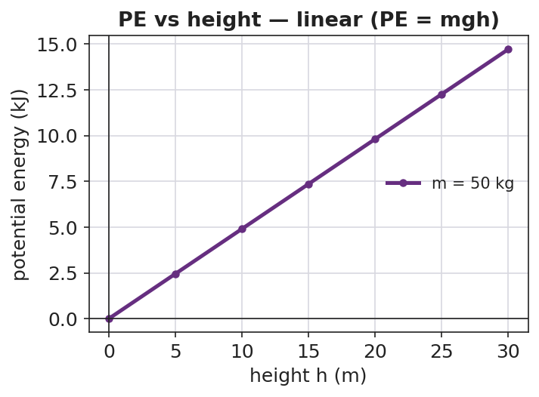
Gravitational PE vs height is a straight line through the origin
Teacher facilitation language:
“You doubled the height — what did the stored energy do? Now predict tripling before you test.” “When you moved the reference line, the object didn’t move — so why did the PE number change?”
Anticipated student responses:
- “Doubling the height doubled the PE — it’s a straight line.” — yes; PE ∝ h.
- “PE changed when we moved the zero line — so ‘height’ is measured from somewhere.” — land the reference-height idea.

Teacher facilitation during Explore
- What to look for — students seeing PE ∝ h (linear) and recognizing that PE is relative to a chosen zero.
- What to resist — don’t pre-state PE = mgh; let the sim build the proportionality.
- What to redirect — “PE is just height” → no, it’s mass × g × height; height alone isn’t energy.

Phase 3 · Explain (28 – 35 min)

28–31 min · Turn-and-Talk #2 + class consensus
“From the sim: what three things set the stored energy, and why does the reference height matter?”
Target consensus:
“Gravitational potential energy is mass × g × height: PE = mgh. It grows in a straight line with height. The height must be measured from a chosen reference — change the reference and the number changes, because PE is about relative position.”

31–35 min · Vocabulary introduction (≤ 3 terms) + HOCHMAN
From the reference table: PE = mgh, with g ≈ 9.81 m/s², in joules.
Sample teacher language (Hochman appositive + Because/But/So):
“Appositive: Gravitational potential energy, the energy stored because of an object’s height above a reference point, equals mgh. Because/But/So: We can call the floor ‘zero height’ because PE is measured relative to a reference, but if we chose the tabletop as zero the same book would have less PE, so PE depends on the reference we pick.”

Discussion prompts to deploy here
- “A 2.0 kg book sits on a 1.0 m table. What is its PE relative to the floor? (g ≈ 9.81)”
  - Sample response: “PE = mgh = 2.0 × 9.81 × 1.0 ≈ 19.6 J.”
- “Why does a water tower need to be tall?”
  - Sample response: “Height gives the water gravitational PE, which provides pressure to push water through the pipes.”

Phase 4 · Elaborate (35 – 40 min)

35–38 min · Revise the model + the bar chart
“Return to your three-height drawing. Using PE = mgh, make a bar chart of PE at several lift-hill heights for one car. What pattern do the bar heights follow?”
Project:
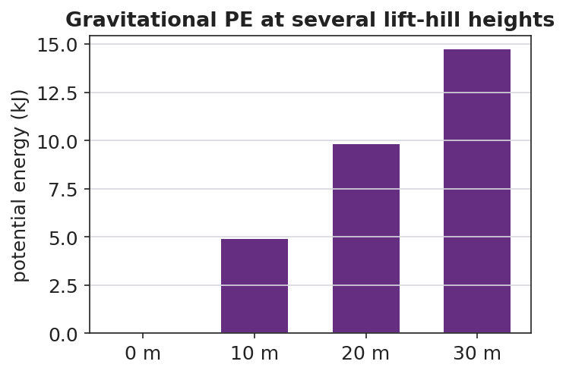
Gravitational PE at several lift-hill heights — bars grow in proportion to height
Target: bar heights are proportional to the lift-hill height — double the height, double the stored energy (a linear pattern).

38–40 min · Return to the phenomenon
“In one Because/But/So sentence, explain why the tallest lift hill stores the most energy — and why we always state PE relative to the ground.”

Phase 5 · Evaluate (40 – 42 min)

40–42 min · Exit Ticket + Closing Reflection
“A 500 kg roller-coaster car is hauled to the top of a 30 m lift hill. (Use g ≈ 9.81 m/s².) (a) Calculate its gravitational potential energy relative to the ground. Show PE = mgh. (b) If the lift hill were only 15 m, what would its PE be, and how does it compare? (c) Explain why your answer to (a) would change if we measured height from a platform halfway up instead of the ground.”
Expected: (a) ≈ 147,150 J; (b) ≈ 73,575 J — half; (c) PE depends on the reference height, so a higher zero gives a smaller h and thus a smaller PE. See Answer_Key.docx.
Closing Reflection (SEL, 30 seconds):
“What is one idea about ‘stored energy’ you’ll carry out of here — and who helped it click?”

Common Misconceptions
- Misconception: “Potential energy is just an object’s height.” → Correction: PE = mgh — it depends on mass and g as well as height; height alone is not energy.
- Misconception: “An object has one true potential energy.” → Correction: PE is measured relative to a chosen reference; change the reference and the PE value changes.
- Misconception: “Heavier objects always fall faster, so they store more PE per height.” → Correction: PE scales with mass (mgh), but in free fall all masses accelerate at g; the two ideas are separate.

Access & Differentiation
- ELL/ENL supports: Sentence frame: *“The object stores more potential energy when its ___ is greater, because PE = m·g·___.”* Word box: {potential energy, height, gravitational field, reference, stored}. Pair “stored” with a “loading-up” gesture.
- IEP/SPED supports: Provide the PE = mgh formula card with g ≈ 9.81 already filled in. Pre-label the reference line on the diagram. Allow the Javalab sim as a hands-on alternative to symbolic work.
- Extensions: Combine with Lesson 03: predict the speed at the bottom of the hill by setting the PE lost equal to KE gained (preview of conservation, Lesson 05).

Strategy Spotlight
HOCHMAN (literacy). The writing moves are the appositive (defining gravitational PE inside the sentence) and Because/But/So to capture the subtle reference-height idea — the place students most often lose precision. Model the appositive, then have students expand the kernel “PE is stored energy” into a full definition naming height and reference. The Because/But/So in Phase 4 forces them to articulate why the reference matters in one controlled sentence; collect and revise two or three as a class.

NYSSLS Observation Checklist Crosswalk
# | Checklist item | Where it appears in this lesson
1 | Local/relatable phenomenon | Phase 1 — roller-coaster lift hill / water tower
2 | Turn and Talk (2–3×) | Phase 1 (TT#1 — what sets stored energy), Phase 3 (TT#2 — PE = mgh + reference)
3 | Students develop questions/models/procedures | Phase 1 (initial model), Phase 2 (Javalab sim investigation), Phase 4 (revise model)
4 | CCC defined and used | Lesson Overview · Energy and Matter, applied in Phase 2
5 | ENL — ≤ 3 vocab, second half | Phase 3 — vocabulary at 31–35 min (potential energy / height / gravitational field)
6 | Revisit phenomenon with evidence | Phase 4 — PE-at-heights bar chart; restate lift hill
7 | ENL/SPED supports | Access & Differentiation block
8 | Assessment check | Phase 5 — Exit Ticket (500 kg coaster car)

Companion Materials
- Student_Worksheet.docx — the 5E student investigation + Javalab sim guide (hand out at start of Phase 2)
- Student_Notes.docx — guided note-guide for vocabulary and the worked example
- Answer_Key.docx — answers to “Make It Make Sense” prompts and the Exit Ticket

Key Vocabulary (max 3)
- potential energy — energy stored because of an object’s position; gravitational PE = mgh, in joules
- height — the vertical distance above a chosen reference point; the h in PE = mgh
- gravitational field — the region where gravity acts; its strength g ≈ 9.81 m/s² near Earth’s surface sets the g in PE = mgh

Gravitational Potential Energy — Student Worksheet
Unit: Work, Energy & Power — Lesson 04 Name: _______________________ Date: __________ Period: ____

Phenomenon
A roller-coaster car is slowly hauled up the lift hill. Nothing exciting happens on the way up — but every meter of height stores energy the coaster will spend on the way down. A water tower does the same thing with water.
Driving question: What is being stored as the car climbs, and what does the amount of stored energy depend on?

Notice & Wonder
I notice… | I wonder…
Turn & Talk #1: What two things about the coaster car decide how much energy is stored at the top? Use the word height.

Initial Model
Draw the coaster car on the lift hill at three heights.
My prediction — when the height doubles, the stored energy becomes ____________ times bigger, because _______________________________________________

Investigation — Javalab: Potential energy due to gravity
Open https://javalab.org/en/potential_energy_en/. Record what changes the stored energy.
Test | What I changed | PE before | PE after | Effect
1. Double the height
2. Double the mass
3. Move the reference line (zero)

Gravitational PE vs height
Key question: In test 3 the object did not move, yet the PE number changed. Why?

Make It Make Sense
- A 2.0 kg book sits on a 1.0 m table. What is its gravitational PE relative to the floor? Use PE = mgh with g ≈ 9.81 m/s².
- Two coaster cars sit at the same height. Car A is 400 kg; car B is 800 kg. Which has more PE, and by what factor? Explain.
- Why must we always state the reference height (the “zero”) when we report a potential energy?

Vocabulary in Action
Use each term in a sentence about today’s phenomenon.
- potential energy: _______________________________________________
- height: _______________________________________________
- gravitational field: _______________________________________________

Revise Your Model
Using PE = mgh, make a bar chart of PE at several lift-hill heights for one car. What pattern do the bar heights follow?

Gravitational PE at several heights
The bar heights follow this pattern: ____________ . Revise your prediction: when height doubles, PE becomes ____________ times bigger because _______________________________________________

Exit Ticket
A 500 kg roller-coaster car is hauled to the top of a 30 m lift hill. (Use g ≈ 9.81 m/s².)
- Calculate its gravitational potential energy relative to the ground. Show PE = mgh.
- If the lift hill were only 15 m, what would its PE be, and how does it compare to part (a)?
- Explain why your answer to (a) would change if we measured height from a platform halfway up instead of from the ground.

Gravitational Potential Energy — Student Notes
Unit: Work, Energy & Power — Lesson 04 Name: _______________________ Date: __________ Period: ____

Learning Targets
By the end of today’s 42 minutes I can:
- Define gravitational potential energy and compute it with PE = mgh.
- Explain why PE is measured relative to a reference height.
- Predict how PE changes when height or mass changes.

Key Vocabulary
- potential energy — _______________________________________________
- height — _______________________________________________
- gravitational field — _______________________________________________

Guided Notes
Big idea: Gravitational potential energy is energy __________ because of an object’s __________ above a reference point.
- Reference-table formula: PE = mgh, where m is __________ (kg), g ≈ __________ m/s², and h is __________ (m). Unit: __________ (J).
- PE grows in a __________ line with height: double the height → __________ the PE.
- PE also grows with __________: double the mass → __________ the PE.
- Height must be measured from a chosen __________. Change the reference → the PE value __________.
- g (the strength of the __________) is about 9.81 m/s² near Earth’s surface.
Pattern table (m = 50 kg, g ≈ 9.81):
Height | PE
10 m | ≈ __________ J
20 m | ≈ __________ J
30 m | ≈ __________ J


Gravitational potential energy vs. height (PE = mgh): PE increases in direct proportion to height above the reference level.

Worked Example
Problem. A 3.0 kg flowerpot sits on a balcony 5.0 m above the sidewalk. What is its gravitational PE relative to the sidewalk? (g ≈ 9.81 m/s²)
Solution. 1. List knowns: m = __________ kg, g ≈ __________ m/s², h = __________ m. 2. Formula: PE = mgh = __________ × __________ × __________. 3. Compute: PE ≈ __________ J. 4. The reference here is the __________; from the balcony floor the PE would be __________.

Summary
Finish the sentence (Because / But / So):
The tallest lift hill stores the most energy because __________________________________________, but __________________________________________, so __________________________________________.

Gravitational Potential Energy — Answer Key

Cover
Unit: Work, Energy & Power — Lesson 04: Gravitational Potential Energy East Meadow Schools × Valley Stream Central HSD Strategy chip: HOCHMAN

Make-It-Make-Sense Answers
- PE = mgh = 2.0 kg × 9.81 m/s² × 1.0 m ≈ 19.6 J (about 20 J) relative to the floor. · Rubric: correct substitution with g ≈ 9.81 AND ≈ 19.6 J. · NYSSLS: HS-PS3-2
- Both at the same height, so only mass differs. PE ∝ m, so car B (800 kg) has twice the PE of car A (400 kg). · Rubric: answer 2× AND justified by PE ∝ m. · NYSSLS: HS-PS3-2
- PE = mgh uses h measured from a reference. The same object has different h (and thus different PE) depending on where we call “zero,” because potential energy describes relative position, not an absolute property. · Rubric: states PE is relative to a chosen reference. · NYSSLS: HS-PS3-2

Exit Ticket Answer
- PE = mgh = 500 kg × 9.81 m/s² × 30 m = 147,150 J (≈ 1.47 × 10⁵ J) relative to the ground.
- PE = 500 × 9.81 × 15 = 73,575 J (≈ 7.36 × 10⁴ J) — exactly half, because PE is proportional to height.
- Measuring from a platform halfway up makes h smaller (15 m instead of 30 m), so the PE would be smaller; PE depends on the reference height we choose.
Tolerance/rubric: (a) shows mgh and ≈ 147,000 J; (b) ≈ 73,600 J AND “half”; (c) explains the reference-height dependence. 1 point each. Accept g = 9.8 (≈ 147,000 J / ≈ 73,500 J). NYSSLS: HS-PS3-2.

Closing Reflection (rubric)
Closing reflection is formative, not graded. Award full credit for any honest response. Look for: - A genuine “stored energy” idea the student is taking away - Naming a peer or self-acknowledgment

Conservation of Energy — Teacher Guide

Cover
Unit: Work, Energy & Power — Lesson 05: Conservation of Energy East Meadow Schools × Valley Stream Central High School District Strategy chips: ACTIVE LEARNING

Curated Resources (from East Meadow Scope & Sequence)

NYSSLS Standards
This lesson is the unit’s central computational payoff for HS-PS3-1: “Create a computational model to calculate the change in energy of one component in a system when the change in energy of the other component(s) and energy flows in and out of the system are known.” (CCC: Systems and System Models.) With no friction (no energy flow out), a drop in PE equals the gain in KE — students compute one component from the other. It also synthesizes HS-PS3-2 (energy = motion + relative position).

Phenomenon
- A skate park half-pipe / a pendulum / a roller coaster — energy trades between height and speed but the total stays the same. PhET Energy Skate Park: https://phet.colorado.edu/en/simulations/energy-skate-park-basics
- Javalab roller coaster: https://javalab.org/en/roller_coaster_en/

Javalab / Labs
- PhET Energy Skate Park Basics (bar-graph energy view): link above.
- Javalab roller coaster: link above.

Assessments
- PhET Energy Skate Park guided questions. The Exit Ticket below is the formative check; the “Make It Make Sense” items map to HS-PS3-1.

Lesson Overview
Duration | 42 minutes (1 period)
NYSSLS link | HS-PS3-1 (core — compute one energy component from another); HS-PS3-2 (synthesis)
CCC focus | Systems and System Models — with no energy flow out, total mechanical energy of the system is conserved.
Strategy chips | ACTIVE LEARNING (PhET/Javalab exploration, predict-and-test, energy bar-graph reading)
Materials | Computers/tablets (PhET + Javalab); a pendulum (string + mass) for a live demo; whiteboards.
Safety | Secure the pendulum mount; clear the swing path.
Prior knowledge | KE = ½mv² (Lesson 03), PE = mgh (Lesson 04), the joule.
Lesson objectives — students can:
- State conservation of energy: without friction, KE + PE (mechanical energy) stays constant.
- Describe the energy transformation PE ↔ KE as a skater/coaster/pendulum moves.
- Use conservation to compute a missing energy or speed: PE lost = KE gained.

Phase 1 · Engage (0 – 10 min)

0–3 min · Opening Connection (SEL)
Pair-share, one sentence: “Name something that trades back and forth — like effort and rest, or saving and spending.” Surface a couple, then frame: energy does the same trade between height and speed.

3–7 min · Phenomenon hook — the skate park / pendulum
Teacher actions. Release a pendulum from one side; it swings up to nearly the same height on the other side, again and again. (Or play a skate-park half-pipe clip.)
Sample teacher language:
“Watch how high it comes back. Almost exactly where it started — over and over. At the bottom it’s fast; at the top it’s stopped. Something is being traded. What, and is anything lost?”
Anticipated student responses:
- “It’s losing energy each swing.” — true with friction; we’ll isolate the frictionless ideal first.
- “Fast at the bottom, stopped at the top.” — capture the KE↔PE trade.
- “The energy turns into speed and back.” — exactly the transformation we’ll name.

7–10 min · Notice & Wonder + Turn-and-Talk #1
Two columns. Then:
“Turn to your partner: where is the pendulum fastest, where is it highest, and what does that tell you about where each kind of energy is biggest?”

Bridge to Phase 2
Each student leaves with an initial model: “As the pendulum swings down, its ______ energy turns into ______ energy because ______.”

Phase 2 · Explore (10 – 28 min)

10–13 min · Initial Model (silent / individual)
Prompt:
“Sketch the half-pipe (or pendulum). Mark TOP, MIDDLE, BOTTOM. At each point, predict whether KE and PE are HIGH, MEDIUM, or ZERO.”

13–28 min · Investigation — PhET Energy Skate Park + Javalab coaster
Active-learning exploration. Turn ON the energy bar-graph in PhET. With friction OFF first.
- Watch the KE and PE bars as the skater moves. At the top: which bar is tall? At the bottom?
- Read the total bar at top, middle, and bottom. Is it constant? Record three values.
- Turn friction ON. What now happens to the total over time? Where does the “missing” energy go?
- On the Javalab coaster, find a point where KE = PE and explain what that means.
Project to anchor the pattern:
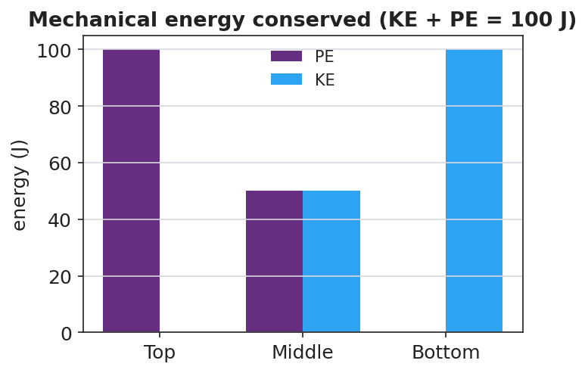
Stacked energy bar chart: PE and KE at top, middle, bottom sum to a constant 100 J
Teacher facilitation language:
“Add the two bars at each point. Do they sum to the same total? Predict the total at the middle before you look.” “With friction on, the total shrank — energy isn’t destroyed, so where did it go?”
Anticipated student responses:
- “PE plus KE is the same number everywhere — 100 J.” — the conservation insight.
- “With friction the total drops; it became heat.” — energy leaves the mechanical system as thermal energy.

Teacher facilitation during Explore
- What to look for — students summing KE + PE to a constant; locating the PE↔KE trade.
- What to resist — don’t state “conservation” before they sum the bars themselves.
- What to redirect — “energy disappeared” (friction case) → “energy is conserved overall; some left as heat — it’s not in the mechanical total anymore.”

Phase 3 · Explain (28 – 35 min)

28–31 min · Turn-and-Talk #2 + class consensus
“From the bar graphs: what is true about KE + PE without friction, and what does the skater’s motion do to those two energies?”
Target consensus:
“Without friction, mechanical energy (KE + PE) stays constant — energy is conserved. As the skater drops, PE transforms into KE; as it rises, KE transforms back into PE. With friction, some mechanical energy converts to heat, so the mechanical total drops, but total energy is still conserved.”

31–35 min · Vocabulary introduction (≤ 3 terms)
Define from the bar graphs.
Sample teacher language:
“The sum KE + PE is the mechanical energy. The rule that it doesn’t change without friction is conservation of energy. The swap from PE to KE and back is an energy transformation. So: PE lost = KE gained.”

Discussion prompts to deploy here
- “A 2.0 kg ball is dropped from 5.0 m. Ignoring friction, what is its KE just before it lands?”
  - Sample response: “PE lost = mgh = 2.0 × 9.81 × 5.0 ≈ 98 J, so KE ≈ 98 J at the bottom.”
- “Why does a pendulum eventually stop in the real world?”
  - Sample response: “Friction and air resistance transform some mechanical energy into heat each swing, so KE + PE slowly decreases.”

Phase 4 · Elaborate (35 – 40 min)

35–38 min · Revise the model + the cross-over graph
“Return to your TOP/MIDDLE/BOTTOM sketch. Now plot KE and PE vs. position along the track. Where do the curves cross, and what is true of their sum everywhere?”
Project:
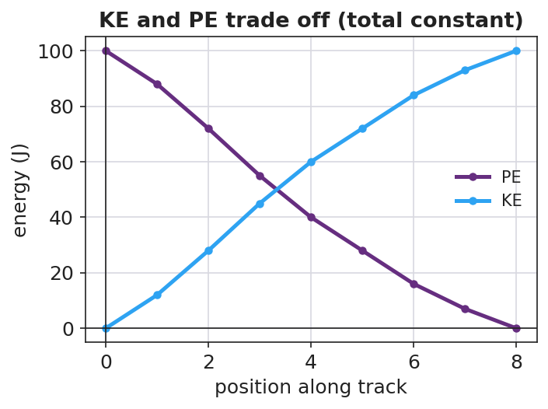
KE and PE vs position — the two curves cross while their sum stays constant
Target: the KE and PE curves are mirror images that cross where KE = PE; their sum is a flat line — the conserved mechanical energy.

38–40 min · Return to the phenomenon
“In one sentence, explain why the pendulum returns to (almost) the same height every swing, using conservation of energy and energy transformation.”

Phase 5 · Evaluate (40 – 42 min)

40–42 min · Exit Ticket + Closing Reflection
“A 0.50 kg cart starts at rest at the top of a frictionless track 2.0 m high. (Use g ≈ 9.81 m/s².) (a) What is its PE at the top? Show PE = mgh. (b) Using conservation of energy, what is its KE at the bottom? Explain. (c) On a real track with friction, would the KE at the bottom be more, less, or equal? Where does the difference go?”
Expected: (a) ≈ 9.81 J; (b) ≈ 9.81 J (PE lost = KE gained); (c) less — some energy transforms into heat. See Answer_Key.docx.
Closing Reflection (SEL, 30 seconds):
“Where did you see energy ‘trade’ today, and who helped you make sense of the swap?”

Common Misconceptions
- Misconception: “Energy gets used up / disappears.” → Correction: Energy is conserved; with friction it transforms into heat and leaves the mechanical total, but total energy is unchanged.
- Misconception: “At the bottom of the hill the cart has both maximum PE and maximum KE.” → Correction: At the lowest point PE is minimum and KE is maximum; they trade off.
- Misconception: “A pendulum can swing higher than it started.” → Correction: Without added energy, it can at most return to its starting height (conservation); friction makes it return lower.

Access & Differentiation
- ELL/ENL supports: Sentence frame: *“As the skater goes down, ___ energy turns into ___ energy, but the total (KE + PE) stays ___ because energy is ___.”* Word box: {mechanical energy, conservation of energy, energy transformation, constant, heat}. Use up/down hand gestures for PE/KE.
- IEP/SPED supports: Provide the PhET bar-graph screenshot with TOP/MIDDLE/BOTTOM pre-labeled; students fill HIGH/MEDIUM/ZERO. Provide the “PE lost = KE gained” relationship as a formula card.
- Extensions: Solve for speed at the bottom by setting mgh = ½mv² and canceling mass: v = √(2gh). Predict the skater’s speed at the bottom of a given hill and check in PhET.

Strategy Spotlight
ACTIVE LEARNING. Students discover conservation by manipulating the PhET skater and reading their own energy bar graphs — turning friction on and off to see the mechanical total hold, then leak. Require a prediction before each manipulation (predict-and-test), and have pairs report the total energy they measured at three points so the class sees the constant emerge from shared data, not from the teacher. The friction toggle is the key “aha”: energy is still conserved; it just left as heat.

NYSSLS Observation Checklist Crosswalk
# | Checklist item | Where it appears in this lesson
1 | Local/relatable phenomenon | Phase 1 — skate park / pendulum / coaster
2 | Turn and Talk (2–3×) | Phase 1 (TT#1 — fastest vs. highest), Phase 3 (TT#2 — KE + PE constant)
3 | Students develop questions/models/procedures | Phase 1 (initial model), Phase 2 (PhET/Javalab exploration), Phase 4 (revise model)
4 | CCC defined and used | Lesson Overview · Systems and System Models, applied in Phase 2 (friction on/off)
5 | ENL — ≤ 3 vocab, second half | Phase 3 — vocabulary at 31–35 min (mechanical energy / conservation / transformation)
6 | Revisit phenomenon with evidence | Phase 4 — KE/PE cross-over graph; restate pendulum return
7 | ENL/SPED supports | Access & Differentiation block
8 | Assessment check | Phase 5 — Exit Ticket (0.50 kg cart)

Companion Materials
- Student_Worksheet.docx — the 5E student investigation + PhET/Javalab guide (hand out at start of Phase 2)
- Student_Notes.docx — guided note-guide for vocabulary and the worked example
- Answer_Key.docx — answers to “Make It Make Sense” prompts and the Exit Ticket

Key Vocabulary (max 3)
- mechanical energy — the sum of an object’s kinetic and potential energy (KE + PE)
- conservation of energy — energy is never created or destroyed; without friction, mechanical energy stays constant
- energy transformation — the conversion of energy from one form to another, such as PE ↔ KE

Conservation of Energy — Student Worksheet
Unit: Work, Energy & Power — Lesson 05 Name: _______________________ Date: __________ Period: ____

Phenomenon
A pendulum released from one side swings up to almost the same height on the other side — over and over. At the bottom it moves fast; at the top it stops. A skate-park half-pipe and a roller coaster do the same trade between height and speed.
Driving question: What is being traded as something rises and falls, and does the total amount of energy stay the same?

Notice & Wonder
I notice… | I wonder…
Turn & Talk #1: Where is the pendulum fastest, where is it highest, and what does that tell you about where each kind of energy is biggest?

Initial Model
Sketch the half-pipe (or pendulum). Mark TOP, MIDDLE, BOTTOM. At each point, predict KE and PE as HIGH, MEDIUM, or ZERO.
Point | KE (high/med/zero) | PE (high/med/zero)
TOP
MIDDLE
BOTTOM

Investigation — PhET Energy Skate Park (+ Javalab coaster)
Open https://phet.colorado.edu/en/simulations/energy-skate-park-basics and turn ON the energy bar graph. Start with friction OFF.
Point | KE bar (J) | PE bar (J) | Total KE + PE (J)
Top
Middle
Bottom

Energy bar chart: PE + KE = constant
Now turn friction ON and watch over time.
Key question: With friction off, what is true about the total (KE + PE)? With friction on, the total shrinks — energy is never destroyed, so where did it go?

Make It Make Sense
- A 2.0 kg ball is dropped from 5.0 m. Ignoring friction, what is its KE just before it lands? Use PE lost = KE gained, with g ≈ 9.81 m/s².
- At the bottom of a frictionless hill, is the cart’s PE maximum or minimum? Is its KE maximum or minimum? Explain.
- Why does a real pendulum eventually stop, even though energy is conserved?

Vocabulary in Action
Use each term in a sentence about today’s phenomenon.
- mechanical energy: _______________________________________________
- conservation of energy: _______________________________________________
- energy transformation: _______________________________________________

Revise Your Model
Plot KE and PE vs. position along the track. Where do the two curves cross, and what is true of their sum everywhere?

KE and PE vs position — cross-over
The curves cross where ____________ . Their sum everywhere is ____________ . The pendulum returns to almost the same height because _______________________________________________

Exit Ticket
A 0.50 kg cart starts at rest at the top of a frictionless track 2.0 m high. (Use g ≈ 9.81 m/s².)
- What is its PE at the top? Show PE = mgh.
- Using conservation of energy, what is its KE at the bottom? Explain.
- On a real track with friction, would the KE at the bottom be more, less, or equal? Where does the difference go?

Conservation of Energy — Student Notes
Unit: Work, Energy & Power — Lesson 05 Name: _______________________ Date: __________ Period: ____

Learning Targets
By the end of today’s 42 minutes I can:
- State conservation of energy: without friction, KE + PE stays constant.
- Describe the energy transformation PE ↔ KE as an object rises and falls.
- Use conservation to find a missing energy or speed (PE lost = KE gained).

Key Vocabulary
- mechanical energy — _______________________________________________
- conservation of energy — _______________________________________________
- energy transformation — _______________________________________________

Guided Notes
Big idea: Mechanical energy is the sum KE + PE. Without friction, this total stays __________.
- Conservation of energy: energy is never __________ or __________ — it only changes form.
- As an object moves down, __________ energy transforms into __________ energy.
- As an object moves up, __________ energy transforms into __________ energy.
- So: PE lost = __________ gained (no friction).
- With friction, some mechanical energy transforms into __________, so KE + PE __________ — but total energy is still conserved.
At each point of a frictionless track (total = 100 J):
Point | PE | KE | Total
Top | 100 J | __________ | 100 J
Middle | 50 J | __________ | __________
Bottom | __________ | 100 J | __________


Energy bar chart at the top, middle, and bottom of a track: PE converts to KE while the total mechanical energy stays constant.

Worked Example
Problem. A 0.50 kg cart starts at rest at the top of a frictionless 2.0 m track. Find its KE and speed at the bottom. (g ≈ 9.81 m/s²)
Solution. 1. PE at top: PE = mgh = 0.50 × 9.81 × 2.0 = __________ J. 2. Conservation: PE lost = KE gained, so KE at bottom = __________ J. 3. Find speed from KE = ½mv²: __________ = ½ × 0.50 × v². 4. Solve: v² = __________ , so v = __________ m/s.

Summary
Finish the sentence (Because / But / So):
A frictionless pendulum returns to the same height every swing because __________________________________________, but __________________________________________, so __________________________________________.

Conservation of Energy — Answer Key

Cover
Unit: Work, Energy & Power — Lesson 05: Conservation of Energy East Meadow Schools × Valley Stream Central HSD Strategy chip: ACTIVE LEARNING

Make-It-Make-Sense Answers
- PE lost = mgh = 2.0 kg × 9.81 m/s² × 5.0 m ≈ 98 J. By conservation (PE lost = KE gained), KE just before landing ≈ 98 J. · Rubric: computes mgh AND equates to KE. · NYSSLS: HS-PS3-1
- At the bottom the height is least, so PE is minimum; all of it has transformed into motion, so KE is maximum. The two trade off. · Rubric: PE minimum AND KE maximum at the bottom. · NYSSLS: HS-PS3-2
- Energy is conserved, but friction and air resistance transform some mechanical energy into heat each swing. The mechanical total (KE + PE) decreases, so the pendulum returns a little lower until it stops. · Rubric: names transformation to heat AND that mechanical energy decreases. · NYSSLS: HS-PS3-1

Exit Ticket Answer
- PE = mgh = 0.50 kg × 9.81 m/s² × 2.0 m = 9.81 J (≈ 9.8 J).
- By conservation of energy on a frictionless track, PE lost = KE gained, so KE at the bottom = 9.81 J (≈ 9.8 J). All the PE became KE.
- Less. Friction transforms some mechanical energy into heat (and a little sound), so less KE reaches the bottom; total energy is still conserved.
Tolerance/rubric: (a) shows mgh and ≈ 9.8 J; (b) ≈ 9.8 J via PE lost = KE gained; (c) “less” + “energy goes to heat.” 1 point each. Accept g = 9.8 (≈ 9.8 J). NYSSLS: HS-PS3-1.

Closing Reflection (rubric)
Closing reflection is formative, not graded. Award full credit for any honest response. Look for: - A genuine description of where energy “traded” today - Naming a peer or self-acknowledgment

Energy in Systems: Wheels to Watts — Teacher Guide

Cover
Unit: Work, Energy & Power — Lesson 06: Energy in Systems (Wheels to Watts) East Meadow Schools × Valley Stream Central High School District Strategy chips: BTC

Curated Resources (from East Meadow Scope & Sequence)

NYSSLS Standards
This NYS Investigation lesson targets HS-PS3-3: “Design, build, and refine a device that works within given constraints to convert one form of energy into another form of energy.” (CCC: Energy and Matter.) Students track energy flow through a real conversion device, separate useful from wasted energy, compute efficiency, and refine the design — the full engineering cycle. It rests on the conservation idea (Lesson 05): the “wasted” energy is not destroyed, only converted to heat.

Phenomenon
- Regenerative braking / a bike generator powering a light — “Wheels to Watts”: motion → electricity. https://www.youtube.com/watch?v=q4_yTYHM8gc (How regenerative braking works)
- The Physics Classroom — energy transformation & efficiency overview: https://www.physicsclassroom.com/class/energy/Lesson-2/Mechanical-Energy

Javalab / Labs
- Wheels-to-Watts build (this lesson): a hand-crank or bike generator + small load (LED/buzzer). Javalab energy index for supporting sims: https://javalab.org/en/category/energy_en/

Assessments
- The Wheels-to-Watts design rubric (useful output vs. input, with a refinement). The Exit Ticket below is the formative check; “Make It Make Sense” items map to HS-PS3-3.

Lesson Overview
Duration | 42 minutes (1 period; pairs well with a double period for the build/refine)
NYSSLS link | HS-PS3-3 (design, build, refine an energy-conversion device)
CCC focus | Energy and Matter — energy flows through a system, splitting into useful output and wasted (heat) energy.
Strategy chips | BTC (random groups, VNPS for the efficiency/refinement reasoning)
Materials | Hand-crank or bike generator; LED/buzzer/small motor; multimeter (optional); VNPS boards + markers; random grouping cards; the regenerative-braking clip.
Safety | Secure the generator; keep fingers clear of moving wheels/cranks; low-voltage loads only.
Prior knowledge | Work, power (Lesson 02), and conservation of energy (Lesson 05).
Lesson objectives — students can:
- Trace energy transfer through a conversion device, separating useful output from wasted energy.
- Define and compute efficiency = useful output ÷ energy input (as a fraction or percent).
- Propose and justify a refinement that raises a device’s efficiency (HS-PS3-3).

Phase 1 · Engage (0 – 10 min)

0–3 min · Opening Connection (SEL)
Pair-share, one sentence: “Name something you do that ‘wastes’ effort no matter how careful you are.” Surface a couple. Frame: every machine wastes some energy too — the question is how much.

3–7 min · Phenomenon hook — regenerative braking / bike generator
Teacher actions. Play the regenerative-braking clip, or hand-crank a generator to light an LED. Note how warm the generator gets.
Sample teacher language:
“When this car brakes, instead of throwing away the motion as heat in the brake pads, it captures some of it as electricity. But not all of it — feel how warm this generator gets. Where does the rest of the energy go?”
Anticipated student responses:
- “It turns motion into electricity.” — capture the transformation.
- “Some becomes heat — the generator is warm.” — exactly the wasted-energy idea.
- “You can’t get all of it back.” — seeds efficiency < 100%.

7–10 min · Notice & Wonder + Turn-and-Talk #1
Two columns. Then:
“Turn to your partner: of all the energy you put into the crank, how much do you think comes out as useful electricity — all of it? Where does the rest go?”

Bridge to Phase 2
Each student leaves with an initial model: “Energy goes in as ______, comes out useful as ______, and is wasted as ______.”

Phase 2 · Explore (10 – 28 min)

10–13 min · BTC setup — random groups + VNPS
Form visibly random groups of 3. Claim a vertical non-permanent surface. Each group will track energy through the Wheels-to-Watts device and reason about efficiency at the board.

13–28 min · Investigation — Wheels to Watts (build → measure → refine)
Thin-sliced design task:
- Trace the flow. For the bike/hand generator + LED, label the energy at each stage: input (your motion / chemical from food) → useful (electrical/light) → wasted (heat, friction, sound).
- Quantify. Given an input of 100 J, decide where a realistic split goes (e.g., 75 J useful, 25 J wasted). Compute efficiency = useful ÷ input.
- Compare devices. Rank an incandescent bulb (~5%), an LED (~40%+), the bike generator (~75%) by efficiency. Why so different?
- Refine (HS-PS3-3). Propose ONE change to your device that would raise its efficiency (reduce friction, better gearing, less resistance). Predict the new efficiency and justify.
Project to anchor the input-vs-output idea:
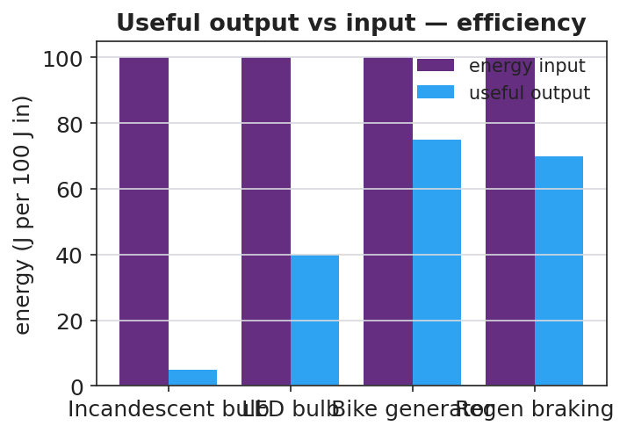
Useful output vs energy input for several devices — efficiency
Teacher facilitation language (BTC — bounce questions back):
“If 100 J go in and 75 J come out useful, where are the other 25 J — are they destroyed?” “Your refinement claims higher efficiency — what term in ‘useful ÷ input’ did your change improve, and how do you know?”
Anticipated student responses:
- “Efficiency is useful over input — 75/100 = 75%.” — target.
- “The wasted 25 J became heat; energy is conserved, it just isn’t useful.” — ties to Lesson 05.
- “Less friction → more useful output → higher efficiency.” — valid refinement reasoning.

Teacher facilitation during Explore
- What to look for — groups computing efficiency as a ratio and locating wasted energy as heat (not “lost”).
- What to resist — don’t grade refinements; ask groups to justify against another board.
- What to redirect — “energy is lost” → “conserved; it left the useful path as heat.”

Phase 3 · Explain (28 – 35 min)

28–31 min · Turn-and-Talk #2 + class consensus
“Tour another board. How did they compute efficiency, and what happened to the energy that wasn’t useful?”
Target consensus:
“A device transfers energy from one form to another. Efficiency = useful output ÷ energy input. The rest isn’t destroyed — it becomes heat (and a little sound/friction). No real device is 100% efficient.”

31–35 min · Vocabulary introduction (≤ 3 terms)
Define from the flow charts.
Sample teacher language:
“Efficiency is the fraction of input energy that comes out useful: useful ÷ input. Energy transfer is energy moving or changing form through the device. The whole crank-generator-LED setup is the system we’re analyzing — and across the whole system, energy is conserved.”

Discussion prompts to deploy here
- “A motor uses 200 J and delivers 150 J of useful work. What is its efficiency?”
  - Sample response: “150 / 200 = 0.75 = 75%.”
- “Why can no real device be 100% efficient?”
  - Sample response: “Friction and resistance always convert some energy to heat, so useful output is always less than input.”

Phase 4 · Elaborate (35 – 40 min)

35–38 min · Revise the model + the flow chart
“Return to your energy-flow sketch. Using a 100 J input, chart how much is useful vs. wasted for your refined device. Did your refinement raise the useful bar?”
Project:
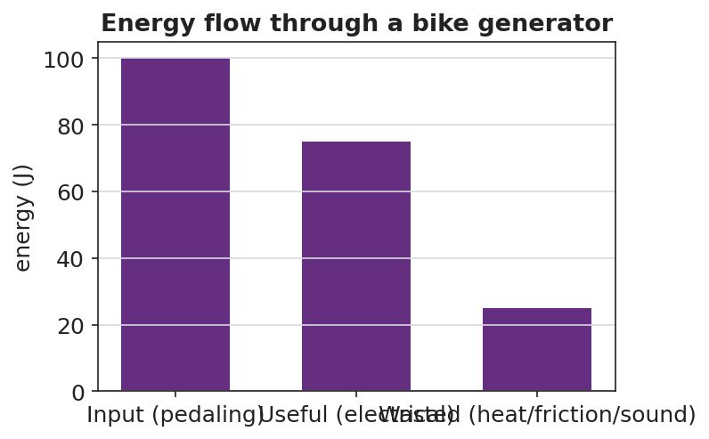
Energy flow through a bike generator: input splits into useful and wasted
Target: the input bar splits into a useful bar and a wasted (heat) bar; a good refinement shifts energy from the wasted bar to the useful bar, raising efficiency.

38–40 min · Return to the phenomenon
“In one sentence, explain why regenerative braking is better than normal braking in energy terms — and why it still can’t recover 100% of the car’s energy. Use efficiency and energy transfer.”

Phase 5 · Evaluate (40 – 42 min)

40–42 min · Exit Ticket + Closing Reflection
“A bike generator takes in 400 J of pedaling energy and delivers 300 J of useful electrical energy. (a) Calculate the efficiency. Show useful ÷ input. (b) Where did the other 100 J go? Did it disappear? (c) Propose ONE refinement that would raise the efficiency, and explain why it works.”
Expected: (a) 0.75 = 75%; (b) ~100 J became heat (friction in bearings/wires) and sound — conserved, not destroyed; (c) e.g., better bearings / less resistive wire → less heat → more useful output. See Answer_Key.docx.
Closing Reflection (SEL, 30 seconds):
“What is one place in your life you now see ‘wasted’ energy you’d want to capture — and who sharpened that idea for you?”

Common Misconceptions
- Misconception: “Wasted energy is destroyed.” → Correction: Energy is conserved; “wasted” energy is converted to heat/sound that isn’t useful — it still exists.
- Misconception: “A good machine can be 100% efficient.” → Correction: Friction and resistance always divert some energy to heat, so real efficiency is always below 100%.
- Misconception: “Efficiency is the useful energy in joules.” → Correction: Efficiency is a ratio (useful ÷ input), with no units; it’s often written as a percent.

Access & Differentiation
- ELL/ENL supports: Sentence frame: *“The device takes in ___ energy and gives out useful ___ energy; the rest becomes , so its efficiency is ÷ ___.”* Word box: {efficiency, energy transfer, system, useful, wasted, heat}. Use a “splitting” gesture for input → useful + wasted.
- IEP/SPED supports: Provide a pre-drawn energy-flow diagram with input/useful/wasted boxes to fill; provide the efficiency = useful ÷ input formula card and one worked percent. Offer a measuring/recording role on the build.
- Extensions: Build a multi-stage chain (generator → battery → motor) and compute the overall efficiency as the product of stage efficiencies; explain why long chains lose more.

Strategy Spotlight
BTC (Building Thinking Classrooms). The design-and-refine task is delivered as thin slices at vertical non-permanent surfaces with visibly random groups: trace the flow, compute efficiency, compare devices, then propose a refinement. The refinement slice is the HS-PS3-3 core — groups must justify a design change against the efficiency ratio, defending it to a neighboring board rather than to the teacher. Answer questions with questions (“where did the 25 J go?”) so the conservation-plus-efficiency reasoning is built by students.

NYSSLS Observation Checklist Crosswalk
# | Checklist item | Where it appears in this lesson
1 | Local/relatable phenomenon | Phase 1 — regenerative braking / bike generator
2 | Turn and Talk (2–3×) | Phase 1 (TT#1 — how much comes out useful), Phase 3 (TT#2 — board tour on efficiency)
3 | Students develop questions/models/procedures | Phase 1 (initial model), Phase 2 (build + measure + refine), Phase 4 (revise model)
4 | CCC defined and used | Lesson Overview · Energy and Matter, applied in Phase 2
5 | ENL — ≤ 3 vocab, second half | Phase 3 — vocabulary at 31–35 min (efficiency / energy transfer / system)
6 | Revisit phenomenon with evidence | Phase 4 — energy-flow chart; restate regenerative braking
7 | ENL/SPED supports | Access & Differentiation block
8 | Assessment check | Phase 5 — Exit Ticket (bike generator efficiency + refinement)

Companion Materials
- Student_Worksheet.docx — the 5E student investigation + Wheels-to-Watts design log (hand out at start of Phase 2)
- Student_Notes.docx — guided note-guide for vocabulary and the worked example
- Answer_Key.docx — answers to “Make It Make Sense” prompts and the Exit Ticket

Key Vocabulary (max 3)
- efficiency — the fraction of input energy that comes out as useful output; efficiency = useful ÷ input
- energy transfer — the movement or conversion of energy from one place or form to another
- system — the set of connected components being analyzed; energy is conserved across the whole system

Energy in Systems: Wheels to Watts — Student Worksheet
Unit: Work, Energy & Power — Lesson 06 Name: _______________________ Date: __________ Period: ____

Phenomenon
When a car with regenerative braking slows down, it captures some of its motion as electricity instead of throwing it all away as heat in the brakes. A bike generator does the same: your pedaling lights a bulb — but the generator gets warm. Not all of the energy makes it through. “Wheels to Watts.”
Driving question: When a device converts one form of energy into another, how much comes out useful, where does the rest go, and how can we make it better?

Notice & Wonder
I notice… | I wonder…
Turn & Talk #1: Of all the energy you put into the crank, how much do you think comes out as useful electricity? Where does the rest go?

Initial Model
Draw your Wheels-to-Watts device (generator → load). Label the energy at each stage.
Energy goes IN as ____________ , comes OUT useful as ____________ , and is WASTED as ____________ .

Investigation — Wheels to Watts (build → measure → refine)
Work at your group’s board.
Step | Result
1. Trace the flow (input → useful → wasted)
2. Split a 100 J input: ___ J useful, ___ J wasted
3. Efficiency = useful ÷ input =
4. Rank devices by efficiency (incandescent ~5%, LED ~40%, generator ~75%)
5. Refine: one change to raise efficiency, and your predicted new efficiency

Useful output vs input for several devices
Key question: If 100 J go in and 75 J come out useful, where are the other 25 J — are they destroyed?

Make It Make Sense
- A motor uses 200 J of electrical energy and delivers 150 J of useful work. What is its efficiency? Show useful ÷ input.
- An incandescent bulb is about 5% efficient; an LED is about 40% efficient. For every 100 J supplied, how much useful light energy does each give? Where does the rest go?
- Why can no real device be 100% efficient?

Vocabulary in Action
Use each term in a sentence about today’s phenomenon.
- efficiency: _______________________________________________
- energy transfer: _______________________________________________
- system: _______________________________________________

Revise Your Model
Using a 100 J input, chart how much is useful vs. wasted for your refined device. Did your refinement move energy from the wasted bar into the useful bar?

Energy flow through a bike generator
My refinement was ____________ . It raises efficiency because it reduces ____________ , which means more energy comes out as ____________ .

Exit Ticket
A bike generator takes in 400 J of pedaling energy and delivers 300 J of useful electrical energy.
- Calculate the efficiency. Show useful ÷ input.
- Where did the other 100 J go? Did it disappear?
- Propose ONE refinement that would raise the efficiency, and explain why it works.

Energy in Systems: Wheels to Watts — Student Notes
Unit: Work, Energy & Power — Lesson 06 Name: _______________________ Date: __________ Period: ____

Learning Targets
By the end of today’s 42 minutes I can:
- Trace energy transfer through a conversion device (useful vs. wasted).
- Define and compute efficiency = useful ÷ input.
- Propose a refinement that raises a device’s efficiency.

Key Vocabulary
- efficiency — _______________________________________________
- energy transfer — _______________________________________________
- system — _______________________________________________

Guided Notes
Big idea: A device transfers energy from one form to another, but only part of the input comes out __________.
- Efficiency = useful output ÷ energy input (a ratio, often written as a __________).
- Efficiency has no __________ (joules ÷ joules cancel).
- The energy that is not useful is not __________ — by conservation it becomes __________ (and a little sound).
- No real device is __________ % efficient, because __________ and resistance always divert energy to heat.
- A good refinement moves energy from the __________ bar into the __________ bar.
Energy split (100 J input):
Path | Energy
Input | 100 J
Useful output | __________ J
Wasted (heat) | __________ J
Efficiency = useful ÷ input | __________


Input energy vs. useful output energy: the ratio of useful output to input is the efficiency; the rest is transferred to the surroundings.

Worked Example
Problem. A bike generator takes in 500 J of pedaling energy and delivers 350 J of useful electrical energy. Find its efficiency and the wasted energy.
Solution. 1. Efficiency = useful ÷ input = __________ ÷ __________ . 2. Compute: efficiency = __________ = __________ %. 3. Wasted energy = input − useful = 500 − 350 = __________ J. 4. That wasted energy became __________ ; it was not destroyed (energy is conserved).

Summary
Finish the sentence (Because / But / So):
Regenerative braking is better than normal braking because __________________________________________, but __________________________________________, so __________________________________________.

Energy in Systems: Wheels to Watts — Answer Key

Cover
Unit: Work, Energy & Power — Lesson 06: Energy in Systems (Wheels to Watts) East Meadow Schools × Valley Stream Central HSD Strategy chip: BTC (NYS Investigation)

Make-It-Make-Sense Answers
- Efficiency = useful ÷ input = 150 J ÷ 200 J = 0.75 = 75%. · Rubric: correct ratio AND 75%. · NYSSLS: HS-PS3-3
- Incandescent: 5% of 100 J = 5 J of useful light; LED: 40% of 100 J = 40 J of useful light. The rest (95 J and 60 J) becomes heat. · Rubric: both useful values AND “rest becomes heat.” · NYSSLS: HS-PS3-3
- No real device is 100% efficient because friction and electrical resistance always convert some input energy into heat (and sound), so useful output is always less than input. · Rubric: names friction/resistance → heat → useful < input. · NYSSLS: HS-PS3-3

Exit Ticket Answer
- Efficiency = useful ÷ input = 300 J ÷ 400 J = 0.75 = 75%.
- The other 100 J became heat (friction in bearings, resistance in the wires) and a little sound. It did not disappear — energy is conserved; it just left the useful path.
- Any reasonable refinement that reduces wasted energy, e.g.: better/oiled bearings or smoother gearing (less friction), thicker/lower-resistance wire (less resistive heating), or a better-matched load. It works by shifting energy from the wasted (heat) path to the useful (electrical) output, raising useful ÷ input.
Tolerance/rubric: (a) shows the ratio and 75%; (b) “100 J → heat, not destroyed”; (c) a refinement that reduces friction/resistance AND a correct justification. 1 point each. NYSSLS: HS-PS3-3.

Closing Reflection (rubric)
Closing reflection is formative, not graded. Award full credit for any honest response. Look for: - A genuine “wasted energy I’d capture” example - Naming a peer or self-acknowledgment

Thermal Energy & Conservation (Thermodynamics) — Unit Plan

Cover
Unit: Thermal Energy & Conservation (Thermodynamics) East Meadow Schools × Valley Stream Central High School District 3 lessons · ~3 instructional periods (42 min each) Format: DOCX (Teacher Guide · Student Worksheet · Student Notes · Answer Key per lesson)

Unit Scope (from East Meadow Scope & Sequence)
This unit develops the particle model of thermal energy and the conservation of energy as heat transfers between objects. It builds on the Energy unit (kinetic energy; energy is conserved and transfers) and culminates in a calorimetry investigation that satisfies the unit anchor, HS-PS3-4. Students move from what temperature and thermal energy mean (Lesson 01), to which way heat flows and why energy spreads out (Lesson 02), to measuring and balancing that transfer quantitatively (Lesson 03).
# | Lesson | Core idea
01 | Thermal Energy and Temperature | Temperature = average particle KE; thermal energy = total particle KE (depends on amount of substance)
02 | Heat Transfer and the Second Law of Thermodynamics | Heat flows hot → cold to thermal equilibrium; conduction/convection/radiation; energy spreads to a more uniform distribution
03 | Calorimetry — Thermal Tales | Q = m·c·ΔT; in a closed system heat lost = heat gained; specific heat

Pacing Calendar
Day | Lesson | Phenomenon anchor | Strategy
1 | 01 Thermal Energy and Temperature | Sparkler vs. bathtub — which is “hotter,” which holds more energy? | Restorative Circle (unit opener)
2 | 02 Heat Transfer / Second Law | Penguin huddle; ice cube melting in a warm drink | Hochman
3 | 03 Calorimetry — Thermal Tales | Mix hot + cold water; predict the final temperature | Active Learning (NYS Investigation)
A double-period day on Day 3 lets the calorimetry investigation run long enough for multiple trials and the Q-balance analysis.

Strategy Rotation
- RESTORATIVE CIRCLE: Lesson 01 — unit-opening circle (“a time you felt surprisingly hot or cold”) that seeds the temperature-vs-thermal-energy distinction.
- HOCHMAN (sentence-level literacy): Lesson 02 — Because/But/So expansion on the direction of heat flow and the second law.
- ACTIVE LEARNING (NYS Investigation): Lesson 03 — students plan and conduct the Thermal Tales calorimetry lab and generate the heat lost = heat gained evidence.
SEL (Opening Connection + Closing Reflection), ELL/SPED supports, 2–4 figures, and a Curated Resources block appear in every lesson.

NYSSLS Coverage Matrix
PE | Description | Lessons
HS-PS3-4 | “Plan and conduct an investigation to provide evidence that the transfer of thermal energy when two components of different temperature are combined within a closed system results in a more uniform energy distribution among the components (second law of thermodynamics). (Systems and System Models).” | 01 (foundation), 02 (core — second law), 03 (investigation)
HS-PS3-2 | Energy as the motion of particles and energy stored in fields (Energy and Matter) | 01 (thread — temperature/thermal energy as particle KE)
HS-PS3-1 | Quantitative energy accounting within a system (Systems and System Models) | 03 (thread — Q = m·c·ΔT energy balance)

Vocabulary Scope
Three terms maximum per lesson, introduced in the second half (NYSSLS observation item 5).
Lesson | Terms
01 | temperature · thermal energy · kinetic energy
02 | heat · thermal equilibrium · second law of thermodynamics
03 | calorimetry · specific heat · heat

Thermal Energy and Temperature — Teacher Guide

Cover
Unit: Thermal Energy & Conservation (Thermodynamics) — Lesson 01: Thermal Energy and Temperature East Meadow Schools × Valley Stream Central High School District Strategy chips: RESTORATIVE CIRCLE

Curated Resources (from East Meadow Scope & Sequence)

NYSSLS Standards
This is the unit-opening lesson for HS-PS3 (Energy). It builds the particle-level meaning of temperature and thermal energy that the whole unit rests on, threading directly toward HS-PS3-4: “Plan and conduct an investigation to provide evidence that the transfer of thermal energy when two components of different temperature are combined within a closed system results in a more uniform energy distribution among the components (second law of thermodynamics). (Systems and System Models).” Today students do not yet measure transfer — they first establish what is being transferred (energy carried by moving particles) and why temperature alone does not tell you how much. It also connects back to the Energy unit’s HS-PS3-2 (energy as the motion of particles and energy stored in fields).

Phenomenon
- A sparkler glows at over 1,000 °C, yet you can hold it inches away unharmed; a warm bath at 40 °C would scald you if it were that hot. Which is “hotter,” and which holds more thermal energy? https://www.youtube.com/watch?v=A9eDRUd6lZk (sparkler chemistry/temperature)
- Particle motion simulation (PhET States of Matter) — heat a sample and watch the particles speed up: https://phet.colorado.edu/en/simulations/states-of-matter-basics

Javalab / Labs
- Javalab — Brownian motion / molecular motion (particles move faster as temperature rises): https://javalab.org/en/brownian_motion_en/
- Javalab — Temperature and molecular motion: https://javalab.org/en/temperature_en/

Assessments
- Exit Ticket below (sparkler vs. bathtub ranking) is the formative check.
- PhET States of Matter has an embedded temperature/speed observation that can serve as a quick check-for-understanding.

Lesson Overview
Duration | 42 minutes (1 period)
NYSSLS link | HS-PS3-4 (unit anchor — foundation) · HS-PS3-2 (energy of particles)
CCC focus | Energy and Matter — energy is carried by the motion of particles; the amount of matter changes how much energy a sample holds.
Strategy chips | RESTORATIVE CIRCLE (unit opener)
Materials | Sparkler image/clip (no live flame indoors); two beakers of room-temperature water (a small cup and a large container) plus thermometers; whiteboards/markers; particle-diagram handout.
Safety | Do not light a sparkler indoors — use the clip/photo. Water beakers are room temperature only.
Prior knowledge | Energy unit — kinetic energy depends on mass and speed; energy is conserved and can transfer.
Lesson objectives — students can:
- Define temperature as the average kinetic energy of the particles in a substance.
- Define thermal energy as the total kinetic energy of all the particles, which depends on temperature and the amount of substance.
- Explain how two objects can be at the same temperature yet hold very different amounts of thermal energy (a cup vs. a swimming pool).

Phase 1 · Engage (0 – 12 min)

0–3 min · Opening Connection (SEL) — Restorative Circle (unit opener)
This launches the Thermodynamics unit, so open with a brief restorative circle. Pass a talking piece. Prompt: “Tell us about a time you felt ‘hot’ or ‘cold’ in a way that surprised you — and one word for how it felt.” One sentence each, no cross-talk. This surfaces everyday sensory ideas about heat that we will sharpen into temperature and thermal energy.

3–8 min · Phenomenon hook — sparkler vs. bathtub
Teacher actions. Show the sparkler clip/photo (burning at ~1,000 °C) beside a photo of a warm bath (~40 °C). State the puzzle plainly.
Sample teacher language:
“This sparkler is over a thousand degrees — far hotter than this bath. So why can a kid hold the sparkler an inch away and be fine, but that water at the same thousand degrees would be a disaster? Which one is ‘hotter,’ and which one carries more energy?”
Anticipated student responses:
- “The sparkler is hotter but tiny, so it can’t hurt you much.” — capture this; it is exactly the thermal-energy-vs-temperature distinction in plain words.
- “The water has more stuff in it.” — name “amount of substance”; hold it for Phase 3.
- “Degrees just mean how hot something is.” — note it; we will refine “degrees” into average particle motion.

8–12 min · Notice & Wonder + Turn-and-Talk #1
Capture two columns on the board. Then:
“Turn to your partner: what is the difference between something being hot and something having a lot of heat energy? Use the word particles if you can.”
Take 2–3 responses. Desirable seed: the sparkler’s bits move fast but there are very few of them; the bath has slower-moving water but enormous amounts of it. Leave it open if no one lands it.

Bridge to Phase 2
Every student leaves Phase 1 with a one-sentence initial model: “The sparkler is hotter but the bath has more energy because ______.”

Phase 2 · Explore (12 – 32 min)

12–17 min · Initial Model (silent / individual)
Prompt on the board:
“Draw the particles inside the sparkler tip and inside the bathtub. Use arrows to show how fast each particle is moving and dots to show how many there are. Then write one sentence: which has faster particles, and which has more total particle motion?”
This surfaces intuitions about speed (temperature) vs. count × speed (thermal energy) before any vocabulary.

17–32 min · Investigation — particles, speed, and amount
Use the PhET States of Matter sim (projected or on devices) and the two beakers of room-temperature water.
- Speed = temperature. In PhET, add heat and watch the particles. Record: what happens to particle speed as the thermometer climbs? What happens when you cool it?
- Same temperature, different amounts. Measure the small cup and the large container of water — both read room temperature. Ask: if every particle in both is moving at the same average speed, which container has more total particle motion?
- Particle diagram. Give students this diagram and have them annotate which side is hotter and why:
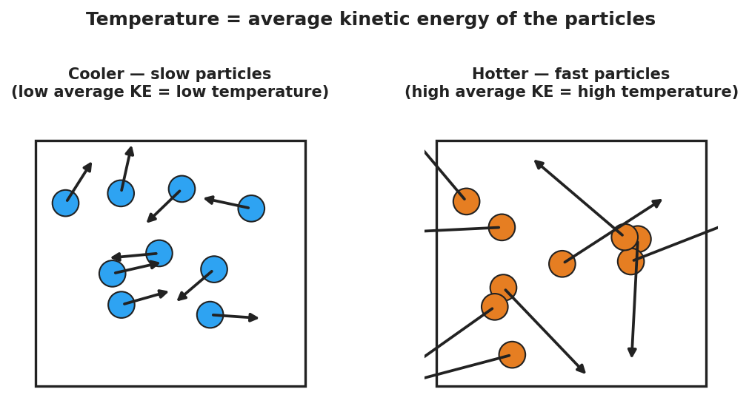
Slow particles (cool) vs fast particles (hot); average arrow length is the temperature
Teacher facilitation language:
“Heating it up — are the particles getting bigger, or moving faster?” “Both beakers are the same temperature. Same average speed. So why would the big one take far more energy to boil away?” “If I doubled the amount of water but kept the temperature the same, did the average particle speed change? Did the total energy change?”

Teacher facilitation during Explore
- What to look for — students separating how fast (per particle) from how many (total). That split is the whole lesson.
- What to resist — don’t say “temperature is average KE” yet; let the sim and beakers establish “faster = hotter, more particles = more total energy” first.
- What to redirect — students who say “more water is hotter” should be asked: “Both thermometers read the same. Is it hotter, or does it just hold more?”

Phase 3 · Explain (32 – 37 min)

32–35 min · Turn-and-Talk #2 + class consensus
“Across the sim and the beakers, what did temperature actually measure — and what did amount change?”
Target consensus:
“Temperature measures how fast the particles move on average. Thermal energy is the total motion of all the particles — so it depends on temperature and how much substance there is.”
Reinforce with the comparison chart:
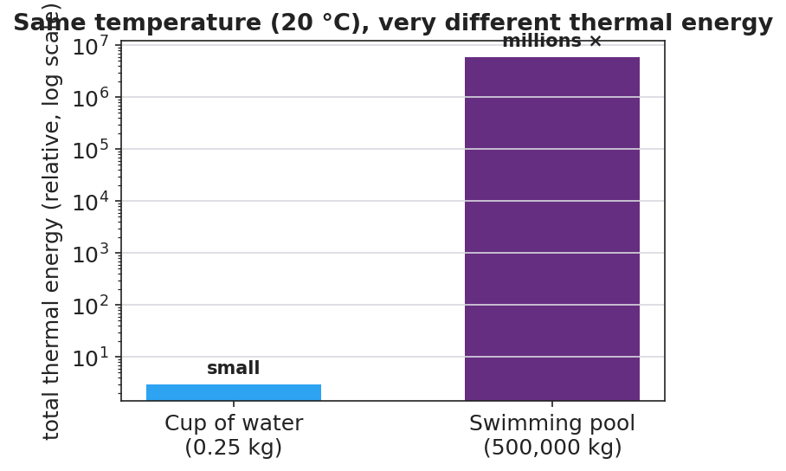
Cup and pool at the same temperature; the pool holds millions of times more thermal energy

35–37 min · Vocabulary introduction (≤ 3 terms)
Sample teacher language:
“The energy of motion is kinetic energy. Temperature is the average kinetic energy of the particles — how fast they move, on average. Thermal energy is the total kinetic energy of all the particles, so it grows with both temperature and the amount of substance. A cup and a pool can read the same temperature, but the pool has far more thermal energy.”

Discussion prompts to deploy here
- “A cup of tea and a backyard pool both read 30 °C. Which has more thermal energy, and why?”
  - Sample student response: “The pool — same average particle speed, but vastly more particles, so far more total kinetic energy.”
- “Why is the sparkler safe to hold even though it is hotter than the bath?”
  - Sample student response: “Its particles move fast (high temperature), but there are very few of them, so the total thermal energy delivered to your skin is tiny.”

Phase 4 · Elaborate (37 – 40 min)

37–39 min · Revise the model
“Return to your particle drawing. Re-label one side ‘high average KE = high temperature’ and use dots to show total amount. Rewrite your one-sentence explanation using the words temperature and thermal energy.”

39–40 min · Return to the phenomenon
“Why would a single drop of boiling water sting but not seriously burn, while a whole bathtub at the same 100 °C would be deadly? Answer in one sentence using temperature and thermal energy.”
Target: “Both are at the same temperature (same average particle speed), but the bathtub holds enormously more thermal energy because it has so many more particles — so it can transfer far more energy to you.”

Phase 5 · Evaluate (40 – 42 min)

40–42 min · Exit Ticket + Closing Reflection
“A lit sparkler tip is about 1,000 °C. A warm bath is about 40 °C. (a) Which has the higher temperature, and what does temperature measure about the particles? (b) Which one could transfer more thermal energy to your body, and why? (c) Two buckets of water read exactly 25 °C, but one holds 1 L and the other holds 50 L. Which has more thermal energy? Explain.”
Expected: (a) the sparkler — temperature is the average kinetic energy (average speed) of the particles; (b) the bath — far more particles means far more total thermal energy to transfer; (c) the 50 L bucket — same average particle speed but 50× as many particles, so much more total kinetic energy. See Answer_Key.docx.
Closing Reflection (SEL, 30 seconds):
“What is one idea today that changed how you think about ‘hot’? Who helped you make sense of it?”

Common Misconceptions
- Misconception: “Temperature and heat energy are the same thing.” → Correction: Temperature is the average particle motion; thermal energy is the total — it also depends on how much substance there is.
- Misconception: “A bigger/hotter object always has more energy.” → Correction: A tiny very-hot object (sparkler) can hold less thermal energy than a large cooler object (pool); amount of substance matters.
- Misconception: “Heating something makes its particles bigger.” → Correction: Particles do not grow; they move faster. Higher temperature = faster average particle motion.

Access & Differentiation
- ELL/ENL supports: Sentence frame: “The ___ has a higher temperature because its particles move , but the has more thermal energy because it has ___ particles.” Word-choice box: {faster, slower, more, fewer, average, total}. Pair temperature with a hand gesture (fingers wiggling fast vs. slow) and thermal energy with arms spread wide (lots of particles).
- IEP/SPED supports: Provide a pre-drawn two-box particle diagram; students add arrow lengths and dot counts rather than drawing from scratch. Offer the PhET slider as a hands-on alternative to writing.
- Extensions: Ask students to estimate, in words, how many times more thermal energy a 50 L pool of 25 °C water holds than a 1 L cup at the same temperature, and justify the ratio using “same average speed, 50× the particles.”

Strategy Spotlight
RESTORATIVE CIRCLE (unit opener). Today’s opening uses a circle to launch the Thermodynamics unit. Use a talking piece, one-sentence responses, and equity of voice (everyone speaks or passes). The prompt — a time you felt surprisingly hot or cold — is chosen so you can call it back in Phase 3 (“that surprise — something small but intensely hot, or something mild but huge — is exactly temperature vs. thermal energy”). Keep the circle to ~2–3 minutes; the goal is community plus a shared anchor, not a long discussion.

NYSSLS Observation Checklist Crosswalk
# | Checklist item | Where it appears in this lesson
1 | Local/relatable phenomenon | Phase 1 — sparkler vs. bathtub; boiling drop in Phase 4
2 | Turn and Talk (2–3×) | Phase 1 (TT#1 — hot vs. lots of energy), Phase 3 (TT#2 — temperature vs. amount)
3 | Students develop questions/models/procedures | Phase 1 (initial model), Phase 2 (PhET + beaker investigation), Phase 4 (revise model)
4 | CCC defined and used | Lesson Overview · Energy and Matter, restated in Phase 2
5 | ENL — ≤ 3 vocab, second half | Phase 3 — vocabulary at 35–37 min (temperature / thermal energy / kinetic energy)
6 | Revisit phenomenon with evidence | Phase 4 — boiling drop vs. bathtub + particle-diagram re-labeling
7 | ENL/SPED supports | Access & Differentiation block
8 | Assessment check | Phase 5 — Exit Ticket (sparkler/bath + two buckets)

Companion Materials
- Student_Worksheet.docx — the 5E student investigation (hand out at start of Phase 2)
- Student_Notes.docx — guided note-guide for vocabulary and the worked example
- Answer_Key.docx — answers to “Make It Make Sense” prompts and the Exit Ticket
- figures/particle_speed.png, figures/cup_vs_pool_energy.png — projection visuals

Key Vocabulary (max 3)
- temperature — a measure of the average kinetic energy of the particles in a substance (how fast they move, on average)
- thermal energy — the total kinetic energy of all the particles in a substance; depends on temperature and the amount of substance
- kinetic energy — the energy an object or particle has because of its motion

Thermal Energy and Temperature — Student Worksheet
Unit: Thermal Energy & Conservation — Lesson 01 Name: _______________________ Date: __________ Period: ____

Phenomenon
A lit sparkler burns at over 1,000 °C — yet a child can hold it inches away and be fine. A warm bath is only about 40 °C, but if it were ever 1,000 °C it would be deadly. Same idea, very different danger.

Slow particles versus fast particles
Driving question: What is the difference between something being hot and something holding a lot of energy?

Notice & Wonder
I notice… | I wonder…
Turn & Talk #1: What is the difference between a thing being hot and a thing having a lot of heat energy? Use the word particles.

Initial Model
Draw the particles inside the sparkler tip and inside the bathtub. Use arrow length to show how fast each particle moves and dots to show how many there are.
Sketch here:
Which has faster particles? __________ Which has more total particle motion? __________

Investigation
Use the particle simulation and the two beakers of room-temperature water.
Step | What I did | What I observed | What it tells me
1. Add heat in the sim
2. Cool it down in the sim
3. Small cup vs. large container (same temperature)
Key question: Both beakers read the same temperature. Why would the larger one take far more energy to boil away?

Make It Make Sense
- A cup of tea and a backyard pool both read 30 °C. Which has more thermal energy, and why?
- Why is a sparkler safe to hold even though it is far hotter than bathwater?
- If you double the amount of water but keep the temperature the same, what happens to the average particle speed? What happens to the total thermal energy?

Vocabulary in Action
Use each term in a sentence about today’s phenomenon.
- temperature: _______________________________________________
- thermal energy: _______________________________________________
- kinetic energy: _______________________________________________

Revise Your Model
Return to your Initial Model. Re-label one side “high average KE = high temperature” and use dots to show the total amount of substance. Rewrite your explanation using temperature and thermal energy.

Exit Ticket
A lit sparkler tip is about 1,000 °C. A warm bath is about 40 °C.
- Which has the higher temperature, and what does temperature measure about the particles?
- Which one could transfer more thermal energy to your body, and why?
- Two buckets of water read exactly 25 °C, but one holds 1 L and the other holds 50 L. Which has more thermal energy? Explain.

Thermal Energy and Temperature — Student Notes
Unit: Thermal Energy & Conservation — Lesson 01 Name: _______________________ Date: __________ Period: ____

Learning Targets
By the end of today’s 42 minutes I can:
- Define temperature as the average kinetic energy of the particles.
- Define thermal energy as the total kinetic energy of all the particles.
- Explain how two objects can be the same temperature but hold different amounts of thermal energy.

Key Vocabulary
- temperature — _______________________________________________
- thermal energy — _______________________________________________
- kinetic energy — _______________________________________________

Guided Notes
Big idea: Everything is made of particles that are always __________. The energy of that motion is __________ energy.
- Temperature measures the __________ kinetic energy of the particles → how __________ they move, on average.
- Heating a substance makes its particles move __________ (not bigger). Cooling makes them move __________.
- Thermal energy is the __________ kinetic energy of __________ the particles.
- Thermal energy depends on two things: the __________ (average speed) and the __________ of substance (how many particles).
Same temperature, different thermal energy:
- A cup and a swimming pool can both read 20 °C → the particles move at the same __________ speed.
- But the pool has far more __________, so it holds far more __________ energy.

Cup vs pool — same temperature, very different thermal energy

Worked Example
Problem. A 0.25 kg cup of tea and a 500,000 kg swimming pool both read 25 °C. Which holds more thermal energy, and why?
Solution. 1. Same temperature → the particles move at the same __________ speed (same average kinetic energy each). 2. Thermal energy = average KE × the __________ of particles. 3. The pool has about __________ times as many particles → far more __________ kinetic energy. The pool holds vastly more thermal energy, even though it is not hotter.

Summary
Finish the sentence (Because / But / So):
A sparkler is hotter than a bathtub because __________________________________________, but __________________________________________, so __________________________________________.

Thermal Energy and Temperature — Answer Key

Cover
Unit: Thermal Energy & Conservation (Thermodynamics) — Lesson 01: Thermal Energy and Temperature East Meadow Schools × Valley Stream Central HSD Strategy chip: RESTORATIVE CIRCLE

Make-It-Make-Sense Answers
- The pool has more thermal energy. Both are at 30 °C, so the particles move at the same average speed (same temperature). But the pool has enormously more particles, so the total kinetic energy — the thermal energy — is far greater. · Rubric: names “same average speed / same temperature” AND “more particles → more total energy” → full credit. · NYSSLS: HS-PS3-4 (foundation)
- The sparkler’s particles move very fast (high temperature), but there are very few of them, so the total thermal energy it can transfer to your skin is tiny. Bathwater has slower particles but a huge number of them. · Rubric: distinguishes high temperature from low total thermal energy. · NYSSLS: HS-PS3-2 / HS-PS3-4
- The average particle speed stays the same (temperature is unchanged). The total thermal energy doubles, because there are now twice as many moving particles. · Rubric: average speed unchanged AND total energy doubles. · NYSSLS: HS-PS3-2

Exit Ticket Answer
- The sparkler has the higher temperature. Temperature measures the average kinetic energy (average speed) of the particles.
- The bath could transfer more thermal energy. It holds far more particles, so its total thermal energy is much greater than the sparkler’s, even though each sparkler particle moves faster.
- The 50 L bucket has more thermal energy. Both read 25 °C (same average particle speed), but the 50 L bucket has about 50× as many particles, so its total kinetic energy is much larger.
Tolerance/rubric: (a) sparkler AND “average kinetic energy/average speed”; (b) bath AND “more particles → more total thermal energy”; (c) 50 L AND “same temperature, far more particles.” 1 point each. NYSSLS: HS-PS3-4 (foundation), HS-PS3-2.

Closing Reflection (rubric)
Closing reflection is formative, not graded. Award full credit for any honest response. Look for: - A genuine shift-in-thinking statement in answer 1 (e.g., “I used to think hotter always meant more energy”). - Naming a peer or self-acknowledgment in answer 2.

Heat Transfer and the Second Law of Thermodynamics — Teacher Guide

Cover
Unit: Thermal Energy & Conservation (Thermodynamics) — Lesson 02: Heat Transfer and the Second Law of Thermodynamics East Meadow Schools × Valley Stream Central High School District Strategy chips: HOCHMAN

Curated Resources (from East Meadow Scope & Sequence)

NYSSLS Standards
This lesson is the conceptual core of the unit’s anchor standard, HS-PS3-4: “Plan and conduct an investigation to provide evidence that the transfer of thermal energy when two components of different temperature are combined within a closed system results in a more uniform energy distribution among the components (second law of thermodynamics). (Systems and System Models).” Students establish the direction of spontaneous heat flow (hot → cold), the idea of thermal equilibrium, and the second law of thermodynamics as the statement that energy spreads toward a more uniform distribution. Lesson 03 then measures the transfer quantitatively with Q = m·c·ΔT.

Phenomenon
- Penguin huddle (BBC) — emperor penguins rotate through a tight huddle so warmth spreads and no one stays frozen on the outside: https://www.youtube.com/watch?v=4Py9eXIO_z0
- An ice cube melting in a warm drink — track the drink cooling and the ice warming until both reach one temperature.
- Heat pipe / metal spoon in hot soup — the handle warms even though only the bowl end touched the soup.

Javalab / Labs
- Javalab — Heat transfer / thermal equilibrium (two bodies at different temperatures reach equilibrium): https://javalab.org/en/heat_transfer_en/
- Javalab — Conduction, convection, radiation: https://javalab.org/en/heat_transfer_methods_en/

Assessments
- Exit Ticket below (spoon in soup + direction of heat flow) is the formative check.
- Javalab equilibrium sim has an observable “temperatures meet” endpoint usable as a quick check.

Lesson Overview
Duration | 42 minutes (1 period)
NYSSLS link | HS-PS3-4 (core — second law, uniform energy distribution)
CCC focus | Systems and System Models — within a closed system, energy redistributes from concentrated (hot) to spread-out (uniform).
Strategy chips | HOCHMAN (sentence-level literacy: Because/But/So)
Materials | Warm water + ice cubes + clear cups + thermometers (one set per group); metal spoon; penguin-huddle clip; heat-transfer-modes diagram; whiteboards.
Safety | Use warm (not scalding) tap water. Wipe spills to prevent slips.
Prior knowledge | Lesson 01 — temperature is average particle KE; thermal energy is total particle KE.
Lesson objectives — students can:
- Describe how heat flows spontaneously from a hotter object to a cooler one until they reach thermal equilibrium.
- Identify conduction, convection, and radiation as the three ways thermal energy transfers.
- State the second law of thermodynamics in their own words: in a closed system, thermal energy spreads to a more uniform distribution.

Phase 1 · Engage (0 – 12 min)

0–3 min · Opening Connection (SEL)
Quick whip-around (one sentence): “Name one thing you do to warm up or cool down — and say whether you are adding or letting go of energy.” This primes the direction-of-flow idea.

3–8 min · Phenomenon hook — the penguin huddle / ice in a drink
Teacher actions. Play ~60 seconds of the penguin-huddle clip; the birds on the cold edge rotate inward and warmth spreads through the group. Then drop an ice cube into a cup of warm water at each table and start a stopwatch.
Sample teacher language:
“Watch the penguins on the outside — they’re freezing. Watch what the huddle does about it. Now, in your cup: the water is warm and the ice is cold. In two minutes, what will the thermometer say? Will the ice ‘win,’ will the water ‘win,’ or something else?”
Anticipated student responses:
- “The water warms the ice up until they’re the same.” — capture “the same”; that is thermal equilibrium.
- “Cold flows into the water.” — gently flag: we will argue it is energy that flows (hot → cold), not “cold.”
- “The penguins share heat so nobody freezes.” — name it: energy spreads out to become more uniform.

8–12 min · Notice & Wonder + Turn-and-Talk #1
Two columns on the board. Then:
“Turn to your partner: which way does the energy move — from the warm water to the ice, or from the ice to the water? How do you know?”
Target seed: energy always moves from the hotter thing to the colder thing, never the other way on its own. Leave open if unresolved.

Bridge to Phase 2
Each student leaves with a one-sentence initial model: “The energy moves from ______ to ______ because ______.”

Phase 2 · Explore (12 – 32 min)

12–17 min · Initial Model (silent / individual)
Prompt on the board:
“Draw the warm water and the ice cube the instant they meet. Use arrows to show which way thermal energy flows. Predict the final temperature: closer to the ice, closer to the warm water, or in between?”

17–32 min · Investigation — tracking two temperatures to equilibrium
Each group measures two temperatures over time: the warm water and a cold-water (or melting-ice) sample, recording every 30 seconds.
- Direction. Which sample’s temperature goes down? Which goes up?
- Equilibrium. Do the two temperatures meet? What happens after they meet?
- Modes. Touch the metal spoon left in hot water (conduction); watch warm water rise in the cup (convection); feel warmth from a lamp without touching it (radiation). Use the diagram:
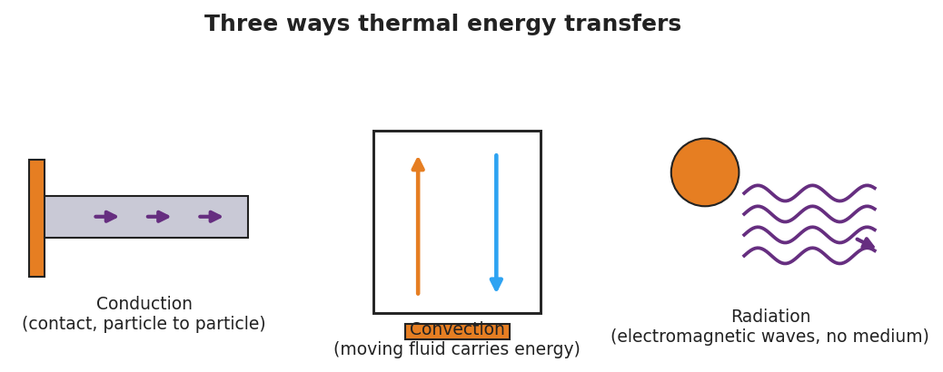
Conduction, convection, and radiation — three ways thermal energy transfers
Plot the class data as two converging curves:
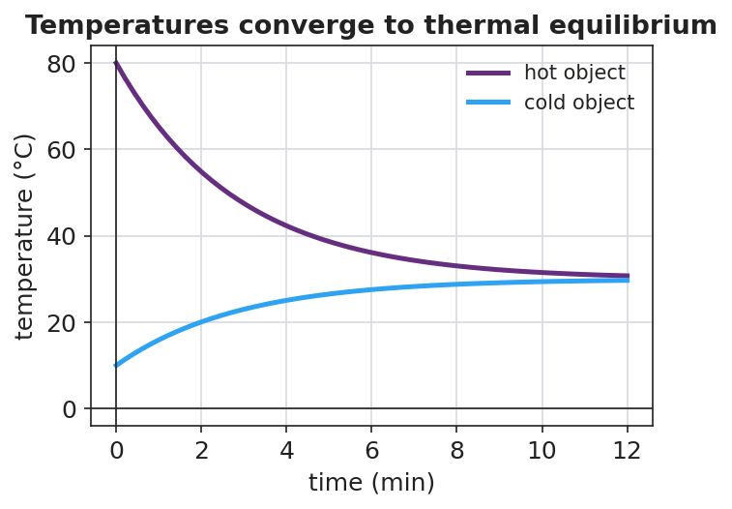
Two objects’ temperatures converging to thermal equilibrium
Teacher facilitation language:
“Tell me which thermometer is dropping and which is climbing. Now — do they ever cross, or do they meet and stop?” “Is ‘cold’ flowing into the water, or is energy flowing out of the water into the ice?” “Once they’re equal, does energy keep moving back and forth, or has it spread out evenly?”

Teacher facilitation during Explore
- What to look for — students noticing the two curves converge and then flatten at one shared temperature.
- What to resist — don’t name the second law yet; let the converging curves do the arguing.
- What to redirect — “cold flows in” → ask “What is actually moving — energy, or cold? Which direction?” Steer to “energy flows hot → cold.”

Phase 3 · Explain (32 – 37 min)

32–35 min · Turn-and-Talk #2 + class consensus
“Across every group, which way did the energy always flow, and where did the temperatures end up?”
Target consensus:
“Thermal energy always flows on its own from the hotter object to the cooler one, until both reach the same temperature — thermal equilibrium. The energy spreads out to become more uniform.”

35–37 min · Vocabulary introduction (≤ 3 terms)
Sample teacher language:
“The thermal energy that moves because of a temperature difference is called heat. It always flows from hot to cold until the objects reach thermal equilibrium — the same temperature. The rule that energy spontaneously spreads to a more uniform distribution is the second law of thermodynamics.”

Discussion prompts to deploy here
- “Why does the metal spoon handle get warm even though only the bowl end is in the soup?”
  - Sample student response: “Conduction — fast-moving particles at the hot end bump the next particles, passing energy along until the handle warms toward equilibrium.”
- “Why do the penguins rotate through the huddle?”
  - Sample student response: “So thermal energy spreads more uniformly through the group — no one stays at the cold edge; that’s the second law working for them.”

Phase 4 · Elaborate (37 – 40 min)

37–39 min · Revise the model — Hochman Because/But/So
This is the Hochman strategy lesson. Have every student expand one kernel sentence using all three conjunctions:
“Complete: ‘Thermal energy flows from the hot water into the ice because ____, but ____, so ____.’”
Model one on the board first, e.g.: “…because the hot water’s particles have more energy, but the flow stops once both are the same temperature, so the system reaches thermal equilibrium with energy spread evenly.”

39–40 min · Return to the phenomenon
“Use the second law to explain in one sentence why the penguin huddle keeps the whole group alive.”
Target: “Energy spreads from the warm inner birds outward to a more uniform distribution as they rotate, so no penguin stays cold enough to die — the second law made even.”

Phase 5 · Evaluate (40 – 42 min)

40–42 min · Exit Ticket + Closing Reflection
“You drop a warm metal spoon into a cup of cold water in an insulated (closed) container. (a) Which way does thermal energy flow, and why? (b) What is the final situation called, and how do the two temperatures compare then? (c) Name the heat-transfer mode that warms the spoon’s handle, and state the second law of thermodynamics in your own words.”
Expected: (a) from the warmer spoon to the cooler water — heat flows hot → cold; (b) thermal equilibrium — the spoon and water reach the same temperature; (c) conduction; second law: in a closed system energy spontaneously spreads to a more uniform distribution. See Answer_Key.docx.
Closing Reflection (SEL, 30 seconds):
“What is one thing today that changed how you think? Who helped you make sense of it?”

Common Misconceptions
- Misconception: “Cold flows into warm objects.” → Correction: Cold is not a substance. Thermal energy flows from hot to cold; “getting colder” means losing energy.
- Misconception: “Heat and temperature are the same.” → Correction: Heat is energy in transit due to a temperature difference; temperature is the average particle KE of one object.
- Misconception: “At equilibrium, energy stops moving entirely.” → Correction: Particles still move and exchange energy, but there is no net flow — the distribution is uniform.

Access & Differentiation
- ELL/ENL supports: Sentence frame: *“Thermal energy flows from the ___ object to the ___ object until they reach ___.”* Word-choice box: {hotter, cooler, thermal equilibrium, heat, uniform}. Pair equilibrium with two hands meeting at the same height.
- IEP/SPED supports: Provide a pre-labeled two-line graph axis; students draw the two converging curves rather than building the table from scratch. Offer the spoon-in-water station as a hands-on alternative to writing.
- Extensions: Ask students to explain why a closed thermos slows — but cannot stop — the approach to equilibrium, and which transfer modes a thermos is designed to block.

Strategy Spotlight
HOCHMAN (sentence-level literacy). Phase 4 uses the Hochman Because / But / So expansion on a single kernel sentence about heat flow. Model one complete expansion first, then require each student to produce one that is physics-correct (energy flows hot → cold; flow stops at equilibrium). The three conjunctions force cause (because), limitation (but), and consequence (so) — exactly the reasoning the second law demands. Keep it to one sentence; quality over quantity.

NYSSLS Observation Checklist Crosswalk
# | Checklist item | Where it appears in this lesson
1 | Local/relatable phenomenon | Phase 1 — penguin huddle / ice in a warm drink; spoon in soup in Phase 3
2 | Turn and Talk (2–3×) | Phase 1 (TT#1 — which way energy moves), Phase 3 (TT#2 — direction + endpoint)
3 | Students develop questions/models/procedures | Phase 1 (initial model), Phase 2 (two-temperature investigation), Phase 4 (revise model)
4 | CCC defined and used | Lesson Overview · Systems and System Models, restated in Phase 2
5 | ENL — ≤ 3 vocab, second half | Phase 3 — vocabulary at 35–37 min (heat / thermal equilibrium / second law)
6 | Revisit phenomenon with evidence | Phase 4 — penguin huddle re-explained + Because/But/So
7 | ENL/SPED supports | Access & Differentiation block
8 | Assessment check | Phase 5 — Exit Ticket (spoon in cold water)

Companion Materials
- Student_Worksheet.docx — the 5E student investigation (hand out at start of Phase 2)
- Student_Notes.docx — guided note-guide for vocabulary and the worked example
- Answer_Key.docx — answers to “Make It Make Sense” prompts and the Exit Ticket
- figures/approach_equilibrium.png, figures/heat_transfer_modes.png — projection visuals

Key Vocabulary (max 3)
- heat — thermal energy that flows from a hotter object to a cooler one because of a temperature difference
- thermal equilibrium — the state in which two objects in contact reach the same temperature and there is no net flow of thermal energy between them
- second law of thermodynamics — in a closed system, thermal energy spontaneously spreads to a more uniform (less concentrated) distribution

Heat Transfer and the Second Law of Thermodynamics — Student Worksheet
Unit: Thermal Energy & Conservation — Lesson 02 Name: _______________________ Date: __________ Period: ____

Phenomenon
Emperor penguins survive −40 °C winters by packing into a tight huddle and slowly rotating, so the warm birds in the center and the freezing birds on the edge keep trading places. Meanwhile, on your desk, an ice cube is melting in a cup of warm water.

Conduction, convection, and radiation
Driving question: Which way does thermal energy move when a hot thing and a cold thing meet — and where do they end up?

Notice & Wonder
I notice… | I wonder…
Turn & Talk #1: Does energy move from the warm water to the ice, or from the ice to the water? How do you know?

Initial Model
Draw the warm water and the ice cube the instant they meet. Use arrows to show which way thermal energy flows.
Sketch here:
My prediction — the final temperature will be: closer to the ice / closer to the warm water / in between (circle one)

Investigation
Measure both temperatures every 30 seconds and record them.
Time (s) | Warm-water temp (°C) | Cold/ice temp (°C)
0
30
60
90
120
Then sketch the two curves on the same axes (warm one starts high, cold one starts low):
[ graph space ]
Key question: Do the two temperatures cross, or do they meet and stop? What is that endpoint called?

Make It Make Sense
- Which way does thermal energy flow when a hot object touches a cold object? Why never the other way on its own?
- A metal spoon left in hot soup gets warm at the handle, even though only the bowl end touches the soup. Which transfer mode explains this?
- Why do the penguins keep rotating through the huddle? Use the idea that energy “spreads out.”

Vocabulary in Action
Use each term in a sentence about today’s phenomenon.
- heat: _______________________________________________
- thermal equilibrium: _______________________________________________
- second law of thermodynamics: _______________________________________________

Revise Your Model
Expand this kernel sentence using all three conjunctions (Because / But / So):
“Thermal energy flows from the hot water into the ice because _______________________________________________, but _______________________________________________, so _______________________________________________.”

Exit Ticket
You drop a warm metal spoon into a cup of cold water in an insulated (closed) container.
- Which way does thermal energy flow, and why?
- What is the final situation called, and how do the two temperatures compare then?
- Name the heat-transfer mode that warms the spoon’s handle, and state the second law of thermodynamics in your own words.

Heat Transfer and the Second Law of Thermodynamics — Student Notes
Unit: Thermal Energy & Conservation — Lesson 02 Name: _______________________ Date: __________ Period: ____

Learning Targets
By the end of today’s 42 minutes I can:
- Describe how heat flows from a hotter object to a cooler one until thermal equilibrium.
- Identify conduction, convection, and radiation as the three modes of heat transfer.
- State the second law of thermodynamics in my own words.

Key Vocabulary
- heat — _______________________________________________
- thermal equilibrium — _______________________________________________
- second law of thermodynamics — _______________________________________________

Guided Notes
Big idea: When two objects at different temperatures touch, thermal energy flows from the __________ object to the __________ object. It never flows the other way on its own.
- The energy moving because of a temperature difference is called __________.
- The flow continues until both objects reach the __________ temperature — this is __________.
- At equilibrium there is no __________ flow of energy (particles still move, but energy is spread evenly).
Three ways thermal energy transfers:
- Conduction — energy passes by __________ (particle to particle), e.g. a spoon handle warming.
- Convection — a moving __________ (liquid or gas) carries the energy, e.g. warm water rising.
- Radiation — energy travels as __________ waves and needs no medium, e.g. warmth from the Sun.

Conduction, convection, radiation
Second law of thermodynamics: In a __________ system, thermal energy spontaneously spreads to a more __________ distribution.

Two temperatures converging to equilibrium

Worked Example
Problem. A hot rock at 80 °C is placed in a sealed, insulated box with cool water at 10 °C. Describe what happens over time.
Solution. 1. Thermal energy flows from the __________ rock to the __________ water (hot → cold). 2. The rock’s temperature __________ and the water’s temperature __________. 3. They keep changing until both reach the __________ temperature → thermal equilibrium. 4. The energy that was concentrated in the rock is now spread more __________ across the system — the second law in action.

Summary
Finish the sentence (Because / But / So):
Thermal energy flows from the hot object to the cold object because __________________________________________, but __________________________________________, so __________________________________________.

Heat Transfer and the Second Law of Thermodynamics — Answer Key

Cover
Unit: Thermal Energy & Conservation (Thermodynamics) — Lesson 02: Heat Transfer and the Second Law of Thermodynamics East Meadow Schools × Valley Stream Central HSD Strategy chip: HOCHMAN

Make-It-Make-Sense Answers
- Thermal energy flows from the hotter object to the cooler object. It never flows the other way on its own because that is the second law of thermodynamics — energy spontaneously spreads toward a more uniform distribution, not toward a more concentrated one. · Rubric: states hot → cold AND that the reverse is non-spontaneous / second law. · NYSSLS: HS-PS3-4
- Conduction. Fast-moving particles at the hot (bowl) end collide with neighboring particles, passing energy along the metal until the handle warms. · Rubric: names conduction AND mentions particle-to-particle transfer. · NYSSLS: HS-PS3-4
- Rotating moves cold edge birds to the warm center and warm center birds to the edge, so thermal energy spreads more uniformly through the whole group instead of staying concentrated — keeping every penguin warm enough to survive. · Rubric: links rotation to a more uniform energy distribution. · NYSSLS: HS-PS3-4

Exit Ticket Answer
- Thermal energy flows from the warm spoon to the cold water — heat always flows from hotter to cooler.
- The final situation is thermal equilibrium: the spoon and the water reach the same temperature, and there is no further net flow of energy between them.
- The handle warms by conduction. Second law (student wording): in a closed system, thermal energy spreads out on its own to a more uniform distribution (energy goes from concentrated/hot to spread-out, never the reverse spontaneously).
Tolerance/rubric: (a) hot → cold (spoon → water); (b) “thermal equilibrium” AND “same temperature / no net flow”; (c) conduction AND a correct paraphrase of the second law. 1 point each. NYSSLS: HS-PS3-4.

Closing Reflection (rubric)
Closing reflection is formative, not graded. Award full credit for any honest response. Look for: - A genuine shift-in-thinking statement in answer 1 (e.g., “I used to think cold moved into things”). - Naming a peer or self-acknowledgment in answer 2.

Calorimetry — Thermal Tales — Teacher Guide

Cover
Unit: Thermal Energy & Conservation (Thermodynamics) — Lesson 03: Calorimetry — Thermal Tales East Meadow Schools × Valley Stream Central High School District Strategy chips: ACTIVE LEARNING

Curated Resources (from East Meadow Scope & Sequence)

NYSSLS Standards
This lesson is the investigation that fully satisfies the unit anchor, HS-PS3-4: “Plan and conduct an investigation to provide evidence that the transfer of thermal energy when two components of different temperature are combined within a closed system results in a more uniform energy distribution among the components (second law of thermodynamics). (Systems and System Models).” Students plan and conduct a calorimetry investigation: combine hot and cold water in a closed (insulated) cup, predict and measure the final temperature, and show with Q = m·c·ΔT that the heat lost by the hot water equals the heat gained by the cold water. This is the quantitative payoff of Lesson 02’s hot-to-cold flow.

Phenomenon
- Thermal Tales / mixing water — pour a measured mass of hot water into a measured mass of cold water in an insulated cup; predict the final temperature before you read the thermometer. Reference investigation framing (NYSED Investigating Energy / Thermal Energy tasks): https://www.nysed.gov/curriculum-instruction/science-learning-standards
- PhET Energy Forms and Changes — heat and mix substances, watch energy chunks move: https://phet.colorado.edu/en/simulations/energy-forms-and-changes

Javalab / Labs
- Calorimetry / “Thermal Tales” lab (this lesson) — hot + cold water mixing in a foam-cup calorimeter; heat lost = heat gained.
- Javalab — Specific heat / calorimetry: https://javalab.org/en/specific_heat_en/

Assessments
- Exit Ticket below (predict-the-final-temperature calculation) is the formative check.
- The completed calorimetry data table + Q-balance is a NYSSLS investigation artifact for HS-PS3-4.

Lesson Overview
Duration | 42 minutes (1 period; pairs well with a double-period day for a longer run)
NYSSLS link | HS-PS3-4 (investigation — plan, conduct, evidence; closed system; uniform distribution)
CCC focus | Energy and Matter / Systems and System Models — energy is conserved within a closed system; heat lost = heat gained.
Strategy chips | ACTIVE LEARNING (NYS Investigation)
Materials | Foam-cup calorimeters with lids; hot water (~80 °C) and cold water (~20 °C); graduated cylinders/balances; thermometers; stopwatch; whiteboards. NYS Reference Table (Q = m·c·ΔT; c_water = 4,186 J/kg·°C).
Safety | Hot water ~80 °C — pour carefully, no scalding water above that. Wipe spills immediately.
Prior knowledge | Lessons 01–02 — thermal energy is total particle KE; heat flows hot → cold to equilibrium.
Lesson objectives — students can:
- Use Q = m·c·ΔT to calculate the heat gained or lost by a water sample.
- Show that, in a closed system, the heat lost by the hot object equals the heat gained by the cold object.
- Plan and conduct a calorimetry investigation and predict the final equilibrium temperature.

Phase 1 · Engage (0 – 12 min)

0–3 min · Opening Connection (SEL)
Quick whip-around (one sentence): “Name one time you mixed something hot and something cold — and what you got.” (Coffee + ice, hot cocoa + cold milk, a bath you adjusted.) This anchors the predict-the-mix task.

3–8 min · Phenomenon hook — predict the mix
Teacher actions. Hold up a cup of hot water (~80 °C) and a cup of cold water (~20 °C), each the same amount. Before mixing, ask every student to commit to a prediction on a whiteboard.
Sample teacher language:
“Equal amounts: this one’s 80 degrees, this one’s 20. I pour them together in this insulated cup. Write down right now — what does the thermometer read after they mix? Don’t hedge. Commit to a number.”
Anticipated student responses:
- “100 — you add them.” — common error; surface it, we will refute with conservation.
- “50 — it’s the average.” — for equal masses this is right; ask them why the average works.
- “Somewhere in the middle, closer to whichever there’s more of.” — excellent; this previews unequal masses.

8–12 min · Notice & Wonder + Turn-and-Talk #1
Two columns on the board. Then:
“Turn to your partner: the hot water cools down and the cold water warms up. Is the energy that leaves the hot water the same amount the cold water gains? Why?”
Target seed: in a closed cup, no energy escapes — what the hot loses, the cold gains. Leave open if unresolved.

Bridge to Phase 2
Each student commits a predicted final temperature with one sentence of reasoning.

Phase 2 · Explore (12 – 32 min)

12–16 min · Initial Model + plan the investigation (Active Learning)
Prompt on the board:
“With your group, write the procedure: what will you measure (masses, starting temperatures), how will you keep the system closed, and how will you know when you’ve reached the final temperature?”
Groups draft a short plan; circulate and approve before they pour. This is the plan and conduct an investigation move of HS-PS3-4.

16–32 min · Investigation — the Thermal Tales calorimetry run
Each group:
- Measures and records the mass and starting temperature of the hot water and the cold water.
- Pours both into the foam-cup calorimeter, lids it, and records the temperature every 15 seconds until it levels off.
- Plots both samples meeting at the final temperature, and computes Q for each side.
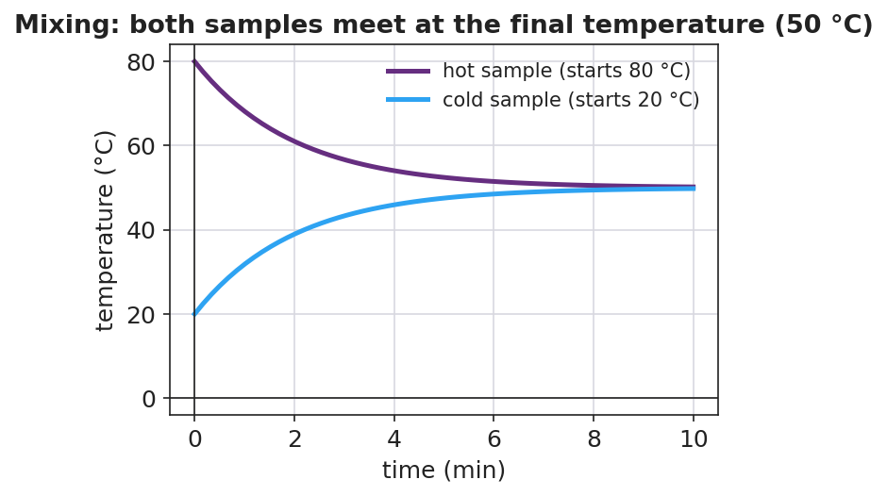
Hot and cold samples meeting at the final temperature
Then they test the conservation claim with Q = m·c·ΔT (c_water = 4,186 J/kg·°C from the Reference Table):
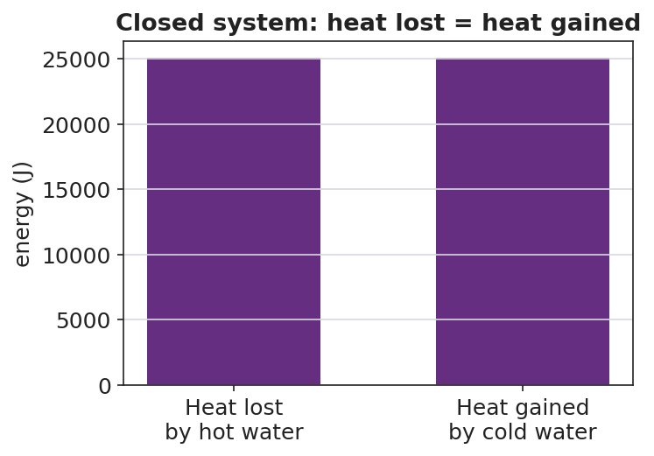
Heat lost by the hot water equals heat gained by the cold water
Teacher facilitation language:
“What’s your ΔT for the hot water? For the cold water? Now run Q = m·c·ΔT for each.” “Compare the two Q’s — are they close? If not, where did the missing energy go?” “Why did we use a foam cup with a lid instead of a metal beaker?”

Teacher facilitation during Explore
- What to look for — Q_lost ≈ Q_gained (within a few percent); students attributing the small gap to energy escaping the “closed” cup.
- What to resist — don’t hand them the final-temperature formula; let the measured equilibrium and the Q-balance teach it.
- What to redirect — groups whose Q’s are far apart: check ΔT signs and that masses (not volumes mislabeled) were used.

Phase 3 · Explain (32 – 37 min)

32–35 min · Turn-and-Talk #2 + class consensus
“Compare your hot-water Q to your cold-water Q. What’s the relationship, and what does it prove about the closed system?”
Target consensus:
“In a closed system the heat lost by the hot water equals the heat gained by the cold water — energy is conserved. Q = m·c·ΔT lets us calculate each side, and they balance.”

35–37 min · Vocabulary introduction (≤ 3 terms)
Sample teacher language:
“Measuring heat transfer this way — in an insulated cup — is called calorimetry. The ‘c’ in Q = m·c·ΔT is the specific heat: how much energy it takes to raise 1 kg of a substance by 1 °C. And heat, Q, is the thermal energy that moved from the hot sample into the cold one.”

Discussion prompts to deploy here
- “If you mix equal masses of hot and cold water, why is the final temperature the average?”
  - Sample student response: “Same mass and same c, so equal-size ΔT’s balance — the hot drops as much as the cold rises, landing in the middle.”
- “If you mixed a little hot water into a lot of cold water, where would the final temperature land?”
  - Sample student response: “Closer to the cold water — the large mass needs a big Q to change temperature, so it barely moves while the small hot sample drops a lot.”

Phase 4 · Elaborate (37 – 40 min)

37–39 min · Revise the model — predict an unequal mix
“Predict: 0.10 kg of 80 °C water poured into 0.30 kg of 20 °C water. Will the final temperature be above or below 50 °C? Justify with Q = m·c·ΔT (heat lost = heat gained).”
Target reasoning: below 50 °C — the larger cold mass dominates; setting m_hot·c·(80 − T_f) = m_cold·c·(T_f − 20) gives T_f = 35 °C.

39–40 min · Return to the phenomenon
“Use heat lost = heat gained to explain in one sentence why your mixed cup settled where it did.”
Target: “The hot water lost exactly as much thermal energy as the cold water gained, so the final temperature sat where those two Q’s balanced — at thermal equilibrium.”

Phase 5 · Evaluate (40 – 42 min)

40–42 min · Exit Ticket + Closing Reflection
“In an insulated cup you mix 0.20 kg of water at 80 °C with 0.20 kg of water at 20 °C. (c_water = 4,186 J/kg·°C.) (a) Using heat lost = heat gained, what is the final temperature? (b) Calculate the heat gained by the cold water with Q = m·c·ΔT. (c) How does that compare to the heat lost by the hot water, and what principle does that show?”
Expected: (a) 50 °C (equal masses → average); (b) Q = (0.20)(4,186)(50 − 20) = 25,116 J ≈ 2.5 × 10⁴ J; (c) equal in size to the heat lost by the hot water — conservation of energy in a closed system (heat lost = heat gained). See Answer_Key.docx.
Closing Reflection (SEL, 30 seconds):
“What is one thing today that changed how you think? Who helped you make sense of it?”

Common Misconceptions
- Misconception: “Mixing 80 °C and 20 °C water gives 100 °C.” → Correction: Temperatures do not add; energy is conserved. Equal masses average to 50 °C.
- Misconception: “The final temperature is always the average.” → Correction: Only when the masses (and specific heats) are equal. Unequal masses pull the result toward the larger sample.
- Misconception: “Heat and temperature are interchangeable in Q = m·c·ΔT.” → Correction: Q (joules) is energy transferred; ΔT (°C) is the temperature change. They are linked by mass and specific heat, not equal.

Access & Differentiation
- ELL/ENL supports: Sentence frame: *“The heat lost by the ___ water equals the heat gained by the ___ water, so the final temperature is ___.”* Word-choice box: {hot, cold, equal, conserved, specific heat}. Provide the Q = m·c·ΔT formula with each symbol labeled in the student’s home language where possible.
- IEP/SPED supports: Provide a partially worked Q calculation (masses and c filled in; student computes ΔT and multiplies). Offer a calculator and a two-row “lost / gained” table to organize the numbers. Group roles (timer, recorder, pourer) so every student has an entry point.
- Extensions: Have students mix a metal (e.g. a warmed steel nut) into cold water and solve for the metal’s specific heat from the calorimetry data — a true unknown-c determination.

Strategy Spotlight
ACTIVE LEARNING (NYS Investigation). Phase 2 hands students the plan and conduct responsibility required by HS-PS3-4: they write the procedure, choose what to measure, keep the system closed, and decide how they will know they reached the final temperature. The teacher approves plans but does not script them. Students then generate their own evidence (the Q-balance) rather than receiving it. Keep groups to 3–4 with clear roles so the hands-on time stays productive.

NYSSLS Observation Checklist Crosswalk
# | Checklist item | Where it appears in this lesson
1 | Local/relatable phenomenon | Phase 1 — predict the hot+cold water mix; everyday mixing in the SEL opener
2 | Turn and Talk (2–3×) | Phase 1 (TT#1 — lost = gained?), Phase 3 (TT#2 — compare the two Q’s)
3 | Students develop questions/models/procedures | Phase 2 — groups plan and conduct the calorimetry investigation (HS-PS3-4)
4 | CCC defined and used | Lesson Overview · Energy and Matter / Systems, restated in Phase 2
5 | ENL — ≤ 3 vocab, second half | Phase 3 — vocabulary at 35–37 min (calorimetry / specific heat / heat)
6 | Revisit phenomenon with evidence | Phase 4 — predict an unequal mix using heat lost = heat gained
7 | ENL/SPED supports | Access & Differentiation block
8 | Assessment check | Phase 5 — Exit Ticket (final temperature + Q calculation)

Companion Materials
- Student_Worksheet.docx — the 5E student investigation / calorimetry lab (hand out at start of Phase 2)
- Student_Notes.docx — guided note-guide for the formula and the worked example
- Answer_Key.docx — answers to “Make It Make Sense” prompts and the Exit Ticket
- figures/mixing_temps.png, figures/heat_lost_gained.png — projection visuals

Key Vocabulary (max 3)
- calorimetry — the measurement of heat transfer, usually by mixing substances in an insulated container and tracking temperature change
- specific heat — the energy needed to raise the temperature of 1 kg of a substance by 1 °C (the “c” in Q = m·c·ΔT)
- heat — the thermal energy (Q) transferred from a hotter object to a cooler one, measured in joules

Calorimetry — Thermal Tales — Student Worksheet
Unit: Thermal Energy & Conservation — Lesson 03 Name: _______________________ Date: __________ Period: ____

Phenomenon
Your teacher holds equal amounts of hot water (80 °C) and cold water (20 °C). They are about to be poured together into an insulated cup. What will the thermometer read after they mix?

Hot and cold samples meeting at one final temperature
Driving question: When hot and cold water mix in a closed cup, what decides the final temperature?
Reference Table formula: Q = m·c·ΔT (c_water = 4,186 J/kg·°C)

Notice & Wonder
I notice… | I wonder…
My prediction (commit to a number before mixing): final temperature = __________ °C
Turn & Talk #1: The hot water cools and the cold water warms. Is the energy that leaves the hot water the same amount the cold water gains? Why?

Initial Model
With your group, plan the investigation. Write your procedure:
- What will you measure (masses, starting temperatures)? ____________________
- How will you keep the system closed? ____________________
- How will you know you have reached the final temperature? ____________________

Investigation
Record your calorimetry run.
 | Hot water | Cold water
Mass m (kg)
Starting temp (°C)
Final temp T_f (°C)
ΔT = T_f − start (°C)
Q = m·c·ΔT (J)

Time (s) | Mixed temperature (°C)
0
15
30
45
60
Key question: Compare the size of Q for the hot water and the cold water. What is the relationship?

Make It Make Sense
- Why does mixing equal masses of hot and cold water give a final temperature in the middle (the average)?
- If you mixed a little hot water into a lot of cold water, would the final temperature land above or below the average? Why?
- Why did we use a foam cup with a lid instead of an open metal beaker?

Vocabulary in Action
Use each term in a sentence about today’s investigation.
- calorimetry: _______________________________________________
- specific heat: _______________________________________________
- heat: _______________________________________________

Revise Your Model
Predict: 0.10 kg of 80 °C water poured into 0.30 kg of 20 °C water. Will the final temperature be above or below 50 °C? Justify using Q = m·c·ΔT (heat lost = heat gained).

Exit Ticket
In an insulated cup you mix 0.20 kg of water at 80 °C with 0.20 kg of water at 20 °C. (c_water = 4,186 J/kg·°C.)
- Using heat lost = heat gained, what is the final temperature?
- Calculate the heat gained by the cold water with Q = m·c·ΔT.
- How does that compare to the heat lost by the hot water, and what principle does that show?

Calorimetry — Thermal Tales — Student Notes
Unit: Thermal Energy & Conservation — Lesson 03 Name: _______________________ Date: __________ Period: ____

Learning Targets
By the end of today’s 42 minutes I can:
- Use Q = m·c·ΔT to calculate the heat gained or lost by a sample.
- Show that, in a closed system, heat lost = heat gained.
- Plan and conduct a calorimetry investigation and predict the final temperature.

Key Vocabulary
- calorimetry — _______________________________________________
- specific heat — _______________________________________________
- heat — _______________________________________________

Guided Notes
The formula (Reference Table): Q = m · c · ΔT
- Q = __________ transferred, in joules (J)
- m = __________ of the substance, in kilograms (kg)
- c = __________ heat (for water, c = __________ J/kg·°C)
- ΔT = change in __________ = T_final − T_start (°C)
Closed-system rule: When a hot object and a cold object mix in an insulated container, no energy escapes, so:
heat __________ by the hot object = heat __________ by the cold object

Heat lost = heat gained
- For equal masses of the same substance, the final temperature is the __________ of the two starting temperatures.
- For unequal masses, the final temperature lands closer to the __________ (larger-mass) sample.

Hot and cold samples meeting at the final temperature

Worked Example
Problem. Mix 0.20 kg of water at 80 °C with 0.20 kg of water at 20 °C in an insulated cup. Find the final temperature and the heat transferred. (c = 4,186 J/kg·°C.)
Solution. 1. Equal masses of the same substance → final temperature is the __________ → T_f = __________ °C. 2. Heat gained by the cold water: Q = m·c·ΔT = (0.20)(4,186)(50 − 20) = __________ J. 3. Heat lost by the hot water: Q = (0.20)(4,186)(80 − 50) = __________ J. 4. The two Q’s are __________ in size → energy is conserved (heat lost = heat gained).

Summary
Finish the sentence (Because / But / So):
When hot water and cold water mix in a closed cup, the final temperature settles in between because __________________________________________, but __________________________________________, so __________________________________________.

Calorimetry — Thermal Tales — Answer Key

Cover
Unit: Thermal Energy & Conservation (Thermodynamics) — Lesson 03: Calorimetry — Thermal Tales East Meadow Schools × Valley Stream Central HSD Strategy chip: ACTIVE LEARNING

Make-It-Make-Sense Answers
- With equal masses of the same substance, the two samples have the same m and the same c, so a given temperature change costs the same energy on each side. The hot water’s temperature drops by the same amount the cold water’s temperature rises, landing exactly in the middle — the average. · Rubric: links equal m and c to equal-size, opposite ΔT → average. · NYSSLS: HS-PS3-4
- Below the average. The large cold mass needs a large Q to change temperature, so it barely warms, while the small hot sample cools a lot. The final temperature is pulled toward the larger (cold) mass. · Rubric: states “closer to the larger/cold mass” with a mass-based reason. · NYSSLS: HS-PS3-4
- The foam cup with a lid is an insulator, keeping the system closed so almost no thermal energy escapes. That makes heat lost ≈ heat gained, which is what we are testing. A metal beaker would conduct energy out to the surroundings. · Rubric: identifies insulation / closed system. · NYSSLS: HS-PS3-4
Revise-Your-Model (unequal mix) answer: Set heat lost = heat gained: (0.10)(c)(80 − T_f) = (0.30)(c)(T_f − 20). The c cancels: 0.10(80 − T_f) = 0.30(T_f − 20) → 8 − 0.10 T_f = 0.30 T_f − 6 → 14 = 0.40 T_f → T_f = 35 °C (below 50 °C, as predicted — the larger cold mass dominates).

Exit Ticket Answer
- Equal masses of the same substance → final temperature is the average: T_f = 50 °C.
- Q gained by cold water = m·c·ΔT = (0.20 kg)(4,186 J/kg·°C)(50 − 20 °C) = (0.20)(4,186)(30) = 25,116 J ≈ 2.5 × 10⁴ J.
- The heat lost by the hot water is Q = (0.20)(4,186)(80 − 50) = 25,116 J — equal in size to the heat gained. This shows conservation of energy in a closed system (heat lost = heat gained), consistent with the second law’s drive toward thermal equilibrium.
Tolerance/rubric: (a) 50 °C; (b) 2.5 × 10⁴ J (accept 25,000–25,200 J); (c) “equal” AND “energy conserved / heat lost = heat gained.” 1 point each. NYSSLS: HS-PS3-4.

Closing Reflection (rubric)
Closing reflection is formative, not graded. Award full credit for any honest response. Look for: - A genuine shift-in-thinking statement in answer 1 (e.g., “I used to think you add the temperatures”). - Naming a peer or self-acknowledgment in answer 2.

Electrostatics — Unit Plan

Cover
Unit: Electrostatics East Meadow Schools × Valley Stream Central High School District 6 lessons · ~6 instructional periods (42 min each) Format: DOCX (Teacher Guide · Student Worksheet · Student Notes · Answer Key per lesson)

Unit Scope (from East Meadow Scope & Sequence)
This unit develops the electric interaction from the ground up: the two kinds of charge, how charge moves (or doesn’t) through materials, the three ways objects become charged, the quantitative force law (Coulomb’s law), and the field model that explains action at a distance. It builds directly on the Forces unit — especially Universal Gravitation, whose inverse-square law reappears for charge (HS-PS2-4, the Patterns crosscutting concept) — and it sets up Circuits and Magnetism.
# | Lesson | Core idea
01 | Electric Charge | Two kinds of charge (+/−); like repel, unlike attract; charge is conserved and quantized
02 | Conductors, Insulators, and Charging by Conduction | Charge moves freely in conductors, not in insulators; contact transfers same-sign charge
03 | Charging by Induction and Polarization | Induction charges without contact (opposite sign); polarization shifts charge in a neutral object
04 | Coulomb’s Law | Fₑ = k·q₁·q₂ / r²; the inverse-square Pattern shared with gravity
05 | Electric Fields | E = Fₑ / q; a field is force per unit charge; points away from + and toward −
06 | Electric Field Lines | Rules for drawing field lines; single charge, dipole, parallel plates

Pacing Calendar
Day | Lesson | Phenomenon anchor | Strategy
1 | 01 Electric Charge | Balloon sticks to hair/wall; static shock | Restorative Circle (unit opener)
2 | 02 Conductors / Insulators / Conduction | Van de Graaff hair; charged rod on an electroscope | Active Learning
3 | 03 Induction / Polarization | Charged rod bends water / attracts neutral paper | BTC
4 | 04 Coulomb’s Law | PhET Coulomb’s Law: two charged spheres | Hochman
5 | 05 Electric Fields | Plasma ball lighting a fluorescent bulb at a distance | Active Learning
6 | 06 Electric Field Lines | Semolina-in-oil reveals the field between electrodes | Hochman
Double-period days (every other day) allow the investigation phases of Lessons 02–03 (sorting/BTC board work) and the PhET data sweeps of Lesson 04 to run long.

Strategy Rotation
- RESTORATIVE CIRCLE: Lesson 01 — unit-opening circle (“a shock, spark, or cling you’ve felt”).
- ACTIVE LEARNING: Lessons 02, 05 — predict-sort-test on vertical whiteboards (conductors/insulators) and the human field-map.
- BTC (Building Thinking Classrooms): Lesson 03 — random groups + vertical non-permanent surfaces on the induction thin-slice.
- HOCHMAN (literacy): Lessons 04, 06 — Because/But/So expansion and appositives on Coulomb’s law and the field-line rules.
SEL (Opening Connection + Closing Reflection), ELL/SPED supports, and a Curated Resources block appear in every lesson.

NYSSLS Coverage Matrix
PE | Description | Lessons
HS-PS2-4 | “Use mathematical representations of Newton’s Law of Gravitation and Coulomb’s Law to describe and predict the gravitational and electrostatic forces between objects. (Patterns)” | 04 (core — Coulomb’s law)
HS-PS3-5 | “Develop and use a model of two objects interacting through electric or magnetic fields to illustrate the forces between objects and the changes in energy of the objects due to the interaction. (Cause and Effect)” | 01, 02, 03 (mechanism), 05, 06 (field model)
Crosscutting concepts: Patterns (the inverse-square law shared by Coulomb and gravity, Lesson 04) and Cause and Effect (charge causes interaction, field causes force, throughout).

Vocabulary Scope
Three terms maximum per lesson, introduced in the second half (NYSSLS observation item 5).
Lesson | Terms
01 | electric charge · positive charge · negative charge
02 | conductor · insulator · charging by conduction
03 | polarization · induction · grounding
04 | Coulomb’s law · electrostatic force · inverse-square law
05 | electric field · test charge · field strength
06 | field line · dipole · uniform field

Electric Charge — Teacher Guide

Cover
Unit: Electrostatics — Lesson 01: Electric Charge East Meadow Schools × Valley Stream Central High School District Strategy chips: RESTORATIVE CIRCLE

Curated Resources (from East Meadow Scope & Sequence)

NYSSLS Standards
This unit opens the study of HS-PS2 and HS-PS3 as they apply to electricity. The Electric Charge row establishes the cause behind every later lesson — that matter carries two kinds of charge — so it threads toward HS-PS3-5: “Develop and use a model of two objects interacting through electric or magnetic fields to illustrate the forces between objects and the changes in energy of the objects due to the interaction. (Cause and Effect).” The quantitative force these charges exert (Coulomb’s law, HS-PS2-4) is developed in Lesson 04.

Phenomenon
- Balloon rubbed on hair sticks to a wall; hair stands up: https://www.youtube.com/watch?v=VFbyDCG_QoM
- Static shock from a doorknob after walking on carpet (Khan Academy, “Charge and electric force”): https://www.khanacademy.org/science/physics/electric-charge-electric-force-and-voltage

Javalab / Labs
- Electroscope (charge detector): https://javalab.org/en/electroscope_en/
- Charging by friction (rub two materials, watch charge transfer): https://javalab.org/en/charging_by_friction_en/

Assessments
- Khan Academy “Charge and electric force” check-for-understanding set (link above). The Exit Ticket below is the formative check for this lesson.

Lesson Overview
Duration | 42 minutes (1 period)
NYSSLS link | HS-PS3-5 (foundation — what charges are, before modeling their interaction)
CCC focus | Cause and Effect — the attraction or repulsion you see is caused by an invisible property, charge.
Strategy chips | RESTORATIVE CIRCLE (unit opener)
Materials | Balloons (one per pair); wool/hair; small paper bits; two inflated balloons on strings; an acetate/glass rod and silk if available; whiteboards/markers.
Safety | Standard classroom safety; keep balloons away from open flame. No high-voltage sources today.
Prior knowledge | Atoms contain protons (+) and electrons (−); the idea of a force as a push or pull (from the Forces unit).
Lesson objectives — students can:
- State that there are exactly two kinds of charge (positive and negative), and that like charges repel while unlike charges attract.
- Explain a static-electricity phenomenon in terms of electrons transferring from one object to another (charge is conserved — never created or destroyed, only moved).
- Predict whether two charged objects will attract or repel given their signs.

Phase 1 · Engage (0 – 12 min)

0–3 min · Opening Connection (SEL) — Restorative Circle (unit opener)
This is the first lesson of a new unit, so open with a brief restorative circle. Pass a talking piece. Prompt: “Tell us about a time something surprised you with a shock, a spark, or a ‘cling’ — a sweater, a doorknob, a blanket fresh from the dryer.” One sentence each; no cross-talk. This builds community and surfaces the everyday static experiences you will explain today.

3–8 min · Phenomenon hook — the clinging balloon
Teacher actions. Rub a balloon on your hair (or wool) and hold it to the wall — it sticks. Bring it near a student’s hair — strands rise toward it. Sprinkle small paper bits and lower the balloon; the bits leap up.
Sample teacher language:
“I didn’t put glue on this balloon. So what did rubbing it on my hair do to it that makes the wall hold onto it?”
Anticipated student responses:
- “It got staticky.” — capture the word; “static” is exactly the everyday name for what we’ll call charge.
- “The rubbing made heat / made it sticky.” — reframe: rubbing moved something, not melted it.
- “It picked up electrons from your hair.” — excellent; hold it for Phase 3, don’t confirm yet.

8–12 min · Notice & Wonder + Turn-and-Talk #1
Capture two columns on the board. Then:
“Turn to your partner: the balloon and the wall were both ordinary before. What changed, and why would they now pull on each other?”
Take 2–3 responses. Desirable insight: something invisible moved onto the balloon when it was rubbed. Leave it open if no one lands it.

Bridge to Phase 2
Every student should leave Phase 1 with a one-sentence initial model: “The balloon sticks because ______.”

Phase 2 · Explore (12 – 32 min)

12–17 min · Initial Model (silent / individual)
Prompt on the board:
“Draw the rubbed balloon next to the wall. Show what you think moved (and which way) when it was rubbed. Then predict: will the balloon also stick to a second rubbed balloon, or push it away?”
This surfaces students’ intuitions about charge transfer before any vocabulary.

17–32 min · Investigation — two balloons and the electroscope
Stations (or whole-class):
- Two like-charged balloons — rub both on hair, hang on strings; bring them close. They swing apart.
- Charged balloon + neutral paper bits — the bits jump toward the balloon.
- Javalab electroscope — touch a rubbed rod near the electroscope; the leaves spread. Repeat with the other material.
Use the attract/repel diagram below to make the rule visible while students test the balloons.
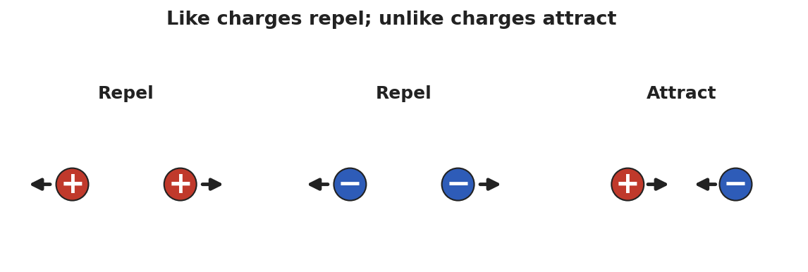
Three side-by-side diagrams of paired charges: two positive charges repel (arrows point apart), two negative charges repel, and a positive next to a negative attract (arrows point together).
Teacher facilitation language:
“When did the two objects pull together, and when did they push apart? What’s different about those two cases?” “If both balloons were rubbed the same way, do they carry the same kind of charge or opposite kinds?”

Teacher facilitation during Explore
- What to look for — students noticing that two of the same (two rubbed balloons) repel, while charged + neutral attracts.
- What to resist — don’t supply “positive/negative” yet; let “same pushes, different pulls” emerge from the balloons.
- What to redirect — students who say “the balloon makes its own charge” should be asked where it could come from (the hair lost what the balloon gained).

Phase 3 · Explain (32 – 37 min)

32–35 min · Turn-and-Talk #2 + class consensus
“Across the stations, what was always true about objects that pushed apart versus objects that pulled together?”
Target consensus:
“Matter carries one of two kinds of charge. The same kind repels; opposite kinds attract. Rubbing moves tiny charged particles (electrons) from one object to the other — it doesn’t create them. Whatever one object loses, the other gains.”

35–37 min · Vocabulary introduction (≤ 3 terms)
Sample teacher language:
“We call the two kinds positive charge and negative charge. The thing being moved is electric charge itself — it comes in whole packages (multiples of the elementary charge e = 1.6 × 10⁻¹⁹ C), and it is conserved: never made or destroyed, only transferred. A neutral object simply has equal positive and negative charge.”
The clinging balloon below is the model students return to in Phase 4.
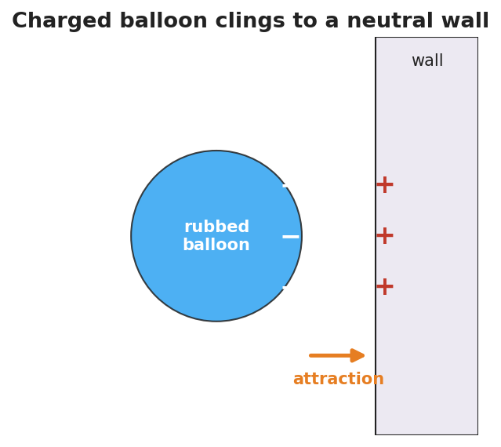
A negatively charged balloon held against a neutral wall; minus signs cover the balloon’s near face and plus signs appear on the wall surface closest to it, with an arrow showing the attraction between them.

Discussion prompts to deploy here
- “Your hair stands up toward the balloon you just used on it. What sign is your hair now, and why?”
  - Sample student response: “The balloon took electrons, so my hair lost negatives and is positive — opposite to the balloon, so it’s attracted.”
- “If you charge a balloon −5 units, what happened to the hair?”
  - Sample student response: “The hair became +5 units; the total charge didn’t change.”

Phase 4 · Elaborate (37 – 40 min)

37–39 min · Revise the model
“Return to your balloon drawing. Re-label what moved using the words electric charge and negative/positive. Write one sentence explaining the stick using conservation of charge.”

39–40 min · Return to the phenomenon
“Why do you get a shock at a metal doorknob after walking across carpet? Answer in one sentence using charge.”
Target: “Walking rubbed extra electrons onto me; touching the metal lets that built-up charge jump across as a spark, returning me to neutral.”

Phase 5 · Evaluate (40 – 42 min)

40–42 min · Exit Ticket + Closing Reflection
“Two small spheres hang side by side. (a) When both are rubbed with the same cloth, they swing apart. What does that tell you about their charges? (b) A third sphere is brought near and the first sphere swings toward it. What sign is the third sphere? (c) A balloon gains a charge of −8 units after being rubbed on a wool sock. What is the charge on the sock, and why?”
Expected: (a) they carry the same sign (like charges repel); (b) opposite to the first — attraction means unlike charges; (c) +8 units, because charge is conserved (the electrons the balloon gained came from the sock). See Answer_Key.docx.
Closing Reflection (SEL, 30 seconds):
“What is one everyday ‘shock or cling’ moment you now understand differently? Who helped you make sense of it?”

Common Misconceptions
- Misconception: “Rubbing creates charge out of nothing.” → Correction: Rubbing transfers charge; electrons move from one object to the other. Charge is conserved.
- Misconception: “There is only one kind of electricity that things have more or less of.” → Correction: There are two distinct kinds, positive and negative; neutral means equal amounts of each.
- Misconception: “A charged object and a neutral object can’t interact.” → Correction: A charged object attracts a neutral one (it polarizes it) — developed fully in Lesson 03.

Access & Differentiation
- ELL/ENL supports: Sentence frame: “The two objects ___ (attracted/repelled) because they have ___ (the same / opposite) charge.” Word-choice box: {positive, negative, charge, attract, repel, conserved, neutral}. Pair repel with hands pushing apart and attract with hands pulling together.
- IEP/SPED supports: Provide the attract/repel diagram pre-printed; students label each pair “attract” or “repel” rather than drawing arrows from scratch. Offer the balloon-on-hair demo as a hands-on alternative to written explanation.
- Extensions: Have students rank a triboelectric list (hair, glass, rubber, plastic) and predict which way electrons move when two are rubbed together, justifying with conservation.

Strategy Spotlight
RESTORATIVE CIRCLE (unit opener). Today’s opening uses a circle to launch the Electrostatics unit. Use a talking piece, one-sentence responses, and equity of voice (everyone speaks or passes). The prompt — a shock, spark, or cling you’ve felt — is chosen so you can call back to it in Phase 3 (“that surprising zap has a name: a transfer of charge”). Keep the circle to ~2–3 minutes; the goal is community plus shared lived experience to explain, not a long discussion.

NYSSLS Observation Checklist Crosswalk
# | Checklist item | Where it appears in this lesson
1 | Local/relatable phenomenon | Phase 1 — balloon on hair/wall; doorknob shock in Phase 4
2 | Turn and Talk (2–3×) | Phase 1 (TT#1 — what changed), Phase 3 (TT#2 — push vs. pull)
3 | Students develop questions/models/procedures | Phase 1 (initial model), Phase 2 (balloon + electroscope investigation), Phase 4 (revise model)
4 | CCC defined and used | Lesson Overview · Cause and Effect, restated in Phase 2
5 | ENL — ≤ 3 vocab, second half | Phase 3 — vocabulary at 35–37 min (electric charge / positive / negative)
6 | Revisit phenomenon with evidence | Phase 4 — doorknob + balloon re-labeling
7 | ENL/SPED supports | Access & Differentiation block
8 | Assessment check | Phase 5 — Exit Ticket (two-sphere sign reasoning + conservation)

Companion Materials
- Student_Worksheet.docx — the 5E student investigation (hand out at start of Phase 2)
- Student_Notes.docx — guided note-guide for vocabulary and the worked example
- Answer_Key.docx — answers to “Make It Make Sense” prompts and the Exit Ticket

Key Vocabulary (max 3)
- electric charge — a basic property of matter that causes electric forces; it comes in two kinds (positive and negative) and in whole multiples of the elementary charge e = 1.6 × 10⁻¹⁹ C
- positive charge — the kind of charge carried by protons; two positives repel
- negative charge — the kind of charge carried by electrons; a positive and a negative attract

Electric Charge — Student Worksheet
Unit: Electrostatics — Lesson 01 Name: _______________________ Date: __________ Period: ____

Phenomenon
Your teacher rubs a balloon on their hair and it sticks to the wall — no glue. Held near your head, the balloon makes your hair rise toward it. Small bits of paper jump up to meet it.
Driving question: What invisible change does rubbing make, and why does it cause objects to pull or push on each other?

Notice & Wonder
I notice… | I wonder…
Turn & Talk #1: The balloon and the wall were both ordinary before. What changed, and why would they now pull on each other?

Initial Model
Draw the rubbed balloon next to the wall. Show what you think moved (and which direction) when the balloon was rubbed. Then predict: will the balloon stick to a second rubbed balloon, or push it away?

My prediction: _______________________________

Investigation
The diagram shows the rule you are testing: same kinds of charge repel; opposite kinds attract.

Three diagrams of charge pairs: two + charges repel, two − charges repel, and a + with a − attract.
Complete each station. Record what you observe and what it tells you.
Station | What I did | What happened | What it tells me
1. Two rubbed balloons on strings
2. Charged balloon + paper bits
3. Javalab electroscope
Key question: When did the two objects pull together, and when did they push apart? What was different about those cases?

Make It Make Sense
- Two balloons are each rubbed on the same wool sweater, then brought close. Do they attract or repel? How do you know?
- A balloon is rubbed and gains a negative charge. Where did that charge come from, and what sign is the object it was rubbed on?
- A neutral scrap of paper is pulled toward a charged balloon. Was the paper given a charge, or is something else going on?

Vocabulary in Action
Use each term in a sentence about today’s phenomenon.
- electric charge: _______________________________________________
- positive charge: _______________________________________________
- negative charge: _______________________________________________

Revise Your Model
Return to your Initial Model. Re-label what moved using electric charge and positive/negative. Rewrite your explanation of why the balloon sticks, using the idea that charge is conserved (only moved, never made).

Exit Ticket
Two small spheres hang side by side.
- When both are rubbed with the same cloth, they swing apart. What does that tell you about their charges?
- A third sphere is brought near, and the first sphere swings toward it. What sign is the third sphere?
- A balloon gains a charge of −8 units after being rubbed on a wool sock. What is the charge on the sock, and why?

Electric Charge — Student Notes
Unit: Electrostatics — Lesson 01 Name: _______________________ Date: __________ Period: ____

Learning Targets
By the end of today’s 42 minutes I can:
- State that there are two kinds of charge and that like charges repel while unlike charges attract.
- Explain a static phenomenon as a transfer of electrons (charge is conserved).
- Predict whether two charged objects attract or repel from their signs.

Key Vocabulary
- electric charge — _______________________________________________
- positive charge — _______________________________________________
- negative charge — _______________________________________________

Guided Notes
Big idea: All matter is made of atoms that contain __________ charge (protons) and __________ charge (electrons).
- There are exactly __________ kinds of charge: positive and negative.
- Like charges __________ (push apart). Unlike charges __________ (pull together).
- A neutral object has __________ amounts of positive and negative charge.
- Charge is quantized: it comes in whole multiples of the elementary charge e = __________ × 10⁻¹⁹ C.
- Charge is conserved: it is never created or destroyed, only __________ from one object to another.
Rubbing a balloon on hair:
- Electrons move from the __________ onto the __________.
- The balloon becomes __________ (gained electrons); the hair becomes __________ (lost electrons).

A negatively charged balloon clinging to a neutral wall; the wall surface nearest the balloon shows + signs.
The same kind repels; the opposite kind attracts — that single rule explains every demo today:

Three charge pairs: + with + repel, − with − repel, + with − attract.

Worked Example
Problem. A glass rod is rubbed with silk. The rod ends up with a charge of +6 units. What charge does the silk carry, and why?
Solution. 1. Rubbing only __________ charge — it does not create it (conservation of charge). 2. The rod became +6, so it __________ 6 units of negative charge (electrons). 3. Those electrons went __________ the silk, so the silk carries a charge of __________ units. 4. Total charge before = total charge after = __________.

Summary
Finish the sentence (Because / But / So):
Two balloons rubbed the same way push each other apart because __________________________________________, but a balloon and a neutral wall pull together __________________________________________, so __________________________________________.

Electric Charge — Answer Key

Cover
Unit: Electrostatics — Lesson 01: Electric Charge East Meadow Schools × Valley Stream Central HSD Strategy chip: RESTORATIVE CIRCLE

Make-It-Make-Sense Answers
- They repel. Rubbing both balloons on the same material gives them the same kind of charge, and like charges repel. · Rubric: “repel” AND “same charge” → full credit. · NYSSLS: HS-PS3-5
- The charge (electrons) came from the wool sweater/hair it was rubbed on; that object is left with the opposite (positive) charge. Charge was transferred, not created. · Rubric: names the source object AND opposite sign. · NYSSLS: HS-PS3-5
- The paper was not given a charge. The neutral paper’s own charges shift slightly (polarization), so its near side is attracted to the balloon. It remains overall neutral. · Rubric: says paper stays neutral AND mentions its charges shifting/polarizing. · NYSSLS: HS-PS3-5

Exit Ticket Answer
- The two spheres carry the same sign of charge — like charges repel, so they swing apart.
- The third sphere is oppositely charged to the first (attraction means unlike charges).
- The sock carries +8 units. Charge is conserved: the 8 units of negative charge (electrons) the balloon gained came from the sock, leaving it positive by the same amount.
Tolerance/rubric: (a) “same sign / like charges” + repel; (b) “opposite sign”; (c) “+8” AND a conservation justification. 1 point each. NYSSLS: HS-PS3-5.

Closing Reflection (rubric)
Closing reflection is formative, not graded. Award full credit for any honest response. Look for: - A genuine everyday example reinterpreted as a charge transfer in answer 1 - Naming a peer or self-acknowledgment in answer 2

Conductors, Insulators, and Charging by Conduction — Teacher Guide

Cover
Unit: Electrostatics — Lesson 02: Conductors, Insulators, and Charging by Conduction East Meadow Schools × Valley Stream Central High School District Strategy chips: ACTIVE LEARNING

Curated Resources (from East Meadow Scope & Sequence)

NYSSLS Standards
This lesson continues building toward HS-PS3-5: “Develop and use a model of two objects interacting through electric or magnetic fields to illustrate the forces between objects and the changes in energy of the objects due to the interaction. (Cause and Effect).” Students model why a charged object shares its charge on contact — because in a conductor, charge is free to move — which is the mechanism behind the interactions they will quantify in later lessons.

Phenomenon
- Van de Graaff generator makes hair stand on end (Physics demo): https://www.youtube.com/watch?v=2gYUmTGYbeI
- Touching a charged rod to a metal-leaf electroscope makes the leaves spread (PhET / classroom demo): https://www.youtube.com/watch?v=Yb56oCEMBuc

Javalab / Labs
- Electroscope (charge by touching): https://javalab.org/en/electroscope_en/
- Conductor and insulator (where does charge go?): https://javalab.org/en/conductor_and_insulator_en/

Assessments
- PhET “Balloons and Static Electricity” — sweater (insulator) vs. the conducting wall: https://phet.colorado.edu/en/simulations/balloons-and-static-electricity. The Exit Ticket below is the formative check for this lesson.

Lesson Overview
Duration | 42 minutes (1 period)
NYSSLS link | HS-PS3-5 (mechanism — free vs. fixed charge in interacting objects)
CCC focus | Cause and Effect — whether charge spreads or stays put is caused by the material’s structure (free electrons or not).
Strategy chips | ACTIVE LEARNING
Materials | Electroscope (or Javalab); charged rod (PVC/acetate) + cloth; assorted samples (metal spoon, copper wire, wooden ruler, glass, rubber, plastic); aluminum foil; whiteboards/markers.
Safety | If a Van de Graaff is used, follow its discharge procedure; keep it away from students with cardiac devices.
Prior knowledge | Lesson 01 — two kinds of charge; like repel, unlike attract; charge is conserved and carried by electrons.
Lesson objectives — students can:
- Distinguish a conductor (charge moves freely) from an insulator (charge stays put) and classify common materials.
- Describe charging by conduction: direct contact with a charged object transfers charge, leaving both objects with the same sign.
- Predict the sign of an object after it is charged by conduction.

Phase 1 · Engage (0 – 12 min)

0–2 min · Opening Connection (SEL)
Quick whip-around (one phrase each): “Name something that lets things pass through it easily, and something that blocks them.” (water vs. a wall; a hallway vs. a locked door.) This primes the conductor/insulator contrast without naming it.

2–8 min · Phenomenon hook — the electroscope jumps
Teacher actions. Show the metal electroscope. Touch a charged rod directly to its metal knob. The thin leaves spring apart and stay apart after the rod is gone. Then touch the knob with your finger — the leaves collapse. (If available, run the Van de Graaff: a volunteer’s hair stands on end because the charge spreads over every strand.)
Sample teacher language:
“I touched the metal once and the leaves are still spread. Why did the charge stay — and why does my finger make it vanish?”
Anticipated student responses:
- “The charge went into the metal and got stuck.” — partly right; it moved in, but ask why it doesn’t move out on its own.
- “Your finger is grounding it.” — excellent; hold the word “ground” (we name it next lesson).
- “The leaves repel because they have the same charge.” — yes! Connect to Lesson 01’s “like charges repel.”

8–12 min · Notice & Wonder + Turn-and-Talk #1
Capture two columns. Then:
“Turn to your partner: the rod touched only the top knob, but the bottom leaves moved. How did the charge get all the way down?”
Target idea: charge can travel through the metal. Leave open if unspoken.

Bridge to Phase 2
Each student writes a one-sentence initial model: “The leaves spread because ______.”

Phase 2 · Explore (12 – 32 min)

12–16 min · Initial Model (silent / individual)
“Draw the electroscope. Show where the charge is right after the rod touches the knob, and which way it moves. Predict whether a wooden ruler touched to the knob would do the same thing.”

16–32 min · Active-Learning investigation — sort and test
Hand each group a tray of samples (metal spoon, copper wire, wooden ruler, glass, rubber band, plastic, aluminum foil). Active-learning protocol:
- Predict + sort — groups sort samples into “lets charge move” vs. “blocks charge” before testing, on a whiteboard.
- Test — touch a charged rod, then the sample, to the electroscope knob. Does the charge reach the leaves?
- Gallery walk — groups circulate, compare sorts, and revise. Mismatches become the discussion.
Use the diagram below as the model students are building.
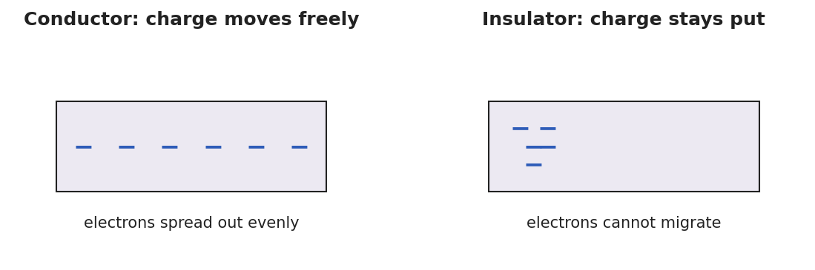
Two panels: in a conductor, minus signs spread evenly across the block (electrons move freely); in an insulator, minus signs stay clustered where they were placed (electrons cannot migrate).
Teacher facilitation language:
“Which samples let the leaves move, and what do those samples have in common?” “When you touched the charged rod straight to the knob, did the rod lose some charge? How could you tell?”

Teacher facilitation during Explore
- What to look for — groups grouping metals together as “charge moves” and naming the metal/non-metal pattern.
- What to resist — don’t pre-classify the samples; let the gallery-walk disagreements drive the consensus.
- What to redirect — students who think the rod must keep all its charge should compare the rod before and after several touches.

Phase 3 · Explain (32 – 37 min)

32–35 min · Turn-and-Talk #2 + class consensus
“What kind of material let the charge travel to the leaves, and what happened to the rod’s charge when it touched a conductor?”
Target consensus:
“In some materials — metals — electrons are free to move, so charge spreads through them; these are conductors. In others — rubber, glass, plastic — charge stays where you put it; these are insulators. When a charged object touches a conductor, some charge moves onto it, and both end up with the same sign.”

35–37 min · Vocabulary introduction (≤ 3 terms)
Sample teacher language:
“A conductor lets charge move freely (metals). An insulator holds charge in place (rubber, glass). Transferring charge by direct touch is charging by conduction — and because charge just spreads from one to the other, both objects end up with the same sign.”
The three-step diagram below is the model students revisit in Phase 4.
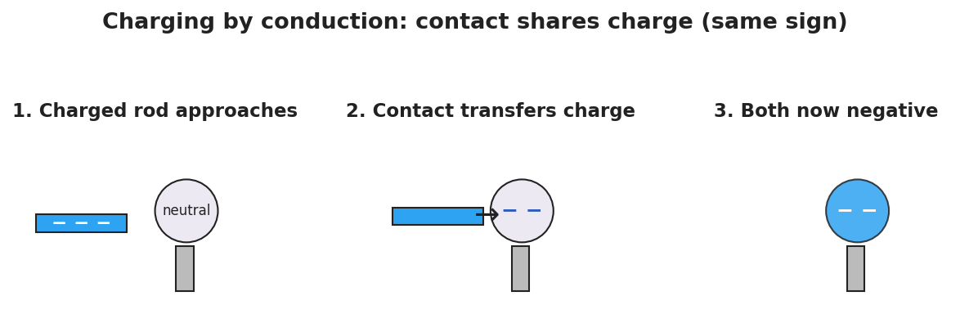
A three-step sequence: a negatively charged rod approaches a neutral metal sphere, then touches it and transfers electrons, and finally the rod is removed leaving the sphere negatively charged — the same sign as the rod.

Discussion prompts to deploy here
- “You charge a metal sphere by touching it with a negative rod. What sign is the sphere now?”
  - Sample student response: “Negative — conduction shares the rod’s charge, so the sphere gets the same sign.”
- “Why won’t a charged rubber rod share its charge if you touch it to a wooden block?”
  - Sample student response: “Both are insulators; the charge can’t move, so it stays on the rubber.”

Phase 4 · Elaborate (37 – 40 min)

37–39 min · Revise the model
“Return to your electroscope drawing. Re-label it: is the metal a conductor or insulator? Use conduction to explain in one sentence why the leaves stayed spread after the rod left.”

39–40 min · Return to the phenomenon
“On the Van de Graaff, why does every hair stand up, not just the ones you touch? Answer in one sentence.”
Target: “The dome is a conductor, so the charge spreads to every strand; all the hairs get the same sign and repel each other.”

Phase 5 · Evaluate (40 – 42 min)

40–42 min · Exit Ticket + Closing Reflection
“(a) Classify each as a conductor or insulator: copper wire, rubber band, aluminum foil, glass rod. (b) A negatively charged rod is touched directly to a neutral metal sphere. What sign is the sphere afterward? Name the charging method. (c) Explain in one sentence why a charged comb shares its charge with a metal doorknob you touch it to, but not with a dry plastic cup.”
Expected: (a) copper = conductor, rubber = insulator, aluminum = conductor, glass = insulator; (b) negative, by conduction (same sign as the rod); (c) the doorknob is a conductor so charge moves onto it, while the plastic cup is an insulator that won’t let charge flow. See Answer_Key.docx.
Closing Reflection (SEL, 30 seconds):
“What did a groupmate notice during the sort that changed your sorting? Name one thing you’d test differently next time.”

Common Misconceptions
- Misconception: “Conduction reverses the charge — the touched object becomes opposite.” → Correction: Conduction shares charge, so both objects end up the same sign. (Opposite sign comes from induction, Lesson 03.)
- Misconception: “Insulators can’t be charged at all.” → Correction: Insulators can hold charge (a rubbed balloon!) — they just won’t let it move or spread.
- Misconception: “Charge flows through anything if you push hard enough.” → Correction: In an insulator the electrons are bound; ordinary contact does not free them to move.

Access & Differentiation
- ELL/ENL supports: Sentence frame: *“A ___ (conductor/insulator) lets charge ___ (move/stay), so when it touches a charged object the charge ___.”* Word-choice box: {conductor, insulator, move freely, stay put, same sign, conduction}. Provide a two-column T-chart pre-labeled “moves / stays.”
- IEP/SPED supports: Pre-sort half the samples as worked examples; students place only the remaining ones. Offer the Javalab electroscope as a low-prep alternative to handling a physical rod.
- Extensions: Have students explain why airplanes and fuel trucks are bonded with a wire before refueling, using conductor + conduction + charge buildup.

Strategy Spotlight
ACTIVE LEARNING. Today’s Explore is a predict–sort–test–revise cycle on vertical whiteboards. Students commit to a sort before testing (productive struggle), then a gallery walk turns disagreements into the lesson’s discussion. Keep groups to 3, rotate the marker, and resist confirming answers during the walk — the mismatches between groups are the teaching tool. Your role is to ask “what do your ‘moves’ samples have in common?” rather than to classify for them.

NYSSLS Observation Checklist Crosswalk
# | Checklist item | Where it appears in this lesson
1 | Local/relatable phenomenon | Phase 1 — electroscope/Van de Graaff; doorknob + comb in Phase 5
2 | Turn and Talk (2–3×) | Phase 1 (TT#1 — how charge reached the leaves), Phase 3 (TT#2 — what let charge travel)
3 | Students develop questions/models/procedures | Phase 1 (initial model), Phase 2 (predict-sort-test), Phase 4 (revise model)
4 | CCC defined and used | Lesson Overview · Cause and Effect, restated in Phase 2
5 | ENL — ≤ 3 vocab, second half | Phase 3 — vocabulary at 35–37 min (conductor / insulator / charging by conduction)
6 | Revisit phenomenon with evidence | Phase 4 — Van de Graaff hair + electroscope re-labeling
7 | ENL/SPED supports | Access & Differentiation block
8 | Assessment check | Phase 5 — Exit Ticket (classify + conduction sign)

Companion Materials
- Student_Worksheet.docx — the 5E student investigation (hand out at start of Phase 2)
- Student_Notes.docx — guided note-guide for vocabulary and the worked example
- Answer_Key.docx — answers to “Make It Make Sense” prompts and the Exit Ticket

Key Vocabulary (max 3)
- conductor — a material (such as a metal) in which charge moves freely because some electrons are not bound to single atoms
- insulator — a material (such as rubber, glass, or plastic) in which charge stays put because electrons are bound and cannot migrate
- charging by conduction — transferring charge by direct contact with a charged object; both objects end up with the same sign

Conductors, Insulators, and Charging by Conduction — Student Worksheet
Unit: Electrostatics — Lesson 02 Name: _______________________ Date: __________ Period: ____

Phenomenon
Your teacher touches a charged rod to the metal knob of an electroscope. The thin metal leaves at the bottom spring apart — and stay apart even after the rod is taken away. A touch of a finger makes them collapse.
Driving question: What decides whether charge spreads through an object or stays stuck in one spot?

Notice & Wonder
I notice… | I wonder…
Turn & Talk #1: The rod touched only the top knob, but the bottom leaves moved. How did the charge get all the way down?

Initial Model
Draw the electroscope. Show where the charge is right after the rod touches the knob, and which way it moves. Predict: would a wooden ruler touched to the knob do the same thing?

My prediction: _______________________________

Investigation
In a conductor, charge spreads out freely; in an insulator, it stays where you put it.

Two panels: a conductor with charge spread evenly across it, and an insulator with charge clustered in one spot.
Predict first, then test. Sort each sample before touching it to the electroscope.
Sample | My prediction (moves / stays) | What happened | Conductor or insulator?
Copper wire
Wooden ruler
Aluminum foil
Rubber band
Glass rod
Key question: What do all your “charge moves” samples have in common?

Make It Make Sense
- A negatively charged rod is touched to a neutral metal sphere. What sign is the sphere afterward, and what is this charging method called?
- Why does touching a charged metal object with your bare hand make its charge disappear?
- A charged balloon (an insulator) is pressed against a wooden block. Will the block become charged all over? Why or why not?

Vocabulary in Action
Use each term in a sentence about today’s phenomenon.
- conductor: _______________________________________________
- insulator: _______________________________________________
- charging by conduction: _______________________________________________

Revise Your Model
Return to your Initial Model. Re-label the electroscope: is the metal a conductor or insulator? Using conduction, write one sentence explaining why the leaves stayed spread after the rod was removed.

Exit Ticket
- Classify each as a conductor or insulator: copper wire, rubber band, aluminum foil, glass rod.
- A negatively charged rod is touched directly to a neutral metal sphere. What sign is the sphere afterward? Name the charging method.
- Explain in one sentence why a charged comb shares its charge with a metal doorknob, but not with a dry plastic cup.

Conductors, Insulators, and Charging by Conduction — Student Notes
Unit: Electrostatics — Lesson 02 Name: _______________________ Date: __________ Period: ____

Learning Targets
By the end of today’s 42 minutes I can:
- Tell a conductor from an insulator and classify common materials.
- Explain charging by conduction and why both objects end with the same sign.
- Predict the sign of an object charged by conduction.

Key Vocabulary
- conductor — _______________________________________________
- insulator — _______________________________________________
- charging by conduction — _______________________________________________

Guided Notes
Big idea: Whether charge spreads depends on the __________ of the material.
- In a conductor (mostly __________), some electrons are free to move, so charge spreads __________.
- In an insulator (rubber, glass, plastic), electrons are __________, so charge stays __________.
- Charging by conduction = transferring charge by direct __________ with a charged object.
- After conduction, both objects have the __________ sign (the charge simply spreads from one to the other).
Electroscope:
- The metal is a __________, so charge from the rod travels down to the __________.
- The two leaves get the __________ sign, so they __________ (push apart).

Three-step charging by conduction: a − rod approaches a neutral metal sphere, touches it, then leaves the sphere negative.
Conductor vs. insulator at the particle level:

A conductor with charge spread evenly; an insulator with charge stuck in one place.

Worked Example
Problem. A rod carrying a charge of −10 units is touched to an identical neutral metal sphere. The charge shares equally between the two metals. What charge ends up on the sphere, and what sign is it?
Solution. 1. The rod is a conductor and the sphere is a conductor, so charge can __________ between them. 2. Total charge = −10 units, shared __________ between two identical metals → −5 units each. 3. The sphere ends up with __________ units — the __________ sign as the rod (conduction shares charge, it does not reverse it).

Summary
Finish the sentence (Because / But / So):
A charged rod shares its charge with a metal sphere on contact because __________________________________________, but it will not share with a rubber block __________________________________________, so __________________________________________.

Conductors, Insulators, and Charging by Conduction — Answer Key

Cover
Unit: Electrostatics — Lesson 02: Conductors, Insulators, and Charging by Conduction East Meadow Schools × Valley Stream Central HSD Strategy chip: ACTIVE LEARNING

Make-It-Make-Sense Answers
- The sphere becomes negative — the same sign as the rod. This is charging by conduction: direct contact lets some of the rod’s charge spread onto the sphere. · Rubric: “negative” AND “conduction.” · NYSSLS: HS-PS3-5
- Your body and the ground form a conductor to the Earth, so the excess charge spreads off the object into the ground through you, leaving it neutral. · Rubric: charge leaves through you to ground/Earth. · NYSSLS: HS-PS3-5
- No. The wooden block is an insulator, so even at the contact point the charge cannot spread through it; only the touched spot might hold a little charge. · Rubric: identifies wood as an insulator AND says charge can’t spread. · NYSSLS: HS-PS3-5

Exit Ticket Answer
- Copper wire = conductor; rubber band = insulator; aluminum foil = conductor; glass rod = insulator.
- The sphere is negative, charged by conduction (it ends with the same sign as the rod).
- The doorknob is a conductor, so charge moves freely onto it; the plastic cup is an insulator, so charge cannot flow into it.
Tolerance/rubric: (a) all four correct = 1 pt (½ for 2–3 correct); (b) “negative” + “conduction”; (c) contrasts conductor vs. insulator. 1 point each. NYSSLS: HS-PS3-5.

Closing Reflection (rubric)
Closing reflection is formative, not graded. Award full credit for any honest response. Look for: - A specific moment in the gallery walk that shifted the student’s sort in answer 1 - A concrete “test differently” idea in answer 2 (e.g., trying a longer wire, a wet vs. dry sample)

Charging by Induction and Polarization — Teacher Guide

Cover
Unit: Electrostatics — Lesson 03: Charging by Induction and Polarization East Meadow Schools × Valley Stream Central High School District Strategy chips: BTC

Curated Resources (from East Meadow Scope & Sequence)

NYSSLS Standards
This lesson develops HS-PS3-5: “Develop and use a model of two objects interacting through electric or magnetic fields to illustrate the forces between objects and the changes in energy of the objects due to the interaction. (Cause and Effect).” Induction and polarization are the clearest cases of objects interacting at a distance — the charged rod rearranges charge in a neutral object it never touches, which is exactly the field-mediated interaction the next lessons model.

Phenomenon
- A charged rod attracts a thin stream of water / tiny paper bits without touching (Veritasium/standard demo): https://www.youtube.com/watch?v=N2lWX_zk1Q4
- Glass rod rubbed with silk picks up small neutral scraps (Khan Academy, “Triboelectric effect and charge”): https://www.khanacademy.org/science/physics/electric-charge-electric-force-and-voltage

Javalab / Labs
- Electrostatic induction (charge a sphere without contact): https://javalab.org/en/electrostatic_induction_en/
- Electroscope (induction vs. conduction): https://javalab.org/en/electroscope_en/

Assessments
- PhET “Balloons and Static Electricity” — drag the balloon near the neutral wall and watch the wall’s charges shift (polarization): https://phet.colorado.edu/en/simulations/balloons-and-static-electricity. The Exit Ticket below is the formative check.

Lesson Overview
Duration | 42 minutes (1 period)
NYSSLS link | HS-PS3-5 (interaction at a distance — rearranging charge without contact)
CCC focus | Cause and Effect — a charged object causes charge in a neutral object to rearrange, with no contact.
Strategy chips | BTC (Building Thinking Classrooms)
Materials | Charged rods (PVC + acetate) + cloth; metal sphere on an insulating stand (or two touching cans); thin water stream from a tap; paper bits; vertical non-permanent surfaces (whiteboards) + markers; a grounding wire/finger.
Safety | Standard classroom safety. Keep water away from any electrical outlets.
Prior knowledge | Lessons 01–02 — two charges; like repel/unlike attract; conductors let charge move; conduction gives the same sign.
Lesson objectives — students can:
- Explain polarization: a neutral object’s charges shift when a charged object is brought near, so its near side is attracted.
- Describe charging by induction: bring a charge near, ground the far side, remove the ground, then remove the charge — leaving the opposite sign, with no contact.
- Contrast induction (opposite sign, no contact) with conduction (same sign, contact).

Phase 1 · Engage (0 – 10 min)

0–2 min · Opening Connection (SEL)
One-phrase whip-around: “Name a time someone influenced you from a distance — without ever touching or talking to you.” (A role model, a crowd’s mood.) This primes “acting at a distance,” the heart of today’s lesson.

2–7 min · Phenomenon hook — attraction without contact
Teacher actions. Rub a rod and hold it near (not touching) a thin stream of water — the stream bends toward the rod. Then hold it over neutral paper bits — they leap up to it, even though the rod and paper started neutral-to-charged with no contact at all.
Sample teacher language:
“The paper has no charge, the rod never touched it — so how is a neutral scrap of paper being pulled toward something it isn’t even touching?”
Anticipated student responses:
- “The rod pulls the paper like a magnet.” — useful analogy; we’ll sharpen why.
- “The paper must be a little bit charged.” — probe: it was neutral a second ago; what changed?
- “The charges inside the paper moved.” — excellent; this is polarization — hold for Phase 3.

7–10 min · Notice & Wonder + Turn-and-Talk #1
“Turn to your partner: the paper is neutral, yet it’s attracted. What could the charged rod be doing to the inside of the paper?”
Target idea: the rod pushes/pulls the paper’s own charges around. Leave open if unspoken.

Bridge to Phase 2
Each student writes a one-sentence initial model: “The neutral paper is attracted because ______.”

Phase 2 · Explore (10 – 30 min)

BTC launch (random groups, vertical whiteboards)
Form visibly random groups of 3. Each group works at a vertical non-permanent surface. Pose the thin-slice task without front-loading vocabulary:
Thin-slice task: “You have a NEUTRAL metal sphere on an insulating stand and a NEGATIVE rod you may NOT touch to the sphere. Find a sequence of moves — bring the rod near, touch the sphere with a finger (ground), step away — that leaves the sphere with a LASTING positive charge. Draw each step and where the charges are.”
BTC facilitation moves:
“Don’t tell me the answer — show me on the board where the electrons are at each step.” “Your sphere is neutral the whole time the rod is near. So how can it end up positive? What had to leave?”
Mid-task, project the Javalab electrostatic-induction sim so groups can test their proposed sequence. Then reveal the canonical sequence as the model to check against:
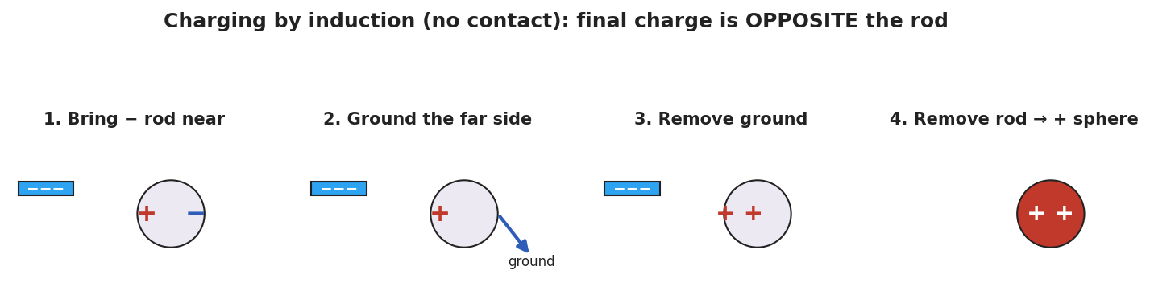
A four-panel sequence of charging a neutral metal sphere by induction with a negative rod: (1) the rod nearby polarizes the sphere with + on the near side and − on the far side; (2) grounding the far side lets electrons flee to the ground; (3) the ground is removed, leaving the sphere net positive; (4) the rod is removed and the positive charge spreads over the sphere.

Teacher facilitation during Explore
- What to look for — groups realizing the ground must be removed before the rod, or the trick fails.
- What to resist — don’t name “induction” until the consolidation; let the sequence emerge on the boards.
- What to redirect — groups who let the rod touch the sphere have done conduction (same sign) — ask them to compare the final sign with the no-touch version.

Phase 3 · Explain (30 – 36 min)

30–34 min · BTC consolidation + class consensus
Tour two or three boards in a deliberate sequence (least-to-most complete). Build the consensus:
“When a charge comes near a neutral object, the object’s own charges shift — near side opposite to the rod, far side same as the rod. That’s polarization, and it explains the attracted paper. If we then connect the far side to the ground, the rod-repelled charge escapes; cut the ground, then remove the rod, and the object is left with the opposite sign — that’s charging by induction, with no contact at all.”

34–36 min · Vocabulary introduction (≤ 3 terms)
Sample teacher language:
“Polarization is the shift of charge within a neutral object. Induction uses that shift, plus a grounding step, to leave an object charged opposite to the rod — without ever touching it.”
Polarization explains the attracted paper:
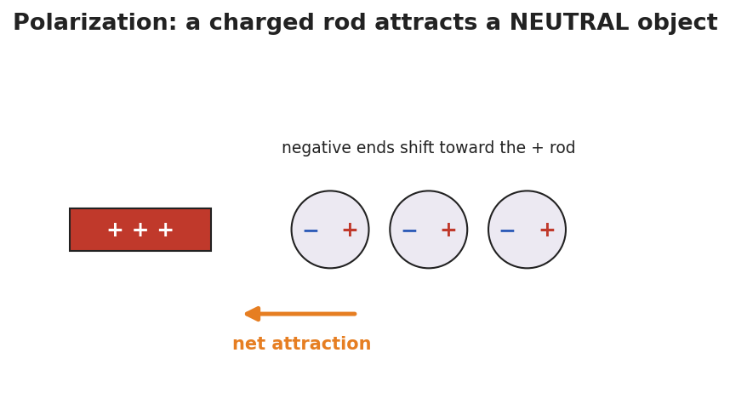
A positive rod near three neutral atoms; in each atom the negative end has shifted toward the rod and the positive end away, so the near side is negative and the whole object is pulled toward the rod.

Discussion prompts to deploy here
- “In induction, why must we remove the ground before the rod?”
  - Sample student response: “If the rod leaves first, the charges just flow back and the object goes neutral again.”
- “A negative rod charges a sphere by induction. What sign is the sphere — and how is that different from conduction?”
  - Sample student response: “Positive — opposite to the rod. Conduction would have made it negative, the same sign, but it needs contact.”

Phase 4 · Elaborate (36 – 40 min)

36–39 min · Revise the model
“Return to your paper-bits drawing. Re-label it using polarization: which side of the paper is attracted, and why? Then write one sentence stating the final sign if you instead charged a metal sphere by induction with a positive rod.”

39–40 min · Return to the phenomenon
“Why does the water stream bend toward either a positive or a negative rod? Answer in one sentence using polarization.”
Target: “Water molecules are polar and rotate so their attracted end faces the rod — so it bends toward a rod of either sign.”

Phase 5 · Evaluate (40 – 42 min)

40–42 min · Exit Ticket + Closing Reflection
“A POSITIVE rod is brought near (not touching) a neutral metal sphere on an insulating stand. (a) Sketch where the + and − charges sit on the sphere while the rod is near. What is this called? (b) You now ground the sphere, remove the ground, then remove the rod. What sign is the sphere’s net charge? Name the method. (c) In one sentence, state the key difference between charging by induction and charging by conduction.”
Expected: (a) negatives gather on the near side, positives on the far side — polarization; (b) the sphere ends up negative (opposite the positive rod), by induction; (c) induction leaves the opposite sign with no contact, while conduction leaves the same sign through direct contact. See Answer_Key.docx.
Closing Reflection (SEL, 30 seconds):
“Which groupmate’s board move helped you see the grounding step? Name one idea you changed your mind about.”

Common Misconceptions
- Misconception: “Induction and conduction give the same result.” → Correction: Induction → opposite sign, no contact; conduction → same sign, with contact.
- Misconception: “A polarized object has gained a net charge.” → Correction: Polarization only shifts existing charge; the object stays overall neutral.
- Misconception: “Order doesn’t matter — remove the rod or the ground first.” → Correction: The ground must be removed before the rod, or the separated charge flows back and the object returns to neutral.

Access & Differentiation
- ELL/ENL supports: Sentence frame: “When the rod comes near, the ___ charges move to the ___ side, so the object becomes ___ (polarized / charged by induction).” Word-choice box: {polarization, induction, grounding, near side, far side, opposite, no contact}. Provide a numbered four-step strip to put in order.
- IEP/SPED supports: Give the four induction panels on cards out of order; students sequence them rather than draw from scratch. Pair the BTC board work with a partner scribe.
- Extensions: Have students design an induction sequence that leaves two spheres oppositely charged at once (the classic two-sphere split), and explain it with grounding.

Strategy Spotlight
BTC (Building Thinking Classrooms). Today uses three BTC pillars: visibly random groups of 3, vertical non-permanent surfaces, and a thin-slice task with the answer withheld. The task (“leave the sphere positive using a negative rod you may not touch”) is deliberately just past what conduction can do, forcing the grounding insight. Consolidate by touring boards least-to-most complete. Keep yourself from naming “induction” until the consolidation — the sequence should be discovered on the boards first.

NYSSLS Observation Checklist Crosswalk
# | Checklist item | Where it appears in this lesson
1 | Local/relatable phenomenon | Phase 1 — bending water/paper bits; water stream in Phase 4
2 | Turn and Talk (2–3×) | Phase 1 (TT#1 — what the rod does inside the paper), Phase 3 (consolidation discussion)
3 | Students develop questions/models/procedures | Phase 1 (initial model), Phase 2 (BTC thin-slice procedure), Phase 4 (revise model)
4 | CCC defined and used | Lesson Overview · Cause and Effect, restated in Phase 2
5 | ENL — ≤ 3 vocab, second half | Phase 3 — vocabulary at 34–36 min (polarization / induction / grounding)
6 | Revisit phenomenon with evidence | Phase 4 — water stream + paper re-labeling
7 | ENL/SPED supports | Access & Differentiation block
8 | Assessment check | Phase 5 — Exit Ticket (induction sequence + induction-vs-conduction contrast)

Companion Materials
- Student_Worksheet.docx — the 5E student investigation (hand out at start of Phase 2)
- Student_Notes.docx — guided note-guide for vocabulary and the worked example
- Answer_Key.docx — answers to “Make It Make Sense” prompts and the Exit Ticket

Key Vocabulary (max 3)
- polarization — the shift of charge within a neutral object when a charged object is brought near; the near side becomes oppositely charged, so the object is attracted (it stays overall neutral)
- induction — charging an object without contact by bringing a charge near, grounding, then removing the ground and the charge; the object is left with the opposite sign
- grounding — connecting an object to the Earth (or a large conductor) so charge can flow off to or from it

Charging by Induction and Polarization — Student Worksheet
Unit: Electrostatics — Lesson 03 Name: _______________________ Date: __________ Period: ____

Phenomenon
Your teacher holds a charged rod near a thin stream of water — the stream bends toward it. The rod never touches the water, and the water started out neutral. Held over tiny scraps of neutral paper, the rod makes them jump up to meet it.
Driving question: How can a charged object pull on a neutral object it never even touches?

Notice & Wonder
I notice… | I wonder…
Turn & Talk #1: The paper is neutral, yet it’s attracted. What could the charged rod be doing to the inside of the paper?

Initial Model
Draw a scrap of neutral paper with a charged rod held above it. Show what you think happens to the charges inside the paper. Predict whether the paper is pulled up, pushed down, or unaffected.

My prediction: _______________________________

Investigation
BTC thin-slice task (vertical whiteboard, groups of 3):
You have a neutral metal sphere on an insulating stand and a negative rod you may not touch to the sphere. Find a sequence of moves — bring the rod near, touch the sphere with a finger (ground), step away — that leaves the sphere with a lasting positive charge. Draw each step and show where the charges are.
Check your sequence against this model:

Four panels of charging a metal sphere by induction with a negative rod: polarize, ground the far side, remove the ground, then remove the rod, leaving the sphere positive.
Step | What I do | Where the charges are
1
2
3
4
Key question: Why must you remove the ground before you remove the rod?

Make It Make Sense
- A charged rod attracts a neutral piece of paper. Explain what happens to the paper’s charges (use the word polarization).
- A negative rod is used to charge a metal sphere by induction. What sign does the sphere end up with, and why?
- A student lets the rod touch the sphere instead. Now what charging method is it, and what sign does the sphere get?

Vocabulary in Action
Use each term in a sentence about today’s phenomenon.
- polarization: _______________________________________________
- induction: _______________________________________________
- grounding: _______________________________________________

Revise Your Model
Return to your Initial Model. Re-label it using polarization: which side of the paper is attracted, and why? Then write one sentence stating the final sign if you charged a metal sphere by induction with a positive rod.

Exit Ticket
A positive rod is brought near (not touching) a neutral metal sphere on an insulating stand.
- Sketch where the + and − charges sit on the sphere while the rod is near. What is this called?
- You ground the sphere, remove the ground, then remove the rod. What sign is the sphere’s net charge? Name the method.
- In one sentence, state the key difference between charging by induction and charging by conduction.

Charging by Induction and Polarization — Student Notes
Unit: Electrostatics — Lesson 03 Name: _______________________ Date: __________ Period: ____

Learning Targets
By the end of today’s 42 minutes I can:
- Explain polarization and why a charged object attracts a neutral one.
- Describe the four steps of charging by induction.
- Contrast induction (opposite sign, no contact) with conduction (same sign, contact).

Key Vocabulary
- polarization — _______________________________________________
- induction — _______________________________________________
- grounding — _______________________________________________

Guided Notes
Polarization (in a neutral object):
- A charged object brought near makes the neutral object’s charges __________.
- The near side becomes __________ (opposite to the rod); the far side becomes __________.
- The object is overall still __________, but its near side is attracted.
Charging by induction (with a negative rod, no contact):
- Bring the negative rod __________ the neutral metal sphere → it polarizes.
- __________ the far side; electrons (repelled by the rod) flee to the __________.
- Remove the __________ first, while the rod is still near.
- Remove the __________; the sphere is left with the __________ sign (positive).

Four panels of induction: polarize, ground, remove ground, remove rod → positive sphere.
Why a neutral object is attracted (polarization):

A + rod near neutral atoms whose negative ends have shifted toward the rod, so the object is pulled toward it.
Induction vs. conduction:
 | Contact? | Final sign vs. rod
Conduction | __________ | __________
Induction | __________ | __________

Worked Example
Problem. A metal sphere is charged by induction using a rod that is +8 units. After the procedure, what sign is the sphere’s net charge, and why?
Solution. 1. The + rod is brought near; it __________ the sphere (− on the near side, + on the far side). 2. Grounding lets the rod-repelled charge (the __________ charges) escape to the ground. 3. Remove the ground, then the rod → the sphere keeps the charge __________ to the rod. 4. The rod was +, so the sphere ends up __________ — opposite, with no contact.

Summary
Finish the sentence (Because / But / So):
A charged rod can attract a neutral object because __________________________________________, but to leave the object permanently charged without touching it __________________________________________, so __________________________________________.

Charging by Induction and Polarization — Answer Key

Cover
Unit: Electrostatics — Lesson 03: Charging by Induction and Polarization East Meadow Schools × Valley Stream Central HSD Strategy chip: BTC

Make-It-Make-Sense Answers
- The rod’s charge makes the paper’s own charges shift (polarize): the near side becomes oppositely charged to the rod and the far side the same. Because the near (opposite) side is closer, the net force is attraction, even though the paper stays neutral. · Rubric: names polarization AND explains near-side attraction. · NYSSLS: HS-PS3-5
- The sphere ends up positive — the opposite sign of the negative rod. The rod repels electrons to the grounded far side; once they drain to ground and the ground/rod are removed (in that order), the sphere is left with a deficit of electrons. · Rubric: “positive/opposite” + grounding mechanism. · NYSSLS: HS-PS3-5
- Letting the rod touch the sphere makes it charging by conduction, and the sphere ends up negative — the same sign as the rod. · Rubric: “conduction” AND “negative/same sign.” · NYSSLS: HS-PS3-5

Exit Ticket Answer
- The sphere’s electrons are repelled away from the positive rod is wrong — the rod is positive, so it attracts electrons: negatives gather on the near side, positives on the far side. This is polarization.
- The sphere ends up negative (opposite the positive rod), charged by induction.
- Induction leaves the opposite sign with no contact; conduction leaves the same sign through direct contact.
Tolerance/rubric: (a) correct charge placement (− near the + rod) + “polarization”; (b) “negative” + “induction”; (c) names opposite-vs-same AND contact-vs-no-contact. 1 point each. NYSSLS: HS-PS3-5.

Closing Reflection (rubric)
Closing reflection is formative, not graded. Award full credit for any honest response. Look for: - A specific board move (especially the grounding step) named in answer 1 - A genuine “changed my mind” statement in answer 2 (e.g., realizing order of removal matters)

Coulomb’s Law — Teacher Guide

Cover
Unit: Electrostatics — Lesson 04: Coulomb’s Law East Meadow Schools × Valley Stream Central High School District Strategy chips: HOCHMAN

Curated Resources (from East Meadow Scope & Sequence)

NYSSLS Standards
This is the quantitative core of the unit and the unit’s anchor to HS-PS2-4: “Use mathematical representations of Newton’s Law of Gravitation and Coulomb’s Law to describe and predict the gravitational and electrostatic forces between objects. (Patterns).” Students see the same inverse-square pattern they met in Universal Gravitation (Forces, Lesson 06) reappear for charge — a deliberate Patterns crosscutting-concept callback.

Phenomenon
- PhET “Coulomb’s Law” — drag two charged spheres, read the force in real time: https://phet.colorado.edu/en/simulations/coulombs-law
- Two charged pith balls / foil-covered balls swing apart on threads (classroom demo): https://www.youtube.com/watch?v=G+coulombs+law+pith+ball

Javalab / Labs
- PhET “Coulomb’s Law” macro scale (primary lab): https://phet.colorado.edu/en/simulations/coulombs-law
- Coulomb force between two charges (Javalab): https://javalab.org/en/coulombs_law_en/

Assessments
- Reference Table relationship: Fₑ = k·q₁·q₂ / r², with k = 8.99 × 10⁹ N·m²/C² and e = 1.6 × 10⁻¹⁹ C. The numeric Exit Ticket below is the formative check.

Lesson Overview
Duration | 42 minutes (1 period)
NYSSLS link | HS-PS2-4 (mathematical representation of Coulomb’s Law; the inverse-square Pattern)
CCC focus | Patterns — the electrostatic force follows the same inverse-square pattern as gravity.
Strategy chips | HOCHMAN (literacy)
Materials | Devices for the PhET sim; calculators; Reference Table; sentence-expansion strips (Because/But/So); whiteboards/markers.
Safety | Standard classroom safety; simulation-based, no hazards.
Prior knowledge | Lessons 01–03 (like repel/unlike attract); the inverse-square law from Universal Gravitation (Fg = G·m₁·m₂ / r²).
Lesson objectives — students can:
- State Coulomb’s law in words and symbols: Fₑ = k·q₁·q₂ / r², and identify each quantity and its unit.
- Predict how the force changes when charge or distance changes (especially the inverse-square fall-off with r).
- Calculate the electrostatic force between two charges using the Reference Table value of k.

Phase 1 · Engage (0 – 10 min)

0–2 min · Opening Connection (SEL)
One-phrase whip-around: “Name something that gets dramatically weaker the farther away you get from it.” (A campfire’s warmth, a speaker’s volume.) This primes the inverse-square fall-off.

2–7 min · Phenomenon hook — PhET two charges
Teacher actions. Open PhET “Coulomb’s Law.” Project two charges with the force readout visible. Double one charge — force doubles. Halve the distance — force quadruples. Let students call out predictions before each move.
Sample teacher language:
“I’m going to move these two charges to half their distance apart. The force won’t just double — watch the number. Predict first: by how much?”
Anticipated student responses:
- “It doubles when you halve the distance.” — capture; the surprise that it quadruples is the hook.
- “More charge means more force.” — yes, build on it: how exactly?
- “It looks like gravity from last unit.” — gold; this is the Patterns callback to HS-PS2-4.

7–10 min · Notice & Wonder + Turn-and-Talk #1
“Turn to your partner: halving the distance made the force four times bigger, not two. What relationship between force and distance would do that?”
Target idea: force depends on distance squared. Leave open if unspoken.

Bridge to Phase 2
Each student writes a one-sentence initial model: “The force gets bigger when ______ and smaller when ______.”

Phase 2 · Explore (10 – 28 min)

10–14 min · Initial Model (silent / individual)
“Sketch two charges a distance r apart. Predict, in words, what happens to the force if you (a) triple one charge, (b) double the distance. Then test each on PhET.”

14–28 min · Investigation — find the pattern on PhET
Structured data collection (devices in pairs):
- Charge sweep — fix r; set q₁ = 1, 2, 3, 4 µC; record force. Pattern: force is proportional to charge.
- Distance sweep — fix charges; set r = 1, 2, 3, 4 units; record force. Pattern: force ÷ 4, ÷ 9, ÷ 16 → inverse-square.
Plot the distance data; it matches the curve below.
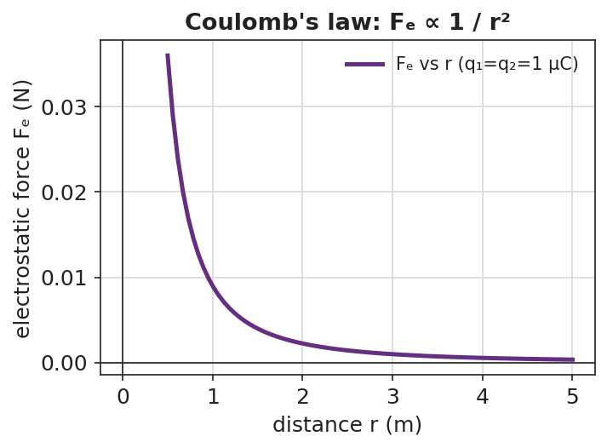
A line graph of electrostatic force versus separation distance: the curve starts high at small r and falls off steeply, flattening as r grows — the inverse-square shape of Coulomb’s law.
Teacher facilitation language:
“When you doubled r, the force didn’t halve — what fraction did it become? And at triple r?” “Where have you seen a force that dies off as 1/r² before this unit?”

Teacher facilitation during Explore
- What to look for — pairs noticing force ÷ 4 at double distance, ÷ 9 at triple → “it’s r squared.”
- What to resist — don’t write the formula yet; let the ÷4, ÷9 data force the squared relationship.
- What to redirect — pairs who confuse “double charge” (×2) with “double distance” (÷4) should re-run one variable at a time.

Phase 3 · Explain (28 – 36 min)

28–31 min · Turn-and-Talk #2 + class consensus
“In one sentence: how does the electrostatic force depend on the two charges and on the distance between them?”
Target consensus:
“The force grows in proportion to each charge and falls off as the square of the distance — exactly like gravity, but for charge.”

31–33 min · Vocabulary introduction (≤ 3 terms)
Sample teacher language:
“This relationship is Coulomb’s law. The push or pull between charges is the electrostatic force, Fₑ. Because it dies off as 1/r², we call it an inverse-square law — the same Pattern as gravity. In symbols: Fₑ = k·q₁·q₂ / r², with k = 8.99 × 10⁹ N·m²/C².”
The two-charge force pair below shows the forces are equal and opposite (Newton’s third law for charge):
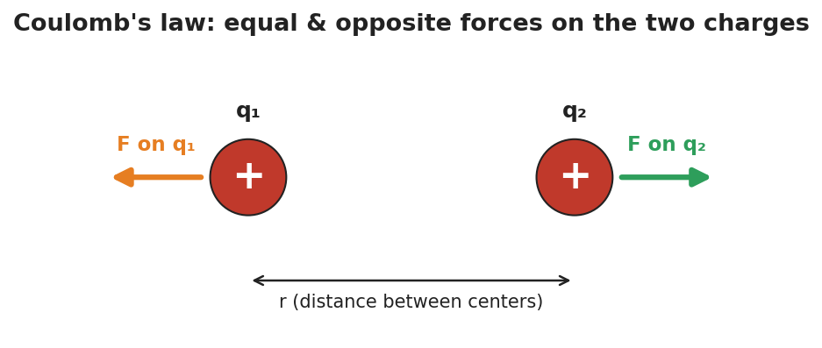
Two like charges with equal-length repulsive force arrows pointing away from each other, separated by a distance r — the electrostatic force on each charge is equal in size and opposite in direction.

33–36 min · HOCHMAN sentence work
Run a Because/But/So expansion of the key relationship on sentence strips:
Stem: “The electrostatic force gets stronger…” - because … (more charge → more force) - but … (it weakens fast as the charges move apart) - so … (doubling the distance cuts the force to one-quarter)
Then an appositive drill: “Coulomb’s law, the rule that the force falls off as 1/r², predicts the force between any two charges.”

Discussion prompts to deploy here
- “If you triple both charges, what happens to the force?”
  - Sample student response: “It goes up nine times — three times for each charge, 3 × 3.”
- “Why is the unit of k written N·m²/C²?”
  - Sample student response: “So that q·q/r² (C²/m²) times k gives newtons — the units cancel to a force.”

Phase 4 · Elaborate (36 – 40 min)

36–39 min · Revise the model (with numbers)
“Two charges of +2.0 × 10⁻⁶ C each sit 0.30 m apart. Use Fₑ = k·q₁·q₂ / r² to find the force. Then state what happens to that force if the distance is doubled.”
Work it with the class (full solution in Student_Notes.docx): Fₑ = (8.99 × 10⁹)(2.0 × 10⁻⁶)(2.0 × 10⁻⁶) / (0.30)² ≈ 0.40 N, repulsive. Doubling r → one-quarter the force ≈ 0.10 N.

39–40 min · Return to the phenomenon
“On PhET, why did halving the distance quadruple the force? Answer in one Because/But/So sentence.”
Target: “Halving r made r² one-quarter as big, but r² is in the denominator, so the force became four times larger.”

Phase 5 · Evaluate (40 – 42 min)

40–42 min · Exit Ticket (numeric) + Closing Reflection
“Use Fₑ = k·q₁·q₂ / r², k = 8.99 × 10⁹ N·m²/C². (a) Two charges, q₁ = +3.0 × 10⁻⁶ C and q₂ = +3.0 × 10⁻⁶ C, are 0.20 m apart. Calculate the electrostatic force. Is it attractive or repulsive? (b) Without recalculating from scratch, state what happens to the force if the distance is tripled. (c) Coulomb’s law shares its 1/r² shape with which force from the Forces unit?”
Expected: (a) Fₑ = (8.99 × 10⁹)(3.0 × 10⁻⁶)(3.0 × 10⁻⁶)/(0.20)² ≈ 2.0 N, repulsive (both positive); (b) tripling r divides the force by 9 → ≈ 0.22 N; (c) gravitation (Fg = G·m₁·m₂/r²). See Answer_Key.docx.
Closing Reflection (SEL, 30 seconds):
“Which sentence stem (because / but / so) made the math click for you today, and why?”

Common Misconceptions
- Misconception: “Doubling the distance halves the force.” → Correction: Distance is squared, so doubling r divides the force by four.
- Misconception: “The bigger charge feels a bigger force than the smaller one.” → Correction: The two charges feel equal and opposite forces (Newton’s third law), regardless of their relative sizes.
- Misconception: “k and the masses/charges have the same role as in gravity.” → Correction: The form is identical (inverse-square), but k (8.99 × 10⁹) is enormous compared with G — the electric force is vastly stronger than gravity for the same separation.

Access & Differentiation
- ELL/ENL supports: Provide the Because/But/So strips pre-printed with the stem. Word-choice box: {Coulomb’s law, electrostatic force, inverse-square, charge, distance, quadruple, quarter}. Pair “inverse-square” with a hand gesture (force shrinking fast as hands separate).
- IEP/SPED supports: Provide a plug-in template for the calculation with the formula and k pre-filled; students substitute only the numbers. Offer a scaffolded “÷4, ÷9, ÷16” table for the distance pattern.
- Extensions: Have students compute the ratio of the electric force to the gravitational force between two protons and explain (with k vs. G) why electricity dominates at the atomic scale.

Strategy Spotlight
HOCHMAN (literacy). Today’s vocabulary and the key relationship are consolidated through sentence-level Hochman moves: a Because/But/So expansion of “the electrostatic force gets stronger…,” and an appositive drill naming Coulomb’s law inside the sentence. These force students to encode the inverse-square idea in precise prose, not just a formula. Keep the strips short (one clause each) and read several aloud — fluency with the sentence is the goal, not length.

NYSSLS Observation Checklist Crosswalk
# | Checklist item | Where it appears in this lesson
1 | Local/relatable phenomenon | Phase 1 — PhET two charges; campfire warmth analogy
2 | Turn and Talk (2–3×) | Phase 1 (TT#1 — why force quadruples), Phase 3 (TT#2 — force vs. charge and distance)
3 | Students develop questions/models/procedures | Phase 1 (initial model), Phase 2 (PhET data sweeps), Phase 4 (numeric revision)
4 | CCC defined and used | Lesson Overview · Patterns (inverse-square callback), restated in Phase 3
5 | ENL — ≤ 3 vocab, second half | Phase 3 — vocabulary at 31–33 min (Coulomb’s law / electrostatic force / inverse-square law)
6 | Revisit phenomenon with evidence | Phase 4 — PhET “why quadruple” Because/But/So
7 | ENL/SPED supports | Access & Differentiation block
8 | Assessment check | Phase 5 — numeric Exit Ticket (calculate Fₑ; predict ×⅑ at triple r)

Companion Materials
- Student_Worksheet.docx — the 5E student investigation (hand out at start of Phase 2)
- Student_Notes.docx — guided note-guide with the full worked calculation
- Answer_Key.docx — worked answers to “Make It Make Sense” prompts and the numeric Exit Ticket

Key Vocabulary (max 3)
- Coulomb’s law — the rule that the electrostatic force between two charges is Fₑ = k·q₁·q₂ / r², with k = 8.99 × 10⁹ N·m²/C²
- electrostatic force — the attractive or repulsive force (Fₑ) between charged objects
- inverse-square law — a relationship in which a quantity falls off as 1 / r²; shared by Coulomb’s law and Newton’s law of gravitation

Coulomb’s Law — Student Worksheet
Unit: Electrostatics — Lesson 04 Name: _______________________ Date: __________ Period: ____
Reference: Fₑ = k·q₁·q₂ / r² · k = 8.99 × 10⁹ N·m²/C² · e = 1.6 × 10⁻¹⁹ C

Phenomenon
Your teacher drags two charged spheres in the PhET “Coulomb’s Law” simulation. Doubling one charge doubles the force — no surprise. But halving the distance quadruples the force, and the readout looks just like the gravity behavior from the Forces unit.
Driving question: How exactly does the force between two charges depend on the charges and on the distance between them?

Notice & Wonder
I notice… | I wonder…
Turn & Talk #1: Halving the distance made the force four times bigger, not two. What relationship between force and distance would do that?

Initial Model
Sketch two charges a distance r apart. Predict, in words, what happens to the force if you (a) triple one charge, (b) double the distance.
- Triple one charge: __________________________
- Double the distance: ________________________

Investigation
Test each prediction on PhET, one variable at a time.
Charge sweep (keep r fixed):
q₁ (µC) | 1 | 2 | 3 | 4
Force (record)
Distance sweep (keep charges fixed):
r (units) | 1 | 2 | 3 | 4
Force (record)
The distance data should trace this inverse-square curve:

A force-versus-distance curve that drops steeply at small distances and flattens at larger distances — the 1/r² shape.
Key question: When you doubled r, the force became what fraction? At triple r?

Make It Make Sense
- The two charges in PhET have very different sizes. Which one feels the bigger force? Explain. (See the force-pair diagram below.)

Two like charges with equal, opposite repulsive force arrows, separated by distance r.
- If you triple both charges, what happens to the force? Show your reasoning.
- Coulomb’s law has the same 1/r² shape as which force from the Forces unit? What does that tell you about how nature works?

Vocabulary in Action
Use each term in a sentence about today’s phenomenon.
- Coulomb’s law: _______________________________________________
- electrostatic force: _______________________________________________
- inverse-square law: _______________________________________________

Revise Your Model
Two charges of +2.0 × 10⁻⁶ C each sit 0.30 m apart. Use Fₑ = k·q₁·q₂ / r² to find the force. Then state what happens to it if the distance is doubled.
Fₑ = ____________________ → Fₑ ≈ __________ N If r is doubled, Fₑ becomes __________________

Exit Ticket
Use Fₑ = k·q₁·q₂ / r², with k = 8.99 × 10⁹ N·m²/C².
- Two charges, q₁ = +3.0 × 10⁻⁶ C and q₂ = +3.0 × 10⁻⁶ C, are 0.20 m apart. Calculate the electrostatic force. Is it attractive or repulsive?
- Without recalculating from scratch, state what happens to the force if the distance is tripled.
- Coulomb’s law shares its 1/r² shape with which force from the Forces unit?

Coulomb’s Law — Student Notes
Unit: Electrostatics — Lesson 04 Name: _______________________ Date: __________ Period: ____
Reference: Fₑ = k·q₁·q₂ / r² · k = 8.99 × 10⁹ N·m²/C² · e = 1.6 × 10⁻¹⁹ C

Learning Targets
By the end of today’s 42 minutes I can:
- State Coulomb’s law in words and symbols and name each quantity’s unit.
- Predict how the force changes when charge or distance changes.
- Calculate the electrostatic force between two charges.

Key Vocabulary
- Coulomb’s law — _______________________________________________
- electrostatic force — _______________________________________________
- inverse-square law — _______________________________________________

Guided Notes
Coulomb’s law: Fₑ = k · q₁ · q₂ / r²
- Fₑ = the __________ force, in newtons (N)
- q₁, q₂ = the two __________, in coulombs (C)
- r = the __________ between the charges, in meters (m)
- k = __________ × 10⁹ N·m²/C² (Coulomb constant)
Patterns:
- Force is __________ to each charge → double a charge, the force __________.
- Force depends on distance __________ (squared) → double r, force becomes __________; triple r, force becomes __________.
- This 1/r² shape is an inverse-square law — the same pattern as __________ (gravitation).

A force-versus-distance curve falling off as 1/r².
The two charges always feel equal and opposite forces (Newton’s third law):

Two charges with equal-length, opposite repulsive force arrows.

Worked Example
Problem. Two charges of +2.0 × 10⁻⁶ C each sit 0.30 m apart. Find the electrostatic force, and state whether it is attractive or repulsive.
Solution. 1. Write the formula: Fₑ = k · q₁ · q₂ / r². 2. Substitute: Fₑ = (8.99 × 10⁹)(2.0 × 10⁻⁶)(2.0 × 10⁻⁶) / (0.30)². 3. Numerator: (8.99 × 10⁹)(4.0 × 10⁻¹²) = __________ ≈ 3.6 × 10⁻² N·m². 4. Divide by r² = (0.30)² = 0.090 m²: Fₑ ≈ __________ ≈ 0.40 N. 5. Both charges are positive, so the force is __________ (repulsive).
Check the pattern: if r doubles to 0.60 m, r² ×4, so Fₑ → 0.40 / 4 = __________ N.

Summary
Finish the sentence (Because / But / So):
The electrostatic force between two charges gets stronger because __________________________________________, but it weakens fast as the charges move apart __________________________________________, so __________________________________________.

Coulomb’s Law — Answer Key

Cover
Unit: Electrostatics — Lesson 04: Coulomb’s Law East Meadow Schools × Valley Stream Central HSD Strategy chip: HOCHMAN Reference: Fₑ = k·q₁·q₂ / r² · k = 8.99 × 10⁹ N·m²/C² · e = 1.6 × 10⁻¹⁹ C

Make-It-Make-Sense Answers
- They feel the same-size force — equal in magnitude and opposite in direction (Newton’s third law). The smaller charge does not feel a smaller force; Fₑ uses the product q₁·q₂, which is the same for both. · Rubric: “equal/same force” + Newton’s third law or “same product.” · NYSSLS: HS-PS2-4
- The force goes up nine times (×9). Each charge tripled multiplies the force by 3, and 3 × 3 = 9. · Rubric: “×9” with the 3 × 3 reasoning. · NYSSLS: HS-PS2-4
- Gravitation (Fg = G·m₁·m₂ / r²). The shared inverse-square shape shows nature reuses the same mathematical Pattern for very different forces. · Rubric: names gravitation AND the Patterns idea. · NYSSLS: HS-PS2-4

Exit Ticket Answer
- Fₑ = (8.99 × 10⁹)(3.0 × 10⁻⁶)(3.0 × 10⁻⁶) / (0.20)² = (8.99 × 10⁹)(9.0 × 10⁻¹²) / 0.040 = (8.09 × 10⁻²) / 0.040 ≈ 2.0 N. Repulsive (both charges positive).
- Tripling the distance multiplies r² by 9, so the force is divided by 9: 2.0 / 9 ≈ 0.22 N.
- Newton’s law of universal gravitation, Fg = G·m₁·m₂ / r² (the inverse-square Pattern, HS-PS2-4).
Tolerance/rubric: (a) accept 2.0 N ± 0.1 (≈ 2.02 N) AND “repulsive”; (b) “÷9” or ≈ 0.22 N; (c) gravitation. 1 point each (part a worth 2: setup + answer). NYSSLS: HS-PS2-4.
Worked detail for (a): q₁·q₂ = (3.0 × 10⁻⁶)² = 9.0 × 10⁻¹² C². Times k: 8.99 × 10⁹ × 9.0 × 10⁻¹² = 8.09 × 10⁻² N·m². Divide by r² = 0.040 m²: 8.09 × 10⁻² / 0.040 = 2.02 N.

Closing Reflection (rubric)
Closing reflection is formative, not graded. Award full credit for any honest response. Look for: - The student naming a specific stem (because / but / so) and tying it to a real understanding (e.g., “but” captured why the force dies off with distance)

Electric Fields — Teacher Guide

Cover
Unit: Electrostatics — Lesson 05: Electric Fields East Meadow Schools × Valley Stream Central High School District Strategy chips: ACTIVE LEARNING

Curated Resources (from East Meadow Scope & Sequence)

NYSSLS Standards
This lesson is the heart of the unit’s modeling standard, HS-PS3-5: “Develop and use a model of two objects interacting through electric or magnetic fields to illustrate the forces between objects and the changes in energy of the objects due to the interaction. (Cause and Effect).” Students develop the field model — the idea that a charge fills the space around it with a force-per-charge that causes a force on any other charge placed there.

Phenomenon
- A plasma ball; bringing a hand or a fluorescent tube near it lights up at a distance (standard demo): https://www.youtube.com/watch?v=plasma+ball+fluorescent
- A fluorescent bulb glows when held near a Van de Graaff or charged source (Veritasium/PhysicsGirl): https://www.youtube.com/watch?v=electric+field+bulb

Javalab / Labs
- Electric field line (place a charge, see the field): https://javalab.org/en/electric_field_line_en/
- Electric field of point charges (Javalab): https://javalab.org/en/electric_field_en/

Assessments
- Reference Table relationship: E = Fₑ / q (units N/C). The Exit Ticket below is the formative check.

Lesson Overview
Duration | 42 minutes (1 period)
NYSSLS link | HS-PS3-5 (the field model of charge interaction)
CCC focus | Cause and Effect — a charge creates a field everywhere, and that field causes a force on any charge placed in it.
Strategy chips | ACTIVE LEARNING
Materials | Plasma ball (or Javalab); small “test charge” tokens for the floor-map activity; tape; calculators; Reference Table; whiteboards/markers.
Safety | If a plasma ball is used, follow its operating limits; no prolonged contact.
Prior knowledge | Lesson 04 — Coulomb’s law (Fₑ = k·q₁·q₂ / r²); the inverse-square fall-off.
Lesson objectives — students can:
- Define the electric field as force per unit charge, E = Fₑ / q, with units N/C.
- Explain the test-charge idea: a tiny positive charge maps the field’s direction (away from +, toward −).
- Calculate field strength from a force and a charge, and the force on a charge from a field.

Phase 1 · Engage (0 – 10 min)

0–2 min · Opening Connection (SEL)
One-phrase whip-around: “Name something you can’t see but you know is there because of what it does to other things.” (Wind moving leaves, gravity, a smell.) This primes “a field you detect by its effect.”

2–7 min · Phenomenon hook — the plasma ball lights a bulb
Teacher actions. Run a plasma ball. Bring a fluorescent tube near it (not touching) — it glows. Move it farther — it dims. The ball is doing something to the space around it.
Sample teacher language:
“The bulb isn’t plugged in and it isn’t touching the ball — yet it lights up, and it dims as I pull it away. What is filling the space between them?”
Anticipated student responses:
- “Electricity is jumping to it.” — close; ask what the electricity travels through.
- “There’s an invisible energy field around the ball.” — excellent; we’ll name it the electric field.
- “It’s like the balloon attracting paper, but stronger.” — yes, connect to the at-a-distance interactions from Lessons 03–04.

7–10 min · Notice & Wonder + Turn-and-Talk #1
“Turn to your partner: the effect on the bulb got weaker as it moved away. What does that tell you about whatever surrounds the ball?”
Target idea: the influence fills space and weakens with distance. Leave open if unspoken.

Bridge to Phase 2
Each student writes a one-sentence initial model: “The bulb lights because the space around the ball ______.”

Phase 2 · Explore (10 – 28 min)

10–14 min · Initial Model (silent / individual)
“Draw the plasma ball. Around it, draw arrows showing how you think it pushes or pulls on a small positive test charge placed at several spots. Where would the push be strongest?”

14–28 min · Active-Learning investigation — map the field with your bodies
Tape a large “+” source charge on the floor. Hand out “test charge” cards (each a small +). Active-learning protocol:
- Place and feel — students stand at assigned spots holding a + test card; each predicts the direction of the force on it and points an arrow (away from the source).
- Map the strength — students close to the source crouch (strong field); those far stand tall (weak field) → a human inverse-square map.
- Flip the source — swap to a “−” source; every arrow reverses (now pointing toward the source). Quick re-vote.
Compare the human map to the field diagram below.
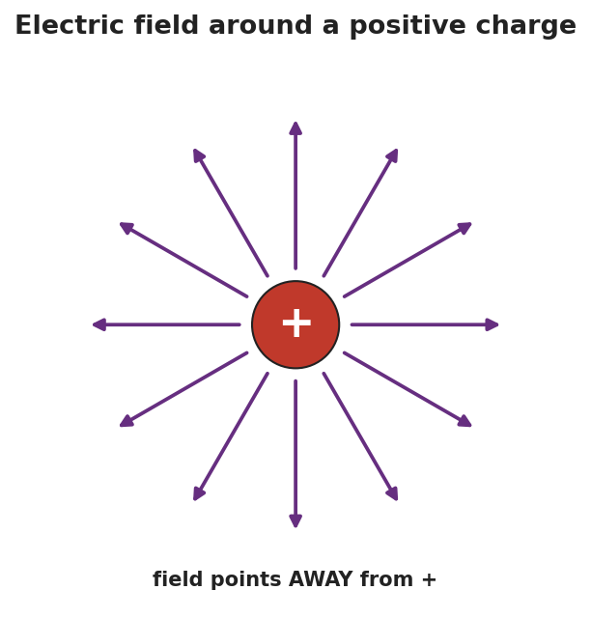
Radial arrows pointing outward from a single positive charge in all directions, representing the electric field around a positive charge — the field points away from a positive source.
Teacher facilitation language:
“Point your test-charge arrow. Which way does the force push a positive test charge near a positive source?” “Who’s feeling the strongest field — and what does that tell us about field strength vs. distance?”

Teacher facilitation during Explore
- What to look for — students pointing arrows away from a + source and toward a − source, and crowding-strength near the source.
- What to resist — don’t give E = Fₑ/q yet; let the human map establish direction and strength first.
- What to redirect — students who point the arrow toward a + source should recall: a + test charge is repelled by +, so it points away.

Phase 3 · Explain (28 – 36 min)

28–31 min · Turn-and-Talk #2 + class consensus
“In one sentence: what is in the space around a charge, and how do we know which way it points?”
Target consensus:
“Every charge surrounds itself with an electric field — a force-per-charge at every point. We probe it with a tiny positive test charge: the field points the way that test charge is pushed (away from +, toward −), and it’s strongest near the source.”

31–33 min · Vocabulary introduction (≤ 3 terms)
Sample teacher language:
“That force-per-charge is the electric field, E = Fₑ / q, measured in newtons per coulomb (N/C). The tiny imaginary charge we use to find its direction is the test charge. The size of E at a point is the field strength — bigger near the source, falling off as 1/r².”
The E-vs-r graph shows the strength falling off:
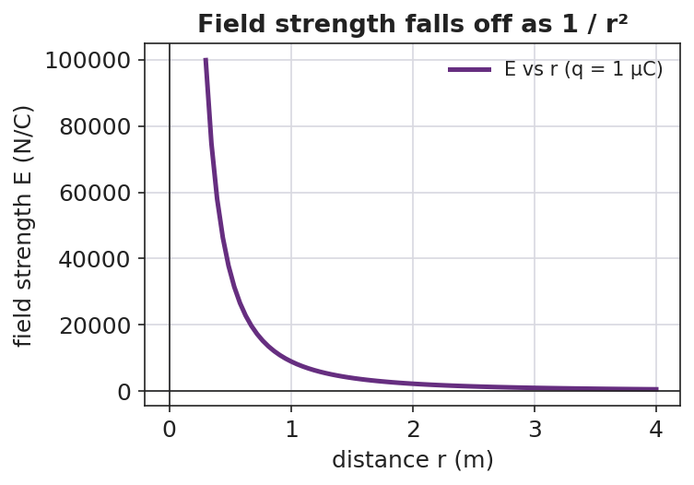
A graph of electric field strength E versus distance r from a point charge, falling off steeply as 1/r².

Discussion prompts to deploy here
- “If a 2 N force acts on a +0.5 C charge placed at a point, what is E there?”
  - Sample student response: “E = Fₑ/q = 2 / 0.5 = 4 N/C.”
- “Why do we use a positive test charge to define the field’s direction?”
  - Sample student response: “It’s the agreed convention — the field points the way a positive charge would be pushed.”

Phase 4 · Elaborate (36 – 40 min)

36–39 min · Revise the model (with numbers)
“A field of 500 N/C exists at a point. (a) What force would it exert on a charge of +2.0 × 10⁻⁶ C placed there? (b) Which way, if the field points east?”
Work it with the class: Fₑ = E·q = (500)(2.0 × 10⁻⁶) = 1.0 × 10⁻³ N, directed east (a positive charge follows the field).

39–40 min · Return to the phenomenon
“Why does the fluorescent tube glow brighter the closer it is to the plasma ball? Answer in one sentence using field strength.”
Target: “The electric field is stronger closer to the ball, so it pushes the gas’s charges harder and the tube glows brighter.”

Phase 5 · Evaluate (40 – 42 min)

40–42 min · Exit Ticket + Closing Reflection
“Use E = Fₑ / q. (a) A charge of +4.0 × 10⁻⁶ C feels a force of 0.012 N at a point. Calculate the electric field strength there, with units. (b) Draw the field around a single negative charge — which way do the arrows point? (c) In one sentence, explain what a ‘test charge’ is and why it must be small.”
Expected: (a) E = Fₑ/q = 0.012 / (4.0 × 10⁻⁶) = 3.0 × 10³ N/C; (b) arrows point inward, toward the negative charge; (c) a tiny positive charge used to probe a field’s direction and strength — small so it doesn’t disturb the field it’s measuring. See Answer_Key.docx.
Closing Reflection (SEL, 30 seconds):
“What part of the human field-map helped you ‘see’ the invisible field? Whose arrow helped you fix yours?”

Common Misconceptions
- Misconception: “The field only exists where there’s another charge to feel it.” → Correction: The field fills the space around a charge whether or not a second charge is present; the second charge just reveals it.
- Misconception: “The field points whichever way the source charge would move.” → Correction: By convention E points the way a positive test charge is pushed (away from +, toward −).
- Misconception: “Field strength and force are the same thing.” → Correction: E is force per coulomb (N/C); the force on a particular charge is Fₑ = E·q.

Access & Differentiation
- ELL/ENL supports: Sentence frame: “The electric field points ___ a positive charge and ___ a negative charge, and it is ___ (stronger/weaker) close to the source.” Word-choice box: {electric field, test charge, field strength, away from, toward, N/C}. Provide pre-drawn radial arrows to label.
- IEP/SPED supports: Give an E = Fₑ/q plug-in template with units printed; students substitute numbers only. Offer the human field-map as the hands-on alternative to drawing.
- Extensions: Have students combine Coulomb’s law and E = Fₑ/q to show E = k·q / r² for a point charge, and use it to find the field 0.10 m from a +1 µC charge.

Strategy Spotlight
ACTIVE LEARNING. Today’s Explore turns the class into a living field map: each student is a positive test charge that points the force direction and crouches/stands to show strength. Flipping the source from + to − forces an immediate, embodied re-vote. Keep the activity kinetic and quick (3–4 source positions), then connect the human map directly to the radial-arrow diagram. Your role is to ask “which way are you pushed?” rather than to draw the field for them.

NYSSLS Observation Checklist Crosswalk
# | Checklist item | Where it appears in this lesson
1 | Local/relatable phenomenon | Phase 1 — plasma ball lighting a bulb; brightness vs. distance in Phase 4
2 | Turn and Talk (2–3×) | Phase 1 (TT#1 — what fills the space), Phase 3 (TT#2 — field direction and strength)
3 | Students develop questions/models/procedures | Phase 1 (initial model), Phase 2 (human field-map), Phase 4 (numeric revision)
4 | CCC defined and used | Lesson Overview · Cause and Effect, restated in Phase 2
5 | ENL — ≤ 3 vocab, second half | Phase 3 — vocabulary at 31–33 min (electric field / test charge / field strength)
6 | Revisit phenomenon with evidence | Phase 4 — bulb brightness + field-strength explanation
7 | ENL/SPED supports | Access & Differentiation block
8 | Assessment check | Phase 5 — Exit Ticket (calculate E; field direction around −)

Companion Materials
- Student_Worksheet.docx — the 5E student investigation (hand out at start of Phase 2)
- Student_Notes.docx — guided note-guide with the worked field calculation
- Answer_Key.docx — worked answers to “Make It Make Sense” prompts and the Exit Ticket

Key Vocabulary (max 3)
- electric field — the force per unit charge at a point in space around a charge: E = Fₑ / q, measured in newtons per coulomb (N/C)
- test charge — a tiny positive charge used to probe a field’s direction and strength without disturbing it
- field strength — the magnitude of the electric field at a point; larger near the source and falling off as 1/r²

Electric Fields — Student Worksheet
Unit: Electrostatics — Lesson 05 Name: _______________________ Date: __________ Period: ____
Reference: E = Fₑ / q (units: N/C) · k = 8.99 × 10⁹ N·m²/C²

Phenomenon
Your teacher holds a fluorescent tube near a plasma ball — it glows, even though it isn’t plugged in or touching the ball. Move it away and it dims. Something is filling the space around the ball.
Driving question: What is in the space around a charge, and how can we describe its direction and strength?

Notice & Wonder
I notice… | I wonder…
Turn & Talk #1: The effect on the bulb got weaker as it moved away. What does that tell you about whatever surrounds the ball?

Initial Model
Draw the plasma ball. Around it, draw arrows showing how it would push or pull on a small positive test charge placed at several spots. Mark where the push would be strongest.

Strongest at: _________________________________

Investigation
Human field map. Stand at your assigned spot holding a + test-charge card near the floor “+” source.
My spot | Direction my + card is pushed | Near or far from source? | Strong or weak field?
Round 1 (+ source)
Round 2 (− source)
Compare your map to the field around a single positive charge:

Arrows radiating outward in all directions from a single positive charge.
Key question: Which way does the field point near a positive source? Near a negative source?

Make It Make Sense
- A 2.0 N force acts on a +0.5 C charge placed at a point. What is the electric field strength there? Show E = Fₑ/q.
- The field strength drops as you move away from the source (see the graph). What shape is that fall-off, and where have you seen it before?

A graph of field strength E versus distance r, falling off as 1/r².
- Why do we use a positive test charge (and a small one) to define the field’s direction?

Vocabulary in Action
Use each term in a sentence about today’s phenomenon.
- electric field: _______________________________________________
- test charge: _______________________________________________
- field strength: _______________________________________________

Revise Your Model
A field of 500 N/C exists at a point, pointing east. (a) What force would it exert on a +2.0 × 10⁻⁶ C charge placed there? (b) Which direction?
Fₑ = E·q = ____________________ ≈ __________ N Direction: ____________________

Exit Ticket
Use E = Fₑ / q.
- A charge of +4.0 × 10⁻⁶ C feels a force of 0.012 N at a point. Calculate the electric field strength there, with units.
- Draw the field around a single negative charge. Which way do the arrows point?
- In one sentence, explain what a “test charge” is and why it must be small.

Electric Fields — Student Notes
Unit: Electrostatics — Lesson 05 Name: _______________________ Date: __________ Period: ____
Reference: E = Fₑ / q (units: N/C) · k = 8.99 × 10⁹ N·m²/C²

Learning Targets
By the end of today’s 42 minutes I can:
- Define the electric field as force per unit charge (E = Fₑ / q).
- Explain the test-charge idea and which way the field points.
- Calculate field strength from a force and a charge.

Key Vocabulary
- electric field — _______________________________________________
- test charge — _______________________________________________
- field strength — _______________________________________________

Guided Notes
Big idea: A charge fills the space around it with an electric field — a __________ per unit charge at every point.
- Formula: E = __________ / __________, with units __________ (newtons per coulomb).
- We find its direction with a tiny positive test charge: the field points the way that charge is __________.
- Near a positive charge, the field points __________ (away).
- Near a negative charge, the field points __________ (toward).
- Field strength is __________ near the source and falls off as __________ (inverse-square).

Radial arrows pointing away from a positive charge.

A graph of field strength E versus distance, falling off as 1/r².
Two ways to use E = Fₑ / q:
- Find the field: E = Fₑ / q.
- Find the force on a charge in a field: Fₑ = __________ · __________.

Worked Example
Problem. A field of 500 N/C points east at a point. What force does it exert on a charge of +2.0 × 10⁻⁶ C placed there, and in which direction?
Solution. 1. Rearrange E = Fₑ / q to solve for force: Fₑ = __________ · __________. 2. Substitute: Fₑ = (500 N/C)(2.0 × 10⁻⁶ C) = __________ N. 3. Result: Fₑ ≈ 1.0 × 10⁻³ N. 4. The charge is __________, so it is pushed in the __________ direction the field points → east.

Summary
Finish the sentence (Because / But / So):
A charge fills the space around it with an electric field because __________________________________________, but you only feel a force when another charge sits in that field __________________________________________, so __________________________________________.

Electric Fields — Answer Key

Cover
Unit: Electrostatics — Lesson 05: Electric Fields East Meadow Schools × Valley Stream Central HSD Strategy chip: ACTIVE LEARNING Reference: E = Fₑ / q (N/C) · k = 8.99 × 10⁹ N·m²/C²

Make-It-Make-Sense Answers
- E = Fₑ / q = 2.0 N / 0.5 C = 4 N/C. · Rubric: correct formula AND 4 N/C with units. · NYSSLS: HS-PS3-5
- It falls off as an inverse-square (1/r²) — the same shape as Coulomb’s law (Lesson 04) and gravitation. · Rubric: “inverse-square / 1/r²” AND a prior connection. · NYSSLS: HS-PS3-5
- A positive test charge is the agreed convention for field direction (the field points the way a + charge is pushed). It must be small so it does not disturb (move or distort) the field it is measuring. · Rubric: convention/direction AND “small so it doesn’t disturb the field.” · NYSSLS: HS-PS3-5

Exit Ticket Answer
- E = Fₑ / q = 0.012 N / (4.0 × 10⁻⁶ C) = 3.0 × 10³ N/C (3000 N/C).
- The arrows point inward — toward the negative charge (a + test charge is attracted to it).
- A test charge is a tiny positive charge used to probe a field’s direction and strength; it must be small so it does not disturb the field it is measuring.
Tolerance/rubric: (a) 3.0 × 10³ N/C with units (accept 3000 N/C); (b) “toward / inward”; (c) “small positive” + “doesn’t disturb the field.” 1 point each (part a worth 2: setup + answer). NYSSLS: HS-PS3-5.

Closing Reflection (rubric)
Closing reflection is formative, not graded. Award full credit for any honest response. Look for: - A specific feature of the human field-map (direction arrows or the crouch-for-strong idea) named in answer 1 - A peer acknowledgment in answer 2

Electric Field Lines — Teacher Guide

Cover
Unit: Electrostatics — Lesson 06: Electric Field Lines East Meadow Schools × Valley Stream Central High School District Strategy chips: HOCHMAN

Curated Resources (from East Meadow Scope & Sequence)

NYSSLS Standards
This lesson completes the field model of HS-PS3-5: “Develop and use a model of two objects interacting through electric or magnetic fields to illustrate the forces between objects and the changes in energy of the objects due to the interaction. (Cause and Effect).” Field lines are the visual representation students use to illustrate the forces between charges — for a single charge, a dipole, and parallel plates.

Phenomenon
- Semolina grains (or grass seed) in oil line up along the field of charged electrodes (classic field-mapping demo): https://www.youtube.com/watch?v=field+lines+semolina+oil
- Iron-filings analogy for visualizing an invisible field (Veritasium): https://www.youtube.com/watch?v=field+lines+visualization

Javalab / Labs
- Electric field line (single charge, dipole, plates): https://javalab.org/en/electric_field_line_en/
- Electric field of point charges (Javalab): https://javalab.org/en/electric_field_en/

Assessments
- Reference Table relationship: E = Fₑ / q (line density ↔ field strength). The Exit Ticket below is the formative check.

Lesson Overview
Duration | 42 minutes (1 period)
NYSSLS link | HS-PS3-5 (using a model — field lines — to illustrate the forces between charges)
CCC focus | Cause and Effect — line direction shows the force direction; line density shows the field strength.
Strategy chips | HOCHMAN (literacy)
Materials | Javalab field-line sim; (optional) semolina-in-oil dish with electrodes; rulers; sentence-expansion strips (appositive / Because-But-So); whiteboards/markers.
Safety | If running the semolina/oil dish with electrodes, keep the high-voltage supply away from students and observe its limits.
Prior knowledge | Lesson 05 — the electric field (E = Fₑ/q); field points away from + and toward −; strength falls off with distance.
Lesson objectives — students can:
- State and apply the rules for drawing field lines: start on +, end on −, never cross, line density shows strength.
- Draw the field-line pattern for a single charge, a dipole, and parallel plates (a uniform field).
- Read field strength from line spacing (closer lines = stronger field).

Phase 1 · Engage (0 – 10 min)

0–2 min · Opening Connection (SEL)
One-phrase whip-around: “Name a map or diagram you read where the lines tell you something — a subway map, a weather chart, a contour line.” This primes the idea that lines on a page carry meaning.

2–7 min · Phenomenon hook — semolina reveals the field
Teacher actions. Show the semolina-in-oil dish (or the video): switch on the electrodes and the grains snap into curved chains running between them — the invisible field made visible. Or run the Javalab sim and drop test points that trace lines.
Sample teacher language:
“Each grain just lined itself up along something it can’t see. Those chains are a picture of the field. What rules do they seem to follow — where do the chains start, end, and how do they bunch up?”
Anticipated student responses:
- “They go from one electrode to the other.” — capture: lines connect + to −.
- “They’re closer together near the points.” — gold: density shows strength.
- “They never seem to cross.” — excellent; this is one of the core rules.

7–10 min · Notice & Wonder + Turn-and-Talk #1
“Turn to your partner: from the semolina chains, write two ‘rules’ the field lines seem to obey.”
Target ideas: lines run from one charge to the other; they bunch up where the field is strong; they don’t cross. Leave open if unspoken.

Bridge to Phase 2
Each student writes a one-sentence initial model: “The chains run from ______ to ______, and they are closest together where ______.”

Phase 2 · Explore (10 – 28 min)

10–14 min · Initial Model (silent / individual)
“Draw a single + charge and sketch how you think the field lines leave it. Then draw a + and a − near each other and sketch the lines between them.”

14–28 min · Investigation — discover the rules (Javalab)
Pairs use the Javalab field-line sim to build three patterns and record what they notice:
- Single + charge — lines leave straight out in all directions; density falls with distance.
- Dipole (+ and −) — lines curve from the + to the −, never crossing.
- Parallel plates (+ and −) — lines run straight, evenly spaced → a uniform field.
Use the reference diagrams below to confirm each pattern.
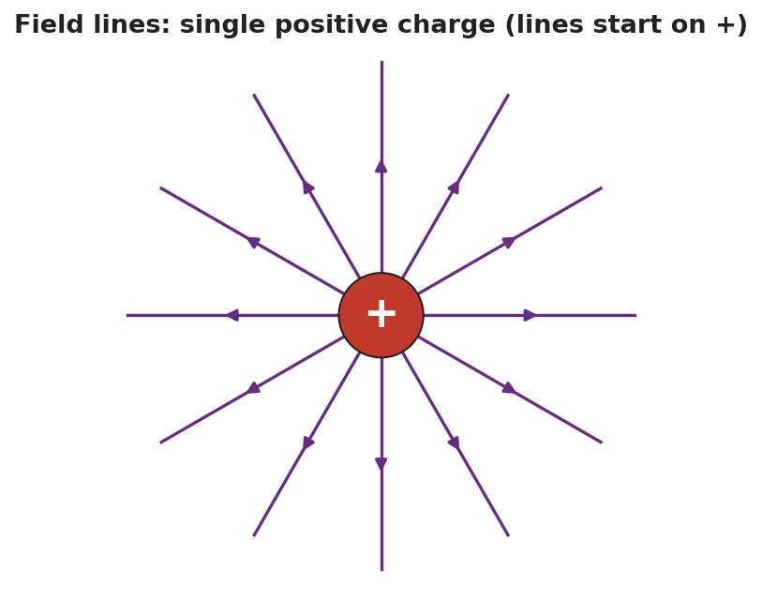
Field lines for a single positive charge: straight lines radiating outward in all directions, each with an arrow pointing away from the charge.
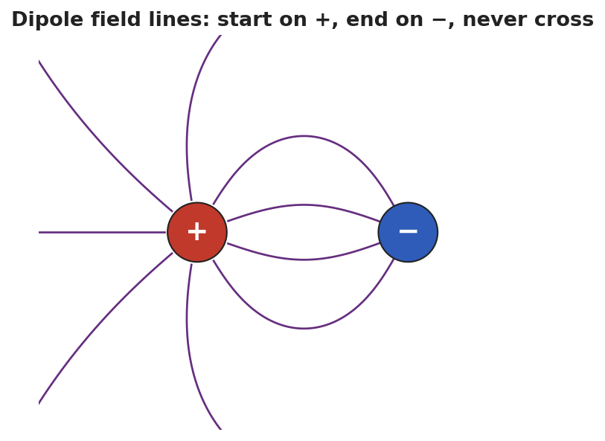
Dipole field lines: curved lines that start on the positive charge and end on the negative charge, none of them crossing.
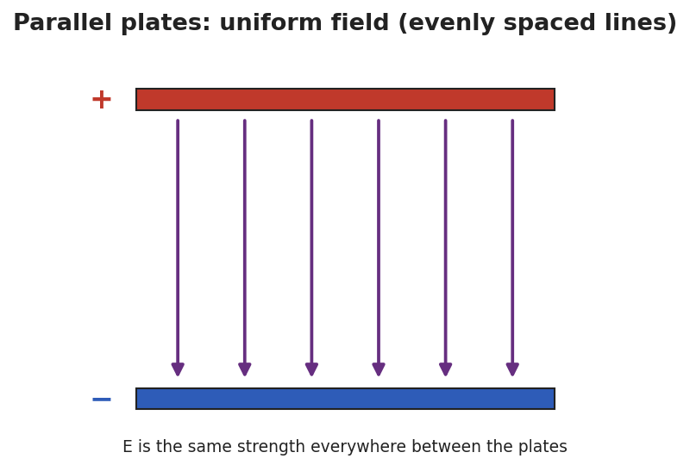
Parallel-plate field: a positive top plate and a negative bottom plate with straight, evenly spaced field lines running from + to −, representing a uniform field of constant strength.
Teacher facilitation language:
“Where do every one of your lines begin, and where do they end?” “Between the plates, are the lines bunching up anywhere, or evenly spaced? What does even spacing tell you about the field’s strength?”

Teacher facilitation during Explore
- What to look for — pairs articulating start-on-+, end-on-−, never-cross, and density-shows-strength from the sim.
- What to resist — don’t list the rules first; let the three patterns reveal them.
- What to redirect — pairs who draw crossing lines should be asked: “if two lines crossed, the field would point two ways at once — can it?”

Phase 3 · Explain (28 – 36 min)

28–31 min · Turn-and-Talk #2 + class consensus
“State the four rules for drawing electric field lines, in your own words.”
Target consensus (the four rules):
“1) Lines start on positive charges and end on negative ones. 2) They point the way a positive test charge would move. 3) They never cross. 4) Where lines are closer together, the field is stronger.”

31–33 min · Vocabulary introduction (≤ 3 terms)
Sample teacher language:
“These are field lines. A + and a − charge close together form a dipole, with lines curving from + to −. Between parallel plates the lines are straight and evenly spaced — a uniform field, the same strength everywhere.”

33–36 min · HOCHMAN sentence work
Run an appositive drill naming the dipole inside a sentence:
“A dipole, a pair of equal and opposite charges set close together, produces field lines that curve from the + to the −.”
Then a Because/But/So expansion of the density rule:
Stem: “Field lines that are close together…” - because … (a strong field is drawn with crowded lines) - but … (far from a charge the lines spread out) - so … (you can read the field’s strength straight off the spacing)

Discussion prompts to deploy here
- “Why can’t two field lines ever cross?”
  - Sample student response: “A crossing point would have the field pointing two directions at once, which is impossible.”
- “How is the field between parallel plates different from the field around a single charge?”
  - Sample student response: “The plates give a uniform field — straight, evenly spaced lines; a single charge’s field spreads out and weakens with distance.”

Phase 4 · Elaborate (36 – 40 min)

36–39 min · Revise the model
“Return to your dipole sketch. Re-draw it to obey all four rules: lines start on +, end on −, don’t cross, and crowd where the field is strong. Label where the field is strongest.”

39–40 min · Return to the phenomenon
“Why did the semolina grains line up exactly along the field lines? Answer in one sentence.”
Target: “Each grain became polarized and lined up end-to-end along the field’s direction, tracing the lines we’d draw.”

Phase 5 · Evaluate (40 – 42 min)

40–42 min · Exit Ticket + Closing Reflection
“(a) State two rules for drawing electric field lines. (b) Two diagrams show field lines: in Diagram A the lines are close together; in Diagram B they are spread far apart. Where is the field stronger, and how do you know? (c) Sketch the field lines for a single negative charge — which way do the arrows point, and where do they end?”
Expected: (a) any two of: start on +, end on −; never cross; point the way a + test charge moves; density shows strength; (b) Diagram A — closely spaced lines mean a stronger field; (c) straight lines pointing inward toward the negative charge (lines end on negative charges). See Answer_Key.docx.
Closing Reflection (SEL, 30 seconds):
“Which Hochman sentence (the appositive or a Because/But/So) best captured a rule for you today?”

Common Misconceptions
- Misconception: “Field lines can cross.” → Correction: They never cross — a crossing would mean the field points two ways at one point.
- Misconception: “Field lines are real, physical wires.” → Correction: They are a model — a way to picture the field’s direction and strength; the field itself is continuous.
- Misconception: “Evenly spaced or not, spacing doesn’t matter.” → Correction: Line density encodes strength: crowded = strong, spread out = weak; uniform spacing means a uniform field.

Access & Differentiation
- ELL/ENL supports: Sentence frame: “Field lines start on the ___ charge and end on the ___ charge; where they are ___ (close/far), the field is ___ (strong/weak).” Word-choice box: {field line, dipole, uniform field, start, end, never cross, density}. Provide pre-printed +, −, and plate templates to draw onto.
- IEP/SPED supports: Give partially drawn patterns (single charge, dipole, plates) with a few lines complete; students add the rest following the rules. Offer the Javalab sim as the primary tool over freehand drawing.
- Extensions: Have students draw the field for two like charges (both +) and explain the “no-man’s-land” point between them where the field is zero (no lines).

Strategy Spotlight
HOCHMAN (literacy). The four field-line rules are consolidated as sentences, not a bullet list: an appositive that defines a dipole inside a working sentence, and a Because/But/So expansion of the density rule. This pushes students to encode each rule in precise prose, supporting transfer to constructed-response items. Keep each strip to one clause and read several aloud; the goal is sentence fluency with the rule, not length.

NYSSLS Observation Checklist Crosswalk
# | Checklist item | Where it appears in this lesson
1 | Local/relatable phenomenon | Phase 1 — semolina-in-oil field reveal; grains lining up in Phase 4
2 | Turn and Talk (2–3×) | Phase 1 (TT#1 — two rules from the chains), Phase 3 (TT#2 — state the four rules)
3 | Students develop questions/models/procedures | Phase 1 (initial model), Phase 2 (Javalab pattern-building), Phase 4 (revise dipole)
4 | CCC defined and used | Lesson Overview · Cause and Effect (direction + density), restated in Phase 2
5 | ENL — ≤ 3 vocab, second half | Phase 3 — vocabulary at 31–33 min (field line / dipole / uniform field)
6 | Revisit phenomenon with evidence | Phase 4 — semolina explanation + dipole re-draw
7 | ENL/SPED supports | Access & Differentiation block
8 | Assessment check | Phase 5 — Exit Ticket (rules; density→strength; single-negative sketch)

Companion Materials
- Student_Worksheet.docx — the 5E student investigation (hand out at start of Phase 2)
- Student_Notes.docx — guided note-guide for the rules and the worked example
- Answer_Key.docx — answers to “Make It Make Sense” prompts and the Exit Ticket

Key Vocabulary (max 3)
- field line — a line drawn to represent an electric field: it starts on a positive charge, ends on a negative charge, never crosses another, and shows the field’s strength by how closely spaced it is
- dipole — a pair of equal and opposite charges set close together; its field lines curve from the + charge to the − charge
- uniform field — a field of constant strength and direction, shown by straight, evenly spaced field lines (as between parallel plates)

Electric Field Lines — Student Worksheet
Unit: Electrostatics — Lesson 06 Name: _______________________ Date: __________ Period: ____

Phenomenon
Your teacher switches on two electrodes in a dish of semolina grains in oil. The grains snap into curved chains running between the electrodes — an invisible field suddenly made visible.
Driving question: What rules do field lines follow, and how do they show us the direction and strength of an electric field?

Notice & Wonder
I notice… | I wonder…
Turn & Talk #1: From the semolina chains, write two rules the field lines seem to obey.
Rule 1: __________________________________________ Rule 2: __________________________________________

Initial Model
Draw a single + charge and sketch how you think the field lines leave it. Then draw a + and a − near each other and sketch the lines between them.

Investigation
Use the Javalab field-line sim to build three patterns. Record what you notice.
Setup | Where lines start / end | Spacing (even? bunched?) | Field strongest where?
1. Single + charge
2. Dipole (+ and −)
3. Parallel plates
Confirm each against these diagrams:

Field lines radiating outward from a single positive charge.

Dipole field lines curving from + to −, never crossing.

Parallel plates with straight, evenly spaced field lines — a uniform field.
Key question: Why can’t two field lines ever cross?

Make It Make Sense
- List the four rules for drawing electric field lines.
- Two diagrams show field lines: in Diagram A the lines are close together; in Diagram B they are far apart. Where is the field stronger, and how do you know?
- How is the field between parallel plates different from the field around a single charge?

Vocabulary in Action
Use each term in a sentence about today’s phenomenon.
- field line: _______________________________________________
- dipole: _______________________________________________
- uniform field: _______________________________________________

Revise Your Model
Return to your dipole sketch. Re-draw it to obey all four rules: lines start on +, end on −, never cross, and crowd where the field is strong. Label where the field is strongest.

Exit Ticket
- State two rules for drawing electric field lines.
- Two diagrams show field lines: in Diagram A the lines are close together; in Diagram B they are spread far apart. Where is the field stronger, and how do you know?
- Sketch the field lines for a single negative charge. Which way do the arrows point, and where do they end?

Electric Field Lines — Student Notes
Unit: Electrostatics — Lesson 06 Name: _______________________ Date: __________ Period: ____

Learning Targets
By the end of today’s 42 minutes I can:
- State and apply the four rules for drawing field lines.
- Draw the field for a single charge, a dipole, and parallel plates.
- Read field strength from line spacing.

Key Vocabulary
- field line — _______________________________________________
- dipole — _______________________________________________
- uniform field — _______________________________________________

Guided Notes
The four rules for field lines:
- Lines start on __________ charges and end on __________ charges.
- They point the way a __________ test charge would move.
- Field lines never __________.
- Where lines are __________ together, the field is __________ (density shows strength).
Three key patterns:
- Single charge: lines go straight __________ (for +) and weaken with distance.

Field lines radiating from a single positive charge.
- Dipole (+ and −): lines curve from the __________ to the __________, never crossing.

Dipole field lines from + to −.
- Parallel plates: straight, __________ spaced lines → a __________ field (same strength everywhere).

Parallel plates with a uniform field.

Worked Example
Problem. Two field-line diagrams are drawn to the same scale. In Diagram A the lines are spaced 2 mm apart; in Diagram B they are spaced 8 mm apart. In which diagram is the electric field stronger, and how do you know?
Solution. 1. Rule 4: line __________ shows field strength. 2. Closer lines mean a __________ field; lines farther apart mean a __________ field. 3. Diagram A has lines only __________ mm apart (closer), so Diagram A has the stronger field.

Summary
Finish the sentence (Because / But / So):
Field lines that are close together show a strong field because __________________________________________, but far from a charge the lines spread out __________________________________________, so __________________________________________.

Electric Field Lines — Answer Key

Cover
Unit: Electrostatics — Lesson 06: Electric Field Lines East Meadow Schools × Valley Stream Central HSD Strategy chip: HOCHMAN

Make-It-Make-Sense Answers
- The four rules: (1) lines start on + charges and end on − charges; (2) they point the way a positive test charge would move; (3) lines never cross; (4) closer lines mean a stronger field (density shows strength). · Rubric: all four = full credit (¾ for three). · NYSSLS: HS-PS3-5
- Diagram A (the closely spaced lines) has the stronger field, because line density represents field strength — crowded lines = strong field. · Rubric: “A” AND density-shows-strength reasoning. · NYSSLS: HS-PS3-5
- Parallel plates give a uniform field — straight, evenly spaced lines, the same strength everywhere. A single charge’s field spreads out and weakens with distance (lines diverge and the field falls off as 1/r²). · Rubric: “uniform vs. spreading/weakening.” · NYSSLS: HS-PS3-5

Exit Ticket Answer
- Any two of: lines start on + and end on −; lines never cross; lines point the way a + test charge moves; closer lines mean a stronger field.
- Diagram A (close-together lines) has the stronger field. Line density encodes field strength, so more crowded lines = stronger field.
- Straight lines pointing inward, toward the negative charge — field lines end on negative charges (and point the way a + test charge would be pulled).
Tolerance/rubric: (a) any two valid rules = 1 pt; (b) “A” + density reasoning; (c) “toward / inward” AND “lines end on −.” 1 point each. NYSSLS: HS-PS3-5.

Closing Reflection (rubric)
Closing reflection is formative, not graded. Award full credit for any honest response. Look for: - The student naming the appositive or a specific Because/But/So sentence and tying it to one of the four rules

Current Electricity — Unit Plan

Cover
Unit: Current Electricity East Meadow Schools × Valley Stream Central High School District 5 lessons · ~5 instructional periods (42 min each) Format: DOCX (Teacher Guide · Student Worksheet · Student Notes · Answer Key per lesson)

Unit Scope (from East Meadow Scope & Sequence)
This unit develops the physics of moving charge: what current and voltage are, how Ohm’s Law (V = I·R) relates them through resistance, how resistance arises in a wire, how resistors combine in series and parallel circuits, and how current and magnetism interact through electromagnetic induction. It builds on the energy ideas of HS-PS3 and the charge ideas from Electrostatics, and it closes with the field/energy connection that anchors generators and motors.
# | Lesson | Core idea
01 | Electric Current and Ohm’s Law | Current = charge ÷ time; voltage drives current; V = I·R; slope of V–I is R
02 | Resistance in a Wire | R rises with length and resistivity, falls with cross-sectional area; temperature matters
03 | Series Circuits | One path; same current everywhere; R_total = R₁ + R₂ + …; voltage drops add
04 | Parallel Circuits | Multiple paths; same voltage per branch; currents add; 1/R_total = Σ 1/R
05 | Electromagnetism (The Induction Junction) | Current makes a magnetic field; a changing field induces current; generators & motors

Pacing Calendar
Day | Lesson | Phenomenon anchor | Strategy
1 | 01 Electric Current and Ohm’s Law | Energy stick that lights when hands complete the loop | Hochman
2 | 02 Resistance in a Wire | Thin/long vs. thick/short wire changes bulb brightness | BTC
3 | 03 Series Circuits | Old holiday lights — one missing bulb kills the string | Active Learning
4 | 04 Parallel Circuits | Home outlets — unplug one lamp, others stay lit | Active Learning
5 | 05 Electromagnetism (Induction) | Coil + magnet lighting an LED; electromagnet + paperclips | Active Learning (NYS Investigation)
Double-period days (every other day) let the investigation phases of Lessons 03–05 run long with the PhET/Javalab labs and the hands-on induction station.

Strategy Rotation
- HOCHMAN (literacy): Lesson 01 — Because/But/So expansion on the V–I–R relationship (the “but” clause carries the resistance idea).
- BTC (Building Thinking Classrooms): Lesson 02 — visibly random groups at vertical non-permanent surfaces on a resistance thin-slice (length vs. area).
- ACTIVE LEARNING: Lessons 03, 04, 05 — predict-measure-reconcile at PhET stations (series/parallel) and a hands-on NYS induction investigation.
SEL (Opening Connection + Closing Reflection), ELL/SPED supports, and a Curated Resources block appear in every lesson.

NYSSLS Coverage Matrix
PE | Description | Lessons
HS-PS3-6 | Analyze data to support the claim that Ohm’s Law describes the mathematical relationship among the potential difference, current, and resistance of an electric circuit. | 01 (core), 02 (origin of R), 03 (series), 04 (parallel)
HS-PS3-5 | Develop and use a model of two objects interacting through electric or magnetic fields to illustrate the forces and the changes in energy due to the interaction. | 05 (core — induction, generators/motors)
HS-PS3-3 | Design a device that converts energy from one form to another (thread). | 05 (generator/motor energy conversion — connection)

Vocabulary Scope
Three terms maximum per lesson, introduced in the second half (NYSSLS observation item 5).
Lesson | Terms
01 | current · voltage · resistance
02 | resistance · resistivity · cross-sectional area
03 | series circuit · equivalent resistance · current
04 | parallel circuit · branch · equivalent resistance
05 | magnetic field · electromagnet · electromagnetic induction

Electric Current and Ohm’s Law — Teacher Guide

Cover
Unit: Current Electricity — Lesson 01: Electric Current and Ohm’s Law East Meadow Schools × Valley Stream Central High School District Strategy chips: HOCHMAN

Curated Resources (from East Meadow Scope & Sequence)

NYSSLS Standards
This lesson is the anchor for HS-PS3-6: “Analyze data to support the claim that Ohm’s Law describes the mathematical relationship among the potential difference, current, and resistance of an electric circuit.” Students collect (or read) V–I data, see the straight-line pattern, and name the slope as resistance. It builds on the energy ideas of HS-PS3 (energy transfer in a system) and sets up the series/parallel analysis in Lessons 03–04.

Phenomenon
- Energy-stick / human-circuit toy that lights and buzzes only when two people complete the loop by holding hands: https://www.youtube.com/results?search_query=energy+stick+human+circuit
- Why a dimmer knob changes brightness — changing resistance changes current (Khan Academy, “Ohm’s law”): https://www.khanacademy.org/science/physics/circuits-topic/circuits-resistance/a/ee-voltage-and-current

Javalab / Labs
- PhET Circuit Construction Kit: DC — build a battery + resistor loop, read the ammeter and voltmeter: https://phet.colorado.edu/en/simulations/circuit-construction-kit-dc
- Javalab — Electric current (charge flowing through a conductor): https://javalab.org/en/electric_current_en/

Assessments
- PhET CCK-DC guided data table (V vs I) — formative during Explore.
- Exit ticket below (numeric Ohm’s-law problem) is the formative check; full key in Answer_Key.docx.

Lesson Overview
Duration | 42 minutes (1 period)
NYSSLS link | HS-PS3-6 (core — V, I, R relationship)
CCC focus | Patterns — V plotted against I forms a straight line whose slope is the resistance.
Strategy chips | HOCHMAN (Because/But/So on the V–I relationship)
Materials | Energy stick (or a simple battery–bulb kit); devices/Chromebooks for PhET CCK-DC; whiteboards/markers; calculators.
Safety | Low-voltage kits only (≤ 6 V). No wall outlets. Do not short a battery directly across its terminals — always include a bulb or resistor.
Prior knowledge | Charge (positive/negative), conservation of charge, and energy as the capacity to do work.
Lesson objectives — students can:
- Define current as charge per unit time (amperes) and voltage as the push that drives charge around a circuit.
- Use Ohm’s Law, V = I·R, to solve for any one of V, I, or R given the other two.
- Interpret a V-vs-I graph: a straight line through the origin whose slope equals the resistance.

Phase 1 · Engage (0 – 10 min)

0–2 min · Opening Connection (SEL)
Quick whip-around (one sentence each, pass allowed): “Name one thing in your home that needs to be ‘plugged in’ or charged to work.” Capture two or three answers; you’ll return to the idea that all of these move electric charge.

2–7 min · Phenomenon hook — the energy stick
Teacher actions. Hold the energy stick by one metal end. Nothing happens. Grab the other end with your free hand — it lights and buzzes. Break contact — it stops. Then form a chain of students holding hands; the stick lights only when the loop is closed.
Sample teacher language:
“Watch — when the loop is open, nothing. The moment we close the loop with our hands, charge can flow all the way around and the light comes on. What’s our skin doing in this circuit?”
Anticipated student responses:
- “We’re the wire.” — capture this; skin is a (poor) conductor completing the path.
- “Electricity needs a complete circle.” — exactly; name it closed loop / complete circuit.
- “More people should make it brighter/dimmer.” — flag it; we’ll connect more people = more resistance later.

7–10 min · Notice & Wonder + Turn-and-Talk #1
Two columns on the board. Then:
“Turn to your partner: what has to be true for the charge to flow? Use the word path in your answer.”
Target insight: charge needs a complete, closed path and a push (the battery) to keep it moving.

Bridge to Phase 2
Each student writes a one-sentence initial model: “The stick lights up because ______.”

Phase 2 · Explore (10 – 30 min)

10–14 min · Initial Model (silent / individual)
Prompt on the board:
“Draw the energy-stick loop with two people holding hands. Mark where the push comes from and draw arrows showing which way the charge moves around the loop. Predict: what would make the light brighter?”

14–30 min · Investigation — PhET Circuit Construction Kit DC
Students build a single battery + resistor loop, add an ammeter (current, A) in the loop and a voltmeter (voltage, V) across the resistor.
- Same resistor, change the battery voltage. Record V and I for 9 V, 18 V, 27 V across a fixed resistor. Plot V (y) vs I (x).
- Same battery, change the resistor. Watch the current drop as resistance rises.
Teacher facilitation language:
“When you double the battery voltage, what happens to the current? Is it exactly double?” “Your V-vs-I points — are they making a line? What does the steepness of that line tell you?” “Which resistor let the most current through for the same push?”
Use the V-vs-I graph below to make the linear pattern (slope = R) visible once a group has three data points.
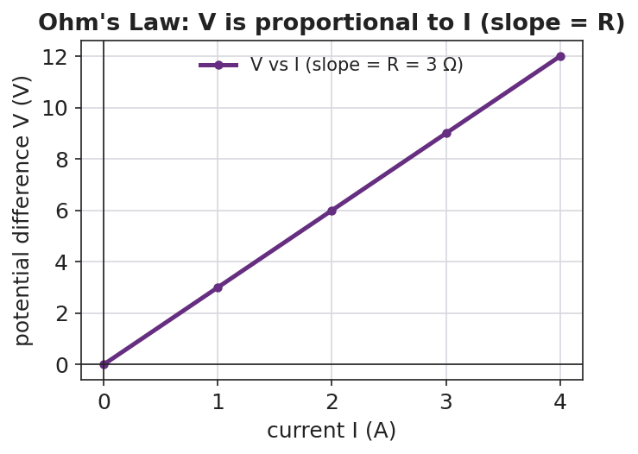
Graph of potential difference V on the vertical axis versus current I on the horizontal axis: the points fall on a straight line through the origin, and the slope of the line equals the resistance R.
The single-loop schematic students are building:
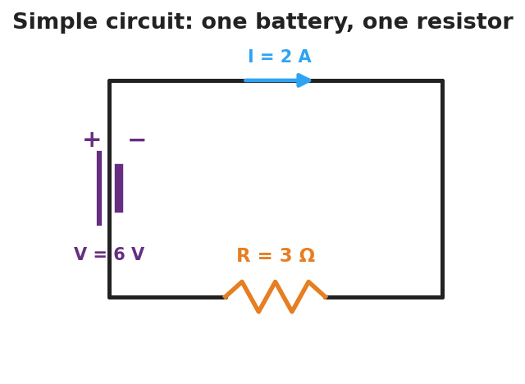
Schematic of a simple circuit: a battery labeled V equals 6 volts on the left side drives a current I equals 2 amperes clockwise through a single resistor labeled R equals 3 ohms on the bottom wire.

Teacher facilitation during Explore
- What to look for — groups noticing that V ÷ I gives the same number every time for one resistor (that number is R).
- What to resist — don’t hand them “V = IR” yet; let the straight line emerge from the data.
- What to redirect — students who say “more voltage means more resistance” should re-check: more voltage means more current; resistance is the slope, set by the resistor.

Phase 3 · Explain (30 – 36 min)

30–33 min · Turn-and-Talk #2 + class consensus
“Across your data, how did current respond when you increased the voltage but kept the same resistor?”
Target consensus:
“Current grows in proportion to voltage. For one resistor, V divided by I is always the same number — that constant is the resistance.”

33–36 min · Vocabulary introduction (≤ 3 terms)
Sample teacher language:
“The flow of charge is current — charge per second, measured in amperes. The push that drives it is the voltage (potential difference), in volts. What slows the flow is the resistance, in ohms. Put them together and you get Ohm’s Law: V = I·R — voltage equals current times resistance. On your graph, the slope is R.”
Reference relationships to post: V = I·R; power P = V·I = I²·R.

Discussion prompts to deploy here
- “A 12 V battery drives 3 A through a resistor. What is the resistance?”
  - Sample response: “R = V/I = 12/3 = 4 Ω.”
- “If you keep the resistor the same but double the voltage, what happens to the current?”
  - Sample response: “It doubles, because I = V/R and R didn’t change.”

Phase 4 · Elaborate (36 – 40 min)

36–38 min · Hochman Because/But/So
Students complete a Because/But/So sentence on the core relationship:
“Current increases when voltage increases because ____, but ____, so ____.”
Target: …because voltage is the push that drives charge, but the resistance limits how much charge gets through, so the current is set by both together (I = V/R).

38–40 min · Return to the phenomenon
“On the energy stick, why does adding more people in the hand-chain make it harder to light? Answer in one sentence using resistance and current.”
Target: “Each person adds resistance, so for the same small voltage the current drops below what the stick needs to light.”

Phase 5 · Evaluate (40 – 42 min)

40–42 min · Exit Ticket + Closing Reflection
“A resistor has 6 V across it and carries 2 A of current. (a) What is its resistance? Show V = I·R. (b) The voltage is raised to 12 V with the same resistor. What is the new current? (c) In one sentence, what does the slope of a V-vs-I graph represent?”
Expected: (a) R = V/I = 6/2 = 3 Ω; (b) I = V/R = 12/3 = 4 A; (c) the slope equals the resistance. See Answer_Key.docx.
Closing Reflection (SEL, 30 seconds):
“What is one thing about electricity you understand now that you didn’t this morning?”

Common Misconceptions
- Misconception: “Current gets used up as it goes around the loop.” → Correction: Charge is conserved; the same current flows all the way around a single loop. Energy is transferred, not the charge itself.
- Misconception: “Voltage flows through the wire.” → Correction: Current (charge) flows; voltage is the difference in electric potential between two points — the push, not the stuff that moves.
- Misconception: “More resistance means more current.” → Correction: For a fixed voltage, more resistance means less current (I = V/R).

Access & Differentiation
- ELL/ENL supports: Sentence frame: “Current is the ___ of charge; voltage is the ___ that drives it; resistance ___ the flow.” Word box: {flow, push, opposes, amperes, volts, ohms}. Pair current with a hand-sweeping gesture (flow) and resistance with a hand-blocking gesture.
- IEP/SPED supports: Provide the V-vs-I axes pre-drawn and a partly filled data table; students plot two given points and read the slope. Offer a triangle “V over I·R” cover-up card for solving Ohm’s Law.
- Extensions: Have students compute the power delivered to the resistor in the exit ticket (P = V·I) and explain why a higher-resistance wire of the same length runs hotter for the same voltage (P = V²/R reasoning).

Strategy Spotlight
HOCHMAN (sentence-level literacy). The Elaborate phase uses a Because/But/So expansion on a single physics relationship (voltage up → current up, limited by resistance). Insist on one complete sentence with all three conjunctions; the “but” clause is where the resistance idea must appear, which is exactly the conceptual hinge of Ohm’s Law. Read two or three aloud and revise one together so students hear how the “but” sharpens the claim.

NYSSLS Observation Checklist Crosswalk
# | Checklist item | Where it appears in this lesson
1 | Local/relatable phenomenon | Phase 1 — energy-stick human circuit; dimmer callback
2 | Turn and Talk (2–3×) | Phase 1 (TT#1 — what makes charge flow), Phase 3 (TT#2 — current vs. voltage)
3 | Students develop questions/models/procedures | Phase 1 (initial model), Phase 2 (PhET data + graph), Phase 4 (revise)
4 | CCC defined and used | Lesson Overview · Patterns (linear V–I), used in Phase 2 graph
5 | ENL — ≤ 3 vocab, second half | Phase 3 — current / voltage / resistance at 33–36 min
6 | Revisit phenomenon with evidence | Phase 4 — why more people dims the stick
7 | ENL/SPED supports | Access & Differentiation block
8 | Assessment check | Phase 5 — numeric Ohm’s-law exit ticket

Companion Materials
- Student_Worksheet.docx — the 5E student investigation (hand out at start of Phase 2)
- Student_Notes.docx — guided note-guide for vocabulary and the worked example
- Answer_Key.docx — answers to “Make It Make Sense” prompts and the Exit Ticket

Key Vocabulary (max 3)
- current — the rate of flow of electric charge through a conductor, equal to charge ÷ time, measured in amperes (A)
- voltage — the potential difference (electrical “push”) between two points that drives current around a circuit, measured in volts (V)
- resistance — the opposition a material offers to the flow of charge; the slope of a V-vs-I graph, measured in ohms (Ω)

Electric Current and Ohm’s Law — Student Worksheet
Unit: Current Electricity — Lesson 01 Name: _______________________ Date: __________ Period: ____

Phenomenon
Your teacher holds an “energy stick.” Nothing happens — until two people grab the metal ends and complete the loop with their hands. Then it lights up and buzzes. Break the loop, and it goes dark again.
Driving question: What has to be true for electric charge to flow, and what controls how much flows?

Notice & Wonder
I notice… | I wonder…
Turn & Talk #1: What has to be true for the charge to flow? Use the word path in your answer.

Initial Model
Draw the energy-stick loop with two people holding hands. Mark where the push comes from and draw arrows for which way the charge moves. Then predict: what would make the light brighter?

My prediction: _______________________________

Investigation
In PhET Circuit Construction Kit: DC, build one battery connected to one resistor. Add an ammeter (reads current I in amperes) in the loop and a voltmeter (reads voltage V in volts) across the resistor.

Schematic of a simple circuit: a battery on the left drives current I around a single loop through one resistor R on the bottom wire.
Part A — Same resistor, change the voltage. Set the resistor to a fixed value. Record current at three battery voltages.
Battery voltage V (V) | Current I (A) | V ÷ I (Ω)
9
18
27
Plot your three points with I on the x-axis and V on the y-axis. Draw the best-fit line.

Graph of voltage V versus current I showing a straight line through the origin whose slope equals the resistance R.
Part B — Same voltage, change the resistor. Keep the battery fixed and increase the resistance. What happens to the current?

Key question: What number do you get every time you compute V ÷ I for the same resistor? What is that number called?

Make It Make Sense
- A resistor has 12 V across it and 3 A flowing through it. Use V = I·R to find its resistance.
- A 4 Ω resistor is connected to a 24 V battery. How much current flows?
- The slope of your V-vs-I line was 3. What physical quantity does that slope represent, and what are its units?

Vocabulary in Action
Use each term in a sentence about today’s phenomenon.
- current: _______________________________________________
- voltage: _______________________________________________
- resistance: _______________________________________________

Revise Your Model
Return to your Initial Model. Add the energy-stick hand-chain. Explain, using resistance and current, why adding more people makes the stick harder to light.

Exit Ticket
A resistor has 6 V across it and carries 2 A of current.
- What is its resistance? Show V = I·R.
- The voltage is raised to 12 V with the same resistor. What is the new current?
- In one sentence, what does the slope of a V-vs-I graph represent?

Electric Current and Ohm’s Law — Student Notes
Unit: Current Electricity — Lesson 01 Name: _______________________ Date: __________ Period: ____

Learning Targets
By the end of today’s 42 minutes I can:
- Define current (charge ÷ time) and voltage (the push that drives charge).
- Use V = I·R to solve for V, I, or R.
- Read a V-vs-I graph and explain that its slope is the resistance.

Key Vocabulary
- current — _______________________________________________
- voltage — _______________________________________________
- resistance — _______________________________________________

Guided Notes
What flows, and what pushes it.
- Current (I) is the flow of electric __________ through a wire. It equals charge ÷ __________, and is measured in __________ (A).
- Voltage (V), also called potential difference, is the __________ that drives the charge around the loop. It is measured in __________ (V).
- Resistance (R) is how much a material __________ the flow. It is measured in __________ (Ω).
- Charge needs a __________ (closed) loop to flow — break the loop and the current __________.
Ohm’s Law.
V = I · R (voltage = current × resistance)
Rearranged: I = V ÷ __________ and R = V ÷ __________.
Reading the V-vs-I graph. When you plot V (up) against I (across) for one resistor, the points form a straight __________ through the origin. The __________ of that line equals the __________.

Graph of voltage versus current: a straight line through the origin whose slope equals the resistance R.
Power (extension). The electrical power delivered is P = V·I = I²·R, measured in watts (W).

Worked Example
Problem. A resistor has 9 V across it and a current of 3 A flowing through it. (a) Find its resistance. (b) If the voltage is raised to 18 V, find the new current.
Solution. 1. Write Ohm’s Law: V = I·R, so R = V ÷ I = 9 V ÷ 3 A = __________ Ω. 2. Same resistor, new voltage: I = V ÷ R = 18 V ÷ __________ Ω = __________ A. 3. Doubling the voltage __________ the current, because R stayed the same.

Summary
Finish the sentence (Because / But / So):
Current increases when the voltage increases because __________________________________________, but __________________________________________, so __________________________________________.

Electric Current and Ohm’s Law — Answer Key

Cover
Unit: Current Electricity — Lesson 01: Electric Current and Ohm’s Law East Meadow Schools × Valley Stream Central HSD Strategy chip: HOCHMAN

Make-It-Make-Sense Answers
- R = V ÷ I = 12 V ÷ 3 A = 4 Ω. · Rubric: correct rearrangement of V = I·R AND correct value with unit. · NYSSLS: HS-PS3-6
- I = V ÷ R = 24 V ÷ 4 Ω = 6 A. · Rubric: solves I = V/R; unit amperes. · NYSSLS: HS-PS3-6
- The slope represents the resistance, in ohms (Ω) — a slope of 3 means R = 3 Ω. · Rubric: names resistance AND gives ohms. · NYSSLS: HS-PS3-6

Exit Ticket Answer
- R = V ÷ I = 6 V ÷ 2 A = 3 Ω. (Must show V = I·R rearranged.)
- Same resistor (3 Ω), new voltage 12 V: I = V ÷ R = 12 ÷ 3 = 4 A.
- The slope of a V-vs-I graph represents the resistance of the circuit element.
Tolerance/rubric: (a) 3 Ω with work; (b) 4 A; (c) “slope = resistance.” 1 point each. Accept correct units stated as Ω and A. NYSSLS: HS-PS3-6.

Closing Reflection (rubric)
Formative, not graded. Award full credit for any honest one-sentence response that names a specific idea now understood (e.g., “current is the flow, voltage is the push,” “the slope is resistance,” “the loop must be closed”).

Resistance in a Wire — Teacher Guide

Cover
Unit: Current Electricity — Lesson 02: Resistance in a Wire East Meadow Schools × Valley Stream Central High School District Strategy chips: BTC

Curated Resources (from East Meadow Scope & Sequence)

NYSSLS Standards
This lesson supports HS-PS3-6: “Analyze data to support the claim that Ohm’s Law describes the mathematical relationship among the potential difference, current, and resistance of an electric circuit.” Here students analyze how the resistance term in Ohm’s Law is itself determined — by the wire’s length, cross-sectional area, material (resistivity), and temperature. It deepens Lesson 01’s V = I·R by explaining where R comes from.

Phenomenon
- A circuit built with a thin/long wire glows dim; the same circuit with a thick/short wire glows bright (extension-cord and filament demos): https://www.youtube.com/results?search_query=wire+thickness+resistance+demonstration
- Why long, thin extension cords drop voltage and run warm (Khan Academy, “Resistivity and conductivity”): https://www.khanacademy.org/science/physics/circuits-topic/circuits-resistance/a/resistivity-and-conductivity

Javalab / Labs
- PhET — Resistance in a Wire: drag sliders for resistivity ρ, length L, and area A, and watch R change: https://phet.colorado.edu/en/simulations/resistance-in-a-wire
- PhET Circuit Construction Kit: DC — substitute wires of different length to see current change: https://phet.colorado.edu/en/simulations/circuit-construction-kit-dc

Assessments
- PhET Resistance-in-a-Wire data table (R vs L, R vs A) — formative during Explore.
- Exit ticket below; full key in Answer_Key.docx.

Lesson Overview
Duration | 42 minutes (1 period)
NYSSLS link | HS-PS3-6 (supports — origin of the R term)
CCC focus | Patterns / Scale — R rises in proportion to length and falls in proportion to cross-sectional area.
Strategy chips | BTC (Building Thinking Classrooms — random groups, vertical surfaces)
Materials | Devices for PhET Resistance in a Wire; whiteboards / vertical non-permanent surfaces; markers; (optional) nichrome vs. copper wire samples, thick vs. thin.
Safety | If running a real filament demo, use a low-voltage supply; wire can get hot — do not touch a powered nichrome coil.
Prior knowledge | Lesson 01 — current, voltage, resistance, and Ohm’s Law V = I·R.
Lesson objectives — students can:
- Predict how the resistance of a wire changes when its length or cross-sectional area changes.
- Explain the role of the material’s resistivity and of temperature in setting a wire’s resistance.
- Analyze R-vs-L and R-vs-A data to state the proportional relationships (R ∝ L, R ∝ 1/A).

Phase 1 · Engage (0 – 10 min)

0–2 min · Opening Connection (SEL)
One-sentence whip-around: “Describe a time you used a really long extension cord — did anything seem off about the device on the end?” Surface “it was dimmer / charged slower”; you’ll explain why by the end.

2–7 min · Phenomenon hook — thin vs. thick, long vs. short
Teacher actions. Show (live or on video) the same battery + bulb circuit wired first with a long, thin wire, then a short, thick wire. The bulb is noticeably brighter with the short, thick wire.
Sample teacher language:
“Same battery, same bulb — the only thing I changed was the wire connecting them. Why would the wire itself change how bright the bulb is?”
Anticipated student responses:
- “The thin wire blocks the electricity.” — capture “blocks”; we’ll sharpen to more resistance.
- “Longer means it has farther to travel.” — useful intuition; longer wire = more resistance.
- “Different metal?” — flag it; material (resistivity) matters too.

7–10 min · Notice & Wonder + Turn-and-Talk #1
“Turn to your partner: list every property of the wire that you think could change the brightness. Use the word resistance.”
Target list: length, thickness (area), material, maybe temperature.

Bridge to Phase 2
Each student writes a one-sentence initial model: “A thin, long wire dims the bulb because ______.”

Phase 2 · Explore (10 – 30 min)

10–14 min · Initial Model (BTC — random groups to vertical surfaces)
Form visibly random groups of three and send them to vertical non-permanent surfaces. Prompt:
“At your board, predict: if you make a wire twice as long, what happens to R? If you make it twice as thick (double the area), what happens to R? Write a prediction before you touch the sim.”

14–30 min · Investigation — PhET Resistance in a Wire
Groups drag the sliders one variable at a time and record R.
- Vary length L (hold ρ and A fixed). Record R at L = 1, 2, 3, 4, 5.
- Vary area A (hold ρ and L fixed). Record R as A doubles, triples, quadruples.
- Change material/resistivity ρ qualitatively — does a higher ρ raise or lower R?
Teacher facilitation language (circulating at the boards):
“When you doubled the length, exactly how did R change? Is that a straight-line pattern?” “When you doubled the area, did R double — or do something else?” “Convince your group: is area in the top or the bottom of the resistance relationship?”
Use the R-vs-length graph and the R-vs-area bar chart to consolidate the two patterns:
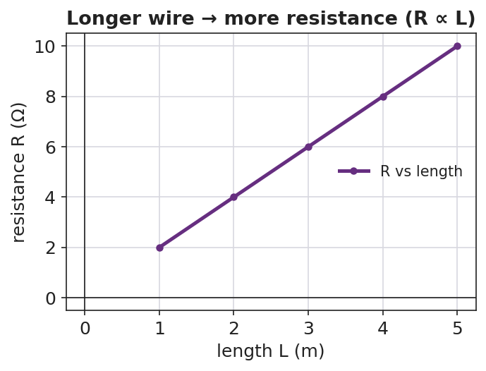
Line graph of resistance R versus wire length L: the points rise on a straight line, showing resistance is proportional to length.
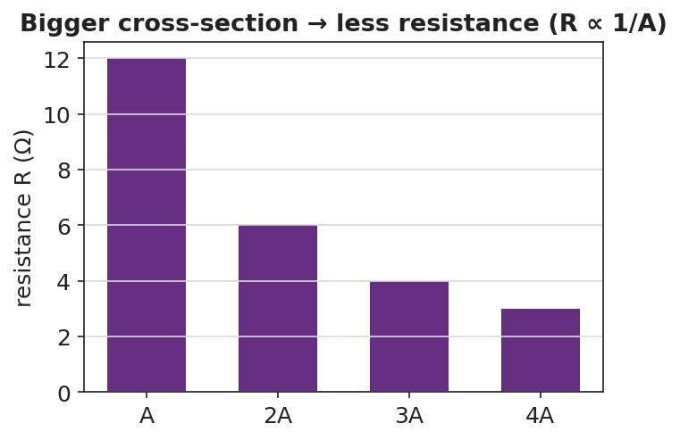
Bar chart of resistance versus cross-sectional area for areas A, 2A, 3A, and 4A: the bars fall as area increases, showing resistance is inversely proportional to area.
The wire model students are reasoning about — length L, cross-sectional area A, material resistivity ρ:
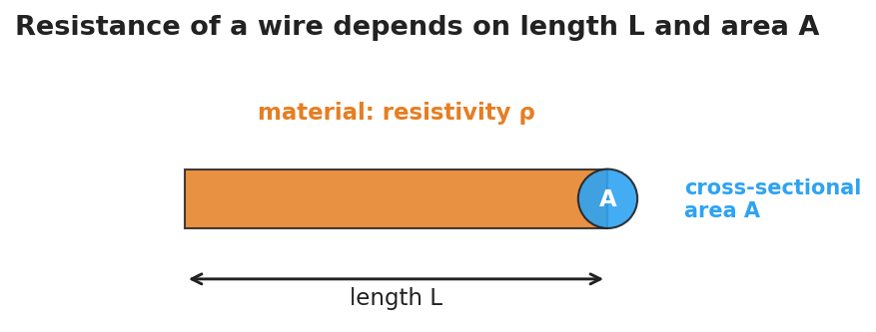
Diagram of a wire showing its length L along the long dimension, a circular end cap labeled cross-sectional area A, and a label for the material’s resistivity rho.

Teacher facilitation during Explore
- What to look for — groups stating “R doubles when L doubles” (direct) and “R halves when A doubles” (inverse).
- What to resist — handing them ρ·L/A; let the sim’s sliders reveal direct vs. inverse first.
- What to redirect — groups who change two sliders at once: insist on one variable at a time (control of variables).

Phase 3 · Explain (30 – 36 min)

30–33 min · Group consensus + Turn-and-Talk #2
“At your board, write one sentence each for length and for area: ’When ___ increases, R ___ because ___.’”
Target consensus:
“Resistance goes up with length and down with cross-sectional area. A wider wire gives charge more room to flow; a longer wire makes it fight resistance over a greater distance.”

33–36 min · Vocabulary introduction (≤ 3 terms)
Sample teacher language:
“We already met resistance. The property of the material itself is its resistivity — symbol ρ. Copper has low ρ (good conductor); nichrome has high ρ. And the wire’s thickness is its cross-sectional area, A. Put it together: R grows with length and resistivity, and shrinks with area. (Heating the wire also raises R for most metals.)”
Reference relationship to post: resistance ties back to Ohm’s Law V = I·R — change R, and the current changes.

Discussion prompts to deploy here
- “You have two copper wires, same thickness, but one is twice as long. Which has more resistance, and by how much?”
  - Sample response: “The long one — twice the resistance, because R is proportional to length.”
- “Why are thick wires used for high-current appliances?”
  - Sample response: “More cross-sectional area means less resistance, so less heat and voltage loss.”

Phase 4 · Elaborate (36 – 40 min)

36–38 min · Apply to the extension cord
“Explain why a long, thin extension cord makes a power tool run weaker than a short, thick one. Use length, area, and resistance in your answer.”
Target: the long, thin cord has high resistance, so more voltage is lost in the cord and less reaches the tool.

38–40 min · Return to the phenomenon
“Back to our two wires and the bulb: in one sentence, why did the short, thick wire make the bulb brighter?”
Target: “The short, thick wire has lower resistance, so more current reaches the bulb (I = V/R).”

Phase 5 · Evaluate (40 – 42 min)

40–42 min · Exit Ticket + Closing Reflection
“Two wires are made of the same material. (a) Wire B is twice as long as Wire A (same thickness). How does B’s resistance compare to A’s? (b) Wire C is twice as thick as Wire A (same length, so double the cross-sectional area). How does C’s resistance compare to A’s? (c) Name one property of the material itself that affects resistance.”
Expected: (a) twice the resistance; (b) half the resistance; (c) resistivity (ρ) — also accept temperature. See Answer_Key.docx.
Closing Reflection (SEL, 30 seconds):
“Whose explanation at the boards today helped you see the area pattern? Name them.”

Common Misconceptions
- Misconception: “A thicker wire has more resistance because there’s more metal.” → Correction: More cross-sectional area gives charge more parallel room to flow, so resistance decreases (R ∝ 1/A).
- Misconception: “Resistance only depends on the material.” → Correction: It depends on material (ρ) and geometry (length and area) and temperature.
- Misconception: “Longer wires carry more current because they’re bigger.” → Correction: Longer wires have more resistance, so for the same voltage they carry less current.

Access & Differentiation
- ELL/ENL supports: Sentence frames at the board: *“When length increases, resistance ___.”* / *“When area increases, resistance ___.”* Word box: {increases, decreases, longer, wider, resistivity, material}. Pair resistivity with sample wires labeled “easy flow” (copper) and “hard flow” (nichrome).
- IEP/SPED supports: Pre-filled data tables for the sim; students circle “up” or “down” rather than recording raw numbers. Provide the R-vs-L and R-vs-A figures with the patterns pre-drawn for annotation.
- Extensions: Introduce the full relationship R = ρ·L / A and have students compute R for a copper wire (ρ ≈ 1.7 × 10⁻⁸ Ω·m) of a given length and area; predict the effect of heating the wire.

Strategy Spotlight
BTC (Building Thinking Classrooms). Use visibly random groups of three and vertical non-permanent surfaces (whiteboards or windows). Give the thin-slice task verbally, not on a handout, and keep students standing. Circulate with the facilitation questions above rather than answers; when one group lands the “R halves when A doubles” insight, route other groups to go read that board. The vertical surfaces make every group’s thinking public, which is the point.

NYSSLS Observation Checklist Crosswalk
# | Checklist item | Where it appears in this lesson
1 | Local/relatable phenomenon | Phase 1 — thin/thick wire bulb; extension cord
2 | Turn and Talk (2–3×) | Phase 1 (TT#1 — wire properties), Phase 3 (TT#2 — length/area sentences)
3 | Students develop questions/models/procedures | Phase 1 (initial model), Phase 2 (sim, control of variables), Phase 4 (revise)
4 | CCC defined and used | Lesson Overview · Patterns/Scale, used in Phase 2 graphs
5 | ENL — ≤ 3 vocab, second half | Phase 3 — resistance / resistivity / cross-sectional area at 33–36 min
6 | Revisit phenomenon with evidence | Phase 4 — why the short, thick wire is brighter
7 | ENL/SPED supports | Access & Differentiation block
8 | Assessment check | Phase 5 — R-vs-length/area exit ticket

Companion Materials
- Student_Worksheet.docx — the 5E student investigation (hand out at start of Phase 2)
- Student_Notes.docx — guided note-guide for vocabulary and the worked example
- Answer_Key.docx — answers to “Make It Make Sense” prompts and the Exit Ticket

Key Vocabulary (max 3)
- resistance — the opposition a wire offers to the flow of charge, set by its length, area, material, and temperature, measured in ohms (Ω)
- resistivity — a property of the material itself (symbol ρ) describing how strongly it opposes current; copper is low, nichrome is high
- cross-sectional area — the area of the wire’s circular end face (A); a larger area gives charge more room to flow, lowering resistance

Resistance in a Wire — Student Worksheet
Unit: Current Electricity — Lesson 02 Name: _______________________ Date: __________ Period: ____

Phenomenon
The same battery and the same bulb are connected first with a long, thin wire — the bulb glows dim. Then they’re connected with a short, thick wire — the bulb glows bright. The only thing that changed was the wire.
Driving question: What properties of a wire decide how much it resists the flow of charge?

Notice & Wonder
I notice… | I wonder…
Turn & Talk #1: List every property of the wire that could change the brightness. Use the word resistance.

Initial Model
At your group’s board, predict before you touch the simulation:
- If you make a wire twice as long (same thickness), what happens to its resistance R?
- If you make a wire twice as thick (double the cross-sectional area, same length), what happens to R?
Length prediction: __________________________ Area prediction: ____________________________

Investigation
Open PhET Resistance in a Wire. Change one slider at a time.

Diagram of a wire labeled with its length L, its circular end cap as cross-sectional area A, and the material’s resistivity rho.
Part A — Vary length L (keep ρ and A fixed):
Length L (m) | Resistance R (Ω)
1
2
3
4
5

Line graph of resistance versus length showing a rising straight line: resistance is proportional to length.
Part B — Vary area A (keep ρ and L fixed). As area gets bigger, what happens to R?


Bar chart of resistance versus cross-sectional area showing the bars get shorter as area increases.
Part C — Material. Increase the resistivity ρ slider. Does R go up or down?

Key question: Complete each pattern. R is proportional to __________ and inversely proportional to __________.

Make It Make Sense
- A wire is made twice as long with the same thickness. By what factor does its resistance change?
- A wire is made twice as thick (double the area) with the same length. By what factor does its resistance change?
- Copper has a low resistivity and nichrome has a high resistivity. Which makes a better connecting wire, and why?

Vocabulary in Action
Use each term in a sentence about today’s phenomenon.
- resistance: _______________________________________________
- resistivity: _______________________________________________
- cross-sectional area: _______________________________________________

Revise Your Model
Return to your Initial Model. Rewrite your explanation for why the long, thin wire dimmed the bulb, using length, cross-sectional area, and resistance.

Exit Ticket
Two wires are made of the same material.
- Wire B is twice as long as Wire A (same thickness). How does B’s resistance compare to A’s?
- Wire C is twice as thick as Wire A (same length, double the cross-sectional area). How does C’s resistance compare to A’s?
- Name one property of the material itself that affects resistance.

Resistance in a Wire — Student Notes
Unit: Current Electricity — Lesson 02 Name: _______________________ Date: __________ Period: ____

Learning Targets
By the end of today’s 42 minutes I can:
- Predict how a wire’s resistance changes with its length and its cross-sectional area.
- Explain how the material’s resistivity and temperature affect resistance.
- Analyze R-vs-L and R-vs-A data to state the proportional relationships.

Key Vocabulary
- resistance — _______________________________________________
- resistivity — _______________________________________________
- cross-sectional area — _______________________________________________

Guided Notes
What sets a wire’s resistance? Four things:
- Length L — a longer wire has __________ resistance. R is __________ to length (R ∝ L).
- Cross-sectional area A — a thicker wire has __________ resistance. R is __________ to area (R ∝ 1/A).
- Material (resistivity ρ) — a higher-ρ material like nichrome has __________ resistance than a low-ρ material like __________.
- Temperature — for most metals, heating the wire __________ its resistance.
The two key patterns:

Line graph of resistance versus length: a rising straight line showing R is proportional to length.
When length doubles, resistance __________.

Bar chart of resistance versus cross-sectional area: bars shrink as area grows, showing R is inversely proportional to area.
When area doubles, resistance __________.
Connection to Ohm’s Law. Resistance is the R in V = I·R. If a wire’s resistance is high, then for the same voltage the current is __________.

Worked Example
Problem. Wire A and Wire B are the same copper, same thickness, but Wire B is three times as long as Wire A. Wire A has resistance 2 Ω. (a) Find Wire B’s resistance. (b) If both are connected to the same 12 V battery, which carries more current?
Solution. 1. Resistance is proportional to length, so tripling the length __________ the resistance: R_B = 3 × 2 Ω = __________ Ω. 2. Using I = V ÷ R: Wire A carries 12 ÷ 2 = __________ A; Wire B carries 12 ÷ 6 = __________ A. 3. Wire A carries more current because it has the __________ resistance.

Summary
Finish the sentence (Because / But / So):
A long, thin wire dims the bulb because __________________________________________, but __________________________________________, so __________________________________________.

Resistance in a Wire — Answer Key

Cover
Unit: Current Electricity — Lesson 02: Resistance in a Wire East Meadow Schools × Valley Stream Central HSD Strategy chip: BTC

Make-It-Make-Sense Answers
- Resistance is proportional to length, so doubling the length doubles the resistance (× 2). · Rubric: states direct proportion AND factor of 2. · NYSSLS: HS-PS3-6
- Resistance is inversely proportional to area, so doubling the area halves the resistance (× ½). · Rubric: states inverse proportion AND factor of ½. · NYSSLS: HS-PS3-6
- Copper makes the better connecting wire because it has lower resistivity, so it resists current less and wastes less energy as heat. · Rubric: names copper AND links to lower resistivity. · NYSSLS: HS-PS3-6

Exit Ticket Answer
- Wire B has twice (2×) the resistance of Wire A, because resistance is proportional to length.
- Wire C has half (½) the resistance of Wire A, because resistance is inversely proportional to cross-sectional area.
- The resistivity (ρ) of the material. (Also accept temperature as a property affecting resistance.)
Tolerance/rubric: (a) 2× / “doubles”; (b) ½ / “halves”; (c) resistivity (or temperature). 1 point each. NYSSLS: HS-PS3-6.

Closing Reflection (rubric)
Formative, not graded. Award full credit for naming a specific peer and/or the idea their board helped reveal (the inverse-area pattern is the common “aha”).

Series Circuits — Teacher Guide

Cover
Unit: Current Electricity — Lesson 03: Series Circuits East Meadow Schools × Valley Stream Central High School District Strategy chips: ACTIVE LEARNING

Curated Resources (from East Meadow Scope & Sequence)

NYSSLS Standards
This lesson supports HS-PS3-6: “Analyze data to support the claim that Ohm’s Law describes the mathematical relationship among the potential difference, current, and resistance of an electric circuit.” Students apply V = I·R to a single-path circuit, discover that resistances add (R_total = R₁ + R₂ + …) and that the same current flows everywhere while voltage drops add up to the source. It extends Lessons 01–02 to multi-resistor circuits.

Phenomenon
- Old-style holiday light string where removing or burning out one bulb kills the whole string: https://www.youtube.com/results?search_query=why+do+old+christmas+lights+all+go+out
- Series-circuit walkthrough (Khan Academy, “Series resistors”): https://www.khanacademy.org/science/physics/circuits-topic/circuits-resistance/a/ee-series-resistors

Javalab / Labs
- PhET Circuit Construction Kit: DC — build a one-loop series circuit with three resistors; measure current at several points and voltage across each resistor: https://phet.colorado.edu/en/simulations/circuit-construction-kit-dc

Assessments
- PhET CCK-DC series data table (I at three points; V across each resistor) — formative during Explore.
- Exit ticket below; full key in Answer_Key.docx.

Lesson Overview
Duration | 42 minutes (1 period)
NYSSLS link | HS-PS3-6 (core — Ohm’s Law in a series path)
CCC focus | Systems and System Models — a series circuit is one path; what happens at one element constrains the whole system.
Strategy chips | ACTIVE LEARNING (build-measure-predict at PhET stations)
Materials | Devices for PhET CCK-DC; whiteboards; calculators; (optional) an old holiday light string and a fresh one for the hook.
Safety | Low-voltage / simulated circuits only. If using a real light string, keep it unplugged during inspection.
Prior knowledge | Lessons 01–02 — Ohm’s Law V = I·R; resistance and its origins.
Lesson objectives — students can:
- Identify a series circuit as a single path and explain why the same current flows everywhere in it.
- Compute the equivalent resistance of resistors in series (R_total = R₁ + R₂ + …) and use it to find the current.
- Explain why the voltage drops across series resistors add up to the source voltage.

Phase 1 · Engage (0 – 10 min)

0–2 min · Opening Connection (SEL)
One-sentence whip-around: “Describe a time when one small thing breaking shut down something much bigger (a group project, a relay race, a recipe).” Hold the metaphor; a series circuit fails exactly this way.

2–7 min · Phenomenon hook — the holiday lights
Teacher actions. Show the old light string. Remove (or “burn out”) one bulb — the whole string goes dark. Contrast with a modern string where the rest stay lit.
Sample teacher language:
“I pulled out one bulb and the entire string died. There are fifty bulbs — why would one missing bulb take down all of them?”
Anticipated student responses:
- “It broke the circle.” — yes; one path, one break stops everything.
- “They’re all connected in a line.” — capture “line”; that’s series.
- “The electricity can’t get around the gap.” — exactly; no alternate path.

7–10 min · Notice & Wonder + Turn-and-Talk #1
“Turn to your partner: in a single-loop circuit, if you removed one resistor, what happens to the current everywhere else? Use the word path.”
Target: with only one path, breaking it stops the current everywhere.

Bridge to Phase 2
Each student writes a one-sentence initial model: “One missing bulb kills the whole string because ______.”

Phase 2 · Explore (10 – 30 min)

10–14 min · Initial Model (silent / individual)
Prompt on the board:
“Sketch three bulbs wired in a single loop with a battery. Draw one arrow showing the current. Predict: is the current the same at every bulb, or does it shrink as it passes each one?”
This surfaces the “current gets used up” misconception before measurement.

14–30 min · Investigation — PhET CCK-DC series circuit
Students build a battery (20 V) with three resistors (2 Ω, 3 Ω, 5 Ω) in one loop.
- Measure current at three points (before R₁, between R₂ and R₃, after R₃). Is it the same?
- Measure voltage across each resistor; add the three drops.
- Remove one resistor (open the loop) — what happens to the current?
Teacher facilitation language:
“Is the ammeter reading the same at all three spots? What does that tell you about current in a series loop?” “Add up the three voltage drops — how does the total compare to the battery’s 20 V?” “You found R_total. How does it compare to R₁ + R₂ + R₃?”
Use the schematic and the voltage-drop bar chart to consolidate:
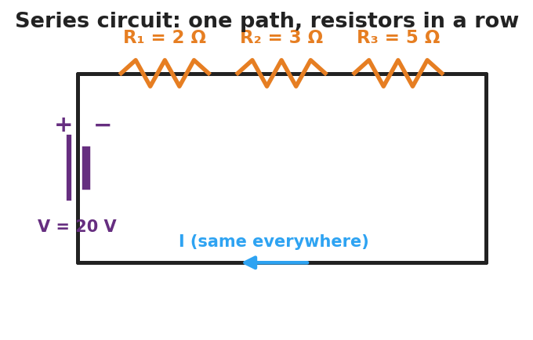
Schematic of a series circuit: a 20-volt battery on the left side drives a single current through three resistors in a row along the top wire labeled R-one 2 ohms, R-two 3 ohms, and R-three 5 ohms; the current is the same everywhere.
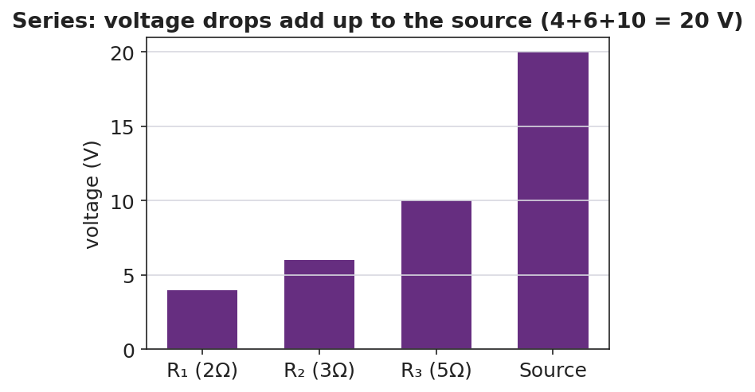
Bar chart of voltage drops in a series circuit: 4 volts across R-one, 6 volts across R-two, 10 volts across R-three, summing to the 20-volt source.

Teacher facilitation during Explore
- What to look for — groups stating “the ammeter reads the same everywhere” and “the three drops add to the battery voltage.”
- What to resist — handing them R_total = ΣR; let them sum the resistors and check against I = V/R_total.
- What to redirect — students who think current is consumed: have them re-read all three ammeters aloud (identical).

Phase 3 · Explain (30 – 36 min)

30–33 min · Turn-and-Talk #2 + class consensus
“Across your measurements, what three rules describe a series circuit?”
Target consensus:
“(1) The current is the same everywhere. (2) The total resistance is the sum of the resistors. (3) The voltage drops add up to the source voltage.”

33–36 min · Vocabulary introduction (≤ 3 terms)
Sample teacher language:
“A circuit with a single path is a series circuit. Because there’s one path, the current is the same at every point. The single resistor that could replace all of them is the equivalent resistance: R_total = R₁ + R₂ + R₃. Then the loop current is just I = V ÷ R_total.”
Reference relationships to post: V = I·R; series R_total = R₁ + R₂ + …; power P = V·I = I²·R.

Discussion prompts to deploy here
- “Three 2 Ω resistors are in series with a 12 V battery. What’s R_total and the current?”
  - Sample response: “R_total = 6 Ω; I = 12/6 = 2 A everywhere.”
- “Why do the voltage drops have to add up to the source?”
  - Sample response: “All the energy the battery gives each charge is spent crossing the resistors, so the drops total the battery voltage.”

Phase 4 · Elaborate (36 – 40 min)

36–38 min · Apply — add a resistor
“You add a fourth resistor in series. Predict what happens to R_total and to the current. Explain in one sentence.”
Target: R_total increases, so the current decreases (same battery, more total resistance).

38–40 min · Return to the phenomenon
“Explain, in one sentence using series and path, why one missing bulb kills the whole old light string.”
Target: “The bulbs are in series — one path — so a missing bulb breaks the only path and stops the current everywhere.”

Phase 5 · Evaluate (40 – 42 min)

40–42 min · Exit Ticket + Closing Reflection
“A 24 V battery is connected in series to a 4 Ω and an 8 Ω resistor. (a) Find the equivalent (total) resistance. (b) Find the current in the circuit. (c) Find the voltage drop across the 8 Ω resistor and check that the two drops add to 24 V.”
Expected: (a) R_total = 12 Ω; (b) I = 24/12 = 2 A; (c) V₈ = I·R = 2 × 8 = 16 V; V₄ = 8 V; 16 + 8 = 24 V. See Answer_Key.docx.
Closing Reflection (SEL, 30 seconds):
“What’s one prediction you made today that the measurements proved wrong — and what changed your mind?”

Common Misconceptions
- Misconception: “Current is used up as it passes each resistor.” → Correction: Current is the same at every point in a series loop; it is the voltage (energy per charge) that drops across each resistor.
- Misconception: “Adding resistors in series increases the current.” → Correction: Adding series resistors raises R_total, so the current decreases for the same battery.
- Misconception: “Each resistor gets the full battery voltage.” → Correction: The battery voltage is shared — the drops across the resistors add up to the source.

Access & Differentiation
- ELL/ENL supports: Sentence frames: “In a series circuit, the current is ___ everywhere.” / “The total resistance is the ___ of the resistors.” Word box: {same, sum, single path, voltage drops, add}. Color-code the single current path on the schematic.
- IEP/SPED supports: Provide a pre-built PhET file and a fill-in table (I at each point, V across each resistor). Give a partly worked R_total = R₁ + R₂ + R₃ template.
- Extensions: Have students show algebraically that the voltage drops must add to the source (V = I·R₁ + I·R₂ + I·R₃ = I·R_total) and compute the power dissipated in each resistor (P = I²·R), noting which runs hottest.

Strategy Spotlight
ACTIVE LEARNING. Students build, measure, and predict at PhET stations rather than receive the three series rules. Structure each station with a predict → measure → reconcile loop: predict the ammeter reading, take it, then explain any mismatch. The removal-of-a-resistor test is the active hinge — it forces the “one path” idea into the open. Close by having groups post their three-rule consensus and compare.

NYSSLS Observation Checklist Crosswalk
# | Checklist item | Where it appears in this lesson
1 | Local/relatable phenomenon | Phase 1 — old holiday light string
2 | Turn and Talk (2–3×) | Phase 1 (TT#1 — removing a resistor), Phase 3 (TT#2 — three series rules)
3 | Students develop questions/models/procedures | Phase 1 (initial model), Phase 2 (build/measure/predict), Phase 4 (revise)
4 | CCC defined and used | Lesson Overview · Systems and System Models, used in Phase 2
5 | ENL — ≤ 3 vocab, second half | Phase 3 — series circuit / equivalent resistance / current at 33–36 min
6 | Revisit phenomenon with evidence | Phase 4 — why one missing bulb kills the string
7 | ENL/SPED supports | Access & Differentiation block
8 | Assessment check | Phase 5 — series Ohm’s-law exit ticket

Companion Materials
- Student_Worksheet.docx — the 5E student investigation (hand out at start of Phase 2)
- Student_Notes.docx — guided note-guide for vocabulary and the worked example
- Answer_Key.docx — answers to “Make It Make Sense” prompts and the Exit Ticket

Key Vocabulary (max 3)
- series circuit — a circuit with a single path for charge, so the current is the same at every point
- equivalent resistance — the single resistance that could replace a group of resistors; in series, R_total = R₁ + R₂ + …
- current — the rate of flow of charge (amperes); in a series circuit it is identical everywhere in the loop

Series Circuits — Student Worksheet
Unit: Current Electricity — Lesson 03 Name: _______________________ Date: __________ Period: ____

Phenomenon
An old string of holiday lights has fifty bulbs. You remove just one bulb — and the entire string goes dark. On a newer string, removing one bulb leaves the rest glowing.
Driving question: Why can a single missing bulb shut down an entire string of lights?

Notice & Wonder
I notice… | I wonder…
Turn & Talk #1: In a single-loop circuit, if you removed one resistor, what happens to the current everywhere else? Use the word path.

Initial Model
Sketch three bulbs wired in a single loop with a battery. Draw one arrow for the current. Predict: is the current the same at every bulb, or does it shrink as it passes each one?

My prediction: _______________________________

Investigation
Open PhET Circuit Construction Kit: DC. Build a 20 V battery with three resistors in one loop: R₁ = 2 Ω, R₂ = 3 Ω, R₃ = 5 Ω.

Schematic of a series circuit: a 20-volt battery drives one current through three resistors in a row, R-one 2 ohms, R-two 3 ohms, R-three 5 ohms; the current is the same everywhere.
Part A — Current. Measure the current at three points.
Point | Current I (A)
Before R₁
Between R₂ and R₃
After R₃
What do you notice about the three readings?

Part B — Voltage drops. Measure the voltage across each resistor and add them.
Resistor | Voltage drop (V)
R₁ (2 Ω)
R₂ (3 Ω)
R₃ (5 Ω)
Sum

Bar chart of series voltage drops: 4 V, 6 V, and 10 V across the three resistors, summing to the 20 V source.
Part C — Break it. Remove one resistor (open the loop). What happens to the current everywhere?

Key question: How does R₁ + R₂ + R₃ compare to the total resistance you’d compute from I = V ÷ R_total?

Make It Make Sense
- Three resistors (1 Ω, 2 Ω, 3 Ω) are in series with a 12 V battery. Find the equivalent resistance and the current.
- In a series circuit the current is 2 A everywhere. The resistors are 3 Ω and 5 Ω. Find the voltage drop across each.
- You add a fourth resistor in series. Does the current go up or down? Why?

Vocabulary in Action
Use each term in a sentence about today’s phenomenon.
- series circuit: _______________________________________________
- equivalent resistance: _______________________________________________
- current: _______________________________________________

Revise Your Model
Return to your Initial Model. Was the current actually the same at every bulb? Rewrite your explanation for why one missing bulb kills the whole old string, using series and path.

Exit Ticket
A 24 V battery is connected in series to a 4 Ω resistor and an 8 Ω resistor.
- Find the equivalent (total) resistance.
- Find the current in the circuit.
- Find the voltage drop across the 8 Ω resistor, and check that the two drops add to 24 V.

Series Circuits — Student Notes
Unit: Current Electricity — Lesson 03 Name: _______________________ Date: __________ Period: ____

Learning Targets
By the end of today’s 42 minutes I can:
- Identify a series circuit and explain why the current is the same everywhere in it.
- Compute the equivalent resistance in series (R_total = R₁ + R₂ + …) and find the current.
- Explain why the voltage drops add up to the source voltage.

Key Vocabulary
- series circuit — _______________________________________________
- equivalent resistance — _______________________________________________
- current — _______________________________________________

Guided Notes
A series circuit has a single __________ for charge. Because there is only one path:
- The current is the __________ at every point in the loop.
- The total (equivalent) resistance is the __________ of the resistors: > R_total = R₁ + R₂ + R₃ + …
- The voltage drops across the resistors __________ up to the source voltage.
- One break anywhere stops the current __________.

Schematic of a series circuit: one battery drives a single current through three resistors in a row; the current is the same everywhere.
Finding the current. Once you have R_total, use Ohm’s Law: > I = V ÷ R_total (this same I flows through every resistor)
Voltage drops add to the source:

Bar chart of voltage drops in a series circuit summing to the source voltage.
Reference: V = I·R · series R_total = R₁ + R₂ + … · power P = V·I = I²·R

Worked Example
Problem. A 20 V battery is in series with R₁ = 2 Ω, R₂ = 3 Ω, and R₃ = 5 Ω. (a) Find R_total. (b) Find the current. (c) Find the voltage drop across R₃.
Solution. 1. R_total = R₁ + R₂ + R₃ = 2 + 3 + 5 = __________ Ω. 2. I = V ÷ R_total = 20 ÷ 10 = __________ A (this current flows through every resistor). 3. Voltage across R₃: V₃ = I·R₃ = 2 × 5 = __________ V. (Check: drops are 4 V + 6 V + 10 V = __________ V = the source.)

Summary
Finish the sentence (Because / But / So):
In a series circuit the current is the same everywhere because __________________________________________, but __________________________________________, so __________________________________________.

Series Circuits — Answer Key

Cover
Unit: Current Electricity — Lesson 03: Series Circuits East Meadow Schools × Valley Stream Central HSD Strategy chip: ACTIVE LEARNING

Make-It-Make-Sense Answers
- R_total = 1 + 2 + 3 = 6 Ω; I = V ÷ R_total = 12 ÷ 6 = 2 A (everywhere). · Rubric: correct sum AND I = V/R_total. · NYSSLS: HS-PS3-6
- V across 3 Ω = I·R = 2 × 3 = 6 V; V across 5 Ω = 2 × 5 = 10 V. · Rubric: uses the common 2 A current with V = I·R for each. · NYSSLS: HS-PS3-6
- The current goes down, because adding a series resistor raises R_total and I = V ÷ R_total. · Rubric: “down” AND links to larger R_total. · NYSSLS: HS-PS3-6

Exit Ticket Answer
- R_total = 4 Ω + 8 Ω = 12 Ω.
- I = V ÷ R_total = 24 ÷ 12 = 2 A.
- Across the 8 Ω: V₈ = I·R = 2 × 8 = 16 V. Across the 4 Ω: V₄ = 2 × 4 = 8 V. Check: 16 + 8 = 24 V = the source. ✓
Tolerance/rubric: (a) 12 Ω; (b) 2 A; (c) 16 V with a correct sum-check to 24 V. 1 point each. NYSSLS: HS-PS3-6.

Closing Reflection (rubric)
Formative, not graded. Award full credit for naming a real prediction that was disproved (most common: “current gets used up / shrinks at each bulb”) and what changed their mind (identical ammeter readings).

Parallel Circuits — Teacher Guide

Cover
Unit: Current Electricity — Lesson 04: Parallel Circuits East Meadow Schools × Valley Stream Central High School District Strategy chips: ACTIVE LEARNING

Curated Resources (from East Meadow Scope & Sequence)

NYSSLS Standards
This lesson supports HS-PS3-6: “Analyze data to support the claim that Ohm’s Law describes the mathematical relationship among the potential difference, current, and resistance of an electric circuit.” Students apply V = I·R to a multi-path circuit, discover that each branch sees the full source voltage, that branch currents add to the total, and that the equivalent resistance follows 1/R_total = Σ(1/R). It completes the series/parallel pair begun in Lesson 03.

Phenomenon
- Home outlets — unplug one lamp and the others stay lit (house wiring is parallel): https://www.youtube.com/results?search_query=why+are+house+circuits+wired+in+parallel
- Parallel-resistor walkthrough (Khan Academy, “Parallel resistors”): https://www.khanacademy.org/science/physics/circuits-topic/circuits-resistance/a/ee-parallel-resistors

Javalab / Labs
- PhET Circuit Construction Kit: DC — build a battery with two or three resistor branches; measure the voltage across each branch and the current in each branch and in the main wire: https://phet.colorado.edu/en/simulations/circuit-construction-kit-dc

Assessments
- PhET CCK-DC parallel data table (branch voltages; branch and total currents) — formative during Explore.
- Exit ticket below; full key in Answer_Key.docx.

Lesson Overview
Duration | 42 minutes (1 period)
NYSSLS link | HS-PS3-6 (core — Ohm’s Law across parallel branches)
CCC focus | Systems and System Models — multiple independent paths; a system can keep functioning when one branch fails.
Strategy chips | ACTIVE LEARNING (build-measure-predict at PhET stations)
Materials | Devices for PhET CCK-DC; whiteboards; calculators; (optional) a power strip with several plugged-in lamps for the hook.
Safety | Low-voltage / simulated circuits only. Never demonstrate house wiring with real mains.
Prior knowledge | Lessons 01–03 — Ohm’s Law V = I·R; series rules (single path, current same, R adds).
Lesson objectives — students can:
- Identify a parallel circuit and explain why each branch has the same voltage across it.
- Explain why branch currents add to the total current, and why one branch can fail while others keep working.
- Compute the equivalent resistance of parallel resistors using 1/R_total = 1/R₁ + 1/R₂ + … and find branch currents.

Phase 1 · Engage (0 – 10 min)

0–2 min · Opening Connection (SEL)
One-sentence whip-around: “Name a system in your life with a ‘backup path’ — where if one option fails, you still have another way through.” Hold the idea of independent paths.

2–7 min · Phenomenon hook — home outlets
Teacher actions. Plug three lamps into a power strip; all are lit. Unplug one — the other two stay bright. Contrast with yesterday’s series string, where one removal killed everything.
Sample teacher language:
“Yesterday one missing bulb killed the whole string. Today I unplug one lamp and the others don’t even flicker. What’s different about how these are wired?”
Anticipated student responses:
- “They each have their own wire.” — yes; separate branches / paths.
- “The electricity has another way to go.” — capture; multiple paths.
- “Each one is connected straight to the outlet.” — each branch sees the full voltage.

7–10 min · Notice & Wonder + Turn-and-Talk #1
“Turn to your partner: if each lamp has its own path to the source, what must be true about the voltage each lamp gets? Use the word branch.”
Target: each branch gets the full source voltage.

Bridge to Phase 2
Each student writes a one-sentence initial model: “Unplugging one lamp leaves the others lit because ______.”

Phase 2 · Explore (10 – 30 min)

10–14 min · Initial Model (silent / individual)
Prompt on the board:
“Sketch three lamps each wired directly across the same battery (three branches). Predict: does each lamp get the full battery voltage or a share of it? Does the same current flow through all three?”

14–30 min · Investigation — PhET CCK-DC parallel circuit
Students build a 12 V battery with three parallel resistor branches (6 Ω, 3 Ω, 2 Ω).
- Measure the voltage across each branch. Are they equal?
- Measure the current in each branch and in the main wire. How do the branch currents relate to the total?
- Open one branch — what happens to the other branches?
Teacher facilitation language:
“Is the voltmeter reading the same across all three branches? What does that tell you?” “Add the three branch currents — how do they compare to the current in the main wire?” “When you open one branch, do the others change? Why does that match the lamp demo?”
Use the schematic and the branch-current bar chart to consolidate:
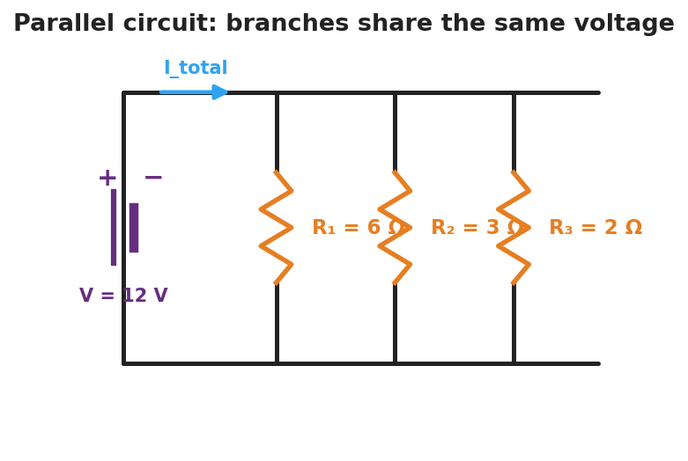
Schematic of a parallel circuit: a 12-volt battery on the left connects to a top rail and a bottom rail, with three vertical resistor branches between them labeled R-one 6 ohms, R-two 3 ohms, and R-three 2 ohms; the total current splits among the branches.
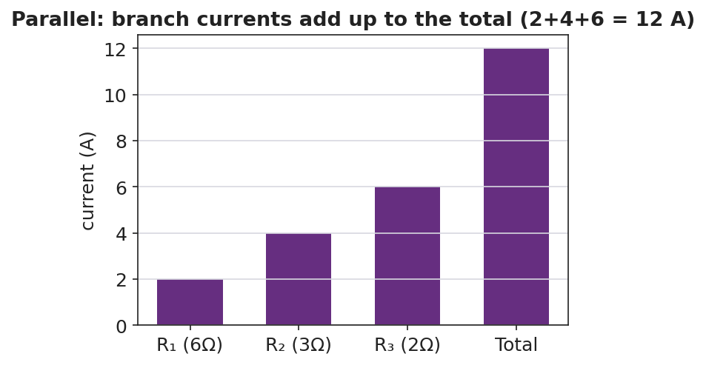
Bar chart of branch currents in a parallel circuit: 2 amps, 4 amps, and 6 amps in the three branches, summing to a 12-amp total.

Teacher facilitation during Explore
- What to look for — groups stating “the voltage is the same across every branch” and “the branch currents add to the main current.”
- What to resist — handing them 1/R_total = Σ1/R; let them compute each branch current with I = V/R first, then add.
- What to redirect — students surprised that R_total is less than the smallest resistor: more paths means less total opposition.

Phase 3 · Explain (30 – 36 min)

30–33 min · Turn-and-Talk #2 + class consensus
“Across your measurements, what three rules describe a parallel circuit?”
Target consensus:
“(1) The voltage is the same across every branch. (2) The branch currents add up to the total. (3) The equivalent resistance is less than any single branch.”

33–36 min · Vocabulary introduction (≤ 3 terms)
Sample teacher language:
“A circuit with more than one path is a parallel circuit. Each separate path is a branch, and every branch has the full source voltage across it. The single resistor that could replace them all is the equivalent resistance — but in parallel you combine reciprocals: 1/R_total = 1/R₁ + 1/R₂ + 1/R₃. Because you’re adding paths, R_total comes out smaller than any one branch.”
Reference relationships to post: V = I·R; parallel 1/R_total = 1/R₁ + 1/R₂ + …; power P = V·I = I²·R.

Discussion prompts to deploy here
- “Two 4 Ω resistors are in parallel across 8 V. Find each branch current and the total.”
  - Sample response: “Each branch: I = 8/4 = 2 A; total = 4 A; R_total = 2 Ω.”
- “Why is R_total smaller than the smallest branch resistor?”
  - Sample response: “Every added branch gives charge another path, so overall it’s easier for current to flow.”

Phase 4 · Elaborate (36 – 40 min)

36–38 min · Apply — add a branch
“You add a fourth lamp in parallel. Predict what happens to the total current drawn from the battery and to the equivalent resistance. Explain in one sentence.”
Target: equivalent resistance drops further, so the total current the battery delivers increases.

38–40 min · Return to the phenomenon
“Explain, in one sentence using parallel and branch, why unplugging one lamp leaves the others lit.”
Target: “The lamps are in parallel — each on its own branch — so opening one branch leaves the other branches (and their full voltage) untouched.”

Phase 5 · Evaluate (40 – 42 min)

40–42 min · Exit Ticket + Closing Reflection
“A 12 V battery is connected to two parallel resistors: 4 Ω and 6 Ω. (a) What is the voltage across each resistor? (b) Find the current in each branch. (c) Find the total current and the equivalent resistance (1/R_total = 1/4 + 1/6).”
Expected: (a) 12 V across each; (b) I₄ = 3 A, I₆ = 2 A; (c) total = 5 A, R_total = 12/5 = 2.4 Ω. See Answer_Key.docx.
Closing Reflection (SEL, 30 seconds):
“What surprised you most about parallel circuits compared with yesterday’s series circuits?”

Common Misconceptions
- Misconception: “The voltage splits among the parallel branches.” → Correction: Each branch gets the full source voltage; it’s the current that splits among the branches.
- Misconception: “Adding a parallel branch raises the total resistance.” → Correction: Adding branches lowers the equivalent resistance (more paths for current), so the battery delivers more total current.
- Misconception: “Opening one branch changes the others.” → Correction: Branches are independent; opening one leaves the others’ voltage and current unchanged.

Access & Differentiation
- ELL/ENL supports: Sentence frames: *“In a parallel circuit, the voltage across each branch is ___.”* / “The branch currents ___ to the total.” Word box: {same, add, branch, multiple paths, full voltage}. Color-code each branch a different color on the schematic.
- IEP/SPED supports: Provide a pre-built PhET file and a fill-in table (branch voltages, branch currents). Give a step-by-step reciprocal template for 1/R_total with the fractions pre-set.
- Extensions: Have students show that for two parallel resistors R_total = (R₁·R₂)/(R₁+R₂), and explain why home circuits use parallel wiring (each device gets full voltage and operates independently) while computing the power each branch draws (P = V²/R).

Strategy Spotlight
ACTIVE LEARNING. As in Lesson 03, students build-measure-predict at PhET stations. The active hinge here is opening one branch and watching the others stay lit — the experiential counterpart to yesterday’s series break. Run a predict → measure → reconcile loop on branch voltage (predict equal, confirm) and on total current (predict the sum, confirm). Have groups post their three-rule consensus side-by-side with the series rules from Lesson 03 to make the contrast explicit.

NYSSLS Observation Checklist Crosswalk
# | Checklist item | Where it appears in this lesson
1 | Local/relatable phenomenon | Phase 1 — home outlets / power strip
2 | Turn and Talk (2–3×) | Phase 1 (TT#1 — branch voltage), Phase 3 (TT#2 — three parallel rules)
3 | Students develop questions/models/procedures | Phase 1 (initial model), Phase 2 (build/measure/predict), Phase 4 (revise)
4 | CCC defined and used | Lesson Overview · Systems and System Models, used in Phase 2
5 | ENL — ≤ 3 vocab, second half | Phase 3 — parallel circuit / branch / equivalent resistance at 33–36 min
6 | Revisit phenomenon with evidence | Phase 4 — why other lamps stay lit
7 | ENL/SPED supports | Access & Differentiation block
8 | Assessment check | Phase 5 — parallel Ohm’s-law exit ticket

Companion Materials
- Student_Worksheet.docx — the 5E student investigation (hand out at start of Phase 2)
- Student_Notes.docx — guided note-guide for vocabulary and the worked example
- Answer_Key.docx — answers to “Make It Make Sense” prompts and the Exit Ticket

Key Vocabulary (max 3)
- parallel circuit — a circuit with more than one path for charge, so every branch has the same full source voltage across it
- branch — one of the separate parallel paths between the same two points; its current is set by its own resistance (I = V/R)
- equivalent resistance — the single resistance that could replace the branches; in parallel, 1/R_total = 1/R₁ + 1/R₂ + … (smaller than any branch)

Parallel Circuits — Student Worksheet
Unit: Current Electricity — Lesson 04 Name: _______________________ Date: __________ Period: ____

Phenomenon
Three lamps are plugged into a power strip — all lit. You unplug one, and the other two stay bright. Yesterday, removing one bulb from a series string killed the whole string. Something is wired differently here.
Driving question: How can one lamp turn off while the others stay on?

Notice & Wonder
I notice… | I wonder…
Turn & Talk #1: If each lamp has its own path to the source, what must be true about the voltage each lamp gets? Use the word branch.

Initial Model
Sketch three lamps each wired directly across the same battery (three branches). Predict: does each lamp get the full battery voltage or a share of it? Does the same current go through all three?

My prediction: _______________________________

Investigation
Open PhET Circuit Construction Kit: DC. Build a 12 V battery with three parallel resistor branches: R₁ = 6 Ω, R₂ = 3 Ω, R₃ = 2 Ω.

Schematic of a parallel circuit: a 12-volt battery connects to a top and bottom rail, with three vertical resistor branches between them, R-one 6 ohms, R-two 3 ohms, R-three 2 ohms; the total current splits among the branches.
Part A — Branch voltages. Measure the voltage across each branch.
Branch | Voltage (V)
R₁ (6 Ω)
R₂ (3 Ω)
R₃ (2 Ω)
What do you notice?

Part B — Currents. Measure the current in each branch and in the main wire.
Branch | Current (A)
R₁ (6 Ω)
R₂ (3 Ω)
R₃ (2 Ω)
Sum
Main wire

Bar chart of branch currents in a parallel circuit: 2 A, 4 A, and 6 A summing to a 12 A total.
Part C — Open a branch. Disconnect one branch. What happens to the other branches?

Key question: How do the branch currents compare to the current in the main wire? Is R_total bigger or smaller than the smallest branch resistor?

Make It Make Sense
- Two 4 Ω resistors are in parallel across an 8 V battery. Find the current in each branch and the total current.
- For those two 4 Ω resistors, find the equivalent resistance using 1/R_total = 1/4 + 1/4.
- You add a fourth lamp in parallel. Does the total current from the battery go up or down? Why?

Vocabulary in Action
Use each term in a sentence about today’s phenomenon.
- parallel circuit: _______________________________________________
- branch: _______________________________________________
- equivalent resistance: _______________________________________________

Revise Your Model
Return to your Initial Model. Did each lamp get the full voltage? Rewrite your explanation for why unplugging one lamp leaves the others lit, using parallel and branch.

Exit Ticket
A 12 V battery is connected to two parallel resistors: 4 Ω and 6 Ω.
- What is the voltage across each resistor?
- Find the current in each branch.
- Find the total current and the equivalent resistance (use 1/R_total = 1/4 + 1/6).

Parallel Circuits — Student Notes
Unit: Current Electricity — Lesson 04 Name: _______________________ Date: __________ Period: ____

Learning Targets
By the end of today’s 42 minutes I can:
- Identify a parallel circuit and explain why each branch has the same voltage.
- Explain why branch currents add to the total and why one branch can fail while others stay on.
- Compute the equivalent resistance in parallel (1/R_total = 1/R₁ + 1/R₂ + …) and find branch currents.

Key Vocabulary
- parallel circuit — _______________________________________________
- branch — _______________________________________________
- equivalent resistance — _______________________________________________

Guided Notes
A parallel circuit has more than one __________ for charge. Because each branch connects to the same two points:
- The voltage across every branch is the __________ (the full source voltage).
- The branch currents __________ up to the total current in the main wire.
- The equivalent resistance combines as reciprocals: > 1 / R_total = 1/R₁ + 1/R₂ + 1/R₃ + …
- R_total comes out __________ than any single branch (more paths = easier flow).
- Opening one branch leaves the other branches __________.

Schematic of a parallel circuit: a battery connected to three resistor branches that each see the full source voltage.
Finding branch currents. Each branch follows Ohm’s Law with the full voltage: > I_branch = V ÷ R_branch then add them for the total.
Branch currents add to the total:

Bar chart of branch currents adding up to the total current in a parallel circuit.
Reference: V = I·R · parallel 1/R_total = 1/R₁ + 1/R₂ + … · power P = V·I = I²·R

Worked Example
Problem. A 12 V battery has three parallel branches: R₁ = 6 Ω, R₂ = 3 Ω, R₃ = 2 Ω. (a) Voltage across each branch? (b) Current in each branch? (c) Total current and equivalent resistance.
Solution. 1. Each branch has the full __________ V across it. 2. Branch currents (I = V/R): I₁ = 12/6 = __________ A; I₂ = 12/3 = __________ A; I₃ = 12/2 = __________ A. 3. Total current = 2 + 4 + 6 = __________ A. Equivalent resistance: R_total = V ÷ I_total = 12 ÷ 12 = __________ Ω — note it’s smaller than the 2 Ω branch.

Summary
Finish the sentence (Because / But / So):
Unplugging one lamp leaves the others lit because __________________________________________, but __________________________________________, so __________________________________________.

Parallel Circuits — Answer Key

Cover
Unit: Current Electricity — Lesson 04: Parallel Circuits East Meadow Schools × Valley Stream Central HSD Strategy chip: ACTIVE LEARNING

Make-It-Make-Sense Answers
- Each branch has the full 8 V, so each branch current = 8 ÷ 4 = 2 A; total = 2 + 2 = 4 A. · Rubric: full voltage on each branch AND correct branch/total currents. · NYSSLS: HS-PS3-6
- 1/R_total = 1/4 + 1/4 = 2/4 = 1/2, so R_total = 2 Ω (smaller than either branch). · Rubric: correct reciprocal sum AND inverts to 2 Ω. · NYSSLS: HS-PS3-6
- The total current goes up, because adding a parallel branch lowers the equivalent resistance, so the battery delivers more total current. · Rubric: “up” AND links to lower R_total. · NYSSLS: HS-PS3-6

Exit Ticket Answer
- Each resistor has the full 12 V across it (parallel branches share the source voltage).
- I₄ = V ÷ R = 12 ÷ 4 = 3 A; I₆ = 12 ÷ 6 = 2 A.
- Total current = 3 + 2 = 5 A. Equivalent resistance: 1/R_total = 1/4 + 1/6 = 3/12 + 2/12 = 5/12, so R_total = 12/5 = 2.4 Ω (check: 12 V ÷ 5 A = 2.4 Ω ✓).
Tolerance/rubric: (a) 12 V each; (b) 3 A and 2 A; (c) 5 A total and 2.4 Ω. 1 point each. Accept R_total ≈ 2.4 Ω. NYSSLS: HS-PS3-6.

Closing Reflection (rubric)
Formative, not graded. Award full credit for any honest surprise that contrasts parallel with series (common: “the voltage is the same on every branch, not split” or “the total resistance got smaller, not bigger”).

Electromagnetism: The Induction Junction — Teacher Guide

Cover
Unit: Current Electricity — Lesson 05: Electromagnetism (The Induction Junction) East Meadow Schools × Valley Stream Central High School District Strategy chips: ACTIVE LEARNING

Curated Resources (from East Meadow Scope & Sequence)

NYSSLS Standards
This lesson is a NYS Required Investigation on electromagnetism. It supports HS-PS3-5: “Develop and use a model of two objects interacting through electric or magnetic fields to illustrate the forces between objects and the changes in energy of the objects due to the interaction.” Students model how a current creates a magnetic field, and how a changing magnetic field transfers energy into a circuit as an induced current — connecting the current-electricity unit to fields and energy. (It builds on, but does not directly assess, the Ohm’s-Law standard HS-PS3-6 from Lessons 01–04.)

Phenomenon
- A coil of wire + a magnet lighting an LED only while the magnet moves through the coil (shake-flashlight / hand-crank generator): https://www.youtube.com/results?search_query=magnet+coil+led+induction+demonstration
- A battery-powered coil (electromagnet) picking up paperclips, then dropping them when the current is cut: https://www.youtube.com/results?search_query=electromagnet+paperclips+demonstration

Javalab / Labs
- Javalab — Electromagnetic induction (move a magnet through a coil, watch the induced current): https://javalab.org/en/electromagnetic_induction_en/
- PhET — Faraday’s Electromagnetic Lab / Generator (magnet, coil, light bulb): https://phet.colorado.edu/en/simulations/faradays-law

Assessments
- Javalab/PhET induction observation table (when does the LED light? when is it brightest?) — formative during Explore.
- Exit ticket below; full key in Answer_Key.docx.

Lesson Overview
Duration | 42 minutes (1 period) · NYS Required Investigation
NYSSLS link | HS-PS3-5 (core — electric/magnetic field interaction and energy transfer)
CCC focus | Energy and Matter — energy is transferred between a moving magnet and a circuit through the magnetic field.
Strategy chips | ACTIVE LEARNING (predict-test-explain with a real coil/magnet)
Materials | Coil of magnetized wire, strong magnet, LED or galvanometer (or shake-flashlight); battery + iron nail + insulated wire for the electromagnet; paperclips; devices for Javalab/PhET.
Safety | Low-voltage only. The electromagnet wire can warm up — limit how long the battery stays connected. Keep strong magnets away from devices and pacemakers.
Prior knowledge | Lessons 01–04 — current, voltage, complete circuits; the idea that current is moving charge.
Lesson objectives — students can:
- Explain that a moving charge / electric current produces a magnetic field (an electromagnet).
- Describe electromagnetic induction: a changing magnetic field through a coil induces a current.
- Use a field model to explain how generators and motors transfer energy between motion and electric current.

Phase 1 · Engage (0 – 10 min)

0–2 min · Opening Connection (SEL)
One-sentence whip-around: “Name something you charge or power by moving it — a shake flashlight, a hand-crank radio, a bike light.” Hold the idea that motion can make electricity.

2–7 min · Phenomenon hook — coil, magnet, and LED
Teacher actions. Hold a magnet still inside the coil — the LED stays dark. Move the magnet in and out — the LED flashes. Then connect the iron-nail coil to a battery and pick up paperclips; disconnect, and they drop.
Sample teacher language:
“Holding the magnet still — nothing. But the moment I move it through the coil, the LED lights. And over here, the coil only grabs paperclips while the battery is connected. What links moving magnets and electric current?”
Anticipated student responses:
- “You have to keep moving it.” — capture; it’s the change that matters.
- “The coil becomes a magnet when the battery’s on.” — yes; current makes a magnetic field.
- “Faster shaking makes it brighter.” — flag; faster change → more induced current.

7–10 min · Notice & Wonder + Turn-and-Talk #1
“Turn to your partner: what do the LED demo and the paperclip demo have in common? Use the word magnetic field.”
Target: current ↔ magnetic field — current makes a field; a changing field makes current.

Bridge to Phase 2
Each student writes a one-sentence initial model: “The LED only lights while the magnet moves because ______.”

Phase 2 · Explore (10 – 30 min)

10–14 min · Initial Model (silent / individual)
Prompt on the board:
“Draw the coil with the magnet inside it and the LED in the loop. Mark when the LED is ON. Predict: does it matter how fast you move the magnet? Does it matter if you stop?”

14–30 min · Investigation — coil/magnet + Javalab/PhET (NYS Investigation)
Hands-on station plus the simulation.
- Electromagnet. Connect the nail-coil to the battery; count paperclips lifted. Add more coil turns or a second battery — does it lift more?
- Induction. Move the magnet through the coil slowly, then quickly. When is the LED brightest? What happens when the magnet sits still?
- Reverse it. Pull the magnet out — does the current reverse (LED on opposite lead / galvanometer needle flips)?
Teacher facilitation language:
“When the magnet sits still inside the coil, is the field changing? Is there any current?” “Faster motion — what happens to the brightness? What does that tell you about ‘rate of change’?” “More coil turns or more current — does the electromagnet get stronger?”
Use the two diagrams to consolidate the current→field and field-change→current ideas:
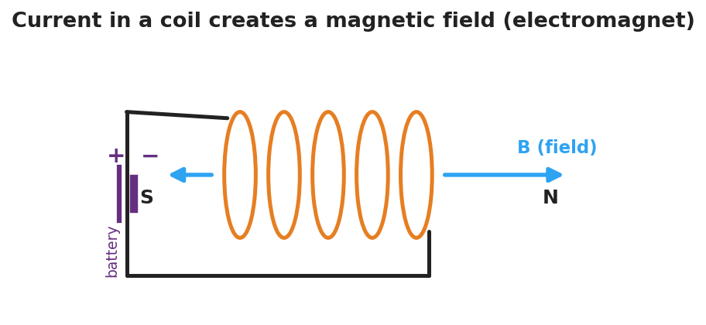
Diagram of current flowing through a wire coil: the loops of the coil create a magnetic field B running along the coil’s axis, with a north pole at one end and a south pole at the other, like a bar magnet.
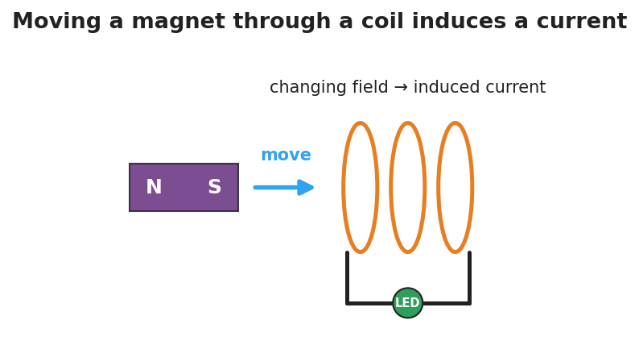
Diagram of electromagnetic induction: a bar magnet with north and south poles moves toward a wire coil connected to an LED; the changing magnetic field through the coil induces a current that lights the LED.

Teacher facilitation during Explore
- What to look for — groups stating “current only while the magnet moves” and “faster motion → brighter LED.”
- What to resist — supplying “Faraday’s law” equations; keep it at the model level (changing field → induced current).
- What to redirect — students who expect a steady LED from a still magnet: point them back to “is the field changing?”

Phase 3 · Explain (30 – 36 min)

30–33 min · Turn-and-Talk #2 + class consensus
“Across both demos, what is the two-way relationship between current and magnetic fields?”
Target consensus:
“An electric current creates a magnetic field (that’s an electromagnet). And a changing magnetic field through a coil creates — induces — a current. Faster change means more induced current.”

33–36 min · Vocabulary introduction (≤ 3 terms)
Sample teacher language:
“The region around a magnet or a current where magnetic forces act is the magnetic field. A coil carrying current that acts like a magnet is an electromagnet. And when a changing magnetic field through a coil drives a current, that’s electromagnetic induction — the principle behind every generator. A generator turns motion into current; a motor runs it backward, turning current into motion.”
Connection to energy (HS-PS3-5): the moving magnet transfers energy through the field into the circuit as electrical energy.

Discussion prompts to deploy here
- “Why doesn’t a magnet just resting inside a coil light the LED?”
  - Sample response: “The field isn’t changing, so no current is induced.”
- “How does a bike’s hand-crank/dynamo light work?”
  - Sample response: “Spinning moves a magnet near a coil, the changing field induces a current that lights the lamp.”

Phase 4 · Elaborate (36 – 40 min)

36–38 min · Apply — generators and motors
“A wind turbine spins a magnet inside a coil. Explain, using electromagnetic induction, how the wind ends up powering a light bulb.”
Target: the spinning magnet keeps changing the field through the coil, which induces a current that carries energy to the bulb — motion energy → electrical energy.

38–40 min · Return to the phenomenon
“In one sentence using electromagnetic induction, explain why the shake-flashlight only makes light while you shake it.”
Target: “Shaking keeps moving the magnet through the coil, so the changing field induces a current — stop shaking and the field stops changing, so the current (and light) stops.”

Phase 5 · Evaluate (40 – 42 min)

40–42 min · Exit Ticket + Closing Reflection
“(a) A current flows through a coil of wire. What does it create around the coil? (b) A magnet is held perfectly still inside a coil connected to an LED. Is there an induced current? Why or why not? (c) Name one device that uses electromagnetic induction to generate electricity, and explain in one sentence where the energy comes from.”
Expected: (a) a magnetic field (it becomes an electromagnet); (b) no — the field isn’t changing, and only a changing field induces current; (c) a generator/dynamo/turbine — the energy comes from the motion that keeps the field changing. See Answer_Key.docx.
Closing Reflection (SEL, 30 seconds):
“Where in your own life do you now realize electromagnetic induction is quietly working?”

Common Misconceptions
- Misconception: “A magnet sitting in a coil produces a current.” → Correction: Only a changing magnetic field induces a current; a stationary magnet’s steady field induces nothing.
- Misconception: “An electromagnet is permanently magnetic.” → Correction: It’s magnetic only while current flows; cut the current and the field collapses.
- Misconception: “Generators create energy.” → Correction: Generators convert energy — the motion that spins the magnet supplies the energy that becomes electrical energy.

Access & Differentiation
- ELL/ENL supports: Sentence frames: “A current makes a ___ field.” / *“A changing field induces a ___.”* Word box: {magnetic, current, moving, changing, induction, electromagnet}. Pair induction with the in-and-out magnet gesture.
- IEP/SPED supports: Provide the coil/magnet diagrams pre-labeled; students circle “ON” vs. “OFF” for each scenario (magnet still / moving / stopped). Offer the Javalab sim as a low-stakes alternative to the hands-on station.
- Extensions: Have students explain why a faster spin or more coil turns increases the induced voltage (Faraday’s law qualitatively) and sketch how a motor reverses a generator (current in → motion out), tying back to energy transfer (HS-PS3-5).

Strategy Spotlight
ACTIVE LEARNING (NYS Required Investigation). Students physically move the magnet and watch the LED rather than being told the rule. Build a predict → test → explain loop: predict whether the LED lights for (magnet still / slow / fast / pulled out), test each, then reconcile. The “still magnet = dark LED” result is the conceptual hinge — it isolates change as the cause. Capture each group’s observation table; the class consensus on “current ↔ changing field” should come from their data, not the slide.

NYSSLS Observation Checklist Crosswalk
# | Checklist item | Where it appears in this lesson
1 | Local/relatable phenomenon | Phase 1 — shake flashlight; coil/magnet LED; electromagnet + paperclips
2 | Turn and Talk (2–3×) | Phase 1 (TT#1 — what the demos share), Phase 3 (TT#2 — current↔field)
3 | Students develop questions/models/procedures | Phase 1 (initial model), Phase 2 (NYS investigation), Phase 4 (revise)
4 | CCC defined and used | Lesson Overview · Energy and Matter, used in Phase 2/4
5 | ENL — ≤ 3 vocab, second half | Phase 3 — magnetic field / electromagnet / electromagnetic induction at 33–36 min
6 | Revisit phenomenon with evidence | Phase 4 — why the shake-flashlight needs shaking
7 | ENL/SPED supports | Access & Differentiation block
8 | Assessment check | Phase 5 — induction exit ticket

Companion Materials
- Student_Worksheet.docx — the 5E student investigation (hand out at start of Phase 2)
- Student_Notes.docx — guided note-guide for vocabulary and the worked example
- Answer_Key.docx — answers to “Make It Make Sense” prompts and the Exit Ticket

Key Vocabulary (max 3)
- magnetic field — the region around a magnet or a current-carrying wire where magnetic forces act, represented by field lines from north to south
- electromagnet — a coil of wire that becomes magnetic only while an electric current flows through it; more turns or more current makes it stronger
- electromagnetic induction — the production of a current in a coil by a changing magnetic field; the basis of generators (motion → electricity)

Electromagnetism: The Induction Junction — Student Worksheet
Unit: Current Electricity — Lesson 05 Name: _______________________ Date: __________ Period: ____

Phenomenon
A magnet held still inside a coil of wire does nothing. But move the magnet in and out, and an LED in the circuit flashes. Across the room, a coil wrapped around a nail picks up paperclips — but only while a battery is connected.
Driving question: What is the two-way connection between electric current and magnetism?

Notice & Wonder
I notice… | I wonder…
Turn & Talk #1: What do the LED demo and the paperclip demo have in common? Use the words magnetic field.

Initial Model
Draw the coil with the magnet inside it and the LED in the loop. Mark when the LED is ON. Predict: does it matter how fast you move the magnet? What happens if you stop?

My prediction: _______________________________

Investigation
Hands-on station + Javalab/PhET simulation.

Diagram of current in a coil creating a magnetic field along its axis, with a north and a south pole like a bar magnet.
Part A — Electromagnet. Connect the nail-coil to the battery and count paperclips lifted. Then add more coil turns or a second battery.
Setup | Paperclips lifted
Battery + coil
More turns / more current
What makes the electromagnet stronger?

Part B — Induction. Move the magnet through the coil at different speeds and record the LED.

Diagram of electromagnetic induction: a moving bar magnet’s changing field through a coil induces a current that lights an LED.
Magnet action | LED (off / dim / bright)
Held still inside coil
Moved slowly
Moved quickly
Pulled back out
Part C — Reverse. When you pull the magnet out instead of pushing it in, what happens to the current direction (which LED lead lights / which way the needle moves)?

Key question: Under what condition does the coil have an induced current? What makes that current bigger?

Make It Make Sense
- A current flows through a coil of wire. What forms around the coil, and what is the coil now acting like?
- A magnet is held perfectly still inside a coil connected to an LED. Is there an induced current? Explain.
- A hand-crank flashlight has no battery. Explain where the light’s energy comes from, using electromagnetic induction.

Vocabulary in Action
Use each term in a sentence about today’s phenomenon.
- magnetic field: _______________________________________________
- electromagnet: _______________________________________________
- electromagnetic induction: _______________________________________________

Revise Your Model
Return to your Initial Model. Did the speed of the magnet matter? Rewrite your explanation for why the LED only lights while the magnet moves, using electromagnetic induction.

Exit Ticket
- A current flows through a coil of wire. What does it create around the coil?
- A magnet is held perfectly still inside a coil connected to an LED. Is there an induced current? Why or why not?
- Name one device that uses electromagnetic induction to generate electricity, and explain in one sentence where the energy comes from.

Electromagnetism: The Induction Junction — Student Notes
Unit: Current Electricity — Lesson 05 Name: _______________________ Date: __________ Period: ____

Learning Targets
By the end of today’s 42 minutes I can:
- Explain that an electric current creates a magnetic field (an electromagnet).
- Describe electromagnetic induction: a changing magnetic field induces a current.
- Use a field model to explain how generators transfer energy between motion and current.

Key Vocabulary
- magnetic field — _______________________________________________
- electromagnet — _______________________________________________
- electromagnetic induction — _______________________________________________

Guided Notes
The two-way relationship (the “induction junction”):
- Current → field. A current in a coil of wire creates a __________ field. The coil acts like a bar magnet — this is an __________. More coil turns or more current makes it __________.

Diagram of current in a coil creating a magnetic field with north and south poles.
- Changing field → current. A changing magnetic field through a coil __________ a current. This is electromagnetic induction.
  - A magnet held __________ inside a coil induces __________ current (the field isn’t changing).
  - Moving the magnet __________ induces a larger current (faster change → more current).

Diagram of induction: a moving magnet’s changing field through a coil induces a current that lights an LED.
Generators and motors (energy connection — HS-PS3-5).
- A generator spins a magnet near a coil; the changing field induces a current. It converts __________ energy into __________ energy.
- A motor runs the idea backward: current in → __________ out.

Worked Example
Problem. A student moves a magnet into a coil connected to an LED. (a) Why does the LED light only while the magnet moves? (b) She moves it twice as fast — what happens to the LED, and why? (c) Where does the LED’s energy come from?
Solution. 1. The LED lights only while moving because only a __________ magnetic field induces a current. 2. Moving twice as fast makes the field change __________, so the induced current is __________ and the LED is brighter. 3. The energy comes from the __________ she does moving the magnet — motion energy becomes electrical energy.

Summary
Finish the sentence (Because / But / So):
The LED lights only while the magnet moves through the coil because __________________________________________, but __________________________________________, so __________________________________________.

Electromagnetism: The Induction Junction — Answer Key

Cover
Unit: Current Electricity — Lesson 05: Electromagnetism (The Induction Junction) East Meadow Schools × Valley Stream Central HSD Strategy chip: ACTIVE LEARNING · NYS Required Investigation

Make-It-Make-Sense Answers
- A magnetic field forms around the coil; the coil is now acting like a magnet — an electromagnet. · Rubric: names magnetic field AND electromagnet. · NYSSLS: HS-PS3-5
- No induced current. A current is induced only by a changing magnetic field; a still magnet’s field is steady (not changing), so nothing is induced. · Rubric: “no” AND explains via unchanging field. · NYSSLS: HS-PS3-5
- The energy comes from the motion (the muscular work of cranking): cranking spins a magnet near a coil, the changing field induces a current by electromagnetic induction, and that current lights the bulb. · Rubric: energy from motion AND links via induction. · NYSSLS: HS-PS3-5

Exit Ticket Answer
- It creates a magnetic field around the coil — the coil becomes an electromagnet.
- No — the magnetic field is not changing, and only a changing magnetic field induces a current.
- A generator (or dynamo / wind turbine / hand-crank flashlight). The energy comes from the motion that keeps the magnetic field changing through the coil — mechanical energy is converted to electrical energy.
Tolerance/rubric: (a) magnetic field / electromagnet; (b) “no” with the unchanging-field reason; (c) any induction generator named AND energy traced to motion. 1 point each. NYSSLS: HS-PS3-5.

Closing Reflection (rubric)
Formative, not graded. Award full credit for naming any real place induction operates (phone chargers, generators, hand-crank/shake devices, microphones, card readers) — the goal is transfer of the model, not a single right answer.

Waves — Unit Plan

Cover
Unit: Waves & Sound East Meadow Schools × Valley Stream Central High School District 10 lessons · ~10 instructional periods (42 min each) Format: DOCX (Teacher Guide · Student Worksheet · Student Notes · Answer Key per lesson)

Unit Scope (from East Meadow Scope & Sequence)
This unit develops the physics of waves — mechanical and electromagnetic — from anatomy and the wave equation through interference, the Doppler effect, the EM spectrum, geometric optics, and the analog-to-digital encoding of information. It builds on Energy (a wave transports energy) and connects outward to astronomy (redshift → expanding universe) and to information technology (digital transmission and storage).
# | Lesson | Core idea
01 | Wave Anatomy and Characteristics | Amplitude, wavelength, frequency, period; a wave transfers energy, not matter
02 | Transverse and Longitudinal Waves | Oscillation perpendicular (light) vs. parallel (sound) to travel
03 | Wave Speed, Frequency, and Wavelength | v = f·λ; at fixed speed, f and λ trade off inversely; T = 1/f
04 | Standing Waves and Resonance | Interference of reflections → nodes/antinodes; resonance at natural frequencies
05 | Interference (Constructive and Destructive) | Superposition; in phase adds, out of phase cancels
06 | The Doppler Effect | Relative motion shifts observed frequency; light → red/blueshift
07 | The Electromagnetic Spectrum | EM waves are transverse, all travel at c; radio → gamma by increasing f
08 | Refraction and Snell’s Law | Light bends when speed changes; n₁ sin θ₁ = n₂ sin θ₂; total internal reflection
09 | Optics (Lenses and Mirrors) | Ray diagrams; 1/f = 1/dₒ + 1/dᵢ; real vs. virtual images
10 | Digital Technologies and Information | Analog vs. digital; sampling/bits; digital is robust to noise
Reference-table equations used in this unit: v = f·λ · T = 1/f · n₁ sin θ₁ = n₂ sin θ₂ · 1/f = 1/dₒ + 1/dᵢ

Pacing Calendar
Day | Lesson | Phenomenon anchor | Strategy
1 | 01 Wave Anatomy | Stadium wave; slinky; guitar string | Restorative Circle (unit opener)
2 | 02 Transverse / Longitudinal | Slinky shaken side-to-side vs. push-pull | Active Learning
3 | 03 Wave Speed (v = f·λ) | Guitar strings of different thickness/length | Hochman
4 | 04 Standing Waves / Resonance | Standing wave on a string; shattering glass; fire table | Active Learning
5 | 05 Interference | Two speakers → loud/quiet spots; noise-canceling headphones | BTC
6 | 06 Doppler Effect | Ambulance siren; race car; galaxy redshift | Hochman
7 | 07 EM Spectrum | Radios, X-rays, microwaves — one room, whole spectrum | Active Learning
8 | 08 Refraction / Snell’s Law | Laser bending into water; broken pencil; disappearing Pyrex | Hochman
9 | 09 Optics (Lenses & Mirrors) | Glasses; magnifying glass; curved mirror | Active Learning
10 | 10 Digital Technologies | Vinyl vs. streaming; pixelated vs. smooth image | BTC
Double-period days (every other day) allow the lab phases of Lessons 03, 08, and 09 to run long with PhET/oPhysics measurement and ray-tracing work.

Strategy Rotation
- HOCHMAN (literacy): Lessons 03, 06, 08 — Because/But/So expansion on the key causal relationships (v = f·λ trade-off; Doppler shift; refraction from a speed change).
- ACTIVE LEARNING: Lessons 02, 04, 07, 09 — slinky/human-wave building, harmonic hunting, EM-spectrum card sort, and hands-on ray-tracing.
- BTC (Building Thinking Classrooms): Lessons 05, 10 — random groups + vertical non-permanent surfaces on interference thin-slices and the analog/digital evaluation.
- RESTORATIVE CIRCLE: Lesson 01 — unit-opening circle (“a sound or signal that travels to you”).
SEL (Opening Connection + Closing Reflection), ELL/SPED supports, and a Curated Resources block appear in every lesson.

NYSSLS Coverage Matrix
PE | Description | Lessons
HS-PS4-1 | Mathematical representations of frequency, wavelength, and speed of waves in various media (Cause and Effect) | 01, 02, 03 (core), 04, 05, 06, 07
HS-PS4-6 (NYS) | Mathematical models relating image/object size & location and focal lengths of lenses and mirrors | 08 (Snell’s law foundation), 09 (core)
HS-PS4-2 | Evaluate the advantages of digital transmission and storage of information (Stability and Change) | 10
HS-ESS1-2 | Big Bang from astronomical evidence of light spectra (connection) | 06 (Doppler redshift → expanding universe)

Vocabulary Scope
Three terms maximum per lesson, introduced in the second half (NYSSLS observation item 5).
Lesson | Terms
01 | amplitude · wavelength · frequency
02 | transverse wave · longitudinal wave · medium
03 | wave speed · period · hertz
04 | standing wave · node · resonance
05 | superposition · constructive interference · destructive interference
06 | Doppler effect · frequency shift · redshift
07 | electromagnetic wave · spectrum · speed of light
08 | refraction · index of refraction · Snell’s law
09 | focal length · converging lens · image
10 | analog signal · digital signal · bit

Wave Anatomy and Characteristics — Teacher Guide

Cover
Unit: Waves — Lesson 01: Wave Anatomy and Characteristics East Meadow Schools × Valley Stream Central High School District Strategy chips: RESTORATIVE CIRCLE

Curated Resources (from East Meadow Scope & Sequence)

NYSSLS Standards
HS-PS4-1. “Use mathematical representations to support a claim regarding relationships among the frequency, wavelength, and speed of waves traveling in various media. (Cause and Effect)”
This opening lesson builds the vocabulary and mental picture students need before they can reason mathematically with v = f·λ in Lessons 02–03. Establishing crest, trough, amplitude, wavelength, frequency, and period is the prerequisite for every wave claim that follows.

Phenomenon
- A stadium “wave” travels around the bowl, but each fan stays in their seat — only their arms go up and down: https://www.youtube.com/watch?v=njBJW9pStLA
- A slinky pulse and a plucked guitar string as live, in-room versions of the same idea.

Javalab / Labs
- PhET Wave on a String — drive a string at the left end and watch a wave travel: https://phet.colorado.edu/en/simulations/wave-on-a-string

Assessments
- PhET Wave on a String “Oscillate + Slow Motion” check: students set amplitude and frequency and measure wavelength. Exit ticket below serves as the formative check.

Lesson Overview
Duration | 42 minutes (1 period)
NYSSLS link | HS-PS4-1 (vocabulary + model foundation)
CCC focus | Cause and Effect — driving the source faster (higher frequency) causes the wave’s shape to change, but the medium itself does not travel.
Strategy chips | RESTORATIVE CIRCLE (unit opener)
Materials | Long spring/slinky; a length of rope; a guitar or ukulele (optional); rulers; whiteboards/markers; device for PhET.
Safety | Give the slinky room; do not stretch past ~3 m or release under tension.
Prior knowledge | Energy transfer (Energy unit); the idea of a repeating, periodic motion.
Lesson objectives — students can:
- Label the parts of a wave: crest, trough, amplitude, and wavelength.
- Distinguish frequency (cycles per second) from period (seconds per cycle) and state that they are reciprocals (T = 1/f).
- Explain, with evidence, that a wave transfers energy without transferring matter.

Phase 1 · Engage (0 – 12 min)

0–3 min · Opening Connection (SEL) — Restorative Circle (unit opener)
This is the first lesson of the Waves unit, so open with a brief restorative circle. Pass a talking piece. Prompt: “Name a sound or signal that travels to you every day — a voice, a song, a notification — and where it comes from.” One sentence each, no cross-talk. This seeds the central idea: something travels to you, but the air, the wire, or the screen did not come with it.

3–8 min · Phenomenon hook — the stadium wave
Teacher actions. Play the stadium-wave clip with the sound off for ~30 seconds. Then run a slinky pulse across the front bench so students see the in-room version.
Sample teacher language:
“Watch one single fan, not the whole stadium. Did that person travel around the stadium? Then what did go all the way around?”
Anticipated student responses:
- “The wave moved but the people stayed.” — exactly the target; capture the word stayed.
- “Energy went around.” — affirm and hold; we will sharpen this.
- “The people passed it on.” — good, reframe as “each one moved up and down in place.”

8–12 min · Notice & Wonder + Turn-and-Talk #1
Capture two columns on the board. Then:
“Turn to your partner: what actually traveled around the stadium, and what stayed put? Use the word energy in your answer.”
Take 2–3 responses. Desirable insight: the disturbance (energy) traveled; the matter (people, slinky coils) only moved in place and returned.

Bridge to Phase 2
Every student leaves Phase 1 with a one-sentence initial model: “In the stadium wave, ______ traveled but ______ stayed put.”

Phase 2 · Explore (12 – 32 min)

12–17 min · Initial Model (silent / individual)
Prompt on the board:
“Draw the slinky at one instant as a wave passes. Mark a high point and a low point. Draw an arrow showing which way the wave moves, and an arrow showing which way a single coil moves. Are they the same direction?”
This surfaces the matter-vs-energy distinction before any vocabulary.

17–32 min · Investigation — PhET Wave on a String + slinky stations
Students work in pairs at PhET (with a slinky available to handle):
- Amplitude — set the oscillator higher/lower. What part of the wave changes? (Tie a ribbon to one slinky coil — does the ribbon travel down the slinky, or bob in place?)
- Frequency — speed up and slow down the oscillator. Count cycles in 10 seconds. What happens to the spacing of the crests?
- Energy, not matter — pause the sim and tag one point on the string. Step it forward. Does the tagged point move along the string, or up and down?
Use the labeled-wave figure to anchor the vocabulary you will name in Phase 3:
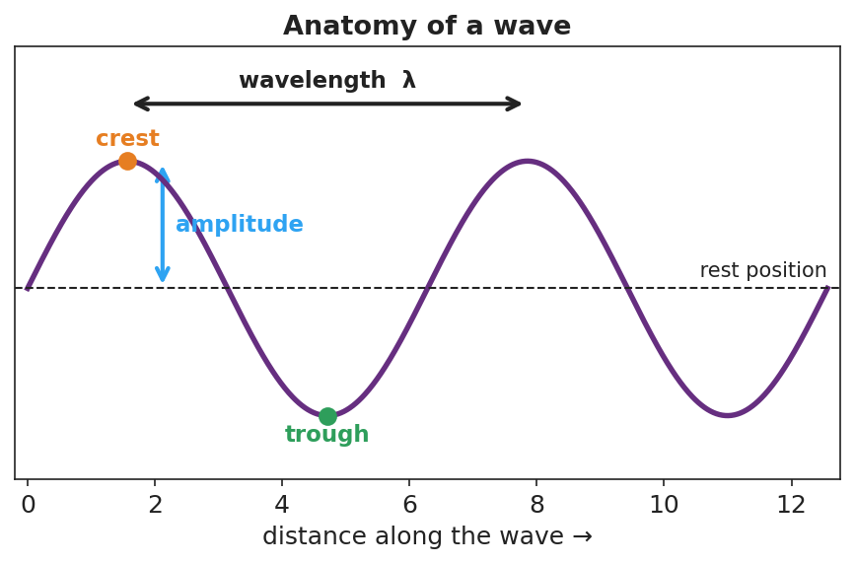
A sine wave with the crest, trough, rest position, amplitude (rest-to-crest), and wavelength (crest-to-crest) all labeled.

Teacher facilitation during Explore
- What to look for — pairs noticing that the ribbon/tagged point bobs in place while crests march along; that more cycles per second means crests are closer together.
- What to resist — don’t define “frequency” or “wavelength” yet; let the counting and the ribbon do the teaching.
- What to redirect — students who say “the string moves to the right” should be asked, “does that piece of string end up on the right, or does it come back?”

Phase 3 · Explain (32 – 37 min)

32–35 min · Turn-and-Talk #2 + class consensus
“Across both the slinky and PhET, what moved along the medium and what only moved in place?”
Target consensus:
“A wave is a disturbance that carries energy from place to place. The matter it travels through only vibrates in place — it does not travel with the wave.”

35–37 min · Vocabulary introduction (≤ 3 terms)
Sample teacher language:
“The height of the wave from rest to a crest is the amplitude — bigger amplitude means more energy. The distance from one crest to the next is the wavelength. And how many full cycles pass a point each second is the frequency, measured in hertz. The time for one cycle is its period, and period and frequency are reciprocals: T = 1/f.”
Show the frequency/period figure here:
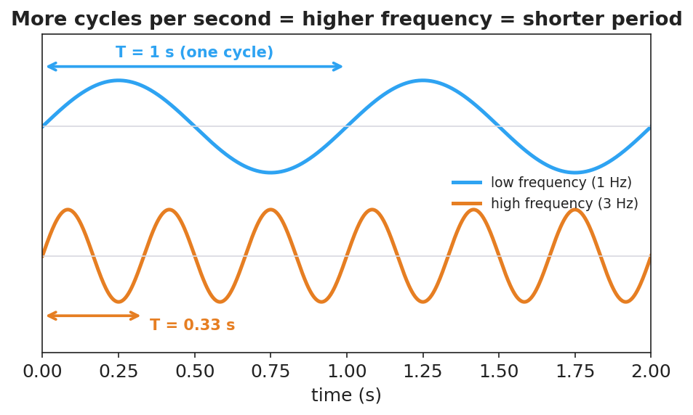
Two waves over the same two seconds: a 1 Hz wave with period T = 1 s, and a 3 Hz wave with period T = 0.33 s, showing more cycles per second means a shorter period.

Discussion prompts to deploy here
- “A wave’s amplitude doubles. Does it travel faster?”
  - Sample student response: “No — amplitude is about energy/height, not speed. Speed depends on the medium.”
- “If a wave’s frequency is 4 Hz, what is its period?”
  - Sample student response: “T = 1/f = 1/4 = 0.25 s per cycle.”

Phase 4 · Elaborate (37 – 40 min)

37–39 min · Revise the model
“Return to your slinky drawing. Label the crest, trough, amplitude, and one wavelength. Re-write your one-sentence explanation using the words energy, amplitude, and wavelength.”

39–40 min · Return to the phenomenon
“Back to the stadium: what is the ‘amplitude’ of the stadium wave, and what stayed in place? Answer in one sentence.”
Target: “The amplitude is how high fans raise their arms; the fans (the matter) stayed in their seats while the wave (energy) traveled around.”

Phase 5 · Evaluate (40 – 42 min)

40–42 min · Exit Ticket + Closing Reflection
“A buoy bobs up and down 12 times in 6 seconds as ocean waves pass. (a) What is the frequency of the waves? (b) What is the period? (c) Does the water itself travel toward the shore with the wave? Explain in one sentence.”
Expected: (a) f = 12/6 = 2 Hz; (b) T = 1/f = 0.5 s; (c) no — the water (matter) bobs in place; the wave carries energy toward shore. See Answer_Key.docx.
Closing Reflection (SEL, 30 seconds):
“What is one everyday ‘wave’ you now see differently? Who in your group helped you picture it?”

Common Misconceptions
- Misconception: “A wave carries the medium along with it (the water moves to shore).” → Correction: The medium vibrates in place; only energy is transported.
- Misconception: “Bigger waves (higher amplitude) move faster.” → Correction: Amplitude is energy/height; wave speed is set by the medium, not the amplitude.
- Misconception: “Frequency and period are the same thing.” → Correction: They are reciprocals — frequency is cycles per second, period is seconds per cycle (T = 1/f).

Access & Differentiation
- ELL/ENL supports: Sentence frame: “A wave carries ______ but not ______; the ______ moves up and down in place.” Word-choice box: {energy, matter, amplitude, wavelength, frequency, crest, trough}. Pair amplitude with a hand gesture (high vs. low).
- IEP/SPED supports: Provide a pre-printed blank sine curve; students drag/label cut-out tags (crest, trough, amplitude, wavelength) rather than drawing from scratch. Offer the slinky as a hands-on alternative to the simulation.
- Extensions: Have students measure a real wavelength in PhET by reading the ruler tool, then predict how the wavelength changes when they double the frequency at the same speed (preview of Lesson 03).

Strategy Spotlight
RESTORATIVE CIRCLE (unit opener). Today’s circle launches the Waves unit. Use a talking piece, one-sentence responses, and equity of voice (everyone speaks or passes). The prompt — a sound or signal that travels to you and where it comes from — is chosen so you can call it back in Phase 3 (“the song reached your ears, but the singer’s air did not travel to you — energy did”). Keep the circle to ~2–3 minutes; the goal is community plus a shared anchor.

NYSSLS Observation Checklist Crosswalk
# | Checklist item | Where it appears in this lesson
1 | Local/relatable phenomenon | Phase 1 — stadium wave; slinky; ocean buoy in Phase 5
2 | Turn and Talk (2–3×) | Phase 1 (TT#1 — what traveled), Phase 3 (TT#2 — along vs. in place)
3 | Students develop questions/models/procedures | Phase 1 (initial model), Phase 2 (PhET + slinky stations), Phase 4 (revise model)
4 | CCC defined and used | Lesson Overview · Cause and Effect, restated in Phase 2
5 | ENL — ≤ 3 vocab, second half | Phase 3 — vocabulary at 35–37 min (amplitude / wavelength / frequency)
6 | Revisit phenomenon with evidence | Phase 4 — stadium-wave amplitude re-label
7 | ENL/SPED supports | Access & Differentiation block
8 | Assessment check | Phase 5 — Exit Ticket (ocean buoy)

Companion Materials
- Student_Worksheet.docx — the 5E student investigation (hand out at start of Phase 2)
- Student_Notes.docx — guided note-guide for vocabulary and the worked example
- Answer_Key.docx — answers to “Make It Make Sense” prompts and the Exit Ticket

Key Vocabulary (max 3)
- amplitude — the maximum distance a wave rises from its rest position; larger amplitude means more energy
- wavelength — the distance between two matching points on a wave, such as crest to crest (symbol λ)
- frequency — the number of complete wave cycles that pass a point each second, measured in hertz (Hz)

Wave Anatomy and Characteristics — Student Worksheet
Unit: Waves — Lesson 01 Name: _______________________ Date: __________ Period: ____

Phenomenon
A “wave” travels all the way around a packed stadium — but every single fan stays in their own seat, just raising and lowering their arms. On the front bench, a slinky pulse races from one end to the other, yet each coil only jiggles in place.
Driving question: When a wave travels, what actually moves — and what stays put?

Notice & Wonder
I notice… | I wonder…
Turn & Talk #1: What actually traveled around the stadium, and what stayed put? Use the word energy in your answer.

Initial Model
Draw the slinky at one instant as a wave passes. Mark a high point and a low point. Draw one arrow for the direction the wave moves, and a second arrow for the direction a single coil moves.

Are the two arrows the same direction? _______________________

Investigation
Open PhET Wave on a String and keep a slinky handy. Tie a ribbon to one slinky coil.
Station | What I changed | What happened to the wave | What happened to the ribbon / tagged point
1. Amplitude (oscillator height)
2. Frequency (oscillator speed)
3. Energy, not matter (tag one point)
Use this labeled wave to name the parts you measured:

A sine wave with crest, trough, rest position, amplitude, and wavelength labeled.
Key question: Did the ribbon (a piece of matter) travel down the slinky, or move in place? What does that tell you about what a wave transports?

Make It Make Sense
- On the wave diagram above, which measurement tells you how much energy the wave carries? Explain.
- A wave’s frequency is 5 Hz. What is its period? Show the formula you used.
- Two ocean waves have the same speed, but Wave A has a larger amplitude than Wave B. Which carries more energy? Does it travel faster? Explain.

Vocabulary in Action
Use each term in a sentence about today’s phenomenon.
- amplitude: _______________________________________________
- wavelength: _______________________________________________
- frequency: _______________________________________________

Revise Your Model
Return to your Initial Model. Label the crest, trough, amplitude, and one wavelength. Rewrite your explanation using the words energy, amplitude, and wavelength.

Exit Ticket
A buoy bobs up and down 12 times in 6 seconds as ocean waves pass.
- What is the frequency of the waves?
- What is the period?
- Does the water itself travel toward the shore with the wave? Explain in one sentence.

Wave Anatomy and Characteristics — Student Notes
Unit: Waves — Lesson 01 Name: _______________________ Date: __________ Period: ____

Learning Targets
By the end of today’s 42 minutes I can:
- Label the parts of a wave: crest, trough, amplitude, and wavelength.
- Tell the difference between frequency (cycles per second) and period, and use T = 1/f.
- Explain that a wave transfers energy, not matter.

Key Vocabulary
- amplitude — _______________________________________________
- wavelength — _______________________________________________
- frequency — _______________________________________________

Guided Notes
Big idea: A wave is a __________ that carries __________ from one place to another. The matter it passes through only __________ in place — it does not travel with the wave.
Label the wave below:

A sine wave with crest, trough, rest position, amplitude, and wavelength labeled.
- Crest — the __________ point of the wave.
- Trough — the __________ point of the wave.
- Amplitude — distance from rest to a crest; more amplitude → more __________.
- Wavelength (λ) — distance from one crest to the __________ crest.
Frequency and period.
- Frequency (f) = number of cycles per __________, measured in __________ (Hz).
- Period (T) = time for __________ complete cycle, in seconds.
- They are reciprocals: T = 1 / __________ and f = 1 / __________.

Two waves over the same two seconds: a 1 Hz wave (T = 1 s) and a 3 Hz wave (T = 0.33 s).
More cycles per second → __________ frequency → __________ period.

Worked Example
Problem. A wave passes a dock and a seagull bobs up and down 20 times in 4 seconds. Find the frequency and the period.
Solution. 1. Frequency: f = cycles ÷ time = 20 ÷ 4 = __________ Hz. 2. Period: T = 1 / f = 1 / __________ = __________ s per cycle. 3. Check: 5 cycles each second × 4 seconds = __________ cycles. ✓

Summary
Finish the sentence (Because / But / So):
A wave travels across a slinky because __________________________________________, but __________________________________________, so __________________________________________.

Wave Anatomy and Characteristics — Answer Key

Cover
Unit: Waves — Lesson 01: Wave Anatomy and Characteristics East Meadow Schools × Valley Stream Central HSD Strategy chip: RESTORATIVE CIRCLE

Make-It-Make-Sense Answers
- Amplitude tells you the energy. The larger the amplitude (height from rest to crest), the more energy the wave carries. Wavelength and frequency describe the wave’s shape and timing, not its energy. · Rubric: names amplitude AND links it to energy → full credit. · NYSSLS: HS-PS4-1
- Period T = 1/f = 1/5 = 0.2 s per cycle. · Rubric: correct reciprocal formula AND correct value with units. · NYSSLS: HS-PS4-1
- Wave A carries more energy because it has the larger amplitude. It does not travel faster — wave speed is set by the medium, not the amplitude, and both waves are in the same water. · Rubric: larger amplitude → more energy AND speed unchanged. · NYSSLS: HS-PS4-1

Exit Ticket Answer
- f = 12 cycles ÷ 6 s = 2 Hz.
- T = 1/f = 1/2 = 0.5 s per cycle.
- No. The water bobs up and down in place (the matter stays put); the wave carries energy toward shore, not the water itself.
Tolerance/rubric: (a) 2 Hz with work; (b) 0.5 s; (c) must state water stays in place AND energy travels. 1 point each. NYSSLS: HS-PS4-1.

Closing Reflection (rubric)
Closing reflection is formative, not graded. Award full credit for any honest response. Look for: - An everyday “wave” the student now interprets as energy travel without matter travel - Naming a peer or a self-acknowledgment in the second answer

Transverse and Longitudinal Waves — Teacher Guide

Cover
Unit: Waves — Lesson 02: Transverse and Longitudinal Waves East Meadow Schools × Valley Stream Central High School District Strategy chips: ACTIVE LEARNING

Curated Resources (from East Meadow Scope & Sequence)

NYSSLS Standards
HS-PS4-1. “Use mathematical representations to support a claim regarding relationships among the frequency, wavelength, and speed of waves traveling in various media. (Cause and Effect)”
Sorting waves into transverse and longitudinal types lets students see that the same relationships (amplitude, wavelength, frequency, v = f·λ) apply to both light (transverse) and sound (longitudinal). The wave type is a property of the medium and the disturbance — a Cause-and-Effect link the unit returns to in the EM spectrum (Lesson 07) and refraction (Lesson 08).

Phenomenon
- A long slinky shaken side-to-side makes a wave you can see wiggling across the room; the same slinky pushed and pulled along its length makes a compression pulse race down it: https://www.youtube.com/watch?v=Rbuhdo0AZDU

Javalab / Labs
- Javalab Transverse and Longitudinal Waves — animated side-by-side particle motion: https://javalab.org/en/transverse_longitudinal_wave_en/

Assessments
- Javalab “tag a particle” check: students predict whether the tagged dot moves across the screen or oscillates in place, for each wave type. Exit ticket below serves as the formative check.

Lesson Overview
Duration | 42 minutes (1 period)
NYSSLS link | HS-PS4-1 (wave types; both obey v = f·λ)
CCC focus | Cause and Effect — how you disturb the medium (across vs. along) causes the two different wave types.
Strategy chips | ACTIVE LEARNING
Materials | Long slinky (one per group of 4); tape ribbons; Javalab on devices; whiteboards.
Safety | Keep slinky ends held; never release a stretched slinky.
Prior knowledge | Lesson 01 — crest, trough, amplitude, wavelength; energy travels, matter does not.
Lesson objectives — students can:
- Describe how the medium oscillates relative to the direction the wave travels.
- Classify a wave as transverse (oscillation perpendicular to travel) or longitudinal (oscillation parallel to travel) and give an example of each.
- Identify compressions and rarefactions in a longitudinal wave such as sound.

Phase 1 · Engage (0 – 12 min)

0–3 min · Opening Connection (SEL)
Quick check-in: “Show me with your hand: are you feeling more like a side-to-side day or a steady-straight-ahead day?” One gesture each. This primes the two motions you’ll formalize as transverse vs. longitudinal.

3–8 min · Phenomenon hook — one slinky, two waves
Teacher actions. Stretch a slinky across the front. First shake one end side to side — students see a transverse wiggle. Then push and pull the same end along its length — students see a compression pulse sprint down it. Same slinky, same energy idea, two very different looks.
Sample teacher language:
“Same slinky, same person, same energy — but two completely different-looking waves. What did I change about how I moved my hand?”
Anticipated student responses:
- “You shook it sideways the first time, in-and-out the second.” — exactly; capture the two hand motions.
- “The second one looks like it’s squishing.” — affirm; we’ll name compressions.
- “They both still went down the slinky.” — yes — energy travels both times.

8–12 min · Notice & Wonder + Turn-and-Talk #1
Capture two columns. Then:
“Turn to your partner: in each case, which way did a single coil move compared to the way the wave traveled?”
Target insight: in the first wave the coil moved across the travel direction; in the second it moved along it.

Bridge to Phase 2
Every student leaves with a one-sentence initial model: “The two waves were different because the coils moved ______ vs. ______ the direction the wave traveled.”

Phase 2 · Explore (12 – 32 min)

12–17 min · Initial Model (silent / individual)
Prompt:
“Draw both slinky waves. For each, draw one arrow for the wave’s travel direction and one arrow for how a single coil moves. Circle the case where the two arrows are perpendicular.”

17–32 min · Investigation — ACTIVE LEARNING: be the wave
Groups of 4. Each group has a slinky and a device with the Javalab sim.
- Build a transverse wave. Tape a ribbon to one coil. Shake side to side. Track the ribbon: does it travel along the slinky or move across, in place?
- Build a longitudinal wave. Push/pull along the length. Find where coils bunch (compression) and spread (rarefaction). Track the ribbon again.
- Human wave (kinesthetic). Line up shoulder-to-shoulder. For transverse, each person steps left/right as the “wave” passes; for longitudinal, each leans forward/back (toward/away from neighbors). Which one looks like sound?
- Javalab check. Tag a particle in each animation. Confirm your slinky observations.
Use this figure to compare what each group is building:
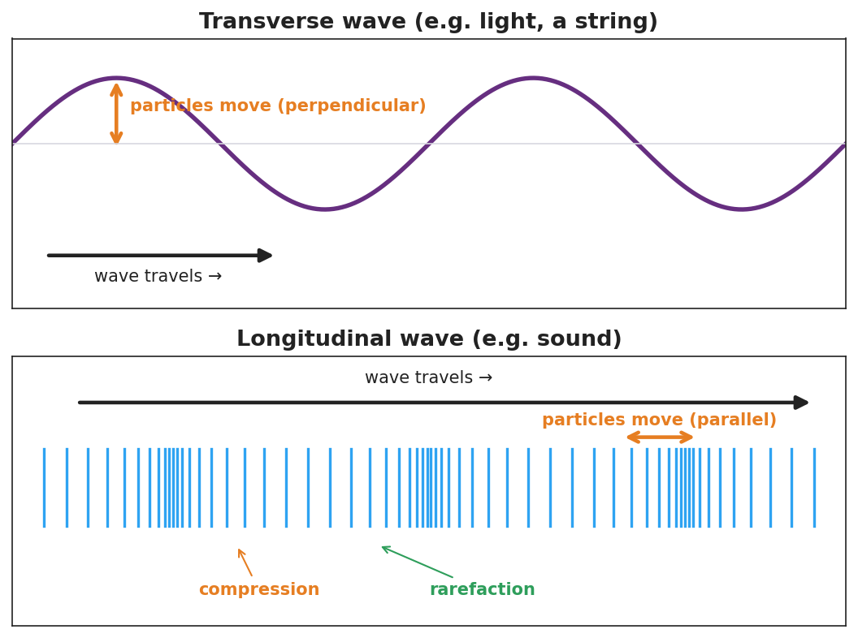
Top: a transverse wave (sine) with travel arrow horizontal and particle motion perpendicular. Bottom: a longitudinal wave shown as vertical lines that bunch into compressions and spread into rarefactions, with particle motion parallel to travel.
This second figure isolates the single-particle motion students should track at each station — up/down (perpendicular) for transverse, back/forth (parallel) for longitudinal:
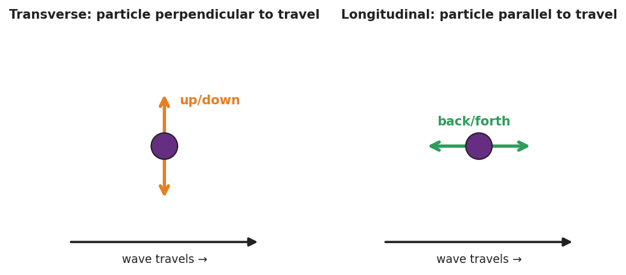
Two panels: a single particle in a transverse wave moving up and down (perpendicular to travel), and a single particle in a longitudinal wave moving back and forth (parallel to travel), each beside the rightward wave-travel arrow.

Teacher facilitation during Explore
- What to look for — groups stating the relationship between oscillation and travel, not just “sideways” vs. “in-out.”
- What to resist — don’t supply the words transverse/longitudinal yet; let “perpendicular” and “parallel” emerge from the ribbon tracking.
- What to redirect — students who say the longitudinal coil “travels down the slinky” should re-tag the ribbon and watch it return.

Phase 3 · Explain (32 – 37 min)

32–35 min · Turn-and-Talk #2 + class consensus
“What is the rule that separates the two wave types?”
Target consensus:
“If the medium oscillates across (perpendicular to) the direction of travel, it’s one type. If it oscillates along (parallel to) the direction of travel, it’s the other.”

35–37 min · Vocabulary introduction (≤ 3 terms)
Sample teacher language:
“When the particles move perpendicular to the wave’s travel — like the sideways slinky and like light — we call it a transverse wave. When they move parallel to the travel — like the push-pull slinky and like sound — it’s a longitudinal wave, with compressions (bunched) and rarefactions (spread out). The stuff the wave travels through is the medium.”

Discussion prompts to deploy here
- “Sound needs air, water, or a solid to travel. Which wave type is sound, and why does it need a medium?”
  - Sample student response: “Longitudinal — the particles have to push on the next ones, so it needs matter to push.”
- “A wave on a guitar string — transverse or longitudinal?”
  - Sample student response: “Transverse — the string moves up and down while the wave travels along its length.”

Phase 4 · Elaborate (37 – 40 min)

37–39 min · Revise the model
“Return to your two slinky drawings. Label one transverse and one longitudinal. On the longitudinal one, mark a compression and a rarefaction. Re-write your one-sentence rule using both vocabulary words.”

39–40 min · Return to the phenomenon
“If a friend asks why the side-to-side slinky and the push-pull slinky look so different, what’s your one-sentence answer using transverse and longitudinal?”
Target: “They’re different wave types — the side-to-side one is transverse (medium moves perpendicular to travel) and the push-pull one is longitudinal (medium moves parallel to travel).”

Phase 5 · Evaluate (40 – 42 min)

40–42 min · Exit Ticket + Closing Reflection
“A sound wave travels through air toward your ear. (a) Is sound a transverse or longitudinal wave? (b) Describe how the air molecules move compared to the direction the sound travels. (c) Name the bunched-up regions and the spread-out regions of a sound wave.”
Expected: (a) longitudinal; (b) molecules move back-and-forth parallel to the travel direction; (c) compressions (bunched) and rarefactions (spread out). See Answer_Key.docx.
Closing Reflection (SEL, 30 seconds):
“Which hands-on station made the idea click for you, and who in your group made it work?”

Common Misconceptions
- Misconception: “In a longitudinal wave the particles travel all the way down with the wave.” → Correction: They oscillate back and forth in place; only the compression pattern (energy) travels.
- Misconception: “All waves are S-shaped like the ones in pictures.” → Correction: That picture fits transverse waves; longitudinal waves are compressions and rarefactions, often drawn as a sine of density but physically a push-pull.
- Misconception: “Sound can travel through empty space like light.” → Correction: Sound is longitudinal and needs a medium to push through; space is a near-vacuum, so sound cannot travel there.

Access & Differentiation
- ELL/ENL supports: Sentence frame: “In a ______ wave the medium moves ______ to the direction the wave travels.” Word-choice box: {transverse, longitudinal, perpendicular, parallel, compression, rarefaction, medium}. Pair perpendicular and parallel with crossed-arm and aligned-arm gestures.
- IEP/SPED supports: Provide a two-column sort with pre-printed examples (light, sound, guitar string, slinky push-pull); students place each under “transverse” or “longitudinal.” Use the human-wave station as a movement-based alternative to writing.
- Extensions: Earthquake waves — research P-waves (longitudinal) vs. S-waves (transverse) and explain why S-waves cannot pass through Earth’s liquid outer core.

Strategy Spotlight
ACTIVE LEARNING. Students physically build both wave types with a slinky and with their own bodies (the human-wave station) before any term is named. The kinesthetic memory (“I stepped sideways” vs. “I leaned forward and back”) becomes the anchor for transverse vs. longitudinal. Facilitate by circulating with one question — “Which way did your body move compared to the wave?” — and resist naming the terms until Phase 3.

NYSSLS Observation Checklist Crosswalk
# | Checklist item | Where it appears in this lesson
1 | Local/relatable phenomenon | Phase 1 — one slinky, two waves; sound in Phase 5
2 | Turn and Talk (2–3×) | Phase 1 (TT#1 — coil vs. travel direction), Phase 3 (TT#2 — the rule)
3 | Students develop questions/models/procedures | Phase 1 (initial model), Phase 2 (slinky + human-wave + Javalab), Phase 4 (revise)
4 | CCC defined and used | Lesson Overview · Cause and Effect, restated in Phase 2
5 | ENL — ≤ 3 vocab, second half | Phase 3 — vocabulary at 35–37 min (transverse / longitudinal / medium)
6 | Revisit phenomenon with evidence | Phase 4 — label and explain the two slinky waves
7 | ENL/SPED supports | Access & Differentiation block
8 | Assessment check | Phase 5 — Exit Ticket (sound in air)

Companion Materials
- Student_Worksheet.docx — the 5E student investigation (hand out at start of Phase 2)
- Student_Notes.docx — guided note-guide for vocabulary and the worked example
- Answer_Key.docx — answers to “Make It Make Sense” prompts and the Exit Ticket

Key Vocabulary (max 3)
- transverse wave — a wave in which the medium oscillates perpendicular to the direction the wave travels (e.g., light, a wave on a string)
- longitudinal wave — a wave in which the medium oscillates parallel to the direction the wave travels, forming compressions and rarefactions (e.g., sound)
- medium — the matter (solid, liquid, or gas) through which a mechanical wave travels

Transverse and Longitudinal Waves — Student Worksheet
Unit: Waves — Lesson 02 Name: _______________________ Date: __________ Period: ____

Phenomenon
Your teacher takes one slinky and makes two completely different-looking waves with it. First they shake the end side to side — a wiggle travels across the room. Then they push and pull the same end along its length — a squeeze races down the coils. Same slinky, same energy. Two different waves.
Driving question: What did the teacher change about how they moved their hand to make two different wave types?

Notice & Wonder
I notice… | I wonder…
Turn & Talk #1: In each case, which way did a single coil move compared to the way the wave traveled?

Initial Model
Draw both slinky waves. For each, draw one arrow for the wave’s travel direction and one arrow for how a single coil moves. Circle the case where the two arrows are perpendicular.

Investigation
Work in a group of 4 with a slinky and the Javalab simulation. Tape a ribbon to one coil.
Station | What I did | Did the ribbon travel or move in place? | Coil motion vs. wave travel
1. Side-to-side slinky
2. Push-pull slinky
3. Human wave (step / lean)
4. Javalab tag-a-particle
Compare your two waves to this diagram:

Top: transverse wave with perpendicular particle motion. Bottom: longitudinal wave with compressions, rarefactions, and parallel particle motion.
Key question: Which station moved your body across the wave’s travel, and which moved it along the travel? Which one is like sound?

Make It Make Sense
- Light is a transverse wave. Describe how the wave “oscillates” compared to the direction the light travels.
- Sound is a longitudinal wave. Why does it need a medium (air, water, or a solid) to travel?
- A wave on a guitar string — transverse or longitudinal? Justify your answer with the direction the string moves.

Vocabulary in Action
Use each term in a sentence about today’s phenomenon.
- transverse wave: _______________________________________________
- longitudinal wave: _______________________________________________
- medium: _______________________________________________

Revise Your Model
Return to your two slinky drawings. Label one transverse and one longitudinal. On the longitudinal one, mark a compression and a rarefaction. Rewrite your rule using both vocabulary words.

Exit Ticket
A sound wave travels through air toward your ear.
- Is sound a transverse or longitudinal wave?
- Describe how the air molecules move compared to the direction the sound travels.
- Name the bunched-up regions and the spread-out regions of a sound wave.

Transverse and Longitudinal Waves — Student Notes
Unit: Waves — Lesson 02 Name: _______________________ Date: __________ Period: ____

Learning Targets
By the end of today’s 42 minutes I can:
- Describe how the medium oscillates compared to the direction a wave travels.
- Classify a wave as transverse or longitudinal and give an example of each.
- Identify compressions and rarefactions in a longitudinal wave.

Key Vocabulary
- transverse wave — _______________________________________________
- longitudinal wave — _______________________________________________
- medium — _______________________________________________

Guided Notes
There are two ways the matter in a wave can move compared to the way the wave travels:

Top: transverse wave (particles move perpendicular). Bottom: longitudinal wave with compressions and rarefactions (particles move parallel).
Transverse wave.
- The medium moves __________ (perpendicular) to the direction of travel.
- Examples: light, a wave on a __________.
- Has crests and __________.
Longitudinal wave.
- The medium moves __________ (parallel) to the direction of travel.
- Example: __________ (it needs a medium to push through).
- Bunched-up regions = __________; spread-out regions = __________.
The medium is the __________ the wave travels through. A wave does not travel with the medium — the medium just __________ in place.

Worked Example
Problem. Decide whether each wave is transverse or longitudinal, and explain how you know.
Wave | Type | How the medium moves
Light from the sun | __________ | __________ to travel
Sound from a speaker | __________ | __________ to travel
Ripple on a pond surface | __________ | __________ to travel
Reasoning. I look at the direction the medium oscillates compared with the direction the wave travels. If __________, it’s transverse; if __________, it’s longitudinal.

Summary
Finish the sentence (Because / But / So):
Sound and light are both waves that carry energy because __________________________________________, but __________________________________________, so __________________________________________.

Transverse and Longitudinal Waves — Answer Key

Cover
Unit: Waves — Lesson 02: Transverse and Longitudinal Waves East Meadow Schools × Valley Stream Central HSD Strategy chip: ACTIVE LEARNING

Make-It-Make-Sense Answers
- In light (transverse), the wave oscillates perpendicular to the direction the light travels — the electric and magnetic fields wiggle across the line of travel while the energy moves forward. · Rubric: states perpendicular relationship. · NYSSLS: HS-PS4-1
- Sound is longitudinal: the particles push on the next particles to pass the compression along, so there must be matter (a medium) to do the pushing. In a vacuum there are no particles to push, so sound cannot travel. · Rubric: links particle-pushing to needing a medium. · NYSSLS: HS-PS4-1
- Transverse. The string moves up and down (side to side) while the wave travels along the length of the string — the motion is perpendicular to the travel direction. · Rubric: transverse AND perpendicular justification. · NYSSLS: HS-PS4-1

Exit Ticket Answer
- Longitudinal.
- The air molecules move back and forth parallel to the direction the sound travels (not across it).
- Bunched-up regions are compressions; spread-out regions are rarefactions.
Tolerance/rubric: (a) longitudinal; (b) parallel/back-and-forth along travel; (c) both terms correct. 1 point each. NYSSLS: HS-PS4-1.

Closing Reflection (rubric)
Formative, not graded. Award full credit for any honest response. Look for: - Naming a specific station (slinky, human wave, Javalab) that made the idea click - An acknowledgment of a group member’s contribution

Wave Speed, Frequency, and Wavelength — Teacher Guide

Cover
Unit: Waves — Lesson 03: Wave Speed, Frequency, and Wavelength East Meadow Schools × Valley Stream Central High School District Strategy chips: HOCHMAN

Curated Resources (from East Meadow Scope & Sequence)

NYSSLS Standards
HS-PS4-1. “Use mathematical representations to support a claim regarding relationships among the frequency, wavelength, and speed of waves traveling in various media. (Cause and Effect)”
This is the lesson where students do the mathematical representation: v = f·λ. They use it to support the claim that in a given medium the speed is fixed, so frequency and wavelength must trade off (an inverse relationship). This is the quantitative heart of HS-PS4-1.

Phenomenon
- Guitar strings of different thickness and length sound different notes even when plucked the same way: https://www.youtube.com/watch?v=DLOmHViGqYY

Javalab / Labs
- PhET Wave on a String (oscillate mode) — fix the speed, change the driver frequency, measure the wavelength with the ruler tool: https://phet.colorado.edu/en/simulations/wave-on-a-string

Assessments
- PhET measurement task: students complete an f-vs-λ data table at fixed tension (fixed speed) and confirm f·λ is constant. Numeric exit ticket below serves as the formative check.

Lesson Overview
Duration | 42 minutes (1 period)
NYSSLS link | HS-PS4-1 (core — the v = f·λ relationship)
CCC focus | Cause and Effect — at a fixed wave speed, increasing frequency causes wavelength to decrease (inverse trade-off).
Strategy chips | HOCHMAN
Materials | Guitar/ukulele or rubber bands stretched over a box; rulers; calculators; whiteboards; device for PhET.
Safety | None beyond normal classroom care.
Prior knowledge | Lessons 01–02 — wavelength, frequency, period (T = 1/f); wave types.
Lesson objectives — students can:
- Use the equation v = f·λ to solve for speed, frequency, or wavelength.
- Explain that in a given medium the wave speed is constant, so f and λ are inversely related.
- Convert between period and frequency using T = 1/f.

Phase 1 · Engage (0 – 12 min)

0–3 min · Opening Connection (SEL)
Quick check-in: “Name a song stuck in your head — and whether it’s a high-pitched or low-pitched part.” One sentence each. This previews high vs. low frequency.

3–8 min · Phenomenon hook — different strings, different notes
Teacher actions. Pluck a thick, low string and a thin, high string on a guitar. Then play the same string open vs. fretted (shorter). Same instrument, different pitches.
Sample teacher language:
“I plucked these the same way, but they sound completely different. The wave speed on each string is set by the string itself. So if the speed is fixed, what must be different about the waves making these two notes?”
Anticipated student responses:
- “The thick one is lower.” — affirm; lower pitch = lower frequency.
- “The short string is higher.” — yes; shorter → higher frequency.
- “Different wavelengths?” — capture; this is the target.

8–12 min · Notice & Wonder + Turn-and-Talk #1
Capture columns. Then:
“Turn to your partner: if two notes travel at the same speed on a string but have different frequencies, what has to be different about their wavelengths?”
Target: higher frequency must mean shorter wavelength, so the speed comes out the same.

Bridge to Phase 2
Initial model sentence: “At a fixed wave speed, a higher-frequency wave must have a ______ wavelength.”

Phase 2 · Explore (12 – 32 min)

12–17 min · Initial Model (silent / individual)
Prompt:
“Predict: if you keep the wave speed the same but double the frequency, what happens to the wavelength? Write your prediction and a reason.”

17–32 min · Investigation — PhET measurement (fixed speed)
Pairs at PhET in oscillate mode, tension fixed (so speed is fixed):
- Set frequency to a low value. Use the ruler to measure one wavelength. Record f and λ.
- Increase frequency in steps. Measure λ each time. Build a data table of (f, λ).
- Compute f·λ for each row. What do you notice about the product?
- Plot λ vs. f on a quick whiteboard graph.
Use these figures to anchor the pattern and the equation:
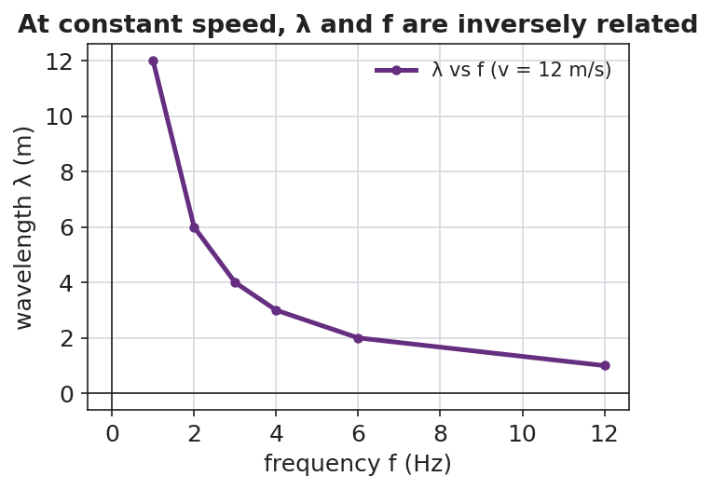
A line graph of wavelength versus frequency at a constant wave speed of 12 m/s, showing an inverse (curved-down) relationship.
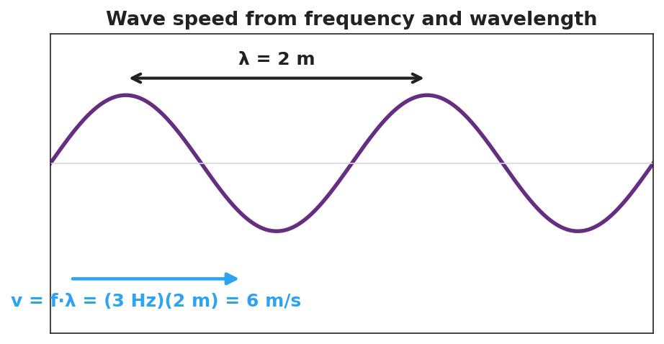
A wave with wavelength λ = 2 m labeled, showing the worked relationship v = f·λ = (3 Hz)(2 m) = 6 m/s.

Teacher facilitation during Explore
- What to look for — pairs noticing f·λ stays (nearly) constant; the λ-vs-f graph curving downward (inverse, not straight-line).
- What to resist — don’t write v = f·λ on the board yet; let the constant product surface from the data.
- What to redirect — students who expect a straight line should be asked, “if f goes up and the product stays the same, what must λ do?”

Phase 3 · Explain (32 – 37 min)

32–35 min · Turn-and-Talk #2 + class consensus
“Why did f·λ come out the same in every row?”
Target consensus:
“Because f·λ equals the wave’s speed, and the speed didn’t change — it’s set by the medium. So when f goes up, λ must go down to keep the product (the speed) the same.”

35–37 min · Vocabulary introduction (≤ 3 terms) + the HOCHMAN sentence
Sample teacher language:
“That constant product is the wave speed: v = f·λ. Frequency is measured in hertz (cycles per second), and the time for one cycle is the period, T = 1/f.”
HOCHMAN Because/But/So expansion (do this aloud, then students write):
“In a given medium the wave speed is constant because the medium sets how fast a disturbance travels, but the source can change the frequency, so the wavelength must change in the opposite direction to keep v = f·λ true.”

Discussion prompts to deploy here
- “A wave travels at 340 m/s with a frequency of 170 Hz. What is its wavelength?”
  - Sample student response: “λ = v/f = 340/170 = 2 m.”
- “If you double the frequency at the same speed, what happens to the wavelength?”
  - Sample student response: “It halves — they’re inversely related.”

Phase 4 · Elaborate (37 – 40 min)

37–39 min · Revise the model
“Return to your prediction. Was it right? Re-write it as a Because/But/So sentence using v = f·λ and the words wave speed, frequency, and wavelength.”

39–40 min · Return to the phenomenon
“Back to the guitar: the thin string and thick string can carry the same note’s speed — so why do they sound different? Answer in one sentence using frequency and wavelength.”
Target: “Each string’s wave speed is fixed, so a different frequency (pitch) means a different wavelength — that’s why thinner/shorter strings sound higher.”

Phase 5 · Evaluate (40 – 42 min)

40–42 min · Exit Ticket + Closing Reflection
“A sound wave in air travels at 340 m/s. (a) A note has a frequency of 256 Hz. Find its wavelength. Show v = f·λ rearranged. (b) A higher note has a frequency of 512 Hz at the same speed. Without a calculator, is its wavelength longer or shorter, and by what factor? (c) What is the period of the 256 Hz note?”
Expected: (a) λ = v/f = 340/256 ≈ 1.33 m; (b) shorter — half the wavelength, since frequency doubled at the same speed; (c) T = 1/f = 1/256 ≈ 0.0039 s. See Answer_Key.docx.
Closing Reflection (SEL, 30 seconds):
“What is one thing about the v = f·λ relationship that finally clicked today?”

Common Misconceptions
- Misconception: “Increasing the frequency makes the wave travel faster.” → Correction: Speed is set by the medium; raising f shortens λ instead — the product v = f·λ stays the same.
- Misconception: “Wavelength and frequency are directly proportional.” → Correction: At constant speed they are inversely proportional (f up → λ down).
- Misconception: “Period and frequency are the same number.” → Correction: They are reciprocals; a 256 Hz note has a tiny period of about 0.0039 s.

Access & Differentiation
- ELL/ENL supports: Provide the formula triangle (v on top; f and λ on the bottom) and a sentence frame: “When frequency goes ______, wavelength goes ______, because the speed stays ______.” Word-choice box: {up, down, constant, inversely}.
- IEP/SPED supports: Give a partially completed v = f·λ table; students fill only the missing cell using the formula triangle. Provide calculators and a worked first row.
- Extensions: Different media — a sound wave moving from air (340 m/s) into water (~1500 m/s) keeps the same frequency (set by the source). What happens to its wavelength? (It gets longer.) Preview of refraction (Lesson 08).

Strategy Spotlight
HOCHMAN. The key relationship is built as a single complex sentence using Because / But / So. Model it aloud first, then have students write their own. The conjunctions force the causal logic: the speed is fixed because the medium sets it, but the source changes the frequency, so the wavelength must change in the opposite direction. This sentence-level expansion is the literacy core of the lesson; collect a few and read them back to refine precision (e.g., replacing “changes” with “decreases”).

NYSSLS Observation Checklist Crosswalk
# | Checklist item | Where it appears in this lesson
1 | Local/relatable phenomenon | Phase 1 — guitar strings; sound wave in Phase 5
2 | Turn and Talk (2–3×) | Phase 1 (TT#1 — same speed, different f), Phase 3 (TT#2 — why f·λ is constant)
3 | Students develop questions/models/procedures | Phase 1 (prediction), Phase 2 (PhET data table + graph), Phase 4 (revise)
4 | CCC defined and used | Lesson Overview · Cause and Effect, restated in Phase 2
5 | ENL — ≤ 3 vocab, second half | Phase 3 — vocabulary at 35–37 min (wave speed / period / hertz)
6 | Revisit phenomenon with evidence | Phase 4 — guitar explanation using v = f·λ
7 | ENL/SPED supports | Access & Differentiation block
8 | Assessment check | Phase 5 — numeric Exit Ticket (sound in air)

Companion Materials
- Student_Worksheet.docx — the 5E student investigation (hand out at start of Phase 2)
- Student_Notes.docx — guided note-guide for vocabulary and the worked example
- Answer_Key.docx — answers to “Make It Make Sense” prompts and the Exit Ticket

Key Vocabulary (max 3)
- wave speed — how fast a wave’s energy travels through a medium; v = f·λ, set by the medium (not by amplitude or frequency)
- period — the time for one complete wave cycle, in seconds; the reciprocal of frequency, T = 1/f
- hertz — the unit of frequency, equal to one cycle per second (Hz)

Wave Speed, Frequency, and Wavelength — Student Worksheet
Unit: Waves — Lesson 03 Name: _______________________ Date: __________ Period: ____

Phenomenon
Your teacher plucks a thick low string and a thin high string the same way — they sound like completely different notes. The wave speed on each string is fixed by the string itself, yet the pitches are not the same.
Driving question: If two notes travel at the same speed, what must be different about their waves?

Notice & Wonder
I notice… | I wonder…
Turn & Talk #1: If two waves on a string travel at the same speed but have different frequencies, what has to be different about their wavelengths?

Initial Model
Predict: if you keep the wave speed the same but double the frequency, what happens to the wavelength? Write your prediction and a reason.

My reason: _______________________________________________

Investigation
Open PhET Wave on a String in oscillate mode with the tension fixed (so the speed stays constant). Use the ruler to measure one wavelength at each frequency.
Frequency f (Hz) | Wavelength λ (m) | Product f × λ
These figures show the pattern you are testing:

Wavelength versus frequency at constant speed — an inverse relationship.

A wave labeled with λ = 2 m and the worked relationship v = f·λ = (3 Hz)(2 m) = 6 m/s.
Key question: What do you notice about the column f × λ? What does that product represent?

Make It Make Sense
- A wave travels at 340 m/s with a frequency of 170 Hz. Find its wavelength. Show v = f·λ rearranged.
- At a fixed wave speed, you triple the frequency. What happens to the wavelength, and by what factor?
- Write a Because/But/So sentence explaining why frequency and wavelength are inversely related at a constant wave speed.

Vocabulary in Action
Use each term in a sentence about today’s investigation.
- wave speed: _______________________________________________
- period: _______________________________________________
- hertz: _______________________________________________

Revise Your Model
Return to your prediction. Was it right? Rewrite it as a Because / But / So sentence using v = f·λ and the words wave speed, frequency, and wavelength.
Because __________________________________________, but __________________________________________, so __________________________________________.

Exit Ticket
A sound wave in air travels at 340 m/s.
- A note has a frequency of 256 Hz. Find its wavelength. Show v = f·λ rearranged.
- A higher note has a frequency of 512 Hz at the same speed. Without a calculator, is its wavelength longer or shorter, and by what factor?
- What is the period of the 256 Hz note?

Wave Speed, Frequency, and Wavelength — Student Notes
Unit: Waves — Lesson 03 Name: _______________________ Date: __________ Period: ____

Learning Targets
By the end of today’s 42 minutes I can:
- Use v = f·λ to solve for speed, frequency, or wavelength.
- Explain why, in a given medium, frequency and wavelength are inversely related.
- Convert between period and frequency with T = 1/f.

Key Vocabulary
- wave speed — _______________________________________________
- period — _______________________________________________
- hertz — _______________________________________________

Guided Notes
The wave equation: v = f · λ
- v = wave __________ (m/s)
- f = __________ (Hz)
- λ = __________ (m)
Big idea. In a given medium the wave speed is __________ (set by the medium). So if the source raises the frequency, the wavelength must go __________ to keep the product the same.

Wavelength versus frequency at constant speed — an inverse relationship.
- Higher frequency → __________ wavelength (inverse).
- The product f·λ always equals the __________.
Period and frequency are reciprocals:
- T = 1 / __________ and f = 1 / __________.

A wave labeled with λ = 2 m and v = f·λ = (3 Hz)(2 m) = 6 m/s.

Worked Example
Problem. A wave travels at 6 m/s. Its frequency is 3 Hz. (a) Find the wavelength. (b) Find the period.
Solution. 1. Rearrange v = f·λ for wavelength: λ = v / f = 6 / 3 = __________ m. 2. Period: T = 1 / f = 1 / 3 = __________ s (about 0.33 s). 3. Check with v = f·λ: (3 Hz)(2 m) = __________ m/s. ✓

Summary
Finish the sentence (Because / But / So):
In one medium the wave speed stays the same because __________________________________________, but __________________________________________, so __________________________________________.

Wave Speed, Frequency, and Wavelength — Answer Key

Cover
Unit: Waves — Lesson 03: Wave Speed, Frequency, and Wavelength East Meadow Schools × Valley Stream Central HSD Strategy chip: HOCHMAN

Make-It-Make-Sense Answers
- Rearrange v = f·λ → λ = v/f = 340 / 170 = 2 m. · Rubric: correct rearrangement AND value with units. · NYSSLS: HS-PS4-1
- Tripling the frequency at fixed speed makes the wavelength one-third as long (inverse relationship). · Rubric: states 1/3 AND inverse reasoning. · NYSSLS: HS-PS4-1
- Example: “The wave speed stays constant because the medium sets how fast a disturbance moves, but the source can raise the frequency, so the wavelength must shrink to keep v = f·λ true.” · Rubric: correct Because/But/So with inverse logic. · NYSSLS: HS-PS4-1

Exit Ticket Answer
- λ = v/f = 340 / 256 ≈ 1.33 m.
- Shorter — half the wavelength (≈ 0.66 m), because doubling the frequency at the same speed halves the wavelength.
- T = 1/f = 1/256 ≈ 0.0039 s (about 3.9 ms).
Tolerance/rubric: (a) 1.3–1.33 m with v = f·λ shown; (b) “half / shorter by factor 2”; (c) ≈ 0.0039 s. 1 point each. NYSSLS: HS-PS4-1.

Closing Reflection (rubric)
Formative, not graded. Award full credit for any honest response. Look for: - A specific statement of what clicked about v = f·λ (often the inverse trade-off) - Genuine reflection rather than a restated definition

Standing Waves and Resonance — Teacher Guide

Cover
Unit: Waves — Lesson 04: Standing Waves and Resonance East Meadow Schools × Valley Stream Central High School District Strategy chips: ACTIVE LEARNING

Curated Resources (from East Meadow Scope & Sequence)

NYSSLS Standards
HS-PS4-1. “Use mathematical representations to support a claim regarding relationships among the frequency, wavelength, and speed of waves traveling in various media. (Cause and Effect)”
Standing waves are a direct consequence of v = f·λ on a bounded medium: only certain wavelengths (and therefore certain frequencies) “fit” between the fixed ends, producing the harmonic series. Resonance is the Cause-and-Effect link — driving a system at one of its natural frequencies causes a large-amplitude response.

Phenomenon
- A standing wave on a vibrating string (Melde’s experiment) and a “musical fire table” (a Rubens’ tube) showing standing sound waves: https://www.youtube.com/watch?v=PHRO_d0M5wo
- An opera singer shattering a wine glass by matching its resonant frequency: https://www.youtube.com/watch?v=BE827gwnnk4

Javalab / Labs
- Javalab Standing Wave — drive a fixed-end string and watch nodes and antinodes form at the natural frequencies: https://javalab.org/en/standing_wave_en/

Assessments
- Javalab “find the harmonics” task: students sweep the driving frequency to locate the first three standing-wave patterns and count nodes/antinodes. Exit ticket below serves as the formative check.

Lesson Overview
Duration | 42 minutes (1 period)
NYSSLS link | HS-PS4-1 (which wavelengths “fit”; resonance)
CCC focus | Cause and Effect — driving a bounded medium at a natural frequency causes a large, stable standing-wave pattern.
Strategy chips | ACTIVE LEARNING
Materials | Long elastic cords or strings (one per group); a function generator/string vibrator OR a hand-shaken rope; tuning forks; a wine glass + dampened finger (demo); devices for Javalab.
Safety | Eye protection if doing a real glass-shatter demo; otherwise show the video.
Prior knowledge | Lessons 01–03 — wavelength, frequency, v = f·λ; reflection of a wave at a fixed end.
Lesson objectives — students can:
- Explain that a standing wave forms when a wave interferes with its own reflection, creating fixed nodes and antinodes.
- Identify nodes (no motion) and antinodes (maximum motion) and count them for the first few harmonics.
- Explain resonance: a large response occurs when a system is driven at one of its natural frequencies.

Phase 1 · Engage (0 – 12 min)

0–3 min · Opening Connection (SEL)
Quick check-in: “Name something that ‘clicks’ for you when the timing is just right — a song, a sport, a routine.” One sentence each. This previews resonance: the right timing produces a big effect.

3–8 min · Phenomenon hook — the glass and the string
Teacher actions. Play the wine-glass shatter clip, then shake a rope at increasing speed until a clean standing-wave loop snaps into place. Most frequencies make a messy rope; one special frequency makes a clean, big, standing pattern.
Sample teacher language:
“Most of the time the rope just looks chaotic. But at one special speed of my hand, it locks into this beautiful, big, still-looking pattern. What’s special about that frequency?”
Anticipated student responses:
- “It looks like it’s standing still.” — capture standing; the loops stay in place.
- “You hit the right rhythm.” — affirm; that’s resonance in everyday words.
- “The wave bounced back and added to itself.” — excellent; this is the mechanism.

8–12 min · Notice & Wonder + Turn-and-Talk #1
Capture columns. Then:
“Turn to your partner: where on the rope is there no motion at all, and where is the motion biggest?”
Target: there are points that never move (future nodes) and points that swing the most (future antinodes).

Bridge to Phase 2
Initial model sentence: “A clean, big rope pattern formed because the wave and its ______ added together at just the right ______.”

Phase 2 · Explore (12 – 32 min)

12–17 min · Initial Model (silent / individual)
Prompt:
“Sketch the rope at the special frequency. Mark with an X every point that does not move, and with a star every point that moves the most. Predict what happens to the number of loops if you shake faster.”

17–32 min · Investigation — ACTIVE LEARNING: hunt the harmonics
Groups of 3–4, each with a string/cord (one end fixed or held, the other shaken or driven) and Javalab open:
- Find the fundamental. Shake slowly and increase frequency until one clean loop appears. Mark the still points and the big-swing point.
- Climb the series. Keep increasing frequency. Catch the 2-loop pattern, then the 3-loop pattern. Record how many nodes and antinodes each has.
- Off-resonance test. Set a frequency between two harmonics. What does the rope do? (Messy, small.)
- Javalab confirm. Reproduce the first three harmonics in the sim; count nodes/antinodes.
Use this figure to compare each group’s harmonics:
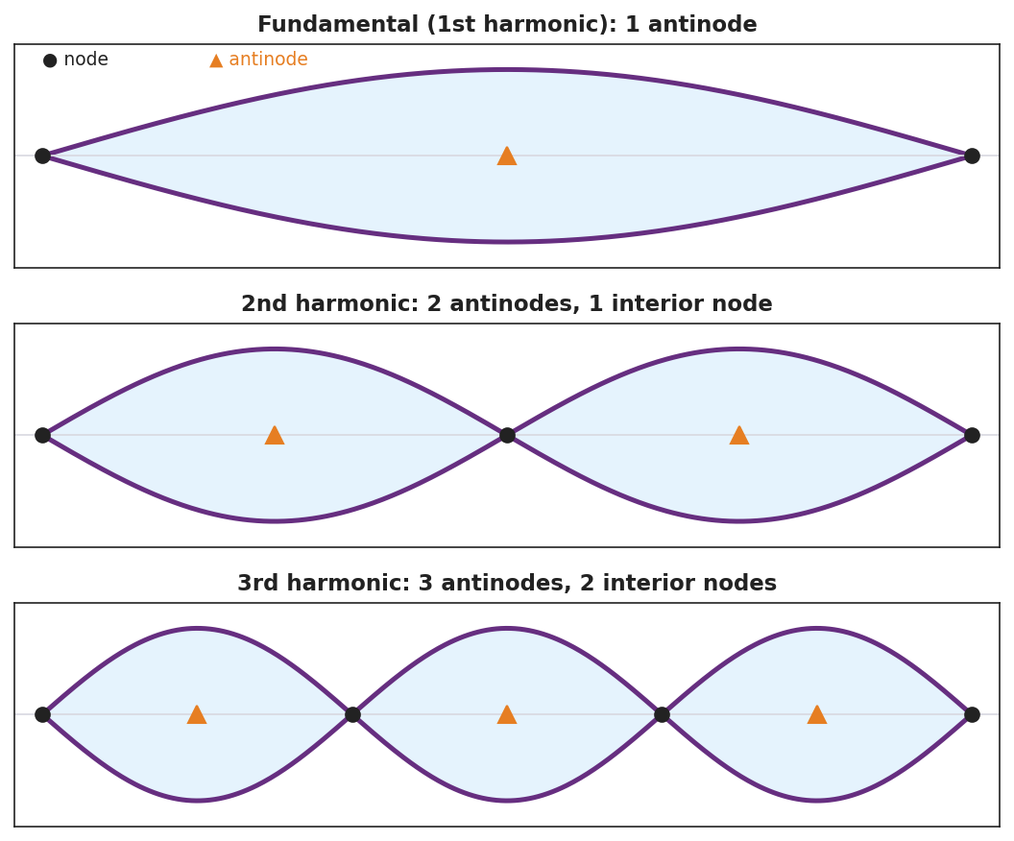
Three fixed-end standing-wave patterns: the fundamental (1 antinode), the 2nd harmonic (2 antinodes, 1 interior node), and the 3rd harmonic (3 antinodes, 2 interior nodes), with nodes and antinodes marked.
The resonance curve below explains why only the off-resonance test (step 3) gives a small, messy response — amplitude spikes sharply only at the natural frequency:
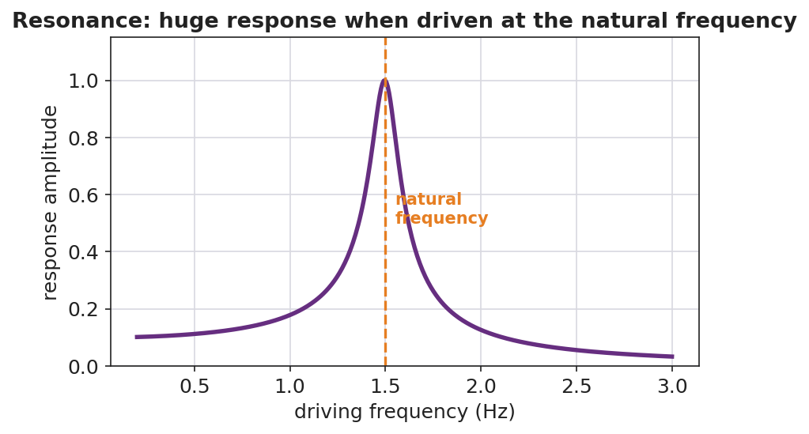
A resonance response curve: response amplitude is small at most driving frequencies but spikes sharply at the natural frequency.

Teacher facilitation during Explore
- What to look for — groups connecting “only certain hand-speeds work” to “only certain wavelengths fit between the ends.”
- What to resist — don’t name node/antinode/resonance yet; let “still point” and “big-swing point” and “the right speed” emerge.
- What to redirect — students who think the pattern travels should be asked, “do the loops move along the rope, or stay in place?”

Phase 3 · Explain (32 – 37 min)

32–35 min · Turn-and-Talk #2 + class consensus
“Why does only the right frequency make a clean, standing pattern?”
Target consensus:
“The wave reflects off the fixed end and travels back. At certain frequencies the returning wave lines up with the new wave so they always add the same way, creating a pattern that stays in place with fixed still points and big-swing points.”

35–37 min · Vocabulary introduction (≤ 3 terms)
Sample teacher language:
“A pattern that stays in place from a wave interfering with its own reflection is a standing wave. The points that never move are nodes; the points of maximum motion are antinodes. And when you drive a system at one of its natural frequencies and get this big response, that’s resonance — exactly how the opera singer shattered the glass.”

Discussion prompts to deploy here
- “How many nodes does the 3rd harmonic have between the two ends?”
  - Sample student response: “Two interior nodes (plus the two fixed ends).”
- “Why did the glass shatter only at one pitch?”
  - Sample student response: “That pitch matched the glass’s natural frequency — resonance built the vibration up until it broke.”

Phase 4 · Elaborate (37 – 40 min)

37–39 min · Revise the model
“Return to your rope sketch. Re-label the X’s as nodes and the stars as antinodes. Add a one-sentence definition of resonance using the word natural frequency.”

39–40 min · Return to the phenomenon
“Explain to a peer, in one sentence, why pushing a swing at just the right rhythm makes it go higher — and connect it to the rope and the glass.”
Target: “Pushing at the swing’s natural frequency is resonance, the same reason the rope locks into a standing wave and the glass shatters — driving at the natural frequency builds a large response.”

Phase 5 · Evaluate (40 – 42 min)

40–42 min · Exit Ticket + Closing Reflection
“A standing wave on a string shows 2 full loops between the fixed ends. (a) How many nodes are there in total (including the ends)? How many antinodes? (b) Define resonance in one sentence. (c) A bridge can sway dangerously if wind or marching feet hit a certain frequency. Which idea from today explains this?”
Expected: (a) 3 nodes (two ends + one middle), 2 antinodes; (b) resonance = large-amplitude response when a system is driven at its natural frequency; (c) resonance. See Answer_Key.docx.
Closing Reflection (SEL, 30 seconds):
“When did your group hit ‘resonance’ today — a moment where everything clicked? What made it work?”

Common Misconceptions
- Misconception: “A standing wave is not really moving.” → Correction: It is two waves moving in opposite directions; the pattern of nodes/antinodes stays fixed while the medium still oscillates.
- Misconception: “Any frequency makes a standing wave.” → Correction: Only the natural frequencies (where reflections line up) produce standing waves; other frequencies give a messy, small response.
- Misconception: “Resonance is just ‘loud.’” → Correction: Resonance is a large-amplitude response that occurs specifically when the driving frequency matches a natural frequency.

Access & Differentiation
- ELL/ENL supports: Sentence frame: “A node is a point that ______; an antinode is a point that ______. Resonance happens when the driving frequency ______ a natural frequency.” Word-choice box: {never moves, moves the most, matches, standing wave}. Pair node with a closed fist (no motion) and antinode with a wide wave of the hand.
- IEP/SPED supports: Provide the harmonics figure with blanks; students label N (node) and A (antinode) rather than drawing. Offer the hand-shaken rope as a tactile alternative to the function generator.
- Extensions: For a fixed-fixed string of length L, the fundamental wavelength is 2L. Have students predict the wavelengths of the 2nd and 3rd harmonics (L and 2L/3) and use v = f·λ to relate the harmonic frequencies.

Strategy Spotlight
ACTIVE LEARNING. Students physically sweep the driving frequency and “catch” each harmonic, marking the still points and big-swing points with their own hands before the words node, antinode, and resonance are introduced. The act of hunting — most frequencies fail, a few succeed — builds an intuition for natural frequencies that a lecture cannot. Facilitate with one prompt: “What’s special about the frequencies that work?”

NYSSLS Observation Checklist Crosswalk
# | Checklist item | Where it appears in this lesson
1 | Local/relatable phenomenon | Phase 1 — shattering glass, shaken rope; bridge/swing in Phase 4–5
2 | Turn and Talk (2–3×) | Phase 1 (TT#1 — still vs. big-swing points), Phase 3 (TT#2 — why only the right frequency)
3 | Students develop questions/models/procedures | Phase 1 (initial model), Phase 2 (harmonic hunt + Javalab), Phase 4 (revise)
4 | CCC defined and used | Lesson Overview · Cause and Effect, restated in Phase 2
5 | ENL — ≤ 3 vocab, second half | Phase 3 — vocabulary at 35–37 min (standing wave / node / resonance)
6 | Revisit phenomenon with evidence | Phase 4 — swing/glass/rope connection
7 | ENL/SPED supports | Access & Differentiation block
8 | Assessment check | Phase 5 — Exit Ticket (2-loop standing wave; bridge)

Companion Materials
- Student_Worksheet.docx — the 5E student investigation (hand out at start of Phase 2)
- Student_Notes.docx — guided note-guide for vocabulary and the worked example
- Answer_Key.docx — answers to “Make It Make Sense” prompts and the Exit Ticket

Key Vocabulary (max 3)
- standing wave — a fixed pattern of nodes and antinodes formed when a wave interferes with its own reflection in a bounded medium
- node — a point in a standing wave that stays at rest (no motion) because the two waves always cancel there
- resonance — the large-amplitude response that occurs when a system is driven at one of its natural frequencies

Standing Waves and Resonance — Student Worksheet
Unit: Waves — Lesson 04 Name: _______________________ Date: __________ Period: ____

Phenomenon
An opera singer holds one steady note and a wine glass shatters. On a shaken rope, most hand-speeds make a messy mess — but at one special speed the rope locks into a clean, big pattern that seems to stand still.
Driving question: What is special about the one frequency that makes a clean, standing pattern?

Notice & Wonder
I notice… | I wonder…
Turn & Talk #1: On the rope at the special frequency, where is there no motion at all, and where is the motion biggest?

Initial Model
Sketch the rope at the special frequency. Mark with an X every point that does not move, and a star at every point that moves the most. Predict: what happens to the number of loops if you shake faster?

My prediction: _______________________________________________

Investigation
Work in a group of 3–4 with a string and the Javalab Standing Wave sim.
Step | Frequency / speed | Number of loops | Nodes (still points) | Antinodes (big-swing)
1. Fundamental
2. Next harmonic
3. Third harmonic
4. Off-resonance (between) |  | (messy?)
Compare your patterns to this diagram:

Three standing-wave harmonics with nodes and antinodes marked: fundamental, 2nd, and 3rd.
Key question: What did the rope do at a frequency between two harmonics? What does that tell you about which frequencies “work”?

Make It Make Sense
- How does a standing wave form? Use the words reflection and interfere.
- The 3rd harmonic on a fixed-end string has how many nodes (including the ends) and how many antinodes?
- Why did the wine glass shatter at only one specific pitch? Use the word natural frequency.

Vocabulary in Action
Use each term in a sentence about today’s phenomenon.
- standing wave: _______________________________________________
- node: _______________________________________________
- resonance: _______________________________________________

Revise Your Model
Return to your rope sketch. Re-label the X’s as nodes and the stars as antinodes. Add a one-sentence definition of resonance using the words natural frequency.

Exit Ticket
A standing wave on a string shows 2 full loops between the fixed ends.
- How many nodes are there in total (including the ends)? How many antinodes?
- Define resonance in one sentence.
- A bridge can sway dangerously if wind or marching feet hit a certain frequency. Which idea from today explains this?

Standing Waves and Resonance — Student Notes
Unit: Waves — Lesson 04 Name: _______________________ Date: __________ Period: ____

Learning Targets
By the end of today’s 42 minutes I can:
- Explain how a standing wave forms from a wave and its reflection.
- Identify nodes and antinodes and count them for the first harmonics.
- Explain resonance in terms of natural frequency.

Key Vocabulary
- standing wave — _______________________________________________
- node — _______________________________________________
- resonance — _______________________________________________

Guided Notes
How a standing wave forms. A wave hits a fixed end and __________ back. The returning wave __________ (interferes) with the new wave. At certain frequencies they always add the same way, making a pattern that stays in __________.

Three standing-wave harmonics with nodes and antinodes labeled.
- Node — a point that __________ moves (the waves cancel there).
- Antinode — a point that moves the __________.
- Fundamental (1st harmonic) — __________ antinode.
- 2nd harmonic — __________ antinodes, 1 interior node.
- 3rd harmonic — 3 antinodes, __________ interior nodes.
Resonance. Driving a system at one of its __________ frequencies produces a __________ (large) response. Examples: a swing pushed in rhythm, a shattering glass, a vibrating string.

Worked Example
Problem. A standing wave on a string shows 3 full loops between the fixed ends.
Solution. 1. Each loop is one antinode → there are __________ antinodes. 2. Nodes appear between loops plus at both fixed ends → __________ nodes total. 3. This is the __________ harmonic.

Summary
Finish the sentence (Because / But / So):
A shaken rope usually looks messy because __________________________________________, but __________________________________________, so __________________________________________.

Standing Waves and Resonance — Answer Key

Cover
Unit: Waves — Lesson 04: Standing Waves and Resonance East Meadow Schools × Valley Stream Central HSD Strategy chip: ACTIVE LEARNING

Make-It-Make-Sense Answers
- A wave travels to a fixed end and reflects back. The reflected wave interferes with the incoming wave; at the natural frequencies they always add the same way, producing a fixed pattern of nodes and antinodes. · Rubric: uses reflection AND interference. · NYSSLS: HS-PS4-1
- The 3rd harmonic has 4 nodes (two fixed ends + two interior) and 3 antinodes. · Rubric: both counts correct. · NYSSLS: HS-PS4-1
- The glass has a natural frequency. When the singer’s pitch matched it, resonance built the glass’s vibration to a large amplitude until it shattered. · Rubric: names natural frequency AND resonance. · NYSSLS: HS-PS4-1

Exit Ticket Answer
- 2 full loops → 3 nodes total (both ends + one in the middle) and 2 antinodes (one per loop).
- Resonance is the large-amplitude response that happens when a system is driven at one of its natural frequencies.
- Resonance — the wind or marching feet drive the bridge at its natural frequency, building a dangerously large sway.
Tolerance/rubric: (a) 3 nodes AND 2 antinodes; (b) must include “natural frequency”; (c) resonance. 1 point each. NYSSLS: HS-PS4-1.

Closing Reflection (rubric)
Formative, not graded. Award full credit for any honest response. Look for: - A genuine “click” moment connected to the group’s harmonic hunt - Acknowledgment of what made the collaboration work

Interference: Constructive and Destructive — Teacher Guide

Cover
Unit: Waves — Lesson 05: Interference (Constructive and Destructive) East Meadow Schools × Valley Stream Central High School District Strategy chips: BTC

Curated Resources (from East Meadow Scope & Sequence)

NYSSLS Standards
HS-PS4-1. “Use mathematical representations to support a claim regarding relationships among the frequency, wavelength, and speed of waves traveling in various media. (Cause and Effect)”
Interference is the principle of superposition in action and is the mechanism behind the standing waves of Lesson 04. Two waves of the same frequency and wavelength add point-by-point; whether they reinforce or cancel depends on their phase — a Cause-and-Effect relationship between path difference and loudness/brightness.

Phenomenon
- Two speakers playing the same steady tone create “loud spots” and “quiet spots” as you walk across a room: https://www.youtube.com/watch?v=ImoQqDyHd1Y
- Noise-canceling headphones: a microphone hears the noise and the speaker plays the opposite wave to cancel it.

Javalab / Labs
- Javalab Wave Superposition / Interference — drag two waves together and watch them add: https://javalab.org/en/wave_synthesis_en/

Assessments
- Javalab superposition task: students align two waves in phase (predict the sum) and then shift one by half a wavelength (predict cancellation). Exit ticket below serves as the formative check.

Lesson Overview
Duration | 42 minutes (1 period)
NYSSLS link | HS-PS4-1 (superposition; mechanism of standing waves)
CCC focus | Cause and Effect — the phase relationship between two waves causes either reinforcement (constructive) or cancellation (destructive).
Strategy chips | BTC (Building Thinking Classrooms)
Materials | Vertical non-permanent surfaces (whiteboards/windows); markers; two small speakers + tone generator app; ripple-tank video or Javalab on devices.
Safety | Keep tone-generator volume moderate.
Prior knowledge | Lessons 01–04 — amplitude, wavelength, frequency; standing waves come from interfering reflections.
Lesson objectives — students can:
- State the principle of superposition: overlapping waves add point-by-point.
- Distinguish constructive interference (in phase → amplitudes add) from destructive interference (out of phase → amplitudes cancel).
- Explain a real “loud/quiet spot” or noise-canceling situation using interference.

Phase 1 · Engage (0 – 12 min)

0–3 min · Opening Connection (SEL)
Quick check-in: “Name a time two things combined to make something bigger — or two things canceled each other out.” One sentence each. This previews constructive vs. destructive.

3–8 min · Phenomenon hook — walk the room of two speakers
Teacher actions. Play the same steady tone from two speakers a few meters apart. Walk slowly across the front; students hear the volume rise and fall. Show the noise-canceling clip as the second case.
Sample teacher language:
“Same tone, two speakers, and yet some spots are loud and some are nearly silent — and I didn’t touch the volume. How can adding a second speaker make a spot quieter?”
Anticipated student responses:
- “The sounds cancel somewhere.” — exactly; capture cancel.
- “They add up in the loud spots.” — yes; reinforcement.
- “The waves are out of step.” — excellent; this is phase.

8–12 min · Notice & Wonder + Turn-and-Talk #1
Capture columns. Then:
“Turn to your partner: what would have to be true about the two waves arriving at a quiet spot for them to cancel?”
Target: they arrive out of step — a crest of one lands on a trough of the other.

Bridge to Phase 2
Initial model sentence: “A quiet spot happens because the two waves arrive ______, so they ______ each other.”

Phase 2 · Explore (12 – 32 min)

12–17 min · Initial Model (silent / individual)
Prompt:
“Draw two waves arriving at the same point. Draw one version that would make a LOUD spot and one that would make a QUIET spot. What’s different about how the crests line up?”

17–32 min · Investigation — BTC: random groups, vertical surfaces
Form visibly random groups of 3; send each to a vertical non-permanent surface with one marker per group. Pose the thin-slice tasks one at a time, escalating:
- Two identical waves, crest-on-crest. Draw the sum. (Bigger.)
- Two identical waves, crest-on-trough. Draw the sum. (Flat — zero.)
- Shift one wave by half a wavelength. What’s the sum now? Relate it to task 2.
- Stretch: In the two-speaker room, why does the quiet spot become loud if you cover one speaker? (Removing one wave removes the cancellation.)
Have students confirm at Javalab, then check predictions against this figure pair:
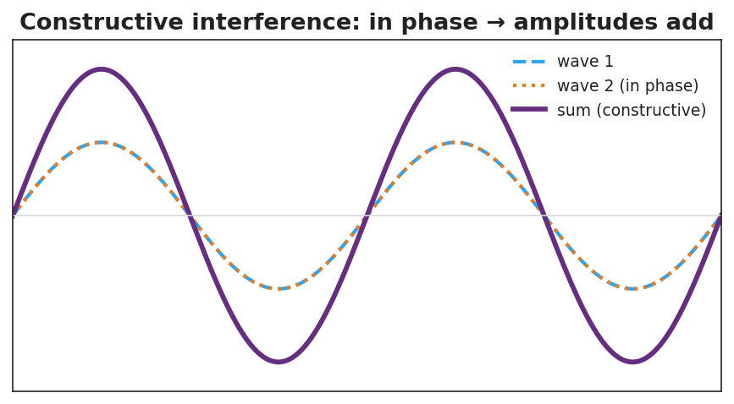
Two in-phase waves adding to a larger wave — constructive interference.
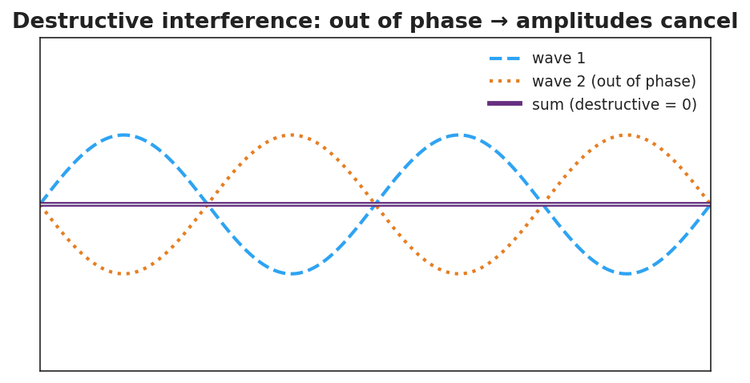
Two out-of-phase waves canceling to a flat line — destructive interference.

Teacher facilitation during Explore
- What to look for — groups adding waves point-by-point (sampling several x-values), not just eyeballing.
- What to resist — don’t supply “superposition,” “constructive,” or “destructive” yet; circulate and ask, “what did you do to combine them?”
- What to redirect — groups who say “they just disappear” should be asked, “where did the energy go — is it gone everywhere, or moved to the loud spots?”

Phase 3 · Explain (32 – 37 min)

32–35 min · Turn-and-Talk #2 + class consensus
“What is the rule for combining two overlapping waves, and what decides whether you get a loud or quiet result?”
Target consensus:
“You add the two waves point-by-point. If they’re in step (in phase), the crests add and you get a bigger wave. If they’re out of step (a crest on a trough), they cancel.”

35–37 min · Vocabulary introduction (≤ 3 terms)
Sample teacher language:
“Adding overlapping waves point-by-point is superposition. When they’re in phase and reinforce, that’s constructive interference. When they’re out of phase and cancel, that’s destructive interference — exactly how noise-canceling headphones silence a hum.”

Discussion prompts to deploy here
- “Two waves of amplitude 3 cm meet exactly in phase. What is the amplitude of the result?”
  - Sample student response: “6 cm — they add.”
- “The same two waves meet exactly out of phase. What is the result?”
  - Sample student response: “Zero — they cancel.”

Phase 4 · Elaborate (37 – 40 min)

37–39 min · Revise the model
“Return to your loud-spot and quiet-spot drawings. Label one constructive and one destructive. Add a sentence using the word superposition.”

39–40 min · Return to the phenomenon
“Explain in one sentence how noise-canceling headphones make a hum disappear, using destructive interference.”
Target: “The headphones play a wave that is exactly out of phase with the hum, so by superposition the two cancel — destructive interference — and you hear silence.”

Phase 5 · Evaluate (40 – 42 min)

40–42 min · Exit Ticket + Closing Reflection
“Two speakers play the same tone. At one point in the room a listener hears almost nothing. (a) Is this constructive or destructive interference? (b) Describe how the two waves are arriving at that point (in phase or out of phase?). (c) Two waves of amplitude 4 cm meet exactly in phase. What is the resulting amplitude?”
Expected: (a) destructive; (b) out of phase — crest meets trough; (c) 8 cm. See Answer_Key.docx.
Closing Reflection (SEL, 30 seconds):
“In your random group today, when did your thinking ‘add up’ (constructive) — and was there a moment it ‘canceled’ and you had to rethink?”

Common Misconceptions
- Misconception: “When two waves cancel, the energy is destroyed.” → Correction: Energy is conserved — it is redistributed to the constructive (loud/bright) regions; cancellation is local.
- Misconception: “Two waves always make a bigger wave.” → Correction: Only if in phase; out of phase they cancel.
- Misconception: “Interference only happens with sound.” → Correction: All waves interfere — light, water, and radio waves too.

Access & Differentiation
- ELL/ENL supports: Sentence frame: “When two waves are ______ they add (constructive); when they are ______ they cancel (destructive).” Word-choice box: {in phase, out of phase, superposition, amplitude}. Pair constructive with hands coming together and destructive with hands canceling.
- IEP/SPED supports: Provide graph paper with two pre-drawn waves aligned; students add the y-values at marked x-points to build the sum. Offer a “crest + trough = flat” manipulative (two transparency sine curves to overlay).
- Extensions: Path difference — explain why a fixed point is loud or quiet in terms of the difference in distance to the two speakers (a whole number of wavelengths → constructive; a half-wavelength offset → destructive).

Strategy Spotlight
BTC (Building Thinking Classrooms). Use visibly random groups of 3 and vertical non-permanent surfaces (whiteboards/windows), one marker per group. Pose the interference tasks as escalating thin slices — start with crest-on-crest, then crest-on-trough, then a half-wavelength shift — giving each task only after the previous is solved. The vertical surface keeps thinking public and erasable; the single marker forces collaboration. Defer all vocabulary to Phase 3.

NYSSLS Observation Checklist Crosswalk
# | Checklist item | Where it appears in this lesson
1 | Local/relatable phenomenon | Phase 1 — two-speaker loud/quiet spots; noise-canceling headphones
2 | Turn and Talk (2–3×) | Phase 1 (TT#1 — cancellation condition), Phase 3 (TT#2 — the combining rule)
3 | Students develop questions/models/procedures | Phase 1 (initial model), Phase 2 (BTC vertical-surface tasks + Javalab), Phase 4 (revise)
4 | CCC defined and used | Lesson Overview · Cause and Effect, restated in Phase 2
5 | ENL — ≤ 3 vocab, second half | Phase 3 — vocabulary at 35–37 min (superposition / constructive / destructive)
6 | Revisit phenomenon with evidence | Phase 4 — noise-canceling explanation
7 | ENL/SPED supports | Access & Differentiation block
8 | Assessment check | Phase 5 — Exit Ticket (quiet spot; amplitude sum)

Companion Materials
- Student_Worksheet.docx — the 5E student investigation (hand out at start of Phase 2)
- Student_Notes.docx — guided note-guide for vocabulary and the worked example
- Answer_Key.docx — answers to “Make It Make Sense” prompts and the Exit Ticket

Key Vocabulary (max 3)
- superposition — the principle that when waves overlap, the total displacement is the point-by-point sum of the individual waves
- constructive interference — when waves meet in phase so their amplitudes add, producing a larger wave (louder/brighter)
- destructive interference — when waves meet out of phase so their amplitudes cancel, producing a smaller wave or silence

Interference: Constructive and Destructive — Student Worksheet
Unit: Waves — Lesson 05 Name: _______________________ Date: __________ Period: ____

Phenomenon
Two speakers play the exact same steady tone. As you walk across the room, the volume rises and falls — some spots are loud, some are nearly silent — and nobody touched the volume knob. Noise-canceling headphones do something even stranger: they add sound to create silence.
Driving question: How can adding a second wave make a spot quieter?

Notice & Wonder
I notice… | I wonder…
Turn & Talk #1: What would have to be true about two waves arriving at a quiet spot for them to cancel?

Initial Model
Draw two waves arriving at the same point. Draw one version that makes a LOUD spot and one that makes a QUIET spot. What is different about how the crests line up?

Investigation
Work in your random group of 3 at a vertical surface (one marker). Solve each task, then confirm in Javalab.
Task | Sketch the sum | What I found
1. Crest-on-crest
2. Crest-on-trough
3. Shift one wave by ½ wavelength
4. Why does covering one speaker make a quiet spot loud?
Compare your sketches to these:

Two in-phase waves adding to a larger wave — constructive interference.

Two out-of-phase waves canceling to a flat line — destructive interference.
Key question: When two waves cancel at a quiet spot, where did the energy go? Is it gone everywhere?

Make It Make Sense
- State the principle of superposition in your own words.
- Two waves of amplitude 3 cm meet exactly in phase. What is the resulting amplitude? What if they meet exactly out of phase?
- Explain how noise-canceling headphones make a hum disappear. Use the term destructive interference.

Vocabulary in Action
Use each term in a sentence about today’s phenomenon.
- superposition: _______________________________________________
- constructive interference: _______________________________________________
- destructive interference: _______________________________________________

Revise Your Model
Return to your loud-spot and quiet-spot drawings. Label one constructive and one destructive. Add a sentence using the word superposition.

Exit Ticket
Two speakers play the same tone. At one point in the room a listener hears almost nothing.
- Is this constructive or destructive interference?
- Describe how the two waves are arriving at that point (in phase or out of phase?).
- Two waves of amplitude 4 cm meet exactly in phase. What is the resulting amplitude?

Interference: Constructive and Destructive — Student Notes
Unit: Waves — Lesson 05 Name: _______________________ Date: __________ Period: ____

Learning Targets
By the end of today’s 42 minutes I can:
- State the principle of superposition.
- Distinguish constructive interference from destructive interference.
- Explain a real loud/quiet spot or noise-canceling situation.

Key Vocabulary
- superposition — _______________________________________________
- constructive interference — _______________________________________________
- destructive interference — _______________________________________________

Guided Notes
Superposition. When two waves overlap, the total displacement at each point is the __________ of the two waves at that point. You add them __________-by-__________.

Two in-phase waves adding to a larger wave.
Constructive interference.
- The waves are __________ phase (crest lines up with crest).
- The amplitudes __________.
- Result: a __________ wave (louder / brighter).

Two out-of-phase waves canceling to a flat line.
Destructive interference.
- The waves are __________ phase (crest lines up with trough).
- The amplitudes __________.
- Result: a __________ wave, or silence.
Energy is not destroyed. At a cancellation point the energy is __________ to the constructive (loud) regions — total energy is conserved.

Worked Example
Problem. Two waves, each with amplitude 5 cm, overlap. Find the resulting amplitude (a) exactly in phase, (b) exactly out of phase.
Solution. 1. In phase: amplitudes add → 5 + 5 = __________ cm (constructive). 2. Out of phase: amplitudes cancel → 5 − 5 = __________ cm (destructive). 3. So the same two waves can make a big wave or __________, depending on phase.

Summary
Finish the sentence (Because / But / So):
Two speakers playing the same tone can make a spot silent because __________________________________________, but __________________________________________, so __________________________________________.

Interference: Constructive and Destructive — Answer Key

Cover
Unit: Waves — Lesson 05: Interference (Constructive and Destructive) East Meadow Schools × Valley Stream Central HSD Strategy chip: BTC

Make-It-Make-Sense Answers
- Superposition: when two waves overlap, the total displacement at each point equals the point-by-point sum of the two waves. · Rubric: conveys point-by-point addition. · NYSSLS: HS-PS4-1
- In phase → amplitudes add → 6 cm (constructive). Out of phase → amplitudes cancel → 0 cm (destructive). · Rubric: both values correct with phase reasoning. · NYSSLS: HS-PS4-1
- The headphone plays a wave that is exactly out of phase with the hum. By superposition the two cancel (destructive interference), so the listener hears silence. · Rubric: out-of-phase AND cancellation. · NYSSLS: HS-PS4-1

Exit Ticket Answer
- Destructive interference.
- The two waves arrive out of phase — a crest of one meets a trough of the other, so they cancel.
- In phase → amplitudes add → 8 cm.
Tolerance/rubric: (a) destructive; (b) out of phase / crest-on-trough; (c) 8 cm. 1 point each. NYSSLS: HS-PS4-1.

Closing Reflection (rubric)
Formative, not graded. Award full credit for any honest response. Look for: - A specific moment thinking “added up” or had to be revised within the random group - Evidence of reflection on the collaborative process at the vertical surface

The Doppler Effect — Teacher Guide

Cover
Unit: Waves — Lesson 06: The Doppler Effect East Meadow Schools × Valley Stream Central High School District Strategy chips: HOCHMAN

Curated Resources (from East Meadow Scope & Sequence)

NYSSLS Standards
HS-PS4-1. “Use mathematical representations to support a claim regarding relationships among the frequency, wavelength, and speed of waves traveling in various media. (Cause and Effect)”
The Doppler effect is a Cause-and-Effect consequence of v = f·λ: relative motion between source and observer compresses or stretches the wavelength, so the observed frequency shifts. Connection to HS-ESS1-2 (“Construct an explanation of the Big Bang theory based on astronomical evidence of light spectra…”): the same physics gives redshift, the evidence that distant galaxies are receding and the universe is expanding.

Phenomenon
- An ambulance siren drops in pitch the instant it passes you; a race car “neeee-yowwm”: https://www.youtube.com/watch?v=imoxDcn2Sgo
- Astronomers’ redshift: light from receding galaxies is shifted toward longer (redder) wavelengths.

Javalab / Labs
- Javalab Doppler Effect — drag a moving source and watch the wavefronts bunch ahead and stretch behind: https://javalab.org/en/doppler_effect_en/

Assessments
- Javalab observer task: students place observers ahead of and behind a moving source and report which hears a higher frequency. Exit ticket below serves as the formative check.

Lesson Overview
Duration | 42 minutes (1 period)
NYSSLS link | HS-PS4-1 (core); connects to HS-ESS1-2 (redshift / expanding universe)
CCC focus | Cause and Effect — relative motion of source/observer causes a shift in the observed frequency and wavelength.
Strategy chips | HOCHMAN
Materials | A buzzer or phone playing a steady tone on a string to whirl safely (or video); devices for Javalab; whiteboards.
Safety | If whirling a buzzer, clear a wide circle and use a secure string.
Prior knowledge | Lessons 01–03 — frequency, wavelength, v = f·λ; wavefront idea.
Lesson objectives — students can:
- Explain that the Doppler effect is an apparent frequency shift caused by relative motion of source and observer.
- Predict that an approaching source sounds higher-pitched and a receding source sounds lower-pitched.
- Connect the light version (blueshift/redshift) to evidence for an expanding universe.

Phase 1 · Engage (0 – 12 min)

0–3 min · Opening Connection (SEL)
Quick check-in: “Name a sound that tells you something is coming or going — a siren, footsteps, a train.” One sentence each. This primes the source-in-motion idea.

3–8 min · Phenomenon hook — the passing siren
Teacher actions. Play the ambulance clip. Ask students to listen for the exact moment the pitch changes. Whirl a buzzer on a string (or show the video) so they hear it live: higher as it swings toward them, lower as it swings away.
Sample teacher language:
“The driver of that ambulance hears one steady pitch the whole time. But you, standing on the curb, hear it drop the instant it passes. The siren didn’t change — so what did?”
Anticipated student responses:
- “It gets lower after it passes.” — exactly; capture approaching-vs-receding.
- “The sound stretches out.” — excellent; this is the wavelength idea.
- “It’s moving toward you then away.” — yes; relative motion.

8–12 min · Notice & Wonder + Turn-and-Talk #1
Capture columns. Then:
“Turn to your partner: if the siren makes the same pitch the whole time, why do you hear it change?”
Target: because the source is moving, the waves reaching you are bunched (approaching) or stretched (receding).

Bridge to Phase 2
Initial model sentence: “The pitch you hear changes because the moving source ______ the waves in front and ______ the waves behind.”

Phase 2 · Explore (12 – 32 min)

12–17 min · Initial Model (silent / individual)
Prompt:
“Draw a source sitting still, making circular wavefronts. Then draw the same source moving to the right. Show what happens to the spacing of the wavefronts ahead of it and behind it.”

17–32 min · Investigation — Javalab Doppler + wavefront sketching
Pairs at Javalab:
- Stationary source. Watch the evenly spaced circular wavefronts. Note the wavelength everywhere is the same.
- Moving source. Set the source moving. Compare the wavelength ahead of it vs. behind it.
- Place observers. One observer ahead, one behind. Which hears more wavefronts per second (higher frequency)?
- Light version. Read the sim’s note (or teacher’s) that light does the same: toward you = blueshift, away = redshift.
Use this figure to anchor the bunching/stretching pattern:
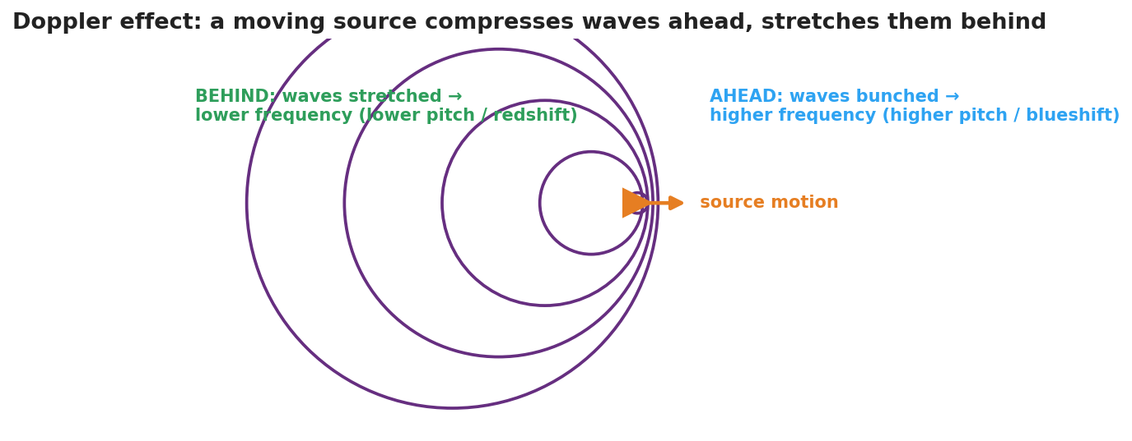
Concentric wavefronts from a source moving to the right: the circles bunch together ahead (higher frequency, blueshift) and spread out behind (lower frequency, redshift).
The bar chart below quantifies the same idea for a 700 Hz source: an observer ahead hears a higher frequency, an observer behind hears a lower one:
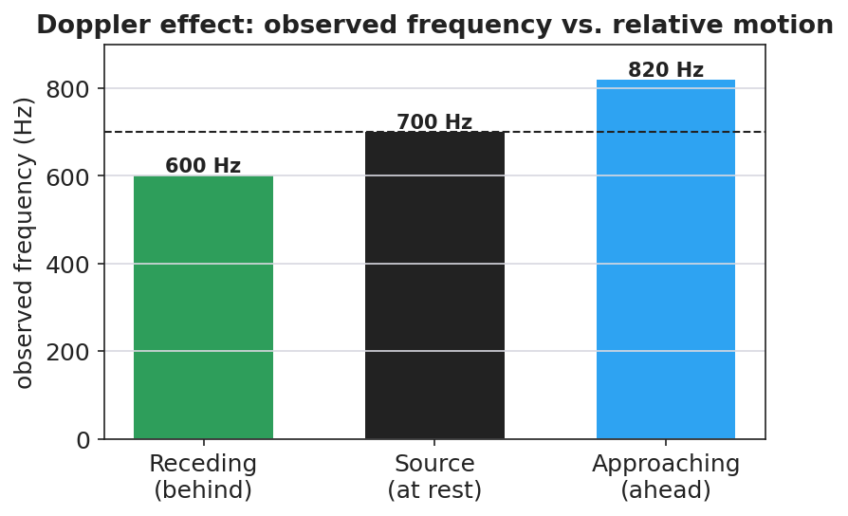
A bar chart of observed frequency for a 700 Hz source: about 600 Hz when receding (behind), 700 Hz at rest, and about 820 Hz when approaching (ahead).

Teacher facilitation during Explore
- What to look for — pairs stating that the wavelength changes ahead/behind, and connecting shorter wavelength to higher frequency (via v = f·λ).
- What to resist — don’t name “Doppler effect,” “frequency shift,” or “redshift” yet; let “bunched/stretched” and “higher/lower” emerge.
- What to redirect — students who think the source’s own pitch changes should re-watch the moving observer vs. the source’s frame.

Phase 3 · Explain (32 – 37 min)

32–35 min · Turn-and-Talk #2 + class consensus
“Why does an approaching source sound higher and a receding source sound lower?”
Target consensus:
“When the source moves toward you, each new wavefront is emitted a little closer, so the wavelength is shorter and the frequency you receive is higher. When it moves away, the wavelengths stretch and the frequency is lower.”

35–37 min · Vocabulary introduction (≤ 3 terms) + the HOCHMAN sentence
Sample teacher language:
“This apparent change in observed frequency due to relative motion is the Doppler effect. The change itself is a frequency shift. For light, a source moving away stretches the wavelength toward the red end — a redshift — which is exactly how astronomers know distant galaxies are racing away from us.”
HOCHMAN Because/But/So expansion (model aloud, then students write):
“A passing siren drops in pitch because the moving source compresses the wavelengths ahead and stretches them behind, but the source itself never changes its frequency, so only the observed frequency shifts as the source approaches and then recedes.”

Discussion prompts to deploy here
- “A star’s light is redshifted. Is it moving toward us or away from us?”
  - Sample student response: “Away — the wavelengths are stretched (longer/redder), so it’s receding.”
- “Does the Doppler effect change the speed of the wave in the medium?”
  - Sample student response: “No — the speed is set by the medium; only the observed wavelength and frequency change.”

Phase 4 · Elaborate (37 – 40 min)

37–39 min · Revise the model
“Return to your moving-source drawing. Label the bunched side ‘higher frequency (blueshift)’ and the stretched side ‘lower frequency (redshift).’ Write your Because/But/So sentence.”

39–40 min · Return to the phenomenon
“In one sentence, tell a friend why the ambulance sounds higher coming and lower going, using Doppler effect and frequency shift.”
Target: “The Doppler effect: as the ambulance approaches, the waves bunch up so I hear a higher frequency; as it recedes, they stretch out so I hear a lower frequency — a frequency shift caused by its motion.”

Phase 5 · Evaluate (40 – 42 min)

40–42 min · Exit Ticket + Closing Reflection
“A race car drives past a spectator. (a) Does the engine sound higher or lower as it approaches? Explain using wavelength. (b) After it passes, what happens to the pitch and why? (c) Astronomers see the light from a distant galaxy redshifted. What does this tell us about the galaxy’s motion, and what does that suggest about the universe?”
Expected: (a) higher — wavelengths bunch/shorten on approach; (b) lower — wavelengths stretch as it recedes; (c) the galaxy is moving away from us, evidence that the universe is expanding (HS-ESS1-2). See Answer_Key.docx.
Closing Reflection (SEL, 30 seconds):
“What’s one place you’ll now notice the Doppler effect in daily life?”

Common Misconceptions
- Misconception: “The source changes its pitch as it moves.” → Correction: The source’s frequency is constant; only the observed frequency shifts because of relative motion.
- Misconception: “The Doppler effect changes the wave’s speed.” → Correction: Speed is fixed by the medium; the wavelength and observed frequency change, not v.
- Misconception: “Redshift means the object is literally red.” → Correction: Redshift means the wavelengths are shifted toward the red (longer) end; the object is receding.

Access & Differentiation
- ELL/ENL supports: Sentence frame: “When a source moves ______ you, the waves bunch up and the frequency is ______; when it moves ______ you, the waves stretch and the frequency is ______.” Word-choice box: {toward, away, higher, lower, redshift, blueshift}. Pair approach (hand toward face) and recede (hand away) gestures.
- IEP/SPED supports: Provide the moving-source figure with the two sides blank; students label “higher/bunched” and “lower/stretched.” Offer the whirling-buzzer demo as the auditory anchor.
- Extensions: Police radar guns use the Doppler shift of reflected radio waves to measure car speed. Sketch how a larger speed produces a larger frequency shift.

Strategy Spotlight
HOCHMAN. The Doppler explanation is built as one complex sentence with Because / But / So, forcing students to hold the causal chain: the moving source compresses/stretches wavelengths, but the source frequency is unchanged, so only the observed frequency shifts. Model it, have students write their own, then read several aloud and tighten the language (e.g., distinguishing “observed frequency” from “the source’s frequency”). The appositive “a frequency shift” can be folded in for advanced writers.

NYSSLS Observation Checklist Crosswalk
# | Checklist item | Where it appears in this lesson
1 | Local/relatable phenomenon | Phase 1 — passing siren; race car in Phase 5; redshift connection
2 | Turn and Talk (2–3×) | Phase 1 (TT#1 — why you hear a change), Phase 3 (TT#2 — approach vs. recede)
3 | Students develop questions/models/procedures | Phase 1 (initial model), Phase 2 (Javalab + wavefront sketch), Phase 4 (revise)
4 | CCC defined and used | Lesson Overview · Cause and Effect, restated in Phase 2
5 | ENL — ≤ 3 vocab, second half | Phase 3 — vocabulary at 35–37 min (Doppler effect / frequency shift / redshift)
6 | Revisit phenomenon with evidence | Phase 4 — labeled moving-source model + Because/But/So
7 | ENL/SPED supports | Access & Differentiation block
8 | Assessment check | Phase 5 — Exit Ticket (race car; galaxy redshift)

Companion Materials
- Student_Worksheet.docx — the 5E student investigation (hand out at start of Phase 2)
- Student_Notes.docx — guided note-guide for vocabulary and the worked example
- Answer_Key.docx — answers to “Make It Make Sense” prompts and the Exit Ticket

Key Vocabulary (max 3)
- Doppler effect — the apparent change in a wave’s observed frequency caused by relative motion between the source and the observer
- frequency shift — the difference between the frequency emitted by the source and the frequency received by the observer
- redshift — a shift of light toward longer (redder) wavelengths, observed when a source moves away; evidence that distant galaxies are receding (an expanding universe)

The Doppler Effect — Student Worksheet
Unit: Waves — Lesson 06 Name: _______________________ Date: __________ Period: ____

Phenomenon
An ambulance races past you. The driver hears one steady siren the whole time — but you, on the curb, hear the pitch drop the instant it passes. Out in space, astronomers see the light from distant galaxies “shifted” toward red.
Driving question: If the siren makes the same pitch the whole time, why do you hear it change?

Notice & Wonder
I notice… | I wonder…
Turn & Talk #1: If the siren’s pitch is constant, why does the listener on the curb hear it change?

Initial Model
Draw a source sitting still, making circular wavefronts. Then draw the same source moving to the right. Show what happens to the spacing of the wavefronts ahead of it and behind it.

Investigation
Open Javalab Doppler Effect.
Step | What I observed
1. Stationary source — wavefront spacing
2. Moving source — spacing ahead vs. behind
3. Observer ahead vs. behind — who hears higher f?
4. Light version — toward = ______ , away = ______
Compare to this diagram:

Wavefronts from a source moving right: bunched ahead (higher frequency / blueshift), stretched behind (lower frequency / redshift).
Key question: When the source moves toward an observer, what happens to the wavelength they receive — and therefore to the frequency they hear?

Make It Make Sense
- Why does an approaching source sound higher in pitch? Use the word wavelength.
- A star’s light is redshifted. Is it moving toward us or away from us? How do you know?
- Does the Doppler effect change the speed of the wave in the medium? Explain.

Vocabulary in Action
Use each term in a sentence about today’s phenomenon.
- Doppler effect: _______________________________________________
- frequency shift: _______________________________________________
- redshift: _______________________________________________

Revise Your Model
Return to your moving-source drawing. Label the bunched side “higher frequency (blueshift)” and the stretched side “lower frequency (redshift).” Then write a Because / But / So sentence.
Because __________________________________________, but __________________________________________, so __________________________________________.

Exit Ticket
A race car drives past a spectator.
- Does the engine sound higher or lower as it approaches? Explain using wavelength.
- After it passes, what happens to the pitch and why?
- Astronomers see the light from a distant galaxy redshifted. What does this tell us about the galaxy’s motion, and what does that suggest about the universe?

The Doppler Effect — Student Notes
Unit: Waves — Lesson 06 Name: _______________________ Date: __________ Period: ____

Learning Targets
By the end of today’s 42 minutes I can:
- Explain the Doppler effect as an apparent shift caused by relative motion.
- Predict that an approaching source sounds higher and a receding source sounds lower.
- Connect light’s redshift to evidence for an expanding universe.

Key Vocabulary
- Doppler effect — _______________________________________________
- frequency shift — _______________________________________________
- redshift — _______________________________________________

Guided Notes
The big idea. The source makes a __________ frequency. But if the source (or observer) is __________, the observed frequency changes.

Wavefronts from a source moving right: bunched ahead, stretched behind.
Approaching source.
- Wavefronts ahead are __________ (bunched).
- Shorter wavelength → __________ frequency → higher pitch.
- For light: shifted toward blue (__________).
Receding source.
- Wavefronts behind are __________ (spread out).
- Longer wavelength → __________ frequency → lower pitch.
- For light: shifted toward red (__________).
Important: the wave speed does not change — only the observed __________ and __________ change.
Connection to astronomy (HS-ESS1-2). Distant galaxies show __________, so they are moving __________ from us — evidence the universe is __________.

Worked Example
Problem. You stand on a corner. A fire truck with a constant 700 Hz siren drives toward you, then away.
Solution. 1. As it approaches, the wavelengths bunch up, so you hear a frequency __________ than 700 Hz. 2. As it recedes, the wavelengths stretch, so you hear a frequency __________ than 700 Hz. 3. The driver always hears __________ Hz, because there is no relative motion between the driver and the siren.

Summary
Finish the sentence (Because / But / So):
A passing siren drops in pitch because __________________________________________, but __________________________________________, so __________________________________________.

The Doppler Effect — Answer Key

Cover
Unit: Waves — Lesson 06: The Doppler Effect East Meadow Schools × Valley Stream Central HSD Strategy chip: HOCHMAN

Make-It-Make-Sense Answers
- As the source approaches, each new wavefront is emitted a little closer to you, so the wavelength is shorter. By v = f·λ at constant speed, a shorter wavelength means a higher frequency → higher pitch. · Rubric: shorter wavelength → higher frequency. · NYSSLS: HS-PS4-1
- The star is moving away from us. Redshift means the wavelengths are stretched (longer/redder), which happens when the source recedes. · Rubric: away + redshift reasoning. · NYSSLS: HS-PS4-1 / HS-ESS1-2
- No. The wave speed is set by the medium and stays the same. Only the observed wavelength and frequency change. · Rubric: speed unchanged + reason. · NYSSLS: HS-PS4-1

Exit Ticket Answer
- Higher. Approaching, the wavefronts bunch up so the wavelength shortens; shorter wavelength → higher frequency → higher pitch.
- Lower. Receding, the wavefronts stretch so the wavelength lengthens → lower frequency → lower pitch.
- The galaxy is moving away from us. Because nearly all distant galaxies are redshifted, this is evidence that the universe is expanding (Big Bang / HS-ESS1-2).
Tolerance/rubric: (a) higher + wavelength shortening; (b) lower + wavelength stretching; (c) receding AND expanding universe. 1 point each. NYSSLS: HS-PS4-1, HS-ESS1-2.

Closing Reflection (rubric)
Formative, not graded. Award full credit for any honest response. Look for: - A specific everyday place the student will notice the Doppler effect - Genuine reflection rather than a restated definition

The Electromagnetic Spectrum — Teacher Guide

Cover
Unit: Waves — Lesson 07: The Electromagnetic Spectrum East Meadow Schools × Valley Stream Central High School District Strategy chips: ACTIVE LEARNING

Curated Resources (from East Meadow Scope & Sequence)

NYSSLS Standards
HS-PS4-1. “Use mathematical representations to support a claim regarding relationships among the frequency, wavelength, and speed of waves traveling in various media. (Cause and Effect)”
The EM spectrum is the ultimate test of v = f·λ: every band — radio to gamma — travels at the same speed c in vacuum, so the bands differ only by frequency and wavelength (which trade off inversely). Naming the order radio → micro → IR → visible → UV → X → gamma is a Cause-and-Effect application of v = f·λ at fixed v = c.

Phenomenon
- A single classroom “uses” the whole spectrum: the radio plays music (radio waves), the microwave heats lunch (microwaves), the remote works (infrared), you see the board (visible), sunscreen blocks sunburn (ultraviolet), the nurse takes an X-ray, and radiation therapy uses gamma rays: https://www.youtube.com/watch?v=cfXzwh3KadE

Javalab / Labs
- Javalab Electromagnetic Wave — a 3D transverse EM wave (electric and magnetic fields perpendicular): https://javalab.org/en/electromagnetic_wave_en/

Assessments
- Card-sort + Javalab check: students order the seven bands by increasing frequency and confirm all share c. Exit ticket below serves as the formative check.

Lesson Overview
Duration | 42 minutes (1 period)
NYSSLS link | HS-PS4-1 (all EM waves obey v = f·λ at v = c)
CCC focus | Cause and Effect — because v = c is fixed for all EM waves, a higher frequency causes a proportionally shorter wavelength.
Strategy chips | ACTIVE LEARNING
Materials | Seven band cards per group (radio, micro, IR, visible, UV, X-ray, gamma) with one example each; devices for Javalab; whiteboards.
Safety | None.
Prior knowledge | Lessons 01–03 — frequency, wavelength, v = f·λ; Lesson 02 — transverse waves.
Lesson objectives — students can:
- State that EM waves are transverse and travel at c = 3.0 × 10⁸ m/s in a vacuum.
- Order the spectrum from radio to gamma by increasing frequency / decreasing wavelength.
- Explain that all EM waves share the same speed, so frequency and wavelength trade off.

Phase 1 · Engage (0 – 12 min)

0–3 min · Opening Connection (SEL)
Quick check-in: “Name a device you used this morning that sent or received an invisible signal.” One sentence each. This primes the “invisible waves everywhere” idea.

3–8 min · Phenomenon hook — one room, the whole spectrum
Teacher actions. Point around the room: the speaker (radio), the microwave (microwaves), the TV remote (IR), your eyes (visible), the sunscreen poster (UV), the X-ray on the screen, the cancer-treatment clip (gamma). Same family of waves, wildly different uses.
Sample teacher language:
“Every one of these — the radio, the remote, your own eyes, an X-ray — is the same kind of wave. They all travel at the same speed. So what makes a radio wave different from an X-ray?”
Anticipated student responses:
- “They have different energies.” — affirm; energy tracks frequency.
- “Different wavelengths.” — yes; this is the key sorting variable.
- “Some you can see, some you can’t.” — true; visible is a tiny slice.

8–12 min · Notice & Wonder + Turn-and-Talk #1
Capture columns. Then:
“Turn to your partner: if all these waves travel at the same speed, what must be different between a radio wave and a gamma ray?”
Target: frequency and wavelength differ (inversely), since speed is the same.

Bridge to Phase 2
Initial model sentence: “Radio waves and X-rays are the same kind of wave but differ in ______ and ______.”

Phase 2 · Explore (12 – 32 min)

12–17 min · Initial Model (silent / individual)
Prompt:
“Make your best guess at the order of the spectrum from longest wavelength to shortest. Where does visible light fall? Where would the highest-energy waves go?”

17–32 min · Investigation — ACTIVE LEARNING: build the spectrum
Groups of 3–4 get seven shuffled band cards (each with an example and, on the back, a wavelength).
- Order by use/intuition first. Lay the cards left-to-right however your group thinks they go.
- Check with wavelengths. Flip the cards. Re-order by decreasing wavelength. Does visible light land between IR and UV?
- Apply v = f·λ. Since v = c for all, rank by frequency. Which band has the highest frequency? The shortest wavelength?
- Javalab. View the 3D EM wave; confirm it’s transverse and note that all bands share c.
Use this figure as the answer key the groups check against:
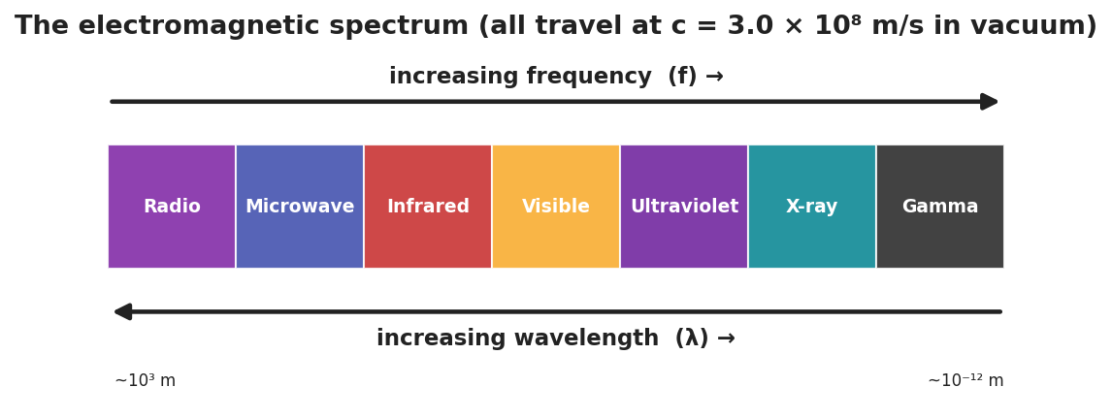
A horizontal band chart of the electromagnetic spectrum, radio to gamma, with arrows showing increasing frequency one way and increasing wavelength the other; all bands travel at c = 3.0 × 10⁸ m/s.
This paired bar chart makes the key claim explicit — every band shares the same speed c, even though their wavelengths span 15 orders of magnitude:
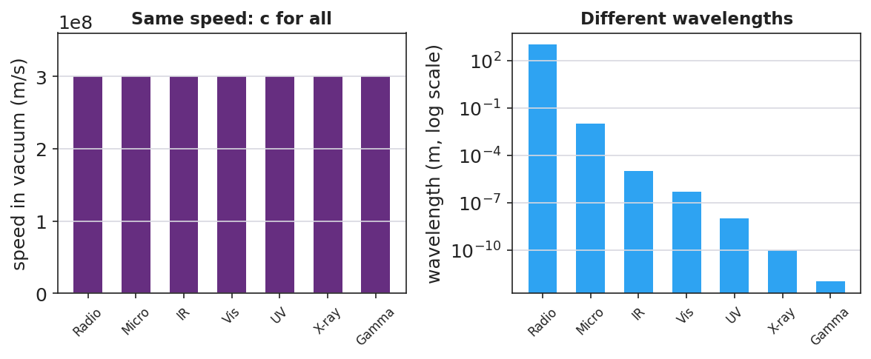
Two bar charts: on the left, all seven EM bands have the identical speed c = 3.0 × 10⁸ m/s; on the right, their wavelengths differ enormously on a logarithmic scale, from kilometers (radio) to picometers (gamma).

Teacher facilitation during Explore
- What to look for — groups using v = c (fixed) to argue that higher frequency must mean shorter wavelength.
- What to resist — don’t give the order; let the card-flip and v = f·λ reasoning produce it.
- What to redirect — groups who think “different waves go different speeds” should revisit the v = c claim at Javalab.

Phase 3 · Explain (32 – 37 min)

32–35 min · Turn-and-Talk #2 + class consensus
“What stays the same across the whole spectrum, and what changes from band to band?”
Target consensus:
“All EM waves are transverse and travel at the same speed, c, in a vacuum. What changes is the frequency and wavelength — and they trade off inversely (radio = low f / long λ; gamma = high f / short λ).”

35–37 min · Vocabulary introduction (≤ 3 terms)
Sample teacher language:
“These are all electromagnetic waves — waves of electric and magnetic fields that need no medium. The full ordered family is the spectrum. And the speed they all share in a vacuum is the speed of light, c = 3.0 × 10⁸ m/s.”

Discussion prompts to deploy here
- “Which has the longer wavelength: a radio wave or an X-ray?”
  - Sample student response: “Radio — it has the lowest frequency, so by v = f·λ the longest wavelength.”
- “Do microwaves travel faster than visible light in a vacuum?”
  - Sample student response: “No — all EM waves travel at c in a vacuum.”

Phase 4 · Elaborate (37 – 40 min)

37–39 min · Revise the model
“Return to your guessed order. Correct it using the spectrum chart. Add an arrow for ‘increasing frequency’ and one for ‘increasing wavelength,’ pointing opposite ways.”

39–40 min · Return to the phenomenon
“In one sentence, explain to a peer why a radio wave and an X-ray are the ‘same kind’ of wave, using electromagnetic wave and speed of light.”
Target: “Both are electromagnetic waves that travel at the speed of light; they only differ in frequency and wavelength, with X-rays having far higher frequency and shorter wavelength than radio waves.”

Phase 5 · Evaluate (40 – 42 min)

40–42 min · Exit Ticket + Closing Reflection
“Use the EM spectrum. (a) List these in order of increasing frequency: visible light, radio, X-ray, infrared. (b) A microwave and a gamma ray both travel through a vacuum. Which is faster? Explain. (c) Ultraviolet light has a higher frequency than visible light. Compare their wavelengths.”
Expected: (a) radio < infrared < visible < X-ray; (b) neither — both travel at c in vacuum; (c) UV has a shorter wavelength than visible (higher f → shorter λ). See Answer_Key.docx.
Closing Reflection (SEL, 30 seconds):
“Which part of the spectrum will you ‘see’ differently now — and who in your group sorted it best?”

Common Misconceptions
- Misconception: “Higher-frequency EM waves travel faster.” → Correction: All EM waves travel at c in a vacuum; higher frequency means shorter wavelength, not higher speed.
- Misconception: “EM waves need a medium like sound does.” → Correction: EM waves are not mechanical; they travel through a vacuum (that’s why sunlight reaches Earth).
- Misconception: “Visible light is a big part of the spectrum.” → Correction: Visible light is a tiny band between infrared and ultraviolet.

Access & Differentiation
- ELL/ENL supports: Sentence frame: “All EM waves travel at ______, so a higher frequency means a ______ wavelength.” Word-choice box: {c / speed of light, shorter, longer, transverse}. Provide a bilingual band-name glossary (radio, micro, IR, visible, UV, X-ray, gamma).
- IEP/SPED supports: Provide the seven band cards pre-printed with both the name and a familiar example image; students sequence rather than recall. Color-code the cards to match the spectrum figure.
- Extensions: Use c = f·λ to compute the wavelength of a 100 MHz FM radio station (λ = c/f = 3.0×10⁸ / 1.0×10⁸ = 3 m) and compare to an X-ray (~10⁻¹⁰ m).

Strategy Spotlight
ACTIVE LEARNING. Groups physically build the spectrum from shuffled cards, first by intuition and then by flipping to reveal wavelengths and reasoning with v = c. The manipulation — argue, flip, re-order, justify — makes the inverse f/λ relationship concrete before it is named. Facilitate with one prompt: “All the same speed — so what has to be true about frequency and wavelength as you move down the line?”

NYSSLS Observation Checklist Crosswalk
# | Checklist item | Where it appears in this lesson
1 | Local/relatable phenomenon | Phase 1 — one room uses the whole spectrum
2 | Turn and Talk (2–3×) | Phase 1 (TT#1 — what differs at same speed), Phase 3 (TT#2 — same vs. changing)
3 | Students develop questions/models/procedures | Phase 1 (guessed order), Phase 2 (card sort + Javalab), Phase 4 (revise)
4 | CCC defined and used | Lesson Overview · Cause and Effect, restated in Phase 2
5 | ENL — ≤ 3 vocab, second half | Phase 3 — vocabulary at 35–37 min (electromagnetic wave / spectrum / speed of light)
6 | Revisit phenomenon with evidence | Phase 4 — radio-vs-X-ray explanation
7 | ENL/SPED supports | Access & Differentiation block
8 | Assessment check | Phase 5 — Exit Ticket (order by frequency; same speed)

Companion Materials
- Student_Worksheet.docx — the 5E student investigation (hand out at start of Phase 2)
- Student_Notes.docx — guided note-guide for vocabulary and the worked example
- Answer_Key.docx — answers to “Make It Make Sense” prompts and the Exit Ticket

Key Vocabulary (max 3)
- electromagnetic wave — a transverse wave of oscillating electric and magnetic fields that requires no medium and travels at the speed of light in a vacuum
- spectrum — the full ordered range of electromagnetic waves, from radio (low frequency) through gamma rays (high frequency)
- speed of light — the speed of all electromagnetic waves in a vacuum, c = 3.0 × 10⁸ m/s

The Electromagnetic Spectrum — Student Worksheet
Unit: Waves — Lesson 07 Name: _______________________ Date: __________ Period: ____

Phenomenon
Look around the room. The speaker plays music (radio waves), the microwave heats lunch (microwaves), the remote changes the channel (infrared), your eyes read the board (visible light), sunscreen blocks sunburn (ultraviolet), and a nurse can take an X-ray. Every one of these is the same kind of wave, all traveling at the same speed.
Driving question: If all these waves travel at the same speed, what makes a radio wave different from an X-ray?

Notice & Wonder
I notice… | I wonder…
Turn & Talk #1: If all these waves travel at the same speed, what must be different between a radio wave and a gamma ray?

Initial Model
Make your best guess at the order of the spectrum from longest wavelength to shortest. Where does visible light fall? Where would the highest-energy waves go?

Investigation
Work in a group with the seven band cards. Order, flip to check, then reason with v = c.
Step | Result
1. Our first guess (left → right)
2. Re-order by decreasing wavelength
3. Highest-frequency band? Shortest wavelength?
4. Javalab — is the EM wave transverse? Same speed for all?
Check your order against this chart:

The electromagnetic spectrum, radio to gamma, with increasing frequency one way and increasing wavelength the other; all travel at c.
Key question: Since v = c is the same for every band, what must be true about frequency and wavelength as you move from radio toward gamma?

Make It Make Sense
- Which has the longer wavelength: a radio wave or an X-ray? Use v = f·λ to justify your answer.
- Do microwaves travel faster than visible light in a vacuum? Explain.
- An FM radio station broadcasts at 100 MHz (1.0 × 10⁸ Hz). Use λ = c/f to find its wavelength. (c = 3.0 × 10⁸ m/s)

Vocabulary in Action
Use each term in a sentence about today’s phenomenon.
- electromagnetic wave: _______________________________________________
- spectrum: _______________________________________________
- speed of light: _______________________________________________

Revise Your Model
Return to your guessed order. Correct it using the chart. Add an arrow for “increasing frequency” and one for “increasing wavelength,” pointing opposite ways.

Exit Ticket
Use the EM spectrum.
- List these in order of increasing frequency: visible light, radio, X-ray, infrared.
- A microwave and a gamma ray both travel through a vacuum. Which is faster? Explain.
- Ultraviolet light has a higher frequency than visible light. Compare their wavelengths.

The Electromagnetic Spectrum — Student Notes
Unit: Waves — Lesson 07 Name: _______________________ Date: __________ Period: ____

Learning Targets
By the end of today’s 42 minutes I can:
- State that electromagnetic waves are transverse and travel at the speed of light in a vacuum.
- Order the spectrum from radio to gamma by increasing frequency.
- Explain that all EM waves share c, so frequency and wavelength trade off.

Key Vocabulary
- electromagnetic wave — _______________________________________________
- spectrum — _______________________________________________
- speed of light — _______________________________________________

Guided Notes
What EM waves have in common.
- They are __________ waves (electric and magnetic fields oscillate perpendicular to travel).
- They need __________ medium — they travel through a vacuum.
- They all travel at the __________ of light, c = 3.0 × 10⁸ m/s, in a vacuum.

The electromagnetic spectrum from radio to gamma, with frequency and wavelength axes.
The order (low frequency → high frequency):
Radio → Microwave → __________ → Visible → __________ → X-ray → __________
- As frequency __________, wavelength __________ (because v = c is fixed: v = f·λ).
- Visible light is a __________ (small) band between infrared and ultraviolet.

Worked Example
Problem. An FM station broadcasts at 100 MHz (1.0 × 10⁸ Hz). Find its wavelength. (c = 3.0 × 10⁸ m/s)
Solution. 1. Use v = f·λ with v = c: λ = c / f. 2. λ = (3.0 × 10⁸) / (1.0 × 10⁸) = __________ m. 3. Compare: an X-ray’s wavelength is about 10⁻¹⁰ m — far __________ than a radio wave’s. ✓

Summary
Finish the sentence (Because / But / So):
A radio wave and an X-ray are the same kind of wave because __________________________________________, but __________________________________________, so __________________________________________.

The Electromagnetic Spectrum — Answer Key

Cover
Unit: Waves — Lesson 07: The Electromagnetic Spectrum East Meadow Schools × Valley Stream Central HSD Strategy chip: ACTIVE LEARNING

Make-It-Make-Sense Answers
- A radio wave has the longer wavelength. Radio has the lowest frequency; since v = f·λ with v = c fixed, the lowest frequency gives the longest wavelength. · Rubric: radio + v = f·λ reasoning. · NYSSLS: HS-PS4-1
- No. In a vacuum all EM waves travel at c = 3.0 × 10⁸ m/s, so microwaves and visible light have the same speed. · Rubric: same speed + states c. · NYSSLS: HS-PS4-1
- λ = c/f = (3.0 × 10⁸) / (1.0 × 10⁸) = 3.0 m. · Rubric: correct formula AND 3 m. · NYSSLS: HS-PS4-1

Exit Ticket Answer
- Increasing frequency: radio < infrared < visible < X-ray.
- Neither — they are equally fast. Both travel at c = 3.0 × 10⁸ m/s in a vacuum.
- UV has a shorter wavelength than visible light, because higher frequency means shorter wavelength (v = c fixed).
Tolerance/rubric: (a) correct order; (b) equal speed = c; (c) UV shorter wavelength with reasoning. 1 point each. NYSSLS: HS-PS4-1.

Closing Reflection (rubric)
Formative, not graded. Award full credit for any honest response. Look for: - A specific band the student now understands differently - Acknowledgment of a peer’s contribution to the card sort

Refraction and Snell’s Law — Teacher Guide

Cover
Unit: Waves — Lesson 08: Refraction and Snell’s Law East Meadow Schools × Valley Stream Central High School District Strategy chips: HOCHMAN

Curated Resources (from East Meadow Scope & Sequence)

NYSSLS Standards
HS-PS4-6 (NYS). “Use mathematical models to determine relationships among the size and location of images, size and location of objects, and focal lengths of lenses and mirrors.”
Refraction is the bending of light that makes lenses and mirrors form images at all, so this lesson is the conceptual and mathematical entry to HS-PS4-6 (developed fully in Lesson 09). Students apply the mathematical model Snell’s law, n₁ sin θ₁ = n₂ sin θ₂, to relate the index of refraction and the bending angle — a direct Cause-and-Effect link between a change in speed and a change in direction.

Phenomenon
- A laser beam bends as it crosses from air into water; a pencil looks “broken” at the surface of a glass; a Pyrex stirrer “disappears” when placed in cooking oil of matching index: https://www.youtube.com/watch?v=y55tzg_jW9I

Javalab / Labs
- PhET Bending Light — fire a ray at a boundary, vary the angle and the media, and read both angles: https://phet.colorado.edu/en/simulations/bending-light

Assessments
- PhET Snell’s-law lab: students collect (θ₁, θ₂) pairs for air→water and confirm n₁ sin θ₁ = n₂ sin θ₂. Numeric exit ticket below serves as the formative check.

Lesson Overview
Duration | 42 minutes (1 period)
NYSSLS link | HS-PS4-6 (NYS) — mathematical model for light at a boundary
CCC focus | Cause and Effect — a change in light’s speed when it enters a new medium causes it to bend (refract).
Strategy chips | HOCHMAN
Materials | Laser pointer + clear tank of water (or video); a pencil in a glass of water; protractors; calculators with sin/sin⁻¹; PhET on devices.
Safety | Never aim a laser at eyes; keep beams below eye level and pointed into the tank.
Prior knowledge | Lessons 01–03 — v = f·λ; Lesson 07 — light is an EM wave that travels at c in vacuum (slower in matter).
Lesson objectives — students can:
- Explain that light bends when it changes media because its speed changes.
- Use the index of refraction n and Snell’s law (n₁ sin θ₁ = n₂ sin θ₂) to solve for an unknown angle or index.
- Describe total internal reflection and when it occurs.

Phase 1 · Engage (0 – 12 min)

0–3 min · Opening Connection (SEL)
Quick check-in: “Name a time something looked different from how it really was.” One sentence each. This primes the “your eyes are fooled by bending light” idea.

3–8 min · Phenomenon hook — the broken pencil and the bending laser
Teacher actions. Put a pencil in a glass of water — it looks broken at the surface. Fire a laser into a tank of water (or play the clip) so students see the beam kink at the boundary.
Sample teacher language:
“The pencil isn’t broken and the laser isn’t crooked. Yet the beam clearly bends the instant it hits the water. What changes for the light right at that surface?”
Anticipated student responses:
- “The water bends it.” — affirm; we’ll explain why.
- “Light slows down in water.” — excellent; this is the cause.
- “It’s like a lens.” — good; foreshadows Lesson 09.

8–12 min · Notice & Wonder + Turn-and-Talk #1
Capture columns. Then:
“Turn to your partner: the laser only bends at the boundary, not inside the water. What does that tell you about what causes the bend?”
Target: something changes exactly at the boundary — the light’s speed — and that causes the direction change.

Bridge to Phase 2
Initial model sentence: “Light bends at the boundary because its ______ changes when it enters a new ______.”

Phase 2 · Explore (12 – 32 min)

12–17 min · Initial Model (silent / individual)
Prompt:
“Draw a ray hitting the water at an angle. Draw the normal (perpendicular to the surface). Predict: does the ray bend toward the normal or away from it when it slows down?”

17–32 min · Investigation — PhET Bending Light (Snell’s law lab)
Pairs at PhET:
- See the bend. Fire air→water at 45°. Note that the refracted ray bends toward the normal (water is slower).
- Collect data. Record (θ₁, θ₂) for several incident angles. Compute sin θ₁ and sin θ₂.
- Find the pattern. Compute the ratio sin θ₁ / sin θ₂. Compare to n₂/n₁ (≈ 1.33 for air→water).
- Total internal reflection. Now go water→air and increase the angle. Find the angle past which the ray cannot leave — it reflects entirely.
Use this ray diagram to fix the geometry and the equation:
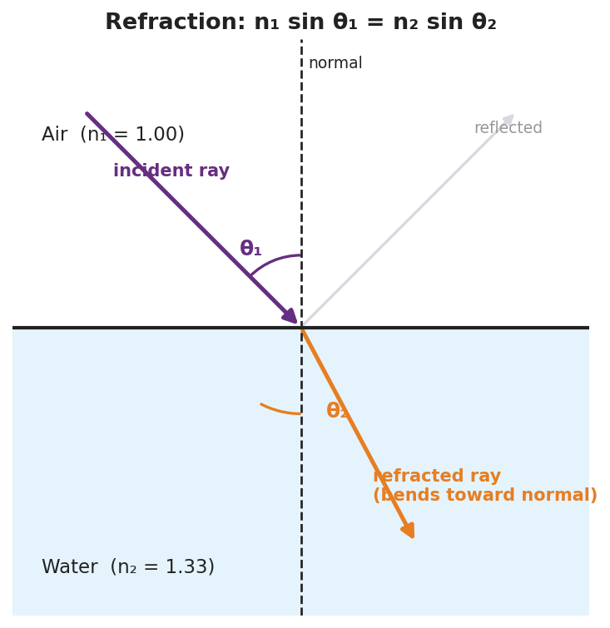
A refraction ray diagram at an air–water boundary: the normal, the incident ray at angle θ₁ in air (n₁ = 1.00), the refracted ray bending toward the normal at θ₂ in water (n₂ = 1.33), and a faint reflected ray; labeled with Snell’s law n₁ sin θ₁ = n₂ sin θ₂.
This chart of indices explains how much light bends in each material — the higher the index, the slower the light and the stronger the bend:
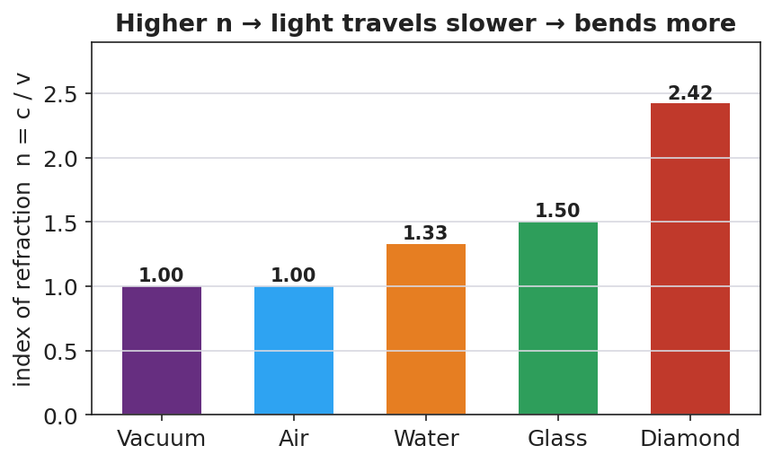
A bar chart of the index of refraction for vacuum (1.00), air (1.00), water (1.33), glass (1.50), and diamond (2.42), noting n = c/v: higher n means slower light and more bending.

Teacher facilitation during Explore
- What to look for — pairs discovering that sin θ₁ / sin θ₂ is constant (= n₂/n₁) — the data form of Snell’s law.
- What to resist — don’t write Snell’s law first; let the constant ratio emerge from their (θ₁, θ₂) data.
- What to redirect — students who measure angles from the surface instead of the normal should re-read where the protractor’s zero goes.

Phase 3 · Explain (32 – 37 min)

32–35 min · Turn-and-Talk #2 + class consensus
“Why does light bend toward the normal entering water, and what stays constant in your data?”
Target consensus:
“Light slows in water, so it bends toward the normal. The ratio sin θ₁ / sin θ₂ stays constant — it equals the ratio of the indices, which is the math behind the bending.”

35–37 min · Vocabulary introduction (≤ 3 terms) + the HOCHMAN sentence
Sample teacher language:
“The bending of light when it changes media is refraction. How much a material slows light is its index of refraction, n = c/v (n = 1 in vacuum, 1.33 in water, ~1.5 in glass). The rule relating angles and indices is Snell’s law: n₁ sin θ₁ = n₂ sin θ₂.”
HOCHMAN Because/But/So expansion (model aloud, then students write):
“Light bends toward the normal when it enters water because the water slows it down, but its frequency stays the same, so its wavelength shortens and the wavefronts pivot, changing the ray’s direction.”

Discussion prompts to deploy here
- “Light goes from air (n = 1.00) into glass (n = 1.50) at θ₁ = 30°. Find θ₂.”
  - Sample student response: “sin θ₂ = (1.00·sin30°)/1.50 = 0.333 → θ₂ ≈ 19.5°.”
- “When does total internal reflection happen?”
  - Sample student response: “Going from a slower (higher-n) medium to a faster one, past the critical angle — the light can’t escape, so it all reflects.”

Phase 4 · Elaborate (37 – 40 min)

37–39 min · Revise the model
“Return to your prediction. Label the incident angle θ₁, the refracted angle θ₂, and the normal. Write your Because/But/So sentence and confirm: into a slower medium, the ray bends toward the normal.”

39–40 min · Return to the phenomenon
“Explain in one sentence why the pencil looks broken, using refraction and index of refraction.”
Target: “Light from the underwater part of the pencil refracts (bends) as it leaves the higher-index water into the lower-index air, so your eye traces it back to the wrong spot and the pencil looks broken.”

Phase 5 · Evaluate (40 – 42 min)

40–42 min · Exit Ticket + Closing Reflection
“Light travels from air (n = 1.00) into water (n = 1.33). (a) The incident angle is 40°. Use Snell’s law to find the angle of refraction. Show your work. (b) Does the ray bend toward or away from the normal? Why? (c) The Pyrex stirrer ‘disappears’ in oil of the same index. Explain why, in one sentence.”
Expected: (a) sin θ₂ = (1.00·sin40°)/1.33 = 0.483 → θ₂ ≈ 28.9°; (b) toward the normal (entering a slower, higher-n medium); (c) equal indices mean no speed change, so no refraction or reflection at the boundary — the light passes straight through, making the glass invisible. See Answer_Key.docx.
Closing Reflection (SEL, 30 seconds):
“What’s one illusion in your daily life you can now explain with refraction?”

Common Misconceptions
- Misconception: “Light bends because the water ‘pushes’ it.” → Correction: Light bends because its speed changes at the boundary; the frequency stays the same and the wavelength changes.
- Misconception: “Angles are measured from the surface.” → Correction: Incident and refracted angles are measured from the normal (perpendicular to the surface).
- Misconception: “Light always bends the same way.” → Correction: Entering a slower medium it bends toward the normal; entering a faster medium it bends away (and can totally internally reflect).

Access & Differentiation
- ELL/ENL supports: Sentence frame: “When light enters a ______ medium, it slows down and bends ______ the normal.” Word-choice box: {slower, faster, toward, away, normal}. Provide a worked Snell’s-law example with each calculator key labeled (sin, ×, ÷, sin⁻¹).
- IEP/SPED supports: Provide the ray diagram pre-drawn with the normal; students measure θ₁ and θ₂ with a protractor rather than constructing rays. Give a Snell’s-law “plug-in” template with the unknown isolated.
- Extensions: Fiber optics — explain how total internal reflection keeps a light pulse trapped inside a glass fiber, enabling internet data transmission (links to Lesson 10).

Strategy Spotlight
HOCHMAN. The causal mechanism is captured in one Because / But / So sentence: light slows in water (because), its frequency is unchanged (but), so its wavelength shortens and the ray pivots toward the normal (so). This sentence does the heavy lifting of separating cause (speed change) from the constant (frequency) and the result (direction change). Model it, have students write, then refine — many will first say “the water bends it”; push them to name the speed change as the cause.

NYSSLS Observation Checklist Crosswalk
# | Checklist item | Where it appears in this lesson
1 | Local/relatable phenomenon | Phase 1 — broken pencil, bending laser; disappearing Pyrex in Phase 5
2 | Turn and Talk (2–3×) | Phase 1 (TT#1 — bend only at boundary), Phase 3 (TT#2 — why toward normal)
3 | Students develop questions/models/procedures | Phase 1 (prediction), Phase 2 (PhET Snell’s-law data), Phase 4 (revise)
4 | CCC defined and used | Lesson Overview · Cause and Effect, restated in Phase 2
5 | ENL — ≤ 3 vocab, second half | Phase 3 — vocabulary at 35–37 min (refraction / index of refraction / Snell’s law)
6 | Revisit phenomenon with evidence | Phase 4 — broken-pencil explanation
7 | ENL/SPED supports | Access & Differentiation block
8 | Assessment check | Phase 5 — numeric Exit Ticket (air→water; Pyrex)

Companion Materials
- Student_Worksheet.docx — the 5E student investigation (hand out at start of Phase 2)
- Student_Notes.docx — guided note-guide for vocabulary and the worked example
- Answer_Key.docx — answers to “Make It Make Sense” prompts and the Exit Ticket

Key Vocabulary (max 3)
- refraction — the bending of light (or any wave) as it passes from one medium into another because its speed changes
- index of refraction — a number n = c/v that tells how much a medium slows light (n = 1 in vacuum, 1.33 in water, ≈ 1.5 in glass)
- Snell’s law — the mathematical model relating the angles and indices at a boundary: n₁ sin θ₁ = n₂ sin θ₂

Refraction and Snell’s Law — Student Worksheet
Unit: Waves — Lesson 08 Name: _______________________ Date: __________ Period: ____

Phenomenon
A pencil standing in a glass of water looks broken at the surface. A laser beam fired into a tank of water kinks the instant it hits the water. And a Pyrex stirrer placed in oil of just the right kind seems to vanish completely.
Driving question: What changes for the light right at the surface that makes it bend?

Notice & Wonder
I notice… | I wonder…
Turn & Talk #1: The laser bends only at the boundary, not inside the water. What does that tell you about what causes the bend?

Initial Model
Draw a ray hitting the water at an angle. Draw the normal (perpendicular to the surface). Predict: when the light slows down, does the ray bend toward the normal or away from it?

My prediction: _______________________________________________

Investigation
Open PhET Bending Light. Fire rays from air into water and measure angles from the normal.
Incident angle θ₁ | Refracted angle θ₂ | sin θ₁ | sin θ₂ | sin θ₁ ÷ sin θ₂
Use this ray diagram to set up your geometry:

Refraction at an air–water boundary: normal, incident ray θ₁ in air (n₁ = 1.00), refracted ray θ₂ in water (n₂ = 1.33), labeled with n₁ sin θ₁ = n₂ sin θ₂.
Key question: What is the value of sin θ₁ ÷ sin θ₂? How does it compare to n₂ ÷ n₁ for air→water (≈ 1.33)?

Make It Make Sense
- Light goes from air (n = 1.00) into glass (n = 1.50) at θ₁ = 30°. Use Snell’s law to find θ₂. Show your work.
- Why does light bend toward the normal when it enters a slower (higher-n) medium? Write a Because/But/So sentence.
- Total internal reflection: under what conditions can light not escape a medium, reflecting entirely instead?

Vocabulary in Action
Use each term in a sentence about today’s phenomenon.
- refraction: _______________________________________________
- index of refraction: _______________________________________________
- Snell’s law: _______________________________________________

Revise Your Model
Return to your prediction. Label the incident angle θ₁, the refracted angle θ₂, and the normal. Confirm: into a slower medium, the ray bends toward the normal. Write your Because/But/So sentence.
Because __________________________________________, but __________________________________________, so __________________________________________.

Exit Ticket
Light travels from air (n = 1.00) into water (n = 1.33).
- The incident angle is 40°. Use Snell’s law to find the angle of refraction. Show your work.
- Does the ray bend toward or away from the normal? Why?
- The Pyrex stirrer “disappears” in oil of the same index. Explain why, in one sentence.

Refraction and Snell’s Law — Student Notes
Unit: Waves — Lesson 08 Name: _______________________ Date: __________ Period: ____

Learning Targets
By the end of today’s 42 minutes I can:
- Explain that light bends (refraction) when its speed changes between media.
- Use the index of refraction and Snell’s law to find an unknown angle or index.
- Describe total internal reflection.

Key Vocabulary
- refraction — _______________________________________________
- index of refraction — _______________________________________________
- Snell’s law — _______________________________________________

Guided Notes
Why light bends. When light crosses into a new medium, its __________ changes. Its frequency stays the __________, so its wavelength changes — and the ray pivots, bending at the boundary.
- Into a slower (higher-n) medium → bends __________ the normal.
- Into a faster (lower-n) medium → bends __________ from the normal.
Index of refraction: n = c / v.
- Vacuum: n = __________
- Water: n ≈ __________
- Glass: n ≈ __________

Refraction at an air–water boundary with the normal, θ₁, θ₂, and n₁ sin θ₁ = n₂ sin θ₂.
Snell’s law (reference table):
n₁ sin θ₁ = n₂ sin θ₂
Angles are always measured from the __________ (not the surface).
Total internal reflection. Going from a slower to a __________ medium, past a critical angle the light cannot escape and __________ entirely. (This is how fiber-optic cables carry data.)

Worked Example
Problem. Light goes from air (n₁ = 1.00) into glass (n₂ = 1.50) at θ₁ = 30°. Find θ₂.
Solution. 1. Snell’s law: n₁ sin θ₁ = n₂ sin θ₂. 2. sin θ₂ = (n₁ sin θ₁) / n₂ = (1.00 × sin 30°) / 1.50 = (1.00 × 0.500) / 1.50 = __________. 3. θ₂ = sin⁻¹(0.333) ≈ __________°. 4. Check: θ₂ < θ₁, so the ray bent __________ the normal (entered a slower medium). ✓

Summary
Finish the sentence (Because / But / So):
A pencil looks broken in a glass of water because __________________________________________, but __________________________________________, so __________________________________________.

Refraction and Snell’s Law — Answer Key

Cover
Unit: Waves — Lesson 08: Refraction and Snell’s Law East Meadow Schools × Valley Stream Central HSD Strategy chip: HOCHMAN

Make-It-Make-Sense Answers
- Snell’s law: n₁ sin θ₁ = n₂ sin θ₂ → sin θ₂ = (1.00 × sin 30°) / 1.50 = (1.00 × 0.500) / 1.50 = 0.333 → θ₂ ≈ 19.5°. · Rubric: correct setup AND ≈ 19–20°. · NYSSLS: HS-PS4-6
- Example: “Light bends toward the normal entering water because the water slows it down, but its frequency stays the same, so its wavelength shortens and the ray pivots toward the normal.” · Rubric: Because/But/So with speed change as cause. · NYSSLS: HS-PS4-6
- Total internal reflection happens when light travels from a slower (higher-n) medium toward a faster (lower-n) one at an angle greater than the critical angle — the ray cannot refract out, so it reflects entirely. · Rubric: high-n → low-n AND past critical angle. · NYSSLS: HS-PS4-6

Exit Ticket Answer
- sin θ₂ = (n₁ sin θ₁)/n₂ = (1.00 × sin 40°)/1.33 = (1.00 × 0.643)/1.33 = 0.483 → θ₂ ≈ 28.9° (about 29°).
- Toward the normal, because the light enters a slower, higher-index medium (water), so the refracted angle is smaller than the incident angle.
- The oil and Pyrex have the same index of refraction, so light does not change speed at the boundary — no refraction and no reflection — and the glass becomes invisible.
Tolerance/rubric: (a) 28°–29° with Snell’s law shown; (b) toward the normal + slower-medium reason; (c) equal indices → no bend. 1 point each. NYSSLS: HS-PS4-6.

Closing Reflection (rubric)
Formative, not graded. Award full credit for any honest response. Look for: - A specific everyday illusion the student can now explain with refraction - Genuine reflection rather than a restated definition

Optics: Lenses and Mirrors — Teacher Guide

Cover
Unit: Waves — Lesson 09: Optics (Lenses and Mirrors) East Meadow Schools × Valley Stream Central High School District Strategy chips: ACTIVE LEARNING

Curated Resources (from East Meadow Scope & Sequence)

NYSSLS Standards
HS-PS4-6 (NYS). “Use mathematical models to determine relationships among the size and location of images, size and location of objects, and focal lengths of lenses and mirrors.”
This is the core HS-PS4-6 lesson. Building on refraction (Lesson 08), students use ray diagrams and the thin-lens / mirror equation 1/f = 1/dₒ + 1/dᵢ to relate object distance, image distance, and focal length, and to predict whether an image is real or virtual.

Phenomenon
- Corrective glasses and contact lenses fix blurry vision; a magnifying glass enlarges print and can focus sunlight; a curved makeup/shaving mirror magnifies your face: https://www.youtube.com/watch?v=Q3FrL_T0r2c

Javalab / Labs
- oPhysics Converging Lens and Concave/Convex Mirror — drag the object and read the image position, size, and type: https://www.ophysics.com/l1.html

Assessments
- oPhysics ray-tracing task: students place an object at several distances and record image distance, magnification, and real/virtual, confirming 1/f = 1/dₒ + 1/dᵢ. Quantitative exit ticket below serves as the formative check.

Lesson Overview
Duration | 42 minutes (1 period)
NYSSLS link | HS-PS4-6 (NYS) — the thin-lens / mirror equation
CCC focus | Cause and Effect — the object’s distance relative to the focal length causes a real or virtual image of a predictable size and location.
Strategy chips | ACTIVE LEARNING
Materials | Converging lenses (magnifiers); concave mirrors (or spoons); a candle/LED + screen; rulers; calculators; devices for oPhysics.
Safety | Do not focus sunlight onto skin or flammable material with a lens.
Prior knowledge | Lesson 08 — refraction, index of refraction, Snell’s law (lenses bend light by refraction; mirrors by reflection).
Lesson objectives — students can:
- Distinguish converging from diverging lenses and concave from convex mirrors, and identify the focal point.
- Draw principal rays to locate an image and classify it as real or virtual.
- Use 1/f = 1/dₒ + 1/dᵢ to solve for focal length, object distance, or image distance.

Phase 1 · Engage (0 – 12 min)

0–3 min · Opening Connection (SEL)
Quick check-in: “Name something you use to see better — glasses, a phone zoom, a screen.” One sentence each. This primes “lenses shape what we see.”

3–8 min · Phenomenon hook — the magnifying glass surprise
Teacher actions. Hand out (or demo) a magnifying glass. Have students hold it close to text (enlarged, upright) and then far from text/a window (small, upside-down image). Same lens, two completely different images.
Sample teacher language:
“Close up, the magnifier makes the print bigger and right-side-up. Move it far away, and look — the image flips upside down and shrinks. Same lens. What changed?”
Anticipated student responses:
- “How far away it is.” — exactly; object distance is the variable.
- “It flipped.” — capture; foreshadows real vs. virtual.
- “It focuses the window on the wall.” — great; that’s a real image.

8–12 min · Notice & Wonder + Turn-and-Talk #1
Capture columns. Then:
“Turn to your partner: what decides whether the image is big-and-upright or small-and-upside-down?”
Target: the object’s distance compared with the lens’s focal length.

Bridge to Phase 2
Initial model sentence: “The magnifier gives a different image depending on the ______ between the object and the lens.”

Phase 2 · Explore (12 – 32 min)

12–17 min · Initial Model (silent / individual)
Prompt:
“Draw a lens with a candle on the left. Sketch where you think the image forms when the candle is FAR from the lens, then when it’s VERY CLOSE. Label which one is upside-down.”

17–32 min · Investigation — ACTIVE LEARNING: ray-trace and measure
Groups of 3–4 with a converging lens, a screen, a light source, and oPhysics open:
- Real image. Place the object well beyond the focal point. Move the screen until the image is sharp. Measure dₒ and dᵢ; note size and orientation (inverted).
- Virtual image. Bring the object inside the focal length. The screen shows nothing — look through the lens (magnified, upright, virtual).
- Concave mirror. Repeat with a concave mirror (or the bowl of a spoon): far object → small inverted real image; close object → magnified upright image.
- oPhysics. Drag the object, record (dₒ, dᵢ) pairs, and check 1/f = 1/dₒ + 1/dᵢ.
Use these ray diagrams to standardize the three principal rays:
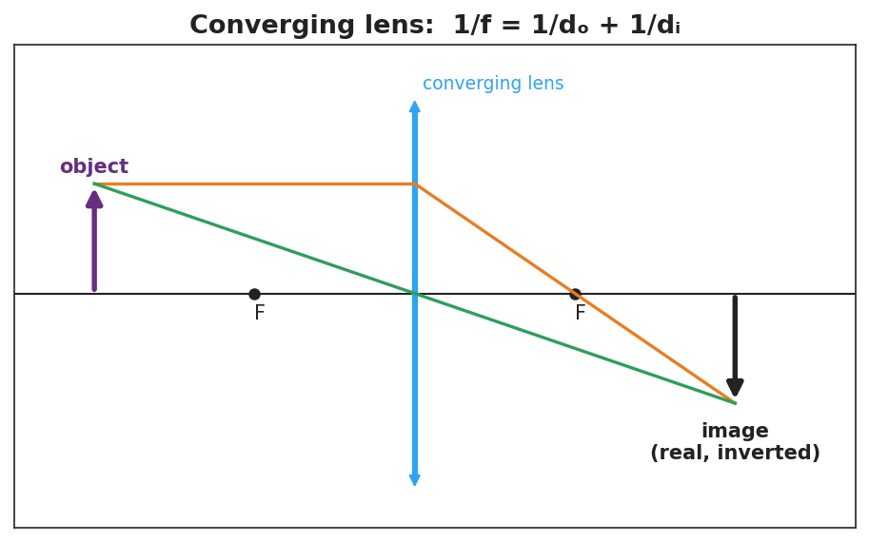
A converging-lens ray diagram: an object beyond F, the parallel ray refracting through the far focus, the central ray going straight, meeting at a real, inverted image; labeled 1/f = 1/dₒ + 1/dᵢ.
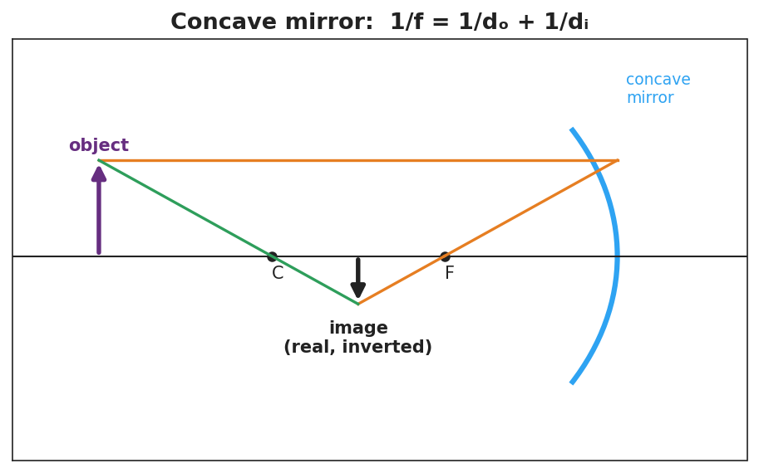
A concave-mirror ray diagram: an object beyond C, the parallel ray reflecting through F, the ray through C reflecting back on itself, meeting at a real, inverted image; labeled 1/f = 1/dₒ + 1/dᵢ.

Teacher facilitation during Explore
- What to look for — groups connecting “object inside f → no image on the screen” to “virtual image” (cannot be projected).
- What to resist — don’t give the equation first; let the (dₒ, dᵢ) data reveal the 1/f relationship.
- What to redirect — students who expect a screen image from a close object should be asked, “can you catch this image on paper, or only see it through the lens?”

Phase 3 · Explain (32 – 37 min)

32–35 min · Turn-and-Talk #2 + class consensus
“What decides whether you get a real (projectable) or virtual (look-through) image?”
Target consensus:
“If the object is beyond the focal point, a converging lens or concave mirror forms a real, inverted image you can project. If the object is inside the focal length, the image is virtual, upright, and magnified — you can only see it by looking through.”

35–37 min · Vocabulary introduction (≤ 3 terms)
Sample teacher language:
“The distance from the lens or mirror to its focus is the focal length, f. A lens that brings parallel rays together is a converging lens (and a concave mirror converges too). What forms where the rays meet — or appear to meet — is the image, related by 1/f = 1/dₒ + 1/dᵢ.”

Discussion prompts to deploy here
- “An object is 30 cm from a converging lens with f = 10 cm. Where is the image?”
  - Sample student response: “1/dᵢ = 1/f − 1/dₒ = 1/10 − 1/30 = 1/15 → dᵢ = 15 cm (real, inverted).”
- “Why can’t you project the magnified image from a magnifying glass onto a wall?”
  - Sample student response: “It’s a virtual image — the rays don’t actually meet, so there’s nothing to catch on a screen.”

Phase 4 · Elaborate (37 – 40 min)

37–39 min · Revise the model
“Return to your candle sketch. Re-draw both cases with the three principal rays. Label one image real, inverted and one virtual, upright. Note where the focal point F is.”

39–40 min · Return to the phenomenon
“Explain in one sentence why the magnifier’s image flips when you move it far from the page, using focal length and image.”
Target: “When the page is closer than the focal length the image is virtual and upright (magnified), but when the page is beyond the focal length the rays cross and form a real, inverted image — so it flips.”

Phase 5 · Evaluate (40 – 42 min)

40–42 min · Exit Ticket + Closing Reflection
“A converging lens has a focal length of 12 cm. An object is placed 36 cm from the lens. (a) Use 1/f = 1/dₒ + 1/dᵢ to find the image distance. Show your work. (b) Is the image real or virtual? Upright or inverted? (c) If the object is moved to 6 cm (inside the focal length), can the image be projected on a screen? Why or why not?”
Expected: (a) 1/dᵢ = 1/12 − 1/36 = 1/18 → dᵢ = 18 cm; (b) real and inverted (object beyond f); (c) no — inside f the image is virtual and cannot be projected. See Answer_Key.docx.
Closing Reflection (SEL, 30 seconds):
“What’s one device with a lens or mirror you now understand better, and who helped you trace the rays?”

Common Misconceptions
- Misconception: “A bigger lens always magnifies more.” → Correction: Magnification depends on the focal length and object distance, not the lens diameter.
- Misconception: “All images can be projected on a screen.” → Correction: Only real images (rays actually meet) project; virtual images (rays only appear to meet) cannot.
- Misconception: “Converging and concave mean opposite things.” → Correction: A converging lens and a concave mirror both bring parallel rays to a focus; they converge light.

Access & Differentiation
- ELL/ENL supports: Sentence frame: “When the object is ______ the focal length, the image is ______ (real/virtual) and ______ (upright/inverted).” Word-choice box: {beyond, inside, real, virtual, upright, inverted}. Provide a labeled ray-diagram template.
- IEP/SPED supports: Provide pre-drawn principal axes with F marked; students draw only the two easiest rays (parallel and central). Give a 1/f = 1/dₒ + 1/dᵢ template with the unknown isolated and a worked example beside it.
- Extensions: Diverging lenses and convex mirrors always form reduced, upright, virtual images. Explain why a convex (passenger-side) car mirror is labeled “objects are closer than they appear.”

Strategy Spotlight
ACTIVE LEARNING. Students physically place objects, hunt for the sharp image on a screen, and discover that a close object yields no screen image (a virtual image) before any term is introduced. Tracing the three principal rays by hand on the diagram cements the geometry. Facilitate with one prompt during the hunt: “Can you catch this image on paper, or only see it through the lens?” — separating real from virtual by experience.

NYSSLS Observation Checklist Crosswalk
# | Checklist item | Where it appears in this lesson
1 | Local/relatable phenomenon | Phase 1 — magnifying glass; glasses, spoons; car mirror in extensions
2 | Turn and Talk (2–3×) | Phase 1 (TT#1 — what decides image type), Phase 3 (TT#2 — real vs. virtual)
3 | Students develop questions/models/procedures | Phase 1 (initial sketch), Phase 2 (ray-trace + oPhysics data), Phase 4 (revise)
4 | CCC defined and used | Lesson Overview · Cause and Effect, restated in Phase 2
5 | ENL — ≤ 3 vocab, second half | Phase 3 — vocabulary at 35–37 min (focal length / converging lens / image)
6 | Revisit phenomenon with evidence | Phase 4 — magnifier flip explanation
7 | ENL/SPED supports | Access & Differentiation block
8 | Assessment check | Phase 5 — quantitative Exit Ticket (lens, f = 12 cm)

Companion Materials
- Student_Worksheet.docx — the 5E student investigation (hand out at start of Phase 2)
- Student_Notes.docx — guided note-guide for vocabulary and the worked example
- Answer_Key.docx — answers to “Make It Make Sense” prompts and the Exit Ticket

Key Vocabulary (max 3)
- focal length — the distance (f) from a lens or mirror to its focal point, where parallel rays converge
- converging lens — a lens (thicker in the middle) that brings parallel rays together at the focal point; a concave mirror does the same by reflection
- image — the reproduction of an object formed by a lens or mirror; real if rays actually meet (projectable), virtual if they only appear to meet

Optics: Lenses and Mirrors — Student Worksheet
Unit: Waves — Lesson 09 Name: _______________________ Date: __________ Period: ____

Phenomenon
Hold a magnifying glass close to this page — the print looks bigger and right-side-up. Now hold it far from a window — the image flips upside down and shrinks. Same lens, two totally different images. Eyeglasses, magnifiers, and curved mirrors all do this kind of thing.
Driving question: What decides whether a lens makes an image big-and-upright or small-and-upside-down?

Notice & Wonder
I notice… | I wonder…
Turn & Talk #1: What decides whether the image is big-and-upright or small-and-upside-down?

Initial Model
Draw a lens with a candle on the left. Sketch where the image forms when the candle is far from the lens, then when it is very close. Label which image is upside-down.

Investigation
Work in a group with a converging lens, a screen, a light source, and oPhysics.
Trial | Object distance dₒ | Image distance dᵢ | Real or virtual? | Upright or inverted?
1. Object far (beyond F)
2. Object inside F
3. Concave mirror, object far
Use these ray diagrams to trace your three principal rays:

Converging-lens ray diagram: object beyond F → real, inverted image; 1/f = 1/dₒ + 1/dᵢ.

Concave-mirror ray diagram: object beyond C → real, inverted image; 1/f = 1/dₒ + 1/dᵢ.
Key question: When the object was inside the focal length, could you catch the image on the screen? What does that tell you about the image?

Make It Make Sense
- An object is 30 cm from a converging lens with f = 10 cm. Use 1/f = 1/dₒ + 1/dᵢ to find the image distance.
- Why can’t you project a magnifying glass’s enlarged image onto a wall?
- A converging lens and a concave mirror are both called “converging.” What do they have in common?

Vocabulary in Action
Use each term in a sentence about today’s phenomenon.
- focal length: _______________________________________________
- converging lens: _______________________________________________
- image: _______________________________________________

Revise Your Model
Return to your candle sketch. Re-draw both cases with the three principal rays. Label one image real, inverted and one virtual, upright, and mark the focal point F.

Exit Ticket
A converging lens has a focal length of 12 cm. An object is placed 36 cm from the lens.
- Use 1/f = 1/dₒ + 1/dᵢ to find the image distance. Show your work.
- Is the image real or virtual? Upright or inverted?
- If the object is moved to 6 cm (inside the focal length), can the image be projected on a screen? Why or why not?

Optics: Lenses and Mirrors — Student Notes
Unit: Waves — Lesson 09 Name: _______________________ Date: __________ Period: ____

Learning Targets
By the end of today’s 42 minutes I can:
- Identify a converging lens / concave mirror and its focal point.
- Draw principal rays to locate an image and label it real or virtual.
- Use 1/f = 1/dₒ + 1/dᵢ to solve for f, dₒ, or dᵢ.

Key Vocabulary
- focal length — _______________________________________________
- converging lens — _______________________________________________
- image — _______________________________________________

Guided Notes
Focal point and focal length. Parallel rays hitting a converging lens (or concave mirror) meet at the __________ point. The distance to it is the __________ length, f.

Converging-lens ray diagram: object beyond F → real, inverted image.
Three principal rays (converging lens):
- A ray parallel to the axis refracts through the far __________.
- A ray through the __________ of the lens goes straight.
- Where the rays cross is the __________.

Concave-mirror ray diagram: object beyond C → real, inverted image.
Real vs. virtual images.
- Object beyond the focal length → image is __________ and inverted; can be __________ on a screen.
- Object inside the focal length → image is __________ and upright; can only be __________ through the lens (magnifier).
The thin-lens / mirror equation (reference table):
1/f = 1/dₒ + 1/dᵢ

Worked Example
Problem. A converging lens has f = 10 cm. An object sits dₒ = 30 cm away. Find the image distance.
Solution. 1. 1/dᵢ = 1/f − 1/dₒ = 1/10 − 1/30. 2. Common denominator: 3/30 − 1/30 = __________ /30 = 1/15. 3. dᵢ = __________ cm. 4. Since dₒ > f, the image is __________ and inverted. ✓

Summary
Finish the sentence (Because / But / So):
A magnifying glass can make an image either upright or upside-down because __________________________________________, but __________________________________________, so __________________________________________.

Optics: Lenses and Mirrors — Answer Key

Cover
Unit: Waves — Lesson 09: Optics (Lenses and Mirrors) East Meadow Schools × Valley Stream Central HSD Strategy chip: ACTIVE LEARNING

Make-It-Make-Sense Answers
- 1/dᵢ = 1/f − 1/dₒ = 1/10 − 1/30 = 3/30 − 1/30 = 2/30 = 1/15 → dᵢ = 15 cm (real, inverted, since dₒ > f). · Rubric: correct equation AND 15 cm. · NYSSLS: HS-PS4-6
- The magnifier’s enlarged image is virtual — the refracted rays only appear to come from it and never actually meet, so there is nothing to catch on a screen. · Rubric: identifies virtual + rays don’t meet. · NYSSLS: HS-PS4-6
- Both converge light: a converging lens brings parallel rays to a focus by refraction, and a concave mirror brings them to a focus by reflection. Both form real, inverted images when the object is beyond f. · Rubric: both bring parallel rays to a focus. · NYSSLS: HS-PS4-6

Exit Ticket Answer
- 1/dᵢ = 1/f − 1/dₒ = 1/12 − 1/36 = 3/36 − 1/36 = 2/36 = 1/18 → dᵢ = 18 cm.
- Real and inverted — the object (36 cm) is beyond the focal length (12 cm).
- No. Inside the focal length the image is virtual (upright, magnified); virtual images cannot be projected on a screen because the rays do not actually meet.
Tolerance/rubric: (a) 18 cm with the equation shown; (b) real AND inverted; (c) no + virtual reasoning. 1 point each. NYSSLS: HS-PS4-6.

Closing Reflection (rubric)
Formative, not graded. Award full credit for any honest response. Look for: - A specific lens/mirror device the student now understands - Acknowledgment of a peer who helped trace the rays

Digital Technologies and Information — Teacher Guide

Cover
Unit: Waves — Lesson 10: Digital Technologies and Information East Meadow Schools × Valley Stream Central High School District Strategy chips: BTC

Curated Resources (from East Meadow Scope & Sequence)

NYSSLS Standards
HS-PS4-2. “Evaluate questions about the advantages of using a digital transmission and storage of information. (Stability and Change)”
This closing lesson asks students to evaluate why modern technology encodes information digitally. Waves (the whole unit) are how signals travel; here students compare an analog wave to its digital (sampled, bit-encoded) version and weigh the advantages — robustness to noise, exact copying, and easy storage. The Crosscutting Concept is Stability and Change: digital encoding keeps information stable as it is transmitted and copied.

Phenomenon
- A scratchy vinyl record (analog) vs. a crisp streamed song (digital); a blurry, pixelated photo “cleaning up” as more data loads; a tenth-generation photocopy vs. a re-printed PDF: https://www.youtube.com/watch?v=Hh-qWaMG6Sw

Javalab / Labs
- Javalab Analog vs Digital Signal — toggle between a smooth wave and its sampled, quantized version and add “noise”: https://javalab.org/en/analog_digital_signal_en/

Assessments
- Telephone-game data activity + Javalab noise test: students pass an analog vs. a digital “message” down a line and measure which survives copying. Exit ticket below serves as the formative check.

Lesson Overview
Duration | 42 minutes (1 period)
NYSSLS link | HS-PS4-2 (advantages of digital transmission/storage)
CCC focus | Stability and Change — digital encoding keeps information stable against noise and repeated copying.
Strategy chips | BTC (Building Thinking Classrooms)
Materials | Vertical non-permanent surfaces + markers; graph paper; an old photocopy + a fresh PDF print (demo); devices for Javalab.
Safety | None.
Prior knowledge | Lessons 01–07 — waves carry information as signals; amplitude/frequency encode a message.
Lesson objectives — students can:
- Distinguish an analog signal (continuous) from a digital signal (discrete samples encoded as bits).
- Explain how sampling and bits represent a wave, and that more bits / faster sampling means higher fidelity.
- Evaluate, with reasoning, why digital transmission and storage are more robust to noise and easier to copy than analog.

Phase 1 · Engage (0 – 12 min)

0–3 min · Opening Connection (SEL)
Quick check-in: “Name a message that got ‘garbled’ on the way to you — a bad photocopy, a frozen video call, a misheard rumor.” One sentence each. This primes the noise/fidelity idea.

3–8 min · Phenomenon hook — vinyl crackle vs. clean stream
Teacher actions. Play a few seconds of a scratchy vinyl/old tape recording, then the same song streamed. Show a tenth-generation photocopy next to a freshly printed PDF. Old analog copies degrade; digital copies don’t.
Sample teacher language:
“Copy a copy of a copy on this photocopier and it turns to mush. But I can copy this PDF a million times and the millionth is identical to the first. Why does one survive copying and the other doesn’t?”
Anticipated student responses:
- “The digital one is just numbers.” — excellent; capture this.
- “The analog one picks up noise.” — yes; noise accumulates.
- “Computers can fix errors.” — good; digital is correctable.

8–12 min · Notice & Wonder + Turn-and-Talk #1
Capture columns. Then:
“Turn to your partner: what is it about storing something as numbers (digital) that lets it survive copying perfectly?”
Target: a digital signal only has to decide between a few exact values, so small noise can be cleaned back to the nearest value.

Bridge to Phase 2
Initial model sentence: “A digital copy survives because the signal is stored as ______ instead of a continuous ______.”

Phase 2 · Explore (12 – 32 min)

12–17 min · Initial Model (silent / individual)
Prompt:
“Draw a smooth wave (analog). Now show how you would store it using only a few measured points (samples). What information do you lose? What do you gain?”

17–32 min · Investigation — BTC: random groups, vertical surfaces
Form visibly random groups of 3 at vertical non-permanent surfaces, one marker each. Escalating thin-slice tasks:
- Sample it. Given a printed analog wave, mark sample points at regular intervals and round each to the nearest grid line (quantize). Draw the resulting stair-step.
- More vs. fewer samples. Redraw with twice as many samples. Which stair-step matches the original better?
- Add noise. Add a small random wobble to both an analog wave and a digital stair-step. After “cleaning” (rounding to nearest level), which one recovers the original exactly?
- Evaluate (the HS-PS4-2 question). List two advantages of digital over analog for transmitting and storing a song. Is there any disadvantage?
Confirm at Javalab, then compare to these figures:
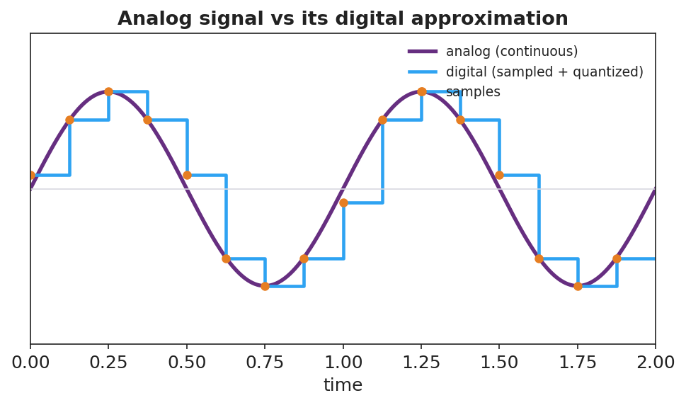
A smooth analog sine wave overlaid with its digital version: sample points and a stair-step (sampled and quantized) approximation.
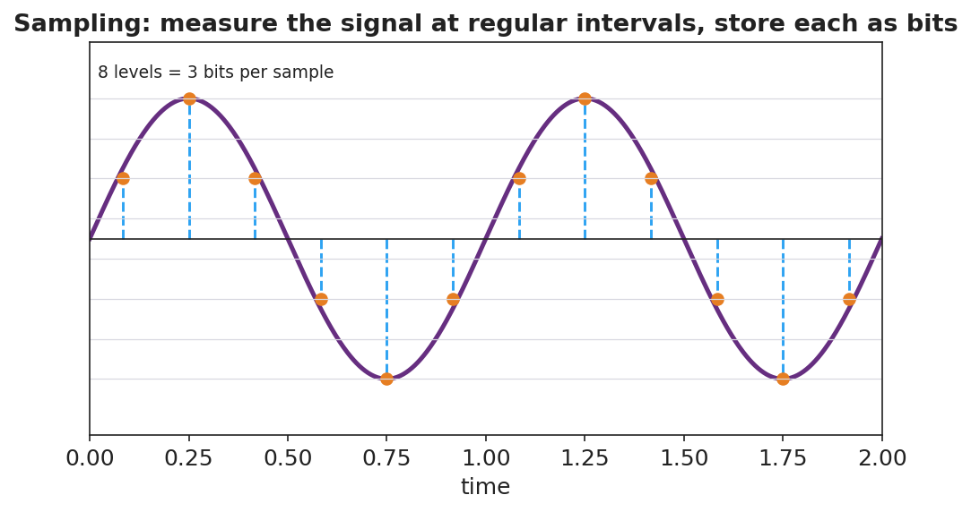
A sampling diagram: a continuous wave measured at regular time intervals, each sample stored at a discrete level (8 levels = 3 bits).

Teacher facilitation during Explore
- What to look for — groups reasoning that small noise on a digital signal rounds back to the correct level, while noise on analog is indistinguishable from the real signal.
- What to resist — don’t define analog/digital/bit first; let “smooth vs. stair-step” and “numbers vs. continuous” emerge.
- What to redirect — groups who claim digital is “always better/perfect” should be pushed to find the cost (lost detail between samples; needs enough bits/sampling rate).

Phase 3 · Explain (32 – 37 min)

32–35 min · Turn-and-Talk #2 + class consensus
“Why does digital information survive transmission and copying better than analog?”
Target consensus:
“An analog signal is continuous, so any noise becomes part of the signal and builds up with each copy. A digital signal is a set of exact numbers (bits); small noise can be cleaned back to the nearest value, so copies stay identical.”

35–37 min · Vocabulary introduction (≤ 3 terms)
Sample teacher language:
“A continuous, smoothly varying signal is analog. A signal stored as discrete sampled values is digital. The smallest unit of digital information — a single 0 or 1 — is a bit; more bits per sample means more levels and higher fidelity.”

Discussion prompts to deploy here
- “Why does a digital photo copied 100 times look identical, but a photocopied photo degrades?”
  - Sample student response: “The digital photo is exact numbers that get reproduced perfectly; the photocopy adds a little noise each time.”
- “What’s a disadvantage of digital?”
  - Sample student response: “You lose the detail between samples unless you sample fast enough and use enough bits.”

Phase 4 · Elaborate (37 – 40 min)

37–39 min · Revise the model
“Return to your sampled wave. Label the smooth curve analog and the stair-step digital. Add a one-sentence evaluation: why is digital better for sending a song across the world?”

39–40 min · Return to the phenomenon
“Explain in one sentence why the streamed song stays crisp but the vinyl gets scratchier, using analog, digital, and noise.”
Target: “Vinyl is analog, so every scratch adds noise to the continuous groove; a streamed song is digital — stored as bits — so noise can be removed by rounding to the nearest value and every copy stays identical.”

Phase 5 · Evaluate (40 – 42 min)

40–42 min · Exit Ticket + Closing Reflection
“A friend says, ‘Records sound warmer, so analog must be better in every way.’ (a) Define analog and digital signals. (b) Give two advantages of digital for transmitting and storing music. (c) Evaluate the friend’s claim: name one thing analog might do well and one clear advantage of digital they’re overlooking.”
Expected: (a) analog = continuous signal, digital = discrete sampled values stored as bits; (b) robust to noise / identical copies / easy to store and compress; (c) analog can capture continuous nuance, but digital resists noise and copies perfectly — the friend overlooks robustness/fidelity in transmission. See Answer_Key.docx.
Closing Reflection (SEL, 30 seconds):
“After this whole Waves unit, what’s one wave idea you’ll carry with you — and how did this class help you ‘tune in’?”

Common Misconceptions
- Misconception: “Digital signals are perfect with no information loss.” → Correction: Sampling and quantization discard detail between samples; fidelity depends on sampling rate and bit depth.
- Misconception: “Analog is old and useless.” → Correction: Analog captures continuous variation; the lesson is about trade-offs, especially digital’s robustness to noise.
- Misconception: “A bit is the same as a byte / a sample.” → Correction: A bit is a single 0/1; multiple bits encode one sample’s level (e.g., 3 bits = 8 levels).

Access & Differentiation
- ELL/ENL supports: Sentence frame: “An analog signal is ______; a digital signal is ______. Digital survives noise because ______.” Word-choice box: {continuous, discrete/sampled, rounded to the nearest value, bits}. Provide the analog-vs-digital figure with both labeled.
- IEP/SPED supports: Provide graph paper with an analog wave already drawn and grid levels marked; students place sample dots and round to the nearest line. Offer the photocopy-degradation demo as a concrete anchor for “noise builds up.”
- Extensions: Estimate the bits needed for CD audio (16 bits/sample × 44,100 samples/s × 2 channels) and discuss why higher sampling rates and bit depths improve fidelity but increase file size.

Strategy Spotlight
BTC (Building Thinking Classrooms). Use visibly random groups of 3 at vertical non-permanent surfaces, one marker per group. The escalating thin slices — sample, refine, add noise, then evaluate — culminate in the HS-PS4-2 evaluation question, which is genuinely open and benefits from public, erasable thinking. Defer vocabulary to Phase 3 and circulate with one prompt: “After adding noise, which signal can you clean back to the original — and why?”

NYSSLS Observation Checklist Crosswalk
# | Checklist item | Where it appears in this lesson
1 | Local/relatable phenomenon | Phase 1 — vinyl vs. stream; photocopy vs. PDF
2 | Turn and Talk (2–3×) | Phase 1 (TT#1 — why numbers survive copying), Phase 3 (TT#2 — why digital is robust)
3 | Students develop questions/models/procedures | Phase 1 (initial model), Phase 2 (BTC sampling + noise tasks + Javalab), Phase 4 (revise)
4 | CCC defined and used | Lesson Overview · Stability and Change, restated in Phase 2
5 | ENL — ≤ 3 vocab, second half | Phase 3 — vocabulary at 35–37 min (analog signal / digital signal / bit)
6 | Revisit phenomenon with evidence | Phase 4 — vinyl-vs-stream explanation
7 | ENL/SPED supports | Access & Differentiation block
8 | Assessment check | Phase 5 — Exit Ticket (evaluate the “analog is better” claim)

Companion Materials
- Student_Worksheet.docx — the 5E student investigation (hand out at start of Phase 2)
- Student_Notes.docx — guided note-guide for vocabulary and the worked example
- Answer_Key.docx — answers to “Make It Make Sense” prompts and the Exit Ticket

Key Vocabulary (max 3)
- analog signal — a continuous, smoothly varying signal that can take any value (e.g., a vinyl groove, a sound wave in air)
- digital signal — a signal represented by discrete sampled values encoded as bits, taking only specific levels
- bit — the smallest unit of digital information, a single 0 or 1; more bits per sample give more levels and higher fidelity

Digital Technologies and Information — Student Worksheet
Unit: Waves — Lesson 10 Name: _______________________ Date: __________ Period: ____

Phenomenon
A vinyl record gets scratchier every time it’s played, and a copy of a copy of a photocopy turns to mush. But you can stream the same song a million times, or copy a PDF endlessly, and the last copy is identical to the first.
Driving question: Why does a digital copy survive perfectly while an analog copy degrades?

Notice & Wonder
I notice… | I wonder…
Turn & Talk #1: What is it about storing something as numbers (digital) that lets it survive copying perfectly?

Initial Model
Draw a smooth wave (analog). Now show how you would store it using only a few measured points (samples). What information do you lose? What do you gain?

Investigation
Work in your random group of 3 at a vertical surface. Use graph paper and Javalab.
Task | What we did | What we found
1. Sample + round an analog wave
2. Twice as many samples
3. Add noise to both, then “clean”
4. List 2 advantages of digital
Compare your stair-step to these:

Analog sine wave overlaid with its sampled, quantized digital version.

A sampling diagram: a wave measured at regular intervals, each sample stored at a discrete level (8 levels = 3 bits).
Key question: After you added noise, which signal could you clean back to the original exactly — analog or digital? Why?

Make It Make Sense
- Define analog and digital signals in your own words.
- Why does a digital photo copied 100 times look identical, but a photocopied photo degrades?
- Name one disadvantage of digital — what gets lost when you sample a smooth wave?

Vocabulary in Action
Use each term in a sentence about today’s phenomenon.
- analog signal: _______________________________________________
- digital signal: _______________________________________________
- bit: _______________________________________________

Revise Your Model
Return to your sampled wave. Label the smooth curve analog and the stair-step digital. Add a one-sentence evaluation: why is digital better for sending a song across the world?

Exit Ticket
A friend says, “Records sound warmer, so analog must be better in every way.”
- Define analog and digital signals.
- Give two advantages of digital for transmitting and storing music.
- Evaluate the friend’s claim: name one thing analog might do well and one clear advantage of digital they’re overlooking.

Digital Technologies and Information — Student Notes
Unit: Waves — Lesson 10 Name: _______________________ Date: __________ Period: ____

Learning Targets
By the end of today’s 42 minutes I can:
- Distinguish an analog signal from a digital signal.
- Explain how sampling and bits represent a wave.
- Evaluate why digital transmission and storage resist noise and copy perfectly.

Key Vocabulary
- analog signal — _______________________________________________
- digital signal — _______________________________________________
- bit — _______________________________________________

Guided Notes
Analog vs. digital.

Analog sine wave overlaid with its sampled, quantized digital version.
- Analog — a __________ signal that can take any value (vinyl groove, sound in air).
- Digital — a signal stored as __________ (sampled) values, each rounded to a level and written as __________.
Sampling. To digitize a wave you measure it at regular __________ and store each measurement.

Sampling: a wave measured at regular intervals, 8 levels = 3 bits.
- More samples per second + more bits per sample → __________ fidelity.
- A bit is a single __________ or __________; 3 bits give 2³ = __________ levels.
Why digital wins (HS-PS4-2, Stability and Change).
- Noise on a digital signal can be __________ back to the nearest level → copies stay identical.
- Noise on an analog signal becomes part of the signal and __________ up with each copy.
- Digital is also easy to __________, compress, and error-check.
Trade-off: digital loses the detail __________ the samples unless you sample fast enough.

Worked Example
Problem. A sound is sampled with 3 bits per sample. (a) How many levels is that? (b) Why does adding a 4th bit improve the recording?
Solution. 1. 3 bits → 2³ = __________ levels. 2. A 4th bit → 2⁴ = __________ levels, so each sample is rounded to a __________ value → higher fidelity. 3. More bits trade larger __________ for better quality. ✓

Summary
Finish the sentence (Because / But / So):
A streamed song stays crisp but a vinyl record gets scratchier because __________________________________________, but __________________________________________, so __________________________________________.

Digital Technologies and Information — Answer Key

Cover
Unit: Waves — Lesson 10: Digital Technologies and Information East Meadow Schools × Valley Stream Central HSD Strategy chip: BTC

Make-It-Make-Sense Answers
- Analog = a continuous signal that can take any value (smooth wave). Digital = a signal stored as discrete sampled values encoded as bits (a stair-step of specific levels). · Rubric: continuous vs. discrete/sampled. · NYSSLS: HS-PS4-2
- A digital photo is stored as exact numbers (bits) that are reproduced perfectly each copy; a photocopy is analog and adds a little noise every time, which accumulates and degrades the image. · Rubric: exact numbers reproduce vs. noise accumulates. · NYSSLS: HS-PS4-2
- Sampling discards the detail between the sample points (and rounds each sample to the nearest level); if you don’t sample fast enough or use enough bits, the digital version misses fine variation. · Rubric: names lost detail between samples / quantization. · NYSSLS: HS-PS4-2

Exit Ticket Answer
- Analog = continuous signal (any value); digital = discrete sampled values stored as bits.
- Any two: resistant to noise (can be cleaned back to exact levels); perfect, identical copies; easy to store, compress, and error-check; easy to transmit over long distances without degrading.
- Analog can capture continuous nuance/detail (the “warmth”), but the friend overlooks that digital is far more robust to noise and copies perfectly — a major advantage for transmitting and storing music.
Tolerance/rubric: (a) both defined; (b) two valid advantages; (c) one fair point for analog AND one clear digital advantage (robustness/fidelity). 1 point each. NYSSLS: HS-PS4-2.

Closing Reflection (rubric)
Formative, not graded. Award full credit for any honest response. Look for: - One wave idea from the whole unit the student will carry forward - A genuine reflection on how the class helped them learn

Modern Physics — Unit Plan

Cover
Unit: Modern Physics East Meadow Schools × Valley Stream Central High School District 5 lessons · ~5 instructional periods (42 min each) Format: DOCX (Teacher Guide · Student Worksheet · Student Notes · Answer Key per lesson)

Unit Scope (from East Meadow Scope & Sequence)
This closing unit reframes everything students have learned about waves, energy, and matter at the scale of the atom and the nucleus. Light, which earlier behaved as a wave, now also behaves as a stream of energy packets called photons. Matter, which earlier was modeled as solid particles, is now organized into a small set of fundamental particles. The unit develops and uses models (a core SEP) as the through-line: each lesson revises a model when new evidence demands it. It builds on Waves (frequency and wavelength) and Energy, and it connects outward to chemistry (nuclear change) and astronomy (starlight and the Big Bang).
# | Lesson | Core idea
01 | The Photoelectric Effect | Light is quantized: photons of energy E = h·f eject electrons only above a threshold frequency
02 | Models of the Atom | The atomic model evolved (Dalton → Thomson → Rutherford → Bohr → quantum) as evidence accumulated
03 | Energy-Level Diagrams and Spectra | Electrons occupy discrete energy levels; photon jumps produce line spectra that fingerprint elements
04 | The Standard Model | Matter is built from quarks and leptons; forces are carried by bosons
05 | Fusion, Fission, and Radioactive Decay | Nuclear changes release enormous energy (E = mc², scale only); they power stars and form elements

Pacing Calendar
Day | Lesson | Phenomenon anchor | Strategy
1 | 01 Photoelectric Effect | Different-color lasers on a photo surface — only some eject electrons | Hochman
2 | 02 Models of the Atom | Rutherford gold-foil scattering | Active Learning
3 | 03 Energy Levels & Spectra | Gas-discharge tubes show colored line spectra, not a rainbow | BTC
4 | 04 The Standard Model | Cassiopeia Project Standard Model video — what is everything made of? | Hochman
5 | 05 Fusion / Fission / Decay | The Sun, nuclear power, and carbon dating | Active Learning
Double-period days (every other day) let the Explore phases of Lessons 01 and 03 run long with the PhET and ophysics simulations as full labs.

Strategy Rotation
- HOCHMAN (literacy): Lessons 01, 04 — Because/But/So expansion and appositives on the key relationships (E = h·f and threshold frequency; quarks/leptons/bosons as an organizing model).
- ACTIVE LEARNING: Lessons 02, 05 — gold-foil claim-evidence card sort and model-revision gallery; the fission/fusion/decay station rotation.
- BTC (Building Thinking Classrooms): Lesson 03 — random groups + vertical non-permanent surfaces on an energy-level/spectrum thin-slice.
SEL (Opening Connection + Closing Reflection), ELL/SPED supports, and a Curated Resources block appear in every lesson.

NYSSLS Coverage Matrix
PE | Description | Lessons
HS-PS4-4 | Evaluate the validity and reliability of claims about the effects of different frequencies of electromagnetic radiation absorbed by matter (Cause and Effect) | 01 (core)
HS-PS1-8 | Develop models to illustrate changes in the nucleus and the energy released during fission, fusion, and radioactive decay (Energy and Matter) — scale of energy only | 05 (core)
HS-ESS1-2 | Construct an explanation of the Big Bang based on light spectra, galaxy motion, and composition — connection to wavelength/frequency of light and star formation | 03 (spectra), 05 (star formation, thread)
The Science and Engineering Practice Developing and Using Models anchors Lessons 02 and 04, which are conceptual model-building lessons rather than single-PE lessons.

Vocabulary Scope
Three terms maximum per lesson, introduced in the second half (NYSSLS observation item 5).
Lesson | Terms
01 | photon · photoelectric effect · threshold frequency
02 | nucleus · electron · atomic model
03 | energy level · photon emission · line spectrum
04 | quark · lepton · fundamental particle
05 | fission · fusion · radioactive decay

The Photoelectric Effect — Teacher Guide

Cover
Unit: Modern Physics — Lesson 01: The Photoelectric Effect East Meadow Schools × Valley Stream Central High School District Strategy chips: HOCHMAN

Curated Resources (from East Meadow Scope & Sequence)

NYSSLS Standards
This lesson is the core treatment of HS-PS4-4: “Evaluate the validity and reliability of claims in published materials of the effects that different frequencies of electromagnetic radiation have when absorbed by matter. (Cause and Effect).” The photoelectric effect is the cleanest case in the curriculum where the frequency of light — not its brightness — is the cause that determines an effect (whether electrons are ejected). It also closes the Waves unit’s wave model of light by introducing the complementary particle (photon) model.

Phenomenon
- Different-color lasers (red, green, violet) shining on a glow/photo surface — only some colors eject electrons, no matter how bright: https://www.youtube.com/watch?v=kcSYV8bMQzg
- Why a UV lamp fogs photographic paper but a much brighter red lamp does not (cause-and-effect framing).

Javalab / Labs
- PhET Photoelectric Effect simulation: https://phet.colorado.edu/en/simulations/photoelectric

Assessments
- Exit ticket below (threshold-frequency reasoning) is the formative check. The PhET simulation includes built-in data tables students can screenshot as evidence.

Lesson Overview
Duration | 42 minutes (1 period)
NYSSLS link | HS-PS4-4 (core)
CCC focus | Cause and Effect — the frequency of light, not its intensity, causes (or fails to cause) electron ejection.
Strategy chips | HOCHMAN (Because/But/So + appositive on threshold frequency)
Materials | Projector for the laser/PhET demo; student devices or a shared screen for PhET; whiteboards/markers; reference table (E = h·f, h = 6.63×10⁻³⁴ J·s).
Safety | If using real lasers, never aim at eyes; the simulation is the safe default.
Prior knowledge | Waves — frequency and wavelength (violet light is higher frequency than red); energy as a measurable quantity.
Lesson objectives — students can:
- Describe light as a stream of energy packets (photons) whose energy is set by frequency, E = h·f.
- Explain why electrons are ejected only above a threshold frequency, regardless of intensity.
- Use E = h·f to calculate a photon’s energy and compare it to a threshold.

Phase 1 · Engage (0 – 10 min)

0–2 min · Opening Connection (SEL)
Quick whip-around (one sentence each, pass allowed): “Name something where doing it harder doesn’t help — only doing it a different way does.” (e.g., a key that’s the wrong shape — pushing harder won’t open the lock.) Park these; you’ll call back to “wrong shape vs. harder push” when intensity fails but frequency succeeds.

2–7 min · Phenomenon hook — colored lasers on a photo surface
Teacher actions. Project the laser clip (or PhET). Shine a bright red beam on the surface: no electrons leave. Switch to a dim violet beam: electrons fly off immediately.
Sample teacher language:
“I just made the red light much brighter and nothing happened. Then I used a dim purple light and electrons jumped off right away. Brightness lost to color. Why would the color of the light decide this, when more brightness couldn’t?”
Anticipated student responses:
- “Purple light is stronger.” — reframe: “Stronger how? It’s actually dimmer. What’s different about purple?”
- “Maybe purple has more energy per beam.” — capture energy; we’ll sharpen “per beam” to “per packet.”
- “It’s the frequency — purple is higher frequency.” — gold; hold it for Phase 3.

7–10 min · Notice & Wonder + Turn-and-Talk #1
Two columns on the board. Then:
“Turn to your partner: what does brightness change, and what does color change? Predict which one controls whether electrons leave.”
Target seed: brightness = how many; color (frequency) = how much energy each carries.

Bridge to Phase 2
Every student leaves with a one-sentence initial model: “Electrons are ejected when ______.”

Phase 2 · Explore (10 – 30 min)

10–14 min · Initial Model (silent / individual)
Prompt on the board:
“Draw the light hitting the metal. Show what you think ‘brighter’ does and what ‘higher frequency’ does. Predict: which change will start ejecting electrons?”

14–30 min · Investigation — PhET Photoelectric Effect
Students (pairs) run the PhET sim and fill the data table on the worksheet:
- Hold frequency low (red), raise intensity to max. Do electrons eject? (No.)
- Hold intensity low, raise frequency until electrons just begin to leave. Record that frequency — the threshold.
- Above threshold: raise frequency higher. What happens to the speed/energy of ejected electrons? (Increases.)
- Above threshold: raise intensity. What happens to the number of electrons? (Increases, but their energy does not.)
Teacher facilitation language:
“At max brightness with red light — anything? Now creep the frequency up. Watch for the exact moment electrons appear.” “Once they’re flying, what does turning up brightness change — their number or their speed?” “What does turning up frequency change instead?”
Use the diagram below to make “one photon, one electron” visible while students model the ejection event:
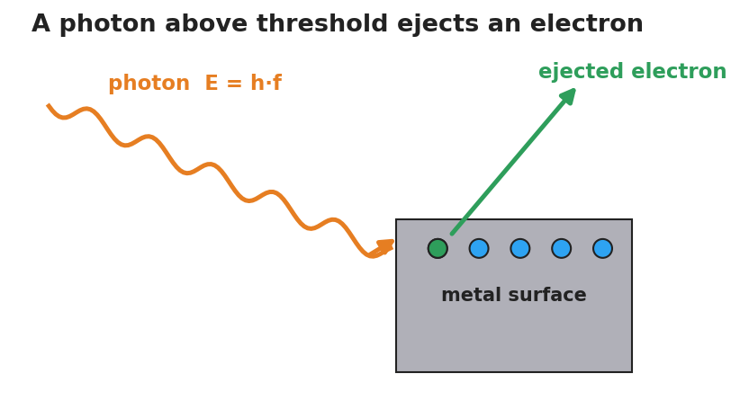
A single photon of energy E equals h times f strikes a metal surface and ejects one electron, which flies away.

Teacher facilitation during Explore
- What to look for — students noticing the sharp on/off at a particular frequency, not a gradual fade.
- What to resist — don’t name “photon” or “quantized” yet; let the threshold surprise them.
- What to redirect — “more brightness = more energy” should be tested: more brightness below threshold still ejects nothing.

Phase 3 · Explain (30 – 36 min)

30–33 min · Turn-and-Talk #2 + class consensus
“Brightness changed the number of electrons but never started them. Frequency had an on/off line. What does that tell you about how light delivers its energy?”
Target consensus:
“Light arrives in separate packets. Each packet’s energy depends on frequency. One packet hits one electron — if that single packet doesn’t carry enough energy, no amount of extra packets (brightness) helps.”

33–36 min · Vocabulary introduction (≤ 3 terms)
Sample teacher language:
“Each energy packet of light is a photon — a particle of light. Its energy is E = h·f, so higher frequency means a more energetic photon. The ejecting of electrons by light is the photoelectric effect. The lowest frequency that can eject any electron is the threshold frequency — below it, brightness is useless; above it, brightness only adds more electrons.”

Discussion prompts to deploy here
- “Why can’t a brighter red beam ever eject an electron that violet ejects easily?”
  - Sample student response: “Brighter red just sends more low-energy photons; each one is still too weak. Violet photons each clear the threshold.”
- “If h is tiny, why does frequency matter so much?”
  - Sample student response: “E = h·f — h is fixed, so the only way to raise each photon’s energy is to raise f.”

Phase 4 · Elaborate (36 – 39 min)

36–38 min · Hochman Because/But/So + revise the model
Students complete the sentence stem (modeled, then independent):
“A bright red light cannot eject electrons because ______, but a dim violet light can because ______, so the deciding factor is ______ , not ______.”
Coach the appositive: “A photon, a single packet of light energy, carries E = h·f.”

38–39 min · Return to the phenomenon
“Restate the laser demo in one sentence using photon and threshold frequency.”
Target: “Violet photons cleared the threshold frequency and ejected electrons; red photons — even many of them — each fell below it.”

Phase 5 · Evaluate (39 – 42 min)

39–42 min · Exit Ticket + Closing Reflection
“A metal has a threshold frequency of 5.0×10¹⁴ Hz. (a) Find the energy of one photon of light at 6.0×10¹⁴ Hz. (Use E = h·f, h = 6.63×10⁻³⁴ J·s.) (b) Will that light eject electrons? Explain. (c) Doubling the brightness of light at 4.0×10¹⁴ Hz does what? Why?”
Expected: (a) E = (6.63×10⁻³⁴)(6.0×10¹⁴) ≈ 4.0×10⁻¹⁹ J; (b) yes — 6.0×10¹⁴ Hz is above threshold; (c) nothing is ejected — below threshold, more photons still each lack the energy. See Answer_Key.docx.
Closing Reflection (SEL, 30 seconds):
“What is one idea about light that changed for you today?”

Common Misconceptions
- Misconception: “Brighter light always carries more energy to each electron.” → Correction: Brighter light = more photons, not more energetic ones. Each photon’s energy is set by frequency (E = h·f).
- Misconception: “Light is only a wave.” → Correction: Light also behaves as particles (photons); the photoelectric effect is the evidence the wave model alone cannot explain.
- Misconception: “Any light, given enough time/intensity, eventually ejects electrons.” → Correction: Below the threshold frequency, no intensity and no waiting will eject an electron — it’s an on/off threshold.

Access & Differentiation
- ELL/ENL supports: Sentence frame: “Light below the ___ frequency ejects ___ electrons, but light above it ejects electrons whose energy ___ as frequency rises.” Word box: {threshold, no, increases, photon, intensity}. Pair photon with a gesture (one fist = one packet).
- IEP/SPED supports: Provide the PhET data table pre-labeled; students circle “ejects / does not eject” rather than writing. Offer a partially worked E = h·f calculation with the substitution already set up.
- Extensions: Have students compute the threshold energy in joules from the threshold frequency and explain why two metals with different thresholds respond to different colors.

Strategy Spotlight
HOCHMAN (literacy). Today’s literacy move is the Because/But/So expansion in Phase 4, which forces students to coordinate cause (frequency) against a distractor (intensity) in a single complex sentence. Model one aloud, then release. The appositive drill — “A photon, a single packet of light energy, carries E = h·f” — gives students a compact way to define the new term mid-sentence, a transferable academic-writing structure.

NYSSLS Observation Checklist Crosswalk
# | Checklist item | Where it appears in this lesson
1 | Local/relatable phenomenon | Phase 1 — colored lasers; UV vs. red lamp
2 | Turn and Talk (2–3×) | Phase 1 (TT#1 — brightness vs. color), Phase 3 (TT#2 — how light delivers energy)
3 | Students develop questions/models/procedures | Phase 1 (initial model), Phase 2 (PhET investigation), Phase 4 (revise model)
4 | CCC defined and used | Lesson Overview · Cause and Effect (frequency → ejection), restated in Phase 3
5 | ENL — ≤ 3 vocab, second half | Phase 3 — vocabulary at 33–36 min (photon / photoelectric effect / threshold frequency)
6 | Revisit phenomenon with evidence | Phase 4 — restate the laser demo using new terms
7 | ENL/SPED supports | Access & Differentiation block
8 | Assessment check | Phase 5 — Exit Ticket (E = h·f + threshold)

Companion Materials
- Student_Worksheet.docx — the 5E student investigation with the PhET data table (hand out at start of Phase 2)
- Student_Notes.docx — guided note-guide for vocabulary and the E = h·f worked example
- Answer_Key.docx — answers to “Make It Make Sense” prompts and the Exit Ticket

Key Vocabulary (max 3)
- photon — a single packet (particle) of light energy; its energy is E = h·f, where h = 6.63×10⁻³⁴ J·s
- photoelectric effect — the ejection of electrons from a surface when light of high enough frequency strikes it
- threshold frequency — the lowest frequency of light that can eject electrons from a given surface; below it, no electrons leave regardless of intensity

The Photoelectric Effect — Student Worksheet
Unit: Modern Physics — Lesson 01 Name: _______________________ Date: __________ Period: ____

Phenomenon
A very bright red laser shines on a metal surface — and nothing happens. Then a dim violet light hits the same surface and electrons fly off instantly. Turning the red light brighter still does nothing.
Driving question: What decides whether light can knock electrons off a surface — how bright it is, or its color (frequency)?

Notice & Wonder
I notice… | I wonder…
Turn & Talk #1: What does changing the brightness of light do? What does changing the color do? Which one do you predict controls electron ejection?

Initial Model
Draw the light hitting the metal. Show what you think “brighter” does and what “higher frequency (more violet)” does. Then predict which change will start ejecting electrons.

My prediction: _______________________________

Investigation
Use the PhET Photoelectric Effect simulation. The diagram shows one photon striking the metal and ejecting one electron — use it as your model of a single ejection event.

A single photon of energy E equals h times f strikes a metal surface and ejects one electron.
Test | What I changed | Electrons ejected? (Y/N) | What changed about them (number / energy)
1. Red light, brightness to MAX
2. Raise frequency slowly |  |  | (record the frequency where ejection starts)
3. Above threshold, raise frequency more
4. Above threshold, raise brightness
Key question: Below the ejecting frequency, does turning up the brightness ever start ejecting electrons?

Make It Make Sense
- A bright red beam ejects no electrons, but a dim violet beam does. What does this tell you about how light delivers its energy?
- Above the threshold, turning up the brightness adds more electrons but does not speed them up. Turning up the frequency speeds them up. Explain why, using the idea of a photon.
- A photon’s energy is E = h·f. If you wanted to give each photon more energy, what would you change?

Vocabulary in Action
Use each term in a sentence about today’s phenomenon.
- photon: _______________________________________________
- photoelectric effect: _______________________________________________
- threshold frequency: _______________________________________________

Revise Your Model
Return to your Initial Model. Using photon and threshold frequency, rewrite your explanation of why brightness failed but color succeeded.

Exit Ticket
A metal has a threshold frequency of 5.0×10¹⁴ Hz. (Reference table: E = h·f, h = 6.63×10⁻³⁴ J·s.)
- Find the energy of one photon of light at 6.0×10¹⁴ Hz.
- Will that light eject electrons from this metal? Explain.
- Light at 4.0×10¹⁴ Hz is made twice as bright. What happens to the ejected electrons? Why?

The Photoelectric Effect — Student Notes
Unit: Modern Physics — Lesson 01 Name: _______________________ Date: __________ Period: ____

Learning Targets
By the end of today’s 42 minutes I can:
- Describe light as a stream of energy packets (photons) whose energy depends on frequency.
- Explain why electrons are ejected only above a threshold frequency, no matter the brightness.
- Use E = h·f to calculate a photon’s energy.

Key Vocabulary
- photon — _______________________________________________
- photoelectric effect — _______________________________________________
- threshold frequency — _______________________________________________

Guided Notes
Big idea: Light is not only a wave — it also arrives in __________ packets called photons.
- The energy of one photon: E = h·f, where h = __________ J·s (Planck’s constant) and f is the __________.
- Higher frequency → __________ energy per photon. (Violet photons carry more energy than red photons.)
- Brightness = how __________ photons arrive each second (the number), not how much energy each one has.
The photoelectric effect (one photon, one electron):
- One photon hits one __________. If that single photon’s energy is high enough, the electron is __________.
- The lowest frequency that can eject any electron is the threshold frequency.
  - Below threshold: __________ electrons leave, no matter how bright.
  - Above threshold: raising brightness adds __________ electrons; raising frequency adds __________ to each electron.

A single photon of energy E equals h times f strikes a metal surface and ejects one electron.
The graph below shows it: no electron energy below the threshold frequency f₀, then a straight line rising with frequency.
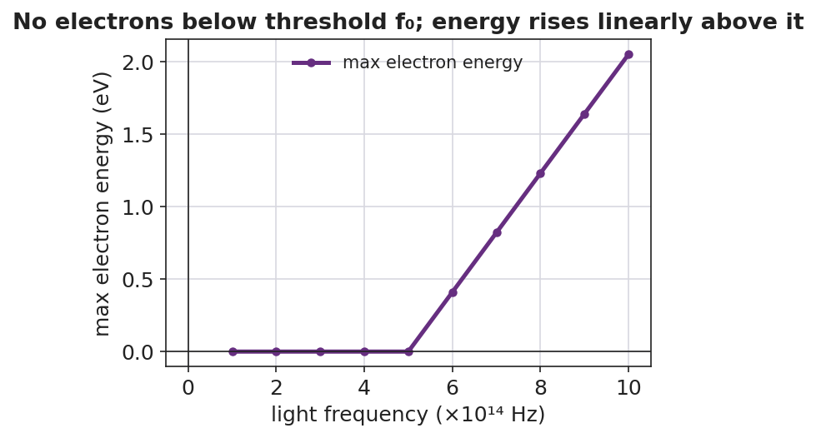
Graph of maximum ejected-electron energy versus light frequency: zero below the threshold frequency, then rising linearly above it.

Worked Example
Problem. Find the energy of one photon of green light with frequency 5.5×10¹⁴ Hz. (h = 6.63×10⁻³⁴ J·s.)
Solution. 1. Write the formula: E = h·f. 2. Substitute: E = (6.63×10⁻³⁴ J·s)(5.5×10¹⁴ Hz). 3. Multiply: E = __________ J ≈ 3.6×10⁻¹⁹ J. 4. A violet photon (higher f) would have __________ energy; a red photon (lower f) would have __________ energy.

Summary
Finish the sentence (Because / But / So):
A very bright red light cannot eject electrons because __________________________________________, but a dim violet light can because __________________________________________, so __________________________________________.

The Photoelectric Effect — Answer Key

Cover
Unit: Modern Physics — Lesson 01: The Photoelectric Effect East Meadow Schools × Valley Stream Central HSD Strategy chip: HOCHMAN

Make-It-Make-Sense Answers
- Light delivers its energy in separate packets (photons), not as one continuous flow. A single red photon is too weak to free an electron, and many weak photons (a bright red beam) still can’t — each electron is hit by one photon at a time. A violet photon carries enough energy in one packet. · Rubric: names packets/photons AND states “one photon hits one electron” → full credit. · NYSSLS: HS-PS4-4
- Brightness adds more photons, so more electrons are freed, but each electron still gets the energy of just one photon — so their speed/energy doesn’t change. Raising the frequency raises each photon’s energy (E = h·f), so each freed electron leaves with more energy. · Rubric: links brightness → number and frequency → energy-per-electron. · NYSSLS: HS-PS4-4
- Raise the frequency (use higher-frequency / more-violet light). Since E = h·f and h is fixed, frequency is the only factor that changes a photon’s energy. · Rubric: identifies frequency via E = h·f. · NYSSLS: HS-PS4-4

Exit Ticket Answer
- E = h·f = (6.63×10⁻³⁴ J·s)(6.0×10¹⁴ Hz) = 3.98×10⁻¹⁹ J ≈ 4.0×10⁻¹⁹ J.
- Yes. 6.0×10¹⁴ Hz is above the threshold frequency (5.0×10¹⁴ Hz), so each photon carries enough energy to eject an electron.
- Nothing is ejected. 4.0×10¹⁴ Hz is below the threshold; doubling the brightness only doubles the number of too-weak photons — each still lacks the energy to free an electron.
Tolerance/rubric: (a) E ≈ 4.0×10⁻¹⁹ J (accept 3.9–4.0×10⁻¹⁹ J), must show E = h·f; (b) “yes” + “above threshold”; (c) “no electrons” + “below threshold / brightness only adds photons.” 1 point each. NYSSLS: HS-PS4-4.

Closing Reflection (rubric)
Closing reflection is formative, not graded. Award full credit for any honest response. Look for: - A genuine shift-in-thinking statement (e.g., “I used to think brighter always meant more energy”). - A correct association between frequency/color and photon energy.

Models of the Atom — Teacher Guide

Cover
Unit: Modern Physics — Lesson 02: Models of the Atom East Meadow Schools × Valley Stream Central High School District Strategy chips: ACTIVE LEARNING

Curated Resources (from East Meadow Scope & Sequence)

NYSSLS Standards
This is a model-building lesson anchored to the Science and Engineering Practice Developing and Using Models. Students see that a scientific model is revised when new evidence appears — the central habit of mind behind every Modern Physics standard. It builds the atomic structure that the spectra lesson (HS-ESS1-2 connection) and the nuclear-change lesson (HS-PS1-8) depend on.

Phenomenon
- Rutherford’s gold-foil scattering: most alpha particles pass straight through a thin gold foil, but a tiny fraction bounce sharply backward: https://www.youtube.com/watch?v=XBqHkraf8iE
- Rutherford’s own line: “as if you fired a 15-inch shell at a piece of tissue paper and it came back and hit you.”

Javalab / Labs
- Rutherford scattering (interactive): https://javalab.org/en/rutherford_scattering_en/

Assessments
- Exit ticket below (match a model to the evidence that overturned it). The gold-foil claim-evidence card sort in Phase 2 is the formative check.

Lesson Overview
Duration | 42 minutes (1 period)
NYSSLS link | SEP: Developing and Using Models (supports HS-PS1-8 and HS-ESS1-2 later in the unit)
CCC focus | Patterns / Stability and Change — a model holds until new evidence forces a change.
Strategy chips | ACTIVE LEARNING (claim–evidence card sort + model-revision gallery)
Materials | Pre-cut model/evidence card sets (one per group); chart paper or whiteboards; markers; the model-progression handout.
Safety | None — simulation and paper-based.
Prior knowledge | Atoms contain protons, neutrons, electrons (from earlier science); charge basics (+/−).
Lesson objectives — students can:
- Sequence the atomic models (Dalton → Thomson → Rutherford → Bohr → quantum) and state what each got right.
- Explain how the gold-foil experiment provided evidence for a small, dense nucleus.
- Argue, using evidence, why a scientific model changes over time.

Phase 1 · Engage (0 – 10 min)

0–2 min · Opening Connection (SEL)
Whip-around (one sentence, pass allowed): “Tell me about a time you changed your mind because you got new information.” Park responses — you’ll connect them to “scientists change models with new evidence.”

2–7 min · Phenomenon hook — the gold-foil surprise
Teacher actions. Play the gold-foil clip (or run the Javalab sim). Set up the expectation first: scientists thought the atom was a soft “pudding” of positive charge. Show alphas firing at the foil; most pass through, a rare few rebound.
Sample teacher language:
“They expected every bullet to sail straight through soft pudding. Instead, one in thousands bounced straight back. Rutherford said it was like firing a cannon shell at tissue paper and having it come back at you. What inside the atom could do that?”
Anticipated student responses:
- “There’s something hard in the middle.” — gold; capture small + hard + central.
- “The whole atom is solid.” — counter with: “Then why do most pass straight through?”
- “It’s charged and pushed them back.” — capture; the dense center is positive.

7–10 min · Notice & Wonder + Turn-and-Talk #1
“Turn and talk: if MOST pass through but a FEW bounce hard, what must the inside of the atom look like — solid, empty, or something in between?”
Target seed: mostly empty space with a tiny, dense, charged center.

Bridge to Phase 2
Each student writes a one-sentence initial model: “The atom’s inside must be ______ because ______.”

Phase 2 · Explore (10 – 30 min)

10–14 min · Initial Model (silent / individual)
Prompt:
“Draw what you think the inside of a gold atom looks like, based on the scattering result. Mark where the ‘hard’ part is and how much is empty.”

14–30 min · Investigation — model/evidence card sort (ACTIVE LEARNING)
Groups of 3–4 receive shuffled cards: five model cards (Dalton solid sphere, Thomson plum pudding, Rutherford nucleus, Bohr orbits, quantum cloud) and matching evidence cards (e.g., “elements combine in fixed ratios,” “rays bend toward + plate → negative particles exist,” “alpha particles bounce back,” “atoms emit only specific colors of light,” “electrons behave as probability clouds”). Groups:
- Order the models oldest → newest.
- Match each model to the evidence that supported it and the evidence that broke it.
- Build a chart-paper timeline; star the gold-foil card as the turning point for the nucleus.
Teacher facilitation language:
“Which evidence card could Dalton’s solid sphere NOT explain?” “What did Thomson get right that Dalton missed — and what did the gold foil reveal that Thomson missed?” “Bohr’s orbits explain which observation that Rutherford’s couldn’t? (Hold that — it’s Lesson 03.)”
Use the progression figure to anchor the gallery:
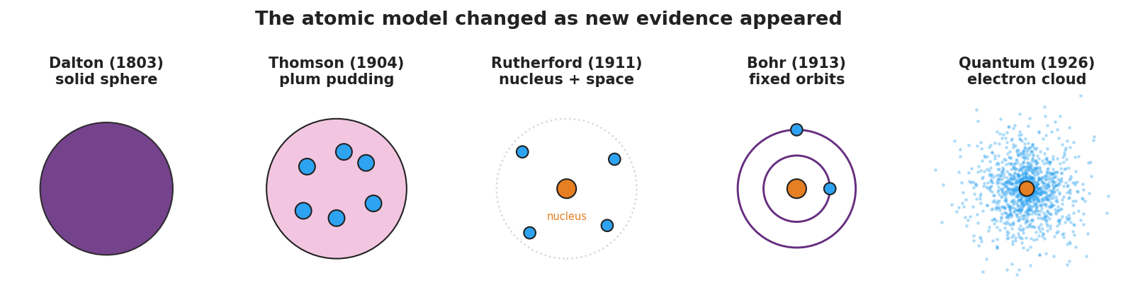
Five-panel progression of atomic models: Dalton solid sphere, Thomson plum pudding, Rutherford nucleus with empty space, Bohr fixed orbits, and the quantum electron cloud.
And the scattering diagram for the turning-point card:
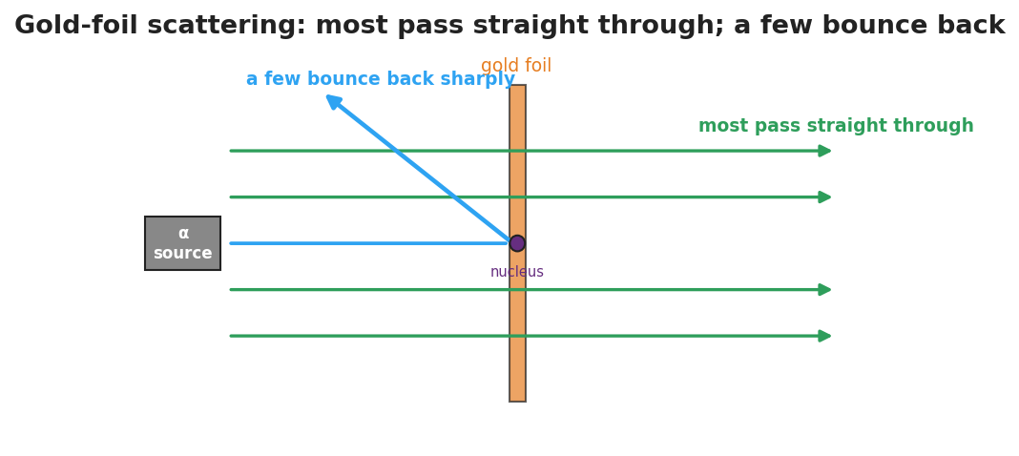
Gold-foil scattering: most alpha particles pass straight through the foil while a few deflect sharply off the tiny dense nucleus.

Teacher facilitation during Explore
- What to look for — groups tying each change to a specific new observation, not just memorizing an order.
- What to resist — don’t pre-label which evidence breaks which model; let the sort do the reasoning.
- What to redirect — “the newest model is the only right one” → every model was the best fit for its evidence.

Phase 3 · Explain (30 – 36 min)

30–33 min · Gallery walk + class consensus
Groups post timelines; one quick gallery walk. Then build consensus:
“Across all five, what always triggered a new model? New, surprising evidence that the old model couldn’t explain.”

33–36 min · Vocabulary introduction (≤ 3 terms)
Sample teacher language:
“The tiny, dense, positively charged center the gold foil revealed is the nucleus. The light, negatively charged particles around it are electrons. A picture scientists use to represent the atom’s structure is an atomic model — and that model has changed every time new evidence arrived.”

Discussion prompts to deploy here
- “Why didn’t Thomson’s plum-pudding model survive the gold-foil result?”
  - Sample student response: “Soft, spread-out positive charge couldn’t bounce an alpha straight back; only a tiny dense nucleus could.”
- “Is the quantum model ‘the truth’ or just the current best model?”
  - Sample student response: “The current best model — it fits today’s evidence, and it could be revised again.”

Phase 4 · Elaborate (36 – 39 min)

36–38 min · Revise the model
“Return to your Initial Model. Redraw the gold atom using the words nucleus and electron, showing the right proportions (tiny dense center, lots of empty space).”

38–39 min · Return to the phenomenon
“In one sentence, explain the gold-foil result using nucleus.”
Target: “Most alphas pass through the empty space, but the few that hit the tiny dense nucleus are pushed sharply back.”

Phase 5 · Evaluate (39 – 42 min)

39–42 min · Exit Ticket + Closing Reflection
“(a) Which atomic model first included a tiny, dense nucleus, and what experiment supported it? (b) Name one thing the Thomson (plum-pudding) model got right. (c) Why do scientists change a model like the atom over time?”
Expected: (a) Rutherford’s model; the gold-foil scattering experiment; (b) atoms contain negative electrons (and a positive part); (c) new evidence appears that the old model cannot explain. See Answer_Key.docx.
Closing Reflection (SEL, 30 seconds):
“Whose idea in your group helped you make sense of the timeline today?”

Common Misconceptions
- Misconception: “The newest model proves the old ones were wrong/stupid.” → Correction: Each model was the best explanation for the evidence available; models improve, they don’t shame their predecessors.
- Misconception: “The atom is mostly solid matter.” → Correction: An atom is overwhelmingly empty space; the nucleus is tiny but holds nearly all the mass.
- Misconception: “Electrons orbit the nucleus on neat circular tracks.” → Correction: That’s the Bohr picture; the current quantum model describes electrons as probability clouds, not fixed paths.

Access & Differentiation
- ELL/ENL supports: Sentence frame: *“The ___ model changed to the ___ model because of evidence from ___.”* Word box: {Thomson, Rutherford, gold foil, nucleus, electron}. Provide the model cards with both a picture and a one-word label.
- IEP/SPED supports: Pre-sort the card set into the correct order for some groups; their task becomes matching evidence to a given sequence. Provide a fill-in timeline rather than blank chart paper.
- Extensions: Have students research and add a sixth card — a modern refinement (e.g., isotopes, the discovery of the neutron) — and justify where it fits and what evidence supports it.

Strategy Spotlight
ACTIVE LEARNING. The card sort makes students do the historical reasoning rather than receive a timeline. Cognitive load stays on the model–evidence relationship. Keep groups to 3–4, rotate a “challenger” role whose job is to ask “what evidence breaks this model?”, and end with a brief gallery walk so every group sees an alternative arrangement before consensus. This positions the gold-foil result as the turning point students argue toward, not one you announce.

NYSSLS Observation Checklist Crosswalk
# | Checklist item | Where it appears in this lesson
1 | Local/relatable phenomenon | Phase 1 — gold-foil “cannon shell off tissue paper”
2 | Turn and Talk (2–3×) | Phase 1 (TT#1 — what’s inside the atom), Phase 3 (gallery-walk consensus discussion)
3 | Students develop questions/models/procedures | Phase 1 (initial model), Phase 2 (card sort + timeline), Phase 4 (revise model)
4 | CCC defined and used | Lesson Overview · Patterns / Stability and Change, restated in Phase 3
5 | ENL — ≤ 3 vocab, second half | Phase 3 — vocabulary at 33–36 min (nucleus / electron / atomic model)
6 | Revisit phenomenon with evidence | Phase 4 — re-explain gold foil using nucleus
7 | ENL/SPED supports | Access & Differentiation block
8 | Assessment check | Phase 5 — Exit Ticket (model ↔ evidence)

Companion Materials
- Student_Worksheet.docx — the 5E student investigation with the card-sort timeline (hand out at start of Phase 2)
- Student_Notes.docx — guided note-guide for the model progression and vocabulary
- Answer_Key.docx — answers to “Make It Make Sense” prompts and the Exit Ticket

Key Vocabulary (max 3)
- nucleus — the tiny, dense, positively charged center of an atom; it holds nearly all the atom’s mass
- electron — a light, negatively charged particle found in the space around the nucleus
- atomic model — a scientific picture or representation of the atom’s structure, revised as new evidence appears

Models of the Atom — Student Worksheet
Unit: Modern Physics — Lesson 02 Name: _______________________ Date: __________ Period: ____

Phenomenon
Scientists fired tiny positive “bullets” (alpha particles) at an ultra-thin sheet of gold. They expected all of them to sail straight through. Almost all did — but a tiny fraction bounced straight back, as if they had hit something small and hard.
Driving question: What does the gold-foil result tell us about what is inside an atom — and why did the atomic model keep changing?

Notice & Wonder
I notice… | I wonder…
Turn & Talk #1: If most bullets pass straight through but a few bounce hard, what must the inside of the atom look like — solid, empty, or something in between?

Initial Model
Draw what you think the inside of a gold atom looks like, based on the scattering result. Mark where the “hard” part is and how much of the atom is empty.

My idea: _______________________________

Investigation
Your group has model cards and evidence cards. The figures below show the model progression and the gold-foil setup.

Five-panel progression of atomic models: Dalton solid sphere, Thomson plum pudding, Rutherford nucleus, Bohr orbits, and the quantum electron cloud.

Gold-foil scattering: most alpha particles pass straight through while a few bounce sharply off the tiny dense nucleus.
- Order the model cards from oldest to newest.
- Match each model to the evidence that supported it and the evidence that broke it.
Model | What it got right | The evidence that broke it
Dalton (solid sphere)
Thomson (plum pudding)
Rutherford (nucleus)
Bohr (orbits)
Quantum (electron cloud) |  | (current best model)
Key question: What did it take, every single time, to make scientists change the atomic model?

Make It Make Sense
- Why couldn’t Thomson’s plum-pudding model explain the alpha particles that bounced straight back?
- The atom is mostly empty space, yet it has nearly all its mass in one tiny spot. Where is that mass, and what is that spot called?
- Is the quantum (electron-cloud) model “the final truth,” or could it change? Explain.

Vocabulary in Action
Use each term in a sentence about today’s phenomenon.
- nucleus: _______________________________________________
- electron: _______________________________________________
- atomic model: _______________________________________________

Revise Your Model
Return to your Initial Model. Redraw the gold atom using the words nucleus and electron, with the correct proportions (tiny dense center, lots of empty space).

Exit Ticket
- Which atomic model first included a tiny, dense nucleus, and which experiment supported it?
- Name one thing the Thomson (plum-pudding) model got right.
- Why do scientists change a model like the atom over time?

Models of the Atom — Student Notes
Unit: Modern Physics — Lesson 02 Name: _______________________ Date: __________ Period: ____

Learning Targets
By the end of today’s 42 minutes I can:
- Put the atomic models in order and state what each one got right.
- Explain how the gold-foil experiment gave evidence for a nucleus.
- Explain why a scientific model changes over time.

Key Vocabulary
- nucleus — _______________________________________________
- electron — _______________________________________________
- atomic model — _______________________________________________

Guided Notes
Big idea: An atomic model is a picture of the atom that scientists __________ whenever new evidence appears.
The progression (oldest → newest):

Five-panel progression of atomic models: Dalton solid sphere, Thomson plum pudding, Rutherford nucleus, Bohr orbits, and the quantum electron cloud.
- Dalton — the atom is a tiny, solid __________ (no inside parts).
- Thomson — discovered the __________ (negative); pictured them stuck in a positive “pudding.”
- Rutherford — the gold-foil experiment showed the atom is mostly __________ space with a tiny, dense, positive __________.
- Bohr — electrons travel in fixed __________ around the nucleus (sets up Lesson 03).
- Quantum — electrons are best described as a __________ cloud (probability), not fixed paths.
The gold-foil evidence:

Gold-foil scattering: most alpha particles pass straight through while a few bounce sharply off the tiny dense nucleus.
- Most alpha particles passed __________ through → the atom is mostly empty.
- A few bounced sharply __________ → there is a tiny, dense, positive __________.

Worked Example
Problem. A classmate says, “The newest model proves all the old models were wrong, so they were useless.” How would you correct this using the idea of evidence?
Solution. 1. Each model was the __________ explanation for the evidence available at that time. 2. A model changes when new __________ appears that the old model cannot explain. 3. So the old models were not useless — each one __________ the next. (Thomson’s electron survived into every later model.)

Summary
Finish the sentence (Because / But / So):
Scientists believed the atom was a soft “plum pudding” because __________________________________________, but the gold-foil experiment showed __________________________________________, so __________________________________________.

Models of the Atom — Answer Key

Cover
Unit: Modern Physics — Lesson 02: Models of the Atom East Meadow Schools × Valley Stream Central HSD Strategy chip: ACTIVE LEARNING

Make-It-Make-Sense Answers
- The plum-pudding model spread the positive charge thinly across the whole atom. A soft, spread-out positive charge could only nudge an alpha particle slightly — it could never bounce one straight back. A sharp rebound requires a tiny, dense, concentrated positive region, which the model didn’t have. · Rubric: contrasts spread-out charge (Thomson) with concentrated charge (nucleus). · NYSSLS: SEP — Developing and Using Models
- The mass is concentrated in the nucleus, the tiny, dense, positively charged center; the rest of the atom is mostly empty space holding the light electrons. · Rubric: names the nucleus AND “tiny/dense/center.” · NYSSLS: SEP — Developing and Using Models
- It could change. The quantum model is the current best fit to today’s evidence, but if scientists found a new observation it could not explain, the model would be revised again — that is how all atomic models developed. · Rubric: “current best model” + “could change with new evidence.” · NYSSLS: SEP — Developing and Using Models

Exit Ticket Answer
- Rutherford’s model first included a tiny, dense nucleus; it was supported by the gold-foil scattering experiment (most alphas pass through, a few bounce back).
- Thomson’s model correctly included negative electrons inside the atom (and a positive part to balance them).
- Because new evidence appears that the old model cannot explain; scientists revise the model so it fits all the observations.
Tolerance/rubric: (a) “Rutherford” + “gold foil”; (b) any correct feature (electrons present / atom has + and − parts); (c) “new evidence the old model can’t explain.” 1 point each. NYSSLS: SEP — Developing and Using Models.

Closing Reflection (rubric)
Closing reflection is formative, not graded. Award full credit for any honest response. Look for: - Naming a specific peer or group idea that helped (collaboration). - An accurate sense that models improve with evidence rather than being simply “right” or “wrong.”

Energy-Level Diagrams and Spectra — Teacher Guide

Cover
Unit: Modern Physics — Lesson 03: Energy-Level Diagrams and Spectra East Meadow Schools × Valley Stream Central High School District Strategy chips: BTC

Curated Resources (from East Meadow Scope & Sequence)

NYSSLS Standards
This lesson develops the model that supports the HS-ESS1-2 connection: “Construct an explanation of the big bang theory based on astronomical evidence of light spectra, motion of distant galaxies, and composition of matter (Energy and Matter)” — specifically the connection to wavelength and frequency of light and the formation of stars. Because each element emits a unique set of wavelengths, astronomers read the line spectra in starlight to identify what distant stars are made of. The lesson also extends Lesson 01 (photons, E = h·f) and Lesson 02 (the Bohr model).

Phenomenon
- Gas-discharge tubes: hydrogen, helium, and neon tubes each glow a different color and, through a diffraction grating, show only a few sharp colored lines — not a full rainbow: https://www.youtube.com/watch?v=byp3KFwMjW8

Javalab / Labs
- ophysics hydrogen spectrum / energy levels: https://ophysics.com/modern2.html
- “H Spectrum” lab: measure hydrogen’s visible emission lines through a grating and match them to energy-level jumps.

Assessments
- Exit ticket below (why a line spectrum, and how it fingerprints an element). The energy-level / spectrum matching at the boards in Phase 2 is the formative check.

Lesson Overview
Duration | 42 minutes (1 period)
NYSSLS link | HS-ESS1-2 connection (light spectra → composition of stars; star formation)
CCC focus | Energy and Matter / Patterns — discrete energy levels produce a repeatable pattern of emitted wavelengths.
Strategy chips | BTC (random groups + vertical non-permanent surfaces, thin-slice problems)
Materials | Vertical whiteboards/windows + markers; diffraction gratings + discharge tubes if available (or the ophysics sim); the energy-level handout; reference table (E = h·f).
Safety | Discharge tubes use high voltage — teacher-operated only; the simulation is the safe default.
Prior knowledge | Photons and E = h·f (Lesson 01); the Bohr model with electrons in fixed levels (Lesson 02); visible-light color ↔ wavelength/frequency.
Lesson objectives — students can:
- Explain that electrons occupy discrete energy levels and that a photon is emitted or absorbed when an electron jumps between them.
- Relate the size of an energy jump to the frequency/wavelength (color) of the emitted photon.
- Explain why each element produces a unique line spectrum and how astronomers use it to identify stars.

Phase 1 · Engage (0 – 10 min)

0–2 min · Opening Connection (SEL)
Whip-around (one sentence, pass allowed): “Name something you can recognize instantly from just a tiny clue — a ringtone, a logo, a friend’s footsteps.” Park these; you’ll call back to “elements have a fingerprint” in Phase 3.

2–7 min · Phenomenon hook — discharge tubes vs. a rainbow
Teacher actions. Show a hydrogen tube (or sim) through a grating: only a few sharp colored lines. Then show white light through the same grating: a full continuous rainbow. Switch to helium: a different set of lines.
Sample teacher language:
“Sunlight through this grating gives a smooth rainbow — every color. But this glowing hydrogen gives only four sharp lines, always the same four. Helium gives a totally different set. Why would a glowing gas pick only certain colors?”
Anticipated student responses:
- “The gas only makes some colors.” — capture only certain colors.
- “Each gas has its own pattern.” — gold; we’ll name this a fingerprint.
- “It’s about the electrons.” — capture; connect to Bohr’s levels from Lesson 02.

7–10 min · Notice & Wonder + Turn-and-Talk #1
“Turn and talk: a rainbow has every color, but hydrogen shows only a few. Using last lesson’s idea of electron levels, why would only certain colors come out?”
Target seed: electrons can only sit on certain “steps,” so only certain jumps — and only certain photon energies/colors — are possible.

Bridge to Phase 2
Each student writes a one-sentence initial model: “A glowing gas emits only certain colors because ______.”

Phase 2 · Explore (10 – 30 min)

10–13 min · Initial Model (silent / individual)
Prompt:
“Draw a few horizontal lines as electron ‘energy steps.’ Show an electron and use an arrow to show what you think it does to release light.”

13–30 min · Investigation — BTC at the boards
Form visibly random groups of 3 (cards). Each group works a vertical surface through a thin-sliced problem set (reveal one at a time):
- Here is an energy-level diagram. An electron drops from n = 3 to n = 1. Draw the arrow. Does it absorb or emit a photon?
- Which drop releases a higher-energy (bluer) photon: n = 4 → n = 2, or n = 3 → n = 2? Why?
- Match three given drops to three colored lines on a spectrum strip (biggest drop ↔ highest-frequency line).
- Two unknown gases show different line patterns. Could they be the same element? Explain.
Teacher facilitation language:
“Bigger jump down — bigger energy gap — what does that do to the photon’s frequency? Its color?” “If the steps are fixed, how many different photon energies are even possible?” “Defend it to the group at the next board — do they agree which line is the biggest drop?”
Anchor with the energy-level diagram and the spectrum strip:
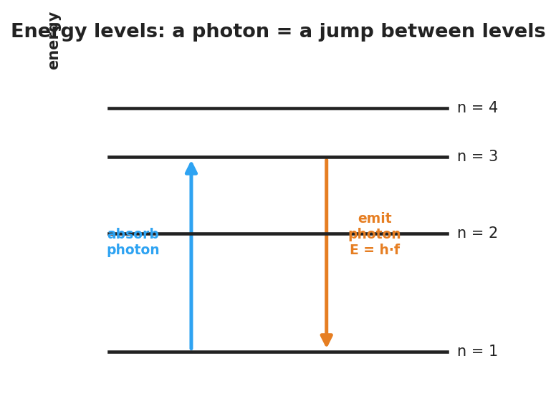
Energy-level diagram: an electron absorbs a photon to jump up and emits a photon E = h·f when it drops down between discrete levels.
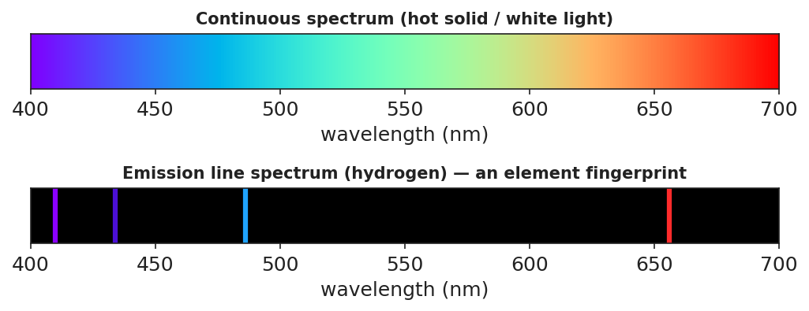
Top: a continuous rainbow spectrum from white light. Bottom: hydrogen’s emission line spectrum — a few bright colored lines on black, an element fingerprint.

Teacher facilitation during Explore
- What to look for — groups connecting bigger energy gap → higher frequency → bluer line.
- What to resist — don’t hand out the term “line spectrum” yet; let the pattern emerge.
- What to redirect — “the gas just glows that color” → it glows specific colors because only specific jumps exist.

Phase 3 · Explain (30 – 36 min)

30–33 min · Consensus
“Why only a few lines, and why always the same few for a given gas?”
Target consensus:
“Electrons can only occupy fixed energy levels, so only certain jumps are possible. Each jump emits a photon whose energy — and color — equals the gap. The set of gaps is unique to each element, so each element shows the same fixed set of lines.”

33–36 min · Vocabulary introduction (≤ 3 terms)
Sample teacher language:
“Each allowed electron ‘step’ is an energy level. When an electron drops to a lower level, it releases a photon — that’s photon emission, and E = h·f for that photon equals the energy gap. The full set of sharp colored lines a glowing element produces is its line spectrum — its fingerprint.”

Discussion prompts to deploy here
- “How can astronomers know a distant star contains hydrogen without ever visiting it?”
  - Sample student response: “The starlight shows hydrogen’s exact line pattern — its fingerprint — so we know hydrogen is there.”
- “Why is a star’s light evidence used in the Big Bang explanation?”
  - Sample student response: “Spectra tell us what stars are made of and (with shifts) how they move — evidence for how matter and the universe formed.”

Phase 4 · Elaborate (36 – 39 min)

36–38 min · Revise the model
“Return to your energy-step drawing. Add labels: which arrow direction emits a photon, and which color comes from the biggest drop? Connect one line in the spectrum strip to one jump in your diagram.”

38–39 min · Return to the phenomenon
“In one sentence, explain why hydrogen shows only a few lines, using energy level and line spectrum.”
Target: “Hydrogen’s electrons can only jump between fixed energy levels, so only a few photon energies are possible — producing hydrogen’s unique line spectrum.”

Phase 5 · Evaluate (39 – 42 min)

39–42 min · Exit Ticket + Closing Reflection
“(a) White light makes a continuous rainbow, but glowing hydrogen makes only a few sharp lines. Explain why, using energy levels. (b) An electron drops from n = 4 → n = 1 (a big drop) and from n = 2 → n = 1 (a small drop). Which emitted photon has the higher frequency? Why? (c) How can astronomers tell what a distant star is made of?”
Expected: (a) electrons occupy only discrete levels, so only certain jumps/photon energies (colors) are possible; (b) the n = 4 → n = 1 drop — larger energy gap → higher-frequency photon (E = h·f); (c) by matching the star’s line spectrum to known element fingerprints. See Answer_Key.docx.
Closing Reflection (SEL, 30 seconds):
“What clicked for you at the boards today, and who helped it click?”

Common Misconceptions
- Misconception: “Atoms can emit any color of light.” → Correction: Only colors matching the gaps between fixed energy levels are emitted, so each element gives a few specific lines.
- Misconception: “Bigger energy jump = redder light.” → Correction: Bigger energy gap = higher-energy photon = higher frequency = bluer light (E = h·f).
- Misconception: “Line spectra and continuous rainbows are the same thing.” → Correction: A hot solid/white light gives a continuous spectrum; a glowing low-density gas gives discrete lines.

Access & Differentiation
- ELL/ENL supports: Sentence frame: *“When an electron drops to a ___ energy level, it ___ a photon; a bigger drop makes a ___-frequency color.”* Word box: {lower, emits, higher, energy level, line spectrum}. Pair jump with a stair-step hand gesture.
- IEP/SPED supports: Provide a pre-drawn energy-level diagram with the arrows already drawn; students label “emit/absorb” and “bigger/smaller gap.” Offer color chips to physically match to spectrum lines.
- Extensions: Give students hydrogen’s four visible wavelengths and have them order the jumps by energy, then research why these are called the Balmer series.

Strategy Spotlight
BTC (Building Thinking Classrooms). Use visibly random groups of three and vertical non-permanent surfaces so thinking is public and mobile. Deliver the problems as a thin-sliced sequence — each problem a small step harder than the last — and circulate without giving answers, redirecting groups to defend their reasoning to the next board. The vertical surfaces let you see, in one glance, which groups have connected “bigger gap → bluer line,” so you know exactly when to pull the class to consensus.

NYSSLS Observation Checklist Crosswalk
# | Checklist item | Where it appears in this lesson
1 | Local/relatable phenomenon | Phase 1 — discharge tubes vs. rainbow; starlight fingerprints
2 | Turn and Talk (2–3×) | Phase 1 (TT#1 — why only some colors), Phase 3 (consensus discussion)
3 | Students develop questions/models/procedures | Phase 1 (initial model), Phase 2 (board work), Phase 4 (revise model)
4 | CCC defined and used | Lesson Overview · Energy and Matter / Patterns, restated in Phase 3
5 | ENL — ≤ 3 vocab, second half | Phase 3 — vocabulary at 33–36 min (energy level / photon emission / line spectrum)
6 | Revisit phenomenon with evidence | Phase 4 — re-explain hydrogen lines; starlight in Phase 3
7 | ENL/SPED supports | Access & Differentiation block
8 | Assessment check | Phase 5 — Exit Ticket (line spectra + starlight)

Companion Materials
- Student_Worksheet.docx — the 5E student investigation with the board-work problems (hand out at start of Phase 2)
- Student_Notes.docx — guided note-guide for energy-level jumps and the worked example
- Answer_Key.docx — answers to “Make It Make Sense” prompts and the Exit Ticket

Key Vocabulary (max 3)
- energy level — one of the fixed, allowed energies an electron can have in an atom (its allowed “steps”)
- photon emission — the release of a photon when an electron drops to a lower energy level; the photon’s energy equals the gap (E = h·f)
- line spectrum — the unique set of sharp colored lines a glowing element emits; it acts as the element’s fingerprint

Energy-Level Diagrams and Spectra — Student Worksheet
Unit: Modern Physics — Lesson 03 Name: _______________________ Date: __________ Period: ____

Phenomenon
Sunlight through a diffraction grating spreads into a smooth, continuous rainbow — every color. But a glowing tube of hydrogen gas through the same grating shows only a few sharp colored lines — always the same ones. Helium glows with a completely different set of lines.
Driving question: Why does a glowing gas emit only certain colors, and how can that fingerprint tell us what a distant star is made of?

Notice & Wonder
I notice… | I wonder…
Turn & Talk #1: A rainbow has every color, but hydrogen shows only a few. Using the idea of electron energy levels, why would only certain colors come out?

Initial Model
Draw a few horizontal lines as electron “energy steps.” Show an electron and use an arrow to show what you think it does to release light.

My idea: _______________________________

Investigation
Work the problems at your board. Use these figures.

Energy-level diagram: an electron absorbs a photon to jump up and emits a photon E = h·f when it drops down between discrete levels.

Top: a continuous rainbow from white light. Bottom: hydrogen’s emission line spectrum — a few bright lines on black.
- An electron drops from n = 3 to n = 1. Draw the arrow. Does it emit or absorb a photon? _______________
- Which drop releases a higher-energy (bluer) photon: n = 4 → n = 2, or n = 3 → n = 2? Why?
- Match each drop to a colored line (biggest drop ↔ highest-frequency line):
Electron drop | Size of energy gap | Line color (predict)
n = 4 → n = 1
n = 3 → n = 2
n = 2 → n = 1
- Two unknown gases show different line patterns. Could they be the same element? Explain.
Key question: If electrons can only sit on certain energy levels, how many different photon colors can a single element emit?

Make It Make Sense
- White light makes a continuous rainbow, but glowing hydrogen makes only a few sharp lines. Explain why, using energy levels.
- A big electron drop and a small electron drop both emit photons. Which photon has the higher frequency (bluer color)? Why?
- How can astronomers know what a distant star is made of without going there?

Vocabulary in Action
Use each term in a sentence about today’s phenomenon.
- energy level: _______________________________________________
- photon emission: _______________________________________________
- line spectrum: _______________________________________________

Revise Your Model
Return to your energy-step drawing. Label which arrow direction emits a photon and which color comes from the biggest drop. Connect one line in the spectrum strip to one jump in your diagram.

Exit Ticket
- White light makes a continuous rainbow, but glowing hydrogen makes only a few sharp lines. Explain why, using energy levels.
- An electron drops from n = 4 → n = 1 (a big drop) and from n = 2 → n = 1 (a small drop). Which emitted photon has the higher frequency? Why?
- How can astronomers tell what a distant star is made of?

Energy-Level Diagrams and Spectra — Student Notes
Unit: Modern Physics — Lesson 03 Name: _______________________ Date: __________ Period: ____

Learning Targets
By the end of today’s 42 minutes I can:
- Explain that electrons occupy fixed energy levels and emit a photon when they drop.
- Relate the size of an electron’s jump to the frequency (color) of the emitted photon.
- Explain why each element makes a unique line spectrum and how that identifies stars.

Key Vocabulary
- energy level — _______________________________________________
- photon emission — _______________________________________________
- line spectrum — _______________________________________________

Guided Notes
Big idea: Electrons in an atom can only have certain fixed energies, called energy levels — like steps on a ladder, not a ramp.

Energy-level diagram: an electron absorbs a photon to jump up and emits a photon E = h·f when it drops down between discrete levels.
- To jump up a level, an electron must absorb a photon.
- To drop down a level, an electron __________ a photon — this is photon emission.
- The photon’s energy equals the size of the __________: E = h·f.
- A bigger drop → bigger energy gap → __________ frequency → bluer color.
- A smaller drop → smaller gap → __________ frequency → redder color.
Why a line spectrum:

Top: a continuous rainbow from white light. Bottom: hydrogen’s line spectrum — a few bright lines on black.
- Because levels are fixed, only certain jumps — and only certain photon colors — are __________.
- Each element has its own set of gaps, so each makes its own unique line spectrum (a __________).
- Astronomers match a star’s line spectrum to known elements to learn what the star is __________ of. (This is part of the evidence behind the Big Bang explanation.)

Worked Example
Problem. In an atom, electron drops A (n = 5 → n = 1) and B (n = 2 → n = 1) both emit photons. Which photon has the higher frequency?
Solution. 1. Compare the energy gaps: drop A is the __________ jump, so the bigger gap. 2. A bigger gap means a __________-energy photon. 3. Since E = h·f, a higher-energy photon has a __________ frequency (bluer). 4. So **drop ___** emits the higher-frequency photon.

Summary
Finish the sentence (Because / But / So):
White light makes a smooth, continuous rainbow, because __________________________________________, but glowing hydrogen makes only a few sharp lines because __________________________________________, so __________________________________________.

Energy-Level Diagrams and Spectra — Answer Key

Cover
Unit: Modern Physics — Lesson 03: Energy-Level Diagrams and Spectra East Meadow Schools × Valley Stream Central HSD Strategy chip: BTC

Make-It-Make-Sense Answers
- Electrons can only occupy fixed energy levels, so only certain jumps are possible. Each jump emits a photon whose energy equals the gap between levels, so only certain photon energies — only certain colors — come out. White light, by contrast, contains all energies/colors, giving a continuous rainbow. · Rubric: “fixed/discrete levels → only certain jumps → only certain colors.” · NYSSLS: HS-ESS1-2 (connection)
- The big drop emits the higher-frequency (bluer) photon. A bigger energy gap means a higher-energy photon, and since E = h·f, higher energy means higher frequency. · Rubric: big gap → high energy → high frequency, references E = h·f. · NYSSLS: HS-ESS1-2 (connection)
- Astronomers spread the starlight into a spectrum and match its line spectrum (its fingerprint) to the known line patterns of elements measured on Earth. Matching lines reveal which elements the star contains. · Rubric: “match the star’s line spectrum to known element fingerprints.” · NYSSLS: HS-ESS1-2 (connection)

Exit Ticket Answer
- Electrons occupy only discrete energy levels, so only certain jumps — and therefore only certain photon energies/colors — are possible; that gives a few sharp lines instead of a full rainbow. White light contains all colors, so it spreads continuously.
- The n = 4 → n = 1 drop emits the higher-frequency photon. It is the larger energy gap, so the photon carries more energy, and E = h·f means more energy → higher frequency.
- By matching the line spectrum in the star’s light to the known fingerprint spectra of elements measured on Earth.
Tolerance/rubric: (a) discrete levels → limited colors; (b) “n = 4 → n = 1” + “bigger gap → higher frequency (E = h·f)”; (c) “match line spectrum to known element fingerprints.” 1 point each. NYSSLS: HS-ESS1-2 (connection).

Closing Reflection (rubric)
Closing reflection is formative, not graded. Award full credit for any honest response. Look for: - A specific “aha” moment from the board work (e.g., “bigger jump = bluer light”). - Acknowledgment of a groupmate’s contribution (collaboration at the vertical surfaces).

The Standard Model — Teacher Guide

Cover
Unit: Modern Physics — Lesson 04: The Standard Model East Meadow Schools × Valley Stream Central High School District Strategy chips: HOCHMAN

Curated Resources (from East Meadow Scope & Sequence)

NYSSLS Standards
This is a conceptual model-building lesson anchored to the SEP Developing and Using Models. The Standard Model is the modern answer to “what is everything made of?” — it organizes all known matter particles (quarks and leptons) and force carriers (bosons) into a single chart, exactly as the periodic table organizes elements. It extends the atomic-structure work of Lesson 02 (electrons and nuclei) down to the next level and sets up the nuclear changes of Lesson 05 (protons and neutrons are made of quarks).

Phenomenon
- Cassiopeia Project: “The Standard Model” — a clear visual tour of quarks, leptons, and the forces between them: https://www.youtube.com/watch?v=Unl1jXFnzgo
- The driving puzzle: if atoms are made of protons, neutrons, and electrons — what are those made of?

Javalab / Labs
- Particle Adventure (interactive Standard Model explorer): https://www.particleadventure.org/

Assessments
- Exit ticket below (classify particles; build a proton from quarks). The “build-a-particle” sort in Phase 2 is the formative check.

Lesson Overview
Duration | 42 minutes (1 period)
NYSSLS link | SEP: Developing and Using Models (organizing matter; supports HS-PS1-8 in Lesson 05)
CCC focus | Systems and System Models / Patterns — a small set of fundamental particles, organized like a periodic table, builds everything.
Strategy chips | HOCHMAN (Because/But/So + appositive on quark / lepton)
Materials | Projector for the Cassiopeia clip; particle cards (quarks u/d, electron, neutrino, photon, gluon); the Standard-Model chart handout; whiteboards.
Safety | None — video and paper-based.
Prior knowledge | Atoms = protons + neutrons + electrons (Lessons 02–03); the periodic table as an organizing tool.
Lesson objectives — students can:
- State that all matter is built from two families of fundamental particles: quarks and leptons.
- Explain that protons and neutrons are made of quarks (a proton = up-up-down) and that forces are carried by bosons.
- Use the Standard-Model chart as a model that organizes particles, the way the periodic table organizes elements.

Phase 1 · Engage (0 – 10 min)

0–2 min · Opening Connection (SEL)
Whip-around (one sentence, pass allowed): “What is the smallest ‘building block’ you can think of that bigger things are made from?” (Lego bricks, pixels, letters in words.) Park these; you’ll call back to “a few blocks build everything” in Phase 3.

2–7 min · Phenomenon hook — “what is everything made of?”
Teacher actions. Play the Cassiopeia Standard Model clip (first few minutes). Pose the chain: a chair → atoms → protons, neutrons, electrons → and then?
Sample teacher language:
“We zoomed in: the chair is atoms, the atom is a nucleus plus electrons, the nucleus is protons and neutrons. So I’ll keep zooming — what is a proton made of? Is there a bottom to this, or does it go forever?”
Anticipated student responses:
- “Smaller protons.” / “It goes forever.” — reframe: scientists found it does bottom out.
- “Quarks!” (if seen before) — capture; we’ll organize them.
- “Electrons are already smallest.” — affirm partly: electrons are fundamental; protons are not.

7–10 min · Notice & Wonder + Turn-and-Talk #1
“Turn and talk: scientists found a small set of particles that everything is built from. Why might it help to organize them into a chart, like the periodic table?”
Target seed: a chart reveals patterns and families, and shows what’s fundamental vs. built-from-parts.

Bridge to Phase 2
Each student writes a one-sentence initial model: “I think a proton is made of ______.”

Phase 2 · Explore (10 – 30 min)

10–13 min · Initial Model (silent / individual)
Prompt:
“Draw a proton. If it has smaller parts inside, draw them and label what you’d call them.”

13–30 min · Investigation — build-a-particle sort
Groups get particle cards and the Standard-Model chart. Tasks:
- Sort the cards into matter particles (quarks + leptons) and force carriers (bosons).
- Within matter, separate quarks (up, down, …) from leptons (electron, neutrino).
- Build a proton and a neutron from quark cards. (Proton = up + up + down; neutron = up + down + down.) Check the charges add up (+⅔ +⅔ −⅓ = +1 for the proton; +⅔ −⅓ −⅓ = 0 for the neutron).
- Where does the familiar electron sit? (It’s a lepton — already fundamental, not made of quarks.)
Teacher facilitation language:
“Add the quark charges in your proton — do they land on +1?” “Which of your cards is already fundamental — has nothing smaller inside?” “What’s the boson’s job? It’s not matter — it carries a force between matter particles.”
Anchor with the chart and the proton diagram:
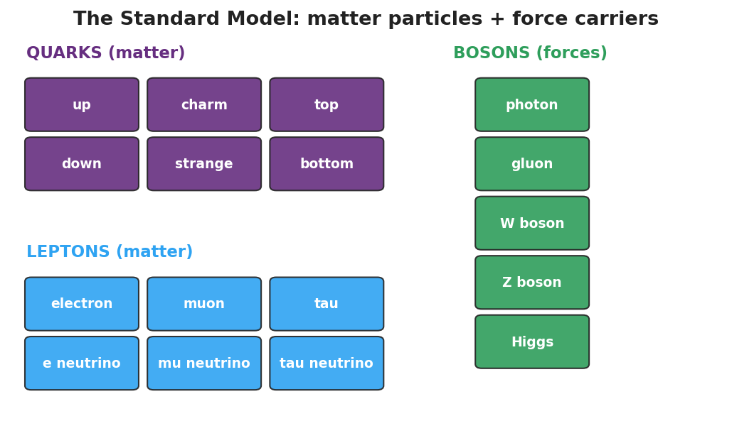
Standard-Model chart: a grid of quarks and leptons (matter particles) plus bosons (force carriers).
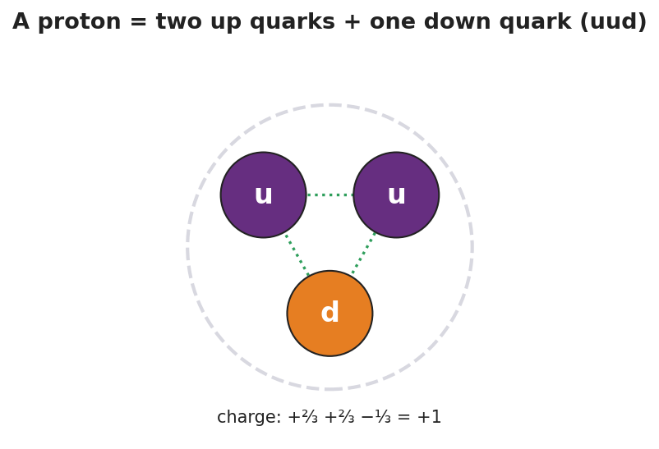
A proton drawn as two up quarks and one down quark (uud); the charges +2/3, +2/3, and −1/3 add to +1.

Teacher facilitation during Explore
- What to look for — groups checking that quark charges sum to the right particle charge.
- What to resist — don’t over-detail the second/third generations or color charge; keep it to the organizing idea.
- What to redirect — “electrons are made of quarks” → no, electrons are leptons, already fundamental.

Phase 3 · Explain (30 – 36 min)

30–33 min · Consensus
“What is the smallest level we found, and how is it organized?”
Target consensus:
“Everything is built from a small set of fundamental particles: quarks make up protons and neutrons, and leptons include the electron. Forces between them are carried by bosons. The Standard-Model chart organizes them the way the periodic table organizes elements.”

33–36 min · Vocabulary introduction (≤ 3 terms)
Sample teacher language:
“A quark is a fundamental matter particle; protons and neutrons are each made of three quarks. A lepton is the other family of matter particles — the electron is a lepton. Both quarks and leptons are fundamental particles: as far as we know, they have no smaller parts inside.”

Discussion prompts to deploy here
- “How is the Standard Model like the periodic table?”
  - Sample student response: “Both organize the basic pieces into families that show patterns; the table organizes elements, the Standard Model organizes the particles inside them.”
- “Why isn’t a proton on the chart of fundamental particles?”
  - Sample student response: “A proton is made of quarks, so it’s not fundamental — only its quarks are.”

Phase 4 · Elaborate (36 – 39 min)

36–38 min · Hochman Because/But/So + revise the model
Students complete the stem (modeled, then independent):
“A proton is not a fundamental particle because ______, but an electron is because ______, so the truly fundamental matter particles are the ______ and the ______.”
Coach the appositive: “A quark, a fundamental building block of protons and neutrons, carries a fractional charge.”

38–39 min · Return to the phenomenon
“Restate the ‘what is everything made of?’ chain in one sentence using quark and fundamental particle.”
Target: “Everything is built from fundamental particles — quarks (which make protons and neutrons) and leptons (like the electron).”

Phase 5 · Evaluate (39 – 42 min)

39–42 min · Exit Ticket + Closing Reflection
“(a) Name the two families of fundamental matter particles. (b) A proton is made of two up quarks and one down quark. Is a proton a fundamental particle? Explain. (c) The electron belongs to which family — quarks or leptons?”
Expected: (a) quarks and leptons; (b) no — it is made of smaller particles (quarks), so it is not fundamental; (c) leptons. See Answer_Key.docx.
Closing Reflection (SEL, 30 seconds):
“What’s one question about the universe you now want to ask?”

Common Misconceptions
- Misconception: “Protons and neutrons are the smallest particles.” → Correction: They are made of quarks; quarks (and leptons like the electron) are the fundamental particles.
- Misconception: “Electrons are made of quarks too.” → Correction: Electrons are leptons — already fundamental, with no quarks inside.
- Misconception: “Bosons are matter.” → Correction: Bosons are force carriers (like the photon), not matter particles.

Access & Differentiation
- ELL/ENL supports: Sentence frame: “A ___ is a fundamental particle, but a ___ is made of smaller parts, so the ___ is fundamental and the ___ is not.” Word box: {quark, proton, electron, lepton, fundamental}. Pair fundamental with “can’t break it smaller” and a closed-fist gesture.
- IEP/SPED supports: Provide pre-grouped card sets (matter vs. force already separated); students only build the proton/neutron. Give a partially completed chart to fill the last few tiles.
- Extensions: Have students build a neutron (udd), verify its zero charge, and explain why a free neutron’s beta decay (Lesson 05) changes a down quark into an up quark.

Strategy Spotlight
HOCHMAN (literacy). The Because/But/So in Phase 4 forces students to coordinate a contrast — fundamental (electron/quark) vs. composite (proton) — in one complex sentence, the heart of the lesson’s conceptual distinction. Model one, then release. The appositive drill — “A quark, a fundamental building block of protons and neutrons, carries a fractional charge” — gives students a compact academic structure for defining a new term in place, transferable to any content area.

NYSSLS Observation Checklist Crosswalk
# | Checklist item | Where it appears in this lesson
1 | Local/relatable phenomenon | Phase 1 — “what is everything made of?” zoom-in from a chair to quarks
2 | Turn and Talk (2–3×) | Phase 1 (TT#1 — why organize into a chart), Phase 3 (consensus discussion)
3 | Students develop questions/models/procedures | Phase 1 (initial model), Phase 2 (build-a-particle sort), Phase 4 (revise model)
4 | CCC defined and used | Lesson Overview · Systems and System Models / Patterns, restated in Phase 3
5 | ENL — ≤ 3 vocab, second half | Phase 3 — vocabulary at 33–36 min (quark / lepton / fundamental particle)
6 | Revisit phenomenon with evidence | Phase 4 — restate the “what is everything made of?” chain
7 | ENL/SPED supports | Access & Differentiation block
8 | Assessment check | Phase 5 — Exit Ticket (classify particles; proton from quarks)

Companion Materials
- Student_Worksheet.docx — the 5E student investigation with the build-a-particle sort (hand out at start of Phase 2)
- Student_Notes.docx — guided note-guide for the particle families and the worked example
- Answer_Key.docx — answers to “Make It Make Sense” prompts and the Exit Ticket

Key Vocabulary (max 3)
- quark — a fundamental matter particle; protons and neutrons are each built from three quarks (a proton is up-up-down)
- lepton — the other family of fundamental matter particles; the electron is a lepton
- fundamental particle — a particle with no smaller parts inside, as far as we know (quarks and leptons are fundamental; protons are not)

The Standard Model — Student Worksheet
Unit: Modern Physics — Lesson 04 Name: _______________________ Date: __________ Period: ____

Phenomenon
Zoom in on a chair: it’s made of atoms. An atom is a nucleus plus electrons. The nucleus is protons and neutrons. So what is a proton made of? Scientists kept zooming — and found that the zoom finally stops at a small set of particles that everything else is built from.
Driving question: What are the smallest building blocks of matter, and how do scientists organize them?

Notice & Wonder
I notice… | I wonder…
Turn & Talk #1: Scientists found a small set of particles that everything is built from. Why might it help to organize them into a chart, like the periodic table?

Initial Model
Draw a proton. If you think it has smaller parts inside, draw them and label what you would call them.

My idea: _______________________________

Investigation
Use the particle cards and the figures below.

Standard-Model chart: a grid of quarks and leptons (matter particles) plus bosons (force carriers).

A proton drawn as two up quarks and one down quark (uud); charges +2/3, +2/3, −1/3 add to +1.
- Sort the cards into matter particles and force carriers (bosons).
- Within matter, separate the quarks from the leptons.
Card | Matter or force carrier? | If matter: quark or lepton?
up
down
electron
neutrino
photon
- Build a proton from quark cards and check the charge adds up.
Particle | Quarks | Charges added | Total charge
Proton | up + up + down | (+⅔) + (+⅔) + (−⅓)
Neutron | up + down + down | (+⅔) + (−⅓) + (−⅓)
Key question: Which of your cards is already fundamental — has nothing smaller inside?

Make It Make Sense
- A proton is made of two up quarks and one down quark. Is a proton a fundamental particle? Explain.
- How is the Standard-Model chart similar to the periodic table?
- The electron is not made of quarks. Which family does it belong to, and what does that tell you about it?

Vocabulary in Action
Use each term in a sentence about today’s phenomenon.
- quark: _______________________________________________
- lepton: _______________________________________________
- fundamental particle: _______________________________________________

Revise Your Model
Return to your Initial Model of a proton. Redraw it using quark cards (up, up, down) and check that the charges add to +1. Label which particles are fundamental.

Exit Ticket
- Name the two families of fundamental matter particles.
- A proton is made of two up quarks and one down quark. Is a proton a fundamental particle? Explain.
- The electron belongs to which family — quarks or leptons?

The Standard Model — Student Notes
Unit: Modern Physics — Lesson 04 Name: _______________________ Date: __________ Period: ____

Learning Targets
By the end of today’s 42 minutes I can:
- Name the two families of fundamental particles that build all matter.
- Explain that protons and neutrons are made of quarks, and forces are carried by bosons.
- Use the Standard-Model chart as a model that organizes particles.

Key Vocabulary
- quark — _______________________________________________
- lepton — _______________________________________________
- fundamental particle — _______________________________________________

Guided Notes
Big idea: All matter is built from a small set of fundamental particles — particles with no smaller parts inside.

Standard-Model chart: a grid of quarks and leptons (matter particles) plus bosons (force carriers).
- Matter particles come in two families: quarks and __________.
- Quarks join together to build protons and __________.
- Leptons include the familiar __________ (which is already fundamental).
- Forces between matter particles are carried by bosons (for example, the __________ carries the electromagnetic force).
Building a proton (and a neutron):

A proton drawn as two up quarks and one down quark (uud); charges +2/3, +2/3, −1/3 add to +1.
- Proton = up + up + down → charge (+⅔) + (+⅔) + (−⅓) = __________.
- Neutron = up + down + down → charge (+⅔) + (−⅓) + (−⅓) = __________.
- So a proton is not fundamental — it is made of __________.
The Standard Model organizes particles the way the __________ table organizes elements.

Worked Example
Problem. Is an electron a fundamental particle? Is a proton? Explain how you know.
Solution. 1. An electron is a __________ — it has no smaller parts inside, so it is fundamental. 2. A proton is made of three __________ (up, up, down), so it has smaller parts inside. 3. Therefore the proton is not __________; only its quarks are.

Summary
Finish the sentence (Because / But / So):
A proton is not a fundamental particle because __________________________________________, but an electron is fundamental because __________________________________________, so __________________________________________.

The Standard Model — Answer Key

Cover
Unit: Modern Physics — Lesson 04: The Standard Model East Meadow Schools × Valley Stream Central HSD Strategy chip: HOCHMAN

Make-It-Make-Sense Answers
- No, a proton is not fundamental. It is made of smaller particles — two up quarks and one down quark — so it has parts inside. Only particles with no smaller parts (like quarks and the electron) are fundamental. · Rubric: “made of quarks → has smaller parts → not fundamental.” · NYSSLS: SEP — Developing and Using Models
- Both are organizing models: the periodic table sorts the elements into families that reveal patterns, and the Standard Model sorts the fundamental particles (quarks, leptons, bosons) into families that reveal patterns. The Standard Model is one level “smaller” — it organizes the particles the elements are built from. · Rubric: “both organize basic pieces into families/patterns.” · NYSSLS: SEP — Developing and Using Models
- The electron is a lepton. Leptons are fundamental, so the electron has no smaller parts inside — it is a basic building block, unlike the proton. · Rubric: “lepton” + “fundamental / no smaller parts.” · NYSSLS: SEP — Developing and Using Models

Exit Ticket Answer
- The two families of fundamental matter particles are quarks and leptons.
- No — a proton is made of smaller particles (two up quarks and one down quark), so it has parts inside and is not fundamental. (Its quarks are fundamental.)
- The electron is a lepton.
Tolerance/rubric: (a) “quarks and leptons”; (b) “no” + “made of quarks / has smaller parts”; (c) “lepton.” 1 point each. NYSSLS: SEP — Developing and Using Models.

Closing Reflection (rubric)
Closing reflection is formative, not graded. Award full credit for any honest response. Look for: - A genuine new question about matter or the universe (curiosity). - Evidence the student distinguishes “fundamental” from “made of smaller parts.”

Fusion, Fission, and Radioactive Decay — Teacher Guide

Cover
Unit: Modern Physics — Lesson 05: Fusion, Fission, and Radioactive Decay East Meadow Schools × Valley Stream Central High School District Strategy chips: ACTIVE LEARNING

Curated Resources (from East Meadow Scope & Sequence)

NYSSLS Standards
This lesson is the core treatment of the chemistry-shared HS-PS1-8: “Develop models to illustrate the changes in the composition of the nucleus of the atom and the energy released during the processes of fission, fusion, and radioactive decay. (Energy and Matter) (only teach scale of energy release).” Per the standard, we teach the scale of nuclear energy (E = mc² as a why-it’s-enormous idea, not a calculation). It connects to HS-ESS1-2 through star formation: fusion in stars is what lights them and forges new elements.

Phenomenon
- The Sun (fusion), a nuclear power plant (fission), and carbon-14 dating of ancient artifacts (radioactive decay) — three places nuclear change shows up: https://www.youtube.com/watch?v=KWAsz59F8gA
- The puzzle: the Sun has burned for billions of years. No chemical fire could last that long — so what powers it?

Javalab / Labs
- Nuclear fission / chain reaction (interactive): https://javalab.org/en/nuclear_fission_en/

Assessments
- Exit ticket below (classify a nuclear change; explain the scale of energy). The fission/fusion/decay station sort in Phase 2 is the formative check.

Lesson Overview
Duration | 42 minutes (1 period)
NYSSLS link | HS-PS1-8 (core; scale of energy only) · HS-ESS1-2 (star formation connection)
CCC focus | Energy and Matter — nuclear changes rearrange the nucleus and release enormous energy.
Strategy chips | ACTIVE LEARNING (three-station rotation: fission, fusion, decay)
Materials | Three station setups (model pieces or printed scenarios); the fission/fusion and decay diagrams; whiteboards; reference note: E = mc² (scale only).
Safety | None — models and simulation; no radioactive sources.
Prior knowledge | The nucleus holds protons and neutrons (Lessons 02, 04); quarks make up nucleons (Lesson 04); energy is conserved/transferred.
Lesson objectives — students can:
- Distinguish fission (a heavy nucleus splits), fusion (light nuclei combine), and radioactive decay (a nucleus emits α, β, or γ).
- Explain that nuclear changes release enormous energy compared with chemical reactions, on the scale described by E = mc² (no calculation).
- Connect fusion to star formation and decay to applications like carbon dating.

Phase 1 · Engage (0 – 10 min)

0–2 min · Opening Connection (SEL)
Whip-around (one sentence, pass allowed): “Name something that has lasted way longer than you’d expect.” Park these; you’ll call back to “the Sun has burned for billions of years” in Phase 1’s hook.

2–7 min · Phenomenon hook — what powers the Sun?
Teacher actions. Show the Sun / power-plant / carbon-dating clip. Pose the puzzle: a campfire burns out in hours; the Sun has shone for ~5 billion years. Chemical burning cannot explain that.
Sample teacher language:
“A bonfire dies overnight. The Sun has been blazing for five billion years and is barely halfway done. No chemical fire could last like that. Where is all that energy coming from — and why is it so much more than burning?”
Anticipated student responses:
- “It’s huge, so it lasts.” — capture huge, but push: size alone isn’t the source.
- “It’s nuclear.” — gold; we’ll split nuclear change into three types.
- “Stuff turns into energy.” — capture; this is the E = mc² scale idea (later).

7–10 min · Notice & Wonder + Turn-and-Talk #1
“Turn and talk: the same word — nuclear — covers the Sun, power plants, and carbon dating. Predict how the nucleus might change differently in each.”
Target seed: some nuclei split, some combine, some emit a particle.

Bridge to Phase 2
Each student writes a one-sentence initial model: “Nuclear energy is so large because ______.”

Phase 2 · Explore (10 – 30 min)

10–13 min · Initial Model (silent / individual)
Prompt:
“Draw a nucleus (protons + neutrons). Show one way you think it could change to release energy.”

13–30 min · Investigation — three-station rotation (ACTIVE LEARNING)
Groups rotate through three stations (~5 min each); each has a scenario card + model pieces:
- Fission station. A neutron strikes a heavy uranium nucleus; it splits into two lighter nuclei + more neutrons + energy. Model it; note the chain-reaction possibility.
- Fusion station. Two light hydrogen nuclei are forced together into a heavier nucleus + energy. Model it; label this as what powers the Sun and stars.
- Decay station. An unstable nucleus emits alpha (a helium nucleus), beta (an electron, as a neutron becomes a proton), or gamma (a high-energy photon). Sort three scenario cards by decay type; note carbon-14 dating as a use of decay.
Teacher facilitation language:
“At fission — what hits the nucleus to start it, and what comes out that could start the next one?” “At fusion — are nuclei joining or splitting? Which one happens in the Sun?” “At decay — which type changes the element (alpha/beta), and which just sheds energy (gamma)?”
Anchor with the diagrams:
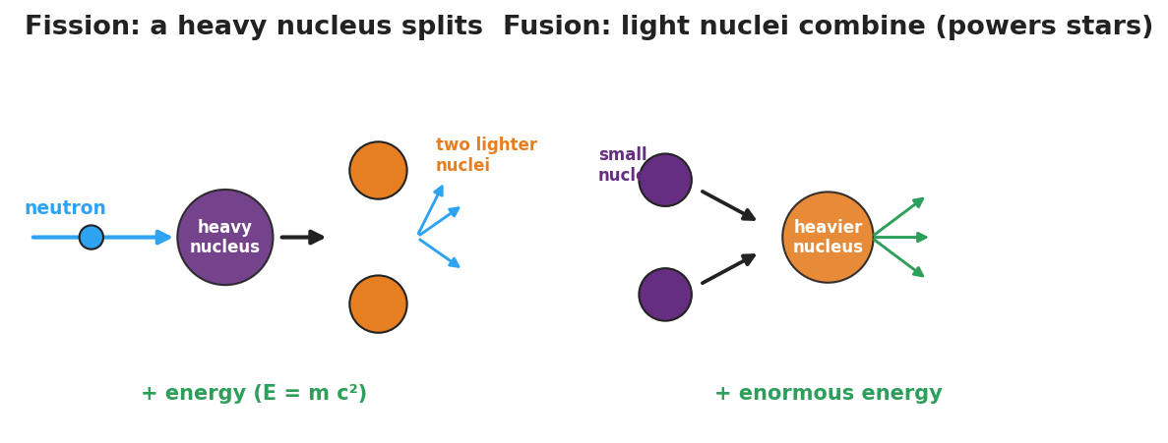
Side-by-side diagram: fission, where a neutron splits a heavy nucleus into two lighter nuclei plus more neutrons and energy; and fusion, where light nuclei combine into a heavier nucleus plus enormous energy.
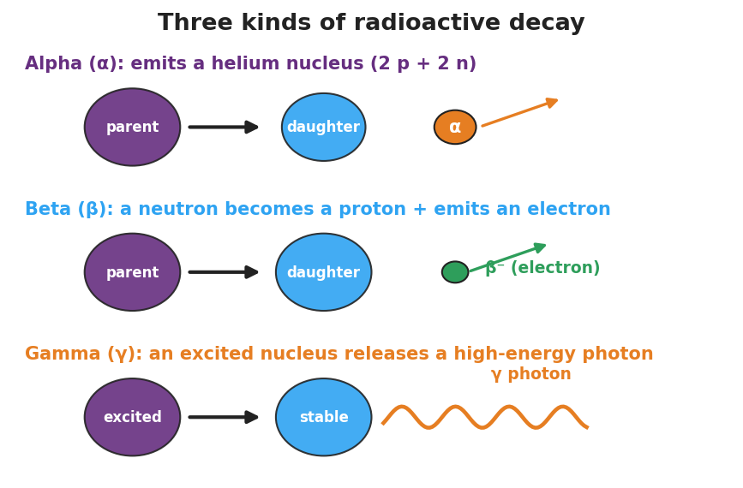
Diagram of alpha, beta, and gamma decay: alpha emits a helium nucleus, beta emits an electron as a neutron becomes a proton, and gamma releases a high-energy photon.

Teacher facilitation during Explore
- What to look for — groups correctly sorting “split vs. combine vs. emit” and tying fusion to stars.
- What to resist — do not do E = mc² calculations; keep energy at the scale/comparison level per the standard.
- What to redirect — “fission and fusion are the same” → fission splits heavy nuclei; fusion combines light ones.

Phase 3 · Explain (30 – 36 min)

30–33 min · Consensus
“Three nuclear changes, one common result — what is it, and why is it so much bigger than burning?”
Target consensus:
“Fission splits a heavy nucleus, fusion combines light nuclei, and radioactive decay emits a particle (α/β/γ). All rearrange the nucleus and release energy — and because a small amount of mass is converted to energy (E = mc², where c is huge), the energy released is enormous compared with chemical reactions.”

33–36 min · Vocabulary introduction (≤ 3 terms)
Sample teacher language:
“Fission is the splitting of a heavy nucleus into lighter ones — that’s how nuclear power plants work. Fusion is the combining of light nuclei into a heavier one — that’s what powers the Sun and forms elements in stars. Radioactive decay is when an unstable nucleus emits radiation (alpha, beta, or gamma) on its own. All three release energy on the scale of E = mc².”

Discussion prompts to deploy here
- “Why does fusion connect to how stars and elements form?”
  - Sample student response: “Stars fuse light nuclei into heavier ones, which lights the star and builds the elements that later make planets and us.”
- “Why is nuclear energy so much larger than chemical energy?”
  - Sample student response: “A tiny bit of mass becomes energy, and E = mc² with a huge c means even tiny mass gives huge energy.”

Phase 4 · Elaborate (36 – 39 min)

36–38 min · Revise the model
“Return to your Initial Model. Redraw it as one of the three changes — fission, fusion, or decay — and label where the enormous energy comes from (mass → energy, E = mc², scale only).”

38–39 min · Return to the phenomenon
“In one sentence, explain what powers the Sun, using fusion.”
Target: “The Sun is powered by fusion — light hydrogen nuclei combine into heavier nuclei, releasing enormous energy (E = mc² scale) and forming new elements.”

Phase 5 · Evaluate (39 – 42 min)

39–42 min · Exit Ticket + Closing Reflection
“(a) A heavy uranium nucleus is struck by a neutron and splits into two lighter nuclei. Is this fission, fusion, or decay? (b) The Sun combines hydrogen nuclei into helium. Which process is this, and what does it have to do with star formation? (c) Why is the energy from a nuclear change so much larger than the energy from burning fuel? (Use E = mc² as a scale idea — no calculation.)”
Expected: (a) fission; (b) fusion — fusion powers and lights stars and forms heavier elements; (c) a small amount of mass is converted to energy, and because c is enormous, E = mc² gives a huge energy from tiny mass — far more than chemical bonds release. See Answer_Key.docx.
Closing Reflection (SEL, 30 seconds):
“What’s one place in your life that nuclear physics quietly shows up?”

Common Misconceptions
- Misconception: “Fission and fusion are basically the same.” → Correction: Fission splits a heavy nucleus; fusion combines light nuclei. Opposite directions.
- Misconception: “The Sun is a giant chemical fire.” → Correction: The Sun runs on nuclear fusion; no chemical fire could last billions of years.
- Misconception: “Nuclear energy comes from nowhere.” → Correction: A tiny amount of mass is converted to energy (E = mc²); because c is enormous, even a little mass yields enormous energy.

Access & Differentiation
- ELL/ENL supports: Sentence frame: *“In , a heavy nucleus splits; in , light nuclei combine; in ___, a nucleus emits radiation.”* Word box: {fission, fusion, radioactive decay, neutron, energy}. Pair fusion with hands coming together, fission with hands splitting apart.
- IEP/SPED supports: Provide pre-sorted station cards (already labeled fission/fusion/decay) so the task is matching the energy/result rather than identifying the type. Offer the alpha/beta/gamma diagram as a fill-in match.
- Extensions: Have students explain, using beta decay, how a neutron (udd) becomes a proton (uud) — connecting to the quark changes from Lesson 04 — and why this changes the element.

Strategy Spotlight
ACTIVE LEARNING. The three-station rotation lets students model each nuclear change with their hands before any definitions, so “split vs. combine vs. emit” is physical, not memorized. Keep stations to ~5 minutes with a clear rotation signal, assign a recorder at each, and reserve E = mc² strictly for the scale-of-energy discussion in Phase 3 (per HS-PS1-8, no calculation). End with a whole-class consensus so the three stations resolve into one big idea.

NYSSLS Observation Checklist Crosswalk
# | Checklist item | Where it appears in this lesson
1 | Local/relatable phenomenon | Phase 1 — the Sun, nuclear power, carbon dating
2 | Turn and Talk (2–3×) | Phase 1 (TT#1 — how the nucleus changes differently), Phase 3 (consensus discussion)
3 | Students develop questions/models/procedures | Phase 1 (initial model), Phase 2 (station modeling), Phase 4 (revise model)
4 | CCC defined and used | Lesson Overview · Energy and Matter, restated in Phase 3
5 | ENL — ≤ 3 vocab, second half | Phase 3 — vocabulary at 33–36 min (fission / fusion / radioactive decay)
6 | Revisit phenomenon with evidence | Phase 4 — explain the Sun using fusion
7 | ENL/SPED supports | Access & Differentiation block
8 | Assessment check | Phase 5 — Exit Ticket (classify change; scale of energy)

Companion Materials
- Student_Worksheet.docx — the 5E student investigation with the three-station sort (hand out at start of Phase 2)
- Student_Notes.docx — guided note-guide for the three nuclear changes and the worked example
- Answer_Key.docx — answers to “Make It Make Sense” prompts and the Exit Ticket

Key Vocabulary (max 3)
- fission — the splitting of a heavy nucleus into lighter nuclei, releasing energy (used in nuclear power plants)
- fusion — the combining of light nuclei into a heavier nucleus, releasing enormous energy (powers the Sun and forms elements in stars)
- radioactive decay — the spontaneous emission of radiation (alpha, beta, or gamma) from an unstable nucleus

Fusion, Fission, and Radioactive Decay — Student Worksheet
Unit: Modern Physics — Lesson 05 Name: _______________________ Date: __________ Period: ____

Phenomenon
A campfire burns out overnight. The Sun has blazed for about five billion years — and is barely halfway done. No chemical fire could last that long. The same word, nuclear, shows up in the Sun, in power plants, and in carbon-14 dating of ancient bones.
Driving question: Where does nuclear energy come from, why is it so enormous, and how does the nucleus change in each case?

Notice & Wonder
I notice… | I wonder…
Turn & Talk #1: The same word — nuclear — covers the Sun, power plants, and carbon dating. Predict how the nucleus might change differently in each.

Initial Model
Draw a nucleus (protons + neutrons). Show one way you think it could change to release energy.

My idea: _______________________________

Investigation
Rotate through the three stations. Use the figures below.

Side-by-side diagram: fission, where a neutron splits a heavy nucleus into two lighter nuclei plus more neutrons and energy; and fusion, where light nuclei combine into a heavier nucleus plus enormous energy.

Diagram of alpha, beta, and gamma decay: alpha emits a helium nucleus, beta emits an electron as a neutron becomes a proton, and gamma releases a high-energy photon.
Station | What happens to the nucleus? | Splits, combines, or emits? | Where do you see it in the real world?
1. Fission
2. Fusion
3. Radioactive decay (α / β / γ)
Key question: What do all three nuclear changes have in common?

Make It Make Sense
- A heavy uranium nucleus is hit by a neutron and breaks into two lighter nuclei. Is this fission, fusion, or decay? How do you know?
- The Sun combines hydrogen nuclei into helium. Which process is this, and what does it have to do with how stars and elements form?
- Why is the energy released by a nuclear change so much larger than the energy from burning fuel? (Use E = mc² as a scale idea — no calculation.)

Vocabulary in Action
Use each term in a sentence about today’s phenomenon.
- fission: _______________________________________________
- fusion: _______________________________________________
- radioactive decay: _______________________________________________

Revise Your Model
Return to your Initial Model. Redraw it as one of the three changes — fission, fusion, or decay — and label where the enormous energy comes from (mass → energy, E = mc², scale only).

Exit Ticket
- A heavy uranium nucleus is struck by a neutron and splits into two lighter nuclei. Is this fission, fusion, or decay?
- The Sun combines hydrogen nuclei into helium. Which process is this, and what does it have to do with star formation?
- Why is the energy from a nuclear change so much larger than the energy from burning fuel? (Use E = mc² as a scale idea — no calculation.)

Fusion, Fission, and Radioactive Decay — Student Notes
Unit: Modern Physics — Lesson 05 Name: _______________________ Date: __________ Period: ____

Learning Targets
By the end of today’s 42 minutes I can:
- Tell apart fission, fusion, and radioactive decay by how the nucleus changes.
- Explain why nuclear changes release enormous energy (E = mc², scale only).
- Connect fusion to star formation and decay to uses like carbon dating.

Key Vocabulary
- fission — _______________________________________________
- fusion — _______________________________________________
- radioactive decay — _______________________________________________

Guided Notes
Big idea: In a nuclear change, the nucleus itself changes, and a tiny amount of mass becomes a huge amount of energy.

Side-by-side diagram: fission (a neutron splits a heavy nucleus into two lighter nuclei plus neutrons and energy) and fusion (light nuclei combine into a heavier nucleus plus enormous energy).
- Fission — a heavy nucleus __________ into lighter nuclei (+ extra neutrons + energy). Used in nuclear __________ plants.
- Fusion — light nuclei __________ into a heavier nucleus (+ enormous energy). Powers the __________ and forms elements in stars.
Radioactive decay — an unstable nucleus emits radiation on its own:

Diagram of alpha, beta, and gamma decay.
- Alpha (α) — emits a __________ nucleus (2 protons + 2 neutrons).
- Beta (β) — a neutron becomes a proton and emits an __________.
- Gamma (γ) — emits a high-energy __________ (no change in protons/neutrons).
Why so much energy? A small amount of __________ is converted to energy. Because E = mc² and c (the speed of light) is __________, even a tiny mass gives an enormous energy — far more than burning fuel. (Scale idea only — no calculation.)

Worked Example
Problem. A campfire lasts one night, but the Sun has shone for billions of years. Why can the Sun outlast any chemical fire?
Solution. 1. A campfire is a __________ reaction (rearranging atoms/bonds) — relatively little energy. 2. The Sun runs on nuclear __________ — combining hydrogen nuclei into heavier ones. 3. A tiny amount of mass turns into energy, and E = mc² (huge c) makes that energy __________ — so the Sun’s fuel lasts far longer.

Summary
Finish the sentence (Because / But / So):
A campfire burns out in one night because __________________________________________, but the Sun has shone for billions of years because __________________________________________, so __________________________________________.

Fusion, Fission, and Radioactive Decay — Answer Key

Cover
Unit: Modern Physics — Lesson 05: Fusion, Fission, and Radioactive Decay East Meadow Schools × Valley Stream Central HSD Strategy chip: ACTIVE LEARNING

Make-It-Make-Sense Answers
- This is fission — a heavy nucleus is split into lighter nuclei (here, started by an incoming neutron, which also releases more neutrons + energy). · Rubric: “fission” + “heavy nucleus splits.” · NYSSLS: HS-PS1-8
- This is fusion — light hydrogen nuclei combine into a heavier helium nucleus. Fusion is what powers stars (lights them and lets them last billions of years) and forms heavier elements, which later build planets and living things — the connection to star formation. · Rubric: “fusion” + “powers stars / forms elements.” · NYSSLS: HS-PS1-8, HS-ESS1-2 (connection)
- In a nuclear change, a tiny amount of mass is converted into energy. By E = mc², and because c (the speed of light) is enormous, even a tiny mass yields a huge amount of energy — far more than the energy stored in chemical bonds (burning). (Scale comparison only; no calculation expected.) · Rubric: “small mass → energy via E = mc², huge because c is large.” · NYSSLS: HS-PS1-8

Exit Ticket Answer
- Fission — a heavy nucleus splits into two lighter nuclei.
- Fusion — light nuclei combine into a heavier one. Fusion powers and lights stars and forges heavier elements, so it is central to how stars form and how the matter around us was made.
- A small amount of mass is converted to energy; because E = mc² and c is enormous, even a tiny mass releases a huge amount of energy — far more than a chemical reaction like burning. (Scale idea only, no calculation.)
Tolerance/rubric: (a) “fission”; (b) “fusion” + star/element formation connection; (c) “mass → energy, E = mc², huge because c is large.” 1 point each. NYSSLS: HS-PS1-8; (b) also HS-ESS1-2 (connection).

Closing Reflection (rubric)
Closing reflection is formative, not graded. Award full credit for any honest response. Look for: - A real-world place nuclear physics appears (Sun, power, medical imaging, smoke detectors, carbon dating). - Evidence the student connects nuclear change to the scale of energy released.

