**WEEK 1**

**SAR Image Despeckling with Deep Learning Methods**

**Optical vs SAR Remote Sensing Systems**

**Passive Systems**

Passive remote sensing systems rely on external sources of light, typically the sun, to illuminate the Earth's surface. The sensors on the satellite capture the reflected light, producing vibrant and colorful images. This method is effective in clear weather conditions and during daylight, providing high-resolution visual details of the landscape. Optical sensors, for example, capture visible and near-infrared light reflected from the Earth's surface, enabling the generation of detailed and colorful images.

**Active Systems**

Active remote sensing systems, such as Synthetic Aperture Radar (SAR), operate differently. Instead of relying on external light sources, they emit their own electromagnetic waves and measure the reflections from the Earth's surface. This capability allows SAR systems to function independently of weather conditions and daylight, making them highly versatile and reliable for continuous monitoring.

 

**Radar Technology**

Radar (Radio Detection and Ranging) technology involves sending short microwave pulses towards the Earth. The radar system then receives and analyzes the reflected signals to generate images. This technology has several advantages, including the ability to operate in all weather conditions and to provide unique information that optical systems cannot. However, radar images can be complex to interpret due to the nature of the reflections and the presence of speckle.

**Radar Altimetry**

Radar altimetry is used to measure the height of the Earth's surface with high accuracy, often in the order of centimeters. It works by sending radar pulses and measuring the time it takes for the pulses to return. Applications of radar altimetry include monitoring ocean surface topography and studying the propagation of tsunami waves.

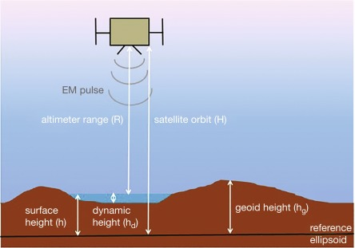

**Side-Looking Airborne Radar (SLAR)**

SLAR is used for airborne imaging at short distances, typically from an aircraft. It sends microwave pulses at an angle, theta, and requires a large antenna to capture the reflected signals. SLAR provides medium resolution images and is commonly used for plane-based surveys.

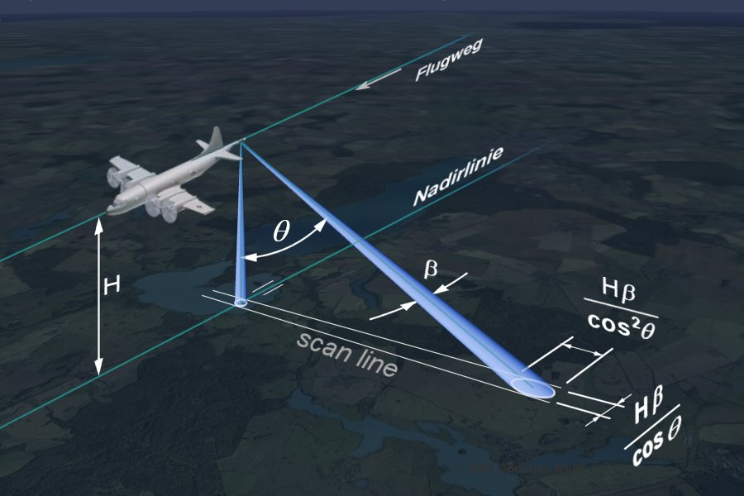

**Synthetic Aperture Radar (SAR)**

**SAR Image Formation**

SAR technology involves transmitting multiple microwave pulses towards the Earth and combining the received echoes to create high-resolution images. The raw data undergoes complex processing, including range compression to determine the origin of the echoes and focusing to enhance the resolution in both range and azimuth directions.

**SAR Image Characteristics**

SAR images are structured as 2D arrays with fast time (range time) in the y-direction, representing the time for the signal to travel to and from the target, and slow time (azimuth time) in the x-direction, representing the position along the flight path of the SAR platform. SAR systems operate at different wavelengths (bands) and polarizations, which affect the information captured from the scene. For instance, L-band penetrates vegetation to reveal ground features, while X-band reflects more from the top surfaces of objects like trees.

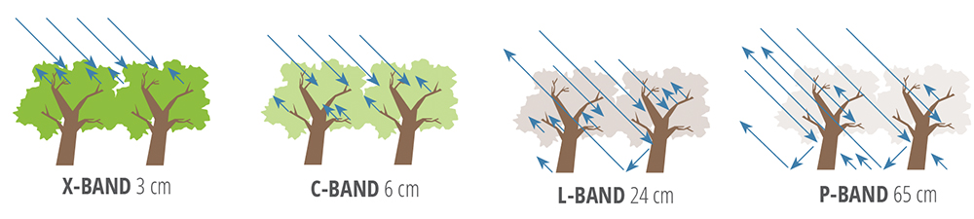

**Types of Backscatter**

SAR images depict various types of backscatter based on the interaction of the microwave signal with the target:

* **Mirror Reflection**: Occurs on smooth surfaces like water.
* **Diffuse Reflection**: From rough surfaces like soil.
* **Volume Scattering**: In semi-transparent objects like vegetation and snow.
* **Double-Bounce Scattering**: Common in urban areas where buildings reflect the signal.

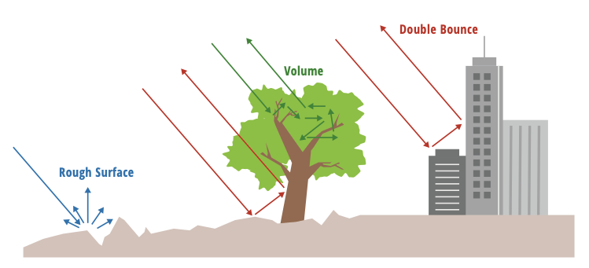

**SAR Speckle and Phase**

**Speckle**

Speckle appears as a random salt-and-pepper effect in SAR images, caused by variations in the reflected signal. While it is not strictly noise, speckle can hinder image interpretation and requires specialized mitigation techniques.

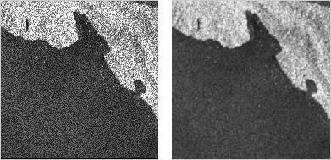

**Phase**

The SAR phase represents the rotation angle of the reflected wave and is influenced by factors such as foreshortening (where objects appear smaller due to viewing angle) and layover (where echoes from tilted objects overlap). Moving targets within the scene can also be displaced due to the Doppler effect.

**SAR Penetration and Variants**

SAR technology can penetrate certain materials like vegetation, revealing features hidden underneath. This capability is valuable for archaeological studies and disaster response.

**Interferometric SAR (InSAR)** InSAR measures surface deformation changes by analyzing the phase difference between multiple SAR images.

**Polarimetric SAR**

Polarimetric SAR analyzes the polarization of the reflected waves to extract additional information about the target.

**Deep Learning for SAR Despeckling**

Deep learning offers powerful methods for tackling the issue of speckle in SAR images. By leveraging large datasets and sophisticated algorithms, deep learning can significantly enhance the quality of SAR images, facilitating better interpretation and analysis.

**SUPERVISED LEARNING**

Supervised learning requires training data consisting of pairs of speckle-free and speckle-corrupted SAR images. The model learns to map the noisy image to its despeckled counterpart. However, the scarcity of ground truth (speckle-free) SAR data poses a challenge.

**Noise Reduction Techniques**

Deep learning models adapted for noise reduction can be trained to address SAR speckle characteristics. Examples include Non-Local Means (NLM) filtering and Noise2Noise frameworks.

**Generative Adversarial Networks (GANs)**

GANs can be used to generate despeckled images from noisy ones. A generative model creates realistic speckle-free images, while a discriminative model distinguishes real from generated images, driving the generative model to improve.

**Benefits of Deep Learning Approaches**

Deep learning approaches automate despeckling, removing the need for manual parameter tuning. They offer improved performance over traditional methods and can be adapted to specific types of SAR data or applications for targeted despeckling.

**Interferometric Phase and Parameter Estimation**

**Interferometric Phase**

InSAR involves combining two images (slave and master) into an interferogram. The process includes using synthetic test data such as boxcar, spinphase, NL-InSAR, OC-InSAR BM3D, and Phi-Net for phase unwrapping. The goal is to convert the interferogram into an absolute phase by using wrap counts, assuming no phase jump larger than 2pi between adjacent pixels.

**Parameter Estimation**

Real SAR images are fed into a well-trained network model, which extracts relevant parameters. These parameters are then compared to simulation images using an electromagnetic simulator, and a similarity measurement is performed to refine the SAR image.

**Conclusion**

Deep learning presents a promising avenue for improving SAR despeckling. By utilizing large datasets and advanced algorithms, deep learning techniques can significantly enhance the quality of SAR images, facilitating better interpretation and analysis. Future directions include exploring new deep learning architectures specifically designed for SAR despeckling, developing techniques for handling limited training data, and integrating deep learning despeckling with other SAR image processing tasks for a holistic approach.