AXOMRANK
BRAND IDENTITY GUIDE
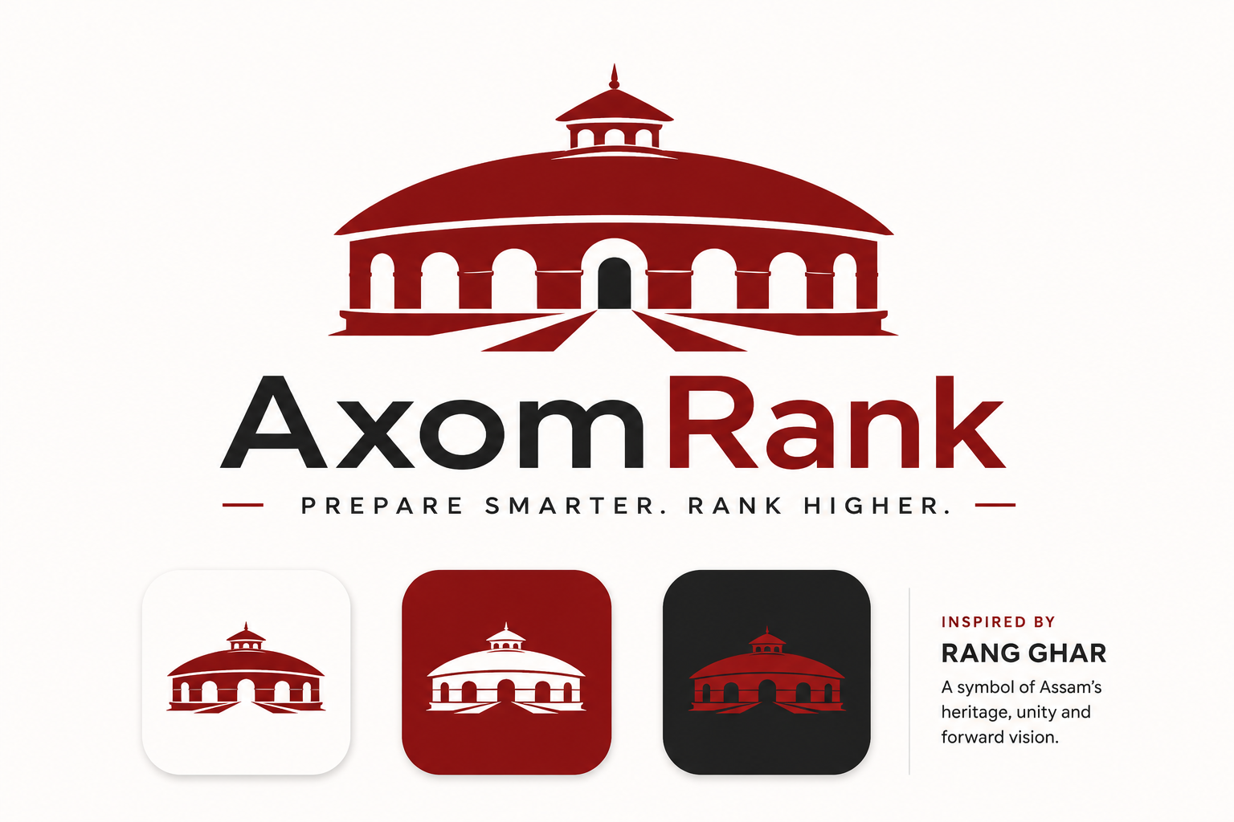
Prepare smarter. Rank higher.
Version 1.0 | August 2026

1. Brand Foundation

Brand
AxomRank

Category
Assam-first competitive-examination intelligence and preparation platform.

Initial product
AxomRank ADRE — digital preparation for Assam Direct Recruitment Examination aspirants.

Long-term ambition
Expand from ADRE into APSC, Assam Police, TET, Forest, SSC and other competitive examinations while keeping Assam as the core market identity.

Brand promise
Give aspirants a clearer path from study to measurable improvement through high-quality practice, analytics and targeted revision.
Core idea
AxomRank should feel like a serious technology product built for Assam — not a traditional coaching centre, PDF shop or generic ed-tech clone.

2. Brand Meaning & Story
“Axom” establishes regional identity. “Rank” establishes measurable achievement, competition and progress.
The visual identity takes its cultural anchor from the Rang Ghar. Rather than reproducing the monument literally across the brand, its architectural character becomes a restrained design language: symmetry, broad curved forms, repeated arches, horizontal bands and strong negative space.
Rang Ghar principle
Use Rang Ghar as an inspiration and design grammar, not as decoration. The brand should remain recognisably modern and digital.

Brand metaphor
Rang Ghar represents a place of gathering and viewing. AxomRank adapts that idea into a digital gathering point where Assam’s aspirants prepare, test themselves, compare performance and improve.

3. Brand Personality
Intelligent — Data-driven, precise and evidence-oriented.
Ambitious — Focused on improvement and achievement.
Trustworthy — Clear about what is official, independent and evidence-based.
Modern — Digital-first, clean and uncluttered.
Assamese — Rooted in Assam without becoming folkloric.
Practical — Useful before motivational; action before slogans.

What AxomRank should not feel like
- Generic coaching-centre branding
- Government branding or implied official affiliation
- Overly patriotic or decorative visual language
- Cheap discount-driven ed-tech
- Motivational-speaker culture
- A cluttered PDF marketplace

4. Logo System

Primary mark
A simplified Rang Ghar-inspired architectural emblem paired with the AxomRank wordmark.

Design principle
The mark should be recognisable as a compact architectural silhouette while remaining simple enough to work as a favicon, app icon and social avatar.

Required logo variants
- Primary horizontal lock-up
- Stacked lock-up
- Symbol-only mark
- One-colour dark version
- One-colour white/reversed version
- Small-size/favicon version

Logo rules
- Do not add gradients, glow, 3D effects or drop shadows.
- Do not surround the mark with unnecessary decorative Assamese patterns.
- Do not stretch, rotate or distort the mark.
- Do not recreate the logo in an unapproved colour.
- Do not attach the tagline to every instance of the logo.

5. Colour System
The palette deliberately avoids generic ed-tech blue/orange conventions. It uses a restrained red, white and charcoal system that connects to Assamese visual culture while remaining contemporary.
Colour | HEX | Role | Use
Axom Red | #A71930 | Primary brand | Logo, key actions, highlights
Deep Charcoal | #171717 | Primary neutral | Wordmark, headings, body text
White | #FFFFFF | Primary background | UI, print, negative space
Mist | #F5F5F3 | Soft surface | Cards, sections, subtle backgrounds
Soft Grey | #E5E5E5 | Structure | Borders, dividers, disabled UI
Secondary Grey | #6B7280 | Muted text | Metadata, helper text
Colour rule
Red should be used with restraint. The identity is not “everything red”; white space and charcoal create the premium, modern feel.

6. Typography
Typography should feel contemporary, highly legible and software-oriented.

English
Preferred direction: Inter, Manrope or Geist. Select one family as the production standard after testing across web and mobile.

Assamese
Use a high-quality Unicode Assamese typeface with strong screen readability. Test it against the chosen English font so bilingual headings and body copy feel like one system.

Hierarchy
- Large display heading — bold, short and confident.
- Section heading — clear and compact.
- Body — highly readable, normal weight.
- Metadata — small, muted and functional.
- Numbers/scores — strong and highly legible.

7. Rang Ghar Design Language
The visual system should abstract architectural characteristics rather than repeatedly showing a literal Rang Ghar.
- Broad curved roof-like arcs for section separators and hero backgrounds.
- Repeated arch geometry for cards, tabs or subtle decorative framing.
- Horizontal bands to establish hierarchy.
- Strong symmetry for major brand compositions.
- Generous negative space to keep the identity contemporary.
- Simple architectural silhouettes in illustrations.
Do not overuse it
The Rang Ghar connection should be felt more often than it is seen. Most product screens should remain clean and functional.

8. Iconography
Create a custom geometric icon family derived from the visual proportions of the logo.
- Mock Test
- PYQ Vault
- Assam GK
- Current Affairs
- Practice
- Analytics
- Mistake Bank
- Revision
- Rank
- Study Plan
- Performance
- Profile

9. Product Brand Architecture
Brand | Product | Purpose
AxomRank | ADRE | Core ADRE preparation
AxomRank | Mock Arena | Full and sectional mock tests
AxomRank | PYQ Vault | Previous-year question practice
AxomRank | Mistake Bank | Automatic wrong-answer revision
AxomRank | Daily 10 | Daily short practice habit
AxomRank | Assam GK | Assam-specific knowledge system
AxomRank | Current Affairs | Exam-oriented current affairs

10. AxomRank Score
AxomRank Score should become a signature product concept: a transparent performance indicator that helps students see improvement over time.
Example display: “AxomRank Score 742 | +61 this month”.
The underlying calculation should combine relevant performance signals such as accuracy, speed, consistency and difficulty-adjusted performance. The methodology should be documented rather than presented as a mysterious AI score.

11. Voice & Messaging

Voice
- Short
- Confident
- Useful
- Specific
- Data-aware
- Respectful

Preferred messaging style
Instead of generic motivation: “Work hard and achieve your dreams.”
Prefer: “118/150. Your accuracy is strong. Arithmetic is holding you back.”
The product should speak like a smart senior aspirant or coach: direct, practical and evidence-oriented.

12. Social & Content Identity
- Question of the Day
- Assam GK
- PYQ of the Day
- Current Affairs
- Mock Result
- Rank/Improvement
- Study Strategy
- Exam Updates
All templates should use the same red/charcoal/white palette, typography and Rang Ghar geometric grammar so a post is recognisable as AxomRank before the account name is read.

13. UI / Digital Design Principles
- Mobile-first
- Fast and lightweight
- High contrast and accessible
- Generous white space
- Clear hierarchy
- Minimal decorative elements
- Data visualisations that prioritise comprehension
- Consistent states for loading, success, error, empty and locked content

14. Photography & Illustration
Use real Assam and real aspirants wherever photography is needed. Prefer natural light, authentic environments and documentary-style moments.
Avoid generic stock imagery such as staged laptop users, exaggerated success poses and cliché coaching-centre visuals.
Illustrations should be minimal, geometric and compatible with the Rang Ghar design grammar.

15. Brand Applications
- Website and mobile app
- Favicon and app icon
- Instagram/Facebook/YouTube
- Telegram and WhatsApp
- Mock-test reports
- Question papers and PDFs
- Certificates
- Email templates
- Digital advertisements
- Future merchandise or event material

16. Brand Guidelines Checklist
- Final logo files in SVG/PNG
- Primary/secondary logo lock-ups
- Clear-space and minimum-size rules
- Approved colour swatches
- English and Assamese typography
- Icon set
- Rang Ghar geometric primitives
- Social templates
- UI component library
- Tone-of-voice examples
- Product naming rules
- Correct/incorrect usage examples

17. Immediate Next Steps
1. Finalize the Rang Ghar-inspired logo as a vector identity.
2. Lock the Axom Red / Charcoal / White palette.
3. Select and test the English and Assamese typefaces.
4. Build the Rang Ghar geometric design language.
5. Create the icon family.
6. Create the AxomRank UI design system.
7. Create social-media templates.
8. Produce the final brand guidelines PDF after the above elements are approved.

