Multi-marker eDNA metabarcoding reveals contrasting micro-eukaryote communities and a shared rotifer assemblage in two Brahmaputra floodplain wetlands of Assam, India
Sahil Seikh¹ [add co-authors]
¹ Department of Zoology, B. Borooah College (Autonomous), Guwahati, Assam, India
Corresponding author: Sahil Seikh, sahilseikh132@gmail.com (ORCID: [add])

Abstract
Floodplain wetlands of the Brahmaputra valley are under growing urban pressure, yet molecular baselines of their plankton are lacking. We characterised the plankton of Deepor Beel, a Ramsar wetland bordering the municipal solid-waste dumping ground of Guwahati, and the less disturbed Chandubi Beel using environmental DNA metabarcoding of two markers: the 18S rRNA V4 region for micro-eukaryotes and the mitochondrial cytochrome c oxidase I (COI) gene for metazoans. From 620,380 read pairs, joint denoising yielded 982 18S and 345 COI amplicon sequence variants. The micro-eukaryote communities were almost distinct (14.5% of variants shared): Chandubi Beel was dominated by green algae, diatoms and free-living protozoa, whereas Deepor Beel was richer (685 vs 436 variants) and dominated by fungi (24% of reads), oomycetes and desmids. In contrast, 77.1% of COI variants occurred in both wetlands, where rotifers formed 60–65% of reads. When the abundant unassigned COI variants were compared at protein level, 22 of them grouped with rotifers, so many rotifer lineages in these wetlands are absent from reference libraries. The rotifer quotient QB/T of 5 in both wetlands and the enrichment of Brachionus and Keratella tropica at Deepor Beel indicate nutrient-rich conditions. DNA detections agreed with published microscopy for the dominant desmid and rotifer genera. This is the first molecular plankton baseline for either wetland, and most named animal genera were detected by only one of the two markers, which argues for combining markers in wetland biomonitoring in north-eastern India.
Keywords Biomonitoring · Ramsar site · Zooplankton · Phytoplankton · Desmids · Cytochrome c oxidase I

Introduction
Wetland plankton respond within weeks to changes in nutrient load, organic matter and hydrology, which makes them sensitive indicators of ecological condition. Identifying them by microscopy is, however, slow and demands separate expertise for rotifers, crustaceans, protists and algae, while small and fragile forms are routinely overlooked. Environmental DNA (eDNA) metabarcoding is a complementary approach. DNA that organisms shed into the water is amplified with taxonomically informative markers and sequenced in a single assay, and its use for monitoring Indian fresh waters is growing (Sahu et al., 2025).
Mitochondrial cytochrome c oxidase I (COI) resolves metazoan zooplankton to species where reference sequences exist, whereas the nuclear 18S rRNA gene captures the broader eukaryotic assemblage (algae, protists and fungi), usually at coarser taxonomic ranks. No single marker, then, recovers a whole plankton community on its own. Studies that combine markers consistently detect more taxa than either marker alone (Zhang et al., 2018; Stefanni et al., 2018; Sildever et al., 2021; Zhao et al., 2021), and eDNA surveys have linked shifts in plankton composition to anthropogenic pressure in lakes and reservoirs (Lin et al., 2023; Jo et al., 2026). The reliability of species-level assignments nevertheless depends on reference databases, which remain incomplete for tropical freshwater invertebrates (Chen et al., 2025).
Deepor Beel is a Ramsar-listed floodplain wetland of the Brahmaputra on the south-western edge of Guwahati city. It lies immediately beside the city's municipal solid-waste dumping ground, which exposes it to leachate and organic enrichment in addition to urban encroachment. Chandubi Beel, a natural lake in the same district, is comparatively undisturbed. The rotifers and algae of Deepor Beel have been described by microscopy (Sharma, 2010; Baruah et al., 2020), but no molecular survey exists for either wetland.
We sampled each wetland once and sequenced two markers, which supports a baseline description of the plankton rather than a test of differences. Four questions guided the analysis: (i) how the micro-eukaryote and metazoan communities of the pressured and the reference wetland differ, (ii) what biological indicators reveal about their trophic state in the absence of chemical monitoring, (iii) how much of the community can be named with current reference libraries, and (iv) whether DNA detections agree with earlier microscopy.

Materials and methods

Study area and sampling
Surface water was collected on 29 March 2026 at one near-shore location in each wetland: Deepor Beel (W2; 26.10953° N, 91.70818° E) and Chandubi Beel (W1; 25.881015° N, 91.422898° E), Kamrup district, Assam, India. The study was designed as a biological baseline and did not include water chemistry; the contrast between the wetlands is defined by their setting (Deepor Beel adjoining the municipal solid-waste dumping ground of Guwahati, and Chandubi Beel without comparable pressure), and the trophic state of each is inferred from biological indicators (see below).

DNA extraction, amplification and sequencing
DNA extraction, PCR amplification and library preparation were carried out by Eurofins Genomics following the provider's standard amplicon protocol. Two markers were amplified: the V4 region of the 18S rRNA gene with primers E572F (5′-CYGCGGTAATTCCAGCTC-3′) and E1009R (5′-AYGGTATCTRWTCRTCTTYG-3′) (Comeau et al., 2011), and the 313-bp "Leray" fragment of COI with mlCOIintF (5′-GGWACWGGWTGAACWGTWTAYCCYCC-3′) (Leray et al., 2013) and jgHCO2198 (5′-TAIACYTCIGGRTGICCRAARAAYCA-3′) (Geller et al., 2013). Libraries were sequenced on an Illumina MiSeq (2 × 300 bp). The identity of both primer pairs was confirmed directly from the reads.

Read processing
Read integrity was verified against the provider's MD5 checksums and quality assessed with FastQC v0.13.0 and MultiQC v1.35 (Ewels et al., 2016). Primers were removed with Cutadapt v5.2 (Martin, 2011) using linked adapters: the 5′ primer was required at the start of each read (maximum error rate 0.15), the reverse-complemented opposite primer was trimmed when present, and pairs lacking either primer were discarded. Reads were then processed per marker with DADA2 v1.38.0 (Callahan et al., 2016) in R v4.5.3 (R Core Team, 2026): truncation at 270/210 bp (18S) and 250/200 bp (COI), maxEE 2/4, maxN 0, error models learned per read direction, joint (pooled) denoising of both samples so that identical sequences received the same amplicon sequence variant (ASV) in both wetlands, merging with a minimum overlap of 12 bp and no mismatches, and consensus chimera removal. COI ASVs were retained only if their length differed from 313 bp by whole codons and they translated without stop codons under the invertebrate mitochondrial code (NCBI table 5); 18S ASVs were retained if 350–480 bp long.

Taxonomic assignment
ASVs were classified with the SINTAX algorithm (Edgar, 2016) in VSEARCH v2.32.0 (Rognes et al., 2016) against PR2 v5.1.1 for 18S (Guillou et al., 2012) and the Eukaryote CO1 Reference Set v5.1.0 for COI (Porter & Hajibabaei, 2018). A rank was accepted only if its bootstrap support was ≥ 0.80 and the identity to the closest reference sequence reached a rank-specific minimum (COI: order 85%, family 90%, genus 95%, species 97%; 18S: family 95%, genus 97%, species 99%). The 40 most abundant COI ASVs with < 85% identity to the reference set were searched against NCBI core_nt with BLASTn; hits below 80% identity were not used. ASVs among these without a ≥ 90% DNA match were further compared at the protein level: the reference set was translated with SeqKit v2.14.0 (Shen et al., 2016) and searched with DIAMOND v2.2.8 blastx (Buchfink et al., 2021) (ultra-sensitive mode, invertebrate mitochondrial code, E ≤ 10⁻¹⁰). A consensus phylum was assigned when at least three hits lay within 95% of the best bit score and ≥ 70% of them agreed.

Community analyses
Diversity analyses used vegan v2.7.5 (Oksanen et al., 2025). Alpha diversity was computed after rarefying both samples of each marker to the shallower depth, averaged over 100 random subsamples, and reported as observed ASVs, Shannon, Simpson and Pielou indices and Hill numbers (q1 = exp H′; q2 = 1/D). Overlap between wetlands was summarised as shared and unique ASVs, genera and species with Jaccard similarity and Bray–Curtis dissimilarity. 18S ASVs were grouped into ecological roles from their PR2 division and class, and COI ASVs into animal groups. For the rotifer quotient QB/T (Sládeček, 1983), COI ASVs were clustered into species-level operational units at 97% identity with VSEARCH and Brachionus and Trichocerca units counted per wetland. DNA detections for Deepor Beel were compared with the taxa reported by microscopy for rotifers (Sharma, 2010) and algae (Baruah et al., 2020). With one sample per wetland, no inferential statistics were applied; all contrasts are descriptive. Bioinformatic scripts and draft text were prepared with the assistance of a large language model (Claude, Anthropic); all code, results and text were checked by the authors. All scripts are publicly available (see Data availability).

Results and discussion

Sequencing depth and data processing
Sequencing produced 620,380 read pairs, of which 87.8–89.6% carried both primers (Table 1). After denoising, merging, chimera removal (9.3% of 18S and 3.8% of COI reads) and curation, 53.3–57.2% (18S) and 69.7–71.7% (COI) of raw pairs were retained. Curation removed few reads (COI: 31 ASVs, 0.4% of reads; 18S: 53 ASVs, 2.6%), and the retained COI ASVs clustered at 313 and 316 bp, as expected for a protein-coding fragment. For both markers in both wetlands the rarefaction curves levelled off (Fig. 1), so further sequencing of these libraries would have added few new ASVs.
Table 1 Sequencing and processing summary: read pairs remaining after each step and the share of raw pairs retained
Marker — wetland | Raw | Primers | Filtered | Merged | Non-chimeric | Curated | % retained
18S — Chandubi Beel | 166,108 | 145,813 | 115,951 | 104,117 | 93,012 | 88,564 | 53.3
18S — Deepor Beel | 143,035 | 128,222 | 101,027 | 88,768 | 81,898 | 81,828 | 57.2
COI — Chandubi Beel | 167,886 | 148,980 | 125,051 | 123,126 | 117,653 | 116,954 | 69.7
COI — Deepor Beel | 143,351 | 127,418 | 107,049 | 106,300 | 102,969 | 102,761 | 71.7
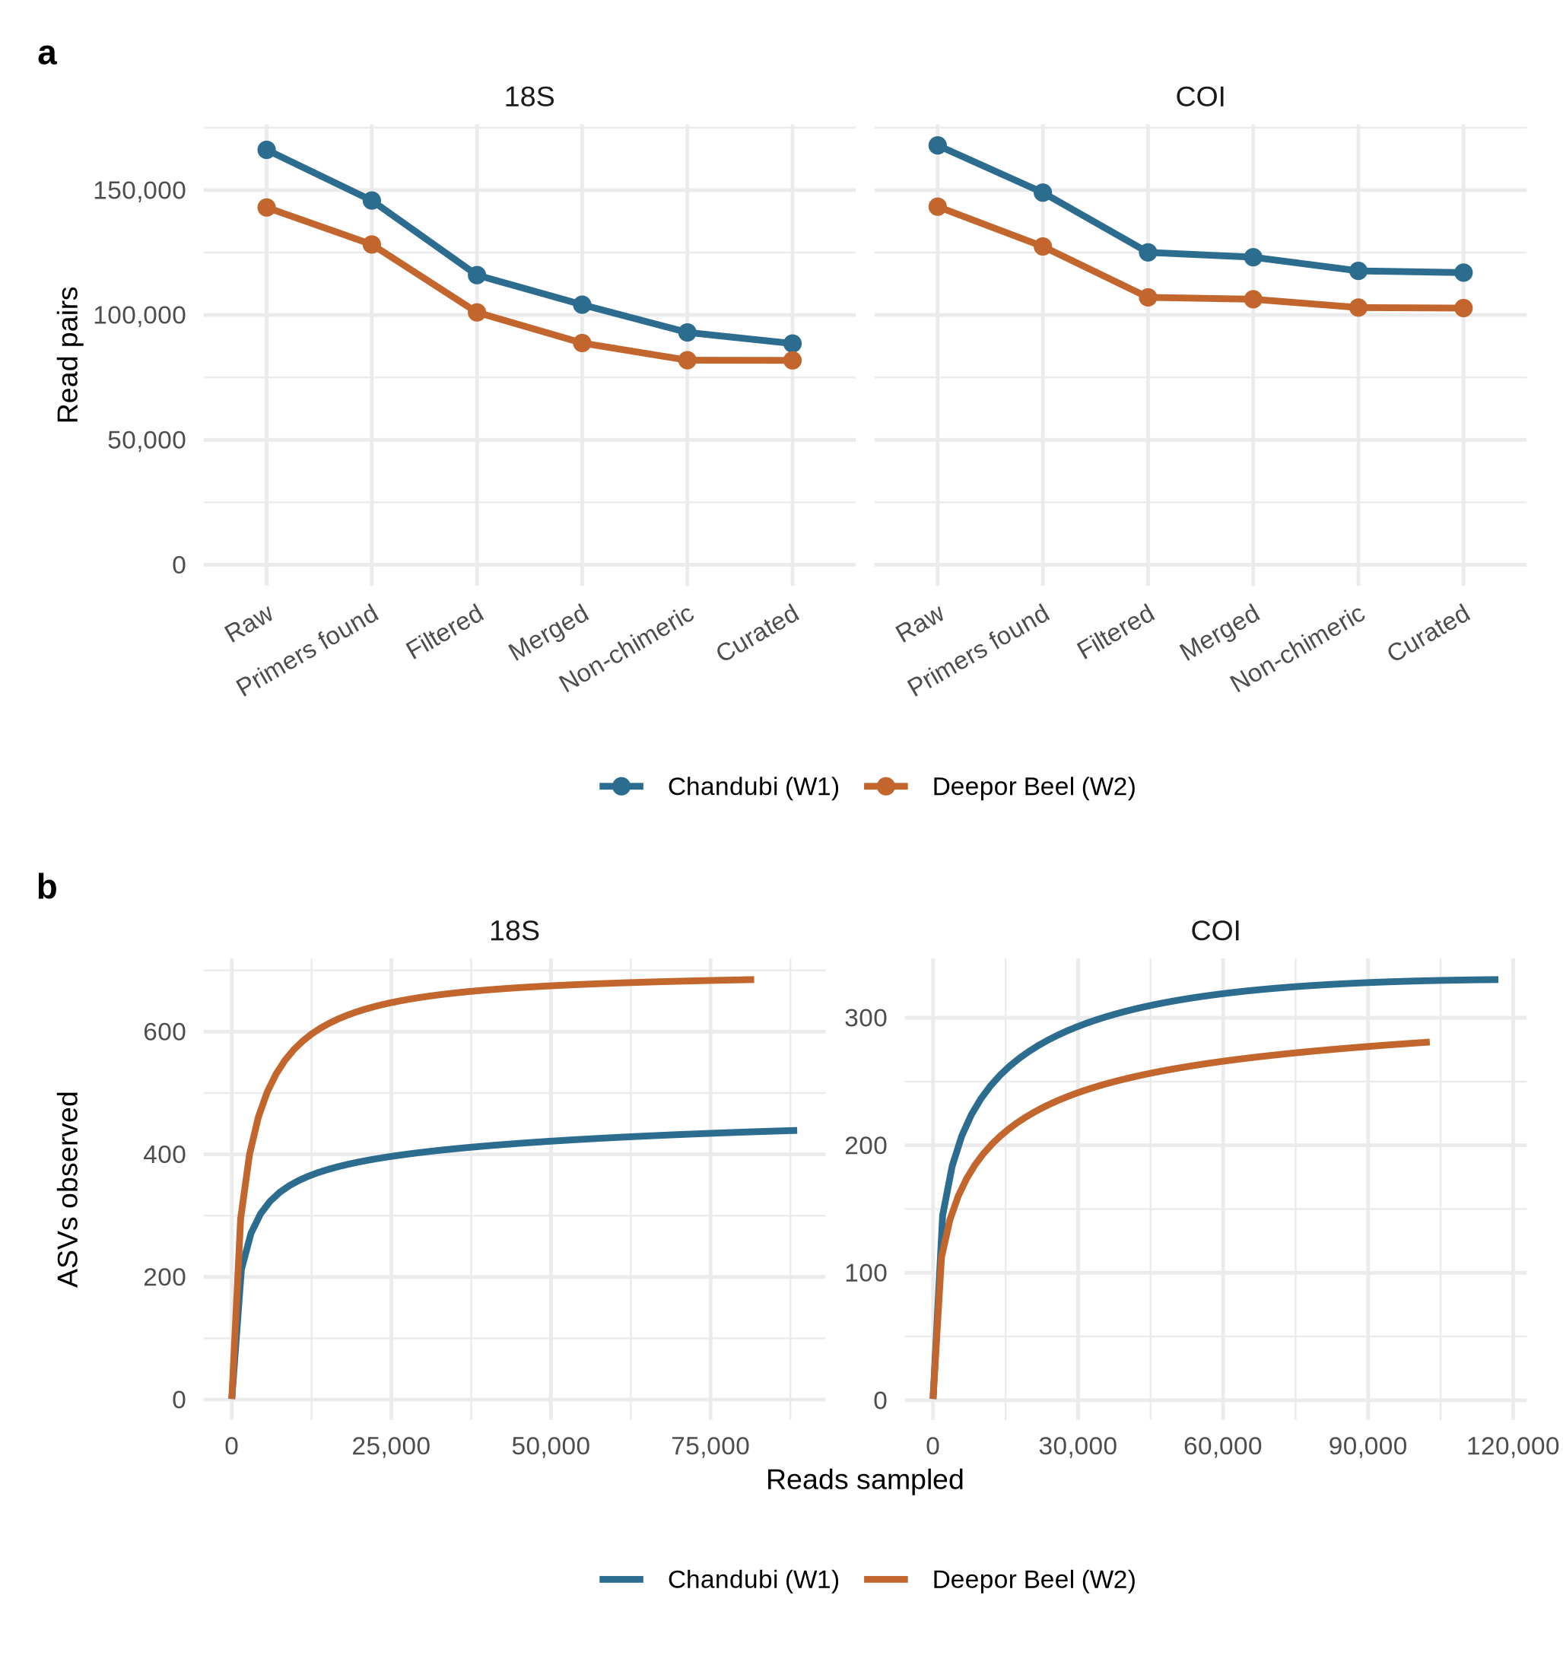
Fig. 1 Read processing and sequencing depth. a Read pairs remaining after each processing step for each marker and wetland. b Rarefaction curves of curated amplicon sequence variants (ASVs); curves reaching a plateau indicate sufficient sequencing depth

Taxonomic resolution and the reference-library gap
The 18S data were well covered by PR2: 87–93% of reads were named at division level and 110 genera were identified. COI resolution was much lower: only 31% (Chandubi Beel) and 42% (Deepor Beel) of reads were named even to phylum, because 63% of COI reads were less than 85% identical to any reference sequence. GenBank searches showed that many of these unknowns matched unnamed "rotifer environmental samples" or known rotifers at only 80–89% DNA identity. At the protein level, 22 of 32 such ASVs were placed among rotifers with 89–98% amino-acid identity to Trichocerca, Euchlanis, Filinia, Lecane and Brachionus (Fig. 2), together accounting for 29% and 25% of COI reads. The single most abundant COI variant (15–19% of reads in both wetlands) translated cleanly but was at most 72% identical to any GenBank sequence, and its protein fell between a nematode (86%) and stramenopile algae, so its identity remains unresolved. The gap therefore lies in the reference libraries rather than in the data. North-eastern Indian rotifers are poorly represented in them, which is consistent with the limitations noted for freshwater invertebrates generally (Chen et al., 2025).
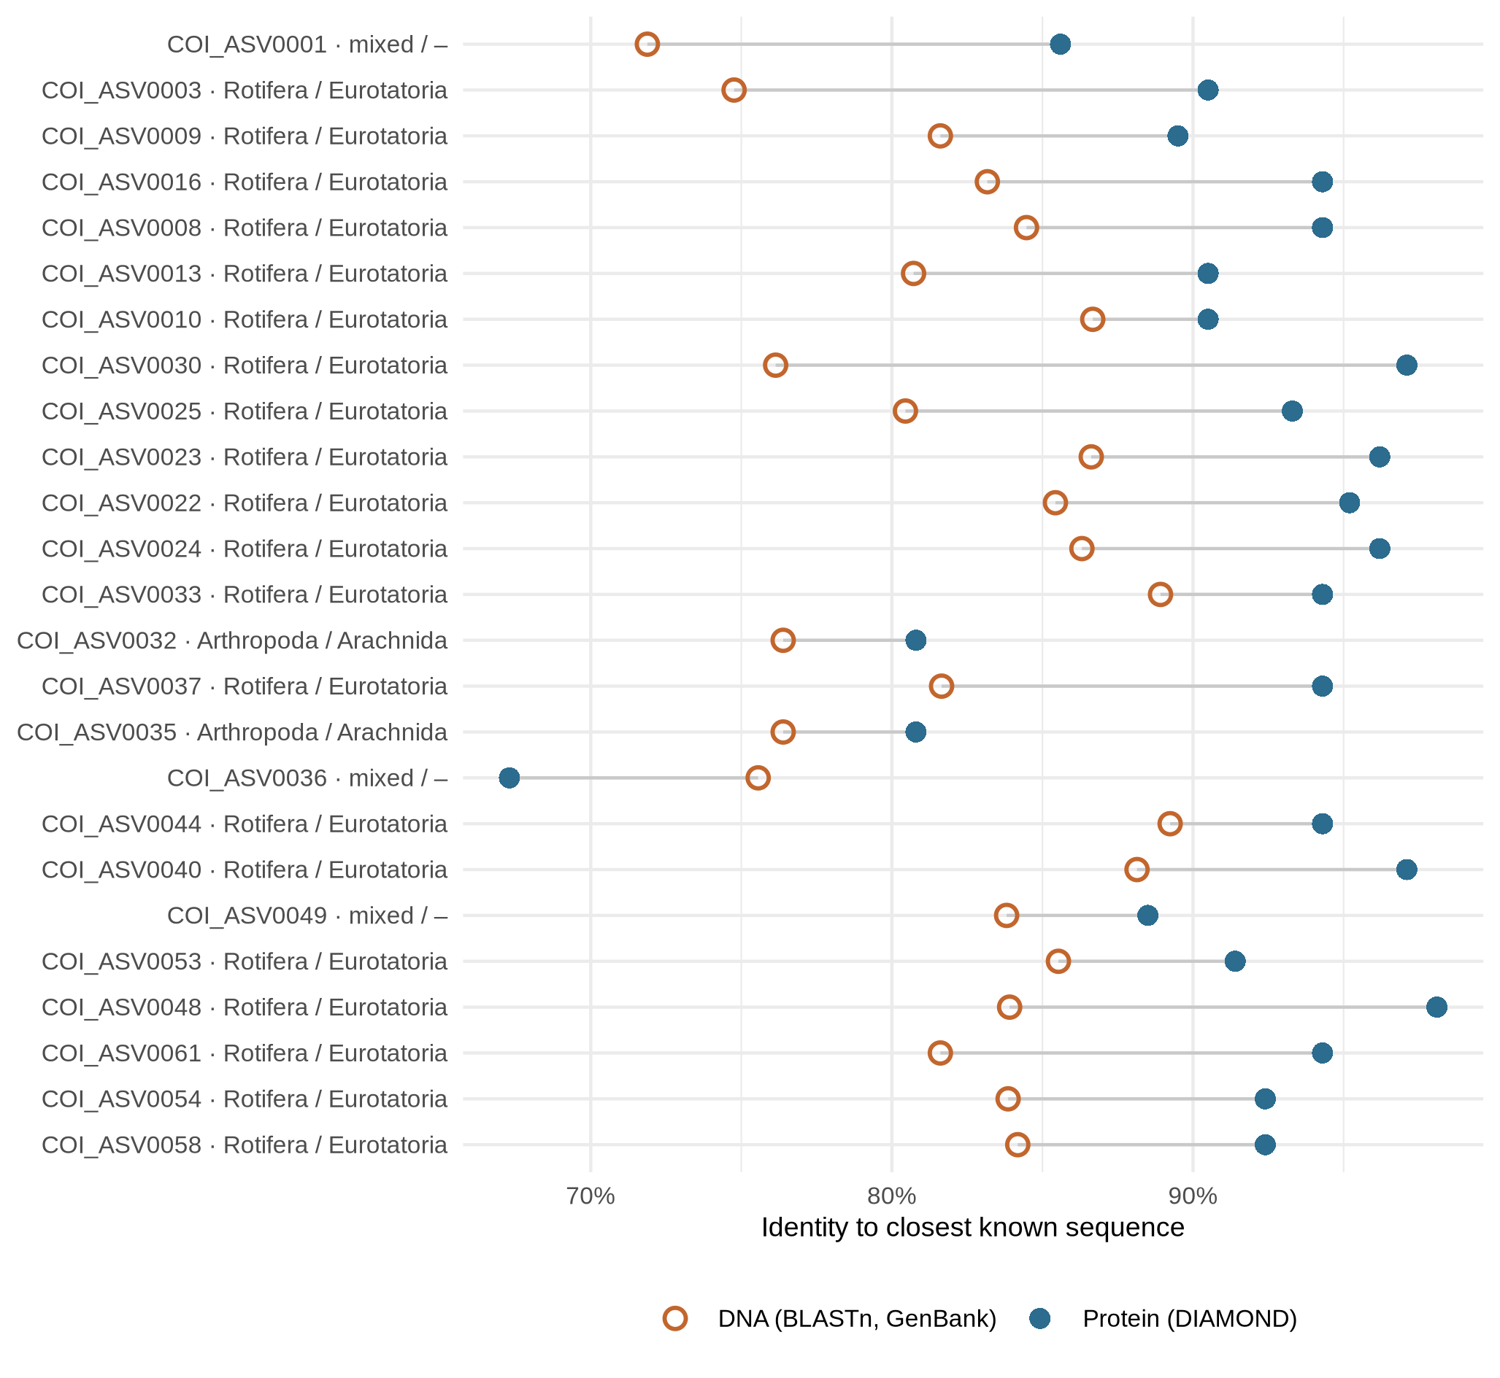
Fig. 2 Identity of the unassigned COI ASVs to the closest known sequence at DNA level (open circles; GenBank, BLASTn) and protein level (filled circles; translated CO1 Reference Set, DIAMOND). Labels give the consensus phylum/class of the closest proteins; 'mixed' indicates no agreement

Community composition and ecological roles
The micro-eukaryote communities of the two wetlands differed in structure (Fig. 3a). In Chandubi Beel, algae formed 29% of 18S reads, dominated by green algae (16%; Desmodesmus, Chlamydomonas, Pteromonas) and diatoms (9%; Cyclotella, Aulacoseira, Nitzschia), together with free-living protozoa (24%), notably the cercozoan Neoheteromita. In Deepor Beel, algae formed a similar share (27%) but were dominated by desmids (15%; Staurastrum, Cosmarium, Pleurotaenium), and fungi (24%) and oomycetes (9%) took a far larger share than in Chandubi Beel (8% and 4%). The most abundant Deepor-specific genera were the oomycete Aphanomyces, the algal-parasitic chytrid Rhizophydium and the golden alga Lepidochromonas (Fig. 4). Such a weighting towards decomposers and parasites is consistent with the organic input expected beside a solid-waste dumping ground, although organic loading itself was not measured in this study.
In the COI data, rotifers dominated both wetlands (60% and 65% of reads after integrating reference and protein-level assignments; Fig. 3b), led by Brachionus and Keratella. Copepods, ostracods and insects together contributed less than 1% of COI reads, although copepods (Mesocyclops, Microcyclops and Eucyclops) were recovered by 18S.
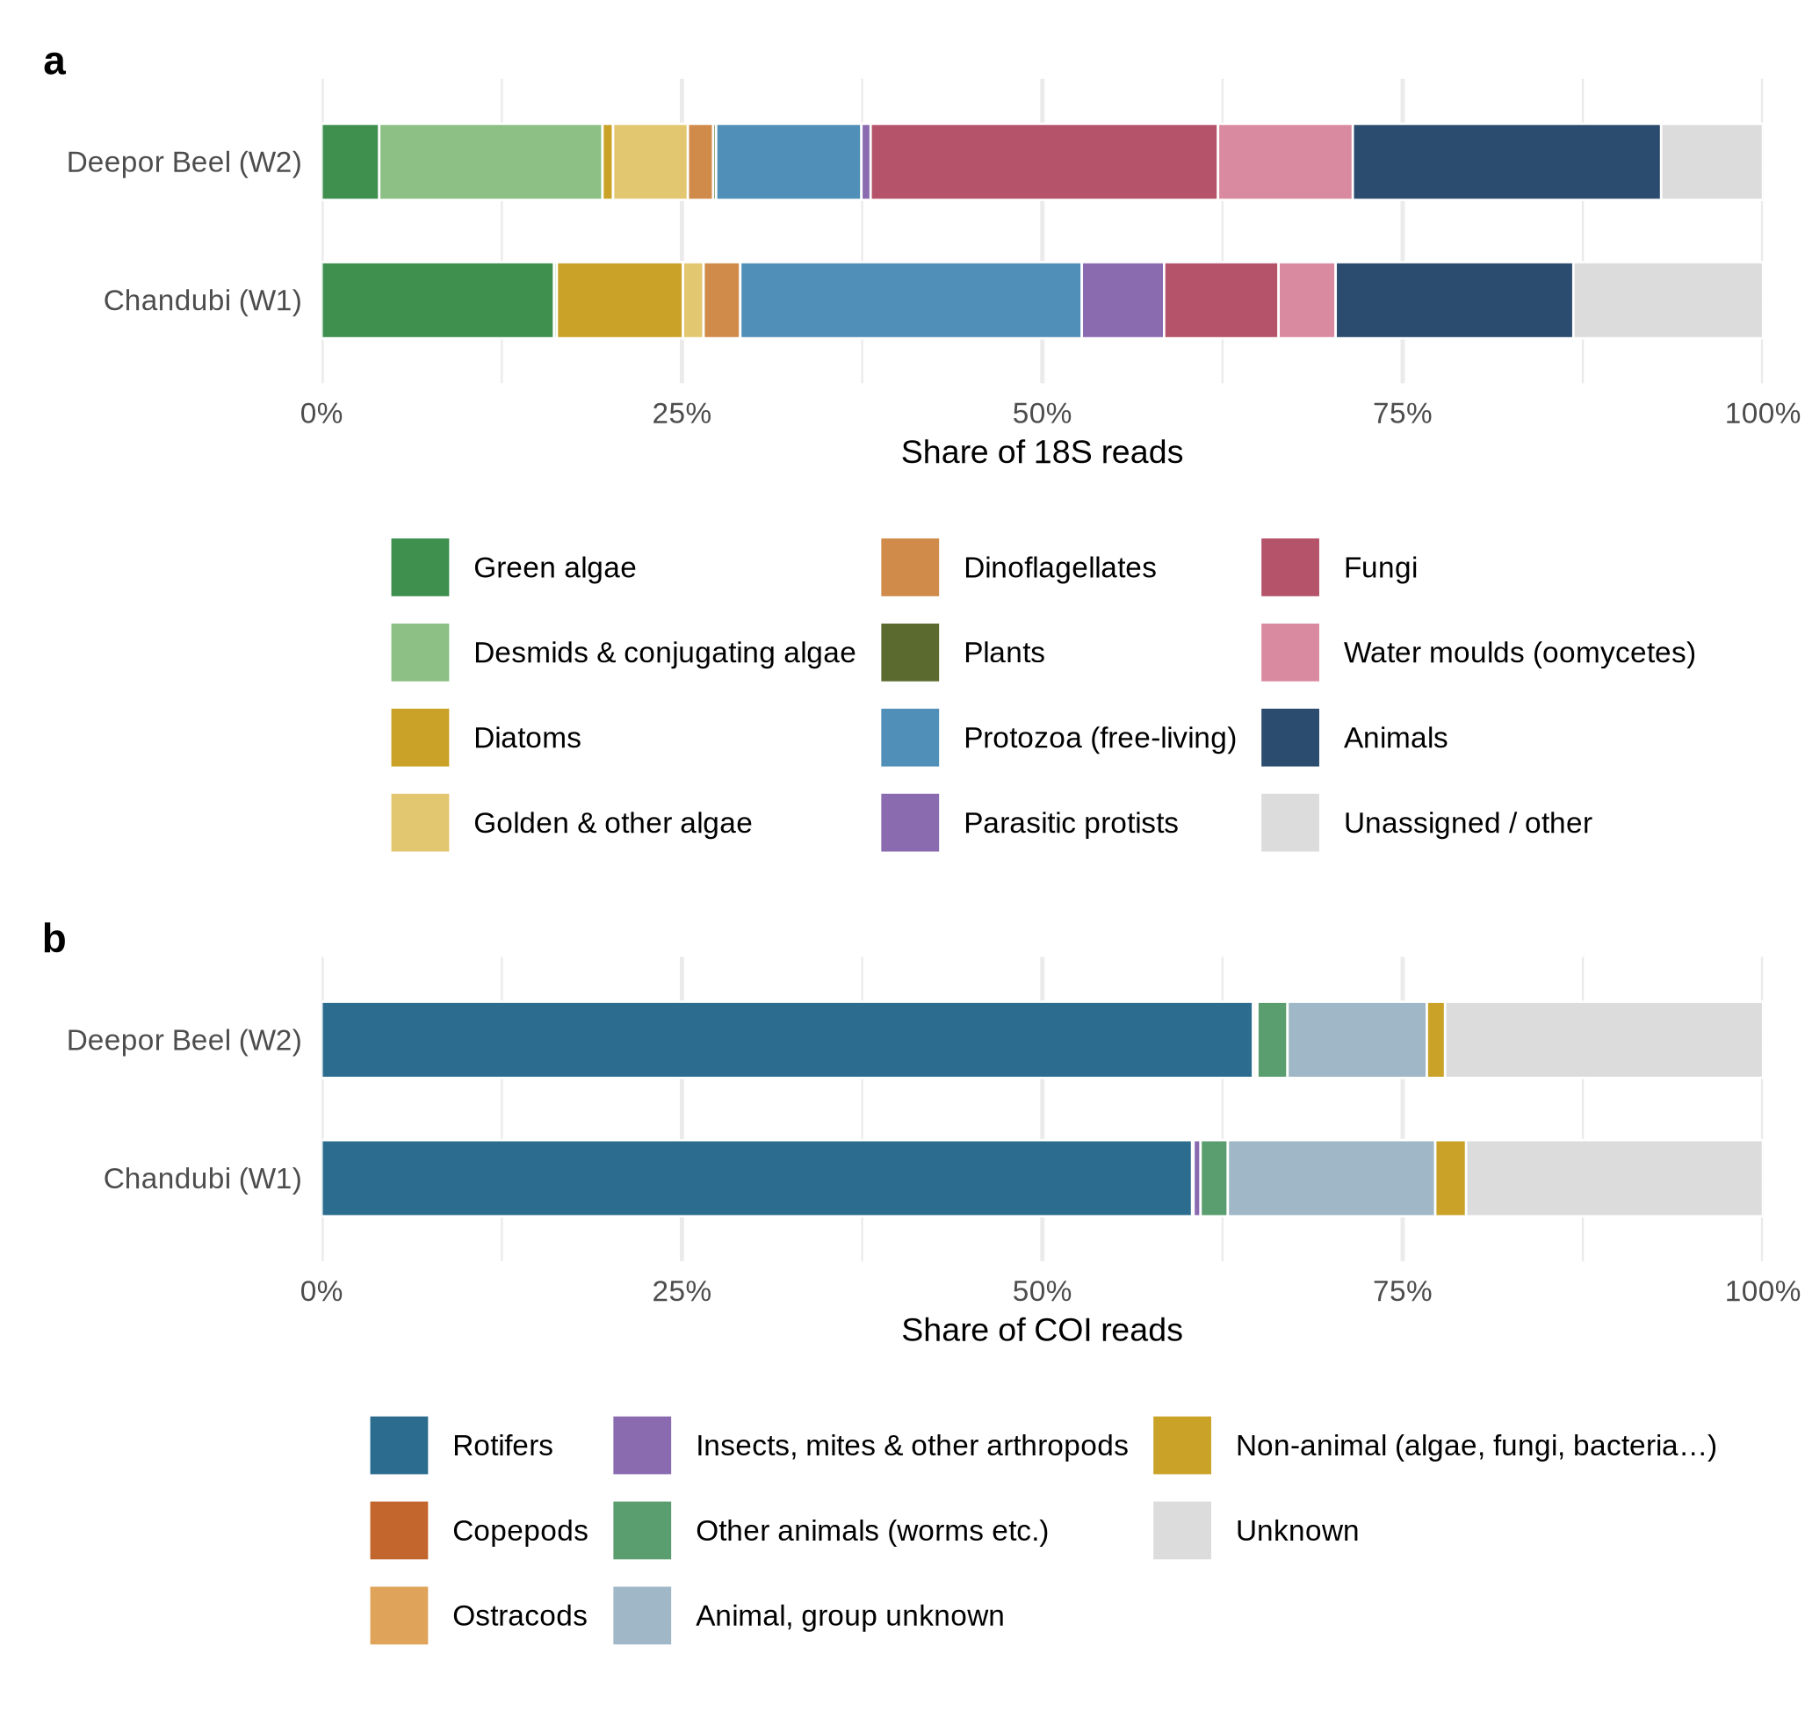
Fig. 3 Community composition. a Share of 18S rRNA reads by ecological role. b Share of COI reads by animal group, combining reference-set and protein-level assignments
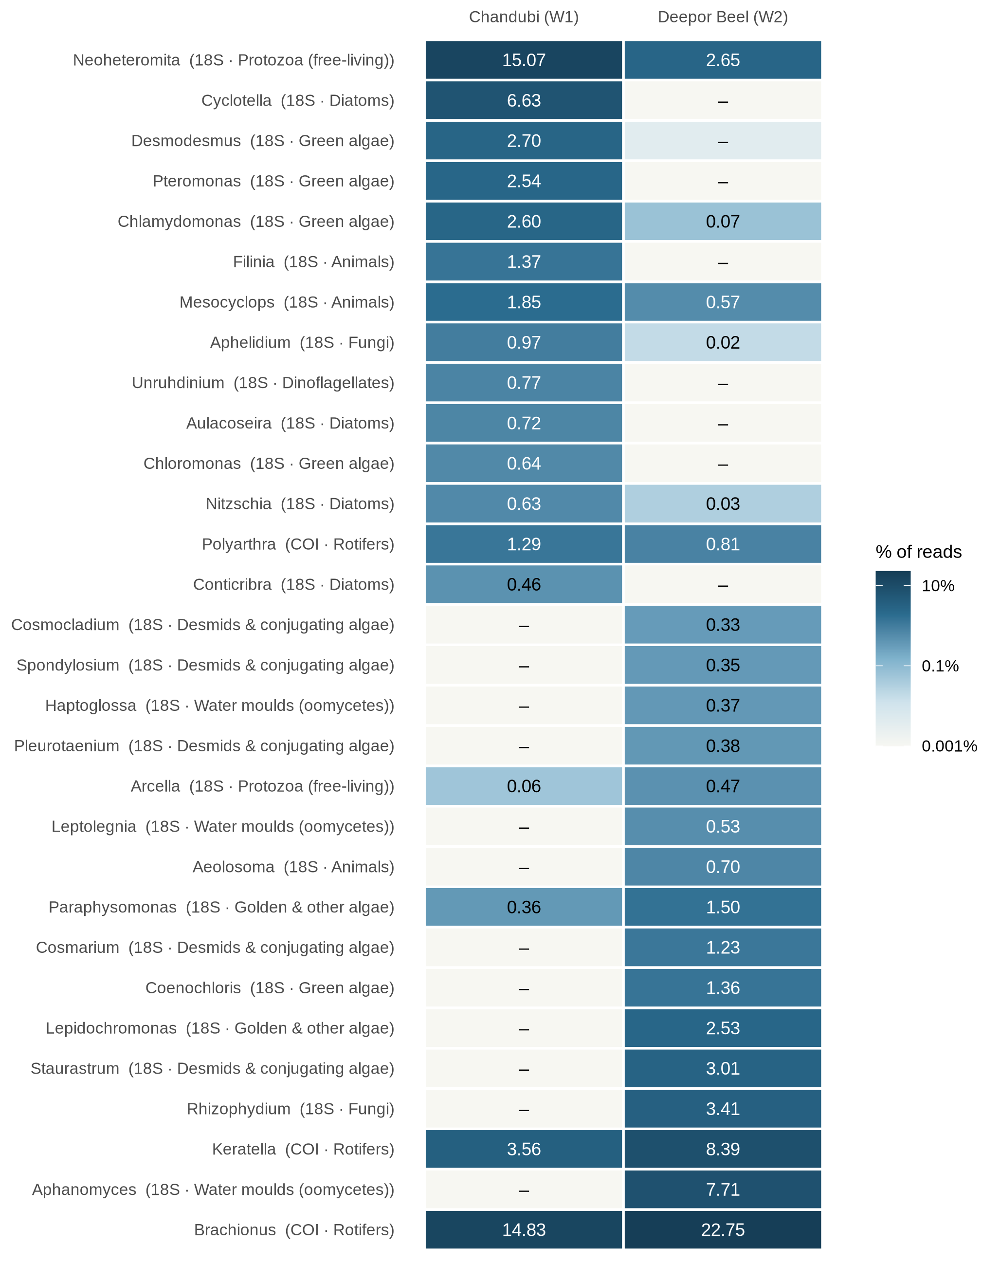
Fig. 4 The 30 most abundant named genera from both markers, as percentage of all reads of the respective marker in each wetland, ordered from Chandubi-leaning (top) to Deepor-leaning (bottom)

Diversity and overlap between wetlands
The two markers gave opposite diversity rankings (Table 2, Fig. 5a). For 18S, Deepor Beel was considerably richer (685 vs 436 ASVs at equal depth; Hill q1 121.7 vs 73.9). For COI, Chandubi Beel was richer and more even (329 vs 281 ASVs; q1 43.1 vs 30.5), reflecting the stronger dominance of a few rotifers in Deepor Beel.
Overlap differed even more (Fig. 5b). Only 14.5% of 18S ASVs and 24.5% of named 18S genera occurred in both wetlands (Bray–Curtis dissimilarity 0.95), whereas 77.1% of COI ASVs were shared at similar relative abundance (Bray–Curtis 0.23). In other words, largely the same rotifer assemblage occurs in both wetlands, but their algal, protist and fungal communities are mostly distinct. A shared rotifer pool is plausible for floodplain lakes of the same river system, as rotifers disperse readily through resting eggs and seasonal hydrological connection, whereas micro-eukaryote producers and decomposers respond more directly to local conditions such as organic loading and macrophyte cover.
Table 2 Alpha diversity after rarefaction to equal depth per marker (mean of 100 subsamples)
Marker — wetland | Depth | ASVs | Shannon | Simpson | Pielou | Hill q1 | Hill q2
18S — Chandubi Beel | 81,828 | 436 | 4.30 | 0.960 | 0.71 | 73.9 | 25.2
18S — Deepor Beel | 81,828 | 685 | 4.80 | 0.976 | 0.73 | 121.7 | 42.2
COI — Chandubi Beel | 102,761 | 329 | 3.76 | 0.949 | 0.65 | 43.1 | 19.8
COI — Deepor Beel | 102,761 | 281 | 3.42 | 0.930 | 0.61 | 30.5 | 14.3
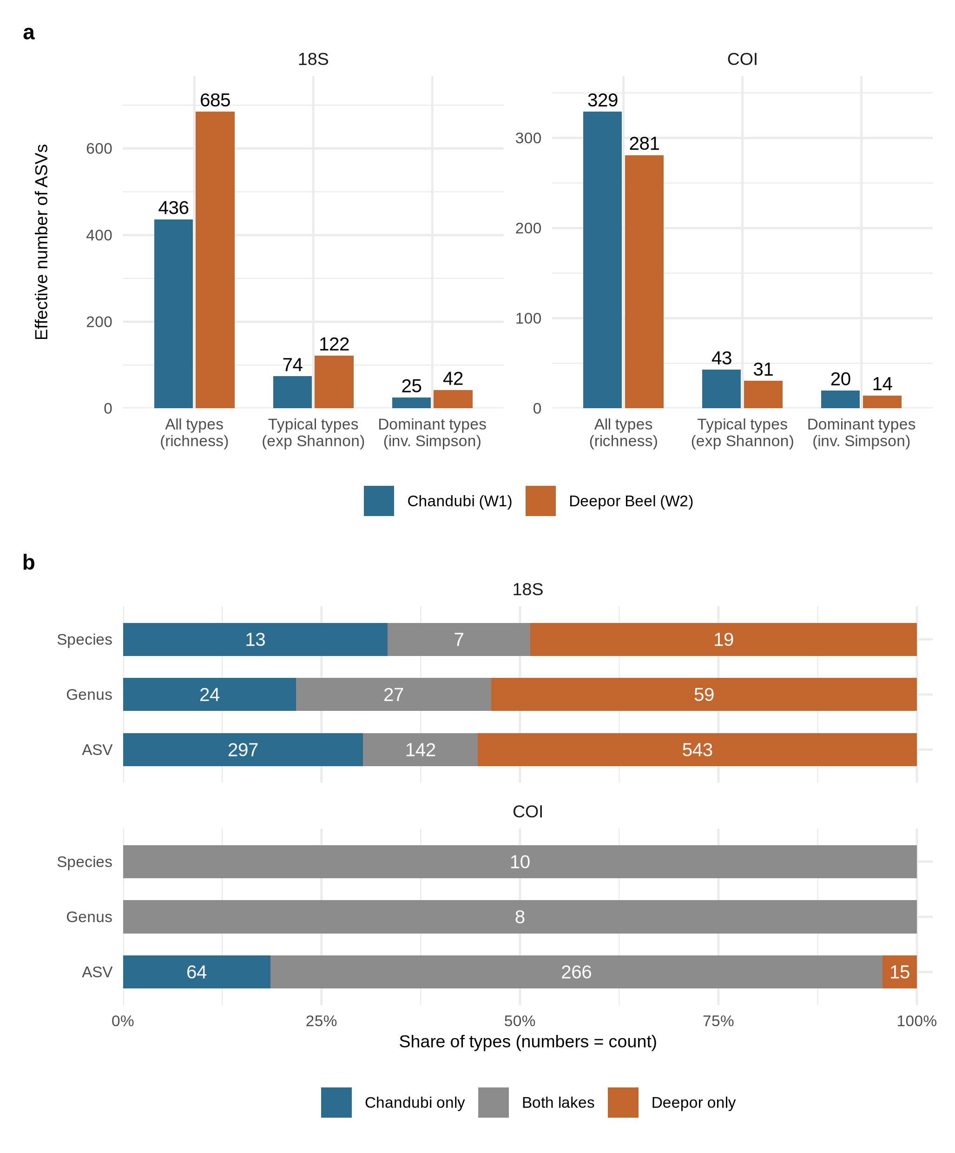
Fig. 5 Diversity and overlap. a Alpha diversity as effective numbers of ASVs (richness, Hill q1, Hill q2). b Share of ASVs, named genera and named species found only in Chandubi Beel, in both wetlands, or only in Deepor Beel; numbers are counts

Biological indicators of trophic state
Because no chemical data were collected, we read the trophic condition of the two wetlands from indicator taxa (Table 3). The rotifer quotient QB/T was 5 in both wetlands (10 Brachionus against 2 Trichocerca species-level units; Fig. 6), well above the threshold of 2 for eutrophic water (Sládeček, 1983); some genus assignments rest on distant matches and the value is therefore provisional. The eutrophy-associated Brachionus (14.8% vs 22.7% of COI reads), B. caudatus (4.5% vs 7.4%) and Keratella tropica (1.1% vs 2.4%) were more abundant in Deepor Beel, in line with organic enrichment from the adjacent dumping ground. Chandubi Beel nevertheless carried diatoms typical of enriched water, namely Cyclotella meneghiniana (1.9%), Nitzschia palea and Aulacoseira granulata, which indicates that it too is nutrient-rich rather than pristine. The prominence of desmids in Deepor Beel may reflect the macrophyte-rich habitat of this wetland, in which desmids commonly occur.
Table 3 Indicator taxa and their share of reads (%) of the respective marker in each wetland
Taxon | Marker | Group | Chandubi | Deepor
Brachionus | COI | Rotifer | 14.83 | 22.75
Brachionus calyciflorus | COI | Rotifer | 1.15 | 1.74
Brachionus caudatus | COI | Rotifer | 4.53 | 7.44
Keratella tropica | COI | Rotifer | 1.11 | 2.36
Polyarthra vulgaris | COI | Rotifer | 0.91 | 0.54
Filinia longiseta | 18S | Rotifer | 1.37 | 0.00
Mesocyclops | 18S | Copepod | 1.85 | 0.57
Cyclotella meneghiniana | 18S | Diatom | 1.94 | 0.00
Nitzschia palea | 18S | Diatom | 0.63 | 0.03
Aulacoseira granulata | 18S | Diatom | 0.27 | 0.00
Staurastrum | 18S | Desmid | 0.00 | 3.01
Cosmarium | 18S | Desmid | 0.00 | 1.23
Gonyostomum semen | 18S | Raphidophyte | 0.00 | 0.06
Botryococcus braunii | 18S | Green alga | 0.00 | 0.30
Rhizophydium | 18S | Chytrid fungus | 0.00 | 3.41
Indicator associations follow the general water-quality literature; percentages are relative read abundance
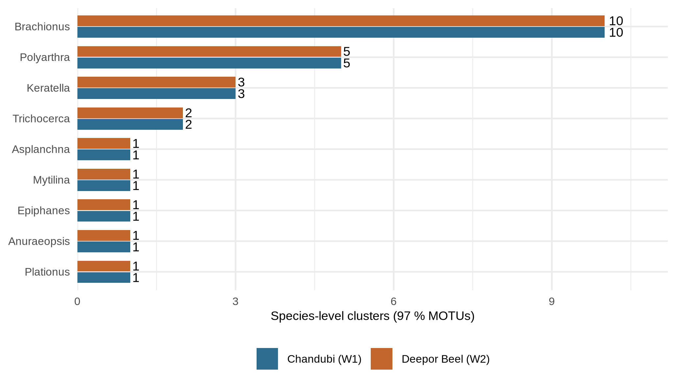
Fig. 6 Rotifer genera represented by species-level units (COI ASVs clustered at 97% identity) in each wetland. The Brachionus:Trichocerca quotient (QB/T) is given in the text

Agreement with microscopy
DNA detections for Deepor Beel agreed well with earlier microscopy (Fig. 7). For algae, 16 of the 63 genera listed by Baruah et al. (2020) were also found by 18S, including the dominant desmids Cosmarium and Staurastrum, and DNA added 23 genera not listed. Of the genera found only by microscopy, 17 were cyanobacteria, which lack an 18S gene, or euglenoids, which are poorly amplified by V4 primers. For rotifers, DNA detected 4 of the five quantitatively important genera and 6 of the seven important families reported by Sharma (2010), but only 2 of the seven important species, a shortfall that again points to the reference-library gap rather than to the absence of these species.
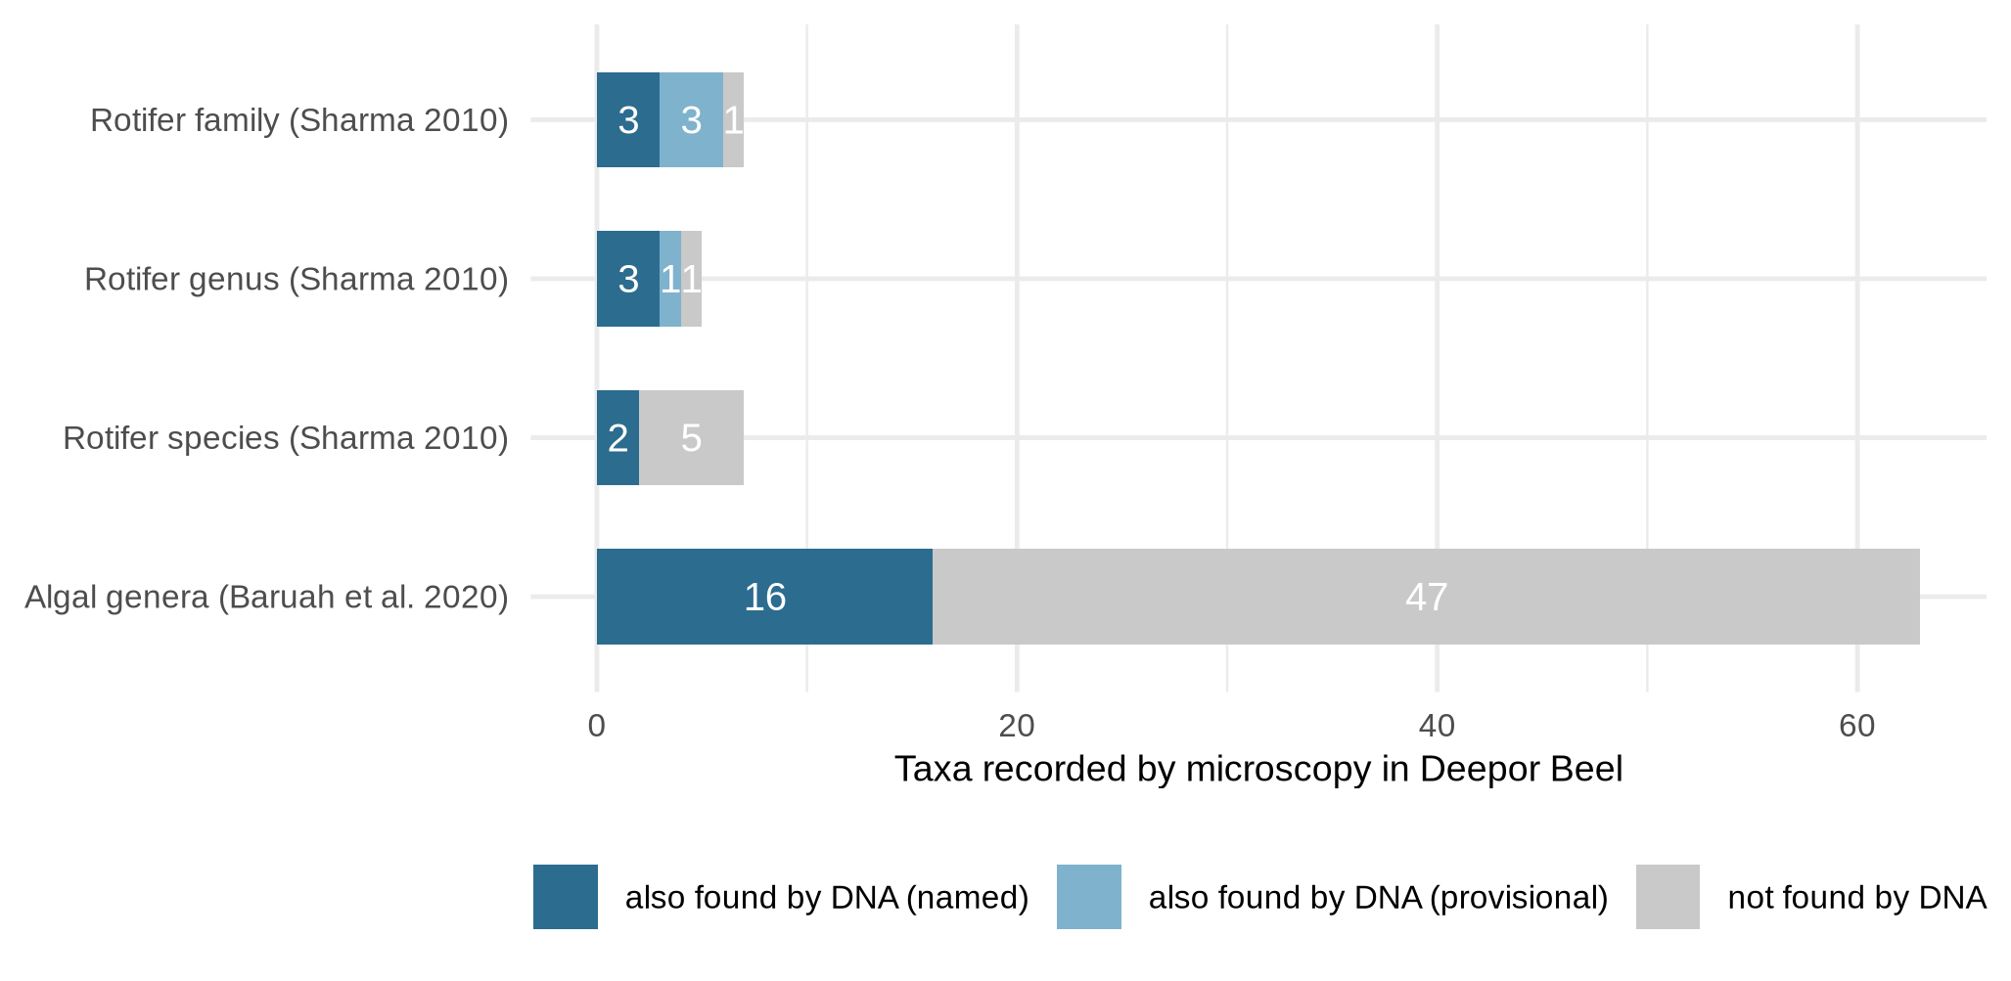
Fig. 7 Taxa reported by microscopy in Deepor Beel (rotifers: Sharma, 2010; algae: Baruah et al., 2020) and whether they were also detected by eDNA

Complementarity of markers and limitations
Of the animal genera named, 14 were detected only by 18S (flatworms, gastrotrichs, oligochaetes and the copepods Eucyclops and Microcyclops), 5 only by COI (including Brachionus, Keratella and Polyarthra) and 1 by both. Relying on COI alone would have missed 14 of these 20 genera, and relying on 18S alone would have missed 5, which supports multi-marker designs for wetland monitoring (Zhang et al., 2018; Stefanni et al., 2018; Zhao et al., 2021). Adding a phytoplankton-specific marker such as chloroplast 16S would further resolve the algal and cyanobacterial fraction (Lemonnier et al., 2025).
The study is a baseline with one sample per wetland, so differences are descriptive and cannot be tested statistically. Read proportions reflect DNA abundance, which is affected by copy number, body size and primer affinity, rather than biomass. Indicator interpretations are qualitative, and repeated, seasonal sampling with replication would be needed to quantify the effect of the dumping ground on Deepor Beel.

Conclusions
According to this first molecular plankton baseline for Deepor Beel and Chandubi Beel, the two wetlands share their rotifer zooplankton but differ sharply in their micro-eukaryote communities. Deepor Beel, beside the city's solid-waste dumping ground, carries a richer community dominated by fungi, oomycetes, desmids and decomposers, and a stronger signal of eutrophy-associated rotifers, while Chandubi Beel is dominated by green algae, diatoms and protozoa. Rotifer indicators point to nutrient-rich conditions in both wetlands. Many rotifer lineages and the most abundant COI sequence lack reference sequences, so barcoding the regional fauna should be treated as a priority. For future monitoring of these wetlands, pairing 18S with COI and checking DNA detections against microscopy, as done here, is a practical approach.

Acknowledgements
[Acknowledgements]

Author contributions
Sahil Seikh: conceptualisation, sampling, investigation, data analysis, writing – original draft. [Add other authors and contributions.]

Funding
[State funding sources, or: The authors did not receive support from any organization for the submitted work.]

Data availability
Raw sequence reads are deposited in the NCBI Sequence Read Archive under BioProject PRJNA1551452 (BioSamples SAMN64467025 and SAMN64467026). ASV sequences, ASV and taxonomy tables, and all analysis scripts are available at https://github.com/Angsumi/Sahil_Metagenome.

Declarations
Ethics approval: Not applicable; the study used environmental water samples and involved no human participants or animals. Consent to participate: Not applicable. Consent for publication: Not applicable. Competing interests: [The authors declare no competing interests.]

References
Baruah, P. P., Boruah, B., Nath, S., Kalita, H., & Bhattacharjee, S. (2020). Algal diversity in Deepor Beel of Assam: A Ramsar site of North East India. Nelumbo, 221–252. https://doi.org/10.20324/nelumbo/v62/2020/153155
Buchfink, B., Reuter, K., & Drost, H. G. (2021). Sensitive protein alignments at tree-of-life scale using DIAMOND. Nature Methods, 18(4), 366–368. https://doi.org/10.1038/s41592-021-01101-x
Callahan, B. J., McMurdie, P. J., Rosen, M. J., Han, A. W., Johnson, A. J. A., & Holmes, S. P. (2016). DADA2: high-resolution sample inference from Illumina amplicon data. Nature Methods, 13(7), 581–583. https://doi.org/10.1038/nmeth.3869
Chen, X., Yan, Z., Li, S., & Yao, M. (2025). Advancing aquatic biodiversity assessments of invertebrates using eDNA metabarcoding: A systematic evaluation of primers for marine and freshwater communities. Methods in Ecology and Evolution, 16(10), 2408–2430. https://doi.org/10.1111/2041-210x.70152
Comeau, A. M., Li, W. K. W., Tremblay, J. É., Carmack, E. C., & Lovejoy, C. (2011). Arctic Ocean microbial community structure before and after the 2007 record sea ice minimum. PLoS ONE, 6(11), e27492. https://doi.org/10.1371/journal.pone.0027492
Edgar, R. C. (2016). SINTAX: a simple non-bayesian taxonomy classifier for 16S and ITS sequences. openRxiv. https://doi.org/10.1101/074161
Ewels, P., Magnusson, M., Lundin, S., & Käller, M. (2016). MultiQC: summarize analysis results for multiple tools and samples in a single report. Bioinformatics, 32(19), 3047–3048. https://doi.org/10.1093/bioinformatics/btw354
Geller, J., Meyer, C., Parker, M., & Hawk, H. (2013). Redesign of PCR primers for mitochondrial cytochrome c oxidase subunit I for marine invertebrates and application in all‐taxa biotic surveys. Molecular Ecology Resources, 13(5), 851–861. https://doi.org/10.1111/1755-0998.12138
Guillou, L., Bachar, D., Audic, S., Bass, D., Berney, C., Bittner, L., Boutte, C., Burgaud, G., de Vargas, C., Decelle, J., del Campo, J., Dolan, J. R., Dunthorn, M., Edvardsen, B., Holzmann, M., Kooistra, W. H. C. F., Lara, E., Le Bescot, N., Logares, R., … Christen, R. (2012). The protist ribosomal reference database (PR2): a catalog of unicellular eukaryote small sub-unit rRNA sequences with curated taxonomy. Nucleic Acids Research, 41(D1), D597–D604. https://doi.org/10.1093/nar/gks1160
Jo, G. Y., Suman, T. Y., Ji, C. W., Hong, C., Park, Y. S., Kong, D. S., & Kwak, I. S. (2026). Seasonal and spatiotemporal dynamics of plankton communities using eDNA metabarcoding in Singal Reservoir. Environmental Management, 76(3), 92. https://doi.org/10.1007/s00267-025-02357-1
Lemonnier, C., Alric, B., Domaizon, I., & Rimet, F. (2025). Comparison of metabarcoding and shotgun sequencing confirms the relevance of chloroplastic rRNA genes to assess community structure of Lake phytoplankton. Molecular Ecology Resources, 26(1), e70077. https://doi.org/10.1111/1755-0998.70077
Leray, M., Yang, J. Y., Meyer, C. P., Mills, S. C., Agudelo, N., Ranwez, V., Boehm, J. T., & Machida, R. J. (2013). A new versatile primer set targeting a short fragment of the mitochondrial COI region for metabarcoding metazoan diversity: application for characterizing coral reef fish gut contents. Frontiers in Zoology, 10(1), 34. https://doi.org/10.1186/1742-9994-10-34
Lin, Y., Zhong, W., Zhang, X., Zhou, X., He, L., Lv, J., & Zhao, Z. (2023). Environmental DNA metabarcoding revealed the impacts of anthropogenic activities on phytoplankton diversity in Dianchi Lake and ITS three inflow rivers. Ecology and Evolution, 13(5), e10088. https://doi.org/10.1002/ece3.10088
Martin, M. (2011). Cutadapt removes adapter sequences from high-throughput sequencing reads. EMBnet.journal, 17(1), 10. https://doi.org/10.14806/ej.17.1.200
Oksanen, J., Simpson, G. L., Blanchet, F. G., Kindt, R., Legendre, P., Minchin, P. R., et al. (2025). vegan: Community ecology package (R package version 2.7-5). https://CRAN.R-project.org/package=vegan
Porter, T. M., & Hajibabaei, M. (2018). Automated high throughput animal CO1 metabarcode classification. Scientific Reports, 8(1), 4226. https://doi.org/10.1038/s41598-018-22505-4
R Core Team. (2026). R: A language and environment for statistical computing (Version 4.5.3). R Foundation for Statistical Computing. https://www.R-project.org/
Rognes, T., Flouri, T., Nichols, B., Quince, C., & Mahé, F. (2016). VSEARCH: a versatile open source tool for metagenomics. PeerJ, 4, e2584. https://doi.org/10.7717/peerj.2584
Sahu, A., Singh, M., Laxmi, R. K., Shah, T. K., & Sharma, M. (2025). Environmental DNA (eDNA): an eco-friendly approach for conservation of Indian freshwater diversity—a review. Environmental Science and Pollution Research, 32(15), 9333–9360. https://doi.org/10.1007/s11356-025-36202-z
Sharma, B. K. (2010). Rotifer communities of Deepor Beel, Assam, India: richness, abundance and ecology. Journal of Threatened Taxa, 2(8), 1077–1086. https://doi.org/10.11609/jott.o2411.1077-86
Shen, W., Le, S., Li, Y., & Hu, F. (2016). SeqKit: A cross-platform and ultrafast toolkit for FASTA/Q file manipulation. PLOS ONE, 11(10), e0163962. https://doi.org/10.1371/journal.pone.0163962
Sildever, S., Laas, P., Kolesova, N., Lips, I., Lips, U., & Nagai, S. (2021). Plankton biodiversity and species co-occurrence based on environmental DNA – a multiple marker study. Metabarcoding and Metagenomics, 5, e72371. https://doi.org/10.3897/mbmg.5.72371
Sládeček, V. (1983). Rotifers as indicators of water quality. Hydrobiologia, 100(1), 169–201. https://doi.org/10.1007/bf00027429
Stefanni, S., Stanković, D., Borme, D., de Olazabal, A., Juretić, T., Pallavicini, A., & Tirelli, V. (2018). Multi-marker metabarcoding approach to study mesozooplankton at basin scale. Scientific Reports, 8(1), 12085. https://doi.org/10.1038/s41598-018-30157-7
Zhang, G. K., Chain, F. J. J., Abbott, C. L., & Cristescu, M. E. (2018). Metabarcoding using multiplexed markers increases species detection in complex zooplankton communities. Evolutionary Applications, 11(10), 1901–1914. https://doi.org/10.1111/eva.12694
Zhao, L., Zhang, X., Xu, M., Mao, Y., & Huang, Y. (2021). DNA metabarcoding of zooplankton communities: species diversity and seasonal variation revealed by 18S rRNA and COI. PeerJ, 9, e11057. https://doi.org/10.7717/peerj.11057

