

CS3461 – OPERATING SYSTEMS LABORATORY
DEPARTMENT OF COMPUTER SCIENCE AND ENGINEERING

NAME :

REG NO. :

YEAR :

SEMESTER :

BRANCH :




BONAFIDE CERTIFICATE

This is a certified Bonafide Record Work of Mr./Ms.

Register No. submitted for the Anna University Practical Examination held on in CS3461-OPERATING SYSTEMS Laboratory during the year 2023-2024.

Signature of the Lab In-charge | Head of the Department
Internal Examiner | External Examiner
Date:____________________

INSTITUTE VISION

Jeppiaar Institute of Technology aspires to provide technical education in futuristic technologies with theperspective of innovative, industrial and social application for the betterment of humanity.

INSTITUTE MISSION

IM1: To produce competent and disciplined high-quality professionals with the practical skills necessaryto excel as innovative professionals and entrepreneurs for the benefit of the society.
IM2: To improve the quality of education through excellence in teaching and learning, research,leadership and by promoting the principles of scientific analysis, and creative thinking.
IM3: To provide excellent infrastructure, serene and stimulating environment that is most conducive tolearning.
IM4: To strive for productive partnership between the Industry and the Institute for research anddevelopment in the emerging fields and creating opportunities for employability.
IM5: To serve the global community by instilling ethics, values and life skills among the studentsneeded to enrich their lives.

DEPARTMENT VISION
To impart futuristic technological education, innovation and collaborative research in the field of Computer Science and Engineering and to develop Quality Professionals for the improvement of the society and industry.

DEPARTMENT MISSION
DM1: Develop the students as professionally competent and disciplined engineers for the benefit of thedevelopment of the country.
DM2: Produce excellent infrastructure to adopt latest technologies, industry- instituteinteraction andencouraging research activities.
DM3: Provide multidisciplinary technical skills to pursue research activities, higher studies,entrepreneurship and perpetual learning.
DM4: Enrich students with professional integrity and ethical standards to handle social challengessuccessfully in their life.

PROGRAM EDUCATIONAL OBJECTIVES(PEO’S)

Graduates can
PEO1 Apply their technical competence in computer science to solve real world problems, with technical and people leadership.
PEO2 Conduct cutting edge research and develop solutions on problems of social relevance.
PEO3 Work in a business environment, exhibiting team skills, work ethics, adaptability and lifelong learning.

PROGRAM SPECIFIC OUTCOMES(PSO’S)
The Students will be able to
PSO1 Exhibit design and programming skills to build and automate business solutions using cutting edge technologies.
PSO2 Strong theoretical foundation leading to excellence and excitement towards research, to provide elegant solutions to complex problems.
PSO3 Ability to work effectively with various engineering fields as a team to design, build and develop system applications.

PROGRAM OUTCOMES

Engineering Graduates will be able to:
- Engineering knowledge: (K3) Apply the knowledge of mathematics, science, engineering fundamentals, and an engineering specialization to the solution of complex engineering problems.
- Problem analysis: (K4) Identify, formulate, review research literature, and analyze complex engineering problems reaching substantiated conclusions using first principles of mathematics, natural sciences, and engineering sciences.
- Design/development of solutions: (K4) Design solutions forcomplex engineering problems and design system components or processes that meet the specified needswith appropriate consideration for the public health and safety, and the cultural, societal, and environmental considerations.
- Conduct investigations of complex problems: (K5) Use research-based knowledge and research methods including design of experiments, analysis and interpretation of data, and synthesis of theinformation to provide valid conclusions.
- Modern tool usage: (K3, K5, K6) Create, select, and apply appropriate techniques, resources, and modern engineering and IT tools including prediction and modelling to complex engineering activities with an understanding of the limitations.
- The engineer and society: (A3) Apply reasoning informed by the contextual knowledge to assess societal, health, safety, legal and cultural issues and the consequent responsibilities relevant to the professional engineering practice.
- Environment and sustainability: (A2) Understand the impact of the professional engineering solutions in societal and environmental contexts, and demonstrate the knowledge of, and need for sustainable development.
- Ethics: (A3) Apply ethical principles and commit to professional ethics and responsibilities and normsof the engineering practice.
- Individual and team work: (A3) Function effectively as an individual, and as a member or leader in diverse teams, and in multidisciplinary settings.
- Communication: (A3) Communicate effectively on complex engineering activities with the engineering community and with society at large, such as, being able to comprehend and write effective reports and design documentation, make effective presentations, and give and receive clear instructions.
- Project management and finance: (A3) Demonstrate knowledge and understanding of the engineeringand management principles and apply these to one’s own work, as a member and leader in a team, to manage projects and in multidisciplinary environments.
- Life-long learning: (A2) recognize the need for and have the preparation and ability to engage in independent and life-long learning in the broadest context of technological change.

ANNA UNIVERSITY SYLLABUS

CS3461-OPERATING SYSTEMS LABORATORY

- Installation of Operating system : Windows/ Linux

- Illustrate UNIX commands and Shell Programming

L T P C 0 0 3 1.5

- Process Management using System Calls : Fork, Exec, Getpid, Exit, Wait, Close

- Write C programs to implement the various CPU Scheduling Algorithms

- Illustrate the inter process communication strategy

- Implement mutual exclusion by Semaphores

- Write a C program to avoid Deadlock using Banker's Algorithm

- Write a C program to Implement Deadlock Detection Algorithm

- Write C program to implement Threading

- Implement the paging Technique using C program

- Write C programs to implement the following Memory Allocation Methods

a. First Fit b. Worst Fit c. Best Fit

- Write C programs to implement the various Page Replacement Algorithms

- Write C programs to Implement the various File Organization Techniques

- Implement the following File Allocation Strategies using C programs

a. Sequential b. Indexed c. Linked

- Write C programs for the implementation of various disk scheduling algorithms

- Install any guest operating system like Linux using VMware.

INDEX

S.No. | DATE | Name Of The Experiment | Pg No. | Signature
1 |  | Installation of Windows Operating System
2 |  | Illustration of UNIX commands and Shell Programming
3 |  | Implementation of Process Management using System Calls :  Fork, Exec, Getpid, Exit, Wait, Close
4 |  | Implementation of various CPU Scheduling Algorithms
5 |  | Implementation of the inter process communication strategy
6 |  | Implementation of mutual exclusion by Semaphores
7 |  | Implementation of Deadlock Avoidance using Banker's  Algorithm
8 |  | Implementation of Deadlock Detection Algorithm
9 |  | Implementation of Threading
10 |  | Implementation of the paging Technique using C program
11 |  | Implementation of the following Memory Allocation Methods  a. First Fit b. Worst Fit c. Best Fit
12 |  | Implementation of Page Replacement Algorithms
13 |  | Implementation of various File Organization Techniques
14 |  | Implement the following File Allocation Strategies a. Sequential b. Indexed c. Linked
15 |  | Implementation of various disk scheduling algorithms
16 |  | Install any guest operating system like Linux using VMware.
Content Beyond Syllabus
17 |  | Implementation of Dead Lock Prevention
18 |  | Implement Contiguous File Allocation Technique

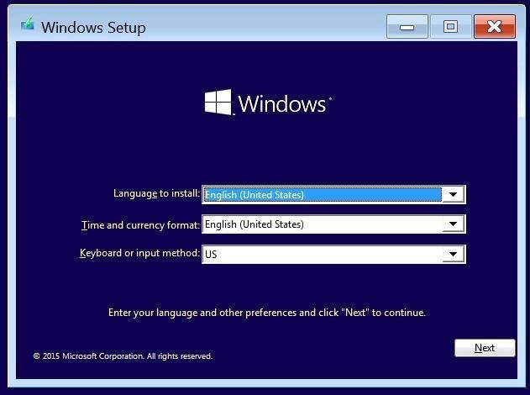
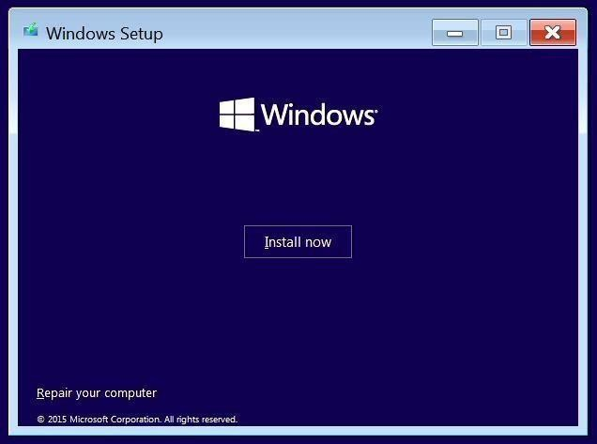

Ex.No:1 Installation of Windows Operating System Date :

Aim: To study the installation of Windows operating system.

Procedure:

Follow the steps below to proceed with the Windows 10 installation.
  - Select the following Language, Time, and Keyboard Layout and select “Next”.

  - Select “Install now” option.

  - Enter the product key to activate Windows and press “Next”, or press “Skip” to enter a valid product key later.

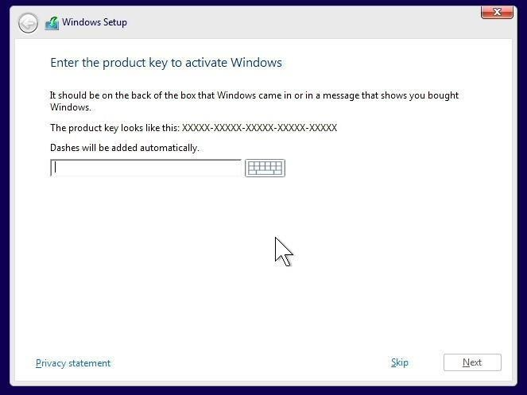
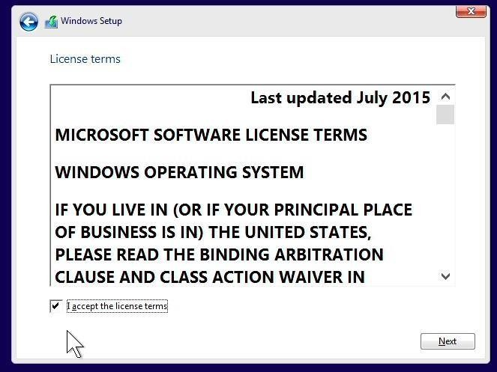
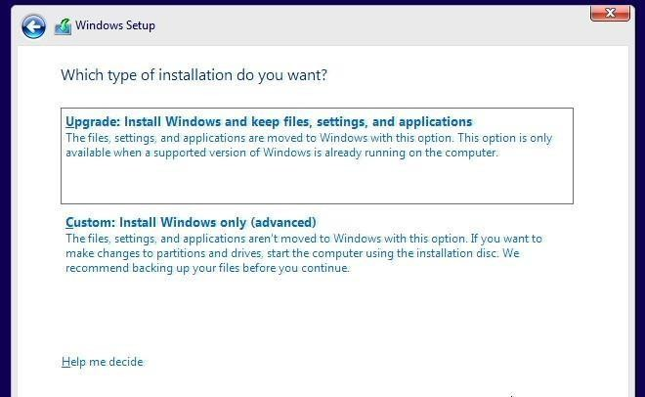

  - Check the box next to “I accept the license terms” and select “Next”.

  - Choose the type of installation to perform.
    - To upgrade to Windows 10 from an earlier version of Windows, select the “Upgrade” option below.
    - To perform a clean OS installation, select “Custom: Install Windows only (advanced)” option below. For instructional purposes, this option was selected below.

  - Select the “Load driver” option to load the appropriate driver for the storage device.


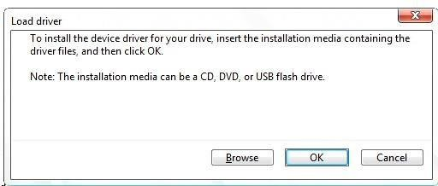
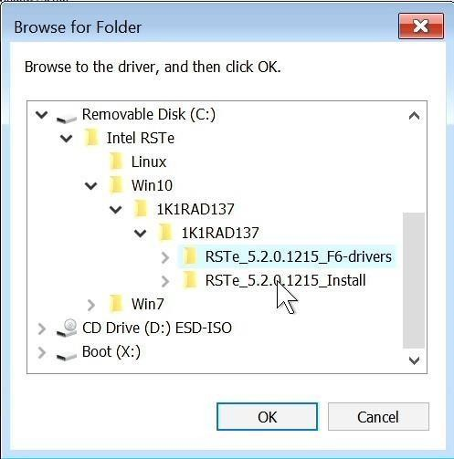

  - Make sure to load the appropriate storage device driver onto a CD, DVD, or USB flash drive before completing the next step.
    - For storages devices attached to the Intel storage controller, load the Intel Rapid Storage Technology enterprise (RSTe) driver.

      - Select “Browse”, and browse to the CD, DVD, or USB flash drive to where the storage device driver is located and select “OK”.

    - For storages devices attached to the Broadcom controller, load the Broadcom storage driver.

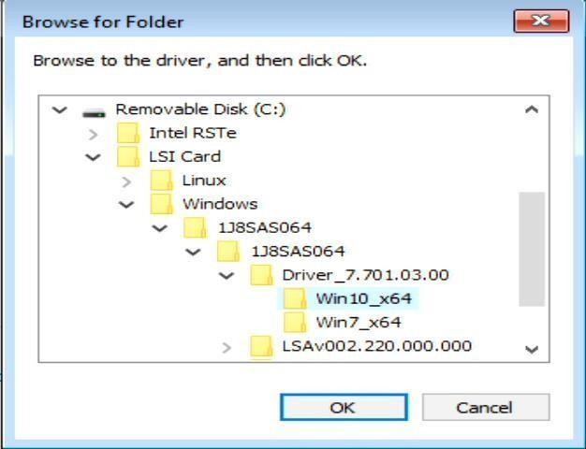
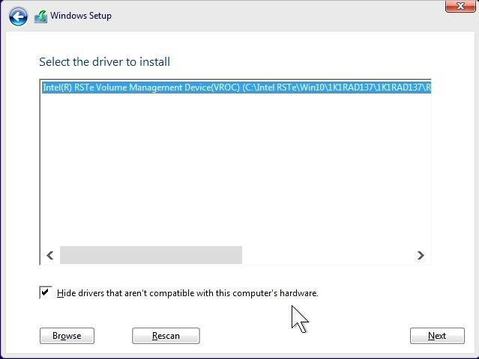
      - Select “Browse”, browse to the CD, DVD, or USB flash drive to where the storage device driver is located and select “OK”.

  - Select the driver to install.

  - Select the drive to install Windows and select “Next” at the bottom.

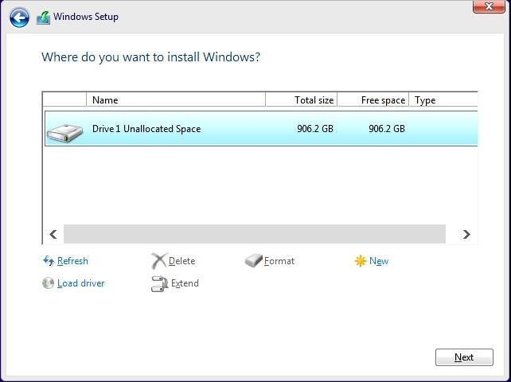
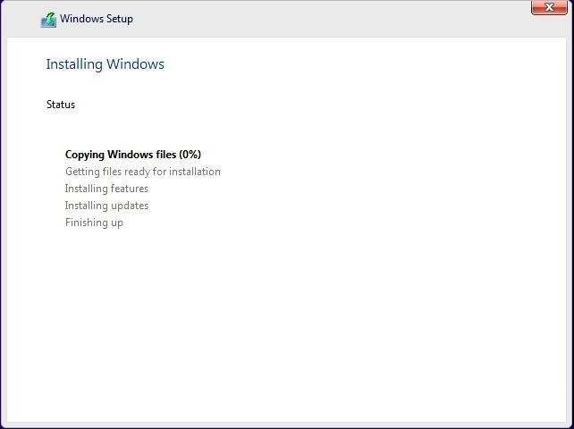
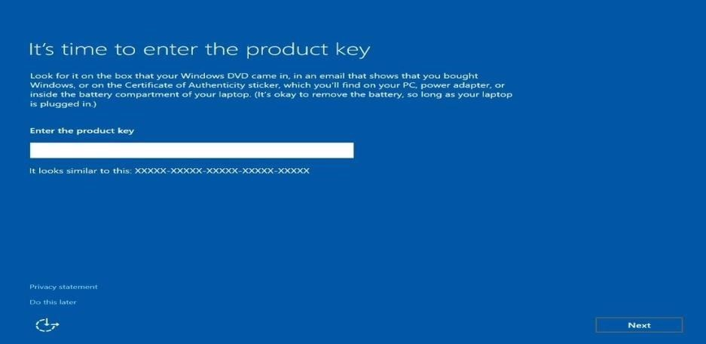

  - Installing Windows screen.

  - After the installation completes, the system will automatically reboot. If no product key

was entered above, then it’ll prompt to enter a product key again. Either enter the product key here and select “Next” or select “Do this later” at the bottom left.

  - Select “Use Express Settings” at the bottom right to use the default settings or select “Customize settings” at the bottom left. For instructional purposes, “Use Express settings” was selected.

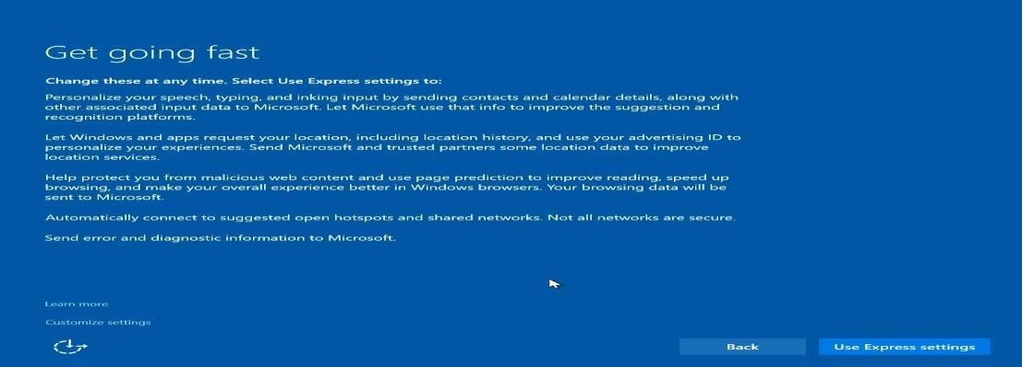
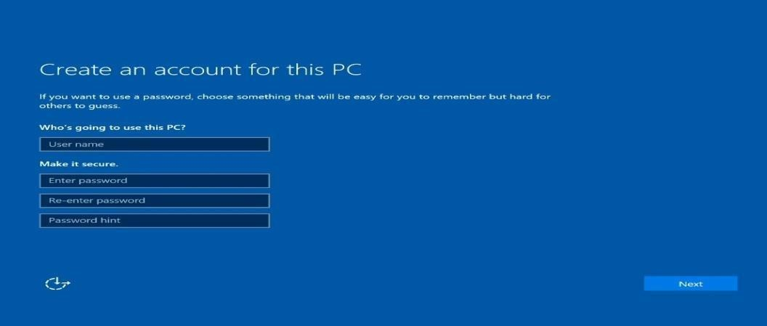


  - Create an account by typing a “User name”. Optionally, type a password to make it secure.

  - Windows 10 desktop screen.

  - At this point, download and install the appropriate device drivers, i.e. Intel Chipset, Intel AMT, Ethernet, Graphics, etc.
  - Restart the system after installation.

Result:
Thus the Windows operating system installation has been studied successfully.

Ex.No:2a Basic Commands in UNIX Date :

Aim:
To study and execute UNIX commands.

UNIX Commands

- Cat Command
It is used to create a file, display the contents of a file and concatenating the
files.
$cat > filename /for create
$cat filename /for display
$cat file1 file2 >file3 /for concatenate

- Date Command
It is used to display the current date, time, month and year.
$date +%d /display date
$date +%m /display month
$date +%h /display month in words
$date +%y /display year
$date +%R /display the time with hour and mins
$date +%T /display time with hour,mins and sec

  - Calendar Command
It is used to display the calendar of the given month and year.
$cal year /display the year calendar
$cal month year /display the calendar of given month

  - Who / who am i Command
It is used to display the data about all the users, who are currently logged into the system.
$who /display all users
$who am I /display about user

  - Man command
It is used to display the description and usage of particular command.

$man command name /display the description of the cmd

  - Head Command
It is used to display the text from top of the file content to mentioned
line.

$head – (option) filename / display text from top

  - Tail command
It is used to display the text from bottom of the file content to
mentioned line.

$tail – (option) filename / display text from bottom

  - Wc Command
It is used to count the number of lines, words and characters in the given
file.

$wc filename /display no of lines, words and characters

  - Copy Command
It is used to copy the content from one file to another file.

$cp source destination /copy content from source to destination.

  - Move Command
It is used to rename the file.

$mv filename1 filename2 /for renaming

  - Compare Command
It is used to compare two sorted files line by line.

$cmp file1 file2 /to compare file1& 2

  - Echo Command
It is used to display whatever message we want to display on the screen.

$echo message /display the given msg

  - Read Command
It is used to get the user input from keyboard.

$read variable name /get input from keyboard

  - Write Command
It is used to send message to any logged in users. It’s a two way communications.

$write username /send msg

  - Link Command
It is used to link the content from one file to another file. It’s same as copy
command
$ln source destination
Or
$link file1 file2 /Link the two files

  - Directory Commands
It is used to making, changing and removing directories.
$mkdir dirname /to create directory

$cd dirname /to change working directory
$rmdir dirname /to remove the directory
$cd .. /to close the working directory

  - List Command
It is used to display list of files in the current working directory.
$ls –(option)
Options a- List all directory
entries l- List files in long format. r- List files in reverse
order t- List files in recently used order
s- List no of blocks(memory) used by the file

  - Remove Command
It is used to remove files from a directory.
$rm filename
Or
$rm –(option) filename /remove the file

Options

i- Ask user whether he wants to delete the file or not r- Delete entries / entire content of the file recursively f- Forcing to delete

  - Pwd Command
It is used to display current working directory.

$pwd /display current directory

  - Print Command
It is used to print the content of file.

$lp filename /print the file

  - Sort Command
It is used to sort the content in the file.

$sort filename /sort the content

  - Tty Command
It is used to know the terminal name that we are using.

$tty /display the terminal name

  - Bc Command
It is used as an online calculator.

$bc /open an online calculator

  - Message Command

It is used to avoid message from other users.

$mesg /to avoid the msg

  - Mail Command
It is used as a simple email utility available on UNIX system

$mail username /sends mail

  - Wall Command
It is used to send message to all users, those who are currently logged in.

$wall message /send msg to all users

  - News Command
It is used to permit users to read messages published by the system administrator.

$news /allow to read admin msg.

  - Grep Command (Global Regular Expression and Print)
It is used to search and print specified patterns from a file.

$grep text filename /search and print given text from file

  - Cut Command
It is used to select specified field from a line of text.

$cut –c(option) filename /cut a text

  - Paste Command
It is used to paste back the cut characters.

$paste filename /paste back the text

  - Common Command
It is used to compare two sorted files and compares each line of the first file with its corresponding line in the second file.

$comm file1 file2 /to compare the files

  - Difference Command
It is used to display file differences.

$diff file1 file2 /find the difference from the two identical files

  - Finger Command
It is used to gather and display the information about users, which includes login name, realname, home directory etc...

$finger username /display user details.

  - Password Command
It is used to change the password.

$passwd /to change password

  - Nl Command
It is used to add line number to file content.

$nl filename /add no to the file content

  - Which Command
It is used to report the path to the command or the shell alias in use

$which /to display the path

- Clear Command
It is used to clear the screen.

$tput clear /to clear the screen

- Reply Command
It is used to send reply to the specified user.

$reply username /to send reply

- More Command
It is used to scroll your screen when your file content is too large.

$more filename /to scroll the screen

- Compress Command
It is used to compress the file and save it as file.z.

$compress filename /to compress

Output:
FILE COMMANDS

- Cat Command

[examuser1@linux ~]$ cat > file1 hi Welcome
This is my first unix file Thank You

[examuser1@linux ~]$ cat >file2 This is my second File
Thank You

[examuser1@linux ~]$ cat file1 hi
Welcome
This is my first unix file Thank You

[examuser1@linux ~]$ cat file2 This is my second File
Thank You
[examuser1@linux ~]$ cat file1 file2 > file3 [examuser1@linux ~]$ cat file3
hi Welcome
This is my first unix file Thank You
This is my second File Thank You

- Copy Command [examuser1@linux ~]$ cp file1 file4
[examuser1@linux ~]$ cat file4 hi
Welcome
This is my first unix file Thank You
- Move Command [examuser1@linux ~]$ mv file4 file5 [examuser1@linux ~]$ cat file5
hi Welcome
This is my first unix file Thank You

- Remove Command

[examuser1@linux ~]$ rm file5 [examuser1@linux ~]$ cat file5 cat: file5: No such file or directory
- WC Command [examuser1@linux ~]$ wc file3
6 17 81 file3

WORKING WITH DIRECTORIES

- Creating A Directory [examuser1@linux ~]$ mkdir unix
- Changing the working Directory [examuser1@linux ~]$ cd unix
- Current working Directory

[exam1@redhat unix]$ pwd
/home/exam1/unix [exam1@redhat unix]$ cd ..
- The Path

[examuser1@linux ~]$ echo $HOME
/home/exam1

- Moving files within directories [examuser1@linux ~]$ mv file4 unix
mv: cannot stat `file4': No such file or directory

[examuser1@linux ~]$ cat > file6 hello unix
world

[examuser1@linux ~]$ mv file6 unix [examuser1@linux ~]$ cd unix
[exam1@redhat unix]$ cat file6 hello unix
world

- Removing Directory

[examuser1@linux ~]$ cd unix [exam1@redhat unix]$ rm file6 [exam1@redhat unix]$ cd .. [examuser1@linux ~]$ rmdir unix

CALENDAR AND DATE COMMANDS

- Calendar command - Year [examuser1@linux ~]$ cal 2010 2010
January February March

Su Mo Tu We Th Fr Sa Su Mo Tu We Th Fr Sa Su Mo Tu We Th Fr Sa
1 |  |  | 2 | 1 | 2 3 4 5 6 |  |  |  | 1 2 3 | 4 | 5 6
3 4 5 6 7 8 |  |  | 9 | 7 8 | 9 10 11 12 13 |  |  |  | 7 8 9 10 | 11 | 12 13
10 11 12 13 | 14 | 15 16 |  | 14 15 | 16 | 17 18 | 19 | 20 | 14 15 16 17 | 18 | 19 20
17 18 19 20 | 21 | 22 23 |  | 21 22 | 23 | 24 25 | 26 | 27 | 21 22 23 24 | 25 | 26 27
24 25 26 27 | 28 | 29 30 |  |  |  |  |  |  | 28 29 30 31
31

April |  |  |  | May |  |  |  |  | June
Su Mo Tu We Th Fr Sa |  |  |  | Su Mo Tu We Th Fr Sa |  |  |  |  | Su Mo Tu We Th Fr Sa
 |  |  | 1 2 3 |  |  | 1 |  |  | 1 |  | 2 3 4 |  | 5
4 | 5 | 6 | 7 8 9 10 | 2 3 |  | 4 5 6 7 8 |  |  | 6 7 8 |  | 9 10 11 |  | 12
11 | 12 | 13 | 14 15 16 17 | 9 10 |  | 11 12 13 14 15 |  |  | 13 14 15 |  | 16 17 18 |  | 19
18 | 19 | 20 | 21 22 23 24 | 16 17 |  | 18 19 20 21 22 |  |  | 20 21 22 |  | 23 24 25 |  | 26
25 | 26 | 27 | 28 29 30 | 23 24 |  | 25 26 27 28 29 |  |  | 27 28 29 |  | 30
 |  |  |  | 30 31
July |  |  |  | August |  |  |  |  | September
Su Mo Tu We Th Fr Sa |  |  |  | Su Mo Tu We Th Fr Sa |  |  |  |  | Su Mo Tu We Th Fr Sa
1 2 3 |  |  |  | 1 2 3 4 5 6 7 |  |  |  |  | 1 2 3 4
4 | 5 | 6 | 7 8 9 10 | 8 | 9 10 11 12 13 14 |  |  |  | 5 | 6 7 | 8 9 | 10 11
11 | 12 | 13 | 14 15 16 17 | 15 | 16 17 18 19 20 21 |  |  |  | 12 | 13 14 | 15 16 | 17 18
18 | 19 | 20 | 21 22 23 24 | 22 | 23 24 25 |  | 26 | 27 28 | 19 | 20 21 | 22 23 24 25
25 | 26 | 27 | 28 29 30 31 | 29 | 30 31 |  |  |  | 26 | 27 28 | 29 30

October |  |  | November |  | December
Su Mo Tu We Th Fr Sa |  |  | Su Mo Tu We Th Fr Sa |  | Su Mo Tu We Th Fr Sa
1 2 |  |  | 1 2 3 4 5 6 |  | 1 2 3 | 4
3 4 5 | 6 7 | 8 9 | 7 | 8 9 10 11 12 13 | 5 6 7 8 9 10 11
10 11 12 | 13 14 | 15 16 | 14 | 15 16 17 18 19 20 | 12 13 14 15 16 17 18
17 18 19 | 20 21 | 22 23 | 21 | 22 23 24 25 26 27 | 19 20 21 22 23 24 25
24 25 26 27 28 29 30 |  |  | 28 | 29 30 | 26 27 28 29 30 31 31

- Calendar command – Month of the Year [examuser1@linux ~]$ cal 5 2012
May 2012
Su | Mo Tu | We | Th Fr | Sa
 | 1 | 2 | 3 4 | 5
6 | 7 8 | 9 | 10 11 | 12
13 | 14 15 | 16 | 17 18 | 19
20 | 21 22 | 23 | 24 25 | 26
27 | 28 29 | 30 | 31

- Date Commands

[examuser1@linux ~]$ date Tue Jan 1 00:26:15 IST 2002
[examuser1@linux ~]$ date +%d 01
[examuser1@linux ~]$ date +%m 01
[examuser1@linux ~]$ date +%h Jan
[examuser1@linux ~]$ date +%y 02
[examuser1@linux ~]$ date +%R 00:26
[examuser1@linux ~]$ date +%T 00:27:03
PIPES
- Pipes in who command [examuser1@linux ~]$ who | wc -l
1
- Longway pipeline [examuser1@linux ~]$ ls | sort | wc -l
5
- Capturing output while using pipes : tee [examuser1@linux ~]$ cat file3|wc|tee file4
6 17 81

[examuser1@linux ~]$ cat file4
6 17 81

OTHER BASIC COMMANDS

- Who

[examuser1@linux ~]$ who
exam1 pts/1 Jan 1 00:02 (10.0.5.18)
- who am i Command [examuser1@linux ~]$ who am I
exam1 pts/1 Jan 1 00:02 (10.0.5.18)

- Man command

[examuser1@linux ~]$ man cat man cat
CAT(1) FSF CAT(1) NAME
cat - concatenate files and print on the standard output

SYNOPSIS
cat [OPTION] [FILE]...

DESCRIPTION
Concatenate FILE(s), or standard input, to standard output.

-A, --show-all
equivalent to -vET

-b, --number-nonblank number nonblank output lines

-e equivalent to -vE

-E, --show-ends
display $ at end of each line

-n, --number
number all output lines

- List Command

[examuser1@linux ~]$ ls -t
postfix.l file7 file4 file3 file2 file1 new
- Print Command [examuser1@linux ~]$ lp file3 lp:
error - scheduler not responding!

- Sort Command

[examuser1@linux ~]$ sort file3 hi
Thank You Thank You
This is my first unix file This is my second File Welcome

- Password Command

[examuser1@linux ~]$ passwd Changing password for user exam1. Changing password for exam1 (current) UNIX password:
You must wait longer to change your password passwd: Authentication token manipulation error
- Which Command [examuser1@linux ~]$ which
Usage: /usr/bin/which [options] [--] programname [...]
Options: --version, -[vV] Print version and exit successfully.
--help, Print this help and exit successfully.
--skip-dot Skip directories in PATH that start with a dot.
--skip-tilde Skip directories in PATH that start with a tilde.
--show-dot Don't expand a dot to current directory in output.
--show-tilde Output a tilde for HOME directory for non-root.
--tty-only Stop processing options on the right if not on tty.
--all, -a Print all matches in PATH, not just the first --read-alias,
-i Read list of aliases from stdin.
--skip-alias Ignore option --read-alias; don't read stdin.
--read-functions Read shell functions from stdin.
--skip-functions Ignore option --read-functions; don't read stdin.

Result:
Thus the basic UNIX commands have been studied and executed.

Ex: No: 2b Shell Programming Date :

- Biggest of Three Numbers

Aim:
To write a shell program for finding the biggest among 3 numbers

Algorithm:
  - Get the 3 values
  - Check if ‘a’ is greater than ‘b’
  - If step 2 is true, go to step 4. else, go to step 7
  - Check if ‘a’ is bigger than ‘c’
  - If step 4 is true, print “a is big”. else print “c is big”
  - Go to step 9
  - Check if ‘b’ is greater than ‘c’
  - If step 7 is true, print “b is big”. Else, print “c is big”
  - End of program

Program:

echo "enter a" read a echo "enter b" read b echo "enter c" read c if [
$a -gt $b -a $a -gt $c ] then echo "a is big" elif [
$b -gt $c ] then echo "b is big"
else echo "c is big" fi

Output:
[examuser1@linux ~]$ sh biggest.sh enter a
5 enter
b 4 enter c 2 a is big Result:

Result:
Thus the shell program for finding the biggest among 3 numbers, has been written and executed successfully.

Checking Odd or Even Aim:
To write a shell program to find the given number is odd or even Algorithm:
  - Get a number from the user, say num.
  - check if (num % 2) = = 0
    - Display the given number is even otherwise
    - Display the given number is odd
  - Stop the program

Program:

echo "enter any number" read num
if [ `expr $num % 2` -eq 0 ] then echo number is even else
echo number is odd fi

Output:
[examuser1@linux ~]$ sh oddeven.sh enter any number
5
number is odd
[examuser1@linux ~]$ sh oddeven.sh enter any number
4
number is even

Result:
Thus the shell program for finding whether the given number is odd or even has been
written and executed successfully.

Finding Factorial Aim:
To write a shell program to find factorial of given number.

Algorithm:
  - Read a number say n.
  - Initialize i=1,f=1
  - Repeat until I is leass than n. 3.1.f=f*i
- 2.i=i+1
- Display factorial (f) of n
- Stop

Program:

echo "enter number" read n
i=1 f=1
while [ $i -le $n ] do f=`expr $f \*
$i` i=`expr $i + 1` done
echo "Factorial is.. $f"

Output:
[examuser1@linux ~]$ sh fact.sh enter number
5
Factorial is.. 120

Result:
Thus the shell program to find factorial of given number has been written and executed successfully.

Arithmetic Operations Aim:
To write a shell program for implementing arithmetic operations.

Algorithm:
  - Display menu to user.
Say, 1.Add 2. Sub 3. Mul 4. Div 5.exit
  - Prompt user to enter 2 values (say a, b) and enter choice of operation.
  - Using switch case statement, use choice value for processing output accordingly.
  - If choice=1, return sum (a+b)
  - If choice=2, return difference (a-b)
  - If choice=3, return product (a*b)
  - If choice=4, return quotient (a/b) 4Display result.
.

Program:

echo "Enter two numbers" read a b
echo "1.Add 2.Sub 3.Mul 4.Div 5.Exit" read op case $op in 1)c=`expr $a +
$b`;;
- c=`expr $a - $b`;;
- c=`expr $a \* $b`;;
- c=`expr $a / $b`;; 5)exit
esac echo
$c

Output:

[examuser1@linux ~]$ sh case.sh Enter two numbers
5 4
1.Add 2.Sub 3.Mul 4.Div 5.Exit 1
9
[examuser1@linux ~]$ sh case.sh Enter two numbers
5 4
1.Add 2.Sub 3.Mul 4.Div 5.Exit 2
1
[examuser1@linux ~]$ sh case.sh Enter two numbers
5 4

1.Add 2.Sub 3.Mul 4.Div 5.Exit 3
20
[examuser1@linux ~]$ sh case.sh Enter two numbers
8 4
1.Add 2.Sub 3.Mul 4.Div 5.Exit 4
2

Result:
Thus the shell program for implementing arithmetic operations has been written and
executed successfully.

EX. NO. 3a Implementation of Process Management using fork and getpid system calls Date :

Aim:

call.

To create a new child process using fork system call and implement getpid system

Algorithm
  - Declare a variable x to be shared by both child and parent.
  - Create a child process using fork system call.
  - If return value is -1 then
    - Print "Process creation unsuccessfull"
    - Terminate using exit system call.
  - If return value is 0 then
    - Print "Child process"
    - Print process id of the child using getpid system call
    - Print value of x
    - Print process id of the parent using getppid system call
  - Otherwise
    - Print "Parent process"
    - Print process id of the parent using getpid system call
    - Print value of x
    - Print process id of the shell using getppid system call.
  - Stop

Program:
#include<stdio.h> #include<stdlib.h> #include<unistd.h> #include<sys/types.h
> main() { pid_t pid; int x=5; pid=fork(); x++; if(pid<0) {
printf("process creation error"); exit(-1); }
else if(pid==0)
{
printf("child process:");
printf("\n process id is %d",getpid()); printf("\n value of x is %d",x);
printf("\n process id of parent is%d\n",getppid());
} else { printf("\n .

Output:

[examuser1@linux ~]$ cc fork.c [examuser1@linux ~]$ ./a.out child process:

process id is 7353 value of x is 6
process id of parent is7352 parent process:
process id is 7352 value of x is 6
process id of shell is 7122

Result
Thus a child process is created with copy of its parent's address space.

EX. NO. 3b Implementation of Process Management using wait system call Date :

Aim:
To block a parent process until child completes using wait system call.

Algorithm:
- Create a child process using fork system call.
- If return value is -1 then
  - Print "Process creation unsuccessfull" 3. Terminate using exit system call.
  - If return value is > 0 then
- Suspend parent process until child completes using wait system
call
- Print "Parent starts"
- Print even numbers from 0–10
- Print "Parent ends"
  - If return value is 0 then
- Print "Child starts"
- Print odd numbers from 0–10
- Print "Child ends" 6. Stop

Program: #include<stdio.h> #include<stdlib.h> #include<unistd.h> #include<sys/types.h
>
#include<sys/wait.h> main() { int i,status; pid_t pid; pid=fork(); if(pid<0) {
printf("\n process creation failure\n"); exit(-1); }
else if(pid>0)
{
wait(NULL);
printf("\n parent starts \n even nos:"); for(i=2;i<=10;i+=2)
printf("%3d",i);
printf("\n parent ends\n");
}
else if(pid==0)

{
printf("child starts \n odd nos:"); for(i=1;i<10;i+=2) printf("%3d",i); printf("\n child ends\n");
}
}

Output:
[examuser1@linux ~]$ cc wait.c [examuser1@linux ~]$ ./a.out

child starts odd nos: 1 3 5 7 9 child ends

parent starts even nos: 2 4 6 8 10 parent ends

Result
Thus using wait system call zombie child processes were avoided.

EX. NO. 3c Implementation of Process Management using exec system call Date :

Aim:
To load an executable program in a child processes exec system call.

Algorithm:
- If no. of command line arguments ◻ 3 then stop.
- Create a child process using fork system call.
- If return value is -1 then
  - Print "Process creation unsuccessfull"
  - Terminate using exit system call.
- If return value is > 0 then
  - Suspend parent process until child completes using wait system call
  - Print "Child Terminated".
  - Terminate the parent process.
- If return value is 0 then
  - Print "Child starts"
  - Load the program in the given path into child process using exec system call.
  - If return value of exec is negative then print the exception and stop.
  - Terminate the child process. 6. Stop Program:
#include<stdio.h> #include<sys/types.h> #include<unistd.h> #include<stdlib.h> main(int argc,char *argv[])
{ pid_t pid; int i; if(argc!=3)
{ printf("\n insufficient arguments load program"); printf("\n usage:./a.out <path>
<cmd> \n"); exit(-1); } switch(pid=fork())
{ case -1:
printf("fork failed"); exit(-1); case 0:
printf("child process\n"); i=execl(argv[1],argv[2],0); if(i<0)
{
printf("%s program not loaded using exec system call \n",argv[2]); exit(-1);
}
default:

wait(NULL);
printf("child terminated \n"); exit(0);
}
}

Output:

[examuser1@linux ~]$ cc exec.c [examuser1@linux ~]$ ./a.out /usr/bin/who who child process
root :0 Jan 11 22:51 exam1 pts/1
Jan 11 22:58 (10.0.5.25) exam43 pts/4 Jan
11 23:16 (10.0.5.134) exam40 pts/5 Jan
11 23:16 (10.0.5.136) exam31 pts/6 Jan
11 23:18 (10.0.5.138) exam42 pts/7 Jan
11 23:20 (10.0.5.135) exam39 pts/8 Jan
11 23:21 (10.0.5.137) exam34 pts/3 Jan
12 00:02 (10.0.5.146) exam35 pts/9 Jan
12 00:20 (10.0.5.148) exam33 pts/10 Jan
12 00:26 (10.0.5.151) exam38 pts/11 Jan
12 00:32 (10.0.5.156) exam28 pts/12 Jan
12 00:42 (10.0.5.157) exam24 pts/2 Jan
12 00:42 (10.0.5.158) exam36 pts/0 Jan
12 00:45 (10.0.5.149) exam32 pts/13 Jan
12 00:49 (10.0.5.152) child terminated

Result
Thus the child process loads a binary executable file into its address space.

EX. NO. 3d. Implementation of Process Management using system calls: open, read, write, close, exit
Date :

Aim:
To implement UNIX I/O system calls open ,read , write,close and exit.

Algorithm:
- Declare a character buffer buf to store 100 bytes.
- Get the new filename as command line argument.
- Create a file with the given name using open system call with O_CREAT and O_TRUNC options.
- Check the file descriptor.
  - If file creation is unsuccessful, then stop.
- Get input from the console until user types Ctrl+D
  - Read 100 bytes (max.) from console and store onto buf using read system call
  - Write length of buf onto file using write system call.
- Close the file using close system call.

- Stop

Program:
#include <stdlib.h> #include <string.h> #include <fcntl.h> main(int argc, char *argv[])
{ int fd, n, len; char buf[100]; if (argc != 2)
{
printf("Usage: ./a.out <filename>\n"); exit(- 1);
}
fd = open(argv[1], O_WRONLY|O_CREAT|O_TRUNC, 0644); if(fd < 0) { printf("File creation problem\n");
exit(-1); }
printf("\n The execution of creat & write system calls:\n"); printf("Press Ctrl+D at end in a new line:\n");

while((n = read(0, buf, sizeof(buf))) > 0)
{
len = strlen(buf); write(fd, buf, len);
}
close(fd);

printf("\nFile has been created and contents are written in the file\n");

fd = open(argv[1], O_RDONLY); if(fd
== -1)
{
printf("%s file does not exist\n", argv[1]); exit(- 1); } printf("\nExecution of read system call:\n"); printf("\nOpening the file %s to read\n",argv[1]); printf("Contents of the file %s is : \n", argv[1]); while(read(fd, buf, sizeof(buf))
> 0) printf("%s", buf); close(fd);
}

Output:
[examuser1@linux ~]$ cc orw.c [examuser1@linux ~]$ ./a.out os.txt

The execution of creat & write system calls:
Press Ctrl+D at end in a new line:

System calls provide interface between a process and the operating system. File has been created and contents are written in the file
Execution of read system call:

Opening the file os.txt to read Contents of the file os.txt is :

System calls provide interface between a process and the operating system.

Result:
Thus the program for implementing system calls open,read, write,close and exit have been executed successfully.

Ex.No.: 4 Implementation of various CPU Scheduling Algorithms

Ex.No.4a FIRST COME FIRST SERVE SCHEDULING
Date :

Aim:

To write a program in C to implement the FCFS Gantt Chart

Algorithm:

- Start the program.
- Get the number of process to be executed
- Get the process name and its burst time.
- Calculate the waiting time and turn around time for each process
- Draw the Gantt chart using the graphics mode.
- Stop the program.

Program:
#include<stdio.h> struct process
{
int btime,wtime,ttime;
}p[50];
main() { int n,i,j,h,c;
float tot_turn=0.0,tot_wait=0.0,avg_turn=0.0,avg_wait=0.0; printf("\n\n\t\t\t\tFIRST COME FIRST SERVE SCHEDULING\n\n");
printf("\t\t\t\t*********************************\n"); printf("Enter the number of process=");
scanf("%d",&n); printf("\n"); for(i=1;i<=n;i++)
{
printf("Enter the burst time %d:",i); scanf("%d",&p[i].btime);
} i=1; p[i].wtime=0;
p[i].ttime=p[i].btime; tot_wait=p[i].wtime; tot_turn=p[i].ttime; for(i=2;i<=n;i++)
{
p[i].wtime=p[i-1].wtime+p[i-1].btime;
p[i].ttime=p[i].wtime+p[i].btime; tot_wait=tot_wait+p[i].wtime; tot_turn=tot_turn+p[i].ttime;
}
avg_wait=tot_wait/n;

avg_turn=tot_turn/n;
printf("\nProcess No \tBurst Time \tWaiting Time \tTurn Around Time"); for(i=1;i<=n;i++)
{
printf("\n%d\t\t%d\t\t%d\t\t%d",i,p[i].btime,p[i].wtime,p[i].ttime);
}
printf("\n\nAverage Waiting Time=%f",avg_wait); printf("\nAverage Turn Around Time=%f",avg_turn); printf("\n"); printf("\n\t\t\t\tGANTT CHART"); printf("\n\t\t\t\t***********\n\n"); for(i=1;i<=n;i++)
{ printf("%d",p[i].wtime); for(j=1;j<=p[i].btime;j++) printf("_"); } for(i=1;i<=n;i++)
{
c=p[i].wtime+p[i].btime;
} printf("%d",c);
printf("\n\n"); return 0;
}

Output:

[examuser1@linux ~]$ cc FCFS_Gantt.c [examuser1@linux ~]$ ./a.out

FIRST COME FIRST SERVE SCHEDULING
********************************* Enter the number of process=5
Enter the burst time 1:10 Enter the burst time 2:5 Enter the burst time 3:2 Enter the burst time 4:3 Enter the burst time 5:5

Process No Burst Time Waiting Time Turn Around Time
1 | 10 | 0 | 10
2 | 5 | 10 | 15
3 | 2 | 15 | 17
4 | 3 | 17 | 20
5 | 5 | 20 | 25

Average Waiting Time=12.400000 Average Turn Around Time=17.400000

GANTT CHART
***********
0 10 15 17 20 25

Result:
Thus the program to implement FCFS scheduling algorithm has been written and executed successfully.

Ex.No.4b Shortest Job First Scheduling Date :

Aim:

To write a program in C to implement the SJF scheduling algorithm.

Algorithm:

- Start the process.
- Declare the array size.
- Get the number of elements to be inserted.
- Select the process which has shortest burst time will execute first.
- If two processes have same burst length then FCFS scheduling algorithm used.
- Make the average waiting length of next process.
- Start with the first process from its selection as above and let the other process in queue.
- Calculate the total number of burst time
- Display the values.
- Terminate the process.

Program:

#include<stdio.h> main() {
int i,j,n,t,d,h,tot=0,tt=0,p[20],c[20],a[20]; printf("\n\t\t\t\tSHORTEST JOB FIRST SCHEDULING\n"); printf("\t\t\t\t*****************************\n\n"); printf("Enter the number of process:"); scanf("%d",&n); printf("\nEnter the %d process\n",n);
for(i=0;i<n;i++) scanf("%d",&p[i]);
for(i=0;i<n-1;i++) for(j=i+1;j<n;j++) if(p[i]>p[j])
{ t=p[i];
p[i]=p[j];
p[j]=t; }
printf("\nSorted Process\n"); for(i=0;i<n;i++) printf("%d\n",p[i]); c[0]=0; for(i=0;i<n-1;i++) c[i+1]=c[i]+p[i];

for(i=0;i<n;i++) a[i]=c[i]+p[i];
printf("\nP.No \tProcess \tWaiting Time \tTurn Around Time"); for(i=0;i<n;i++)
{
printf("\n%d\t%d\t\t%d\t\t%d",i+1,p[i],c[i],a[i]); tot=tot+c[i]; tt=tt+a[i]; } printf("\n\nAverage Waiting Time %f",((float)tot/n)); printf("\nAverage Turn Around Time %f",((float)tt/n)); printf("\n");
printf("\n\n\t\t\t\t\tGANTT CHART"); printf("\n\n\t\t\t\t\t***********"); printf("\n\n\t\t\t\t"); for(i=0;i<n;i++)
{
printf("%d",c[i]);
for(j=1;j<p[i];j++)
printf("_"); } for(i=1;i<n;i++)
{ d=c[i]+p[i];
}
printf("%d",d);
printf("\n\n"); return 0;
}

Output:

[examuser1@linux ~]$ cc Gntt_SJF.c [examuser1@linux ~]$ ./a.out

SHORTEST JOB FIRST SCHEDULING
***************************** Enter the number of process:5
Enter the 5 process 10
5
3
1
8
Sorted Process 1
3
5
8
10

P.No | Process | Waiting Time | Turn Around Time
1 | 1 | 0 1

2 | 3 | 1 |  | 4
3 | 5 |  | 4 |  | 9
4 | 8 |  | 9 |  | 17
5 | 10 |  | 17 |  | 27
Average Waiting Time 6.200000 Average Turn Around Time 11.600000

GANTT CHART
***********
01 4 9 17 27

Result:
Thus the program to implement shortest job first scheduling algorithm has been written and executed successfully.

Ex.No.4c Priority Scheduling Date :

Aim:

To write a program in C to implement the priority scheduling algorithm.

Algorithm:

- Start the program.
- Initialize the variables in structure.
- Get the number of process, priority and burst time from the user.
- Start the process execution according to the priority.
- The total execution time is calculated by adding the burst time.
- Calculate the average waiting time and turnaround time using total execution and waiting time
- Terminate the program.

Program:
#include<stdio.h> main() { int n,b[10],w[10],i,j,h,t,tt,d; int stime[10],a[10],p[10]; float avg=0;
printf("\n\t\t\t\tPRIORITY SCHEDULING ALGORITHM"); printf("\n\t\t\t\t*****************************\n"); printf("Enter how many jobs:");
scanf("%d",&n);
printf("\nEnter burst time & priority for corresponding job\n\n"); for(i=1;i<=n;i++)
{ printf("Process
%d:",i);
scanf("%d %d",&b[i],&p[i]); a[i]=i; }
for(i=1;i<=n;i++) for(j=i;j<=n;j++) if(p[i]>p[j])
{ t=b[i];
tt=a[i]; b[i]=b[j];
a[i]=a[j]; b[j]=t;
a[j]=tt; }
w[1]=0;
printf("\nProcess %d Waiting Time:0",a[1]); for(i=2;i<=n;i++)
{
w[i]=b[i-1]+w[i-1];
printf("\nProcess %d waiting time:%d",a[i],w[i]); avg+=w[i]; } printf("\nTotal Waiting Time:%f",avg); printf("\nAverage Waiting

Time=%f\n",avg/n); printf("\nGANTT CHART"); printf("\n***********\n\n"); for(i=1;i<=n;i++) { printf("%d ",b[i]); }
printf("\n\n"); for(i=1;i<=n;i++) {
printf("%d",w[i]); for(j=1;j<=b[i];j++)
printf("_"); } for(i=1;i<=n;i++) { d=w[i]+b[i];
} printf("%d",d); return 0;
}

Output:
[examuser1@linux ~]$ cc pri_gantt.c [examuser1@linux ~]$ ./a.out

PRIORITY SCHEDULING ALGORITHM
***************************** Enter how many jobs:5
Enter burst time & priority for corresponding job Process 1:10 3
Process 2:1 1
Process 3:2 3
Process 4:1 4
Process 5:5 2

Process 5 Waiting Time:0 Process 1 waiting time:5 Process 2 waiting time:15 Process 3 waiting time:16 Process 4 waiting time:18

Total Waiting Time:54.000000 Average Waiting Time=10.800000

GANTT CHART
*********** 5 10 1 2 1
0 5 15_16 18_19

Result:
Thus the program to implement priority scheduling algorithm has been written and executed successfully.

Ex.4d Round Robin Scheduling Date :

Aim:
To write a program to implement the Round Robin CPU scheduling Algorithm

Algorithm:
- Start the program
- Get the number of processors
- Get the Burst time(BT) of each processors
- Get the Quantum time(QT) or time slice.
- Execute each processor until reach the QT or BT
- Time of reaching processor’s BT is it’s Turn Around Time(TAT)
- Time waits to start the execution, is the waiting time(WT) of each processor
- Calculation of Turn Around Time and Waiting Time 8.1.tot_TAT = tot_TAT + cur_TAT 8.2.avg_TAT = tot_TAT/num_of_proc
8.3.tot_WT = tot_WT + cur_WT
- 4.avg_WT = tot_WT/num_of_proc
- Display the result
- STOP the program

Program:
#include<stdio.h>
int n,b[10],z[10],q,i,j,r,m[50],e=0,avg=0; float f; main() { printf("\n\n\t\t\t\t\tROUND ROBIN\n\n");
printf("\t\t\t\t\t*****************\n"); printf("Enter how many jobs:");
scanf("%d",&n);
printf("\nEnter burst time for corresponding job..\n"); printf("\n"); for(i=1;i<=n;i++)
{
printf("Process %d:",i); scanf("%d",&b[i]); z[i]=b[i]; }
printf("\nEnter the time slice value:"); scanf("%d",&q);
rr();//no return type with no argument function average(); return 0; } rr() { int max=0; max=b[1]; for(j=1;j<=n;j++) if(max<=b[j]) max=b[j];
if((max%q)==0) r=(max/q); else r=(max/q)+1; for(i=1;i<=r;i++) {

printf("\n\nRound %d",i); for(j=1;j<=n;j++) { if(b[j]>0) { b[j]=b[j]-q;
if(b[j]<=0) { b[j]=0;

printf("\nProcess %d is completed",j);
} else
{
printf("\nProcess %d remaining time is %d",j,b[j]);
}
}
} } return 0; } average() { for(i=1;i<=n;i++)
{ e=0;
for(j=1;j<=r;j++)
{ if(z[i]!=0) {
if(z[i]>=q) {
m[i+e]=q; z[i]-
=q; } else { m[i+e]=z[i];
z[i]=0; } } else m[i+e]=0; e=e+n;
} } for(i=2;i<=n;i++) for(j=1;j<=i-1;j++) avg=avg+m[j]; for(i=n+1;i<=r*n;i++)
{ if(m[i]!=0) { for(j=i-
(n-1);j<=i-1;j++)
avg=m[j]+avg;
} } f=avg/n; printf("\n\nTotal Waiting:%d",avg); printf("\n\nAverage Waiting Time:%f\n",f); printf("\n\t\t\t\tGANTT CHART"); printf("\n\t\t\t\t***********\n\n"); for(i=1;i<=r*n;i++) { if(m[i]!=0) { if(i%n==0) { printf("P%d",(i%n)+(n));
} else { printf("P%d",(i%n)); for(j=1;j<=m[i];j++) printf("_",h);
}
} }
printf("\n\n\n"); return 0; }

Output:

[examuser1@linux ~]$ cc rr_gantt.c [examuser1@linux ~]$ ./a.out

ROUND ROBIN
***********
Enter how many jobs:5
Enter burst time for corresponding job.. Process 1:3
Process 2:5
Process 3:2
Process 4:5
Process 5:5

Enter the time slice value:2

Round 1
Process 1 remaining time is 1
Process 2 remaining time is 3 Process 3 is completed Process 4 remaining time is 3
Process 5 remaining time is 3

Round 2
Process 1 is completed Process 2 remaining time is 1
Process 4 remaining time is 1
Process 5 remaining time is 1

Round 3
Process 2 is completed Process 4 is completed Process 5 is completed

Total Waiting:54
Average Waiting Time:10.000000 GANTT CHART
***********
P1 P2 P3 P4 P5P1_P2 P4 P5P2_P4_P5

Result:
Thus the program to implement round robin scheduling algorithm has been written and executed successfully.

Ex: No: 5 Illustration of Interprocess Communication using Shared Memory Date :

Aim:
To write a C program to implement inter process communication using shared memory .
Algorithm:
- Start the Program
- Obtain the required process id 3. Increment the *ptr=*ptr+1;
- Print the process identifier.
- Check the values of sem_num, sem_op, sem_flg.
- Stop the execution. Program:
#include<stdio.h>
#include<sys/shm.h> #include<sys/ipc.h> int main() { int
child,shmid,i;
char *shmptr; child=fork(); if(!child)
{
shmid=shmget(2041,32,0666|IPC_CREAT); shmptr=shmat(shmid,0,0); printf("\n
Parent writing\n");
for(i=0;i<10;i++)
{ shmptr[i]='a'+i; putchar(shmptr[i]);
} }
else
{
shmid=shmget(2041,32,0666); shmptr=shmat(shmid,0,0); printf("\n child is reading\n"); for(i=0;i<10;i++) putchar(shmptr[i]); shmdt(NULL); shmctl(shmid,IPC_RMID,NULL);
} return 0;
}

Output:
[examuser1@linux ~]$cc memory.c [examuser1@linux ~]$./a.out

Parent writing abcdefghij

child is reading abcdefghij

Result:
Thus the program to implement interprocess communication using shared memory has been written and executed successfully.

Ex.No:6 Implementation of Mutex for Producer Consumer Problem by
Semaphores
Date :

Aim:
To write a C-program to implement mutex for the producer – consumer problem by
semaphores.

Algorithm:
- Start the program.
- Declare the required variables.
- Initialize the buffer size and get maximum item you want to produce.
- Get the option, which you want to do either producer, consumer or exit from the operation.
- If you select the producer, check the buffer size if it is full the producer should not produce the item or otherwise produce the item and increase the value buffer size.
- If you select the consumer, check the buffer size if it is empty the consumer should not consume the item or otherwise consume the item and decrease the value of buffer size.
- If you select exit come out of the program.
- Stop the program.

Program:
#include<stdio.h> int mutex=1,full=0,empty=3,x=0; main() { int n;
void producer(); void consumer();
int wait(int); int signal(int);
printf("\n1.PRODUCER\n2.CONSUMER\n3.EXIT\n"); while(1)

printf("\nENTER YOUR CHOICE\n"); scanf("%d",&n); switch(n)
{
case 1: if((mutex==1)&&(empty!=0)) producer();
else
printf("BUFFER IS FULL");
break; case 2:
if((mutex==1)&&(full!=0)) consumer();
else
printf("BUFFER IS EMPTY");
break; case 3: exit(0); break;
}
} } int wait(int s) { return(--s);
} int signal(int s) { return(++s); } void producer()

mutex=wait(mutex); full=signal(full); empty=wait(empty); x++;
printf("\nproducer produces the item%d",x); mutex=signal(mutex);
}
void consumer()
{
mutex=wait(mutex); full=wait(full); empty=signal(empty); printf("\n consumer consumes item%d",x); x--;
mutex=signal(mutex);
}

Output:
[examuser1@linux ~]$vi semaphore.c [examuser1@linux ~]$cc semaphore.c
[examuser1@linux ~]$ ./a.out 1.PRODUCER
- CONSUMER
- EXIT

ENTER YOUR CHOICE 1
producer produces the item1 ENTER YOUR CHOICE 1

producer produces the item2 ENTER YOUR CHOICE 2
consumer consumes item2 ENTER YOUR CHOICE 2
consumer consumes item1 ENTER YOUR CHOICE 2 BUFFER IS EMPTY ENTER YOUR CHOICE 1
producer produces the item1 ENTER YOUR CHOICE 1
producer produces the item2 ENTER YOUR CHOICE 3

Result:
Thus the C program to implement mutex for the producer – consumer problem by semaphores has been written and executed successfully.

Ex.No:7 Implementation of Bankers algorithm for Deadlock Avoidance Date :

Aim:
To write a C program to implement bankers algorithm for dead lock avoidance Algorithm:
- Start the Program
- Get the values of resources and processes.
- Get the avail value.
- After allocation find the need value.
- Check whether its possible to allocate. If possible it is safe state
- If the new request comes then check that the system is in safety or not if we allow the request.
- Stop the execution Program:
#include<stdio.h> int max[100][100]; int alloc[100][100]; int need[100][100]; int avail[100]; int n,r; void input(); void show(); void cal(); int main() { int i,j;
input();
show();
cal(); return 0; } void input()
{
int i,j;
printf("Enter the no of Processes\t"); scanf("%d",&n);
printf("Enter the no of resources instances\t"); scanf("%d",&r);
printf("Enter the Max Matrix\n"); for(i=0;i<n;i++)
{
for(j=0;j<r;j++)
{
scanf("%d",&max[i][j]);
}
}
printf("Enter the Allocation Matrix\n"); for(i=0;i<n;i++)

{
for(j=0;j<r;j++)
{
scanf("%d",&alloc[i][j]);
}
}
printf("Enter the available Resources\n"); for(j=0;j<r;j++) {
scanf("%d",&avail[j]);
} } void show() { int i,j;
printf("Process\t Allocation\t Max\t Available\t"); for(i=0;i<n;i++)
{ printf("\nP%d\t ",i+1);
for(j=0;j<r;j++)
{
printf("%d ",alloc[i][j]);
} printf("\t"); for(j=0;j<r;j++)
{
printf("%d ",max[i][j]);
} printf("\t"); if(i==0) { for(j=0;j<r;j++) printf("%d ",avail[j]);
} } }
void cal()
{
int finish[100],temp,need[100][100],flag=1,k,c1=0; int safe[100];
int i,j; for(i=0;i<n;i++)
{
finish[i]=0; }
//find need matrix for(i=0;i<n;i++)
{
for(j=0;j<r;j++)
{
need[i][j]=max[i][j]-alloc[i][j];
} } printf("\n"); while(flag) { flag=0; for(i=0;i<n;i++)

{ int c=0; for(j=0;j<r;j++)
{
if((finish[i]==0)&&(need[i][j]<=avail[j]))
{ c++;
if(c==r)
{
for(k=0;k<r;k++)
{
avail[k]+=alloc[i][j]; finish[i]=1; flag=1;
}
printf("P%d->",i); if(finish[i]==1)
{ i=n; }
}
}
}
}
}
for(i=0;i<n;i++)
{
if(finish[i]==1)
{ c1++; }
else
{ printf("P%d-
>",i);
} }
if(c1==n)
{
printf("\n The system is in safe state");
}
else {
printf("\n Process are in dead lock"); printf("\n System is in unsafe state");
}
}

Output:

Enter the no of Processes 5
Enter the no of resources instances 3 Enter the Max Matrix
7 5 3

3 2 2
9 0 2
2 2 2
4 3 3
Enter the Allocation Matrix 0 1 0
2 0 0
3 0 2
2 1 1
0 0 2
Enter the available Resources 3 3 2
Process Allocation Max Available
P1 | 0 1 0 | 7 5 3 3 3 2
P2 | 2 0 0 | 3 2 2
P3 | 3 0 2 | 9 0 2
P4 | 2 1 1 | 2 2 2
P5 | 0 0 2 | 4 3 3
P1->P3->P4->P2->P0->
The system is in safe state

Result:
Thus the program to implement Bankers algorithm for deadlock avoidance has been written and executed successfully.

Ex.No:8 Implementation of Deadlock Detection Algorithm Date :

Aim:
To write a C program to implement Deadlock Detection algorithm
Algorithm:
- Start the Program
- Get the values of resources and processes.
- Get the avail value.
- After allocation find the need value.
- Check whether its possible to allocate.
- If it is possible then the system is in safe state.
- Stop theexecution

Program:
#include<stdio.h> int max[100][100]; int alloc[100][100]; int need[100][100]; int avail[100]; int n,r; void input(); void show(); void cal(); int main() {
int i,j;
printf("********** Deadlock Detection Algorithm************\n"); input(); show(); cal(); return 0; } void input() {
int i,j;
printf("Enter the no of Processes\t"); scanf("%d",&n);
printf("Enter the no of resource instances\t"); scanf("%d",&r); printf("Enter the
Max Matrix\n"); for(i=0;i<n;i++)
{
for(j=0;j<r;j++)
{
scanf("%d",&max[i][j]);
}
}
printf("Enter the Allocation Matrix\n"); for(i=0;i<n;i++) {
for(j=0;j<r;j++)
{

scanf("%d",&alloc[i][j]);
}
}
printf("Enter the available Resources\n"); for(j=0;j<r;j++)
{
scanf("%d",&avail[j]);
} } void show() { int i,j;
printf("Process\t Allocation\t Max\t Available\t"); for(i=0;i<n;i++)
{ printf("\nP%d\t ",i+1);
for(j=0;j<r;j++)
{
printf("%d ",alloc[i][j]);
} printf("\t"); for(j=0;j<r;j++)
{
printf("%d ",max[i][j]);
} printf("\t"); if(i==0) { for(j=0;j<r;j++)
printf("%d ",avail[j]);
} } }
void cal()
{
int finish[100],temp,need[100][100],flag=1,k,c1=0; int dead[100]; int safe[100]; int i,j; for(i=0;i<n;i++)
{
finish[i]=0;
}
for(i=0;i<n;i++)
{
for(j=0;j<r;j++)
{
need[i][j]=max[i][j]-alloc[i][j];
} } while(flag) { flag=0; for(i=0;i<n;i++)
{ int c=0; for(j=0;j<r;j++)
{
if((finish[i]==0)&&(need[i][j]<=avail[j]))

{
c++;
if(c==r)
{
for(k=0;k<r;k++)
{
avail[k]+=alloc[i][j]; finish[i]=1; flag=1;
}
if(finish[i]==1)
{
i=n;
}
}
}
}
} } j=0;
flag=0; for(i=0;i<n;i++)
{
if(finish[i]==0)
{
dead[j]=i; j++;
flag=1;
} }
if(flag==1)
{
printf("\n\nSystem is in Deadlock and the Deadlock processes are\n"); for(i=0;i<n;i++)
{
printf("P%d\t",dead[i]);
}
}
else
{
printf("\nNo Deadlock Occur");
}
}

Output:

[examuser1@linux ~]$ vi ddet.c [examuser1@linux ~]$ cc ddet.c [examuser1@linux ~]$ ./a.out

********** Deadlock Detection Algo ************ Enter the no of Processes 3
Enter the no of resource instances 3 Enter the Max Matrix
3 6 8
4 3 3
3 4 4
Enter the Allocation Matrix 3 3 3
2 0 3
1 2 4
Enter the available Resources 1 2 0
Process Allocation Max Available
P1 | 3 3 3 | 3 6 8 | 1 2 0
P2 | 2 0 3 | 4 3 3
P3 | 1 2 4 | 3 4 4

System is in Deadlock and the Deadlock processes are P0 P1 P2

Result:
Thus the program to implement deadlock detection algorithm has been written and executed successfully.

Ex.No:9 Implementation of Threading Date :

Aim:

To write a C program to implement Threading & Synchronization Algorithm:
- Start the Program
- Initialize the process thread array.
- Print the job started status.
- Print the job finished status.
- Start the main function
- Check for the process creation if not print error message.
- Stop the execution

Program:

#include<stdio.h> #include<string.h> #include<pthread.h> #include<stdlib.h> #include<unistd.h> pthread_t tid[2];
int counter;
void* doSomeThing(void *arg)
{ unsigned long i = 0; counter += 1; printf("\n Job %d started\n", counter); for(i=0; i<(0xFFFFFFFF);i++);
printf("\n Job %d finished\n", counter); return NULL;
} int main(void)
{ int i = 0;
int err;

while(i < 2)
{
err = pthread_create(&(tid[i]), NULL, &doSomeThing, NULL); if (err != 0)
printf("\ncan't create thread :[%s]", strerror(err)); i++;
}
pthread_join(tid[0], NULL); pthread_join(tid[1], NULL);
return 0;
}

Output:

$ ./tgsthreads Job 1 started
Job 2 started
Job 2 finished
Job 2 finished

Result:
Thus the program to implement threading and synchronization application has been written and executed successfully.

Ex: No: 10 Implementation of Paging Technique Date :

Aim:
To write a C program to implement paging technique.

Algorithm:

  - Start the program.
  - Get the number of pages in the process.
  - Get the size of the pages.
  - Get the page table values in frame numbers.
  - Insert the pages into the memory using the formula Z=l[i/m]*m+(i/m) 6. Display the memory allocation
7. Stop the program. Program:

#include<stdio.h> #include<conio.h> void main(void)
{ int i,m,n,k,z,l[30]; char data[25][10],mem[50][10]; clrscr(); for(i=0;i<50;i++) strcpy(mem[i]," "); printf("Enter the number of pages"); scanf("%d",&n); printf("\nEnter the page size:"); scanf("%d",&m);
k=m*n;
printf("\nEnter the %d number of data:\n",k); for(i=0;i<k;i++) scanf("%s",data[i]); printf("Enter the %d page table values:\n",n); for(i=0;i<n;i++) scanf("%d",&l[i]); for(i=0;i<k;i++)
{ z=l[i/m]*m+(i%m);
strcpy(mem[z],data[i]);
}
printf("\t Memory allocation"); for(i=0;i<30;i++) printf("\t%d\t\t%s\n",i,mem[i]); getch();
}

Output:

Enter the number of pages 4 Enter the page size 4 Enter the 16 number of data a b c d e f g h
i j k
l m
n o p enter the 4 page table values:
2
4
0 1  allocation |  | memory
0 | i
1 | j
2 | k
3 | l
4 | m
5 | n
6 | o
7 | p
8 | a
9 | b
10 | c
11 | d
12
13
14
15
16 | e
17 | f
18 | g
19 | h
20
21
22
23
24
25
26
27
28
29

Result:
Thus the c program to implement the paging technique has been written and executed successfully.

Ex.No:11 Implementation of the following Memory Allocation Methods for fixed partition
Date :

Aim:

To write a program to implement memory allocation method for fixed partition using first fit,worst fit,best fit algorithms.

Algorithm:

- Start the process.
- Declare the size.
- Get the number of processes to be inserted.
- For first fit
  - Allocate the first hole that is big enough for searching.
  - Start from the beginning set of holes.
  - If not start at the hole, which is sharing the previous first fit search end.
  - Compare the hole.
  - If large enough, then stop searching in the procedure.
- For Worst Fit
  - Allocate the largest free hole available in the memory that is sufficient enough to hold the process within the system.
  - Search the complete memory for available free partitions

  - Allocate the process to the memory partition which is the largest out of all.

- For best fit

  - Allocate the best hole that is small enough for searching.

  - Start at the best of the set of holes.

  - If not start at the hole, which is sharing the previous best fit search end.
  - Compare the hole.
  - If small enough, then stop searching in the procedure.
  - Display the values.
- Terminate the process.

Program:
#include<stdio.h> int main()
{
int n,p,i,j,tmp,t;
int size[10],first[10],best[10],worst[10];
printf(" Memory Allocation Strategy \n\n Enter the number of holes in the Main Memory
: ");
scanf("%d",&n);

printf(" Mention their sizes.\n"); for (i=0;i<n;i++)
{
printf("Hole %d : ",i+1);
scanf("%d",&size[i]);
}
printf(" Holes and their sizes \n\n"); for (i=0;i<n;i++)
{
printf(" Hole %d : %d\n",i+1,size[i]); first[i]=size[i];
best[i]=size[i];
worst[i]=size[i];
}
printf("Enter the size of new process : "); scanf("%d",&p);
printf("\n FIRST - FIT \n *********** \n"); for (i=0;i<n;i++)
{
if (size[i]>=p)
{
first[i]=size[i]-p; break;
}
} if
(n==i+1)
{
printf(". New process of size %d cannot be stored in any holes",p);
goto l;
}
for (i=0;i<n;i++)
{
printf("\tHole %d : %d\n",i+1,first[i]);
}
l:printf("\n BEST - FIT \n *********** \n"); t=0; for (i=0;i<n;i++) best[i]=size[i]-p; tmp=best[0];
for (i=1;i<n;i++)

{
if (best[i]>0)
{
if (best[i]<tmp)
{
tmp=best[i]; t=i; }
}
}
for (i=0;i<n;i++) best[i]=size[i]; if (best[t]>=p) best[t]=best[t]-p;
else
{
printf(". New process of size %d cannot be stored in any holes.",p);
goto l1;
}
for (i=0;i<n;i++) printf("\tHole
%d : %d\n",i+1,best[i]);
l1: printf("\n WORST - FIT \n *********** \n"); t=0; for (i=0;i<n;i++) best[i]=size[i]-p; tmp=best[0];
for (i=1;i<n;i++)
{
if (best[i]>0)
{
if (best[i]>tmp)
{
tmp=best[i]; t=i; }
}
}
for (i=0;i<n;i++) worst[i]=size[i]; if (worst[t]>=p) worst[t]=worst[t]-p;
else
{
printf(". New process of size %d cannot be stored in any holes.",p);
goto l2;
}
for (i=0;i<n;i++) printf("\tHole %d :
%d\n",i+1,worst[i]);
l2: printf("\nProgram Ended");
}

Output:
[examuser1@linux ~]$ vi fit.c [examuser1@linux ~]$ cc fit.c [examuser1@linux ~]$./a.out Memory Allocation Strategy

Enter the number of holes in the Main Memory : 3 Mention their sizes.
Hole 1 : 100
Hole 2 : 50
Hole 3 : 150
Holes and their sizes

Hole 1 : 100
Hole 2 : 50
Hole 3 : 150
Enter the size of new process : 40

FIRST - FIT
***********
Hole 1 : 60
Hole 2 : 50
Hole 3 : 150

BEST - FIT
***********
Hole 1 : 100
Hole 2 : 10
Hole 3 : 150

WORST - FIT
***********
Hole 1 : 100
Hole 2 : 50
Hole 3 : 110 Program Ended

Result:
Thus the c program to implement memory allocation methods for fixed partitions has been written and executed successfully.

Ex: No: 12a Implementation Of FIFO Page Replacement
Algorithm
Date :

Aim:
To write a program to implement FIFO page replacement algorithm.

Algorithm:
- Start the process.
- Declare the size with respect to page length.
- Check the need of replacement from page to memory.
- Check the need of replacement from old page to new page in memory.
- Form a queue to hold all pages.
- Insert the page memory into the queue.
- Check for bad replacement and page faults.
- Get the number of process to be inserted.
- Display the values.
- Stop the process. Program:

#include<stdio.h> #include<conio.h> void main() {
int n,ref[50],f,frame[10],i,fault=0,k=0,j; clrscr();
printf("\n Enter the number of reference string:"); scanf("%d",&n); printf("\n Enter the reference string values");
for(i=0;i<n;i++) scanf("%d",&ref[i]);
printf("\n Enter the frame size:"); scanf("%d",&f); printf("\n FIFO page replacement \n"); for(i=0;i<f;i++)
{ frame[i]=ref[i];
printf("%d\t",frame[i]);
} fault=f; while(i<n)
{
for(j=0;j<f;j++)
{
if(ref[i]==frame[j])
{
break;
} }
if(f==j)
{
fault++
;
frame[ k]=ref[ i];

k++;
if(k== 3) k=0;
printf("
\n"); for(j=0
;j<f;j+
+)
printf("
%d\t",f rame[j]
);
} i++;
}
printf("\n Number of page fault is %d",fault); getch();
}

Output:
Enter the number of reference string:6

Enter the reference string values2 3
4
5
6
7

Enter the frame size:3 FIFO page replacement
2 | 3 | 4
5 | 3 | 4
5 | 6 | 4
5 | 6 | 7

Number of page fault is 6

Result:
Thus the c program to implement FIFO page replacement has been written and executed successfully.

Ex: No: 12b Implementation Of LRU Page Replacement Algorithm Date :

Aim:
To write a program to implement LRU page replacement

Algorithm:
- Start the process.
- Declare the size.
- Get the number of pages to be inserted.
- Get the value.
- Declare the counter and stack value.
- Select the least recently used by counter value. 7. Stack them according to the selection 8. Display the values.
- Stop the process.

Program:
#include<stdio.h> #include<conio.h> int main()
{
int q[20],p[50],c=0,c1,d,f,i,j,k=0,n,r,t,b[20],c2[20]; clrscr(); printf("Enter the number of pages:"); scanf("%d",&n); printf("Enter the references string");
for(i=0;i<n;i++) scanf("%d",&p[i]);
printf("Enter the no of frames:"); scanf("%d",&f); q[k]=p[k];
printf("\n\t%d\n",q[k]); c++; k++;
for(i=1;i<n;i++)
{ c1=0;
for(j=0;j<f;j++)
{
if(p[i]!=q[j]) c1++; }
if(c1==f)
{ c++; if(k<f) {
q[k]=p[i]; k++; for(j=0;j<k;j++) printf("\t%d",q[ j]); printf("\n");
} else { for(r=0;r<f;r++)
{ c2[r]=0;
for(j=i-1;j<n;j--
) { if(q[r]!=p[j]) c2[r]++;

else break; } } for(r=0;r<f;r++) b[r]=c2[r]; for(r=0;r<f;r++)
{
for(j=r;j<f;j++)
{ if(b[r]<b[j]) { t=b[r]; b[r]=b[j];
b[j]=t; }
} }
for(r=0;r<f;r++) { if(c2[r]==b[0])
q[r]=p[i]; printf("\t%d",q[r]);
} printf("\n");
}
} }
printf("\n The no. of page faults is %d",c); return 0; }

Output:
Enter the number of pages:18 Enter the references string
7
0
1
2
0
3
0
4
2
3
0
3
2
1
2
0
1
7
Enter the no of frames:4

7
7 | 0
7 | 0 | 1
7 | 0 | 1 | 2
3 | 0 | 1 | 2
3 | 0 | 4 | 2
3 | 0 | 1 | 2
7 | 0 | 1 | 2

The no. of page faults is 8

Result:
Thus the c program to implement LRU page replacement has been written and executed successfully.

Ex. No: 12c Optimal (LFU) Page Replacement Algorithm Date :

Aim:
To write a program to implement LFU page replacement.

Algorithm:

- Start the process.
- Declare the size.
- Get the number of pages to be inserted.
- Get the value.
- Declare the counter and stack value.
- Select the least frequently used by counter value. 7. Stack them according to the selection 8. Display the values.
- Stop the process.

Program:
#include<stdio.h> #include<conio.h>
int i,j,nof,nor,flag=0,ref[50],frm[50],pf=0,victim=-1; int recent[10],optcal[50],count=0; int optvictim(); void main() { clrscr();
printf("\n OPTIMAL PAGE REPLACEMENT ALGORITHN"); printf("\n. ");
printf("\nEnter the no.of frames"); scanf("%d",&nof);
printf("Enter the no.of reference string"); scanf("%d",&nor); printf("Enter the reference string"); for(i=0;i<nor;i++) scanf("%d",&ref[i]);
clrscr();
printf("\n OPTIMAL PAGE REPLACEMENT ALGORITHM");
printf("\n................................"); printf("\nThe given string"); printf("\n....................\n"); for(i=0;i<nor;i++) printf("%4d",ref[i]);
for(i=0;i<nof;i++)
{ frm[i]=- 1;
optcal[i]=0;
}
for(i=0;i<10;i++) recent[i]=0;
printf("\n");
for(i=0;i<nor;i++)
{
flag=0;
printf("\n\tref no %d ->\t",ref[i]);

for(j=0;j<nof;j++)
{
if(frm[j]==ref[i])
{
flag=1; break;
}
}

if(flag==0)
{

count++; if(count<=nof)
victim++; else
victim=optvictim(i); pf++;

frm[victim]=ref[i]; for(j=0;j<nof;j++)
printf("%4d",frm[j]);
}
}
printf("\n Number of page faults: %d",pf); getch(); }
int optvictim(int index)
{ int i,j,temp,notfound;
for(i=0;i<nof;i++)
{
notfound=1; for(j=index;j<nor;j++)
if(frm[i]==ref[j])
{
notfound=0;
optcal[i]=j; break;
} if(notfound==1) return i;
}
temp=optcal[0]; for(i=1;i<nof;i++)
if(temp<optcal[i])
temp=optcal[i]; for(i=0;i<nof;i++) if(frm[temp]==frm[i])
return i;
return 0;
}

Output:

OPTIMAL PAGE REPLACEMENT ALGORITHM

Enter no.of Frames. 3
Enter no.of reference string. 6

Enter reference string.. 6 5 4 2 3 1

OPTIMAL PAGE REPLACEMENT ALGORITHM
The given reference string:
…………………. | 6 | 5 4 2 3 |  |  | 1
Reference NO 6-> | 6 |  | -1 | -1
Reference NO 5-> | 6 |  | 5 | -1
Reference NO 4-> | 6 |  | 5 | 4
Reference NO 2-> | 2 |  | 5 | 4
Reference NO 3-> | 2 |  | 3 | 4
Reference NO 1-> | 2 |  | 3 | 1
No.of page faults...6

Result:
Thus the c program to implement Optimal (LFU) page replacement has been written and executed successfully.

Ex.No: 13 a Single Level Directory Date :

Aim:
To write a C program to implement File Organization concept using the technique Single
level directory.

Algorithm:
- Start the Program
- Initialize values gd=DETECT,gm,count,i,j,mid,cir_x.
- Initialize graph function
- Set back ground color with setbkcolor();
- Read number of files in variable count.
- Check i<count; mid=640/count;
- Stop the execution
Program:

#include<stdio.h> #include<conio.h> #include<stdlib.h> #include<graphics.h> void main()
{
int gd=DETECT, gm, count, i, j, mid, cir_x; char fname[10][20]; clrscr();
initgraph(&gd, &gm, "c:\c\bgi"); cleardevice(); setbkcolor(GREEN); puts("Enter no. of Files fo you have?"); scanf("%d", &count);

for(i=00;i<count;i++)
{
cleardevice(); setbkcolor(GREEN); printf("Enter File %d Name", i+1); scanf("%s", fname[i]); setfillstyle(1,MAGENTA); mid = 640 / count;

cir_x=mid/3; bar3d(270,100,370,150,0,0);
settextstyle(2,0,4); settextjustify(1,1); outtextxy(320,125,"Root Directory"); setcolor(BLUE); for(j=0;j<=i;j++,cir_x+=mid)

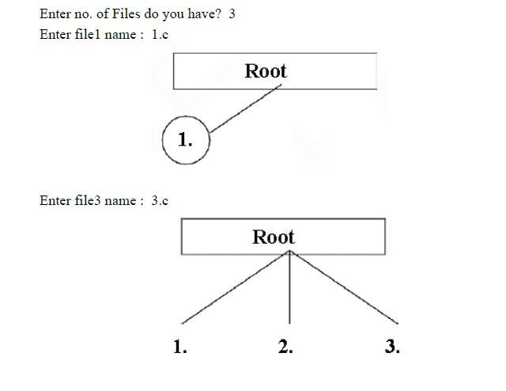
{
line(320,150,cir_x,250);
fillellipse(cir_x,250,30,30); outtextxy(cir_x,250,fname[j]);
} getch();
}
}

Output:

Result:

Thus the C program to implement File Organization concept using the technique Single level directory has been written and executed successfully.

Ex.No: 13 b Two Level Directoryies Date :

Aim:
To write a C program to implement File Organization concept using the technique two
level directories.

Algorithm:
- Start the Program
- Initialize structure elements
- Start main function
- Set variables gd =DETECT, gm;
- Create structure using create (&root,0,”null”,0,639,320);
- initgraph(&gd,&gm,”c:\tc\bgi”);
- Stop the execution

Program:
#include<stdio.h> #include<graphics.h> struct tree_element
{
char name[20]; int x,y,ftype,lx,rx,nc,level; struct tree_element *link[5];
};
typedef struct tree_element node; void main()
{
int gd=DETECT,gm; node *root; root=NULL; clrscr();
create(&root,0,"null",0,639,320); clrscr(); initgraph(&gd,&gm,"c:\\tc\\bgi"); display(root);
getch(); closegraph();
}
create(node **root, int lev, char *dname,
int lx,int rx,int x)
{ int i,gap;
if(*root==NULL)
{
(*root)=(node*)malloc(sizeof(node));
printf("Enter Name of Dir/File under %s):",dname); fflush(stdin); gets((*root)->name); if(lev==0||lev==1) (*root)->ftype=1; else

(*root)->ftype=2; (*root)->level=lev; (*root)->y=50+lev*50; (*root)->x=x;
(*root)->lx=lx; (*root)->rx=rx; for(i=0;i<5;i++) (*root)-
>link[i]=NULL; if((*root)->ftype==1)
{
if(lev==0||lev==1)
{ if((*root)-
>level==0)
printf("How many Users :"); else
printf("How many Files :"); printf("(for%s):", (*root)->name);
scanf("%d",& (*root)->nc);
}else(*root)->nc=0; if((*root)-
>nc==0) gap=rx-lx; else gap=(rx-lx)/(*root)->nc; for(i=0;i<(*root)->nc;i++) create(&((*root)->link[i]),lev+1,
(*root)->name,lx+gap*i,lx+gap*i+gap,lx+gap*i+gap/2);
}
else (*root)->nc=0;
} }
display(node *root)
{
int i; settextstyle(2,0,4); settextjustify(1,1); setfillstyle(1,BLUE); setcolor(14);
if(root!=NULL)
{
for(i=0;i<root->nc;i++)
{
line(root->x,root->y,root->link[i]->x,root->link[i]->y);
} if(root->ftype==1) bar3d(root->x-20, root->y-10,root-
>x+20,root->y+10,0,0); else fillellipse(root->x,root-
>y,20,20); outtextxy(root->x,root->y,root->name); for(i=0;i<root->nc;i++)
{
display(root->link[i]);
} }
}

Output:
Enter Name of Dir/File (under null) : sld How many Users (for sld) : 2
Enter Name of Dir/File (under sld) : tld How many Files (for tld) : 2
Enter Name of Dir/File (under tld) : hir Enter Name of Dir/File (under tld) : dag Enter Name of Dir/File (under sld) : bin How many Files (for bin) : 2
Enter Name of Dir/File (under bin) : exe Enter Name of Dir/File (under bin) : obj

Result:
Thus the C program to implement File Organization concept using the technique two level directories has been written and executed successfully.

Ex.No: 13 c Hierarchical Directories Date :

Aim:
To write a C program to implement File Organization concept using the technique
hierarchical level directories.

Algorithm:
- Start the Program
- Define structure and declare structure variables
- In main declare variables
- Check a directory tree structure
- Display the directory tree in graphical mode.
- Stop the execution Program: #include<stdio.h> #include<graphics.h> struct tree_element
{
char name[20]; int x,y,ftype,lx,rx,nc,level; struct tree_element *link[5];
};
typedef struct tree_element node; void main()
{
int gd=DETECT,gm; node *root; root=NULL;
clrscr(); create(&root,0,"root",0,639,320);
clrscr();
initgraph(&gd,&gm,"c:\\tc\\BGI"); display(root);
getch(); closegraph();
}
create(node **root,int lev, char *dname, int lx,int rx,int x)
{ int i,gap;
if(*root==NULL)
{
(*root)=(node *)malloc(sizeof(node));
printf("Enter Name of Dir/File (under %s) : ",dname); fflush(stdin); gets((*root)->name);
printf("Enter 1 for Dir/2 for File :"); scanf("%d",&(*root)->ftype); (*root)->level=lev;
(*root)->y=50+lev*50; (*root)->x=x;

(*root)->lx=lx;
(*root)->rx=rx; for(i=0;i<5;i++) (*root)->link[i]=NULL; if((*root)->ftype== 1)
{
printf("No. of Sub Directories / Files (for %s) :",
(*root)->name); scanf("%d",&(*root)->nc); if((*root)-
>nc==0)
gap=rx-lx;
else gap=(rx-lx)/(*root)->nc; for(i=0;i<(*root)->nc;i++) create(&((*root)-
>link[i]),lev+1,(*root)->name, lx+gap*i,lx+gap*i+gap,lx+gap*i+gap/2);
}
else(*root)->nc=0;
}
}
display(node *root)
{
int i; settextstyle(2,0,4); settextjustify(1,1); setfillstyle(1,BLUE); setcolor(14); if(root!=NULL)
{
for(i=0;i<root->nc;i++)
{
line(root->x,root->y,root->link[i]->x,root->link[i]->y);
}
if(root->ftype==1)
bar3d(root->x-20, root->y-10,root->x+20,root->y+10,0,0); else
fillellipse(root->x, root->y,20,20); outtextxy(root->x, root->y, root->name); for(i=0;i<root->nc;i++)
{
display(root->link[i]);
}
}
}

Output:
Enter Name of Dir/File (under root) : ROOT Enter 1 for Dir/2 for File :1
No. of Sub Directories / Files (for ROOT) :2 Enter Name of Dir/File (under ROOT) : USER 1 Enter 1 for Dir/2 for File :1
No. of Sub Directories / Files (for USER 1) :1 Enter Name of Dir/File (under USER 1) : SUBDIR Enter 1 for Dir/2 for File :1
No. of Sub Directories / Files (for SUBDIR) :2 Enter Name of Dir/File (under SUBDIR) : JAVA Enter 1 for Dir/2 for File :1
No. of Sub Directories / Files (for JAVA) :0 Enter Name of Dir/File (under SUBDIR) : VB Enter 1 for Dir/2 for File :1
No. of Sub Directories / Files (for VB) :0
Enter Name of Dir/File (under ROOT) : USER 2 Enter 1 for Dir/2 for File :1
No. of Sub Directories / Files (for USER 2) :2
Enter Name of Dir/File (under USER 2) : SUBDIR 2 Enter 1 for Dir/2 for File :1
No. of Sub Directories / Files (for SUBDIR 2) :2 Enter Name of Dir/File (under SUBDIR 2) : PPL Enter 1 for Dir/2 for File :1
No. of Sub Directories / Files (for PPL) :2 Enter Name of Dir/File (under PPL) : B Enter 1 for Dir/2 for File :2
Enter Name of Dir/File (under PPL) : C Enter 1 for Dir/2 for File :2
Enter Name of Dir/File (under SUBDIR 2) : AI Enter 1 for Dir/2 for File :1
No. of Sub Directories / Files (for AI) :2 Enter Name of Dir/File (under AI) : D Enter 1 for Dir/2 for File :2
Enter Name of Dir/File (under AI) : E Enter 1 for Dir/2 for File :2

Result:
Thus the C program to implement File Organization concept using the technique hierarchical level directory has been written and executed successfully.

Ex.No: 13 d Directed Acyclic Graph Directory Date :

Aim:
To write a C program to implement File Organization concept using the technique
directed acyclic graph directory.

Algorithm:
1. | Start the Program
2. | Define structure and declare structure variables
3. | In main declare variables
4. | Check a directory tree structure
5. | Display the directory tree in graphical mode 6. | Stop.
Program:

#include<stdio.h> #include<conio.h> #include<graphics.h> #include<string.h> struct tree_element
{
char name[20]; int x,y,ftype,lx,rx,nc,level; struct tree_element *link[5];
};
typedef struct tree_element node; typedef struct
{ char from[20]; char to[20]; }link; link L[10]; int nofl; node *root; void main()
{
int gd=DETECT, gm; root=NULL; clrscr();
create(&root,0,"root",0,639,320); read_links(); clrscr();
initgraph(&gd,&gm,"c:\\tc\\BGI"); draw_link_lines(); display(root); getch(); closegraph();
}
read_links()
{
int i;
printf("How many Links :"); scanf("%d",&nofl);

for(i=0;i<nofl;i++)
{
printf("File / Dir :"); fflush(stdin); gets(L[i].from); printf("Username :");
fflush(stdin); gets(L[i].to);
} }
draw_link_lines()
{ int i,x1,y1,x2,y2;
for(i=0;i<nofl;i++)
{
search(root,L[i].from,&x1,&y1); search(root,L[i].to,&x1,&y1); setcolor(LIGHTGREEN); setlinestyle(3,0,1); line(x1,y1,x2,y2); setcolor(YELLOW); setlinestyle(0,0,1);
} }
search(node *root,char *s,int *x,int *y)
{

int i; if(root!=NULL)
{

{ *x=root->x;
*y=root->y; return; } else {

if(strcmpi(root->name,s)==0)

for(i=0;i<root->nc;i++)
search(root->link[i],s,x,y);
}
} }
create(node **root,int lev,char *dname,int lx, int rx,int x)
{
int i,gap; if(*root==NULL)
{
(*root)=(node *)malloc(sizeof(node));
printf("Enter Name of Dir / File (under %s):",dname); fflush(stdin); gets((*root)->name);
printf("Enter 1 for Dir / 2 for File :");
scanf("%d",&(*root)->ftype); (*root)->level=lev;
(*root)->y=50+lev*50; (*root)->x=x;
(*root)->lx=lx; (*root)->rx=rx; for(i=0;i<5;i++) (*root)-

>link[i]=NULL; if((*root)-
>ftype==1)
{
printf("No. of Sub-Directories / Files (for %s) :", (*root)->name);
scanf("%d",&(*root)->nc);
if((*root)->nc==0) gap=rx-lx; else gap=(rx-lx)/(*root)->nc; for(i=0;i<(*root)->nc;i++) create(&((*root)->link[i]), lev+1,
(*root)->name,lx+gap*i,lx+gap*i+gap,lx+gap*i+gap/2);
} else
*root)->nc=0;
}
}
/* Displays the Constructed Tree in Grpahics mode */ display(node
*root)
{
int i; settextstyle(2,0,4); settextjustify(1,1); setfillstyle(1,BLUE); setcolor(14);
if(root!=NULL)
{
for(i=0;i<root->nc;i++)
{
line(root->x,root->y,root->link[i]->x, root->link[i]->y);
} if(root->ftype==1)
bar3d(root->x-20, root->y-10, root->x+20, root->y+10,0,0); else
fillellipse(root->x, root->y, 20, 20); outtextxy(root-
>x, root->y, root->name); for(i=0;i<root->nc;i++)
{
display(root->link[i]);
}
}
}

Output :
Enter Name of Dir/File (under root) : ROOT Enter 1 for Dir / 2 for File : 1
No. of Sub-Directories / Files (for ROOT) : 2 Enter Name of Dir/File (under ROOT) : USER 1 Enter 1 for Dir / 2 for File : 1
No. of Sub-Directories / Files (for USER 1) : 2 Enter Name of Dir/File (under USER 1) : VB Enter 1 for Dir / 2 for File : 1
No. of Sub-Directories / Files (for VB) : 2 Enter Name of Dir/File (under VB) : A Enter 1 for Dir / 2 for File : 2
Enter Name of Dir/File (under VB) : B Enter 1 for Dir / 2 for File : 2
Enter Name of Dir/File (under USER 1) : C Enter 1 for Dir / 2 for File : 2
Enter Name of Dir/File (under ROOT) : USER 2 Enter 1 for Dir / 2 for File : 1
No. of Sub-Directories / Files (for USER2) : 1 Enter Name of Dir/File (under USER 2) : JAVA Enter 1 for Dir / 2 for File : 1
No. of Sub-Directories / Files (for JAVA) : 2

Enter Name of Dir/File (under JAVA) : D Enter 1 for Dir / 2 for File : 2
Enter Name of Dir/File (under JAVA) : HTML Enter 1 for Dir / 2 for File : 1
No. of Sub-Directories / Files (for JAVA) : 0 How many Links : 2
File/Dir : B
User Name : USER 2 File/Dir : HTML User Name : USER 1

Result:
Thus the C program to implement File Organization concept using directed acyclic graph directory has been written and executed successfully.

Ex.No.14a Sequential File Allocation

Date :

Aim:
To implement sequential file allocation technique.

Algorithm:
- Start the program.
- Get the number of files.
- Get the memory requirement of each file.
- Allocate the required locations to each in sequential order. 4.1.Randomly select a location from available location s1= random(100);
  - Check whether the required locations are free from the selected location.
  - Allocate and set flag=1 to the allocated locations.
- Print the results file number, length , Blocks allocated.
- Stop the program.

Program:
#include<stdio.h> int main() {
int f[50],i,st,j,len,c,k,count=0; for(i=0;i<50;i++) f[i]=0; X: printf("\n enter starting block & length of files"); scanf("%d%d",&st,&len);
printf("\n file not allocated(yes-1/no-0)"); for(k=st;k<(st+len);k++)
if(f[k]==0) count++;
if(len==count)
{
for(j=st;j<(st+len);j++) if(f[i]==0) { f[j]=1;
printf("\n%d\t%d",j,f[j]); if(j==(st+len-1))
printf("\n the file is allocated to disk");
} }
else
printf("file is not allocated");
count=0; printf("\n if u want to enter more files(y-1/n-0)");
scanf("%d",&c); if(c==1) goto X; else exit(0); return 0;
}

Output:

[examuser1@linux ~]$ cc sequential.c [examuser1@linux ~]$ ./a.out
enter starting block & length of files3 5

file not allocated(yes-1/no-0)
3 1
4 1
5 1
6 1
7 1

the file is allocated to disk if u want to enter more files(y-1/n-0)1

enter starting block & length of files0 3

file not allocated(yes-1/no-0)
0 1
1 1
2 1

the file is allocated to disk if u want to enter more files(y-1/n-0)1

enter starting block & length of files5 3

file not allocated(yes-1/no-0)file is not allocated if u want to enter more files(y-1/n-0)1

enter starting block & length of files8 3

file not allocated(yes-1/no-0)
8 1
9 1
10 1

the file is allocated to disk
if u want to enter more files(y-1/n-0)0

Result:
Thus the C program to implement sequential file allocation has been written and executed successfully.

Ex.No: 14 b Indexed File Allocation Strategy Date :

Aim:
To write a C program to implement File Allocation concept using indexed allocation
Technique.

Algorithm:
- Start the Program
- Get the number of files.
- Get the memory requirement of each file.
- Allocate the required locations by selecting a location randomly.
- Print the results file no,length, blocks allocated.
- Stop the execution.

Program:
#include<stdio.h> #include<conio.h> #include<string.h> struct file { char n[20]; int ind;
}s[20];
int no,i= -1,a,b,f,j= -1,fe,t; char tem[20];
void create();
void display(); void del(); void main()
{
clrscr();
while(1) {
printf("\n \n Menu" );
printf("\n 1.Create \n 2.Display \n 3.Delete \n 4.Exit "); printf("Enter Your Choice : ");
scanf("%d",&no); switch(no) { case 1: create(); break; case 2 : display(); break; case 3: del(); break; case 4: exit(0); default
: printf("Wrong Choice");
}

} } void create() { i++;
printf("\n Enter the name of the record : "); scanf("%s",&s[i].n); printf("\n Enter the Index no. :"); scanf("%d",&s[i].ind); j++;
} void display() { for(a=0;a<i;a++) { for(b=0;b<i;b++) {
if(s[b].ind > s[b+1].ind)
{ t = s[b].ind; s[b].ind
= s[b+1].ind;
s[b+1].ind = t; strcpy(tem,s[b].n); strcpy(s[b].n,s[b+1].n); strcpy(s[b+1].n,tem);
}
else continue;
} }
printf("\n \t Index Recordname"); for(i=0;i<=j;i++) { printf("\n \t %d
\t",s[i].ind); printf("\t %s",s[i].n);
} i--; } void del() { int de,index= -1, k=0,l; if(i!= -1) {
printf("Enter Index no. to be Deleted : "); scanf("%d", &de); index = de; while(s[k].ind!= de)
{ k++;
printf("\n \t \t \t %d",k);
} for(l=k;l<=j;l++) s[l] = s[l+1];
i--; j--;
printf("\n Index no. %d File is deleted",index);
}
}

Output :

Menu 1.Create 2.Display
3.Delete 4.Exit

Enter Your Choice : 1
Enter the name of the record : a.java Enter the index no : 0
Enter the Field no : 1

Menu 1.Create 2.Display 3.Delete 4.Exit
Enter your Choice : 1
Enter the name of the record : b.c Enter the index no : 1
Enter the Field no : 2

Menu 1.Create 2.Display 3.Delete 4.Exit
Enter your choice : 2

Index Recordname FieldNo
0 a.java 1 1 b.c 2

Menu 1.Create 2.Display 3.Delete 4.Exit
Enter your Choice : 4

Result:
Thus the C program to implement indexed file allocation has been written and executed successfully.

Ex.No.: 14c Linked File Allocation Strategy Date :

Aim:
To write a C program to implement File Allocation concept using Linked List
Technique.

Algorithm:
1. Start the Program 2. Get the number of files.
- Allocate the required locations by selecting a location randomly
- Check whether the selected location is free.
- If the location is free allocate and set flag =1 to the allocated locations.
- Print the results file no, length, blocks allocated.
- Stop the execution

Program:
#include<stdio.h> #include<conio.h> void main()
{
int f[50],p,i,j,k,a,st,len,n; char c; for(i=0;i<50;i++) f[i]=0;
printf("enter how many blocks already allocated"); scanf("%d",&p);
printf("\nenter the blocks nos"); for(i=0;i<p;i++)
{
scanf("%d",&a); f[a]=1; }
printf("enter index starting block & length"); scanf("%d%d",&st,&len);
k=len; if(f[st]==0)
{
for(j=st;j<(k+st);j++)
{ if(f[j]==0)
{ f[j]=1;
printf("\n%d->%d",j,f[j]);
}
else
{
printf("\n %d->file is already allocated",j); k++;
}
}
} else
printf("\nif u enter one more (yes-1/no-0)");

scanf("%d",&c); if(c==1) goto X; else exit(); getch();
}

Output:
enter how many blocks already allocated4

enter the blocks nos4 8
2 7
enter index sarting block & length1 10

1->1
2->file is already allocated 3->1
4->file is already allocated 5->1
6->1
7->file is already allocated
8->file is already allocated 9->1
10->1
11->1
12->1
13->1
14->1

Result:
Thus the C program to implement linked file allocation has been written and executed successfully.

Ex.No.: 15 Implementation of various Disk Scheduling Algorithms Ex.No.: 15a FCFS Disk Scheduling

Aim:
To write a C program to implement FCFS disk scheduling.

Algorithm:

- Let Request array represents an array storing indexes of tracks that have been requested in ascending order of their time of arrival. ‘head’ is the position of disk head.
- Let us one by one take the tracks in default order and calculate the absolute distance of the track from the head.
- Increment the total seeks count with this distance.
- Currently serviced track position now becomes the new head position.
- Go to step 2 until all tracks in request array have not been serviced.

Program:

#include<stdio.h> #include<stdlib.h
> intmain() { intRQ[100],i,n,TotalHeadMoment=0,initial; printf("Enter the number of Requests\n");
scanf("%d",&n); printf("Enter the Requests
sequence\n"); for(i=0;i<n;i++)
scanf("%d",&RQ[i]);
printf("Enter initial head position\n"); scanf("%d",&initial);
// logic for FCFS disk scheduling for(i=0;i<n;i++)
{
TotalHeadMoment=TotalHeadMoment+abs(RQ[i]-initial); initial=RQ[i];
}

printf("Total head moment is %d",TotalHeadMoment); return0;

Output:
Enter the number of Request 8
Enter the Requests Sequence 95 180 34 119 11 123 62 64
Enter initial head position 50
Total head movement is 644

Result:
Thus the C program to implement FCFS disk scheduling has been written and executed successfully.

Ex.No.: 15b SSTF Disk Scheduling Date :

Aim:
To write a C program to implement SSTF disk scheduling.

Algorithm:
  - Let Request array represents an array storing indexes of tracks that have been requested,‘head’ is the position of disk head.
  - Find the positive distance of all tracks in the request array from head.
  - Find a track from requested array which has not been accessed/serviced yet and has minimum distance from head.
  - Increment the total seek count with this distance.
  - Currently serviced track position now becomes the new head position.
  - Go to step 2 until all tracks in request array have not been serviced.

Program:
#include<stdio.h> #include<stdlib.h
> int main() {
int RQ[100],i,n,TotalHeadMoment=0,initial,count=0; printf("Enter the number of Requests\n"); scanf("%d",&n);
printf("Enter the Requests sequence\n"); for(i=0;i<n;i++)
scanf("%d",&RQ[i]);
printf("Enter initial head position\n"); scanf("%d",&initial);

// logic for sstf disk scheduling

/* loop will execute until all process is completed*/ while(count!=n)
{
int min=1000,d,index; for(i=0;i<n;i++)
{
d=abs(RQ[i]-initial); if(min>d)
{
min=d; index=i;
}

}
TotalHeadMoment=TotalHeadMoment+min; initial=RQ[index];
// 1000 is for max
// you can use any number RQ[index]=1000;
count++;
}

printf("Total head movement is %d",TotalHeadMoment); return 0;
}

Output:
Enter the number of Request 8
Enter Request Sequence
95 180 34 119 11 123 62 64
Enter initial head Position 50
Total head movement is 236

Result:
Thus the C program to implement SSTF disk scheduling has been written and executed successfully

Ex.No.: 15c SCAN Disk Scheduling Date :

Aim:
To write a C program to implement SCAN disk scheduling.

Algorithm:
- Let Request array represents an array storing indexes of tracks that have been requested in ascending order of their time of arrival. ‘head’ is the position of disk head.
- Let direction represents whether the head is moving towards left or right.
- In the direction in which head is moving service all tracks one by one.
- Calculate the absolute distance of the track from the head.
- Increment the total seek count with this distance.
- Currently serviced track position now becomes the new head position.
- Go to step 3 until we reach at one of the ends of the disk.
- If we reach at the end of the disk reverse the direction and go to step 2 until all tracks in request array have not been serviced.

Program:
#include<stdio.h> #include<stdlib.h
> int main() {
int RQ[100],i,j,n,TotalHeadMoment=0,initial,size,move; printf("Enter the number of Requests\n"); scanf("%d",&n); printf("Enter the Requests sequence\n");
for(i=0;i<n;i++) scanf("%d",&RQ[i]);
printf("Enter initial head position\n"); scanf("%d",&initial);
printf("Enter total disk size\n");
scanf("%d",&size);
printf("Enter the head movement direction for high 1 and for low 0\n"); scanf("%d",&move);

// logic for Scan disk scheduling

/*logic for sort the request array */ for(i=0;i<n;i++)
{
for(j=0;j<n-i-1;j++)
{ if(RQ[j]>RQ[j+1])
{ int
temp; temp=RQ[j]; RQ[j]=RQ[j+1];
RQ[j+1]=temp;

}

}
}

int index; for(i=0;i<n;i++)
{
if(initial<RQ[i])
{
index=i; break;
}
}

// if movement is towards high value if(move==1)
{
for(i=index;i<n;i++)
{
TotalHeadMoment=TotalHeadMoment+abs(RQ[i]-initial); initial=RQ[i];
}
// last movement for max size TotalHeadMoment=TotalHeadMoment+abs(size-RQ[i-1]-1);
initial = size-1; for(i=index-1;i>=0;i--)
{
TotalHeadMoment=TotalHeadMoment+abs(RQ[i]-initial); initial=RQ[i];

}
}
// if movement is towards low value else
{
for(i=index-1;i>=0;i--)
{
TotalHeadMoment=TotalHeadMoment+abs(RQ[i]-initial); initial=RQ[i];
}
// last movement for min size TotalHeadMoment=TotalHeadMoment+abs(RQ[i+1]-0); initial =0; for(i=index;i<n;i++)
{

TotalHeadMoment=TotalHeadMoment+abs(RQ[i]-initial); initial=RQ[i];

}
}

printf("Total head movement is %d",TotalHeadMoment); return 0;
}

Output:
Enter the number of Request 8
Enter the Requests Sequence 95 180 34 119 11 123 62 64
Enter initial head position 50
Enter total disk size 200
Enter the head movement direction for high 1 and for low 0 1 Total head movement is 337

Result:
Thus the C program to implement SCAN disk scheduling has been written and executed successfully

Ex.No.: 15d CSCAN Disk Scheduling Date :

Aim:
To write a C program to implement CSCAN disk scheduling.

Algorithm:
- Let Request array represents an array storing indexes of tracks that have been requested in ascending order of their time of arrival. ‘head’ is the position of disk head.
- The head services only in the right direction from 0 to the size of the disk.
- While moving in the left direction does not service any of the tracks.
- When we reach the beginning (left end) reverse the direction.
- While moving in the right direction it services all tracks one by one.
- While moving in the right direction calculates the absolute distance of the track from the head.
- Increment the total seeks count with this distance.
- Currently serviced track position now becomes the new head position.
- Go to step 6 until we reach the right end of the disk.
- If we reach the right end of the disk reverse the direction and go to step 3 until all tracks in the request array have not been serviced.

Program:
#include<stdio.h> #include<stdlib.h
> int main() {
int RQ[100],i,j,n,TotalHeadMoment=0,initial,size,move; printf("Enter the number of Requests\n"); scanf("%d",&n); printf("Enter the Requests sequence\n");
for(i=0;i<n;i++) scanf("%d",&RQ[i]);
printf("Enter initial head position\n"); scanf("%d",&initial);
printf("Enter total disk size\n");
scanf("%d",&size);
printf("Enter the head movement direction for high 1 and for low 0\n"); scanf("%d",&move);

// logic for C-Scan disk scheduling

/*logic for sort the request array */ for(i=0;i<n;i++)
{
for( j=0;j<n-i-1;j++)
{ if(RQ[j]>RQ[j+1])
{ int
temp;

temp=RQ[j]; RQ[j]=RQ[j+1];
RQ[j+1]=temp;
}

}
}

int index; for(i=0;i<n;i++)
{
if(initial<RQ[i])
{
index=i; break;
}
}

// if movement is towards high value if(move==1)
{
for(i=index;i<n;i++)
{
TotalHeadMoment=TotalHeadMoment+abs(RQ[i]-initial); initial=RQ[i];
}
// last movement for max size TotalHeadMoment=TotalHeadMoment+abs(size-RQ[i-1]-1);
/*movement max to min disk */ TotalHeadMoment=TotalHeadMoment+abs(size-1-0); initial=0;
for( i=0;i<index;i++)
{
TotalHeadMoment=TotalHeadMoment+abs(RQ[i]-initial); initial=RQ[i];

}
}
// if movement is towards low value else
{ for(i=index- 1;i>=0;i--)
{
TotalHeadMoment=TotalHeadMoment+abs(RQ[i]-initial); initial=RQ[i];
}

// last movement for min size TotalHeadMoment=TotalHeadMoment+abs(RQ[i+1]-0);
/*movement min to max disk */ TotalHeadMoment=TotalHeadMoment+abs(size-1-0);
initial =size-1;
for(i=n-1;i>=index;i--)
{
TotalHeadMoment=TotalHeadMoment+abs(RQ[i]-initial); initial=RQ[i];

}
}

printf("Total head movement is %d",TotalHeadMoment); return 0;
}

Output:

Enter the number of Request 8
Enter the Requests Sequence 95 180 34 119 11 123 62 64
Enter initial head position 50
Enter total disk size 200
Enter the head movement direction for high 1 and for low 0 1 Total head movement is 382

Result:
Thus the C program to implement CSCAN disk scheduling has been written and executed successfully.

Ex.No.: 15e CLOOK Disk Scheduling Date :

Aim:
To write a C program to implement CLOOK disk scheduling.

Algorithm:
- Let Request array represents an array storing indexes of the tracks that have been requested in ascending order of their time of arrival and head is the position of the disk head.
- The initial direction in which the head is moving is given and it services in the same direction.
- The head services all the requests one by one in the direction it is moving.
- The head continues to move in the same direction until all the requests in this direction have been serviced.
- While moving in this direction, calculate the absolute distance of the tracks from the head.
- Increment the total seeks count with this distance.
- Currently serviced track position now becomes the new head position.
- Go to step 5 until we reach the last request in this direction.
- If we reach the last request in the current direction then reverse the direction and move the head in this direction until we reach the last request that is needed to be serviced in this direction without servicing the intermediate requests.
- Reverse the direction and go to step 3 until all the requests have not been serviced.

Program:
#include<stdio.h> #include<stdlib.h
> int main() {
int RQ[100],i,j,n,TotalHeadMoment=0,initial,size,move; printf("Enter the number of Requests\n"); scanf("%d",&n); printf("Enter the Requests sequence\n");
for(i=0;i<n;i++) scanf("%d",&RQ[i]);
printf("Enter initial head position\n"); scanf("%d",&initial);
printf("Enter total disk size\n");
scanf("%d",&size);
printf("Enter the head movement direction for high 1 and for low 0\n"); scanf("%d",&move);

// logic for C-look disk scheduling

/*logic for sort the request array */ for(i=0;i<n;i++)

{
for( j=0;j<n-i-1;j++)
{ if(RQ[j]>RQ[j+1])
{ int
temp; temp=RQ[j]; RQ[j]=RQ[j+1];
RQ[j+1]=temp;
}

}
}

int index; for(i=0;i<n;i++)
{
if(initial<RQ[i])
{
index=i; break;
}
}

// if movement is towards high value if(move==1)
{
for(i=index;i<n;i++)
{
TotalHeadMoment=TotalHeadMoment+abs(RQ[i]-initial); initial=RQ[i];
}

for( i=0;i<index;i++)
{
TotalHeadMoment=TotalHeadMoment+abs(RQ[i]-initial); initial=RQ[i];

}
}
// if movement is towards low value else
{
for(i=index-1;i>=0;i--)
{

TotalHeadMoment=TotalHeadMoment+abs(RQ[i]-initial); initial=RQ[i];
}

for(i=n-1;i>=index;i--)
{
TotalHeadMoment=TotalHeadMoment+abs(RQ[i]-initial); initial=RQ[i];

}
}

printf("Total head movement is %d",TotalHeadMoment); return 0;
}

Output:

Enter the number of Request 8
Enter the Requests Sequence 95 180 34 119 11 123 62 64
Enter initial head position 50
Enter the head movement direction for high 1 and for low 0 1 Total head movement is 322

Result:
Thus the C program to implement CLOOK disk scheduling has been written and executed successfully.

INSTALL LINUX USING VMWARE
Ex.No:16

Date:

Aim:

Procedure:
- Download the VMWARE which is available in the website. VMware workstation player includes everything that is needed for standard virtual machine task.
- Launch the installer and follow the installation wizard. Select the option to install an Enhanced Keyboard Driver.
- proceed through the installation wizard and restart windows when prompted.

Create Linux Virtual Machine:
Start by launching VMware Workstation player, When ready to create VM.

Click Create a new virtual machine.
- Select the default option, Installer disc image file (iso).
- Click Browse to find ISO file.
- With guest OS selected click Next.
- Select Linux as a guest operating system type.
- Under version, scroll through the list and select the OS.
- Click Next to proceed and if necessary, input a Virtual Machine Name.
- Confirm the storage Location and change if needed.
After selecting and configuring the operating system, build the virtual machine.
- Under Specify Disk Capacity adjust Maximum Disk Size if required (Default is enough).
- Select Split virtual disk in to multiple files as this makes moving the VM to a new PC easy.
- Click Next then confirm the details on the next screen.
- If anything seems wrong click Back, otherwise click Finish.
Now the Linux virtual machine will be added to VMware Workstation Player.

To installing Linux in VMware is follow the steps given below:
- Download the free VMware workstation player.
- Install, and restart windows.
- Create and configure your virtual machine.
- Install Linux in the Virtual Machine.
Restart the Virtual Machine and use Linux

Result:

Thus the Linux Using VMware installation has been studied successfully.

Ex.No.: 17 DEAD LOCK PREVENTION
Date :

AIM: To implement deadlock prevention technique

Banker‘s Algorithm:

When a new process enters a system, it must declare the maximum number of instances of each resource type it needed. This number may exceed the total number of resources in the system. When the user request a set of resources, the system must determine whether the allocation of each resources will leave the system in safe state. If it will the resources are allocation; otherwise the process must wait until some other process release the resources.

DESCRIPTION:

Data structures
n- Number of process, m-number of resource types.

Available: Available[j]=k, k – instance of resource type Rj is available. Max: If max[i, j]=k, Pi may request at most k instances resource Rj.
Allocation: If Allocation [i, j]=k, Pi allocated to k instances of resource Rj Need:
If Need[I, j]=k, Pi may need k more instances of resource type Rj, Need[I, j]=Max[I, j]-Allocation[I, j];

Safety Algorithm

Work and Finish be the vector of length m and n respectively, Work=Available and Finish[i] =False.
Find an i such that both Finish[i] =False Need<=Work

If no such I exists go to step 4.

- work=work+Allocation, Finish[i] =True;
if Finish[1]=True for all I, then the system is in safe state

ALGORITHM:

  - Start the program.

  - Get the values of resources and processes.

  - Get the avail value.

  - After allocation find the need value.

  - Check whether its possible to allocate.

  - If it is possible then the system is in safe state.

  - Else system is not in safety state

  - Stop the process.

SOURCE CODE :

#include<stdio.h> #include<conio.h
> void main() { char job[10][10];
int time[10],avail,tem[10],temp[10]; int safe[10]; int ind=1,i,j,q,n,t;
clrscr(); printf("Enter no of jobs: "); scanf("%d",&n); for(i=0;i<n;i++)
{
printf("Enter name and time: "); scanf("%s%d",&job[i],&time[i]);
}
printf("Enter the available resources:"); scanf("%d",&avail);
for(i=0;i<n;i++)
{ temp[i]=time[i]; tem[i]=i; } for(i=0;i<n;i++) for(j=i+1;j<n;j++
)
{
if(temp[i]>temp[j])
{
t=temp[i]; temp[i]=te mp[j]; temp[j]=t; t=tem[i]; tem[i]=tem [j];
tem[j]=t;
}
}
for(i=0;i<n;i++) { q=tem[i]; if(time[q]<=avail
)
{ safe[ind]=tem[i]; avail=avail-tem[q]; printf("%s",job[safe[ind]])
;
ind++
; }
else {
printf("No safe sequence\n");
} } printf("Safe sequence is:"); for(i=1;i<ind; i++)
printf("%s %d\n",job[safe[i]],time[safe[i]]); getch();
}

OUTPUT:

Enter no of jobs:4
Enter name and time: A 1 Enter name and time: B 4 Enter name and time: C 2
Enter name and time: D 3 Enter the available resources: 20 Safe sequence is: A 1, C 2, D 3, B 4.

Result:
Thus the program to implement deadlock Prevention algorithm has been written and executed successfully.

EX NO: 17 Implement Contiguous file allocation technique.

Date:

Aim:

To write a program for implement the contiguous file allocation technique.

Algorithm:

- Start the program
- Declare the size
- Get the number of files to be inserted.
- Get the capacity of each file.
- Get the starting address.
- The file is allocated in memory
- The file is not allocated if the contiguous memory is not available.
- Display the result
- Stop the program.
Program :

#include<stdio.h> main()
{ int nf, fc[20], mb[100], i, j, k, fb[100], fs[20], mc=0; clrscr();
printf("\nEnter the number of files: "); scanf("%d",&nf);
for(i=0;i<nf;i++)
{ printf("\nEnter the capacity of file %d:
",i+1); scanf("%d",&fc[i]); printf("\nEnter the starting address of file %d:
",i+1); scanf("%d",&fs[i]);
}
printf("\n---CONTIGUOUS FILE ALLOCATION---\n");
for(i=0;i<100;i++) fb[i]=1; for(i=0;i<nf;i++)
{ j=fs[i];
{ if(fb[j]==1)
{ for(k=j;k<(j+fc[i]);k++)
{ if(fb[k]==1)
mc++;
}
if(mc==fc[i]){
for(k=fs[i];k<(f
s[i]+fc[i]);k++)

{ fb[k]=0;
}
printf("\nFile %d allocated in memory %d to %d...",i+1,fs[i],fs[i]+fc[i]-1); }

}
else
printf("\nFile %d not allocated since %d contiguous memory not available from %d...",i+1,fc[i],fs[i]); }

mc=0;
}
}

Output :

Enter the number of files: 3 Enter the capacity of file 1: 21
Enter the starting address of file 1: 21 Enter the capacity of file 2: 24
Enter the starting address of file 2: 36 Enter the capacity of file 3: 2
Enter the starting address of file 3: 54
---CONTIGUOUS FILE ALLOCATION---
File 1 allocated in memory 21 to 41...
File 2 not allocated since 24 contiguous memory not available from 36... File 3 allocated in memory 54 to 55...

Result:
Thus the C program to implement sequential file allocation has been written and executed successfully.

