Dominique Anguiano

CPE301 – SPRING 2016

Design Assignment 0

**DO NOT REMOVE THIS PAGE DURING SUBMISSION:**

The student understands that all required components should be submitted in complete for grading of this assignment.

|  |  |  |  |
| --- | --- | --- | --- |
| **NO** | **SUBMISSION ITEM** | **COMPLETED (Y/N)** | **MARKS**  **(/MAX)** |
| 0. | COMPONENTS LIST AND CONNECTION BLOCK DIAGRAM w/ PINS |  |  |
| 1. | INITIAL CODE OF TASK 1/A |  |  |
| 2. | SCREENSHOTS OF EACH TASK OUTPUT |  |  |
| 3. | GITHUB LINK OF THE DA |  |  |
|  |  |  |  |
|  |  |  |  |
|  |  |  |  |
|  |  |  |  |
|  |  |  |  |
|  |  |  |  |
|  |  |  |  |
|  |  |  |  |
|  |  |  |  |

|  |  |  |  |
| --- | --- | --- | --- |
| 1. | INITIAL CODE OF TASK 1/A |  |  |

;

; DA 0 Task 1.asm

;

; Created: 2/13/2016 4:02:48 AM

; Author : Dominique

;

.org 0

sbi DDRB, 2 ; Set PORTB.2 as an output

ldi r16, 0 ; Initialize r16 to 0

; This register will hold the sum

ldi r17, 59 ; Load immediate value 59 into the register

add r16, r17 ; r16 = r16 + r17

ldi r17, 54 ; Load immediate value 54 into the register

add r16, r17 ; r16 = r16 + r17

ldi r17, 59 ; Load immediate value 59 into the register

add r16, r17 ; r16 = r16 + r17

ldi r17, 41 ; Load immediate value 41 into the register

add r16, r17 ; r16 = r16 + r17

ldi r17, 45 ; Load immediate value 45 into the register

add r16, r17 ; r16 = r16 + r17

brcs Overflow ; Branch if an overflow occurs

NoOverflow:

ldi r18, 0 ; Set value of 0 into register to set PORTB.2 pin

; to low

out PORTB, r18 ; Send value of r18 to corresponding bit

jmp NoOverflow ; Branch to NoOverflow

Overflow:

ldi r18, 4 ; Set value of 4 into register to set PORTB.2 pin

; to high

out PORTB, r18 ; Send value of r18 to corresponding bit

jmp Overflow ; Branch to Overflow

|  |  |  |  |
| --- | --- | --- | --- |
| 7. | SCREENSHOTS OF EACH TASK OUTPUT |  |  |

TASK 1/A

Screenshots of program execution at the Beginning and End of Task A.

Beginning of Task A Screenshot

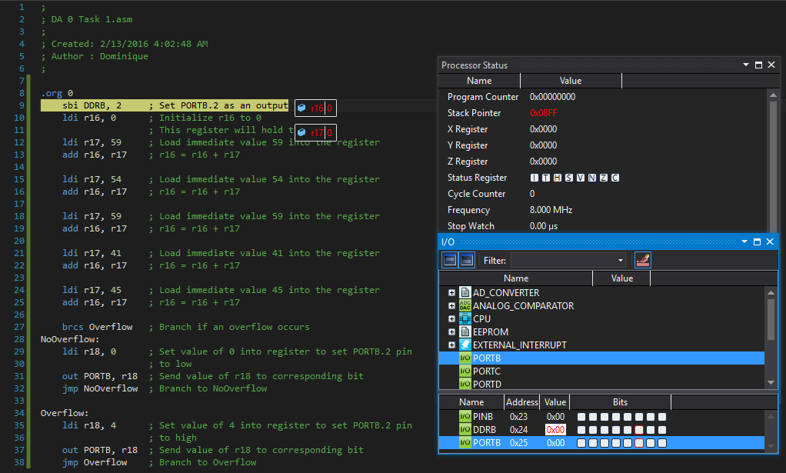

End of Task A Screenshot

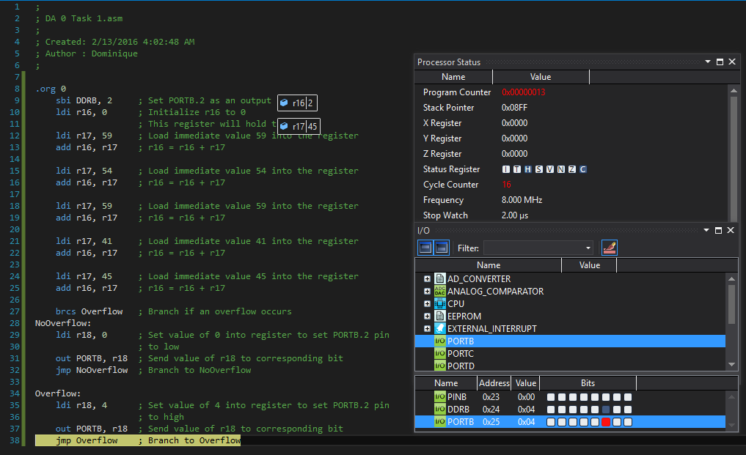

TASK 1/B:

Determine the Execution Time and Number of Cycles for the algorithm with a simulation

# of Cycles = 16

$$Execution time=2.00 μs$$

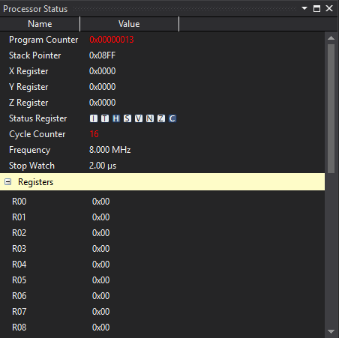

|  |  |  |  |
| --- | --- | --- | --- |
| 9. | VIDEO LINKS OF EACH DEMO |  |  |
| N/A | | | |
| 10. | GOOGLECODE LINK OF THE DA |  |  |
| <https://github.com/Anguian3/anguian3-submissions> | | | |

**Student Academic Misconduct Policy**

<http://studentconduct.unlv.edu/misconduct/policy.html>

“This assignment submission is my own, original work”.

Dominique Anguiano